模型名称 | 版本类型 | RMSE（均方根误差） | MAE（平均绝对误差） | R2（拟合优度）
LASSO | Baseline | 0.5425 | 0.4435 | 0.1345
LASSO | Enhanced | 0.5164 | 0.4071 | 0.2194
随机森林 | Baseline | 0.4980 | 0.3818 | 0.2704
随机森林 | Enhanced | 0.4976 | 0.3720 | 0.2752
Elastic Net | Baseline | 0.6754 | 0.5187 | -1.6628
Elastic Net | Enhanced | 0.5164 | 0.4071 | 0.2194
PCA | Baseline | 0.6457 | 0.5225 | -0.2265
PCA | Enhanced | 0.6518 | 0.5111 | -0.2438
PLS | Baseline | 0.6122 | 0.4978 | -0.1025
PLS | Enhanced | 0.6205 | 0.4799 | -0.1270
Comb | Baseline | 0.6990 | 0.5406 | -1.8515
Comb | Enhanced | 0.6867 | 0.5092 | -1.7376

- LASSO
Baseline
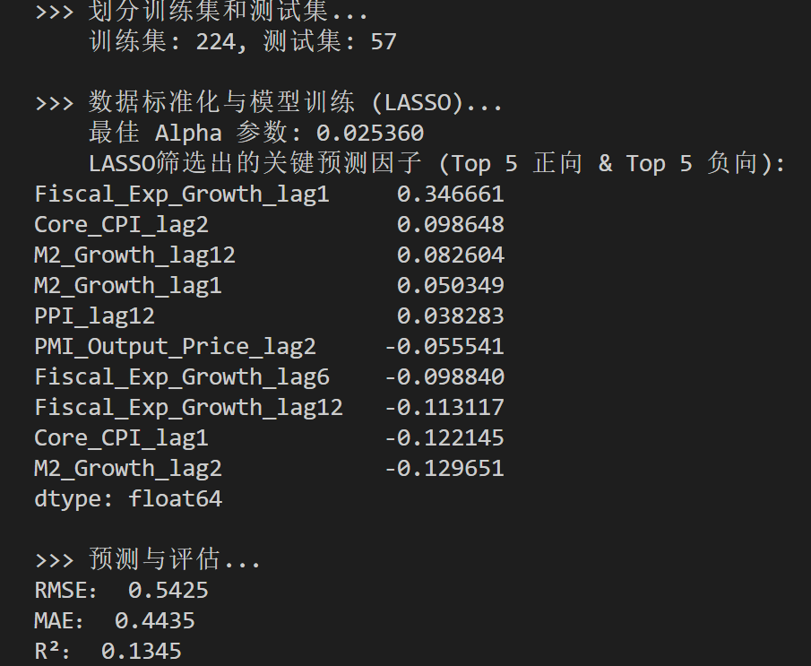
Enhanced
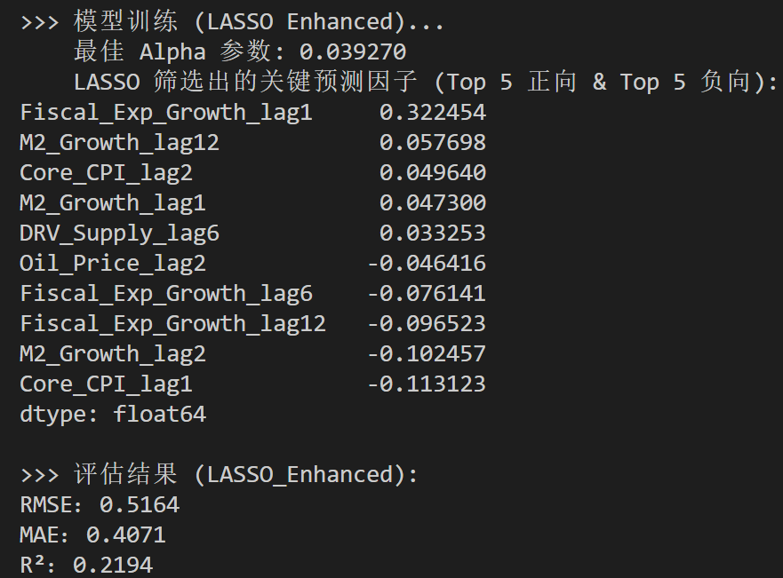

- 随机森林
Baseline
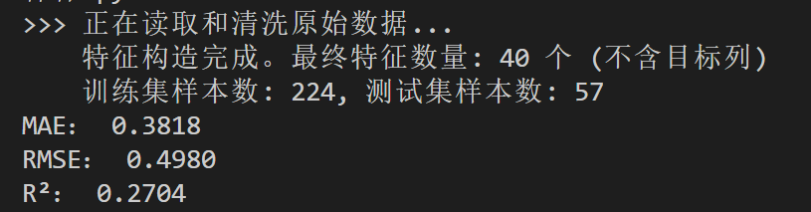
Enhanced
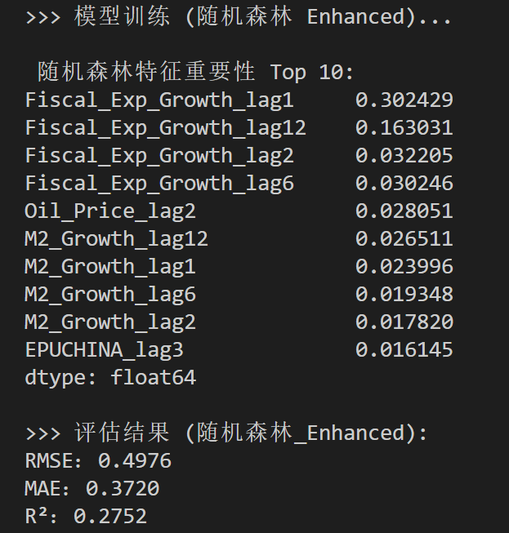

- Elastic Net
Baseline
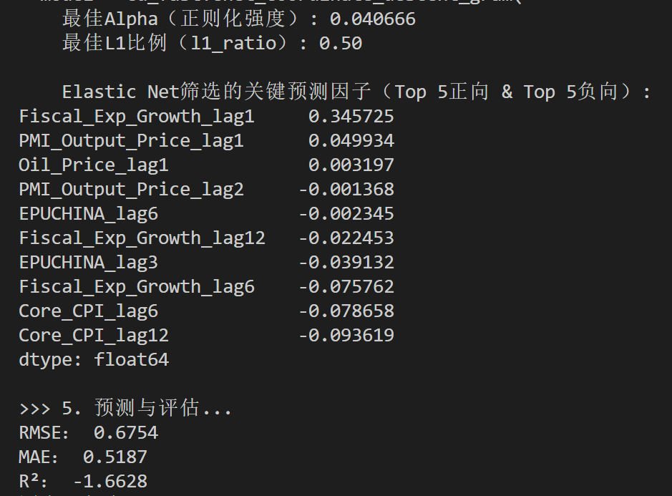
Enhanced
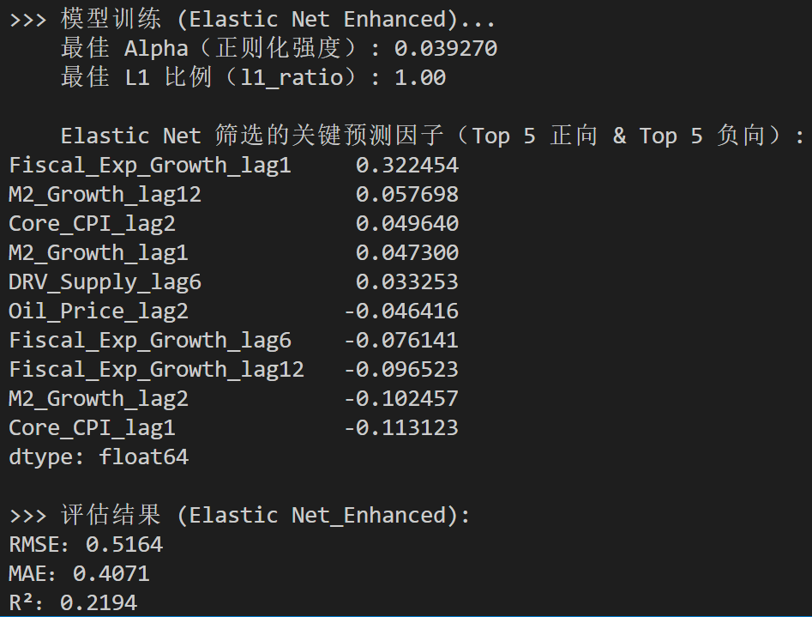

- PCA
Baseline
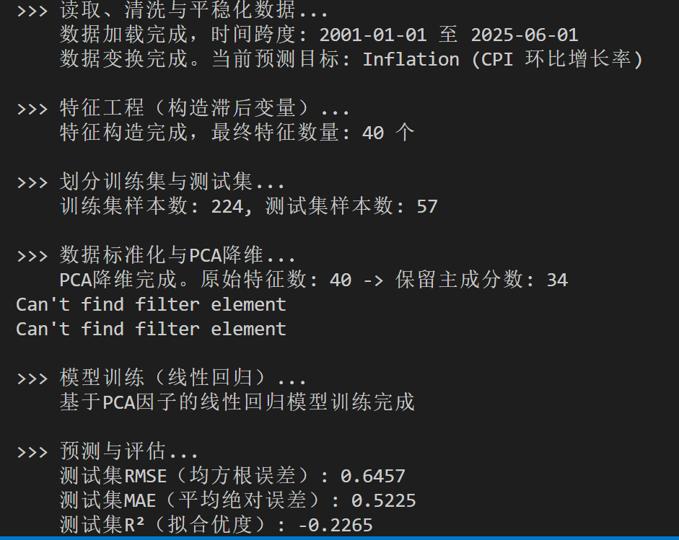
Enhanced
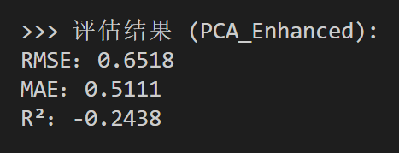

- PLS
Baseline
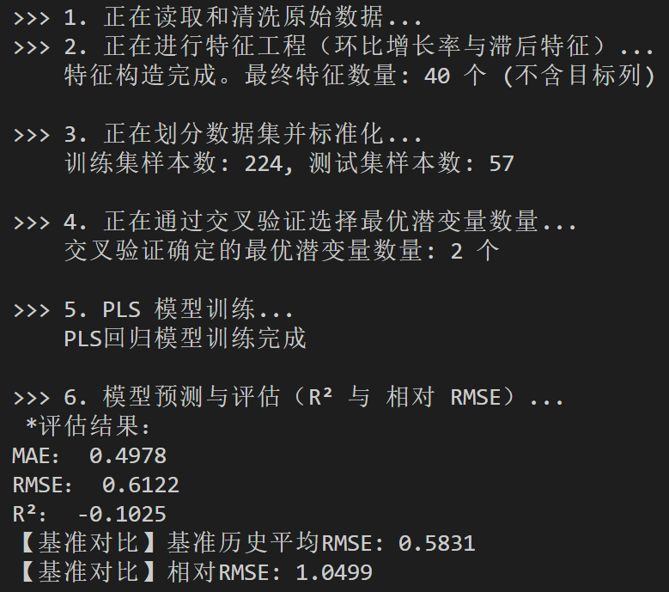
Enhanced
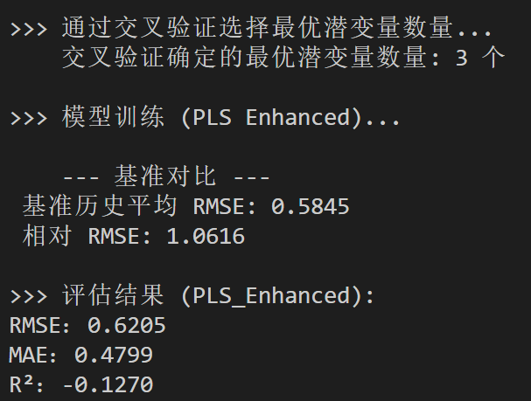

- Comb
Baseline
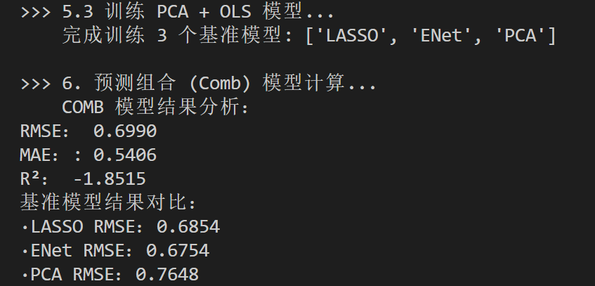
Enhanced
