Documentation for Willify

“Access All Music Whenever You Are” is the homepage of my website. As you can see we got top navigation button so we can navigate through the different page in ease. Each page have similar design to other. In homepage I fill it with songs for best seller and recommended songs with interactive horizontal scroll.

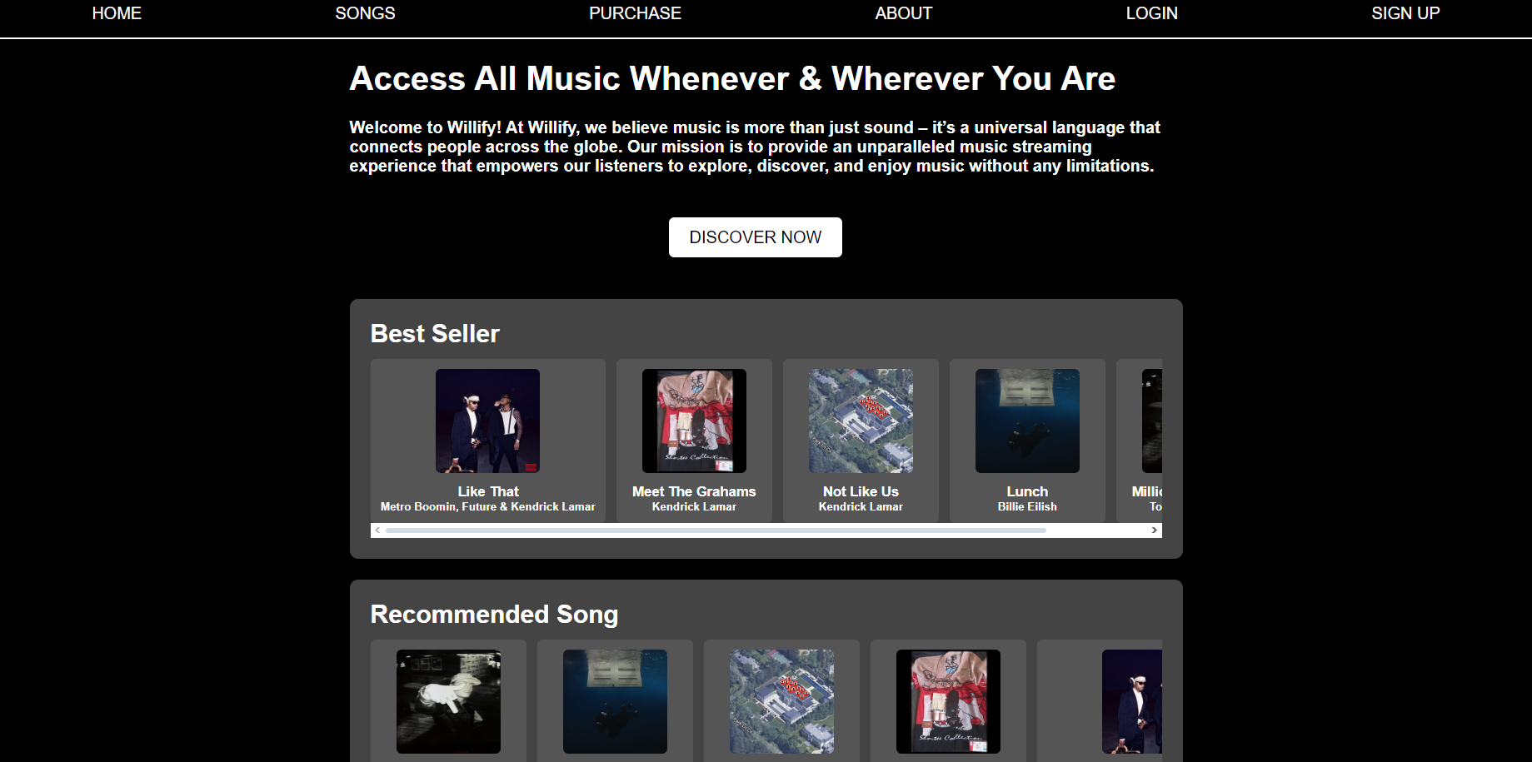

This is the page for all songs that is can be accessed (Song detail isn’t done)

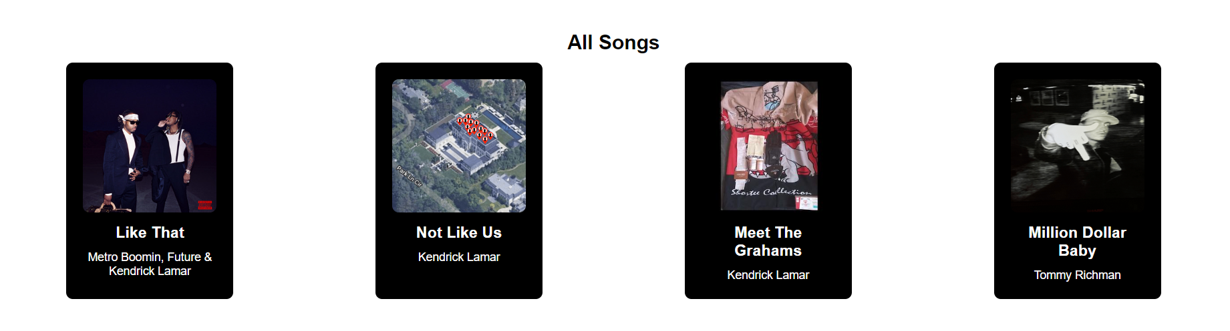

This is about us page, tells about who is the developer and our purpose making willify

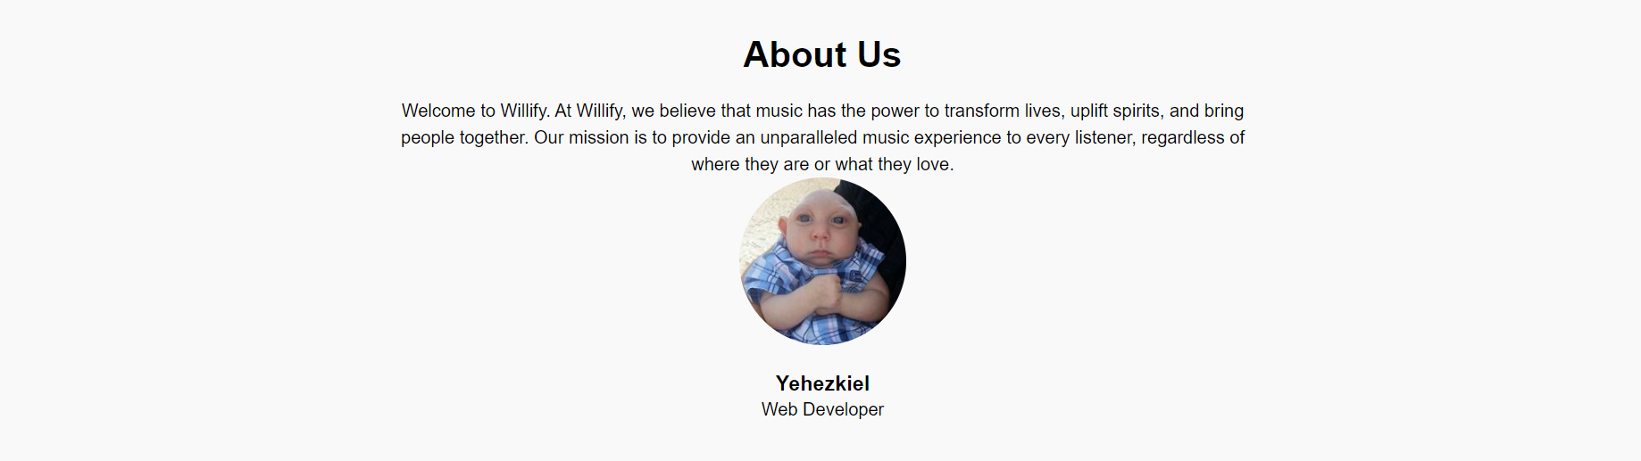

This is the login page, you need to make an account in sign up page first

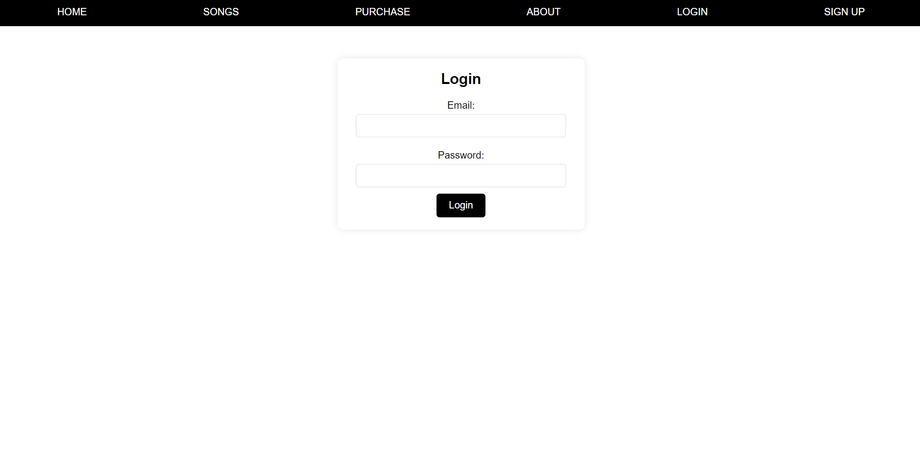

This is the Sign Up Page you can get a new account then login to you account

