Stubby, Totally Stubby, NSSA, and OSPF lab

9/28/2023 Brit Stevens

**Purpose:**

The purpose of this lab was to understand the uses of different OSPF special areas for optimized management. It also taught us how to set up these special area with interarea communication between them. In order to view and verify that these areas were set up correctly we had to learn monitoring the LSA type 1-7 packets through a switch and with a network capturing software.

**Background Information on lab concepts:**

OSPF is an interouting protocol that advertises what Ip’s each router is connected to and finds the best route for the quickest delivery of information to their destination (for example the internet or other desktop workstations). An Ip is used to identify where any source of information is coming from and to identify where it goes over any network. It is also a link/state protocol meaning different ports on the routers have different roles with certain actions that they can follow. Each role has a specific task like listening to see if they’re needed to transfer data or actively pushing data if they’re the fastest at transferring data across a network. Another important thing to always consider is redundancy with many routes to the same router to ensure transfer of data is consistent even if one single router goes down. This allows for a routing table to be built for each router when the Ip’s are shared through OSPF, so all connected end devices are seen and have a known location to allow for communication between many routers and throughout an office. The different special area OSPF protocols we used were, Stubby Area, Totally Stubby area, Not So Stubby Area (NSSA), and OSPF Area. Each has its own special use and can receive different OSPF LSA type packets. LSA type 1 is a Router LSA meaning it is sent from an internal router to adjacent routers to notify them of any updates to the network as well as the cost (how long it would take for data to transmit) to each port. LSA type 2 is a Network LSA meaning the DR router (the commanding router which has the least cost) will advertise any changes in topology of the network to other routers in the same area. LSA type 3 is a Summary LSA meaning it is sent between areas the announce IP routes to each network. LSA type 4 is an ASBR Summary LSA meaning it is re-advertisement of type 5 LSA packets to networks where the next ip hop information may be unknown, such as remote networks. LSA type 5 Packets are External LSAs to give ip routes between different routing protocols and are sent to between all areas. LSA type 7 are NSSA LSA packets which are sent between NSSA area’s and the ABR associated with that area. They give external routes to advertise after being converted by the ABR to the backbone area (an area that can receive all LSAs and connects multiple areas). Stubby Area is optimized for areas that have one ASBR connecting that area to the rest of the Network. Because all the traffic goes through a single router, Stubby Area inputs a default route instead many external routes to clear up the routing table and save bandwidth. It allows LSA type 1, 2, and 3. Totally Stubby Area is the same as a stubby area but does not allow LSA type 3 packets. To reach the rest of the network it restricts the Summary packets and uses a default route to connect. Allows LSA type 1 and 2. NSSA is similar to stubby areas but is used to advertise an external route on the other end of the network. To do this it sends a type 7 packets to the ABR to advertise it as a type 5 to the rest of the network.

**Lab Summary**:

First we drew a diagram and came up with an IP scheme of how we’re going to set up the routers. We had to account for the different areas and how each special area functions in order to set it up correctly. We used packet tracer to set up the diagram digitally to allow easier management as we figured out how these new concepts worked. To set it up fully we researched how each special config needed to be set up with certain commands and applied them to the specific routers. For the most part all the routers we configured similarly with one different command to make them OSPF, Stubby, and Totally Stubby while in the ospf router config. After setting these all up correctly and testing for connectivity in packet tracer, we used the same diagram on the rack. Once the rack was set up correctly we used wireshark and configured the switches to view all the LSA types with the transmitted ospf packets.

**Lab Commands:**

**Router:**

Router ospf [process id] – lets us configure ospf

Network [network address] [wild card mask] area [area id] -advertises what Ip address connected to the routers

Router-id [x.x.x.x] -gives a unique address in the link state table.

Ipv6 router ospf [process id] - enables Ipv6 addresses on ospf communication.

(In interface) Ipv6 ospf area [area id] – assign an interface to an area of ospf

Area X NSAA – sets an area to not so stubby area in the router interface

Redistribute connected – pushes the known subnets to adjacent routers

Area X no-sum – to enable Totally stubby ospf with no summary packets

Area X stub – to enable stubby area and restrict type 5 LSA packets

**Switch:**

Monitor Session source [interface] – copies all data from an interface

Monitor session destination [interface] – paired with the other command transmits all the saved data to an destinated port.

**Network Diagram with IP’s:** 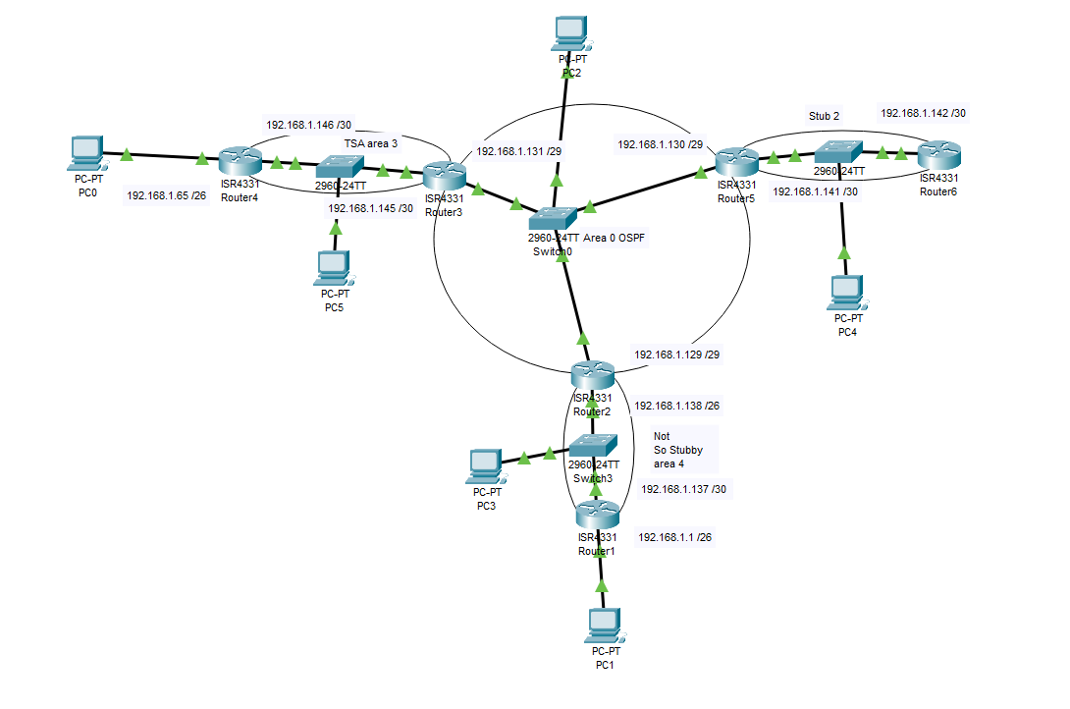

**Configurations:**

**R1 Ip routes:**

Codes: L - local, C - connected, S - static, R - RIP, M - mobile, B - BGP

D - EIGRP, EX - EIGRP external, O - OSPF, IA - OSPF inter area

N1 - OSPF NSSA external type 1, N2 - OSPF NSSA external type 2

E1 - OSPF external type 1, E2 - OSPF external type 2, E - EGP

i - IS-IS, L1 - IS-IS level-1, L2 - IS-IS level-2, ia - IS-IS inter area

* - candidate default, U - per-user static route, o - ODR

P - periodic downloaded static route

Gateway of last resort is not set

192.168.1.0/24 is variably subnetted, 6 subnets, 3 masks

C 192.168.1.128/29 is directly connected, GigabitEthernet0/0/0

L 192.168.1.129/32 is directly connected, GigabitEthernet0/0/0

C 192.168.1.136/30 is directly connected, GigabitEthernet0/0/1

L 192.168.1.138/32 is directly connected, GigabitEthernet0/0/1

O IA 192.168.1.140/30

[110/2] via 192.168.1.130, 00:31:05, GigabitEthernet0/0/0

O IA 192.168.1.144/30

[110/2] via 192.168.1.131, 00:31:05, GigabitEthernet0/0/0

O N2 200.0.0.0/24 [110/20] via 192.168.1.137, 00:26:00, GigabitEthernet0/0/1

**R1 Running config:**

Current configuration : 1940 bytes

Last configuration change at 18:36:55 UTC Mon Oct 2 2023

version 16.7

service timestamps debug datetime msec

service timestamps log datetime msec

platform qfp utilization monitor load 80

no platform punt-keepalive disable-kernel-core

hostname R1

boot-start-marker

boot-end-marker

vrf definition Mgmt-intf

address-family ipv4

exit-address-family

address-family ipv6

exit-address-family

no aaa new-mode

subscriber templating

vtp domain cisco

vtp mode transparent

multilink bundle-name authenticated

license udi pid ISR4321/K9 sn FDO220523GF

license boot level appxk9

no license smart enable

diagnostic bootup level minimal

spanning-tree extend system-id

redundancy

mode none

interface Loopback0

ip address 200.0.0.1 255.255.255.0

interface GigabitEthernet0/0/0

ip address 192.168.1.1 255.255.255.192

ip ospf 4 area 4

negotiation auto

interface GigabitEthernet0/0/1

ip address 192.168.1.137 255.255.255.252

ip ospf 4 area 4

negotiation auto

interface Serial0/1/0

no ip address

shutdown

interface Serial0/1/1

no ip address

shutdown

interface GigabitEthernet0/2/0

no ip address

shutdown

negotiation auto

interface GigabitEthernet0/2/1

no ip address

shutdown

negotiation auto

interface GigabitEthernet0

vrf forwarding Mgmt-intf

no ip address

shutdown

negotiation auto

router ospf 4

router-id 2.2.2.2

area 4 nssa

redistribute connected subnets

network 192.168.1.0 0.0.0.63 area 4

network 192.168.1.136 0.0.0.3 area 4

ip forward-protocol nd

ip http server

ip http authentication local

ip http secure-server

ip tftp source-interface GigabitEthernet0

control-plane

line con 0

logging synchronous

transport input none

stopbits 1

line aux 0

stopbits 1

line vty 0 4

login

wsma agent exec

wsma agent config

wsma agent filesys

wsma agent notify

end

**R2 Ip routes:**

Gateway of last resort is not set

192.168.1.0/24 is variably subnetted, 6 subnets, 3 masks

C 192.168.1.128/29 is directly connected, GigabitEthernet0/0/0

L 192.168.1.129/32 is directly connected, GigabitEthernet0/0/0

C 192.168.1.136/30 is directly connected, GigabitEthernet0/0/1

L 192.168.1.138/32 is directly connected, GigabitEthernet0/0/1

O IA 192.168.1.140/30

[110/2] via 192.168.1.130, 00:31:05, GigabitEthernet0/0/0

O IA 192.168.1.144/30

[110/2] via 192.168.1.131, 00:31:05, GigabitEthernet0/0/0

O N2 200.0.0.0/24 [110/20] via 192.168.1.137, 00:26:00, GigabitEthernet0/0/1

**R2 Running config:**

Current configuration : 4060 bytes

Last configuration change at 17:47:25 UTC Mon Oct 2 2023

version 16.9

service timestamps debug datetime msec

service timestamps log datetime msec

platform qfp utilization monitor load 80

platform punt-keepalive disable-kernel-core

hostname R2

boot-start-marker

boot-end-marker

vrf definition Mgmt-intf

address-family ipv4

exit-address-family

address-family ipv6

exit-address-family

no aaa new-model

login on-success log

subscriber templating

vtp domain cisco

vtp mode transparent

multilink bundle-name authenticated

crypto pki trustpoint TP-self-signed-2189345785

enrollment selfsigned

subject-name cn=IOS-Self-Signed-Certificate-2189345785

revocation-check none

rsakeypair TP-self-signed-2189345785

crypto pki certificate chain TP-self-signed-2189345785

certificate self-signed 01

license udi pid ISR4321/K9 sn FDO21482DXE

license boot level appxk9

no license smart enable

diagnostic bootup level minimal

spanning-tree extend system-id

redundancy

mode none

interface GigabitEthernet0/0/0

ip address 192.168.1.129 255.255.255.248

ip ospf 1 area 0

negotiation auto

interface GigabitEthernet0/0/1

ip address 192.168.1.138 255.255.255.252

ip ospf 1 area 4

negotiation auto

interface Serial0/1/0

no ip address

shutdown

interface Serial0/1/1

no ip address

shutdown

interface GigabitEthernet0/2/0

no ip address

shutdown

negotiation auto

interface GigabitEthernet0/2/1

no ip address

shutdown

negotiation auto

interface GigabitEthernet0

vrf forwarding Mgmt-intf

no ip address

shutdown

negotiation auto

router ospf 1

router-id 1.1.1.1

area 4 nssa

redistribute connected subnets

network 192.168.1.128 0.0.0.7 area 0

network 192.168.1.136 0.0.0.3 area 4

default-information originate

ip forward-protocol nd

ip http server

ip http authentication local

ip http secure-server

ip tftp source-interface GigabitEthernet0

control-plane

line con 0

logging synchronous

transport input none

stopbits 1

line aux 0

stopbits 1

line vty 0 4

login

End

**R3 Ip routes:**

Gateway of last resort is not set

192.168.1.0/24 is variably subnetted, 6 subnets, 3 masks

C 192.168.1.128/29 is directly connected, GigabitEthernet0/0/0

L 192.168.1.131/32 is directly connected, GigabitEthernet0/0/0

O IA 192.168.1.136/30

[110/2] via 192.168.1.129, 00:30:18, GigabitEthernet0/0/0

O IA 192.168.1.140/30

[110/2] via 192.168.1.130, 01:09:46, GigabitEthernet0/0/0

C 192.168.1.144/30 is directly connected, GigabitEthernet0/0/1

L 192.168.1.145/32 is directly connected, GigabitEthernet0/0/1

O E2 200.0.0.0/24 [110/20] via 192.168.1.129, 00:25:18, GigabitEthernet0/0/0

**R3 Running config:**

Current configuration : 4008 bytes

Last configuration change at 17:28:59 UTC Mon Oct 2 2023

version 16.9

service timestamps debug datetime msec

service timestamps log datetime msec

platform qfp utilization monitor load 80

platform punt-keepalive disable-kernel-core

hostname R3

boot-start-marker

boot-end-marker

vrf definition Mgmt-intf

address-family ipv4

exit-address-family

address-family ipv6

exit-address-family

no aaa new-model

login on-success log

subscriber templating

vtp domain cisco

vtp mode transparent

multilink bundle-name authenticated

crypto pki trustpoint TP-self-signed-2557841031

enrollment selfsigned

subject-name cn=IOS-Self-Signed-Certificate-2557841031

revocation-check none

rsakeypair TP-self-signed-2557841031

crypto pki certificate chain TP-self-signed-2557841031

certificate self-signed 01

license udi pid ISR4321/K9 sn FDO21500G1N

license boot level appxk9

no license smart enable

diagnostic bootup level minimal

spanning-tree extend system-id

redundancy

mode none

interface GigabitEthernet0/0/0

ip address 192.168.1.131 255.255.255.248

ip ospf 1 area 0

negotiation auto

interface GigabitEthernet0/0/1

ip address 192.168.1.145 255.255.255.252

ip ospf 1 area 3

negotiation auto

interface Serial0/1/0

no ip address

shutdown

interface Serial0/1/1

no ip address

shutdown

interface GigabitEthernet0/2/0

no ip address

shutdown

negotiation auto

interface GigabitEthernet0/2/1

no ip address

shutdown

negotiation auto

interface GigabitEthernet0

vrf forwarding Mgmt-intf

no ip address

shutdown

negotiation auto

router ospf 1

router-id 3.3.3.3

area 3 stub no-summary

network 192.168.1.128 0.0.0.7 area 0

network 192.168.1.144 0.0.0.3 area 3

ip forward-protocol nd

ip http server

ip http authentication local

ip http secure-server

ip tftp source-interface GigabitEthernet0

control-plane

line con 0

logging synchronous

transport input none

stopbits 1

line aux 0

stopbits 1

line vty 0 4

login

End

**R4 Ip routes:**

Gateway of last resort is 192.168.1.145 to network 0.0.0.0

O*IA 0.0.0.0/0 [110/2] via 192.168.1.145, 01:08:28, GigabitEthernet0/0/1

192.168.1.0/24 is variably subnetted, 2 subnets, 2 masks

C 192.168.1.144/30 is directly connected, GigabitEthernet0/0/1

L 192.168.1.146/32 is directly connected, GigabitEthernet0/0/1

**R4 running config:**

Current configuration : 3795 bytes

Last configuration change at 17:59:36 UTC Mon Oct 2 2023

version 16.9

service timestamps debug datetime msec

service timestamps log datetime msec

platform qfp utilization monitor load 80

platform punt-keepalive disable-kernel-core

hostname R4

boot-start-marker

boot-end-marker

vrf definition Mgmt-intf

address-family ipv4

exit-address-family

address-family ipv6

exit-address-family

no aaa new-model

login on-success log

subscriber templating

vtp domain cisco

vtp mode transparent

multilink bundle-name authenticated

crypto pki trustpoint TP-self-signed-2240717686

enrollment selfsigned

subject-name cn=IOS-Self-Signed-Certificate-2240717686

revocation-check none

rsakeypair TP-self-signed-2240717686

crypto pki certificate chain TP-self-signed-2240717686

certificate self-signed 01

license udi pid ISR4321/K9 sn FDO214414DZ

no license smart enable

diagnostic bootup level minimal

spanning-tree extend system-id

redundancy

mode none

interface GigabitEthernet0/0/0

ip address 192.168.1.65 255.255.255.192

ip ospf 3 area 3

negotiation auto

interface GigabitEthernet0/0/1

ip address 192.168.1.146 255.255.255.252

ip ospf 3 area 3

negotiation auto

interface Serial0/1/0

no ip address

shutdown

interface Serial0/1/1

no ip address

shutdown

interface GigabitEthernet0

vrf forwarding Mgmt-intf

no ip address

shutdown

negotiation auto

router ospf 3

router-id 4.4.4.4

area 3 stub no-summary

network 192.168.1.64 0.0.0.63 area 3

network 192.168.1.144 0.0.0.3 area 3

ip forward-protocol nd

ip http server

ip http authentication local

ip http secure-server

ip tftp source-interface GigabitEthernet0

control-plane

line con 0

logging synchronous

transport input none

stopbits 1

line aux 0

stopbits 1

line vty 0 4

login

End

**R5 Ip routes:**

Gateway of last resort is not set

192.168.1.0/24 is variably subnetted, 6 subnets, 3 masks

C 192.168.1.128/29 is directly connected, GigabitEthernet0/0/0

L 192.168.1.130/32 is directly connected, GigabitEthernet0/0/0

O IA 192.168.1.136/30

[110/2] via 192.168.1.129, 00:29:31, GigabitEthernet0/0/0

C 192.168.1.140/30 is directly connected, GigabitEthernet0/0/1

L 192.168.1.141/32 is directly connected, GigabitEthernet0/0/1

O IA 192.168.1.144/30

[110/2] via 192.168.1.131, 01:08:59, GigabitEthernet0/0/0

O E2 200.0.0.0/24 [110/20] via 192.168.1.129, 00:24:31, GigabitEthernet0/0/0

**R5 running config:**

Current configuration : 1488 bytes

Last configuration change at 17:36:28 UTC Mon Oct 2 2023

version 16.9

service timestamps debug datetime msec

service timestamps log datetime msec

platform qfp utilization monitor load 80

platform punt-keepalive disable-kernel-core

hostname R5

boot-start-marker

boot-end-marker

vrf definition Mgmt-intf

address-family ipv4

exit-address-family

address-family ipv6

exit-address-family

no aaa new-model

login on-success log

subscriber templating

multilink bundle-name authenticated

license udi pid ISR4321/K9 sn FDO215009QY

no license smart enable

diagnostic bootup level minimal

spanning-tree extend system-id

redundancy

mode none

interface GigabitEthernet0/0/0

ip address 192.168.1.130 255.255.255.248

ip ospf 1 area 0

negotiation auto

interface GigabitEthernet0/0/1

ip address 192.168.1.141 255.255.255.252

ip ospf 1 area 2

negotiation auto

interface Serial0/1/0

no ip address

interface Serial0/1/1

no ip address

interface GigabitEthernet0

vrf forwarding Mgmt-intf

no ip address

negotiation auto

router ospf 1

router-id 5.5.5.5

area 2 stub

network 192.168.1.128 0.0.0.7 area 0

network 192.168.1.140 0.0.0.3 area 2

ip forward-protocol nd

no ip http server

ip http secure-server

ip tftp source-interface GigabitEthernet0

control-plane

line con 0

logging synchronous

transport input none

stopbits 1

line aux 0

stopbits 1

line vty 0 4

login

End

**R6 config:**

Current configuration : 3704 bytes

Last configuration change at 17:48:43 UTC Mon Oct 2 2023

version 16.9

service timestamps debug datetime msec

service timestamps log datetime msec

platform qfp utilization monitor load 80

platform punt-keepalive disable-kernel-core

hostname R6

boot-start-marker

boot-end-marker

vrf definition Mgmt-intf

address-family ipv4

exit-address-family

address-family ipv6

exit-address-family

no aaa new-model

login on-success log

subscriber templating

vtp domain cisco

vtp mode transparent

multilink bundle-name authenticated

crypto pki trustpoint TP-self-signed-318861592

enrollment selfsigned

subject-name cn=IOS-Self-Signed-Certificate-318861592

revocation-check none

rsakeypair TP-self-signed-318861592

crypto pki certificate chain TP-self-signed-318861592

certificate self-signed 01

license udi pid ISR4321/K9 sn FDO214420HM

no license smart enable

diagnostic bootup level minimal

spanning-tree extend system-id

redundancy

mode none

interface GigabitEthernet0/0/0

no ip address

shutdown

negotiation auto

interface GigabitEthernet0/0/1

ip address 192.168.1.142 255.255.255.252

ip ospf 2 area 2

negotiation auto

interface Serial0/1/0

no ip address

shutdown

interface Serial0/1/1

no ip address

shutdown

interface GigabitEthernet0

vrf forwarding Mgmt-intf

no ip address

shutdown

negotiation auto

router ospf 2

router-id 6.6.6.6

area 2 stub

network 192.168.1.140 0.0.0.3 area 2

ip forward-protocol nd

ip http server

ip http authentication local

ip http secure-server

ip tftp source-interface GigabitEthernet0

control-plane

line con 0

logging synchronous

transport input none

stopbits 1

line aux 0

stopbits 1

line vty 0 4

login

End

**R6 ip routes:**

Gateway of last resort is 192.168.1.141 to network 0.0.0.0

192.168.1.0/24 is variably subnetted, 7 subnets, 4 masks

O IA 192.168.1.0/26 [110/4] via 192.168.1.141, 01:22:16, GigabitEthernet0/0/1

O IA 192.168.1.64/26 [110/4] via 192.168.1.141, 01:22:16, GigabitEthernet0/0/1

O IA 192.168.1.128/29 [110/2] via 192.168.1.141, 01:22:31, GigabitEthernet0/0/1

O IA 192.168.1.136/30 [110/3] via 192.168.1.141, 01:22:16, GigabitEthernet0/0/1

C 192.168.1.140/30 is directly connected, GigabitEthernet0/0/1

L 192.168.1.142/32 is directly connected, GigabitEthernet0/0/1

O IA 192.168.1.144/30 [110/3] via 192.168.1.141, 01:22:16, GigabitEthernet0/0/1

O*IA 0.0.0.0/0 [110/2] via 192.168.1.141, 01:22:31, GigabitEthernet0/0/1

**Evidence** **of connection**:

NSSA

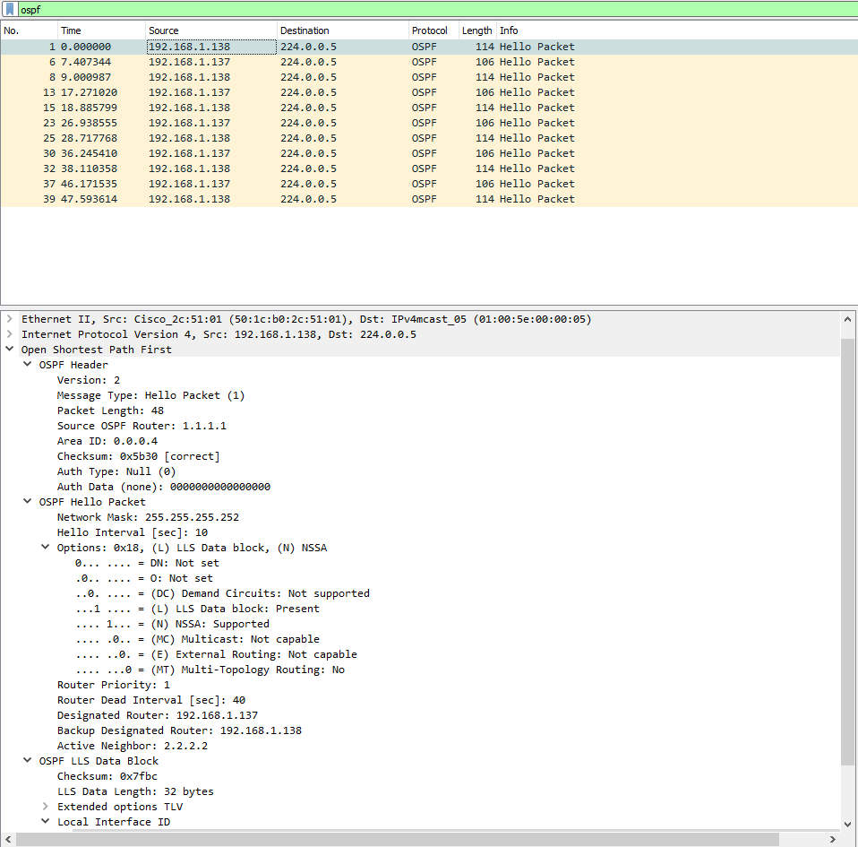

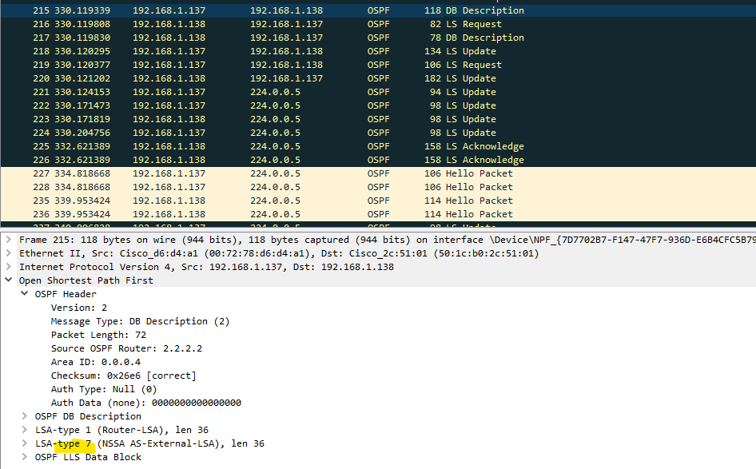

OSPF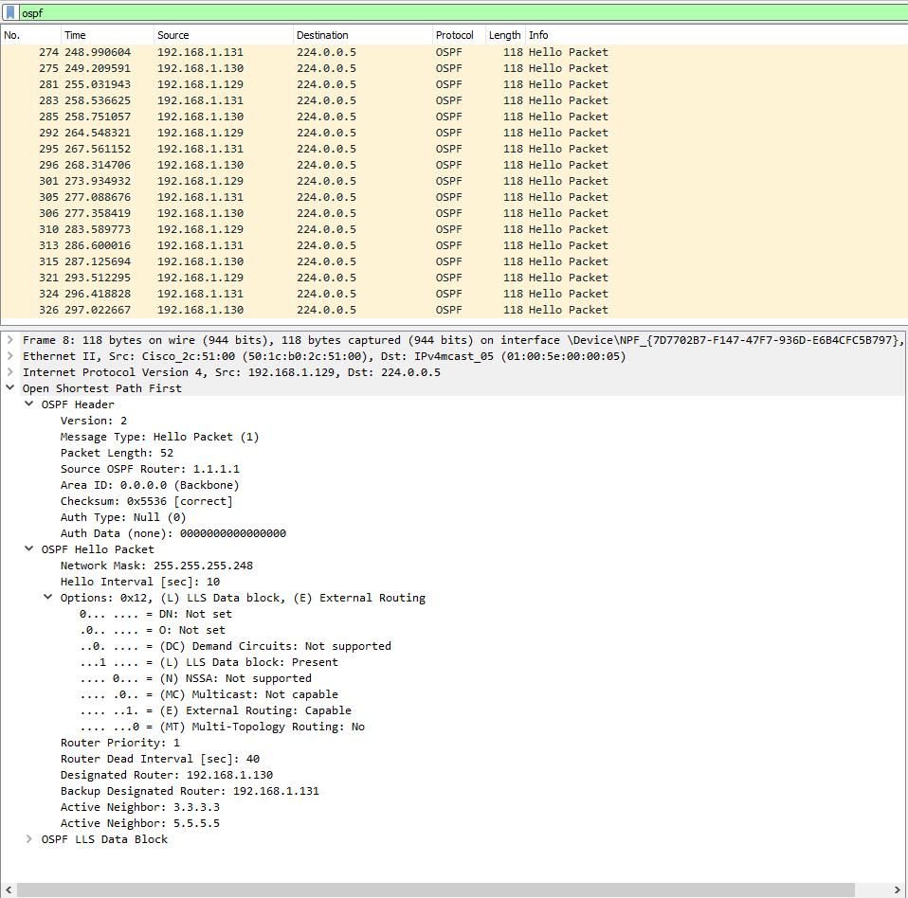

Stub

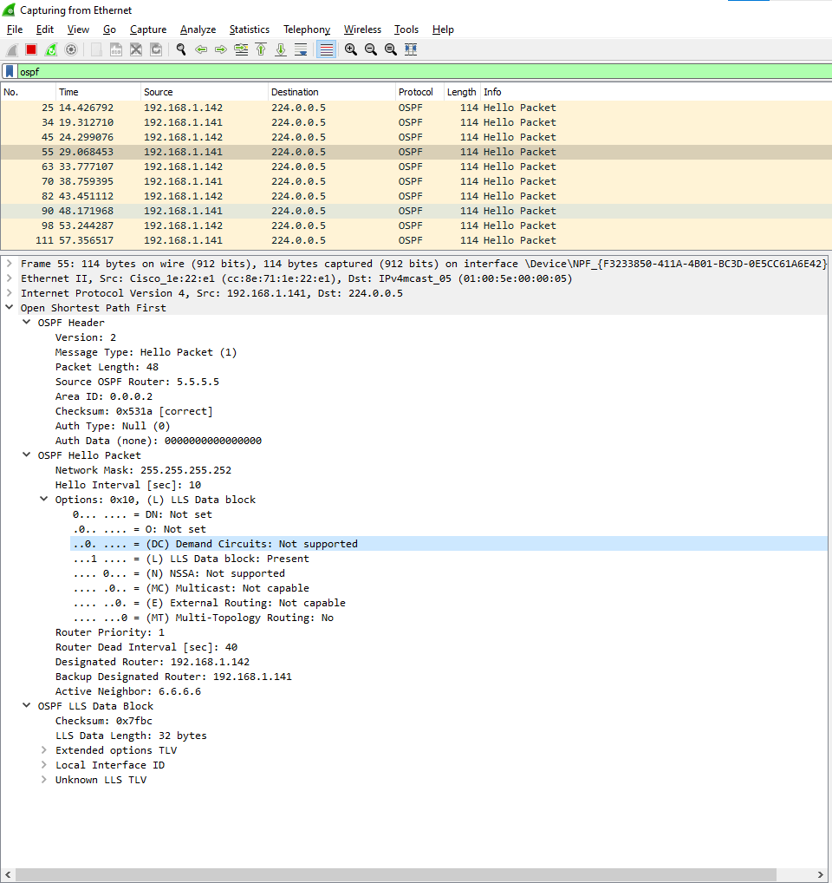

TSA

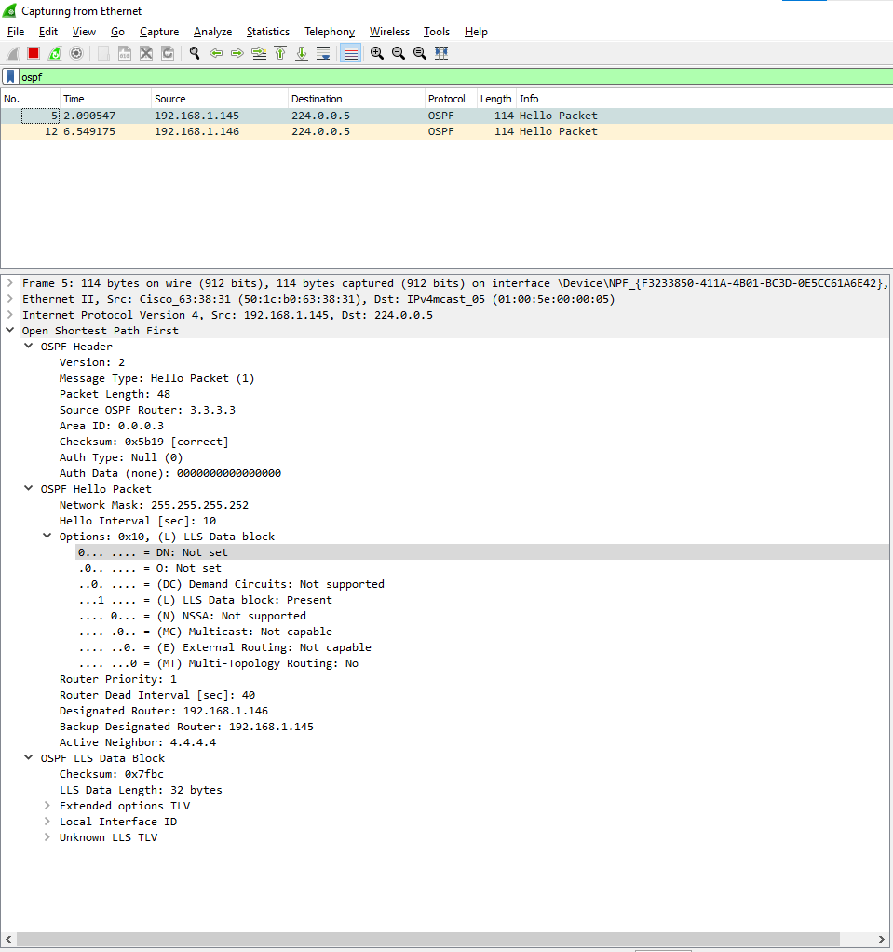

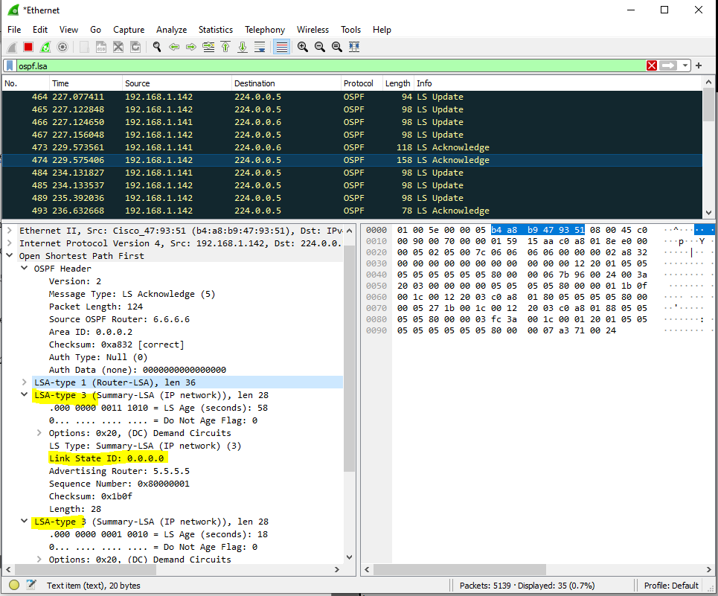

**Problems:**

* Rack console port non-functional
  + Found the issue behind the rack and fixed it
* Multiple router process ID
  + We thought it was necessary to connect 2 differnce special areas but researched more and found it is unesscessary.
    - Fixed by removing from config and keeping required config
* No external route for NSSA to advertise
  + Added loopback interface IP to advertise.
* Struggled to view LSA packets on network capture program
  + Assumed there was an issue in the router config. After trial and error with different commands to no result we looked into the switch.
    - Added session monitor commands to switch to capture traffic

**Conclusion:**

Even though we had many issues with this lab we managed to make the lab successful and capture traffic through Wireshark. We watched a couple videos to understand what we were attempting to do and to learn the concepts. Now we know what the different special areas of OSPF do and the best-case scenarios use of them. We also learned the configs to set up every special area with the requirements and restrictions that come with them. Learning how to better overview all traffic on a network is very crucial so researching how to do that was most likely my biggest takeaway from this lab.

