INDEX

|  |  |  |
| --- | --- | --- |
| S.no | TOPIC | Page  No. |
| 1. | Tool information | 4 |
| 2. | Introduction | 9 |
| 3. | Scope of the system | 10 |
| 4. | Analysis | 11 |
| 5. | Requirement of Software and Hardware | 13 |
| 6. | System Design | 16 |
| 7. | Input and Output Design | 21 |
| 8. | Advantages and limitations | 30 |
| 9. | Future Enhancement | 30 |
| 10. | Bibliography | 31 |

PROJECT PROFILE

Project Title : E-Learning Platform

Front End Tool : HTML,CSS,JavaScript

Back End Tool : PHP,MYSQL

Platform Utilized : Windows

Project Team Size : Solo

Prepared By : Mod Rajkumar

Guide By : Vishal Langaliya

Submitted By : **SSR COLLEGE OF ARTS, COMMERCE AND SCIENCE.**

ACKNOWLEDGEMENT

# I am over helmed in all humbleness and gratefulness to acknowledge my depth to all those who have helped me to put these ideas,wella above the level of simplicity and into something concrete.

# I would like to express my special thanks of gratitude to my teacher as well as our principal who gave me the golden opportunity to do this wonderful project on the topic (E-Learning Platform), which also helped me in doing a lot of Research and I came to know about so many new thing. I am raaly thankful to them.

# 

**Mod Rajkumar**

SOFTWARE DEVELOPMENT PLATFORM

*Tools and Technolgies Used :*

HTML

* The extended reach of information and services to customers that the(14F.) Inyernet has enabled, has created a new challenge for the developer.
* The developer should develop a user interface that is distributable, available on multiple platforms and supports a wide range of client environments from handheld wireless devices to high-end workstations.
* So, to maintain a broad reach to client environments and to achieve greatest compatibility with all browsers, this system uses standard HTML.
* Hyper Text Mark-up Language is the standard language for creating documents for the World Wide Web.
* The user interface has been designed in HTML hence can be browsed in any web browser.
* We can format a document for display and add hyperlinkes to other documents.

PHP

* The PHP Hypertext pre-processor is a programming language that allows web developers to create dynamic content that interacts with databases.
* PHP is basically used for developing web-based software applications.
* PHP is powerful enough to be at the core of the biggest blogging system on the web. PHP file contain text,HTML,CSS,JavaScript and PHP code.

* PHP code is executed on the server and the result is returned to the browser as plain HTML.
* PHP can generate dynamic page content.PHP can create,open,read.delete and close file on server.
* PHP can send and receive cookies.PHP can encrypt data.
* With PHP you are not limited to output HTML.
* You can also output any text,such as XHTML and XML.PHP runs on various platforms like windows, UNIX, Linux, Mac OS, X.PHP is compatible with almost all servers used today.

**JavaScript**

* JavaScript is a scripting language used to enable programmatic access to objects within other applications.It was developed by Brendan Eich.
* It is primarily used in the form of client-side javascript for the development of dynamic websites.
* JavaScript is a dialect of the ECMA Script standard and is characterized as a dynamic, weakly typed, prototype-based language with first-class function.
* JavaScript was influenced by many Languages and was designed to look like java,but be easier for non-programmers to work with.
* JavaScript, despite the name, is essentially unrelated to the Java programming language even though the two do have superficial similarities.
* Both language use syntaxes influenced by that of C syntax,and Javscript copies many java names and naming conventions.
* The key design principles within JavaScript are inherited from the self and Scheme programming languages.
* The language’s name is the result of a co-marketinf deal between Netscape and Sun,in exchange for Nestscape bundling Sun’s Java runtime with their then-dominant browser.
* “JavaScript” is a trademark of Sun Microsystems. It was used under license for technology invented and implemented by Netscape Communications and current entities such as the Mozilla Foundation.

**CSS**

* These have been used to separate data from presentation.
* By using these style sheets throughout the project, a uniform look and feel can be maintained for all the HTML elements and tags that have been used in the project.
* If there is any revamp the way the content has been presented in the website, the changes can be made to the appropriate style sheet,which will be reflected across all the style sheets.

**MySQL**

* MySQL is a high-preformance, multiuser relational database management system for database driven software applications.
* Designed around three fundamental principles-speed, stability and ease of use, and freely available under the DNU (General Public License). MySQL has been dubbed the world’s most popular open-sourse database by its parent company,MySQL AB.
* Today, MySQL is available for a wide variety of platforms, including Linux, MacOS and Windows.

**PREFACE**

There is a project work as a subject in B.B.A(C.A) Sem. 4 syllabus. The main purpose of this project is to get practical as well as theoretical knowledge in any IT firm or in any organization.

Project helps a student in growing in the direction of practical implementation of any system. The project checks the patience and working ability of the student and helps in achieving a very important thing is experience.

During this project work I tried my level best to be the professionals and also tried to realize the fact that I am capable enough to face challenges.

I studied lots of documents online for the reference to my project. This is my pleasure to present this project work as our subject.

I learned a lot by doing this project.

**INTRODUCTION**

As we know that the education cost is increasing day by day in India and the middle class students can’t afford the high education. We understand that not everyone has the time or resources to pursue traditional education That’s why I create an E-Learning platform ( learningGO ) That offers free online courses to help students for achieve learning goals. With our user friendly interface and expertly curated content, you can learn at your own pace, anytime and anywhere.

This application will help you to learn in structure and sequential way.Here first you learn level by level and then you can test your knowledge through our Test feature. We have a note feature, where student can make own notes.

**BACKGROUND**

In today’s growing world very few students learn through a books and That is very confusing and slow process. This method is helped equally but to learn fast

e-learning method is very useful. In learning we provide content in level by level and explain in a easy way through images and graphs makes the application worthy to use.

My project is being built by HTML, CSS, JS, PHP and MYSQL.

**OBJECTIVES**

The objective behind building this application is very simple nut very useful. This application can be a blessing whose earnings are less but wanted to learn new Technology and skills at very low cost or free. This application providing access to education for anyone, regardless of their financial situation or geographic location.

**SCOPE**

This application fall in the category of education sector and the scope is to educat lot of student. According to recent research reports, the demand of global E-Learning Market size & share is expected to reach to USD 374.3 Billion by 2026. If we provide a good and quality content then we can generate revenue through selling a course at very low cost.

**# REQUIREMENT & ANALYSIS**

**PROBLEM DEFINITION**

* Entering in the details about the E-Learning, users, categories etc. tracking the database is complicated when the details are maintained manually. This makes the maintenance of schedule erroneous

.

**Limitation:**

* It is time consuming
* Some time it leads to wrong information
* It consumes lot of men power to better results
* Percentage of accuracy is less

**REQUIREMENT SPECIFICATION**

* The system that is going to be developed is E-Learning Platform (learningGO).
* This is an online learning platform that is to be used by the users as a student to learn new skills at the same time to check the knowledge and makes the notes and enjoy the services it provides at zero cost.

This project intends to computerize the learning system in online form in order to improve the quality of education.

**APPLICABILITY**

This E-Learning application project in PHP focuses mainly on dealing with each student learning. Also, the application displays all the available courses. In addition, the system allows to make notes and test feature. In overview of this web application, user can simply register for their own personal account. Meaning, each user will have their own personal learning records.

After the login process user can shoose a particular course or technology which want to user learn. After that, the system presents all content in form of levels.so that student can learn level by level. After the completing all levels the system provide test feature to check the learning level.

Available Features:

* Personal user panel
* Courses in structure way
* Test
* Notes making

**Requirement of Software and Hardware**

* Software and hardware are needed for the development and implememnt of our project.
* There are following hardware is required for this website.

|  |  |
| --- | --- |
| Processor | 2.0 Ghz or more |
| RAM | 1GB or more |
| Hard Disk | 500GB or more |

* There are following software is required for this application.

|  |  |
| --- | --- |
| Front End | HTML,CSS,JavaScript |
| Back End | PHP,MYSQL |

* **Preliminary Production Description :**

HTML : For website design.

CSS : For website design.

Figma : For UI design.

PHP : For code and Database Integration.

MYSQL : For Database.

JavaScript : For Validations.

PLANNING & SCHEDULING

* **Project Planning:**

|  |  |  |
| --- | --- | --- |
| Activities |  | Time Duration |
| Requirement Gathering |  | 1 week |
| Design |  | 2 weeks |
| Development & Coding |  | 1 week |
| Quality Assurance |  | 2 weeks |
| Testing & Implementation |  | 1 week |

**SYSTEM DESIGN USING DESIGNING TOOLS**

* **Data Flow Diagrams (DFD)**

A data flow diagram (DFD) is a graphical representation of the “flow” of data through an information system, modelling its process aspects. Often, they are a preliminary step used to create an overview of the system which can later be elaborated. DFDs can also be used for the visualization of data processing.

* **0 or Context Level DFD :**

User

E-Learning

Platform

(learningGO)

Response

Request

Register

* **1st Level DFD (User) :**

Login

User

Choose

Course

Test

Make

Notes

Logout

* **2nd Level DFD (User) :**

**User**

**2.0**

**Login**

**1.0**

**Register**

**Tb1 users**

**2.0.4**

**Edit profile**

*jhfhfhfh*

**2.0.3**

**Make Notes**

*jhfhfhfh*

**2.0.2**

**Test**

*jhfhfhfh*

**2.0.1**

**Choose level**

*jhfhfhfh*

**

* **ER-Diagraam :**

Register

User

Login

Home page

DATA DICTIONARY

Table Name : Users

Table Description : This table can store user data which are helpful for User to login into the system.

Database of sign up page :

|  |  |  |  |  |
| --- | --- | --- | --- | --- |
| Sr. No. | Column Name | Data Type | Size | Constraints |
| 1. | E-mail | Varchar | 11 | Primary key |
| 2. | First name | Varchar | 25 | Not null |
| 3. | Last name | Varchar | 25 | Not null |
| 4. | password | Varchar | 50 | Not null |
| 5. | Phone no. | int | 12 | Not null |

Database of sign in page :

|  |  |  |  |  |
| --- | --- | --- | --- | --- |
| Sr. No. | Column Name | Data Type | Size | Constraints |
| 1. | E-mail | Varchar | 11 | Primary key |
| 2. | Password | Varchar | 50 | Not null |

**INPUT & OUTPUT DESIGN**

**USER**

**Screen Name** : User Login

**Screen Purpose** : User needs to enter into the system.

Screen Shot :

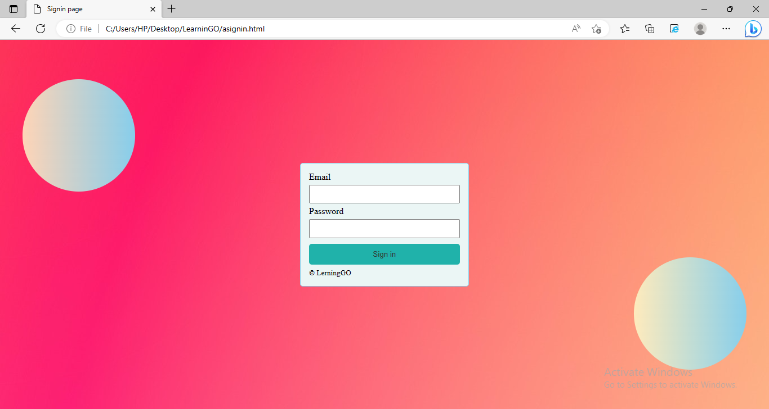

**Screen Name** : User Registration

**Screen Purpose** : User needs to register themselves by Entering first name, last name, email, password for registering and login into the system.

Screen Shot :

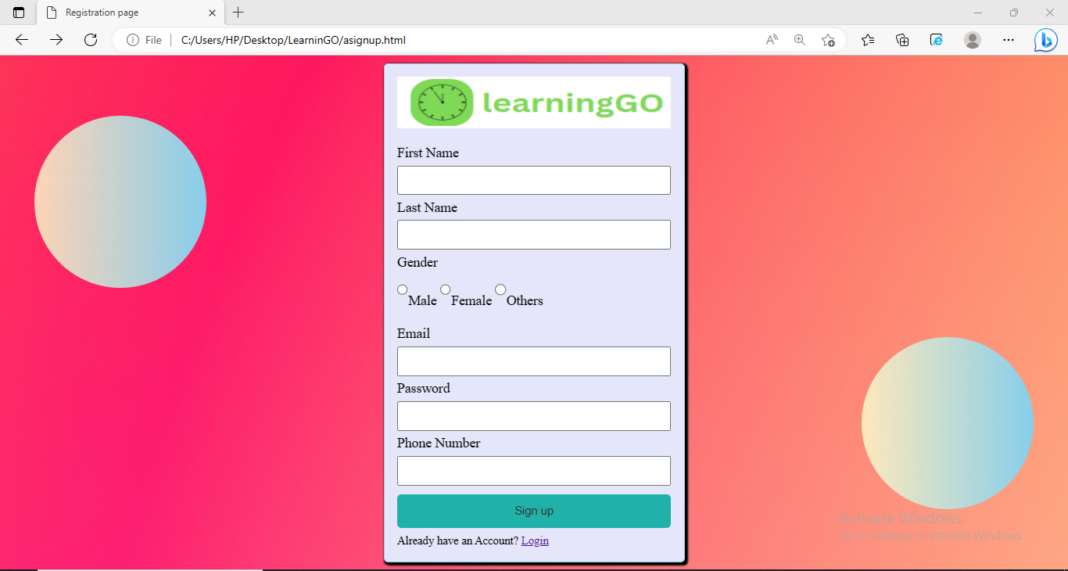

**Screen Name** : Home Page

**Screen Purpose :** Display all the features of website.

Screen Shot :

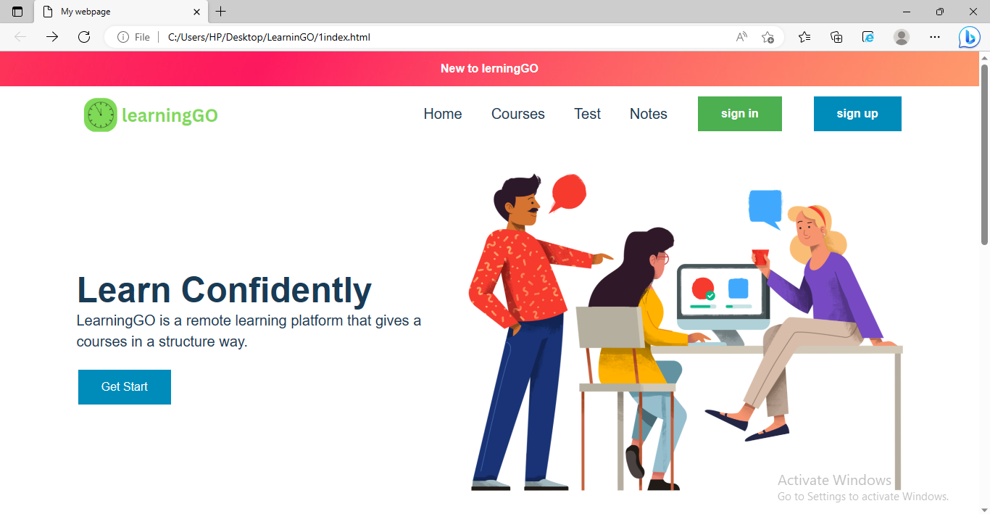

**Screen Name** : Courses Page

**Screen Purpose :** To display all the courses and select the course by the user.

Screen shot :

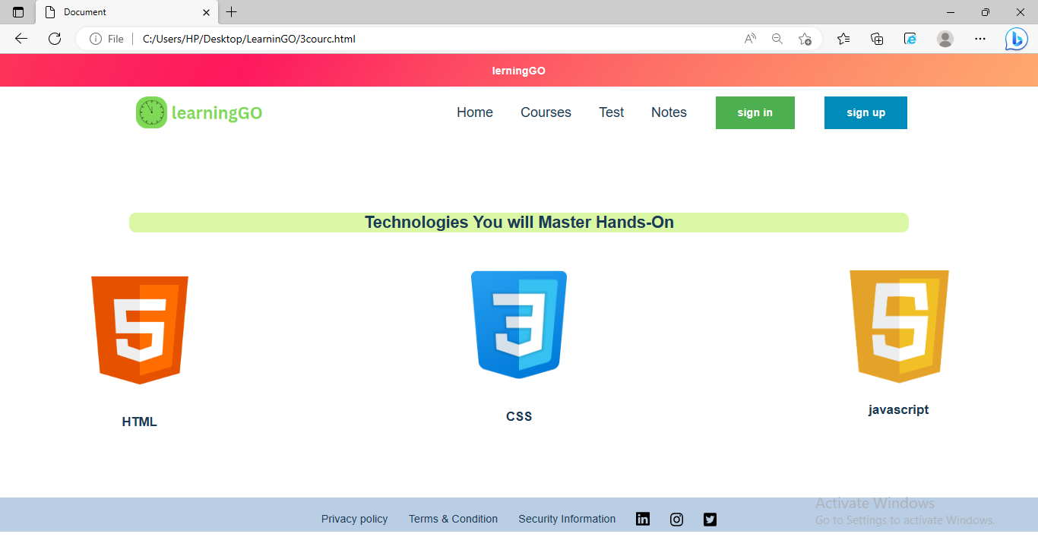

**Screen Name** : Test Page

**Screen Purpose :** To check the knowledge of student.

Screen shot :

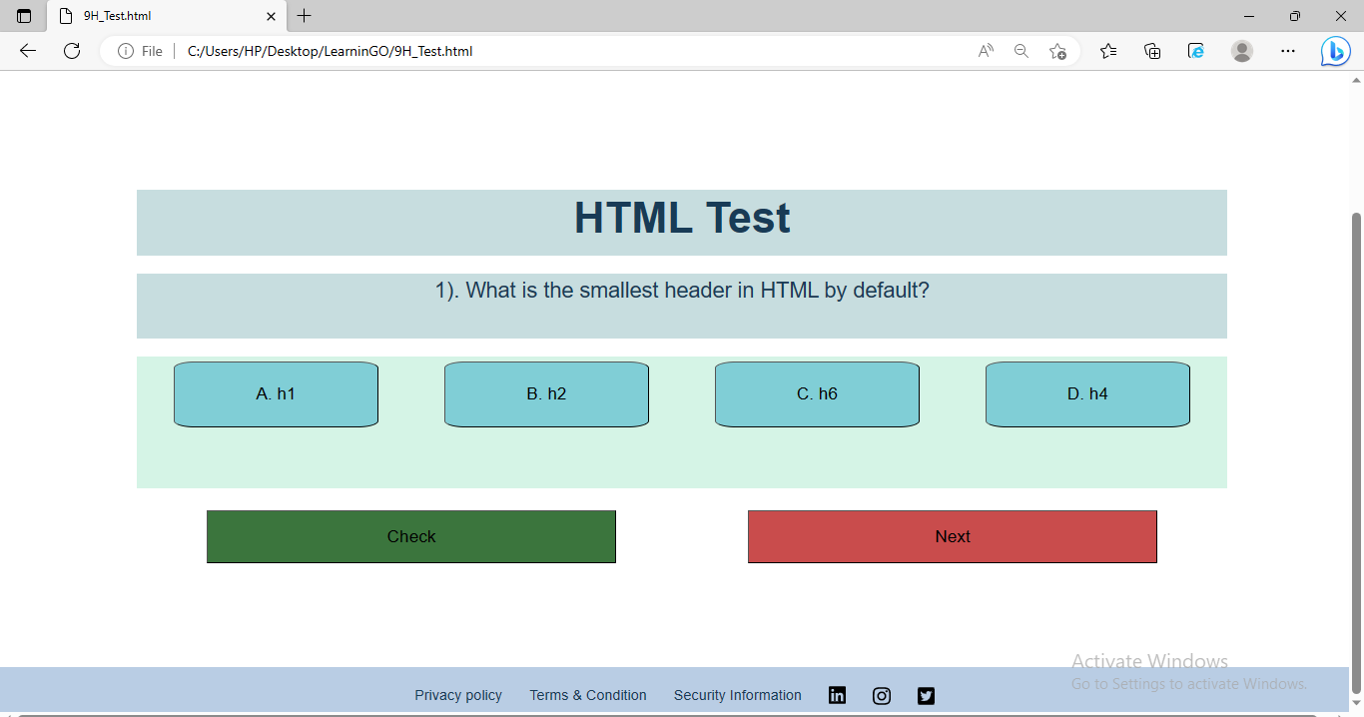

**Screen Name** : Note Page

**Screen Purpose :** To make a notes.

Screen shot :

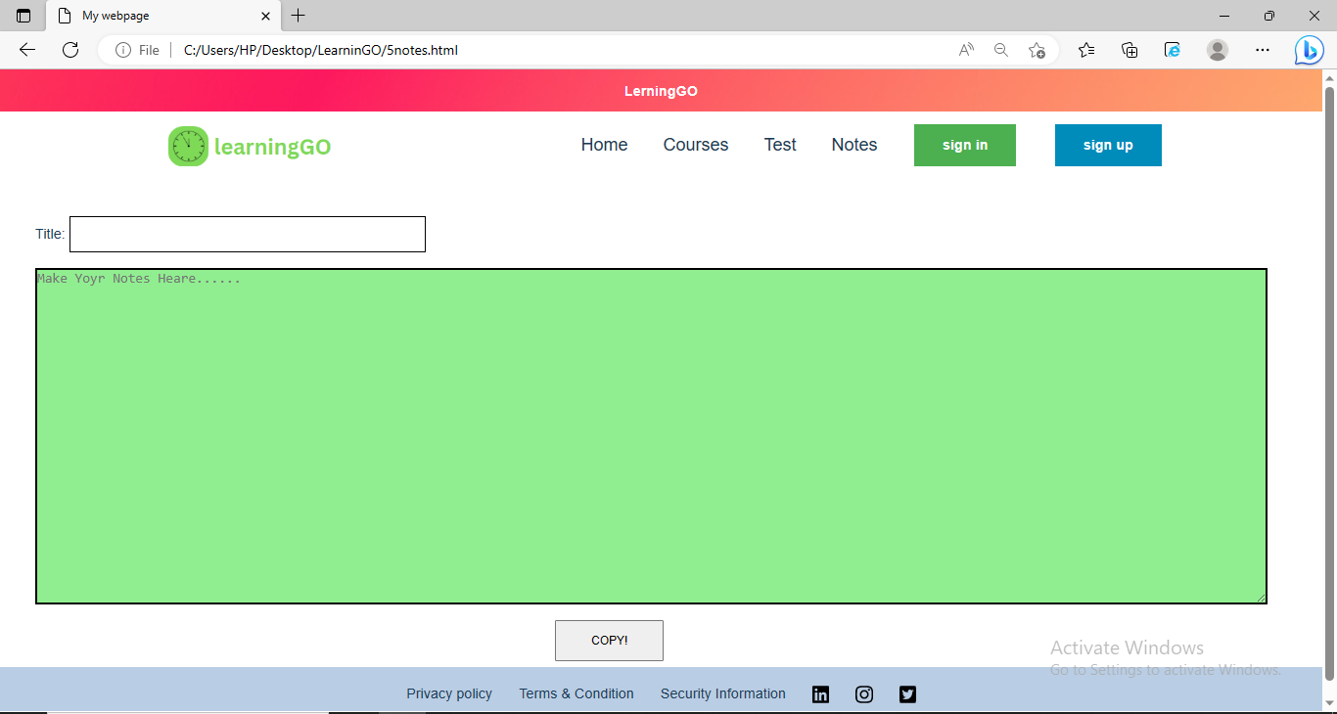

**TESTING & IMPLIMENTATION**

Testing is a process in which the system is run on manually creates input so that the system is correctly working as desire or not. Testing is basically some stage represents.

* **Black box testing :**
* “The black box testing without having knowledge of interior working of the application is called black box testing.”
* Black box testing also known as closed box testing.
* The tester is oblivious to the system architecture and does not have access to the source code.
* A tester will interact with the system’s user interface by providing input and examining output without knowing how and where the inputs are working upon.
* There are some characteristics:
* Functionality
* Requirements, use, standard
* Correctness
* Business forms, documents

* **White box testing :**
* White box testing is the detailed investigation of internal logic and structure of the code.
* White box testing is also know as clear box testing and open box testing.
* The tester needs to have a look inside the source code and fined out which unit/chunk of the code is behaving inappropriately.
* As the tester has knowledge of the source code, it becomes very easy to find out which type of data can help in testing the application effectively.
* There are some characteristics :
* Module design
* Implementation
* Verify each software unit interface correctly

**TEST CASE**

* A test case is a document, which has a set of test data, preconditions, expected results and post conditions, developed for particular test scenario in order to verify compliance against a specific requirement.
* The test case acts as the starting point for test execution, and after applying a set of input values, the application has a definitive out come and leaves the system at some end point or also known as execution post condition.
* A test case represents some parameters such as :
* Test case id
* Test case description
* Test steps
* Input test data
* Input data
* Expected result
* Test case is an indispensable component of the software testing life cycle that step validate the application under test.
* Test case for User Login :

|  |  |  |  |  |
| --- | --- | --- | --- | --- |
| **Test Case ID** | **Description** | **Test Steps** | **Input Test Data** | **Input Data** |
| TC1 | Check User Login and password | 1.Enter Valid Login id  2.Enter Valid Password  3.Click on Login button | Correct Login id  & correct password | Login ID:  [c@p.com](mailto:c@p.com)  Pass:123 |
| TC2 | Check User Login and password | 1.Enter Invalid Login id  2.Enter Valid Password  3.Click on Login button | InCorrect Login id & correct password | Login ID:  Admin10  Pass:india |
| TC3 | Check User Login and password | 1.Enter Valid Login id  2.Enter inValid Password  3.Click on Login button | Correct Login id  & incorrect password | Login ID:  [ck@p.com](mailto:ck@p.com)  Pass:456 |

**LIMITATION OF SYSTEM**

* The limitations of this application are listed below :

1. There are very limited function in the system.
2. Mobile app is need to be developed.
3. Email address cannot be updated.
4. If user forgets the email or password, then account recovery is not possible.
5. There are limited courses available.

**FUTURE SCOPE OF THE SYSTEM**

As opposed to my current development, a few more functionalities can be added to further expand the project.

* First of all more courses can be add.
* Inbuild code Runner and compiler can be add.
* Provide a readymade notes for download in pdf format.
* Gaming format for learning.
* We can provide a feature that user also can add content.

**BIBLIOGRAPHY**

References :

* **Web Resources**
* [www.google.com](http://www.google.com)
* [www.w3schools.com](http://www.w3schools.com)
* [www.GeeksforGeeks.com](http://www.GeeksforGeeks.com)
* [www.icons8.com](http://www.icons8.com)
* [www.wikipedia.com](http://www.wikipedia.com)
* **Books :**

1. Web technologies - 1

**THANK YOU**