- INTRODUCTION
Today Firewalls have become the staple of network security architectures, primarily providing access control to network resources, and they have been successfully deployed in the large majority of the networks like government organization and individual users. Firewall and Intrusion Detection (IDS) are adopted more frequently. Network attacks a crucial element in providing networks with the reliability required in today's competitive environment. However, while most firewalls provide effective access control, many are not designed to detect an attacks at the application level. Many methods have been developed to secure the network infrastructure and communication over the Internet, among them the use of firewalls, encryption, decryption and virtual private networks. Intrusion detection is a relatively new addition to such techniques. Intrusion detection system started appearing in the last few years. Using intrusion detection system, you can collect and use information from known types of attacks and find out if someone is trying to attack your network or particular hosts. The information collected can be used to hardening your network security, and legal purposes.

INTRUSION detection as defined by the Sys Admin, Audit, Networking, and Security (SANS) Institute is the art of detecting inappropriate, inaccurate, or anomalous activity. Today, intrusion detection is one of the high priority and challenging tasks for network administrators and security professionals. More sophisticated security tools mean that the attackers come up with newer and more advanced penetration methods to defeat the installed security systems and . Thus, there is a need to safeguard the networks from known vulnerabilities and at the same time take steps to detect new and unseen, but possible, system abuses by developing more reliable and efficient intrusion detection systems. Any intrusion detection system has some inherent requirements. Its prime purpose is to detect as many attacks as possible with minimum number of false alarms, i.e., the system must be accurate in detecting attacks.

1.1. VARIOUS INTRUSION DETECTION SYSTEMS (IDS)
IDS inspect all inbound and outbound network activity and identify suspicious patterns that may indicate a network or system attack from someone attempting to break into or to compromise a system. An intrusion detection system monitors network traffic and monitors for suspicious activity and alerts the system or network administrator. In some cases the IDS may also respond to anomalous or malicious traffic by taking action such as blocking the user or source IP address from accessing the network [12]. There are different types of IDS but we follow the signature based IDS. Most intrusion detection systems (IDS) are what are known as signature-based. This means that they operate in much the same way as a virus scanner, by searching for a known identity or a signature for each specific intrusion event. And, while signature-based IDS is very efficient at sniffing out known attacks, like anti-virus software, depend on receiving regular signature updates, to keep in touch with variations in hacker’s techniques. In other words, signature-based IDS is only as good as its database of stored signatures.
There are so many types of IDS mechanisms:
- Network intrusion detection system (NIDS).
- Host-based intrusion detection system (HIDS).
- Protocol-based IDS(PIDS).
- Application protocol-based intrusion detection system (APIDS).
1.1.1. Network IDS
NIDS are intrusion detection systems that capture data packets travelling on the network media (cables, wireless)and match them to a database of signatures. Depending upon whether a packet is matched with an intruder signature, an alert is generated or the packet is logged to a file or database. One major use of Snort is as a NIDS30].

1.1.2. Host IDS or HIDS
Host-based intrusion detection systems or HIDS are installed as agents on a host. These intrusion detection systems can look into system and application log files to detect any intruder activity.
Some of these systems are reactive, meaning that they inform you only when something has happened. Some HIDS are proactive; they can sniff the network traffic coming to a particular host on which the HIDS is installed and alert you in real time[ HYPERLINK \l "Bry" 26 ]. Additionally, intrusion detection systems can also be classified as signature based or anomaly based depending upon the attack detection method.
1.1.3. Anomaly based IDS
Anomaly based IDS detects computer intrusions by monitoring system activity and classifying it is either normal or anomalous. It attempts to characterize abnormal behavior, and tries to detect any deviation from normal behavior. The advantage of anomaly based detection is a relatively high detection rate for new types of intrusions.
1.1.4. Signature Based IDS
Signature based system will check packet firstly and it compare with the database signature.
Other method is used for the detection of attack on the network hybrid system because it contains both approach signature base and anomaly base system. Another approach for detecting intrusions is to consider both the normal and the known anomalous patterns for training a system and then performing classification on the test data. Such a system incorporates the advantages of both the signature-based and the anomaly-based systems and is known as the Hybrid System.
Hybrid systems can be very efficient, subject to the classification method used, and can also be used to label unseen or new instances as they assign one of the known classes to every test instance. This is possible because during training the system learns features from all the classes .The only concern with the hybrid method is the availability of labelled data.
However, data requirement is also a concern for the signature- and the anomaly-based systems as they require completely anomalous and attack free data, respectively, which are not easy to detect.

1.1.5. Application protocol based IDS
Application protocol based IDS normally sit between group of services/processes monitors and analyze the behaviour and state of application protocol in use by the system between two connected devices.
The rest of this paper is organized as follows: It describe the use of Conditional Random Fields (CRFs) for intrusion detection and the Layered Approach. We then describe how to integrate the Layered Approach and the CRFs; we give our experimental results and compare the proposed method with other approaches that are known to perform well. Further observe that the proposed system, Layered CRFs, performs significantly better than other systems.
1.2. Functions of IDS
Intrusion Detection System performs variety of functions
- Monitoring and analysis for user and system activity.
- Auditing of system configurations and vulnerabilities.
- Assessing the integrity of critical system and data files.
- Recognition of activity patterns reflecting known attacks.

- PROBLEM STATEMENT
2.1. Existing System
The field of intrusion detection and network security has been around since late1980s. Since then, a number of methods and frameworks have been proposed and many systems have been built to detect intrusions.
Various techniques such as association rules, clustering, naive Bayes classifier, support vector machines, genetic algorithms, artificial neural networks, and others have been applied to detect intrusions. In this section, we briefly discuss these techniques and frameworks. Experimental results on the benchmark KDD ’99 intrusion data set show that our proposed system based on Layered Conditional Random Fields outperforms other well-known methods such as the decision trees and the naive Bayes.
2.1.1 ISSUES IN EXISTING INTRUSION DETECTION SYSTEML:
1) The problems of detection in High-speed network environment. The current network speeds of data transmission have exceeded the computing detection speed. Detection system will miss some of the network data packets, which result in omission so as to influence the system's accuracy and effectiveness.
2) Attack means update fast and become more diverse, complex and intelligent. Existing real-time intrusion detection system has not enough capacity to detect the covert and complex attacks in technically, which will result in omit and false positive behaviour problems. Currently, this is the biggest problem that Intrusion Detection System facing.
3) Expansibility problem-Including time and space expansibility, for the intrusion behaviours that have large time span and under distributed environment, mature solutions are still lacking today.
4) Lots of flooding data from all sources and system messages, etc. are often not very good and timely handled, which waste and reduce the processing power of intrusion detection systems and detection performance.

5) The complexity of anomaly detection, due to the inherently dynamic nature of computer networks, is major disadvantage of anomaly detection, as well as their high false alarm rate because of the entire scope of the behaviour of an information system may not be covered during the learning phase.
2.2. Proposed system
Other approaches for detecting intrusion include the use of autonomous and probabilistic agents for intrusion detection. These methods are generally aimed at developing a distributed intrusion detection system.
To overcome the weakness of a single intrusion detection system, a number of frameworks have been proposed, which describe the collaborative use of network-based and host based systems.
Systems that employ both signature based and behavior-based techniques are discussed in the authors describe a data mining framework for building adaptive intrusion detection models.
The data analyzed by the intrusion detection system for classification often has a number of features that are highly correlated and complex relationships exist between them.
When classifying network connections as either normal or as attack, a system may consider features such as “logged in” and “number of file creations.” When these features are analyzed individually, they do not provide any information that can aid in detecting attacks.
However, when these features are analyzed together, they can provide meaningful information, which can be helpful for the classification task.
2.2.1 INTEGRATING LAYERED APPROACH WITH CONDITIONAL RANDOM FIELD
We now describe the Layer-based Intrusion Detection System (LIDS) in detail. The LIDS draws its motivation from what we call as the Airport Security model, where a number of security checks are performed one after the other in a sequence.
Similar to this model, the LIDS represents a sequential Layered Approach and is based on ensuring availability, confidentiality, and integrity of data and (or) services over a network.
Advantages of using proposed system:
- The goal of using a layered model is to reduce computation and the overall time required to detect anomalous events.
- The time required to detect an intrusive event is significant and can be reduced by eliminating the communication overhead among different layers.
- This can be achieved by making the layers autonomous and self-sufficient to block an attack without the need of a central decision-maker. Every layer in the LIDS framework is trained separately and then deployed sequentially.
- We define four layers that correspond to the four attack groups mentioned in the data set.
- In order to make the layers independent, some features may be present in more than one layer. The layers essentially act as filters that block any anomalous connection, thereby eliminating the need of further processing at subsequent layers enabling quick response to intrusion.
- The effect of such a sequence of layers is that the anomalous events are identified and blocked as soon as they are detected.

- LITERATURE SURVEY
Literature survey is the most important step in software development process. Before developing the tool it is necessary to determine the time factor, economy and company strength. Once these things are satisfied, then next step is to determine which operating system and language can be used for developing the tool. Once the programmers start building the tool the programmers need lot of external support. This support can be obtained from senior programmers, from book or from websites. Before building the system the above consideration are taken into account for developing the proposed system.
3.1 A Detailed Analysis of the KDD CUP 99 Data Set:
During the last decade, anomaly detection has attracted the attention of many researchers to overcome the weakness of signature-based IDSs in detecting novel attacks, and KDDCUP’99 is the mostly widely used data set for the evaluation of these systems. With the enormous growth of computer networks usage and the huge increase in the number of applications running on top of it, network security is becoming increasingly more important. As it is shown in [1], all the computer systems suffer from security vulnerabilities which are both technically difficult and economically costly to be solved by the manufacturers. Therefore, the role of Intrusion Detection Systems (IDSs), as special-purpose devices to detect anomalies and attacks in the network, is becoming more important. The research in the intrusion detection field has been mostly focused on anomaly-based and misuse-based detection techniques for a long time.
While misuse-based detection is generally favoured in commercial products due to its predictability and high accuracy, in academic research anomaly detection is typically conceived as a more powerful method due to its theoretical potential for addressing novel attacks. The first important deficiency in the KDD data set is the huge number of redundant records. Analyzing KDD train and test sets, we found that about 78% and 75% of the records are duplicated in the train and test set, respectively.

This large amount of redundant records in the train set will cause learning algorithms to be biased towards the more frequent records, and thus prevent it from learning unfrequented records which are usually more harmful to networks such as U2R attacks. The existence of these repeated records in the test set, on the other hand, will cause the evaluation results to be biased by the methods which have better detection rates on the frequent records.
3.2 Syntax and Semantics-Based Signature Database for Hybrid Intrusion Detection Systems:
Signature-based intrusion detection systems (IDSs) have the advantages of producing a lower false alarm rate and using less system resources compared to anomaly based systems. However, they are susceptible to obfuscation used by attackers to introduce new variants of the attacks stored in the database. Some of the disadvantages of signature-based IDSs can be attributed to the fact that they are mostly purely syntactic and ignore the semantics of the monitored systems. In this paper, we present the design and implementation of a signature database that assists a Specification-based ID in a converged environment. Our design is novel in terms of considering the semantics of the monitored protocols alongside their syntax[2]. Our protocol semantics awareness is based on the state transition analysis technique which models intrusions at a high level using state transition diagrams. The signature database is hierarchically designed to insure a balance between ease of use and fast retrieval in real time. The database prototype is tested against some implemented attacks and shows promising efficiency.
3.3 Intrusion Detection Using Data Mining Techniques:
Pattern Matching is the simple type of attack detection technique. It has the simple concept of string matching.
Using pattern matching technique, IDSs generally match the text (audit records) or binary sequences against known attack signatures. A pattern matching technique basically looks for a specific attack signature which may be presented in audit record.
The limitation of pattern matching approach is that it can recognize only known attacks.
Statistical modelling is among the earliest methods used for detecting intrusions in electronic information systems. It is assumed that an intruder’s behaviour is noticeably different from that of a normal user, and statistical models are used to aggregate the user’s behaviour and distinguish an attacker from a normal user. The techniques are applicable to other subjects, such as user groups and programs.
Data mining and machine learning methods focus on analyzing the properties of the audit patterns rather than identifying the process which generated them.
Data mining (DM), also called Knowledge-Discovery and Data Mining, is the process of automatically searching large volumes of data for patterns using association rules.
Data mining approaches derive association rules and frequent episodes from available sample data, not from human experts. Using these rules, Lee et. al. developed a data mining framework for the purpose of intrusion detection.
In particular, system usage behaviours are recorded and analyzed to generate rules which can recognize misuse attacks.
The drawback of such frameworks is that they tend to produce a large number of rules and thereby, increase the complexity of the system.
A Bayesian network is a model that encodes probabilistic relationships among variables of interest. This technique is generally used for intrusion detection in combination with statistical schemes, a procedure that yields several advantages, including the capability of encoding interdependencies between variables and of predicting events, as well as the ability to incorporate both prior knowledge and data. However, a serious disadvantage of using Bayesian networks is that their results are similar to those derived from threshold-based systems, while considerably higher computational effort is required.
Support vector map real valued input feature vector to higher dimensional feature space through nonlinear mapping and have been used for detecting intrusions.

The system can provide real-time attack detection capability, deal with large dimensionality of data and perform multi class classification. It do not consider the order of occurrence of events for attack detection.
Markov chains and hidden Markov model is a set of states that are interconnected through certain transition probabilities, which determine the topology and the capabilities of the model. However, modelling system calls alone may not always provide accurate classification as various connection level features are ignored. Further, hidden Markov models cannot model long range dependencies between the observations.

- REQUIREMENTS SPECIFICATION:
Frontend: Java
Swings
RMI
Backend: MS. Access

Swing is a GUI widget toolkit for Java. It is part of Oracle's Java Foundation Classes (JFC) – an API for providing a graphical user interface (GUI) for Java programs.
Swing was developed to provide a more sophisticated set of GUI components than the earlier Abstract Window Toolkit (AWT). Swing provides a native look and feel that emulates the look and feel of several platforms, and also supports a pluggable look and feel that allows applications to have a look and feel unrelated to the underlying platform. It has more powerful and flexible components than AWT. In addition to familiar components such as buttons, check boxes and labels, Swing provides several advanced components such as tabbed panel, scroll panes, trees, tables, and lists.
Unlike AWT components, Swing components are not implemented by platform-specific code. Instead, they are written entirely in Java and therefore are platform-independent. The term "lightweight" is used to describe such an element.
Swing is currently in the process of being replaced by JavaFX.
Java was originally developed by James Gosling at Sun Microsystems (which has since been acquired by Oracle Corporation) and released in 1995 as a core component of Sun Microsystems' Java platform. The language derives much of its syntax from C and C++, but it has fewer low-level facilities than either of them.
Java is a general-purpose computer programming language that is concurrent, class-based, object-oriented, and specifically designed to have as few implementation dependencies as possible. It is intended to let application developers "write once, run anywhere" (WORA), meaning that compiled Java code can run on all platforms that support Java without the need for recompilation.
Java applications are typically compiled to byte code that can run on any Java virtual machine (JVM) regardless of computer architecture. Java is one of the most popular programming languages in particularly for client-server web applications, with a reported 9 million developers.
There were five primary goals in the creation of the Java language
- It must be "simple, object-oriented, and familiar".
- It must be "robust and secure".
- It must be "architecture-neutral and portable".
- It must execute with "high performance".
- It must be "interpreted, threaded, and dynamic".
RemoteMethodInvocation (Java RMI) is a Java API that performs remote method invocation, the object-oriented equivalent of remote procedure calls (RPC), with support for direct transfer of serialized Java classes and distributed garbage collection.
The original implementation depends on Java Virtual Machine (JVM) class representation mechanisms and it thus only supports making calls from one JVM to another. The protocol underlying this Java-only implementation is known as Java Remote Method Protocol (JRMP). In order to support code running in a non-JVM context, a CORBA version was later developed.
Usage of the term RMI may denote solely the programming interface or may signify both the API and JRMP, IIOP, or another implementation, whereas the term RMI-IIOP (read: RMI over IIOP) specifically denotes the RMI interface delegating most of the functionality to the supporting CORBA implementation.
The basic idea of Java RMI, the distributed garbage-collection (DGC) protocol, and much of the architecture underlying the original Sun implementation, come from the 'network objects' feature of Modula-3.
Microsoft Access combines the relational Microsoft Jet Database Engine with a graphical user interface and software-development tools. It is a member of the Microsoft Office suite of applications, included in the Professional and higher editions or sold separately.
Microsoft Access stores data in its own format based on the Access Jet Database Engine. It can also import or link directly to data stored in other applications and databases.
Software developers, data architects and power users can use Microsoft Access to develop application software. Like other Microsoft Office applications, Access is supported by Visual Basic for Applications (VBA), an object-based programming language that can reference a variety of objects including DAO (Data Access Objects), ActiveX Data Objects, and many other ActiveX components. Visual objects used in forms and reports expose their methods and properties in the VBA programming environment, and VBA code modules may declare and call Windows operating system operations.
Usage of The Technologies In The Proposed Project
- Java is being used to implement the modules such a way that it can be accessed on any system (PLATFORM INDEPENDENT).
- Java Data Base Connectivity is used to connect through the database in order to access the data from it where data is stored ensuring that authorized access is done.
- Remote Method Invocation (RMI) is being used for the accessing of the resources through implementing client server environment.

- SYSTEM ANALYSYS
5.1. APPROACHES TO IMPLEMENT IDS
Intrusion detection has been an active field of research for starting in 1980s after the influential paper from Anderson . Several researchers have proposed various intrusion detection methods and frameworks which are available to protect a computer system or network from attacks. Various techniques such as association rules, clustering, Naïve Bayes, Support Vector Machines, Neural Networks, and others have been developed to detect intrusions. This section provides a brief literature review on these technologies and related frameworks. These methods can be broadly divided into three major categories:
5.1.1. Pattern Matching
Pattern Matching is the simple type of attack detection technique. It has the simple concept of string matching. Using pattern matching technique, IDSs generally match the text (audit records) or binary sequences against known attack signatures. A pattern matching technique basically looks for a specific attack signature which may be presented in audit record. The limitation of pattern matching approach is that it can recognize only known attacks.
It requires continuous updates of attack signatures to identify new attacks. Pattern matching approach is well suited for misuse detection. Snort system is based upon pattern matching.
5.1.2. Statistical Methods
Statistical modelling is among the earliest methods used for detecting intrusions in electronic information systems. It is assumed that an intruder’s behaviour is noticeably different from that of a normal user, and statistical models are used to aggregate the user’s behaviour and distinguish an attacker from a normal user.
The techniques are applicable to other subjects, such as user groups and programs. Two statistical models that have been proposed for anomaly detection: NIDES/STAT and Haystack.

5.1.3. Data Mining and Machine Learning
Data mining and machine learning methods focus on analyzing the properties of the audit patterns rather than identifying the process which generated them. These methods include approaches for mining association rules, classification and cluster analysis.
5.1.4. Clustering
For unsupervised intrusion detection, data clustering methods can be applied. These methods involve computing a distance between numeric features and therefore they cannot easily deal with symbolic attributes, resulting in inaccuracy. Addition, clustering methods consider the features independently and are unable to capture the relationship between different features of a single record which results in lower accuracy.
5.1.5. Data Mining
Data mining (DM), also called Knowledge-Discovery and Data Mining, is the process of automatically searching large volumes of data for patterns using association rules. Data mining approaches derive association rules and frequent episodes from available sample data, not from human experts. Using these rules, Lee et. al. developed a data mining framework for the purpose of intrusion detection.
In particular, system usage behaviours are recorded and analyzed to generate rules which can recognize misuse attacks. The drawback of such frameworks is that they tend to produce a large number of rules and thereby, increase the complexity of the system.
5.1.6. Bayesian Classifiers
A Bayesian network is a model that encodes probabilistic relationships among variables of interest.
This technique is generally used for intrusion detection in combination with statistical schemes, a procedure that yields several advantages, including the capability of encoding interdependencies between variables and of predicting events, as well as the ability to incorporate both prior knowledge and data.
However, a serious disadvantage of using Bayesian networks is that their results are similar to those derived from threshold-based systems, while considerably higher computational effort is required.
5.1.7. Decision Trees
Decision trees are one of the most commonly used supervised learning algorithms in IDS due to its simplicity, high detection accuracy and fast adaptation. Decision trees used for intrusion detection select the best features for each decision node during tree construction based on some well-defined criteria . One such criterion is the gain ratio which is used in C4.5.
A decision tree is composed of three basic elements:
- A decision node specifying a test attributes.
- An edge or a branch corresponding to the one of the possible attribute values which means one of the test attribute outcomes.
A leaf which is also named an answer node contains the class to which the object belongs.
5.2. Project description
- Conditional Random Field
The CRFs have proven to be very successful in such tasks, as they do not make any unwarranted assumptions about the data. Hence, we explore the suitability of CRFs for intrusion detection. System may consider features such as “logged in” and “number of file creations.” When these features are analyzed individually, they do not provide any information that can aid in detecting attacks.
However, when these features are analyzed together, they can provide meaningful information, which can be helpful for the classification task.
- Probe layer
The probe attacks are aimed at acquiring information about the target network from a source that is often external to the network.
Hence, basic connection level features such as the “duration of connection” and “source bytes” are significant while features like “number of files creations” and “number of files accessed” are not expected to provide information for detecting probes.
- DoS layer
For the DoS layer, traffic features such as the “percentage of connections having same destination host and same service” and packet level features such as the “source bytes” and “percentage of packets with errors” are significant. To detect DoS attacks, it may not be important to know whether a user is “logged in or not.”
- R2L layer
The R2L attacks are one of the most difficult to detect as they involve the network level and the host level features. We therefore selected both the network level features such as the “duration of connection” and “service requested” and the host level features such as the “number of failed login attempts” among others for detecting R2L attack.
- U2R layer
The U2R attacks involve the semantic details that are very difficult to capture at an early stage. Such attacks are often content based and target an application. Hence, for U2R attacks, we selected features such as “number of file creations” and “number of shell prompts invoked,” while we ignored features such as “protocol” and “source bytes.”
5.3. CHALLENGES AND REQUIREMENT FOR INTRUSION DETECTION SYSTEM
It is important intrusion detection must detect attacks at an early stage in order to minimize their impact. The major challenges and requirements for building intrusion detection systems are:
- The system must be able to detect as many attacks as possible without giving false alarms i.e the system must be accurate in detecting attacks.
- The system must be able to handle large amount of data without affecting performance and without dropping data.
- A system must not only detect an attack, but also able to identify the type of attack.
- A system must be resistant to attacks since, a system that can be exploited during an attack may not be able to detect attacks reliably.
- The challenge is to build a system which is scalable and can be easily customized as per the specific requirements of the environment where it is deployed.
5.4. CONDITIONAL RANDOM FIELDS
5.4.1. Conditional Probability
Conditional probability is used to compute probability of an event Y given some other event X. Formally it is defined as: (𝑌 | 𝑋) = (𝑋 ∩ 𝑌) (𝑋) Where P(X) > 0. From this definition we can read that if the occurrence of the event X takes place in the same space as the event Y, and there are no other events that may act the occurrence of the event Y, then the conditional probability of the occurrence of the event Y given the event X is the relative proportion of outcomes that satisfy Y among those that satisfy X.
5.4.2. Conditional Random Field Framework
Conditional random fields (CRFs) are a probabilistic framework for labeling and segmenting sequential data, based on the conditional approach described in the previous paragraph. A CRF is a form of undirected graphical model that defines a single log-linear distribution over label sequences given a particular observation sequence.
The primary advantage of CRFs over hidden Markov models is their conditional nature, resulting in the relaxation of the independence assumptions required by HMMs in order to ensure tractable inference. Additionally, CRFs avoid the label bias problem , a weakness exhibited by maximum entropy Markov models (MEMMs) and other conditional Markov models based on directed graphical models.
CRFs outperform both MEMMs and HMMs on a number of real-world sequence labelling tasks. CRF was firstly proposed by Lafferty and his colleagues in 2001, whose model idea mainly came from MEMM (Maximum Entropy Markov Model).
The critical difference between CRFs and MEMMs is that a MEMM uses per-state exponential models for the conditional probabilities of next states given the current state, while a CRF has a single exponential model for the joint probability of the entire sequence of labels given the observation sequence.
Therefore, the weights of different features at different states can be traded off against each other. Conditional models are probabilistic systems that are used to model the conditional distribution over a set of random variables. Such models have been extensively used in the natural language processing tasks. Conditional models offer a better framework as they do not make any unwarranted assumptions on the observations and can be used to model rich overlapping features among visible observations.
5.4.3. Inference in CRF
For general graphs, the problem of exact inference in CRFs is intractable. However there exist special cases for which exact inference is feasible: If the graph is a chain or a tree, message passing algorithms yield exact solutions.
The algorithms used in these cases are analogous to the forward-backward and Viterbi algorithm for the case of HMMs. • If the CRF only contains pair-wise potentials and the energy is sub modular, combinatorial min cut/max flow algorithms yield exact solutions.
5.5. Manual Feature choice
Gupta et al. introduced Manual Feature choice (MFS) methodology in paper [11] and their experimental results show that the MFS performs higher in comparison with some normally used automatic feature choice ways like Neural Network and PCA. MFS selects correlate options by analyzing the characteristics of every variety of attacks as follows:

5.5.1. Denial of Service (DoS):
Attacks normally found variety of attacks with many sorts, DoS attacks plan to block access to sure services by flooding them with illegitimate requests.
5.5.2. Probe Attacks:
Attacks kind aim to realize helpful data concerning hosts by scanning the network in numerous modes.
So, basic association level options square measure necessary for Probe attacks.
5.5.3. Remote to native (R2L):
Attacks of this kind decide to gain access to the remote victim machine while not having AN account thereon. This behavior affects the worth of each the network level and also the host level options. The R2L attacks square measure extraordinarily troublesome to observe, most IDSs did not perform well thereon.
5.5.4. User to Root (U2R):
U2R attacks are one among the foremost troublesome attacks to observe. They aim to realize system’s super user privileges. Hence, the U2R attacks involve the small print of lexemes. And that they square measure typically supported the content and also the target application.
5.6. Frame work of stratified approach:
Present networks and enterprises follow a layered defence approach to ensure security at different access levels by using a variety of tools such as network surveillance, perimeter access control, firewalls, network, host and application intrusion detection systems, data encryption and others.
Given this traditional layered approach, only a single system is employed at every layer which is expected to detect attacks at that particular location.
However, with the rapid increase in the number and type of attacks, a single system is not effective enough given the constraints of achieving high attack detection accuracy and high system throughput.
Hence, we propose a layered framework for building intrusion detection systems which can be used, for example, to build a network intrusion detection system which can detect a wide variety of attacks reliably and efficiently when compared to the traditional network intrusion detection systems.
Another advantage of our Layer based Intrusion Detection System (LIDS) framework is that it is very general and easily customizable depending upon the specific requirements of individual networks.
Layered Framework for building intrusion detection systems which can be used, for example, as a network intrusion detection system and can detect a wide variety of attacks reliably and efficiently when compared to the traditional network intrusion detection systems. In our layered framework, we use a number of separately trained and sequentially arranged sub systems in order to decrease the number of false alarms and increase the attack detection coverage.
Layered framework has the following advantages:
1) The framework is customizable and domain specific knowledge can be easily
2) Incorporated to build individual layers which help to improve accuracy.
3) Individual intrusion detection sub systems are light weight and can be trained separately.
4) Different anomaly and hybrid intrusion detectors can be incorporated in our framework.
The goal of using a layered model is to reduce computation and the overall time required to detect anomalous events.
The time required to detect an intrusive event is significant and can be reduced by eliminating the communication overhead among different layers. This can be achieved by making the layers autonomous and self-sufficient to block an attack without the need of a central decision-maker.
Every layer in the LIDS framework is trained separately and then deployed sequentially. We define four layers that correspond to the four attack groups mentioned in the data set.
They are Probe layer, DoS layer, R2L layer, and U2R layer. Each layer is then separately trained with a small set of relevant features. In order to make the layers independent, some features may be present in more than one layer.
The layers essentially act as filters that block any anomalous connection, thereby eliminating the need of further processing at subsequent layers enabling quick response to intrusion.
The effect of such a sequence of layers is that the anomalous events are identified and blocked as soon as they are detected. And the overall time required detecting anomalous events. Use the CRFs that are more accurate, though expensive, but we implement the Layered Approach to improve overall system performance. The performance of our proposed system, Layered CRFs, is comparable to that of the decision trees and the naive Bayes, and our system has higher attack detection accuracy.
5.6.1. WinPcap
As shown in the figure 5.6, the WinPcap software provides facilities to capture raw packets, both the ones destined to the machine where it's running and the ones exchanged by other hosts (on shared media), filter the packets according to user specified rules before dispatching them to the application, transmit raw packets to the network and to gather statistical values on the network traffic.
5.6.2. Preprocessor
As mentioned in the fig 5.6, the preprocessor defines one class called packet and this class will store all the packets that are generated by the WinPcap. It captures all the packets in the Network Interface by using Jpcap captor.
5.6.2. Signature Database
As shown in the fig 5.6, signature database is a specially prepared pattern database. Every incident is analyzed to get a regular expression describing the type of attack attempt. There is lot of signatures in the database for such analysis. We have used signatures of the project Snort because the database is still being developed by the Snort Project Team, so updates are often released. Snort uses a simple [13], lightweight rules description language that is flexible and quite powerful. There are a number of simple guidelines to remember when developing Snort rules. The first is that Snort rules must be completely contained on a single line; the Snort rule parser doesn't know how to handle rules on multiple lines. Snort rules are divided into two logical sections, the rule header and the rule options.
The rule header contains the rule's action, protocol, source and destination IP addresses, net masks, source and destination ports information. The rule option section contains alert messages and information on which parts of the packet should be inspected to determine if the rule action should be taken[14]. Here is an example rule: alert tcp any any -> 192.168.1.0/24 111 (content:"|0001 86 a5|"; msg: "mountd access";)
5.6.3. Detection Engine
As shown in the fig 5.6, detection engine takes packets from preprocessor and compares them with special signatures from the database . Result of the compassion is sent to the output module, where a report is prepared. The detection engine compares the packets in the preprocessor and in the signature database. The comparison takes place at different layers. To compare the content in this paper layered approach algorithm is adapted, considering different attributes at each layer. Finally it would detect whether the packet has any attack or not .

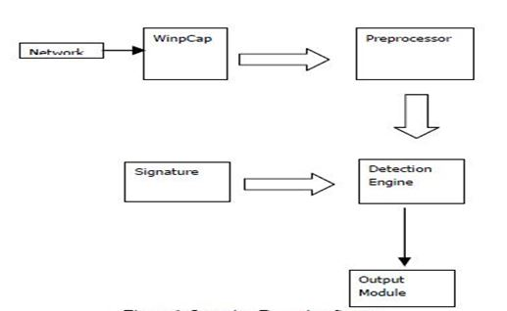
Fig 5.6. Intrusion Detection System is as follows as shown in the above fig .

5.7. BUILDING INDIVIDUAL LAYERS OF THE SYSTEM
Two sets of experiments are performed., From the first experiment, we wish to examine the accuracy of CRFs for intrusion detection. The objective is to see how CRFs compare with other techniques, which are known to perform well. Consider feature selection, and the systems are trained using all the features. From this experiment, it is observed that CRFs perform much better for U2R attacks while the decision trees achieve higher attack detection for Probes and R2L. The difference in attack detection accuracy for DoS is not significant..
Motivates to perform the second experiment where feature selection is performed by selecting a small set of features for every attack group instead of using all the features. The same experiment has to be performed with decision trees and naive Bayes and compare the results.
The integrated models as Layered CRFs, layered decision trees, and layered naïve Bayes, respectively. For better comparison and readability, the results for both the experiments are taken together.
As shown in the fig 5.7, the file is sent from source through destination through passing various layers if the attack is not deteceted while passing of file from source to destination.if the attack is deteceted at particular layer then the file transfer is failed and sent back to source.
Various attacks are being deteceted such as probe attack, DOS attack, R2L aatack, U2R attacks are detected at individual layers.

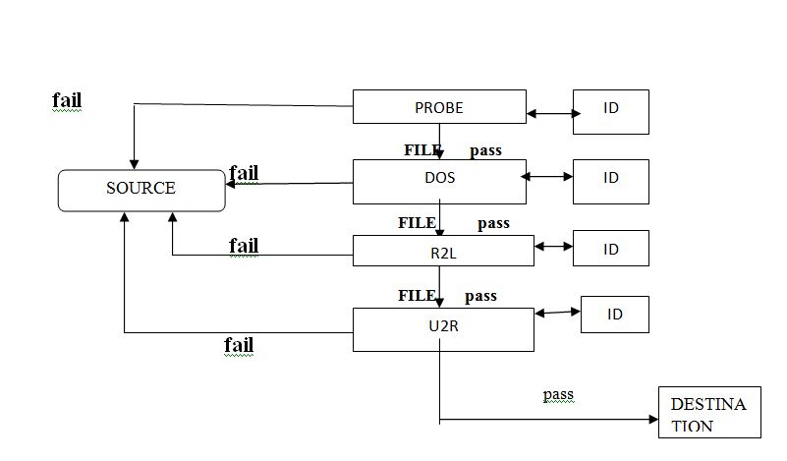
Fig 5.7. Layered Based Approach the file transmission is made through various layers as shown in the above fig 5.7
5.8. Algorithm & Training:
Step 1: Select the number of layers, n, for the complete system.
Step 2: Separately perform features selection for each layer.
Step 3: Train a separate model with CRFs for each layer using the features selected from Step 2.
Step 4: Plug in the trained models sequentially such that only the connections labeled as normal are passed to the next layer. Testing
Step 5: For each (next) test instance perform Steps 6 through 9.
Step 6: Test the instance and label it either as attack or normal.
Step 7: If the instance is labeled as attack, block it and identify it as an attack represented by the layer name at which it is detected and go to Step 5. Else pass the sequence to the next layer.
Step 8: If the current layer is not the last layer in the system, test the instance and go to Step 7. Else go to Step 9.
Step 9: Test the instance and label it either as normal or as an attack. If the instance is labeled as an attack, block it and identify it as an attack corresponding to the layer name.
Final goal is to improve both the attack detection accuracy and the efficiency of the system. Hence, integrate the CRFs and the Layered Approach to build a single system. Experiments are performed and show that the integrated system has dual advantage. First, as expected, the efficiency of the system increases significantly. Second, selection of significant features for each layer, the accuracy of the system further increases. This is because all the 41 features are not required for detecting attacks belonging to a particular attack group. Using more features than required can result in fitting irregularities in the data, which has a negative effect on the attack detection accuracy of the system.

- SYSTEM DESIGN
6.1. Data Flow Diagrams
The DFD is also called as bubble chart. It is a simple graphical formalism that can be used to represent a system in terms of the input data to the system, various processing carried out on these data, and the output data is generated by the system.
DFD LEVEL 0:
As shown in the fig 6.1.1 , various components are taken in to consideration such as probe layer, DOS layer, R2L layer, U2R layer, Message log .The file is to be transferred from server to client .At each layer the corresponding functionalities are invoked and whenever the intruder is detected through unauthorised login the process is being killed .The file is transferred successfully if the attack is normal.

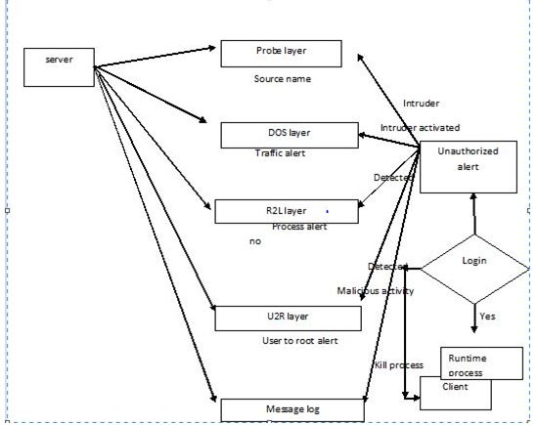
Fig 6.1.1. The sequence of activities done at the initial stage as shown in the above fig .

DFD LEVEL 1
As shown in the fig 6.1.2, various components are taken in to consideration such as probe layer, DOS layer, R2L layer, U2R layer, Message log .The file is to be transferred from server to client .At each layer the corresponding functionalities are invoked and whenever the intruder is detected through unauthorised login the process is being killed .The file is transferred successfully if the attack is normal.

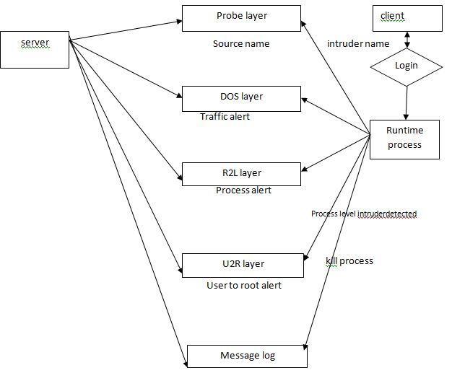

Fig 6.1.2. The sequence of activities done at the first stage as shown in the above fig.

DFD LEVEL 2
As shown in the fig 6.1.3, various components are taken in to consideration such as probe layer, DOS layer, R2L layer, U2R layer, Message log .The file is to be transferred from server to client .At each layer the corresponding functionalities are invoked and whenever the intruder is detected through unauthorised login the process is being killed .The file is transferred successfully if the attack is normal.

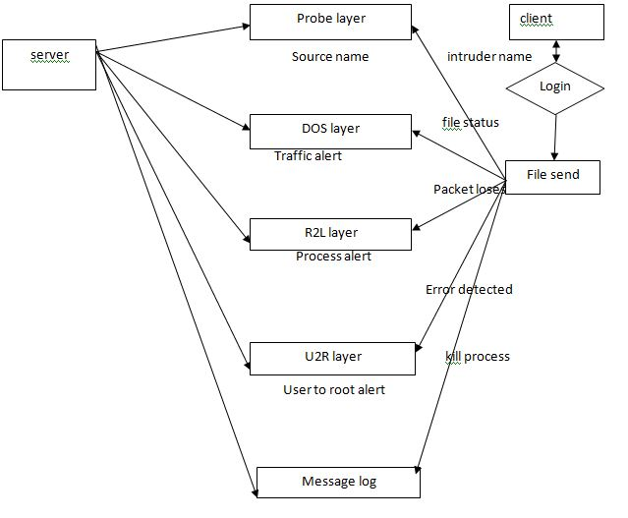

Fig 6.1.3. The sequence of activities done at the second stage as shown in the above fig.

6.2. UML DIAGRAMS
6.2.1 Use case Diagram
As shown in the fig 6.2.1, various actions done on both server and client side such as intruder name and file selection, unauthorised user detected, malicious packet loss, error detected, process killed alert sent is mentioned in the use cases which are invoked at each layer.

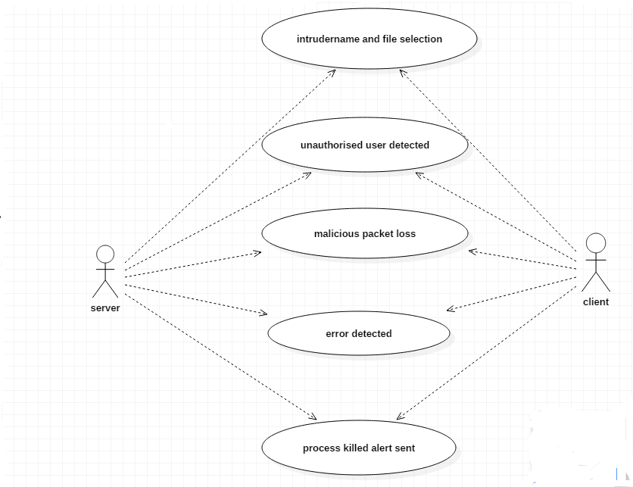
Fig 6.2.1. The sequence of activities done is mentioned in the Usecase as shown in the above fig.

6.2.2. Sequence Diagram
As shown in the fig 6.2.2, various actions done on both server and client side such as intruder name and file selection, unauthorised user detected, malicious packet loss, error detected, process killed alert sent is mentioned in the sequence through focus of control which are invoked at each layers such as probe layer, DOS layer, R2L layer, U2R layer.

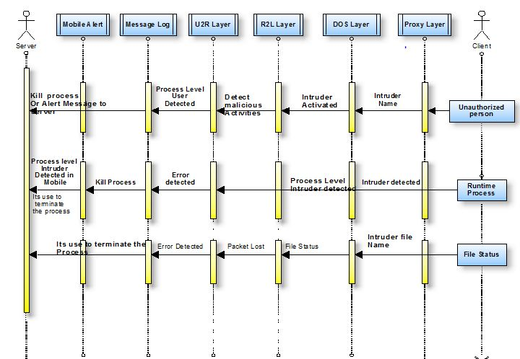

Fig 6.2.2 The sequence of activities done is mentioned as shown in the above fig.

- IMPLEMENTATION
For implementing our project we use following:
- Java as the platform for the project. Java is object oriented programming language. The object model in java is simple and easy to extend. It also have extra features like simplicity, security, robustness, portability etc.
- Rational rose is the tool which we have used for drawing UML diagrams for our project.
- JDBC (Java Database Connectivity) through which JSP pages can be connected to the database for storing, extracting, deleting, viewing the data contents. A JDBC API defines interfaces and classes for writing database applications in java by making database connections.
- Swing is a set of classes that provides more powerful and flexible components like tabbed panes, scroll panes, tables, trees.
- Swing components are written entirely in java and are platform independent.
- A program running on one machine invokes a method belonging to an object whose execution is performed on other machine through using Remote Method Invocation.
EmServer.java
The functionality of this file is how the server connection is being established in order to accept the client requests for accessing their essential resources.
MinWin.java
The layered approach is used to differentiate the attacks when file is sent after being logged in.
MyInterface.java
To get connection and get the IP address of connected interface in order to send the packet through authorized agent and whether to add host or not.

MyServerImpl. Java
To detect the unauthorized alert through the alarm warning when the intruders is detected and deny the permission.
NewUser. Java
In order to add the new agent.
Packet. Java
To send the packets then number of packets sent along with size and give warning message whether the process status completed or not.
User. Java
To login with the user along with the details.

Source Code

Logged.java

import java.awt.*;
import java.io.*;
import javax.swing.filechooser.FileSystemView;
import java.util.StringTokenizer;
import java.net.InetAddress;
import java.rmi.Naming;
import java.util.Date;
import java.util.Vector;
import java.util.Random;
import javax.swing.*;
import javax.swing.ImageIcon;

public class Logged extends javax.swing.JFrame {
Vector v= new Vector(2);
String sss=null;
/** Creates new form Logged */
public Logged() {
initComponents();
v.addElement(new String("Logged.java"));
v.addElement(new String("MinWin.java"));
listres.setListData(v);

}

private void initComponents() {//GEN-BEGIN:initComponents

jPanel1 = new javax.swing.JPanel();
listres = new javax.swing.JList();
jLabel1 = new javax.swing.JLabel();
download = new javax.swing.JButton();
resArea = new TextArea();
save = new javax.swing.JButton();
getContentPane().setLayout(null);
addWindowListener(new java.awt.event.WindowAdapter() {
public void windowClosing(java.awt.event.WindowEvent evt) {
exitForm(evt);
}
});

jPanel1.setLayout(null);

jPanel1.setBorder(new javax.swing.border.EtchedBorder());
listres.setBorder(newjavax.swing.border.SoftBevelBorder(javax.swing.border.BevelBorder.LOWERED));
jPanel1.add(listres);
listres.setBounds(10, 60, 150, 220);

jLabel1.setBackground(new Color(155,244,244));
jLabel1.setFont(new java.awt.Font("Arial", 0, 15));
jLabel1.setText("Resources Available:");
jPanel1.add(jLabel1);
jLabel1.setBounds(10, 10, 180, 40);

download.setBackground(new java.awt.Color(204, 204, 254));
download.setFont(new java.awt.Font("Arial", 0, 15));
download.setText("Download..");
download.addActionListener(new java.awt.event.ActionListener() {
public void actionPerformed(java.awt.event.ActionEvent evt) {
downloadActionPerformed(evt);
}
});

jPanel1.add(download);
download.setBounds(180, 60, 110, 27);

getContentPane().add(jPanel1);
jPanel1.setBounds(20, 30, 340, 300);

// resArea.setBorder(new javax.swing.border.EtchedBorder());
getContentPane().add(resArea);
resArea.setBounds(20, 400, 540, 200);

save.setBackground(new java.awt.Color(204, 204, 254));
save.setFont(new java.awt.Font("Arial", 0, 15));
save.setText("Save");
save.addActionListener(new java.awt.event.ActionListener() {
public void actionPerformed(java.awt.event.ActionEvent evt) {
saveActionPerformed(evt);
}
});
getContentPane().add(save);
save.setBounds(570, 400, 70, 27);
pack();
}//GEN-END:initComponents
private void saveActionPerformed(java.awt.event.ActionEvent evt) {//GEN-FIRST:event_saveActionPerformed
// TODO add your handling code here:
try {
FileDialog fd=new FileDialog(this,"File Store", FileDialog.SAVE);
fd.setVisible(true);
String f= fd.getFile();
fd.setFile(f); // Filename filter
fd.setDirectory("."); // Current directory
fd.show();
FileOutputStream out=new FileOutputStream(f);
String s=resArea.getText();
byte b[]=s.getBytes();
out.write(b);
} catch(Exception e){}
}//GEN-LAST:event_saveActionPerformed
private void downloadActionPerformed(java.awt.event.ActionEvent evt) {//GEN-FIRST:event_downloadActionPerformed
// TODO add your handling code here:
sss=(String)listres.getSelectedValue();
System.out.println(sss);
int ch=0;
try{

File file = new File(sss);
FileInputStream in = new FileInputStream(file);
int i = in.available();
char st[]=new char[i];
int j =0;
while((ch=in.read())!=-1) {
st[j] = (char) ch;
j++;
}
String str=new String(st);
resArea.setText(str);

} catch(Exception e) { System.out.println(e); }

}//GEN-LAST:event_downloadActionPerformed

/** Exit the Application */
private void exitForm(java.awt.event.WindowEvent evt) {//GEN-FIRST:event_exitForm
System.exit(0);
}//GEN-LAST:event_exitForm

/**
* @param args the command line arguments
*/
public static void main(String args[]) {
new Logged().show();
}

// Variables declaration - do not modify//GEN-BEGIN:variables
private javax.swing.JButton download;
private javax.swing.JLabel jLabel1;
private javax.swing.JPanel jPanel1;
private javax.swing.JList listres;
private java.awt.TextArea resArea;
private javax.swing.JButton save;
// End of variables declaration//GEN-END:variables

}

Minwin.java
import java.awt.*;
import java.awt.event.*;
import java.io.*;
import java.rmi.Naming;
import java.util.EventObject;
import javax.swing.*;
import javax.swing.border.*;

class MinWin extends JFrame
implements MouseListener, ActionListener
{

static JList hostname;
static JList status;
static JList action;
static JList warning;
static JList message;
static JList agent;
static JList message1;
static JList agentfunc;
static JList hostname1;
static String filesel = "";
static String filesel1 = "";
static String un;
static String unpa;
JLabel l1;
JLabel l2;
JLabel l3;
JLabel l4;
JLabel l5;
JLabel l6;
JLabel l7;
JLabel l8;
JLabel agfun;
JLabel l9;
JLabel l10;
JLabel l11;
JLabel l12;
static JButton b1;
static JButton date;
static JButton time;
static JButton b4;
static JButton b5;
static JButton b6;
static JButton b7;
JMenuBar mbar;
JMenu file;
JMenuItem filenew;
JMenuItem fileexit;
JMenuItem fileagent;
JMenuItem fileback;
JScrollPane scrollPane;
JScrollPane scrollPane1;
JScrollPane scrollPane2;
JScrollPane scrollPane3;
JScrollPane scrollPane4;
JScrollPane scrollPane5;
JScrollPane scrollPane6;
JScrollPane scrollPane7;
JScrollPane scrollPane8;
JPanel jp =null;
JOptionPane op;
String totalmem;
String freemem;
String threadcount;
String activename;
String osname;
String osarch;
String username;

JButton butCancel;
JButton butOk;
JLabel jLabel10;
JLabel jLabel11;
JLabel jLabel12;
JLabel jLabel13;
JLabel jLabel7;
JLabel jLabel8;
JLabel jLabel9;
JPanel jPanel3;
JPanel jpNewUser;
JTextField txtAdd;
JTextField txtAge;
JTextField txtGender;
JTextField txtName;
JTextField txtPh;
JTextField txtUser;

public MinWin()
{
totalmem = "";
freemem = "";
threadcount = "";
activename = "";
osname = "";
osarch = "";
username = "";
op = new JOptionPane();
un = un;
unpa = unpa;
jp=new JPanel();
jp.setLayout(null);
jp.setBackground(new Color

(150,120,200));

getContentPane().setLayout(null);
l7 = new JLabel(new ImageIcon

("login.gif"));
l7.setBounds(0, 0, 800, 1000);
getContentPane().add(l7);
l7.setVisible(true);
l1 = new JLabel("Layered Approach

Using Conditional Random Fields for Intrusion

Detection");
l1.setBounds(20, 10, 800, 30);
l1.setFont(new Font("Arial", 1, 20));
l1.setForeground(new Color

(255,255,255));
l7.add(l1);
l2 = new JLabel("Probe Layer:");
l2.setBounds(40, 40, 100, 25);
l2.setForeground(new Color

(155,244,244));
l7.add(l2);
l3 = new JLabel("DoS layer:");
l3.setBounds(40, 150, 100, 25);
l3.setForeground(new Color

(155,244,244));
l7.add(l3);
l4 = new JLabel("R2L layer:");
l4.setBounds(40, 245, 100, 25);
l4.setForeground(new Color

(155,244,244));
l7.add(l4);
l5 = new JLabel("U2R layer:");
l5.setBounds(40, 335, 100, 25);
l5.setForeground(new Color

(155,244,244));
l7.add(l5);
l6 = new JLabel("Message Log: ");
l6.setBounds(40, 430, 100, 25);
l6.setForeground(new Color

(155,244,244));
l7.add(l6);
time = new JButton();
time.setBounds(700, 530, 95, 23);
getContentPane().add(time);
date = new JButton();
date.setBounds(600, 530, 100, 23);
getContentPane().add(date);
b1 = new JButton();
b1.setBounds(3, 530, 600, 23);
getContentPane().add(b1);
//Time time1 = new Time();
b4 = new JButton("clear");
b4.setBounds(650, 190, 75, 25);
l7.add(b4);
b4.addActionListener(this);
b5 = new JButton("clear");
b5.setBounds(650, 280, 75, 25);
l7.add(b5);
b5.addActionListener(this);
b6 = new JButton("clear");
b6.setBounds(650, 375, 75, 25);
l7.add(b6);
b6.addActionListener(this);
b7 = new JButton("Store");
b7.setBounds(650, 470, 75, 25);
l7.add(b7);
b7.addActionListener(this);
hostname = new JList();
scrollPane = new JScrollPane

(hostname);
scrollPane.setBounds(40, 70, 600, 70);
l7.add(scrollPane);
hostname.addMouseListener(this);
status = new JList();
scrollPane2 = new JScrollPane(status);
scrollPane2.setBounds(40, 170, 600,

70);
l7.add(scrollPane2);
action = new JList();
scrollPane1 = new JScrollPane(action);
scrollPane1.setBounds(40, 265, 600,

70);
l7.add(scrollPane1);
warning = new JList();
scrollPane3 = new JScrollPane

(warning);
scrollPane3.setBounds(40, 355, 600,

70);
l7.add(scrollPane3);
message = new JList();
scrollPane4 = new JScrollPane

(message);
scrollPane4.setBounds(40, 450, 600,

70);
l7.add(scrollPane4);
mbar = new JMenuBar();
setJMenuBar(mbar);
file = new JMenu("File");
filenew = new JMenuItem("NewUser");
fileagent = new JMenuItem("Agent");
fileback = new JMenuItem("Back");
fileexit = new JMenuItem("Exit");
file.add(filenew);
file.add(fileagent);
file.add(fileback);
file.add(fileexit);
mbar.add(file);
fileexit.addActionListener(this);
filenew.addActionListener(this);
fileagent.addActionListener(this);
fileback.addActionListener(this);
agfun = new JLabel(new ImageIcon

("login.gif"));
agfun.setBounds(0, 0, 800, 530);
getContentPane().add(agfun);
agfun.setVisible(false);
l8 = new JLabel("Layered Approach Using Conditional Random Fields for Intrusion Detection");
l8.setBounds(20, 10, 850, 30);
l8.setFont(new Font("Arial", 1, 20));
l8.setForeground(new Color(255,255,255));
agfun.add(l8);
hostname1 = new JList();
scrollPane8 = new JScrollPane

(hostname1);
scrollPane8.setBounds(40, 70, 300, 120);
agfun.add(scrollPane8);
hostname.addMouseListener(this);
String as[] = {
"User Level Agent", "Packet Level

Agent"
};

agent = new JList(as);
scrollPane5 = new JScrollPane(agent);
scrollPane5.setBounds(40, 230, 300, 120);
agfun.add(scrollPane5);
agent.setSelectedIndex(0);
agent.addMouseListener(this);

agentfunc = new JList();
scrollPane6 = new JScrollPane

(agentfunc);
scrollPane6.setBounds(40, 400, 300, 120);
agfun.add(scrollPane6);

agentfunc.addMouseListener(this);
message1 = new JList();
scrollPane7 = new JScrollPane(message1);
scrollPane7.setBounds(450, 70, 300, 450);
agfun.add(scrollPane7);
message1.addMouseListener(this);

l9 = new JLabel("Probe Layer:");
l9.setBounds(40, 40, 100, 25);
l9.setForeground(new Color(155,244,244));
agfun.add(l9);
l10 = new JLabel("DoS Layer:");
l10.setBounds(40, 200, 100, 25);
l10.setForeground(new Color(155,244,244));
agfun.add(l10);
l11 = new JLabel("R2L Layer:");
l11.setBounds(40, 360, 100, 25);
l11.setForeground(new Color(155,244,244));
agfun.add(l11);
l12 = new JLabel("Message From U2R Layer:");
l12.setBounds(450, 40, 180, 25);
l12.setForeground(new Color

(155,244,244));
agfun.add(l12);

getContentPane().add(jp);
jp.setBounds(0, 0, 800, 530);

// **********************************************
jpNewUser = new JPanel();
jLabel7 = new JLabel();
jPanel3 = new JPanel();
jLabel8 = new JLabel();
txtName = new JTextField();
jLabel9 = new JLabel();
txtAge = new JTextField();
jLabel10 = new JLabel();
txtGender = new JTextField();
jLabel11 = new JLabel();
txtAdd = new JTextField();
jLabel12 = new JLabel();
txtPh = new JTextField();
jLabel13 = new JLabel();
txtUser = new JTextField();
butOk = new JButton();
butCancel = new JButton();

//********************************************

*********************

jpNewUser.setLayout(null);

jpNewUser.setBackground(new

java.awt.Color(150,120,200));
jpNewUser.setPreferredSize(new

java.awt.Dimension(900, 580));
jLabel7.setFont(new java.awt.Font

("Arial", 1, 20));
jLabel7.setForeground(new

java.awt.Color(255,255,255));
jLabel7.setText("Layered Approach Using Conditional Random Fields for Intrusion Detection");
jpNewUser.add(jLabel7);
jLabel7.setBounds(20, 10, 800, 30);

jPanel3.setLayout(null);

jPanel3.setBackground(new java.awt.Color(20, 10, 30));
jPanel3.setBorder(new EtchedBorder());
jLabel8.setFont(new java.awt.Font("Arial", 1, 14));
jLabel8.setForeground(new java.awt.Color(0, 0, 255));
jLabel8.setText("Name:");
jPanel3.add(jLabel8);
jLabel8.setBounds(20, 20, 70, 30);

jPanel3.add(txtName);
txtName.setBounds(150, 20, 110, 21);

jLabel9.setFont(new java.awt.Font("Arial", 1, 14));
jLabel9.setForeground(new java.awt.Color(0, 0, 255));
jLabel9.setText("Age:");
jPanel3.add(jLabel9);
jLabel9.setBounds(20, 60, 70, 30);

jPanel3.add(txtAge);
txtAge.setBounds(150, 60, 110, 21);

jLabel10.setFont(new java.awt.Font("Arial", 1, 14));
jLabel10.setForeground(new java.awt.Color(0, 0, 255));
jLabel10.setText("Gender:");
jPanel3.add(jLabel10);
jLabel10.setBounds(20, 100, 70, 30);

jPanel3.add(txtGender);
txtGender.setBounds(150, 100, 110, 21);

jLabel11.setFont(new java.awt.Font("Arial", 1, 14));
jLabel11.setForeground(new

java.awt.Color(0, 0, 255));
jLabel11.setText("Address:");
jPanel3.add(jLabel11);
jLabel11.setBounds(20, 140, 70, 30);

jPanel3.add(txtAdd);
txtAdd.setBounds(150, 140, 110, 21);

jLabel12.setFont(new java.awt.Font

("Arial", 1, 14));
jLabel12.setForeground(new

java.awt.Color(0, 0, 255));
jLabel12.setText("Phone No:");
jPanel3.add(jLabel12);
jLabel12.setBounds(20, 180, 80, 30);

jPanel3.add(txtPh);
txtPh.setBounds(150, 180, 110, 21);

jLabel13.setFont(new java.awt.Font("Arial", 1, 14));
jLabel13.setForeground(new java.awt.Color(0, 0, 255));
jLabel13.setText("User Character:");
jPanel3.add(jLabel13);
jLabel13.setBounds(20, 220, 120, 30);

jPanel3.add(txtUser);
txtUser.setBounds(150, 220, 110, 21);

butOk.setBackground(new

java.awt.Color(153, 0, 0));
butOk.setFont(new java.awt.Font("Arial", 1, 13));
butOk.setForeground(new java.awt.Color(255, 255, 204));
butOk.setText("OK");
butOk.addActionListener(new

java.awt.event.ActionListener() {
public void actionPerformed

(java.awt.event.ActionEvent evt) {
butOkActionPerformed(evt);
}
});

jPanel3.add(butOk);
butOk.setBounds(50, 300, 90, 25);

butCancel.setBackground(new java.awt.Color(153, 0, 0));
butCancel.setFont(new java.awt.Font("Arial", 1, 13));
butCancel.setForeground(new java.awt.Color(255, 255, 204));
butCancel.setText("Cancel");
butCancel.addActionListener(new

java.awt.event.ActionListener() {
public void actionPerformed

(java.awt.event.ActionEvent evt) {
butCancelActionPerformed(evt);
}
});

jPanel3.add(butCancel);
butCancel.setBounds(170, 300, 80, 25);

jpNewUser.add(jPanel3);
jPanel3.setBounds(210, 110, 320, 370);

getContentPane().add(jpNewUser);
jpNewUser.setBounds(0, 0, 800, 580);
jpNewUser.setVisible(false);

//********************************************

***************

}

public String getTheString(File file1)
{
String s = "";
try
{
FileInputStream fileinputstream = new FileInputStream(file1);
boolean flag = false;
int i;
while((i = fileinputstream.read()) != -1)
{
String s1 = String.valueOf

((char)i);
s = s + s1;
}
}
catch(Exception exception) { }
return s;
}

public void actionPerformed(ActionEvent

actionevent)
{
if(actionevent.getSource() == fileagent)
{
agfun.setVisible(true);
l7.setVisible(false);
}
if(actionevent.getSource() ==

fileexit)
{
System.exit(0);
}
if(actionevent.getSource() == fileback)
{
l7.setVisible(true);
agfun.setVisible(false);
}
////////////////////////
if(actionevent.getSource() == filenew)
{
System.out.println("filenew");

//jpNewUser.setVisible(true);
//agfun.setVisible(false);
//jp.setVisible(false);

NewUser uu= new NewUser();

uu.setSize(800,580);
uu.show();
uu.setTitle(" New User ");

}

//////////////////////////
if(actionevent.getSource() == b4)
{
String as[] = {
""
};
status.setListData(as);
}
if(actionevent.getSource() == b5)
{
String as1[] = {
""
};
warning.setListData(as1);
}
if(actionevent.getSource() == b6)
{
String as2[] = {
""
};
action.setListData(as2);
}
if(actionevent.getSource() == b7)
{
try
{
File file1 = new File("LOG.doc");
FileOutputStream fileoutputstream = new FileOutputStream("LOG.doc",true);
ListModel listmodel = message.getModel();
String as3[] = new String

[listmodel.getSize()];
for(int i = 0; i <

listmodel.getSize(); i++)
{
as3[i] = listmodel.getElementAt(i).toString();
byte abyte0[] = (as3[i] + "\n").getBytes();
fileoutputstream.write(abyte0, (int)file1.length(), as3[i].length());
}

String as4[] = {
""
};
message.setListData(as4);
}
catch(Exception exception)
{
System.out.println(exception);
}
}
}

void butOkActionPerformed

(java.awt.event.ActionEvent evt) {//GEN-FIRST:event_butOkActionPerformed
// TODO add your handling code here:
}//GEN-LAST:event_butOkActionPerformed

void butCancelActionPerformed

(java.awt.event.ActionEvent evt) {//GEN-FIRST:event_butCancelActionPerformed
// TODO add your handling code here:
}//GEN-LAST:event_butCancelActionPerformed

public void mouseClicked(MouseEvent

mouseevent)
{
if(mouseevent.getSource() == hostname1 && mouseevent.getClickCount() == 1)
{
filesel = hostname1.getSelectedValue().toString();
}
if(mouseevent.getSource() == agentfunc)
{
try
{
if(mouseevent.getClickCount()== 1 && agentfunc.getSelectedValue().equals("Kill"))
{
try
{
String aa[] = {"It is used to terminate the

process .","Then it will send the report to

the server"};
message1.setListData(aa);
// System.out.println

("localhost/MyServerImpl1");
// MyInterface1

myinterface1 = (MyInterface1)Naming.lookup

("localhost/MyServerImpl1");
// System.out.println

(myinterface1);
// myinterface1.alpha

();
}
catch(Exception exception)
{
System.out.println

(exception);
}
}
//////////////////
if(mouseevent.getClickCount() == 1 && agentfunc.getSelectedValue().equals("Alert"))
{
try
{
String aa[] =

{"ghsdgfhgsdjgfsdghfgdshgfhsdgfsdfhi","hello"}

;
message1.setListData(aa);
// System.out.println

("localhost/MyServerImpl1");
// MyInterface1 myinterface1 = (MyInterface1)Naming.lookup

("localhost/MyServerImpl1");
// System.out.println(myinterface1);
// myinterface1.alpha

();
}
catch(Exception exception)
{
System.out.println(exception);
} } }
catch(Exception exception1)
{
System.out.println

(exception1);
}
}
if(mouseevent.getSource() == agent)
{
message.clearSelection();
if(agent.getSelectedValue

().equals("User Level Agent"))
{
String as[] = { "" };
message1.setListData(as);
String as1[] = { "Kill", "Alert"
};
agentfunc.setListData(as1);
}

if(mouseevent.getSource()==agentfunc)
{
System.out.println("ffgdfgdfgdfggffdggggg");

if(agentfunc.getSelectedValue().equals("Kill")){

String aa[] = {"hi","hello"};
message.setListData(aa);
}
}
}
}

public void mousePressed(MouseEvent

mouseevent)
{
}

public void mouseReleased(MouseEvent

mouseevent)
{
}

public void mouseExited(MouseEvent

mouseevent)
{
}

public void mouseEntered(MouseEvent

mouseevent)
{
}

public int myoptionpane(String s, String s1)
{
getContentPane().add(op);
MinWin _tmp = this;
int i = JOptionPane.showConfirmDialog(this, s, s1, 2, 2);
return i; } }
- TESTING
The purpose of testing is to discover errors. Testing is the process of trying to discover every conceivable fault or weakness in a work product. It provides a way to check the functionality of components, sub-assemblies, assemblies and/or a finished product It is the process of exercising software with the intent of ensuring that the Software system meets its requirements and user expectations and does not fail in an unacceptable manner. There are various types of test. Each test type addresses a specific testing requirement.
8.1. TESTCASES:
login
i) Test case id: U_log_1
Test case : user login
User-i/p : user logins with the authorized details.
Pass criteria: login successful in order to access the further resources.
ii) Test case id: U_log_2
Test case : user login
User-i/p : user logins with the unauthorized details.
Pass criteria: display the alert that intruder detected whether we need to destroy or not in order to access the further resources.
Packets sending
i)Test case id :U_SP_1
Test case : send the packet
User-i/p : login successful and the packet to be sent is browsed from the respective folder and being sent.
Pass criteria: packet transmission status completed successfully.

ii) Test case id: U_SP_1
Test case : send the packet
User-i/p : login successful and the packet to be sent is browsed from the respective folder and being sent (redundant packet).
Pass criteria: packet transmission status is aborted and the packet lost alert is displayed when the packet level agent is activated
New Agent adding
i) Test case id :U_NA_1
Test case :Add new agent
User-i/p :login successful and to add new agent required fields are entered and submitted successfully.
Pass criteria : alert is displayed that new agent added successfully.
ii) Test case id :U_NA_1
Test case :Add new agent
User-i/p :login successful and to add new agent certain fields are not entered and submitted
Pass criteria : alert is displayed that the required field is not entered please enter it.

- RESULT SCREENS

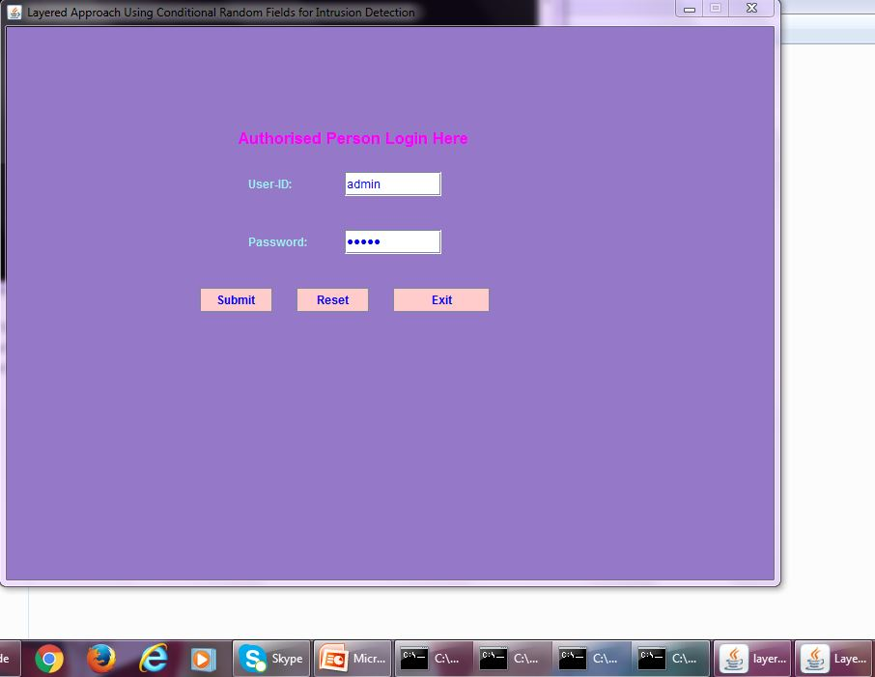
Screenshot 9.1: login page
The authorized user logins with the username and password for the further accessing of the resources as shown in the screenshot 9.1.

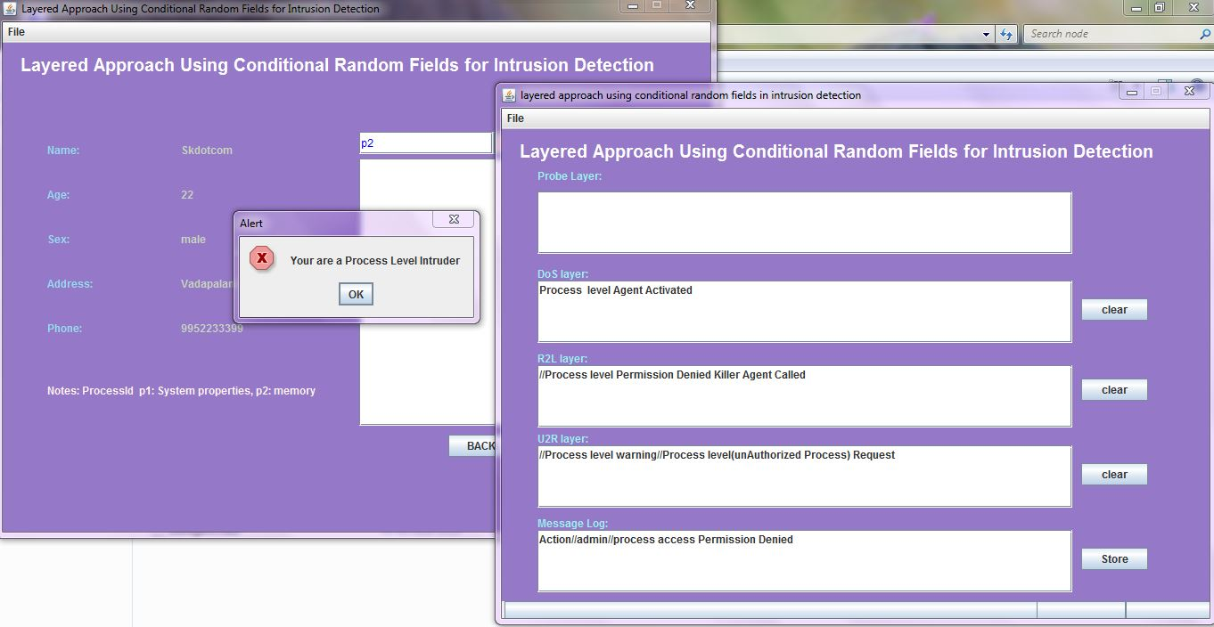
Screenshot 9.2
When the user tries to get the memory status then the functionalities of the individual layers are being observed and the alert box appears when the intruder is detected as shown in the screenshot 9.2.

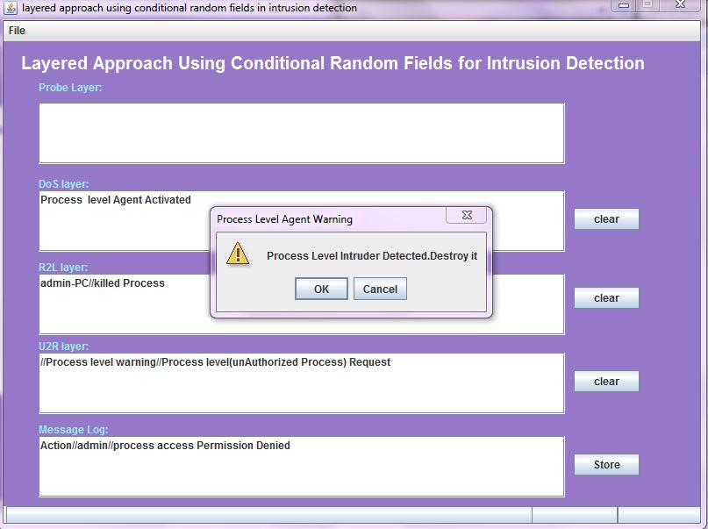
Screenshot 9.3
When the user tries to get the memory status then the functionalities of the individual layers are being observed and the alert box appears when the intruder is detected as shown in the screenshot 9.43.

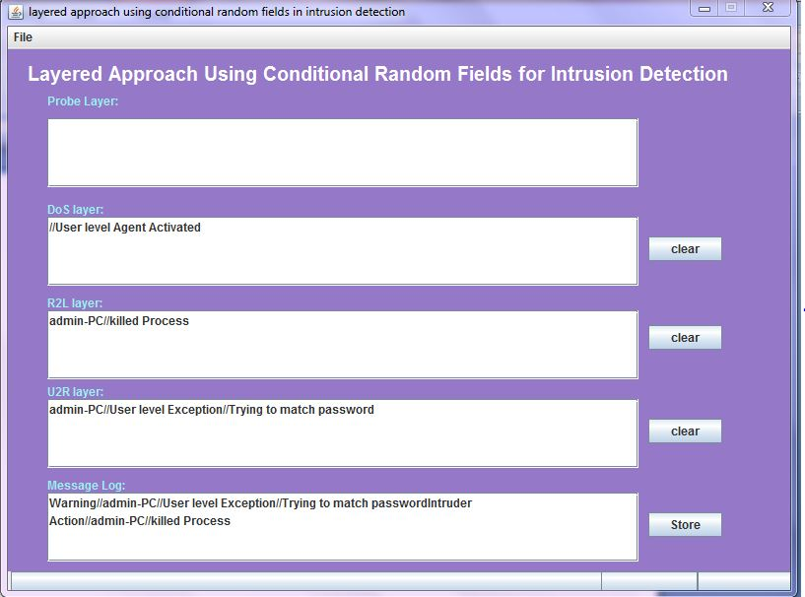
Screenshot 9.4
When the user logins with unauthorized details , then the individual functionalities at each and every layer are observed as shown in the screenshot 9.4.

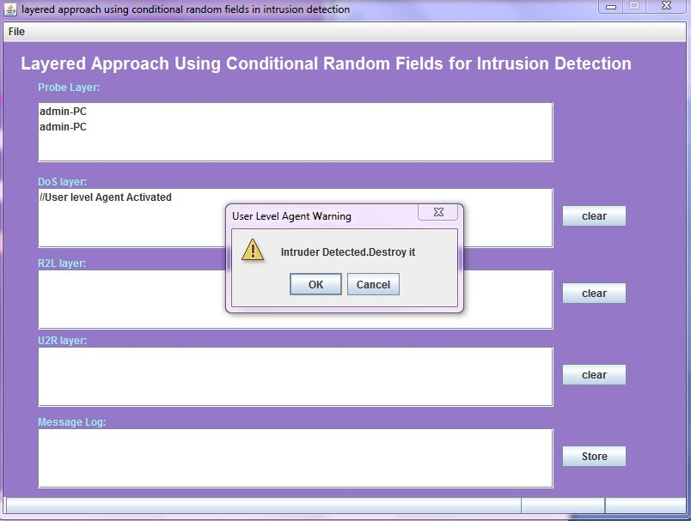
Screenshot 9.5
When the unauthorized user is detected the user level agent warning appears with an alert that intruder detected destroy it as shown in screenshot 9.5.
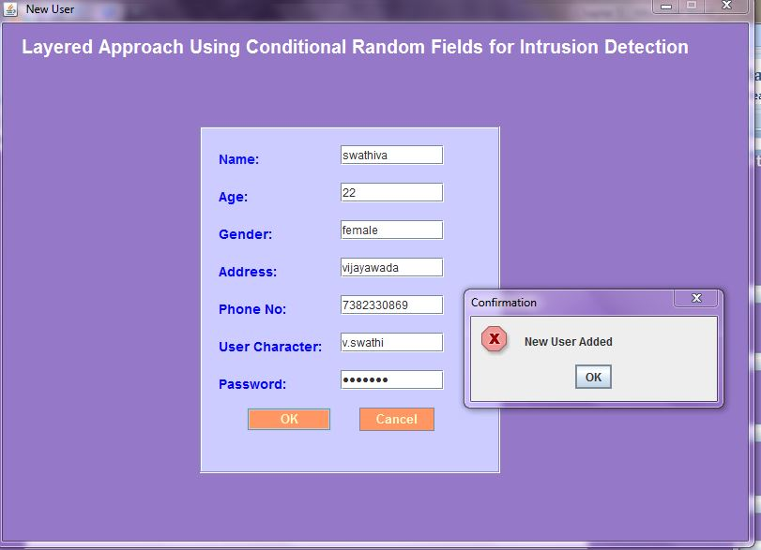
Screenshot 9.6
New user can be added with the filling of details such as name, age, gender, address, phone no, username, password as shown in the screenshot 9.6.
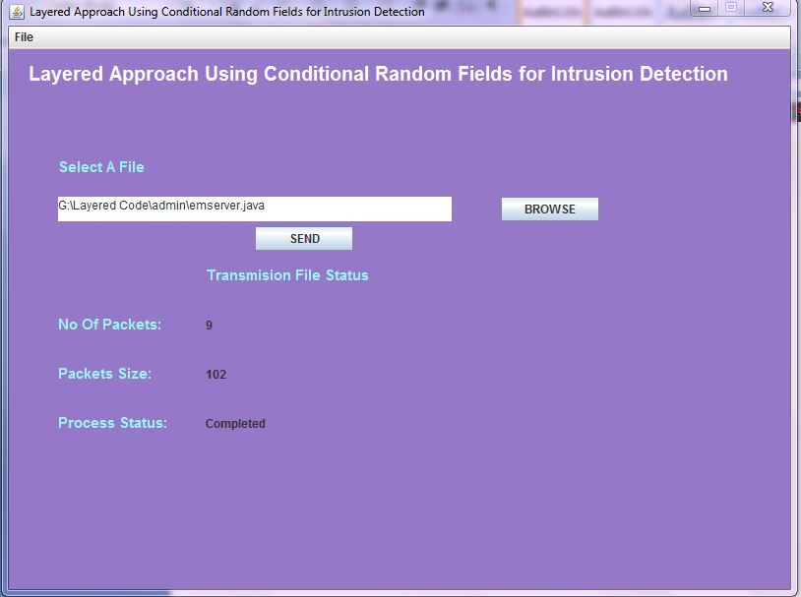
Screenshot 9.7
Packet can be sent once the authorized user logins as shown in the screenshot 9.7.once the packet is sent successfully the information regarding the packet sent such as no.of packets, packets size, process status is evaluated.

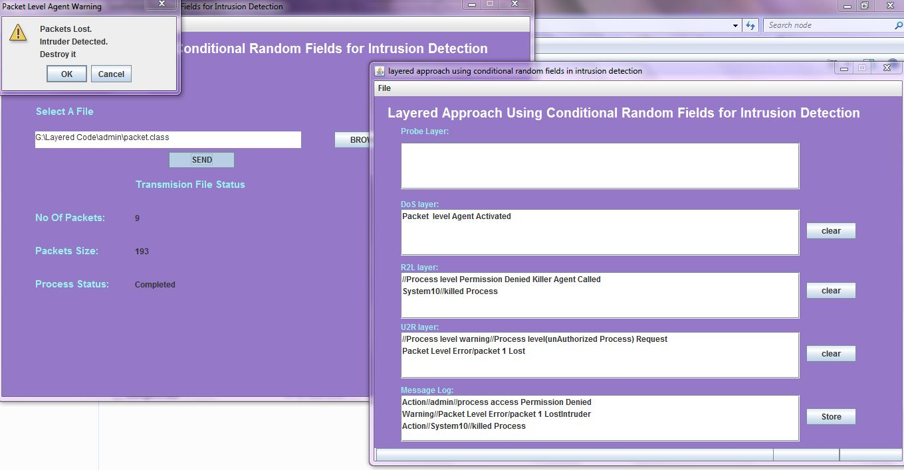
Screenshot 9.9
When the redundant packet is being sent the file status and the functionalities at each and every layered is observed and the packet level agent warning appears whether to destroy or not as shown in the screenshot 9.9.

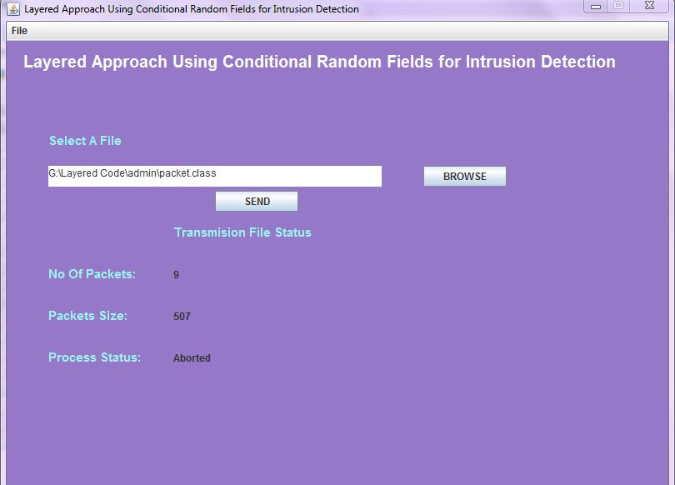
Screenshot 9.9
When the packet level intruder is detected and destroyed the packet transmission is aborted as shown in the screenshot 9.9.

CONCLUSION
Finally, proposed system has the advantage that the number of layers can be increased or decreased depending upon the environment in which the system is deployed, giving flexibility to the network administrators. The areas for future research include the use of our method for extracting features that can aid in the development of signatures for signature-based systems. The signature-based systems can be deployed at the periphery of a network to filter out attacks that are frequent and previously known, leaving the detection of new unknown attacks for anomaly and hybrid systems. Sequence analysis methods such as the CRFs when applied to relational data give the opportunity to employ the Layered Approach, as shown in this project. This can further be extended to implement pipelining of layers in multicore processors, which is likely to result in very high performance.

REFERENCES
- Lee, S. Stolfo, and K. Mok, “Mining Audit Data to Build Intrusion Detection Models,” Proc. Fourth Int’l Conf. Knowledge Discovery and Data Mining (KDD ’98), pp. 66-72, 1998.
- Puketza, Nicholas Joseph (2000). Approaches to Computer Security: Filtering, Testing, and Detection. California: University of California.
- Suman Bharti, Dr. Savita shiwani, Dinesh Goyal, Vinit Agrawal Jaipur, India India,. Intrusion Detection System (IDS) Using Layered Based Approach For Finding Attack. Issue No.8, pp : 1082-1084.
- A. McCallum, D. Freitag, and F. Pereira, “Maximum Entropy Markov Models for Information Extraction and Segmentation,” Proc. 17th Int’l Conf. Machine Learning (ICML ’00), pp. 591598,2000. 5. N.B. Amor, S. Benferhat, and Z. Elouedi, “Naive Bayes vs. Decision Trees in Intrusion Detection Systems,” Proc. ACM Symp. Applied Computing (SAC ’04), pp. 420-424, 2004.
- D.S. Kim and J.S. Park, “Network-Based Intrusion Detection with Support Vector Machines,” Proc. Information Networking, Networking Technologies for Enhanced Internet Services Int’l Conf. (ICOIN ’03), pp. 747-756, 2003.
- R. Agrawal, T. Imielinski, and A. Swami, (1993)“Mining Association Rules between Sets of Items in Large Databases”, Proc. ACM SIGMOD, vol. 22, no. 2, pp. 207-216.
- K.K. Gupta, B. Nath, and R. Kotagiri, (2009)“Network Security Framework”, Int’l J. Computer Science and Network Security, vol. 6, no. 7B,pp. 151-157.
- K.K.Gupta,(2009)“Robust and Efficient Intrusion Detection Systems”, .cs.mu.oz.au/~kgupta/files/phd-completion.pdf.
- Kapil Kumar Gupta, BaikunthNath, RamamohanaraoKotagiri, (2010) “Layered Approach Using Conditional Random Fields for Intrusion Detection”, Proc. IEEE dependable and secure computing.
- KK Gupta, B Nath and K Ramamohanarao, “Layered approach using conditional random ﬁelds for intrusion detection”, IEEE Transactions on Dependable and Secure Computing, vol. 7, no. 1, (2010), pp. 35-49.
- Bhanu Chander*, K. Radhika, D. Jamuna, “An Approach On Layered Framework For Intrusion Detection System”, Asi.an Journal of omputer Science And Information Technology 2: 8 (2013) 230 – 233. 2012, AJCSIT.
- N.B. Amor, S. Benferhat, and Z. Elouedi, “Naive Bayes vs. Decision Trees in Intrusion Detection Systems,” Proc. ACM Symp. Applied Computing (SAC ’04), pp. 420-424, 2004.
- D.S. Kim and J.S. Park, “Network-Based Intrusion Detection with Support Vector Machines,” Proc. Information Networking, Networking Technologies for Enhanced Internet Services Int’l Conf. (ICOIN ’03), pp. 747-756, 2003.
- R. Agrawal, T. Imielinski, and A. Swami, (1993)“Mining Association Rules between Sets of Items in Large Databases”, Proc. ACM SIGMOD, vol. 22, no. 2, pp. 207-216.
- K.K. Gupta, B. Nath, and R. Kotagiri, (2012)“Network Security Framework”, Int’l J. Computer Science and Network Security, vol. 6, no. 7B,pp. 151-157.

