Critical assessment of COVID19 chest X ray severity prediction
DSA5206 Type 2 Project Part II
Assessment framework from Lecture 9 | Experiments completed 27 October 2026
Cohen et al. present a useful retrospective proof of concept for predicting expert chest radiograph severity scores from frozen pretrained features. Our classroom checklist assessment identifies credible labeling and patient grouping, but unresolved sampling, calibration, external validation and clinical deployment gaps. In a new comparison on 94 images from 65 patients, none of the tested alternative pipelines exceeded the strongest published low-dimensional ordinary least squares model on mean held-out absolute error.

Study and task
Aspect | Description
Selected study | Cohen JP et al. Cureus 2020;12:e9448. DOI 10.7759/cureus.9448.
Input and targets | PA chest radiograph; geographic extent 0-8 and opacity 0-6, using the mean of three expert scores.
Published approach | Frozen pretrained DenseNet plus an ordinary linear regression head. The neural network is not retrained on the 94 scored images.
Critical assessment | The 12 questions on Lecture 9 p. 11, elaborated on pp. 14-21, are applied individually.
New experiment | Nine configurations, two targets and 50 identical patient-grouped outer splits: 900 outer model fits, plus inner model selection.

Main experimental finding
Geographic Extent is best with Published OLS 1: 1.165 ± 0.104 MAE. Opacity is best with Published OLS 4: 0.766 ± 0.072 MAE. Ridge improves the unregularized 18-output comparator but does not surpass these low-dimensional references. The standardized Ridge 1024 pipeline also shows an important retained failure.
The numbers in the experiment sections are newly computed results. They are kept distinct from the paper and the group notebook outputs. The assessment concerns prediction of radiographic scores; it does not demonstrate COVID-19 diagnosis, mortality prediction or improved clinical outcomes.

Checklist assessment of data collection
Classroom framework: Lecture 9, p. 11. Each item states the evidence, our judgment and an improvement. A reporting omission is distinguished from evidence of a methodological failure.

1 Is the data collection approved
Ethics approval and consent handling are reported
Evidence. The Human Subjects statement reports approval CERSES-20-058-D and states that consent was obtained or waived. Images were collected from existing public sources and de-identified before analysis. [1, pp. 2 and 7]
Assessment. This supports ethical oversight of the retrospective study. Public availability alone would not establish permission for every secondary use. No prospective study registration is reported; that reporting gap should not be treated as evidence that the study lacked ethics approval.
Improvement. Retain the approval identifier, data attribution and applicable source terms. A future prospective clinical evaluation would require an appropriate protocol and approvals.
Lecture 9, pp. 11 and 14

2 Is the data collected properly
Sources are described but representativeness is uncertain
Evidence. The study uses 94 PA chest radiographs from a public collection, sourced internationally from December 2019 to March 2020. Patients were reported COVID-19 positive, mostly by RT-PCR. [1, p. 2, Section 2.1]
Assessment. The collection is a small convenience sample assembled partly from publications and image-sharing platforms, rather than a defined consecutive clinical cohort. International sources provide diversity but do not establish representative sampling or independent external validation. Exclusion rules and the patient flow are insufficiently detailed.
Improvement. Publish a case flow, patient-level denominators, acquisition settings and inclusion criteria. Validate on consecutive cases from hospitals not involved in model development.
Lecture 9, pp. 11 and 14

3 Is the data of good quality
Expert labels are a strength but label uncertainty remains
Evidence. Three blinded experts, including two experienced chest radiologists, scored geographic extent and opacity. Fleiss' kappa was 0.71 for extent and 0.45 for opacity. The paper states that there was no missing data. [1, p. 2, Sections 2.1 and 2.2]
Assessment. Expert review provides a defensible reference for radiographic severity, although opacity labels show appreciable reader disagreement. A mean expert score is not a clinical outcome. In our fixed public snapshot all 94 targets are present, but age is missing for 25 image records and sex for 17; the paper's missingness statement should therefore not be generalized to all clinical metadata.
Improvement. Report missingness separately for targets and covariates, distinguish images from patients, inspect duplicates and image artifacts, and account for reader variability when interpreting model error.
Lecture 9, pp. 11 and 15

Checklist assessment of preparation and modeling
Classroom framework: Lecture 9, p. 11. Each item states the evidence, our judgment and an improvement. A reporting omission is distinguished from evidence of a methodological failure.

4 How is data preprocessed
The main image transformations are clearly specified
Evidence. Images are center-cropped where needed, resized to 224 by 224 pixels and scaled to approximately -1024 to 1024. The pretrained network is frozen before generating features for the regression models. [1, pp. 2-3, Sections 2.4 and 2.5]
Assessment. This gives a reproducible basic pipeline. However, center-cropping can remove peripheral anatomy, and resizing can obscure small findings. The study does not establish robustness to these choices, acquisition artifacts or differences in radiographic views. Frozen feature extraction does not itself require fitting on the COVID-19 test labels.
Improvement. Record implementation versions and test clinically plausible preprocessing changes. Any fitted scaler, PCA or feature selector introduced in an extension must be fitted within training folds only.
Lecture 9, pp. 11 and 15

5 What ML models are used
A sensible transfer learning design with limited alternatives
Evidence. DenseNet was pretrained on 88,079 non-COVID-19 images from seven datasets. Frozen representations of 1024, 18, 4 or 1 dimensions feed ordinary linear regression, alongside an intercept-only baseline. The task outputs are pre-sigmoid logits. [1, pp. 2-4 and Figure 1]
Assessment. Learning only a small regression head is appropriate for scarce labels. The reported 1+1 parameter count describes the new regression head, not the whole pretrained network. Comparing unregularized high-dimensional regression with a single feature does not establish that high-dimensional representations contain less useful information.
Improvement. Compare regularized regressors on the same frozen features and patient splits. We test Ridge regression and RBF support vector regression, with training-only hyperparameter selection.
Lecture 9, pp. 11 and 16

6 How is the data split
Patient grouping is appropriate but evaluation is internal
Evidence. The 94 images are repeatedly divided approximately 50/50, keeping all timepoints of the same patient together. Table 1 summarizes 50 random train/test splits. [1, pp. 3-4, Section 2.5 and Table 1]
Assessment. Patient grouping addresses direct leakage between repeated scans. The image counts need not be exactly balanced because the allocation is by patients. Repeated test sets overlap, so their results are dependent. Ranking feature configurations on the same repeated test sets also leaves uncertainty about model-selection optimism.
Improvement. Save patient split manifests, reserve test predictions for evaluation and tune alternatives using nested grouped validation. For deployment claims, add hospital-level or temporal external testing.
Lecture 9, pp. 11 and 17

Checklist assessment of evaluation
Classroom framework: Lecture 9, p. 11. Each item states the evidence, our judgment and an improvement. A reporting omission is distinguished from evidence of a methodological failure.

7 Are the metrics appropriate
Regression metrics are suitable but uncertainty and calibration need more work
Evidence. Table 1 reports MAE, MSE, R-squared and Pearson correlation as means and standard deviations over 50 splits. Figure 2 compares predictions with expert scores and shows systematic overestimation at low scores and underestimation at high scores. [1, p. 4]
Assessment. MAE is interpretable in score units and MSE emphasizes extreme errors. Pearson correlation is not accuracy and can remain high despite miscalibration. Split standard deviations are not confidence intervals. The clinical significance of a one-point error is not established, and subgroup performance and prediction intervals are absent.
Improvement. Use held-out MAE as the primary endpoint, retain complementary metrics and inspect score-stratified signed errors. State the dependence of repeated splits and avoid claiming statistical superiority from a small mean difference alone.
Lecture 9, pp. 11, 17 and 23

8 Are the results explainable
Qualitative explanations are provided but not validated for fidelity
Evidence. Figure 4 displays smoothed input-gradient saliency for selected correct and incorrect predictions; Figure 3 visualizes four-dimensional features with t-SNE and survival markers. The authors acknowledge limitations of saliency maps. [1, pp. 3, 5-6]
Assessment. These plots help inspect plausibility, but visually plausible heatmaps do not prove causal reliance on pathology. The t-SNE image is exploratory and does not validate outcome prediction. The public code uses squared gradients with Gaussian sigma 5, whereas the paper describes a 5 by 5 kernel; those are different specifications.
Improvement. Disclose case-selection and smoothing rules, test image-region occlusion and model randomization, and measure sensitivity to text or borders. Avoid interpreting t-SNE clusters as proof of mortality prediction.
Lecture 9, pp. 11 and 18

9 Are the results reproducible and generalizable
Broadly reproducible with versioning gaps; generalizability unproven
Evidence. The authors release data, severity labels, code and model resources. The group notebook reproduces the broad Table 1 ranking. The paper calls for new cohorts with the same scoring system. [1, pp. 1 and 6; 4-5]
Assessment. Open resources enable verification, but exact recreation is affected by changing metadata and software. The paper describes 208 visualization images while the supplied author notebook stores 199. The group repository does not include its custom metadata_2020.csv or a pinned environment. None of these facts establishes performance on a genuinely new hospital cohort.
Improvement. Our experiment fixes a public 2020 commit, records checksums, caches features and publishes split manifests and versions. External validation remains a required next step; close internal reproduction does not demonstrate it.
Lecture 9, pp. 11 and 19

Checklist assessment of clinical use
Classroom framework: Lecture 9, p. 11. Each item states the evidence, our judgment and an improvement. A reporting omission is distinguished from evidence of a methodological failure.

10 Is there an appropriate clinical context
The use case is relevant but the evaluated endpoint is a surrogate
Evidence. The paper proposes assisting serial monitoring and escalation or de-escalation of care, especially in intensive care. Its supervised targets are radiographic extent and opacity. The discussion acknowledges uncertainty about their relationship with functional and clinical outcomes. [1, pp. 1 and 6]
Assessment. Quantitative CXR scoring is a clinically understandable research task. However, agreement with radiologists' scores does not show improved management, reduced mortality or safe triage. Restriction to PA images also limits direct applicability to portable AP examinations in intensive care.
Improvement. Define intended users, acquisition settings and decision points. Evaluate the added value over expert scoring and clinical variables in prospective workflows before claiming clinical benefit.
Lecture 9, pp. 11 and 20

11 What are its limitations
Important limitations are acknowledged and additional ones remain
Evidence. The discussion identifies small sample size, sampling bias, difficulty obtaining labels, the need for new cohorts and uncertain linkage to clinical outcomes. Figure 2 illustrates errors at the extremes. [1, pp. 4 and 6]
Assessment. Additional concerns are limited patient numbers, reader disagreement, incomplete demographic reporting, lack of independent external testing, no formal uncertainty estimates for individual predictions and limited alternative regressors. For one-feature models both predicted scores are affine functions of the same scalar and cannot vary independently.
Improvement. Prioritize external validation, patient-level reporting and error analysis by score and acquisition setting. Our alternative-model comparison addresses only one limitation: the narrow regression comparison; it does not resolve the clinical evidence gaps.
Lecture 9, pp. 11 and 21

12 Is the method ready for deployment
No clinical deployment readiness has been demonstrated
Evidence. The authors caution against premature implementation and state that diagnostic performance requires appropriate clinical evaluation. The study is a retrospective proof of concept without a prospective workflow or clinical impact trial. [1, p. 6, Discussion]
Assessment. The evidence supports a research tool for approximating expert radiographic scores. It does not establish safe autonomous decisions, stable performance across hospitals and devices, or effective human-AI use. Output values can fall outside the score range, and the implications of severe underestimation have not been resolved.
Improvement. Require independent multicenter and temporal validation, prospective human-AI evaluation, uncertainty and failure handling, monitoring for drift and a defined accountable clinical workflow before routine use.
Lecture 9, pp. 11 and 21

Alternative model experiment
The primary question is whether regularization improves frozen 1024-dimensional features enough to outperform the published low-dimensional model. Standardized Ridge 1024 is the primary alternative. Ridge on four or eighteen logits and an RBF support vector regressor on four logits are secondary comparisons. OLS 1 and OLS 4 are retained as strong references because both were leading configurations in the publication.

Cohort and feature extraction
We reconstruct all 94 scored PA images and 65 distinct patient identifiers from public metadata commit 196143d3dd32a2a43ad51d6891d460aaf690d741, dated 30 March 2020. The latest metadata does not preserve the same complete cohort. Targets and patient identifiers are complete. Age and sex are not used as predictors, so missing values in those fields require no model imputation. This is an auditable historical cohort reconstruction, rather than a claim of identity with an unversioned original environment. [5]
Images undergo the published normalization, center crop and 224 by 224 resize. We use the frozen densenet121-res224-all checkpoint in evaluation mode and extract the 18 pre-sigmoid logits and 1024 pooled features. File and weight SHA256 checksums, ordered metadata and cached features are included. The feature extractor does not learn from the COVID-19 target labels. [3,5]

Patient grouped nested evaluation
Component | Fixed specification
Outer evaluation | 50 GroupShuffleSplit draws, seeds 0-49; 50 percent of patient groups in the test set. The same splits are reused for every model.
Inner model selection | 5-fold GroupKFold restricted to each outer training set; optimize mean absolute error.
Ridge alternatives | StandardScaler plus Ridge; alpha in 0.01, 0.1, 1, 10, 100, 1000, 10000.
RBF SVR alternative | StandardScaler plus SVR; C in 0.1, 1, 10, 100; epsilon in 0.1, 0.3; gamma in scale, 0.1.
Endpoints | Primary: held-out image-weighted MAE. Also MSE, R-squared, Pearson correlation, patient-weighted error, signed error and out-of-range predictions.
Safeguards | Patient separation is asserted for outer and inner folds. Scaling is fitted inside the pipeline. Predictions are not clipped and failed-looking predictions remain in the results.

Means and standard deviations describe the 50 overlapping splits. They are not confidence intervals from independent trials. The optional patient-bootstrap contrasts condition on stored out-of-sample errors and do not capture the full variation from retraining or establish external superiority. [6]

Results from the new comparison
Table 1 reports newly measured mean ± standard deviation over the 50 outer splits. All models use the same features, patients and held-out partitions. Lower MAE is better; R-squared can be negative when predictions are worse than using the test mean.
Model | Extent MAE | Opacity MAE | Extent R² | Opacity R²
Mean baseline | 2.072 ± 0.167 | 1.289 ± 0.104 | -0.087 | -0.084
Published OLS 1 | 1.165 ± 0.104 | 0.788 ± 0.062 | 0.598 | 0.585
Published OLS 4 | 1.184 ± 0.121 | 0.766 ± 0.072 | 0.598 | 0.589
Published OLS 18 | 1.323 ± 0.196 | 0.917 ± 0.123 | 0.485 | 0.386
Published OLS 1024 | 1.355 ± 0.127 | 1.020 ± 0.094 | 0.459 | 0.277
Ridge 4 | 1.213 ± 0.128 | 0.770 ± 0.074 | 0.586 | 0.584
Ridge 18 | 1.241 ± 0.193 | 0.829 ± 0.103 | 0.551 | 0.516
Ridge 1024 | 1.419 ± 0.633 | 0.931 ± 0.515 | -1.894 | -3.745
RBF SVR 4 | 1.272 ± 0.202 | 0.893 ± 0.102 | 0.512 | 0.429

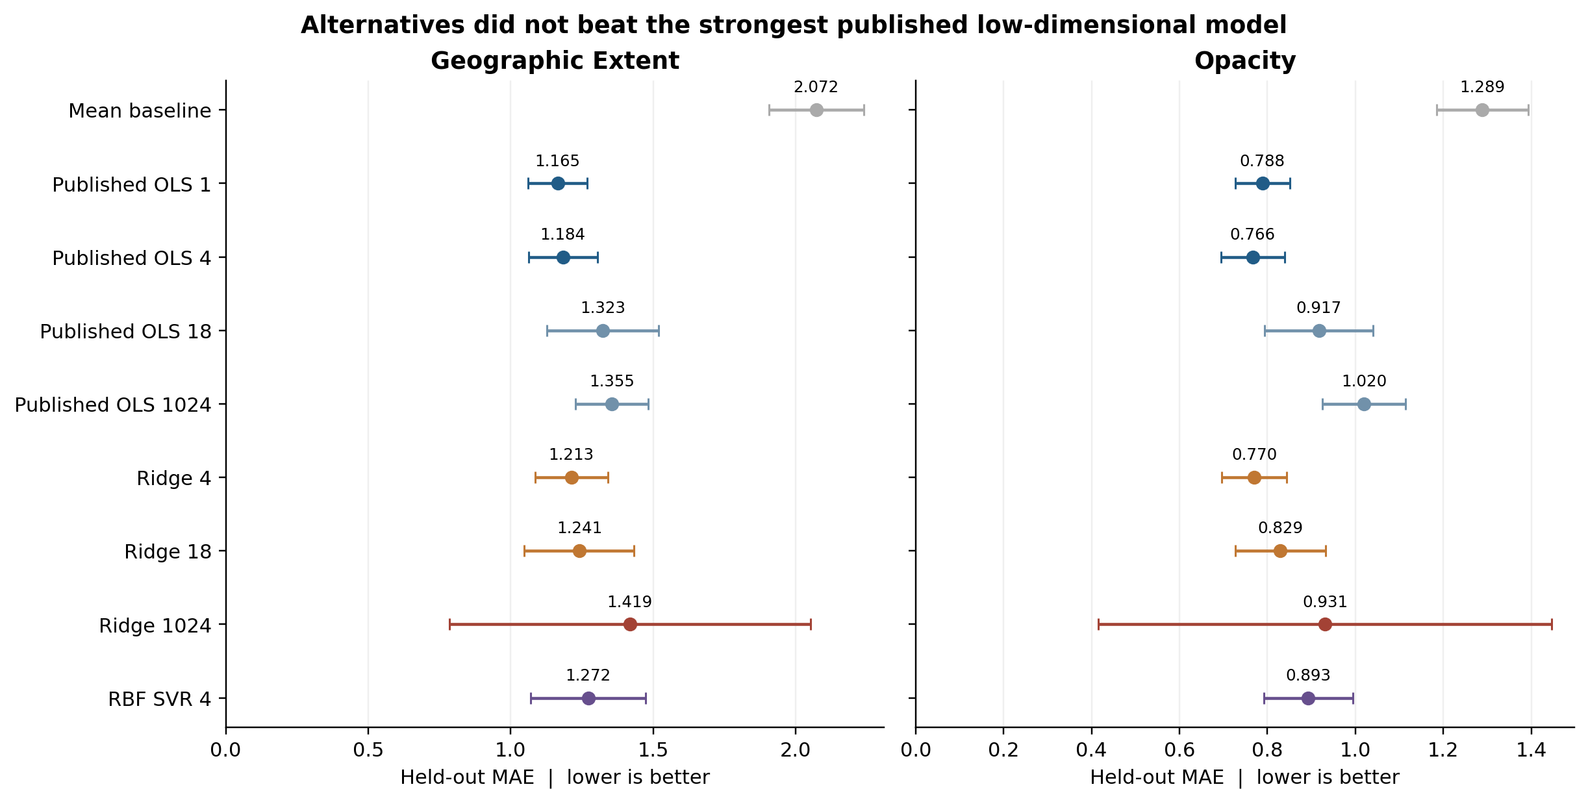
Figure 1. Points are mean MAE and error bars are split standard deviations, not 95 percent confidence intervals. OLS denotes ordinary least squares; the number is the feature dimension. Full MSE, correlation, individual predictions and selected hyperparameters are in the experiment archive.
For context, the original paper reports extent MAE 1.14 for OLS 1 and opacity MAE 0.76 for OLS 4. Our values of 1.165 and 0.766 broadly reproduce that result. Small numeric differences remain because the execution environment and historical data provenance are not identically versioned. [1, Table 1]

Interpretation and failure analysis

Did an alternative achieve better performance
No tested alternative achieved a lower mean MAE than the strongest published reference for its target. Ridge 4 has lower opacity MAE than OLS 1 (0.770 versus 0.788), but remains slightly worse than OLS 4 (0.766). It would therefore be misleading to report an overall improvement by comparing only with the weaker reference.
Target | Alternative | Reference | MAE change | Split wins
Extent | Ridge 4 | OLS 1 | +0.048 | 32%
Extent | Ridge 1024 | OLS 1 | +0.253 | 28%
Opacity | Ridge 4 | OLS 4 | +0.004 | 60%
Opacity | Ridge 1024 | OLS 4 | +0.165 | 28%

A negative MAE change would favor the alternative. Split wins count how often it has lower MAE on the same held-out partition; overlapping splits do not support an independent binomial or t test.

What regularization changed
Ridge 18 reduces extent MAE from 1.323 to 1.241 and opacity MAE from 0.917 to 0.829 relative to OLS 18. Thus, regularization helps that representation, but these gains do not overturn the low-dimensional result. These findings concern the tested pipelines and grids; they do not establish that all possible alternatives are inferior.

Why the high dimensional pipeline failed
At outer seed 27, standardized Ridge 1024 predicts -169.902 for an extent score of 0 in ciaa199.pdf-001-c.png. Its selected alpha is 1000. One feature has training standard deviation about 0.00000592 but takes value 0.278 on this test image, producing a standardized magnitude of about 46,990. That feature dominates the prediction. A second numerical solver reproduces the prediction within 0.00000001. The failure is retained in MAE and explains the very negative mean R-squared.
Filtering near-constant features within training folds or changing the scaling strategy would be reasonable future sensitivity analyses. We have not substituted a repaired model after seeing test results or removed the difficult split.

Error patterns and overall conclusion
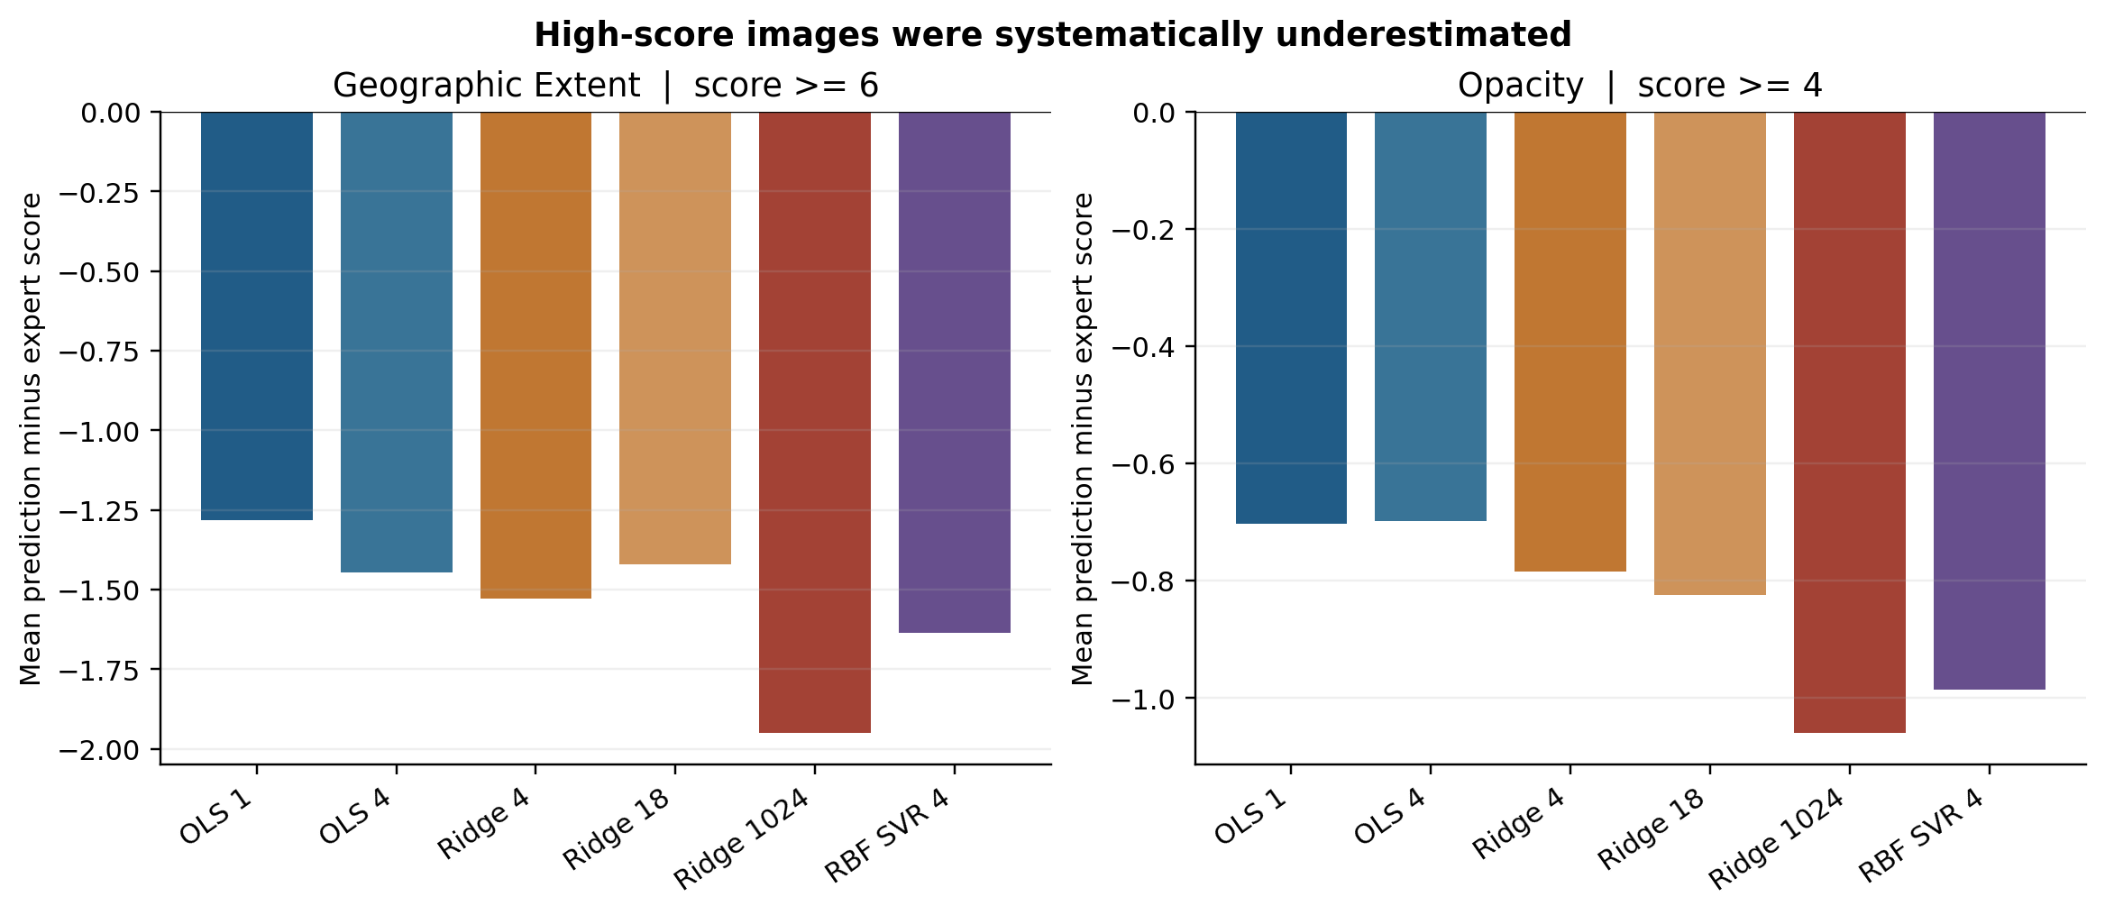
Figure 2. Average signed error within high-score strata, summarized over the same 50 held-out splits. Negative values indicate underestimation. Cutoffs are exploratory radiographic strata: extent at least 6 (18 images) and opacity at least 4 (22 images). They are not validated clinical severity categories.
For OLS 1, high-extent images have mean MAE 1.612 and signed error -1.280, compared with overall MAE 1.165. For OLS 4, high-opacity images have mean MAE 0.830 and signed error -0.698. The tested alternatives do not remove high-score underestimation. This makes failure analysis more informative than reporting correlation alone.

Limits of the new experiment
This remains an internal comparison on only 65 patients with subjective score labels. It does not add a new hospital cohort, test portable AP scans, establish clinical thresholds or show better patient outcomes. Repeated test partitions overlap. Image-weighted results give more influence to patients with more scans; patient-weighted metrics are also provided. The number of alternative pipelines is limited, and no clinical or demographic predictors are included.

Conclusion for Part II
The selected study is a credible small-sample transfer learning proof of concept with good openness and appropriate patient-level separation. The classroom assessment nevertheless identifies weak evidence for representative sampling, external generalization, validated explanations and deployment readiness. Our fair alternative-model comparison supports the published preference for low-dimensional features in this cohort. Regularization improves one high-dimensional comparator, but none of the tested alternatives outperforms the strongest published low-dimensional OLS configuration on mean MAE.
The practical next priorities are independent external validation, training-only controls for unstable features, and evaluation of high-score errors and individual uncertainty. A negative comparative result completes the experimental question; a claim of superiority is not required when the evidence does not support one.

References and reproducibility record
[1] Cohen JP, Dao L, Roth K, et al. Predicting COVID-19 Pneumonia Severity on Chest X-ray With Deep Learning. Cureus. 2020;12(7):e9448. Published article
[2] Zhang Louxin. DSA5206 Lecture 9 Assessment of AI Studies in Medicine. National University of Singapore, 2026. Checklist p. 11; elaboration pp. 14-21; extra reading p. 23.
[3] Original model and code resources. mlmed covid-severity and TorchXRayVision. Original severity resources
[4] DSA5206 group reproduction repository, reviewed commit f2127e6b8f0ae84eef618a308adb657be0cb65c0. Group reproduction
[5] COVID-19 Image Data Collection. Fixed metadata and image snapshot, commit 196143d3dd32a2a43ad51d6891d460aaf690d741, 30 March 2020. Severity label attribution is retained in the supplied CSV. Fixed historical dataset
[6] Scikit-learn version 1.5 documentation. Ridge, StandardScaler, GroupKFold and GridSearchCV. Ridge documentation
[7] DSA5206 Type2 Group Project Guidelines. Part II Critical Assessment and Analysis. Course handout supplied with this task.

Recorded software
Python 3.12.14; NumPy 2.2.6; pandas 3.0.1; SciPy 1.14.1; scikit-learn 1.5.2; PyTorch 2.5.1 CPU; torchvision 0.20.1 CPU; TorchXRayVision 1.3.5; scikit-image 0.24.0; imageio 2.36.0. The full run record is in results/environment.json.

Files supporting the conclusions
The archive contains an executed analysis notebook, source scripts, the ordered cohort, frozen features, source and image hashes, all outer patient splits, all 900 fit metrics, held-out predictions, selected parameters and the retained failure diagnostic. The two report figures are also supplied separately for reuse in slides. Raw images and model weights can be downloaded by the preparation script.
The experiment can be rerun from cached features using requirements-analysis.txt, without downloading images or installing PyTorch. See README.md for commands and attribution. checklist.csv contains the 12 classroom items and the English and Chinese assessment text.

中文说明与课堂 checklist 对应
本附录用于理解英文正文和准备口头汇报。评估严格对应第 9 讲第 11 页的 12 个问题，第 14–21 页是课堂的展开示例。第 10 讲主要讨论电子病历，不是本次 checklist 的来源。
对原论文的总体判断是：它在标签稀缺时有效利用了预训练胸片模型，是有价值的概念验证；但现有证据不足以支持直接临床部署。不能把“预测专家影像评分”扩大解释为“预测死亡率”或“改善治疗”。

1 伦理批准
论文报告伦理批准 CERSES-20-058-D，以及知情同意已取得或获豁免。应评价为伦理信息已报告，不能因为没有看到试验注册号就断言研究未获伦理批准。

2 数据收集
94 张影像来自公开病例集合，来源国际化，但属于便利样本。多来源不等于有代表性的多中心验证，也不能保证能够推广到日常连续就诊患者。

3 数据质量
专家评分可靠性是优点，但 opacity 的评分一致性较低。我们的历史快照中评分完整，年龄缺失 25 条、性别缺失 17 条，因此不能把无缺失泛化到全部临床资料。这些缺失变量未用于本次模型。

4 数据预处理
中心裁剪、224×224 缩放和像素归一化描述清楚。潜在问题是外周肺野被裁掉或细节损失。新增标准化或 PCA 时，应仅在训练折拟合；本实验已遵守这一点。

5 模型选择
方法是冻结 DenseNet 加线性回归，并非用 94 张图重新训练大型网络。1+1 只表示新拟合回归头的参数。高维普通回归较差，不足以证明高维特征本身没有价值。

6 数据划分
同一患者全部影像留在同一侧，能够避免最直接的患者泄漏。50 次测试集会重叠，不能当作 50 个独立样本。本实验保存划分，并在每个训练集内用五折患者分组验证选参。
引用论文时使用 Cohen et al. (2020)。每项判断的原文位置已列在英文正文，便于制作 PPT 时保留证据。不要把课堂用于示范的心脏手术 AKI 研究，其机构或伦理编号套用到这篇胸片论文。

中文实验结论与汇报要点

7 评估指标
MAE、MSE、R² 和相关系数适合回归任务；相关系数 0.8 不能写成准确率 80%。50 次划分的标准差不是置信区间，还需检查高评分低估和预测校准。

8 解释性
热图和 t-SNE 提供直观解释，但没有验证解释忠实性。热图好看不能证明模型利用了真正病灶；生存状态在 t-SNE 上聚集，也不能证明死亡风险预测有效。

9 可复现与泛化
公开数据和代码是优点，但历史 metadata 与软件版本变化阻碍完全一致复刻。本次已固定数据提交、权重校验值和划分。内部数值接近不能替代独立医院或时间队列验证。

10 临床背景
自动量化胸片病变有临床意义，但评分接近专家不等于改善治疗或降低死亡率。研究使用 PA 片，不能直接推及 ICU 常见的便携 AP 片。

11 研究局限
主要限制包括小样本、便利抽样、标注不一致、外部验证缺失及个体不确定性未知。两个分数都来自同一个特征，也限制了它们独立变化的表达能力。新增模型实验只能解决部分方法学问题。

12 部署准备
结论应为有价值的回顾性概念验证，但尚未证明可临床部署。后续需要外部和前瞻性验证、人机协作评价、失败处理及持续监测，不能据现有结果直接自动决定治疗。

替代模型实验可以怎样汇报
本次实际运行了 94 张胸片、65 位患者、两个任务和九组模型。外部采用相同的 50 次患者分组划分，Ridge 与 SVR 的参数只在每个训练集内部通过五折患者分组验证选择。完整预测与划分均已保存。
核心结果是：Geographic Extent 最好的原模型 OLS 1 的 MAE 为 1.165；Opacity 最好的原模型 OLS 4 为 0.766。Ridge 4 分别为 1.213 和 0.770，未超过这两个强基线。虽然 Ridge 4 的 opacity 比 OLS 1 的 0.788 略好，但不能忽略原论文已有表现更好的 OLS 4。
Ridge 改善了 18 维普通回归，但标准化的 1024 维 Ridge 出现了极端失败。该失败没有被删除，也没有用截断掩盖。结果说明：方法变复杂或加入正则化，不保证小样本泛化更好。这个负结果已回答作业要求的“另一模型是否更好”。

