Jim Foley and Josh Collins

ENGR114/Winter 2019:

3/19/19

Revision Number: 1

**Hardware Hookup Guide**

**Hardware Setup:**

Bill of Materials: *(only items used/needed are listed in table)*

|  |  |
| --- | --- |
| Component Name | Vendor and url link |
| Arduino | [SparkFun RedBoard - Programmed with Arduino](https://www.sparkfun.com/products/13975) |
| pH Sensor | [Vernier pH Sensor PH-BTA](https://www.sparkfun.com/products/12872) |
| Sensor Shield | [SparkFun Vernier Interface Shield](https://www.sparkfun.com/products/12858) |
| Mini-B USB cable | [SparkFun USB Mini-B Cable - 6 Foot](https://www.sparkfun.com/products/11301) |
| ph 4 solution | Standard Buffered pH 4 Solution - from PCC Engineering Lab |
| ph 7 solution | Standard Buffered pH 7 Solution - from PCC Engineering Lab |
| ph 10 solution | Standard Buffered pH 10 Solution - from PCC Engineering Lab |

**Hardware Schematic:**

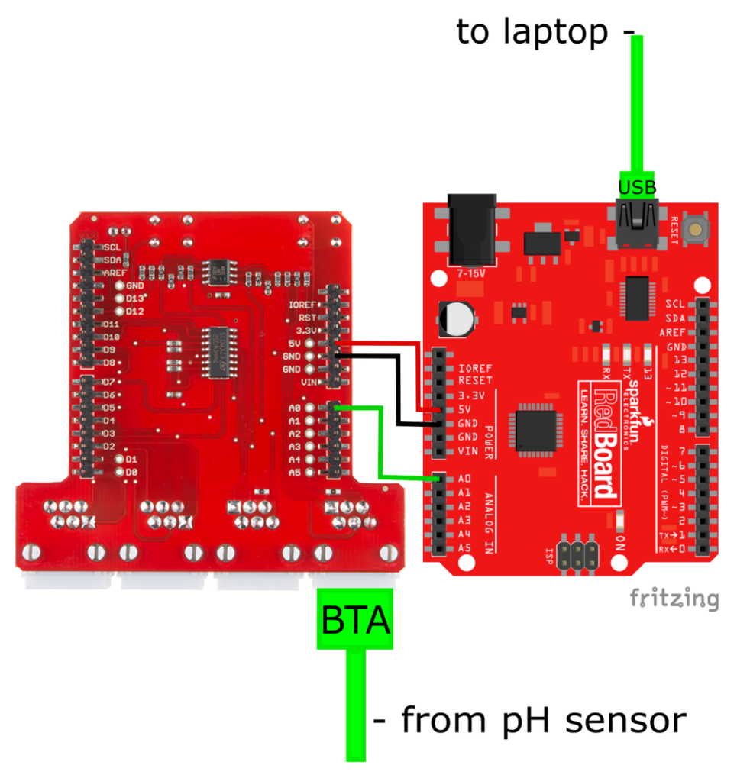

**Hookup Guide:**

The pH sensor (Vernier part# PH-BTA) is connected to the Vernier Interface Shield (Sparkfun part# DEV-12858) using the the pH sensor's British Telecom Analog (BTA) connector. This is then plugged into either the Analog 1 or Analog 2 connector of the shield. The Vernier Interface Shield was placed on top of the Arduino (Sparkfun part# DEV-13975). The boards are aligned properly so the rows of pins on the shield and female Arduino connectors are oriented correctly. The Arduino was powered using the same red Mini-B USB cable (Sparkfun part# CAB-11301) that connects it to a laptop running Jupyter Notebook.

**Images:**

