NIKE SALES DATA ANALYSIS PROJECT
Prepared by: Team Nike
Team Name | Nike
Project Name | Nike Sales Data Analysis Project
Course | Data Analytics
Dataset | Nike_Sales_Uncleaned.csv
Tools | Python, Pandas, NumPy, Matplotlib and Seaborn
Initial Work | 08 August 2026
Documentation / Progress Update | 10 August 2026

Project Overview
Our team developed a complete Nike Sales Data Analysis workflow from raw data inspection through cleaning, feature engineering, KPI calculation, business analysis and visualization. Every stage contributes to the next stage, so the final result represents coordinated teamwork.

Team Objective
Our objective is to transform raw Nike sales records into useful information about revenue, profit, units sold, products, months, regions, sales channels and product lines. Team members work on defined responsibilities while sharing results across the workflow.
Inspect → Clean → Engineer Features → Analyze → Visualize → Document

TEAM MEMBERS, RESPONSIBILITIES AND COLLABORATION
Our responsibilities are divided by primary role, but the analysis is treated as one shared project. The output from one member becomes an input or validation point for another member.
Team Member | Primary Responsibility | Team Contribution
Palavalasa Ganesh | Documentation | Coordinates the written record, progress updates, workflow explanation and final submission material.
G. Sai Kumar | Data Inspection | Checks structure, columns, data types, missing values, duplicates, unique values and invalid records.
M. Anjali | Data Cleaning | Works on duplicate and missing-value handling and prepares records for analysis.
T. Indravathi | Data Cleaning & Validation | Checks cleaned fields, consistency and readiness of the prepared dataset.
S. Jyothirmayi | Data Visualization | Converts the team's analysis outputs into clear charts and graphs for presentation.

How the Work Connects
- Data inspection identifies quality issues that the cleaning stage must address.
- Data cleaning prepares a consistent dataset for the team's calculations and grouped analysis.
- Feature engineering creates fields needed for monthly and business-level analysis.
- Analysis produces the summaries used by the visualization stage.
- Visualization communicates the findings in an accessible form.
- Documentation records the complete workflow and connects every contribution.

Teamwork Principle
No stage is treated as an isolated task. The team reviews outputs across stages so that data quality, calculations, charts and documentation remain consistent.

DATASET OVERVIEW AND INSPECTION

Initial Inspection
Our team begins by loading Nike_Sales_Uncleaned.csv into a Pandas DataFrame named df. We inspect the first records, dataset dimensions, column names, data types and summary statistics before making changes.

Inspection Commands
- df.head() — view the first records.
- df.shape — check the number of rows and columns.
- df.columns — review field names.
- df.info() — review data types and non-null information.
- df.describe() — inspect numerical statistics.
- df.isnull().sum() — identify missing values.
- df.duplicated().sum() — identify duplicate rows.
- df.nunique() — review unique-value counts.

Fields Used in the Analysis
The team works with Order_Date, Product_Name, Product_Line, Region, Sales_Channel, Gender_Category, Units_Sold, MRP, Discount_Applied, Revenue and Profit. Additional analytical fields include Discount_Value, Month, Month_Name and Year.

Data Quality Checks
- Missing values that could affect calculations.
- Duplicate records that could inflate totals.
- Negative Units_Sold values requiring review.
- MRP values less than or equal to zero.
- Negative Profit values requiring interpretation.
- Inconsistent category text such as spacing or capitalization.

DATA CLEANING AND FEATURE ENGINEERING

Cleaning Process
Our team removes duplicate rows with drop_duplicates() and removes rows containing missing values with dropna(). Order_Date is converted into a proper date type using Pandas to_datetime with mixed-format handling and day-first interpretation.
Region, Sales_Channel and Gender_Category are standardized by removing unwanted spaces and converting values to title case. This keeps category labels consistent when the team groups records for analysis.

Feature Engineering
- Discount_Value = MRP × Discount_Applied ÷ 100.
- Month = numeric month extracted from Order_Date.
- Month_Name = three-letter month abbreviation.
- Year = year extracted from Order_Date.

Why These Features Matter
Month_Name supports the monthly revenue trend, while Year supports time-based grouping when multiple years are present. Discount_Value provides an additional calculated measure for understanding discount impact.

Team Validation
After cleaning, the team checks that duplicate removal, missing-value handling, date conversion, category standardization and engineered fields have been applied before moving to analysis.

KPI CALCULATIONS AND BUSINESS ANALYSIS

Key Performance Indicators
After cleaning, our team calculates the following core KPIs:
KPI | Calculation
Total Revenue | df['Revenue'].sum()
Total Profit | df['Profit'].sum()
Total Units Sold | df['Units_Sold'].sum()

Business Analysis
- Monthly Revenue — Revenue grouped by Month_Name and ordered from Jan to Dec.
- Top 10 Products — Revenue grouped by Product_Name, sorted descending and limited to ten products.
- Revenue by Region — Revenue grouped by Region for regional comparison.
- Sales Channel Distribution — Revenue grouped by Sales_Channel.
- Product-Line Profit — Profit grouped by Product_Line.

Revenue and Profit Together
The team uses revenue and profit together because they answer different business questions. Revenue represents sales value, while profit represents the financial return represented by the dataset.

VISUALIZATION 1 — MONTHLY REVENUE TREND
The team groups Revenue by Month_Name and arranges the months chronologically. The resulting monthly_sales summary is presented as a line chart with month on the x-axis and revenue on the y-axis.
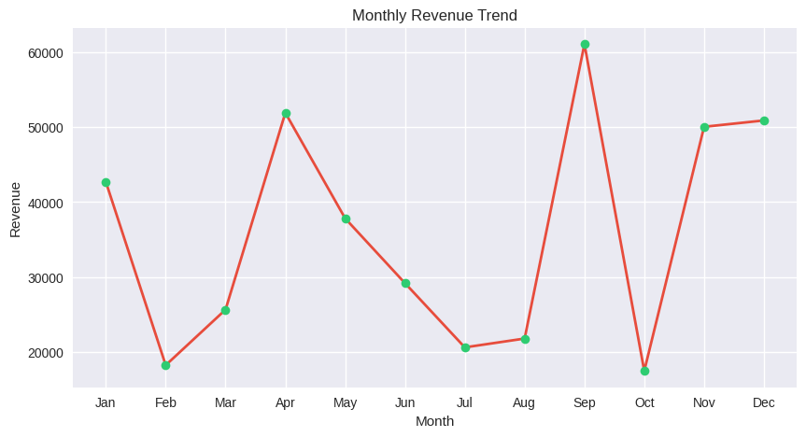
Figure 1. Monthly Revenue Trend — exact visualization supplied from the team's Colab output.

Interpretation
The chart shows a changing monthly revenue pattern, with a pronounced peak in September and another high level in December. The lowest visible points occur around October and February. These observations are taken directly from the supplied visualization.

Teamwork Connection
Inspection verifies the date and revenue fields, cleaning prepares valid records, analysis creates monthly_sales, visualization produces the chart, and documentation explains the result.

VISUALIZATION 2 — TOP 10 PRODUCTS
The team groups Revenue by Product_Name, sorts the results in descending order and selects the top ten products. The supplied Colab visualization uses a gold/mustard bar color and the same chart formatting shown below.
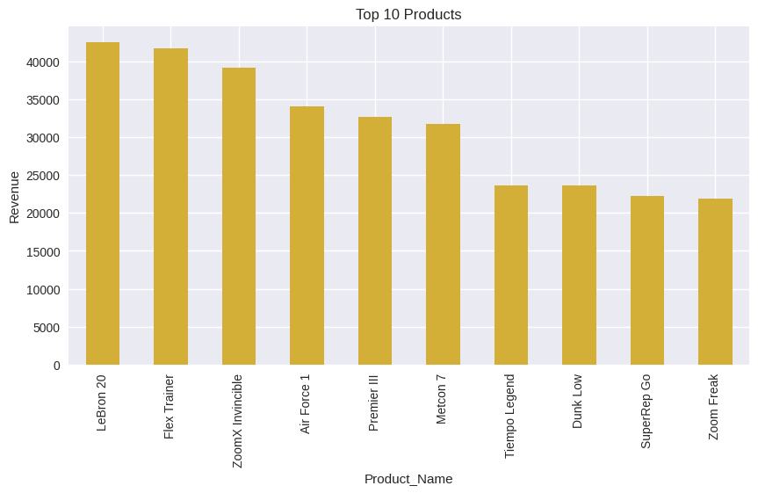
Figure 2. Top 10 Products — exact visualization supplied from the team's Colab output.

Interpretation
Lebron 20 has the highest visible revenue among the displayed top ten, followed by Flex Trainer and ZoomX Invincible. The ranking then decreases through Air Force 1, Premier III, Metcon 7, Tempo Legend, Dunk Low, SuperRep Go and Zoom Freak.

Teamwork Connection
The Product_Name field is inspected and standardized during preparation; grouped revenue creates top_products; the visualization stage converts the ranking into a chart; the documentation stage records the shared method and result.

VISUALIZATION 3 — REVENUE BY REGION
Our team groups Revenue by Region and presents the result as a multi-color bar chart. The supplied visualization retains the distinct colors for individual regions.
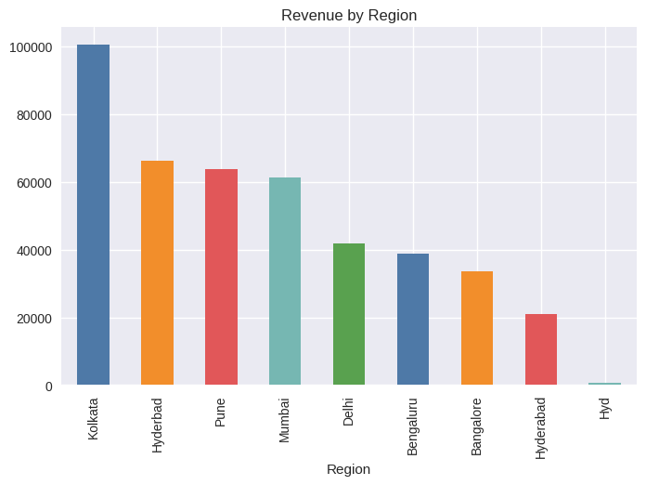
Figure 3. Revenue by Region — exact visualization supplied from the team's Colab output.

Interpretation
Kolkata has the highest visible regional revenue, followed by Hyderabad, Pune and Mumbai. Delhi, Bengaluru and Bangalore form the middle group, while Hyderabad and Hyd appear lower in the supplied output. The chart is reproduced as supplied rather than changing its labels.

Teamwork Connection
The team validates Region values during cleaning, groups Revenue by region during analysis, and uses the resulting summary for visualization and presentation.

VISUALIZATION 4 — SALES CHANNEL DISTRIBUTION
The team groups revenue by Sales_Channel and displays the result as a pie chart. The supplied visualization uses the same blue and orange channel colors and percentage labels.
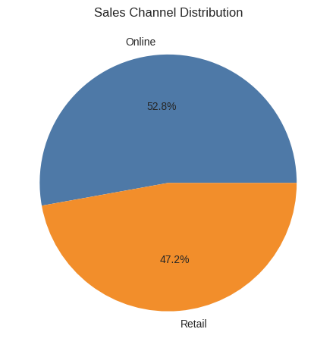
Figure 4. Sales Channel Distribution — exact visualization supplied from the team's Colab output.

Interpretation
Online represents 52.8% of the displayed distribution, while Retail represents 47.2%. The visualization therefore shows a slightly larger contribution from Online than Retail.

Teamwork Connection
Cleaning standardizes Sales_Channel values, analysis calculates channel_sales, visualization converts the proportions into the pie chart, and the team documents the resulting comparison.

VISUALIZATION 5 — CORRELATION MATRIX
The team calculates correlations among MRP, Units_Sold, Revenue and Profit and presents them with a Seaborn heatmap. The supplied output uses the same dark-to-light color scale and annotations.
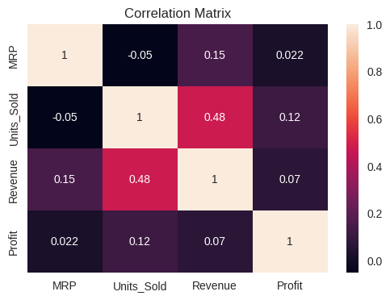
Figure 5. Correlation Matrix — exact visualization supplied from the team's Colab output.

Observed Relationships
- MRP and Units_Sold: -0.05.
- MRP and Revenue: 0.15.
- MRP and Profit: 0.022.
- Units_Sold and Revenue: 0.48.
- Units_Sold and Profit: 0.12.
- Revenue and Profit: 0.07.
The strongest visible relationship in the supplied matrix is between Units_Sold and Revenue at 0.48. The other displayed pairwise relationships are comparatively weak.

Teamwork Connection
The numerical fields are validated during inspection and cleaning, the correlation matrix is calculated during analysis, and the visualization member presents the matrix while the team jointly interprets the displayed relationships.
VISUALIZATION 6 — REVENUE OUTLIERS
The team uses a Revenue boxplot to examine the central distribution, spread and possible outliers. The supplied output uses the same blue boxplot and horizontal orientation.
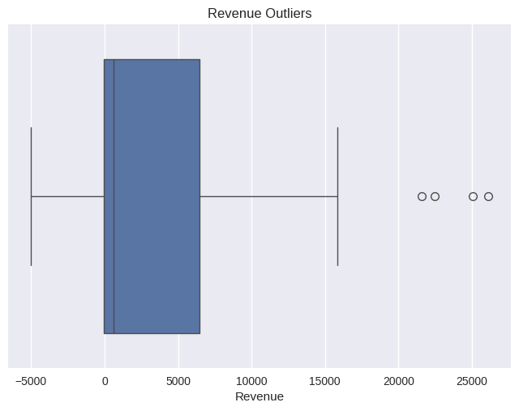
Figure 6. Revenue Outliers — exact visualization supplied from the team's Colab output.

Interpretation
The boxplot shows a broad revenue distribution with several high-value observations appearing as points to the right of the upper whisker. These points indicate potential high-revenue outliers within the supplied visualization.

Why It Matters
Outlier inspection helps the team understand whether unusually high or low observations could influence summary statistics and business conclusions.

Teamwork Connection
The team prepares Revenue during cleaning, uses it for KPI and business analysis, then examines its distribution visually to add another perspective to the final interpretation.

TEAM PROGRESS, FINAL REVIEW AND CONCLUSION

Team Work Completed on 08 August 2026
Our team organized the project documentation structure, recorded member responsibilities, established the workflow and documented the main stages of the Nike sales analysis. Sai Kumar worked on data inspection, Anjali and Indravathi worked on data cleaning and validation, Jyothirmayi worked on visualization, and Ganesh coordinated the documentation.

Progress Updated on 10 August 2026
Our team expanded the documentation into a complete project explanation covering inspection, cleaning, feature engineering, KPI calculations, product/region/channel analysis and visualization.

Final Team Checklist
- Team members and responsibilities documented.
- Dataset inspection and data-quality checks documented.
- Cleaning and feature engineering documented.
- KPIs and business analysis documented.
- Monthly Revenue Trend included with the exact supplied chart.
- Top 10 Products included with the exact supplied chart and color.
- Revenue by Region included with the exact supplied chart and colors.
- Sales Channel Distribution included with the exact supplied chart and colors.
- Correlation Matrix included with the exact supplied heatmap and color scale.
- Revenue Outliers included with the exact supplied boxplot.
- Teamwork connection explained for every visualization.
- Final conclusion and presentation workflow included.

Conclusion
Our team transformed the Nike sales dataset through a connected sequence of inspection, cleaning, feature engineering, KPI calculation, business analysis and visualization. The final visual story covers monthly revenue, top products, regional revenue, sales channels, numerical correlations and revenue outliers.
The visualizations in this final document are the exact images supplied in this conversation, preserving their titles, labels, values, chart appearance and colors. This ensures that the documentation corresponds directly to the team's Colab visualization output.

