We derived the following equations to fit the slowly inactivating K⁺ current (I_{Kd}) as measured from our axonal recordings:
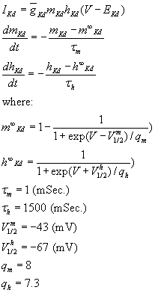
= 0.1 (S/cm²) for the first 60 μm of the axon. The rest of the axon contained the leak conductance only. E_{Kd} = -100 mV. Although the time constant of inactivation used here reasonably fits the slow component of removal of inactivation in real axons, it does not include the fast component. However, this component is prominent only at very hyperpolarized membrane potentials (see Fig. 5E) and is not necessary to include to model action potentials above resting membrane potential.
