Abstract—Dynamic oscillations of local extracellular field potentials between 30 to 100 Hz have been associated with sensory perception, motor task planning, selective attention and working memory in cortical regions of the mammalian brain [1]-[3]. They have also been observed in the hippocampus. However, the degree of correlation between regions with these tasks, as well as their cellular and network mechanisms are still the subject of much study and debate. This is especially true with regard to rhythms observed in the hippocampus, which have been difficult to directly correlate with behavior [1], [4]. A minimal mathematical model was developed to study potential mechanisms of long-range neural transmission of gamma oscillation from the CA3 to the entorhinal cortex via the CA1 region of the hippocampus in this rather complex set of systems. A module was created for each local population of neurons with common intrinsic properties and connectivity to simplify the connection process and make the model more flexible. The first three modules were created using MATLAB Simulink® and tested to confirm that they transmit gamma through the system. The model revealed that initial portion of the signal from CA1 to the entorhinal cortex may be lost in transmission under certain conditions.
Modular minimal model of long-range transmission gamma of oscillation
Teresa A Murray Student Member, IEEE

Index Terms—Entorhinal cortex, hippocampus, Hodgkin-Huxley model, gamma oscillation.

INTRODUCTION
Oscillation occurs when small networks of neurons fire action potentials in synchrony. These local field potential oscillations are a result of coordinated synaptic inputs and cellular properties of neurons which entrain the timing of action potential discharges for a local population of neurons [5]. This bursting activity may supply a dependable input that is capable of transmission of a signal across unreliable, probabilistic synapses between neurons [1]. Gamma oscillation, a form of neural synchrony also known as 40 Hz oscillation can be observed in extracellular field potential recordings as spiking waveforms occurring between 30 to 100 Hz. This rhythmic pattern has been observed in the visual cortex upon presentation of optimal visual stimuli, the olfactory bulb for odor stimuli, and in motor cortex immediately prior to movement [1], [2], [5] and may relate cognition and behavior [6]. Gamma rhythm also occurs in neocortical and subcortical areas and the hippocampus. The hippocampus serves a vital function in higher order brain functions, such as spatial navigation, learning and memory [7]. Hippocampal neurons project to structures via pathways to these other regions including the subiculum, entorhinal cortex (EC), and thalamus, which in turn send efferent signals back to the hippocampus [8] allowing the hippocampus to play a key role in information processing [7].
Short-range synchronization between local populations of neurons does not always result in field potential oscillations, but synchronization over 2 mm usually occurs along with fast field potential oscillation [1], therefore it seems possible that gamma oscillation may be the means of transmitting information over long distances between different brain regions. However, the mechanisms that allow large collections of neurons to effectively interact across different regions of the brain are still not well understood [5]. Furthermore, the idea that synchrony facilitates information transfer between distant components of the nervous system, to create a movement or percept, remains controversial [9].
An example of a neural pathway that spans distances much greater than 2 mm is transmission of information from the CA3 region of the hippocampus to the entorhinal cortex. Signals entering the hippocampus pyramidal cells in the CA3 region, these cells send afferent processes, known as the Schaffer collateral (SC) to the CA1 region, which send signals to other regions including the EC, as shown in Fig. 1. Interneurons (IN) in CA1 appear to entrain the pyramidal cell firing within certain ranges of firing frequencies [1], [5]. This synchronization should be transmitted to the EC.
Mathematical modeling, may lead to possible explanations as to how synchrony is conveyed over these long distances between functional neural centers. The resulting hypotheses could then be tested in vitro or in vivo, the models could be refined and used for further study, including investigations in mechanisms of learning and of pathological conditions, such as Alzheimer's and Parkinson's diseases, attention deficit disorder and schizophrenia [10]. It would be advantageous to have a mathematical model of a hippocampal-cortical system to test mechanisms of propagation of gamma rhythm across multiple regions of the brain. However, these are rather complex systems that involve multiple types of neurons and inhibitory and excitatory feedback loops [1]. So, a streamlined model would be a useful tool for conducting initial investigations. Such a minimal model was constructed. Each type of neuron was modeled as a single compartment with a minimal number of parameters limited to those that are important for their firing rates and entrainment of firing into coherent oscillation in observed frequency ranges. Local networks of the same type of neurons were represented by two neurons at most in a modular fashion. The first three modules of this minimal mathematical system were created using MATLAB Simulink® and tested to confirm that they reproduced experimental observations. These modules include the CA1 and CA3 regions of the hippocampus as well as the CA1 afferent projection to the EC.

Methods

Modeling Network of Excitable Cells
The membrane properties of neurons, the phenomena of excitation, inhibition and their connectivity form the basis of most of the mathematical models used to describe synchrony and oscillatory rhythms in neuronal populations. In general, the most basic oscillatory networks have two major classes of cells, inhibitory interneurons and excitatory principal neurons. Three types of synchronization can result from this combination: (1) inhibition involving interneurons synapsing onto interneurons, (2) recurrent excitation among principal neurons, and (3) inhibition occurring through an excitatory-inhibitory loop [1].
This model incorporates mutual inhibition (1) in the module representing a local network of CA1 interneurons. Recurrent excitation (2) is built into the module for the CA1 pyramidal cell network. Finally, an excitatory-inhibitory loop (3) is formed between CA1 PCs and INs as shown in Fig. 1 below. In the model, the excitatory input from CA3 to CA1 via the Schaffer collateral is simulated with a pulsed current input analogous to their firing frequency in the gamma range. There is a pulse delay on one of the two CA1 PCs to simulate conduction delays [1].

Fig. 1. Diagram of module connectivity. CA3 sends excitatory input to CA1 cells. CA1 INs connect to PCs with inhibitory synapses; conversely PCs connect to INs with excitatory synapses [1].
EC
PC
CA3
PC
Schaffer Collateral
CA1
PC
CA1
IN
Synapse:
Excitatory
Inhibitory
Some methods of simplifying this complex network into a manageable set of equations for creating a model and for simulating it include using single compartment neurons with lumped parameters for ion currents, and limiting the number of neurons in each module to two. Using only two neurons results in a less than smooth trace in some instances, but the firing frequencies are the same as for larger networks [6]. This also made the task of incorporating mild heterogeneity in neural populations relatively simple and added an element of realism [6], [11]. For INs, the current flowing into each cell was slightly different and for PCs, a short varied phase delay was applied. Another simplification strategy was to connect the modules via nodes, rather than wiring each neuron in a network in an all-to-all fashion to neurons in the neighboring network [12].
Each type of neuron was represented using the Hodgkin-Huxley (HH) formalism, with a different set of parameters for each type of neuron. Numerous models of neural activity, including neural synchrony borrow from A. L. Hodgkin and A. F. Huxley’s model of the giant squid axon, consisting of a set of coupled differential equations, was introduced in the 1950s. Their model describes the dynamics in neuronal membrane voltage when specific ions flow in and out of the cell membrane in terms analogous to an RC electrical circuit. It is still the most widely used model of excitable cells [13].

HH Style Equations Shape Interneuron Module
A modified HH model of CA1 hippocampal neurons with inhibitory synapses was developed by White et al. in 1998 to study the effect of mildly heterogeneous neurons on network oscillation and synchronization of interneurons in the hippocampus [6]. Their model of a point neuron, with lumped parameters for each of three ionic currents and the synaptic current, was recreated in MATLAB/Simulink®, and then simulated to ensure that the new model yielded the same responses to current input as shown in Fig. 2. This forms the CA1 IN module. The equations and parameters are described below. A copy of the Simulink® model is included in the Appendix.
A differential equation describes the membrane voltage, V_{m} of a point neuron over time in terms of a current balance as
C dV_{m}/dt = I_{i} – I _{Na} – I_{K} – I_{L} – I_{S}, (1)
where C is a membrane capacitance of 1 μF/cm². The currents across the membrane are, as follows: I _{Na}, sodium ions; I_{K}, potassium ions; I_{L}, leak; I_{S}, synaptic current, and I_{i}, is applied by the experimenter. These currents are described by I_{Na} = g_{Na} m³∞ h (V_{m} – V_{Na}) and I_{K} = g_{K} n⁴∞ h (V_{m} – V_{K}) where the gating of sodium and potassium membrane channels vary nonlinearly as functions of time and membrane voltage. Similarly, the synaptic current is also modeled as a function of time and voltage with I_{S} = Σ (g_{S} /N) s_{j} (V_{m} – V_{S}). The leak current is represented as being dependent upon voltage, but not time, yielding the expression I_{L} = g_{L}(V_{m} – V_{L}) and the applied current, I_{i} is set between 0 – 10 μA/cm² as in White et al. Membrane potential is denoted by V_{m} and the equilibrium potential for each current term is, as follows: V_{Na} = 45 mV, V_{K} = -80 mV, V_{L} = -60 mV and V_{S} = -75 mV [6].
Because the conductance of each ion across the membrane is dependent on both voltage and time, a differential equation is used to model the dynamics of each in 2-4 below. The gating parameter, g is a linear term that represents the maximum conductance and the variables m, n, h and s are functions of time and voltage. Sodium gate activation in the H-H model is normally represented by the variable m. Since interneurons have very fast sodium channels, White et al. assumed that the sodium activation was very fast, so the asymptotic value was used, as follows: m∞ (v) = (1 + exp[0.08(v + 26)])⁻¹. Sodium gate inactivation, h is described by
dh/dt = (h∞ (V_{m}) – h)/τ_{h}(v) (2)
where h∞ (v) = (1 + exp(0.13(v + 38))) ⁻¹ is the maximum inactivation and τ_{h} (v) = 0.6/(1 + exp(- 0.12(v + 67))) is the time constant. Potassium channel activation, n is given by
dn/dt = (n∞ (V_{m}) – n)/τ_{n}(v), (3)
in which n∞ (v) = (1 + exp(- 0.045(v + 10))) ⁻¹ and τ_{n} (v) = 0.5 + (2.0/(1 + exp(0.045(v – 50))). The synapses are assumed to follow first-order kinetics, thus the gating variable s_{j} obeys
ds/dt = F(V_{j})(1 – s) – s_{j}/τ_{s}, (4)
where F(V_{j}) = (1+ exp(- V_{j})) ⁻¹. The synaptic decay constant, τ_{s} range was between 5 – 50 ms. [6]. V_{j} is the membrane voltage of the presynaptic neuron. Two synapses were constructed for each IN. The first facilitates mutual inhibition from neighboring INs and the second is for input from CA1 PCs. Three of the gating parameters were constants, g_{Na} = 30 mS/cm², g_{K} = 20 mS/cm², g_{L} = 0.1 mS/cm², and the g_{S} value ranged from 0 to 2 mS/cm² [6]. Proper functioning of 2-4 was independently confirmed by isolating the subroutine from the model, applying a voltage ramp and observing the sigmoidal curve. Each had the expected form [14]. The dendritic and somatic conductance for each current was lumped using the parameters above to yield characteristics of the waveforms typically observed in recordings, such as the V_{m} resting potential, V_{ion} equilibrium potential, threshold amplitude for an action potential (AP), width of the AP waveform, and frequency response to applied current. Fig. 2A. shows that this module for CA1 IN responds as expected.

Refining CA1 Pyramidal Cell Module
Pyramidal cells produce readily observed field potentials in the hippocampus. A model based on in vivo electrophysiological studies of the hippocampus in rat performed by Varona, et al. was used to produce the initial set of parameters for the CA1 PC module, which also follow HH formalism. The values were refined by testing parameters used in other modeling efforts based on studies of PCs in vivo and in vitro [14]-[16], to yield to waveforms within the range of observed behavior [14]-[18] as described in the previous section.
Parameters values were assigned as follows: g_{Na} = 50, g_{K} = 20, g_{L} = 0.1, g_{S} = 0.5 each in mS/cm²; V_{Na} = 50 mV, V_{K} = -85 mV, V_{L} = -65 mV, and an inhibitory synapse V_{S} = -75 mV to facilitate inhibition via GABA_{A} IN input. The optimal time constant, τ_{s} was 7 ms. A pulse input with periods in physiological range was applied to the “membrane” in the first equation from the previous section to simulate transmission of signals from CA3 PCs. The output from the two CA1 PCs was added and then multiplied by 0.5 to normalize the signal being sent to the next module.
The HH convention for the gating variables, m, n and n was used, which accounts for the slightly different arrangement of function boxes in the model. These equations are of the form dx/dt = α_{x} – x (α_{x} +β_{x}), where x = m, h or n. For Na⁺ activation gating, α_{m} = -3.48(V_{m}-11)/(exp((V_{m}-11)/-12.49))-1) and β_{m} = 0.12(V_{m}-5.9)/(exp((V_{m}-5.9)/4.47))-1); for Na⁺ inactivation, α_{h} = 3/(exp((V_{m}+80)/10)) and β_{h} = 12/(exp((V_{m}-77)/-27))+1); and for K⁺, α_{n} = -0.018V_{m}/(exp((V_{m}/-25))-1) and β_{n} = 0.0036(V_{m}-10) )/(exp((V_{m}-10)/12))-1) [14], [15], [18].

Searching Parameter Space: Entorhinal Cortex Module
Studies and models of the entorhinal cortex principal cells were used to obtain some of the initial parameter values for this module [14], [19], [20]. g_{Na} = 50, g_{K} = 30, g_{L} = 1.8, g_{S} = 0.4 each in mS/cm²; V_{Na} = 50 mV, V_{K} = -95 mV, V_{L} = -65 mV, and a excitatory synapse V_{S} = 0 mV for input from CA1 PC node. I_{i} was set to zero. Na⁺ activation gating parameters were α_{m} = -3.48(V_{m}-11)/(exp((V_{m}-11)/-12.49))-1) and β_{m} = 0.12(V_{m}-5.9)/(exp((V_{m}-5.9)/4.47))-1); Na⁺ inactivation gating was, α_{h} = 3/(exp((V_{m}+80)/10)) and β_{h} = 12/(exp((V_{m}-77)/-27))+1); and K⁺ channels were α_{n} = -0.018V_{m}/(exp((V_{m}/-25))-1) and β_{n} = 0.0036(V_{m}-10) )/(exp((V_{m}-10)/12))-1) [14], [16].
Several parameters were either not defined in the literature or a widely varying values were found. The range of values for each of these was explored to find the values that produced EC-type waveforms in the gamma frequency range. The time constant, τ_{s} was varied from 2 ms to 50 ms. APs were extinguished for values of τ_{s} less than 5 ms; larger values changed the shape of the depolarization curve slightly but did not alter the firing frequency, so a 5 ms time constant was used. g_{S} was also varied and found to facilitate propagation of gamma rhythm at a conductance above 0.4 mS/cm², so this setting was employed. The performance of this network also depended upon the value of g_{L}, with values outside a range of 1.5 to 2.7 mS/cm² rendering the network incapable of transmitting the incoming CA1 signal, g_{L} was set to 1.8 mS/cm².

Results
Preliminary simulations were performed using the interneuron module, consisting of 2 cells with mutual inhibitory feedback that was isolated from the other network modules. As expected the membrane voltage varied with current injection as in White et al. using the same combinations of slightly different current injection levels to represent mild heterogeneity in the population of neurons [6]. Their results for their network representation of self-inhibiting CA1 interneurons were duplicated during simulation of the isolated MATLAB model, confirming that the model was successfully replicated in Simulink ®. Furthermore, their finding that gamma oscillation can be generated and maintained by interneurons in the hippocampus was repeated. The results in Fig. 2A. below demonstrate that the same frequency response was obtained for the identical set of combinations of heterogeneous current levels that they applied to neurons in their model. This can be seen by comparing the membrane voltage traces in their figure 2A with the ones in Fig. 2A below [6].

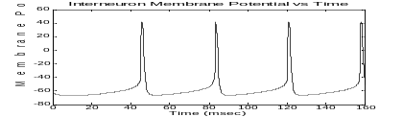
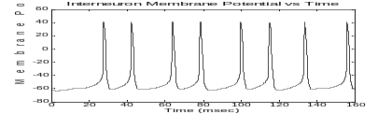
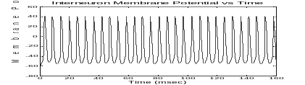
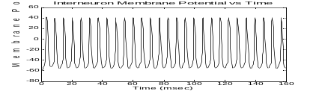
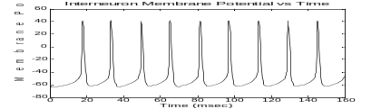
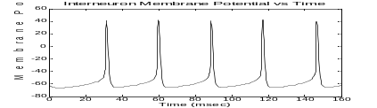
A
B
60
mV
60 ms

Fig. 2. Membrane voltage versus time of one interneuron plotted in A (left) from isolated two-interneuron module during module test and B (right) from system with CA1 IN and PC modules in an excitatory-inhibitory loop. Interneuron firing frequency increases with increasing current input for each network incorporating mild heterogeneity [6], although the two-module system with reciprocal inhibitory feedback has a lower frequency for the same level of current injection. Current injection: top traces 0.4 μA, middle traces 1.6 μA, and lower traces 9.1 μA. Frequency: for A top trace 30 Hz, middle 60 Hz, bottom 180 Hz and for B top trace 25 Hz, middle 56 Hz and bottom 98 Hz. (Vertical scale bar = 60 mV, horizontal scale bar = 60 ms, simulation length was 160 ms.)
To demonstrate the effect of CA1 interneurons on pyramidal cell firing rates, the module was simulated with feedback from the pyramidal cells representing an excitatory-inhibitory feedback loop. For low CA3 input into CA1 via the Schaffer collateral (facilitated by a pulse input into the CA1 neurons in the model). Likewise, a small current injection was applied to the CA1 interneurons (I_{i} = 1.6 and 1.78 μA into each of the two INs respectively). The CA1 pyramidal cells fired at their natural frequency for a low level of input from CA3 without any apparent alteration in their frequency from the interneurons, as shown in the top trace in Fig. 3. At higher levels of CA3 excitation into CA1 (I_{i} = 9.1 and 9.4 μA into the two INs), the CA1 PCs would be expected to fire at the higher end of their frequency range. Apparently, the interneurons entrained the higher PC firing rate, reducing it to the peak of the gamma range at around 50 Hz. For even higher input (I_{i} = 12.4 and 12.8 μA into the two INs), the even higher expected firing rate of the PC network is further reduced to about 40 Hz, which is still in the gamma range.
Transmission from CA1, through CA3 and into to the entorhinal cortex was also examined by simulation of the full model containing all three modules. The model included the feedback from CA1 pyramidal cells to CA1 interneurons. Figure 4 contains overlays of traces of membrane voltage for CA1 pyramidal cells (heavy red traces), CA1 interneurons (black dashed traces) and EC principal cells (thin solid blue traces) generated from separate simulations using increasing levels of input from CA1 to CA3. As expected, the interneurons fire at higher frequencies with higher current input with some modulation from CA1 PCs. They also fire faster than the PCs. Also for each case, the EC principal cells fire just after the CA1 PCs at the same frequencies (when they fire) illustrating an expected conduction delay.
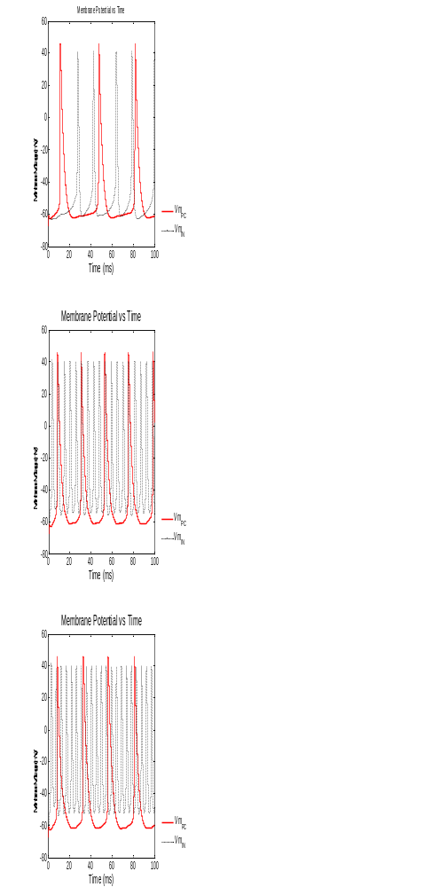
The top plot of Fig. 4 is for the case of low excitatory input into CA3 (I_{i} = 1.6 and1.78 μA into the two heterogeneous INs respectively), the middle plot is for a case of moderately high input (I_{i} = 9.1 and 9.4 μA into INs) and the bottom plot is for

Fig. 3. Heavy red traces are membrane potentials of pyramidal cells in CA1. Black dashed traces are membrane potentials of CA1 interneurons. Top: Low signal level from CA3: Pyramidal cells fire at the rate of 30 Hz set by the CA3 pulse. Interneurons fire at a low frequency of about 50 Hz. Middle: Moderate signal level from CA3: Pyramidal cells fire at the rate of approximately 50 Hz, in the peak of the gamma range as set by the CA3 pulse. Interneurons fire at a frequency of about 180 Hz. Bottom: signal level from CA3: Pyramidal cells fire at the rate of approximately 50 Hz, in the peak of the gamma range as set by the CA3 pulse. Interneurons fire at a high rate of about 210 Hz.

high levels of excitation and firing rates (I_{i} = 12.4 and 12.8 μA into INs). At this higher firing rate the first depolarization in the entorhinal cortex principal cells fails to produce an AP so that the frequency no longer matches the CA1 signal.

Fig. 4. Membrane voltage versus time of CA1 hippocampal pyramidal cell (Vm_{PC} solid red trace), CA1 interneuron (Vm_{IN} black dashed trace) and entorhinal cortex primary cell (Vm_{EC} solid blue trace) from simulation of all three modules connected with excitatory-inhibitory loop in CA1 and a feed forward path to EC.

Discussion
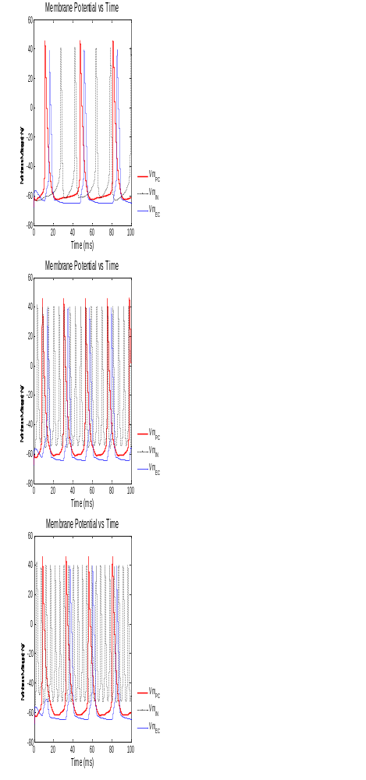
This minimal model of a neural system was developed based upon earlier work that demonstrated that 2 single-compartment neurons could adequately reproduce key features of actual waveforms and their behavior in a local population of neurons [6]. Additionally, it was shown that was not necessary to have all-to-all coupling of neurons [11] in a network model to reproduce appropriate network behavior. Wang’s group postulated that in the limited space of the brain, all-to-all wiring was not feasible. Their modified model coupled several interneurons at a node, with a few of those neurons coupled to interneurons of other nodes. They referred to the coupling scheme as “economy of wiring” and demonstrated that it could produce synchrony and oscillation at a variety of timescales [12]. Their finding was the inspiration for creating this modular set of networks that can be connected with minimal effort and computation. This makes the model more flexible in that various “wiring” schemes may be investigated without rebuilding the interconnections between network neurons one at a time.
Researchers have found that a hippocampal interneuronal network with GABA_{B}-receptor-mediated inhibition could produce 40 Hz oscillations without pyramidal neurons [3], [6]. The first test of the model determined that an isolated module of 2 interneurons could generate oscillations in the gamma frequency range (Fig. 2).
Studies have also shown that blocking synaptic inhibition in networks resulted in exceptionally synchronous epileptiform spiking patterns. Their modeling efforts also revealed that synaptic inhibition is most frequently responsible for synchronization of large populations of neurons [21]-[23]. Therefore, the performance of the neurons in the CA1 inhibitory-excitatory loop was examined to confirm that it too could limit the output to gamma rhythm over a wide range of inputs (Fig. 3). The interneurons appeared to entrain the pyramidal cells firing at higher firing rates. As seen in Fig. 3, interneuron inhibition limited the pyramidal cell oscillation to 50 Hz, which is about the average peak of the gamma range.
Simulating the full three-module model confirmed that gamma rhythm could be propagated from CA1 to EC. Surprisingly, simulations with high levels of excitation from CA3 revealed that leading portion of the signal from CA1 to the entorhinal cortex may be lost in transmission under certain conditions. This may be indicative of actual long-range transmission or it could be a result of inadequately tuned parameters. In either case, the model points to a need for more research to determine more accurate cellular parameters that could improve the model and to devise tests to look at transmission continuity during high activity levels of hippocampal processing.

Conclusions
Reliable transmission of rhythmic oscillation in and between neuronal networks in the hippocampus, cortical regions and other related areas is critical for effective communication of perception, and learning and memory. In vivo studies reveal some evidence, but results can be difficult to replicate or interpret and data sets are incomplete due to the immense complexity of these systems and the relative difficulty of accessing some of these regions. Brain slice recordings allow for easier access to these structures, but maintaining intact and unperturbed networks for studies of long-range transmission of signals over multiple regions of brain is exceedingly difficult at best and may be unlikely. Modeling the cellular and network mechanisms of synchrony may provide clues as to how this transfer is propagated and provide more precise targets for improved studies, as well as indicate potential diagnostic and therapeutic targets for neural disorders. This proof-of-concept modeling effort suggests that modular mathematical modeling simulations may be scaled up to the point that they can provide enough information to formulate suitable hypotheses regarding the mechanisms that propagate gamma oscillation frequency over relatively large distances.
Appendix
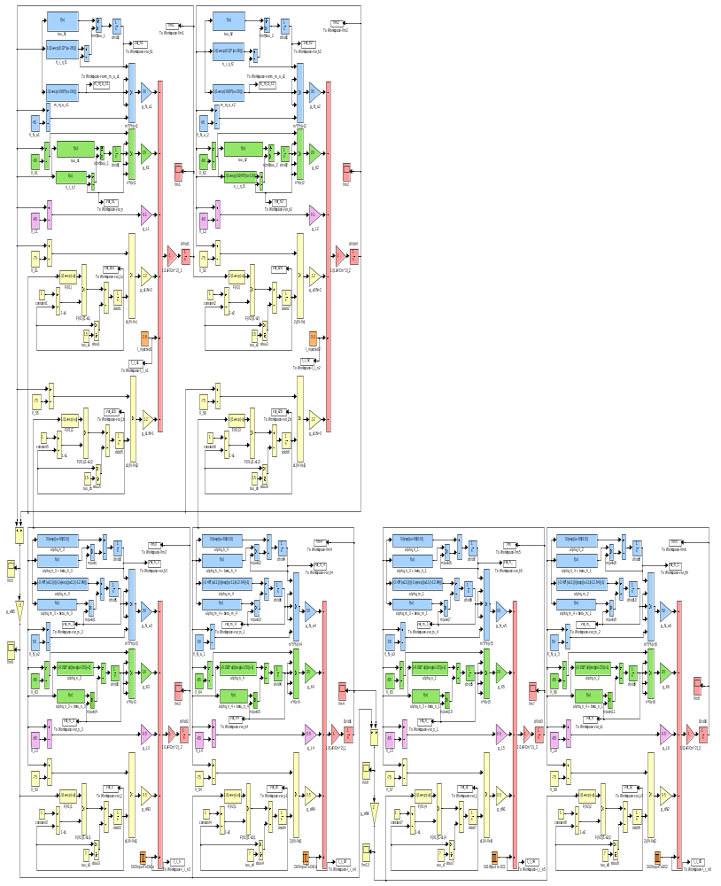
A copy of the MATLAB Simulink® modular minimal model for transmission of gamma frequency from CA3 to CA1 via a network of pyramidal cells and interneurons to the entorhinal cortex is shown below. The first panel shows the CA1 interneuron network at the top and the CA1 pyramidal cell

network at the bottom. The PC network is connected to the population of entorhinal principal cells (this portion was cropped out and placed beneath the other two modules to allow for a larger view of the system).
Acknowledgment
The author thanks Drs. James Abbas, Sharon Crook and Steven Baer, all Arizona State University faculty members for modeling advice.
References
- X-J. Wang. Neural Oscillations, 2003 Available: http://www.wanglab.ccs.brandeis.edu/pdf_pub/wang.ecs2003.pdf.
- A. Bragin, G Jando, Z Nadasdy, J Hetke, and G Buszaki, “Gamma (40-100 Hz) oscillation in the hippocampus of the behaving rat,” J. Neurosci., vol. 15, pp. 47-60, 1995.
- M.A. Whittington, R. D. Traub and J. G. Jefferys, “Synchronized oscillations in interneuron networks, driven by metabotropic glutamate receptor activation,” Nature, vol. 373, pp. 612-615, 1995.
- R. D. Traub, J. G. R. Jeffereys, M. A. Whittington, Fast oscillations in cortical circuits. Cambridge, MA, MIT Press, 1999.
- J. J. Chroback and G. Buszaki, High-frequency oscillations in the output networks of the hippocampal-entorhinal axis of the freely behaving rat. J. Neurosci., vol. 16, pp. 3056-3066, 1996.
- J. A. White, C. C. Chow, J. Ritt, Soto-Trevino, N. Kopell, “Synchronization and oscillatatory dynamics in heterogeneous, mutually inhibited neurons,” J. Comp. Neurosci., vol. 5, pp. 5-16, 1998.
- H. Dvorak-Carbone and E. M. Schuman, "Patterned activity in stratum lacunosum moleculare inhibits CA1 pyramidal neuron firing," J. Neurophysiol., vol. 82, pp 3213-3222, 1999.
- I. M. Stanford, R. D. Traub, and J. G. R. Jeffereys, “Limbic gamma rhythms. II. Synaptic in intrinsic mechanisms underlying spike to blitz in oscillating subicular neurons," J. Neurophysiol., vol. 80, pp 162-171, 1998.
- N. Kopell, “We Got Rhythm: Dynamical Systems of the Nervous System,” Notices of the AMS, vol. 47, pp. 6-16, 2000.
- J. Bronzino, editor, The Biomedical Engineering Handbook. CRC Press LLC. Boca Raton, FL, 1995, pp. 927-929.
- D. Golomb and J. Rinzel Dynamics of globally coupled inhibitory neurons with heterogeneity. Physical Rev. E, vol. 48, pp. 4810-4814, 1993.
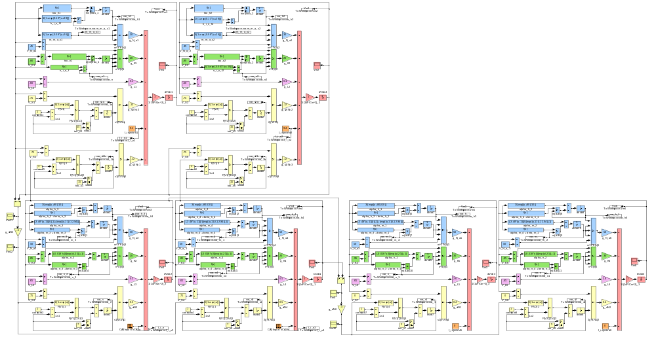
- G. Buszaki, C. Geisler, D. A. Henze, and X-J. Wang, “Interneuron diversity series: circuit complexity and axon wiring economy of cortical interneurons,” TRENDS in Neurosci., vol. 27, 186-193, April 2004.
- J. Keener and J. Sneyd, Mathematical Physiology. New York, Springer-Verlag, 1998, pp. 117, 127.
- X-J. Wang, “Fast burst firing and short-term synaptic plasticity: a model of neocortical chattering neurons,” Neurosci., vol. 89, pp. 347-362, 1999
- P. Varona, J. M. Ibarz, L. Lopez-Aguado, and O. Herreras, “Macroscopic and subcellular factors shaping population spikes,” J. Neurophysiol., vol. 83, pp. 2192-2208, 2000.
- A. Kepecs, X-J. Wang, and J. Lisman, “Bursting neurons signal input slope,” J. Neurosci., vol. 22, pp. 9053-9062, Oct. 15, 2002.
- Y. Fan, B. Zou, Y. Ruan, Z. Pang, and Z. C. Xu, “In vivo demonstration of a late depolarizing postsynaptic potential in CA1 pyramidal neurons,” J. Neurophysiol., vol. 93, pp. 1326-1335, Oct. 10, 2004.
- Z. C. Xu and W. A. Pulsinelli, “Electrophysiological changes of CA1 pyramidal neurons following transient forebrain ischemia: an in vivo intracellular recording and staining study,” J. Neurophysiol., vol. 76, pp. 1689-1697, Sept. 3, 1996.
- H. R. Wilson, “Simplified dynamics of human and mammalian neocortical neurons,” J. Theor. Biol., vol. 200, pp. 375-388, 1999.
- X-J. Wang and G. Buszaki, “Gamma oscillation by synaptic inhibition in a hippocampal interneuronal network model.” J Neurosci, vol. 16, pp. 6402-6413, Oct. 15, 1996.
- X-J. Wang, “Slowly Inactivating Potassium Currents and Cortical Dynamics,” presented at the M.R. Bauer Lecture Series, April 9, 1996. Available: http://www.bio.brandeis.edu/bauer/1996/wang.html
- C. van Vreeswijk, L. F. Abbott, G. B. Ernemtrout, “When inhibition, not excitation, synchronizes neural firing,” J. Comp. Neurosci. vol. 1, pp. 313-322, 1995.
- T. J. Lewis, J. Rinzel Dynamics of spiking neurons connected by both inhibitory and electrical coupling. J. Com.p Neurosci. 14: 283-309, 2003.

Teresa A Murray (SM’03) became a Student Member of IEEE and EMBS in 2003. She is a graduate student in the Harrington Department of Bioengineering at Arizona State University, Tempe, AZ, USA.

Copyright notice: An abbreviated form of this paper, Model of Long Range Transmission of Gamma Oscillation, by Teresa A Murray, was published in IEEE/EMBS Proceedings of the Third International Conference on Neural Engineering, May 2007, Kohala Coast, HI, USA © 2007 IEEE. This manuscript may not be reproduced without the consent of the IEEE.

 Modeling class paper in IEEE format April 4, 2005. TAM supported in part by the National Science Foundation through a Graduate Research Fellowship for author. T. A. Author is a graduate student at Arizona State University (ASU) and affiliate with the Biodesign Institute at ASU, Tempe, AZ 85287-5201 USA phone: 480-965-8162; fax: 480-965-2747; e-mail: teresa.murray@ asu.edu.

