Manual for FRATx (current version FRATx10.m)

The following is a description of how to use the program FRATx.m, which produced all the simulations of Krasne et al (2011). The program was written in Matlab 7.4.0 (R2007a). Also included are remarks relating the program to the mathematical description of it provided in the supplement to the paper (referred to hereafter as the "Supplement"); additional such remarks are included within the program itself. The Supplement is included in the file used to distribute this manual along with the program itself. It can also be found at http:/escholarship.org/uc/item/3hk369c4.

FRATx.m was derived from an earlier program (frat.m) that was written for educational purposes. This manual is modified from the student manual for that teaching program. Therefore, readers should forgive its sometimes didactic or informal style.
It should be mentioned that the educational program, Fraidy Rat (or frat.m) is available at http://mdcune.psych.ucla.edu/modules/frat. The student program is presently available only in compiled form; the necessary Matlab runtime environment needed for using it is also available at the above website (both the program and the Matlab runtime environment are free). The student program is designed to allow students to do standard types of behavioral neuroscience experiments to try to arrive at an understanding of the neural circuitry that underlies fear learning in the automaton. In order to make this problem tractable for the students, the amygdala of frat.m, unlike that of FRATx.m, has only a single LA-like nucleus (the x in FRATx, refers to the "extra" nuclei of the program's amydala over and beyond those of the mono-nucleate frat program). However frat.m has an explicit cortex, hippocampus, thalamus, etc laid out in a two-dimensional stereotaxic atlas and a variety of utilities for doing realistic kinds of experiments. Students can implant stimulating electrodes and recording extracellular microelectores, infuse various drugs, make lesions, etc. We have had considerable experience using it for teaching at UCLA, and we encourage its use elsewhere. We cannot offer support, but when possible, we will try to address occasional questions on an informal basis.
It should be emphasized that FRATx and frat do not give exactly the same results for a given experiment; FRATx was explictly designed to simulate many experimental finings that were ignored in designing the student program, which was designed to achieve the bulk of well-known findings with maximum simplicity. However, simulations of most kinds of experiments are usually qualitatively similar. In fact, the illustrative simulations shown in the manual below, with one exception, used frat rather than FRATx. Therefore most results illustrated in the manual will be slightly different when run using FRATx.

1. Notation

The variable and parameter names used in the Supplement were made as compact as possible to facilitate writing of equations. In the program we often opted instead for longer descriptive names. Moreover, in order to increase readability without using extensive dashes, case of letters in variable and parameter names was adjusted arbitrarily to help the eye parse long variable names. E.g. the "CEM" and "cem" in "CEMs=1" and "Acem", respectively, both refer to central nucleus. Also, in the mathematical description of the Supplement we generally specified the nucleus and cell type of a variable as a subscript; thus A_{LA p} was the activation of principal cells of LA. However, in the program, the amygdala principal cells of LA were called "p" cells, the principal cells of BL were called "q", the inhibitors of LA were referred to as "i" cells, and the inhibitors of BL were called "j" cells. Thus the activation of LA principal cells in the program is simply Ap, the membrane potential of p cells is Vp, etc.

The following table gives translations where the above general rules are insufficient.
Parameter  or variable  for model | Param or  variable for program | Description and comment
α_{LA} | alphaLA | Reinforcement parameter for LA principal cells
α_{BL} | alphaBL | Reinforcement parameter for BL principal cells
β_{LA} | betaLA | Extinction parameter for LA interneurons
β_{BL} | betaBL | Extinction parameter for BL interneurons
η_{LA} | etaLA | Reinforcement parameter for LA interneurons
η_{BL} | etaBL | Reinforcement parameter for BL interneurons
ζ_{LA} | zetaLA | Extinction parameter for LA principal cells
ζ_{BL} | zetaBL | Extinction parameter for BL principal cells
N_{Pcs} | NPcs | Number of cxp neurons representing each CS. 100 by definition
N_{Pcntxt} | NPcntxt | Number of cxp contextual element -representing neurons that can be activated by each context.
N_{I} | NI | Number of cxi neurons available to represent each context
N_{Tcntxt} | NTcntxt | Number of cxt conjunction-representing neurons available to represent each pure context
N_{Tcnj} | NTcntx_cs | Number of cxt neurons available to represent each context/CS conjunction.
N_{Hcntxt} | NHcntxt | Number of hc neurons available to represent each pure context
N_{Hcnj} | NHcntxt_cs | Number of hc neurons available to represnt each context/CS conjunction
V_{LAiMxat} | ViMax | Value of V at which activity of LA interneurons reach unity
V_{BLiMxat} | VjMax | Value of V at which activity of BL interneurons reach unity
V_{LApPrxMxat} | VpMax | Value of V at which activity of LA principal cells reach unity
V_{BLpPrxMxat} | VqMax | Value of V at which activity of BL principal cells reach unity
g_{iLA} | Gi | Relative inhibitory conductance produced LAi-LAp synapses
g_{iBL} | Gj | Relative inhibitory conductance produced by BLi-BLp synapses
g_{BL-CDEm} | Gp_cemON | Parameter specifying strength of fully potentiated LAp - CEm connection.
g_{LA-BL} | Gpq | Relative (i.e 'specific')conductance produced in BLp by LAp
a | a | Activity of CEm that causes maximal F activity
b | b | Activity of CEm at which F begins to respond
c | c | Rate of rise of freezing
d | d | Rate of decay of freezing
σ | psec | Parameter specifying effectiveness of secondary relative to that of primary reinforcement
S_{mx} | maxsec | Activation of A_{CEm} at which A_{S} saturates at unity
π | pi | Exponent controlling attenutation of A_{U} by Ω
Ω_{thrsh} | opThrsh | Threshold value of A_{CEm} at which Ω becomes activated
ξ_{LA} | ArMultLA | Parameter specifying relative impact of A_{R} on back-propagated activity in LA principal cells
ξ_{BL} | ArMultBL | Parameter specifying relative impact of A_{R} on back-propagated activity in BL principal cells
κ_{LA} | kappaLA | Parameter specifying relative impact of A_{R} on 'Ca' level of LA interneurons
κ_{BL} | kappaBL | Parameter specifying relative impact of A_{R} on 'Ca' level of BL interneuurons
θ_{LApR} | thrshRp | Threshold value of B at which R_{LAp} begins to increase
θ_{LAiR} | thrshRi | Threshold value of 'Ca' at which R_{LAi} begins to increase
θ_{LAiX} | thrshXi | Threshold value of 'Ca' at which X_{LAi} begins to increase
θ_{LApX} | thrshXp | Threshold value of B at which X_{LAp} increases
θ_{BLpR} | thrshRq | Threshold value of B at which R_{BLp} begins to increase
θ_{BLiR} | thrshRj | Threshold value of 'Ca' at which R_{BLi} begins to increase
θ_{BLiX} | thrshXj | Threshold value of 'Ca' at which X_{BLi} begins to increase
θ_{BLpX} | thrshXq | Threshold value of B at which X_{BLp} increases
δ_{LA} | endXp | Level of B at which X_{LAp} returns to zero (see Fig. 5C of main paper)
δ_{BL} | endXq | Level of B at which X_{BLp} returns to zero (see Fig. 5C of main paper)
γ | gammaXi | Rate of rise of X_{LAi} (see Fig. 5C of main paper)
ρ | gammaXj | Rate of rise of X_{BLi}
k_{λ} | ilTau | Rate of hippocampal incidental learning
k_{μ} | ilHxTau | Rate of cortical incidental learning
c_{λ} | ilExp | Exponent for hippocampal incidental learning
c_{μ} | ilHxExp | Exponent for cortical incidental learning
k_{λ cnj} | ilCmpndTau | Rate of hippocampal incidental learning for cntxt/CS conjunctions
k_{μ cnj} | ilHxCmpndTau | Rate of cortical incidental learning for cntxt/CS conjunctions
c_{λ cnj} | ilCmpndExp | Exponent for hippocampal incidental learning for cntxt/CS conjunctions
c_{μ cnj} | ilHxCmpndExp | Exponent for cortical incidental learning for cntxt/CS conjunctions
λ_{max} | mx | λ above which λ set to unity
µ_{max} | mxHx | µ above which µ set to unity
ε | thrshElig | Threshold activation for eligibility function.
λ_{A} , etc | ilA, etc. | Hippocampal incidental learning variables
µ_{A} , etc | ilHxA, etc | Cortical incidental learning variables
ν | naloxone | Naloxone flag
A_{F} | Af | Freezing score
A_{F*} | Fsmrd0 | A temporally smeared version of A_{F}
Φ | Fsmrd | A value of A_{F*} suppressed by the US.

2. Using the program

FRATx10.m was written in Matlab 7.4.0 (R2007a). The program and all supporting files (supplied in a folder called fratxProgram (which is a subfolder of a folder called "fratx for posting") should be placed in a single folder. The program requires FRATx10.fig to support the graphical user interface. The program as written also requires some files that are used for the program's animation feature. These are Slide1.jpg, fratframes1, and fratshkd3frames; the program could easily be revised not to need them. The program requires Matlab to run, but requests for a compiled, runtime version will be considered. To start the program, double click the fratx10.m entry in your folder's list of files. When the program comes up in the Matlab Editor, hit F5.

When the program starts, two windows should appear. One is a control panel called fratx... and the other is an animation viewport called Figure 1: Animation, as shown below. This indicates that the program is ready for use.
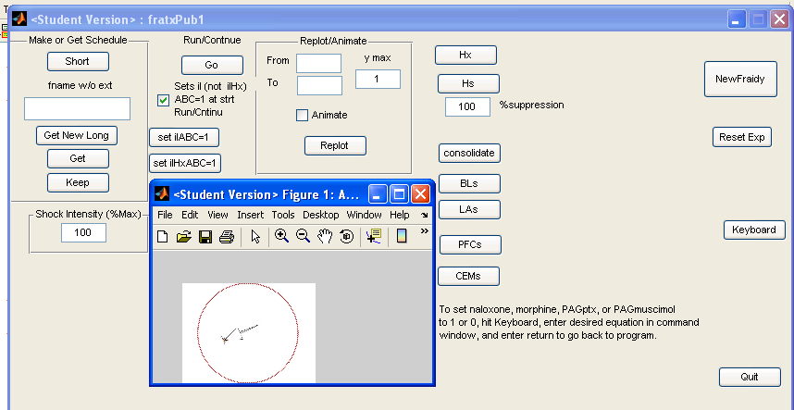

The program allows you to present either of two CSs: CS1 or CS2. Fraidy Rat can be placed in any of three very different environments (contexts A, B, or C), or in its home cage (context 0), where you can't mess with him. You can give him a US (shock) whenever you want so long as he is not in his home cage.

Experiments are specified by an array that within the program is called Exp. It can be constructed either externally or by she "Short" scheduling utility callable from the FRATx GUI.

Each row of Exp has in order:
col: 1 2 3 4 5 6 7
row number, cntxt, cs1, cs2, us, pause, duration (# of 1 sec computation intervals)

Col 1: Exp array row #
Col 2: Context. 1~A, 2~B, 3~C. 0~no context; used optionally when a pause in the expreriment is
scheduled.
Col 3: 1~CS1 on; 0~CS1 off
Col 4: 1~CS2 on; 0~CS2 off
Col 5: 1~US on; 0~US off
Col 6: 0~no pause; 1~pause experiment until Run/Resume button on GUI hit. When value is unity (pause
called) other column 2,3,4,5, and 7 values are ignored.
Col 7: Number of computation intervals during which to apply specifications of this row. Not relevant for
lines requesting a pause.

You may set up an experiment in either of two ways, the “short” way or the “long” way (see the upper left of the control panel). The short way is simpler but has less flexibility. The long way (mostly explained above) is a little more complicated but allows you to do some things that you can't do with the short method. It will be spelled out below.
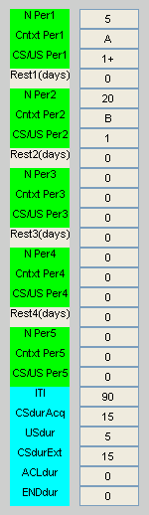
2.1 Specifying an experiment the short way.

Hit Short in the box at the upper-left of the screen. You will see 5 similar green panels separated by white rows plus a turquoise panel at the bottom. The green rows allow you to schedule 5 periods of the experiment separated by rests. Some parameters that are common to all the periods are entered in the turquoise region.

The Short programming method is intended to allow convenient scheduling of standard delay-conditioning experiments in which CS and US co-terminate. Suppose you wanted to schedule an experiment in which you gave 5 conditioning trials using CS1 in context A followed by 20 extinction trials in context B with no rest in between:

You would replace the zeros by the correct values (as shown). For N Per 1 (the number of trials in period 1) you would enter 5. For Cntxt Per 1 (the context for period 1) you would enter A (the program is very case-sensitive). For CS/US Per 1 (the CS to be given, followed by a plus sign ‘+’ if a shock is to be given during the CS and by nothing if a shock is not to be given) you would enter 1+ with NO SPACE between the CS designation and the + sign). If you just wanted to give a US (shock) and didn't want to present a CS, as might be the case if you just wanted to condition fear to the context, you would enter 0+ (you must always enter a 0 if there is to be no CS). Rests are not implemented in fratx (in frat they indicate the number of days in the home cage between one part of an experiment and the next). In the next green block we have programmed the 20 trials of extinction, which occurs in Context B. Note that since there is no US during extinction, there is no + following the CS designation.

At the bottom in the turquoise region you must enter the inter-trial interval (ITI), which will be 90 sec, the CS duration during acquisition (CSdurAcq), which will be 15 sec, the US duration (USdur), which will be 5 sec, and the duration of the CS on extinction trials (CSdurExt) which will be 15 sec. The ITI refers to the time between the simultaneous offset of the CS and US and the start of the next CS. All CS periods, even the first, are preceded by a duration of one ITI. The last two rows allow you to automatically insert an extra rest of a specified number of seconds at the start of each period (aclimitization interval, ACLdur), or at the end of each period (ENDdur); you will probably have little use for these and will usually leave them at 0. We will explain the long form of programming later.

Please note that every box must have an entry. If a box is not relevant for a given experiment, its entry should be 0. When you are done entering the necessary information, hit Done.

An experiment can be made to pause (for making lesions, etc) by placing a minus sign before the number of intervals at the start of a green block (no spaces).

Any time after hitting Done you can save the schedule you are using by entering a name for it in the box labeled fname w/o ext (file name without extension – i.e. no dot) then hitting Keep. Any time you want to make a saved schedule operative, enter its name in the box and hit Get; it will replace any previously entered schedule. You can always see any current short schedule (hand-entered or obtained with Get ) by hitting Short (and you can then modify it as you like) and then Done again to make it available for use. If you want save a modified form of a previously saved schedule without over-writing it, give it a different name before hitting Keep. The schedules you keep in this way get stored in the same folder that has the .m file with the source code for your fratx program.

Note that you can adjust the strength of the US by altering the value in the box called Shock Strength (the max of 100 is preset, but you may change it). Most simulations of Krasne et al (2011) were done using a shock strength of 100 (the maximum). But for some experiments it is necessary to get weak conditioned fear, and this can be done by lowering the strength of shock. You might think that you could achieve the same end by simply giving only a few training trials. But strong fear is learned in only one trial when using a very strong shock.

4.2 Running an experiment.

To run the experiment that you have just prepared hit Run/Continue. If nothing happens, be patient. Sometimes the program needs time to warm up before it is ready for use. Eventually, charts will appear showing the extent of freezing per second (0 means uninterrupted movement and 1 means total freezing) as well as a graph showing events such as the CS, US, context changes, as a function of time (time axis in seconds). The graphs for this experiment should look something like this [The figures in this manual were mostly made using the student version of the program, frat, rather than fratx. The FRATx results will be qualitatively similar to the frat results but not the same. However, just the one graph below was done with FRATx. There will be a number of additional windows showing the values of various variables, which for now can be ignored. Once you are familiar with the program code they will make sense.]:
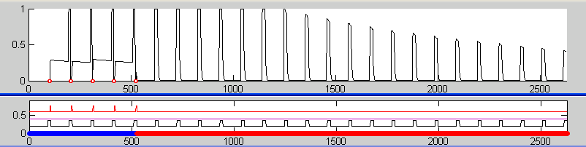
In this case notice that freezing was zero until the first CS/US offset, at which point Fraidy Rat froze substantially. This freezing was due to fear of the context. No freezing was seen during the US because Fraidy Rat's innate response to foot shock is to dance wildly about. After the first CS/US pairing and prior to the next onset of the CS, freezing abated very slightly due to a bit of extinction. But when the CS came on again, there was an increase in fear due to Fraidy Rat having learned to be afraid of the CS on the first pairing. Freezing drops back to zero again when the second US is presented. After five pairings, extinction training commenced in context B. Notice that as soon as the context switched to B, the baseline freezing that had been seen between CS presentations in context A vanished; that is because Fraidy Rat was not afraid of context B, only context A. When the first CS of extinction occurred (the CS was not followed by shock), Fraidy Rat froze, and this happened every time there was a CS, but the freezing to the CS gradually extinguished. .

In order to get a pure measure of fear of the CS that is not mixed together with fear of the context, investigators who are primarily interested in responses to the CS, as opposed to fear of the context, usually test responses to the CS in a different context from that in which conditioning occurred, as we did here. The advantage of this strategy is shown by examining the response to the CS on the last conditioning trial: when the CS1 turns on, the freezing score goes from about 0.3 to 1.0 (i.e. total freezing). You cannot tell from this whether CS1 alone without context would have caused total freezing, but it becomes apparent when Fraidy Rat is tested in a neutral context on the first trial of extinction, that it does do so.

2.3 Continuing a paused experiment

To continue an experiment after a scheduled pause, hit Run/Continue again.

2.4 Re-plotting or animating an experiment.

The program plots the entire experiment on one graph, and things can get pretty compressed in time. To spread them out use the Replot/Animate feature. Just write the first and last x-axis value you want to plot in the From and To boxes, respectively, and hit Replot. Try re-plotting from 1 to 500 [use 1, not 0 as your lowest x value].

You can also see an animation of what Fraidy Rat is actually doing. [The animation, which is very desirable when using the student version of the program for teaching, was retained in fratx just for fun.] To see the animation run Replot with the little Animate box checked. In the animation, the context or situation in which Fraidy Rat finds itself is indicated by the color of the sides of the display (red, green, or blue). The CSs are tones, one pitch for CS1 and another for CS2, which you can hear if your speaker system is turned on. We have also provided two circular lights that turn on, one during CS1 and another during CS2, so that you can tell when CSs are occurring if you don't have a speaker system. But Fraidy Rat can't see these; they are just for you. The animation plays at substantially faster than real time. Nevertheless, you should probably not specify more than about 300 sec of animation, because it will take too long to play, and depending on your computer resources, you could crash the program. You will see that before any conditioning, Fraidy Rat continually explores his testing chamber. But when a cue of which he has become afraid occurs, he slows down or stops moving.

2.5 Wiping Fraidy Rat’s brain clean.

You can wipe Fraidy Rat's brain clean by hitting NewFraidy in the upper right corner of the screen. If pauses were scheduled, be sure the experiment is completed before hitting New Fraidy or strange things may happen.

2.6 Starting a new experiment on the same Fraidy

You can start a new experiment (and new graph) on a previously trained Fraidy by hitting Reset Exp.

2.7 Exiting the program
Hit Quit. Avoid quitting the program by closing windows; it ends up being cumbersome and the program can be slow to stop.

2.8 Scheduling experiments using the Long method.
So far we have been using the easy “Short” method of scheduling experiments, but there are some things you can't do with this. Suppose you wanted to see what Fraidy Rat learns when you present a CS during, rather than before, a US. A real rat would not learn to fear the CS under these circumstances, because the CS does not actually warn of the US, which is already occurring when the CS comes on. As a way of illustrating the Long method of scheduling, let’s see what Fraidy Rat does under such circumstances. You probably won’t need this method very often, but you can refer back to the next few paragraphs when and if you do.

Long schedules are prepared in Excel and imported into Fraidy Rat. The rules are these:
An experiment is specified by a number of rows, each having 7 entries. Each row tells the program to do something for a specified period of time. Each row has 7 items (each in its own column) which are as follows:

Col A. The row number (you must explicitly enter this; our program does not see the inbuilt
Excel row numbers).
Col B. The context: 0=Home Cage 1=Context A 2=Context B 3=Context C.
Col C. CS1: 0=No 1=Yes
Col D. CS2: 0=No 1=Yes
Col E. US: 0=No 1=Yes
Col F. Execute a Pause in the experiment. This allows an opportunity to press effect consolidation, Hx, Hx, etc.

The following Long schedule has some text to explain what is being scheduled, but real Long schedules must not have anything except the numbers on them or Fraidy Rat will crash. This schedule has Fraidy Rat sitting in context A for 60 seconds, then the US comes on, then CS1 comes on, then the US is turned off, then after 2 more seconds CS1 shuts off. In other words, the US comes on for a short time in the middle of the CS, as we had wanted. This is done three times.
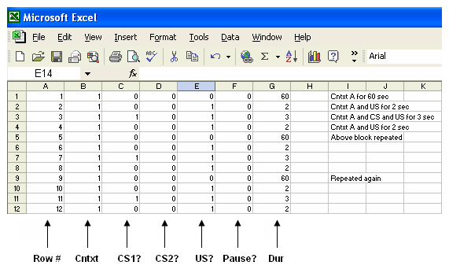
The file is then saved as a text file (tab delimited), which is a format option Excel provides. Again, the spread sheet must have nothing but the block of numerical information. Any other writing on the sheet will cause Fraidy Rat to crash.

You should now open an Excel file and copy the above numerical information into it. You should also add three lines of your own to specify a test of CS1 in context B. That way, when you run the experiment you will see if any response to CS1 has been learned without any background contextual fear to possibly confuse things. Specifically: (1) switch to context B for 60 sec, (2) add in CS1 for 3 sec, and (3) have context B alone for 60 more sec.

Save your file as a tab delimited text file (one of the Save As options in Excel). You can name it whatever you want. Place it in the same folder where the Fraidy Rat program lives. Then go back to Fraidy Rat write the name of your file in the fname box of Make or Get Schedule (without the .txt extension), and hit Get New Long. Your schedule should now be operative. However, do not try to see it by pressing Short, because this is not a Short schedule and the program will probably get confused. Now hit Run/Continue. What you get should look like this:

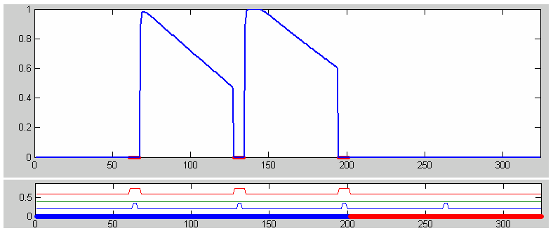

Initially in context A, Fraidy Rat is unafraid and exploring, so the freezing score is zero. When you give the US, he hops about, so the freezing score stays zero. But when the shock stops, he is now afraid of context A and freezes. Over the next 60 sec this freezing extinguishes a bit. But when the shock comes on again, he again hops about, etc. When the context switches to B, all the contextual fear goes away, so the freezing score goes to zero. When the CS1 comes on a little after 250 sec, there is no sign at all of freezing. Thus, like a real rat, Fraidy did not become afraid of a CS that began after the US was already on.

2.9 Switches and other controls

Keyboard. Hitting Keyboard will take you to the Matlab Command window. You can there see the value of or enter new values for any variable or parameter that has been declared as "global" at the start of function goKeyboard_Callback of the program. After doing whatever you have to do there, type return and hit the computer Enter key in order to return control to the GUI.

Ad Hoc Plots. The top graph to come up when a program is run is called "Ad Hoc Plots". This will provide the graph of up to 5 variables that are specified within the program just before Step 10 of function run_continue_Callback.

Special treatment buttons. Hx. Ablates the hippocampus. Hs suppresses the hippocampus (think muscimol) to the extent specified. Consolidate causes the consolidation algorithm to be run. BLs, LAs, PFCs, and CEMs cause total suppression (muscimol) of the nuclei indicated.

Context pre-familiarization. FRAT can be pre-familiarized with all contexts (i.e contextual representations can be established) without writing this explicitly into experimental schedules. When the check box below the Go button is checked, prefamiliarization will occur at the start of all experiments in which Hx has not been invoked. Alternatively hitting ilABC immediately prefamiliarizes to all three contexts if hippocampus is intact and hitting ilHxABC does so if hippocampus has been ablated.

