Sealed end effect
Reviewer 1 comment 15: I wonder if the compartmentalized inhibitory would be similar if the modeled spines are closer to the sealed end of the dendritic branch.
Discussion:
In real layer 2/3 pyramidal neurons the bAP may be strongly or weakly back-propagating which would then determine the impacts of the sealed end effect at various proximal and distal branches of the cell. For example, different cases of the default model (strongly back-propagating) and (weakly back-propagating ones) where the regenerative voltage gated sodium and potassium channel densities are reduced by half or to zero (“passive”) in the dendrite branch are shown below (the x-axis is distance along the dendrite and the y-axis is the voltage). Many voltage snapshots are displayed so the top of these images represent the peak voltages obtained during the simulations:
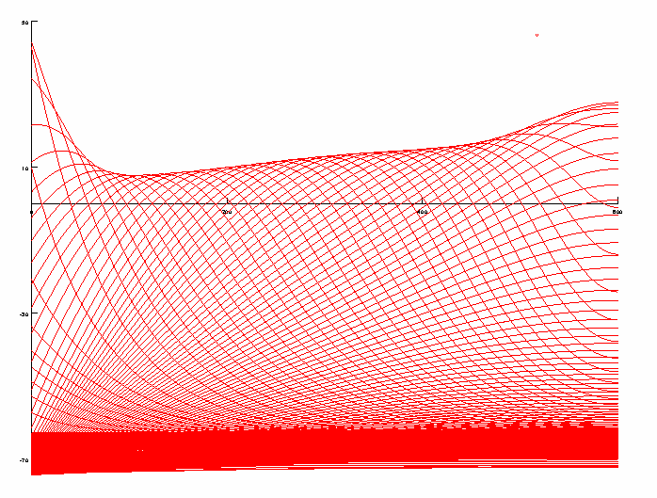
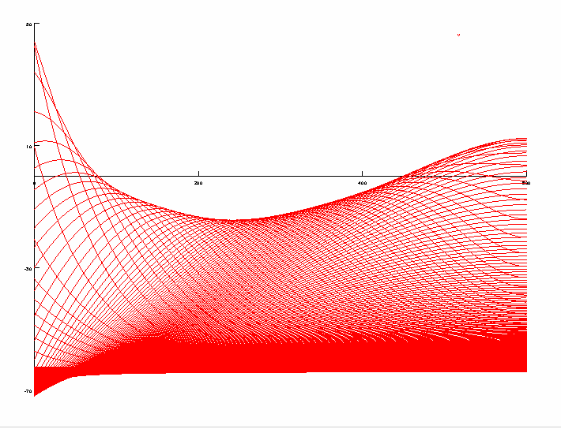
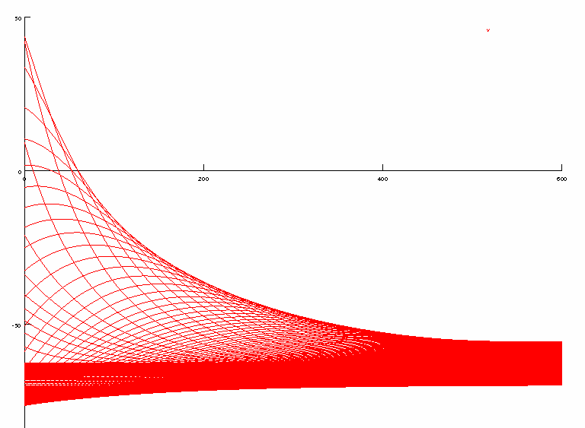

Note simulations with half reduced sodium, potassium dendritic channel densities (above middle) with a longer dendrite (6 mm, below) have the bAP extinguished by the distal tip (one sealed end effect is to boost bAPs if large enough near the sealed end):
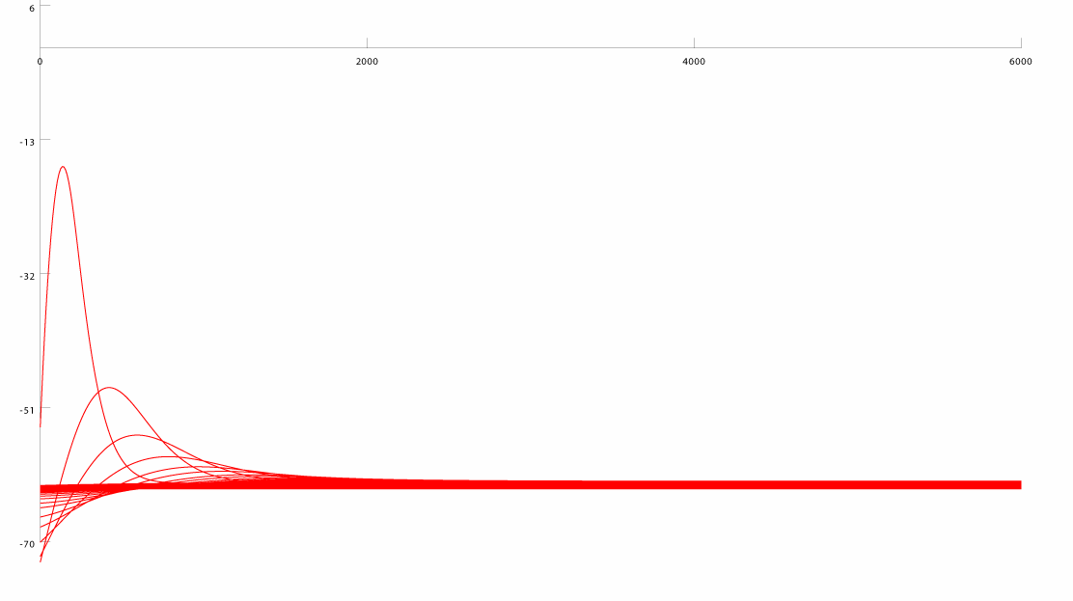
With this in mind lets look at the sealed end effect first in the default model.
The Ca signal in the spine is determined by the shape of the bAP and the presence or absence of the inhibitory event as these determine the voltage trajectory which controls the voltage gated Ca channels Ca current. The bAP has various heights and (temporal) half-widths along the dendritic branch depending on the parameters of the model. Below are spatial profiles of the bAP in our default model at shortly after the time of spike initiation where the voltage peaks at the soma (left), during propagation along the dendrite (middle), and when the peak voltage is reached in the distal tip:

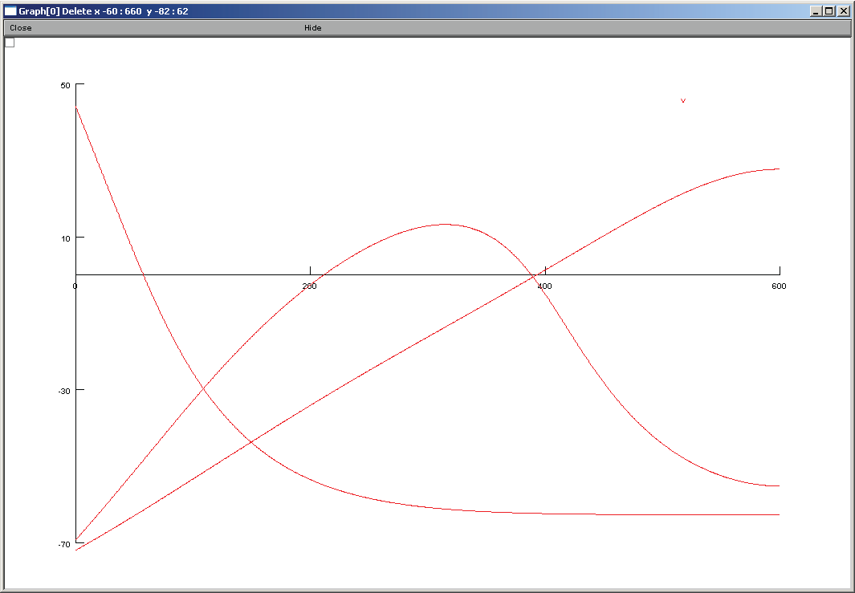
As the spines are moved towards the distal tip of the dendrite the bAP profiles change. Below is a plot again of spatial profiles of the bAP (including the above three) in our default model:
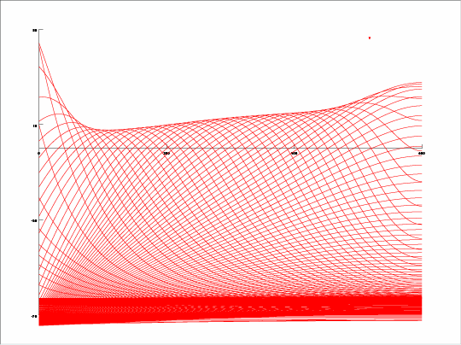
To explore the height variation in the bAP we consider a numerical approximation to an infinite dendrite. BAP profiles for a dendrite that is 10 times as long (6 mm) indicate a constant height is maintained a few hundred microns from the soma until the end of the dendrite:
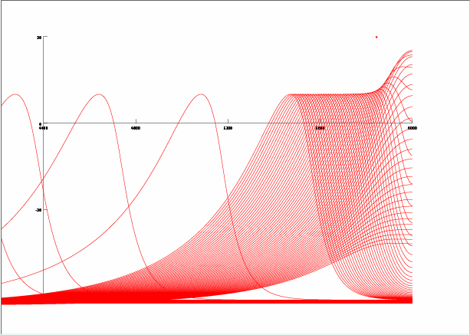
Similarly to the 600 um case the bAP rises up in the last 150 ums of the 6000 um dendrite (a sealed end effect). With this in mind let us consider the delta Ca peaks in bAP alone (ctrl) or bAP coincident with inhibition (inhib) in the spine. These quantities rise, then fall, as the distal spine distance from the soma is moved in the default model (many simulations with inhibited spines position at the x coordinate):
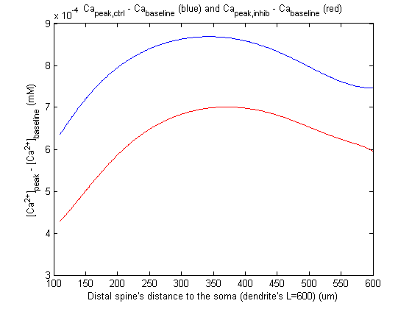
Their ratio rises as function of distance however dips in the distal region:
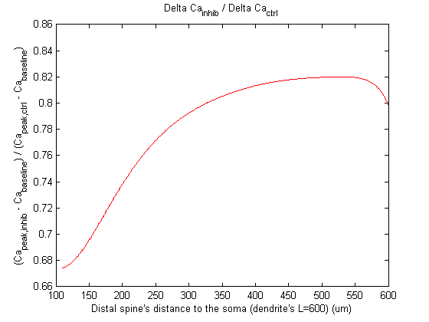
The above graph essentially answers the Reviewers question in that the inhibition ratio is roughly the same (.7-.8) for the spines considered initially 100 microns from the soma and spines near the sealed end (in this case at 600um).
If the bAP height is close to where the voltage gated Ca channels turn on, then coincident inhibition can more significantly change the amount of Ca that enters the spine than in the case where the bAP is high enough that lowering it with inhibition still results in a large enough depolarization to activate Ca channels.
Graphing the height of the bAP peak along the dendrite over four simulations (control (bAP alone) and inhibition (bAP paired with inhibition) in two cases where the spine are proximal to the soma (90, 100, 100 um) and distal (approximately 580, 590, 600 um):

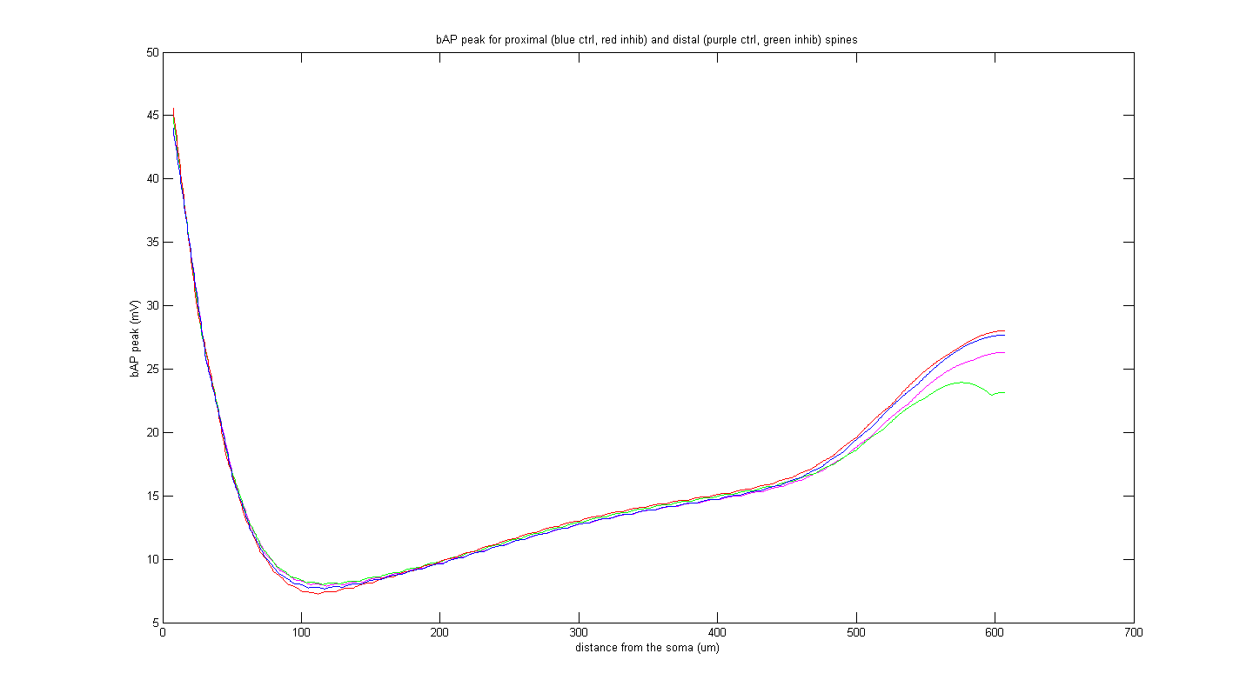
The explanation of growing bAP height corresponds to the (middle dendrite) growing dCa ratio matches however at the distal end this explanation would predict the growing dCa should drop but then rise again at the very end, however the ratio continues to drop. An explanation for this distal tip effect might be the (temporal) half widths of the bAPs have different values for the control and inhibited cases at the different positions along the dendrite. The I_Ca currents are shown below in the default model (for distal spine position at 110), and then when the simulation is run twice more with the spines moved together; the distal one is at 400, and then 600 ums (control black, spine inhibition red) support this hypothesis.

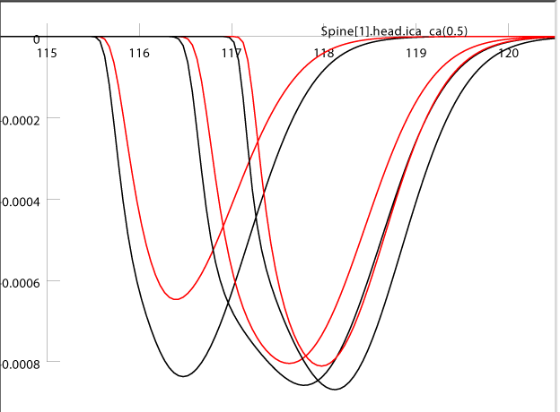

Further thoughts: Calcium currents non-constant spatial distributions are known to be present in some neurons (e.g. Gauck et al. 2001 J Neurosci) and might further complicate the simple theoretical analysis here. The Ca currents in layer 2/3 pyramidal neurons thin distal branch tips have not been investigated experimentally and are challenging because of the small size of the cellular compartments. There is evidence that the Ca signals from bAPs do not reach distal tufts (Waters et al. 2003 J Neurosci 23(24):8558–8567). Sealed ends of the proximal and middle oblique branches will be an interesting area of future experimental investigation when the technology for making these recordings permits it.

