Reduction 1.0 Software
A. Limongiello

Installation

Auto-launch from ModelDB or download and extract the archive and then under:

- ms-win
Compile the mod files by running mknrndll and changing to the extracted folder and selecting to create the nrnmech.dll. Then double click on the REDUCTION1.0.hoc file for the main software and/or double click on MaxStimPROCEDURE1.0.hoc file for the estimation of maxstim parameter useful in REDUCTION1.0.hoc

- linux/unix
Compile the mod files by running nrnivmodl in the extracted folder. Then run "nrngui REDUCTION1.0.hoc" for the main software and/or run "nrngui MaxStimPROCEDURE1.0.hoc" for the estimation of maxstim parameter useful in REDUCTION1.0.hoc

- mac os x
Drag and drop the extracted folder onto the mknrndll icon. Drag and drop the REDUCTION1.0.hoc file from the extracted folder onto the nrngui icon for the main software and/or the MaxStimPROCEDURE1.0.hoc file for the estimation of maxstim parameter useful in REDUCTION1.0.hoc

Use of REDUCTION1.0.hoc

Once REDUCTION1.0.hoc starts you can change many input parameters:

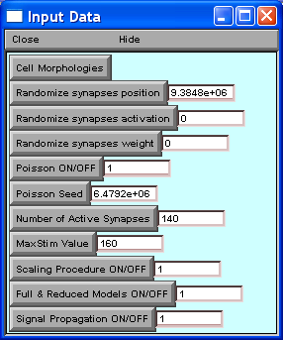 | - Select the Morphology to use  - A seed to randomize the synapses position  - A seed to randomize the synapses activation  - A seed to randomize the synapses weight  - To activate (or not) the Poisson Process  - A seed for Poisson Process  - The number of Active Synapses  - MaxStim Value that can be found from MaxStim PROCEDURE  - To use (or not) the MaxStim Value  - to plot (or not) the two morphologies  - plot (or not) the Signal Propagation of the two models

In the Run Control Panel you can select to run a single model between Morphological or Reduced or both models and after the simulation can see the run time and the accuracy value, as shown below:

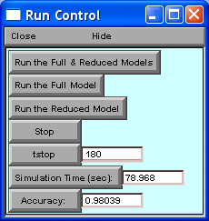
OUTPUT

OUTPUT

An example of output is shown in the following screenshots (Morphology geoc70863.hoc):
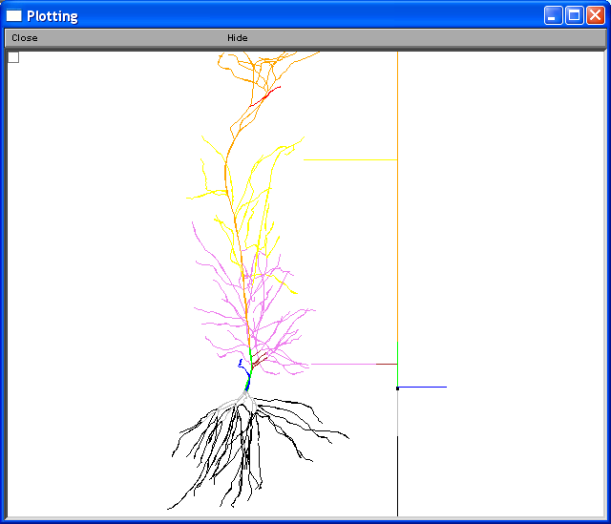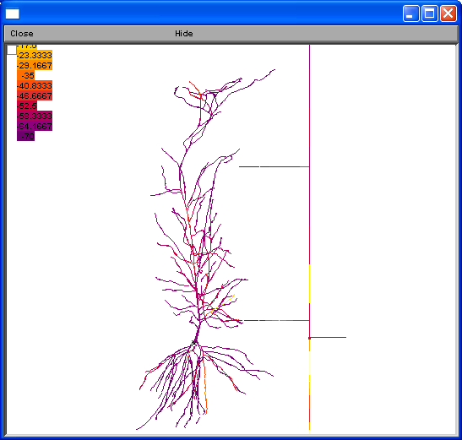
Plot of the clusters and reduced schema Plot of the Signal Propagation of the two models
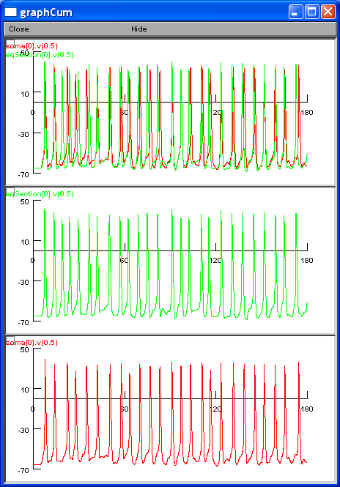
Action potential of Reduced model Action potential of Morphologic model
Action potential of Both Morphologic and Reduced models
Use of MaxStimPROCEDURE1.0.hoc

The MaxStim PROCEDURE has only the number of seed and the morphology as input.

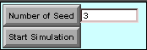

The procedures analyzes the Number of Spikes as a function of the number of synapses, producing a file .xls, and proposes a suitable value for maxStim parameter.

An example of output is shown in the following screenshots (Morphology geoc70863.hoc):

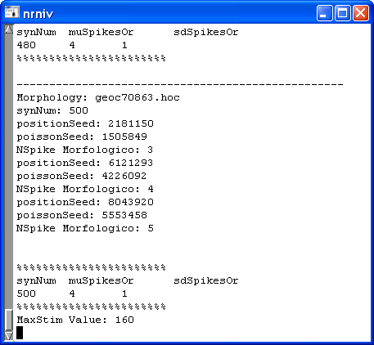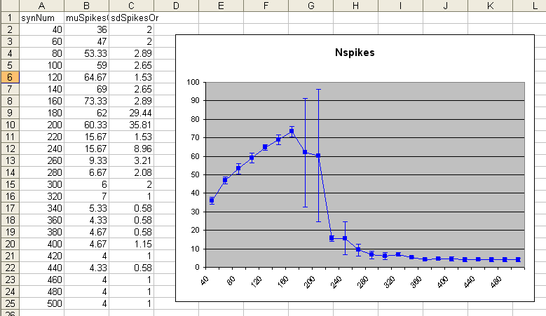

OUTPUT: maxStim

