This is the readme for the models associated with the paper:

Conte C, Lee R, Sarkar M, Terman D (2017)

A mathematical model of recurrent spreading depolarizations.

J Comput Neurosci

[doi:10.1007/s10827-017-0675-3](http://dx.doi.org/10.1007/s10827-017-0675-3)

The code requires XPP, which is freely available from <http://www.math.pitt.edu/~bard/xpp/xpp.html>

The XPP file ‘single_cells.ode’ models one neuron/astrocyte pair.

The XPP file ‘waves.ode’ models a network of 25 neuron/astrocyte pairs.

To run:

-------

Download and extract this archive. On linux/unix you can start with a command like:

xppaut single_cells.ode

Then select in the XPP program

File -> Read set

and select the file "single_cells.ode.set". Then select Integrate ->(G)o in which case you will see the graph:

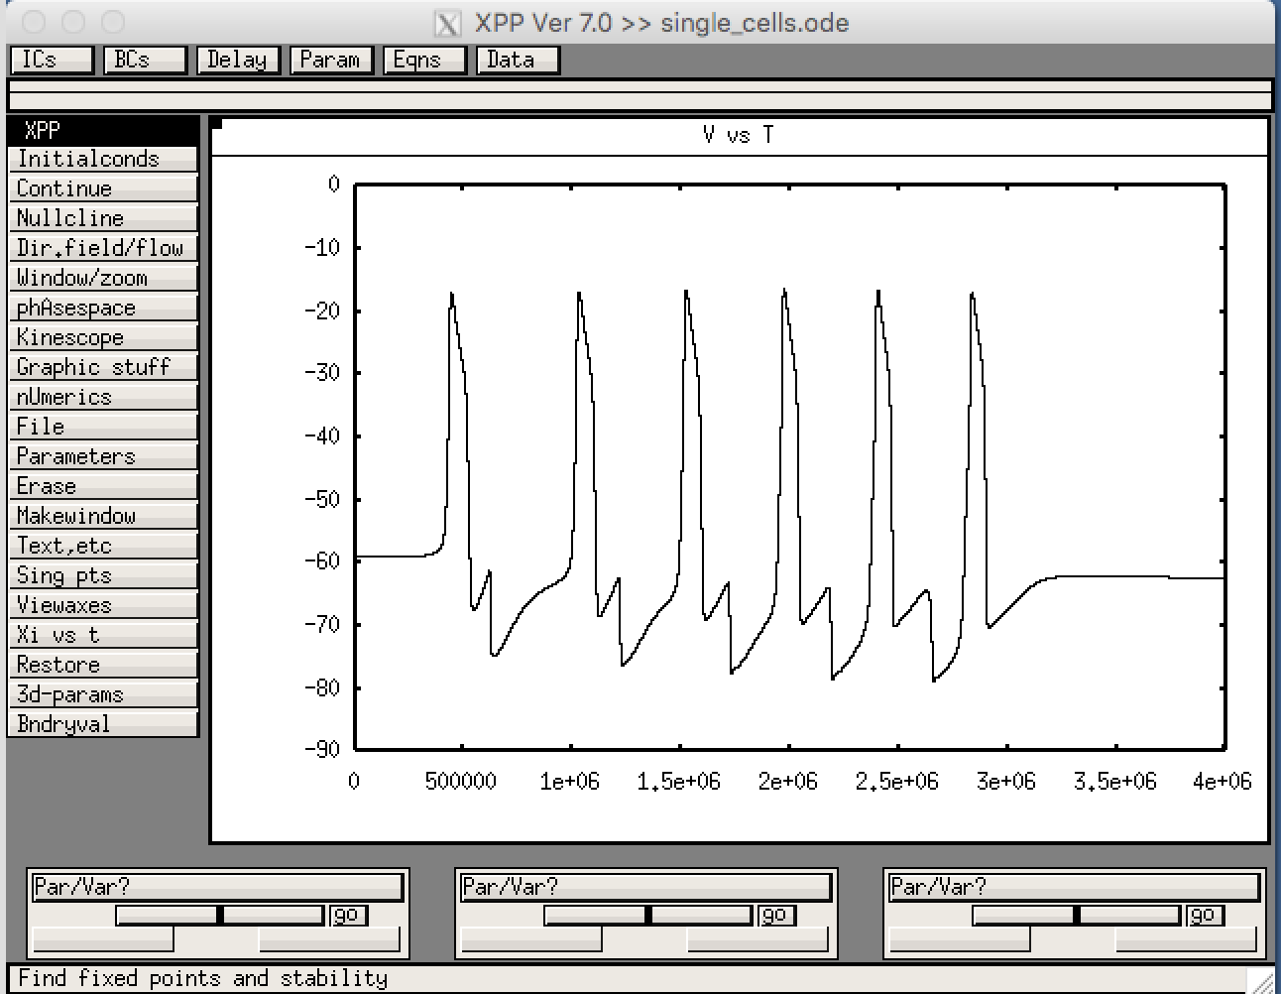

This corresponds to Figure 2 in the paper.

waves.ode can be run in a similar way in which case you will see the graph:

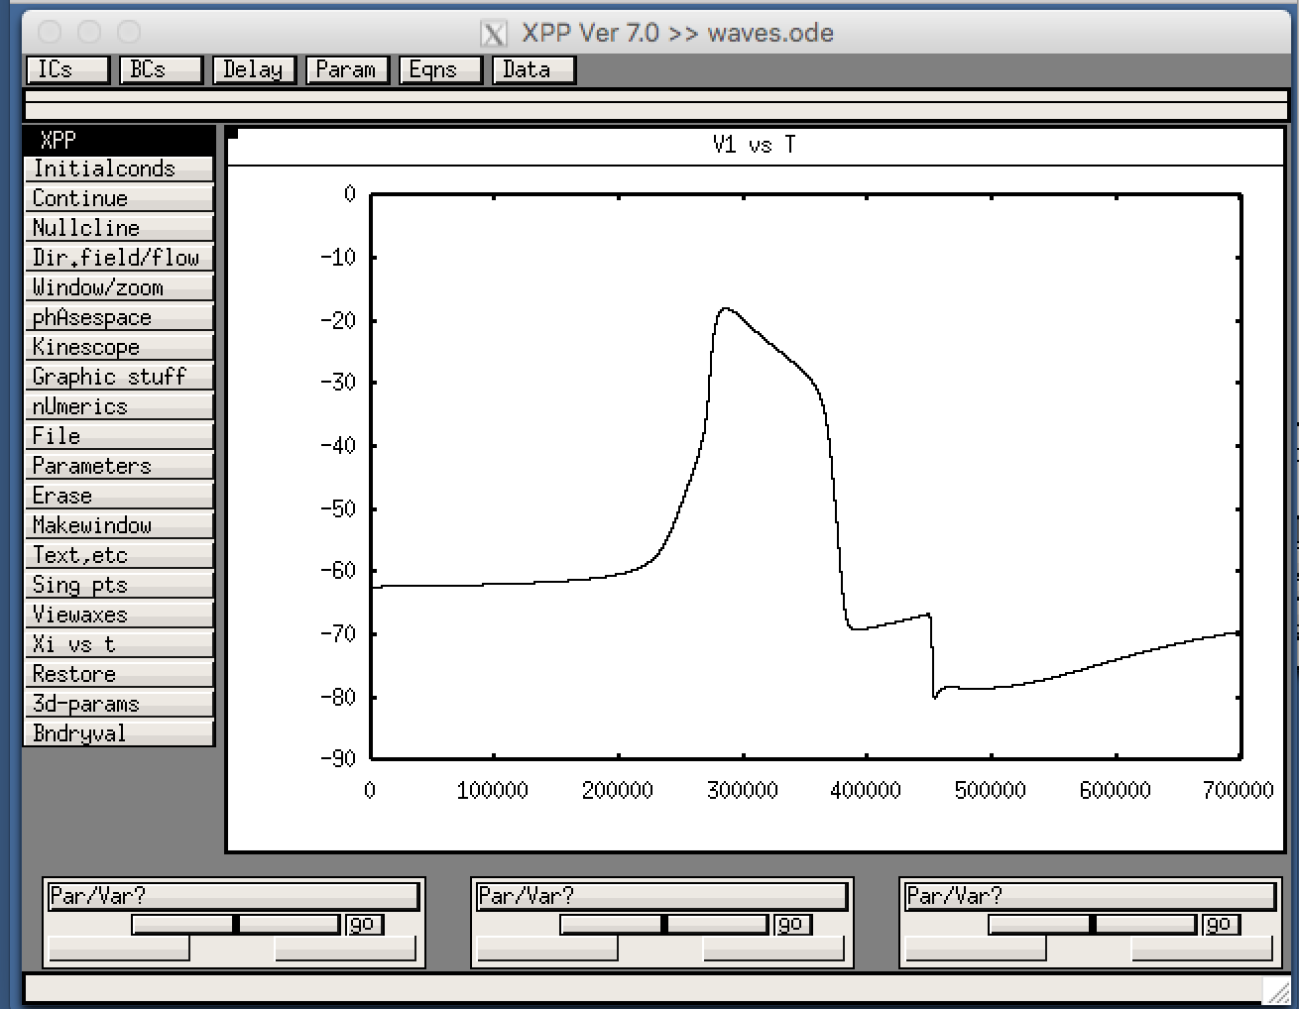

To plot network activity:

Select in the XPP program

View -> Array -> Ok

You should then see

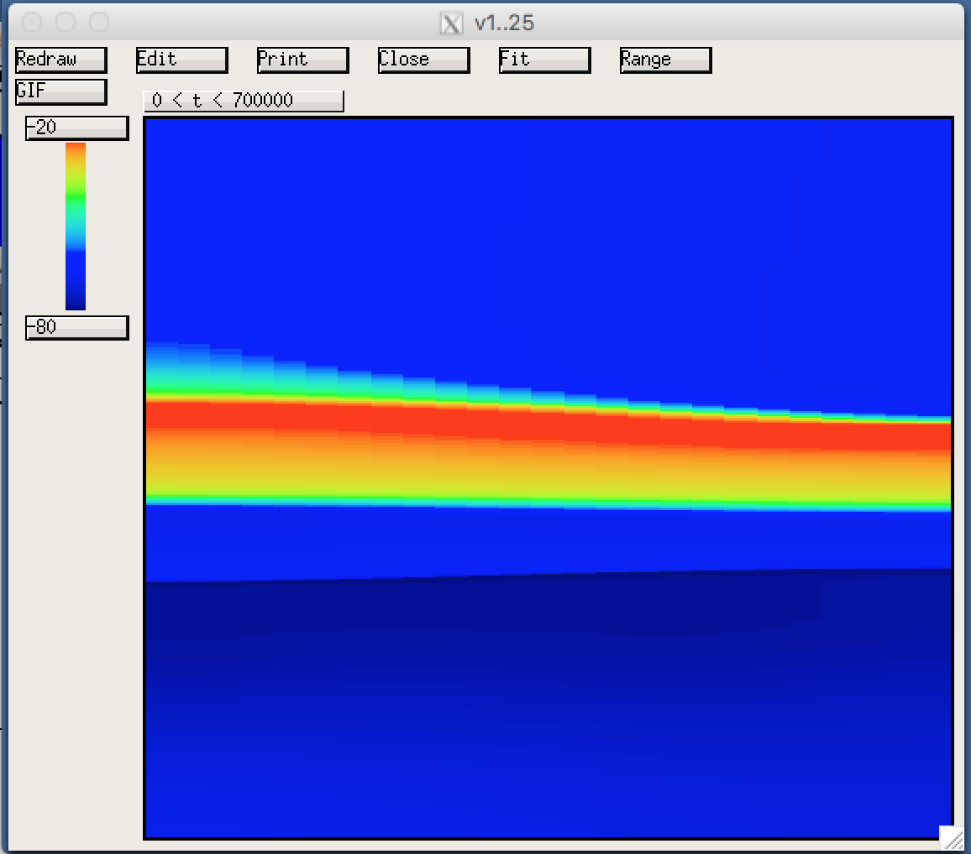

This corresponds to Figure 11 in the paper.