A Manual
For
Single Cell Model (SCM)

Yue Dai
Department of Physiology
University of Manitoba
Winnipeg, Manitoba R3E 3J7
Canada

February, 2001

Contents
-------------------------------------------------
- Single Cell Model (SCM)
- Environment for Running the SCM
- Simulation Environment
- Control panel
- Current injection panel
- Output panel
- Panels for simulation result display
- Notes
- Appendix
- References
-------------------------------------------------

Single Cell Model (SCM)
The single cell model (SCM) was built using GENESIS (Bower and Beeman, 1998), based on properties of cat lumbar motoneurones. The geometry of the model was that of a simplified cylinder structure with five compartments representing the axon, initial segment, soma, and dendrites (Fig.1). The passive parameters of the models were based on data from cat spinal motoneurones. Nine active conductances (g_{Na}, g_{K(DR)} , g_{K(A)}, g_{K(AHP)}, g_{Ca_T}, g_{Ca_L}, g_{Ca_N}, g_{h}, g_{leak}) included in the models are found in mammalian spinal motoneurones. Details of building of the model are given in the Appendix. In this section we briefly describe the usage of the model.
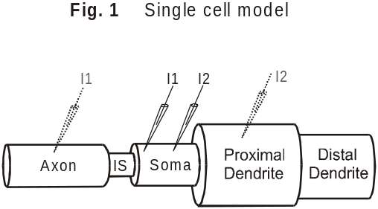
Environment for Running the SCM
The SCM is running under the GENESIS environment supported by Linux or Unix. The model was developed on GENESIS 2.1 that can be downloaded for free from the ftp site (genesis.bbb.caltech.edu). The following steps are to set and to run the SCM in Linux:
1. Install the GENESIS 2.1 (or higher version) in your Linux (or Unix) system;
2. Make a new directory named SCM or any name you like in your home
directory;
3. Copy all the files of SCM to this directory;
4. Set this new directory as your current directory. Under the Linux prompt, type:
genesis scm to start the simulation program.

Simulation Environment
The simulation environment of SCM is composed of eight panels (Fig. 2), including panels of control, current injection, write-out, max conductance, membrane potential, currents, channel conductance, and Ca concentration. A brief description for each panel is given below.
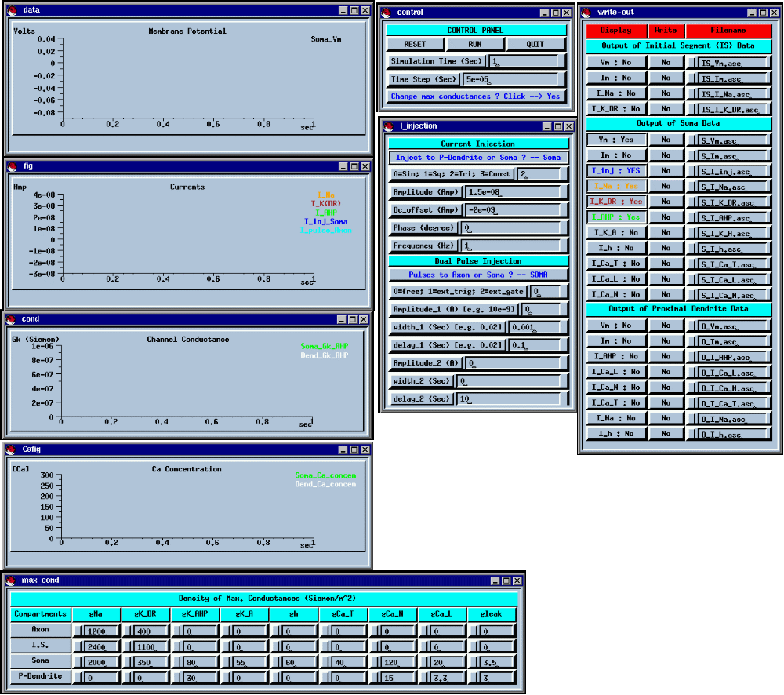
Fig. 2 The SCM simulation environment

1. Control panel
This panel (Fig. 3) is used to control the simulation process. To start the simulation, click RUN button; to stop or reset the simulation, click RESET; and to quit

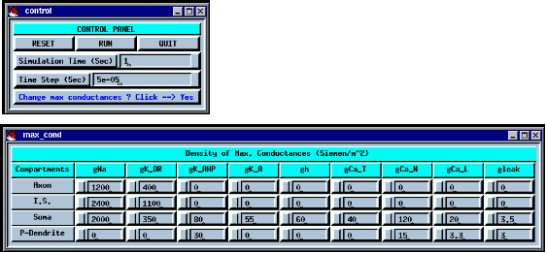
Fig. 3 Control panel
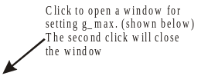

the simulation, click QUIT. To set a period of time or a time step for the simulations, enter the values in the corresponding space. Remember that each resetting value must be confirmed by pressing the Enter key, and that the SI units are used in GENESIS simulations. Clicking the button at the bottom row opens a new panel (shown in Fig. 3) that is used to set the density of max conductance for each channel in the model. Clicking the same button closes the panel. See Table 3 in Appendix for the distribution of the channels.

2. Current injection panel
Five forms of current injection are used in SCM, including injection of sine wave (represented by 0), square wave (1), triangular wave (2), constant current (3), and pulse train (Fig. 4). The first four forms of injection are set in the sub-panel: Current Injection. Parameters for setting this injection include code for the types of the injection (0-3), amplitude of injected current (nA), DC offset of the injection (nA), phase of the injected wave (degree), and frequency of the injection (Hz).
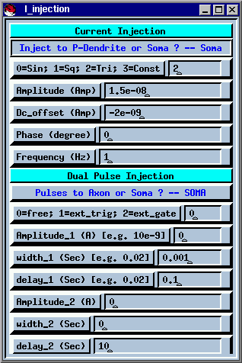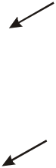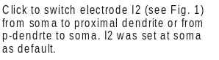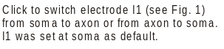
The pulse train injection is set in the sub-panel: Dual Pulse Injection. This injection can generate a variety of pulse patterns: single pulse; double pulses; and pulse trains. The injection can be triggered, gated, or allowed to free run. The present version of SCM uses free run mode. Illustration is shown in the Figure 5.
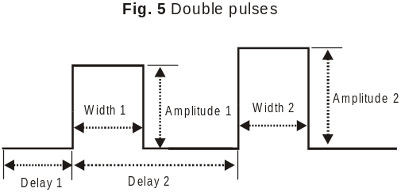

Two electrodes (I1 and I2, see Fig. 1) are used in SCM for current injection. The I1 is used to inject pulses and can be switched between axon and soma compartments by clicking the switching button (Fig. 4). The I2 is used to inject waveform currents (0-3) and can be switched between soma and proximal dendrite compartments by clicking the switching button (Fig 4). Both I1 and I2 are set at the soma compartment as default.

3. Output panel
Simulation results (membrane potential (Vm), membrane current (Im), and ionic currents) from initial segment, soma, and proximal dendrite compartments can be displayed in widows or written out to files in ASC form. The output panel (Fig. 6) in SCM is divided into three fields (columns). The first column is composed of buttons for window display. You can click the buttons to choose whether or not to plot the results in the windows. The second and third columns are used to write out the results to files. You can click the buttons in the second column to choose whether or not to write out the data to files. The default values for the buttons in second column are “No”; that is, no simulation result is written out. Clicking these buttons turns on or off the device for writing-out the data. The default file names are shown in the third column. These names can be changed by typing new ones in the space of the third column.

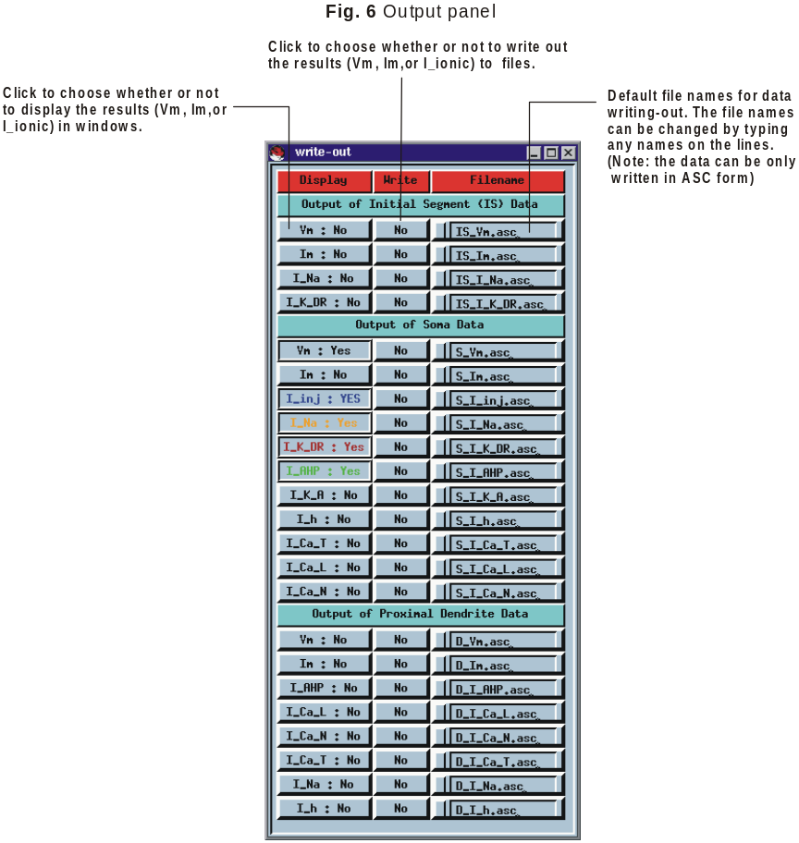

4. Panels for simulation result display
The SCM has four panels or widows to display the simulation results (see Fig. 2). They are Membrane Potential for displaying membrane potentials; Currents for membrane and ionic currents; Channel Conductance for conductances (somatic and dendritic g_{K(AHP)} in present version of SCM); and Ca Concentration for somatic and dendritic calcium concentration. Display of membrane potentials and currents is controlled by buttons in output panel (Fig. 6). Graphs displayed in the windows have a number of special key and mouse mappings as described below:

arrow keys: change the x and y axis offset
shift-arrow keys: change the scale on the x and y axes
ctrl-arrow keys: change the lower boundaries of the graph
shift-ctrl-arrow keys: change the upper boundaries of the graph
mouse events on selects plots, and passes appropriate actions to the scripts
labels for plots associated with the plots.

click and drag on changes the selected axis range
upper/lower values
of axes

click and drag on changes the selected axis
middle values of
axes

ctrl-p prints the graph to a postscript printer

5. Notes
1. Any resetting values for the parameters in the panels of Control Panel, Current Injection, Output (write-out), and Density of Max Conductance, must be confirmed by pressing the Enter key. The previous data will be used if the Enter key is not pressed.
2. The SI (Kilogram-Meter-Second) system is used in GENESIS environment for all simulations.

Appendix
The single cell model (SCM) was built with five compartments (Fig. 1). In general, the cable equation for compartment k (=2, 3, or 4) can be written as

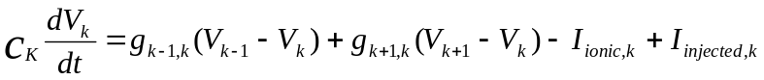 (1)

where, V_{k-1} , V_{k}, and V_{k+1} are membrane potentials of the compartments k-1, k, and k+1; g_{k-1,k} and g_{k,k+1} are conductances between the compartments k-1 and k and compartments k and k+1; C_{k} is the capacitance of the compartment k; I_{injected,k} is the injected current to the compartment k, and I_{ionic,k} is the ionic current of the compartment k. For the soma, proximal dendrite, and axon & initial segment (IS) compartments I_{ionic,k} are written as

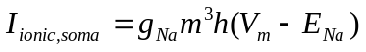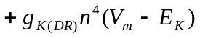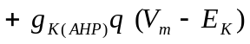 (2)
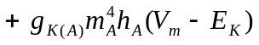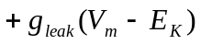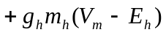
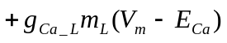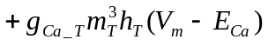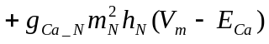

I_{ionic,dendrite} = 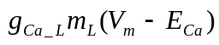 (3)

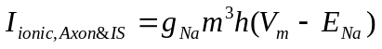 (4)

where, g_{Na}, is the maximum conductance for fast Na⁺ channel; g_{k(DR)}, delayed rectifier K⁺; g_{k(AHP)}, Ca⁺⁺-dependent K⁺ ; g_{k(A)}, A-currents; g_{leak} , leak currents; g_{h}, h-current; g_{Ca_T}, T-type Ca⁺⁺, g_{Ca_N}, N-type Ca⁺⁺, and g_{Ca_L}, L-type Ca⁺⁺. E_{Na}, E_{K}, E_{Ca} and E_{h} are equilibrium potentials for Na⁺, K⁺, Ca⁺⁺ & h currents and equal 55 mV, -75 mV, 80 mV and -55 mV respectively. Letters m, h, n and q (with or without subscripts) are membrane state variables that are defined by the Hodgkin-Huxley type equation:

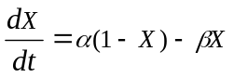 (5)

where steady-state value X∞ = α/( α+ β) and time constant τ=1/( α+ β). The rate functions (see Table 1) for m, h, and n are taken from Traub (1977); q from Traub et al (1991); m_{A} and h_{A} from Takahashi (1990); m_{h} from Binder et al (1996); m_{T} and h_{T} from Tegner et al (1997); and m_{L}, m_{N} and h_{N} from Booth et al (1997). Small adjustments in some rate functions are made to make the model cells produce appropriate behaviour such as an appropriate f-I relation and repetitive firing property.

The intracellular calcium concentration [Ca⁺⁺]_{in} in the soma and dendrite compartments satisfy the following equation (R.D. Traub et al., 1991)

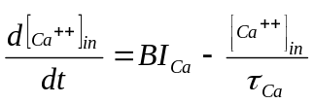 (6)

where B is a scaling constant in arbitrary units and set to -17.402 in the soma compartment and -10.769 in the dendrite compartment. τ_{Ca} is a time constant, the rate of decay of [Ca⁺⁺]_{in} . It is set to 13.33 ms for both soma and dendrite compartments. I_{Ca} is equivalent to the N-type Ca⁺⁺ current.
The rate constants are shown in Table 1, passive parameters of the model in Table 2, and distribution of ionic currents in Table 3.

Table 1. Rate constants in Hodgkin-Huxley equations.

Conductance Compartment Forward (α) Backward (β)

g_{Na} Initial segment (I.S.)
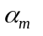= 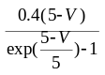 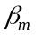= 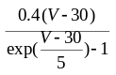
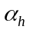= 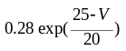 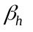= 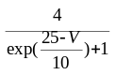
Axon and soma = 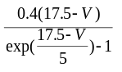 = 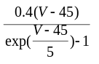
= 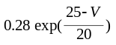 = 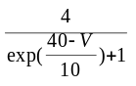
g_{k(DR)} I.S 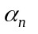= 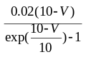 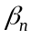= 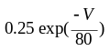
Axon and soma = 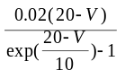 = 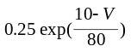
g_{k(A)} soma 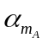= 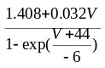 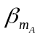= 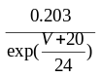
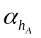= 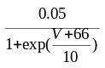 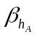= 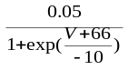
g_{h} Soma 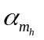= 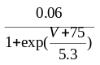 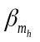= 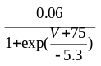
g_{Ca_T} Soma 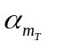= 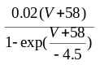 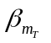= 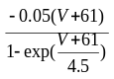
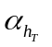= 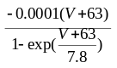 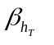= 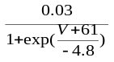
g_{Ca_N} Soma and dendrite 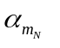= 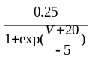 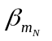= 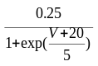
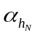= 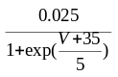 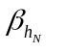= 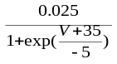
g_{Ca_L} Soma and dendrite 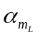= 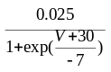 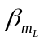 = 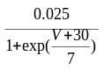
g_{k(AHP)} Soma 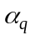=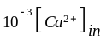 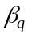= 0.04
Dendrite =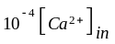 = 0.04

Table 2. Structural measurements of the single cell model and its cable parameters.

Compartment Diameter (μm) Length (μm) R_{M} (Ωm²) R_{A} (Ω m) C_{M} (Farads/m²)

Axon 10 400 0.7 0.2 0.01
Initial segment 6 100 0.7 0.2 0.01
Soma 10 360 0.7 0.2 0.01
Proximal dendrite 40 500 0.7 0.6 0.01
Distal dendrite 30 400 0.7 0.6 0.01

Table 3. Distribution and density of ionic currents in the model.

Density of the Maximum Conductance (S/m²)
Compartment g_{Na} g_{K(DR)} g_{K(AHP)} g_{K(A)} g_{Ca_N} g_{Ca_L} g_{Ca_T} g_{h} g_{leak}

Axon 1200 400 0 0 0 0 0 0 0
Initial segment 2400 1100 0 0 0 0 0 0 0
Soma 2000 350 80 55 120 20 40 60 3.5
Proximal dendrite 0 0 30 0 15 3.3 0 0 3.0
Distal dendrite None

References
Binder, M., Heckman, C.J., and Powers, R. (1996). The physiological control of motoneurone activity. In Handbook of Physiology. Section 12: Regulation and Integration of Multiple System. Rowell, L.B. and Shepherd, J.T. (eds). American Physiology Society, New York: Oxford, pp. 3-53.
Booth, V., Rinzel, J., and Keihn, O. (1997). Compartmental Model of vertebrate motoneurones for Ca²⁺-dependent spiking and plateau potentials under pharmacological treatment. J Neurophysiol 78:3371-3385.
Bower, J.M. and Beeman, D. (1998). The Book of GENESIS, 2nd edition, Springer-Verlag New York.
Takahashi, T. (1990) Membrane currents in visually identified motoneurones of neonatal rat spinal cord. J Physiol(Lond) 423:27-46.
Tegner, J., Hellgren-Kotaleski, J., Lansner, A., and Grillner, S. (1997). Low-voltage-activated calcium channels in the Lamprey locomotor network: simulation and experiment. J. Neurophysiol. 77:1795-1812.
Traub, R.D. (1977). Motoneurones of different geometry and the size principle. Biol. Cybern. 25:163-176.
Traub, R.D., Wong, R.K.S., Miles, R. and Michelson, H. (1991). A model of a CA3 hippocampal pyramidal neuron incorporating voltage-clamp data on intrinsic conductances. J Neurophysiol 66 (2): 635-650.

