Simulation of oscillating neurons in the cochlear nucleus: a possible role for neural nets, onset cells, and synaptic delays
Andreas Bahmer and Gerald Langner
Neuroakustik, Institut für Zoologie, Technische Universität Darmstadt,
{bahmer, gl}@bio.tu-darmstadt.de

1 Introduction
Neurons in the cochlear nucleus (CN), the first processing center in the auditory system, show various response patterns after stimulation. Among these, chopper neurons (choppers) are outstanding because their oscillations are characterized by stable interspike intervals (ISIs) even when the stimulus amplitude changes (Pfeiffer 1966, Blackburn and Sachs 1989). Choppers are subdivided according to their coefficient of variation (CV; the ratio of the standard deviation to the mean of the ISI) into regular (CV<0.35) and irregular (CV>0.35).
T-stellate cells, which are classified as choppers, seem to build interconnected circular networks (Ferragamo, Golding, and Oertel 1998). These chopper networks have certain features (self-excitation and inputs from other neuron types) that differ from those of single neurons. The question arises as to whether, due to minimization processes, the fastest network of choppers exists. Analysis of electrophysiological data has provided evidence for the existence of the smallest possible network consisting of two interconnected neurons with a synaptic delay of 0.4 ms. Choppers show a high dynamic range of up to 90 dB of AM coding and at the same time are more sharply tuned than nerve fibers (Frisina, Smith, and Chamberlain 1990). This suggests that only few nerve fibers from a narrow frequency range project to choppers. This is in line with the finding of Ferragamo et al. (1998) that T-stellate cells receive only about 5 monosynaptic inputs from the nerve. If there is only a small input from nerve fibers with a dynamical range of 30-40 dB of AM coding (Frisina et al. 1990), it is difficult to understand how the high dynamic range of choppers is achieved. Therefore, we suggest that onset neurons, which are classified as octopus cells (Ostapoff, Feng, and Morest 1994) and show a high dynamic range of up to 90-115 dB of AM coding (Frisina et al. 1990), project to choppers. Based on the physiological and anatomical data, we propose a model consisting of a minimum network of two choppers that are interconnected with a synaptic delay of 0.4 ms (Bahmer and Langner 2006a) . Such minimum delays have been found in different systems and in various animals (e.g. Hackett, Jackson, and Rubel 1982; Borst, Helmchen, and Sakmann 1995). The choppers receive input from both the auditory nerve and an onset neuron. This model can reproduce the mean, standard deviation, and coefficient of variation of the ISI and the dynamic features of AM coding of choppers.

2 Methods
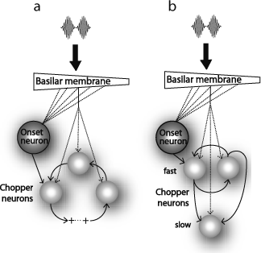 | Fig. 1. Scheme of the simulation topology I (a), II (b). A model of the inner ear produces a response which converges on each chopper neuron via 5 inputs. The onset neuron receives a broadband input and excites one chopper neuron. a: The chopper neurons are arranged serially in a circle and can excite each other. The self-excitation in this network can be stopped by decreasing its input from the auditory nerve. b: Two (or three) fast chopper neurons in a network project as a pace-maker to slower chopper neurons.
The simulation of Hodgkin-Huxley (HH)-like chopper and onset neurons is based on models of Rothman and Manis (2003). The models consist of a single, electrical compartment with a membrane capacitance connected in parallel with a sodium current, a low-threshold potassium current, a high-threshold potassium current, a cation current, a leakage current, an excitatory synaptic current, and an external electrode current source. For the simulations concerning periodicity encoding, a model for the inner ear and leaky-integrate-and-fire (LIF) neurons with synapses is used (Bleeck 2000, Bahmer and Langner 2006b). NEURON and Matlab are used as simulation environments. For the simulation of a network of choppers in NEURON, the input of the two choppers is slightly phase delayed to ensure spike-to-spike oscillations. The resulting topology for the simulations with the proposed additional input from an onset neuron is shown in Fig. 1a (topology I). To produce ISIs as large as those occasionally observed in real choppers (several ms), topology I would require a high number of neurons, as synaptic delays of neurons in the auditory system are found to be in the submillisecond range. Therefore, an alternative topology (topology II, Fig. 1b) is suggested, in which a small network of choppers plays the role of a pace maker. This network can trigger other choppers, which have larger refractory periods to produce larger ISIs. It is reasonable to assume that minimization processes of the networks concerning fast analysis in the time domain are used to produce a minimum synaptic delay. In line with the physiological evidence given below, a minimum synaptic delay of 0.4 ms is introduced in the model. To test the physiological relevance of the topologies, pure tone responses and periodicity encoding are tested and compared with physiological data.

3 Results

3.1 Invariance of ISI in networks of chopper neurons
An HH-like model of a single chopper was compared to a model of a network with two interacting choppers. The simulation results are shown in Fig.1. While the ISIs of the single neuron model depend strongly on signal amplitude, the ISIs of the choppers in the network are relatively constant. This and the corresponding dynamic variation of spike rates is in line with physiological data (Pfeiffer 1966; Blackburn and Sachs 1989).
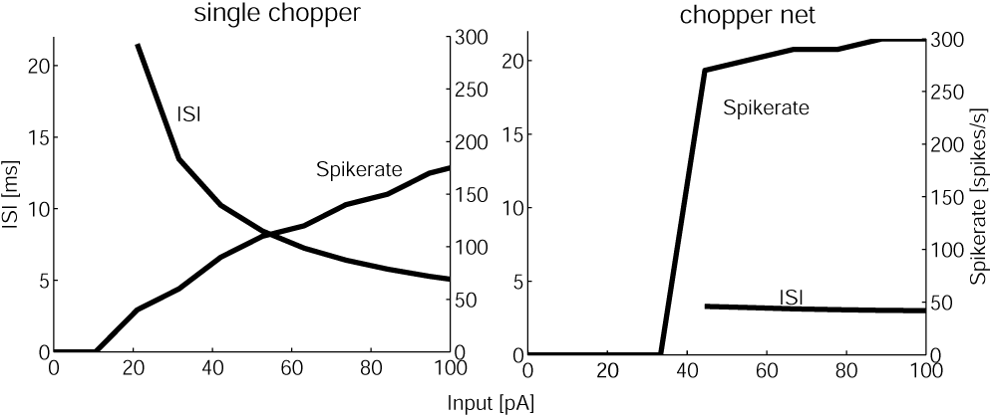
Fig. 2. Simulation results of a single chopper and of a network of two interconnected choppers in NEURON (HH-like model from Rothman and Manis 2003). The variance of ISIs of the single neuron is high, whereas the variance of the ISIs of the network chopper is low.

3.2 Simulation of pure tone response of chopper neurons
Fig. 3a shows the PSTH of a sustained chopper (Blackburn and Sachs 1989), which is characterized by a low CV (<0.35) indicating highly regular interspike intervals. In the PSTH, 4 to 5 response maxima can be clearly seen. The regularity analysis (Fig. 3b) shows a mean interspike interval of about 2 ms, a standard deviation of nearly 0.25 ms and a resulting CV of about 0.15. These values are stable in time. The result of our simulation with topology I, which in this case includes 5 choppers, is shown in Fig. 3a’, b’. The properties of the simulation, such as firing rate, number of peaks, and ratio of peak heights are nearly the same as in the electrophysiological results. Even the regularity analysis could be matched to the analysis of the in vivo recording. For this purpose a jitter (standard deviation 0.26 ms) had to be added to each synaptic delay of the 5 interconnected choppers to fit the CV. The CV in the simulation has a mean value of 0.14 (0.15 in the in vivo recording). Fig. 3a’’, b’’ shows the simulation results of topology II. Again, firing rate and ratio of peak heights match physiological properties. The number of peaks is increased and the regularity analysis shows smoother results and a lower CV (0.07). The jitter (same as in topology I) is added only to the synaptic delay of the interconnections of the fast choppers.
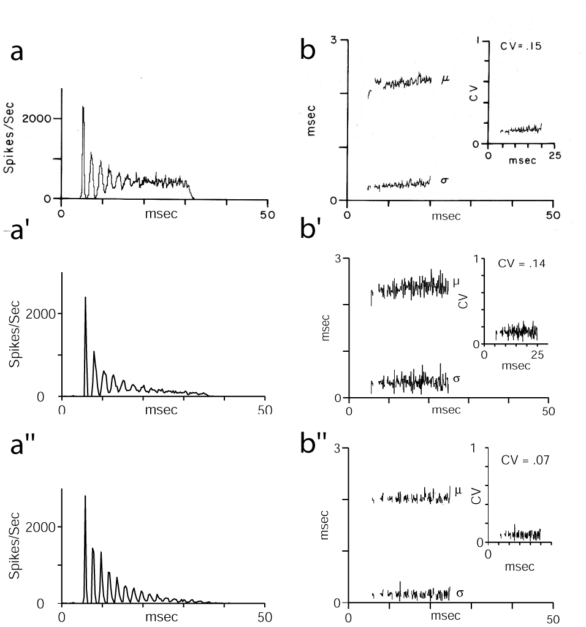 | Fig. 3. a, b: PSTH and regularity analysis (mean interval µ, standard deviation σ, coefficient of variation CV) of a sustained chopper neuron in the CN (from Blackburn and Sachs 1989). a’, b’: Response of simulated chopper neuron (topology I). Stimulus parameters are the same as in the physiological experiment. The graphs match the physiological data. a’’, b’’: Response of simulated chopper neuron (topology II). The response shows more peaks than the physiological data.

3.3 Synchronization to AM signals at different sound pressure levels
To verify the conclusion that choppers receive input from both auditory nerve and onset neurons, we simulate responses of auditory nerve fibers, onset neurons with different integration widths, and choppers with and without input from an onset neuron. For the simulation of the choppers, two choppers are arranged in a circular network. To quantify the degree of synchronization (periodicity coding), the vector strength (e.g. Langner 1992) is calculated for the simulations. Without the input from the onset neuron, the weights of the synapses of the auditory nerve have to be increased to enable chopping. The simulation of a nerve fiber with a CF at the carrier frequency of the AM signal shows that the synchronization to the modulation is small and nearly vanishes above 40 dB SPL (Fig. 4a). Because of their broader bandwidth, the onset neurons encode periodicity much better than an auditory nerve fiber (Fig. 4a). For a “broad” in comparison to a “regular” bandwidth, the synchronization is better at high levels (above 50 dB SPL), but worse at low levels. The explanation for this is that unsaturated nerve fibers away from CF and therefore also from fc are able to encode periodicity information even at high intensities.
Fig. 4b shows the VS of simulations of choppers with and without input from an onset neuron. The different bandwidths of the onset neurons result in chopper responses which show the same dynamic effect as discussed in the previous paragraph for onset neurons. A comparison of the simulation of choppers with and without input from an onset neuron shows the effect and significance of such an input for the dynamic range of periodicity coding.
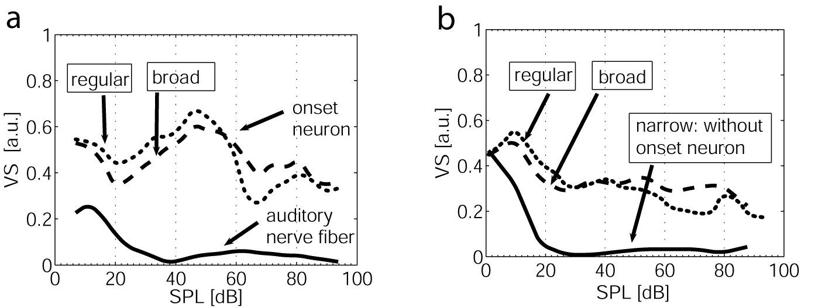
Fig. 4. a: Comparison of VS of the simulation of auditory nerve fibers and two onset neurons at different SPL (response to SAM, fm: 100 Hz, fc: 600 Hz). The onset neurons have different bandwidths (regular and broad) and show robust synchronization over a wide dynamic range. b: Comparison of simulations of chopper neurons. With input from an onset neuron, chopper neurons synchronize to AM signals over a wide dynamic range. By contrast, without input from an onset neuron synchronization deteriorates above 20 dB SPL.

3.4 Evidence for a time constant of 0.4 ms in intervals of chopper responses
Evidence that preferred intervals in intrinsic oscillations consist of multiples of 0.4 ms was first found in the central nucleus of the IC of Guinea fowls (Langner 1981, 1983) and cats (Langner and Schreiner 1988). The intrinsic oscillations were only weakly influenced by changes in stimulus frequency or intensity (Langner and Schreiner 1988). Peaks were prevalent at intervals of 0.8, 1.2, 1.6, 2.0, and 2.4 ms which are all multiples of a base period of 0.4 ms. Since the IC receives a major input from the choppers of the CN (Adams 1983), it was hypothesized that the origin of the intrinsic oscillation found in IC is the CN (Langner 1992)
Further evidence for a minimum synaptic delay was found in responses of units in the VCN recorded by Young, Robert, and Shofner 1988. We analysed the ISIs of chopper´s preferences of certain oscillation intervals. The histogram (Fig. 5) shows peaks at integer multiples of 0.4 ms, indicating a corresponding preference of choppers for such intervals. The null hypothesis, assuming that the interspike intervals of choppers are equally distributed, was tested statistically. For this purpose two classes were generated. One class contained intervals centered at multiples of 0.4 ms with an interval-width of 0.2 ms, and the remaining intervals of the second class were centered at multiples of 0.4 ms + 0.2 ms. By rejection of the null hypothesis (level of significance: 5%), the preference for intervals centered at multiples of 0.4 ms was shown to be significant.

4 Discussion
The simulation of interconnected choppers shows that such a network can produce stable ISIs in spite of changing input strengths, thereby modelling real choppers and outmoding the simulation of single choppers. The response of the network also matches PSTHs and regularity analysis of real choppers
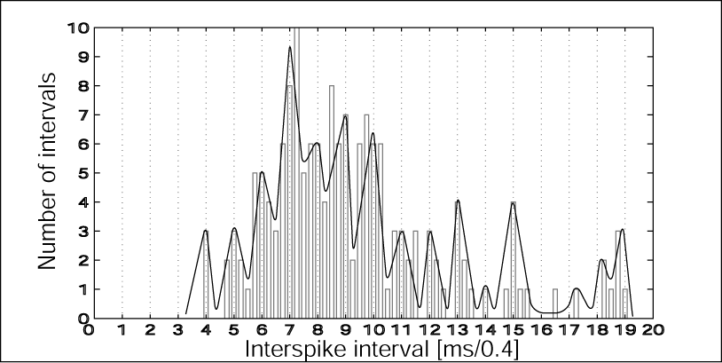 | Fig. 5. Histogram of the interspike intervals of chopper neurons measured by Young et al. 1988. The binwidth is 0.1 ms, the number along the x-axis indicates the lower edge of the interval. The curve has been fitted to the histogram manually.
When synchronizing to AM signals, a dramatic difference shows up between the response of simulated choppers with and without input from onset neurons. The dynamic ranges of periodicity encoding differ by at least 70 dB (Fig. 4b). Since real choppers code periodicity with dynamic range similar to that of onset neurons and since they are located close to these neurons, it seems reasonable to assume that they may receive an input from onset neurons. The question of whether the pitch of harmonic sounds is based on a neuronal analysis of periodicity information available as a temporal code in different frequency channels or, alternatively, on resolved harmonics in single channels continues to be debated. In light of this, the most remarkable feature of the chopper network my be that the combination of broad-band integration in onset neurons and narrow-band input of choppers allows for both the coding of periodicity and of resolved harmonics in single neurons. This would suggest that both types of information are used in parallel in pitch perception.

5 Conclusions
- Based on the anatomical and physiological data we suggest a model of choppers that are arranged in a circular network and receive input from both auditory nerve fibers and an onset neuron.
- It is reasonable to assume that the chopper network employs a minimum synaptic delay.
- Evidence for a minimum synaptic delay of 0.4 ms is given by electrophysiological data.
- The simulation of the model is able to explain the large dynamic range of periodicity encoding in spite of the frequency tuning.
- By combining broad-band with narrow-band analysis, the model may explain corresponding aspects of pitch coding.

Acknowledgements
We would like to thank Mr. W. Hemmert and Mr. M. Holmberg of Infineon Technologies for their support and reading, and Mr. G. T. Sims for critical reading.

References
Adams, J.C. (1983) Multipolar cells in the ventral cochlear nucleus project to the
dorsal cochlear nucleus and the inferior colliculus. Neurosci. Lett. 37, 205-208.
Bahmer, A. and Langner G. (2006a) Oscillating neurons in the cochlear nucleus:
I. Experimental basis of a simulation paradigm. Biol Cybern 95, 371-379.
Bahmer, A. and Langner G. (2006b) Oscillating neurons in the cochlear nucleus:
II. Simulation results. Biol Cybern 95, 381-392.
Blackburn, C., Sachs, M. (1989) Classiffication of unit types in the anteroventral
cochlear nucleus: PST histograms and regularity analysis. J. Neurophysiol. 62, 1303-1329.
Bleeck, S. (2000) Holistische Signalverarbeitung in einem Modell latenzverknüpfter
Neuronen. PhD thesis, TU Darmstadt.
Borst, J.G. (1995) Pre- and postsynaptic whole-cell recordings in the medial nucleus of the trapezoid body of the rat. J. Physiol. 489, 825-840.
Ferragamo, M., Golding, N., Oertel, D. (1998) Synaptic inputs to stellate cells in the
ventral chochlear nucleus. J. Neurophysiol. 79, 51-63.
Frisina, R.D., Smith, R.L., Chamberlain, S.C. (1990) Encoding of amplitude modulation
in the gerbil cochlear nucleus: I. A hierarchy of enhancement. Hear. Res. 44, 99-122.
Hackett J.T., Jackson H., Rubel E.W. (1982) Synaptic excitation of the second and third order auditory neurons in the avian brain stem. Neurosci. 7, 1455-1469.
Langner, G. (1981) Neuronal mechanisms for pitch analysis in the time domain. Exp.
Brain Res. 44, 450-454.
Langner, G. (1983) Evidence for neuronal periodicity detection in the auditory sys-
tem of the guinea fowl: implications for pitch analysis in the time domain. Exp.
Brain Res. 52, 333-355.
Langner, G. (1992) Periodicity coding in the auditory system. Hear. Res. 60, 115-142.
Langner, G., Schreiner, C. (1988) Periodicity coding in the inferior colliculus of the
cat: I. Neuronal mechanisms. J. Neurophysiol. 60, 1799-1822.
Ostapoff, E.M., Feng, J.J., Morest, D.K. (1994) A physiological and structural study
of neuron types in the cochlear nucleus. II. Neuron types and their structural
correlation with response properties. J. Comp. Neurol. 346, 19-42.
Pfeiffer, R.R. (1966) Classification of response patterns of spike discharges for units
in the cochlear nucleus: tone-burst stimulation. Exp. Brain Res. 1, 220-235.
Rothman, J., Manis, P. (2003) The roles potassium currents play in regulating the
electrical activity of ventral cochlear nucleus neurons. J. Neurophysiol. 89, 3097-3113.
Young E. D., Robert J. M., Shofner W. P. (1988) Regularity and latency of units in
ventral cochlear nucleus: Implications for unit classification and generation of
response properties. J. Neurophysiol. 60, 1-29.

