

Bayesian model requirements for MDL and PharmML.
Different situations to be represented and corresponding WinBugs implementation

Related task of the project (Task # and full name): | Input to WP3 and WP4 language specifications and WP5 WinBugs converter/connector
Authors: | Lorenzo Chiudinelli (UNIPV), Nicola Melillo (UNIPV), Paolo Magni (UNIPV), Enrica Mezzalana (UNIPV), Lorenzo Pasotti (UNIPV)
Prepared by: | Lorenzo Chiudinelli (UNIPV), Nicola Melillo (UNIPV), Enrica Mezzalana (UNIPV), Lorenzo Pasotti (UNIPV)
Approved by: | Paolo Magni (UNIPV)

Table of contents

1 Definitions 4
1.1 Acronyms and Abbreviations 4
2 Introduction 5
2.1 Description of the work flow 5
2.2 Structure of this document 5
3 Bayesian models: situations of interest 6
3.1 The model 6
3.2 Single subject scenario 6
3.2.1 All parameters are independent 6
3.2.2 Parameters V and k are correlated 7
3.2.3 All parameters are correlated 9
3.3 Population scenario 10
3.3.1 All parameters are independent 10
3.3.1.1 All parameters are independent, compact notation 12
3.3.1.2 All parameters are independent but some of them do not have prior distribution 13
3.3.2 Parameters V, k and Vpop, kpop are correlated 13
3.3.2.1 Parameters V, k and Vpop, kpop are correlated, compact notation 15
3.3.3 Parameters Vj,kj,tauej and Vpop, kpop, Tpop are correlated 16
3.3.4 Parameters V, k are correlated 18
3.3.5 Parameters Vpop, kpop are correlated 18
3.4 Nonparametric/Empirical prior distributions 19
3.4.1 Single subject scenario (Sec. 3.2) 19
3.4.1.1 Non parametric prior distribution 19
3.4.1.2 Empirical prior distribution 21
3.4.2 Population scenario (Sec. 3.3) 23
3.4.2.1 Non parametric distribution 23
3.4.2.2 Empirical prior distribution 25
3.4.2.3 Non parametric/empirical mixed situation: one parameter with non parametric prior and one parameter with empirical prior 26
4 Use of ordinary differential equations within WinBugs 27
4.1 Only WinBugs without external tools: the ode function 27
4.1.1 Single subject scenario 27
4.1.2 Population scenario 28
4.2 Using BlackBox as external ODE solver 29
4.2.1 Single subject scenario 29
4.2.2 Population scenario 31
5 References 33
6 Document Revision History 34

Definitions

Acronyms and Abbreviations
Acronym | Definition
DoW |  | Description of work

Introduction
The aim of this internal document (it is not a deliverable required by the DoW) is to formally provide structured inputs to WP3 and WP4 in order to extend MDL and PharmML to encode models into the Bayesian framework. It provides, on a very simple model, a list of different possible situations that languages should be able to encode. All cases are provided with the corresponding (Win)Bugs code, since it is an important target code for this kind of models. This document, even if not originally written for that, can also help the development of the PharmML-> (Win)Bugs converter as part of WP5 activities.

Description of the work flow
This document, prepared by UNIPV, will be shared with other key people including the WP3 and WP4 leaders. After collecting comments/suggestions, it will represent the Bayesian requirements for the new release of the language specifications that will be delivered in few months.

Structure of this document
Section 3 presents the different situations that the languages have to be capable to represent. Two cases were considered: single subject models or population of subjects. For each context, different structures of correlation among model parameters were considered. Moreover, the document addresses the issue linked to the definition of prior distribution via empirical distribution.
Section 4 is more devoted to cover aspects linked to WinBugs [1] implementation of models expressed with ODEs. Therefore, the topic is more interesting for WP5.

Bayesian models: situations of interest
The main focus of the document is to discuss the additional information specifically required to describe a model in a Bayesian context: the prior distribution of model parameters. The document describes different situations on a toy example.

The model
The model here considered is the simplest PK model, i.e., a mono-compartmental model with IV administration of a single dose of known amount D. This model can be represented either by using the following analytic solution 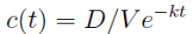 or by using for example this ODE:
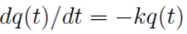 with q(0)=D and c(t)=1/V*q(t).
These are the most frequent situations that can occur to express a model.
In the following examples, we always considered a Gaussian additive noise with zero mean and variance σ²_{e} (or precision τ _{e}). However, different error models can be considered without affecting the general discussion of this document.

Single subject scenario
Data:
Measurements are indicated by z, a vector of n samples taken at different times, specified in the vector t.

Parameters:
The parameters of this model are: V, k (structural model parameters) and σ²_{e} (residual/measurement error variance).
Index i is used to refer to a single (time) instant.

All parameters are independent
In this situation, univariate distributions can be considered for each parameter.

Definition
In this example, V and k are distributed like a lognormal, so ln(V) and ln(k) are distributed like a Normal of mean values lμv=ln(μV) and lμk=ln(μk) and variance σ²_{V} and σ²_{k}, respectively. The precision of the noise is distributed like a Γ(a,b).

Known values: lμV, lμk, σ²_{V}, σ²_{k}, a and b.

Model definition (already defined in both MDL/PharmML)
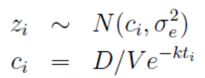

Prior distribution (to be defined in MDL/PharmML)
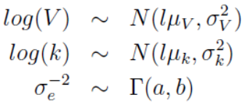

Graphical representation
i=times;
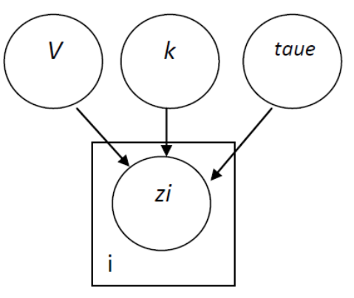

WinBugs code

model {
for (i in 1:n) {
z[i]~dnorm(c[i],taue)
c[i]<-(D/V)*exp(-k*t[i])
}

tauV<-1/sigma2V
tauk<-1/sigma2k

#prior
lV~dnorm(lmuV, tauV)
lk~dnorm(lmuk, tauk)
taue~dgamma(a,b)

# transformation
V<-exp(lV)
k<-exp(lk)
}

Parameters V and k are correlated
Now V and k are not independent random variables but they are correlated.

Definition
In this example, 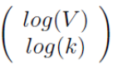 is distributed like a multiNormal. Now, the vector lμ[] includes the same mean that we used before, 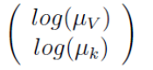 . Σ is the covariance matrix: 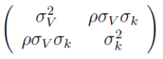 where ρ is the correlation coefficient.

Known values: lμ[], Σ[ , ], a and b. Note that the precision matrix T sometimes used in the following is the inverse of Σ.

Model definition (already defined in both MDL/PharmML)
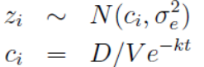

Prior distribution (to be defined in MDL/PharmML)
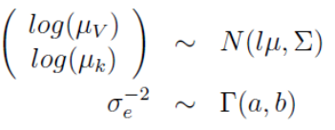

Graphical representation
i=times;
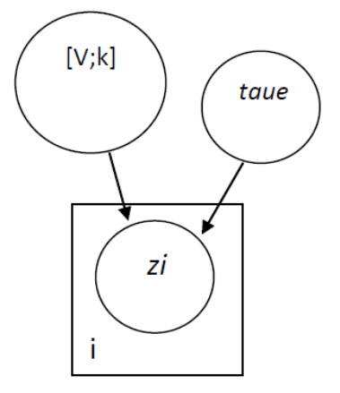

WinBugs code

model {

for (i in 1:n) {
z[i]~dnorm(c[i],taue)
c[i]<-(D/V)*exp(-k*t[i])
}

T[1:2,1:2]<-inverse(S[1:2, 1:2])

#prior distribution
PVett[1,1:2 ]~dmnorm(lmu[ ], T[ , ])
lV<-PVett[1,1]
lk<-PVett[1,2]
taue~dgamma(a,b)

# transformation
V<-exp(lV)
k<-exp(lk)
}

All parameters are correlated
The last case also considers σ²_{e} correlated with V and k parameters, that is, the residual error is a random variable correlated to the other model parameters. This is a quite unusual situation but we have considered it in this document because, for the language definition, this can be a nontrivial case.
Definition
The main difference from the previous situations is that, in this example, we consider τ_{e} distributed like a lognormal (even if this is an unusual choice); lμ[] is a vector of 3 components and S is a 3x3 matrix.

Known values: lμ[], S[ , ].

Model definition (already defined in both MDL/PharmML)
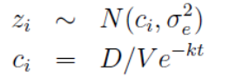

Prior distribution (to be defined in MDL/PharmML)
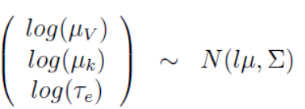

Graphical representation
i=times;
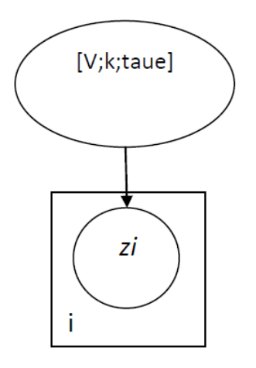

WinBugs code

model {

for (i in 1:n) {
z[i]~dnorm(c[i],taue)
c[i]<-(D/V)*exp(-k*t[i])
}

T[1:3,1:3]<-inverse(S[1:3, 1:3])

#prior
PVett[ 1 , 1:3 ]~dmnorm(lmu[ ], T[ , ])
lV<-PVett[1, 1]
lk<-PVett[1,2]
ltaue<-PVett[1,3]

# model
V<-exp(lV)
k<-exp(lk)
taue<-exp(ltaue)
}

Population scenario
Data:
Measurements are indicated by z, a matrix of j_{end} x i_{end} measurements taken in the different subjects at the different times t (for sake of simplicity, we consider that for all the subjects measurements are taken at the same time instants, but that is not mandatory and can be easily generalized).

Parameters:
The parameters of the individual model are still V, k (structural model parameters) and σ²_{e} (residual/measurement error precision). They are vectors of length j_{end}.
Index i is still used to refer to a single time instant, whereas index j is used to refer to a single subject. Each measurement is distributed like a Normal with mean equal to the model prediction in a subject in a time instant and precision σ²_{e}[j].

All parameters are independent
In this situation, univariate distributions for each parameter can be considered.

Known values:

Model definition (already defined in both MDL/PharmML)
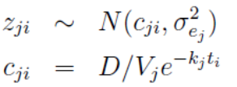
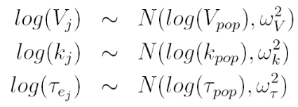

Prior distribution (to be defined in MDL/PharmML)
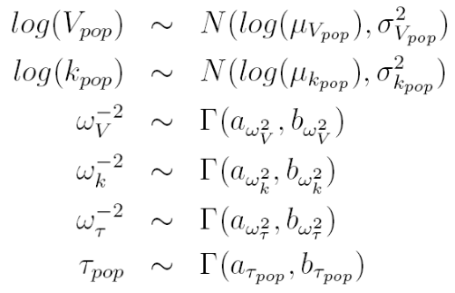

Graphical representation
i=time instants; j=subjects;
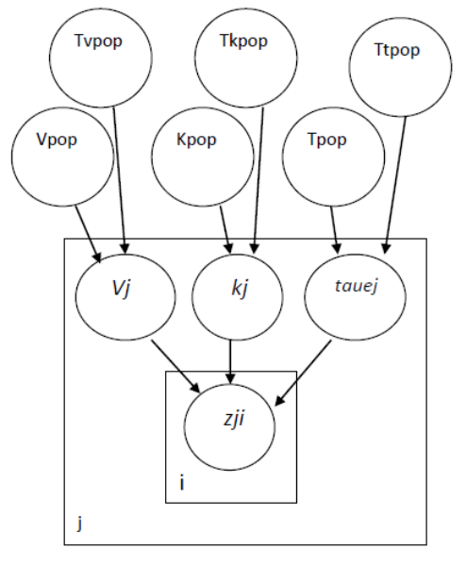

WinBugs code

model{

#first loop to scan subjects (each row of the data-matrix is a different person)
for(j in 1:jend){

#second loop for the observations of each person (each column of the data-matrix is a different instant of time)
for(i in 1:iend){
#note that taue is different for each subject
z[j,i]~dnorm(c[j,i], taue[j])
c[j,i]<-(D/V[j])*exp(-k[j]*t[i])
}

#distribution of V of the j-subject
lV[j]~dnorm(lVpop, TV)
V[j]<-exp(lV[j])

#distribution of k of the j-subject
lk[j]~dnorm(lkpop, Tk)
k[j]<-exp(lk[j])

#distribution of taue of the j-subject
ltaue[j]~dnorm(lTpop, Ttau)
taue[j]<-exp(ltaue[j])
}

# prior on "THETA"
lmu_Vpop<-log(mu_Vpop)
lVpop~dnorm(lmu_Vpop, tau_Vpop)
Vpop<-exp(lVpop)

lmu_kpop<-log(mu_kpop)
lkpop~dnorm(lmu_kpop, tau_kpop)
kpop<-exp(lkpop)

# prior on inverse of "OMEGA"
TV~dgamma(a_omega_V, b_omega_V)
Tk~dgamma(a_omega_k, b_omega_k)
Ttau~dgamma(a_omega_tau, b_omega_tau)

# prior on "SIGMA"
Tpop~dgamma(a_taupop, b_taupop)
lTpop<-log(Tpop)
}

All parameters are independent, compact notation
The previous situation can be also represented via the following equivalent model (WinBugs code not provided).
Known values:

Model definition (already defined in both MDL/PharmML)
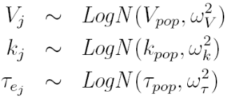

Prior distribution (to be defined in MDL/PharmML)
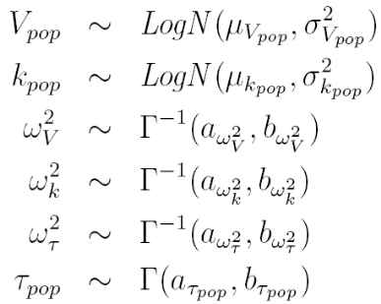

All parameters are independent but some of them do not have prior distribution
In the previous situation (3.3.1) all the parameters have univariate distributions and all the population parameters to be estimated have a prior. Here, we represent a situation where the Vpop, omega_V, taupop and omega_tau do not have a prior distribution. This situation cannot be implemented in WinBugs because a prior is required for each parameter to be estimated. Other target tools (NONMEM and Monolix) can handle situations like this via non-fully Bayesian approaches.

Known values: 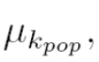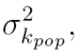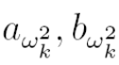

Model definition (already defined in both MDL/PharmML)

Prior distribution (to be defined in MDL/PharmML)
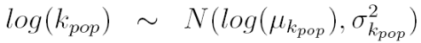
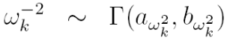

Parameters V, k and Vpop, kpop are correlated
In this case, the model parameters are not independent random variables at both the individual and population level.

Known values:

Model definition (already defined in both MDL/PharmML)
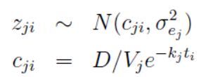
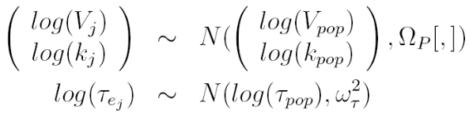

Prior distribution (to be defined in MDL/PharmML)
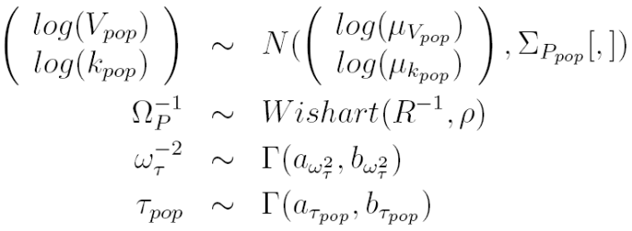

Graphical representation
i=times; j=subjects;
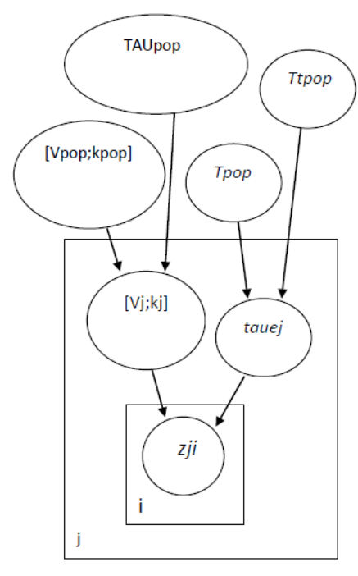

WinBugs code

model{

#first loop to scan subjects (each row of the data-matrix is a different person)
for(j in 1:jend){
#second loop for the observations of each person (each column of the data-matrix is a different instant of time)
for(i in 1:iend){
#note that taue is different for each subject
z[j,i]~dnorm(c[j,i], taue[j])
c[j,i]<-(D/V[j])*exp(-k[j]*t[i])
}

#correlated distribution of V and k of the j-subject
lP[j,1:2]~dmnorm(lPpop[], TP[ , ])

lV[j]<-lP[j,1]
V[j]<-exp(lV[j])
lk[j]<-lP[j,2]
k[j]<-exp(lk[j])

#distribution of taue of the j-subject
ltaue[j]~dnorm(lTpop, Ttau)
taue[j]<-exp(ltaue[j])

}

# prior on "THETA"
tau_Ppop[1:2, 1:2]<-inverse(sigma_Ppop[ , ])

lmu_Ppop[1]<-log(mu_Vpop)
lmu_Ppop[2]<-log(mu_kpop)

lPpop[1:2]~dmnorm(lmu_Ppop[], tau_Ppop[ , ])

lVpop<-lPpop[1]
Vpop<-exp(lVpop)

lkpop<-lPpop[2]
kpop<-exp(lkpop)

# prior on inverse of "OMEGA"
Rinv[1:2,1:2]<-inverse(R[,])
TP[1:2,1:2]~dwish(Rinv[ , ], rho)
Ttau~dgamma(a_omega_tau, b_omega_tau)

# prior on "SIGMA"
Tpop~dgamma(a_taupop, b_taupop)
lTpop<-log(Tpop)
}

Parameters V, k and Vpop, kpop are correlated, compact notation
The previous situation can be also represented via the following equivalent model (WinBugs code not provided).

Known values:

Model definition (already defined in both MDL/PharmML)
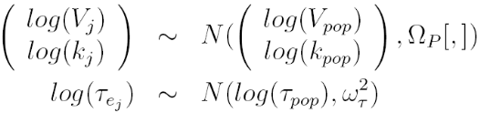

Prior distribution (to be defined in MDL/PharmML)
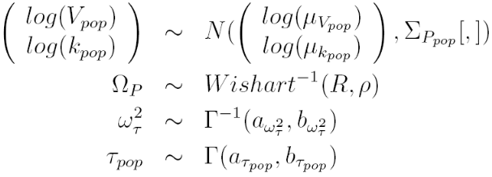

Parameters Vj,kj,tauej and Vpop, kpop, Tpop are correlated
Similarly to situation 3.2.3, in this subsection we suppose a correlation among model parameters and random components. In this case, taue[j] is correlated with V[j] and k[j] and is distributed like a logNormal. SIGMAPpop[,] is a 3x3 matrix. Also taupop is supposed to be correlated with Vpop and kpop.

Known values:

Model definition (already defined in both MDL/PharmML)
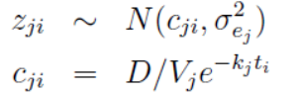
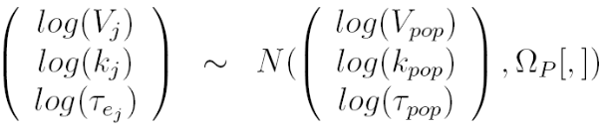

Prior distribution (to be defined in MDL/PharmML)
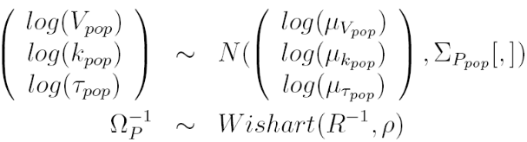

Graphical representation
i=times; j=subjects;

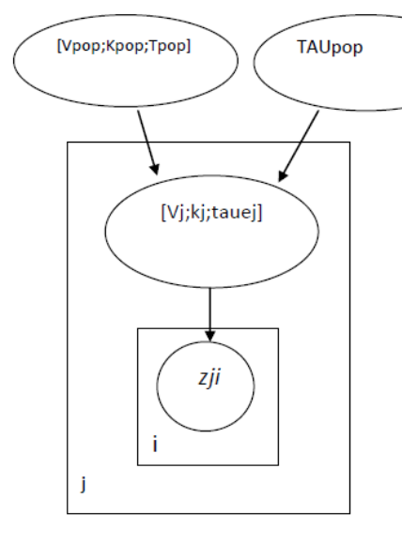
WinBugs code

model{

#first loop to scan subjects (each row of the data-matrix is a different person)
for(j in 1:jend){
#second loop for the observations of each person (each column of the data-matrix is a different instant of time)
for(i in 1:iend){
#note that taue is different for each subject
z[j,i]~dnorm(c[j,i], taue[j])
c[j,i]<-(D/V[j])*exp(-k[j]*t[i])
}

#correlated distribution of V, k and taue of the j-subject
lP[j,1:3]~dmnorm(lPpop[], TP[ , ])

lV[j]<-lP[j,1]
V[j]<-exp(lV[j])
lk[j]<-lP[j,2]
k[j]<-exp(lk[j])
ltaue[j]<-lP[j,3]
taue[j]<-exp(ltaue[j])

}

# prior on "THETA"/"SIGMA"
tau_Ppop[1:3, 1:3]<-inverse(sigma_Ppop[,])

lmu_Ppop[1]<-log(mu_Vpop)
lmu_Ppop[2]<-log(mu_kpop)
lmu_Ppop[3]<-log(mu_Tpop)

lPpop[1:3]~dmnorm(lmu_Ppop[], tau_Ppop[,])

lVpop<-lPpop[1]
Vpop<-exp(lVpop)

lkpop<-lPpop[2]
kpop<-exp(lkpop)

lTpop<-lPpop[3]
Tpop<-exp(lTpop)

# prior on inverse of "OMEGA"
Rinv[1:3,1:3]<-inverse(R[,])
TP[1:3,1:3]~dwish(Rinv[,], rho)
}

Parameters V, k are correlated
In this case, the model parameters are not independent random variables at the individual level (WinBugs code not provided).

Known values:

Model definition (already defined in both MDL/PharmML)
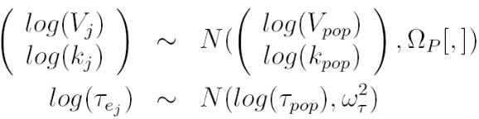

Prior distribution (to be defined in MDL/PharmML)
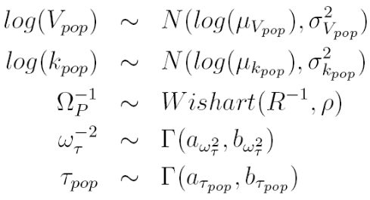

Parameters Vpop, kpop are correlated
In this case, the model parameters are not independent random variables at the population level (WinBugs code not provided).

Known values:

Model definition (already defined in both MDL/PharmML)
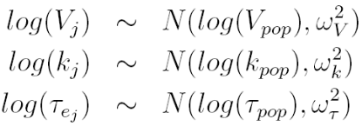

Prior distribution (to be defined in MDL/PharmML)
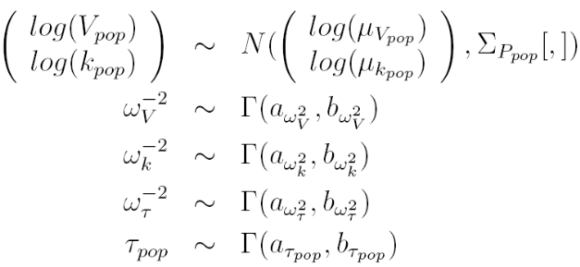

Nonparametric/Empirical prior distributions
Sometimes it can be of interest to express the prior distribution of the model parameters without using a canonical distribution, such as normal, lognormal, gamma, etc. We can express a prior distribution by describing it through a frequency table (a non parametric distribution) or empirically through a set of samples. In the following, we will cope with these situations showing some case studies, as well as the WinBugs implementation. We limit our attention to some of the cases discussed in section 3.2 and 3.3. Note that the WinBugs codes reported above are the same of those shown before except the red parts.

Single subject scenario (Sec. 3.2)

Non parametric prior distribution
In this case, the (joint) prior distribution is specified through a suitable table. Continuous random variables have to be discretized by building classes. For each combination of the parameters values (classes), a probability (or a relative frequency) has to be specified. As an example, if we have a random variable that can assume the value "true" and "false", we have to specify a 2x2 table with the 4 probability values. If the variables are independent, it is possible to define one table for each variable instead of a unique joint table. Some examples are described below.

Independent parameters
In section 3.2.1 the prior was expressed as

Here we suppose to express the distribution of V and k through two tables containing values-probability couples. In WinBugs we can implement it as follows.

Prior distribution (to be defined in MDL/PharmML)

V (Class value) | P  (probability)
Val1 | Prob1
… | …

K  (Class value) | P  (probability)
Val1 | Prob1
… | …

WinBugs code

model {
#prior
indv~dcat(pv[])
indk~dcat(pk[])
V<-v[indv]
k<-k[indk]
taue~dgamma(a,b)

for (i in 1:n) {
z[i]~dnorm(c[i],taue)
c[i]<-(D/V)*exp(-k*t[i])
}
}

Dependent parameters
In section 3.2.3 the prior was expressed as

Here we suppose to express the distribution of V and k through a joint table containing lists of values V/k/probability. In WinBugs we can implement it as follows.

Prior distribution (to be defined in MDL/PharmML)

V (Class value) | K  (Class value) | P  (probability)
Val1 | Val1 | Prob1
… | … | …

WinBugs code

model {
#prior
indvk~dcat(pvk[])
V<-vk[indvk,1]
k<-vk[indvk,2]
taue~dgamma(a,b)

for (i in 1:n) {
z[i]~dnorm(c[i],taue)
c[i]<-(D/V)*exp(-k*t[i])
}
}

Empirical prior distribution
In this case, the (joint) prior distribution is specified through a suitable table of samples. If variables are independent, it is possible to define one vector for each variable instead of a unique joint table. Some examples are reported below.

Independent parameters
In section 3.2.1 the prior was expressed as

Here we suppose to express the distribution of V and k through two vectors containing samples. In WinBugs we can implement it as follows.

Prior distribution (to be defined in MDL/PharmML)

V (Sample value)
Val1
…

K
(Sample value)
Val1
…

WinBugs code

model {
#prior
# pv and pk are two vectors containing the probability of each sample, i.e. 1 over the number of samples
indv~dcat(pv[])
indk~dcat(pk[])
V<-v[indv]
k<-k[indk]
taue~dgamma(a,b)

for (i in 1:n) {
z[i]~dnorm(c[i],taue)
c[i]<-(D/V)*exp(-k*t[i])
}
}

Dependent parameters
In section 3.2.3 the prior was expressed as

Here we suppose to express the distribution of V and k through a joint table containing joint samples of V and k. In WinBugs we can implement it as follows.

Prior distribution (to be defined in MDL/PharmML)

V (Sample value) | k  (Sample value)
Val1 | Val1
… | …

WinBugs code

model {
#prior
# pvk is a vector containing the probability of each joint sample, i.e. 1 over the number of joint samples
indvk~dcat(pvk[])
V<-vk[indvk,1]
k<-vk[indvk,2]
taue~dgamma(a,b)

for (i in 1:n) {
z[i]~dnorm(c[i],taue)
c[i]<-(D/V)*exp(-k*t[i])
}
}

Population scenario (Sec. 3.3)

Non parametric distribution

Independent parameters
In section 3.3.1 the prior was expressed as

Here, similarly to the single subject scenario, we suppose to express the distribution of Vpop, kpop and taupop through two tables containing values-probability couples. In WinBugs we can implement it as follows.

Prior distribution (to be defined in MDL/PharmML)

Vpop (Class value) | P  (probability)
Val1 | Prob1
… | …

kpop  (Class  value) | P  (probability)
Val1 | Prob1
… | …

taupop  (Class  value) | P  (probability)
Val1 | Prob1
… | …

WinBugs code

model{

for(j in 1:jend){
for(i in 1:iend){
#note that taue is different for each subject
z[j,i]~dnorm(c[j,i], taue[j])
c[j,i]<-(D/V[j])*exp(-k[j]*t[i])
}

lV[j]~dnorm(lVpop,TV)
V[j]<-exp(lV[j])

lk[j]~dnorm(lkpop, Tk)
k[j]<-exp(lk[j])

ltaue[j]~dnorm(lTpop, Ttau)
taue[j]<-exp(ltaue[j])
}

#Prior
indv~dcat(pk[])
indk~dcat(pv[])
indt~dcat(pt[])

Vpop<-v[indv]
kpop<-k[indk]
Tpop<-t[indt]

lVpop<-log(Vpop)
lkpop<-log(kpop)
lTpop<-log(Tpop)

# prior on inverse of "OMEGA"
TV~dgamma(a_omega_V, b_omega_V)
Tk~dgamma(a_omega_k, b_omega_k)
Ttau~dgamma(a_omega_tau, b_omega_tau)
}

Dependent parameters
In section 3.3.2 the prior was expressed as

Here we suppose to express the distribution of Vpop and kpop through a joint table containing lists of values Vpop/Kpop/probability. In WinBugs we can implement it as follows.

Prior distribution (to be defined in MDL/PharmML)

Vpop  (Class value) | Kpop  (Class value) | P  (probability)
Val1 | Val1 | Prob1
… | … | …

WinBugs code

model{

for(j in 1:jend){
for(i in 1:iend){
z[j,i]~dnorm(c[j,i], taue[j])
c[j,i]<-(D/V[j])*exp(-k[j]*t[i])
}

lP[j,1:2]~dmnorm(lPpop[], TP[,])

lV[j]<-lP[j,1]
V[j]<-exp(lV[j])
lk[j]<-lP[j,2]
k[j]<-exp(lk[j])

ltaue[j]~dnorm(lTpop, Ttau)
taue[j]<-exp(ltaue[j])
}

#Prior
indvk~dcat(pvkt[])
Vpop<-vkt[indvk,1]
kpop<-vkt[indvk,2]

lPpop[1]<-log(Vpop)
lPpop[2]<-log(kpop)

# prior on inverse of "OMEGA"
Rinv[1:2,1:2]<-inverse(R[,])
TP[1:2,1:2]~dwish(Rinv[ , ], rho)
Ttau~dgamma(a_omega_tau, b_omega_tau)

# prior on "SIGMA"
Tpop~dgamma(a_taupop, b_taupop)
lTpop<-log(Tpop)
}

Empirical prior distribution
We only provide the model for dependent parameters (WinBugs code not provided).

Dependent parameters
In section 3.3.2 the prior was expressed as

Here we suppose to express the distribution of Vpop and kpop through a joint table containing lists of sample values Vpop/Kpop. We can implement it as follows.

Prior distribution (to be defined in MDL/PharmML)

Vpop  (Sample value) | Kpop  (Sample value)
Val1 | Val1
… | …

Non parametric/empirical mixed situation: one parameter with non parametric prior and one parameter with empirical prior
Independent parameters
In section 3.3.1 the prior was expressed as

In this example, the Vpop and kpop parameters have an empirical and non parametric prior distribution, respectively (WinBugs code not provided). We can represent it as follows.

Prior distribution (to be defined in MDL/PharmML)

Vpop (Sample value)
Val1
…

kpop  (Class  value) | P  (probability)
Val1 | Prob1
… | …

Use of ordinary differential equations within WinBugs

Up to now we have used the explicit solution (analytic expression) of the mono-compartimental model, but this is not the only way to describe it, because WinBugs allows to solve ODE through its plugins WBdiff. In the following we define our model directly with differential equations.
WinBugs computes the results in two ways:
- using WBdiff itself and its solvers [2]. This actually gives to WinBugs a further workload, and for complex models the estimation process is significantly slow;
- using an external solver file. In particular, BlackBox 1.5 [3,4] allows the definition (and solution) of differential equations using Pascal code. By running this code, BlackBox 1.5 can create a compiled file that Wbdiff can use like an external ode solver.

Notation:
- init: initial condition of differential equations
- dim: number of equations (variables) in the ode system
- grid: vector of times, its length is n.grid
- origin: initial time, i.e. time related to the initial condition
- tol: tolerance (“the required level of accuracy” of the ode solver)
- theta: vector containing the model parameters embedded in the differential equations, its length is n.par

Only WinBugs without external tools: the ode function

Single subject scenario
In this section we will reformulate the model discussed in sec 3.2.2.

WinBugs code

model {

T[1:2,1:2]<-inverse(S[ 1:2, 1:2])
PVett[1,1:2 ]~dmnorm(lmu[ ], T[ , ])
lmu[1]<-log(mu[1])
lmu[2]<-log(mu[2])
lV<-PVett[1,1]
lk<-PVett[1,2]
taue~dgamma(a,b)

V<-exp(lV)
k<-exp(lk)

c[ 1:n.grid, 1:dim] <- ode(init[1:dim], grid[1:n.grid], D(C[1:dim], t), origin, tol)
D(C[COMP1],t) <- -k*C[COMP1] / V

for (i in 1:n.grid) {
z[i]~dnorm(c[i,1],taue)
}
}

Population scenario
In this section we will reformulate the model discussed in sec 3.3.2.

WinBugs code

model{

for(j in 1:jend){
for(i in 1:iend){
z[j,i]~dnorm(c[j,i,COMP1],taue[j])
c[j,i,COMP1]<-q[j,i,COMP1]/V[j]
}

q[ j,1:n.grid, 1:dim ] <- ode(init[1:dim], times[1:n.grid], D(Q[j,1:dim], t), origin, tol)
D(Q[j,COMP1],t) <- -ke[j]*Q[j,COMP1]
PVett[ j, 1,1:2]~dmnorm(lmuj[], OMEGAvarpop[ , ])

lV[j]<-PVett[ j, 1,1]
V[j]<-exp(lV[j])
lk[j]<-PVett[ j, 1,2]
k[j]<-exp(lk[j])

ltaue[j]~dnorm(lTpop, Ttpop)
taue[j]<-exp(ltaue[j])
}

taumupop[1:2, 1:2]<-inverse(sigmamupop[ , ])

lmupop[1]<-log(mupop[1])
lmupop[2]<-log(mupop[2])

PpopVett[1,1:2]~dmnorm(lmupop[], taumupop[ , ])

lVpop<-PpopVett[1,1]
Vpop<-exp(lVpop)
muj[1]<-Vpop
lmuj[1]<-log(muj[1])

lkpop<-PpopVett[1,2]
kpop<-exp(lkpop)
muj[2]<-kpop
lmuj[2]<-log(muj[2])

Tpop~dgamma(a,b)
lTpop<-log(Tpop)

Rinv[1:2,1:2]<-inverse(R[1:2,1:2])
TAUpop[1:2,1:2]~dwish(Rinv[ , ], rho)

Ttpop~dgamma(at, bt)
}

Using BlackBox as external ODE solver
For a complete description of this tool, please refer to [3]. In the following we only discuss a few examples to show how the Pascal code has to be generated. For sake of readability, in the Pascal code we report in red the only parts that have to be changed in a general template. Other parts can be considered standard code that Pascal use to solve the ODEs.

Single subject scenario
In this section we will reformulate the model discussed in sec 3.2.2 and 4.1.1.

Model implementation in Pascal
MODULE WBDiffOneCompModel;

IMPORT
WBDiffODEMath,
Math;

TYPE
Equations = POINTER TO RECORD (WBDiffODEMath.Equations) END;
Factory = POINTER TO RECORD (WBDiffODEMath.Factory) END;

CONST
nEq = 1;
kk=0;
COMP1=0;

VAR
fact-: WBDiffODEMath.Factory;

PROCEDURE (e: Equations) Derivatives (IN theta, Q: ARRAY OF REAL; n: INTEGER; t: REAL; OUT dQdt: ARRAY OF REAL);

VAR
k: REAL;

BEGIN
k:=theta[kk];
dQdt[COMP1] := -k * Q[COMP1] ;
END Derivatives;

PROCEDURE (equations: Equations) SecondDerivatives (IN theta, x: ARRAY OF REAL; numEq: INTEGER; t: REAL;OUT d2xdt2: ARRAY OF REAL);

BEGIN
HALT(126)
END SecondDerivatives;

PROCEDURE (equations: Equations) Jacobian (IN theta, x: ARRAY OF REAL; numEq: INTEGER; t: REAL; OUT jacob: ARRAY OF ARRAY OF REAL);

BEGIN
HALT(126)
END Jacobian;

PROCEDURE (f: Factory) New (option: INTEGER): WBDiffODEMath.GraphNode;
VAR
equations: Equations;
node: WBDiffODEMath.GraphNode;
BEGIN
NEW(equations);
node := WBDiffODEMath.New(equations, nEq);
RETURN node
END New;

PROCEDURE Install*;
BEGIN
WBDiffODEMath.Install(fact)
END Install;

PROCEDURE Init;
VAR
f: Factory;
BEGIN
NEW(f); fact := f
END Init;

BEGIN
Init

END WBDiffOneCompModel.

WinBugs code

model {

for (i in 1:n.grid) {

z[i]~dnorm(c[i,COMP1],taue)
c[i,COMP1]<-q[i,COMP1]/V
}

T[1:2,1:2]<-inverse(S[ 1:2, 1:2])

#prior
PVett[1, 1:2 ]~dmnorm(lmu[ ], T[ , ])
lmu[1]<-log(mu[1])
lmu[2]<-log(mu[2])
lV<-PVett[1, 1 ]
lk<-PVett[1,2 ]
taue~dgamma(a,b)

# model
V<-exp(lV)
k<-exp(lk)

theta[1]<- k

q[ 1:n.grid,1:dim ]<- one.comp.model( init[1:dim],grid[1:n.grid],theta[1:n.par],origin,tol )
}

Population scenario

In this section we will reformulate the model discussed in sec 3.3.2.
The Pascal code is the same as the one reported in the previous section being linked to the structural model. The related WinBugs code, instead, is here reported.

WinBugs code

model{

for(j in 1:jend){
for(i in 1:iend){
z[ j , i ]~dnorm(c[j,i,COMP1],taue[j])
c[ j, i, COMP1]<-q[j, i, COMP1]/V[j]
}

theta[j,1]<- k[j]
q[j,1:n.grid,1:dim]<-one.comp.model(init[1:dim],t[1:n.grid],theta[j,1:n.par],
origin,tol)

PVett[ j, 1,1:2]~dmnorm(lmuj[], TAUpop[ , ])

lV[j]<-PVett[ j, 1,1]
V[j]<-exp(lV[j])
lk[j]<-PVett[ j, 1,2]
k[j]<-exp(lk[j])

ltaue[j]~dnorm(lTpop, Ttpop)
taue[j]<-exp(ltaue[j])
}

taumupop[1:2, 1:2]<-inverse(sigmamupop[ , ])

lmupop[1]<-log(mupop[1])
lmupop[2]<-log(mupop[2])

PpopVett[1,1:2]~dmnorm(lmupop[], taumupop[ , ])

lVpop<-PpopVett[1,1]
Vpop<-exp(lVpop)
muj[1]<-Vpop
lmuj[1]<-log(muj[1])

lkpop<-PpopVett[1,2]
kpop<-exp(lpop)
muj[2]<-kpop
lmuj[2]<-log(muj[2])

Tpop~dgamma(a,b)
lTpop<-log(Tpop)

Rinv[1:2,1:2]<-inverse(R[1:2,1:2])
TAUpop[1:2,1:2]~dwish(Rinv[ , ], p)
Ttpop~dgamma(at, bt)
}

References
[1] WinBugs software http://www.mrc-bsu.cam.ac.uk/software/bugs/the-bugs-project-winbugs/
[2] http://www.winbugs-development.org.uk/wbdiff.html
http://www.mrc-bsu.cam.ac.uk/bugs/winbugs/WinBUGS14.exe
[3] BlackBox http://www.oberon.ch/blackbox.html
[4] BlackBox 1.5 www.oberon.ch/zip/SetupBlackBox15.exe

Document Revision History

Version | Author | Date | Description
V0.1 | Lorenzo Chiudinelli, Nicola Melillo | 2014-07-28 | Document draft
V0.2 | Paolo Magni, Lorenzo Pasotti | 2014-08-04 | Document draft
V1.0 | Paolo Magni | 2014-08-06 | Finalization of the document draft.
V1.1 | Paolo Magni, Lorenzo Pasotti, Enrica Mezzalana | 2015-02-15 | Added some cases and simplification of WinBugs code in some example

In the following, sometimes precision will be used instead of variance because is a common choice in WinBugs. MDL and PharmML probably will manage variance and standard deviation instead of precision and precision will be computed from them.
This section is more interesting for developing connector and converter than for providing inputs for the language specifications. For sake of simplicity, only a subset of the previous situations is here considered and discussed. However, an extension can be easily performed.

