Ontic Health Generic Model

Generated Documentation

5/28/2020

Contents

1 OnticHealthGeneric::Actors 2

1.1 Diagram: Actors 2

1.2 Association Class Associated Actor 2

1.3 Association Class Boundary of System 3

1.4 Class Person 4

1.5 Association Class Person at location 4

1.6 Class Person Name <<Value>> 5

1.7 Association Class Residency 5

1.8 Class Social Agent 6

1.9 Class System 6

2 OnticHealthGeneric::Foundation 7

3 Class Actor 7

3.1 Direct Supertypes 8

4 Class Actual Entity 8

4.1 Direct Supertypes 8

5 Class Context 9

5.1 Direct Supertypes 9

6 Class Identifiable Thing 10

6.1 Direct Supertypes 10

7 Class Identifiable Type 10

7.1 Direct Supertypes 10

8 Class Thing 10

8.1 Associations 11

9 Class Type 11

9.1 Direct Supertypes 12

9.2 Associations 12

10 OnticHealthGeneric::Foundation::Facets 13

10.1 Diagram: Facets 13

10.2 Class Category Type 13

10.3 Association Facet Constraint 14

10.4 Association Facet Of Entity 14

10.5 Class Facet Type 14

10.6 Class Phase Type 15

11 OnticHealthGeneric::Identifiers 16

11.1 Diagram: Identifiers 16

12 OnticHealthGeneric::Occurrences 17

12.1 Diagram: Occurrences 17

12.2 Class Activity 18

12.3 Class Composite Process <<Role>> 18

12.4 Class Occurrence 18

12.5 Association Class Output 18

12.6 Class Process 19

12.7 Association Class Process Decomposition 19

12.8 Association Class Usage 20

13 OnticHealthGeneric::Qualitative Position 21

13.1 Diagram: Qualitative Position 21

13.2 Class Authority <<Role>> 21

13.3 Class Evidence <<Role>> 21

13.4 Class Qualitative Position 22

14 OnticHealthGeneric::Qualities 23

14.1 Diagram: Qualities 23

14.2 Diagram: Values 24

14.3 Class Quality 24

15 OnticHealthGeneric::Situation Types 24

15.1 Diagram: Situation Types 24

15.2 Class Benchmark 24

15.3 Class Composit Situation Type 24

15.4 Class Repeditive Situation 24

15.5 Association Class Role Derivation 24

15.6 Class Role Type 24

15.7 Class Situation Definition 24

15.8 Class Situation Type 24

15.9 Class Situation Use 24

16 OnticHealthGeneric::Situations 24

16.1 Diagram: Situation Partitions 24

16.2 Diagram: Situation Temporal 24

16.3 Diagram: Situation Top 24

16.4 Class Actual Situation 24

16.5 Association Class Cause and Effect 24

16.6 Class Discreet Thing 24

16.7 Association Class Effect 24

16.8 Association Class Enablement 24

16.9 Class Epistemic Situation 24

16.10 Association Class Indication 24

16.11 Association Class Negation Effect 24

16.12 Class Ontic Situation 24

16.13 Class Participant <<Role>> 24

16.14 Class Relationship 24

16.15 Class Role <<Role>> 24

16.16 Class Situation 24

16.17 Class State 24

16.18 Association State of Entity 24

17 OnticHealthGeneric::Statements 24

17.1 Diagram: Statement Classification 24

17.2 Diagram: Statements 24

17.3 Class Assertive Statement 24

17.4 Class Author <<Role>> 24

17.5 Class Commissive Statement 24

17.6 Class Declaritive Statement 24

17.7 Class Directive Statement 24

17.8 Class Expressive Statement 24

17.9 Class Interrogative Statement 24

17.10 Class Listener <<Role>> 24

17.11 Class Record 24

17.12 Class Statement 24

17.13 Class Utterance 24

18 OnticHealthGeneric::Time & Temporal Entities 24

18.1 Diagram: Time 24

18.2 Class Date and Time <<Quantity Kind>> 24

18.3 Class Date Coordinate <<Quantity Kind>> 24

18.4 Association Duration of Region 24

18.5 Association Entity Exists for Interval 24

18.6 Association Finish 24

18.7 Association Overlaps in Time 24

18.8 Association Start 24

18.9 Class Temporal Composite <<Role>> 24

18.10 Class Temporal Entity 24

18.11 Association Temporal Order 24

18.12 Association Class Temporal Part 24

18.13 Class Temporal Region 24

18.14 Class Time Coordinate <<Quantity Kind>> 24

18.15 Class Time Interval <<Value>> 24

18.16 Class Time Point <<Value>> 24

18.17 Class Time Scale 24

18.18 Association Time Scale Granularity 24

18.19 Association Time Scale of Time Point 24

19 OnticHealthGeneric::Time & Temporal Entities::ISO Time Scale 24

19.1 Diagram: ISO Time 24

19.2 Class 30 am 2020-01-03 : Date Time Coordinate (ISO 8601) <<Unit Value>> 24

20 OnticHealthGeneric::Time & Temporal Entities::XSD Time Scale 24

20.1 Diagram: XSD Time Scale 24

20.2 Class XSD Date <<Unit Value>> 24

20.3 Class XSD Date Time <<Unit Value>> 24

20.4 Class XSD Time <<Unit Value>> 24

21 OnticHealthGeneric::Top level 24

21.1 Diagram: Context 24

21.2 Diagram: Types 24

# OnticHealthGeneric::Actors

## Diagram: Actors

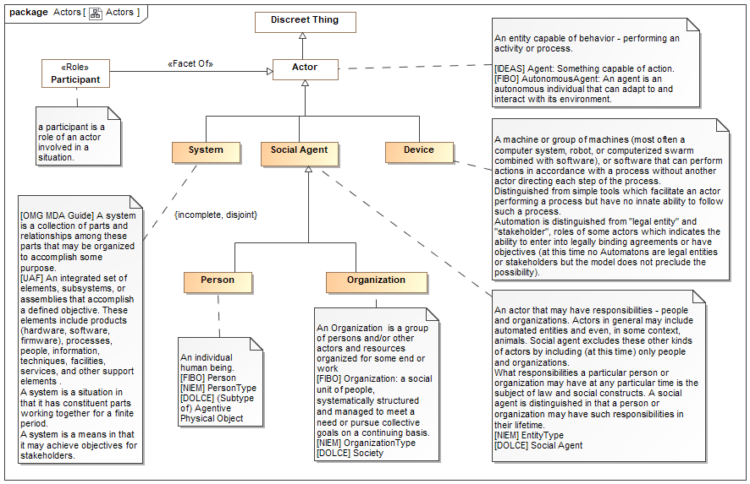

1. Actors

## Association Class Associated Actor

An  associated actor relationship defines a connection between an actor and some other actor they are associated with in some way. Subtypes of actor association  provide additional  semantics  about the association. As an association class, Actor Associations  may have properties and other relationships. Actor associations will typicaly have a timeframe.

 [NIEM] PersonOrganizationAssociationType (More specific concept)

 [NIEM] PersonPersonAssociationType (More specific concept)

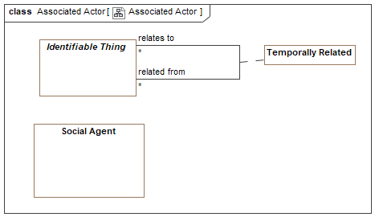

1. Associated Actor

Direct Supertypes

Temporally Related

Association Ends

has associate : Associate [*]



The actor associated with another.

associated with : Social Agent [1..*]



Another actor the subject actor is associated with.

## Association Class Boundary of System

An "edge" of a system affording some level of protection or containment for the system.

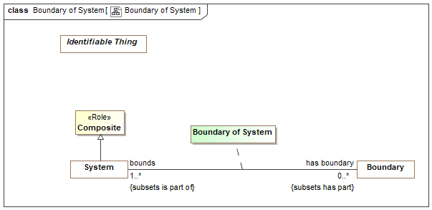

1. Boundary of System

Direct Supertypes

Parthood

Association Ends

has boundary : Boundary [0..*]



Logical or physical border of a system (or enterprise) that may serve to define, contain or protect the system.

bounds : System [1..*]



System for which a boundary is an edge.

## Class Person

An individual human being.

[FIBO] Person

[NIEM] PersonType

[DOLCE] (Subtype of) Agentive Physical Object

Direct Supertypes

Animal, Physical Thing, Social Agent

Associations

has body part : Human Body Part [1..*] *Subsets*: has part:Physical Thing



## Association Class Person at location

A relationship representing the location of a person at a particular time.

[NIEM] PersonLocationAssociationType

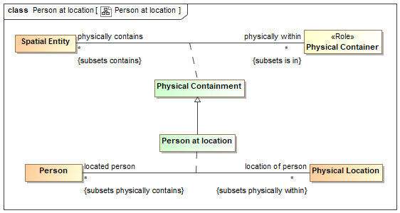

1. Person at location

Direct Supertypes

Physical Containment

Association Ends

location of person : Physical Location [*] *Subsets*: has part:Physical Thing



Location of the subject person.

[FIBO] isSituatedAt (mode general concept)

located person : Person [*] *Subsets*: has part:Physical Thing



A person who is at a location.

## Class Person Name <<Value>>

Text identifying a person by a recognized name.

[FIBO] hasFullLegalName (More specific concept)

[NIEM] PersonNameType

Direct Supertypes

Name

## Association Class Residency

A residence of a person - where they live.

[NIEM] PersonResidenceAssociationType

[FIBO] Residence: Note that residence is not the same as domicile, as a person or organization can have many transient residences but only one legal domicile. The domicile of a formal organization is the address (location) where the establishment is maintained or where the governing power of the organization is exercised.

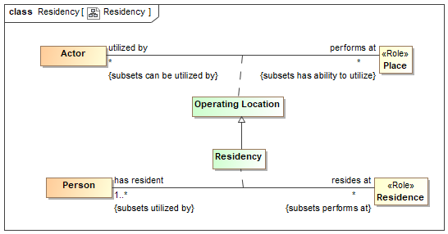

1. Residency

Direct Supertypes

Operating Location

Association Ends

resides at : Residence [*] *Subsets*: has part:Physical Thing



A residence of a person, where they live.

[FIBO] isDomiciledIn: identifies the permanent home or principal establishment of an individual or organization

has resident : Person [1..*] *Subsets*: has part:Physical Thing



A person living in a residence.

## Class Social Agent

An actor that may have responsibilities - people and organizations. Actors in general may include automated entities and even, in some context, animals. Social agent excludes these other kinds of actors by including (at this time) only people and organizations.

What responsibilities a particular person or organization may have at any particular time is the subject of law and social constructs. A social agent is distinguished in that a person or organization may have such responsibilities in their lifetime.

[NIEM] EntityType

[DOLCE] Social Agent

Direct Supertypes

Actor

## Class System

[OMG MDA Guide] A system is a collection of parts and relationships among these parts that may be organized to accomplish some purpose.

[UAF] An integrated set of elements, subsystems, or assemblies that accomplish a defined objective. These elements include products (hardware, software, firmware), processes, people, information, techniques, facilities, services, and other support elements .

A system is a situation in that it has constituent parts working together for a finite period.

A system is a means in that it may achieve objectives for stakeholders.

Direct Supertypes

Actor, Composite, Means, Situation

# OnticHealthGeneric::Foundation

# Class Actor

An entity capable of behavior - performing an activity or process.

[IDEAS] Agent: Something capable of action.

[FIBO] AutonomousAgent: An agent is an autonomous individual that can adapt to and interact with its environment.

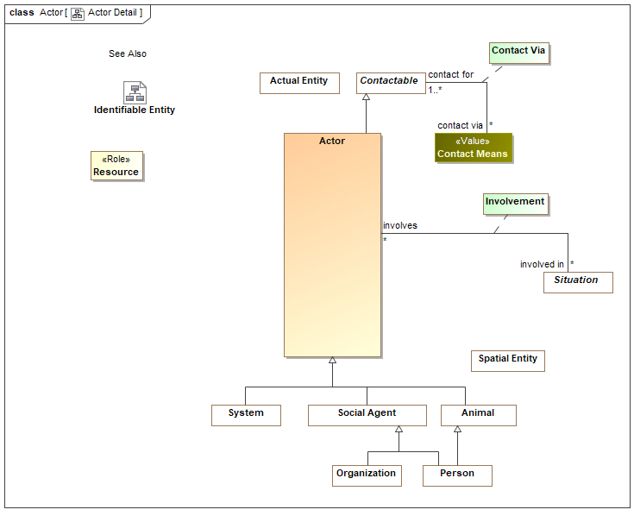

1. Actor Detail

## Direct Supertypes

Contactable, Discreet Thing, Identifiable Thing

# Class Actual Entity

An actual entity is an identifiable, individual person, specific object, process enactment, agreement, etc. Actual Entities do not have to be physical, e.i. may denote social constructs. Actual entities are disjoint from types.

A more specific class of actual entity (e.g., Person) is intended to refine the classification of the individual thing.

Individuality (or selfhood) is the state or quality of being an individual; particularly of being separate from other individuals and possessing identity. Actual entities typically have a lifetime and some individuals may change over that lifetime. Individuals may have parts that together help define the individual but may change over time.

"Actual" does not imply current existence.

[ISO 1087] individual concept: concept (3.2.1) which corresponds to only one object

[UML] Loose correspondence with "InstanceSpecification". SMIF instances are direct instances of their types, there is no "indirection" through value specification as their is in UML.

[Guizzardi] (individual concept)

[CL] Individual: one element of the universe of discourse

[DOLCE] Particular: particulars are entities which have no instances

[SOWA1999] Independent. Can be considered "Actuality" when including social constructs in [SOWA1999] Physical.

[OWL] Individual

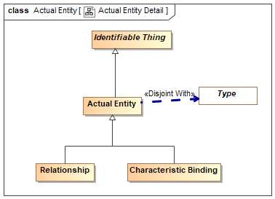

1. Actual Entity Detail

## Direct Supertypes

Identifiable Thing

# Class Context

A <Context> is an identifiable thing that can impact the condition or interpretation of other things.

A context may assert or negate other context.

Subtypes of <Context>, such as location, situation or <Type> ascribe more semantics to the context as well as limit the things it contextualizes.

[CL] Sort: any subset of the universe of discourse over which some quantifier is allowed to range

[ISO 1087] concept field: unstructured set of thematically related concepts (3.2.1)

[SOWA1999] Mediating thing

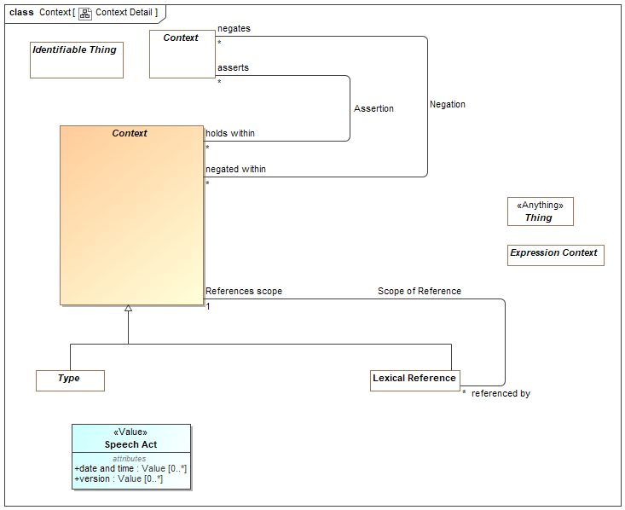

1. Context Detail

## Direct Supertypes

Identifiable Thing

# Class Identifiable Thing

An identifiable thing is any thing that can be distinguished from another, it is disjoint from values. Identifiable thing includes individuals, types, axioms, situations, speech acts, information structures, etc.

Identifiable things always have some kind of identity and may have identifiers. Note that identity is an abstraction that may have representation in models as any number of identifiers, also known as a "sign".

[OWL] Entity type (Implied in section [OWL] 5.8) as an instance of rdfs:Class

## Direct Supertypes

Thing

# Class Identifiable Type

A type of an identifiable entity. All concrete entity instances must have at least one entity type. Entity type may be mixed with other types to fully define an entity.

[FUML] Classifier

[BFO] Universal

[Guarino1994] Substantial or Pseudo-Sortal (Substantial being concrete)

[Guizzardi] A Rigid Universal.

(Rigid Universal): A universal G is rigid (or modally constant) iff for any w,w ∈ W 3. extw(G) = extw(G) Putting definitions 4.1 and 4.3 together, we have that for any rigid universal G the following is true 4. ext(G) = extw(G), for all w ∈ W A rigid universal is one that applies to its instances necessarily, i.e., in every possible world. Every substance sortal G is a rigid universal.

[OWL] rdfs:Class (as Entity Type does not include values). However, non=primitive values are typically represented as rdfs:Class

## Direct Supertypes

Type

# Class Thing

Any thing or value that does or may exist in any possible world. Thing is the supertype of all types and may therefore participate in unbounded relations.

Instances of Thing are referred to as "a thing" in this model.

[IDEAS] Thing

[OWL] Thing

[ISO 1087] object: anything perceivable or conceivable

[FIBO] Thing

[Guizzardi] Thing

[FUML] Element

[SOWA1999] "T"

[OWL] rdfs:Resource

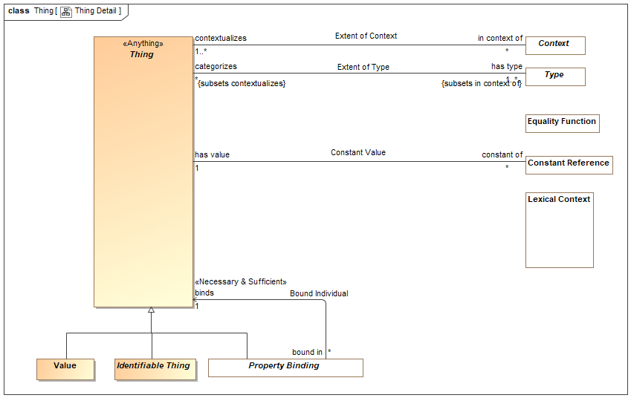

1. Thing Detail

## Associations

plays role : Role [0..*]



# Class Type

A <Type> is a categorization of any thing based on specific criteria. The specific criteria may or may not be formalized in a model.

A <Type> <categorizes> a set of <Thing>s which comprises the "extent" of the type.

A <Type> is a <Context> where the things it <categorizes> are <in the context> of the <Type>.

Types may participate in a taxonomy based on generalizations.

[ISO 1087] general concept: concept (3.2.1) which corresponds to two or more objects (3.1.1) which form a group by reason of common properties

[FIBO] Classifier: a standardized classification or delineation for something, per some scheme for such delineation, within a specified context

[FUML] Type

[CL] Type:: logical framework in which expressions in the logic are classified into syntactic or lexical categories (types) and restricted to apply only to arguments of a fixed type

[Guarino1994] Universal

[OWL] Union(rdfs:Class, rdfs:Datatype)

Similar to:

[IDEAS] Type: A set (or class) of Things.

## Direct Supertypes

Context, Lexical Context, Scoped Context

## Associations

sufficient supertype : Role [0..*]



*through association:* Sufficient Generalization

justifies subtype : Role [0..*]



*through association:* Sufficient Generalization

# OnticHealthGeneric::Foundation::Facets

The facet package defines facets, roles and phases. Types that "mix in" to other types in a specific context or timeframe.

## Diagram: Facets

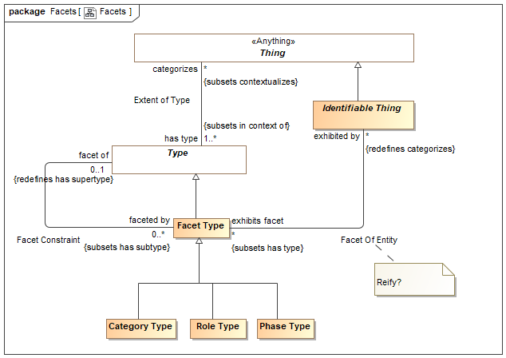

1. Facets

## Class Category Type

A category is a classification or division of people, events or things regarded as having particular shared characteristics. Categorization is typically contextual, potentially transient and may or may not be formally defined.

As with all facets, categories are non-rigid. Something classified by a category must also be classified by an entity type.

Direct Supertypes

Facet Type

## Association Facet Constraint

A Facet Constraint specifies a possible a "mix in" or "non rigid" classification of an entity beyond any fundamental entity type. The must common kinds of facets are roles and phases. Note that the UML profile also specifies subtypes of <<Facet Of>> that are syntactic sugar for facet classification.

The type of individual a facet can apply to may be specified using a facet classification. Note that Facets . A facet classification may be contextual, such as within a relation, situation and/or time frame. Instances may have any number of types and classifications may change over time.

A <<Sufficient>> property is typically used to specify the mediating concept the facet is with respect to.

There are various implementation strategies for facets including multiple classification and dependent objects. SMIF does not commit to any particular implementation strategy.

Association Ends

facet of : Type [0..1]



faceted by : Facet Type [0..*]



## Association Facet Of Entity

Facet of Entity is a first-class relationship defining a facet of an entity. As a relationship the application of the facet to the entity may be time and context specific. The entity will have the type of the identified facet. Properties and relationships specific to the entity exhibiting a facet, if required, may utilize a subtype of Entity Of Facet.

For example, a Person may play the "Parent" role for multiple children and there may be properties and relationships relative to this generic parent role. If it is required to specify properties and relationships specific to the person being a parent of a specific child, a subtype of Facet Of Entity is used.

Direct Supertypes

Extent of Type

Association Ends

exhibits facet : Facet Type [*]



The facet that an entity assumes when it is the facet of an entity.

[FIBO] (for roles) playsRole

exhibited by : Identifiable Thing [*]



Type of the entity exhibiting the facet.

## Class Facet Type

A facet is a "mix in" type that defines an aspect of something but does not define the identity or "fundamental" (A.K.A. "Rigid") type of that thing, but some potentially transient role, phase or other way to classify it. Something must have at least one type that is not a facet to define that things identity.

Facets do not define independent identity of the referent but technology implementations may create independent objects to represent a facet.

An instance of a facet must also have a type that is not a facet to provide the identity of the instance.

The type(s) a facet may categorize may be constrained by a Facet Generalization Constraint. E.g. Policeman is a role of a person.

[Guarino1994] Non-Substantial sortal

[Guizzard] Non-Rigid Universal: A universal G is non-rigid iff for a w ∈ W There is an x such that x ∈ extw(G), and there is a w∈ W such that x ∉extw(G)

[SOWA1999] Prehension (Relative

Direct Supertypes

Type

## Class Phase Type

A phase (or state) is a static characteristic of something that exists for limited time(s). Something takes on or looses a phase as a result of some event. E,g, Teenager, living, closed invoice.

A Phase is a situation in that there is a situation coincident with each phase.

[Guizzardi] (Phased-Sortal): Let PS be a universal and let S be a

substance sortal specialized (restricted by) PS. Now, let extw(~PS) = extw(S) \ extw(PS)

be the complement of the extension of PS in world w. In this formula, the

symbol \ represents the set theoretical operation of set difference. The

universal PS is a phased-sortal iff for all worlds w ∈ W, there is a w ∈ W such

that extw(PS) ∩ extw(~PS) ≠ ∅

Direct Supertypes

Facet Type

# OnticHealthGeneric::Identifiers

## Diagram: Identifiers

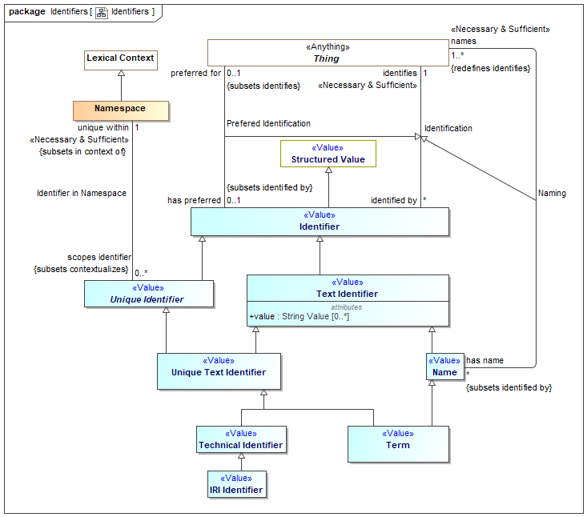

1. Identifiers

# OnticHealthGeneric::Occurrences

## Diagram: Occurrences

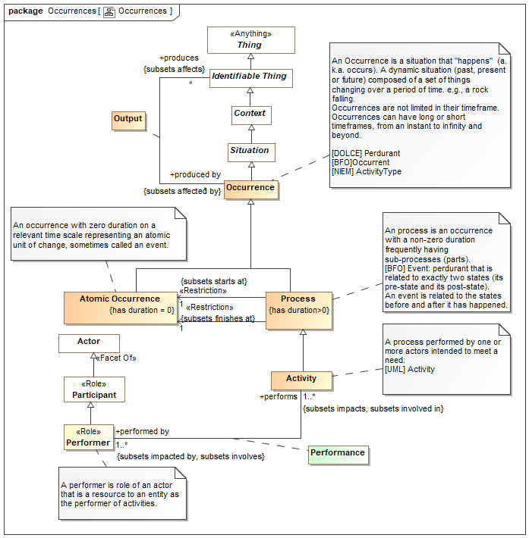

1. Occurrences

## Class Activity

A process performed by one or more actors intended to meet a need.

[UML] Activity

Direct Supertypes

Process, Resource

## Class Composite Process <<Role>>

Direct Supertypes

Process Type, Temporal Composite

## Class Occurrence

An Occurrence is a situation that "happens" (a.k.a. occurs). A dynamic situation (past, present or future) composed of a set of things changing over a period of time. e.g., a rock falling.

Occurrences are not limited in their timeframe. Occurrences can have long or short timeframes, from an instant to infinity and beyond.

[DOLCE] Perdurant

[BFO]Occurrent

[NIEM] ActivityType

Direct Supertypes

Situation

## Association Class Output

Outputs from a process or actual event - the things or situations it creates.

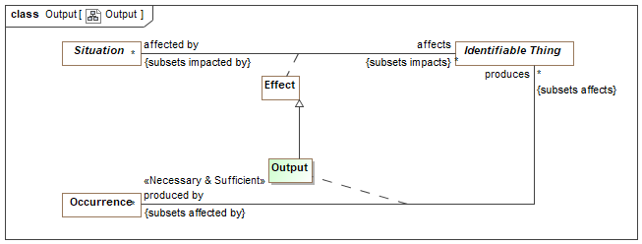

1. Output

Direct Supertypes

Effect

Association Ends

produces : Identifiable Thing [*]



Resources produced by a process or actual event

produced by : Occurrence [*]



Occurrences which produce an entity.

## Class Process

An process is an occurrence with a non-zero duration frequently having sub-processes (parts).

[BFO] Event: perdurant that is related to exactly two states (its pre-state and its post-state).

An event is related to the states before and after it has happened.

Direct Supertypes

Occurrence

Associations

<<Restriction>> : Process Type [1..*] *Subsets*: has type:Type



## Association Class Process Decomposition

Relationship describing the decomposition of a process.

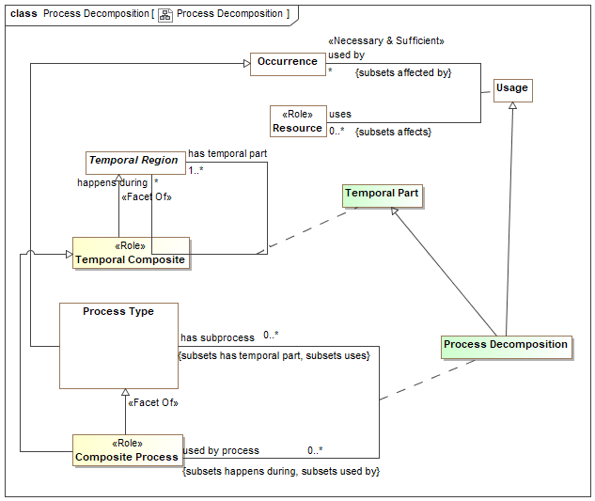

1. Process Decomposition

Direct Supertypes

Temporal Part, Usage

Association Ends

has subprocess : Process Type [0..*] *Subsets*: has type:Type



Process occurring within the scope of and in support a composite process.

used by process : Composite Process [0..*] *Subsets*: has type:Type



Composite processes which utilize the subject property as a component part.

## Association Class Usage

Inputs to a process or actual event - what it uses

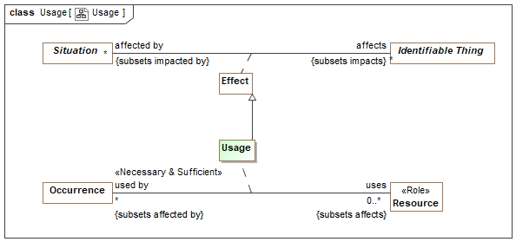

1. Usage

Direct Supertypes

Effect

Association Ends

uses : Resource [0..*] *Subsets*: has type:Type



A resources used by a process or actual event.

used by : Occurrence [*] *Subsets*: has type:Type



A process or actual occurrence that is used by a resource for the resource to fulfill its function.

# OnticHealthGeneric::Qualitative Position

## Diagram: Qualitative Position

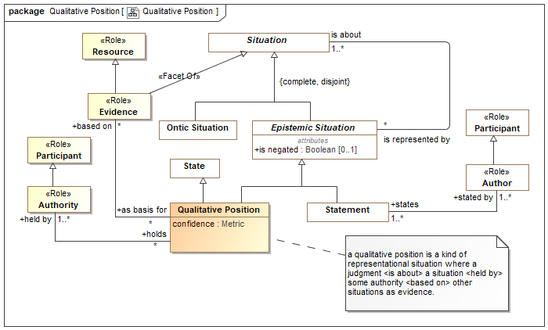

1. Qualitative Position

## Class Authority <<Role>>

Direct Supertypes

Participant

Associations

holds : Qualitative Position [*]



## Class Evidence <<Role>>

Evidence is a kind of resource for situation(s) justifying qualitative positions.

Direct Supertypes

Resource, Situation

Associations

as basis for : Qualitative Position [*]



## Class Qualitative Position

a qualitative position is a kind of representational situation where a judgment <is about> a situation <held by> some authority <based on> other situations as evidence.

Direct Supertypes

Epistemic Situation, State

Attributes

confidence : Metric



Associations

held by : Authority [1..*]



based on : Evidence [*]



# OnticHealthGeneric::Qualities

## Diagram: Qualities

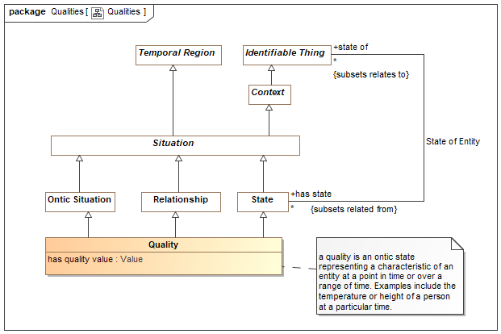

1. Qualities

## Diagram: Values

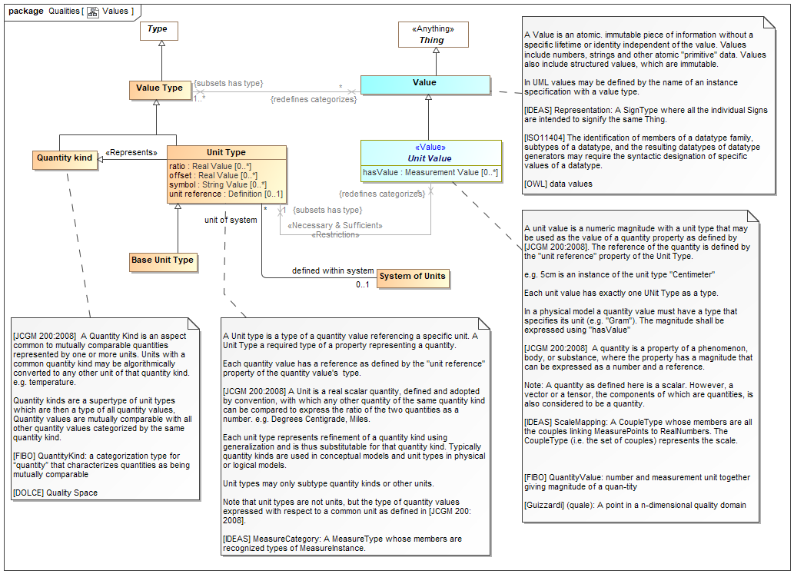

1. Values

## Class Quality

a quality is an ontic state representing a characteristic of an entity at a point in time or over a range of time. Examples include the temperature or height of a person at a particular time.

Direct Supertypes

Ontic Situation, Relationship, State

Attributes

has quality value : Value



# OnticHealthGeneric::Situation Types

## Diagram: Situation Types

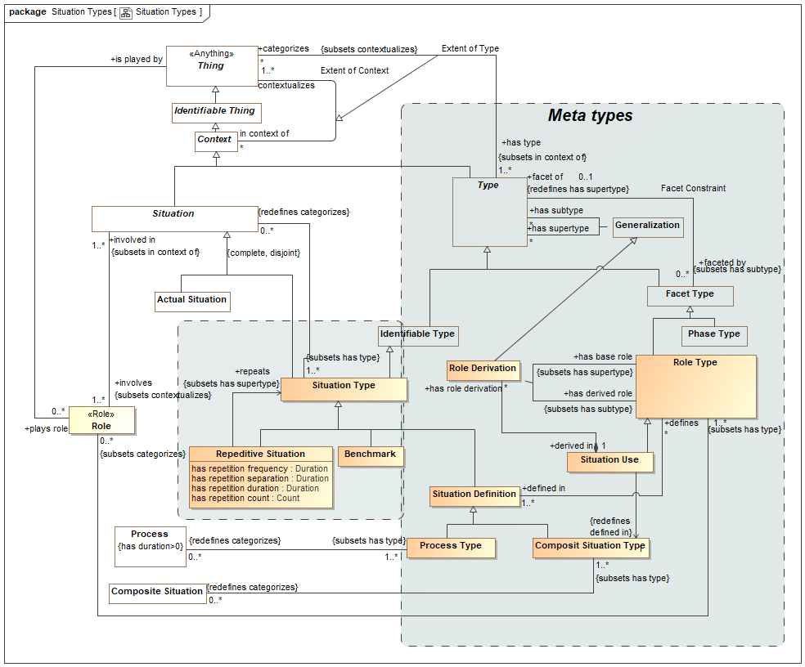

1. Situation Types

## Class Benchmark

A benchmark is a situation type for comparison against expected patterns or values.

Direct Supertypes

Situation Type

## Class Composit Situation Type

A composite situation type is a Situation Definition that uses (synthesizes) other situation definitions as its parts. [Reenskaug 1995] Collaboration

Direct Supertypes

Situation Definition

Associations

<<Restriction>> : Composite Situation [0..*] *Redefines*: categorizes:Thing



## Class Repeditive Situation

a situation that repeats. Repetitive is a "mixin" class, any situation may be repetitive unless otherwise restricted.

Direct Supertypes

Situation Type

Attributes

has repetition frequency : Duration



how often each actual repetition should happen

has repetition separation : Duration



time between actual situations

has repetition duration : Duration



how long each repetition should last

has repetition count : Count



number of times the situation should repeat

Associations

repeats : Situation Type [0..*] *Subsets*: has supertype:Type



situation type that is repeated (if any)

## Association Class Role Derivation

A role derivation "synthesizes" a base role into a role within the context of a situation use based on the synthesis pattern described in

[Reenskaug 1995] Derived Role Constraint.

[UML] Role binding

Direct Supertypes

Generalization

Association Ends

has derived role : Role Type [0..*] *Subsets*: has supertype:Type



role that is defined as being a subtype of a base role

has base role : Role Type [0..*] *Subsets*: has supertype:Type



role that will supertype of derived role and synthesized into the composite pattern.

Associations

derived in : Situation Use [1]



roles defined as meaningful within the situation type

## Class Role Type

A role type is a facet type that defines a specific purpose or behavior of a class of things. E.g. teacher, policeman, or employer.

[Reenskaug 1995] Role

[FIBO] Role. Note that partyInRole or thingInRole are implied by classification of a thing.

Direct Supertypes

Facet Type

Associations

<<Restriction>> : Role [0..*] *Subsets*: categorizes:Thing



defined in : Situation Definition [1..*]



definition is which the role is defined

has derived role : Situation Definition [1..*]



*through association:* Role Derivation

role that is defined as being a subtype of a base role

has base role : Situation Definition [1..*]



*through association:* Role Derivation

role that will supertype of derived role and synthesized into the composite pattern.

## Class Situation Definition

A Situation Definition is a kind of Situation Type that defines roles and constraints describing situations. A situation definition is also a situation in that it has a lifetime and may involve Roles to bind individuals playing roles to situation definitions.

Direct Supertypes

Situation Type

Associations

defines : Role Type [*]



## Class Situation Type

A situation type defines a kind of identifiable arrangement of individuals, assertions and the relations between them over a timespan.

[DTV] situation kind: state of affairs that may or may not happen in some possible world

[Barrwise 1999] Situation Type

Direct Supertypes

Identifiable Property Owner, Identifiable Type, Identifiable Type, Lexical Context, Situation

## Class Situation Use

Situation use is a kind of role type that uses another situation type within a defining composite situation type based on the synthesis pattern described in [Reenskaug 1995] (Synthesis).

Direct Supertypes

Role Type

Associations

: Composit Situation Type [1] *Redefines*: defined in:Situation Definition



has role derivation : Role Derivation [*]



a role derived from a situation that is used by a composite situation.

# OnticHealthGeneric::Situations

## Diagram: Situation Partitions

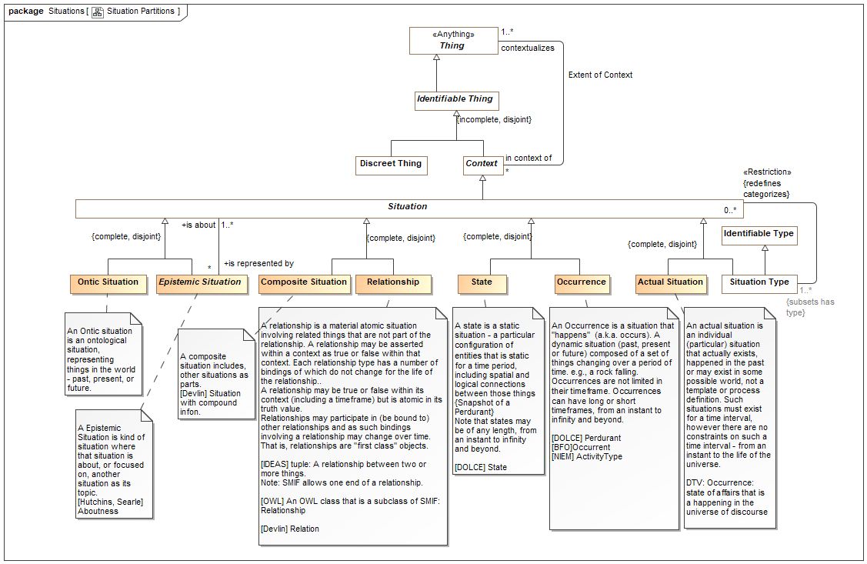

1. Situation Partitions

## Diagram: Situation Temporal

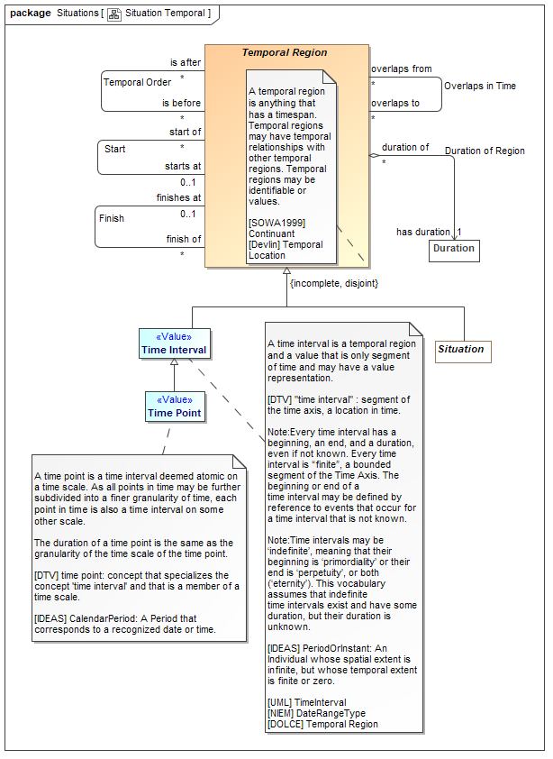

1. Situation Temporal

## Diagram: Situation Top

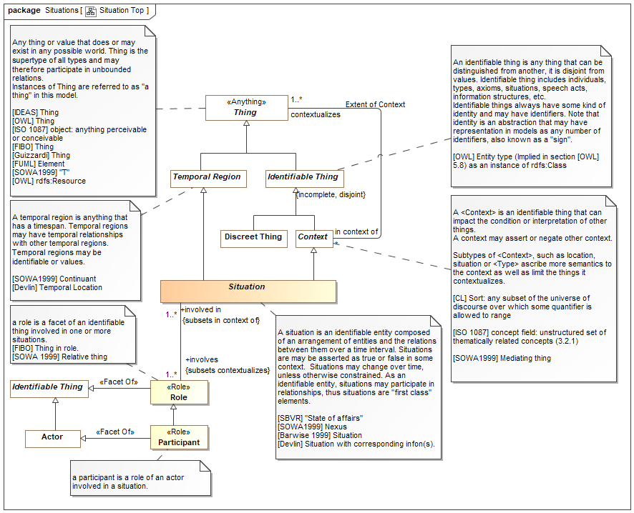

1. Situation Top

## Class Actual Situation

An actual situation is an individual (particular) situation that actually exists, happened in the past or may exist in some possible world, not a template or process definition. Such situations must exist for a time interval, however there are no constraints on such a time interval - from an instant to the life of the universe.

DTV: Occurrence: state of affairs that is a happening in the universe of discourse

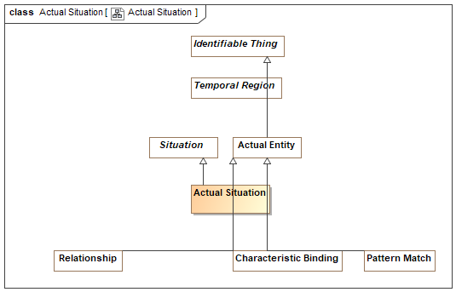

1. Actual Situation

Direct Supertypes

Situation, Temporal Entity

## Association Class Cause and Effect

The causality relation where the <causes> situation is <caused by> a situation.

[FIBO] cause / caused by

[ISO 1087] causal relation: associative relation (3.2.23) involving cause and its effect

NOTE A causal relation exists between the concepts (3.2.1) 'action' and 'reaction', 'nuclear explosion' and 'fall-out'.

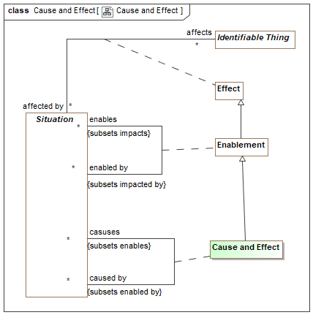

1. Cause and Effect

Direct Supertypes

Enablement

Association Ends

caused by : Situation [*]



One of situations that causes the subject situation.

casuses : Situation [*]



A situation caused by another.

## Class Discreet Thing

A discreet thing is an identifiable thing that may be the subject of temporal relationships but does not inherently include those relationships.

[Devlin] Individual

[Barwise 1999] Uniformity

Direct Supertypes

Identifiable Thing

## Association Class Effect

Any impact on or alteration of an entity by a situation - an effect of the situation.

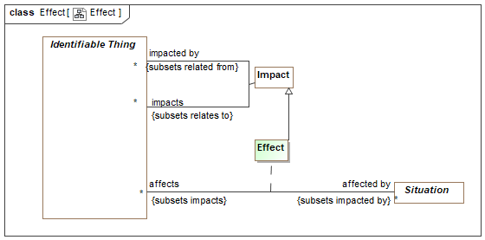

1. Effect

Direct Supertypes

Impact

Association Ends

affects : Identifiable Thing [*]



Entities affected by a action

affected by : Situation [*]



Actions that can cause some change in a related entity.

## Association Class Enablement

A situation that enables (is a condition for), another.

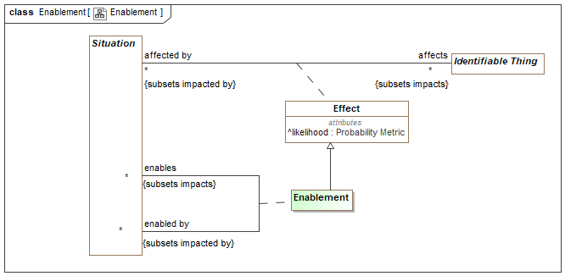

1. Enablement

Direct Supertypes

Effect, Impact

Association Ends

enables : Situation [*]



A situation that is enabled by another.

enabled by : Situation [*]



A situation that enables another.

## Class Epistemic Situation

A Epistemic Situation is kind of situation where that situation is about, or focused on, another situation as its topic.

[Hutchins, Searle] Aboutness

Direct Supertypes

Situation

Attributes

is negated : Boolean [0..1]



is negated inverts the truth value of the statement.

## Association Class Indication

Association Ends

is indicated by : Situation [0..*]



indicates : Situation [0..*]



## Association Class Negation Effect

The negative causality relationship - <negated by> prevents or terminates the <negates> situation.

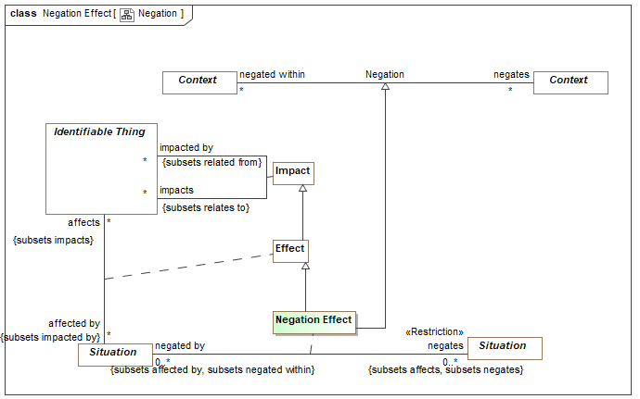

1. Negation

Direct Supertypes

Effect, Negation

Association Ends

negated by : Situation [0..*]



A situation that prevents or terminates another.

negates : Situation [0..*]



A situation that is prevented or terminated by another situation.

## Class Ontic Situation

An Ontic situation is an ontological situation, representing things in the world - past, present, or future.

Direct Supertypes

Situation

## Class Participant <<Role>>

a participant is a role of an actor involved in a situation.

Direct Supertypes

Actor, Role

## Class Relationship

A relationship is a material atomic situation involving related things that are not part of the relationship. A relationship may be asserted within a context as true or false within that context. Each relationship type has a number of bindings of which do not change for the life of the relationship..

A relationship may be true or false within its context (including a timeframe) but is atomic in its truth value.

Relationships may participate in (be bound to) other relationships and as such bindings involving a relationship may change over time. That is, relationships are "first class" objects.

[IDEAS] tuple: A relationship between two or more things.

Note: SMIF allows one end of a relationship.

[OWL] An OWL class that is a subclass of SMIF: Relationship

[Devlin] Relation

Direct Supertypes

Actual Entity, Situation

## Class Role <<Role>>

a role is a facet of an identifiable thing involved in one or more situations.

[FIBO] Thing in role.

[SOWA 1999] Relative thing

Direct Supertypes

Identifiable Thing

Associations

involved in : Situation [1..*] *Subsets*: in context of:Context



<<Restriction>> : Role Type [1..*] *Subsets*: has type:Type



is played by : Thing



## Class Situation

A situation is an identifiable entity composed of an arrangement of entities and the relations between them over a time interval. Situations are may be asserted as true or false in some context. Situations may change over time, unless otherwise constrained. As an identifiable entity, situations may participate in relationships, thus situations are "first class" elements.

[SBVR] "State of affairs"

[SOWA1999] Nexus

[Barwise 1999] Situation

[Devlin] Situation with corresponding infon(s).

Direct Supertypes

Context, Context, Lexical Context, Temporal Region

Associations

involves : Role [1..*] *Subsets*: contextualizes:Thing



is indicated by : Role [1..*] *Subsets*: contextualizes:Thing



*through association:* Indication

indicates : Role [1..*] *Subsets*: contextualizes:Thing



*through association:* Indication

## Class State

A state is a static situation - a particular configuration of entities that is static for a time period, including spatial and logical connections between those things {Snapshot of a Perdurant}

Note that states may be of any length, from an instant to infinity and beyond.

[DOLCE] State

Direct Supertypes

Situation

## Association State of Entity

Relationship between a perdurant (something that exits over time) and a "state" of that entity as a snapshot in time.

Association Ends

state of : Identifiable Thing [*] *Subsets*: contextualizes:Thing



The endurant entity for which the subject state is a snapshot.

has state : State [*] *Subsets*: contextualizes:Thing



A states (or snapshots) of an entity within its lifetime.

# OnticHealthGeneric::Statements

## Diagram: Statement Classification

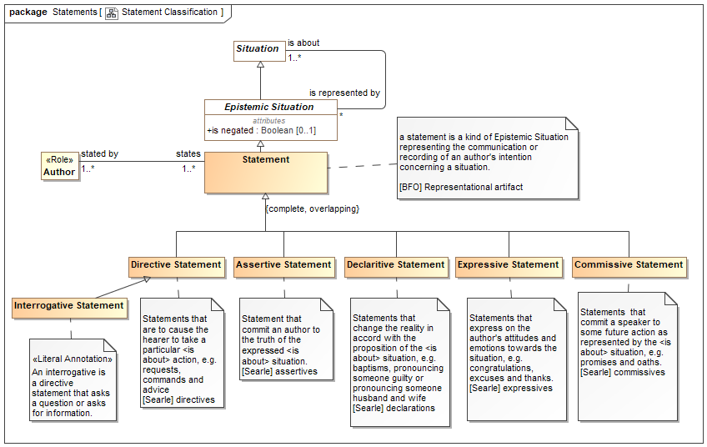

1. Statement Classification

## Diagram: Statements

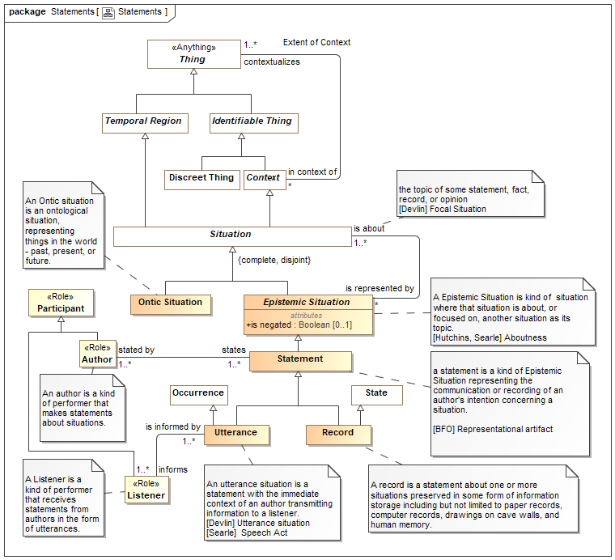

1. Statements

## Class Assertive Statement

Statement that commit an author to the truth of the expressed <is about> situation.

[Searle] assertives

Direct Supertypes

Statement

## Class Author <<Role>>

An author is a kind of performer that makes statements about situations.

Direct Supertypes

Participant

Associations

states : Statement [1..*]



## Class Commissive Statement

Statements that commit a speaker to some future action as represented by the <is about> situation, e.g. promises and oaths.

[Searle] commissives

Direct Supertypes

Statement

## Class Declaritive Statement

Statements that change the reality in accord with the proposition of the <is about> situation, e.g. baptisms, pronouncing someone guilty or pronouncing someone husband and wife

[Searle] declarations

Direct Supertypes

Statement

## Class Directive Statement

Statements that are to cause the hearer to take a particular <is about> action, e.g. requests, commands and advice

[Searle] directives

Direct Supertypes

Statement

## Class Expressive Statement

Statements that express on the author's attitudes and emotions towards the situation, e.g. congratulations, excuses and thanks.

[Searle] expressives

Direct Supertypes

Statement

## Class Interrogative Statement

An interrogative is a directive statement that asks a question or asks for information.

Direct Supertypes

Directive Statement

## Class Listener <<Role>>

A Listener is a kind of performer that receives statements from authors in the form of utterances.

Direct Supertypes

Participant

Associations

is informed by : Utterance [1..*]



## Class Record

A record is a statement about one or more situations preserved in some form of information storage including but not limited to paper records, computer records, drawings on cave walls, and human memory.

Direct Supertypes

State, Statement

## Class Statement

a statement is a kind of Epistemic Situation representing the communication or recording of an author's intention concerning a situation.

[BFO] Representational artifact

Direct Supertypes

Epistemic Situation

Associations

stated by : Author [1..*]



## Class Utterance

An utterance situation is a statement with the immediate context of an author transmitting information to a listener.

[Devlin] Utterance situation

[Searle] Speech Act

Direct Supertypes

Occurrence, Statement

Associations

informs : Listener [1..*]



# OnticHealthGeneric::Time & Temporal Entities

The Time package defines the essential concepts of time and the identification of time intervals.

These time concepts are based on the OMG Date Time Vocabulary [DTV] standard but subsets and simplifies DTV for use in defining, federating and exchanging time aspects of entities.

"Temporal Entity" is introduced as an abstraction to capture the common relationships between time elements. Within DTV these relationships are separate for each kind of time element. The relationships defined for Temporal Entity are grounded in DTV Time Interval as each temporal entity exists for a time interval.

Applications that need to reason about time are encouraged to utilize the full DTV semantics. DTV also contains text that more fully elaborates time concepts.

## Diagram: Time

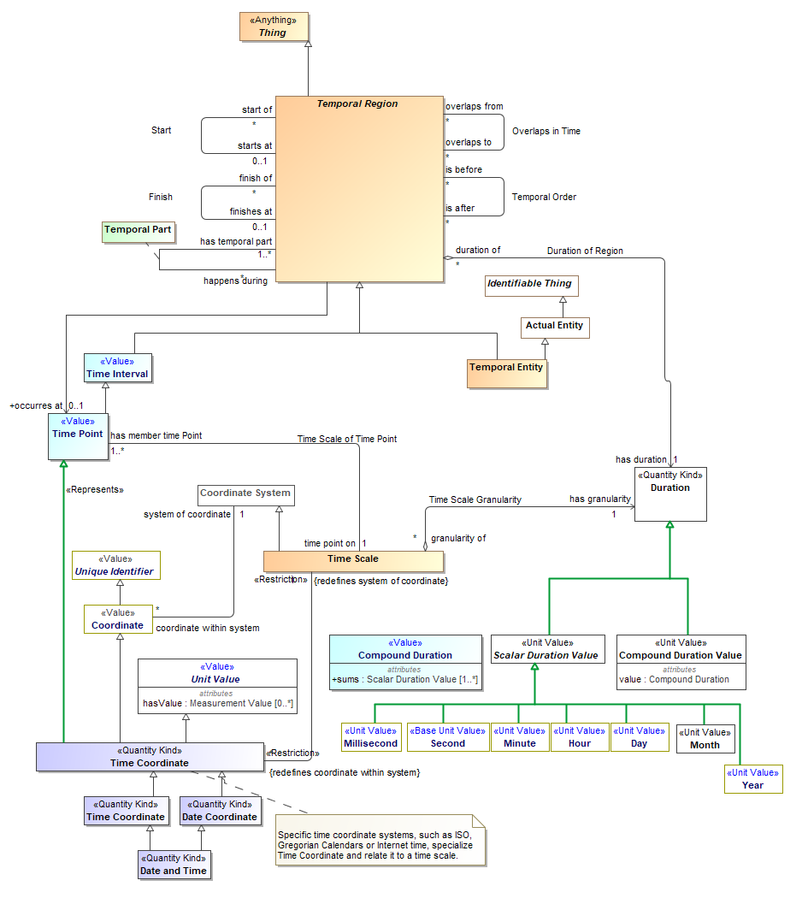

1. Time

## Class Date and Time <<Quantity Kind>>

[FIBO] DateTimeStamp: A DateTimeStamp combines a Date, a time, and a time

Direct Supertypes

Date Coordinate, Time Coordinate

## Class Date Coordinate <<Quantity Kind>>

[FIBO] Date: A Date identifies a calendar day on some calendar.

[NIEM] DateType

Direct Supertypes

Time Coordinate

## Association Duration of Region

[DTV] time interval [of temporal entity] has particular duration:the particular duration is the duration that is the amount of time in the time interval.

Each time interval [Temporal Entity] has a unique duration attribute that is a measure of its size, i.e., the amount of time the time interval occupies. This attribute is mathematically a function that maps time intervals into durations. This mapping function is sometimes called the “range” of a time interval, and some times called the “measure” of a time interval.

Association Ends

duration of : Temporal Region [*]



Temporal entity for which a duration is applicable.

has duration : Duration [1]



Difference between the start and end time. A non-zero positive value representing the amount of time a temporal entity exists.

[DTV] time interval [of temporal entity] has particular duration:the particular duration is the duration that is the amount of time in the time interval.

Each time interval [Temporal Entity] has a unique duration attribute that is a measure of its size, i.e., the amount of time the time interval occupies. This attribute is mathematically a function that maps time intervals into durations. This mapping function is sometimes called the “range” of a time interval, and some times called the “measure” of a time interval.

## Association Entity Exists for Interval

Relationship defining the time interval in which an entity actually exists.

[DTV] occurrence occurs for occurrence interval: the occurrence occurs throughout the occurrence interval and the occurrence does not occur within some time interval2 that meets the occurrence interval and the occurrence does not occur within some time interval3 that is met by the

occurrence interval

[Alen 1983] X is equal to Y: X = Y where X is "interval of" and Y is "exists for". Note that this relates the temporal aspect of "interval of" to the timeframe "exists for".

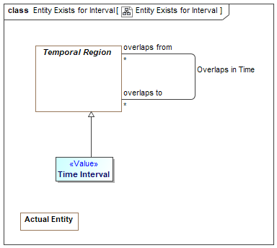

1. Entity Exists for Interval

Direct Supertypes

Overlaps in Time

Association Ends

exists for : Time Interval [1]



Time interval where an entity may be considered "actual", that is existent in the domain of discourse.

interval of : Actual Situation [*]



Entity existent for the full extent of a time interval.

## Association Finish

The time something no longer exists (inclusive).

[DTV] time interval1 finishes time interval2

Synonymous Form:time interval2 is finished by time interval1

Definition:time interval1 is a proper part of time interval2 and there exists no time interval3 that is a proper part of time interval2 and that is after time interval1

[IDEAS] endBoundary: A temporalBoundary where the boundary is a end boundary of the whole.

[Alen 1983] X finishes Y: X f Y where X is "finishes at" and Y is "finish of"

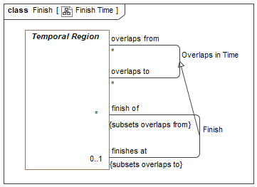

1. Finish Time

Direct Supertypes

Overlaps in Time

Association Ends

finish of : Temporal Region [*]



Thing which no longer exists at a particular time.

finishes at : Temporal Region [0..1]



Time something no longer exists. (Inclusive)

## Association Overlaps in Time

Some or all parts of the related temporal entities exist at the same time. Note that "to" and "from" may be arbitrary. By convention, the containing or prior temporal entity is "from".

[DTV] time interval1 properly overlaps time interval2

An [ISO 1087] temporal relation: sequential relation (3.2.24) involving events in time

[DOLCE] (subtype of) Temporal Quality

[Alen] X overlaps with Y: X o Y, where assignment of X and Y is arbitrary.

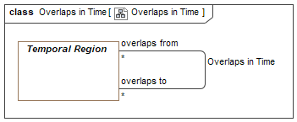

1. Overlaps in Time

Association Ends

overlaps from : Temporal Region [*]



An overlapping temporal component.

overlaps to : Temporal Region [*]



An overlapping temporal component.

## Association Start

The time something starts to exist (inclusive).

[DTV] time interval1 starts time interval2

Synonymous Form:time interval2 is started by time interval1

Definition:time interval1 is a proper part of time interval2 and there exists no time interval3 that is a proper part of time interval2 and that is before time interval1.

[IDEAS] startBoundary: A temporalBoundary where the boundary is a start boundary of the whole.

[Alen 1983] X starts Y: X s Y where X is "starts at" and Y is "start of".

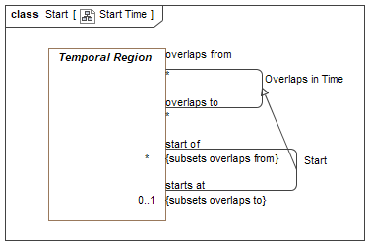

1. Start Time

Direct Supertypes

Overlaps in Time

Association Ends

start of : Temporal Region [*]



Thing which begins to exist at a particular time.

starts at : Temporal Region [0..1]



Time somethings begins to exist. (inclusive).

[FIBO] hasStartDate

## Class Temporal Composite <<Role>>

Direct Supertypes

Composite, Temporal Region

## Class Temporal Entity

An actual entity existing for a duration in time.

Direct Supertypes

Actual Entity, Temporal Region

## Association Temporal Order

A relationship representing ordering of temporal entities in time where the <starts at> of <is after> is greater than or equal to the <finishes at> of <is before>. Related things do not overlap in time.

[DOLCE] (subtype of) Temporal Quality

[DTV] "time interval1 is properly before time interval2": the time interval1 is before the time interval2 and the time interval1 is before a time interval3 and the time interval3 is before the time interval2

[DTV] time interval1 finishes duration after time interval2: The end of one time interval is duration after the end of the other time interval.

[IDEAS] beforeAfter: A couple that asserts one individuals' temporal extent is completely before the temporal extent of another.

An [ISO 1087] temporal relation: sequential relation (3.2.24) involving events in time

[Alen1983] X takes place before Y: X<Y where X is "is before" and Y is "is after".

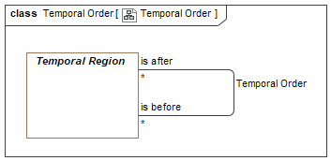

1. Temporal Order

Association Ends

is after : Temporal Region [*]



A temporal entity that starts after the <is before> entity ends.

is before : Temporal Region [*]



A temporal entity that ends after the <is after> entity starts.

## Association Class Temporal Part

The time interval of <has temporal part> is within the time interval of <happens durring>.

[DTV] time interval1 is proper part of time interval2: the time interval1 is a proper part of the time interval2 and a time interval3 is a proper part of the time interval2 and a time interval4 is a proper part of the time interval2 and the time interval3 is before the time interval1 and the time interval1 is before the time interval4.

[IDAS] temporalWholePart: A wholePart that asserts the spatial extent of the (whole) individual is co-extensive with the spatial extent of the (part) individual for a particular period of time.

[Alen 1983] X during Y: Xd Y where X is "happens during" and Y is "has temporal part"

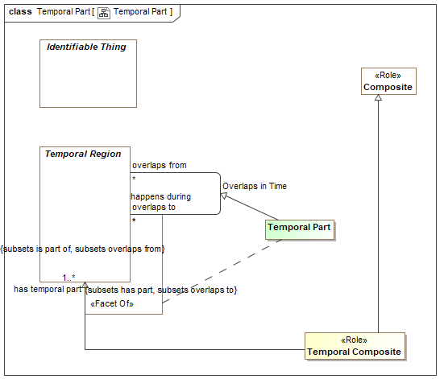

1. Temporal Part

Direct Supertypes

Overlaps in Time, Parthood

Association Ends

happens during : Temporal Region [*]



A situation with overlapping duration (overlapping temporal extent).

has temporal part : Temporal Region [1..*]



Sub-durations of anything that happen - a temporal part.

## Class Temporal Region

A temporal region is anything that has a timespan. Temporal regions may have temporal relationships with other temporal regions. Temporal regions may be identifiable or values.

[SOWA1999] Continuant

[Devlin] Temporal Location

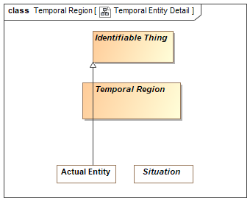

1. Temporal Entity Detail

Direct Supertypes

Thing

Associations

occurres at : Time Point [0..1]



## Class Time Coordinate <<Quantity Kind>>

A designation of a particular time.

Direct Supertypes

Time Coordinate

## Class Time Interval <<Value>>

A time interval is a temporal region and a value that is only segment of time and may have a value representation.

[DTV] "time interval" : segment of the time axis, a location in time.

Note:Every time interval has a beginning, an end, and a duration, even if not known. Every time interval is “finite”, a bounded segment of the Time Axis. The beginning or end of a

time interval may be defined by reference to events that occur for a time interval that is not known.

Note:Time intervals may be ‘indefinite’, meaning that their beginning is ‘primordiality’ or their end is ‘perpetuity’, or both (‘eternity’). This vocabulary assumes that indefinite

time intervals exist and have some duration, but their duration is unknown.

[IDEAS] PeriodOrInstant: An Individual whose spatial extent is infinite, but whose temporal extent is finite or zero.

[UML] TimeInterval

[NIEM] DateRangeType

[DOLCE] Temporal Region

Direct Supertypes

Temporal Region

## Class Time Point <<Value>>

A time point is a time interval deemed atomic on a time scale. As all points in time may be further subdivided into a finer granularity of time, each point in time is also a time interval on some other scale.

The duration of a time point is the same as the granularity of the time scale of the time point.

[DTV] time point: concept that specializes the concept 'time interval' and that is a member of a time scale.

[IDEAS] CalendarPeriod: A Period that corresponds to a recognized date or time.

Direct Supertypes

Time Interval

## Class Time Scale

A time scale is a way to reckon time as a series of consecutive time points identified by time coordinates. e.g. Time scale defined by the Gregorian calendar.

[DTV] time scale: regular sequence that each member of the regular sequence is a time point

Direct Supertypes

Coordinate System

## Association Time Scale Granularity

[DTV] Time scale has granularity: The granularity of the time scale is the duration of the time points of the time scale.

Association Ends

has granularity : Duration [1]



[DTV] the smallest duration that can be distinguished with a given time scale

granularity of : Time Scale [*]



Duration of each time point on a time scale.

## Association Time Scale of Time Point

Relationship defining the time scale on which a time point is defined. e.g. December 7th, 1944 is defined on a Gregorian Calendar time scale.

Association Ends

time point on : Time Scale [1]



Time scale used for defining a time point.

[DTV] time scale has time point:

has member time Point : Time Point [1..*]



Time point defined within a time scale

# OnticHealthGeneric::Time & Temporal Entities::ISO Time Scale

## Diagram: ISO Time

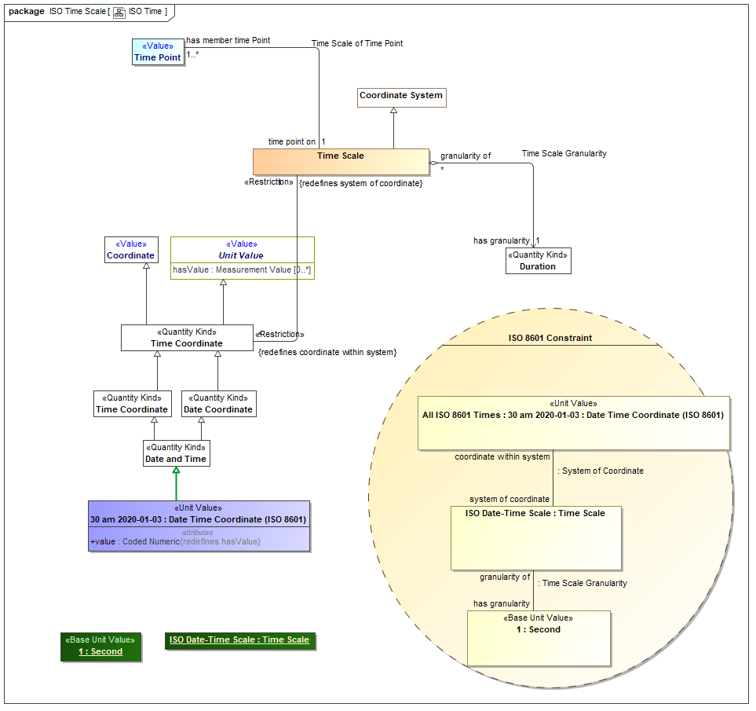

1. ISO Time

## Class 30 am 2020-01-03 : Date Time Coordinate (ISO 8601) <<Unit Value>>

[UAF] A date and time specified in the ISO8601 date-time format including timezone designator (TZD): YYYY-MM-DDThh:mm:ssTZD.

Direct Supertypes

Date and Time

Attributes

value : Coded Numeric



A text string representing a date and time specified in the ISO8601 date-time format including timezone designator (TZD): YYYY-MM-DDThh:mm:ssTZD.

# OnticHealthGeneric::Time & Temporal Entities::XSD Time Scale

XSD Representations of date and time

## Diagram: XSD Time Scale

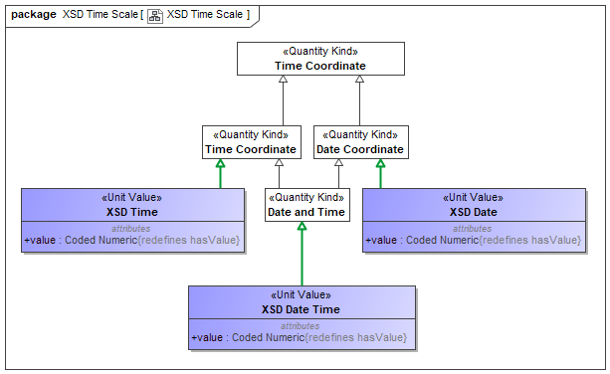

1. XSD Time Scale

## Class XSD Date <<Unit Value>>

An XSD representation of a date

[OWL] xsd:date.

Direct Supertypes

Date Coordinate

Attributes

value : Coded Numeric



A text string representing a date and time specified in the ISO8601 date-time format including timezone designator (TZD): YYYY-MM-DDThh:mm:ssTZD.

## Class XSD Date Time <<Unit Value>>

An XSD representation of a date and time

[OWL] xsd:dateTime

Direct Supertypes

Date and Time

Attributes

value : Coded Numeric



A text string representing a date and time specified in the ISO8601 date-time format including timezone designator (TZD): YYYY-MM-DDThh:mm:ssTZD.

## Class XSD Time <<Unit Value>>

An XSD representation of a time

[OWL] xsd:time

Direct Supertypes

Time Coordinate

Attributes

value : Coded Numeric



A text string representing a date and time specified in the ISO8601 date-time format including timezone designator (TZD): YYYY-MM-DDThh:mm:ssTZD.

# OnticHealthGeneric::Top level

## Diagram: Context

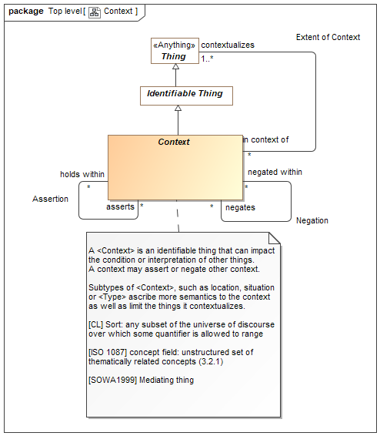

1. Context

## Diagram: Types

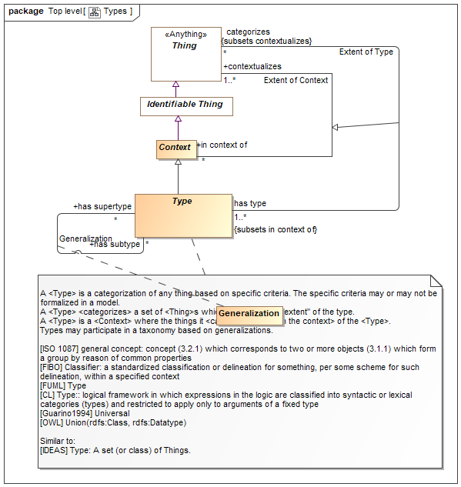

1. Types