Generated File

Contents

1 SMIF Conceptual Model 2

1.1 Diagram: SMIF Packages 3

2 SMIF Conceptual Model::Associations 4

2.1 Diagram: Associations 4

2.2 Class Association 5

2.2.1 Direct Supertypes 5

2.2.2 Associations 5

2.3 Class Association Type 5

2.3.1 Direct Supertypes 5

2.3.2 Associations 5

3 SMIF Conceptual Model::Expressions 6

3.1 Diagram: Expressions 6

3.2 Class Constant Reference 6

3.2.1 Direct Supertypes 7

3.2.2 Associations 7

3.3 Association Constant Value 7

3.3.1 Association Ends 7

3.4 Class Equality 7

3.4.1 Direct Supertypes 7

3.4.2 Associations 7

3.5 Association Equality Constraint 7

3.5.1 Association Ends 7

3.6 Class Evaluation 8

3.6.1 Direct Supertypes 8

3.6.2 Associations 8

3.7 Association Expression Context 8

3.7.1 Direct Supertypes 8

3.7.2 Association Ends 8

3.8 Class Expression Context 8

3.8.1 Direct Supertypes 8

3.8.2 Associations 8

3.9 Association Expression Evaluation 9

3.9.1 Association Ends 9

3.10 Class Expression Node 9

3.10.1 Direct Supertypes 9

3.10.2 Attributes 9

3.10.3 Associations 9

3.11 Class Function Call 9

3.11.1 Direct Supertypes 10

3.11.2 Associations 10

3.12 Association Function Called 10

3.12.1 Direct Supertypes 10

3.12.2 Association Ends 10

3.13 Association Function Implementation 10

3.13.1 Direct Supertypes 10

3.13.2 Association Ends 10

3.14 Class Function Type 10

3.14.1 Direct Supertypes 10

3.14.2 Associations 11

3.15 Class Object Operation Type 11

3.15.1 Direct Supertypes 11

3.15.2 Associations 11

3.16 Association OO Target 11

3.16.1 Association Ends 11

3.17 Association Result type 11

3.17.1 Association Ends 11

3.18 Class Traversal 11

3.18.1 Direct Supertypes 12

3.18.2 Attributes 12

3.18.3 Associations 12

3.19 Association Traverse Through 12

3.19.1 Association Ends 12

4 SMIF Conceptual Model::Facets 13

4.1 Diagram: Facets 13

4.2 Class Facet 13

4.2.1 Direct Supertypes 14

4.2.2 Associations 14

4.3 Class Facet of Entity 14

4.3.1 Direct Supertypes 14

4.3.2 Associations 14

4.4 Class Phase 14

4.4.1 Direct Supertypes 15

4.5 Class Role 15

4.5.1 Direct Supertypes 15

5 SMIF Conceptual Model::Identifiers 16

5.1 Diagram: Identifiers 16

5.2 Association Identification 17

5.2.1 Association Ends 17

5.3 Class Identifier 17

5.3.1 Direct Supertypes 17

5.3.2 Associations 17

5.4 Association Identifier in Namespace 17

5.4.1 Direct Supertypes 18

5.4.2 Association Ends 18

5.5 Class IRI Identifier 18

5.5.1 Direct Supertypes 18

5.6 Class Name 18

5.6.1 Direct Supertypes 18

5.6.2 Associations 18

5.7 Class Namespace 18

5.7.1 Direct Supertypes 19

5.7.2 Associations 19

5.8 Association Naming 19

5.8.1 Direct Supertypes 19

5.8.2 Association Ends 19

5.9 Association Prefered Identification 19

5.9.1 Direct Supertypes 19

5.9.2 Association Ends 19

5.10 Class Technical Identifier 20

5.10.1 Direct Supertypes 20

5.11 Class Term 20

5.11.1 Direct Supertypes 20

5.12 Class Text Identifier 20

5.12.1 Direct Supertypes 20

5.12.2 Attributes 20

5.13 Class Unique Identifier 20

5.13.1 Direct Supertypes 21

5.13.2 Associations 21

5.14 Class Unique Text Identifier 21

5.14.1 Direct Supertypes 21

6 SMIF Conceptual Model::Kernel 22

6.1 Diagram: Kernel Associations 22

6.2 Diagram: Kernel Identifiers 23

6.3 Diagram: Kernel Lexical Scope 24

6.4 Diagram: Kernel Metadata 25

6.5 Diagram: Kernel Properties 25

6.6 Diagram: Kernel Rules Summary 26

6.7 Diagram: Kernel Top Level 27

6.8 Diagram: Kernel Types 28

6.9 Diagram: Kernel Values 29

7 SMIF Conceptual Model::Lexical Scope 30

7.1 Diagram: Lexical Scope 30

7.2 Class Conceptual Package 30

7.2.1 Direct Supertypes 30

7.3 Association Definition 31

7.3.1 Direct Supertypes 31

7.3.2 Association Ends 31

7.4 Class Include 31

7.4.1 Direct Supertypes 31

7.5 Class Lexical Reference 31

7.5.1 Direct Supertypes 31

7.5.2 Associations 31

7.6 Class Lexical Scope 32

7.6.1 Direct Supertypes 32

7.6.2 Associations 32

7.7 Class Logical Package 32

7.7.1 Direct Supertypes 32

7.8 Class Mapping Package 32

7.8.1 Direct Supertypes 32

7.9 Class Model 32

7.9.1 Direct Supertypes 32

7.9.2 Associations 33

7.10 Class Package 33

7.10.1 Direct Supertypes 33

7.10.2 Associations 33

7.11 Class Physical Package 33

7.11.1 Direct Supertypes 33

7.12 Association Prefix 33

7.12.1 Direct Supertypes 33

7.12.2 Association Ends 33

7.13 Class Prefix 33

7.13.1 Direct Supertypes 34

7.13.2 Associations 34

7.14 Association Scope of Reference 34

7.14.1 Association Ends 34

7.15 Association Scope Reference 34

7.15.1 Association Ends 34

7.16 Association Statement 34

7.16.1 Direct Supertypes 34

7.16.2 Association Ends 34

8 SMIF Conceptual Model::Mapping 36

8.1 Diagram: Facades 36

8.2 Diagram: Mapping Rules 37

8.3 Class Abstract Mapping Rule 37

8.3.1 Direct Supertypes 37

8.3.2 Attributes 37

8.4 Class Computed Facade 38

8.4.1 Direct Supertypes 38

8.4.2 Operations 38

8.5 Association Concrete Map End 38

8.5.1 Association Ends 38

8.6 Association Concrete Pattern Body 38

8.6.1 Association Ends 38

8.7 Class Facade 38

8.7.1 Direct Supertypes 38

8.8 Association Map Rule Type Assertion 39

8.8.1 Association Ends 39

8.9 Association Mapped variable 39

8.9.1 Association Ends 39

8.10 Class Mapping 39

8.10.1 Direct Supertypes 39

8.10.2 Associations 39

8.11 Class Match End 40

8.11.1 Direct Supertypes 40

8.11.2 Associations 40

8.12 Class Match Rule 40

8.12.1 Direct Supertypes 40

8.12.2 Attributes 40

8.12.3 Associations 41

8.13 Association Reference Map End 41

8.13.1 Association Ends 41

8.14 Association Reference Pattern Body 41

8.14.1 Association Ends 41

8.15 Association Representation 41

8.15.1 Association Ends 41

8.16 Class Representation Rule 42

8.16.1 Direct Supertypes 42

8.16.2 Attributes 42

8.16.3 Associations 42

8.17 Association Represented Concept 42

8.17.1 Association Ends 42

8.17.2 Enumeration Assertion Strength 42

8.17.3 Known other enumerations 43

9 SMIF Conceptual Model::Metadata 44

9.1 Diagram: Metadata 44

9.2 Association Assertion Statement 45

9.2.1 Direct Supertypes 45

9.2.2 Association Ends 45

9.3 Class Definition 45

9.3.1 Direct Supertypes 45

9.3.2 Attributes 45

9.3.3 Associations 45

9.4 Association Definition Relationship 46

9.4.1 Direct Supertypes 46

9.4.2 Association Ends 46

9.5 Class Information Source 46

9.5.1 Direct Supertypes 46

9.5.2 Associations 46

9.6 Class Metadata 46

9.6.1 Direct Supertypes 46

9.6.2 Associations 46

9.7 Association Metadata relationship 47

9.7.1 Association Ends 47

9.8 Association Record of an Entity 47

9.8.1 Association Ends 47

9.9 Association Source of Information 47

9.9.1 Association Ends 47

9.10 Class Statement 48

9.10.1 Direct Supertypes 48

9.10.2 Attributes 48

10 SMIF Conceptual Model::Patterns 49

10.1 Diagram: Patterns 49

10.2 Class Computed 50

10.2.1 Attributes 50

10.3 Class Expression Variable 50

10.3.1 Direct Supertypes 50

10.4 Class Focus Variable 50

10.4.1 Direct Supertypes 50

10.5 Association Match Rules 50

10.5.1 Direct Supertypes 50

10.5.2 Association Ends 50

10.6 Class Part Variable 50

10.6.1 Direct Supertypes 51

10.6.2 Attributes 51

10.7 Class Pattern 51

10.7.1 Direct Supertypes 51

10.7.2 Associations 51

10.8 Association Pattern Bindings 51

10.8.1 Association Ends 51

10.9 Class Pattern Match 52

10.9.1 Direct Supertypes 52

10.9.2 Associations 52

10.10 Association Pattern Matches 52

10.10.1 Association Ends 52

10.11 Class Pattern of Type 53

10.11.1 Direct Supertypes 53

10.11.2 Associations 53

10.12 Class Pattern Variable 53

10.12.1 Direct Supertypes 53

10.12.2 Attributes 53

10.12.3 Associations 53

10.13 Association Pattern Variables 54

10.13.1 Direct Supertypes 54

10.13.2 Association Ends 54

10.14 Class Proposition Variable 54

10.14.1 Direct Supertypes 54

10.14.2 Associations 54

10.15 Association Qualified Proposition 54

10.15.1 Association Ends 54

10.16 Association Situation Matches 55

10.16.1 Association Ends 55

10.17 Association Subject of Pattern Relationship 55

10.17.1 Direct Supertypes 55

10.17.2 Association Ends 55

10.18 Class Subset Variable 55

10.18.1 Direct Supertypes 55

10.18.2 Associations 55

10.19 Class Type Pattern Variable 55

10.19.1 Direct Supertypes 55

10.19.2 Associations 56

10.20 Class Variable Binding 56

10.20.1 Direct Supertypes 56

10.20.2 Associations 56

10.21 Association Variable Subsets 56

10.21.1 Association Ends 56

10.21.2 Enumeration Variable Qualification 56

11 SMIF Conceptual Model::Properties 59

11.1 Diagram: Characteristics 59

11.2 Diagram: Properties 60

11.3 Class Annotation Property 60

11.3.1 Direct Supertypes 60

11.4 Association Bound Individual 61

11.4.1 Association Ends 61

11.5 Association Bound Property 61

11.5.1 Direct Supertypes 61

11.5.2 Association Ends 61

11.6 Association Bound Subject 61

11.6.1 Association Ends 61

11.7 Class Characteristic Binding 62

11.7.1 Direct Supertypes 62

11.7.2 Associations 62

11.8 Class Characteristic Type 62

11.8.1 Direct Supertypes 62

11.8.2 Associations 62

11.9 Class Owned Property Binding 63

11.9.1 Direct Supertypes 63

11.9.2 Associations 63

11.10 Class Owned Property Type 63

11.10.1 Direct Supertypes 63

11.10.2 Associations 63

11.11 Association Properties Relationship 63

11.11.1 Association Ends 63

11.12 Class Property Binding 64

11.12.1 Direct Supertypes 64

11.12.2 Associations 64

11.13 Class Property Owner 64

11.13.1 Direct Supertypes 65

11.13.2 Associations 65

11.14 Class Property Owner Type 65

11.14.1 Direct Supertypes 65

11.14.2 Associations 65

11.15 Class Property Type 65

11.15.1 Direct Supertypes 65

11.15.2 Associations 65

12 SMIF Conceptual Model::Records 67

12.1 Diagram: Records 67

12.2 Class Record 68

12.2.1 Direct Supertypes 68

12.2.2 Associations 68

12.3 Class Record Type 68

12.3.1 Direct Supertypes 68

12.3.2 Associations 68

12.4 Association Subject of Record Type 68

12.4.1 Association Ends 68

13 SMIF Conceptual Model::Relationships 69

13.1 Diagram: Relationships 69

13.2 Class Relationship 70

13.2.1 Direct Supertypes 70

13.2.2 Associations 70

13.3 Class Relationship Type 70

13.3.1 Direct Supertypes 70

13.3.2 Associations 71

14 SMIF Conceptual Model::Rules 72

14.1 Diagram: General Rules 72

14.2 Diagram: Property Constraints 73

14.3 Diagram: Rules in Context 74

14.4 Diagram: Rules Summary 75

14.5 Diagram: Type Constraints 76

14.6 Class Conditional 76

14.6.1 Attributes 76

14.7 Class Conditional Rule 77

14.7.1 Direct Supertypes 77

14.8 Class Covering Constraint 77

14.8.1 Direct Supertypes 77

14.8.2 Associations 77

14.9 Association Covering Constraint 77

14.9.1 Association Ends 77

14.10 Class Disjoint 77

14.10.1 Direct Supertypes 78

14.11 Class Enumerated 78

14.11.1 Direct Supertypes 78

14.12 Class Equivalent 78

14.12.1 Direct Supertypes 78

14.13 Class Facet Classification Constraint 78

14.13.1 Direct Supertypes 79

14.13.2 Associations 79

14.14 Association Generalization 79

14.14.1 Association Ends 79

14.15 Class Generalization Constraint 79

14.15.1 Direct Supertypes 79

14.15.2 Attributes 79

14.15.3 Associations 80

14.16 Class Multiplicity Constraint 80

14.16.1 Direct Supertypes 80

14.16.2 Attributes 80

14.16.3 Associations 81

14.17 Association Multiplicity Reference 81

14.17.1 Association Ends 81

14.18 Association Multiplicity Target 82

14.18.1 Direct Supertypes 82

14.18.2 Association Ends 82

14.19 Class Property Constraint 82

14.19.1 Direct Supertypes 82

14.19.2 Associations 82

14.20 Class Property Transitivity Constraint 82

14.20.1 Direct Supertypes 82

14.21 Association Property Type 82

14.21.1 Association Ends 82

14.22 Class Property Type Constraint 83

14.22.1 Direct Supertypes 83

14.22.2 Attributes 83

14.22.3 Associations 83

14.23 Class Rule 83

14.23.1 Direct Supertypes 83

14.23.2 Associations 83

14.24 Association Rule Constrains 84

14.24.1 Association Ends 84

14.25 Association Rule Subsumption 84

14.25.1 Association Ends 84

14.26 Association Specialization 84

14.26.1 Direct Supertypes 84

14.26.2 Association Ends 85

14.27 Class Type Constraint 85

14.27.1 Direct Supertypes 85

14.27.2 Associations 85

14.28 Association Unique Set 85

14.28.1 Association Ends 85

14.29 Class Uniqueness Constraint 85

14.29.1 Direct Supertypes 85

14.29.2 Attributes 85

14.29.3 Associations 86

15 SMIF Conceptual Model::Situations 87

15.1 Diagram: Situations 87

15.2 Class Actual Situation 87

15.2.1 Direct Supertypes 88

15.3 Class Situation 88

15.3.1 Direct Supertypes 88

15.3.2 Associations 88

15.4 Class Situation Type 88

15.4.1 Direct Supertypes 89

15.4.2 Associations 89

16 SMIF Conceptual Model::Top level 90

16.1 Diagram: Top Level 90

16.2 Class Actual Entity 91

16.2.1 Direct Supertypes 91

16.3 Association Assertion 91

16.3.1 Association Ends 92

16.4 Class Context 92

16.4.1 Direct Supertypes 93

16.4.2 Associations 93

16.5 Association Extent of Context 93

16.5.1 Association Ends 94

16.6 Class Identifiable Entity 94

16.6.1 Direct Supertypes 95

16.6.2 Associations 96

16.7 Association Negation 96

16.7.1 Association Ends 97

16.8 Class Proposition 97

16.8.1 Direct Supertypes 97

16.8.2 Associations 97

16.9 Class Temporal Entity 98

16.9.1 Direct Supertypes 98

16.10 Class Thing 98

16.10.1 Associations 99

17 SMIF Conceptual Model::Types 100

17.1 Diagram: Type-instance 100

17.2 Diagram: Types 101

17.3 Class Entity Type 101

17.3.1 Direct Supertypes 102

17.3.2 Associations 102

17.4 Association Extent of Type 102

17.4.1 Direct Supertypes 102

17.4.2 Association Ends 102

17.5 Class Intersection Type 102

17.5.1 Direct Supertypes 102

17.6 Class Type 103

17.6.1 Direct Supertypes 103

17.6.2 Associations 103

17.7 Class Union Type 104

17.7.1 Direct Supertypes 104

18 SMIF Conceptual Model::Values 105

18.1 Diagram: Values 107

18.2 Class Base Unit Type 107

18.2.1 Direct Supertypes 107

18.3 Class Quantity kind 108

18.3.1 Direct Supertypes 108

18.4 Association Referenced System of Units 108

18.4.1 Direct Supertypes 108

18.4.2 Association Ends 108

18.5 Class Scalar Quantity 108

18.5.1 Direct Supertypes 108

18.5.2 Attributes 108

18.6 Class Structured Value 109

18.6.1 Direct Supertypes 109

18.6.2 Associations 109

18.7 Class Structured Value Type 109

18.7.1 Direct Supertypes 109

18.7.2 Associations 109

18.8 Class System of Units 109

18.8.1 Direct Supertypes 109

18.8.2 Associations 109

18.9 Class Unit Type 109

18.9.1 Direct Supertypes 110

18.9.2 Attributes 110

18.9.3 Associations 110

18.10 Class Unit Value 110

18.10.1 Direct Supertypes 111

18.10.2 Attributes 111

18.10.3 Associations 111

18.11 Class Value 111

18.11.1 Direct Supertypes 111

18.12 Class Value Type 112

18.12.1 Direct Supertypes 112

18.12.2 Associations 112

Appendix A: Primitive Type 113

18.13 Boolean 113

18.14 Integer 113

18.15 Number 113

18.16 Real Number 113

18.17 Text 113

Appendix B: Data Type 115

18.18 Data Value 115

18.19 Measurement Value 115

18.20 Numeric 115

18.21 Primitive Value 115

Appendix C: Tree 116

18.22 Class Hierarchy 116

18.23 Enumeration Hierarchy 117

# SMIF Conceptual Model

## Diagram: SMIF Packages

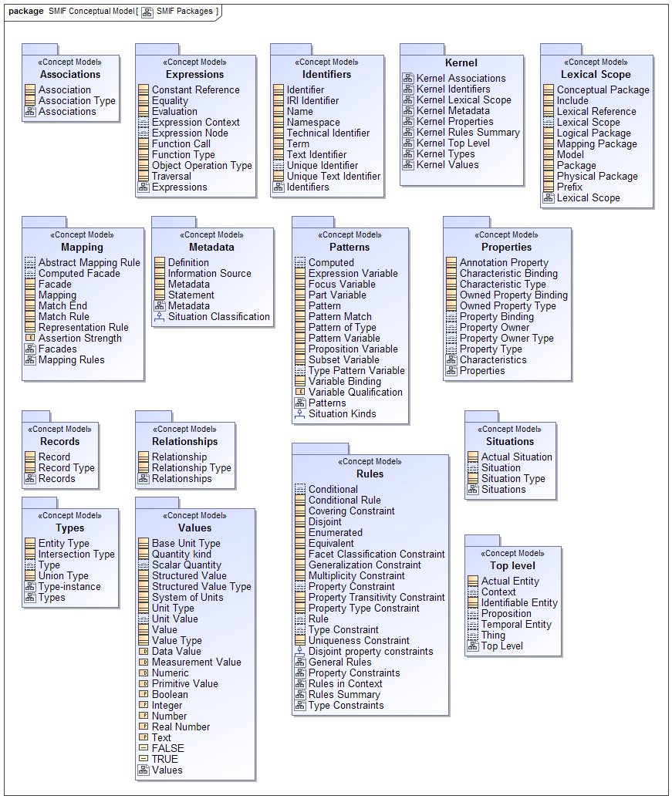

1. SMIF Packages

# SMIF Conceptual Model::Associations

An association asserts a formal condition involving related things, the association ends. An association may be asserted within a context as true or false within that context. Each association has a number of bindings of which are immutable for that association.  
  
Associations are differentiated from relationships in that associations are fully dependent on the things they relate. These are known as "formal", "thin", "internal" or "intrinsic" relations in much of the literature.

## Diagram: Associations

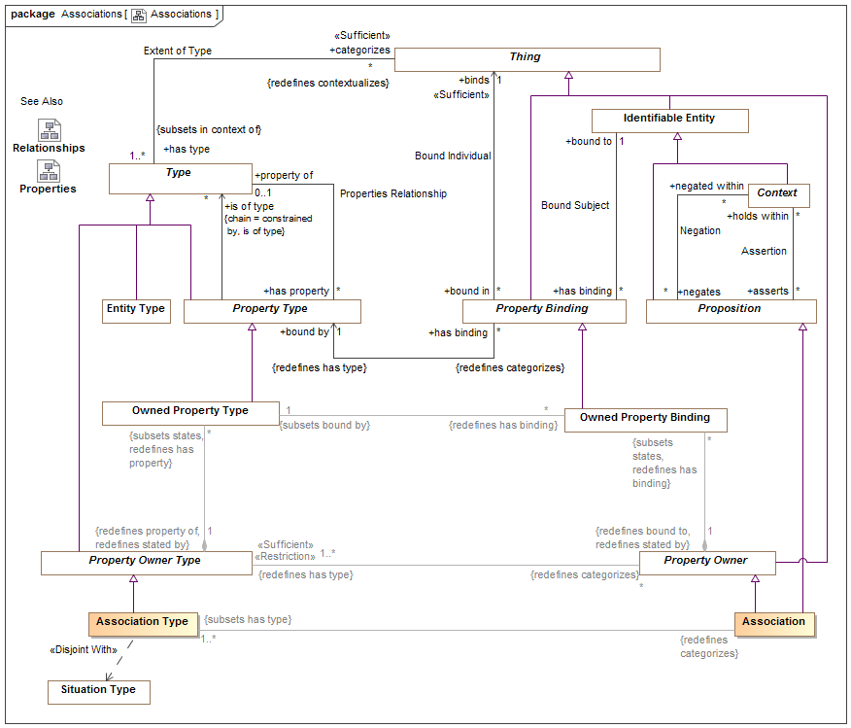

1. Associations

## Class Association

An association makes a logical statement involving related things, the association ends. An association may be asserted within a context as true or false within that context. Each association type has a number of bindings of which are immutable for that association.  
An association may be true or false within its context and is atomic in its truth value.  
Associations are differentiated from relationships in that associations are not situations - they are not temporal and do not change over time. Associations may be a consequence of relationships or other situations or may be derived from qualities of associated ends.  
Associations can "own" owned property bindings as their "ends".  
See also: Relationship  
[Guizzardi] Intrinsic Relation  
[UML] Link  
[DOLCE] Formal Relation

### Direct Supertypes

Property Owner, Proposition

### Associations

: Association Type [1..*] *Subsets*: has type:Type



## Class Association Type

A type of Association (See Association for details) which defines a set of "Association Property Types" which are the types of association property bindings. Associations are not situations - the are not temporal things. THis does not prevent subtypes of associations from being situations.  
[Guizzardi] Intrinsic Relation Type  
[UML] Association  
[OWL] For binary associations, may be considered a pair of properties that are Inverse Object Properties.

### Direct Supertypes

Property Owner Type

### Associations

: Association *Redefines*: categorizes:Thing



# SMIF Conceptual Model::Expressions

Expressions define computations across SMIF models.

## Diagram: Expressions

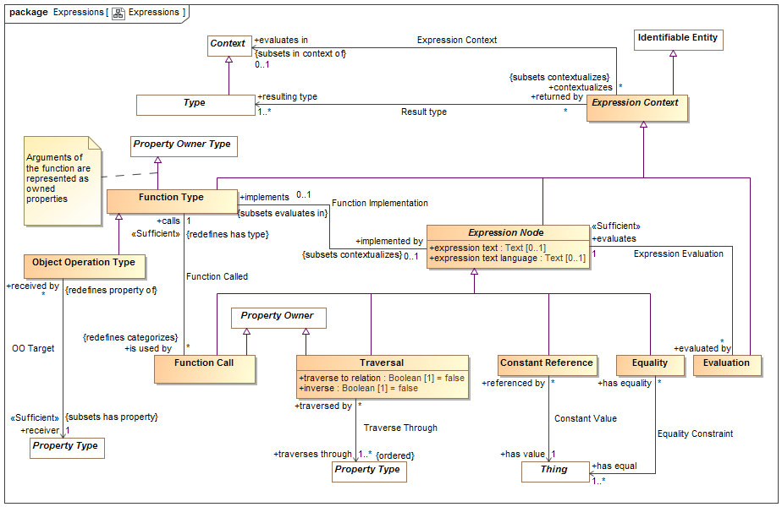

1. Expressions

Expressions define computations

## Class Constant Reference

A calculation that returns a thing identified by <has value>.  
  
[FIBO] Constant  
[FUML] LiteralSpecification where subtype of literal is determined by the type of <has value>.   
-LiteralInteger->type is Integer or a subtype  
-LiteralReal-> type is not integer or a subtype  
-LiteralBoolean->type is Boolean  
-LiteralString->type is Text

### Direct Supertypes

Expression Node

### Associations

has value : Thing [1]



A constant value referenced in an expression.

## Association Constant Value

Relationship defining a link to a constant value within an expression.

### Association Ends

has value : Thing [1]



A constant value referenced in an expression.

referenced by : Constant Reference [*]



Referencing constant expression node.

## Class Equality

Returns TRUE if all <has equal> things have the same value or represent the same thing or set of things regardless of how they are represented.  
Equality will return TRUE or FALSE.  
[ISO11404: EqualityIn every value space there is a notion of equality, for which the following rules hold:  
⎯ for any two instances (a, b) of values from the value space, either a is equal to b, denoted a = b , or a is not equal to b, denoted a ≠ b ;  
⎯ there is no pair of instances (a, b) of values from the value space such that both a = b and a ≠ b ;  
⎯ for every value a from the value space, a = a ;  
⎯ for any two instances (a, b) of values from the value space, a = b if and only if b = a ;  
⎯ for any three instances (a, b, c) of values from the value space, if a = b and b = c , then a = c . On every datatype, the operation Equal is defined in terms of the equality property of the value space, by:  
⎯ for any values a, b drawn from the value space, Equal(a,b) is true if a = b , and false otherwise.

### Direct Supertypes

Expression Node

### Associations

has equal : Thing [1..*]



Set of things that must have the same value or represent the same thing or set of things for Equality to return true.

## Association Equality Constraint

Relationship defining set of things that will be evaluated for equality.

### Association Ends

has equal : Thing [1..*]



Set of things that must have the same value or represent the same thing or set of things for Equality to return true.

has equality : Equality [*]



Equality constraints for a thing.

## Class Evaluation

The evaluation of an expression. All references to an evaluation shall return the result of evaluating the <evaluates> expression node. All expression nodes referenced within an evaluation shall return the result of evaluating that expression node.  
An evaluation may be used in place of anything that requires the <resulting type> of the evaluation.

### Direct Supertypes

Expression Context

### Associations

evaluates : Expression Node [1]



The expression node "head" an evaluation evaluates.

## Association Expression Context

Context in which an expression will be evaluated.

### Direct Supertypes

Extent of Context

### Association Ends

evaluates in : Context [0..1]



Context of evaluation and namespace resolution for an expression.

contextualizes : Expression Context [*]



Expressions referencing a context.

## Class Expression Context

An abstract element defining the static or dynamic evaluation context and resulting type of an expression.  
An expression context that is referenced by another expression context inherits the referencing context by default.

### Direct Supertypes

Identifiable Entity

### Associations

evaluates in : Context [0..1] *Subsets*: in context of:Context



Context of evaluation and namespace resolution for an expression.

resulting type : Type [1..*]



Type of the result of a function  
[UML] type (of an operation or expression).

## Association Expression Evaluation

Relationship defining the expression that will be evaluated by an evaluation.

### Association Ends

evaluates : Expression Node [1]



The expression node "head" an evaluation evaluates.

evaluated by : Evaluation [*]



Evaluations of an expression node.

## Class Expression Node

An abstract class representing the computation of a value which is then bound to the context from which it is called. Each expression node has a type of the most general type it can return.  
  
An expression node may reference other elements. Where the other elements are also expression nodes they will be considered part of the referencing expression and evaluated in the context of that expression.  
  
The set of related expression nodes forms a "tree" for evaluation.  
  
[FIBO] Expression  
[UML] Expression

### Direct Supertypes

Expression Context

### Attributes

expression text : Text [0..1]



Textual expression of the expression which is further refined by subtypes of expression.  
[UML] StringExpression

expression text language : Text [0..1]



expression language used for the expression text

### Associations

evaluated by : Evaluation [*]



Evaluations of an expression node.

## Class Function Call

An element of an expression that performs some operation based on a function type and produces a result. I.e. plus(a,1).  
Arguments are bound to the function call via bindings.

### Direct Supertypes

Expression Node, Property Owner

### Associations

calls : Function Type [1] *Redefines*: has type:Type



Function called

## Association Function Called

Relationship defining the function (a type) called by a function call.

### Direct Supertypes

Extent of Type

### Association Ends

calls : Function Type [1] *Redefines*: has type: Type



Function called

is used by : Function Call [*] *Redefines*: has type: Type



Function calls using a function declaration.

## Association Function Implementation

Relationship defining the implementation of a function by an expression.

### Direct Supertypes

Expression Context

### Association Ends

implemented by : Expression Node [0..1] *Redefines*: has type: Type



Expression which defines the implementation of a function.

implements : Function Type [0..1] *Redefines*: has type: Type



Function implemented by an expression

## Class Function Type

A declaration of a function which performs a calculation on arguments (properties) to produce a result (function result). I.e. the definition of plus(a:Number, b:Number).  
  
Functions are intended to be side-effect free and context free (they only depend on their arguments and don't change anything) but assertions to specify that certain functions are pure may be required,  
Note: FUNCTION ARGUMENTS ARE PROPERTIES of the function.  
  
[FUML] Operation where ownedParameter corresponds with <has property> and type corresponds with <resulting type>.

### Direct Supertypes

Expression Context, Property Owner Type

### Associations

implemented by : Expression Node [0..1] *Subsets*: contextualizes:Thing



Expression which defines the implementation of a function.

is used by : Function Call [*] *Redefines*: categorizes:Thing



Function calls using a function declaration.

## Class Object Operation Type

An operation bound to a specific "receiver" in the "Object Oriented" sense.  
[FUML] Operation

### Direct Supertypes

Function Type

### Associations

receiver : Property Type [1] *Subsets*: has property:Property Type



The property that is the receiver of an object operation.   
[UML] class (of Operation)

## Association OO Target

Relationship defining the "target" type of an object oriented function.

### Association Ends

receiver : Property Type [1] *Subsets*: has property:Property Type



The property that is the receiver of an object operation.   
[UML] class (of Operation)

received by : Object Operation Type [*] *Subsets*: has property:Property Type



The Object Operation for which a receiver is defined.

## Association Result type

Relationship defining the type or types returned by an expression evaluation.

### Association Ends

resulting type : Type [1..*] *Subsets*: has property:Property Type



Type of the result of a function  
[UML] type (of an operation or expression).

returned by : Expression Context [*] *Subsets*: has property:Property Type



Method returning a type.

## Class Traversal

Traversal from the current <evaluates in> context to another across a relation or other structure.  
  
A traversal is a structure such that the structure's bindings may hold other properties of a traversal constant as independent variables where <traverses through> is the dependent variable. The traversal shall be considered to have the type of the relation it is traversing. Traversing binary relations does not require any bindings.  
  
[OWL] ObjectPropertyChain

### Direct Supertypes

Expression Node, Property Owner

### Attributes

traverse to relation : Boolean [1] = false



Where traverse to relation is false, the traversal will return the bound element(s) of the <traverses through> property from the current context via any intermediate relationships.  
  
Where traverse to relation is true, the traversal shall return the structure/situation/relationship owning the property binding.  
  
By default, traverse to relation is false.

inverse : Boolean [1] = false



Indicates that the traversal is defined based on properties that reference the current context. This results in traversing "backwards" across a property to an inverse property or the relation.

### Associations

traverses through : Property Type [1..*]



Property or properties through which a traversal traverses as the dependent variable(s).

## Association Traverse Through

Relationship defining the property of the current context which will be traversed.

### Association Ends

traverses through : Property Type [1..*]



Property or properties through which a traversal traverses as the dependent variable(s).

traversed by : Traversal [*]



Traversals through a property.

# SMIF Conceptual Model::Facets

The facet package defines facets, roles and phases. Types that "mix in" to other types in a specific context or timeframe.

## Diagram: Facets

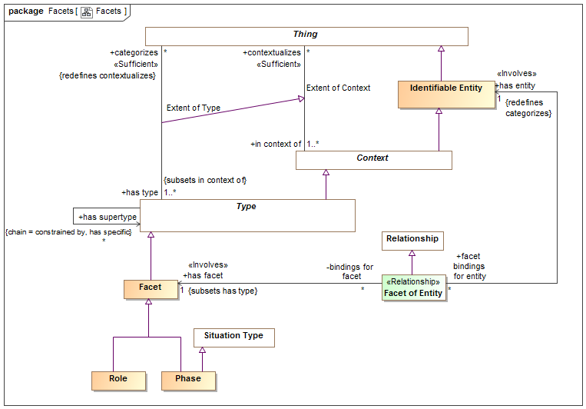

1. Facets

## Class Facet

A facet is a "mix in" type that defines an aspect of something but does not define the identity or "fundamental" (A.K.A. "Rigid") type of that thing, but some potentially transient role, phase or other way to classify it. Something must have at least one type that is not a facet to define that things identity.  
Facets do not define independent identity of the referent but technology implementations may create independent objects to represent a facet.  
An instance of a facet must also have a type that is not a facet to provide the identity of the instance.  
The type(s) a facet may categorize may be constrained by a Facet Generalization Constraint. E.g. Policeman is a role of a person.  
  
[Guarino1994] Non-Substantial sortal  
[Guizzard] Non-Rigid Universal: A universal G is non-rigid iff for a w ∈ W There is an x such that x ∈ extw(G), and there is a w∈ W such that x ∉extw(G)  
  
[SOWA1999] Prehension (Relative

### Direct Supertypes

Type

### Associations

: Facet Classification Constraint *Subsets*: has general:Type



## Class Facet of Entity

Facet of entity is the binding of a particular entity to a facet. May also be considered an "as a" relationship. In the case of a role, it states that an entity plays the role, e.g. "Joe as a policeman". In the case of a phase, it states that an entity has that phase and that it is a phase of that entity, e.g. Sue as a teenager.  
Facet of Entity is a kind of contextual categorization in that the entity assumes all of the characteristics of the facet where the Facet of Entity is asserted. E.g. if Joe has a policeman role, Joe is a policeman.  
  
Facet of entity is an "Extent of Type" association reified as a relationship in that the binding of the entity to the facet may be valid in particular context or time frame. Facet of entity may be the consequence of a relationship. Note: Not represented as an association class due to OMG-MOF limitations.  
  
Facet of entity may only relate entities that have a type compatible with the type of the facet, as defined by a Facet Classification Rule.  
  
[FIBO] (for roles of actors) AgentInRole.  
[FIBO] (for roles of anything else) ThingInRole  
[Guarino1994] Externally Dependent Moment (Also called "Qua individual")  
[SOWA1999] Prehension

### Direct Supertypes

Relationship

### Associations

has facet : Facet [1] *Subsets*: has type:Type



The facet that an entity assumes when it is the facet of an entity.  
[FIBO] (for roles) playsRole

has entity : Identifiable Entity [1] *Redefines*: categorizes:Thing



The entity having a facet (including roles and phases).  
[FIBO] (for roles) isPlayedBy

## Class Phase

A phase (or state) is a static characteristic of something that exists for limited time(s). Something takes on or looses a phase as a result of some event. E,g, Teenager, living, closed invoice.  
A Phase is a situation in that there is a situation coincident with each phase.  
  
[Guizzardi] (Phased-Sortal): Let PS be a universal and let S be a  
substance sortal specialized (restricted by) PS. Now, let extw(~PS) = extw(S) \ extw(PS)  
be the complement of the extension of PS in world w. In this formula, the  
symbol \ represents the set theoretical operation of set difference. The  
universal PS is a phased-sortal iff for all worlds w ∈ W, there is a w ∈ W such  
that extw(PS) ∩ extw(~PS) ≠ ∅

### Direct Supertypes

Facet, Situation Type

## Class Role

A role is a facet type that defines a specific purpose or behavior of a class of things. E.g. teacher, policeman, or employer.  
[FIBO] Role. Note that partyInRole or thingInRole are implied by classification of a thing.

### Direct Supertypes

Facet

# SMIF Conceptual Model::Identifiers

Terms and identifiers provide for signs for (ways to identify) anything.

## Diagram: Identifiers

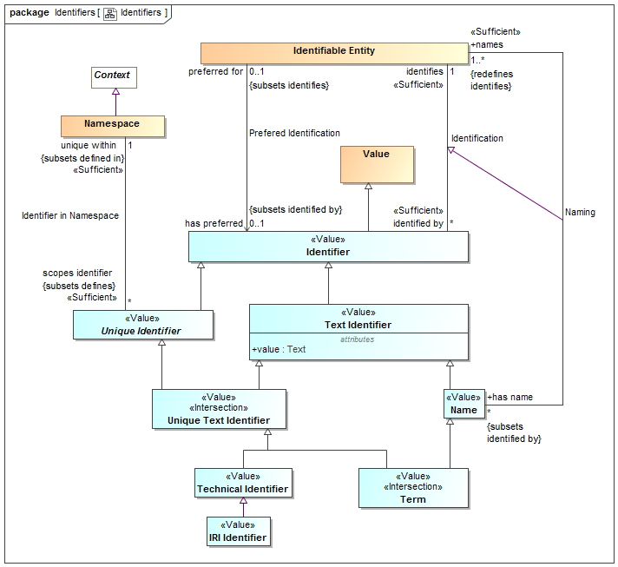

1. Identifiers

An identifier that can be represented as text. The text is in the "value" property.  
  
[IDEAS] Sign: An Individual that signifies a Thing.

## Association Identification

Relationship defining an identifier for an entity.  
  
[IDEAS] namedBy: A couple that asserts that a Name describes a Thing.  
  
[ISO 1087] Designation

### Association Ends

identifies : Identifiable Entity [1] *Redefines*: categorizes: Thing



The entity an identifier identifies.  
  
[FIBO] identifies: is the relationship between something and that which provides a unique reference for it  
  
[ISO 1087] designator: representation of a concept (3.2.1) by a sign which  
denotes it

identified by : Identifier [*] *Redefines*: categorizes: Thing



An identifier for an <Entity>.  
[FIBO] hasDenotation

## Class Identifier

An identifier is any value that is used to distinguish an entity from other entities. Note that any identifier may be contextualized by one or more context, including language context. Identifiers are a “sign” for an identity where identity is an abstraction of individuality that is the basis for identifiers.  
  
[IDEAS] Name: A Representation that identifies a Thing.  
[FIBO] Identifier  
[CL] Term: expression which denotes an individual, consisting of either a name or, recursively, a function term applied to a sequence of arguments, which are themselves terms

### Direct Supertypes

Value

### Associations

identifies : Identifiable Entity [1]



The entity an identifier identifies.  
  
[FIBO] identifies: is the relationship between something and that which provides a unique reference for it  
  
[ISO 1087] designator: representation of a concept (3.2.1) by a sign which  
denotes it

## Association Identifier in Namespace

Relationship defining the namespace within which a unique identifier is defined and unique.  
  
[ISO 1087] monosemy: relation between designations (3.4.1) and concepts (3.2.1) in a given language in which one designation only relates to one concept

### Direct Supertypes

Definition

### Association Ends

unique within : Namespace [1]



The namespace in which an identifier is defined and has a unique value.  
[FUML] memberNamespace

scopes identifier : Unique Identifier [*]



An Identifier defined within the scope of a namespace.  
[FUML] member

## Class IRI Identifier

A IRI/URI Identifier for an entity, as defined in [RFC3987].  
  
[FIBO] anyURI

### Direct Supertypes

Technical Identifier

## Class Name

A word or set of words by which a person, animal, place, or thing is known, addressed, or referred to. Names are not necessarily unique.  
  
[IDEAS] Name: A Representation that identifies a Thing.  
  
[CL] Discourse Name

### Direct Supertypes

Text Identifier

### Associations

names : Identifiable Entity [1..*] *Redefines*: identifies:Identifiable Entity



An entity named by a name.

## Class Namespace

A namespace is a context that provides a way to make identifiers unique and identify exactly one entity. For example, the Virginia driver's license division provides unique driver's license numbers.  
  
Similar to [IDEAS] UniqueNamingScheme: A NamingScheme where different Names will not contain tokens of the same Representation Type.   
Note: SMIF identifiers are not instances of their namespace.  
  
[FIBO] IdentificationScheme: system for allocating identifiers to objects  
  
[ISO 1087] terminology 1: set of designations (3.4.1) belonging to one special language (3.1.3)  
  
[FUML] Namespace  
  
[CL] Vocabulary

### Direct Supertypes

Context

### Associations

scopes identifier : Unique Identifier [*] *Subsets*: defines:Thing



An Identifier defined within the scope of a namespace.  
[FUML] member

## Association Naming

Relationship defining a human meaningfully name for an entity.

### Direct Supertypes

Identification

### Association Ends

names : Identifiable Entity [1..*] *Subsets*: defines:Thing



An entity named by a name.

has name : Name [*] *Subsets*: defines:Thing



A human meaningful name for an entity.  
[FIBO] hasName: that by which some thing is known; may apply to anything  
  
[OWL] rdfs:label

## Association Prefered Identification

Relationship defining the preferred identifier for an entity.  
  
[ISO 1087] preferred term: term (3.4.3) rated according to the scale of the term acceptability rating (3.4.14) as the primary term for a given concept (3.2.1)

### Direct Supertypes

Identification

### Association Ends

has preferred : Identifier [0..1] *Subsets*: defines:Thing



Default identifier to use for an entity.  
Where multiple identifiers are preferred in differing context any method for selecting the most preferred identifier is implementation specific and not specified by this standard.  
[FUML] NamedElement.name: Note: An Identifier that is <preferred for> an entity is equivalent to the name of a named element.

preferred for : Identifiable Entity [0..1] *Subsets*: defines:Thing



The entity an identifier is preferred for.

## Class Technical Identifier

A technical identifier is defined within a technical system, information structure or system of systems for references and identity within that system or information element. Such identifiers may have no meaning outside of that system.  
  
Typical technical identifiers include inter document "refs", record numbers, etc. The system should be referenced as the namespace.

### Direct Supertypes

Unique Text Identifier

## Class Term

A word, phrase or name used by stakeholders to uniquely identify entities.   
  
[ISO 1087] term: verbal designation of a general concept in a specific subject field.

### Direct Supertypes

Name, Unique Text Identifier

## Class Text Identifier

A code or other simple value that can be represented as text, identifying something that may or may not be unique. Simple identifiers may be codes, names, numbers or compound values.  
[NIEM] IdentificationType (IdentificationID=value)

### Direct Supertypes

Identifier

### Attributes

value : Text



Text value of an identifier

## Class Unique Identifier

A unique identifier is an entity used to uniquely identify something. The identified thing is referenced by what the identifier <identifies>.  
Identifiers are defined and <unique within> a lexical scope as its namespace.  
Multiple identifiers may use the same word or text value (or other forms of values) in differing <unique within> namespaces such that the same word may have different meanings in different context.  
An entity may have any number of identifiers.

### Direct Supertypes

Identifier

### Associations

unique within : Namespace [1] *Subsets*: defined in:Lexical Scope



The namespace in which an identifier is defined and has a unique value.  
[FUML] memberNamespace

## Class Unique Text Identifier

An <Identifier> that is represented using text. e.g. a "word", "phrase" or "name".

### Direct Supertypes

Text Identifier, Unique Identifier

# SMIF Conceptual Model::Kernel

The kernel subsets the SMIF classes. The diagrams in this package illustrate the concrete classes that are used to define the SMIF language.  
Note that shaded classes are not instantiated in the kernel and may be "flattened". Specifications for each class and association are defined in the corresponding package for that concept.

## Diagram: Kernel Associations

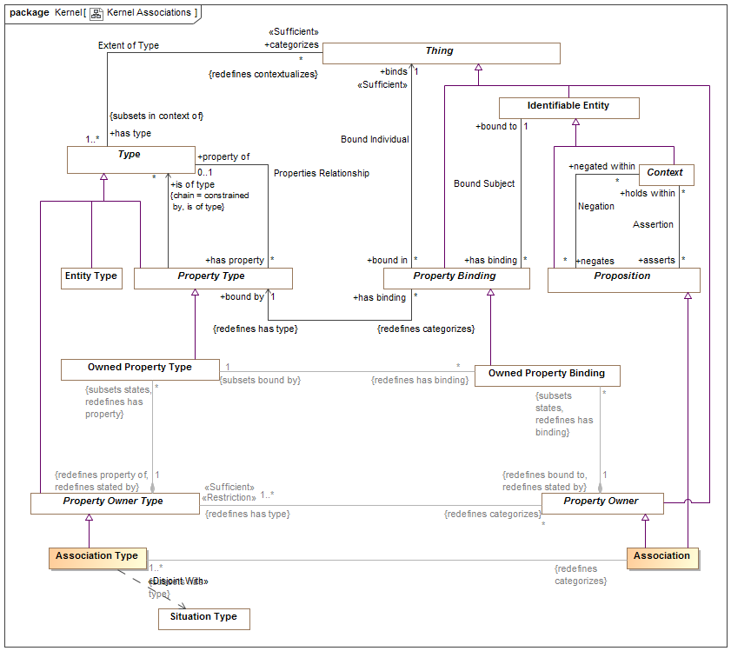

1. Kernel Associations

## Diagram: Kernel Identifiers

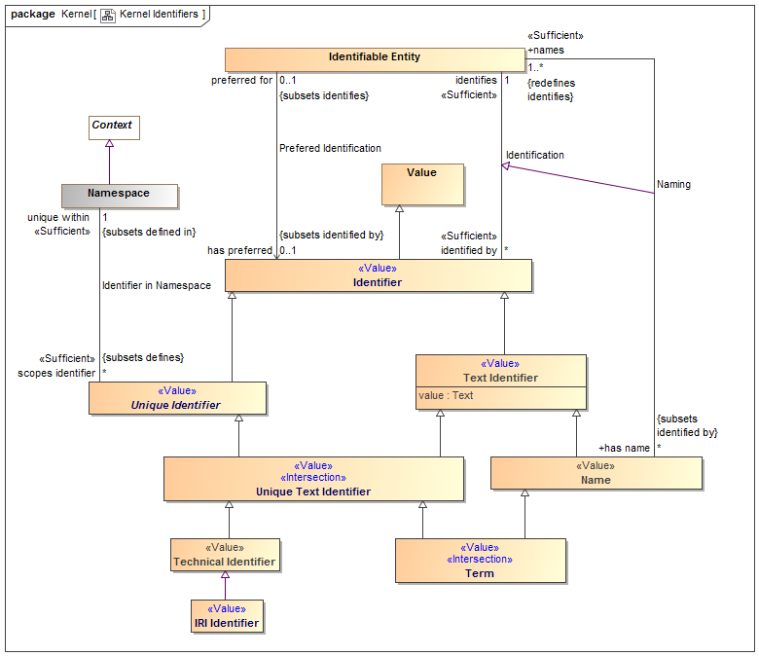

1. Kernel Identifiers

An identifier that can be represented as text. The text is in the "value" property.  
  
[IDEAS] Sign: An Individual that signifies a Thing.

## Diagram: Kernel Lexical Scope

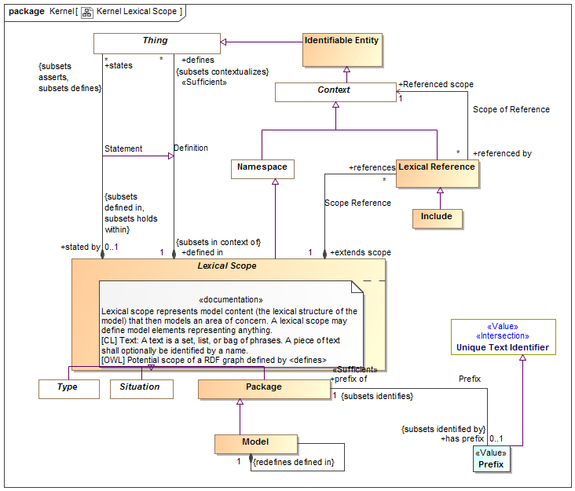

1. Kernel Lexical Scope

## Diagram: Kernel Metadata

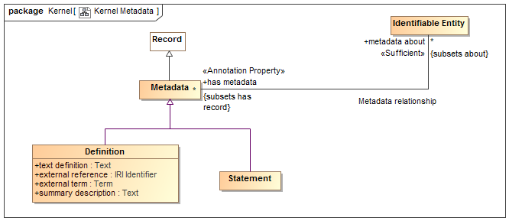

1. Kernel Metadata

## Diagram: Kernel Properties

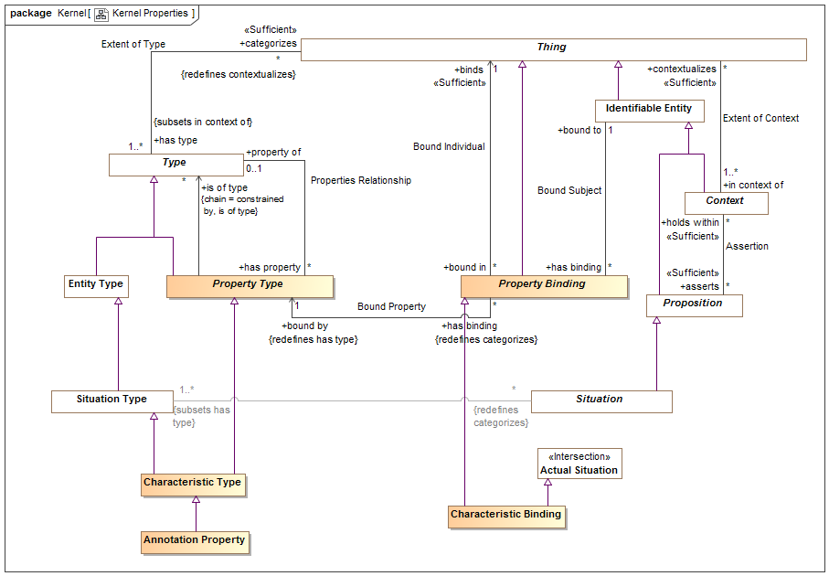

1. Kernel Properties

## Diagram: Kernel Rules Summary

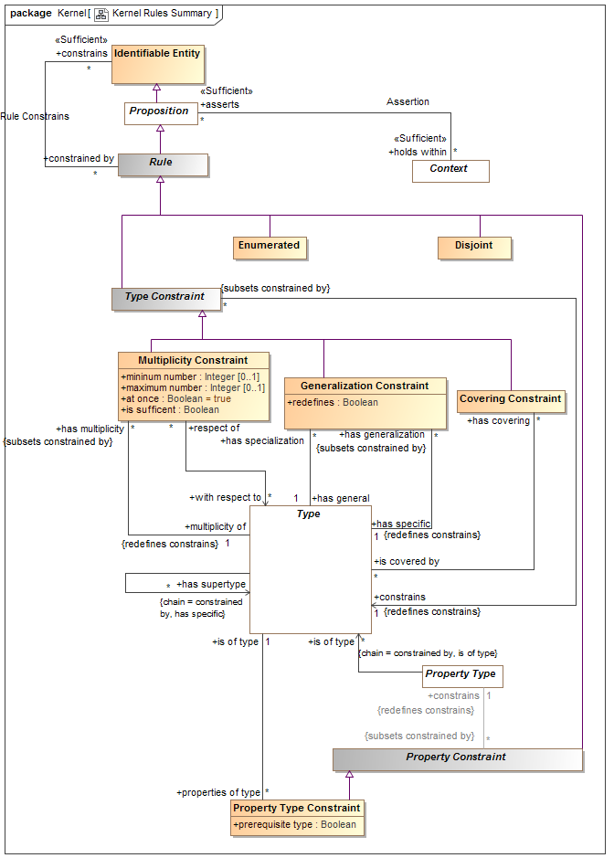

1. Kernel Rules Summary

This diagram shown a summary of the primary rules.

## Diagram: Kernel Top Level

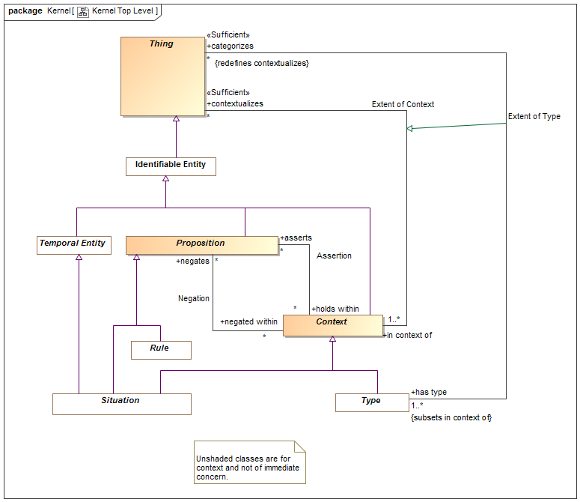

1. Kernel Top Level

Diagram showing summary of top level classes and significant subtypes.

## Diagram: Kernel Types

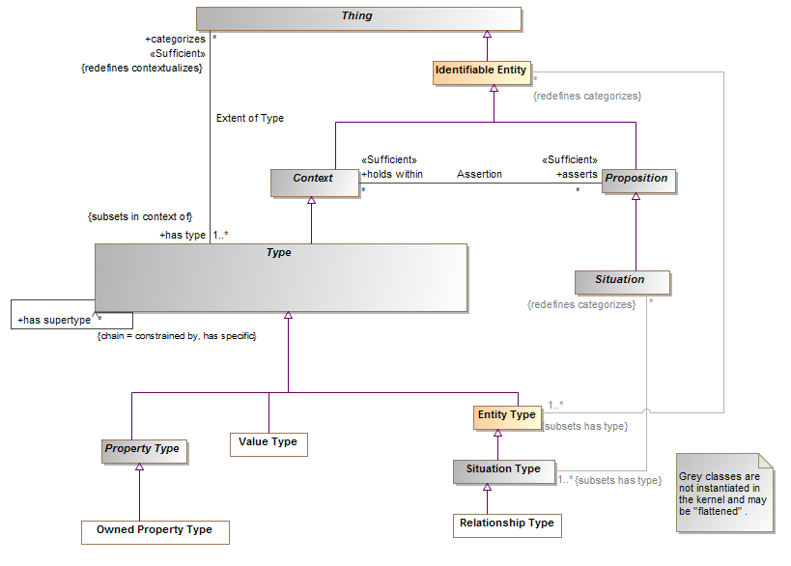

1. Kernel Types

## Diagram: Kernel Values

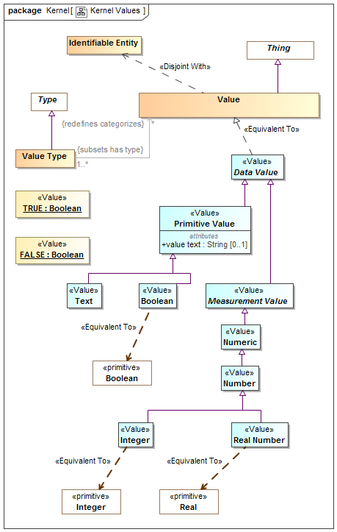

1. Kernel Values

# SMIF Conceptual Model::Lexical Scope

Lexical scope defines the structure of models and the ownership of model elements.

## Diagram: Lexical Scope

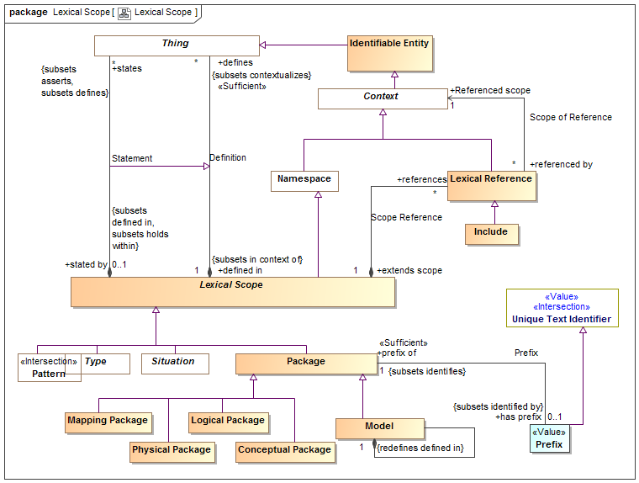

1. Lexical Scope

## Class Conceptual Package

A model of a real or possible world as conceived by the model authors.

### Direct Supertypes

Package

## Association Definition

Relationship defining the set of elements defined within a lexical scope.  
[OWL] RDF Graph

### Direct Supertypes

Extent of Context

### Association Ends

defines : Thing [*] *Subsets*: defined in:Lexical Scope



A model element defined within a lexical scope.  
Definition within a scope does not assert everything within a scope but the lexical scope may be independently asserted, thus asserting what it defines.  
[FUML] ownedElement, ownedMember

defined in : Lexical Scope [1] *Subsets*: defined in:Lexical Scope



Lexical scope defining model elements.  
[UML]owner

## Class Include

An "Include" is an external scope that is visible and asserted by the owning lexical scope.   
[FUML] PackageImport  
[CL] Importation: An importation contains a name. The intention is that the name identifies a piece of Common Logic content represented externally to the text, and the importation re-asserts that content in the text.

### Direct Supertypes

Lexical Reference

## Class Lexical Reference

A Lexical Reference is an external scope that is visible to but not necessarily asserted by the owning lexical scope.

### Direct Supertypes

Context

### Associations

Referenced scope : Context [1]



A referenced context, potentially in another model, that provides visibility to the elements in that context.  
[FUML] importedPackage  
[OWL] directlyImports (implies "Include")

extends scope : Lexical Scope [1]



A lexical scope that is extended by a lexical reference.  
[FUML] importingNamespace

## Class Lexical Scope

Lexical scope represents model content (the lexical structure of the model) that then models an area of concern. A lexical scope may define model elements representing anything.  
[CL] Text: A text is a set, list, or bag of phrases. A piece of text shall optionally be identified by a name.  
[OWL] Potential scope of a RDF graph defined by <defines>

### Direct Supertypes

Namespace

### Associations

defines : Thing [*] *Subsets*: contextualizes:Thing



A model element defined within a lexical scope.  
Definition within a scope does not assert everything within a scope but the lexical scope may be independently asserted, thus asserting what it defines.  
[FUML] ownedElement, ownedMember

references : Lexical Reference [*]



A reference providing visibility of a lexical scope to an internal or external context.

states : Thing [*] *Subsets*: defines:Thing asserts:Proposition



<states> combines <defines> with <has assertion> to both define and assert an element within a lexical scope. <states> provides a more "structural" organization of concepts that are both defined and asserted in the same structure.  
  
<states> is a convenience for the common case where assertion and lexical containment are combined.

## Class Logical Package

A model of information about systems independent of technical representation.

### Direct Supertypes

Package

## Class Mapping Package

A model defining relationships between other models.

### Direct Supertypes

Package

## Class Model

A root package. A model has no owner and may be directly referenced as an independent information resource. A model is defined in it's self.

### Direct Supertypes

Package

### Associations

: Thing [*] *Subsets*: defines:Thing asserts:Proposition



: Thing [*] *Subsets*: defines:Thing asserts:Proposition



## Class Package

A model element that provides a definitional scope for other model elements. A package may be represented as a "graph".  
  
[ISO 1087] concept system: system of concepts set of concepts (3.2.1) structured according to the  
relations among them  
  
[FUML] Package. FUML ownedMember corresponds with SMIF <defines>. FUML "nestedPackage" corresponds with "defines" where the element defined is a package.  
  
[CL] Module: A module consists of a name, an optional set of names called the exclusion set, and a text called the body text.

### Direct Supertypes

Lexical Scope

### Associations

has prefix : Prefix [0..1] *Subsets*: identified by:Identifier



An abbreviation that can be used to identify a package.

## Class Physical Package

A physical, technology specific, data schema representing information about a real or possible world.

### Direct Supertypes

Package

## Association Prefix

Relationship defining the prefix for a package.

### Direct Supertypes

Identification

### Association Ends

has prefix : Prefix [0..1] *Subsets*: identified by:Identifier



An abbreviation that can be used to identify a package.

prefix of : Package [1] *Subsets*: identified by:Identifier



An abbreviation for a package.

## Class Prefix

A technical abbreviation for a package.

### Direct Supertypes

Unique Text Identifier

### Associations

prefix of : Package [1] *Subsets*: identifies:Identifiable Entity



An abbreviation for a package.

## Association Scope of Reference

Relationship defining internal or external context that are referenced by a lexical scope using a lexical reference.

### Association Ends

Referenced scope : Context [1] *Subsets*: identifies:Identifiable Entity



A referenced context, potentially in another model, that provides visibility to the elements in that context.  
[FUML] importedPackage  
[OWL] directlyImports (implies "Include")

referenced by : Lexical Reference [*] *Subsets*: identifies:Identifiable Entity



References to a context.

## Association Scope Reference

Relationship defining references for a scope.

### Association Ends

references : Lexical Reference [*] *Subsets*: identifies:Identifiable Entity



A reference providing visibility of a lexical scope to an internal or external context.

extends scope : Lexical Scope [1] *Subsets*: identifies:Identifiable Entity



A lexical scope that is extended by a lexical reference.  
[FUML] importingNamespace

## Association Statement

Relationship defining the set of elements defined within and asserted by a lexical scope.

### Direct Supertypes

Definition

### Association Ends

states : Thing [*] *Subsets*: identifies:Identifiable Entity



<states> combines <defines> with <has assertion> to both define and assert an element within a lexical scope. <states> provides a more "structural" organization of concepts that are both defined and asserted in the same structure.  
  
<states> is a convenience for the common case where assertion and lexical containment are combined.

stated by : Lexical Scope [0..1] *Subsets*: identifies:Identifiable Entity



<stated by> is a lexical scope that both defines and asserts a model element.

# SMIF Conceptual Model::Mapping

Mapping rules define how data represents concepts or how different data representations are related.

## Diagram: Facades

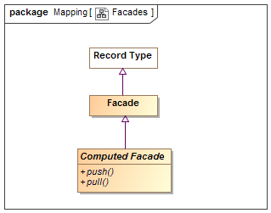

1. Facades

## Diagram: Mapping Rules

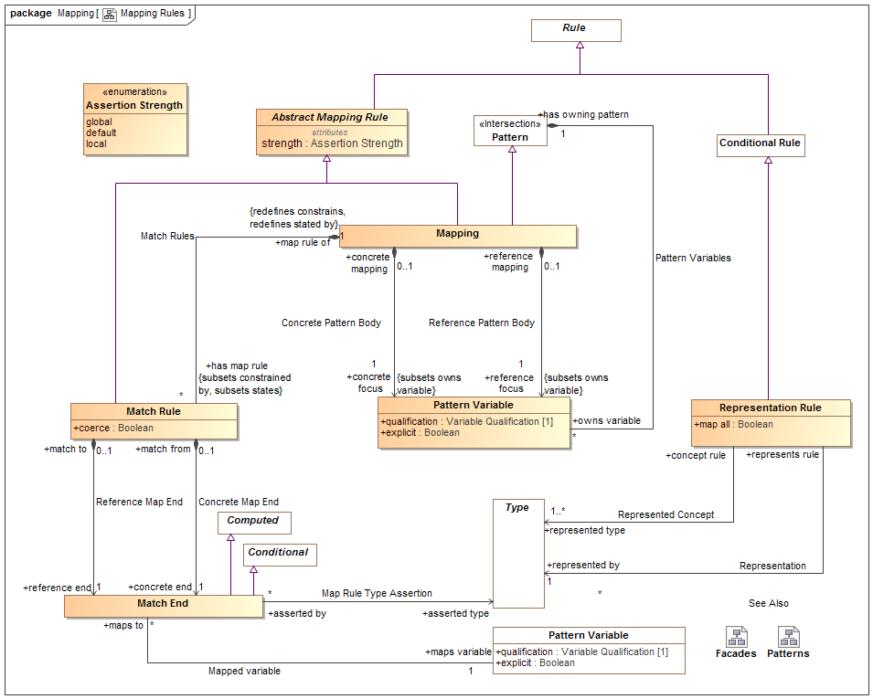

1. Mapping Rules

## Class Abstract Mapping Rule

Abstract mapping rule is an abstract class for the definition of the strength property.

### Direct Supertypes

Rule

### Attributes

strength : Assertion Strength



Strength defines what will cause a rule to be considered for being asserted (firing).

## Class Computed Facade

A facade that is computed by calling external methods.

### Direct Supertypes

Facade

### Operations

public push ()



An operation called to evoke the behavior associated with a new facade element being created or modified. Push asserts the more concrete type based on a reference type.

public pull ()



An operation called to evoke the behavior associated with a facade representing existing elements. Pull asserts the reference type based on a more concrete type.

## Association Concrete Map End

Relationship to the more concrete end of a match rule.

### Association Ends

concrete end : Match End [1] *Subsets*: identifies:Identifiable Entity



One end of a mapping, to be used for more concrete end.

match from : Match Rule [0..1] *Subsets*: identifies:Identifiable Entity



Mapping rule owning a "concrete" end.

## Association Concrete Pattern Body

Relationship between a mapping and a pattern of the more concrete concepts to be mapped.

### Association Ends

concrete focus : Pattern Variable [1] *Subsets*: identifies:Identifiable Entity



The variable or variables that form the basis for the portion of the pattern for the more concrete (physical) model. The concrete portion of the pattern is derived from the transitive closure of all variables reachable from the pattern variable via characteristics, associations or relationships.  
When a pattern matching the set of concrete variables is created or altered the mapping "fires" and the reference pattern is asserted.  
The qualification of the referenced variable is constrained to be ""select".

concrete mapping : Mapping [0..1] *Subsets*: identifies:Identifiable Entity



Mapping for which a more concrete pattern is defined.

## Class Facade

An intermediary data type used to hold common mappings. Facades may be computed and/or have mapping rules.

### Direct Supertypes

Record Type

## Association Map Rule Type Assertion

Relationship defining more concrete types that shall be asserted for an end of a match rule.

### Association Ends

asserted type : Type [*] *Subsets*: identifies:Identifiable Entity



Type that will be asserted for the end that is more concrete than the defined type of a property or relationship. e.g. a unit type.

asserted by : Match End [*] *Subsets*: identifies:Identifiable Entity



Map rule and that asserts a type

## Association Mapped variable

Relationship defining the property that is the source or target of a mapping

### Association Ends

maps variable : Pattern Variable [1] *Subsets*: identifies:Identifiable Entity



Variable that defines a set of elements to map to the other side of the mapping rule. The set of elements shall be those bound to the property on evaluation of the mapping.

maps to : Match End [*] *Subsets*: identifies:Identifiable Entity



Map rule end for a property

## Class Mapping

A mapping is a rule based on a pattern that defines how different representations of the same things correspond. There are two "sub patterns", defined by the concrete and reference variables and other variables reachable from them via characteristics, associations and relationships. These sub-patterns are matched (made to correspond) using "Match Rules"  
Patterns define a set of related elements to be mapped based on two distinguished variables, the "concrete body" and the "reference body".  
Types in a "concrete" body may be defined to be a representation (data about) a concept in a "reference" pattern.  
Match rules define how elements in each of the sub-patterns are mapped, bidirectionally.  
A mapping utilizing more specific types subsumes maps for more general types.  
Note that the roles of "concrete" and "reference" may or may not reflect different levels of abstraction and in some cases the choice may be arbitrary.

### Direct Supertypes

Abstract Mapping Rule, Pattern

### Associations

concrete focus : Pattern Variable [1] *Subsets*: owns variable:Pattern Variable



The variable or variables that form the basis for the portion of the pattern for the more concrete (physical) model. The concrete portion of the pattern is derived from the transitive closure of all variables reachable from the pattern variable via characteristics, associations or relationships.  
When a pattern matching the set of concrete variables is created or altered the mapping "fires" and the reference pattern is asserted.  
The qualification of the referenced variable is constrained to be ""select".

has map rule : Match Rule [*] *Subsets*: constrained by:Rule states:Thing



Map rule that is asserted by a mapping.

reference focus : Pattern Variable [1] *Subsets*: owns variable:Pattern Variable



The variable or variables that form the basis for the portion of the pattern for the more abstract/reference (conceptual) model. The reference portion of the pattern is derived from the transitive closure of all variables reachable from the pattern variable via characteristics, associations or relationships.  
When a pattern matching the set of reference variables is created or altered the mapping "fires" and the concrete pattern is asserted.  
The qualification of the referenced variable is constrained to be ""select".

## Class Match End

One end of a mapping from one thing to another that may be qualified with a condition.  
The set of elements to be mapped is the union of the sets of all mapped types and mapped variables that conform to the condition.  
Match rules are constrained to apply to only conforming types or types that represent the mapped ends (as specified by a representation rule).   
Representation rules applied to a supertype apply to a subtype unless a more specific representation rule is specified for the corresponding types.

### Direct Supertypes

Computed, Conditional

### Associations

asserted type : Type [*]



Type that will be asserted for the end that is more concrete than the defined type of a property or relationship. e.g. a unit type.

maps variable : Pattern Variable [1]



Variable that defines a set of elements to map to the other side of the mapping rule. The set of elements shall be those bound to the property on evaluation of the mapping.

## Class Match Rule

A rule that the 2 ends represent the same things or information about a thing.  
Redundant mappings are ignored and identity is preserved across all mappings.

### Direct Supertypes

Abstract Mapping Rule

### Attributes

coerce : Boolean



Where <coerce> has a value of TRUE a map rule will be evaluated even if the <reference end> is not type compatible with the <concrete end> type.  
Where <coerce> is FALSE or unstated a map rule will be evaluated only if the <reference end> is type compatible with the <concrete end> type.  
Type compatible shall be defined as one of: Being the same type, <concrete end> being a subtype of <reference end> (as defined by a type generalization rule), <concrete end> being a representation of <reference end> (as defined by a representation rule).  
Representation rules applied to a supertype apply to a subtype.

### Associations

concrete end : Match End [1]



One end of a mapping, to be used for more concrete end.

reference end : Match End [1]



One end of a match rule, to be used for more abstract end.

map rule of : Mapping [1] *Redefines*: constrains:Identifiable Entity stated by:Lexical Scope



Mapping containing a map rule.

## Association Reference Map End

Relationship to the reference end of a match rule.

### Association Ends

reference end : Match End [1] *Redefines*: constrains: Identifiable Entity stated by: Lexical Scope



One end of a match rule, to be used for more abstract end.

match to : Match Rule [0..1] *Redefines*: constrains: Identifiable Entity stated by: Lexical Scope



Mapping rule owning a reference" end.

## Association Reference Pattern Body

Relationship between a mapping and a pattern of the more abstract concepts to be mapped.

### Association Ends

reference focus : Pattern Variable [1] *Redefines*: constrains: Identifiable Entity stated by: Lexical Scope



The variable or variables that form the basis for the portion of the pattern for the more abstract/reference (conceptual) model. The reference portion of the pattern is derived from the transitive closure of all variables reachable from the pattern variable via characteristics, associations or relationships.  
When a pattern matching the set of reference variables is created or altered the mapping "fires" and the concrete pattern is asserted.  
The qualification of the referenced variable is constrained to be ""select".

reference mapping : Mapping [0..1] *Redefines*: constrains: Identifiable Entity stated by: Lexical Scope



Mapping for which a more abstract pattern is defined.

## Association Representation

More concrete type that represents information about the represented concept of a representation rule.

### Association Ends

represented by : Type [1] *Redefines*: constrains: Identifiable Entity stated by: Lexical Scope



The representation of a concept in a more specific form

represents rule : Representation Rule *Redefines*: constrains: Identifiable Entity stated by: Lexical Scope



Rule defining a representation of a type.

## Class Representation Rule

A representation rule states that the <represented type> has a representation defined by the <represented by> type.  
Representation rules are used to filter Map Rules such that only represented concepts may be mapped.  
A representation is usually complimented with one or more mapping rules.

### Direct Supertypes

Conditional Rule

### Attributes

map all : Boolean



Specifies a direct mapping between instances of the types in both directions.  
<map all> is equivalent to a mapping with a rule mapping properties of each type but is lower precedence than other mappings - if types have a more specific map it will apply first.

### Associations

represented by : Type [1]



The representation of a concept in a more specific form

represented type : Type [1..*]



A more general or abstract concept that is being represented.

## Association Represented Concept

More abstract type that is <represented by> a more concrete type of a representation rule.

### Association Ends

represented type : Type [1..*]



A more general or abstract concept that is being represented.

concept rule : Representation Rule



Rule defining a concept that is represented by another, more concrete, concept.

### Enumeration Assertion Strength

Rule strength defines what will cause a rule to be considered for being asserted (firing).

package SMIF Conceptual Model::Mapping

public enum Assertion Strength

{global, default, local}

#### Literals

global



The rule will be in effect globally.

default



The rule will only be in effect if no other rule is in effect for the same elements.

local



The rule will only be in effect if required to fulfill another rule.

### Known other enumerations

Enumeration Assertion Strength

# SMIF Conceptual Model::Metadata

Metadata defines data about model elements (their source, definition or trust), which can be differentiated from model elements about the subject domain.

## Diagram: Metadata

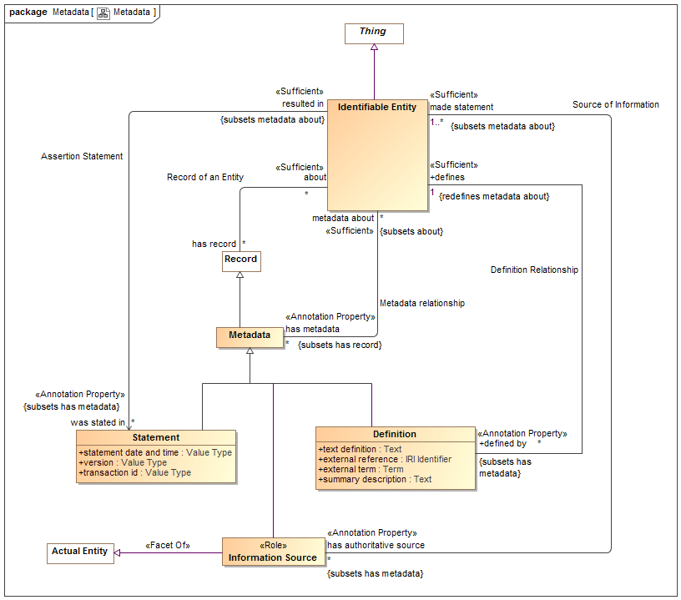

1. Metadata

## Association Assertion Statement

Relationship defining the original statement, speech act or information artifact that asserted something in a model.

### Direct Supertypes

Metadata relationship

### Association Ends

was stated in : Statement [*]



Metadata representing the speech act, document or other record where a statement captured in a model was made.  
[OWL] rdfs:isDefinedBy

resulted in : Identifiable Entity



Statement made in a statement by an information source.

## Class Definition

An informal or natural language definition of a something and potentially a reference to external definitions.  
A Definition may be in the context of a natural language to scope the language it is expressed in.  
  
[ISO 1087] definition: representation of a concept (3.2.1) by a descriptive statement which serves to differentiate it from related concepts  
  
[FUML] Comment (where body corresponds with "text definition").

### Direct Supertypes

Metadata

### Attributes

text definition : Text



Text describing a something in natural language. The language may be indicated by a context of the definition.  
[OWL] rdfs:comment

external reference : IRI Identifier



A reference to an external information resource that further defines something.  
[FIBO] ReferenceDOcument

external term : Term



Specific term in an external resource that further defines something.

summary description : Text



A short description of something.

### Associations

defines : Identifiable Entity [1] *Redefines*: metadata about:Identifiable Entity



Some thing described by a definition.  
[FIBO] defines  
[FUML]annotatedElement

## Association Definition Relationship

Relationship between a thing and its definitions.

### Direct Supertypes

Metadata relationship

### Association Ends

defines : Identifiable Entity [1] *Redefines*: metadata about: Identifiable Entity



Some thing described by a definition.  
[FIBO] defines  
[FUML]annotatedElement

defined by : Definition [*] *Redefines*: metadata about: Identifiable Entity



An informal description of something.  
[FIBO] hasDefinition  
[UML] comment  
[FUML] ownedComment

## Class Information Source

Metadata defining the origin or provenance of a set of statements in a model or data.  
Note that the source could be a human, an organization, a mapping or other automated processes.

### Direct Supertypes

Actual Entity, Metadata

### Associations

made statement : Identifiable Entity [1..*] *Subsets*: metadata about:Identifiable Entity



Metadata representing statements made by an authoritative source.   
Sources may be people, organizations, documents, information systems, etc.

## Class Metadata

Information about the source, provenance or origin of information. Metadata may be a managed entity, providing for provenance.  
[NIEM] MetadataType

### Direct Supertypes

Record

### Associations

metadata about : Identifiable Entity [*] *Subsets*: about:Identifiable Entity



The subject of metadata, the entity described by the metadata.  
[OWL] annotationSubject of Annotation Assertion

## Association Metadata relationship

Relationship between something and metadata about that thing; data about data.  
[OWL] AnnotationAssertion

### Association Ends

metadata about : Identifiable Entity [*] *Subsets*: about:Identifiable Entity



The subject of metadata, the entity described by the metadata.  
[OWL] annotationSubject of Annotation Assertion

has metadata : Metadata [*] *Subsets*: about:Identifiable Entity



Metadata associated with (data about the information concerning) the subject entity.  
[OWL] AnnotationProperty, annotationValue of Annotation Assertion

## Association Record of an Entity

Relationship between a thing and records (or information) about that thing.  
Note that in SMIF, things refer to the actual thing they represent, not data about it (unless the type is a record, in which case the "thing" is the data). This relationship recognizes that both a thing and data about the thing are things.  
  
[IDEAS] describedBy: A representedBy that asserts that a Description describes a Thing.

### Association Ends

about : Identifiable Entity [*] *Subsets*: about:Identifiable Entity



The thing described by a record.

has record : Record [*] *Subsets*: about:Identifiable Entity



A record about something.

## Association Source of Information

Relation defining an entity making a statement represented within a model. E.g. the person or organization that made a statement.  
  
[ISO 1087] source identifier: information in a terminological entry (3.8.2) which indicates the source documenting the terminological data (3.8.1)

### Association Ends

made statement : Identifiable Entity [1..*] *Subsets*: about:Identifiable Entity



Metadata representing statements made by an authoritative source.   
Sources may be people, organizations, documents, information systems, etc.

has authoritative source : Information Source [*] *Subsets*: about:Identifiable Entity



Metadata representing the authority behind a statement - who or what made a statement captured in a model.

## Class Statement

Statements provide metadata as to the source of information - who or what said it.  
This source of the information may be captured using "InformationSource" metadata about the metadata.  
  
[ISO11404] provision that conveys information

### Direct Supertypes

Metadata

### Attributes

statement date and time : Value Type



Metadata representing the date and time the statement was made or modified.

version : Value Type



Metadata representing an identifier for a version of information.

transaction id : Value Type



Identifier for an act or transaction creating or modifying information.

# SMIF Conceptual Model::Patterns

Patterns are templates for structures or compositions of things that may then be expressed as instances of the pattern.

## Diagram: Patterns

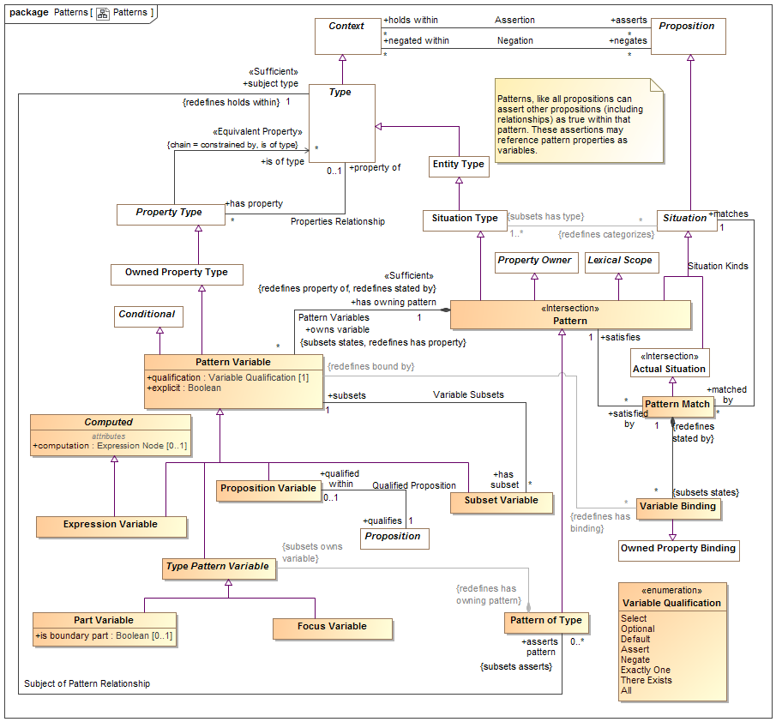

1. Patterns

## Class Computed

### Attributes

computation : Expression Node [0..1]



<computation> provides an expression that computes a value for the variable based on the expression applied to the current context..

## Class Expression Variable

An expression variable defines the value of the variable as computed by <computation>. Note that expression variables are not always able to be asserted or reversed and may therefore not provide for bi-directional mapping patterns. Any ability to assert or reverse a computation is implementation specific.

### Direct Supertypes

Computed, Pattern Variable

## Class Focus Variable

A property variable of a pattern representing the extent of the subject type within the context of the owning pattern.  
The value of qualification shall be "Select".  
The <has type> of the variable is asserted be the same as the subject type of the pattern.

### Direct Supertypes

Type Pattern Variable

## Association Match Rules

Relationship defining the match rules for a mapping.

### Direct Supertypes

Rule Constrains, Statement

### Association Ends

has map rule : Match Rule [*] *Subsets*: about:Identifiable Entity



Map rule that is asserted by a mapping.

map rule of : Mapping [1] *Subsets*: about:Identifiable Entity



Mapping containing a map rule.

## Class Part Variable

A pattern property variable representing a part of the subject type. Additional relations and rules may be made about the part. A type with parts is by its nature a composition.

### Direct Supertypes

Type Pattern Variable

### Attributes

is boundary part : Boolean [0..1]



True if the property is on the boundary of the pattern and connectible (may have relationships) external to the pattern. e.g. "Port"

## Class Pattern

A pattern represents a set of assertions true about individuals or sets of individuals qualified by pattern properties. All propositions asserted or negated by a pattern (as a context) are considered "templates" where identity is not required to match.  
   
The structure of the pattern is defined by the properties and asserted (sub) situations (including relationships) that are asserted by the pattern.  
  
In many cases the relationships and rules defined for a pattern will reference pattern properties. These relationships will hold for instances of the pattern where things are bound to the pattern properties.  
  
[DTV] general situation kind: situation kind that is not an individual situation kind. A situation kind is a general situation kind if it can be exemplified by more than one Event in some possible world, even when it cannot have more than one Event in the possible world chosen to be the universe of discourse.  
  
[UML] StructuredClassifier. Also Similarity with TemplateSignature   
  
[OWL] May be used to represent Class Expressions

### Direct Supertypes

Lexical Scope, Property Owner, Situation, Situation Type

### Associations

owns variable : Pattern Variable [*] *Subsets*: states:Thing *Redefines*: has property:Property Type



A variable property defined within the context of a pattern that is used as part of the patterns definition.  
[UML] ownedAttribute

satisfied by : Pattern Match [*]



Pattern match that satisfies a pattern.

## Association Pattern Bindings

### Association Ends

: Variable Binding [*]



: Pattern Match [1]



## Class Pattern Match

A pattern match provides the corespondents between a pattern and the situations it matches using variable bindings.   
A pattern match implies and proves that the pattern <categorizes> the situation.  
The matched pattern <states> any consequences of the matching, such as the pattern <categorizes> the pattern instance.

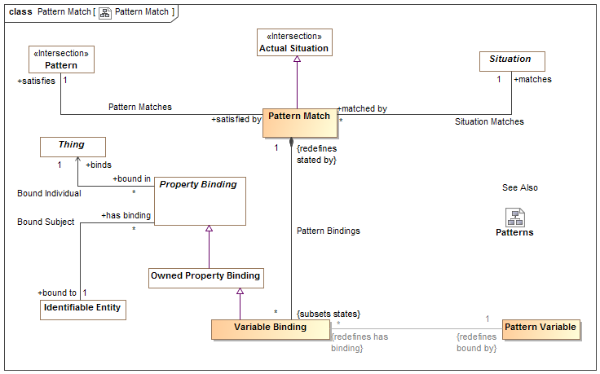

1. Pattern Match

### Direct Supertypes

Actual Situation

### Associations

: Variable Binding [*] *Subsets*: states:Thing



satisfies : Pattern [1]



Pattern that is satisfied by a "Pattern Match" based on a set of "Variable Bindings".

matches : Situation [1]



The situation qualified as matching the <satisfies> pattern based on the set of "Variable Bindings" stated.

## Association Pattern Matches

### Association Ends

satisfies : Pattern [1]



Pattern that is satisfied by a "Pattern Match" based on a set of "Variable Bindings".

satisfied by : Pattern Match [*]



Pattern match that satisfies a pattern.

## Class Pattern of Type

A pattern of type defines a set of properties and relationships that must hold true for all instances of a type. Where the pattern includes parts, the subject type is a composition.  
Patterns augment the semantics of th subject type in the context of the pattern.

### Direct Supertypes

Pattern

### Associations

: Type Pattern Variable *Subsets*: owns variable:Pattern Variable



subject type : Type [1] *Redefines*: holds within:Context



The type which is the context of a pattern of type. The pattern is "about" the subject type.

## Class Pattern Variable

A pattern variable is a property of a pattern that provides a contextual property within that pattern for rules and relationships to be bound to.  
A pattern variable is a placeholder for all or a subset of the instances of the variables type.  
Properties of an association or relationship may be bound to a pattern variable where the type of the pattern variable is compatible with the type of the relationship's property type.  
  
[UML] Similarity with TemplateParameter  
[CL] Functional Term

### Direct Supertypes

Conditional, Owned Property Type

### Attributes

qualification : Variable Qualification [1]



<qualification> defines the behavior of an element with respect to a pattern - how the variable impacts the selection, evaluation or assertion of the pattern.

explicit : Boolean



If true, Element must be explicitly asserted as the indicted type, not derived or inferred from a supertype or super property.

### Associations

: Variable Binding [*] *Redefines*: has binding:Property Binding



has owning pattern : Pattern [1] *Redefines*: property of:Type stated by:Lexical Scope



Pattern owning a pattern variable.

has subset : Subset Variable [*]



Subsets of the variable.

maps to : Match End [*]



Map rule end for a property

## Association Pattern Variables

Relationship defining variable properties within a pattern.

### Direct Supertypes

Statement

### Association Ends

owns variable : Pattern Variable [*]



A variable property defined within the context of a pattern that is used as part of the patterns definition.  
[UML] ownedAttribute

has owning pattern : Pattern [1]



Pattern owning a pattern variable.

## Class Proposition Variable

A proposition variable utilizes some proposition (e.g. relationships) as a part of the definition of a pattern, it extends a basic proposition in that it adds properties to determine the effect the assertion has on pattern instances.  
A Proposition Variable is a lexical scope context that <asserts> or <negates> other propositions qualified by <has strength> and <explicit>. As a lexical scope it may "own" the asserted propositions.  
Proposition Variable is often used with associations and relationships to define the way pattern properties are related to other pattern properties or actual entities.  
For a pattern associations, [UML] Connector. (type = has type). Each ConnectorEnd corresponds with a Structured Property Binding.

### Direct Supertypes

Pattern Variable

### Associations

qualifies : Proposition [1]



## Association Qualified Proposition

Association defining exactly one proposition (such as an association) qualified by a qualified proposition variable.

### Association Ends

qualifies : Proposition [1]



qualified within : Proposition Variable [0..1]



## Association Situation Matches

### Association Ends

matches : Situation [1]



The situation qualified as matching the <satisfies> pattern based on the set of "Variable Bindings" stated.

matched by : Pattern Match [*]



Pattern matches that match the subject situation.

## Association Subject of Pattern Relationship

Relationship defining the subject pattern of a type specific pattern.

### Direct Supertypes

Assertion

### Association Ends

asserts pattern : Pattern of Type [0..*]



A pattern asserted for all instances of a type. Where the pattern includes parts, the type defines a composition.

subject type : Type [1]



The type which is the context of a pattern of type. The pattern is "about" the subject type.

## Class Subset Variable

In a pattern or mapping rule, defines a property that represents a subset of another property. The subset may be constrained by a more specific type, expressions or required cardinalities.  
qualification shall be one of {Select, Optional, Default, Assert, Negate}.  
Where qualification "Default" the default shall only be applied if all <has subset" of the <subsets> variable are empty.

### Direct Supertypes

Pattern Variable

### Associations

subsets : Pattern Variable [1]



Variable that a subset variable subsets. The subset variable shall be populated by a subset of the <subsets> variable based on the type and constraints of the subset variable.

## Class Type Pattern Variable

Type Pattern variable is an abstract supertype that provides for a restriction that parts and focus properties must be owned by a pattern of a type.

### Direct Supertypes

Pattern Variable

### Associations

: Pattern of Type *Redefines*: has owning pattern:Pattern



## Class Variable Binding

A variable binding defines a value for a particular variable of a particular owning pattern as part of a pattern match.

### Direct Supertypes

Owned Property Binding

### Associations

: Pattern Variable [1] *Redefines*: bound by:Property Type



: Pattern Match [1] *Redefines*: stated by:Lexical Scope



## Association Variable Subsets

Set of subsets of a pattern variable.

### Association Ends

subsets : Pattern Variable [1] *Redefines*: stated by: Lexical Scope



Variable that a subset variable subsets. The subset variable shall be populated by a subset of the <subsets> variable based on the type and constraints of the subset variable.

has subset : Subset Variable [*] *Redefines*: stated by: Lexical Scope



Subsets of the variable.

### Enumeration Variable Qualification

Variable qualification values define the behavior of an element with respect to a pattern - how it impacts the selection, evaluation or assertion of the pattern.

package SMIF Conceptual Model::Patterns

public enum Variable Qualification

{Select, Optional, Default, Assert, Negate, Exactly One, There Exists, All}

#### Literals

Select



Select is used in query and mapping patterns, all elements of the classified type that match the pattern are selected as instances of the pattern.  
Select may be considered a qualified "All". Select does not assert the existence of something, it determines the existence of a pattern match such that other assertions may be made.  
Where a pattern is asserted, "Select" variables shall be asserted.  
Relationships between properties with <quantifier>=Select must hold between the selected properties for the pattern to be asserted.

Optional



Optional is used in query and mapping patterns, the property shall be populated as a consequence of the pattern matching.  
Where a pattern is asserted, "Optional" variables shall not be asserted.  
Optional is the default if no qualification is stated.

Default



The element will be asserted only if no other values are asserted within the pattern or as pre-existing assertions.

Assert



The property does not impact the selection of the pattern, it is an asserted consequence of the pattern.

Negate



The property does not impact the selection of the pattern, it is negated consequence of the pattern - it may not exist.

Exactly One



The existential quantifier limited to exactly one of a potentially larger set of the properties type.

There Exists



The existential quantifier - at least one of the properties type.

All



The universal quantifier - the quantified property is a stand-in for all elements of the existent of the quantified type



1. Patterns

# SMIF Conceptual Model::Properties

Properties define the most granular connections between entities or values. Properties may be used as the ends of relationships, to represent individual characteristics or as elements of a data structure.

## Diagram: Characteristics

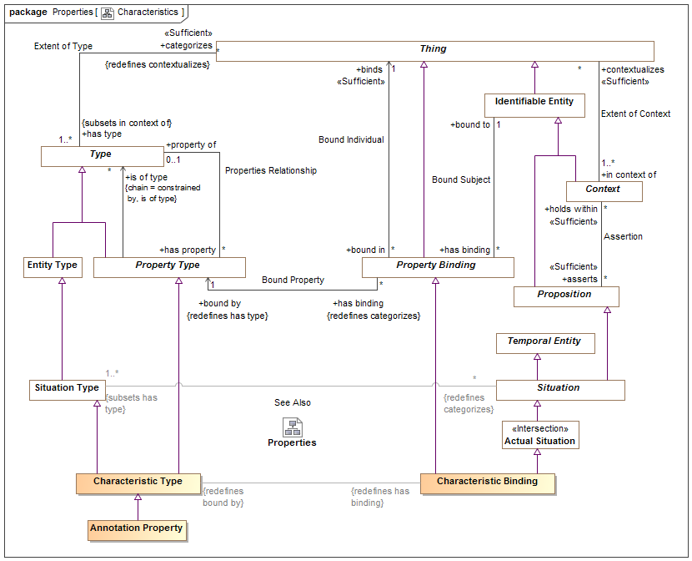

1. Characteristics

## Diagram: Properties

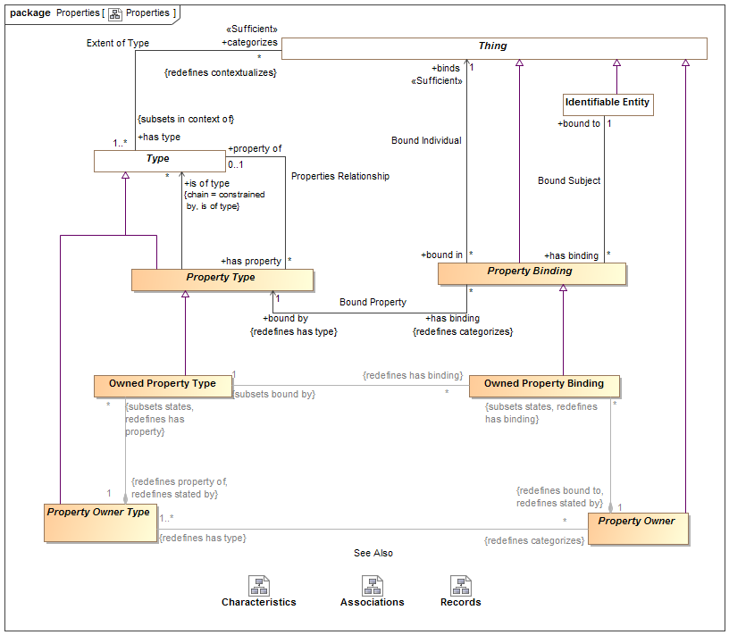

1. Properties

## Class Annotation Property

An annotation property is a specialization of property where the referenced elements represent metadata about the related proposition, structure or information (or model element) rather than a fact or condition of the domain being represented.  
For an annotation property, <is of type> describes instances of the structured type for which the property is defined.  
Typical uses of annotations include provenance of information, when a record was created, etc.  
[ISO11404] annotation: descriptive information unit attached to a datatype, or a component of a datatype, or a procedure (value), to characterize some aspect of the representations, variables, or operations associated with values of the datatype

### Direct Supertypes

Characteristic Type

## Association Bound Individual

Relationship defining the thing bound to a subject based on a bound property - the "object" of the property binding.

### Association Ends

binds : Thing [1] *Redefines*: stated by: Lexical Scope



The thing bound to a property in a specific situation. E.g. if the weight of truck-XYZ is 4500 LBS, the bound individual would be "4500 LBS".  
[FUML] value  
[OWL] rdf:object

bound in : Property Binding [*] *Redefines*: stated by: Lexical Scope



Bindings in which a thing participates.

## Association Bound Property

Relationship defining the property type that defines the semantics of a property binding. E.g. if the weight of truck-XYZ is 4500 LBS, the bound property could be "has weight".

### Direct Supertypes

Extent of Type

### Association Ends

has binding : Property Binding [*] *Redefines*: stated by: Lexical Scope



Bindings referencing a property.

bound by : Property Type [1] *Redefines*: stated by: Lexical Scope



The property a binding binds a thing to.  
[FUML] definingFeature  
[OWL] rdf:predicate

## Association Bound Subject

Relationship defining the subject of a bound property. Where the subject is a relationship, the relationship becomes transparent and the applicable subject(s) are the other ends of the relationship. E.g. if the weight of truck-XYZ is 4500 LBS, the bound subject would be Truck-XYZ".

### Association Ends

has binding : Property Binding [*] *Redefines*: stated by: Lexical Scope



Bindings asserted for properties within a situation.

bound to : Identifiable Entity [1] *Redefines*: stated by: Lexical Scope



The subject of a property binding.  
[FUML] owningInstance (note that in SMIF the owner and subject may not be the same). Where the are the same, the semantics are the same as FUML.  
[OWL] rdf:subject

## Class Characteristic Binding

A characteristic of a specific thing, e.g. the color of Pump-1234 in the <bound to> entity. A characteristic is a "first class" element and may participate in relationships and have annotations.  
  
[IDEAS] measureOfIndividual: A typeInstance that asserts an Individual is an instance of a Measure - i.e. the Individual "has" a property corresponding to the Measure.  
  
[ISO 1087] characteristic: abstraction of a property of an object (3.1.1) or of a  
set of objects  
  
[Guizzardi] quality(x) =def ∃!U qualityUniversal(U) ∧ (x::U)  
  
[DOLCE] Quality

### Direct Supertypes

Actual Situation, Property Binding

### Associations

: Characteristic Type *Redefines*: bound by:Property Type



## Class Characteristic Type

A kind of characteristic a type of thing may have, e.g. paint may have a color. Characteristic type is the type of characteristic bindings which are "first class" elements and may participate in relationships and have other characteristics.  
  
[IDEAS] Property: An IndividualType whose members all exhibit a common trait or feature. Often the Individuals are states having a property (the state of being 18 degrees centigrade), where this property can be a CategoricalProperty (qv.) or a DispositionalProperty (qv.).  
  
[ISO 1087] type of characteristics: category of characteristics (3.2.4) which serves as the criterion of subdivision when establishing concept systems. NOTE The type of characteristics colour embraces characteristics (3.2.4) being red, blue, green, etc. The type of characteristics material embraces characteristics made of wood, metal, etc.  
  
[FIBO] Simple Property: Simple Properties are assertions about things in a class, which may be framed in terms of some simple type of information.   
  
[Guizzardi] qualityUniversal(U)   
  
[DOLCE] Quality Type  
  
[OWL] rdf:Statement  
  
[UML] Property

### Direct Supertypes

Property Type, Situation Type

### Associations

: Characteristic Binding *Redefines*: has binding:Property Binding



## Class Owned Property Binding

An owned property binding defines a value for a particular property of a particular owning property type (or structure).  
Similar to an OWL triple, an owned property binding does not have independent identity.  
Constraint: Each owned property binding must be <bound by> an owned property type that is owned by the <has type> owned type of the <bound to> property owner.  
  
Owned property type is abstract and not intended to directly represent semantic elements.

### Direct Supertypes

Property Binding

### Associations

: Owned Property Type [1] *Subsets*: bound by:Property Type



A structure property binding may bind a characteristic.

: Property Owner [1] *Redefines*: bound to:Identifiable Entity stated by:Lexical Scope



## Class Owned Property Type

An owned property type is a property definition defined as a composite part of an association type - most often used in data structures and relationships. Association property types are the types of association property bindings. Also known as "association end".  
  
[FIBO] Relationship Property  
[FUML] memberEnd (of association) Property

### Direct Supertypes

Property Type

### Associations

: Owned Property Binding [*] *Redefines*: has binding:Property Binding



: Property Owner Type [1] *Redefines*: stated by:Lexical Scope property of:Type



## Association Properties Relationship

Relationship defining the set of properties defined for a type.  
Where the <property of> type is a relationship type, the "subject" of the property is the other ends (properties) of the relationship.  
Where the <property of> type is not a relationship, the subject of the property is the <property of> type.

### Association Ends

has property : Property Type [*] *Redefines*: stated by: Lexical Scope property of: Type



A property of a structured type such that there may be bindings of a thing to instances of the structured type with reference to the property which defines the semantics of the bound thing withing the context of the structure.  
[FUML] feature  
[UML] memberEnd. attribute (of classifier).

property of : Type [0..1] *Redefines*: stated by: Lexical Scope property of: Type



Type for which a property is relevant. The domain of the property.   
<property of> excludes "Owned Property Type" and ("Association Type" that is not "Relationship Type")  
[FUML] featuringClassifier  
[OWL] Domain

## Class Property Binding

A property value binding binds a particular thing (the value) to a situation based on a defined property.  
  
Where <binds> is an expression evaluation, the property value shall evaluate to the evaluation of the expression.  
  
Where <binds> is a property, the property value shall be the property values bound to that property in <bound to> situation.  
  
The bound to thing must conform with the <is of type> type of the property. If the bound individual conforms to the "requires type" of the property, the <is of type> of the bound thing will be asserted.  
  
The type of the <bound to> structure must (directly or indirectly) have the type the <bound by> properties <property of> type.  
  
[FUML] Slot (Noting that in SMIF the binding may or may not be owned by the subject, depending on the subtype of property).  
  
[CL] Binding:   
  
[OWL] Union(ObjectPropertyAssertion, DataPropertyAssertion, AnnotationAssertion), RDF Triple  
=Note: RDF Triples do not have identity where as some subtypes of SMIF:Property Type do have identity and are therefor statements.

### Direct Supertypes

Thing

### Associations

binds : Thing [1]



The thing bound to a property in a specific situation. E.g. if the weight of truck-XYZ is 4500 LBS, the bound individual would be "4500 LBS".  
[FUML] value  
[OWL] rdf:object

bound by : Property Type [1] *Redefines*: has type:Type



The property a binding binds a thing to.  
[FUML] definingFeature  
[OWL] rdf:predicate

bound to : Identifiable Entity [1]



The subject of a property binding.  
[FUML] owningInstance (note that in SMIF the owner and subject may not be the same). Where the are the same, the semantics are the same as FUML.  
[OWL] rdf:subject

## Class Property Owner

Property Owner is an abstract element for anything that may own a set of property bindings. This element is abstract and not intended to directly represent domain concepts. Subtypes of property owner provide semantic interpretation.

### Direct Supertypes

Thing

### Associations

: Owned Property Binding [*] *Subsets*: states:Thing *Redefines*: has binding:Property Binding



: Property Owner Type [1..*] *Redefines*: has type:Type



## Class Property Owner Type

A type of Property Owner (See Property Owner for details) which defines a set of "Owned Property Types" which are the types of owned property bindings.  
Property owner is abstract and not intended to directly represent semantic elements.

### Direct Supertypes

Type

### Associations

: Property Owner [*] *Redefines*: categorizes:Thing



: Owned Property Type [*] *Subsets*: states:Thing *Redefines*: has property:Property Type



## Class Property Type

A property type defines the way in which instances of a type participate in (or, are involved in) instances of another type (including relationships). Sometimes called a variable, argument or role.  
In a conceptual model the terms associated with a property kind are typically "verb phrases" defining how instances of the involved type participate in the situation or relationship.  
In a record (data structure) the property is a "slot" of a record and may have a term which is a noun or verb phrase.  
So that constraints of a type flow to relationships involving that type: All propositions that hold within a type referenced by <is of type> hold within the structured type referenced by <property of>. I.e. the structured type is in the context of the types of its properties.  
In a function, a property is a function argument.  
  
[Guizzardi] MomentUniversal  
  
[FUML] Parameter where owner is operation. Otherwise Property.  
  
[UML] Property. All typed elements in SMIF are Property Types.   
  
[CL] Operator: distinguished syntactic role played by a specified component within a functional term  
  
[OWL] rdf:Property, ObjectUnionOf(owl:ObjectProperty, oe;DatatypeProperty).

### Direct Supertypes

Type

### Associations

is of type : Type [*]



A type of instances bound to a property. Also known as the "range" of a property.  
If asserted the property rule shall be owned and asserted by the properties <property of> type.  
  
[OWL] Range

: Property Constraint [*] *Subsets*: constrained by:Rule



property of : Type [0..1]



Type for which a property is relevant. The domain of the property.   
<property of> excludes "Owned Property Type" and ("Association Type" that is not "Relationship Type")  
[FUML] featuringClassifier  
[OWL] Domain

# SMIF Conceptual Model::Records

A record of the condition of an entity at a point in time - this includes facts, speech acts and DBMS records. Records are a kind of information.  
Records are typically used in data representations, not conceptual models.

## Diagram: Records

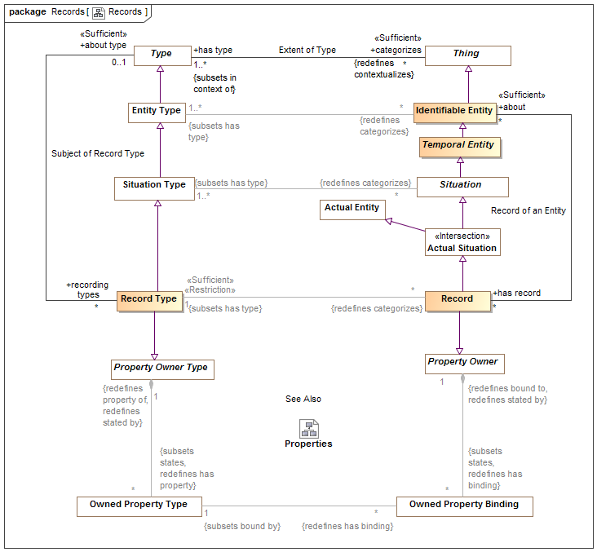

1. Records

## Class Record

A record of the condition of an entity at a point in time - this includes facts, speech acts and DBMS records.   
Records are typically used in data representations, not conceptual models. Records specialize associations as owners of properties.  
  
[IDEAS] A Representation that describes a Thing

### Direct Supertypes

Actual Situation, Property Owner

### Associations

about : Identifiable Entity [*]



The thing described by a record.

: Record Type [1] *Subsets*: has type:Type



## Class Record Type

Type of the record of the condition of an entity at a point in time - this includes facts, speech acts and DBMS records.   
A record type may involve variant and invariant types as variables. Those that are enumerated in a "uniqueness constraint" are invariant (independent variables) uniquely identify the situation which is the subject of the fact type where as the other variables may change over time (dependent variables).  
Record types may be grounded in atomic relations by using invariant conditions.  
Record types represent typical "data structures".

### Direct Supertypes

Property Owner Type, Situation Type

### Associations

: Record [*] *Redefines*: categorizes:Thing



about type : Type [0..1]



Thing for which a record exists

## Association Subject of Record Type

Relationship defining types of records for another type.

### Association Ends

about type : Type [0..1]



Thing for which a record exists

recording types : Record Type [*]



Record for a thing.

# SMIF Conceptual Model::Relationships

Relationships are primitive but identifiable conditions that relate other entities through properties of the relationships. Relationships have their semantics described by a relationship type. The ends of relationships are defined by "structured property type", a relationship may have any number of "ends".  
Relationships are first-class "actual" and "temporal" things that exist in their own right. These are known as "external relations" in much of the theoretical literature.

## Diagram: Relationships

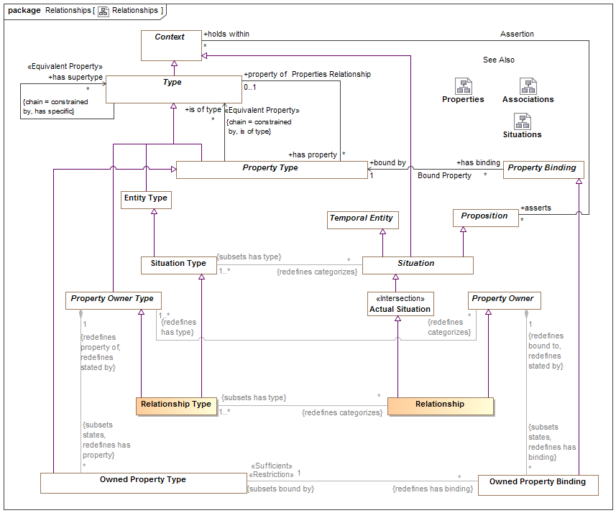

1. Relationships

Relations are atomic actual situations that bind 2 or more properties as a fact.

## Class Relationship

A relationship defines a situation involving related things. A relationship may be asserted within a context as true or false within that context. Each relationship type has a number of bindings of which do not change for the life of the relationship..   
A relationship may be true or false within its context (including a timeframe) but is atomic in its truth value.  
Relationships may participate in (be bound to) other relationships and as such bindings involving a relationship may change over time. That is, relationships are "first class" objects.  
  
[IDEAS] tuple: A relationship between two or more things.  
Note: SMIF allows one end of a relationship.  
  
[OWL] An OWL class that is a subclass of SMIF: Relationship

### Direct Supertypes

Actual Situation, Property Owner

### Associations

: Relationship Type [1..*] *Subsets*: has type:Type



## Class Relationship Type

A relationship type defines a type of condition, the relationship, involving related things. A relationship may be asserted within a context as true or false within that context. Each relationship type has a number of <has property> "structured property type" properties which describe the role of the related things with respect to the relationship, values of which uniquely do not change for the life of the relationship.   
A relationship may be true or false within its context (including a timeframe) but is atomic in its truth value.  
Relationships may participate in (be bound to) other relationships and as such bindings involving a relationship may change over time.   
The terms for properties of a relationship in a conceptual model are typically verb phrases, connecting the relationship with the related types.  
  
[FIBO] A kind of Mediating Thing  
  
[IDEAS] TupleType: The Powertype of tuple.  
  
[FUML] Association where memberEnd corresponds with <has property>. Note that SMIF relationships are "first class" and may also be considered to correspond to an association class where there are any properties or other relationships referencing the subject relationship.  
  
[UML] AssociationClass (note that "end ownership" is meaningless in SMIF).  
  
[Guizzardi2015] Relator: endurants of a special kind, with the power of connecting (mediating) other endurants. Note: Guissardi "mediation" corresponds with relationship properties.

### Direct Supertypes

Property Owner Type, Situation Type

### Associations

: Relationship [*] *Redefines*: categorizes:Thing



# SMIF Conceptual Model::Rules

Rules define constraints or behaviors that are asserted in specified context.

## Diagram: General Rules

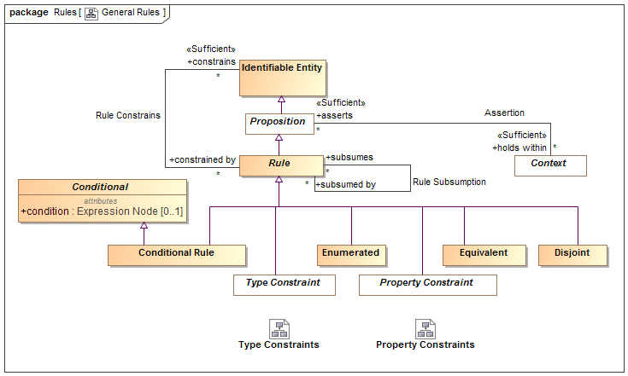

1. General Rules

## Diagram: Property Constraints

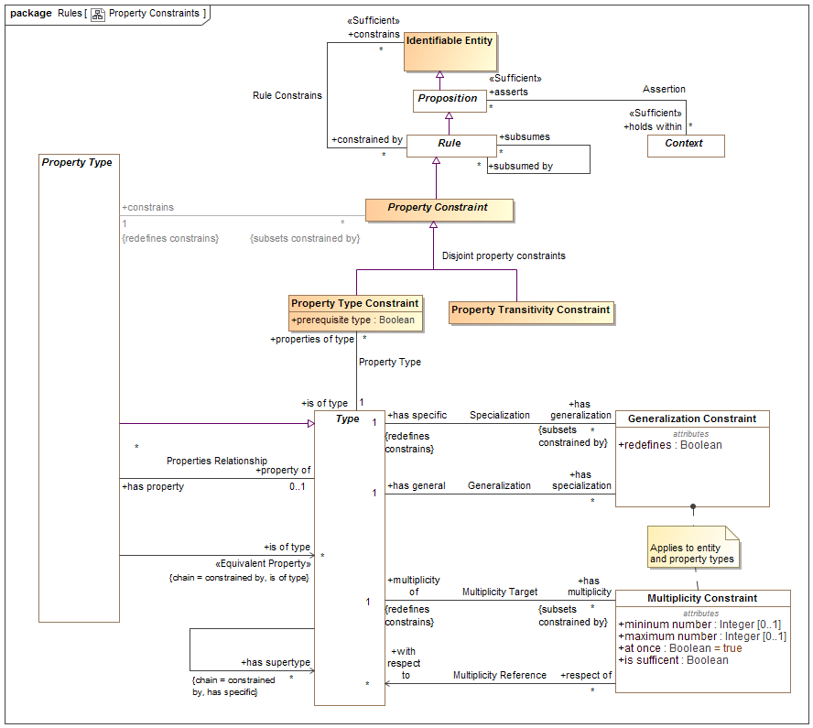

1. Property Constraints

This diagram focuses on rules about properties.

## Diagram: Rules in Context

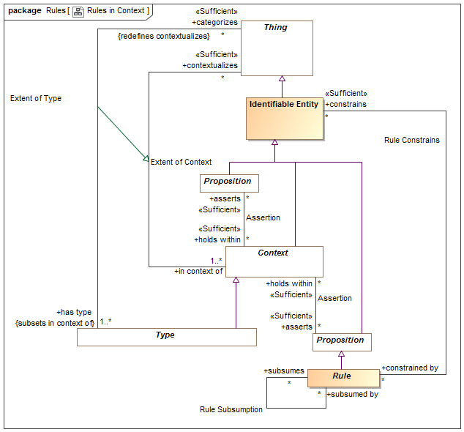

1. Rules in Context

This diagram shows how rules are propositions that may be asserted within any context to apply to any other context, thus realizing the "open world assumption".

## Diagram: Rules Summary

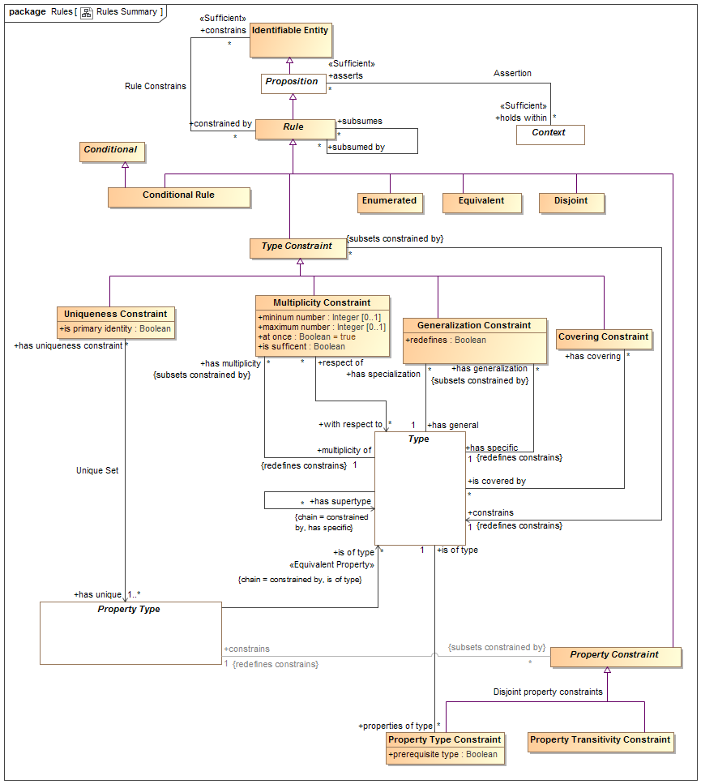

1. Rules Summary

This diagram shown a summary of the primary rules.

## Diagram: Type Constraints

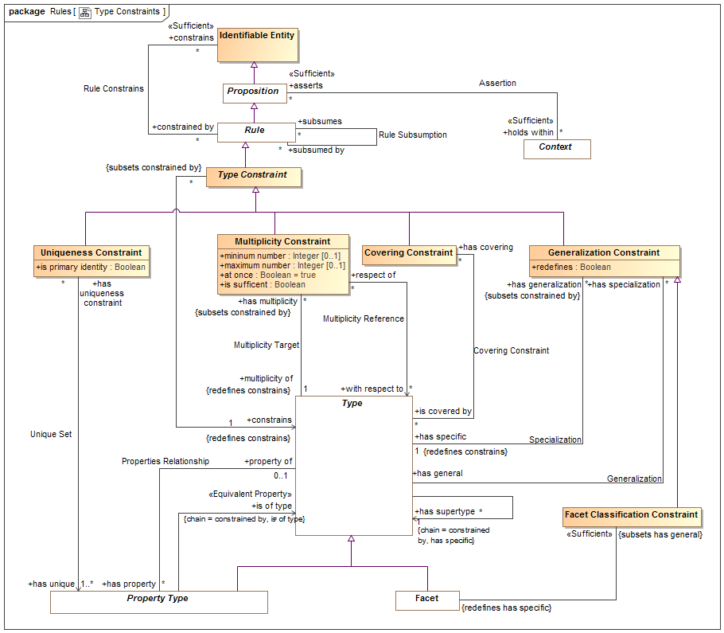

1. Type Constraints

This diagram focuses on rules about types (note that property types are also types).

## Class Conditional

Anything with a condition defined by an expression.

### Attributes

condition : Expression Node [0..1]



Condition that must be TRUE for an element to be asserted. All values other than "TRUE" are FALSE.

## Class Conditional Rule

A rule with a general expression as a condition that applies to what the rule <constrains>. Where asserted, the condition must be true.  
[UML] Constraint where "context" corresponds with <holds within> and "constrainedElement" corresponds with "constrains". "specification" corresponds with "condition".

### Direct Supertypes

Conditional, Rule

## Class Covering Constraint

A constraint that the extent (<categorizes> things) of the <constrains> type is equivalent to the union of the extents of the <is covered by> types.  
[UML] GeneralizationSet with isCovering=TRUE. "constrains" corresponds with the common "general" of each Generalization". "is covered by" corresponds with each "special" of each generalization.

### Direct Supertypes

Type Constraint

### Associations

is covered by : Type [*]



A type covered by a covering constraint.  
  
The <constrains> type must be a direct supertype of all <is covered by> types.

## Association Covering Constraint

Relationship defining the types covered by a covering constraint.

### Association Ends

is covered by : Type [*]



A type covered by a covering constraint.  
  
The <constrains> type must be a direct supertype of all <is covered by> types.

has covering : Covering Constraint [*]



Covering constraints of a type.

## Class Disjoint

Disjoint is a rule that the things denoted by what the rule <constrains> do not and may not denote any of the same set of things.  
When applied to a context (including types) all elements contextualized are included in the set of disjoint individuals.  
  
[FIBO] Mutually Exclusive sets  
  
[IDEAS] PartitionOfSetOfDisjointIndividuals: A FusionOfSetOfIndividuals whose fusioned Type is a SetOfDisjointIndividuals.  
  
[UML] [UML] GeneralizationSet with isDisjoint=TRUE. "constrains" corresponds with "is covered by" of each "special" of each generalization. Note the SMIF does not require that disjoint elements have a common supertype, one may be inferred for UML mapping.  
  
[OWL: Union(DisjointClasses, DisjointObjectProperties, DisjointDataProperties, DifferentIndividuals)

### Direct Supertypes

Rule

## Class Enumerated

The contextualized elements of the <constrains> context is a closed (enumerated) set, it can not be extended. A.K.A. "Closed World Assumption". Elements may not be asserted by any context other than the one specified in <holds within>.  
  
[FIBO] Selections of Things  
[FUML] Wen constraining a type, corresponds with [FUML] "Enumeration". SMIF enumerations are not limited to literals. The "ownedLiteral" corresponds with all elements owned by <holds within>.  
[ISO11404] Enumerated: enumerated is a family of datatypes, each of which comprises a finite number of distinguished values having an intrinsic order.  
[OWL] ObjectUnitionOf( DataOneOf, ObjectOneOf )

### Direct Supertypes

Rule

## Class Equivalent

Equivalent is a rule that the things the rule <constraints> denote the same set of things. When applied to a context (including types) each thing the context contextualizes is included in the set of equivalent things.  
  
Related to*: [ISO 1087] synonymy: relation between or among terms (3.4.3) in a given language representing the same concept (3.2.1)  
  
Related to*: [ISO 1087] equivalence: relation between designations (3.4.1) in different languages representing the same concept (3.2.1)  
  
* SMIF relates concepts, not terms. synonymy may also be represented by multiple terms for the same concept.  
  
[OWL] Union( SameIndividual, EquivalentClasses, EquivalentObjectProperties, EquivalentDataProperties)

### Direct Supertypes

Rule

## Class Facet Classification Constraint

A Facet Classification Constraint asserts that the specialized type is "non rigid" with respect to the general (rigid) type - that is the <has specific> type may change over the lifetime of instances of the <has general> type. The <has specific> type will be inferred to be a Facet. e.g. "Registered voter" is a facet of a person.   
  
[FIBO] isPlayedBy

### Direct Supertypes

Generalization Constraint

### Associations

: Facet *Redefines*: has specific:Type



## Association Generalization

Relationship defining the general type of a generalization constraint.  
  
[ISO 1087] generic concept: concept (3.2.1) in a generic relation (3.2.21) having the narrower intension (3.2.9)

### Association Ends

has general : Type [1] *Redefines*: has specific: Type



The general type in the Generalization rule.  
  
[ISO 1087] concept (3.2.1) in a generic relation (3.2.21) having the broader intension (3.2.9)  
  
[FUML] General (Where redefines is false or not defined)  
[FUML] RedefinableElement.redefinedElement (Where redefines is true)

has specialization : Generalization Constraint [*] *Redefines*: has specific: Type



Specialization rules for a type.

## Class Generalization Constraint

A Type Generalization Constraint is a taxonomic relationship between a more general <has general> type and a more specific <has specific> type. Each instance of the specific type is also an instance of the general type. The specific type inherits the properties and rules of the more general type.   
The extent (<categorizes> property) of the specific type is the same as or a subset of the extent of the more general type.  
Note that "multiple inheritance" is supported.  
  
[IDEAS] superSubtype: A couple relating two Types which asserts that one type is a subset of the other.   
  
[ISO 1087] generic relation: genus-species relation relation between two concepts (3.2.1) where the intension (3.2.9) of one of the concepts includes that of the other concept and at least one additional delimiting characteristic (3.2.7)  
  
[FIBO] Inheritance  
  
[UML] Generalization  
  
[Guizzardi] (Specialization relation): Let F and G be two universals such that F is a specialization of G. Then, for all w ∈ W we have that extw(F) ⊆ extw(G)  
  
[OWL] Union(SubClassOf, SubPropertyOf)

### Direct Supertypes

Type Constraint

### Attributes

redefines : Boolean



Defines the generalization as a redefinition, subsuming the more general type in the definitional context.  
  
Where <redefines> is true the more specific type subsumes the more general type in the definition context. In this case the more general and more specific sets are equivalent. A type may be redefined multiple times, as long as it is unambiguous which definition applies for a particular instance.  
  
Where <redefines> is false or not defined the more specific type represents a subset of the more general property.  
  
Redefinition is most often used with properties (as defined in UML) but may also be applied to other types.

### Associations

has general : Type [1]



The general type in the Generalization rule.  
  
[ISO 1087] concept (3.2.1) in a generic relation (3.2.21) having the broader intension (3.2.9)  
  
[FUML] General (Where redefines is false or not defined)  
[FUML] RedefinableElement.redefinedElement (Where redefines is true)

has specific : Type [1] *Redefines*: constrains:Identifiable Entity



The specific type in a generalization rule.  
[ISO 1087] generic concept: concept (3.2.1) in a generic relation (3.2.21) having the narrower intension (3.2.9)  
[FUML] specific  
[ISO11404] A subtype is a datatype derived from an existing datatype, designated the base datatype, by restricting the value space to a subset of that of the base datatype whilst maintaining all characterizing operations. Subtypes  
are created by a kind of datatype generator which is unusual in that its only function is to define the relationship between the value spaces of the base datatype and the subtype.  
[OWL] Union( rdfs:subClassOf, SubObjectPropertyOf, SubDataPropertyOf)

## Class Multiplicity Constraint

A Multiplicity constraint constrains the number of bindings <multiplicity of> types (including property types) may have in a particular instance of the constrained type.   
  
For a property type, The number of instances bound to a property for the set of instances bound to <with respect to> shall be limited by the minimum and maximum number of the multiplicity.   
  
For non-property types, the multiplicity shall apply to the extent of the type as described by <classifies>.  
  
[IDEAS] superSubType  
  
[FUML] MultiplicityElement: Note: Multiplicity Constraint constraining a type has semantics included in to UML MultiplicityElement.  
  
[OWL] Union(ObjectMaxCardinality, ObjectMinCardinality, ObjectExactCardinality, DataMaxCardinality, DataMinCardinality, DataExactCardinality)

### Direct Supertypes

Type Constraint

### Attributes

mininum number : Integer [0..1]



Minimum number in a set as constrained by a multiplicity.  
[FUML] MultiplicityElement.lowerValue  
[OWL] MinCardinality

maximum number : Integer [0..1]



Maximum number in a set as constrained by a multiplicity.  
[FUML] MultiplicityElement.upperValue  
[OWL] maxCardinality

at once : Boolean = true



When at once is true, the constraint applies for each snapshot in time but not across snapshots (e.g. a car can have at most one driver at a time). When at once is false the constraint applies across all time (e.g. a person has exactly one birth mother across all time).

is sufficent : Boolean



One of the set of sufficient conditions that will infer the type designated in <constrains>.

### Associations

with respect to : Type [*]



One or more types or properties that define the "from" side of a multiplicity.   
  
Where with respect to is undefined and <multiplicity of> is a property, all properties that are <property of> the same structured type as <multiplicity of> shall be considered the set of <with respect to> properties. I.e. all the "other ends" of a relationship.  
  
<with respect to> provides for complex multiplicities across n-ary situations, data structures and relationships.

multiplicity of : Type [1] *Redefines*: constrains:Identifiable Entity



The type or property that is the subject of a multiplicity constraint.

## Association Multiplicity Reference

Multiplicity may be defined between things. E.g. there are 2 wheels on a motorcycle. This is most often required where relationships have more than 2 ends.   
Multiplicity reference defines the "from" side of such a multiplicity (e.g. the motorcycle).

### Association Ends

with respect to : Type [*] *Redefines*: constrains: Identifiable Entity



One or more types or properties that define the "from" side of a multiplicity.   
  
Where with respect to is undefined and <multiplicity of> is a property, all properties that are <property of> the same structured type as <multiplicity of> shall be considered the set of <with respect to> properties. I.e. all the "other ends" of a relationship.  
  
<with respect to> provides for complex multiplicities across n-ary situations, data structures and relationships.

respect of : Multiplicity Constraint [*] *Redefines*: constrains: Identifiable Entity



Multiplicity constraints using a property or type as a <with respect to> reference.

## Association Multiplicity Target

Relationship defining the type a multiplicity rule applies to. Note that properties are types and may also have multiplicity constraints.

### Direct Supertypes

Rule Constrains

### Association Ends

multiplicity of : Type [1] *Redefines*: constrains: Identifiable Entity



The type or property that is the subject of a multiplicity constraint.

has multiplicity : Multiplicity Constraint [*] *Redefines*: constrains: Identifiable Entity



Multiplicity constraint of a type or property.

## Class Property Constraint

Abstract supertype for constraints that constrain properties types.

### Direct Supertypes

Rule

### Associations

constrains : Property Type [1] *Redefines*: constrains:Identifiable Entity



## Class Property Transitivity Constraint

A transitive property defined by <constrains> interlinks two individuals A and C whenever it interlinks A with B and B with C for some individual B.   
For example "larger than" is transitive in that if Joe is larger than Sue and Sue is Larger then Sam, then Joe is larger than Sam.  
[OWL] TransitionObjectProperty

### Direct Supertypes

Property Constraint

## Association Property Type

Relationship defining the type of a property.

### Association Ends

is of type : Type [1] *Redefines*: constrains: Identifiable Entity



A required type of a thing bound to a property.  
Note that the type may be inferred based on the value of <prerequisite type>.  
[OWL] rdfs:range,

properties of type : Property Type Constraint [*] *Redefines*: constrains: Identifiable Entity



Properties typed by a type

## Class Property Type Constraint

A property type constraint defines the type(s) of a property.  
All elements bound to a property must have the type <is of type>. <is of type> may be pre-existing or inferred based on the value of <prerequisite type>.  
Note that Property Type Constraint is a rule independent of the definition of a property to allow for the type of a property to be refined in a more restrictive context.  
  
[FUML] TypedElement.type: Note: A property type constraint applied to a property has the same semantics as a UML TypedElement.  
  
[OWL] Union( AllValuesFrom, SomeValuesFrom, DataPropertyRange, ObjectPropertyRange)). <is of type> corresponds to rdfs:Range. <constrains> corresponds to rdfs:Domain (note that in an association type or relationship type with two property types, the range will be the domain of the "opposite" property, if any).

### Direct Supertypes

Property Constraint

### Attributes

prerequisite type : Boolean



If true, <is of type> is a prerequisite - the bound thing must be of the given type for the property to be bound. A non prerequisite type will cause a binding to infer <is of type>, provided all prerequisite types have been satisfied.

### Associations

is of type : Type [1]



A required type of a thing bound to a property.  
Note that the type may be inferred based on the value of <prerequisite type>.  
[OWL] rdfs:range,

## Class Rule

A rule is a proposition that constrains one or more entities by limiting possible conditions or producing some effect.  
Note that rules may or may not be defined in the same context that they hold within or constraint. This support the "open world assumption" that a rule may be asserted outside of the scope of the rule or what the rule is constraining.

### Direct Supertypes

Proposition

### Associations

constrains : Identifiable Entity [*]



The entity or entities constrained by a rule.   
Where a rule constrains a context, all things contextualized by the context shall be subject to the rule.  
Where there are no <constrains> for a rule, the rule applies globally - to the universal context.

subsumes : Identifiable Entity [*]



When a rule subsumes another the subsumed rule will not apply (fire) if the <subsumed by> rules applies (fires).  
Where rules are also patterns, a rule may specialize another which will subsume the specialized rule as well as include the generalized rule parts as parts of the specialized rule.

subsumed by : Identifiable Entity [*]



When rule is <subsumed by> another the subsumed rule will not apply (fire) if the <subsumed by> rules applies (fires).

## Association Rule Constrains

Relationship defining the entity constrained by a rule. Where no constrained entity is specified, all entities are constrained with the scope of <holds within> are constrained.

### Association Ends

constrains : Identifiable Entity [*]



The entity or entities constrained by a rule.   
Where a rule constrains a context, all things contextualized by the context shall be subject to the rule.  
Where there are no <constrains> for a rule, the rule applies globally - to the universal context.

constrained by : Rule [*]



Rules applying to an entity.

## Association Rule Subsumption

Relationship defining rule subsumption. When a rule subsumes another the subsumed rule will not apply (fire) if the <subsumed by> rules applies (fires).

### Association Ends

subsumes : Rule [*]



When a rule subsumes another the subsumed rule will not apply (fire) if the <subsumed by> rules applies (fires).  
Where rules are also patterns, a rule may specialize another which will subsume the specialized rule as well as include the generalized rule parts as parts of the specialized rule.

subsumed by : Rule [*]



When rule is <subsumed by> another the subsumed rule will not apply (fire) if the <subsumed by> rules applies (fires).

## Association Specialization

Relationship defining the specific type of a generalization constraint.

### Direct Supertypes

Rule Constrains

### Association Ends

has specific : Type [1]



The specific type in a generalization rule.  
[ISO 1087] generic concept: concept (3.2.1) in a generic relation (3.2.21) having the narrower intension (3.2.9)  
[FUML] specific  
[ISO11404] A subtype is a datatype derived from an existing datatype, designated the base datatype, by restricting the value space to a subset of that of the base datatype whilst maintaining all characterizing operations. Subtypes  
are created by a kind of datatype generator which is unusual in that its only function is to define the relationship between the value spaces of the base datatype and the subtype.  
[OWL] Union( rdfs:subClassOf, SubObjectPropertyOf, SubDataPropertyOf)

has generalization : Generalization Constraint [*]



Generalization rules for a type

## Class Type Constraint

A constraint of a type, including Relationships types.

### Direct Supertypes

Rule

### Associations

constrains : Type [1] *Redefines*: constrains:Identifiable Entity



## Association Unique Set

Relationship defining the set of properties that uniquely identify an instance of the constrained type.

### Association Ends

has unique : Property Type [1..*] *Redefines*: constrains: Identifiable Entity



The set of involved properties within a type that uniquely identify an individual.

has uniqueness constraint : Uniqueness Constraint [*] *Redefines*: constrains: Identifiable Entity



Uniqueness constraints for a property.

## Class Uniqueness Constraint

A constraint that, within the <constrains> type the rule applies to, the set of instances bound to the set of types in the "has unique" relation must be unique and serves to define the "identity" of each individual.   
Note: Uniqueness may be used to define a "key".  
[OWL] HasKey where CE (subject class expression) is <constrains> and <has unique> is Union(ObjectPropertyExpression, DataPropertyExpression)

### Direct Supertypes

Type Constraint

### Attributes

is primary identity : Boolean



A uniqueness constraint that can be interpreted as a "primary key", the identity of an entity.

### Associations

has unique : Property Type [1..*]



The set of involved properties within a type that uniquely identify an individual.

# SMIF Conceptual Model::Situations

A situation is a particular configuration of things and their relations including spatial, temporal, and logical connections between those things valid over a period of time. Situations form the basis of all complex, time dependent entities.

## Diagram: Situations

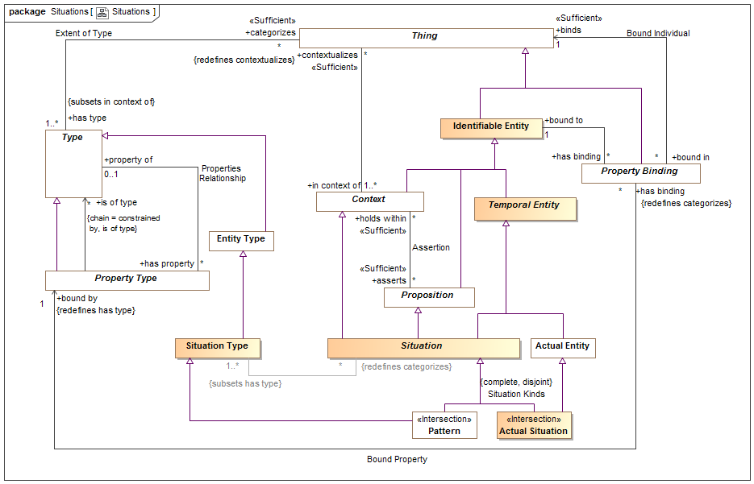

1. Situations

## Class Actual Situation

An actual situation is an individual situation that actually exists, happened in the past or may exist in some possible world, not a template or process definition. Such situations must exist for a time interval, however there are no constraints on such a time interval - from an instant to the life of the universe.  
  
DTV: Occurrence: state of affairs that is a happening in the universe of discourse

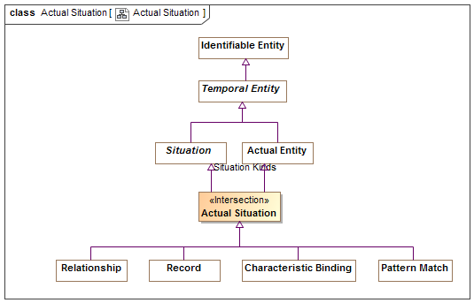

1. Actual Situation

### Direct Supertypes

Actual Entity, Situation

## Class Situation

A situation is an identifiable entity composed of an arrangement of entities and the relations between them over a time interval. Situations are propositions and may be asserted as true or false in some context. Situations may change over time, unless otherwise constrained. As an identifiable entity, situations may participate in relationships, thus situations are "first class" elements in SMIF.  
  
[SBVR] "State of affairs"  
[SOWA1999] Nexus

### Direct Supertypes

Context, Lexical Scope, Proposition, Temporal Entity

### Associations

: Situation Type [1..*] *Subsets*: has type:Type



matched by : Pattern Match [*]



Pattern matches that match the subject situation.

## Class Situation Type

A situation type defines a kind of identifiable arrangement of individuals, assertions and the relations between them over a timespan. As an identifiable entity, situations may participate in other situations and relationships by being bound to properties of those situations or relationships with bindings, thus situations are “first class” entities in a SMIF model.  
The roles or behaviors things (any entity or value) may play in a situation are identified as properties of the situation type.  
Entity types and roles may also be situation types.  
Syn. Type of a state of affairs.  
A situation type may have properties such that instances, may bind things to structures based on properties.  
Things may be bound to a structure (i.e. play a role in the structure) via properties. Things bound to properties of a structure may change over time, unless otherwise constrained.  
  
[DTV] situation kind: state of affairs that may or may not happen in some possible world

### Direct Supertypes

Entity Type

### Associations

: Situation [*] *Redefines*: categorizes:Thing



# SMIF Conceptual Model::Top level

The top level objects provide the foundation for all objects in a SMIF model

## Diagram: Top Level

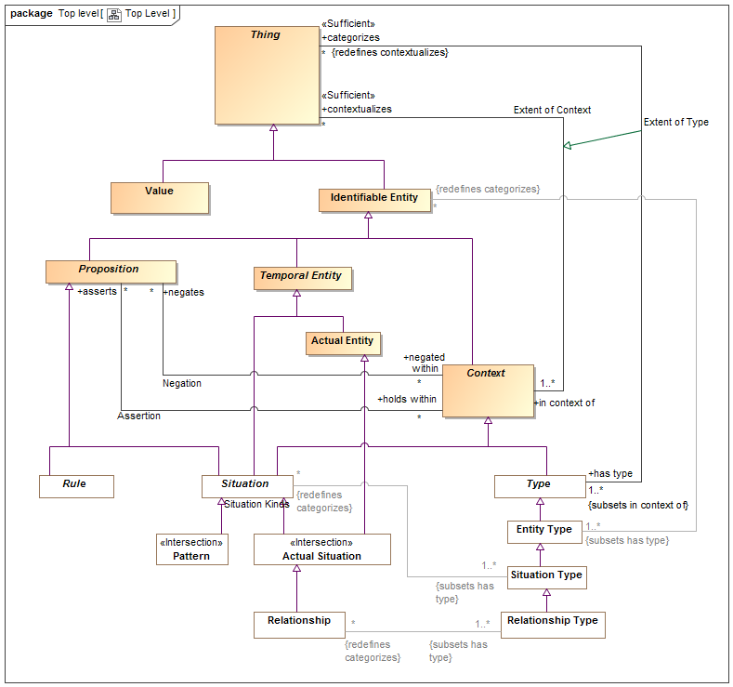

1. Top Level

Diagram showing summary of top level classes and significant subtypes.

## Class Actual Entity

An actual entity is an identifiable, temporal and individual person, specific object, process enactment, agreement, etc. Actual Entities do not have to be physical, e.i. may denote social constructs. Actual entities are disjoint from types.  
A more specific class of actual entity (e.g., Person) is intended to refine the classification of the individual thing.  
Individuality (or selfhood) is the state or quality of being an individual; particularly of being separate from other individuals and possessing identity. Actual entities typically have a lifetime and some individuals may change over that lifetime. Individuals may have parts that together help define the individual but may change over time.   
"Actual" does not imply current existence.  
  
[ISO 1087] individual concept: concept (3.2.1) which corresponds to only one object   
  
[UML] Loose correspondence with "InstanceSpecification". SMIF instances are direct instances of their types, there is no "indirection" through value specification as their is in UML.  
  
[Guizzardi] (individual concept)  
  
[CL] Individual: one element of the universe of discourse  
  
[DOLCE] Particular: particulars are entities which have no instances  
  
[SOWA1999] Independent. Can be considered "Actuality" when including social constructs in [SOWA1999] Physical.  
  
[OWL] Individual

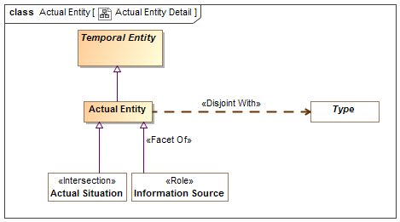

1. Actual Entity Detail

### Direct Supertypes

Temporal Entity

## Association Assertion

An assertion relationship between a context and the propositions asserted within that context. The <asserts> proposition is asserted (defined as "true") for all things contextualized by the <holds within> context. Assertion of truth is not absolute, it is relative to the context. For example, something could be asserted within a context where that entire context is asserted to be false.  
Assertion is transitive.  
[CL] Implication  
[OWL] Assertion; Any [OWL] Assertion included in a graph (All assertions in an OWL graph are asserted by the graph)

### Association Ends

asserts : Proposition [*] *Redefines*: categorizes: Thing



Proposition that is asserted (must be true) for anything contextualized by a context.  
As types are a context, types may assert a proposition for their instances.

holds within : Context [*] *Redefines*: categorizes: Thing



Context in which a proposition is asserted (required to be true). Anything contextualized by the context is subject to the proposition.

## Class Context

A <Context> is a grouping of <contextualizes> things that are related in some way.  
  
A <Context> also <asserts> propositions that hold for all things the context <contextualizes>, thus providing the link between an assertion and the set of things asserted. Likewise a context <negates> propositions that are false within the context.  
  
Subtypes of <Context>, such as <Type> ascribe more semantics to the context as well as the things it <contextualizes>.  
  
A context provides a binding between a set of propositions and the things those propositions apply to.  
  
[CL] Sort: any subset of the universe of discourse over which some quantifier is allowed to range  
  
[ISO 1087] concept field: unstructured set of thematically related concepts (3.2.1)  
  
[SOWA1999] Mediating

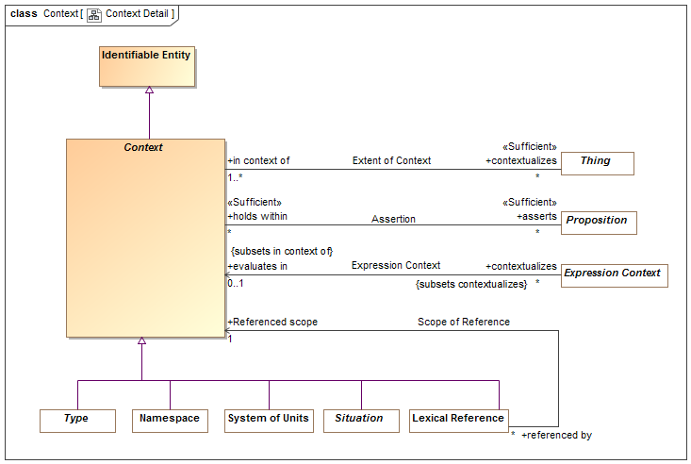

1. Context Detail

### Direct Supertypes

Identifiable Entity

### Associations

asserts : Proposition [*]



Proposition that is asserted (must be true) for anything contextualized by a context.  
As types are a context, types may assert a proposition for their instances.

contextualizes : Thing [*]



The set of things contextualized by a <Context>, or "in" the <Context> and therefor subject to the <asserts> propositions of the <Context>.

negates : Proposition [*]



Proposition that is negatively asserted (must be FALSE) for anything contextualized by a context.  
As types are a context, types may assert or negate a proposition for their instances.

## Association Extent of Context

The association between a context and the set of things contextualized by that context, defining the extent of the context, a set.  
  
[ISO 1087] extension: totality of objects (3.1.1) to which a concept (3.2.1)  
corresponds

### Association Ends

contextualizes : Thing [*]



The set of things contextualized by a <Context>, or "in" the <Context> and therefor subject to the <asserts> propositions of the <Context>.

in context of : Context [1..*]



A <Context> that contextualizes a thing making what it <contextualizes> subject to the propositions referenced by <has assertion> of the context.  
A thing may be <in context of> one or more context.  
[FIBO] hasContext

## Class Identifiable Entity

An identifiable entity is any identifiable thing other than values, this includes individuals, types, axioms, situations, speech acts, information structures, etc.  
Identifiable entities always have some kind of identity and may have identifiers. Note that identity is an abstraction that may have representation in models as any number of identifiers, also known as a "sign".  
  
[OWL] Entity type (Implied in section [OWL] 5.8) as an instance of rdfs:Class

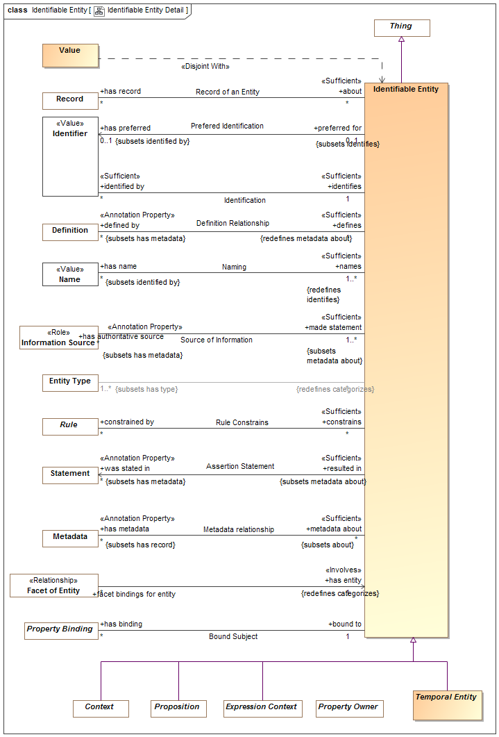

1. Identifiable Entity Detail

### Direct Supertypes

Thing

### Associations

was stated in : Statement [*] *Subsets*: has metadata:Metadata



Metadata representing the speech act, document or other record where a statement captured in a model was made.  
[OWL] rdfs:isDefinedBy

has preferred : Identifier [0..1] *Subsets*: identified by:Identifier



Default identifier to use for an entity.  
Where multiple identifiers are preferred in differing context any method for selecting the most preferred identifier is implementation specific and not specified by this standard.  
[FUML] NamedElement.name: Note: An Identifier that is <preferred for> an entity is equivalent to the name of a named element.

: Entity Type [1..*] *Subsets*: has type:Type



defined by : Definition [*] *Subsets*: has metadata:Metadata



An informal description of something.  
[FIBO] hasDefinition  
[UML] comment  
[FUML] ownedComment

identified by : Identifier [*]



An identifier for an <Entity>.  
[FIBO] hasDenotation

has metadata : Metadata [*] *Subsets*: has record:Record



Metadata associated with (data about the information concerning) the subject entity.  
[OWL] AnnotationProperty, annotationValue of Annotation Assertion

has name : Name [*] *Subsets*: identified by:Identifier



A human meaningful name for an entity.  
[FIBO] hasName: that by which some thing is known; may apply to anything  
  
[OWL] rdfs:label

has record : Record [*]



A record about something.

constrained by : Rule [*]



Rules applying to an entity.

has authoritative source : Information Source [*] *Subsets*: has metadata:Metadata



Metadata representing the authority behind a statement - who or what made a statement captured in a model.

has binding : Property Binding [*]



Bindings asserted for properties within a situation.

## Association Negation

An assertion relationship between a context and the propositions negated (FALSE) within that context. The <negates> proposition is asserted as FALSE for all things contextualized by the <negated within> context. Assertion or negation of truth is not absolute, it is relative to the context.   
[CL] Negation+Implication

### Association Ends

negates : Proposition [*]



Proposition that is negatively asserted (must be FALSE) for anything contextualized by a context.  
As types are a context, types may assert or negate a proposition for their instances.

negated within : Context [*]



Context in which a proposition is negated (required to be FALSE). Anything contextualized by the context is subject to the proposition.

## Class Proposition

A proposition is statement, or condition with a truth value (true or false) that can be determined or asserted with some level of confidence (assessment of confidence being outside of this specification).  
All "facts", statements, speech acts, relationships and rules are propositions.  
Propositions may be asserted to be true within a context which they <holds within>.  
For a situation, the proposition is true if the situation is actual (i.e., takes place, obtains).  
  
[SBVR] the state of affairs is posited by the proposition and if the state of affairs were actual, the proposition would be true  
[CL] Sentence: unit of logical text which is true or false, i.e. which is assigned a truth-value in an interpretation  
[SOWA1999] Proposition

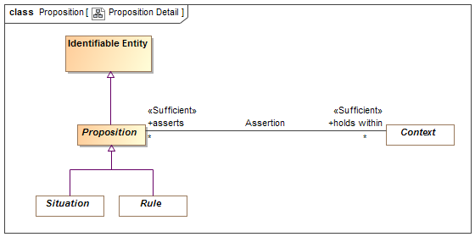

1. Proposition Detail

### Direct Supertypes

Identifiable Entity

### Associations

holds within : Context [*]



Context in which a proposition is asserted (required to be true). Anything contextualized by the context is subject to the proposition.

negated within : Context [*]



Context in which a proposition is negated (required to be FALSE). Anything contextualized by the context is subject to the proposition.

qualified within : Proposition Variable [0..1]



## Class Temporal Entity

A temporal is anything that has a timespan. Temporal things may have temporal relationships with other temporal things.  
  
Note that relationships defined for [DTV] Time Intervals may be specified for <temporal Entity> but are not specified in SMIF.   
  
[SOWA1999] Continuant

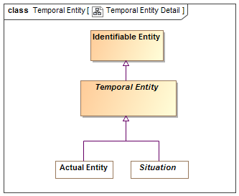

1. Temporal Entity Detail

### Direct Supertypes

Identifiable Entity

## Class Thing

Any thing or value that does or may exist in any possible world. Thing is the supertype of all types and may therefore participate in unbounded relations.  
Instances of Thing are referred to as "a thing" in this model.  
  
[IDEAS] Thing  
[OWL] Thing  
[ISO 1087] object: anything perceivable or conceivable  
[FIBO] Thing  
[Guizzardi] Thing  
[FUML] Element  
[SOWA1999] "T"  
[OWL] rdfs:Resource

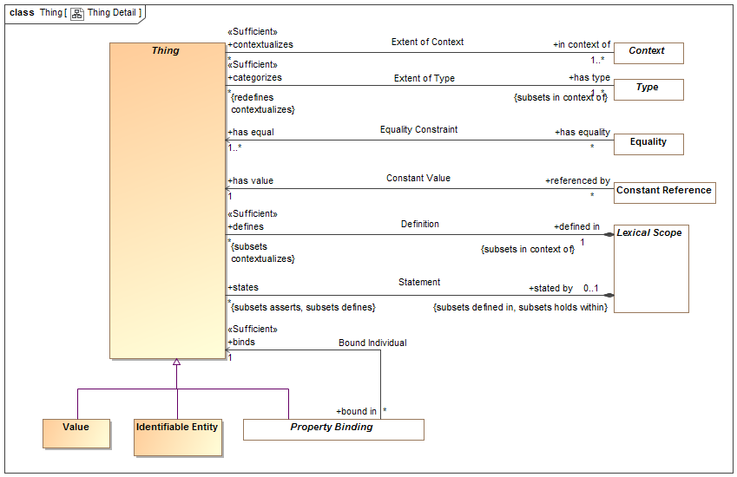

1. Thing Detail

### Associations

defined in : Lexical Scope [1] *Subsets*: in context of:Context



Lexical scope defining model elements.  
[UML]owner

in context of : Context [1..*]



A <Context> that contextualizes a thing making what it <contextualizes> subject to the propositions referenced by <has assertion> of the context.  
A thing may be <in context of> one or more context.  
[FIBO] hasContext

has type : Type [1..*] *Subsets*: in context of:Context



A type that holds for something.  
Things may have multiple types and these types may change over time.   
The <categorized> thing satisfies the constraints of the <has type> type.  
[FIBO] isClassifiedBy  
[OWL] rdf:type

stated by : Lexical Scope [0..1] *Subsets*: defined in:Lexical Scope holds within:Context



<stated by> is a lexical scope that both defines and asserts a model element.

# SMIF Conceptual Model::Types

Types provide for ways to categorize anything based on what it is, the roles it plays or the phases it may be in.  
Something may be categorized by any number of types (multiple classification assumption).

## Diagram: Type-instance

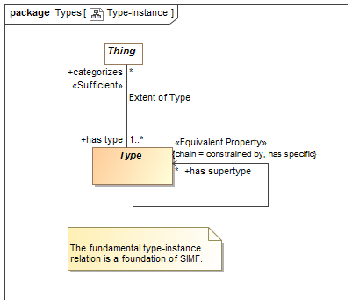

1. Type-instance

## Diagram: Types

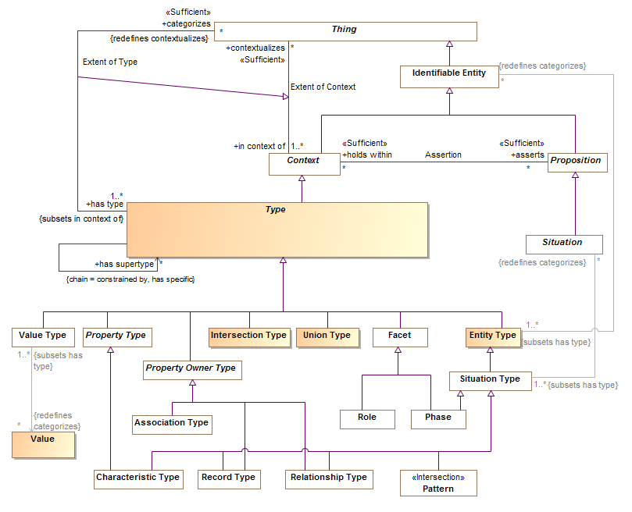

1. Types

## Class Entity Type

A type of an identifiable entity. All concrete entity instances must have at least one entity type. Entity type may be mixed with other types to fully define an entity.  
  
[FUML] Classifier  
  
[Guarino1994] Substantial or Pseudo-Sortal (Substantial being concrete)  
[Guizzardi] A Rigid Universal.  
(Rigid Universal): A universal G is rigid (or modally constant) iff for any w,w ∈ W 3. extw(G) = extw(G) Putting definitions 4.1 and 4.3 together, we have that for any rigid universal G the following is true 4. ext(G) = extw(G), for all w ∈ W A rigid universal is one that applies to its instances necessarily, i.e., in every possible world. Every substance sortal G is a rigid universal.   
[OWL] rdfs:Class (as Entity Type does not include values). However, non=primitive values are typically represented as rdfs:Class

### Direct Supertypes

Type

### Associations

: Identifiable Entity [*] *Redefines*: categorizes:Thing



## Association Extent of Type

The relation between a type and the things that type categorizes, the instances which defines the extent of the type, a set.  
  
[IDEAS] typeInstance: A couple that asserts that a Thing is a member of a Type.  
  
[Guizzardi] (Extension functions): Let W be a non-empty set of  
possible worlds and let w ∈ W be a specific world. The extension function extw(G) maps a universal G to the set of its instances in world w. The extension function ext(G) provides a mapping to the set of instances of the  
universal G that exist in all possible worlds, such that ext(G) = U w∈W w ext (G)  
  
[OWL] ClassAssertion

### Direct Supertypes

Extent of Context

### Association Ends

categorizes : Thing [*] *Redefines*: categorizes: Thing



The set of things described by a type, the "extent" of the type.  
The thing a type <categorizes> is subject to the <has assertion> propositions of the type.  
[FIBO] classifies

has type : Type [1..*] *Redefines*: categorizes: Thing



A type that holds for something.  
Things may have multiple types and these types may change over time.   
The <categorized> thing satisfies the constraints of the <has type> type.  
[FIBO] isClassifiedBy  
[OWL] rdf:type

## Class Intersection Type

An intersection is a type that has an extent which is the complete intersection of the extents of all supertypes. Intersection is a stronger statement than a subtype as a subtype may not be a complete intersection.  
  
[MathWorld] The intersection of two sets A and B is the set of elements common to A and B. This is written A intersection B, and is pronounced "A intersection B" or "A cap B."

### Direct Supertypes

Type

## Class Type

A <Type> is a categorization of any thing based on specific criteria. The specific criteria may or may not be formalized in a model.  
A <Type> <categorizes> a set of <Thing>s which comprises the "extent" of the type.  
A <Type> is a <Context> where the things it <categorizes> are <in the context> of the <Type>.  
  
[IDEAS] Type: A set (or class) of Things.   
[ISO 1087] general concept: concept (3.2.1) which corresponds to two or more objects (3.1.1) which form a group by reason of common properties  
[FIBO] Classifier: a standardized classification or delineation for something, per some scheme for such delineation, within a specified context  
[FUML] Type  
[CL] Type:: logical framework in which expressions in the logic are classified into syntactic or lexical categories (types) and restricted to apply only to arguments of a fixed type  
[Guarino1994] Discriminating Predicate  
[OWL] Union(rdfs:Class, rdfs:Datatype)

### Direct Supertypes

Context, Lexical Scope

### Associations

has supertype : Identifiable Entity [*] *Redefines*: categorizes:Thing



Supertypes(s) of a type as defined by generalization rules.  
  
All statements made about the supertype are true for the subtype. The extent (categorizes) of the subtype is a subset of the extent of the supertype.  
  
Has supertype is a a derived association based on generalization rules.

categorizes : Thing [*] *Redefines*: contextualizes:Expression Context



The set of things described by a type, the "extent" of the type.  
The thing a type <categorizes> is subject to the <has assertion> propositions of the type.  
[FIBO] classifies

has property : Property Type [*]



A property of a structured type such that there may be bindings of a thing to instances of the structured type with reference to the property which defines the semantics of the bound thing withing the context of the structure.  
[FUML] feature  
[UML] memberEnd. attribute (of classifier).

asserts pattern : Pattern of Type [0..*] *Subsets*: asserts:Proposition



A pattern asserted for all instances of a type. Where the pattern includes parts, the type defines a composition.

has covering : Covering Constraint [*]



Covering constraints of a type.

has specialization : Generalization Constraint [*]



Specialization rules for a type.

has multiplicity : Multiplicity Constraint [*] *Subsets*: constrained by:Rule



Multiplicity constraint of a type or property.

properties of type : Property Type Constraint [*]



Properties typed by a type

recording types : Record Type [*]



Record for a thing.

has generalization : Generalization Constraint [*] *Subsets*: constrained by:Rule



Generalization rules for a type

## Class Union Type

A Union is a type that has an extent which is the complete union of the extents of all types that specialize the Union.   
  
[FIBO] Logical Unions  
  
[MathWorld] Given two sets A and B, the union is the set that contains elements or objects that belong to either A or to B or to both. We write A È B   
  
[OWL] ObjectUnionOf( ObjectUnionOf, DataUnionOf)

### Direct Supertypes

Type

# SMIF Conceptual Model::Values

The values package defines the concepts of values and quantities expressed in units.

Values may be differentiated from entities in that values have no independent lifetime or "identity" other than the value its self. E.g. the number 5 "just is" and can't be changed. Properties and relations referencing values can, of course, change but the values are constant.

The failure to properly express units in data models often results in errors, inefficiencies and risk. Translation and federations between models, schema and data sources that is not cognizant of the units used would be even more error prone and risky. For example, what does “Speed limit 50” mean? For these reasons the SMIF language provides specific support for specifying quantity kinds and unit types in conceptual, logical and physical models. The SMIF mapping rules may then perform the appropriate unit conversions.

The foundation of information specification in SMIF at all levels is the type system. Types specified for all properties and relations involving values must match the types of the related values. The concepts of units and values as defined in "VIM" [JCGM 200-2008] is used as the basis for defining the types used in SMIF to guarantee type safety of quantities across different representations. Since many existing models and schema do not include well defined units some effort may be required to find and then specify the implicit units based on documentation, SME interviews or inspection of data or source code. It is recommended that the units used by external models and schema be determined prior to attempting federation and integration of information based on those models or schema.

**VIM [JCGM 200-2008] concepts of quantities and units**

VIM defines

* quantity: property of a phenomenon, body, or substance, where the property has a magnitude that can be expressed as a number and a reference [ed. to a unit]
* kind of quantity (kind): aspect common to mutually comparable quantities
* measurement unit (unit): real scalar quantity, defined and adopted by convention, with which any other quantity of the same kind can be compared to express the ratio of the two quantities as a number

**SMIF concepts of quantities and units**

SMIF uses the VIM concepts to define "quantity values" and types to capture the quantity kind and unit. Types are defined for each Unit. The goals for this type based approach are:

* That it is clearly grounded in semantics as defined in VIM
* That a type may be used to specify the range of a property or relation involving unit based values.
* That a quantity value (e.g. 5 grams) be representable as a simple number with a type.
* That there is a clear type hierarchy starting with a representationally independent type in a conceptual model (e.g. mass) that can be further specialized to a specific unit in a logical model (e.g. grams) and further specialized to be represented by a physical data type (e.g. “double”).
* That external models and schema may have unit specifications asserted without changing the schema.
* That a quantity of an entity be able to be referenced without a specific quantity value being known (e.g. John’s weight).
* That systems of units such as [ISO-80000] or [OMG QUDV] (A part of SysML) be able to be directly referenced as the definition of a unit.

SMIF defines three types to realize the above goals: Quantity Kind, Unit Type, Base Unit Type. SMIF also defines Quantity Values, which are instances of unit types.

In VIM a quantity has a magnitude that is expressed as a number and a reference. The SMIF quantity value is the numeric value of such a quantity where the reference is specified by the “unit reference” property of the quantity value’s type. The quantity value’s type is a “Unit Type”. The Unit type has attributes for converting a unit to a base unit, a symbol and a unit reference. Based on VIM the unit reference may be “a measurement unit, a measurement procedure, a reference material, or a combination of such” and is specified with a description that contains reference information. In summary, the reference of a SMIF quantity value is determined indirectly through its unit type. A quantity value has exactly one unit type and exactly one Quantity Kind. A quantity value expressed in any unit of the same quantity kind may be converted to any other unit of the same quantity kind.

This type-based sapproach allows specification of a property at the conceptual (quantity kind) logical (unit type) or physical (unit type with a numeric type) levels. Such specifications use the same type-based approach used for other aspects of the models. Given this information a SMIF implementation may correctly and reliably convert between compatible types regardless of representation. Please see the specification of the value types, attributes and relationships for more detail.

**Example:**

* A specification for a road segment has a property “Speed limit”.
* The type of this property in a reference conceptual model is “Speed:Quantity Kind”.
* A unit “Kilometer per Hour:Unit Type” is defined as a subtype of “Speed:Quantity Kind” with a “unit reference” of “[ISO-80000.4] Kilometer per Hour”. Note that quantity kinds and unit types would normally be defined in reference models that correspond to a “system of units”.
* Miles per hour is also defined as a subtype of Speed.
* A physical schema defines “Speed-KPH: Integer”.
* A SMIF mapping rule maps “Speed limit” to “Speed-KPH” and asserts a type of “Kilometer per Hour” on the “Speed-KPH” end.
* A data file defines a road “Route One” with a speed limit of 100:KPH-Int.
* When converted to a U.S. application this speed limit of route one can be viewed as 62:MPH-Int.

## Diagram: Values

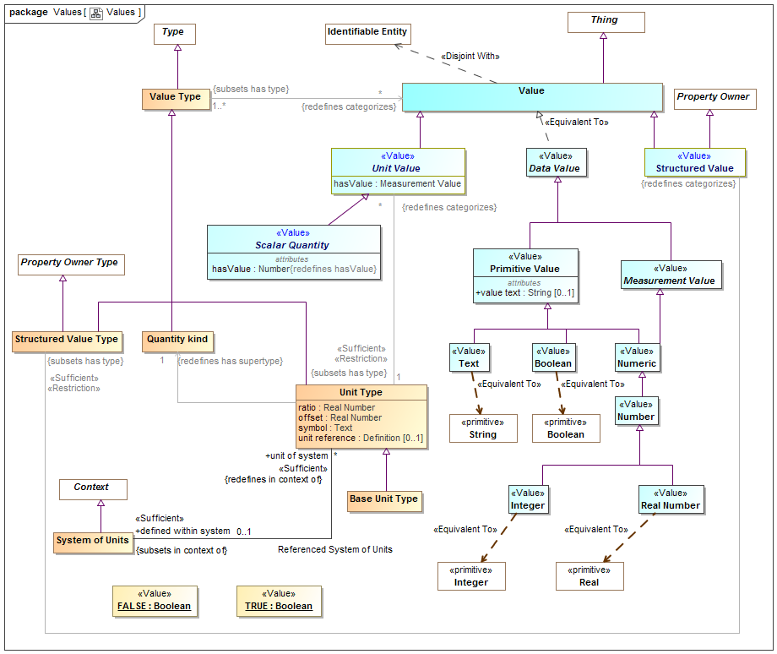

1. Values

## Class Base Unit Type

One unit type of a quantity kind may be marked as the base unit within a system of units. The base unit provides the basis for conversions between units of the same quantity kind. The base unit always has a ratio of one and an offset of zero.  
  
Type of a [JCGM 200:2008] measurement unit that is adopted by convention for a base quantity   
  
[FIBO] (type of) Base Unit: a measurement unit that is defined by a system of units to be the reference measurement unit for a base quantity  
  
There ma be at most one base unit for a quantity kind within a system of units.

### Direct Supertypes

Unit Type

## Class Quantity kind

[JCGM 200:2008] A Quantity Kind is an aspect common to mutually comparable quantities represented by one or more units. Units with a common quantity kind may be algorithmically converted to any other unit of that quantity kind. e.g. temperature.  
  
Quantity kinds are a supertype of unit types which are then a type of all quantity values, Quantity values are mutually comparable with all other quantity values categorized by the same quantity kind.  
  
[FIBO] QuantityKind: a categorization type for “quantity” that characterizes quantities as being mutually comparable  
  
[DOLCE] Quality Space

### Direct Supertypes

Value Type

## Association Referenced System of Units

Relationship between a system of units and the set of unit types defined within that system.

### Direct Supertypes

Extent of Context

### Association Ends

defined within system : System of Units [0..1] *Subsets*: constrained by:Rule



The system of units in which a unit is defined and is the basis for ratio and offset.  
  
By default the system of units is "si": http://www.iso.org/iso/iso_catalogue/catalogue_ics/catalogue_detail_ics.htm?csnumber=30669

unit of system : Unit Type [*] *Subsets*: constrained by:Rule



Unit type defined within a system of units

## Class Scalar Quantity

### Direct Supertypes

Unit Value

### Attributes

hasValue : Number



The value of a quantity that, when multiplied by the unit defined in a subtype of quantity kind, specifies a measurement value such as 3 Meters.

## Class Structured Value

A value that may have sub-elements (owned properties) defined as "structure property type".

### Direct Supertypes

Property Owner, Value

### Associations

: Structured Value Type *Subsets*: has type:Type



## Class Structured Value Type

A structured value type is a type of value that has parts represented as properties - also used for "data types" and forms.

### Direct Supertypes

Property Owner Type, Value Type

### Associations

: Structured Value *Redefines*: categorizes:Thing



## Class System of Units

[JCGM 200:2008] A set of base units and derived units, together with their multiples and submultiples, defined in accordance with given rules, for a given system of quantities.  
  
[FIBO] SystemOfUnits: a set of measurement units associated with a system of quantities, together with a set of rules that assign one measurement unit to be the base unit for each base quantity in the system of quantities and a set of rules for the derivation of other units from the base units

### Direct Supertypes

Context

### Associations

unit of system : Unit Type [*] *Redefines*: in context of:Context



Unit type defined within a system of units

## Class Unit Type

A Unit type is a type of a quantity value referencing a specific unit. A Unit Type a required type of a property representing a quantity.   
  
Each quantity value has a reference as defined by the "unit reference" property of the quantity value's type.  
  
[JCGM 200:2008] A Unit is a real scalar quantity, defined and adopted by convention, with which any other quantity of the same quantity kind can be compared to express the ratio of the two quantities as a number. e.g. Degrees Centigrade, Miles.  
  
Each unit type represents refinement of a quantity kind using generalization and is thus substitutable for that quantity kind. Typically quantity kinds are used in conceptual models and unit types in physical or logical models.  
  
Unit types may only subtype quantity kinds or other units.  
  
Note that unit types are not units, but the type of quantity values expressed in a common unit as defined in [JCGM 200:2008].  
  
[IDEAS] MeasureCategory: A MeasureType whose members are recognized types of MeasureInstance.

### Direct Supertypes

Value Type

### Attributes

ratio : Real Number



The multiplier by which to multiple the referenced unit to convert to the base unit within a system of units.

offset : Real Number



The difference between zero in the referenced unit and zero in the base unit after the ratio is applied within a system of units.

symbol : Text



The accepted symbol for the unit referenced by the unit type

unit reference : Definition [0..1]



The unit reference is the reference to a unit shared by all quantities values that are instances of a unit type.  
  
[JCGM 200:2008] A reference can be a measurement unit, a measurement procedure, a reference material, or a combination of such. For magnitude of a quantity.  
  
Typical references include ISO 8000 and OMG QUDV.

### Associations

: Quantity kind [1] *Redefines*: has supertype:Type



: Unit Value [*] *Redefines*: categorizes:Thing



defined within system : System of Units [0..1] *Subsets*: in context of:Context



The system of units in which a unit is defined and is the basis for ratio and offset.  
  
By default the system of units is "si": http://www.iso.org/iso/iso_catalogue/catalogue_ics/catalogue_detail_ics.htm?csnumber=30669

## Class Unit Value

A unit value is a numeric magnitude with a unit type that may be used as the value of a quantity property as defined by [JCGM 200:2008]. The reference of the quantity is defined by the "unit reference" property of the Unit Type.  
  
e.g. 5cm is an instance of the unit type "Centimeter"  
  
Each unit value has exactly one UNit Type as a type.  
  
In a physical model a quantity value must have a type that specifies its unit (e.g. "Gram"). The magnitude shall be expressed using "hasValue"  
  
[JCGM 200:2008] A quantity is a property of a phenomenon, body, or substance, where the property has a magnitude that can be expressed as a number and a reference.   
  
Note: A quantity as defined here is a scalar. However, a vector or a tensor, the components of which are quantities, is also considered to be a quantity.  
  
[IDEAS] ScaleMapping: A CoupleType whose members are all the couples linking MeasurePoints to RealNumbers. The CoupleType (i.e. the set of couples) represents the scale.  
  
  
  
[FIBO] QuantityValue: number and measurement unit together giving magnitude of a quan-tity  
  
[Guizzardi] (quale): A point in a n-dimensional quality domain

### Direct Supertypes

Value

### Attributes

hasValue : Measurement Value



The value of a quantity that, when multiplied by the unit defined in a subtype of quantity kind, specifies a measurement value such as 3 Meters.  
[OWL] rdf:value restricted to abstract quantity

### Associations

: Unit Type [1] *Subsets*: has type:Type



## Class Value

A Value is an atomic. immutable piece of information without a specific lifetime or identity independent of the value. Values include numbers, strings and other atomic "primitive" data. Values also include structured values, which are immutable.  
  
In UML values may be defined by the name of an instance specification with a value type.  
  
[IDEAS] Representation: A SignType where all the individual Signs are intended to signify the same Thing.  
  
[ISO11404] The identification of members of a datatype family, subtypes of a datatype, and the resulting datatypes of datatype generators may require the syntactic designation of specific values of a datatype.  
  
[OWL] data values

### Direct Supertypes

Thing

## Class Value Type

A type categorizing values where a value is an atomic piece of information without a specific lifetime or identity independent of that value. Values include numbers, strings and other atomic "primitive" data.  
  
[IDEAS] RepresentationType: A Type that is the Powertype of Representation.  
  
[FUML] DataType  
  
[ISO11404] datatype: set of distinct values, characterized by properties of those values, and by operations on those values  
  
[OWL] rdfs:Datatype (Note that some values are represented as OWL classes)

### Direct Supertypes

Type

### Associations

: Value [*] *Redefines*: categorizes:Thing



# Primitive Type

## Boolean

A value that may be true or false.  
  
[FIBO] boolean  
[ISO11404] Description: boolean is the mathematical datatype associated with two-valued logic.  
[OWL] xsd:boolean

## Integer

A number with no fraction.  
  
[IDEAS] Integer: A RationalNumber that can be written without a fractional or decimal component.   
  
[FIBO] integer  
  
[ISO11404] Integer: he mathematical datatype comprising the exact integral values.  
  
[OWL] xsd:integer

## Number

An arithmetical value representing a particular quantity and used in counting and making calculations and for showing order in a series or for identification.  
  
[IDEAS] A Type that is a number - i.e. a RealNumber or an Integer  
  
[FIBO] number  
[NIEM] NumericType

## Real Number

Any number that may have a fraction.  
  
[IDEAS] RealNumber: A Type that is a Dedekind cut of the set of rational numbers.  
  
[ISO11404] real is a family of datatypes which are computational approximations to the mathematical datatype comprising the “real numbers”. Specifically, each real datatype designates a collection of mathematical real values  
  
[OWL] xsd:real

## Text

Text is a <Value> represented using symbols which have a meaning to stakeholders but otherwise have no formal semantic implication. Properties involving values may have a semantic implication.  
  
[FIBO] Text  
[NIEM] TextType  
[OWL] xsd:string

# Data Type

## Data Value

Data value is equivalent with value and only required due to UML restriction that there can be no supertype of a data type and a class.

## Measurement Value

The value of a measure - e.g. 5 MM. Measurement values may be scalar or non-scalar. Scalar measurements will be numeric.

## Numeric

The concept of a numeric value or set of numeric values that may be expressed in any way. This includes "structures" for representing non-scalar values.  
[ISO11404] numeric: A datatype is said to be numeric if its values are conceptually quantities (in some mathematical number system).

## Primitive Value

A simple value with no parts that can be represented as a string.  
[FUML] PrimitiveType  
[ISO11404] primitive datatypes, which are defined axiomatically without reference to other datatypes  
[OWL] rdfs:Literal

# Tree

## Class Hierarchy

## Enumeration Hierarchy