# US primaries as validation test case for the SIMF conceptual modeling language

Sjir Nijssen

Version 2016-Feb-22-19:35 (CET)

A Conceptual Modeling Language needs many, many test cases. Here is one of them.

**The context is US presidential primaries.**

Additional information added to the previous version based on

<https://en.wikipedia.org/wiki/Republican_Party_presidential_primaries,_2016>

and:

<http://elections.virginia.gov/candidatepac-info/presidential-primary-filing/index.html>

The US presidential primaries is a rule based system by which each state and territory can contribute to the nomination by a party of the party candidate for the presidential election. There are three forms of executing this by state, a primary, a caucus and a combination. A party is responsible for the caucus in a state and the state is responsible for a primary. Delegates can be won in a primary or caucus and these delegates are supposed to vote in the national convention that aims to select the candidate for the party.

The US primaries is for many people an interesting phenomenon. People may be interested to derive from the historical facts about primaries such rules as: “No Republican candidate has ever won New Hampshire and South Carolina and lost the nomination.” Source: The Week, February 26, 2016

From the extended presidential primaries data base with facts many more rules can be derived.

This case has been developed for the purpose of the SIMF Meta Model validation work.

We describe hereafter some examples of facts and rules that together dictate how the SIMF Domain Model should look. This domain model is used as a validation exercise for the SIMF Meta Model.

**Primary schedule**

The primaries are held in a presidential election year during the period February-June. A schedule is published at a certain date, projecting the dates of the primaries by state and party.

Part of such a schedule for 2016 is the following:

Information as of January 4, 2016.

|  |  |  |  |
| --- | --- | --- | --- |
| Date | State | Party | Kind-of-Election |
| 2016-Feb-1 | Iowa | Democrat | Caucus |
|  |  | Republican | Caucus |
| 2016-Feb-9 | New Hampshire | Democrat | Primary |
|  |  | Republican | Primary |
|  |  |  |  |
| 2016-Feb-20 | Nevada | Democrat | Caucus |
|  | South Carolina | Republican | Primary |
| 2016-Feb-23 | Nevada | Republican | Caucus |
| 2016-Feb-27 | South Carolina | Democrat | Primary |

An easy to understand verbalization is as follows:

On 2016-Feb-20 the primary is scheduled for Nevada for the Democratic party that is of kind Caucus.

“ 2016-Feb-20 “ “ “ “ “ South Carolina “ “ Republican “ “ “ “ “ Primary.

“ 2016-Feb-23 “ “ “ “ “ Nevada “ “ Republican “ “ “ “ “ Caucus.

“ 2016-Feb-27 “ “ “ “ “ South Carolina “ “ Democratic “ “ “ “ “ Primary.

Some people in our community are interested in the schedule, some are also interested in the results of the primary.

To describe some integrity rules we need to add that Date covers the following three variables: Year, Month, Day.

We can now give the following two rules:

1. The variable Date is dependent on the combination of State and Party.
2. The variable Kind-of-Election is dependent on the combination of Year and Party.
3. Kind-of-Election is either Primary, Caucus or Both.

Now that we know the some semantics explicitly, we can use that knowledge in our business communication and communicate more semantics. First we represent the information in a different way.

Information as of January 4, 2016.

|  |  |  |  |  |  |
| --- | --- | --- | --- | --- | --- |
| Year | Month | Day | State | Party | Kind-of-Election |
| 2016 | Feb | 1 | Iowa | Democrat | Caucus |
|  |  |  |  | Republican | Caucus |
|  |  | 9 | New Hampshire | Democrat | Primary |
|  |  |  |  | Republican | Primary |
|  |  |  |  |  |  |
|  |  | 20 | Nevada | Democrat | Caucus |
|  |  |  | South Carolina | Republican | Primary |
|  |  | 23 | Nevada | Republican | Caucus |
|  |  | 27 | South Carolina | Democrat | Primary |

The democratic party has decided to hold its primary in Nevada on 2016-Feb-1.

“ republican “ “ “ “ “ “ “ “ Nevada “ 2016-Feb-23.

“ republican “ “ “ “ “ “ “ “ Source Carolina “ 2016-Feb-27.

The 2016 presidential primary in Nevada is a Caucus.

“ 2016 “ “ “ South Carolina “ “ Primary.

Here we see that the Primary schedule holds two elementary facts that are combined in a reasonably complex fact.

**Presidential primary election results**

|  |  |  |  |  |  |  |
| --- | --- | --- | --- | --- | --- | --- |
| Year | State | Party | Candidate | Percentage | Delegates | Kind-of-Election |
| 2008 | Iowa | Democrat | Barack Obama | 37,6 |  | C |
|  |  |  | Hillary Clinton | 29,5 |  | C |
|  |  | Republican | Mike Huckabee | 34,4 |  | C |
|  |  |  |  |  |  |  |
|  | New Hampshire | Democrat | Hillary Clinton | 39 |  | P |
|  |  |  | Barack Obama | 36 |  | P |
|  |  | Republican | John McCain | 37 |  | P |
|  |  |  | Mitt Romney | 32 |  | P |
| 2016 | Iowa | Democrat | Hillary Clinton | 49,9 | 25 | C |
|  |  |  | Bernie Sanders | 49,6 | 23 | C |
|  |  | Republican | Ted Cruz | 27,6 | 8 | C |
|  |  |  | Donald Trump | 24,3 | 7 | C |
|  |  |  | John Kasich | 1,9 | 1 | C |
|  |  |  |  |  |  |  |
|  | New Hampshire | Democrat | Bernie Saunders | 60,4 |  |  |
|  |  |  | Hillary Clinton | 38,0 |  |  |
|  |  | Republican | Donald Trump | 35 |  |  |
|  |  |  | John Kasich | 16 |  |  |
|  |  |  | Ted Cruz | 12 |  |  |
|  |  |  |  |  |  |  |
|  | South Carolina | Republican | Donald Trump | 32,5 |  | P |
|  |  |  | Marco Rubio | 22,5 |  | P |
|  |  |  | Ted Cruz | 22,3 |  | P |
|  |  |  |  |  |  |  |
|  | Nevada | Democratic | Hillary Clinton | 52.7 |  | C |
|  |  |  | Bernie Sanders | 47,2 |  | C |

As additional rules are given: Year, State, Party and Candidate are independent variables; Percentage is the dependent variable in this function and is mandatory.

Delegates is a dependent variable, dependent on the first four variables and is optional.

Primary-Caucus-Both is a dependent variable, dependent on the first four variables and is optional.

Test for the SIMF Meta Model: The SIMF Conceptual Domain Model that can be specified based on the information given on this page, should be a valid instantiation of the SIMF Meta Model.

Some people are besides the previous two kinds of facts interested in facts about the primary delegate count so far obtained by the candidates.

**Primary delegate count**

Information as of 2016-Feb-22

|  |  |  |
| --- | --- | --- |
| Party | Candidate | Delegates so far |
| Democratic | Hillary Clinton | 51 |
|  | Bernie Sanders | 51 |
| Republican | Donald Trump | 61 |
|  | Ted Cruz | 11 |
|  | Marco Rubio | 10 |

As of 2016-Feb-22 Hillary Clinton has collected 51 delegates.

“ “ 2016-Feb-22 Donald Trump has collected 61 delegates.

In 2016 Hillary Clinton is a candidate for the democratic party.

“ 2016 Donald Trump “ “ “ “ “ republican party.

Conceptual model as SIMF instances

NOTE: None of the following is suggested as a notation, this is just how it comes out in UML.

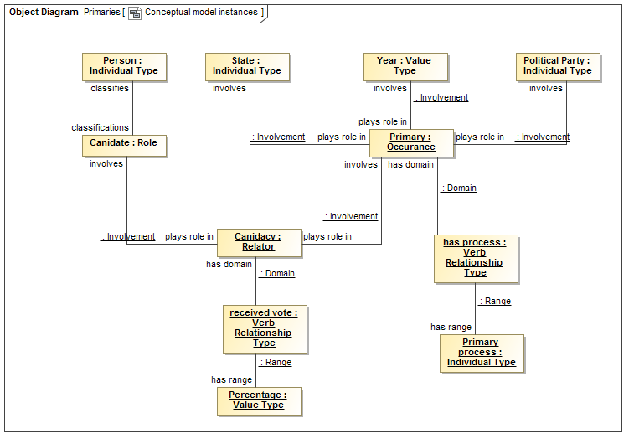

Constraints as stated

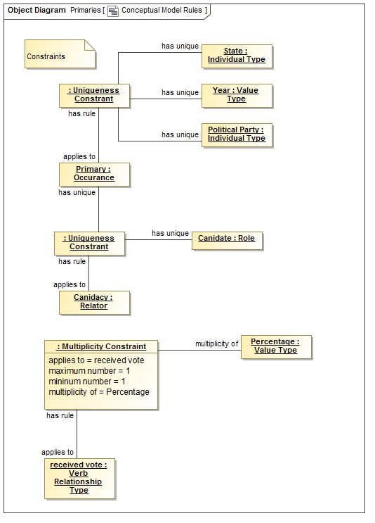

Sjir: I believe the SIMF Meta Model can’t represent the situation that a fact type is elementary and has more than one uniqueness integrity rule. Think of a class in UML that has an attribute in a position. Class and attribute are independent variables that determine the dependent variable position; class and position are independent variables that determine the dependent variable attribute.

So my assertion is that the current Meta Model of SIMF does not provide this functionality.

Some common values

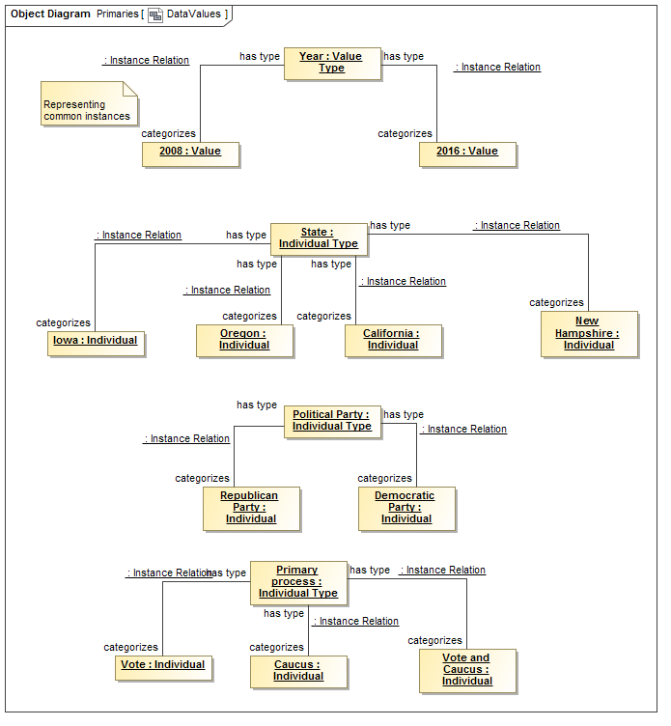

People of interest



The 2008 Iowa primaries

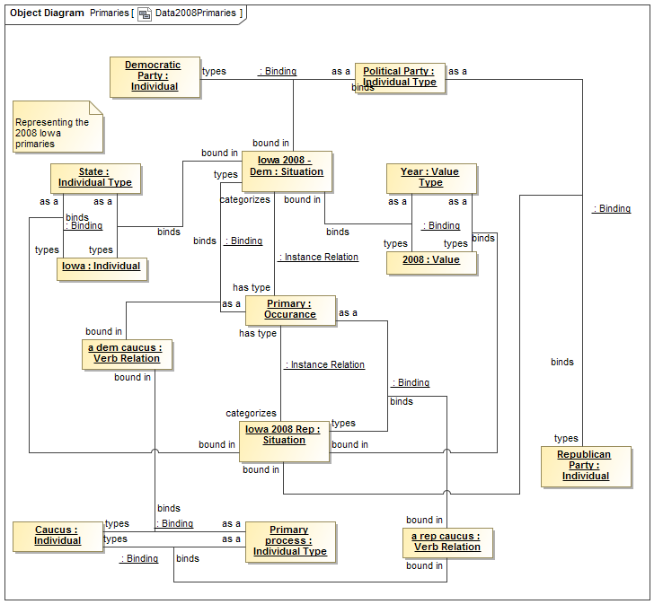

Obama candidacy and results in 2008 Iowa

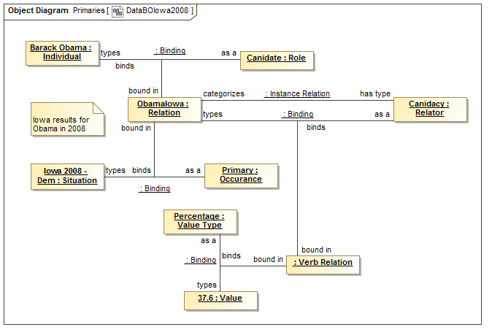

In more than one co-creation in Europe we have come to the conclusion that the most effective way to validate a Domain model (M1) is to use a representative set of examples (M0) in a multidisciplinary group. I think the format used above would make little chance of getting accepted as a presentation in a multidisciplinary group.

Hillary’s candidacy and results in 2008

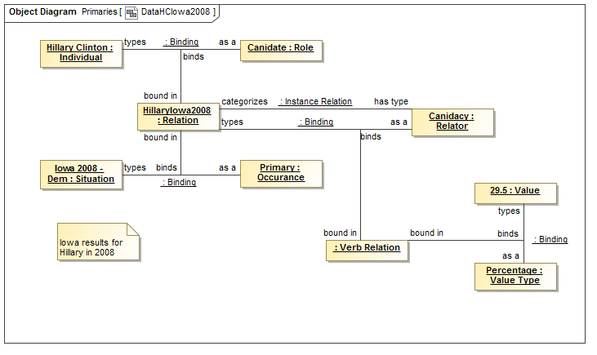

The 2016 New Hampshire Primary and Hillary’s result

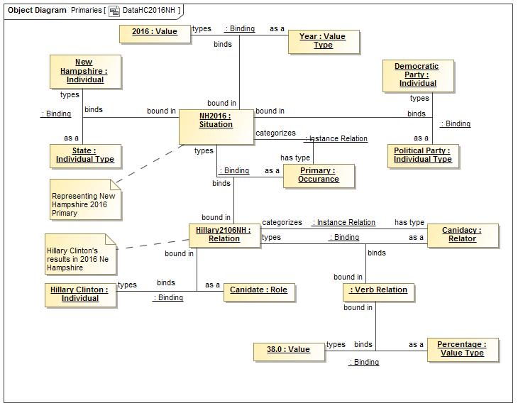

Cory,

One of my major problems with the current SIMF Meta Model is that it does not have both a role, a variable and a way to specify which variables make up a role. That means that an automatic transformation from a SIMF domain model to its RDF representation or a UML representation is not possible.