# US primaries as validation test case for the SIMF conceptual modeling language

Sjir Nijssen

Version 2016-Feb-21-09:30 (CET)

A Conceptual Modeling Language needs many, many test cases. Here is one of them.

**The context is US primaries.**

Additional information added based on

<https://en.wikipedia.org/wiki/Republican_Party_presidential_primaries,_2016>

and:

<http://elections.virginia.gov/candidatepac-info/presidential-primary-filing/index.html>

|  |  |  |  |  |  |  |
| --- | --- | --- | --- | --- | --- | --- |
| Year | State | Party | Candidate | Percentage | Delegates | Primary-  Caucus-  Both |
| 2008 | Iowa | Democrat | Barack Obama | 37,6 |  | C |
|  |  |  | Hillary Clinton | 29,5 |  | C |
|  |  | Republican | Mike Huckabee | 34,4 |  | C |
|  |  |  |  |  |  |  |
|  | New Hampshire | Democrat | Hillary Clinton | 39 |  | P |
|  |  |  | Barack Obama | 36 |  | P |
|  |  | Republican | John McCain | 37 |  | P |
|  |  |  | Mitt Romney | 32 |  | P |
| 2016 | Iowa | Democrat | Hillary Clinton | 49,9 | 25 | C |
|  |  |  | Bernie Sanders | 49,6 | 23 | C |
|  |  | Republican | Ted Cruz | 27,6 | 8 | C |
|  |  |  | Donald Trump | 24,3 | 7 | C |
|  |  |  | John Kasich | 1,9 | 1 | C |
|  |  |  |  |  |  |  |
|  | New Hampshire | Democrat | Bernie Saunders | 60,4 |  |  |
|  |  |  | Hillary Clinton | 38,0 |  |  |
|  |  | Republican | Donald Trump | 35 |  |  |
|  |  |  | John Kasich | 16 |  |  |
|  |  |  | Ted Cruz | 12 |  |  |
|  |  |  |  |  |  |  |
|  | South Carolina | Republican | Donald Trump | 32,5 |  | P |
|  |  |  | Marco Rubio | 22,5 |  | P |
|  |  |  | Ted Cruz | 22,3 |  | P |
|  |  |  |  |  |  |  |
|  | Nevada | Democratic | Hillary Clinton | 52.7 |  | C |
|  |  |  | Bernie Sanders | 47,2 |  | C |
|  | Oregon | Republican | ? | ? | ? | P |
|  |  | Democratic | ? | ? | ? | P |
|  | California | Republican | ? | ? | ? | P |
|  |  | Democratic | ? | ? | ? | P |

As additional rules are given: Year, State, Party and Candidate are independent variables; Percentage is the dependent variable in this function and is mandatory.

Delegates is a dependent variable, dependent on the first four variables and is optional.

Primary-Caucus-Both is a dependent variable, dependent on the first four variables and is optional.

Test for the SIMF Meta Model: The SIMF Conceptual Domain Model that can be specified based on the information given on this page, should be a valid instantiation of the SIMF Meta Model.

Conceptual model as SIMF instances

NOTE: None of the following is suggested as a notation, this is just how it comes out in UML.

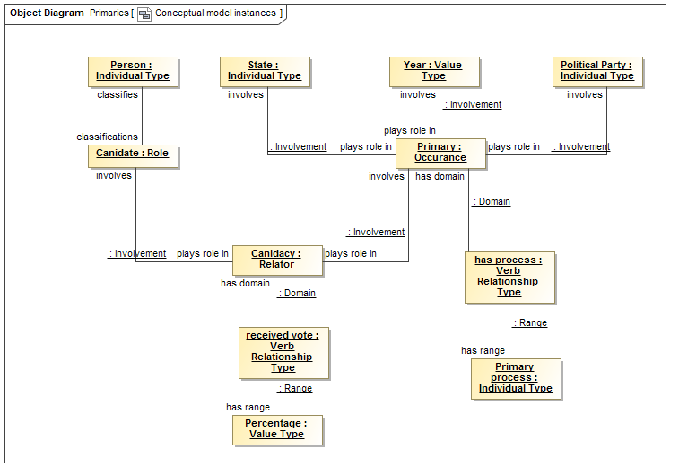

Constraints as stated

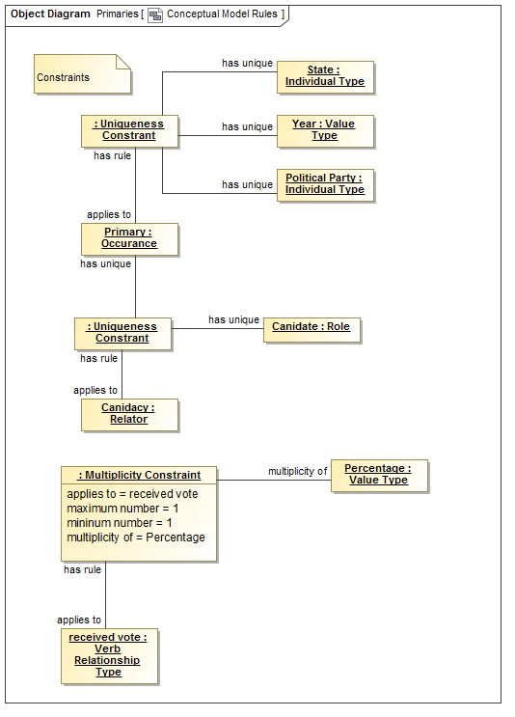

Some common values

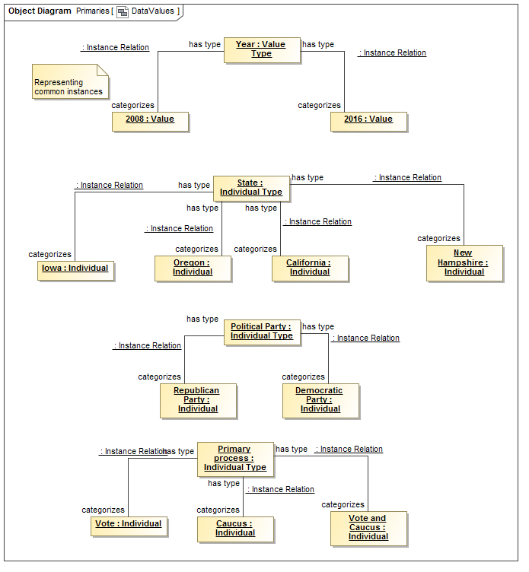

People of interest



The 2008 Iowa primaries

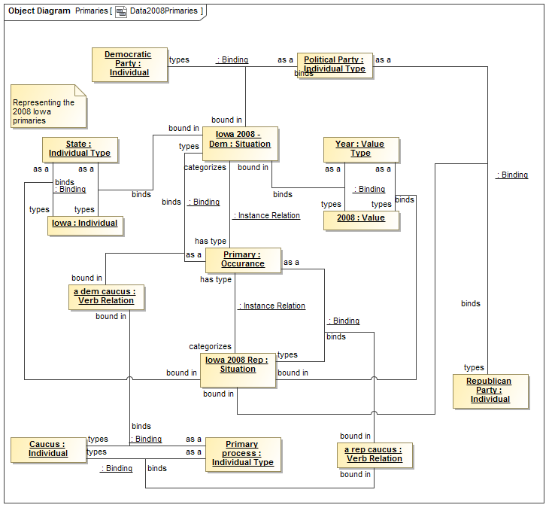

Obama candidacy and results in 2008 Iowa

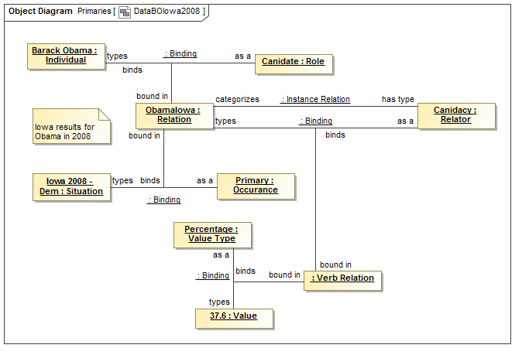

Hillary’s candidacy and results in 2008

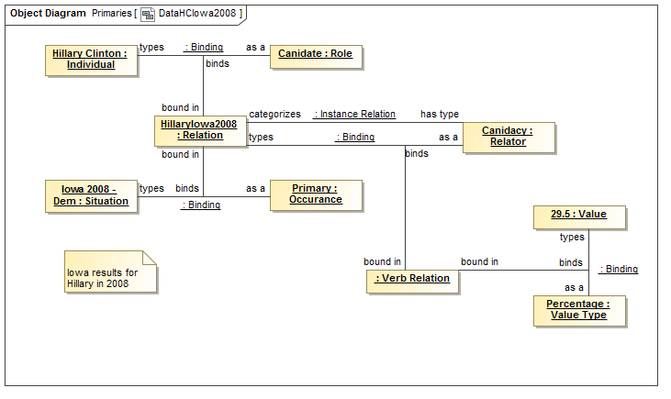

The 2016 New Hampshire Primary and Hillary’s result

