Temporary convenience index
Table of Contents
0.5Temporary convenience index 1
0.6Mapping 4
0.6.1Mapping Components Example 4
0.6.2STIX Concrete Data Model 5
0.6.3OTR Conceptual Reference Model 8
0.6.4STIX / OTR Mapping Rule 9

Illustration Index
Figure 5.1: STIX Mapping Overview 3
Figure 5.2: STIX Concrete Model Fragment 5
Figure 5.3: OTR Conceptual Reference Model Fragment 7
Figure 5.4: STIX - OTR Threat Actor Rule 8

Mapping
Mapping defines how different concrete or logical data structures represent the same or related concepts as defined in a conceptual reference model. By “grounding” the meaning of the data structures in common concepts SMIF provides a foundation for integrating information from multiple sources, translating between data representations and federating information for analytics.
The basis of federation is patterns (See section Error: Reference source not found). A mapping is a pattern that defines a correspondence between two sub-patterns, one “Concrete” and one “Reference”. The concrete pattern shows how data structures represent reference concepts. The sub-patterns are typically derived from different, independent, models. The patterns can then operate bidirectionally (as ling as no functions are used) – if data in the concrete source changes a SMIF implementation can update instances of the reference model. If instances of the reference model change, a SMIF implementation can update the concrete data source.
When using the SMIF UML profile the both models are loaded into UML. The mapping patterns are then represented using UML composite structure diagrams augmented with profile support. We will start with an example expressed using the UML profile and then see how it is represented in the SMIF model.

Mapping Components Example
Our example will focus on the mapping of “threat actors” and “statements” as defined in the “Structured Threat Information Expression” (STIX) XML schema. The STX schema and everything it references are imported into UML using off-the-shelf UML tool capabilities. This results in a UML model that directly reflects this XML schema and can then be used as the basis for mapping to the operational threat risk conceptual reference model (OTR).
Figure 1: STIX Mapping Overview
Figure 1 shows the “top level” of this mapping and the basic components of any mapping.
- A mapping connects two models, one considered the “concrete” model and once considered the “reference” model. The concrete model is the one more specific to a technology, system or solution where as a reference model is more conceptual and less committed to concrete concerns. In this and many cases this choice is reasonably clear. There are cases where the models are at about the same level of abstraction, in which case the choice may be arbitrary – but making a choice of which to call the “concrete” model and which to call the “reference” model is required.
- The “STIX Concrete Data Model” is the concrete model, it is directly derived from an XML schema intended for information exchange between STIX enabled systems. Classes within this model are “ThreatActorType” and “StatementType”.
- The “Threat/Risk Conceptual Reference Model” (OTR Model) is the reference model in this example. This model has been constructed with other models (including STX), threat relevant literature and stakeholder input to capture the concepts represented by STIX and other data models. The goal has been to identify and define the concepts the data is representing and model them as best understood by stakeholders across multiple domains of interest impacting the analysis of threats and risks. The OTR model is not a data model, it is a model of the domain as stakeholders conceive it. This conceptual model is used to “pivot” between different data representations.
- A data element, such as ThreatActorType is intended to model data that represents something in the “real world” (or perhaps a world we imagine as possible, but based on the real world). For each “real world” concept that a data element represents, a <<Represents>> stereotype is defined. This says that the data structure contains some information about the represented concept. <<Represents>> is not generally sufficient to fully map data, that is not its intent, it is a declaration that it can contain information about some concept which is then used to filter the more detailed mapping rules such that only things that represent a concept are mapped to it. We will see how this works, below. In the example we see that the STIX class “ThreatActorType” <<represents>> a real-world threat actor as defined in the OTR model. We also see that a STIX “StatementType” can represent information about any “Identifiable Entity” as defined by the OTR model.
- The rightmost column “Rules defining mapping” shows the specific mapping rules that define how and when the STIX data types represent the OTR concepts. This “insides” of these rules are UML structured classifiers that comprise the rule details. In an implementation of SMIF these rules help implement the translation and federation of data defined using the mapped data models.
- One other element that can be seen at this level is the “strength” of the rules. Strength defines when a rule is asserted (triggered). The “STIX Threat Actor Rule” has “strength-global” which means it always applies and can be triggered by any data source changing. The “STIX Statement Rule” has “strength=local” which means it is only triggered when required to fulfill another rule – such as the threat actor rule. A 3rd possibility is “strength=default” which defines a rule that is only triggered if no other rule has mapped the elements.
The above example should make clear these basic mapping elements; the concrete and reference models, how data elements may represent concepts and the top-level identification of mapping rules. In the following sections we will look at each of these in more detail.

STIX Concrete Data Model

Figure 2 shows a fragment of the STIX model dealing with threat actors. As noted above, this is directly derived from the STIX XML Schema. For the example we will not delve to much into the specifics of the STIX model, it is presented so that the mapping example can be better understood.
Figure 2: STIX Concrete Model Fragment
There are a few things to note about this model. First, there is a good correspondence between “ThreatActorType” as defined here and the general concept of a threat actor. As is typical, the STIX definition makes threat actor specific to Cyber threat actors, for the purposes of STIX. This is more narrow than the general concept of a threat actor – which could cause many kinds of mayhem.
We also note that information about the threat actor (the real actor in the real world) is intermixed with metadata about the threat-actor information, such as confidence. Other than understanding the concepts, there is no deterministic way to know that “Motivation” is probably about the actor where as “Confidence” is about the information record. One of the challenges of mapping is untangling these mixed concerns.
Note that “StatementType” is used in the STIX model for “Intended effect” and “Motivation”. In STIX “StatementType” is used where there are no explicitly modeled data elements for a concept, a StatementType just provides a definition and some metadata for these concepts. In other models these elements may be explicitly modeled, a challenge for integration. Having a motivation or metadata about confidence is not at all specific to threat actors so the OTR model defines these concepts at a much higher level so that they can apply to anything that the would make sense for that concept. So having a name can apply to anything we can identify where as only a threat actor can perpetrate a disruptive action (based on how these concepts are defined in OTR). Conceptual reference models are define concepts free of the context of a particular application or data structure, reflecting their meaning to stakeholders.
As with all UML models, properties or relationships that are defined for a “supertype” (or superclass) apply to all subtypes. So from this diagram we can see that a “threat actor” (like any identifiable entity) may have a name but that if you perpetrate a disruptive action you must “play the role” of a threat actor that must be a “social agent” (person or organization). We will delve into roles, below.

OTR Conceptual Reference Model
The OTR model fragment is figure 3 shows the properties and relationships that will be used to map concepts in the STIX model. Note that these two models are of a very different “shape”, use the same or different terms but clearly have commonality. A fundamental difference is that in the OTR model concepts are defined for their most general interpretation – This is how OTR is structured, how general to define reference concepts is a decision left to the model authors..
Figure 3: OTR Conceptual Reference Model Fragment
Another thing to note is that not all the information in either model is “complete” relative to the other. The purpose of conceptual reference models is to capture shared concepts across domains and different data models. The concepts that are mapped between different data models can be mapped – the others are ignored or must be populated with data specific rules. It is simply not practical for every concept of every data model to be mapped – so we don’t try.
It should also be noted that there is no “required” reference model, any number of reference models may be used to accomplish some mapping. OTR is a reference model for threats and risks, it does not claim to be the only one possible or useful.
As with the STIX model, we will not look to deeply into the specifics of the OTR model semantics as our purpose here is to use these model fragments as part of the mapping example.

STIX / OTR Mapping Rule
Figure 4 shows the detailed mapping of STIX ThreatActorType to OTR Threat Actor as the “composite structure” of the “STIX Threat Actor Rule” we saw in the summary. It does this using pattern variables, relationships and “Match” rules.
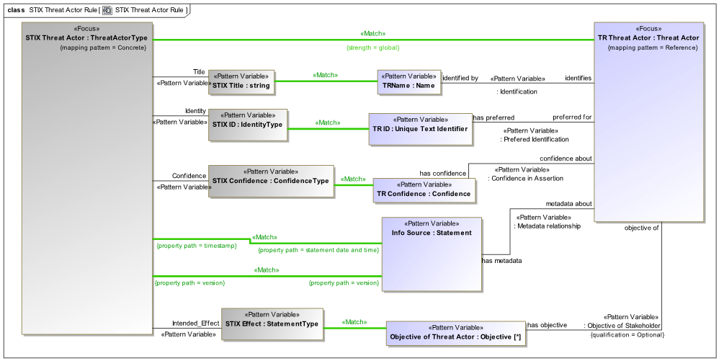
Figure 4: STIX - OTR Threat Actor Rule

