Updated model documentation – generated 3/30/3017
Includes Operational Threat/Risk (OTR) and Semantic Modeling for Information Federation (SMIF)
Contents
1 SMIF Conceptual Model 2
1.1 Diagram: SMIF Packages 3
2 SMIF Conceptual Model::Associations 4
2.1 Diagram: Associations 4
2.2 Class Association 5
2.3 Class Association Type 5
3 SMIF Conceptual Model::Constraints 6
3.1 Diagram: General Rules 6
3.2 Diagram: Property Constraints 7
3.3 Diagram: Rules in Context 8
3.4 Diagram: Rules Summary 9
3.5 Diagram: Type Constraints 10
3.6 Class Conditional 10
3.7 Class Conditional Rule 11
3.8 Class Covering Constraint 11
3.9 Association Covering Constraint 11
3.10 Class Disjoint 11
3.11 Class Enumerated 12
3.12 Class Equivalent 12
3.13 Class Facet Classification Constraint 12
3.14 Association Generalization 13
3.15 Class Generalization Constraint 13
3.16 Class Multiplicity Constraint 14
3.17 Association Multiplicity Reference 15
3.18 Association Multiplicity Target 15
3.19 Class Property Constraint 16
3.20 Class Property Transitivity Constraint 16
3.21 Association Property Type 16
3.22 Class Property Type Constraint 16
3.23 Class Rule 17
3.24 Association Rule Constrains 18
3.25 Association Rule Subsumption 18
3.26 Association Specialization 18
3.27 Class Type Constraint 19
3.28 Association Unique Set 19
3.29 Class Uniqueness Constraint 19
4 SMIF Conceptual Model::Expressions 20
4.1 Diagram: Expressions 20
4.2 Class Constant Reference 20
4.3 Association Constant Value 21
4.4 Class Equality 21
4.5 Association Equality Constraint 21
4.6 Class Evaluation 22
4.7 Association Expression Context 22
4.8 Class Expression Context 22
4.9 Association Expression Evaluation 23
4.10 Class Expression Node 23
4.11 Class Function Call 23
4.12 Association Function Called 24
4.13 Association Function Implementation 24
4.14 Class Function Type 24
4.15 Class Object Operation Type 25
4.16 Association OO Target 25
4.17 Association Result type 25
4.18 Class Traversal 25
4.19 Association Traverse Through 26
5 SMIF Conceptual Model::Facets 27
5.1 Diagram: Facets 27
5.2 Class Category 27
5.3 Class Facet 28
5.4 Class Facet of Entity <<Relationship>> 28
5.5 Class Phase 29
5.6 Class Role 29
6 SMIF Conceptual Model::Identifiers 30
6.1 Diagram: Identifiers 30
6.2 Association Identification 31
6.3 Class Identifier <<Value>> 31
6.4 Association Identifier in Namespace 31
6.5 Class IRI Identifier <<Value>> 32
6.6 Class Name <<Value>> 32
6.7 Class Namespace 32
6.8 Association Naming 33
6.9 Association Prefered Identification 33
6.10 Class Technical Identifier <<Value>> 34
6.11 Class Term <<Value>><<Intersection>> 34
6.12 Class Text Identifier <<Value>> 34
6.13 Class Unique Identifier <<Value>> 34
6.14 Class Unique Text Identifier <<Value>><<Intersection>> 35
7 SMIF Conceptual Model::Kernel 36
7.1 Diagram: Kernel Associations 36
7.2 Diagram: Kernel Identifiers 37
7.3 Diagram: Kernel Lexical Scope 38
7.4 Diagram: Kernel Metadata 39
7.5 Diagram: Kernel Properties 39
7.6 Diagram: Kernel Rules Summary 40
7.7 Diagram: Kernel Top Level 41
7.8 Diagram: Kernel Types 42
7.9 Diagram: Kernel Values 43
8 SMIF Conceptual Model::Lexical Scope 44
8.1 Diagram: Lexical Scope 44
8.2 Class Conceptual Package 44
8.3 Association Definition 45
8.4 Class Include 45
8.5 Class Lexical Reference 45
8.6 Class Lexical Scope 45
8.7 Class Logical Package 46
8.8 Class Mapping Package 46
8.9 Class Model 46
8.10 Class Package 47
8.11 Class Physical Package 47
8.12 Association Prefix 47
8.13 Class Prefix <<Value>> 47
8.14 Association Scope of Reference 48
8.15 Association Scope Reference 48
8.16 Association Statement 48
9 SMIF Conceptual Model::Mapping 49
9.1 Diagram: Facades 49
9.2 Diagram: Mapping Rules 50
9.3 Class Computed Facade 50
9.4 Association Concrete Map End 51
9.5 Association Concrete Pattern Body 51
9.6 Class Facade 51
9.7 Association Map Rule Type Assertion 51
9.8 Association Mapped variable 51
9.9 Class Mapping 52
9.10 Class Match End 53
9.11 Class Match Rule 53
9.12 Association Reference Map End 54
9.13 Association Reference Pattern Body 54
9.14 Association Representation 54
9.15 Class Representation Rule 54
9.16 Association Represented Concept 55
9.16.1 Enumeration Assertion Strength 55
10 SMIF Conceptual Model::Metadata 56
10.1 Diagram: Metadata 56
10.2 Association Assertion Statement 57
10.3 Class Definition 57
10.4 Association Definition Relationship 57
10.5 Class Information Source <<Role>> 58
10.6 Class Metadata 58
10.7 Association Metadata relationship 58
10.8 Association Record of an Entity 59
10.9 Association Source of Information 59
10.10 Class Statement 59
11 SMIF Conceptual Model::Patterns 61
11.1 Diagram: Patterns 61
11.2 Class Computed 62
11.3 Association Exclusion 62
11.4 Class Expression Variable 62
11.5 Class Focus Variable 62
11.6 Association Match Rules 62
11.7 Class Part Variable 63
11.8 Class Pattern <<Intersection>> 63
11.9 Association Pattern Bindings 63
11.10 Class Pattern Match 64
11.11 Association Pattern Matches 64
11.12 Class Pattern of Type 65
11.13 Class Pattern Variable 65
11.14 Association Pattern Variables 66
11.15 Class Proposition Variable 66
11.16 Association Qualified Proposition 67
11.17 Association Situation Matches 67
11.18 Association Subject of Pattern Relationship 67
11.19 Association Subsetting 67
11.20 Class Type Pattern Variable 67
11.21 Class Variable Binding 68
11.21.1 Enumeration Variable Qualification 68
12 SMIF Conceptual Model::Properties 70
12.1 Diagram: Characteristics 70
12.2 Diagram: Properties 71
12.3 Class Annotation Property 71
12.4 Association Bound Individual 72
12.5 Association Bound Property 72
12.6 Association Bound Subject 72
12.7 Class Characteristic Binding 72
12.8 Class Characteristic Type 73
12.9 Class Owned Property Binding 73
12.10 Class Owned Property Type 74
12.11 Association Properties Relationship 74
12.12 Class Property Binding 74
12.13 Class Property Owner 75
12.14 Class Property Owner Type 76
12.15 Class Property Type 76
13 SMIF Conceptual Model::Records 78
13.1 Diagram: Records 78
13.2 Class Record 79
13.3 Class Record Type 79
13.4 Association Subject of Record Type 79
14 SMIF Conceptual Model::Relationships 80
14.1 Diagram: Relationships 80
14.2 Class Relationship 81
14.3 Class Relationship Type 81
15 SMIF Conceptual Model::Situations 82
15.1 Diagram: Situations 82
15.2 Class Actual Situation <<Intersection>> 82
15.3 Class Situation 83
15.4 Class Situation Type 83
16 SMIF Conceptual Model::Top level 85
16.1 Diagram: Top Level 85
16.2 Class Actual Entity 86
16.3 Association Assertion 86
16.4 Class Context 87
16.5 Association Extent of Context 89
16.6 Class Identifiable Entity 89
16.7 Association Negation 92
16.8 Class Proposition 92
16.9 Class Temporal Entity 93
16.10 Class Thing 93
17 SMIF Conceptual Model::Types 96
17.1 Diagram: Type-instance 96
17.2 Diagram: Types 97
17.3 Class Entity Type 97
17.4 Association Extent of Type 98
17.5 Class Intersection Type 98
17.6 Class Type 98
17.7 Class Union Type 100
18 SMIF Conceptual Model::Values 101
18.1 Diagram: Values 103
18.2 Class Base Unit Type 103
18.3 Class Quantity kind 104
18.4 Association Referenced System of Units 104
18.5 Class Scalar Quantity <<Value>> 104
18.6 Class Structured Value <<Value>> 104
18.7 Class Structured Value Type 105
18.8 Class System of Units 105
18.9 Class Unit Type 105
18.10 Class Unit Value <<Value>> 106
18.11 Class Value 107
18.12 Class Value Type 107
19 Threat-risk-conceptual-model 108
19.1 Diagram: Conceptual Threat/Risk Model Diagrams 108
20 Threat-risk-conceptual-model::Generic Concept Library 109
20.1 Diagram: Generic Concept Library 109
21 Threat-risk-conceptual-model::Generic Concept Library::Abilities 111
21.1 Diagram: Ability 111
21.2 Diagram: Alter ability or control 112
21.3 Association Class Ability <<Relationship>> 112
21.4 Association Class Affected Available Resource <<Relationship>> 113
21.5 Class Alter Ability 114
21.6 Association Class Capability <<Relationship>> 114
21.7 Class Facilitator <<Role>> 115
21.8 Class Lose Ability 115
21.9 Class Obtain Ability 116
21.10 Association Class Strenthened Actor <<Relationship>> 116
21.11 Class Transfer Ability 116
21.12 Association Class Weakened Actor <<Relationship>> 116
22 Threat-risk-conceptual-model::Generic Concept Library::Assertions 118
22.1 Diagram: Assertions 118
23 Threat-risk-conceptual-model::Generic Concept Library::Assessments 119
23.1 Diagram: Assessment 119
23.2 Class Assessed Entity <<Role>> 119
23.3 Class Assessment 119
23.4 Class Assessment Activity 120
23.5 Association Class Entity Assessment <<Relationship>> 120
24 Threat-risk-conceptual-model::Generic Concept Library::Contact Information 121
24.1 Diagram: Contact Information 122
24.2 Class Communications Security Level <<Value>> 122
24.3 Class Contact Means <<Value>> 123
24.4 Association Class Contact Via <<Relationship>> 123
24.5 Class Contactable 124
24.6 Class Electronic Contact <<Value>> 124
24.7 Class Email Address <<Value>> 124
24.8 Class Internet Contact <<Value>> 125
24.9 Class Network Identifier <<Value>> 125
24.10 Class Postal Address <<Value>> 125
24.11 Class Postal Address Structured <<Value>> 125
24.12 Class Postal Address Text <<Value>> 126
24.13 Class Postal Code <<Value>> 126
24.14 Class Private Network Contact <<Value>> 127
24.15 Class Radio Contact <<Value>> 127
24.16 Class Social Network Contact <<Value>> 127
24.17 Class Telephone Area Code <<Value>> 127
24.18 Class Telephone Country Code <<Value>> 127
24.19 Class Telephone Number <<Value>> 128
24.20 Class Telephone Number Structured <<Value>> 128
24.21 Class Telephone Number Text <<Value>> 128
24.22 Class Website Contact <<Value>> 129
24.22.1 Enumeration Contact Availability 129
24.22.2 Enumeration Contact Purpose 129
25 Threat-risk-conceptual-model::Generic Concept Library::Containment 131
25.1 Diagram: Containment 131
25.2 Diagram: Move Between Containers 132
25.3 Diagram: Physical Containment 133
25.4 Class Add To Container Event 133
25.5 Class Container <<Role>> 133
25.6 Association Class Containment <<Relationship>> 133
25.7 Class Containment Event 134
25.8 Class Physical Container <<Role>> 134
25.9 Association Class Physical Containment <<Relationship>> 135
25.10 Association Class Recieving Container <<Relationship>> 135
25.11 Class Relocation 136
25.12 Class Removal Event 136
25.13 Association Class Supplying Container <<Relationship>> 136
26 Threat-risk-conceptual-model::Generic Concept Library::Control 137
26.1 Diagram: Control 137
26.2 Diagram: Control Authority 138
26.3 Diagram: Custody 138
26.4 Class Authority <<Role>> 139
26.5 Association Class Control <<Relationship>> 139
26.6 Class Controlled Entity <<Role>> 140
26.7 Class Controlling Actor <<Role>> 140
26.8 Class Custodian <<Role>> 140
26.9 Association Class Custody <<Relationship>> 140
26.10 Class Leader <<Role>> 140
26.11 Association Class Leadership <<Relationship>> 140
26.12 Class Managed Entity <<Role>> 141
26.13 Class Owner <<Role>> 141
26.14 Association Class Ownership <<Relationship>> 141
26.15 Association Class Possession <<Relationship>> 141
26.16 Class Property <<Role>> 142
26.17 Association Class Subject to Authority <<Relationship>> 142
27 Threat-risk-conceptual-model::Generic Concept Library::Credentials 143
27.1 Diagram: Credentials and Managed Identifiers 143
27.2 Association Actor Identifier of Credential 143
27.3 Association Class Attest to Ability <<Relationship>> 144
27.4 Class Credential 145
27.5 Class Identity Provider <<Role>> 145
27.6 Association Class Issue Credential <<Relationship>> 145
27.7 Class Managed Actor Identifier <<Value>> 146
27.8 Association Class Valid for Time Interval <<Relationship>> 146
28 Threat-risk-conceptual-model::Generic Concept Library::Cyber 147
28.1 Diagram: Cyber 148
28.2 Diagram: Cyber Platforms 149
28.3 Diagram: Cyber Resource 149
28.4 Association Class Ability To Execute Software <<Relationship>> 150
28.5 Association Class Automated Capability <<Relationship>> 150
28.6 Association Class Automated Control <<Relationship>> 151
28.7 Class Automated Entity <<Role>> 152
28.8 Class Automation Type 152
28.9 Class Automaton 152
28.10 Class Communicating Device 152
28.11 Class Communications Link 152
28.12 Class Communications Network 153
28.13 Class Computer Control System <<Role>> 153
28.14 Class Computer System 153
28.15 Class Cyber Resource <<Union>> 153
28.16 Class Cyber Weapon <<Role>> 153
28.17 Class Execution Platform <<Union>> 154
28.18 Association Class Information In Computer <<Relationship>> 154
28.19 Association Class Node of a Network <<Relationship>> 154
28.20 Class Software 155
29 Threat-risk-conceptual-model::Generic Concept Library::Enterprises 156
29.1 Diagram: Enterprise 156
29.2 Class Enterprise 157
30 Threat-risk-conceptual-model::Generic Concept Library::Entities 158
30.1 Diagram: Identifiable Entity 159
30.2 Diagram: Identifiable Entity Relationships 160
30.3 Association Class Impact <<Relationship>> 160
30.4 Association Class Parthood <<Relationship>> 161
30.5 Association Class Related <<Relationship>> 162
31 Threat-risk-conceptual-model::Generic Concept Library::Events and Activities 164
31.1 Diagram: Events and Activities 164
31.2 Class Activity 165
31.3 Class Actor 165
31.4 Class Actual Activity <<Intersection>> 166
31.5 Class Actual Event <<Intersection>> 166
31.6 Class Event 166
31.7 Association Class Output <<Relationship>> 166
31.8 Association Class Performance <<Relationship>> 167
31.9 Association Class Usage <<Relationship>> 168
32 Threat-risk-conceptual-model::Generic Concept Library::Identifiers and Coordinates 169
32.1 Diagram: Identifiers 170
32.2 Class Coordinate <<Value>> 170
32.3 Class Coordinate System 170
32.4 Association System of Coordinate 171
33 Threat-risk-conceptual-model::Generic Concept Library::Information 172
33.1 Diagram: Information Action 172
33.2 Diagram: Information Objects 173
33.3 Diagram: Metadata 174
33.4 Class Add Information 174
33.5 Class Atomic Information Object 174
33.6 Class Close Information 175
33.7 Class Confidence 175
33.8 Association Confidence in Assertion 175
33.9 Association Class Contained Information <<Relationship>> 175
33.10 Class Copy Information 176
33.11 Class Create Information 176
33.12 Class Delete Information 176
33.13 Class Document 177
33.14 Class Information Action 177
33.15 Class Information Object 177
33.16 Class Information Repository 178
33.17 Class Information Resource <<Union>> 178
33.18 Class Information Type 178
33.19 Class Modify Information 178
33.20 Class Open Information 178
33.21 Class Read Information 179
33.22 Class Remove Information 179
33.23 Class Structured Information Object 179
33.24 Class Transfer Information 179
34 Threat-risk-conceptual-model::Generic Concept Library::Locations 180
34.1 Diagram: Location 180
34.2 Diagram: Location Identification 181
34.3 Association Address of Location 181
34.4 Association Coordinate of location 182
34.5 Association Designation of a Location 182
34.6 Class Location ID <<Value>> 182
34.7 Class Location Identifier <<Value>> 182
34.8 Association Class Physical Boundary <<Relationship>> 182
34.9 Class Physical Location 183
34.10 Class Physical Point 183
34.11 Class Point On Earth <<Value>> 183
34.12 Association Reference Point 184
34.13 Class Relative Coordinate <<Value>> 184
34.14 Class Spacial Coordinate <<Value>> 184
34.15 Association Topological Region 184
34.16 Class Topology 185
34.17 Class World Geodetic System <<Value>> 185
35 Threat-risk-conceptual-model::Generic Concept Library::Objectives 186
35.1 Diagram: Objectives 186
35.2 Class Benefit 187
35.3 Class Consequence 187
35.4 Association Class Consequence of Situation <<Relationship>> 188
35.5 Class Desirability Assessment 188
35.6 Class Means <<Role>> 189
35.7 Association Class Means To End <<Relationship>> 189
35.8 Class Objective 190
35.9 Association Class Objective of Stakeholder <<Relationship>> 191
35.10 Class Opportunity 192
35.11 Class Stakeholder <<Role>> 193
35.12 Association Class Stakeholder Desirability <<Relationship>> 193
36 Threat-risk-conceptual-model::Generic Concept Library::Observations 195
36.1 Diagram: Measurement 195
36.2 Diagram: Observability 195
36.3 Diagram: Observations 196
36.4 Association Context of Observation 196
36.5 Association Class Measurement <<Relationship>> 196
36.6 Association Class Observability <<Relationship>> 197
36.7 Association Class Observation <<Relationship>> 197
36.8 Class Observation Tool <<Role>> 198
36.9 Class Observer <<Role>> 198
37 Threat-risk-conceptual-model::Generic Concept Library::Organizations 199
37.1 Diagram: Organization 199
37.2 Association Class Membership <<Relationship>> 199
37.3 Class Mission Objective 200
37.4 Class Organization 200
37.5 Class Organizational Unit <<Role>> 201
37.6 Class Parent Organization <<Role>> 201
37.7 Association Class Part of Organization <<Relationship>> 201
37.8 Class Program 202
38 Threat-risk-conceptual-model::Generic Concept Library::Organizations::Corporations 203
38.1 Diagram: Corporations 203
38.2 Class Incorporated Organization 203
38.3 Association Class Incorporation <<Relationship>> 203
39 Threat-risk-conceptual-model::Generic Concept Library::Organizations::Geopolitical Organizations 205
39.1 Diagram: Geopolitical Entities 205
39.2 Class Country 205
39.3 Class Country ID <<Value>> 206
39.4 Class Geopolitical Entity 206
39.5 Class Geopolitical ID <<Value>> 206
39.6 Class Geopolitical Region <<Role>> 206
39.7 Association Class Governing Authority <<Relationship>> 206
40 Threat-risk-conceptual-model::Generic Concept Library::Permissions 207
40.1 Diagram: Permission 207
40.2 Association Class Permission 208
41 Threat-risk-conceptual-model::Generic Concept Library::Persons 209
41.1 Diagram: Person 209
41.2 Diagram: Person Identifiers 210
41.3 Diagram: Person Name Representations 211
41.4 Class Access Identifier <<Value>> 211
41.5 Class Financial Identifier <<Value>> 211
41.6 Class Managed Person Identifier <<Value>> 212
41.7 Class Passport Identifier <<Value>> 212
41.8 Class Person 212
41.9 Association Class Person at location <<Relationship>> 212
41.10 Class Person Name <<Value>> 213
41.11 Class Person Structured Name <<Value>> 213
41.12 Association Class Residency <<Relationship>> 214
41.13 Class Social Security Number <<Value>> 214
42 Threat-risk-conceptual-model::Generic Concept Library::Physical Entities 215
42.1 Diagram: Physical Entities 216
42.2 Class Animal 216
42.3 Class Conveyance 217
42.4 Class Device 218
42.5 Class Item 218
42.6 Class Managed Item Identifier <<Value>> 218
42.7 Class Physical Entity 218
42.8 Class Physical Feature 219
42.9 Class Physical Tool <<Role>> 219
42.10 Class Spacial Entity 219
42.11 Class Telecommunication Device 220
42.11.1 Enumeration Sex Kind 220
43 Threat-risk-conceptual-model::Generic Concept Library::Places 222
43.1 Diagram: Place 222
43.2 Class Facility <<Role>> 222
43.3 Association Class Operating Location <<Relationship>> 222
43.4 Class Place <<Role>> 223
43.5 Association Class Place of Occurrance <<Relationship>> 223
43.6 Class Residence <<Role>> 224
44 Threat-risk-conceptual-model::Generic Concept Library::Policies 225
44.1 Diagram: Policy 225
44.2 Association Class Assertion of Policy <<Relationship>> 225
44.3 Class Policy 226
45 Threat-risk-conceptual-model::Generic Concept Library::Predictions 227
45.1 Diagram: Prediction 227
45.2 Association Class Prediction <<Relationship>> 227
45.3 Class Predictor <<Role>> 228
46 Threat-risk-conceptual-model::Generic Concept Library::Processes 229
46.1 Diagram: Process 230
46.2 Association Class Invoke Process <<Relationship>> 231
46.3 Class Modus Operandi 231
46.4 Class Plan 231
46.5 Class Process Action 232
46.6 Association Class Process Decomposition <<Relationship>> 232
46.7 Class Process Pattern 233
46.8 Association Class When <<Relationship>> 233
47 Threat-risk-conceptual-model::Generic Concept Library::Processes::Composite Conditions 235
47.1 Diagram: Composite Condition 235
47.2 Class AND Condition 235
47.3 Class Composite Condition 235
47.4 Class OR Condition 236
47.5 Class XOR Condition 236
48 Threat-risk-conceptual-model::Generic Concept Library::Processes::Process Effects 237
48.1 Diagram: Process Effects 238
48.2 Class Activity Effecting Entity 238
48.3 Class Create 239
48.4 Class Damage 239
48.5 Class Destroy 239
48.6 Class Disrupt Process 239
48.7 Class Entry Action 240
48.8 Class Exit Action 240
48.9 Class Pause Process 240
48.10 Class Possible Actions 240
48.11 Class Stop Process 240
49 Threat-risk-conceptual-model::Generic Concept Library::Processes::Scenarios 241
49.1 Diagram: Scenarios 241
49.2 Class Defensive Step 242
49.3 Class Disruptive Step 242
49.4 Class Goal State 242
49.5 Class Scenario 242
49.6 Class Scenario Step 242
49.7 Association Class Step in Scenario <<Relationship>> 243
50 Threat-risk-conceptual-model::Generic Concept Library::Quantities and Units 244
50.1 Diagram: Quantities and units 245
50.2 Class Confidence Metric <<Quantity Kind>> 246
50.3 Class Count <<Quantity Kind>> 246
50.4 Class Currency Benefit Metric <<Quantity Kind>> 246
50.5 Class Harm-Benefit Metric <<Quantity Kind>> 246
50.6 Class Metric <<Quantity Kind>> 246
50.7 Class Probability Metric <<Quantity Kind>> 247
50.8 Class Time Coordinate <<Quantity Kind>> 247
50.8.1 <<Value>>Enumeration PentaScale <<Value>> 247
50.8.2 <<Value>>Enumeration TriScale <<Value>> 248
51 Threat-risk-conceptual-model::Generic Concept Library::Quantities and Units::Quantity Kinds 251
51.1 Diagram: Quantity Kinds 251
51.2 Class Absorbed Dose (Radiation) <<Quantity Kind>> 251
51.3 Class Acceleration <<Quantity Kind>> 252
51.4 Class Amount of Substance <<Quantity Kind>> 252
51.5 Class Angle <<Quantity Kind>> 252
51.6 Class Area <<Quantity Kind>> 252
51.7 Class Color <<Quantity Kind>> 252
51.8 Class Concentration <<Quantity Kind>> 252
51.9 Class Concentration (amount of substance) <<Quantity Kind>> 253
51.10 Class Concentration (Mass) <<Quantity Kind>> 253
51.11 Class Concentration (Volume) <<Quantity Kind>> 253
51.12 Class Currency <<Quantity Kind>> 253
51.13 Class Dose Equivalent (Radiation) <<Quantity Kind>> 253
51.14 Class Duration <<Quantity Kind>> 253
51.15 Class Electric Current <<Quantity Kind>> 254
51.16 Class Electric Potential <<Quantity Kind>> 254
51.17 Class Energy <<Quantity Kind>> 254
51.18 Class Force <<Quantity Kind>> 254
51.19 Class Frequency <<Quantity Kind>> 255
51.20 Class Length <<Quantity Kind>> 255
51.21 Class Luminosity <<Quantity Kind>> 255
51.22 Class Mass <<Quantity Kind>> 255
51.23 Class Mass Density <<Quantity Kind>> 255
51.24 Class Physical Quantity <<Quantity Kind>> 256
51.25 Class Power <<Quantity Kind>> 256
51.26 Class Pressure <<Quantity Kind>> 256
51.27 Class Radiation Exposure <<Quantity Kind>> 256
51.28 Class Radioactivity <<Quantity Kind>> 256
51.29 Class Speed <<Quantity Kind>> 256
51.30 Class Temperature <<Quantity Kind>> 256
51.31 Class Volume <<Quantity Kind>> 257
52 Threat-risk-conceptual-model::Generic Concept Library::Quantities and Units::Units 258
52.1 Diagram: Common Units 1 258
52.2 Diagram: Common Units 2 259
52.3 Class Acre <<Unit Value>> 259
52.4 Class Ampere <<Base Unit Value>> 259
52.5 Class Becquerel (Bq) <<Unit Value>> 259
52.6 Class Candela <<Base Unit Value>> 260
52.7 Class Celsius <<Unit Value>> 260
52.8 Class Compound Duration Value <<Unit Value>> 260
52.9 Class Concentration Percent <<Base Unit Value>> 260
52.10 Class Coulomb/kilogram (C/kg). <<Unit Value>> 260
52.11 Class Cubic Feet <<Unit Value>> 260
52.12 Class Cubic Inch <<Unit Value>> 261
52.13 Class Cubic Meter <<Base Unit Value>> 261
52.14 Class Cup (US) <<Unit Value>> 261
52.15 Class Curie (Ci) <<Base Unit Value>> 261
52.16 Class Day <<Unit Value>> 261
52.17 Class Degrees <<Unit Value>> 261
52.18 Class Fahrenheit <<Unit Value>> 261
52.19 Class Fluid Ounce (US) <<Unit Value>> 262
52.20 Class Foot <<Unit Value>> 262
52.21 Class Gallon (Imperial) <<Unit Value>> 262
52.22 Class Gallon (US) <<Unit Value>> 262
52.23 Class Gram <<Unit Value>> 262
52.24 Class Gray (Gy) <<Base Unit Value>> 262
52.25 Class Hertz <<Base Unit Value>> 263
52.26 Class Horsepower <<Unit Value>> 263
52.27 Class Hour <<Unit Value>> 263
52.28 Class Inch <<Unit Value>> 263
52.29 Class Joule <<Base Unit Value>> 263
52.30 Class Kelvin <<Base Unit Value>> 263
52.31 Class Kg per cubic meter <<Base Unit Value>> 264
52.32 Class Kilogram <<Base Unit Value>> 264
52.33 Class Kilogram per cubic meter <<Base Unit Value>> 264
52.34 Class Kilometer <<Unit Value>> 264
52.35 Class Kilometer per Hour <<Base Unit Value>> 264
52.36 Class Kilowatt hour <<Unit Value>> 264
52.37 Class Liquid Volume <<Quantity Kind>> 264
52.38 Class Meter <<Base Unit Value>> 265
52.39 Class Meter per second squared <<Base Unit Value>> 265
52.40 Class Mile <<Unit Value>> 265
52.41 Class Miles per Hour <<Unit Value>> 265
52.42 Class Millimeter <<Unit Value>> 265
52.43 Class Millisecond <<Unit Value>> 265
52.44 Class Minute <<Unit Value>> 266
52.45 Class Mole <<Base Unit Value>> 266
52.46 Class Mole Per Cubic Meter <<Base Unit Value>> 266
52.47 Class Month <<Unit Value>> 266
52.48 Class Newton <<Base Unit Value>> 266
52.49 Class Ounce-Mass (US) <<Unit Value>> 266
52.50 Class Pascal <<Base Unit Value>> 266
52.51 Class Pint (US) <<Unit Value>> 267
52.52 Class Pound-Force <<Unit Value>> 267
52.53 Class Pound-Mass (Imperial) <<Unit Value>> 267
52.54 Class Pound-Mass (US lb) <<Unit Value>> 267
52.55 Class PSI <<Unit Value>> 267
52.56 Class Quart (US) <<Unit Value>> 267
52.57 Class Radians <<Base Unit Value>> 268
52.58 Class Radiation Absorbed Dose (rad) <<Unit Value>> 268
52.59 Class Roentgen (R) <<Base Unit Value>> 268
52.60 Class Roentgen Equivalent Man (REM) <<Unit Value>> 268
52.61 Class Scalar Duration Value <<Unit Value>> 268
52.62 Class Second <<Base Unit Value>> 269
52.63 Class Sievert (Sv), <<Base Unit Value>> 269
52.64 Class Square Feet <<Unit Value>> 269
52.65 Class Square Meter <<Base Unit Value>> 269
52.66 Class Volt <<Base Unit Value>> 270
52.67 Class Watt <<Base Unit Value>> 270
52.68 Class Yard <<Unit Value>> 270
52.69 Class Year <<Unit Value>> 270
53 Threat-risk-conceptual-model::Generic Concept Library::Resources 271
53.1 Diagram: Resource 271
53.2 Diagram: Resource Actions 272
53.3 Class Abuse Resource 272
53.4 Class Capture Resource 272
53.5 Class Damage Resource 272
53.6 Class Exceed Resource Capacity 272
53.7 Class Modify Resource 273
53.8 Class Performer <<Role>> 273
53.9 Class Resource <<Role>> 273
53.10 Class Resource Actions 273
53.11 Association Class Resource Dependency <<Relationship>> 273
53.12 Class Tool <<Role>> 274
54 Threat-risk-conceptual-model::Generic Concept Library::Response 275
54.1 Diagram: Response 275
54.2 Association Class Initiation of Response <<Relationship>> 275
54.3 Class Response <<Role>> 276
55 Threat-risk-conceptual-model::Generic Concept Library::Situations 277
55.1 Diagram: Situation Timeframes 277
55.2 Diagram: Situations 278
55.3 Class Actual State <<Intersection>> 279
55.4 Association Class Cause and Effect <<Relationship>> 279
55.5 Class Current Situation 280
55.6 Association Class Effect <<Relationship>> 280
55.7 Association Class Enablement <<Relationship>> 280
55.8 Association Class Involvement <<Relationship>> 281
55.9 Association Class Negation Effect <<Relationship>> 282
55.10 Class Past Situation 283
55.11 Class Potential Situation 283
55.12 Association Class Scope of Indicator <<Relationship>> 283
55.13 Class State 284
55.14 Association State of Entity 284
56 Threat-risk-conceptual-model::Generic Concept Library::Social Agents 285
56.1 Diagram: Social Agent 285
56.2 Diagram: Social Agent Identifiers 286
56.3 Association Class Assertion <<Relationship>> 286
56.4 Association Class Associated Actor <<Relationship>> 286
56.5 Class License Identifier <<Value>> 287
56.6 Class Local Identifier <<Value>> 287
56.7 Class Managed Social Agent Identifier <<Value>> 287
56.8 Class Regional Identifier <<Value>> 288
56.9 Class Social Agent 288
56.10 Class Tax Authority Identifier <<Value>> 288
57 Threat-risk-conceptual-model::Generic Concept Library::Systems 289
57.1 Diagram: System 289
57.2 Class Access Point 290
57.3 Class Boundary 290
57.4 Association Class Boundary of System <<Relationship>> 290
57.5 Association Class Opening in a Boundary <<Relationship>> 291
57.6 Association Class Point Of Entry <<Relationship>> 291
57.7 Class Subsystem <<Role>> 292
57.8 Class System 292
58 Threat-risk-conceptual-model::Generic Concept Library::Time & Temporal Entities 293
58.1 Diagram: Time 294
58.2 Class Date and Time <<Quantity Kind>> 295
58.3 Class Date Coordinate <<Quantity Kind>> 295
58.4 Association Duration of Entity 295
58.5 Association Entity Exists for Interval 295
58.6 Association Finish Time 296
58.7 Association Overlaps in Time 297
58.8 Association Start Time 298
58.9 Association Temporal Order 299
58.10 Association Class Temporal Part <<Relationship>> 299
58.11 Class Time Coordinate <<Quantity Kind>> 300
58.12 Class Time Interval 300
58.13 Class Time Point 301
58.14 Class Time Scale 301
58.15 Association Time Scale Granularity 301
58.16 Association Time Scale of Time Point 302
59 Threat-risk-conceptual-model::Generic Concept Library::Time & Temporal Entities::ISO Time Scale 303
59.1 Diagram: ISO Time 303
59.2 Class Date Time Coordinate (ISO 8601) <<Unit Value>> 304
60 Threat-risk-conceptual-model::Generic Concept Library::Time & Temporal Entities::XSD Time Scale 305
60.1 Diagram: XSD Time Scale 305
60.2 Class XSD Date <<Unit Value>> 305
60.3 Class XSD Date Time <<Unit Value>> 306
60.4 Class XSD Time <<Unit Value>> 306
61 Threat-risk-conceptual-model::Generic Concept Library::Vendors and Producers 307
61.1 Diagram: Vendors and Producers 307
61.2 Class Client <<Role>> 307
61.3 Class Individual Product <<Role>> 308
61.4 Class Manufactured Thing <<Role>> 308
61.5 Class Producer <<Role>> 308
61.6 Class Product Kind 308
61.7 Association Class Product Line of Supplier <<Relationship>> 308
61.8 Association Class Production <<Relationship>> 309
61.9 Association Class Providing <<Relationship>> 310
61.10 Class Serial Number <<Value>> 311
61.11 Class Supplier <<Role>> 311
62 Threat-risk-conceptual-model::Threat and Risk Specific Concepts 312
62.1 Diagram: Threat and Risk Specific Concepts 313
63 Threat-risk-conceptual-model::Threat and Risk Specific Concepts::.Summary Diagrams 314
63.1 Diagram: Entity Kinds 314
64 Threat-risk-conceptual-model::Threat and Risk Specific Concepts::Accusations 315
64.1 Diagram: Accusations 315
64.2 Association Class Accusation <<Relationship>> 315
65 Threat-risk-conceptual-model::Threat and Risk Specific Concepts::Campaigns 316
65.1 Diagram: Campaign 316
65.2 Class Campaign 316
66 Threat-risk-conceptual-model::Threat and Risk Specific Concepts::Danger 317
66.1 Diagram: Danger 318
66.2 Class Attack <<Role>> 319
66.3 Class Indirect Threat <<Role>> 319
66.4 Class Natural Threat <<Role>> 319
66.5 Association Class Target of Attack <<Relationship>> 319
66.6 Class Threat <<Role>> 320
66.7 Class Unintentional Threat <<Role>> 320
67 Threat-risk-conceptual-model::Threat and Risk Specific Concepts::Danger Sources 321
67.1 Diagram: Danger Sources 321
67.2 Class Accident <<Role>> 321
67.3 Association Class Contribution to Danger <<Relationship>> 322
67.4 Class Danger Source <<Role>> 322
67.5 Class Dangerous Condition <<Role>> 323
67.6 Class Dangerous Event <<Role>> 323
67.7 Class Disrupt Stakeholder's Objective 323
67.8 Association Class Exploit of Vulnerability <<Relationship>> 323
67.9 Class Objective to Disrupt 324
67.10 Class Unwitting Participant <<Role>> 324
68 Threat-risk-conceptual-model::Threat and Risk Specific Concepts::Danger Sources::Source of Danger Categories 325
68.1 Diagram: Source of Danger Categories 325
68.2 Class Biological Danger <<Category>> 326
68.3 Class CBRN Danger <<Category>> 326
68.4 Class Chemical Danger <<Category>> 326
68.5 Class Civil Unrest Danger <<Category>> 326
68.6 Class Criminal Danger <<Category>> 326
68.7 Class Cyber Danger <<Category>> 326
68.8 Class Fire Danger <<Category>> 326
68.9 Class Geophysical Danger <<Category>> 326
68.10 Class Loss of Control Danger <<Category>> 327
68.11 Class Meteorological Danger <<Category>> 327
68.12 Class Nuclear Danger <<Category>> 327
68.13 Class Radiological Danger <<Category>> 327
68.14 Class Safety Danger <<Category>> 327
68.15 Class Security Danger <<Category>> 327
68.16 Class Source of Danger Category <<Category>> 327
68.17 Class Terrorism Danger <<Category>> 328
68.18 Class War Danger <<Category>> 328
69 Threat-risk-conceptual-model::Threat and Risk Specific Concepts::Incidents 329
69.1 Diagram: Incident 329
69.2 Association Class Danger Leads to Incident <<Relationship>> 329
69.3 Class Incident <<Role>> 330
69.4 Class Witness <<Role>> 330
69.5 Association Class Witnessing <<Relationship>> 331
70 Threat-risk-conceptual-model::Threat and Risk Specific Concepts::Incidents::Failure 332
70.1 Diagram: Failure 332
70.2 Class Failure 332
70.3 Association Class Failure of Resource <<Relationship>> 332
71 Threat-risk-conceptual-model::Threat and Risk Specific Concepts::Incidents::Failure Categories 334
71.1 Diagram: Failure Categories 334
71.2 Class Access Control Failure <<Category>> 334
71.3 Class Control Failure <<Category>> 334
71.4 Class Cyber System Failure <<Category>> 335
71.5 Class Failure Category <<Category>> 335
71.6 Class Industrial Control Failure <<Category>> 335
71.7 Class Physical System Failure <<Category>> 335
71.8 Class Process Failure <<Category>> 335
71.9 Class System Failure <<Category>> 335
72 Threat-risk-conceptual-model::Threat and Risk Specific Concepts::Incidents::Impact Categories 336
72.1 Diagram: Impact Categories 336
72.2 Class Communications Impact <<Category>> 336
72.3 Class Compliance Impact <<Category>> 337
72.4 Class Control of Information Impact <<Category>> 337
72.5 Class Decision-making Impact <<Category>> 337
72.6 Class Disinformation Impact <<Category>> 337
72.7 Class Electromagnetic Spectrum Impact <<Category>> 337
72.8 Class Environmental Impact <<Category>> 337
72.9 Class Financial Impact <<Category>> 337
72.10 Class Health Impact <<Category>> 338
72.11 Class Identity Spoof Impact <<Category>> 338
72.12 Class Image Impact <<Category>> 338
72.13 Class Impact Category <<Category>> 338
72.14 Class Information Availability Impact <<Category>> 338
72.15 Class Information Impact <<Category>> 338
72.16 Class Infrastructure Impact <<Category>> 338
72.17 Class Intellectual Property Impact <<Category>> 339
72.18 Class Legal Impact <<Category>> 339
72.19 Class Mission Impact <<Category>> 339
72.20 Class Non-Technical Impact <<Category>> 339
72.21 Class Safety Impact <<Category>> 339
72.22 Class Transport Impact <<Category>> 339
73 Threat-risk-conceptual-model::Threat and Risk Specific Concepts::Incidents::Incident Response 340
73.1 Diagram: Incident Response 340
73.2 Class Incident Containment <<Role>> 340
73.3 Class Incident Recovery <<Role>> 340
73.4 Class Incident Response <<Role>> 341
74 Threat-risk-conceptual-model::Threat and Risk Specific Concepts::Indicators 342
74.1 Diagram: Indicator 342
74.2 Diagram: Sighting 343
74.3 Class Blacklist Indicator 343
74.4 Class Indicator 343
74.5 Association Class Indicator Indicates Situation <<Relationship>> 343
74.6 Class Indicator Pattern 344
74.7 Class Indicator Watchlist 344
74.8 Association Class Sighting <<Relationship>> 345
74.9 Association Class Sighting Indicates Situation <<Relationship>> 345
74.10 Association Class Sighting Matches Indicator <<Relationship>> 346
74.11 Association Class Watch <<Relationship>> 347
74.12 Class Whitelist Indicator 348
75 Threat-risk-conceptual-model::Threat and Risk Specific Concepts::Risk 349
75.1 Diagram: Risk 349
75.2 Diagram: Risk Metrics 350
75.3 Association Class Impose Strategy <<Relationship>> 350
75.4 Class Objective forSafety and Security 350
75.5 Class Objective to Protect Assets 351
75.6 Class Risk 351
75.7 Class Risk Mitigation Strategy 351
75.8 Class Risk Owner <<Role>> 351
75.9 Class Risk Reduction Objective 352
75.10 Association Class Risk To Resource <<Relationship>> 352
75.11 Association Class Risk Topic <<Relationship>> 353
75.12 Association Class Stakeholder Risk <<Relationship>> 354
75.13 Class Threat Likelihood <<Quantity Kind>> 355
75.14 Association Class Valuation of Asset <<Relationship>> 355
75.15 Class Valued Asset <<Role>> 355
75.15.1 Enumeration Likelihood Categories 355
75.15.2 Enumeration Severity Categories 356
76 Threat-risk-conceptual-model::Threat and Risk Specific Concepts::Risk Treatments 357
76.1 Diagram: Risk Treatment 357
76.2 Diagram: Safeguard Monitoring 358
76.3 Class Accept Risk 358
76.4 Association Class Assume Risk <<Relationship>> 358
76.5 Class Avoid Danger 359
76.6 Class Countermeasure <<Role>> 359
76.7 Association Class Countermeasure for Strategy <<Relationship>> 360
76.8 Association Class Countermeasure Mitigates <<Relationship>> 360
76.9 Class Management Control 361
76.10 Class Mitigation Actor <<Role>> 361
76.11 Association Class Monitor <<Relationship>> 361
76.12 Class Monitoring Control 362
76.13 Class Operational Control 362
76.14 Association Class Protection <<Relationship>> 362
76.15 Class Risk Agent <<Role>> 363
76.16 Association Class Risk Treatment <<Relationship>> 363
76.17 Class Risk Treatment Strategy 363
76.18 Association Class Safeguarding <<Relationship>> 364
76.19 Class Technical Control 364
76.20 Class Transfer Risk 364
77 Threat-risk-conceptual-model::Threat and Risk Specific Concepts::Threat Actors 366
77.1 Diagram: Threat Actors 366
77.2 Class Disruptive Action <<Role>> 367
77.3 Association Class Perpetrate <<Relationship>> 367
77.4 Class Threat Actor <<Role>> 368
78 Threat-risk-conceptual-model::Threat and Risk Specific Concepts::Undesirable Situations 369
78.1 Diagram: Undesirable Situations 370
78.2 Class Harm 370
78.3 Association Class Harms Resource <<Relationship>> 371
78.4 Association Class Harms Victim <<Relationship>> 372
78.5 Association Class Source of Harm <<Relationship>> 373
78.6 Class Undesirable Condition <<Role>> 373
78.7 Class Undesirable Event <<Role>> 373
78.8 Class Undesirable Situation <<Role>> 374
78.9 Class Victim <<Role>> 374
79 Threat-risk-conceptual-model::Threat and Risk Specific Concepts::Vulnerabilities 375
79.1 Diagram: Vulnerability 375
79.2 Diagram: Vulnerability Identifiers 376
79.3 Class Physical Vulnerability 376
79.4 Association Class Supporting Condition <<Relationship>> 376
79.5 Class Vulnerability 377
79.6 Class Vulnerability Identifier <<Value>> 377
79.7 Class Vulnerability Metric <<Quantity Kind>> 377
79.8 Association Class Vulnerability of Resource <<Relationship>> 378
80 Threat-risk-conceptual-model::Threat and Risk Specific Concepts::Vulnerabilities::Cyber Vulnerabilities 379
80.1 Diagram: Cyber Vulnerability 379
80.2 Class Communications Vulnerability 380
80.3 Class CVE Identifier <<Value>> 380
80.4 Class Cyber Vulnerability 380
80.5 Class Information System Vulnerability 380
80.6 Class Information Vulnerability 380
80.7 Class OSVDB Identifier <<Value>> 380
80.8 Class Software Vulnerability 381
81 Threat-risk-conceptual-model::Threat and Risk Specific Concepts::Vulnerabilities::Vulnerability Vectors 382
81.1 Diagram: Vulnerability Vectors 383
81.2 Class CVSS Score <<Quantity Kind>> 384
81.2.1 Enumeration Access Complexity 384
81.2.2 Enumeration Access Vector 385
81.2.3 Enumeration Authentication 385
81.2.4 Enumeration Availability Impact 386
81.2.5 Enumeration Collateral Damage Potential 386
81.2.6 Enumeration Confidentiality Impact 387
81.2.7 Enumeration Exploitability 387
81.2.8 Enumeration Integrity Impact 388
81.2.9 Enumeration Remediation Level 389
81.2.10 Enumeration Report Confidence 389
81.2.11 Enumeration Security Requirements 390
81.2.12 Enumeration Target Distribution 390
82 Threat-risk-conceptual-model::Threat and Risk Specific Concepts::Weapons 392
82.1 Diagram: Weapons 392
82.2 Class Physical Weapon <<Role>> 392
82.3 Class Weapon <<Role>> 392
82.4 Association Class Weapon Leverages Vulnerability <<Relationship>> 393

SMIF Conceptual Model

Diagram: SMIF Packages
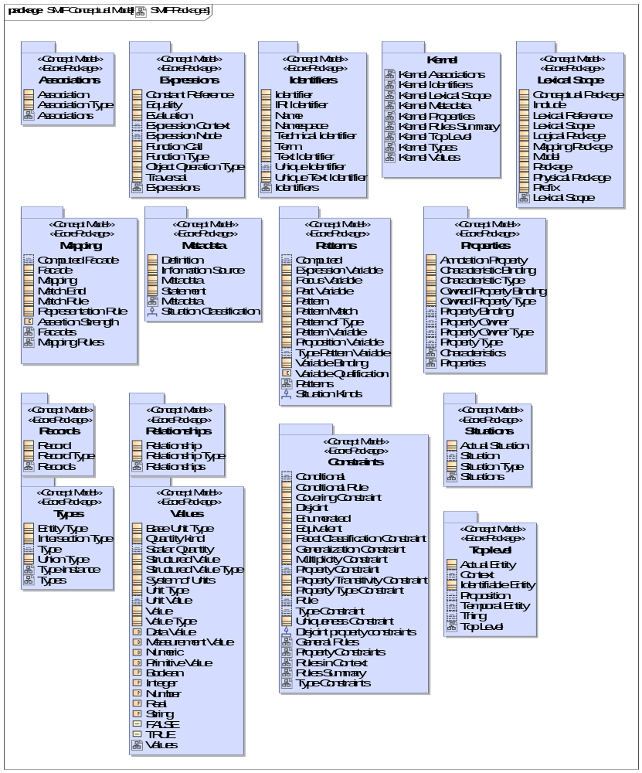
- SMIF Packages

SMIF Conceptual Model::Associations
An association asserts a formal condition involving related things, the association ends. An association may be asserted within a context as true or false within that context. Each association has a number of bindings of which are immutable for that association.
Associations are differentiated from relationships in that associations are fully dependent on the things they relate. These are known as "formal", "thin", "internal" or "intrinsic" relations in much of the literature.

Diagram: Associations
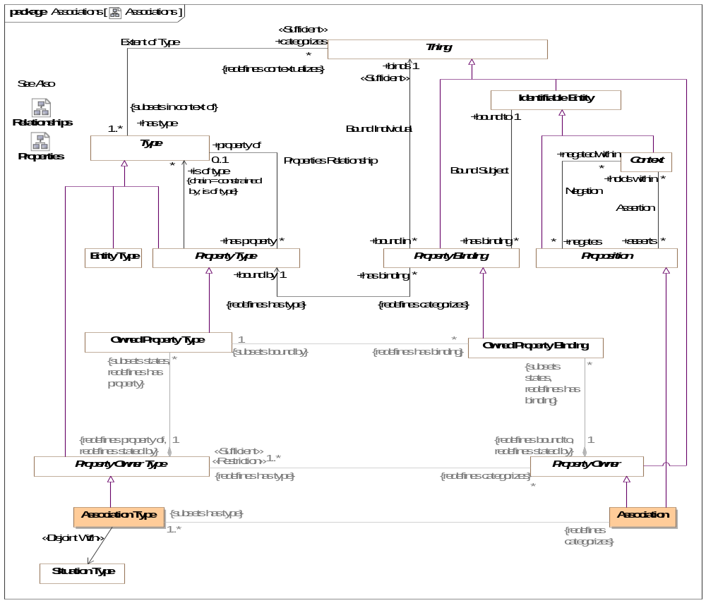
- Associations

Class Association
An association makes a logical statement involving related things, the association ends. An association may be asserted within a context as true or false within that context. Each association type has a number of bindings of which are immutable for that association.
An association may be true or false within its context and is atomic in its truth value.
Associations are differentiated from relationships in that associations are not situations - they are not temporal and do not change over time. Associations may be a consequence of relationships or other situations or may be derived from qualities of associated ends.
Associations can "own" owned property bindings as their "ends".
See also: Relationship
[Guizzardi] Intrinsic Relation
[UML] Link
[DOLCE] Formal Relation
Direct Supertypes
Property Owner, Proposition
Associations
<<Restriction>> : Association Type [1..*] Subsets: has type:Type

Class Association Type
A type of Association (See Association for details) which defines a set of "Association Property Types" which are the types of association property bindings. Associations are not situations - the are not temporal things. THis does not prevent subtypes of associations from being situations.
[Guizzardi] Intrinsic Relation Type
[UML] Association
[OWL] For binary associations, may be considered a pair of properties that are Inverse Object Properties.
Direct Supertypes
Property Owner Type
Associations
<<Restriction>> : Association Redefines: categorizes:Thing

SMIF Conceptual Model::Constraints
Rules define constraints or behaviors that are asserted in specified context.

Diagram: General Rules
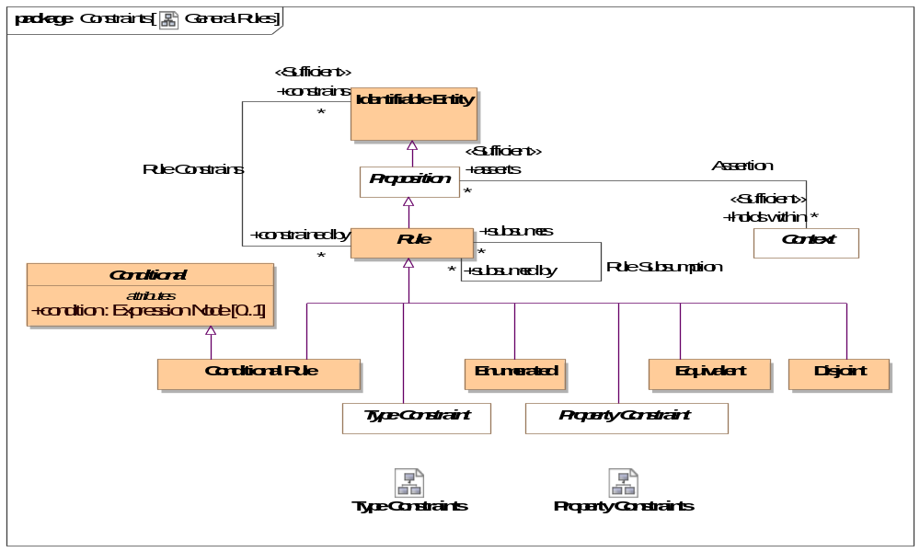
- General Rules

Diagram: Property Constraints
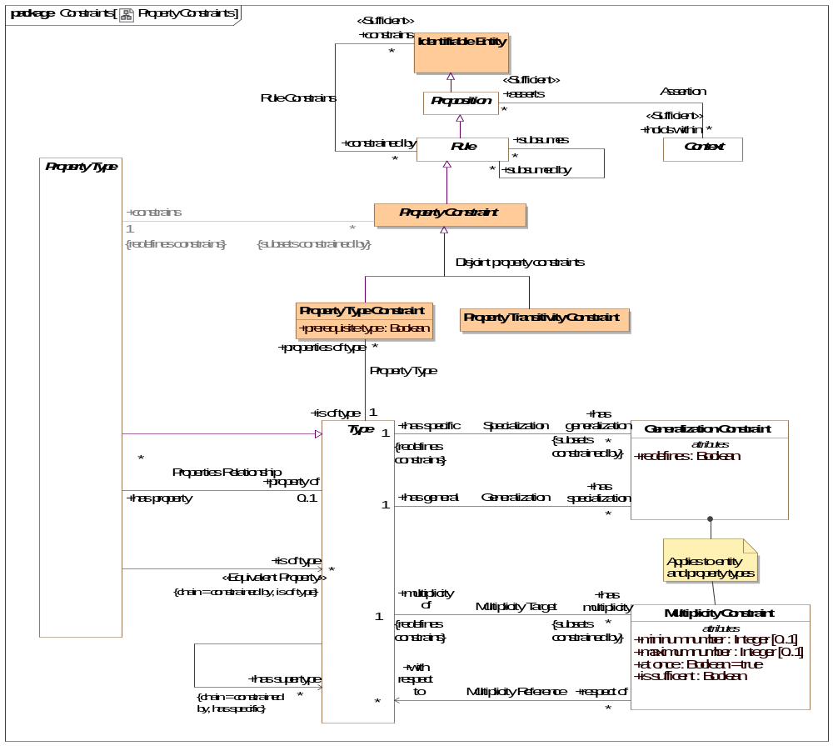
- Property Constraints
This diagram focuses on rules about properties.

Diagram: Rules in Context
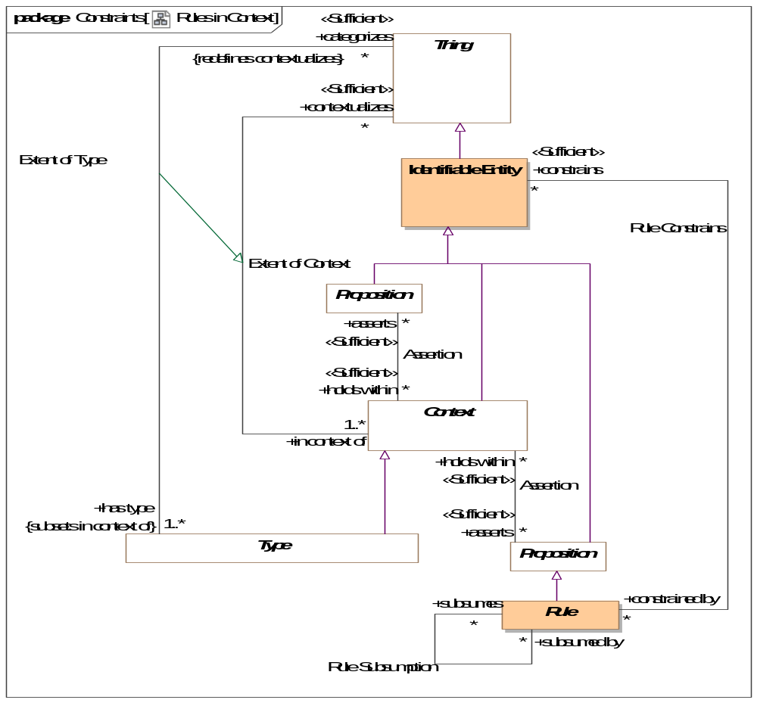
- Rules in Context
This diagram shows how rules are propositions that may be asserted within any context to apply to any other context, thus realizing the "open world assumption".

Diagram: Rules Summary
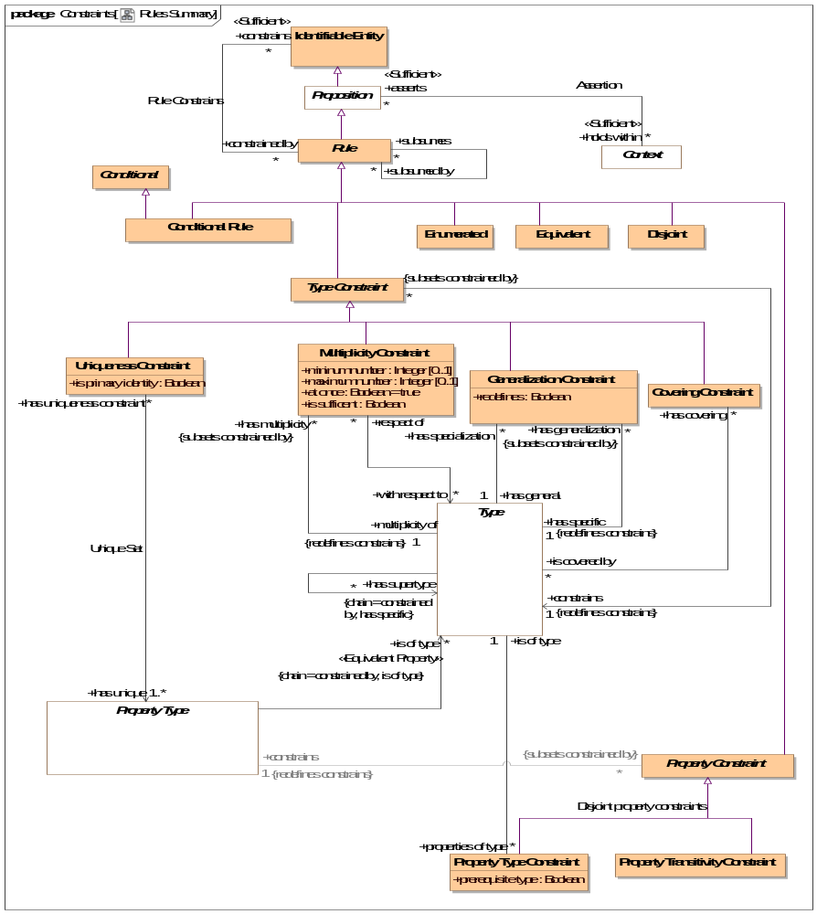
- Rules Summary
This diagram shown a summary of the primary rules.

Diagram: Type Constraints
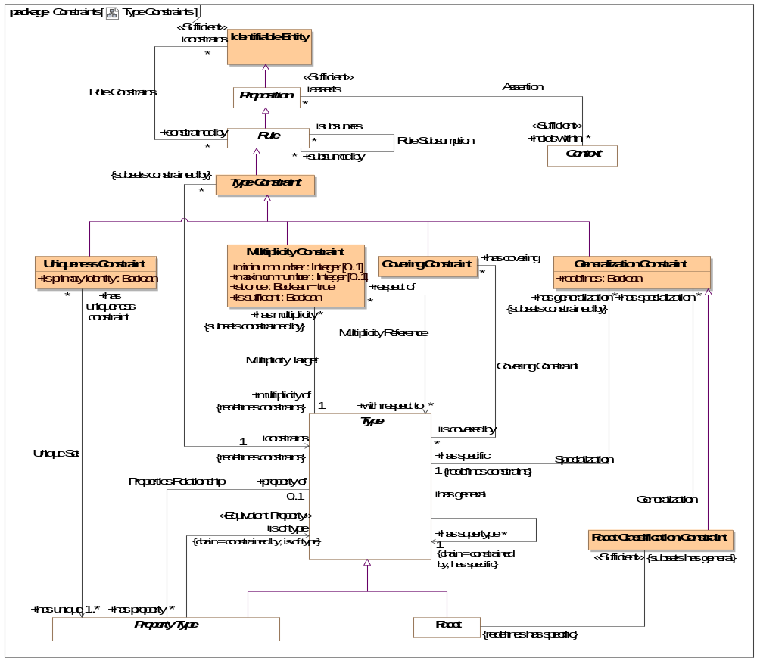
- Type Constraints
This diagram focuses on rules about types (note that property types are also types).

Class Conditional
Anything with a condition defined by an expression.
Attributes
condition : Expression Node [0..1]
Condition that must be TRUE for an element to be asserted. All values other than "TRUE" are FALSE.

Class Conditional Rule
A rule with a general expression as a condition that applies to what the rule <constrains>. Where asserted, the condition must be true.
[UML] Constraint where "context" corresponds with <holds within> and "constrainedElement" corresponds with "constrains". "specification" corresponds with "condition".
Direct Supertypes
Conditional, Rule

Class Covering Constraint
A constraint that the extent (<categorizes> things) of the <constrains> type is equivalent to the union of the extents of the <is covered by> types.
[UML] GeneralizationSet with isCovering=TRUE. "constrains" corresponds with the common "general" of each Generalization". "is covered by" corresponds with each "special" of each generalization.
Direct Supertypes
Type Constraint
Associations
is covered by : Type [*]
through association: Covering Constraint
A type covered by a covering constraint.
The <constrains> type must be a direct supertype of all <is covered by> types.

Association Covering Constraint
Relationship defining the types covered by a covering constraint.
Association Ends
is covered by : Type [*]
A type covered by a covering constraint.
The <constrains> type must be a direct supertype of all <is covered by> types.
has covering : Covering Constraint [*]
Covering constraints of a type.

Class Disjoint
Disjoint is a rule that the things denoted by what the rule <constrains> do not and may not denote any of the same set of things.
When applied to a context (including types) all elements contextualized are included in the set of disjoint individuals.
[FIBO] Mutually Exclusive sets
[IDEAS] PartitionOfSetOfDisjointIndividuals: A FusionOfSetOfIndividuals whose fusioned Type is a SetOfDisjointIndividuals.
[UML] [UML] GeneralizationSet with isDisjoint=TRUE. "constrains" corresponds with "is covered by" of each "special" of each generalization. Note the SMIF does not require that disjoint elements have a common supertype, one may be inferred for UML mapping.
[OWL: Union(DisjointClasses, DisjointObjectProperties, DisjointDataProperties, DifferentIndividuals)
Direct Supertypes
Rule

Class Enumerated
The contextualized elements of the <constrains> context is a closed (enumerated) set, it can not be extended. A.K.A. "Closed World Assumption". Elements may not be asserted by any context other than the one specified in <holds within>.
[FIBO] Selections of Things
[FUML] Wen constraining a type, corresponds with [FUML] "Enumeration". SMIF enumerations are not limited to literals. The "ownedLiteral" corresponds with all elements owned by <holds within>.
[ISO11404] Enumerated: enumerated is a family of datatypes, each of which comprises a finite number of distinguished values having an intrinsic order.
[OWL] ObjectUnitionOf( DataOneOf, ObjectOneOf )
Direct Supertypes
Rule

Class Equivalent
Equivalent is a rule that the things the rule <constraints> denote the same set of things. When applied to a context (including types) each thing the context contextualizes is included in the set of equivalent things.
Related to*: [ISO 1087] synonymy: relation between or among terms (3.4.3) in a given language representing the same concept (3.2.1)
Related to*: [ISO 1087] equivalence: relation between designations (3.4.1) in different languages representing the same concept (3.2.1)
* SMIF relates concepts, not terms. synonymy may also be represented by multiple terms for the same concept.
[OWL] Union( SameIndividual, EquivalentClasses, EquivalentObjectProperties, EquivalentDataProperties)
Direct Supertypes
Rule

Class Facet Classification Constraint
A Facet Classification Constraint asserts that the specialized type is "non rigid" with respect to the general (rigid) type - that is the <has specific> type may change over the lifetime of instances of the <has general> type. The <has specific> type will be inferred to be a Facet. e.g. "Registered voter" is a facet of a person.
[FIBO] isPlayedBy
Direct Supertypes
Generalization Constraint
Associations
<<Sufficient>> : Facet Redefines: has specific:Type

Association Generalization
Relationship defining the general type of a generalization constraint.
[ISO 1087] generic concept: concept (3.2.1) in a generic relation (3.2.21) having the narrower intension (3.2.9)
Association Ends
has general : Type [1] Redefines: has specific: Type
The general type in the Generalization rule.
[ISO 1087] concept (3.2.1) in a generic relation (3.2.21) having the broader intension (3.2.9)
[FUML] General (Where redefines is false or not defined)
[FUML] RedefinableElement.redefinedElement (Where redefines is true)
has specialization : Generalization Constraint [*] Redefines: has specific: Type
Specialization rules for a type.

Class Generalization Constraint
A Type Generalization Constraint is a taxonomic relationship between a more general <has general> type and a more specific <has specific> type. Each instance of the specific type is also an instance of the general type.
The extent (<categorizes> property) of the specific type is the same as or a subset of the extent of the more general type. Therefore, any statement that is true for all members of a supertype must also be true for all members of any subtype.
Note that "multiple inheritance" is supported.
[IDEAS] superSubtype: A couple relating two Types which asserts that one type is a subset of the other.
[ISO 1087] generic relation: genus-species relation relation between two concepts (3.2.1) where the intension (3.2.9) of one of the concepts includes that of the other concept and at least one additional delimiting characteristic (3.2.7)
[FIBO] Inheritance
[UML] Generalization
[Guizzardi] (Specialization relation): Let F and G be two universals such that F is a specialization of G. Then, for all w ∈ W we have that extw(F) ⊆ extw(G)
[OWL] Union(SubClassOf, SubPropertyOf)
Direct Supertypes
Type Constraint
Attributes
redefines : Boolean
Defines the generalization as a redefinition, subsuming the more general type in the definitional context.
Where <redefines> is true the more specific type subsumes the more general type in the definition context. In this case the more general and more specific sets are equivalent. A type may be redefined multiple times, as long as it is unambiguous which definition applies for a particular instance.
Where <redefines> is false or not defined the more specific type represents a subset of the more general property.
Redefinition is most often used with properties (as defined in UML) but may also be applied to other types.
Associations
has general : Type [1]
through association: Generalization
The general type in the Generalization rule.
[ISO 1087] concept (3.2.1) in a generic relation (3.2.21) having the broader intension (3.2.9)
[FUML] General (Where redefines is false or not defined)
[FUML] RedefinableElement.redefinedElement (Where redefines is true)
has specific : Type [1] Redefines: constrains:Identifiable Entity
through association: Specialization
The specific type in a generalization rule.
[ISO 1087] generic concept: concept (3.2.1) in a generic relation (3.2.21) having the narrower intension (3.2.9)
[FUML] specific
[ISO11404] A subtype is a datatype derived from an existing datatype, designated the base datatype, by restricting the value space to a subset of that of the base datatype whilst maintaining all characterizing operations. Subtypes
are created by a kind of datatype generator which is unusual in that its only function is to define the relationship between the value spaces of the base datatype and the subtype.
[OWL] Union( rdfs:subClassOf, SubObjectPropertyOf, SubDataPropertyOf)

Class Multiplicity Constraint
A Multiplicity constraint constrains the number of bindings <multiplicity of> types (including property types) may have in a particular instance of the constrained type.
For a property type, The number of instances bound to a property for the set of instances bound to <with respect to> shall be limited by the minimum and maximum number of the multiplicity.
For non-property types, the multiplicity shall apply to the extent of the type as described by <classifies>.
[IDEAS] superSubType
[FUML] MultiplicityElement: Note: Multiplicity Constraint constraining a type has semantics included in to UML MultiplicityElement.
[OWL] Union(ObjectMaxCardinality, ObjectMinCardinality, ObjectExactCardinality, DataMaxCardinality, DataMinCardinality, DataExactCardinality)
Direct Supertypes
Type Constraint
Attributes
mininum number : Integer [0..1]
Minimum number in a set as constrained by a multiplicity.
[FUML] MultiplicityElement.lowerValue
[OWL] MinCardinality
maximum number : Integer [0..1]
Maximum number in a set as constrained by a multiplicity.
[FUML] MultiplicityElement.upperValue
[OWL] maxCardinality
at once : Boolean = true
When at once is true, the constraint applies for each snapshot in time but not across snapshots (e.g. a car can have at most one driver at a time). When at once is false the constraint applies across all time (e.g. a person has exactly one birth mother across all time).
is sufficent : Boolean
One of the set of sufficient conditions that will infer the type designated in <constrains>.
Associations
with respect to : Type [*]
through association: Multiplicity Reference
One or more types or properties that define the "from" side of a multiplicity.
Where with respect to is undefined and <multiplicity of> is a property, all properties that are <property of> the same structured type as <multiplicity of> shall be considered the set of <with respect to> properties. I.e. all the "other ends" of a relationship.
<with respect to> provides for complex multiplicities across n-ary situations, data structures and relationships.
multiplicity of : Type [1] Redefines: constrains:Identifiable Entity
through association: Multiplicity Target
The type or property that is the subject of a multiplicity constraint.

Association Multiplicity Reference
Multiplicity may be defined between things. E.g. there are 2 wheels on a motorcycle. This is most often required where relationships have more than 2 ends.
Multiplicity reference defines the "from" side of such a multiplicity (e.g. the motorcycle).
Association Ends
with respect to : Type [*] Redefines: constrains: Identifiable Entity
One or more types or properties that define the "from" side of a multiplicity.
Where with respect to is undefined and <multiplicity of> is a property, all properties that are <property of> the same structured type as <multiplicity of> shall be considered the set of <with respect to> properties. I.e. all the "other ends" of a relationship.
<with respect to> provides for complex multiplicities across n-ary situations, data structures and relationships.
respect of : Multiplicity Constraint [*] Redefines: constrains: Identifiable Entity
Multiplicity constraints using a property or type as a <with respect to> reference.

Association Multiplicity Target
Relationship defining the type a multiplicity rule applies to. Note that properties are types and may also have multiplicity constraints.
Direct Supertypes
Rule Constrains
Association Ends
multiplicity of : Type [1] Redefines: constrains: Identifiable Entity
The type or property that is the subject of a multiplicity constraint.
has multiplicity : Multiplicity Constraint [*] Redefines: constrains: Identifiable Entity
Multiplicity constraint of a type or property.

Class Property Constraint
Abstract supertype for constraints that constrain properties types.
Direct Supertypes
Rule
Associations
<<Restriction>> constrains : Property Type [1] Redefines: constrains:Identifiable Entity

Class Property Transitivity Constraint
A transitive property defined by <constrains> interlinks two individuals A and C whenever it interlinks A with B and B with C for some individual B.
For example "larger than" is transitive in that if Joe is larger than Sue and Sue is Larger then Sam, then Joe is larger than Sam.
[OWL] TransitionObjectProperty
Direct Supertypes
Property Constraint

Association Property Type
Relationship defining the type of a property.
Association Ends
is of type : Type [1] Redefines: constrains: Identifiable Entity
A required type of a thing bound to a property.
Note that the type may be inferred based on the value of <prerequisite type>.
[OWL] rdfs:range,
properties of type : Property Type Constraint [*] Redefines: constrains: Identifiable Entity
Properties typed by a type

Class Property Type Constraint
A property type constraint defines the type(s) of a property.
All elements bound to a property must have the type <is of type>. <is of type> may be pre-existing or inferred based on the value of <prerequisite type>.
Note that Property Type Constraint is a rule independent of the definition of a property to allow for the type of a property to be refined in a more restrictive context.
[FUML] TypedElement.type: Note: A property type constraint applied to a property has the same semantics as a UML TypedElement.
[OWL] Union( AllValuesFrom, SomeValuesFrom, DataPropertyRange, ObjectPropertyRange)). <is of type> corresponds to rdfs:Range. <constrains> corresponds to rdfs:Domain (note that in an association type or relationship type with two property types, the range will be the domain of the "opposite" property, if any).
Direct Supertypes
Property Constraint
Attributes
prerequisite type : Boolean
If true, <is of type> is a prerequisite - the bound thing must be of the given type for the property to be bound. A non prerequisite type will cause a binding to infer <is of type>, provided all prerequisite types have been satisfied.
Associations
is of type : Type [1]
through association: Property Type
A required type of a thing bound to a property.
Note that the type may be inferred based on the value of <prerequisite type>.
[OWL] rdfs:range,

Class Rule
A rule is a proposition that constrains one or more entities by limiting possible conditions or producing some effect.
Note that rules may or may not be defined in the same context that they hold within or constraint. This support the "open world assumption" that a rule may be asserted outside of the scope of the rule or what the rule is constraining.
Direct Supertypes
Proposition
Associations
constrains : Identifiable Entity [*]
through association: Rule Constrains
The entity or entities constrained by a rule.
Where a rule constrains a context, all things contextualized by the context shall be subject to the rule.
Where there are no <constrains> for a rule, the rule applies globally - to the universal context.
subsumes : Identifiable Entity [*]
through association: Rule Subsumption
When a rule subsumes another the subsumed rule will not apply (fire) if the <subsumed by> rules applies (fires).
Where rules are also patterns, a rule may specialize another which will subsume the specialized rule as well as include the generalized rule parts as parts of the specialized rule.
subsumed by : Identifiable Entity [*]
through association: Rule Subsumption
When rule is <subsumed by> another the subsumed rule will not apply (fire) if the <subsumed by> rules applies (fires).

Association Rule Constrains
Relationship defining the entity constrained by a rule. Where no constrained entity is specified, all entities are constrained with the scope of <holds within> are constrained.
Association Ends
constrains : Identifiable Entity [*]
The entity or entities constrained by a rule.
Where a rule constrains a context, all things contextualized by the context shall be subject to the rule.
Where there are no <constrains> for a rule, the rule applies globally - to the universal context.
constrained by : Rule [*]
Rules applying to an entity.

Association Rule Subsumption
Relationship defining rule subsumption. When a rule subsumes another the subsumed rule will not apply (fire) if the <subsumed by> rules applies (fires).
Association Ends
subsumes : Rule [*]
When a rule subsumes another the subsumed rule will not apply (fire) if the <subsumed by> rules applies (fires).
Where rules are also patterns, a rule may specialize another which will subsume the specialized rule as well as include the generalized rule parts as parts of the specialized rule.
subsumed by : Rule [*]
When rule is <subsumed by> another the subsumed rule will not apply (fire) if the <subsumed by> rules applies (fires).

Association Specialization
Relationship defining the specific type of a generalization constraint.
Direct Supertypes
Rule Constrains
Association Ends
has specific : Type [1]
The specific type in a generalization rule.
[ISO 1087] generic concept: concept (3.2.1) in a generic relation (3.2.21) having the narrower intension (3.2.9)
[FUML] specific
[ISO11404] A subtype is a datatype derived from an existing datatype, designated the base datatype, by restricting the value space to a subset of that of the base datatype whilst maintaining all characterizing operations. Subtypes
are created by a kind of datatype generator which is unusual in that its only function is to define the relationship between the value spaces of the base datatype and the subtype.
[OWL] Union( rdfs:subClassOf, SubObjectPropertyOf, SubDataPropertyOf)
has generalization : Generalization Constraint [*]
Generalization rules for a type

Class Type Constraint
A constraint of a type, including Relationships types.
Direct Supertypes
Rule
Associations
constrains : Type [1] Redefines: constrains:Identifiable Entity

Association Unique Set
Relationship defining the set of properties that uniquely identify an instance of the constrained type.
Association Ends
has unique : Property Type [1..*] Redefines: constrains: Identifiable Entity
The set of involved properties within a type that uniquely identify an individual.
has uniqueness constraint : Uniqueness Constraint [*] Redefines: constrains: Identifiable Entity
Uniqueness constraints for a property.

Class Uniqueness Constraint
A constraint that, within the <constrains> type the rule applies to, the set of instances bound to the set of types in the "has unique" relation must be unique and serves to define the "identity" of each individual.
Note: Uniqueness may be used to define a "key".
[OWL] HasKey where CE (subject class expression) is <constrains> and <has unique> is Union(ObjectPropertyExpression, DataPropertyExpression)
Direct Supertypes
Type Constraint
Attributes
is primary identity : Boolean
A uniqueness constraint that can be interpreted as a "primary key", the identity of an entity.
Associations
has unique : Property Type [1..*]
through association: Unique Set
The set of involved properties within a type that uniquely identify an individual.

SMIF Conceptual Model::Expressions
Expressions define computations across SMIF models.

Diagram: Expressions
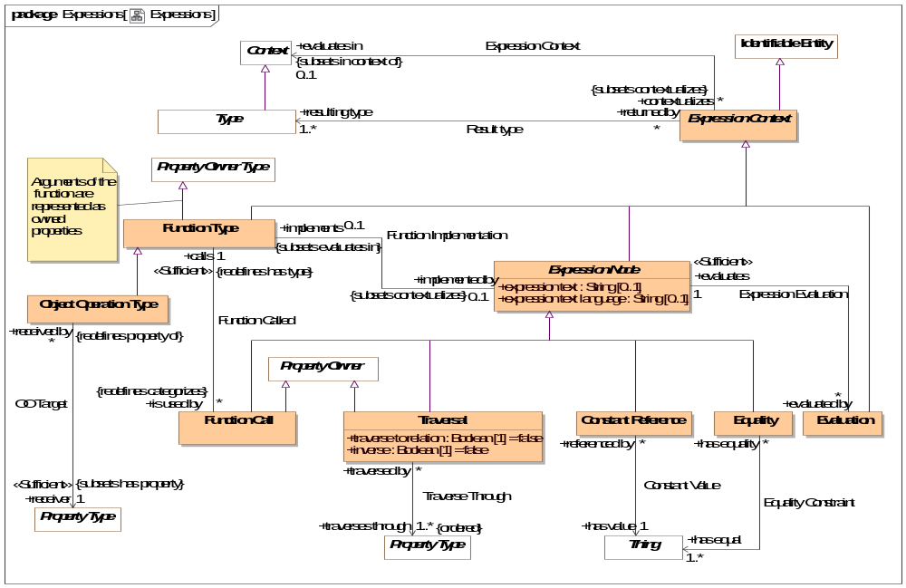
- Expressions
Expressions define computations

Class Constant Reference
A calculation that returns a thing identified by <has value>.
[FIBO] Constant
[FUML] LiteralSpecification where subtype of literal is determined by the type of <has value>.
-LiteralInteger->type is Integer or a subtype
-LiteralReal-> type is not integer or a subtype
-LiteralBoolean->type is Boolean
-LiteralString->type is Text
Direct Supertypes
Expression Node
Associations
has value : Thing [1]
through association: Constant Value
A constant value referenced in an expression.

Association Constant Value
Relationship defining a link to a constant value within an expression.
Association Ends
has value : Thing [1]
A constant value referenced in an expression.
referenced by : Constant Reference [*]
Referencing constant expression node.

Class Equality
Returns TRUE if all <has equal> things have the same value or represent the same thing or set of things regardless of how they are represented.
Equality will return TRUE or FALSE.
[ISO11404: EqualityIn every value space there is a notion of equality, for which the following rules hold:
⎯ for any two instances (a, b) of values from the value space, either a is equal to b, denoted a = b , or a is not equal to b, denoted a ≠ b ;
⎯ there is no pair of instances (a, b) of values from the value space such that both a = b and a ≠ b ;
⎯ for every value a from the value space, a = a ;
⎯ for any two instances (a, b) of values from the value space, a = b if and only if b = a ;
⎯ for any three instances (a, b, c) of values from the value space, if a = b and b = c , then a = c . On every datatype, the operation Equal is defined in terms of the equality property of the value space, by:
⎯ for any values a, b drawn from the value space, Equal(a,b) is true if a = b , and false otherwise.
Direct Supertypes
Expression Node
Associations
has equal : Thing [1..*]
through association: Equality Constraint
Set of things that must have the same value or represent the same thing or set of things for Equality to return true.

Association Equality Constraint
Relationship defining set of things that will be evaluated for equality.
Association Ends
has equal : Thing [1..*]
Set of things that must have the same value or represent the same thing or set of things for Equality to return true.
has equality : Equality [*]
Equality constraints for a thing.

Class Evaluation
The evaluation of an expression. All references to an evaluation shall return the result of evaluating the <evaluates> expression node. All expression nodes referenced within an evaluation shall return the result of evaluating that expression node.
An evaluation may be used in place of anything that requires the <resulting type> of the evaluation.
Direct Supertypes
Expression Context
Associations
evaluates : Expression Node [1]
through association: Expression Evaluation
The expression node "head" an evaluation evaluates.

Association Expression Context
Context in which an expression will be evaluated.
Direct Supertypes
Extent of Context
Association Ends
evaluates in : Context [0..1]
Context of evaluation and namespace resolution for an expression.
contextualizes : Expression Context [*]
Expressions referencing a context.

Class Expression Context
An abstract element defining the static or dynamic evaluation context and resulting type of an expression.
An expression context that is referenced by another expression context inherits the referencing context by default.
Direct Supertypes
Identifiable Entity
Associations
evaluates in : Context [0..1] Subsets: in context of:Context
through association: Expression Context
Context of evaluation and namespace resolution for an expression.
resulting type : Type [1..*]
through association: Result type
Type of the result of a function
[UML] type (of an operation or expression).

Association Expression Evaluation
Relationship defining the expression that will be evaluated by an evaluation.
Association Ends
evaluates : Expression Node [1]
The expression node "head" an evaluation evaluates.
evaluated by : Evaluation [*]
Evaluations of an expression node.

Class Expression Node
An abstract class representing the computation of a value which is then bound to the context from which it is called. Each expression node has a type of the most general type it can return.
An expression node may reference other elements. Where the other elements are also expression nodes they will be considered part of the referencing expression and evaluated in the context of that expression.
The set of related expression nodes forms a "tree" for evaluation.
[FIBO] Expression
[UML] Expression
Direct Supertypes
Expression Context
Attributes
expression text : String [0..1]
Textual expression of the expression which is further refined by subtypes of expression.
[UML] StringExpression
expression text language : String [0..1]
expression language used for the expression text
Associations
evaluated by : Evaluation [*]
through association: Expression Evaluation
Evaluations of an expression node.

Class Function Call
An element of an expression that performs some operation based on a function type and produces a result. I.e. plus(a,1).
Arguments are bound to the function call via bindings.
Direct Supertypes
Expression Node, Property Owner
Associations
calls : Function Type [1] Redefines: has type:Type
through association: Function Called
Function called

Association Function Called
Relationship defining the function (a type) called by a function call.
Direct Supertypes
Extent of Type
Association Ends
calls : Function Type [1] Redefines: has type: Type
Function called
is used by : Function Call [*] Redefines: has type: Type
Function calls using a function declaration.

Association Function Implementation
Relationship defining the implementation of a function by an expression.
Direct Supertypes
Expression Context
Association Ends
implemented by : Expression Node [0..1] Redefines: has type: Type
Expression which defines the implementation of a function.
implements : Function Type [0..1] Redefines: has type: Type
Function implemented by an expression

Class Function Type
A declaration of a function which performs a calculation on arguments (properties) to produce a result (function result). I.e. the definition of plus(a:Number, b:Number).
Functions are intended to be side-effect free and context free (they only depend on their arguments and don't change anything) but assertions to specify that certain functions are pure may be required,
Note: FUNCTION ARGUMENTS ARE PROPERTIES of the function.
[FUML] Operation where ownedParameter corresponds with <has property> and type corresponds with <resulting type>.
Direct Supertypes
Expression Context, Property Owner Type
Associations
implemented by : Expression Node [0..1] Subsets: contextualizes:Thing
through association: Function Implementation
Expression which defines the implementation of a function.
is used by : Function Call [*] Redefines: categorizes:Thing
through association: Function Called
Function calls using a function declaration.

Class Object Operation Type
An operation bound to a specific "receiver" in the "Object Oriented" sense.
[FUML] Operation
Direct Supertypes
Function Type
Associations
receiver : Property Type [1] Subsets: has property:Property Type
through association: OO Target
The property that is the receiver of an object operation.
[UML] class (of Operation)

Association OO Target
Relationship defining the "target" type of an object oriented function.
Association Ends
receiver : Property Type [1] Subsets: has property:Property Type
The property that is the receiver of an object operation.
[UML] class (of Operation)
received by : Object Operation Type [*] Subsets: has property:Property Type
The Object Operation for which a receiver is defined.

Association Result type
Relationship defining the type or types returned by an expression evaluation.
Association Ends
resulting type : Type [1..*] Subsets: has property:Property Type
Type of the result of a function
[UML] type (of an operation or expression).
returned by : Expression Context [*] Subsets: has property:Property Type
Method returning a type.

Class Traversal
Traversal from the current <evaluates in> context to another across a relation or other structure.
A traversal is a structure such that the structure's bindings may hold other properties of a traversal constant as independent variables where <traverses through> is the dependent variable. The traversal shall be considered to have the type of the relation it is traversing. Traversing binary relations does not require any bindings.
[OWL] ObjectPropertyChain
Direct Supertypes
Expression Node, Property Owner
Attributes
traverse to relation : Boolean [1] = false
Where traverse to relation is false, the traversal will return the bound element(s) of the <traverses through> property from the current context via any intermediate relationships.
Where traverse to relation is true, the traversal shall return the structure/situation/relationship owning the property binding.
By default, traverse to relation is false.
inverse : Boolean [1] = false
Indicates that the traversal is defined based on properties that reference the current context. This results in traversing "backwards" across a property to an inverse property or the relation.
Associations
traverses through : Property Type [1..*]
through association: Traverse Through
Property or properties through which a traversal traverses as the dependent variable(s).

Association Traverse Through
Relationship defining the property of the current context which will be traversed.
Association Ends
traverses through : Property Type [1..*]
Property or properties through which a traversal traverses as the dependent variable(s).
traversed by : Traversal [*]
Traversals through a property.

SMIF Conceptual Model::Facets
The facet package defines facets, roles and phases. Types that "mix in" to other types in a specific context or timeframe.

Diagram: Facets
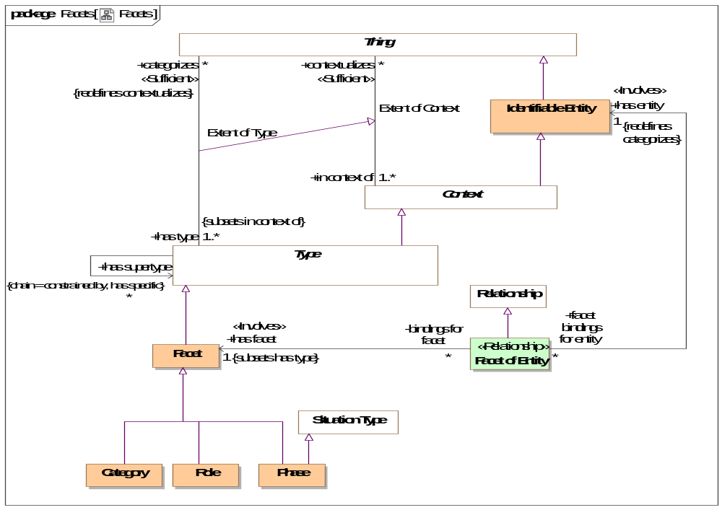
- Facets

Class Category
A category is a classification or division of people, events or things regarded as having particular shared characteristics. Categorization is typically contextual, potentially transient and may or may not be formally defined.
As with all facets, categories are non-rigid. Something classified by a category must also be classified by an entity type.
Direct Supertypes
Facet

Class Facet
A facet is a "mix in" type that defines an aspect of something but does not define the identity or "fundamental" (A.K.A. "Rigid") type of that thing, but some potentially transient role, phase or other way to classify it. Something must have at least one type that is not a facet to define that things identity.
Facets do not define independent identity of the referent but technology implementations may create independent objects to represent a facet.
An instance of a facet must also have a type that is not a facet to provide the identity of the instance.
The type(s) a facet may categorize may be constrained by a Facet Generalization Constraint. E.g. Policeman is a role of a person.
[Guarino1994] Non-Substantial sortal
[Guizzard] Non-Rigid Universal: A universal G is non-rigid iff for a w ∈ W There is an x such that x ∈ extw(G), and there is a w∈ W such that x ∉extw(G)
[SOWA1999] Prehension (Relative
Direct Supertypes
Type
Associations
<<Sufficient>> : Facet Classification Constraint Subsets: has general:Type

Class Facet of Entity <<Relationship>>
Facet of entity is the binding of a particular entity to a facet. May also be considered an "as a" relationship. In the case of a role, it states that an entity plays the role, e.g. "Joe as a policeman". In the case of a phase, it states that an entity has that phase and that it is a phase of that entity, e.g. Sue as a teenager.
Facet of Entity is a kind of contextual categorization in that the entity assumes all of the characteristics of the facet where the Facet of Entity is asserted. E.g. if Joe has a policeman role, Joe is a policeman.
Facet of entity is an "Extent of Type" association reified as a relationship in that the binding of the entity to the facet may be valid in particular context or time frame. Facet of entity may be the consequence of a relationship. Note: Not represented as an association class due to OMG-MOF limitations.
Facet of entity may only relate entities that have a type compatible with the type of the facet, as defined by a Facet Classification Rule.
[FIBO] (for roles of actors) AgentInRole.
[FIBO] (for roles of anything else) ThingInRole
[Guarino1994] Externally Dependent Moment (Also called "Qua individual")
[SOWA1999] Prehension
Direct Supertypes
Relationship
Associations
has facet : Facet [1] Subsets: has type:Type
The facet that an entity assumes when it is the facet of an entity.
[FIBO] (for roles) playsRole
has entity : Identifiable Entity [1] Redefines: categorizes:Thing
The entity having a facet (including roles and phases).
[FIBO] (for roles) isPlayedBy

Class Phase
A phase (or state) is a static characteristic of something that exists for limited time(s). Something takes on or looses a phase as a result of some event. E,g, Teenager, living, closed invoice.
A Phase is a situation in that there is a situation coincident with each phase.
[Guizzardi] (Phased-Sortal): Let PS be a universal and let S be a
substance sortal specialized (restricted by) PS. Now, let extw(~PS) = extw(S) \ extw(PS)
be the complement of the extension of PS in world w. In this formula, the
symbol \ represents the set theoretical operation of set difference. The
universal PS is a phased-sortal iff for all worlds w ∈ W, there is a w ∈ W such
that extw(PS) ∩ extw(~PS) ≠ ∅
Direct Supertypes
Facet, Situation Type

Class Role
A role is a facet type that defines a specific purpose or behavior of a class of things. E.g. teacher, policeman, or employer.
[FIBO] Role. Note that partyInRole or thingInRole are implied by classification of a thing.
Direct Supertypes
Facet

SMIF Conceptual Model::Identifiers
Terms and identifiers provide for signs for (ways to identify) anything.

Diagram: Identifiers
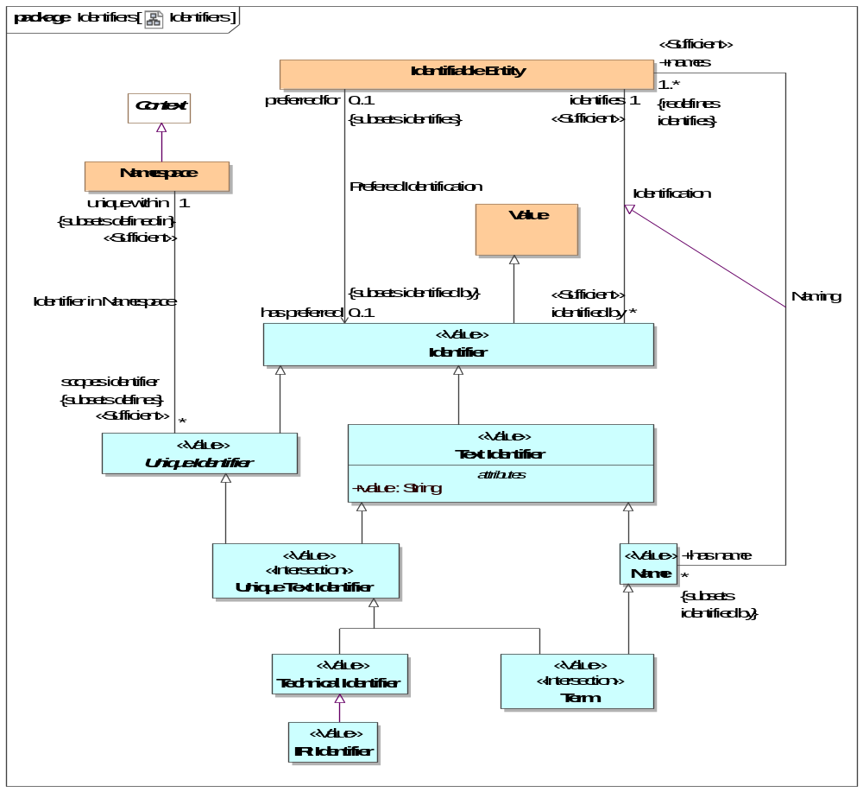
- Identifiers
An identifier that can be represented as text. The text is in the "value" property.
[IDEAS] Sign: An Individual that signifies a Thing.

Association Identification
Relationship defining an identifier for an entity.
[IDEAS] namedBy: A couple that asserts that a Name describes a Thing.
[ISO 1087] Designation
Association Ends
identifies : Identifiable Entity [1] Redefines: categorizes: Thing
The entity an identifier identifies.
[FIBO] identifies: is the relationship between something and that which provides a unique reference for it
[ISO 1087] designator: representation of a concept (3.2.1) by a sign which
denotes it
identified by : Identifier [*] Redefines: categorizes: Thing
An identifier for an <Entity>.
[FIBO] hasDenotation

Class Identifier <<Value>>
An identifier is any value that is used to distinguish an entity from other entities. Note that any identifier may be contextualized by one or more context, including language context. Identifiers are a “sign” for an identity where identity is an abstraction of individuality that is the basis for identifiers.
[IDEAS] Name: A Representation that identifies a Thing.
[FIBO] Identifier
[CL] Term: expression which denotes an individual, consisting of either a name or, recursively, a function term applied to a sequence of arguments, which are themselves terms
Direct Supertypes
Value
Associations
<<Sufficient>> identifies : Identifiable Entity [1]
through association: Identification
The entity an identifier identifies.
[FIBO] identifies: is the relationship between something and that which provides a unique reference for it
[ISO 1087] designator: representation of a concept (3.2.1) by a sign which
denotes it

Association Identifier in Namespace
Relationship defining the namespace within which a unique identifier is defined and unique.
[ISO 1087] monosemy: relation between designations (3.4.1) and concepts (3.2.1) in a given language in which one designation only relates to one concept
Direct Supertypes
Definition
Association Ends
unique within : Namespace [1]
The namespace in which an identifier is defined and has a unique value.
[FUML] memberNamespace
scopes identifier : Unique Identifier [*]
An Identifier defined within the scope of a namespace.
[FUML] member

Class IRI Identifier <<Value>>
A IRI/URI Identifier for an entity, as defined in [RFC3987].
[FIBO] anyURI
Direct Supertypes
Technical Identifier

Class Name <<Value>>
A word or set of words by which a person, animal, place, or thing is known, addressed, or referred to. Names are not necessarily unique.
[IDEAS] Name: A Representation that identifies a Thing.
[CL] Discourse Name
Direct Supertypes
Text Identifier
Associations
names : Identifiable Entity [1..*] Redefines: identifies:Identifiable Entity
through association: Naming
An entity named by a name.

Class Namespace
A namespace is a context that provides a way to make identifiers unique and identify exactly one entity. For example, the Virginia driver's license division provides unique driver's license numbers.
Similar to [IDEAS] UniqueNamingScheme: A NamingScheme where different Names will not contain tokens of the same Representation Type.
Note: SMIF identifiers are not instances of their namespace.
[FIBO] IdentificationScheme: system for allocating identifiers to objects
[ISO 1087] terminology 1: set of designations (3.4.1) belonging to one special language (3.1.3)
[FUML] Namespace
[CL] Vocabulary
Direct Supertypes
Context
Associations
<<Sufficient>> scopes identifier : Unique Identifier [*] Subsets: defines:Thing
through association: Identifier in Namespace
An Identifier defined within the scope of a namespace.
[FUML] member

Association Naming
Relationship defining a human meaningfully name for an entity.
Direct Supertypes
Identification
Association Ends
names : Identifiable Entity [1..*] Subsets: defines:Thing
An entity named by a name.
has name : Name [*] Subsets: defines:Thing
A human meaningful name for an entity.
[FIBO] hasName: that by which some thing is known; may apply to anything
[OWL] rdfs:label

Association Prefered Identification
Relationship defining the preferred identifier for an entity.
[ISO 1087] preferred term: term (3.4.3) rated according to the scale of the term acceptability rating (3.4.14) as the primary term for a given concept (3.2.1)
Direct Supertypes
Identification
Association Ends
has preferred : Identifier [0..1] Subsets: defines:Thing
Default identifier to use for an entity.
Where multiple identifiers are preferred in differing context any method for selecting the most preferred identifier is implementation specific and not specified by this standard.
[FUML] NamedElement.name: Note: An Identifier that is <preferred for> an entity is equivalent to the name of a named element.
preferred for : Identifiable Entity [0..1] Subsets: defines:Thing
The entity an identifier is preferred for.

Class Technical Identifier <<Value>>
A technical identifier is defined within a technical system, information structure or system of systems for references and identity within that system or information element. Such identifiers may have no meaning outside of that system.
Typical technical identifiers include inter document "refs", record numbers, etc. The system should be referenced as the namespace.
Direct Supertypes
Unique Text Identifier

Class Term <<Value>><<Intersection>>
A word, phrase or name used by stakeholders to uniquely identify entities.
[ISO 1087] term: verbal designation of a general concept in a specific subject field.
Direct Supertypes
Name, Unique Text Identifier

Class Text Identifier <<Value>>
A code or other simple value that can be represented as text, identifying something that may or may not be unique. Simple identifiers may be codes, names, numbers or compound values.
[NIEM] IdentificationType (IdentificationID=value)
Direct Supertypes
Identifier
Attributes
value : String
Text value of an identifier

Class Unique Identifier <<Value>>
A unique identifier is an entity used to uniquely identify something. The identified thing is referenced by what the identifier <identifies>.
Identifiers are defined and <unique within> a lexical scope as its namespace.
Multiple identifiers may use the same word or text value (or other forms of values) in differing <unique within> namespaces such that the same word may have different meanings in different context.
An entity may have any number of identifiers.
Direct Supertypes
Identifier
Associations
<<Sufficient>> unique within : Namespace [1] Subsets: defined in:Lexical Scope
through association: Identifier in Namespace
The namespace in which an identifier is defined and has a unique value.
[FUML] memberNamespace

Class Unique Text Identifier <<Value>><<Intersection>>
An <Identifier> that is represented using text. e.g. a "word", "phrase" or "name".
Direct Supertypes
Text Identifier, Unique Identifier

SMIF Conceptual Model::Kernel
The kernel subsets the SMIF classes. The diagrams in this package illustrate the concrete classes that are used to define the SMIF language.
Note that shaded classes are not instantiated in the kernel and may be "flattened". Specifications for each class and association are defined in the corresponding package for that concept.

Diagram: Kernel Associations
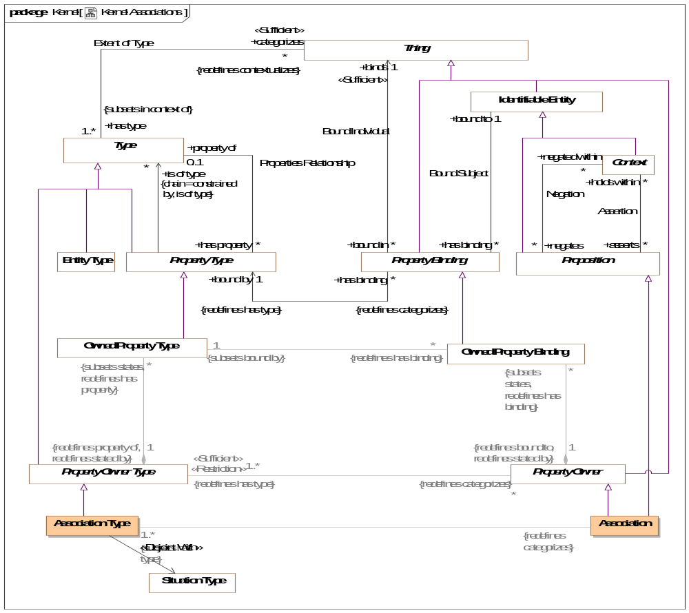
- Kernel Associations

Diagram: Kernel Identifiers
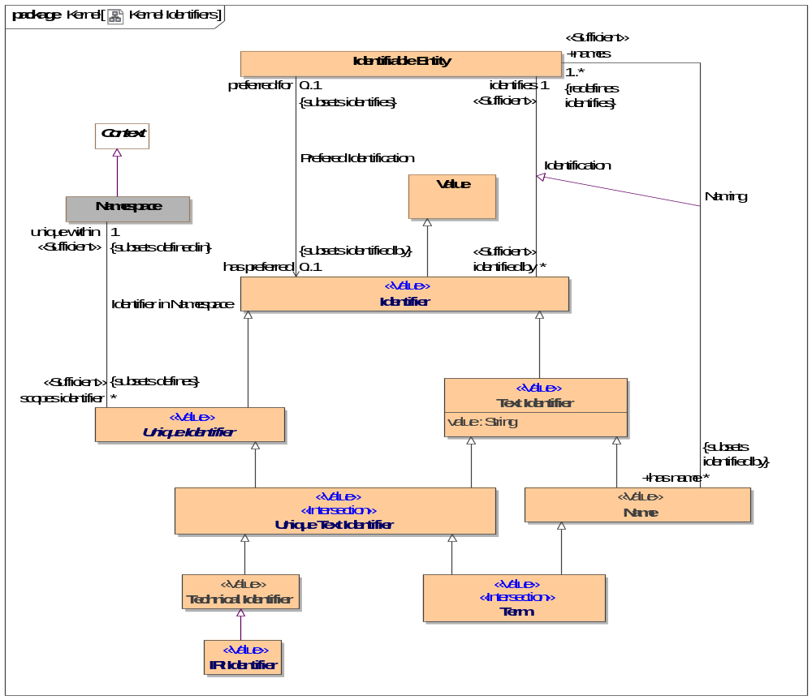
- Kernel Identifiers
An identifier that can be represented as text. The text is in the "value" property.
[IDEAS] Sign: An Individual that signifies a Thing.

Diagram: Kernel Lexical Scope
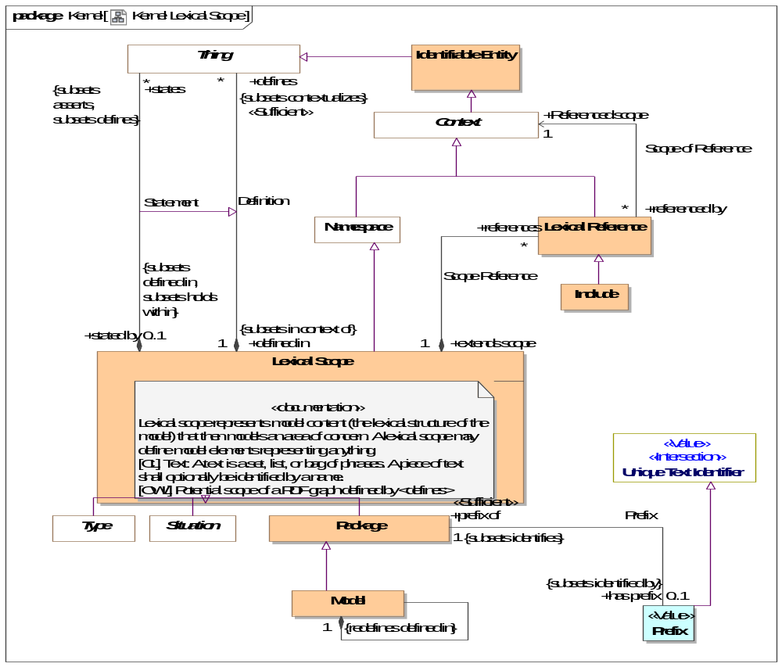
- Kernel Lexical Scope

Diagram: Kernel Metadata
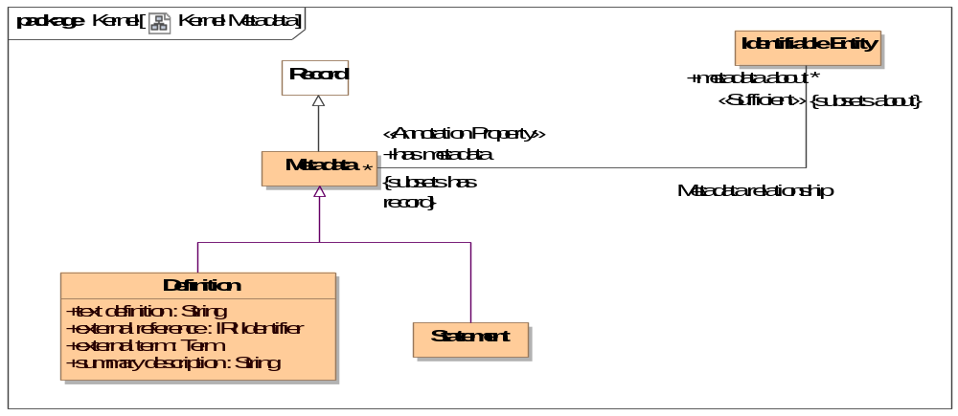
- Kernel Metadata

Diagram: Kernel Properties
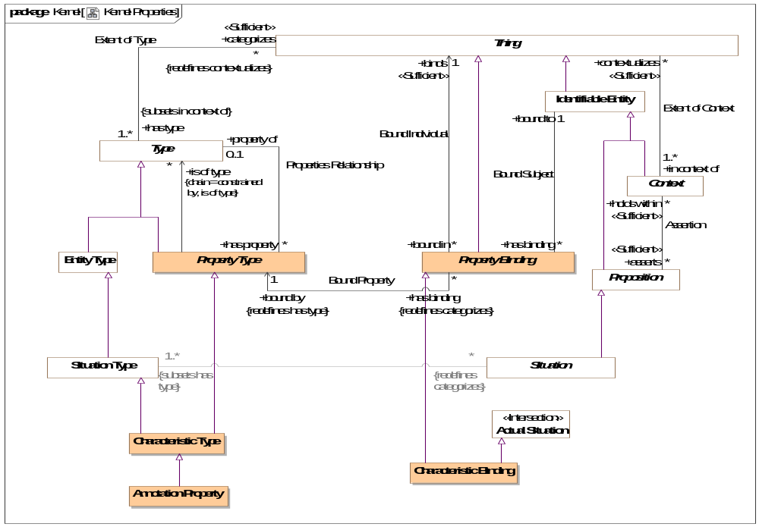
- Kernel Properties

Diagram: Kernel Rules Summary
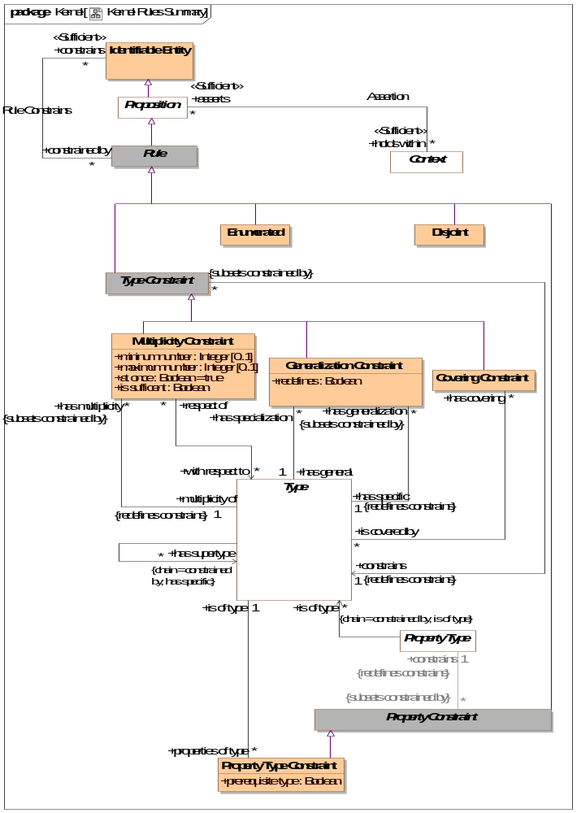
- Kernel Rules Summary
This diagram shown a summary of the primary rules.

Diagram: Kernel Top Level
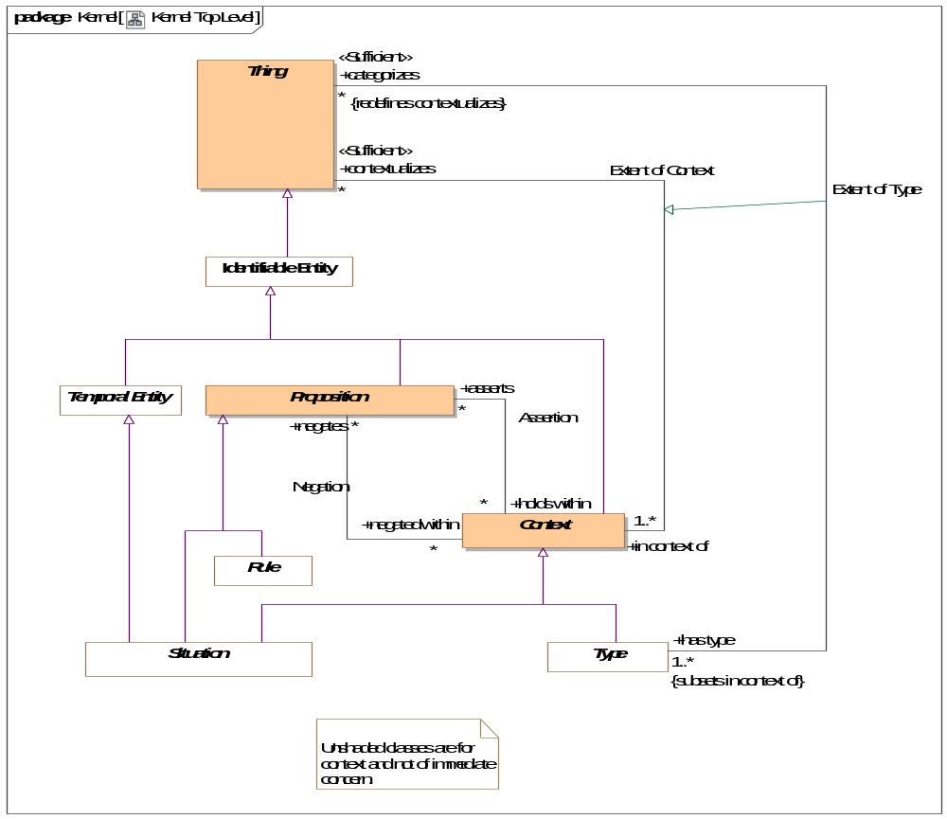
- Kernel Top Level
Diagram showing summary of top level classes and significant subtypes.

Diagram: Kernel Types
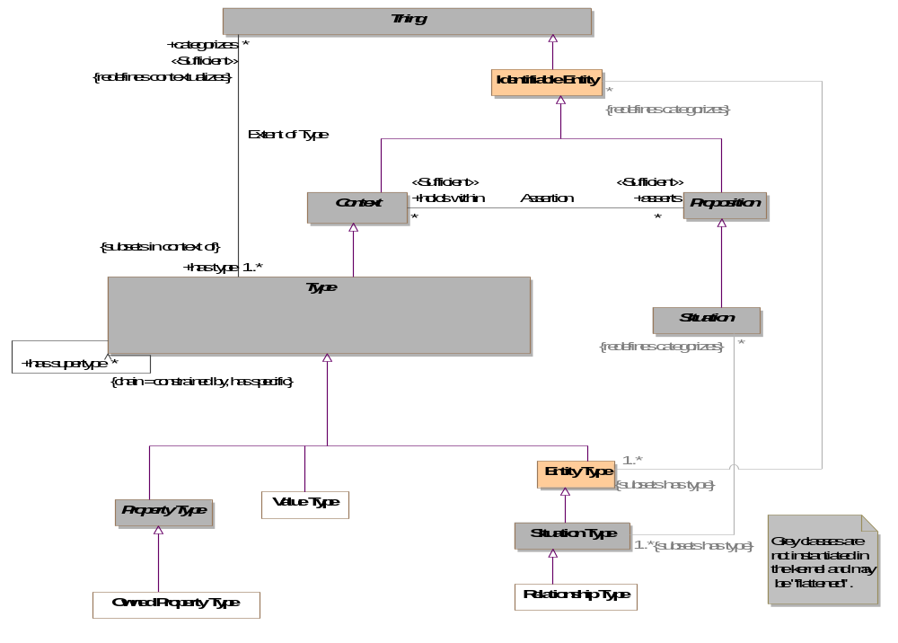
- Kernel Types

Diagram: Kernel Values
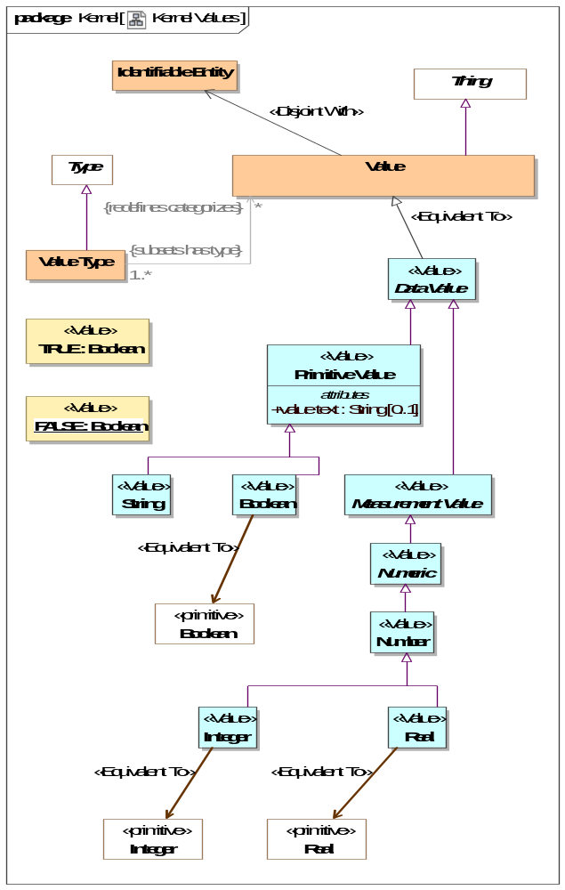
- Kernel Values

SMIF Conceptual Model::Lexical Scope
Lexical scope defines the structure of models and the ownership of model elements.

Diagram: Lexical Scope
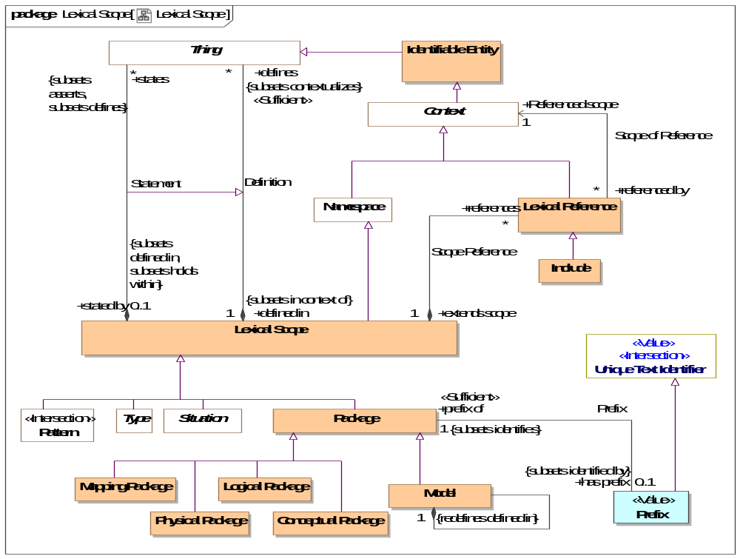
- Lexical Scope

Class Conceptual Package
A model of a real or possible world as conceived by the model authors.
Direct Supertypes
Package

Association Definition
Relationship defining the set of elements defined within a lexical scope.
[OWL] RDF Graph
Direct Supertypes
Extent of Context
Association Ends
defines : Thing [*] Subsets: defined in:Lexical Scope
A model element defined within a lexical scope.
Definition within a scope does not assert everything within a scope but the lexical scope may be independently asserted, thus asserting what it defines.
[FUML] ownedElement, ownedMember
defined in : Lexical Scope [1] Subsets: defined in:Lexical Scope
Lexical scope defining model elements.
[UML]owner

Class Include
An "Include" is an external scope that is visible and asserted by the owning lexical scope.
[FUML] PackageImport
[CL] Importation: An importation contains a name. The intention is that the name identifies a piece of Common Logic content represented externally to the text, and the importation re-asserts that content in the text.
Direct Supertypes
Lexical Reference

Class Lexical Reference
A Lexical Reference is an external scope that is visible to but not necessarily asserted by the owning lexical scope.
Direct Supertypes
Context
Associations
Referenced scope : Context [1]
through association: Scope of Reference
A referenced context, potentially in another model, that provides visibility to the elements in that context.
[FUML] importedPackage
[OWL] directlyImports (implies "Include")
extends scope : Lexical Scope [1]
through association: Scope Reference
A lexical scope that is extended by a lexical reference.
[FUML] importingNamespace

Class Lexical Scope
Lexical scope represents model content (the lexical structure of the model) that then models an area of concern. A lexical scope may define model elements representing anything.
[CL] Text: A text is a set, list, or bag of phrases. A piece of text shall optionally be identified by a name.
[OWL] Potential scope of a RDF graph defined by <defines>
Direct Supertypes
Namespace
Associations
defines : Thing [*] Subsets: contextualizes:Thing
through association: Definition
A model element defined within a lexical scope.
Definition within a scope does not assert everything within a scope but the lexical scope may be independently asserted, thus asserting what it defines.
[FUML] ownedElement, ownedMember
references : Lexical Reference [*]
through association: Scope Reference
A reference providing visibility of a lexical scope to an internal or external context.
states : Thing [*] Subsets: defines:Thing asserts:Proposition
through association: Statement
<states> combines <defines> with <has assertion> to both define and assert an element within a lexical scope. <states> provides a more "structural" organization of concepts that are both defined and asserted in the same structure.
<states> is a convenience for the common case where assertion and lexical containment are combined.

Class Logical Package
A model of information about systems independent of technical representation.
Direct Supertypes
Package

Class Mapping Package
A model defining relationships between other models.
Direct Supertypes
Package

Class Model
A root package. A model has no owner and may be directly referenced as an independent information resource. A model is defined in it's self.
Direct Supertypes
Package
Associations
: Thing [*] Subsets: defines:Thing asserts:Proposition
: Thing [*] Subsets: defines:Thing asserts:Proposition

Class Package
A model element that provides a definitional scope for other model elements. A package may be represented as a "graph".
[ISO 1087] concept system: system of concepts set of concepts (3.2.1) structured according to the
relations among them
[FUML] Package. FUML ownedMember corresponds with SMIF <defines>. FUML "nestedPackage" corresponds with "defines" where the element defined is a package.
[CL] Module: A module consists of a name, an optional set of names called the exclusion set, and a text called the body text.
Direct Supertypes
Lexical Scope
Associations
<<Sufficient>> has prefix : Prefix [0..1] Subsets: identified by:Identifier
through association: Prefix
An abbreviation that can be used to identify a package.

Class Physical Package
A physical, technology specific, data schema representing information about a real or possible world.
Direct Supertypes
Package

Association Prefix
Relationship defining the prefix for a package.
Direct Supertypes
Identification
Association Ends
has prefix : Prefix [0..1] Subsets: identified by:Identifier
An abbreviation that can be used to identify a package.
prefix of : Package [1] Subsets: identified by:Identifier
An abbreviation for a package.

Class Prefix <<Value>>
A technical abbreviation for a package.
Direct Supertypes
Unique Text Identifier
Associations
<<Sufficient>> prefix of : Package [1] Subsets: identifies:Identifiable Entity
through association: Prefix
An abbreviation for a package.

Association Scope of Reference
Relationship defining internal or external context that are referenced by a lexical scope using a lexical reference.
Association Ends
Referenced scope : Context [1] Subsets: identifies:Identifiable Entity
A referenced context, potentially in another model, that provides visibility to the elements in that context.
[FUML] importedPackage
[OWL] directlyImports (implies "Include")
referenced by : Lexical Reference [*] Subsets: identifies:Identifiable Entity
References to a context.

Association Scope Reference
Relationship defining references for a scope.
Association Ends
references : Lexical Reference [*] Subsets: identifies:Identifiable Entity
A reference providing visibility of a lexical scope to an internal or external context.
extends scope : Lexical Scope [1] Subsets: identifies:Identifiable Entity
A lexical scope that is extended by a lexical reference.
[FUML] importingNamespace

Association Statement
Relationship defining the set of elements defined within and asserted by a lexical scope.
Direct Supertypes
Definition
Association Ends
states : Thing [*] Subsets: identifies:Identifiable Entity
<states> combines <defines> with <has assertion> to both define and assert an element within a lexical scope. <states> provides a more "structural" organization of concepts that are both defined and asserted in the same structure.
<states> is a convenience for the common case where assertion and lexical containment are combined.
stated by : Lexical Scope [0..1] Subsets: identifies:Identifiable Entity
<stated by> is a lexical scope that both defines and asserts a model element.

SMIF Conceptual Model::Mapping
Mapping rules define how data represents concepts or how different data representations are related.

Diagram: Facades
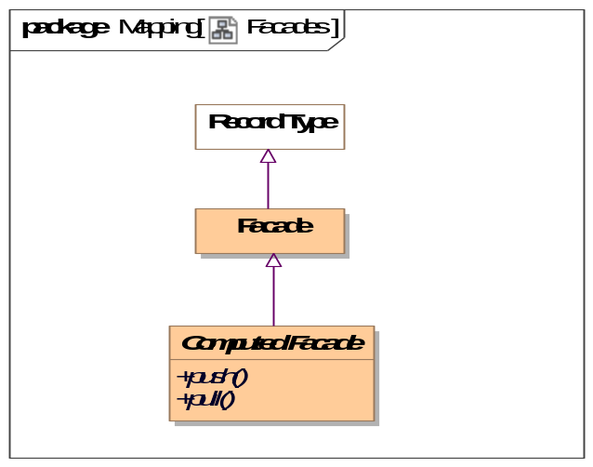
- Facades

Diagram: Mapping Rules
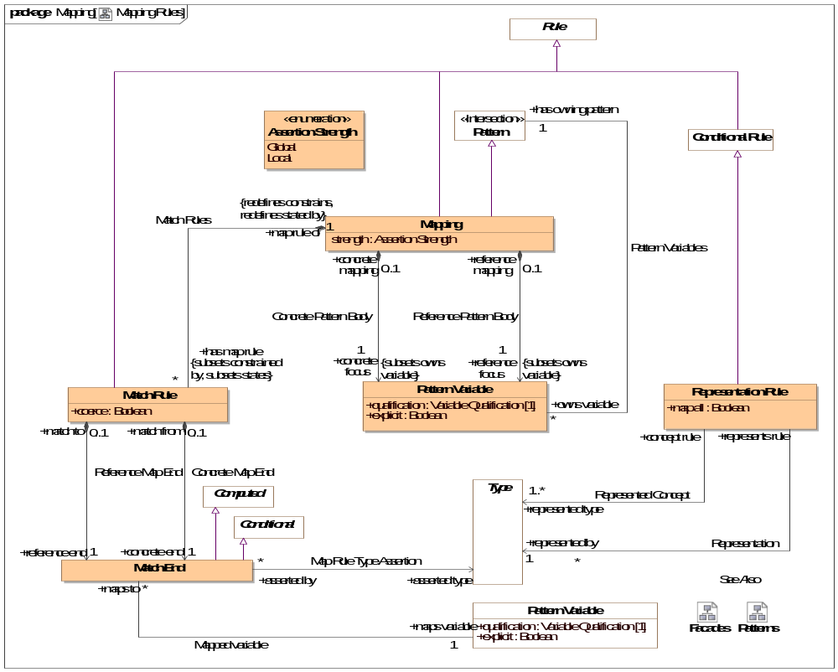
- Mapping Rules

Class Computed Facade
A facade that is computed by calling external methods.
Direct Supertypes
Facade
Operations
public push ()
An operation called to evoke the behavior associated with a new facade element being created or modified. Push asserts the more concrete type based on a reference type.
public pull ()
An operation called to evoke the behavior associated with a facade representing existing elements. Pull asserts the reference type based on a more concrete type.

Association Concrete Map End
Relationship to the more concrete end of a match rule.
Association Ends
concrete end : Match End [1] Subsets: identifies:Identifiable Entity
One end of a mapping, to be used for more concrete end.
match from : Match Rule [0..1] Subsets: identifies:Identifiable Entity
Mapping rule owning a "concrete" end.

Association Concrete Pattern Body
Relationship between a mapping and a pattern of the more concrete concepts to be mapped.
Association Ends
concrete focus : Pattern Variable [1] Subsets: identifies:Identifiable Entity
The variable or variables that form the basis for the portion of the pattern for the more concrete (physical) model. The concrete portion of the pattern is derived from the transitive closure of all variables reachable from the pattern variable via characteristics, associations or relationships.
When a pattern matching the set of concrete variables is created or altered the mapping "fires" and the reference pattern is asserted.
The qualification of the referenced variable is constrained to be ""select".
concrete mapping : Mapping [0..1] Subsets: identifies:Identifiable Entity
Mapping for which a more concrete pattern is defined.

Class Facade
An intermediary data type used to hold common mappings. Facades may be computed and/or have mapping rules.
Direct Supertypes
Record Type

Association Map Rule Type Assertion
Relationship defining more concrete types that shall be asserted for an end of a match rule.
Association Ends
asserted type : Type [*] Subsets: identifies:Identifiable Entity
Type that will be asserted for the end that is more concrete than the defined type of a property or relationship. e.g. a unit type.
asserted by : Match End [*] Subsets: identifies:Identifiable Entity
Map rule and that asserts a type

Association Mapped variable
Relationship defining the property that is the source or target of a mapping
Association Ends
maps variable : Pattern Variable [1] Subsets: identifies:Identifiable Entity
Variable that defines a set of elements to map to the other side of the mapping rule. The set of elements shall be those bound to the property on evaluation of the mapping.
maps to : Match End [*] Subsets: identifies:Identifiable Entity
Map rule end for a property

Class Mapping
A mapping is a rule based on a pattern that defines how different representations of the same things correspond. There are two "sub patterns", defined by the concrete and reference variables and other variables reachable from them via characteristics, associations and relationships. These sub-patterns are matched (made to correspond) using "Match Rules"
Patterns define a set of related elements to be mapped based on two distinguished variables, the "concrete body" and the "reference body".
Types in a "concrete" body may be defined to be a representation (data about) a concept in a "reference" pattern.
Match rules define how elements in each of the sub-patterns are mapped, bidirectionally.
A mapping utilizing more specific types subsumes maps for more general types.
Note that the roles of "concrete" and "reference" may or may not reflect different levels of abstraction and in some cases the choice may be arbitrary.
Direct Supertypes
Pattern, Rule
Attributes
strength : Assertion Strength
Strength defines what will cause a rule to be considered for being asserted (firing).
Associations
concrete focus : Pattern Variable [1] Subsets: owns variable:Pattern Variable
through association: Concrete Pattern Body
The variable or variables that form the basis for the portion of the pattern for the more concrete (physical) model. The concrete portion of the pattern is derived from the transitive closure of all variables reachable from the pattern variable via characteristics, associations or relationships.
When a pattern matching the set of concrete variables is created or altered the mapping "fires" and the reference pattern is asserted.
The qualification of the referenced variable is constrained to be ""select".
has map rule : Match Rule [*] Subsets: constrained by:Rule states:Thing
through association: Match Rules
Map rule that is asserted by a mapping.
reference focus : Pattern Variable [1] Subsets: owns variable:Pattern Variable
through association: Reference Pattern Body
The variable or variables that form the basis for the portion of the pattern for the more abstract/reference (conceptual) model. The reference portion of the pattern is derived from the transitive closure of all variables reachable from the pattern variable via characteristics, associations or relationships.
When a pattern matching the set of reference variables is created or altered the mapping "fires" and the concrete pattern is asserted.
The qualification of the referenced variable is constrained to be ""select".

Class Match End
One end of a mapping from one thing to another that may be qualified with a condition.
The set of elements to be mapped is the union of the sets of all mapped types and mapped variables that conform to the condition.
Match rules are constrained to apply to only conforming types or types that represent the mapped ends (as specified by a representation rule).
Representation rules applied to a supertype apply to a subtype unless a more specific representation rule is specified for the corresponding types.
Direct Supertypes
Computed, Conditional
Associations
asserted type : Type [*]
through association: Map Rule Type Assertion
Type that will be asserted for the end that is more concrete than the defined type of a property or relationship. e.g. a unit type.
maps variable : Pattern Variable [1]
through association: Mapped variable
Variable that defines a set of elements to map to the other side of the mapping rule. The set of elements shall be those bound to the property on evaluation of the mapping.

Class Match Rule
A rule that the 2 ends represent the same things or information about a thing.
Redundant mappings are ignored and identity is preserved across all mappings.
Direct Supertypes
Rule
Attributes
coerce : Boolean
Where <coerce> has a value of TRUE a map rule will be evaluated even if the <reference end> is not type compatible with the <concrete end> type.
Where <coerce> is FALSE or unstated a map rule will be evaluated only if the <reference end> is type compatible with the <concrete end> type.
Type compatible shall be defined as one of: Being the same type, <concrete end> being a subtype of <reference end> (as defined by a type generalization rule), <concrete end> being a representation of <reference end> (as defined by a representation rule).
Representation rules applied to a supertype apply to a subtype.
Associations
concrete end : Match End [1]
through association: Concrete Map End
One end of a mapping, to be used for more concrete end.
reference end : Match End [1]
through association: Reference Map End
One end of a match rule, to be used for more abstract end.
map rule of : Mapping [1] Redefines: constrains:Identifiable Entity stated by:Lexical Scope
through association: Match Rules
Mapping containing a map rule.

Association Reference Map End
Relationship to the reference end of a match rule.
Association Ends
reference end : Match End [1] Redefines: constrains: Identifiable Entity stated by: Lexical Scope
One end of a match rule, to be used for more abstract end.
match to : Match Rule [0..1] Redefines: constrains: Identifiable Entity stated by: Lexical Scope
Mapping rule owning a reference" end.

Association Reference Pattern Body
Relationship between a mapping and a pattern of the more abstract concepts to be mapped.
Association Ends
reference focus : Pattern Variable [1] Redefines: constrains: Identifiable Entity stated by: Lexical Scope
The variable or variables that form the basis for the portion of the pattern for the more abstract/reference (conceptual) model. The reference portion of the pattern is derived from the transitive closure of all variables reachable from the pattern variable via characteristics, associations or relationships.
When a pattern matching the set of reference variables is created or altered the mapping "fires" and the concrete pattern is asserted.
The qualification of the referenced variable is constrained to be ""select".
reference mapping : Mapping [0..1] Redefines: constrains: Identifiable Entity stated by: Lexical Scope
Mapping for which a more abstract pattern is defined.

Association Representation
More concrete type that represents information about the represented concept of a representation rule.
Association Ends
represented by : Type [1] Redefines: constrains: Identifiable Entity stated by: Lexical Scope
The representation of a concept in a more specific form
represents rule : Representation Rule Redefines: constrains: Identifiable Entity stated by: Lexical Scope
Rule defining a representation of a type.

Class Representation Rule
A representation rule states that the <represented type> has a representation defined by the <represented by> type.
Representation rules are used to filter Map Rules such that only represented concepts may be mapped.
A representation is usually complimented with one or more mapping rules.
Direct Supertypes
Conditional Rule
Attributes
map all : Boolean
Specifies a direct mapping between instances of the types in both directions.
<map all> is equivalent to a mapping with a rule mapping properties of each type but is lower precedence than other mappings - if types have a more specific map it will apply first.
Associations
represented by : Type [1]
through association: Representation
The representation of a concept in a more specific form
represented type : Type [1..*]
through association: Represented Concept
A more general or abstract concept that is being represented.

Association Represented Concept
More abstract type that is <represented by> a more concrete type of a representation rule.
Association Ends
represented type : Type [1..*]
A more general or abstract concept that is being represented.
concept rule : Representation Rule
Rule defining a concept that is represented by another, more concrete, concept.

Enumeration Assertion Strength
Rule strength defines what will cause a rule to be considered for being asserted (firing).
package SMIF Conceptual Model::Mapping
public enum Assertion Strength
{Global, Local}

Literals
Global
The rule will be in effect globally.
Local
The rule will only be in effect if required to fulfill another rule.
Known other enumerations
Enumeration Assertion Strength

SMIF Conceptual Model::Metadata
Metadata defines data about model elements (their source, definition or trust), which can be differentiated from model elements about the subject domain.

Diagram: Metadata
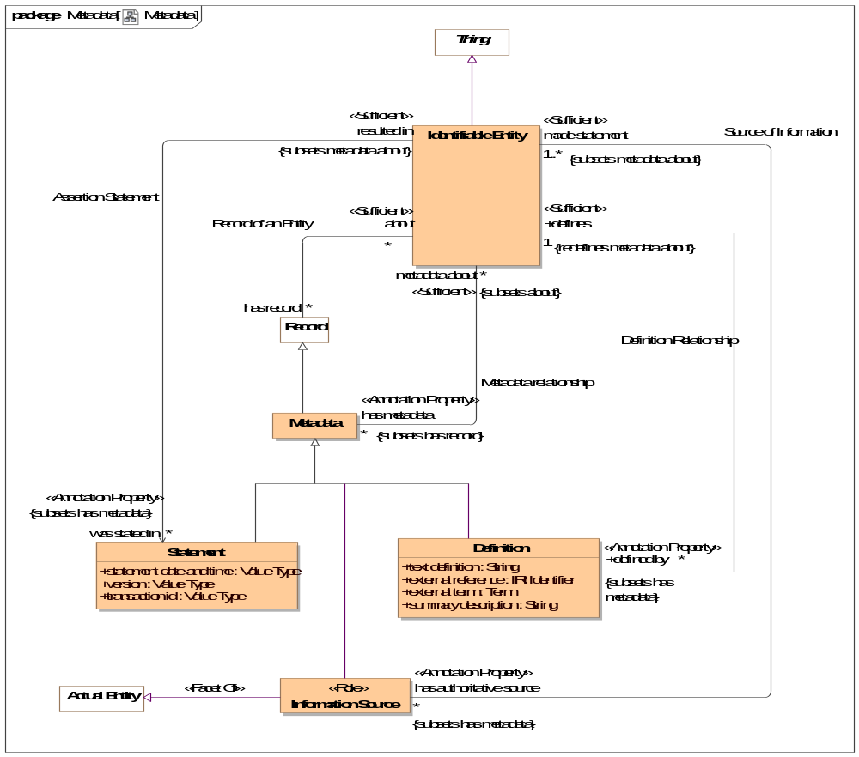
- Metadata

Association Assertion Statement
Relationship defining the original statement, speech act or information artifact that asserted something in a model.
Direct Supertypes
Metadata relationship
Association Ends
was stated in : Statement [*]
Metadata representing the speech act, document or other record where a statement captured in a model was made.
[OWL] rdfs:isDefinedBy
resulted in : Identifiable Entity
Statement made in a statement by an information source.

Class Definition
An informal or natural language definition of a something and potentially a reference to external definitions.
A Definition may be in the context of a natural language to scope the language it is expressed in.
[ISO 1087] definition: representation of a concept (3.2.1) by a descriptive statement which serves to differentiate it from related concepts
[FUML] Comment (where body corresponds with "text definition").
Direct Supertypes
Metadata
Attributes
text definition : String
Text describing a something in natural language. The language may be indicated by a context of the definition.
[OWL] rdfs:comment
external reference : IRI Identifier
A reference to an external information resource that further defines something.
[FIBO] ReferenceDOcument
external term : Term
Specific term in an external resource that further defines something.
summary description : String
A short description of something.
Associations
<<Annotation Property>> defines : Identifiable Entity [1] Redefines: metadata about:Identifiable Entity
through association: Definition Relationship
Some thing described by a definition.
[FIBO] defines
[FUML]annotatedElement

Association Definition Relationship
Relationship between a thing and its definitions.
Direct Supertypes
Metadata relationship
Association Ends
defines : Identifiable Entity [1] Redefines: metadata about: Identifiable Entity
Some thing described by a definition.
[FIBO] defines
[FUML]annotatedElement
defined by : Definition [*] Redefines: metadata about: Identifiable Entity
An informal description of something.
[FIBO] hasDefinition
[UML] comment
[FUML] ownedComment

Class Information Source <<Role>>
Metadata defining the origin or provenance of a set of statements in a model or data.
Note that the source could be a human, an organization, a mapping or other automated processes.
Direct Supertypes
Actual Entity, Metadata
Associations
<<Annotation Property>> made statement : Identifiable Entity [1..*] Subsets: metadata about:Identifiable Entity
through association: Source of Information
Metadata representing statements made by an authoritative source.
Sources may be people, organizations, documents, information systems, etc.

Class Metadata
Information about the source, provenance or origin of information. Metadata may be a managed entity, providing for provenance.
[NIEM] MetadataType
Direct Supertypes
Record
Associations
<<Annotation Property>> metadata about : Identifiable Entity [*] Subsets: about:Identifiable Entity
through association: Metadata relationship
The subject of metadata, the entity described by the metadata.
[OWL] annotationSubject of Annotation Assertion

Association Metadata relationship
Relationship between something and metadata about that thing; data about data.
[OWL] AnnotationAssertion
Association Ends
metadata about : Identifiable Entity [*] Subsets: about:Identifiable Entity
The subject of metadata, the entity described by the metadata.
[OWL] annotationSubject of Annotation Assertion
has metadata : Metadata [*] Subsets: about:Identifiable Entity
Metadata associated with (data about the information concerning) the subject entity.
[OWL] AnnotationProperty, annotationValue of Annotation Assertion

Association Record of an Entity
Relationship between a thing and records (or information) about that thing.
Note that in SMIF, things refer to the actual thing they represent, not data about it (unless the type is a record, in which case the "thing" is the data). This relationship recognizes that both a thing and data about the thing are things.
[IDEAS] describedBy: A representedBy that asserts that a Description describes a Thing.
Association Ends
about : Identifiable Entity [*] Subsets: about:Identifiable Entity
The thing described by a record.
has record : Record [*] Subsets: about:Identifiable Entity
A record about something.

Association Source of Information
Relation defining an entity making a statement represented within a model. E.g. the person or organization that made a statement.
[ISO 1087] source identifier: information in a terminological entry (3.8.2) which indicates the source documenting the terminological data (3.8.1)
Association Ends
made statement : Identifiable Entity [1..*] Subsets: about:Identifiable Entity
Metadata representing statements made by an authoritative source.
Sources may be people, organizations, documents, information systems, etc.
has authoritative source : Information Source [*] Subsets: about:Identifiable Entity
Metadata representing the authority behind a statement - who or what made a statement captured in a model.

Class Statement
Statements provide metadata as to the source of information - who or what said it.
This source of the information may be captured using "InformationSource" metadata about the metadata.
[ISO11404] provision that conveys information
Direct Supertypes
Metadata
Attributes
statement date and time : Value Type
Metadata representing the date and time the statement was made or modified.
version : Value Type
Metadata representing an identifier for a version of information.
transaction id : Value Type
Identifier for an act or transaction creating or modifying information.

SMIF Conceptual Model::Patterns
Patterns are templates for structures or compositions of things that may then be expressed as instances of the pattern.

Diagram: Patterns
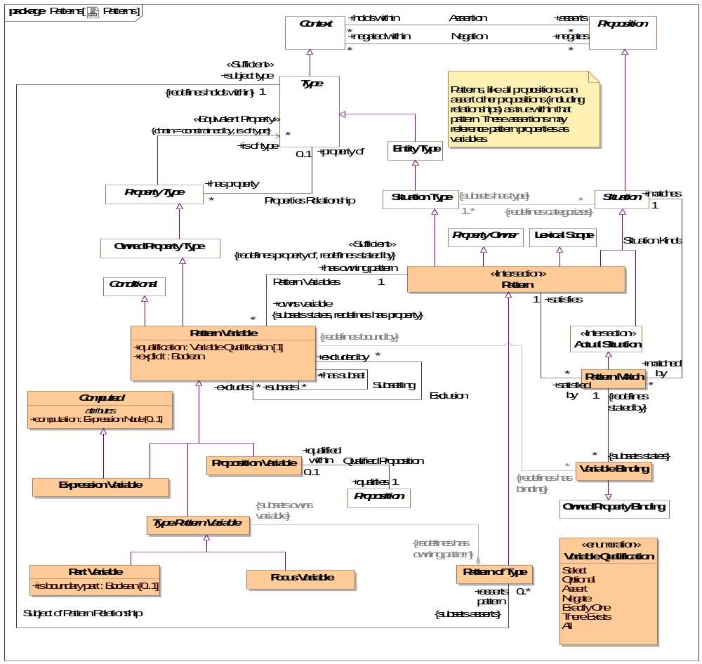
- Patterns

Class Computed
Attributes
computation : Expression Node [0..1]
<computation> provides an expression that computes a value for the variable based on the expression applied to the current context..

Association Exclusion
Association Ends
excluded by : Pattern Variable [*] Subsets: about:Identifiable Entity
excludes : Pattern Variable [*] Subsets: about:Identifiable Entity

Class Expression Variable
An expression variable defines the value of the variable as computed by <computation>. Note that expression variables are not always able to be asserted or reversed and may therefore not provide for bi-directional mapping patterns. Any ability to assert or reverse a computation is implementation specific.
Direct Supertypes
Computed, Pattern Variable

Class Focus Variable
A property variable of a pattern representing the extent of the subject type within the context of the owning pattern.
The value of qualification shall be "Select".
The <has type> of the variable is asserted be the same as the subject type of the pattern.
Direct Supertypes
Type Pattern Variable

Association Match Rules
Relationship defining the match rules for a mapping.
Direct Supertypes
Rule Constrains, Statement
Association Ends
has map rule : Match Rule [*] Subsets: about:Identifiable Entity
Map rule that is asserted by a mapping.
map rule of : Mapping [1] Subsets: about:Identifiable Entity
Mapping containing a map rule.

Class Part Variable
A pattern property variable representing a part of the subject type. Additional relations and rules may be made about the part. A type with parts is by its nature a composition.
Direct Supertypes
Type Pattern Variable
Attributes
is boundary part : Boolean [0..1]
True if the property is on the boundary of the pattern and connectible (may have relationships) external to the pattern. e.g. "Port"

Class Pattern <<Intersection>>
A pattern represents a set of assertions true about individuals or sets of individuals qualified by pattern properties. All propositions asserted or negated by a pattern (as a context) are considered "templates" where identity is not required to match.
The structure of the pattern is defined by the properties and asserted (sub) situations (including relationships) that are asserted by the pattern.
In many cases the relationships and rules defined for a pattern will reference pattern properties. These relationships will hold for instances of the pattern where things are bound to the pattern properties.
[DTV] general situation kind: situation kind that is not an individual situation kind. A situation kind is a general situation kind if it can be exemplified by more than one Event in some possible world, even when it cannot have more than one Event in the possible world chosen to be the universe of discourse.
[UML] StructuredClassifier. Also Similarity with TemplateSignature
[OWL] May be used to represent Class Expressions
Direct Supertypes
Lexical Scope, Property Owner, Situation, Situation Type
Associations
<<Sufficient>> owns variable : Pattern Variable [*] Subsets: states:Thing Redefines: has property:Property Type
through association: Pattern Variables
A variable property defined within the context of a pattern that is used as part of the patterns definition.
[UML] ownedAttribute
satisfied by : Pattern Match [*]
through association: Pattern Matches
Pattern match that satisfies a pattern.

Association Pattern Bindings
Association Ends
: Variable Binding [*]
: Pattern Match [1]

Class Pattern Match
A pattern match provides the corespondents between a pattern and the situations it matches using variable bindings.
A pattern match implies and proves that the pattern <categorizes> the situation.
The matched pattern <states> any consequences of the matching, such as the pattern <categorizes> the pattern instance.
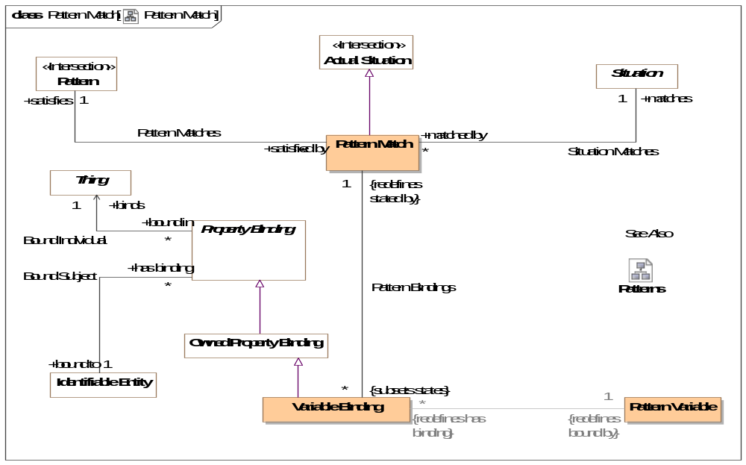
- Pattern Match
Direct Supertypes
Actual Situation
Associations
: Variable Binding [*] Subsets: states:Thing
through association: Pattern Bindings
satisfies : Pattern [1]
through association: Pattern Matches
Pattern that is satisfied by a "Pattern Match" based on a set of "Variable Bindings".
matches : Situation [1]
through association: Situation Matches
The situation qualified as matching the <satisfies> pattern based on the set of "Variable Bindings" stated.

Association Pattern Matches
Association Ends
satisfies : Pattern [1]
Pattern that is satisfied by a "Pattern Match" based on a set of "Variable Bindings".
satisfied by : Pattern Match [*]
Pattern match that satisfies a pattern.

Class Pattern of Type
A pattern of type defines a set of properties and relationships that must hold true for all instances of a type. Where the pattern includes parts, the subject type is a composition.
Patterns augment the semantics of th subject type in the context of the pattern.
Direct Supertypes
Pattern
Associations
<<Restriction>> : Type Pattern Variable Subsets: owns variable:Pattern Variable
<<Sufficient>> subject type : Type [1] Redefines: holds within:Context
through association: Subject of Pattern Relationship
The type which is the context of a pattern of type. The pattern is "about" the subject type.

Class Pattern Variable
A pattern variable is a property of a pattern that provides a contextual property within that pattern for rules and relationships to be bound to.
A pattern variable is a placeholder for all or a subset of the instances of the variables type.
Properties of an association or relationship may be bound to a pattern variable where the type of the pattern variable is compatible with the type of the relationship's property type.
[UML] Similarity with TemplateParameter
[CL] Functional Term
Direct Supertypes
Conditional, Owned Property Type
Attributes
qualification : Variable Qualification [1]
<qualification> defines the behavior of an element with respect to a pattern - how the variable impacts the selection, evaluation or assertion of the pattern.
explicit : Boolean
If true, Element must be explicitly asserted as the indicted type, not derived or inferred from a supertype or super property.
Associations
<<Restriction>> : Variable Binding [*] Redefines: has binding:Property Binding
<<Sufficient>> has owning pattern : Pattern [1] Redefines: property of:Type stated by:Lexical Scope
through association: Pattern Variables
Pattern owning a pattern variable.
has subset : Pattern [1] Redefines: property of:Type stated by:Lexical Scope
through association: Subsetting
Subsets of the variable.
maps to : Match End [*]
through association: Mapped variable
Map rule end for a property
subsets : Match End [*]
through association: Subsetting
Variable that a subset variable subsets. The subset variable shall be populated by a subset of the <subsets> variable based on the type and constraints of the subset variable.
excluded by : Match End [*]
through association: Exclusion
excludes : Match End [*]
through association: Exclusion

Association Pattern Variables
Relationship defining variable properties within a pattern.
Direct Supertypes
Statement
Association Ends
owns variable : Pattern Variable [*]
A variable property defined within the context of a pattern that is used as part of the patterns definition.
[UML] ownedAttribute
has owning pattern : Pattern [1]
Pattern owning a pattern variable.

Class Proposition Variable
A proposition variable utilizes some proposition (e.g. relationships) as a part of the definition of a pattern, it extends a basic proposition in that it adds properties to determine the effect the assertion has on pattern instances.
A Proposition Variable is a lexical scope context that <asserts> or <negates> other propositions qualified by <has strength> and <explicit>. As a lexical scope it may "own" the asserted propositions.
Proposition Variable is often used with associations and relationships to define the way pattern properties are related to other pattern properties or actual entities.
For a pattern associations, [UML] Connector. (type = has type). Each ConnectorEnd corresponds with a Structured Property Binding.
Direct Supertypes
Pattern Variable
Associations
qualifies : Proposition [1]
through association: Qualified Proposition

Association Qualified Proposition
Association defining exactly one proposition (such as an association) qualified by a qualified proposition variable.
Association Ends
qualifies : Proposition [1]
qualified within : Proposition Variable [0..1]

Association Situation Matches
Association Ends
matches : Situation [1]
The situation qualified as matching the <satisfies> pattern based on the set of "Variable Bindings" stated.
matched by : Pattern Match [*]
Pattern matches that match the subject situation.

Association Subject of Pattern Relationship
Relationship defining the subject pattern of a type specific pattern.
Direct Supertypes
Assertion
Association Ends
asserts pattern : Pattern of Type [0..*]
A pattern asserted for all instances of a type. Where the pattern includes parts, the type defines a composition.
subject type : Type [1]
The type which is the context of a pattern of type. The pattern is "about" the subject type.

Association Subsetting
In a pattern or mapping rule, defines a variable that represents a subset of another property (or if multiple, their union). The subset may be constrained by a more specific type, expressions or required cardinalities.
Subset: Set A is a subset of set B if all of the elements (if any) of set A are contained in set B
Association Ends
subsets : Pattern Variable [*]
Variable that a subset variable subsets. The subset variable shall be populated by a subset of the <subsets> variable based on the type and constraints of the subset variable.
has subset : Pattern Variable [*]
Subsets of the variable.

Class Type Pattern Variable
Type Pattern variable is an abstract supertype that provides for a restriction that parts and focus properties must be owned by a pattern of a type.
Direct Supertypes
Pattern Variable
Associations
<<Restriction>> : Pattern of Type Redefines: has owning pattern:Pattern

Class Variable Binding
A variable binding defines a value for a particular variable of a particular owning pattern as part of a pattern match.
Direct Supertypes
Owned Property Binding
Associations
<<Restriction>> : Pattern Variable [1] Redefines: bound by:Property Type
: Pattern Match [1] Redefines: stated by:Lexical Scope
through association: Pattern Bindings

Enumeration Variable Qualification
Variable qualification values define the behavior of an element with respect to a pattern - how it impacts the selection, evaluation or assertion of the pattern.
package SMIF Conceptual Model::Patterns
public enum Variable Qualification
{Select, Optional, Assert, Negate, Exactly One, There Exists, All}

Literals
Select
Select is used in query and mapping patterns, all elements of the classified type that match the pattern are selected as instances of the pattern.
Select may be considered a qualified "All". Select does not assert the existence of something, it determines the existence of a pattern match such that other assertions may be made.
Where a pattern is asserted, "Select" variables shall be asserted.
Relationships between properties with <quantifier>=Select must hold between the selected properties for the pattern to be asserted.
Optional
Optional is used in query and mapping patterns, the property shall be populated as a consequence of the pattern matching.
Where a pattern is asserted, "Optional" variables shall not be asserted.
Optional is the default if no qualification is stated.
Assert
The property does not impact the selection of the pattern, it is an asserted consequence of the pattern.
Negate
The property does not impact the selection of the pattern, it is negated consequence of the pattern - it may not exist.
Exactly One
The existential quantifier limited to exactly one of a potentially larger set of the properties type.
There Exists
The existential quantifier - at least one of the properties type.
All
The universal quantifier - the quantified property is a stand-in for all elements of the existent of the quantified type
- Patterns

SMIF Conceptual Model::Properties
Properties define the most granular connections between entities or values. Properties may be used as the ends of relationships, to represent individual characteristics or as elements of a data structure.

Diagram: Characteristics
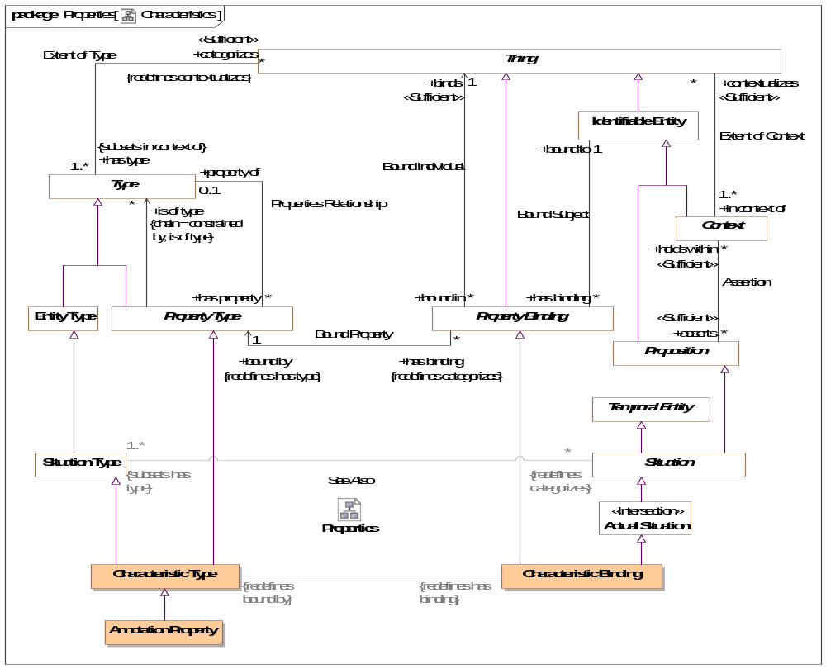
- Characteristics

Diagram: Properties
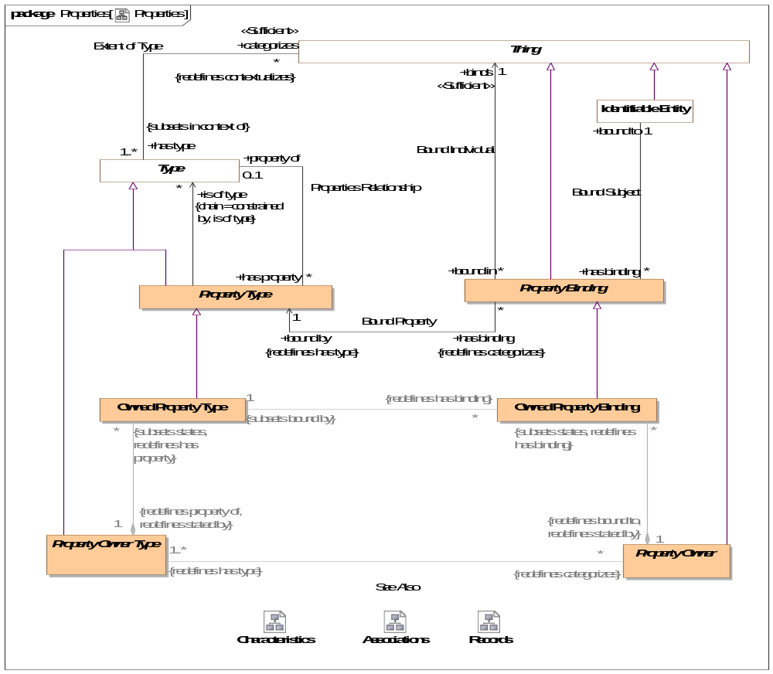
- Properties

Class Annotation Property
An annotation property is a specialization of property where the referenced elements represent metadata about the related proposition, structure or information (or model element) rather than a fact or condition of the domain being represented.
For an annotation property, <is of type> describes instances of the structured type for which the property is defined.
Typical uses of annotations include provenance of information, when a record was created, etc.
[ISO11404] annotation: descriptive information unit attached to a datatype, or a component of a datatype, or a procedure (value), to characterize some aspect of the representations, variables, or operations associated with values of the datatype
Direct Supertypes
Characteristic Type

Association Bound Individual
Relationship defining the thing bound to a subject based on a bound property - the "object" of the property binding.
Association Ends
binds : Thing [1] Redefines: stated by: Lexical Scope
The thing bound to a property in a specific situation. E.g. if the weight of truck-XYZ is 4500 LBS, the bound individual would be "4500 LBS".
[FUML] value
[OWL] rdf:object
bound in : Property Binding [*] Redefines: stated by: Lexical Scope
Bindings in which a thing participates.

Association Bound Property
Relationship defining the property type that defines the semantics of a property binding. E.g. if the weight of truck-XYZ is 4500 LBS, the bound property could be "has weight".
Direct Supertypes
Extent of Type
Association Ends
has binding : Property Binding [*] Redefines: stated by: Lexical Scope
Bindings referencing a property.
bound by : Property Type [1] Redefines: stated by: Lexical Scope
The property a binding binds a thing to.
[FUML] definingFeature
[OWL] rdf:predicate

Association Bound Subject
Relationship defining the subject of a bound property. Where the subject is a relationship, the relationship becomes transparent and the applicable subject(s) are the other ends of the relationship. E.g. if the weight of truck-XYZ is 4500 LBS, the bound subject would be Truck-XYZ".
Association Ends
has binding : Property Binding [*] Redefines: stated by: Lexical Scope
Bindings asserted for properties within a situation.
bound to : Identifiable Entity [1] Redefines: stated by: Lexical Scope
The subject of a property binding.
[FUML] owningInstance (note that in SMIF the owner and subject may not be the same). Where the are the same, the semantics are the same as FUML.
[OWL] rdf:subject

Class Characteristic Binding
A characteristic of a specific thing, e.g. the color of Pump-1234 in the <bound to> entity. A characteristic is a "first class" element and may participate in relationships and have annotations.
[IDEAS] measureOfIndividual: A typeInstance that asserts an Individual is an instance of a Measure - i.e. the Individual "has" a property corresponding to the Measure.
[ISO 1087] characteristic: abstraction of a property of an object (3.1.1) or of a
set of objects
[Guizzardi] quality(x) =def ∃!U qualityUniversal(U) ∧ (x::U)
[DOLCE] Quality
Direct Supertypes
Actual Situation, Property Binding
Associations
<<Restriction>> : Characteristic Type Redefines: bound by:Property Type

Class Characteristic Type
A kind of characteristic a type of thing may have, e.g. paint may have a color. Characteristic type is the type of characteristic bindings which are "first class" elements and may participate in relationships and have other characteristics.
[IDEAS] Property: An IndividualType whose members all exhibit a common trait or feature. Often the Individuals are states having a property (the state of being 18 degrees centigrade), where this property can be a CategoricalProperty (qv.) or a DispositionalProperty (qv.).
[ISO 1087] type of characteristics: category of characteristics (3.2.4) which serves as the criterion of subdivision when establishing concept systems. NOTE The type of characteristics colour embraces characteristics (3.2.4) being red, blue, green, etc. The type of characteristics material embraces characteristics made of wood, metal, etc.
[FIBO] Simple Property: Simple Properties are assertions about things in a class, which may be framed in terms of some simple type of information.
[Guizzardi] qualityUniversal(U)
[DOLCE] Quality Type
[OWL] rdf:Statement
[UML] Property
Direct Supertypes
Property Type, Situation Type
Associations
<<Restriction>> : Characteristic Binding Redefines: has binding:Property Binding

Class Owned Property Binding
An owned property binding defines a value for a particular property of a particular owning property type (or structure).
Similar to an OWL triple, an owned property binding does not have independent identity.
Constraint: Each owned property binding must be <bound by> an owned property type that is owned by the <has type> owned type of the <bound to> property owner.
Owned property type is abstract and not intended to directly represent semantic elements.
Direct Supertypes
Property Binding
Associations
<<Restriction>> : Owned Property Type [1] Subsets: bound by:Property Type
A structure property binding may bind a characteristic.
<<Restriction>> : Property Owner [1] Redefines: bound to:Identifiable Entity stated by:Lexical Scope

Class Owned Property Type
An owned property type is a property definition defined as a composite part of an association type - most often used in data structures and relationships. Association property types are the types of association property bindings. Also known as "association end".
[FIBO] Relationship Property
[FUML] memberEnd (of association) Property
Direct Supertypes
Property Type
Associations
<<Restriction>> : Owned Property Binding [*] Redefines: has binding:Property Binding
<<Restriction>> : Property Owner Type [1] Redefines: stated by:Lexical Scope property of:Type

Association Properties Relationship
Relationship defining the set of properties defined for a type.
Where the <property of> type is a relationship type, the "subject" of the property is the other ends (properties) of the relationship.
Where the <property of> type is not a relationship, the subject of the property is the <property of> type.
Association Ends
has property : Property Type [*] Redefines: stated by: Lexical Scope property of: Type
A property of a structured type such that there may be bindings of a thing to instances of the structured type with reference to the property which defines the semantics of the bound thing withing the context of the structure.
[FUML] feature
[UML] memberEnd. attribute (of classifier).
property of : Type [0..1] Redefines: stated by: Lexical Scope property of: Type
Type for which a property is relevant. The domain of the property.
<property of> excludes "Owned Property Type" and ("Association Type" that is not "Relationship Type")
[FUML] featuringClassifier
[OWL] Domain

Class Property Binding
A property value binding binds a particular thing (the value) to a situation based on a defined property.
Where <binds> is an expression evaluation, the property value shall evaluate to the evaluation of the expression.
Where <binds> is a property, the property value shall be the property values bound to that property in <bound to> situation.
The bound to thing must conform with the <is of type> type of the property. If the bound individual conforms to the "requires type" of the property, the <is of type> of the bound thing will be asserted.
The type of the <bound to> structure must (directly or indirectly) have the type the <bound by> properties <property of> type.
[FUML] Slot (Noting that in SMIF the binding may or may not be owned by the subject, depending on the subtype of property).
[CL] Binding:
[OWL] Union(ObjectPropertyAssertion, DataPropertyAssertion, AnnotationAssertion), RDF Triple
=Note: RDF Triples do not have identity where as some subtypes of SMIF:Property Type do have identity and are therefor statements.
Direct Supertypes
Thing
Associations
binds : Thing [1]
through association: Bound Individual
The thing bound to a property in a specific situation. E.g. if the weight of truck-XYZ is 4500 LBS, the bound individual would be "4500 LBS".
[FUML] value
[OWL] rdf:object
bound by : Property Type [1] Redefines: has type:Type
through association: Bound Property
The property a binding binds a thing to.
[FUML] definingFeature
[OWL] rdf:predicate
bound to : Identifiable Entity [1]
through association: Bound Subject
The subject of a property binding.
[FUML] owningInstance (note that in SMIF the owner and subject may not be the same). Where the are the same, the semantics are the same as FUML.
[OWL] rdf:subject

Class Property Owner
Property Owner is an abstract element for anything that may own a set of property bindings. This element is abstract and not intended to directly represent domain concepts. Subtypes of property owner provide semantic interpretation.
Direct Supertypes
Thing
Associations
<<Restriction>> : Owned Property Binding [*] Subsets: states:Thing Redefines: has binding:Property Binding
<<Sufficient>><<Restriction>> : Property Owner Type [1..*] Redefines: has type:Type

Class Property Owner Type
A type of Property Owner (See Property Owner for details) which defines a set of "Owned Property Types" which are the types of owned property bindings.
Property owner is abstract and not intended to directly represent semantic elements.
Direct Supertypes
Type
Associations
<<Sufficient>><<Restriction>> : Property Owner [*] Redefines: categorizes:Thing
<<Restriction>> : Owned Property Type [*] Subsets: states:Thing Redefines: has property:Property Type

Class Property Type
A property type defines the way in which instances of a type participate in (or, are involved in) instances of another type (including relationships). Sometimes called a variable, argument or role.
In a conceptual model the terms associated with a property kind are typically "verb phrases" defining how instances of the involved type participate in the situation or relationship.
In a record (data structure) the property is a "slot" of a record and may have a term which is a noun or verb phrase.
So that constraints of a type flow to relationships involving that type: All propositions that hold within a type referenced by <is of type> hold within the structured type referenced by <property of>. I.e. the structured type is in the context of the types of its properties.
In a function, a property is a function argument.
[Guizzardi] MomentUniversal
[FUML] Parameter where owner is operation. Otherwise Property.
[UML] Property. All typed elements in SMIF are Property Types.
[CL] Operator: distinguished syntactic role played by a specified component within a functional term
[OWL] rdf:Property, ObjectUnionOf(owl:ObjectProperty, oe;DatatypeProperty).
Direct Supertypes
Type
Associations
is of type : Type [*]
A type of instances bound to a property. Also known as the "range" of a property.
If asserted the property rule shall be owned and asserted by the properties <property of> type.
[OWL] Range
<<Restriction>> : Property Constraint [*] Subsets: constrained by:Rule
property of : Type [0..1]
through association: Properties Relationship
Type for which a property is relevant. The domain of the property.
<property of> excludes "Owned Property Type" and ("Association Type" that is not "Relationship Type")
[FUML] featuringClassifier
[OWL] Domain

SMIF Conceptual Model::Records
A record of the condition of an entity at a point in time - this includes facts, speech acts and DBMS records. Records are a kind of information.
Records are typically used in data representations, not conceptual models.

Diagram: Records
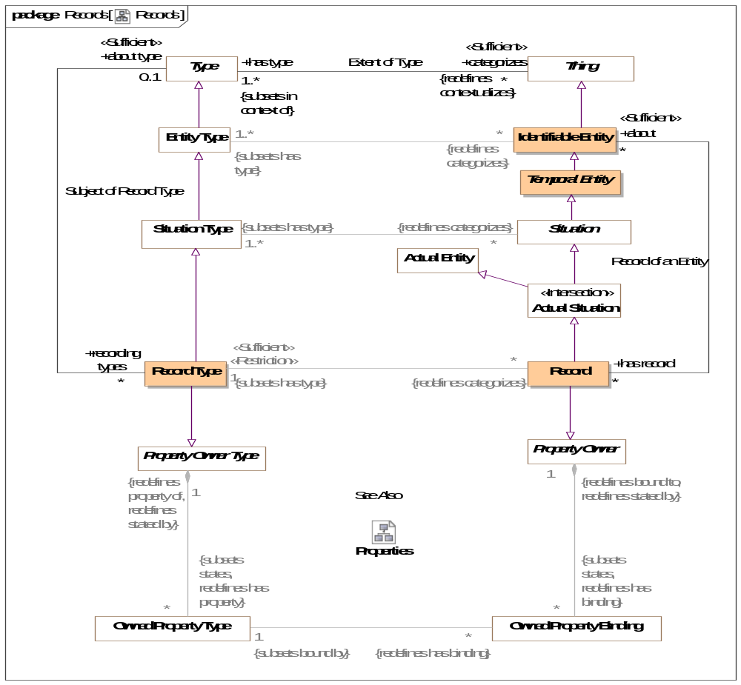
- Records

Class Record
A record of the condition of an entity at a point in time - this includes facts, speech acts and DBMS records.
Records are typically used in data representations, not conceptual models. Records specialize associations as owners of properties.
[IDEAS] A Representation that describes a Thing
Direct Supertypes
Actual Situation, Property Owner
Associations
about : Identifiable Entity [*]
through association: Record of an Entity
The thing described by a record.
<<Sufficient>><<Restriction>> : Record Type [1] Subsets: has type:Type

Class Record Type
Type of the record of the condition of an entity at a point in time - this includes facts, speech acts and DBMS records.
A record type may involve variant and invariant types as variables. Those that are enumerated in a "uniqueness constraint" are invariant (independent variables) uniquely identify the situation which is the subject of the fact type where as the other variables may change over time (dependent variables).
Record types may be grounded in atomic relations by using invariant conditions.
Record types represent typical "data structures".
Direct Supertypes
Property Owner Type, Situation Type
Associations
<<Sufficient>><<Restriction>> : Record [*] Redefines: categorizes:Thing
about type : Type [0..1]
through association: Subject of Record Type
Thing for which a record exists

Association Subject of Record Type
Relationship defining types of records for another type.
Association Ends
about type : Type [0..1]
Thing for which a record exists
recording types : Record Type [*]
Record for a thing.

SMIF Conceptual Model::Relationships
Relationships are primitive but identifiable conditions that relate other entities through properties of the relationships. Relationships have their semantics described by a relationship type. The ends of relationships are defined by "structured property type", a relationship may have any number of "ends".
Relationships are first-class "actual" and "temporal" things that exist in their own right. These are known as "external relations" in much of the theoretical literature.

Diagram: Relationships
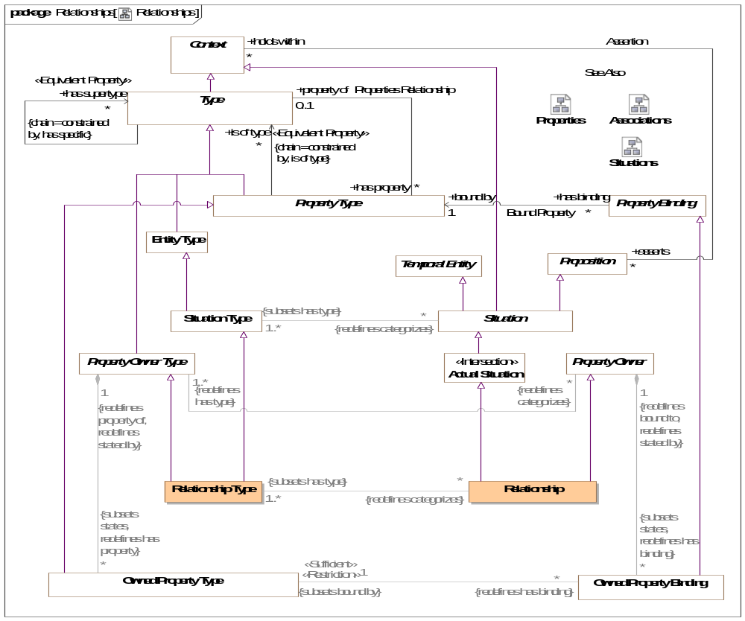
- Relationships
Relations are atomic actual situations that bind 2 or more properties as a fact.

Class Relationship
A relationship defines a situation involving related things. A relationship may be asserted within a context as true or false within that context. Each relationship type has a number of bindings of which do not change for the life of the relationship..
A relationship may be true or false within its context (including a timeframe) but is atomic in its truth value.
Relationships may participate in (be bound to) other relationships and as such bindings involving a relationship may change over time. That is, relationships are "first class" objects.
[IDEAS] tuple: A relationship between two or more things.
Note: SMIF allows one end of a relationship.
[OWL] An OWL class that is a subclass of SMIF: Relationship
Direct Supertypes
Actual Situation, Property Owner
Associations
<<Sufficient>><<Restriction>> : Relationship Type [1..*] Subsets: has type:Type

Class Relationship Type
A relationship type defines a type of condition, the relationship, involving related things. A relationship may be asserted within a context as true or false within that context. Each relationship type has a number of <has property> "structured property type" properties which describe the role of the related things with respect to the relationship, values of which uniquely do not change for the life of the relationship.
A relationship may be true or false within its context (including a timeframe) but is atomic in its truth value.
Relationships may participate in (be bound to) other relationships and as such bindings involving a relationship may change over time.
The terms for properties of a relationship in a conceptual model are typically verb phrases, connecting the relationship with the related types.
[FIBO] A kind of Mediating Thing
[IDEAS] TupleType: The Powertype of tuple.
[FUML] Association where memberEnd corresponds with <has property>. Note that SMIF relationships are "first class" and may also be considered to correspond to an association class where there are any properties or other relationships referencing the subject relationship.
[UML] AssociationClass (note that "end ownership" is meaningless in SMIF).
[Guizzardi2015] Relator: endurants of a special kind, with the power of connecting (mediating) other endurants. Note: Guissardi "mediation" corresponds with relationship properties.
Direct Supertypes
Property Owner Type, Situation Type
Associations
<<Sufficient>><<Restriction>> : Relationship [*] Redefines: categorizes:Thing

SMIF Conceptual Model::Situations
A situation is a particular configuration of things and their relations including spatial, temporal, and logical connections between those things valid over a period of time. Situations form the basis of all complex, time dependent entities.

Diagram: Situations
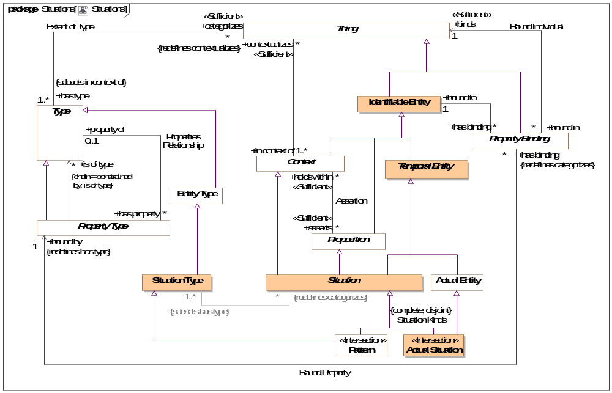
- Situations

Class Actual Situation <<Intersection>>
An actual situation is an individual situation that actually exists, happened in the past or may exist in some possible world, not a template or process definition. Such situations must exist for a time interval, however there are no constraints on such a time interval - from an instant to the life of the universe.
DTV: Occurrence: state of affairs that is a happening in the universe of discourse
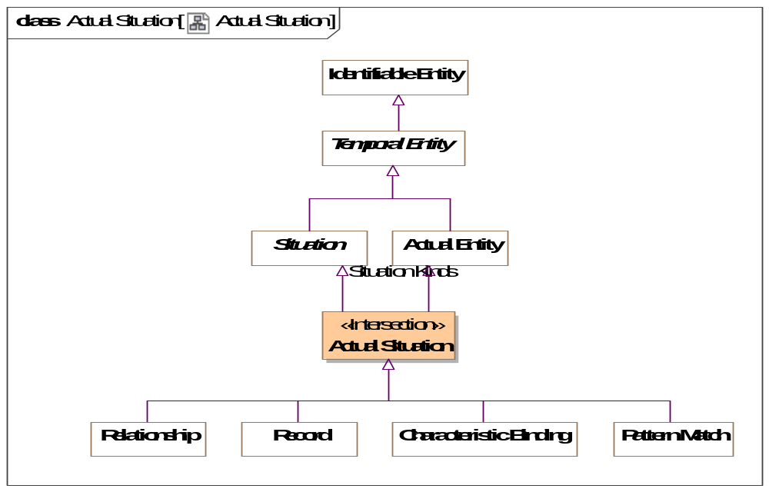
- Actual Situation
Direct Supertypes
Actual Entity, Situation

Class Situation
A situation is an identifiable entity composed of an arrangement of entities and the relations between them over a time interval. Situations are propositions and may be asserted as true or false in some context. Situations may change over time, unless otherwise constrained. As an identifiable entity, situations may participate in relationships, thus situations are "first class" elements in SMIF.
[SBVR] "State of affairs"
[SOWA1999] Nexus
Direct Supertypes
Context, Lexical Scope, Proposition, Temporal Entity
Associations
<<Sufficient>><<Restriction>> : Situation Type [1..*] Subsets: has type:Type
matched by : Pattern Match [*]
through association: Situation Matches
Pattern matches that match the subject situation.

Class Situation Type
A situation type defines a kind of identifiable arrangement of individuals, assertions and the relations between them over a timespan. As an identifiable entity, situations may participate in other situations and relationships by being bound to properties of those situations or relationships with bindings, thus situations are “first class” entities in a SMIF model.
The roles or behaviors things (any entity or value) may play in a situation are identified as properties of the situation type.
Entity types and roles may also be situation types.
Syn. Type of a state of affairs.
A situation type may have properties such that instances, may bind things to structures based on properties.
Things may be bound to a structure (i.e. play a role in the structure) via properties. Things bound to properties of a structure may change over time, unless otherwise constrained.
[DTV] situation kind: state of affairs that may or may not happen in some possible world
Direct Supertypes
Entity Type
Associations
<<Sufficient>><<Restriction>> : Situation [*] Redefines: categorizes:Thing

SMIF Conceptual Model::Top level
The top level objects provide the foundation for all objects in a SMIF model

Diagram: Top Level
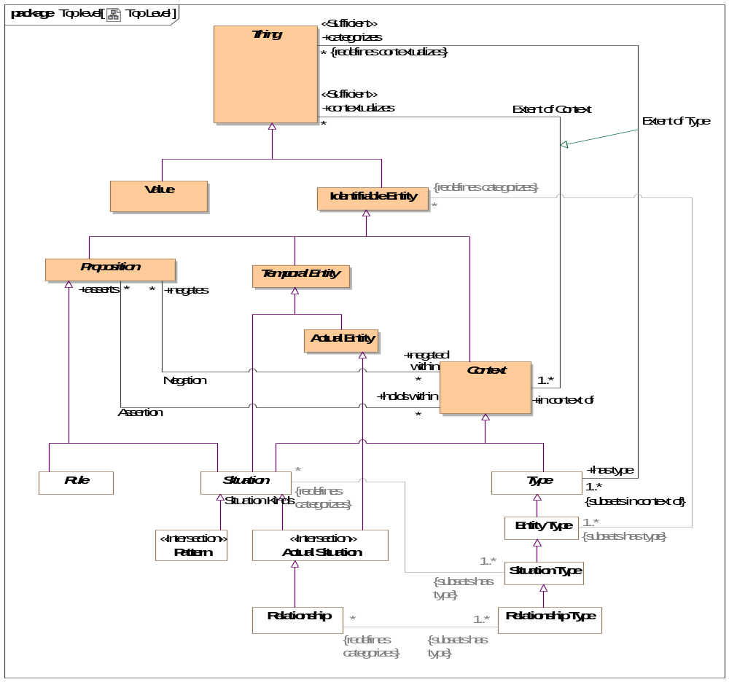
- Top Level
Diagram showing summary of top level classes and significant subtypes.

Class Actual Entity
An actual entity is an identifiable, temporal and individual person, specific object, process enactment, agreement, etc. Actual Entities do not have to be physical, e.i. may denote social constructs. Actual entities are disjoint from types.
A more specific class of actual entity (e.g., Person) is intended to refine the classification of the individual thing.
Individuality (or selfhood) is the state or quality of being an individual; particularly of being separate from other individuals and possessing identity. Actual entities typically have a lifetime and some individuals may change over that lifetime. Individuals may have parts that together help define the individual but may change over time.
"Actual" does not imply current existence.
[ISO 1087] individual concept: concept (3.2.1) which corresponds to only one object
[UML] Loose correspondence with "InstanceSpecification". SMIF instances are direct instances of their types, there is no "indirection" through value specification as their is in UML.
[Guizzardi] (individual concept)
[CL] Individual: one element of the universe of discourse
[DOLCE] Particular: particulars are entities which have no instances
[SOWA1999] Independent. Can be considered "Actuality" when including social constructs in [SOWA1999] Physical.
[OWL] Individual
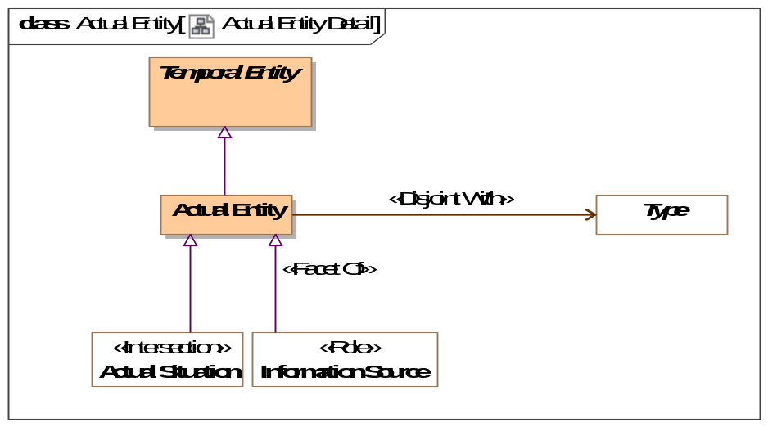
- Actual Entity Detail
Direct Supertypes
Temporal Entity

Association Assertion
An assertion relationship between a context and the propositions asserted within that context. The <asserts> proposition is asserted (defined as "true") for all things contextualized by the <holds within> context. Assertion of truth is not absolute, it is relative to the context. For example, something could be asserted within a context where that entire context is asserted to be false.
Assertion is transitive.
[CL] Implication
[OWL] Assertion; Any [OWL] Assertion included in a graph (All assertions in an OWL graph are asserted by the graph)
Association Ends
asserts : Proposition [*] Redefines: categorizes: Thing
Proposition that is asserted (must be true) for anything contextualized by a context.
As types are a context, types may assert a proposition for their instances.
holds within : Context [*] Redefines: categorizes: Thing
Context in which a proposition is asserted (required to be true). Anything contextualized by the context is subject to the proposition.

Class Context
A <Context> is a grouping of <contextualizes> things that are related in some way.
A <Context> also <asserts> propositions that hold for all things the context <contextualizes>, thus providing the link between an assertion and the set of things asserted. Likewise a context <negates> propositions that are false within the context.
Subtypes of <Context>, such as <Type> ascribe more semantics to the context as well as the things it <contextualizes>.
A context provides a binding between a set of propositions and the things those propositions apply to.
[CL] Sort: any subset of the universe of discourse over which some quantifier is allowed to range
[ISO 1087] concept field: unstructured set of thematically related concepts (3.2.1)
[SOWA1999] Mediating
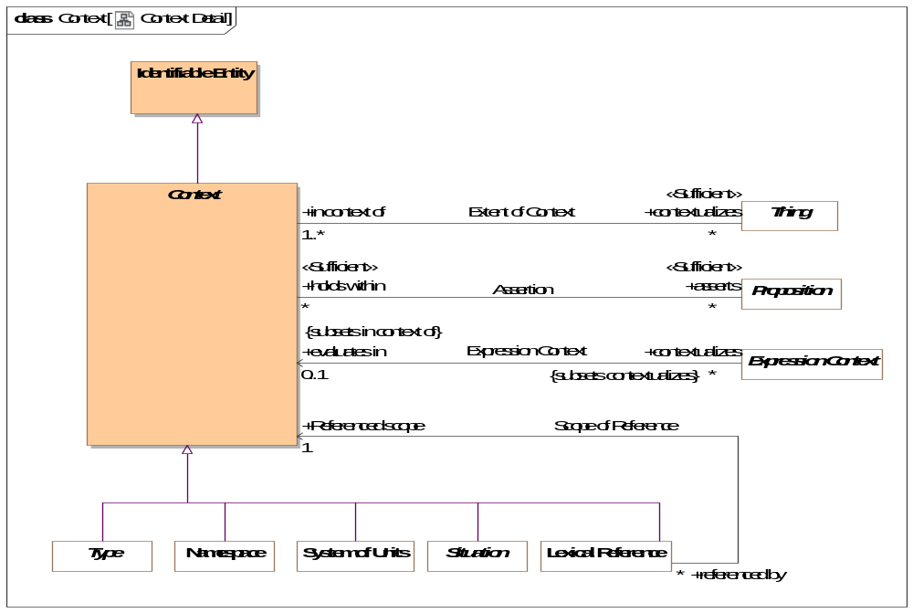
- Context Detail
Direct Supertypes
Identifiable Entity
Associations
<<Sufficient>> asserts : Proposition [*]
through association: Assertion
Proposition that is asserted (must be true) for anything contextualized by a context.
As types are a context, types may assert a proposition for their instances.
contextualizes : Thing [*]
through association: Extent of Context
The set of things contextualized by a <Context>, or "in" the <Context> and therefor subject to the <asserts> propositions of the <Context>.
negates : Proposition [*]
through association: Negation
Proposition that is negatively asserted (must be FALSE) for anything contextualized by a context.
As types are a context, types may assert or negate a proposition for their instances.

Association Extent of Context
The association between a context and the set of things contextualized by that context, defining the extent of the context, a set.
[ISO 1087] extension: totality of objects (3.1.1) to which a concept (3.2.1)
corresponds
Association Ends
contextualizes : Thing [*]
The set of things contextualized by a <Context>, or "in" the <Context> and therefor subject to the <asserts> propositions of the <Context>.
in context of : Context [1..*]
A <Context> that contextualizes a thing making what it <contextualizes> subject to the propositions referenced by <has assertion> of the context.
A thing may be <in context of> one or more context.
[FIBO] hasContext

Class Identifiable Entity
An identifiable entity is any identifiable thing other than values, this includes individuals, types, axioms, situations, speech acts, information structures, etc.
Identifiable entities always have some kind of identity and may have identifiers. Note that identity is an abstraction that may have representation in models as any number of identifiers, also known as a "sign".
[OWL] Entity type (Implied in section [OWL] 5.8) as an instance of rdfs:Class
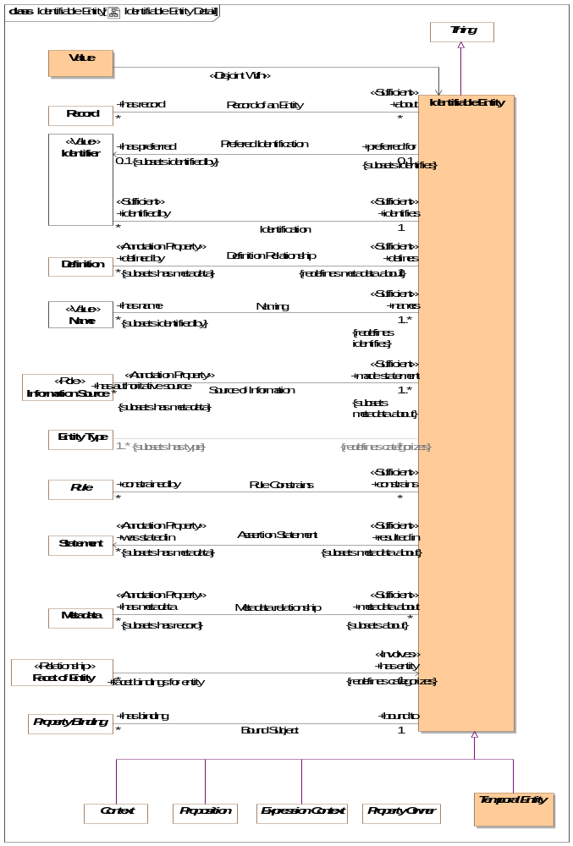
- Identifiable Entity Detail
Direct Supertypes
Thing
Associations
<<Sufficient>> was stated in : Statement [*] Subsets: has metadata:Metadata
through association: Assertion Statement
Metadata representing the speech act, document or other record where a statement captured in a model was made.
[OWL] rdfs:isDefinedBy
has preferred : Identifier [0..1] Subsets: identified by:Identifier
through association: Prefered Identification
Default identifier to use for an entity.
Where multiple identifiers are preferred in differing context any method for selecting the most preferred identifier is implementation specific and not specified by this standard.
[FUML] NamedElement.name: Note: An Identifier that is <preferred for> an entity is equivalent to the name of a named element.
<<Restriction>> : Entity Type [1..*] Subsets: has type:Type
<<Annotation Property>> defined by : Definition [*] Subsets: has metadata:Metadata
through association: Definition Relationship
An informal description of something.
[FIBO] hasDefinition
[UML] comment
[FUML] ownedComment
<<Sufficient>> identified by : Identifier [*]
through association: Identification
An identifier for an <Entity>.
[FIBO] hasDenotation
<<Annotation Property>> has metadata : Metadata [*] Subsets: has record:Record
through association: Metadata relationship
Metadata associated with (data about the information concerning) the subject entity.
[OWL] AnnotationProperty, annotationValue of Annotation Assertion
has name : Name [*] Subsets: identified by:Identifier
through association: Naming
A human meaningful name for an entity.
[FIBO] hasName: that by which some thing is known; may apply to anything
[OWL] rdfs:label
has record : Record [*]
through association: Record of an Entity
A record about something.
constrained by : Rule [*]
through association: Rule Constrains
Rules applying to an entity.
<<Annotation Property>> has authoritative source : Information Source [*] Subsets: has metadata:Metadata
through association: Source of Information
Metadata representing the authority behind a statement - who or what made a statement captured in a model.
has binding : Property Binding [*]
through association: Bound Subject
Bindings asserted for properties within a situation.

Association Negation
An assertion relationship between a context and the propositions negated (FALSE) within that context. The <negates> proposition is asserted as FALSE for all things contextualized by the <negated within> context. Assertion or negation of truth is not absolute, it is relative to the context.
[CL] Negation+Implication
Association Ends
negates : Proposition [*]
Proposition that is negatively asserted (must be FALSE) for anything contextualized by a context.
As types are a context, types may assert or negate a proposition for their instances.
negated within : Context [*]
Context in which a proposition is negated (required to be FALSE). Anything contextualized by the context is subject to the proposition.

Class Proposition
A proposition is statement, or condition with a truth value (true or false) that can be determined or asserted with some level of confidence (assessment of confidence being outside of this specification).
All "facts", statements, speech acts, relationships and rules are propositions.
Propositions may be asserted to be true within a context which they <holds within>.
For a situation, the proposition is true if the situation is actual (i.e., takes place, obtains).
[SBVR] the state of affairs is posited by the proposition and if the state of affairs were actual, the proposition would be true
[CL] Sentence: unit of logical text which is true or false, i.e. which is assigned a truth-value in an interpretation
[SOWA1999] Proposition
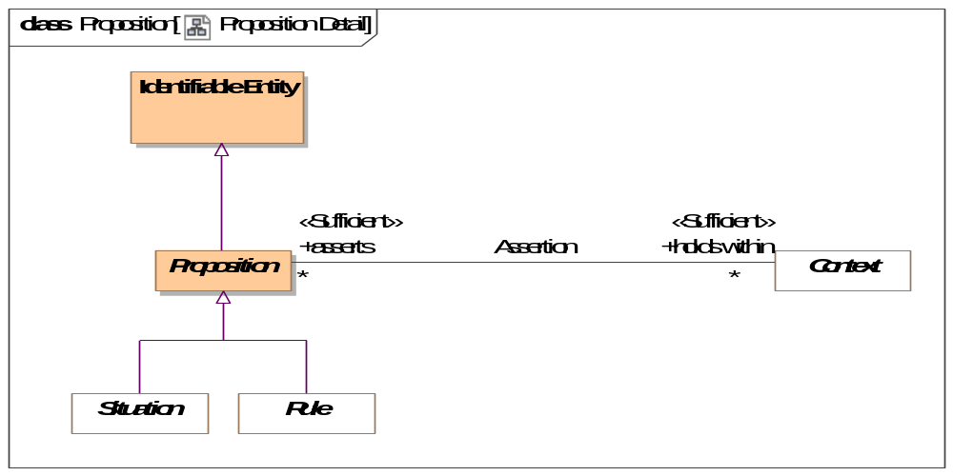
- Proposition Detail
Direct Supertypes
Identifiable Entity
Associations
<<Sufficient>> holds within : Context [*]
through association: Assertion
Context in which a proposition is asserted (required to be true). Anything contextualized by the context is subject to the proposition.
negated within : Context [*]
through association: Negation
Context in which a proposition is negated (required to be FALSE). Anything contextualized by the context is subject to the proposition.
qualified within : Proposition Variable [0..1]
through association: Qualified Proposition

Class Temporal Entity
A temporal is anything that has a timespan. Temporal things may have temporal relationships with other temporal things.
Note that relationships defined for [DTV] Time Intervals may be specified for <temporal Entity> but are not specified in SMIF.
[SOWA1999] Continuant
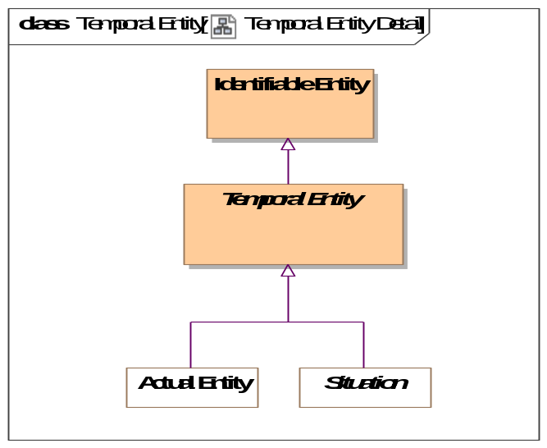
- Temporal Entity Detail
Direct Supertypes
Identifiable Entity

Class Thing
Any thing or value that does or may exist in any possible world. Thing is the supertype of all types and may therefore participate in unbounded relations.
Instances of Thing are referred to as "a thing" in this model.
[IDEAS] Thing
[OWL] Thing
[ISO 1087] object: anything perceivable or conceivable
[FIBO] Thing
[Guizzardi] Thing
[FUML] Element
[SOWA1999] "T"
[OWL] rdfs:Resource
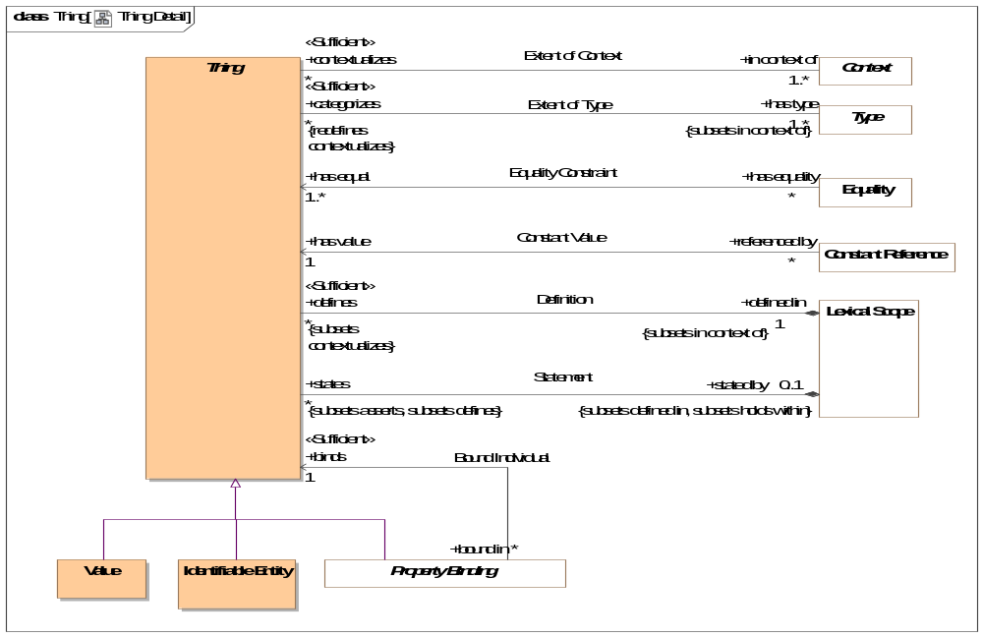
- Thing Detail
Associations
defined in : Lexical Scope [1] Subsets: in context of:Context
through association: Definition
Lexical scope defining model elements.
[UML]owner
in context of : Context [1..*]
through association: Extent of Context
A <Context> that contextualizes a thing making what it <contextualizes> subject to the propositions referenced by <has assertion> of the context.
A thing may be <in context of> one or more context.
[FIBO] hasContext
has type : Type [1..*] Subsets: in context of:Context
through association: Extent of Type
A type that holds for something.
Things may have multiple types and these types may change over time.
The <categorized> thing satisfies the constraints of the <has type> type.
[FIBO] isClassifiedBy
[OWL] rdf:type
stated by : Lexical Scope [0..1] Subsets: defined in:Lexical Scope holds within:Context
through association: Statement
<stated by> is a lexical scope that both defines and asserts a model element.

SMIF Conceptual Model::Types
Types provide for ways to categorize anything based on what it is, the roles it plays or the phases it may be in.
Something may be categorized by any number of types (multiple classification assumption).

Diagram: Type-instance
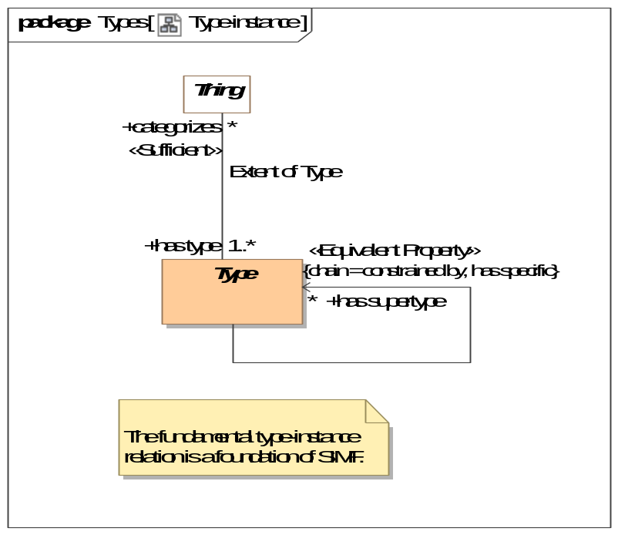
- Type-instance

Diagram: Types
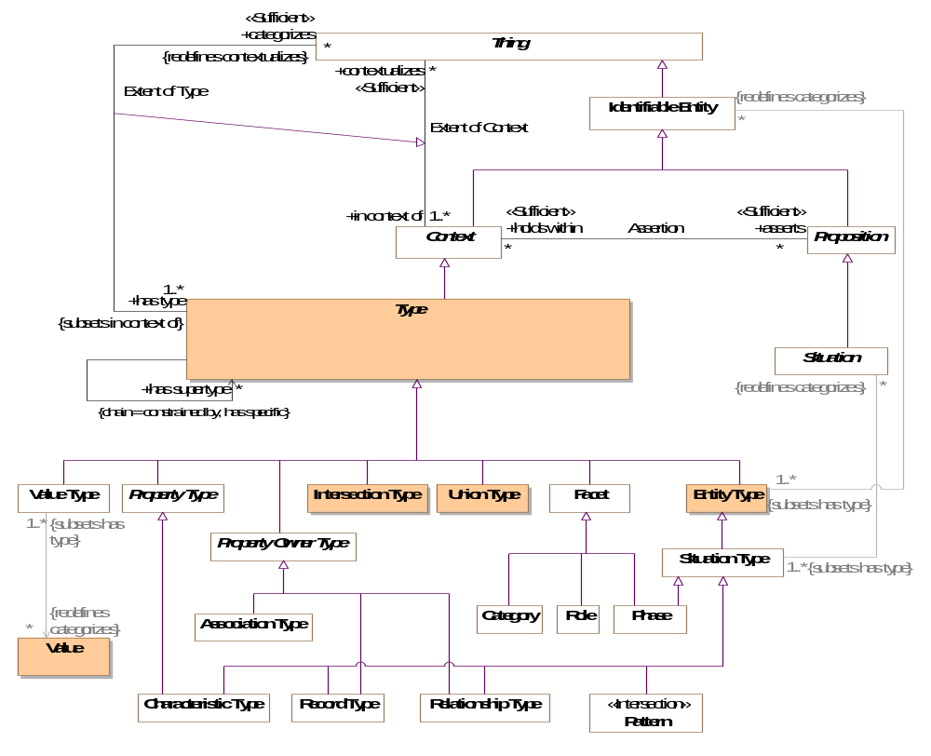
- Types

Class Entity Type
A type of an identifiable entity. All concrete entity instances must have at least one entity type. Entity type may be mixed with other types to fully define an entity.
[FUML] Classifier
[Guarino1994] Substantial or Pseudo-Sortal (Substantial being concrete)
[Guizzardi] A Rigid Universal.
(Rigid Universal): A universal G is rigid (or modally constant) iff for any w,w ∈ W 3. extw(G) = extw(G) Putting definitions 4.1 and 4.3 together, we have that for any rigid universal G the following is true 4. ext(G) = extw(G), for all w ∈ W A rigid universal is one that applies to its instances necessarily, i.e., in every possible world. Every substance sortal G is a rigid universal.
[OWL] rdfs:Class (as Entity Type does not include values). However, non=primitive values are typically represented as rdfs:Class
Direct Supertypes
Type
Associations
<<Restriction>> : Identifiable Entity [*] Redefines: categorizes:Thing

Association Extent of Type
The relation between a type and the things that type categorizes, the instances which defines the extent of the type, a set.
[IDEAS] typeInstance: A couple that asserts that a Thing is a member of a Type.
[Guizzardi] (Extension functions): Let W be a non-empty set of
possible worlds and let w ∈ W be a specific world. The extension function extw(G) maps a universal G to the set of its instances in world w. The extension function ext(G) provides a mapping to the set of instances of the
universal G that exist in all possible worlds, such that ext(G) = U w∈W w ext (G)
[OWL] ClassAssertion
Direct Supertypes
Extent of Context
Association Ends
categorizes : Thing [*] Redefines: categorizes: Thing
The set of things described by a type, the "extent" of the type.
The thing a type <categorizes> is subject to the <has assertion> propositions of the type.
[FIBO] classifies
has type : Type [1..*] Redefines: categorizes: Thing
A type that holds for something.
Things may have multiple types and these types may change over time.
The <categorized> thing satisfies the constraints of the <has type> type.
[FIBO] isClassifiedBy
[OWL] rdf:type

Class Intersection Type
An intersection is a type that has an extent which is the complete intersection of the extents of all supertypes. Intersection is a stronger statement than a subtype as a subtype may not be a complete intersection.
[MathWorld] The intersection of two sets A and B is the set of elements common to A and B. This is written A intersection B, and is pronounced "A intersection B" or "A cap B."
Direct Supertypes
Type

Class Type
A <Type> is a categorization of any thing based on specific criteria. The specific criteria may or may not be formalized in a model.
A <Type> <categorizes> a set of <Thing>s which comprises the "extent" of the type.
A <Type> is a <Context> where the things it <categorizes> are <in the context> of the <Type>.
[ISO 1087] general concept: concept (3.2.1) which corresponds to two or more objects (3.1.1) which form a group by reason of common properties
[FIBO] Classifier: a standardized classification or delineation for something, per some scheme for such delineation, within a specified context
[FUML] Type
[CL] Type:: logical framework in which expressions in the logic are classified into syntactic or lexical categories (types) and restricted to apply only to arguments of a fixed type
[Guarino1994] Discriminating Predicate
[OWL] Union(rdfs:Class, rdfs:Datatype)
Similar to:
[IDEAS] Type: A set (or class) of Things. (Note that SMIF defines the extent of a type a a set, the type is the intent of that set which forms a predicate for which all members of the set is true)
Direct Supertypes
Context, Lexical Scope
Associations
has supertype : Identifiable Entity [*] Redefines: categorizes:Thing
Supertypes(s) of a type as defined a Generalization Constraint. See "Generalization Constraint" for details.
The extent (categorizes) of the subtype is a subset of the extent of the supertype. Any statement that is true for all members of a supertype must also be true for all members of any subtype
Has supertype is a derived association.
categorizes : Thing [*] Redefines: contextualizes:Expression Context
through association: Extent of Type
The set of things described by a type, the "extent" of the type.
The thing a type <categorizes> is subject to the <has assertion> propositions of the type.
[FIBO] classifies
has property : Property Type [*]
through association: Properties Relationship
A property of a structured type such that there may be bindings of a thing to instances of the structured type with reference to the property which defines the semantics of the bound thing withing the context of the structure.
[FUML] feature
[UML] memberEnd. attribute (of classifier).
<<Sufficient>> asserts pattern : Pattern of Type [0..*] Subsets: asserts:Proposition
through association: Subject of Pattern Relationship
A pattern asserted for all instances of a type. Where the pattern includes parts, the type defines a composition.
has covering : Covering Constraint [*]
through association: Covering Constraint
Covering constraints of a type.
has specialization : Generalization Constraint [*]
through association: Generalization
Specialization rules for a type.
has multiplicity : Multiplicity Constraint [*] Subsets: constrained by:Rule
through association: Multiplicity Target
Multiplicity constraint of a type or property.
properties of type : Property Type Constraint [*]
through association: Property Type
Properties typed by a type
recording types : Record Type [*]
through association: Subject of Record Type
Record for a thing.
has generalization : Generalization Constraint [*] Subsets: constrained by:Rule
through association: Specialization
Generalization rules for a type

Class Union Type
A Union is a type that has an extent which is the complete union of the extents of all types that specialize the Union.
[FIBO] Logical Unions
[MathWorld] Given two sets A and B, the union is the set that contains elements or objects that belong to either A or to B or to both. We write A È B
[OWL] ObjectUnionOf( ObjectUnionOf, DataUnionOf)
Direct Supertypes
Type

SMIF Conceptual Model::Values
The values package defines the concepts of values and quantities expressed in units.

Values may be differentiated from entities in that values have no independent lifetime or "identity" other than the value its self. E.g. the number 5 "just is" and can't be changed. Properties and relations referencing values can, of course, change but the values are constant.
The failure to properly express units in data models often results in errors, inefficiencies and risk. Translation and federations between models, schema and data sources that is not cognizant of the units used would be even more error prone and risky. For example, what does “Speed limit 50” mean? For these reasons the SMIF language provides specific support for specifying quantity kinds and unit types in conceptual, logical and physical models. The SMIF mapping rules may then perform the appropriate unit conversions.
The foundation of information specification in SMIF at all levels is the type system. Types specified for all properties and relations involving values must match the types of the related values. The concepts of units and values as defined in "VIM" [JCGM 200-2008] is used as the basis for defining the types used in SMIF to guarantee type safety of quantities across different representations. Since many existing models and schema do not include well defined units some effort may be required to find and then specify the implicit units based on documentation, SME interviews or inspection of data or source code. It is recommended that the units used by external models and schema be determined prior to attempting federation and integration of information based on those models or schema.
VIM [JCGM 200-2008] concepts of quantities and units
VIM defines
- quantity: property of a phenomenon, body, or substance, where the property has a magnitude that can be expressed as a number and a reference [ed. to a unit]
- kind of quantity (kind): aspect common to mutually comparable quantities
- measurement unit (unit): real scalar quantity, defined and adopted by convention, with which any other quantity of the same kind can be compared to express the ratio of the two quantities as a number
SMIF concepts of quantities and units
SMIF uses the VIM concepts to define "quantity values" and types to capture the quantity kind and unit. Types are defined for each Unit. The goals for this type based approach are:
- That it is clearly grounded in semantics as defined in VIM
- That a type may be used to specify the range of a property or relation involving unit based values.
- That a quantity value (e.g. 5 grams) be representable as a simple number with a type.
- That there is a clear type hierarchy starting with a representationally independent type in a conceptual model (e.g. mass) that can be further specialized to a specific unit in a logical model (e.g. grams) and further specialized to be represented by a physical data type (e.g. “double”).
- That external models and schema may have unit specifications asserted without changing the schema.
- That a quantity of an entity be able to be referenced without a specific quantity value being known (e.g. John’s weight).
- That systems of units such as [ISO-80000] or [OMG QUDV] (A part of SysML) be able to be directly referenced as the definition of a unit.
SMIF defines three types to realize the above goals: Quantity Kind, Unit Type, Base Unit Type. SMIF also defines Quantity Values, which are instances of unit types.
In VIM a quantity has a magnitude that is expressed as a number and a reference. The SMIF quantity value is the numeric value of such a quantity where the reference is specified by the “unit reference” property of the quantity value’s type. The quantity value’s type is a “Unit Type”. The Unit type has attributes for converting a unit to a base unit, a symbol and a unit reference. Based on VIM the unit reference may be “a measurement unit, a measurement procedure, a reference material, or a combination of such” and is specified with a description that contains reference information. In summary, the reference of a SMIF quantity value is determined indirectly through its unit type. A quantity value has exactly one unit type and exactly one Quantity Kind. A quantity value expressed in any unit of the same quantity kind may be converted to any other unit of the same quantity kind.
This type-based sapproach allows specification of a property at the conceptual (quantity kind) logical (unit type) or physical (unit type with a numeric type) levels. Such specifications use the same type-based approach used for other aspects of the models. Given this information a SMIF implementation may correctly and reliably convert between compatible types regardless of representation. Please see the specification of the value types, attributes and relationships for more detail.

Example:
- A specification for a road segment has a property “Speed limit”.
- The type of this property in a reference conceptual model is “Speed:Quantity Kind”.
- A unit “Kilometer per Hour:Unit Type” is defined as a subtype of “Speed:Quantity Kind” with a “unit reference” of “[ISO-80000.4] Kilometer per Hour”. Note that quantity kinds and unit types would normally be defined in reference models that correspond to a “system of units”.
- Miles per hour is also defined as a subtype of Speed.
- A physical schema defines “Speed-KPH: Integer”.
- A SMIF mapping rule maps “Speed limit” to “Speed-KPH” and asserts a type of “Kilometer per Hour” on the “Speed-KPH” end.
- A data file defines a road “Route One” with a speed limit of 100:KPH-Int.
- When converted to a U.S. application this speed limit of route one can be viewed as 62:MPH-Int.

Diagram: Values
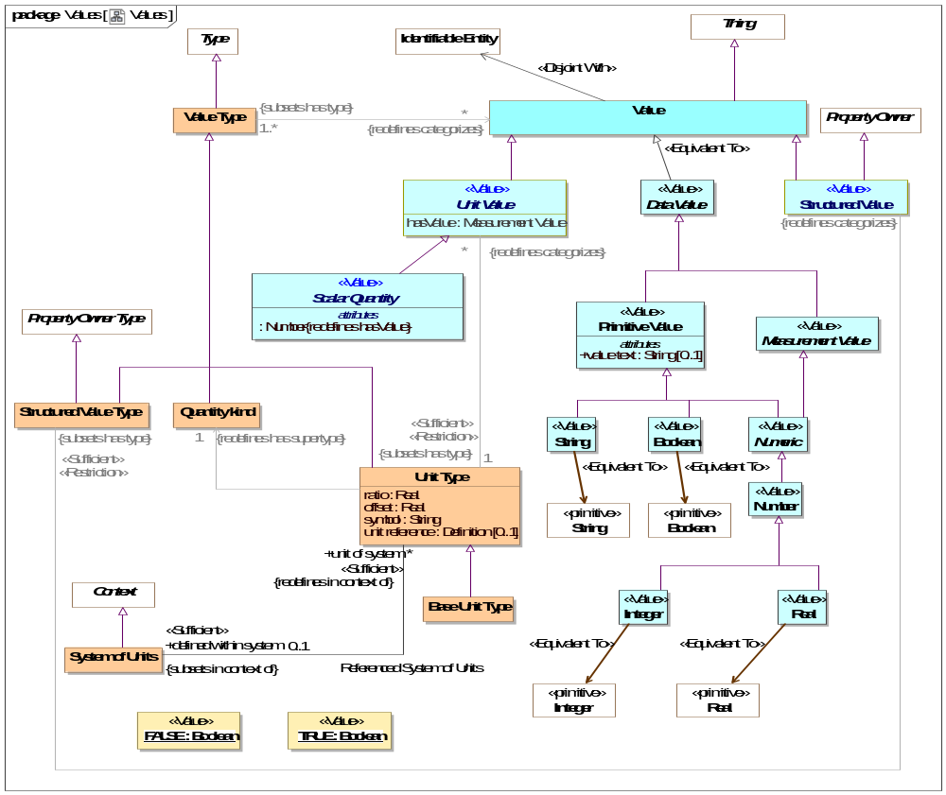
- Values

Class Base Unit Type
One unit type of a quantity kind may be marked as the base unit within a system of units. The base unit provides the basis for conversions between units of the same quantity kind. The base unit always has a ratio of one and an offset of zero.
Type of a [JCGM 200:2008] measurement unit that is adopted by convention for a base quantity
[FIBO] (type of) Base Unit: a measurement unit that is defined by a system of units to be the reference measurement unit for a base quantity
There ma be at most one base unit for a quantity kind within a system of units.
Direct Supertypes
Unit Type

Class Quantity kind
[JCGM 200:2008] A Quantity Kind is an aspect common to mutually comparable quantities represented by one or more units. Units with a common quantity kind may be algorithmically converted to any other unit of that quantity kind. e.g. temperature.
Quantity kinds are a supertype of unit types which are then a type of all quantity values, Quantity values are mutually comparable with all other quantity values categorized by the same quantity kind.
[FIBO] QuantityKind: a categorization type for “quantity” that characterizes quantities as being mutually comparable
[DOLCE] Quality Space
Direct Supertypes
Value Type

Association Referenced System of Units
Relationship between a system of units and the set of unit types defined within that system.
Direct Supertypes
Extent of Context
Association Ends
defined within system : System of Units [0..1] Subsets: constrained by:Rule
The system of units in which a unit is defined and is the basis for ratio and offset.
By default the system of units is "si": http://www.iso.org/iso/iso_catalogue/catalogue_ics/catalogue_detail_ics.htm?csnumber=30669
unit of system : Unit Type [*] Subsets: constrained by:Rule
Unit type defined within a system of units

Class Scalar Quantity <<Value>>
Direct Supertypes
Unit Value
Attributes
: Number
The value of a quantity that, when multiplied by the unit defined in a subtype of quantity kind, specifies a measurement value such as 3 Meters.

Class Structured Value <<Value>>
A value that may have sub-elements (owned properties) defined as "structure property type".
Direct Supertypes
Property Owner, Value
Associations
<<Sufficient>><<Restriction>> : Structured Value Type Subsets: has type:Type

Class Structured Value Type
A structured value type is a type of value that has parts represented as properties - also used for "data types" and forms.
Direct Supertypes
Property Owner Type, Value Type
Associations
<<Sufficient>><<Restriction>> : Structured Value Redefines: categorizes:Thing

Class System of Units
[JCGM 200:2008] A set of base units and derived units, together with their multiples and submultiples, defined in accordance with given rules, for a given system of quantities.
[FIBO] SystemOfUnits: a set of measurement units associated with a system of quantities, together with a set of rules that assign one measurement unit to be the base unit for each base quantity in the system of quantities and a set of rules for the derivation of other units from the base units
Direct Supertypes
Context
Associations
<<Sufficient>> unit of system : Unit Type [*] Redefines: in context of:Context
through association: Referenced System of Units
Unit type defined within a system of units

Class Unit Type
A Unit type is a type of a quantity value referencing a specific unit. A Unit Type a required type of a property representing a quantity.
Each quantity value has a reference as defined by the "unit reference" property of the quantity value's type.
[JCGM 200:2008] A Unit is a real scalar quantity, defined and adopted by convention, with which any other quantity of the same quantity kind can be compared to express the ratio of the two quantities as a number. e.g. Degrees Centigrade, Miles.
Each unit type represents refinement of a quantity kind using generalization and is thus substitutable for that quantity kind. Typically quantity kinds are used in conceptual models and unit types in physical or logical models.
Unit types may only subtype quantity kinds or other units.
Note that unit types are not units, but the type of quantity values expressed with respect to a common unit as defined in [JCGM 200:2008].
[IDEAS] MeasureCategory: A MeasureType whose members are recognized types of MeasureInstance.
Direct Supertypes
Value Type
Attributes
ratio : Real
The multiplier by which to multiple the referenced unit to convert to the base unit within a system of units.
offset : Real
The difference between zero in the referenced unit and zero in the base unit after the ratio is applied within a system of units.
symbol : String
The accepted symbol for the unit referenced by the unit type
unit reference : Definition [0..1]
The unit reference is the reference to a unit shared by all quantities values that are instances of a unit type.
[JCGM 200:2008] A reference can be a measurement unit, a measurement procedure, a reference material, or a combination of such. For magnitude of a quantity.
Typical references include ISO 8000 and OMG QUDV.
Associations
: Quantity kind [1] Redefines: has supertype:Type
<<Sufficient>><<Restriction>> : Unit Value [*] Redefines: categorizes:Thing
<<Sufficient>> defined within system : System of Units [0..1] Subsets: in context of:Context
through association: Referenced System of Units
The system of units in which a unit is defined and is the basis for ratio and offset.
By default the system of units is "si": http://www.iso.org/iso/iso_catalogue/catalogue_ics/catalogue_detail_ics.htm?csnumber=30669

Class Unit Value <<Value>>
A unit value is a numeric magnitude with a unit type that may be used as the value of a quantity property as defined by [JCGM 200:2008]. The reference of the quantity is defined by the "unit reference" property of the Unit Type.
e.g. 5cm is an instance of the unit type "Centimeter"
Each unit value has exactly one UNit Type as a type.
In a physical model a quantity value must have a type that specifies its unit (e.g. "Gram"). The magnitude shall be expressed using "hasValue"
[JCGM 200:2008] A quantity is a property of a phenomenon, body, or substance, where the property has a magnitude that can be expressed as a number and a reference.
Note: A quantity as defined here is a scalar. However, a vector or a tensor, the components of which are quantities, is also considered to be a quantity.
[IDEAS] ScaleMapping: A CoupleType whose members are all the couples linking MeasurePoints to RealNumbers. The CoupleType (i.e. the set of couples) represents the scale.
[FIBO] QuantityValue: number and measurement unit together giving magnitude of a quan-tity
[Guizzardi] (quale): A point in a n-dimensional quality domain
Direct Supertypes
Value
Attributes
hasValue : Measurement Value
The value of a quantity that, when multiplied by the unit defined in a subtype of quantity kind, specifies a measurement value such as 3 Meters.
[OWL] rdf:value restricted to abstract quantity
Associations
<<Sufficient>><<Restriction>> : Unit Type [1] Subsets: has type:Type

Class Value
A Value is an atomic. immutable piece of information without a specific lifetime or identity independent of the value. Values include numbers, strings and other atomic "primitive" data. Values also include structured values, which are immutable.
In UML values may be defined by the name of an instance specification with a value type.
[IDEAS] Representation: A SignType where all the individual Signs are intended to signify the same Thing.
[ISO11404] The identification of members of a datatype family, subtypes of a datatype, and the resulting datatypes of datatype generators may require the syntactic designation of specific values of a datatype.
[OWL] data values
Direct Supertypes
Thing

Class Value Type
A type categorizing values where a value is an atomic piece of information without a specific lifetime or identity independent of that value. Values include numbers, strings and other atomic "primitive" data.
[IDEAS] RepresentationType: A Type that is the Powertype of Representation.
[FUML] DataType
[ISO11404] datatype: set of distinct values, characterized by properties of those values, and by operations on those values
[OWL] rdfs:Datatype (Note that some values are represented as OWL classes)
Direct Supertypes
Type
Associations
<<Restriction>> : Value [*] Redefines: categorizes:Thing

Threat-risk-conceptual-model
The threat risk model

Diagram: Conceptual Threat/Risk Model Diagrams
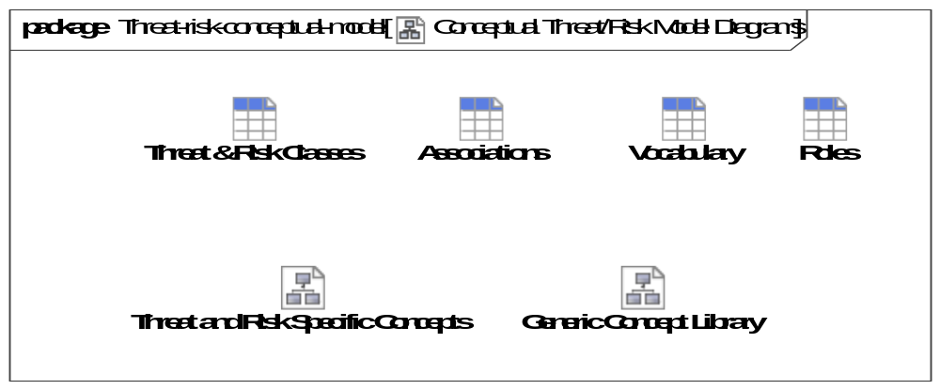
- Conceptual Threat/Risk Model Diagrams

Threat-risk-conceptual-model::Generic Concept Library
Concepts that are common across many domains and purposes such that they may be used as needed to federate and translate information into a threat, risk or other domain. Also known as "Micro theories" in logic.

Diagram: Generic Concept Library
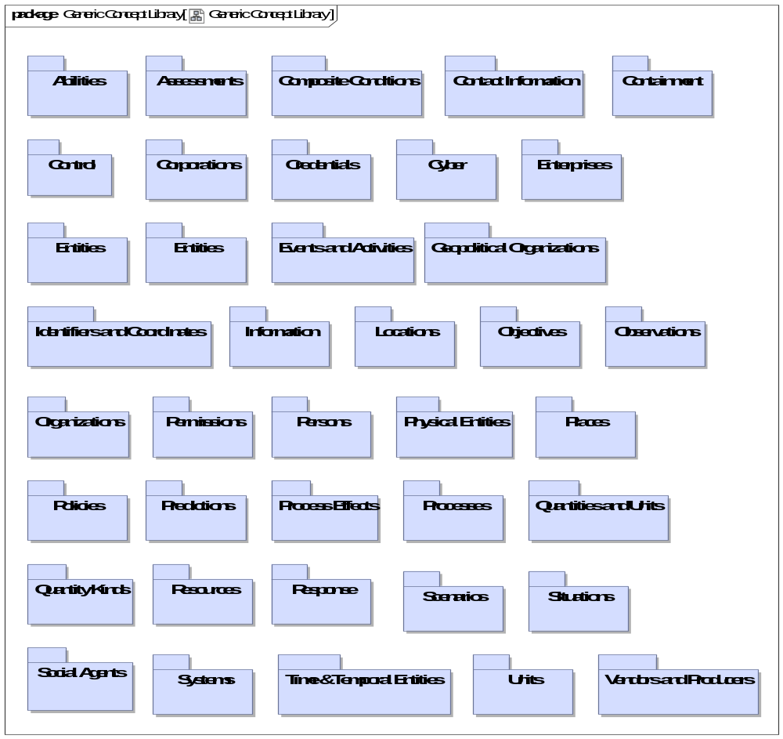
- Generic Concept Library
Modules (as UML packages) defined as generic concepts under threat & risk. Each module focuses on a particular concept with dependencies on other modules. This forms a graph of "micro theories" that can be independently utilized.

Threat-risk-conceptual-model::Generic Concept Library::Abilities
The Ability module defines the basic concept of an Ability as the availability of a resource to an actor. The resource may be specific, such as $5000, a weapon, or general, such as the ability to teach math. Each Ability is a state indicating that it has a lifetime and can participate in all the state/situation and entity relations. Credentials may be physical or virtual and attest to the Ability.
Abilities may be created, enhanced, diminished, or eliminated with an Alter Ability Event. When an actor alters an Ability (of themselves or others) they are playing the role of a Facilitator who performs an Alter Capacity.

Diagram: Ability
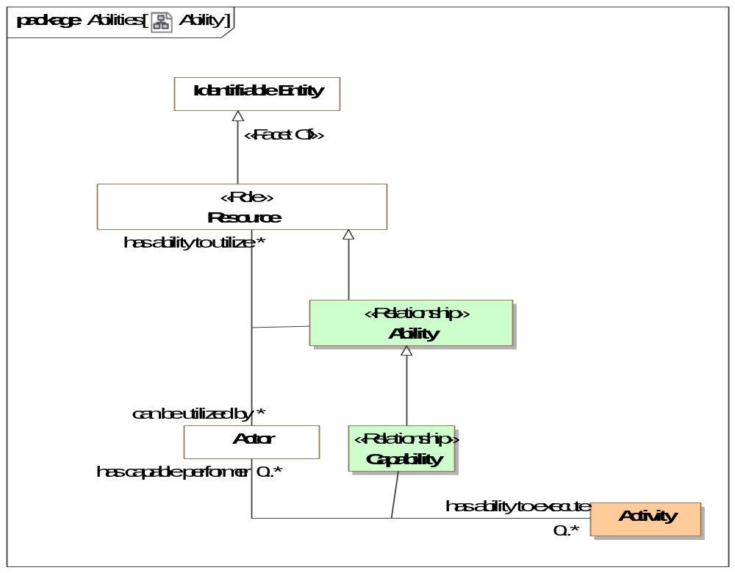
- Ability

Diagram: Alter ability or control
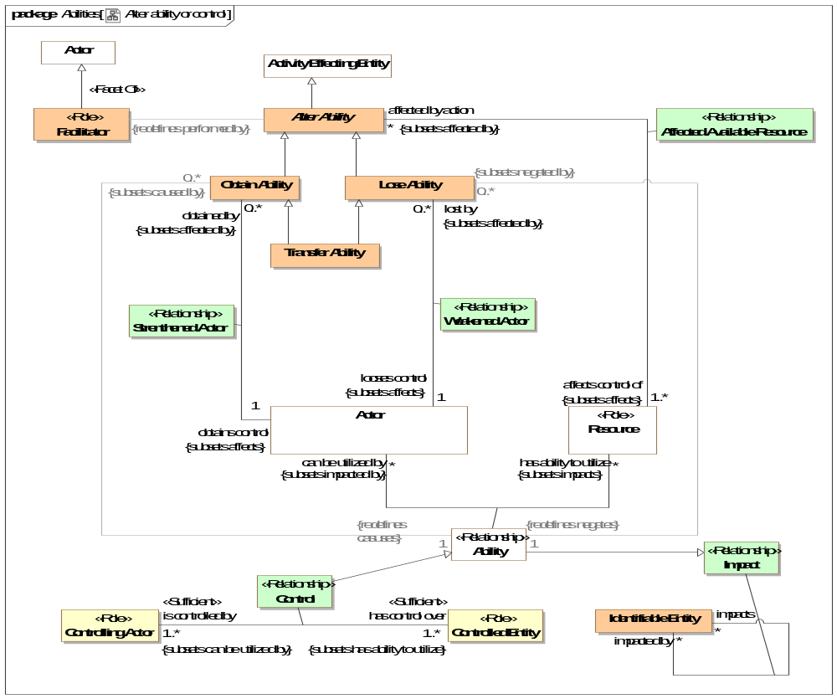
- Alter ability or control

Association Class Ability <<Relationship>>
An Ability is the availability of a resource to an actor to perform activities.
Note that as with any entity, an Ability can also be categorized as a resource and thus the subject of other relationships..
Note that resources can be physical (such as a hammer), activities, virtual or more abstract such as training or experience.
[ISO/IEC 17027:2014] ability: capacity to perform an activity
[NIEM] CapabilityType:
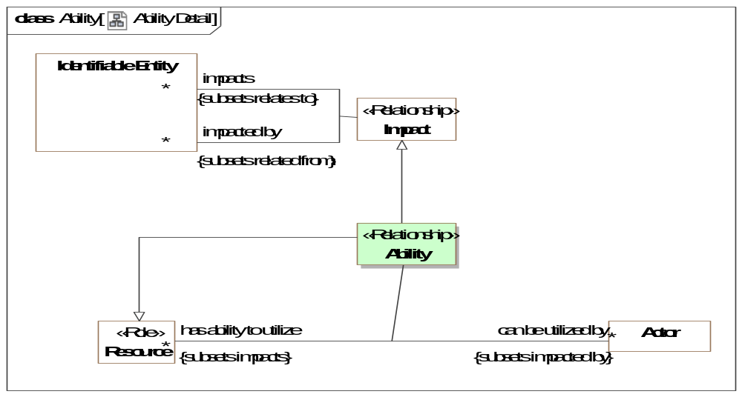
- Ability Detail
Direct Supertypes
Impact, Resource
Association Ends
can be utilized by : Actor [*] Redefines: categorizes: Thing
The actor having the ability to utilize a resource for a purpose.
has ability to utilize : Resource [*] Redefines: categorizes: Thing
A resource an actor can employ as part of a capability.
Associations
<<Restriction>> : Lose Ability [0..*] Subsets: negated by:Situation
<<Restriction>> : Obtain Ability [0..*] Subsets: caused by:Situation

Association Class Affected Available Resource <<Relationship>>
An alter ability action affects an actors control over one or more resources. This relationship defines the set of resources impacted by an alter ability action.
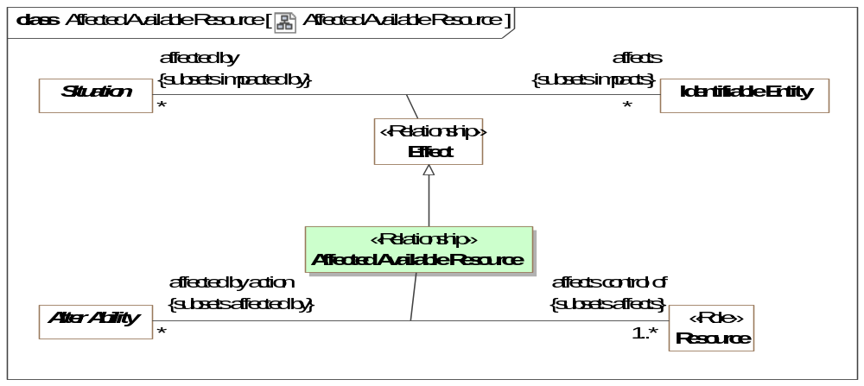
- Affected Available Resource
Direct Supertypes
Effect
Association Ends
affects control of : Resource [1..*] Subsets: caused by:Situation
Resource that an alter ability action impacts in terms of its availably to actors.
affected by action : Alter Ability [*] Subsets: caused by:Situation
Actions which impact the availability of a resource to actors.

Class Alter Ability
The Event of providing or removing abilities (including control) by impacting the resources available to an actor.
Direct Supertypes
Activity Effecting Entity

Association Class Capability <<Relationship>>
A capability is the ability of an actor to have an effect by performing or enacting a process realized through the use of resources. Capability may lead to performance of the activity.
[FIBO] Capability: A capability represents the ability to perform a particular type of work and may involve people with particular skills and knowledge, intellectual property, defined practices, operating facilities, tools and equipment.
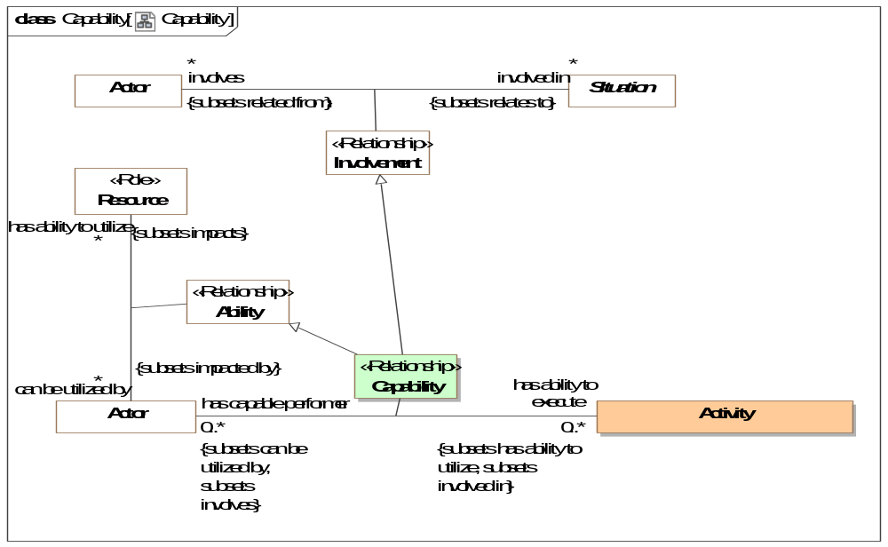
- Capability
Direct Supertypes
Ability, Involvement
Association Ends
has ability to execute : Activity [0..*] Subsets: caused by:Situation
The ability of an actor to perform a process.
has capable performer : Actor [0..*] Subsets: caused by:Situation
Actor capable of performing an process.

Class Facilitator <<Role>>
An actor able to provide an ability to another actor. e.g., Joe has supervisor rights to a database.
Direct Supertypes
Actor

Class Lose Ability
An Event that reduces of the ability of an actor.
Direct Supertypes
Alter Ability

Class Obtain Ability
An Event that increases the resources available to an actor.
Direct Supertypes
Alter Ability

Association Class Strenthened Actor <<Relationship>>
The act of obtaining control of an entity.
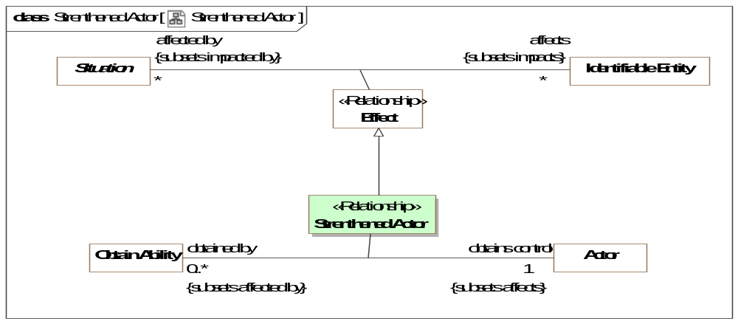
- Strenthened Actor
Direct Supertypes
Effect
Association Ends
obtains control : Actor [1] Subsets: caused by:Situation
Control obtained by a obtain control action.
obtained by : Obtain Ability [0..*] Subsets: caused by:Situation
Method by which control is obtained.

Class Transfer Ability
The purposeful or accidental transfer of ability or control from one actor to another. Such transfer of ability or control may be by agreement or force.
Direct Supertypes
Event, Lose Ability, Obtain Ability

Association Class Weakened Actor <<Relationship>>
Relationship describing how an actor reduces the resources available to an actor.
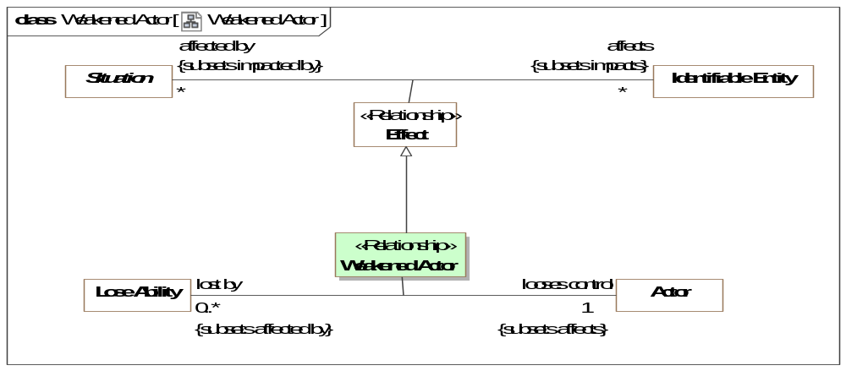
- Weakened Actor
Direct Supertypes
Effect
Association Ends
looses control : Actor [1] Subsets: caused by:Situation
Control that is lost as a result of a lose control Event.
lost by : Lose Ability [0..*] Subsets: caused by:Situation
Action that causes a loss of control.

Threat-risk-conceptual-model::Generic Concept Library::Assertions

Diagram: Assertions
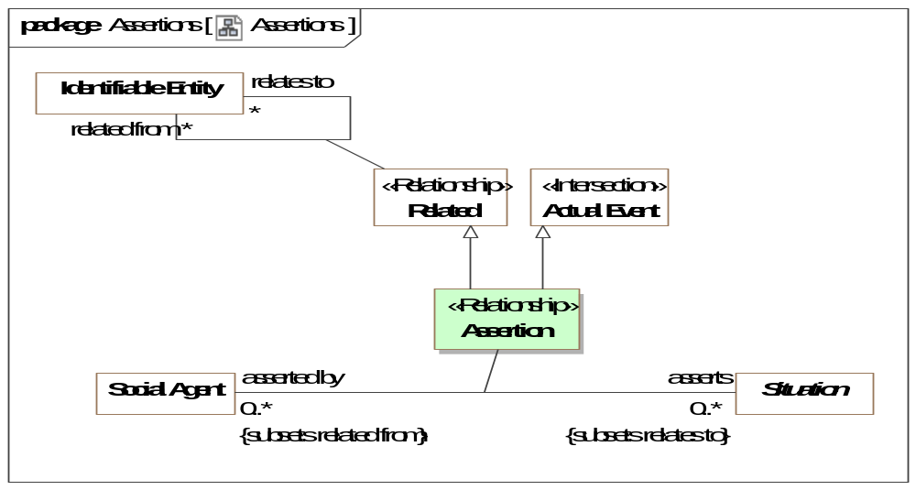
- Assertions

Threat-risk-conceptual-model::Generic Concept Library::Assessments
Concepts relating to the structured evaluation of an entity or entities.

Diagram: Assessment
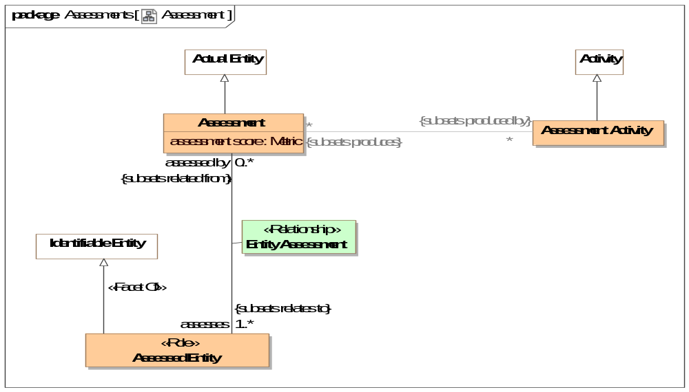
- Assessment
The evaluation or estimation of the nature, quality, or ability of someone or something.
[BMM] Assessment: judgment that an influencer affects the employment of means and/or the achievement of ends

Class Assessed Entity <<Role>>
Role of an entity that is assessed.
Direct Supertypes
Identifiable Entity

Class Assessment
An evaluation, appraisal, or assessment of something or someone.
[NIEM] AssessmentType: The act of evaluating or estimating the nature, ability, or quality of something. {Note: In NIEM the assessment and activity are combined}
Direct Supertypes
Actual Entity
Attributes
assessment score : Metric
An evaluation score of an assessment.[NIEM]

Class Assessment Activity
An activity that results in an assessment - An evaluation, appraisal, or assessment of something or someone. An assessment frequently as an artifact, a report of the assessment.
[NIEM] AssessmentType: The act of evaluating or estimating the nature, ability, or quality of something.
Direct Supertypes
Activity

Association Class Entity Assessment <<Relationship>>
Entities assessed is a relationship between an assessment activity and an entity being assessed that is the topic of an assessment report.
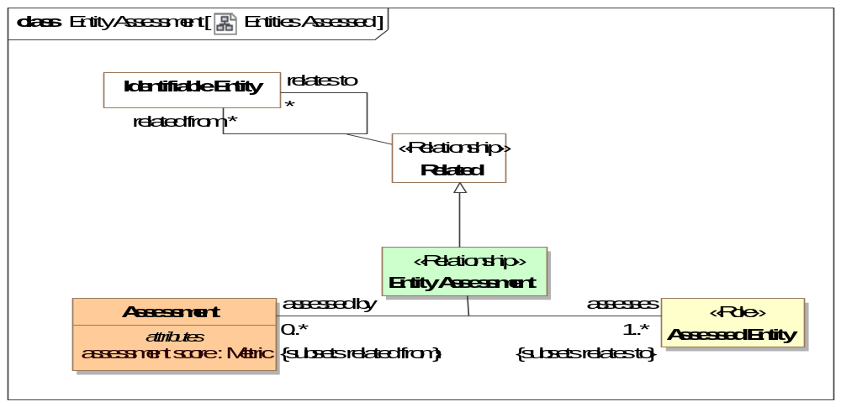
- Entities Assessed
Direct Supertypes
Related
Association Ends
assesses : Assessed Entity [1..*] Subsets: caused by:Situation
Entity assessed by an assessment activity
assessed by : Assessment [0..*] Subsets: caused by:Situation
Entity performing an assessment.

Threat-risk-conceptual-model::Generic Concept Library::Contact Information
The definition of various ways to contact an entity. Subtypes of contact information supply specific formats.

Diagram: Contact Information
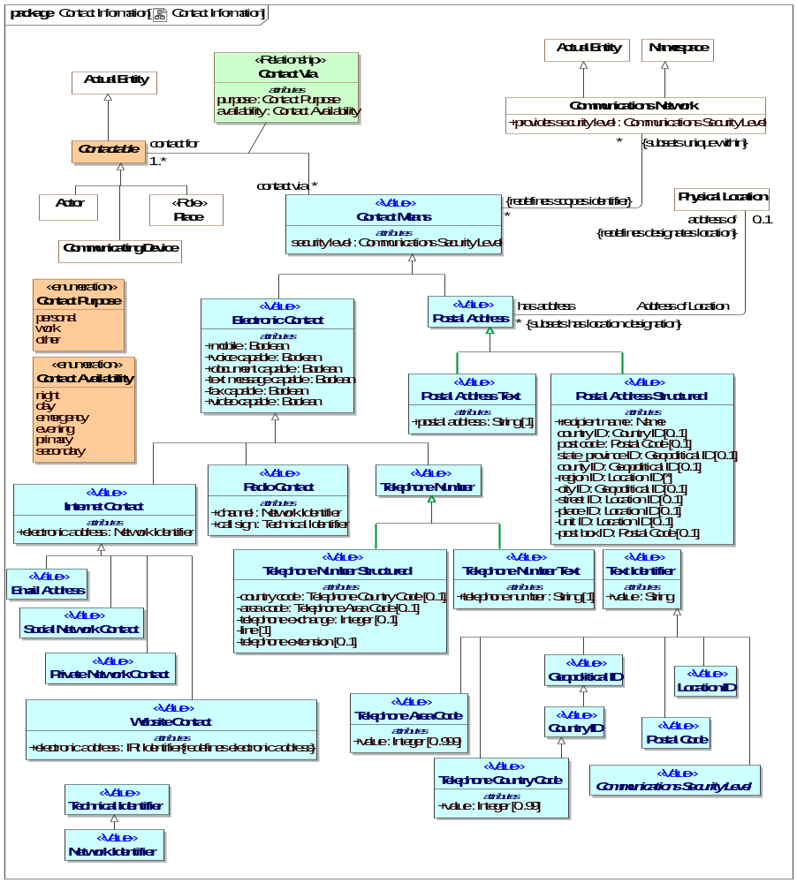
- Contact Information

Class Communications Security Level <<Value>>
An abstract type for levels of security in communications.
Direct Supertypes
Text Identifier

Class Contact Means <<Value>>
Anything that may be used to communicate with an individual.
[FIBO] AddressingScheme
[NIEM] ContactMeans & ContactInformationType
Direct Supertypes
Unique Identifier
Attributes
security level : Communications Security Level
The level of security asserted as provided by the subject contact means. May default to the security level of the communications network.

Association Class Contact Via <<Relationship>>
Information relative to communicating with an entity.
[NIEM] ContactInformationAssociationType
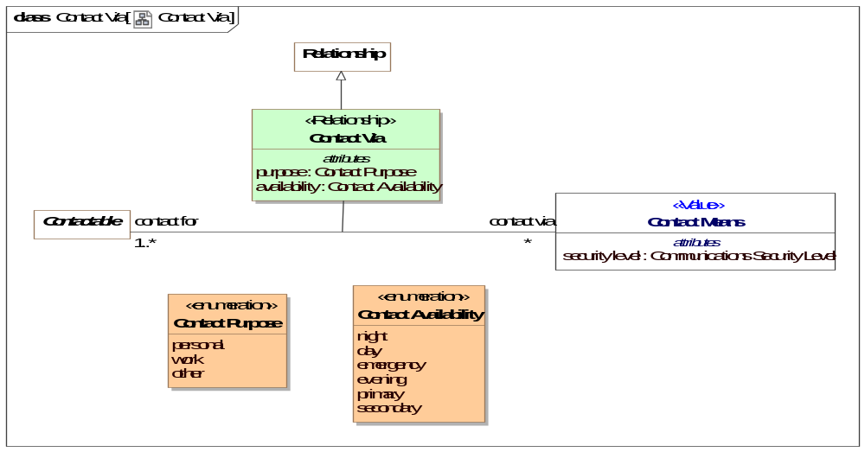
- Contact Via
Direct Supertypes
Relationship
Association Ends
contact via : Contact Means [*] Subsets: caused by:Situation
A way to contact an actor or place.
[FIBO] hasAddress (More specific concept - restricted to Postal Address)
contact for : Contactable [1..*] Subsets: caused by:Situation
An actor or place for which the contact information may be used to contact that entity.
Attributes
purpose : Contact Purpose
Purposes for contacting an entity, primarily work and personal.
[NIEM] ContactPurpose
availability : Contact Availability
An enumeration of the times contact information may be used.
[NIEM] ContactInformationAvailability

Class Contactable
Anything that can be send or receive information or be the proxy for things that can send or receive information, e.g., people, organizations and places.
Direct Supertypes
Actual Entity

Class Electronic Contact <<Value>>
Contact information that enables communications with or via an actor or telecommunications device by electronic means.
[FIBO] VirtualAddress: an address identifying a virtual, i.e. non-physical location
Direct Supertypes
Contact Means
Attributes
mobile : Boolean
Indicator that a contact method is mobile - not fixed to a location.
voice capable : Boolean
An indication that a contact method is voice capable.
document capable : Boolean
An indication that a contact method is capable of receiving documents, e.g., email.
text message capable : Boolean
An indication that a contact method is capable of receiving text messages of limited length.
fax capable : Boolean
Contact method for a communications device that is fax capable.
video capable : Boolean
An indication that a contact method is video capable.

Class Email Address <<Value>>
Contact information for the delivery of mail via an electronic network.
[NIEM] ContactEmailId (of <electronic contact>)
Direct Supertypes
Internet Contact

Class Internet Contact <<Value>>
[NIEM] A means of contact that provides for the digital electronic transmission of information via the Internet or a private network.
Direct Supertypes
Electronic Contact
Attributes
electronic address : Network Identifier
Electronic address by which to contact an entity via the Internet.

Class Network Identifier <<Value>>
A value used to identify a node in an electronic network.
[NIEM] ElectronicAddressType
Direct Supertypes
Technical Identifier

Class Postal Address <<Value>>
An address able to be used to deliver physical mail which may or may not represent a static physical location.
[FIBO] PPostalAddress: a physical address where postal communications can be addressed, for any kind of organization or person.
[NIEM] AddressType
Direct Supertypes
Contact Means, Location Identifier

Class Postal Address Structured <<Value>>
A structured representation of a postal address.
Direct Supertypes
Postal Address
Attributes
recipient name : Name =
Name of the recipient in a postal address which defaults to the name of the entity having the address. Should default to the contact for "has name".
[NIEM] AddressRecipientName
country ID : Country ID [0..1]
Postal country identifier.
post code : Postal Code [0..1]
[OGC] An address component which represents the identification of a subdivision of addresses and postal delivery points in a country, region, or city for postal purposes.
[NIEM] LocationPostalCode
state_province ID : Geopolitical ID [0..1]
Postal state identifier for a geopolitical regions.
[NIEM] LocationState
county ID : Geopolitical ID [0..1]
Postal county identifier.
[NIEM] LocationCounty
region ID : Location ID [*]
Postal region identifier.
[NIEM] AddressUrbanizationName
city ID : Geopolitical ID [0..1]
Postal city identifier.
[NIEM] LocationCityName
street ID : Location ID [0..1]
Postal street identifier.
[NIEM] AddressDeliveryPoint
place ID : Location ID [0..1]
Postal identifier for a specific place: House, building, facility, etc.
unit ID : Location ID [0..1]
Postal province identifier.
[NIEM] AddressSecondaryUnitText
post box ID : Postal Code [0..1]
A code defined for the purposes of delivering physical mail to a specific addresses.
[NIEM] AddressPrivateMailboxText

Class Postal Address Text <<Value>>
A textual representation of a postal address.
Direct Supertypes
Postal Address
Attributes
postal address : String [1]
Textual postal address for the delivery of mail.
[NIEM] AddressFullText

Class Postal Code <<Value>>
A code defined for the purposes of delivering physical mail to a set of addresses. "Zip code" in the U.S.
[OGC] An address component which represents the identification of a subdivision of addresses and postal delivery points in a country, region or city for postal purposes.
[FIBO] PostalCodeArea
Direct Supertypes
Text Identifier

Class Private Network Contact <<Value>>
Contact identifiers valid within a private network.
Direct Supertypes
Internet Contact

Class Radio Contact <<Value>>
Identifier for contact via radio.
[NIEM] ContactRadioType
Direct Supertypes
Electronic Contact
Attributes
channel : Network Identifier
Radio channel used for communications.
[NIEM] ContactRadioChannelText
call sign : Technical Identifier
Radio or user call sign used for radio communications.
[NIEM] ContactRadioCallSignID

Class Social Network Contact <<Value>>
Contact information to be used via a social network.
[NIEM] InstantMessageType
--InstanceMessengerServiceName = <has name>
--InstanceMessengerScreenId = "electronic address"
Direct Supertypes
Internet Contact

Class Telephone Area Code <<Value>>
A three-digit number that identifies one of the telephone service regions into which the US, Canada, and certain other countries are divided and that is dialed when calling from one area to another.
Direct Supertypes
Text Identifier
Attributes
value : Integer [0..999]
3 digit area code.

Class Telephone Country Code <<Value>>
2 digit Telephone codes for contacting people and organizations within countries.
Direct Supertypes
Country ID, Text Identifier
Attributes
value : Integer [0..99]
Country code digits.

Class Telephone Number <<Value>>
A way to contact an actor via a telephone.
[NIEM] TelephoneNumberType
Direct Supertypes
Electronic Contact

Class Telephone Number Structured <<Value>>
Structured representation of a telephone number.
[NIEM] NANPTelephoneNumberType & InternationalTelephoneNumberType
Direct Supertypes
Telephone Number
Attributes
country code : Telephone Country Code [0..1]
Telephone country code.
[NIEM] TelephoneCountryCodeID
area code : Telephone Area Code [0..1]
Telephone area code.
[NIEM] TelephoneAreaCodeID
telephone exchange : Integer [0..1]
Number identifying a telephone exchange.
[NIEM] TelephoneExchangeID
line [1]
Telephone line number.
[NIEM] TelephoneLineID
telephone extension [0..1]
Telephone extension number.

Class Telephone Number Text <<Value>>
Unstructured (text) representation of a telephone number.
[NIEM] FullTelephoneNumberType
Direct Supertypes
Telephone Number
Attributes
telephone number : String [1]
Textual telephone number.
[NIEM] TelephoneNumberFullID

Class Website Contact <<Value>>
A website that can be used to contact an individual.
Direct Supertypes
Internet Contact
Attributes
electronic address : IRI Identifier
Electronic address by which to contact an entity via a website.
[NIEM] ContactWebsiteURI

Enumeration Contact Availability
A data type for a period of time or a situation in which an entity is available to be contacted with the given contact information.[NIEM]
package Threat-risk-conceptual-model::Generic Concept Library::Contact Information
public enum Contact Availability
{night, day, emergency, evening, primary, secondary}

Literals
night
Late night contact.
day
Daytime contact.
emergency
Emergency contact.
evening
Late day or early night contact.
primary
Primary contact.
secondary
Secondary or alternate contact.

Enumeration Contact Purpose
Possible purposes for contact information.[NIEM]
package Threat-risk-conceptual-model::Generic Concept Library::Contact Information
public enum Contact Purpose
{personal, work, other}

Literals
personal
Personal communications.
work
Work communications.
other
Communications other than work or personal.

Threat-risk-conceptual-model::Generic Concept Library::Containment

Diagram: Containment
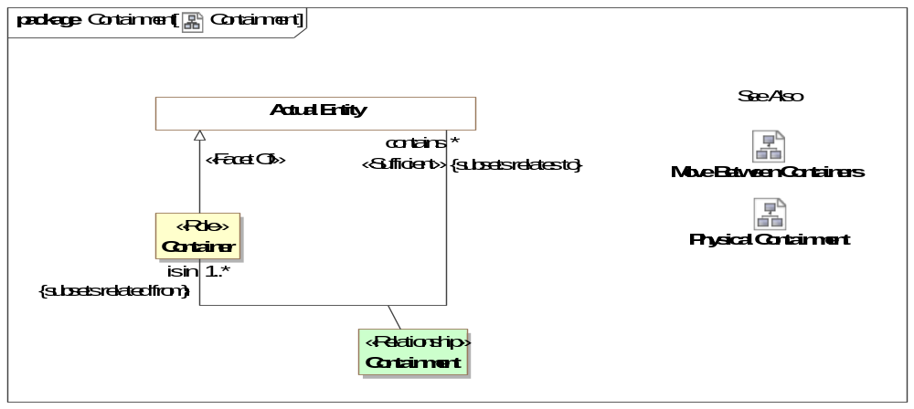
- Containment

Diagram: Move Between Containers
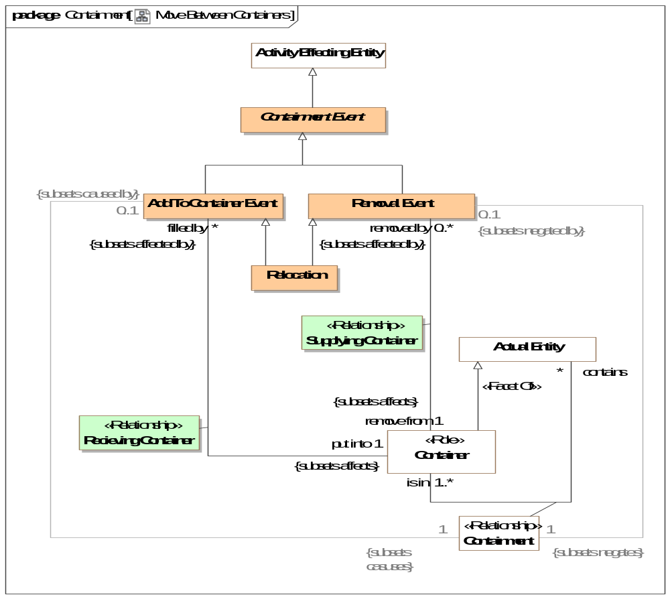
- Move Between Containers

Diagram: Physical Containment
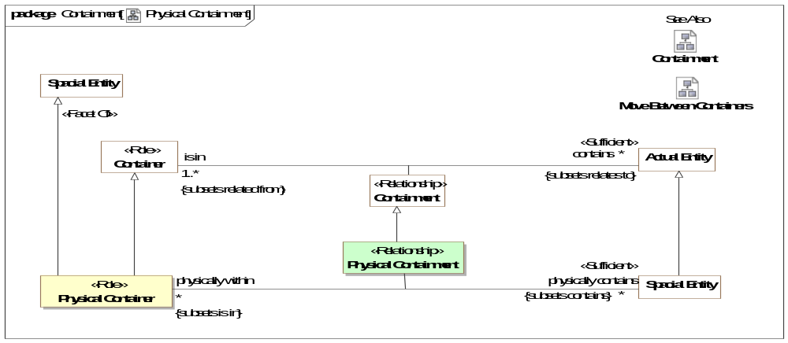
- Physical Containment

Class Add To Container Event
An event that puts things into containers or locations. This results in a new containment relationship.
Direct Supertypes
Containment Event

Class Container <<Role>>
Role of something as a container for other things. Containers & Containment may be physical or virtual.
Direct Supertypes
Actual Entity

Association Class Containment <<Relationship>>
Relationship between a container and a contained thing.
Containment may or may not correspond to a part-of relationship. In some cases both the container (a jar) and what it contains (jelly beans) may be considered parts of a whole (a jar of jelly beans).
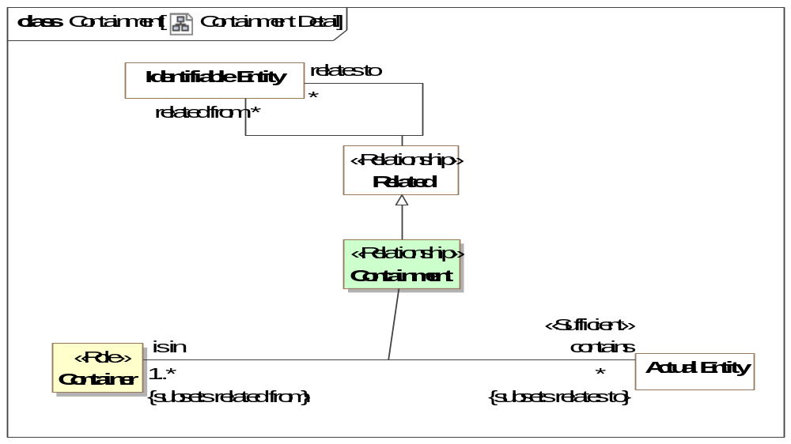
- Containment Detail
Direct Supertypes
Related
Association Ends
contains : Actual Entity [*] Subsets: caused by:Situation
A thing contained within a container.
is in : Container [1..*] Subsets: caused by:Situation
A container which holds one or more contained things.
[FIBO] isLocatedAt: a property linking something to a location or place, which might be physical or virtual
Associations
<<Restriction>> : Add To Container Event [0..1] Subsets: caused by:Situation
<<Restriction>> : Removal Event [0..1] Subsets: negated by:Situation

Class Containment Event
An event impacting containment of the <contained thing>. Subtypes include "Put Into Event", "Removal Event" and "Relocation".
Direct Supertypes
Activity Effecting Entity

Class Physical Container <<Role>>
A physical thing or location that contains other physical things or locations.
[DOLCE] Spacial Location
Direct Supertypes
Container, Spacial Entity

Association Class Physical Containment <<Relationship>>
Location of something physically within a container, including locations.
Direct Supertypes
Containment
Association Ends
physically contains : Spacial Entity [*] Subsets: negated by:Situation
A physical entity contained by another physical entity.{Transitive}
physically within : Physical Container [*] Subsets: negated by:Situation
Physical container in which the subject physical entity is contained.{transitive}
al

Association Class Recieving Container <<Relationship>>
Relationship between a fill action and the container that is filled with something.
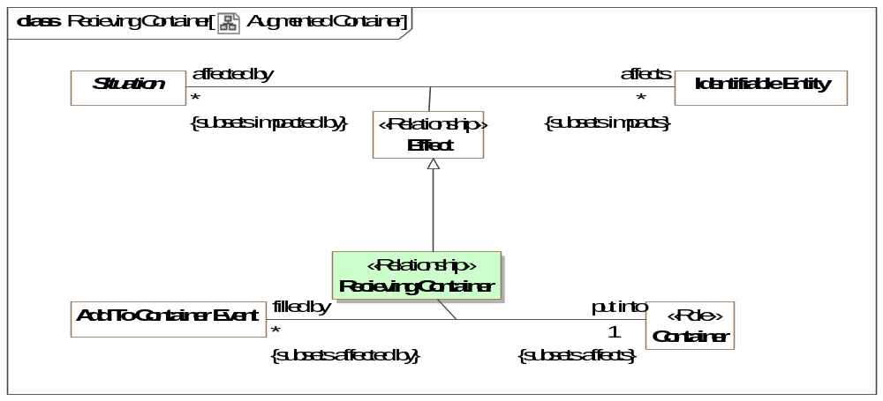
- Augmented Container
Direct Supertypes
Effect
Association Ends
put into : Container [1] Subsets: negated by:Situation
Container that receives something by a fill action.
filled by : Add To Container Event [*] Subsets: negated by:Situation
Action that puts or moves something into a container or location.

Class Relocation
The transfer (send/receive) of something between containers or locations. As an Event, the move may be initiated by an actor different from the sender/receiver or may not be caused by an actor.
Examples include movement of a vehicle from one location to another or movement of supplies between warehouses.
Direct Supertypes
Add To Container Event, Removal Event

Class Removal Event
An event that removes things from containers or locations. This results in the termination of a containment relationship.
Direct Supertypes
Containment Event

Association Class Supplying Container <<Relationship>>
Relationship between a removal action and the container it removes something from.
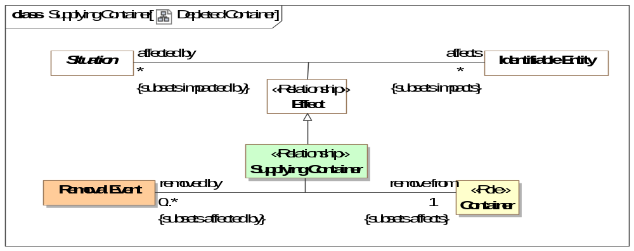
- Depleted Container
Direct Supertypes
Effect
Association Ends
remove from : Container [1] Subsets: negated by:Situation
Container (or location) that contained something that is removed.
removed by : Removal Event [0..*] Subsets: negated by:Situation
Action that removes something from a container or location.

Threat-risk-conceptual-model::Generic Concept Library::Control
Concepts relating to actor's control over resources.

Diagram: Control
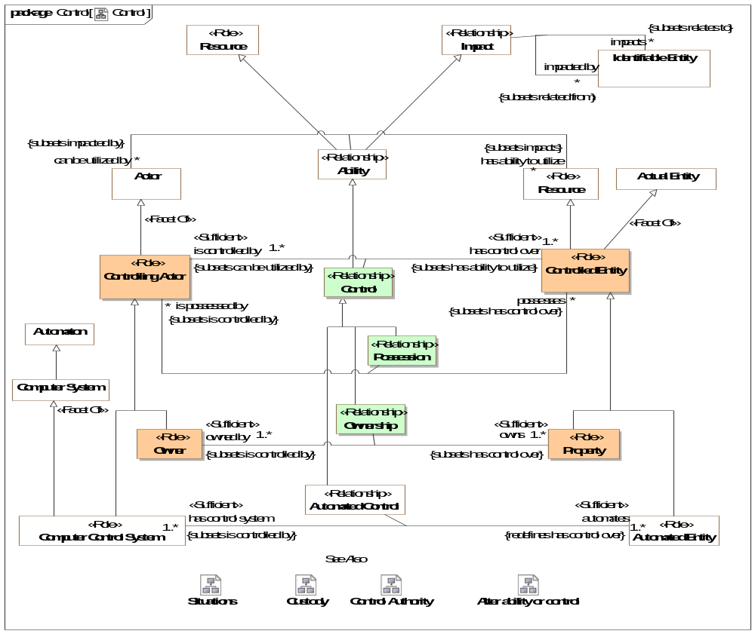
- Control
This diagram shows that control is a kind of ability and that possession, ownership and automated control are kinds of control. For each kind of control there are specific kinds of roles involved.

Diagram: Control Authority
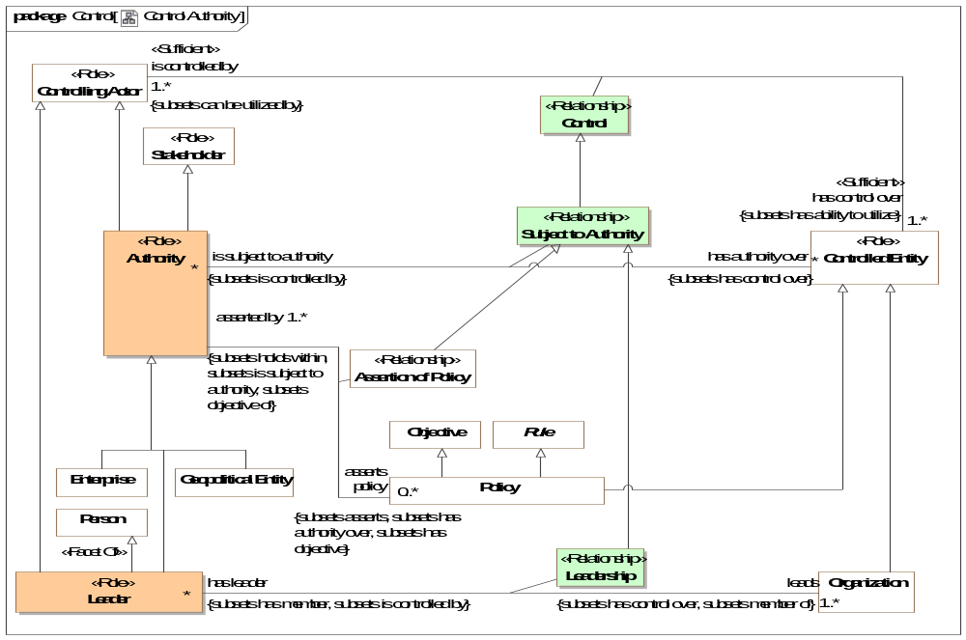
- Control Authority

Diagram: Custody
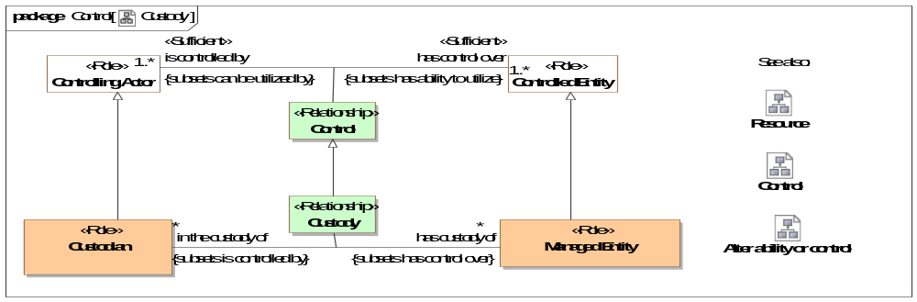
- Custody
Custody provides a general framework for tracking the control, provenance and life cycle of items and information such that the history, trust and provenance may be ascertained. Custody provides for secure supply chains in that the life-cycle or items, information and their parts may be traced.
Custody is the relation between a Custodian and a Managed Entity (Something for which the provenance is interesting).
Trust in a managed entity may also be influenced by the actors that have a capability to impact the resource.

Class Authority <<Role>>
An actor with authority over resources such that it can assert policy or behavior.
[ISO 15779:2011] organization, office, or individual responsible for approving equipment, installations or procedures
Direct Supertypes
Controlling Actor, Stakeholder

Association Class Control <<Relationship>>
The use or influence of an actor over an entity. This includes subtypes of control representing possession, ownership, leadership. and custody.
[FIBO] Control: the possession by a party, direct or indirect, of the power to direct or cause the direction of the management and policies of a thing, whether through the ownership of voting shares, by contract, or otherwise.
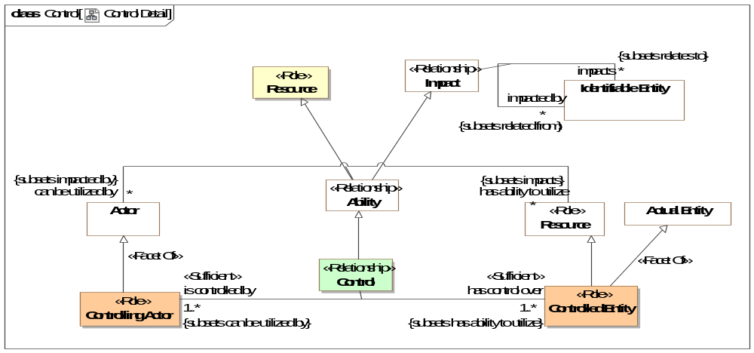
- Control Detail
Direct Supertypes
Ability
Association Ends
has control over : Controlled Entity [1..*] Subsets: negated by:Situation
Entity which an actor controls in some way - by authority or by possession, by force, etc.
[FIBO] controls
is controlled by : Controlling Actor [1..*] Subsets: negated by:Situation
Actor which controls a controlled entity in some way.The nature of control may be refined in subtypes.
[FIBO] isControlledBy

Class Controlled Entity <<Role>>
Role of an entity that is controlled by a controlling actor.
[FIBO] ControlledThing: thing over which some party exercises some form of control in some context
Direct Supertypes
Actual Entity, Resource

Class Controlling Actor <<Role>>
Role of an actor that asserts control over any entity.
[FIBO] ContollingParty: Party which exercises some form of control in some context.
Direct Supertypes
Actor

Class Custodian <<Role>>
An actor who has responsibility for or looks after some managed entity. A Custodian <has custody of> a managed entity via the Custody relation.
Direct Supertypes
Controlling Actor

Association Class Custody <<Relationship>>
The act of a custodian protecting or taking care of a managed entity.
Direct Supertypes
Control
Association Ends
has custody of : Managed Entity [*] Subsets: negated by:Situation
The entity a custodian has custody of.
in the custody of : Custodian [*] Subsets: negated by:Situation
The custodian of a managed entity.

Class Leader <<Role>>
A person who leads or commands a group, organization, or country.
Direct Supertypes
Authority, Controlling Actor, Person

Association Class Leadership <<Relationship>>
An person leading or governing an organization.
Direct Supertypes
Control, Membership, Subject to Authority
Association Ends
leads : Organization [1..*] Subsets: negated by:Situation
An organization a person leads.
has leader : Leader [*] Subsets: negated by:Situation
A person leading or directing an organization.

Class Managed Entity <<Role>>
Any entity for which the custody of or access to the entity is managed such that it can be trusted or protected. A managed entity is in the custody of a custodian via the Custody relation.
Direct Supertypes
Controlled Entity

Class Owner <<Role>>
Role of an actor that owns property.
[FIBO] Owner: A party in the ownership role; one that owns something. The thing owned is an Asset to that Party.
Direct Supertypes
Controlling Actor

Association Class Ownership <<Relationship>>
Relationship defining the ownership of property by an owner.
[FIBO] Ownership: Ownership is the context in which some Party is said to own some Independent Thing. The Party is defined as such due to its being the owning party to that Thing.
Direct Supertypes
Control
Association Ends
owns : Property [1..*] Subsets: negated by:Situation
Property owned by an owner.
[FIBO] owns: to have (something) as one's own, possess
owned by : Owner [1..*] Subsets: negated by:Situation
Owner of an entity as property.
[FIBO] isOwnedBy: identifies the party that owns the asset.
[NIEM] ItemOwner

Association Class Possession <<Relationship>>
A relationship defining the physical possession of an item.
Direct Supertypes
Control
Association Ends
possesses : Controlled Entity [*] Subsets: negated by:Situation
A controlled entity in the physical possession of a controlling actor.
is possessed by : Controlling Actor [*] Subsets: negated by:Situation
The actor that possesses the subject controlled entity.
[NIEM] ItemPossessor

Class Property <<Role>>
Role of an entity which has an owner.
[FIBO] Asset: A thing held by some party and having some value.
Direct Supertypes
Controlled Entity

Association Class Subject to Authority <<Relationship>>
The relationship between an authority and what it has authority over.
Direct Supertypes
Control
Association Ends
has authority over : Controlled Entity [*] Subsets: negated by:Situation
Resource an authority has authority over - may influence in some by setting policy or defining requirements.
[FIBO] governs
is subject to authority : Authority [*] Subsets: negated by:Situation
The authority that has some control over a resource.
[FIBO] isGovernedBy

Threat-risk-conceptual-model::Generic Concept Library::Credentials
Concepts relating to identity and credential management.

Diagram: Credentials and Managed Identifiers
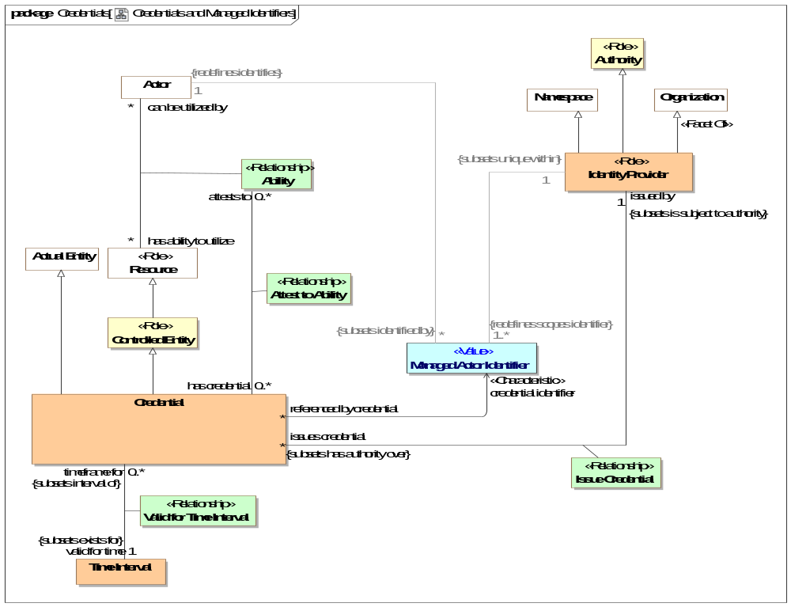
- Credentials and Managed Identifiers

Association Actor Identifier of Credential
Association Ends
credential identifier : Managed Actor Identifier Subsets: negated by:Situation
Managed identifier used by a credential to identify the credential and/or actor.
referenced by credential : Credential [*] Subsets: negated by:Situation
A credential that use the subject managed identifier to identify the credential or actor.

Association Class Attest to Ability <<Relationship>>
Relationship between a credential and the abilities it attests to. Note that ability is a relationship between an actor and a resource, so the credentialed individual is the actor in this relationship, the actor is identified by an identifier referenced by the credential.
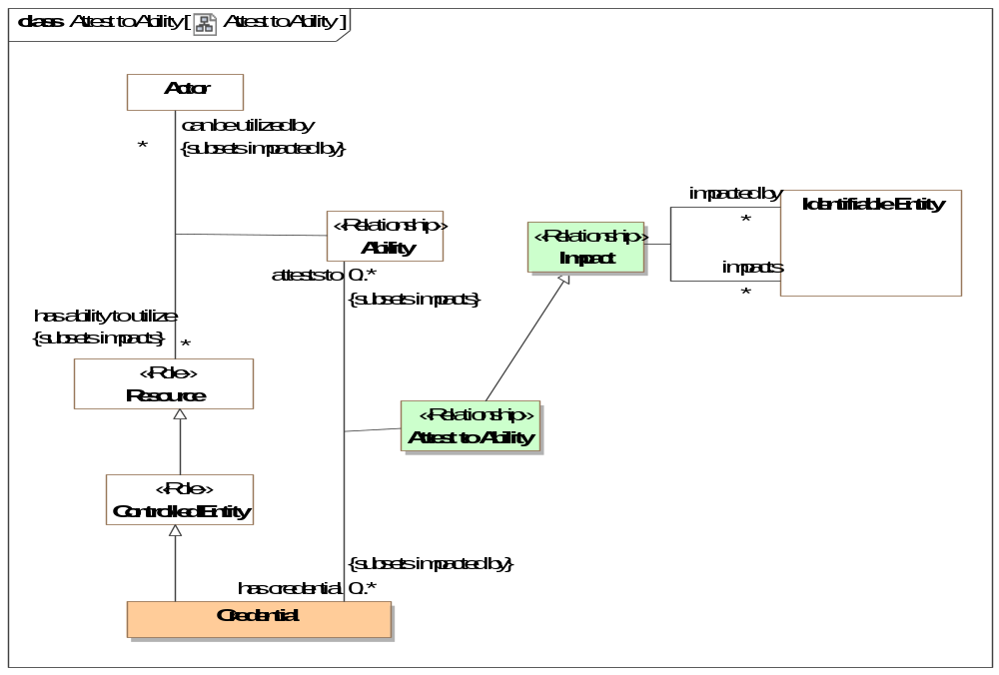
- Attest to Ability
Direct Supertypes
Impact, Relationship
Association Ends
attests to : Ability [0..*] Subsets: negated by:Situation
A statement of a credentialed capability - that an actor has the stated ability to utilize a resource.
has credential : Credential [0..*] Subsets: negated by:Situation
A physical or logical record of an assertion that a particular actor has a particular ability.

Class Credential
A credential is an attestation of qualification, competence, or authority issued to an individual by a third party with a relevant or de-facto authority or assumed competence to do so. Credentials can be physical (a house key), documents (a certificate) or virtual (a PKI key) and may be valid for a specific time frame and in specific context.
Direct Supertypes
Actual Entity, Controlled Entity

Class Identity Provider <<Role>>
Role of an organization that validates identity and issues curated identifiers and credentials for entities.
Direct Supertypes
Authority, Namespace, Organization

Association Class Issue Credential <<Relationship>>
Issuance of and the assertion of the validity of a credential by an identity provider.
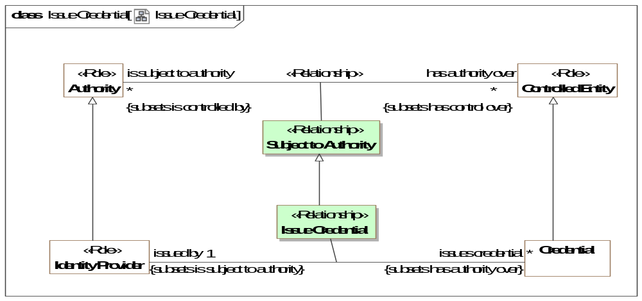
- Issue Credential
Direct Supertypes
Subject to Authority
Association Ends
issues credential : Credential [*] Subsets: negated by:Situation
Credential issued by an identity provider. By issuing the credential the identity provider is asserting the validity of the credential.
issued by : Identity Provider [1] Subsets: negated by:Situation
The identity provider issuing a credential By issuing the credential the identity provider is asserting the validity of the credential.

Class Managed Actor Identifier <<Value>>
An identifier managed by an identity provider who asserts the validity of the identifier. This includes technical/cyber identities as well as traditional identifiers such as passport numbers and corporate IDs. Identities can also be provided for systems, such as a SSL certificate.
Direct Supertypes
Unique Identifier

Association Class Valid for Time Interval <<Relationship>>
Relationship describing the time interval for which a credential is valid.
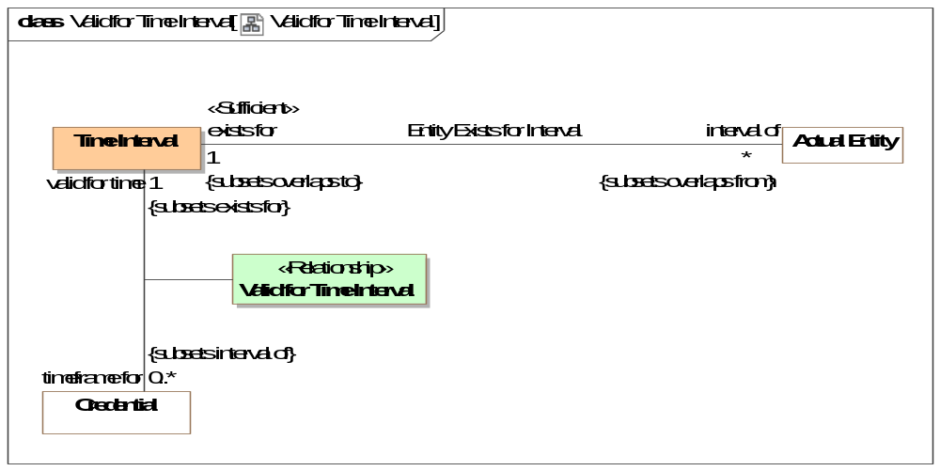
- Valid for Time Interval
Direct Supertypes
Entity Exists for Interval
Association Ends
valid for time : Time Interval [1] Subsets: negated by:Situation
Time interval over which a credential is valid (can be used to provide evidence for an ability).
timeframe for : Credential [0..*] Subsets: negated by:Situation
Credential that is validated within the <valid for time> interval.

Threat-risk-conceptual-model::Generic Concept Library::Cyber
The Cyber package defines instances and subtypes of generic concepts specific to Cyber - computers, software and networks.

Diagram: Cyber
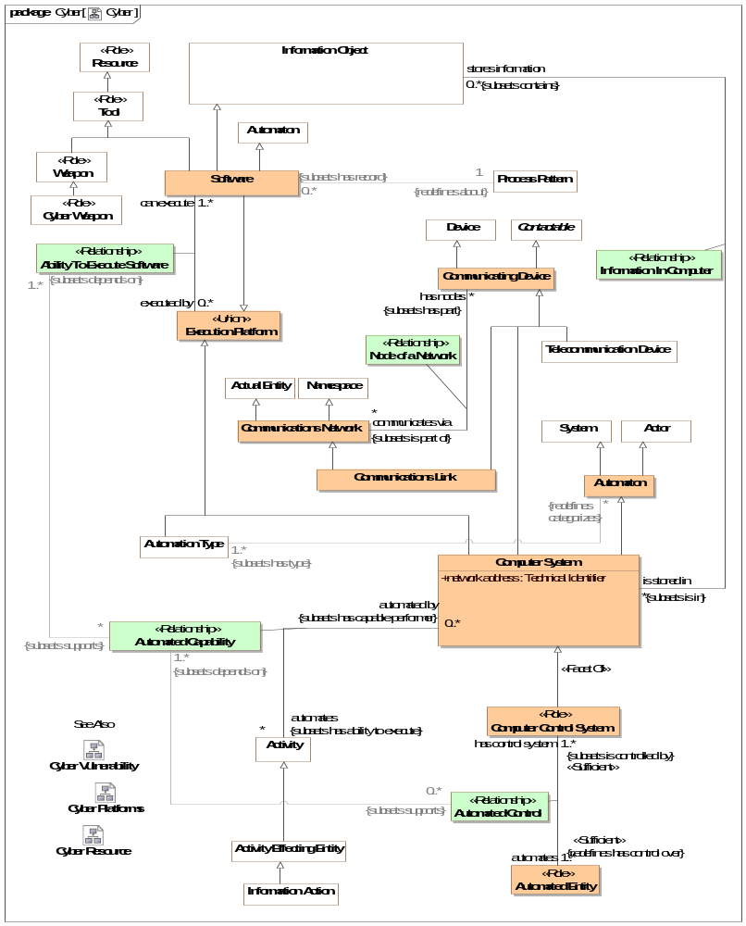
- Cyber

Diagram: Cyber Platforms
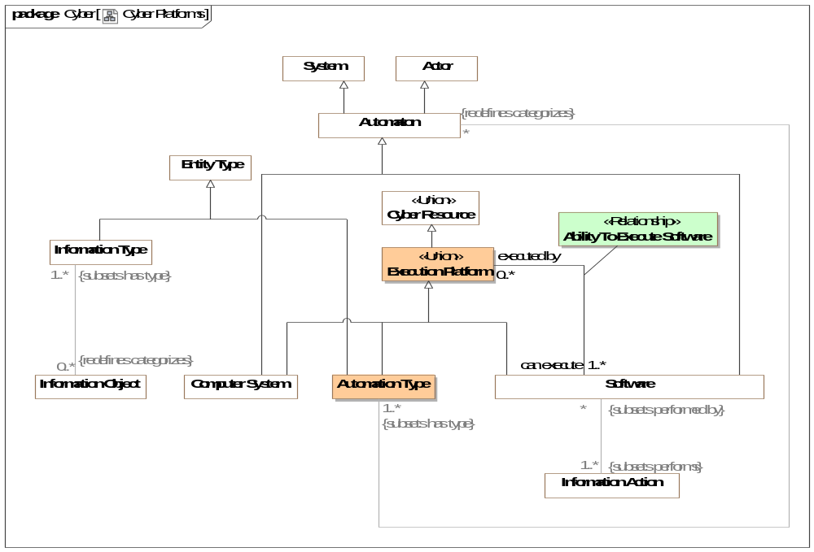
- Cyber Platforms

Diagram: Cyber Resource
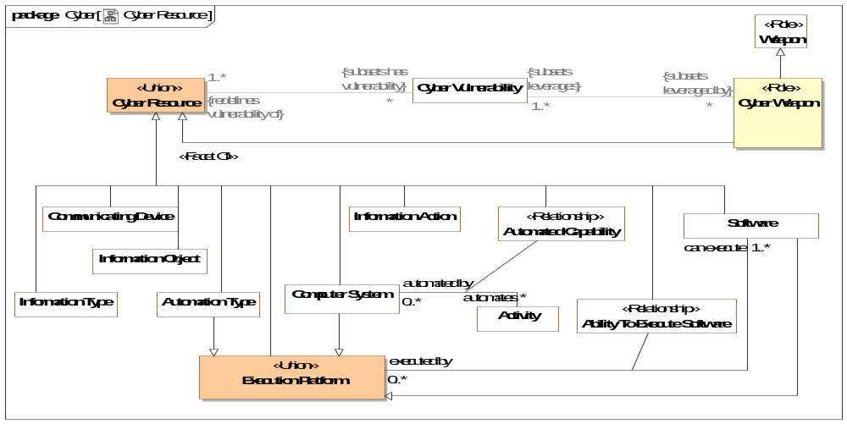
- Cyber Resource

Association Class Ability To Execute Software <<Relationship>>
Relationship between software and platforms that can execute that software. Platforms include specific computers , types of computers and software.
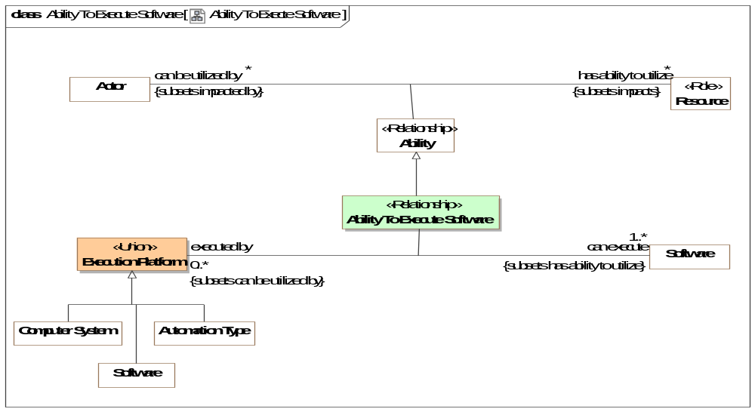
- Ability To Execte Software
Direct Supertypes
Ability, Cyber Resource
Association Ends
executed by : Execution Platform [0..*] Subsets: negated by:Situation
A computer platform (software, computer type or specific computer) able to execute specific software.
can execute : Software [1..*] Subsets: negated by:Situation
Software a computer system, other software or computer type is able to execute.
Associations
<<Restriction>> : Automated Capability [*] Subsets: supports:Resource

Association Class Automated Capability <<Relationship>>
Capability of a specific computer system to automate activities.
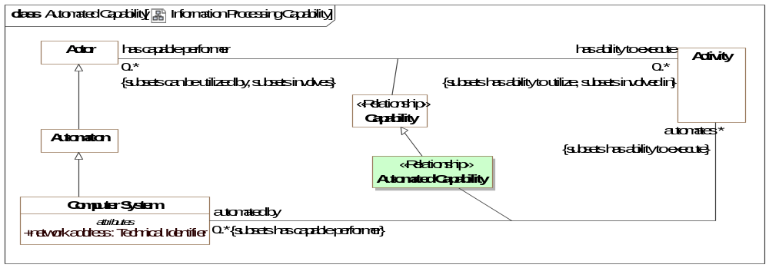
- Information Processing Capability
Direct Supertypes
Capability, Cyber Resource
Association Ends
automates : Activity [*] Subsets: supports:Resource
Activities a computer may automate.
automated by : Computer System [0..*] Subsets: supports:Resource
Computer system capable of automating an activity.
Associations
<<Restriction>> : Automated Control [0..*] Subsets: supports:Resource

Association Class Automated Control <<Relationship>>
Control of an entity by an automated control system - a computer and related software.
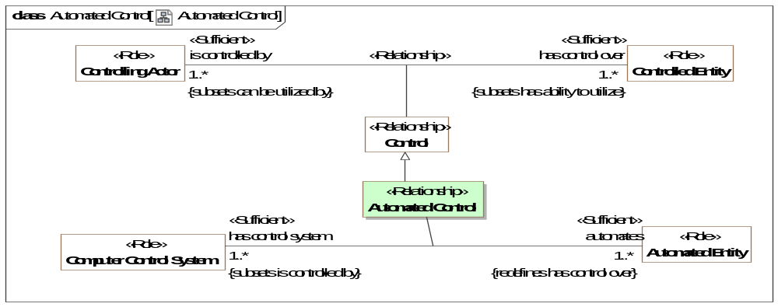
- Automated Control
Direct Supertypes
Control
Association Ends
automates : Automated Entity [1..*] Subsets: supports:Resource
Entity that is controlled by a computer system.
has control system : Computer Control System [1..*] Subsets: supports:Resource
Control system for an automated entity. e.g., an automated machine or facility.

Class Automated Entity <<Role>>
Any actual entity all or partially controlled by automation.
Direct Supertypes
Controlled Entity

Class Automation Type
A categorization of computers and software across any dimension - chip type, operating system, language, manufacturer, virtual machine, etc. The automation type may be used to establish software compatibilities and vulnerabilities. Note that any automation may be categorized by multiple automation types.
Direct Supertypes
Cyber Resource, Entity Type, Execution Platform
Associations
<<Restriction>> : Automaton [*] Redefines: categorizes:Thing

Class Automaton
A machine or group of machines (most often a computer system, robot, or computerized swarm combined with software), or software that can perform actions in accordance with a process without another actor directing each step of the process.
Distinguished from simple tools which facilitate an actor performing a process but have no innate ability to follow such a process.
Automation is distinguished from "legal entity" and "stakeholder", roles of some actors which indicates the ability to enter into legally binding agreements or have objectives (at this time no Automatons are legal entities or stakeholders but the model does not preclude the possibility).
Direct Supertypes
Actor, System
Associations
<<Restriction>> : Automation Type [1..*] Subsets: has type:Type

Class Communicating Device
A device able to communicate or facilitate communications across a network.
Direct Supertypes
Contactable, Cyber Resource, Device

Class Communications Link
A physical or virtual link between communications devices allowing them to communicate.
Direct Supertypes
Communicating Device, Communications Network

Class Communications Network
A physical or electronic system intended to facilitate communications between entities. Includes communications channels, computer networks, physical mail and RF networks.
Direct Supertypes
Actual Entity, Namespace
Attributes
provides security level : Communications Security Level
The level of security asserted for the subject communications network.

Class Computer Control System <<Role>>
A computer control system is a device, or set of devices, that manages, commands, directs or regulates the behavior of other devices or systems. Industrial control systems are used in industrial production for controlling equipment or machines.
Direct Supertypes
Computer System, Controlling Actor

Class Computer System
An identifiable and physical computer system that acts as an automaton agent performing processes.
[ISO/IEC 10514-1:1996] The combination of hardware and, optionally, firmware and software (e.g. operating system) that enables the execution of software.
Direct Supertypes
Automaton, Communicating Device, Container, Cyber Resource, Execution Platform
Attributes
network address : Technical Identifier
Electronic address which allows communication with a computer system as a node on a network.

Class Cyber Resource <<Union>>
Resources that, together, make up information systems capabilities and may be vulnerable to attack or used in an attack.
Associations
<<Restriction>> : Cyber Vulnerability [*] Subsets: has vulnerability:Vulnerability

Class Cyber Weapon <<Role>>
A software weapon able to exploit the vulnerabilities of a cyber system.
Direct Supertypes
Cyber Resource, Weapon
Associations
<<Restriction>> : Cyber Vulnerability [1..*] Subsets: leverages:Vulnerability

Class Execution Platform <<Union>>
Computer hardware or software that provides the capability of executing software. This includes processors, operating systems and virtual machines.
Direct Supertypes
Cyber Resource

Association Class Information In Computer <<Relationship>>
Relationship defining information stored in a computer system.
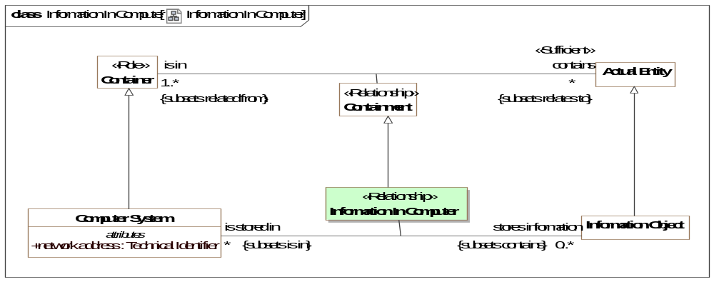
- Information In Computer
Direct Supertypes
Containment
Association Ends
stores information : Information Object [0..*] Subsets: leverages:Vulnerability
Information stored in a computer.
is stored in : Computer System [*] Subsets: leverages:Vulnerability
System storing an information object.

Association Class Node of a Network <<Relationship>>
Relationship between a network and nodes that may communicate on that network.
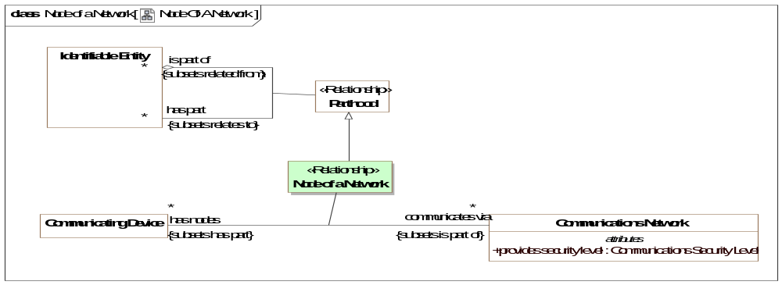
- Node Of A Network
Direct Supertypes
Parthood
Association Ends
communicates via : Communications Network [*] Subsets: leverages:Vulnerability
The network used by a communications device to send and receive information.
has nodes : Communicating Device [*] Subsets: leverages:Vulnerability
The communicating nodes of a communications network. Nodes are able to communicate with each other across the network.

Class Software
Programs and other operating information used by a computer to control its function through the definition of a process.
Direct Supertypes
Automaton, Cyber Resource, Execution Platform, Information Object, Tool
Associations
<<Restriction>> : Information Action [1..*] Subsets: performs:Activity

Threat-risk-conceptual-model::Generic Concept Library::Enterprises
In a generic sense, an enterprise is any organization or collection of organizations that has a common set of goals and/or a single bottom line. An enterprise, by that definition, can encompass a Military Department, DoD as a whole, a division within an organization, an organization in a single location, or a chain of geographically distant organizations linked by a common management or purpose. An enterprise today is often thought of as an extended enterprise where partners, suppliers, customers, along with their activities and supporting systems, are included in the Architectural Description. [DoDAF 2.0] section 51, Defining the Enterprise
The concept of enterprise builds on the concept of a system.

Diagram: Enterprise
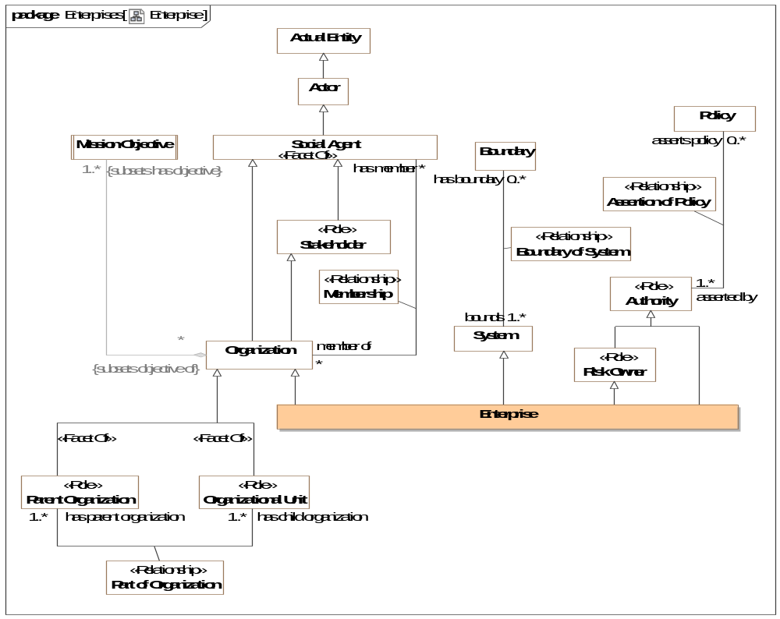
- Enterprise

Class Enterprise
An enterprise is a stakeholder organization, organized as a system, with a mission, members, and authority over resources to accomplish its mission(s). An enterprise provides context for operations and analysis. An enterprise may have parts - its divisions or departments.
[BMM] Organizational Unit:
Direct Supertypes
Authority, Organization, Risk Owner, System

Threat-risk-conceptual-model::Generic Concept Library::Entities
The foundation library provides fundamental concepts that apply to most domains or areas of concern. These fundamental concepts are specialized, combined and related for more specific concerns, such as risk management.
These fundamental concepts provide for links between domains, systems, organizations, cultures and stakeholders.
Unless stated otherwise, these concepts are intended to be mixed together to fully describe something in the "real world".
The foundation builds on the conceptual model defined in [SIMF] (Semantic Information Modeling for Federation), which is included by reference. By using SIMF we avoid redundant definitions of concepts and also allow for easy extension of threat/risk by using the SIMF modeling capabilities.
Note that something may be classified by any number of types (e.g., a transfer of custody that is an actual situation that happened in the past).

Diagram: Identifiable Entity
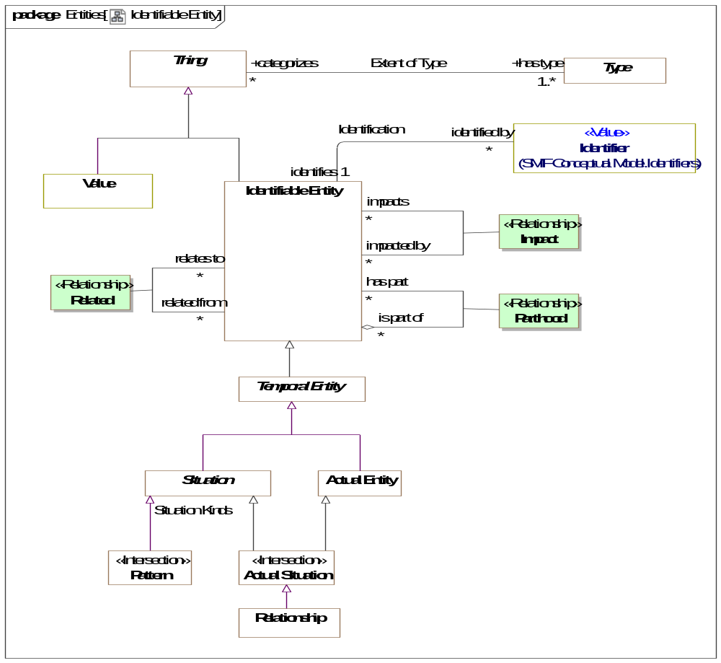
- Identifiable Entity
The above is a summary diagram intended to show significant classes used in the concept library.

Diagram: Identifiable Entity Relationships
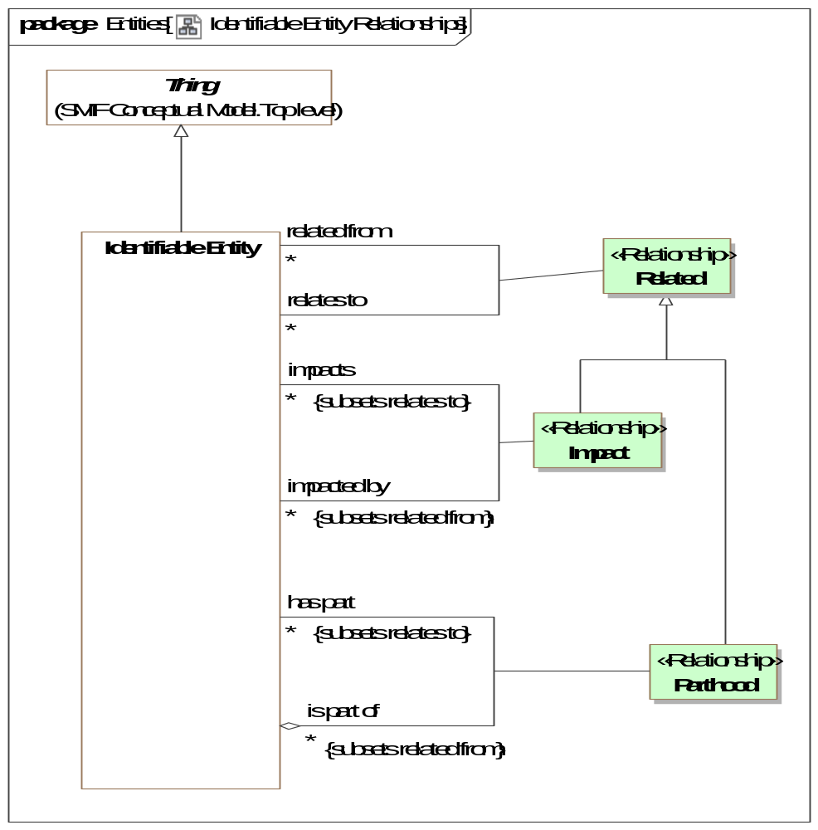
- Identifiable Entity Relationships

Association Class Impact <<Relationship>>
Relationship between some entity and another on which it has some kind of impact or effect.
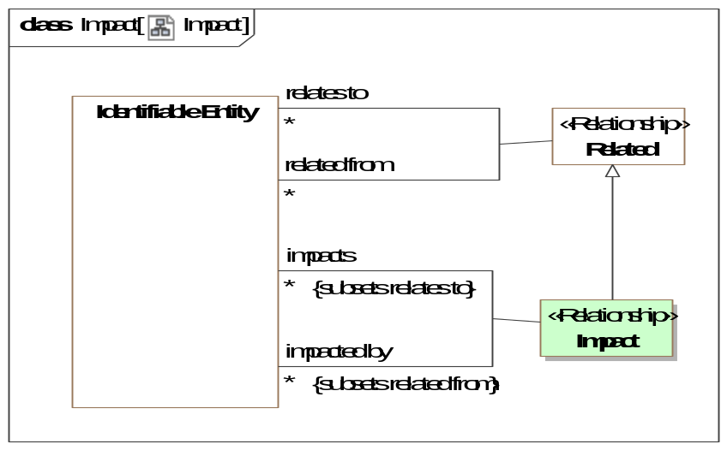
- Impact
Direct Supertypes
Related
Association Ends
impacts : Identifiable Entity [*] Subsets: performs:Activity
Entity that the subject entity impacts in any way.
impacted by : Identifiable Entity [*] Subsets: performs:Activity
Entity that is impacted by another in any way..
Attributes
likelihood : Probability Metric
Metric representing the probability that the <negated by> situation will prevent the <negates> situation

Association Class Parthood <<Relationship>>
Relationship defining one thing as a part of another. More specific concepts of parthood and mereology (the study of parts and their relations) may subtype Parthood.
[IDEAS] wholePart: The whole-part pattern establishes a relationship between individual elements, asserting that one Object element is composed of the other element.
[IDEAS] A couple that asserts one (part) Individual is part of another (whole) Individual.
[ISO 1087] partitive relation: part-whole relation relation between two concepts (3.2.1) where one of the concepts constitutes the whole and the other concept a part of that whole
[DOLCE] Parthood
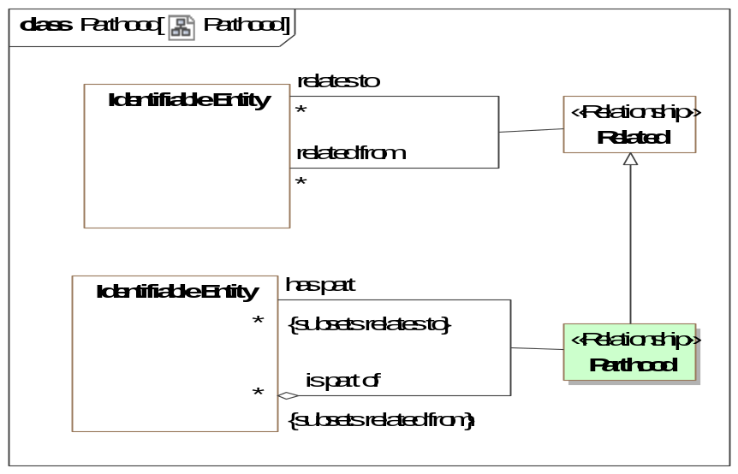
- Parthood
Direct Supertypes
Related
Association Ends
has part : Identifiable Entity [*] Subsets: performs:Activity
Entity that is a part of the subject entity (the whole) such that the part is essential to the whole.
This is a general concept of part and does not assume exclusivity of partness or total part inclusion.
[FIBO] hasPart
[ISO 1087] partitive concept: concept (3.2.1) in a partitive relation (3.2.22) viewed as one of the parts making up the whole
is part of : Identifiable Entity [*] Subsets: performs:Activity
Composite entity (whole) of which this entity is a part.
[FIBO] isPartOf
[ISO 1087] comprehensive concept: concept (3.2.1) in a partitive relation (3.2.22) viewed as the whole

Association Class Related <<Relationship>>
Related defines relationships as first-class entities that are "situations" that may have conditions, context or a time frame. "Related" is the implicit supertype of all entity relationships such that any relationship can be traced between entities. Note that the generalization to Related may not be shown on diagrams.
Note that in UML relationships that are "definitional" and not expected to be time or contextually dependent are shown as regular UML associations where as potentially contextual or time-bound relationships are shown as association classes. This is a notational convention and does not have semantic intent to avoid early commitment to such considerations.
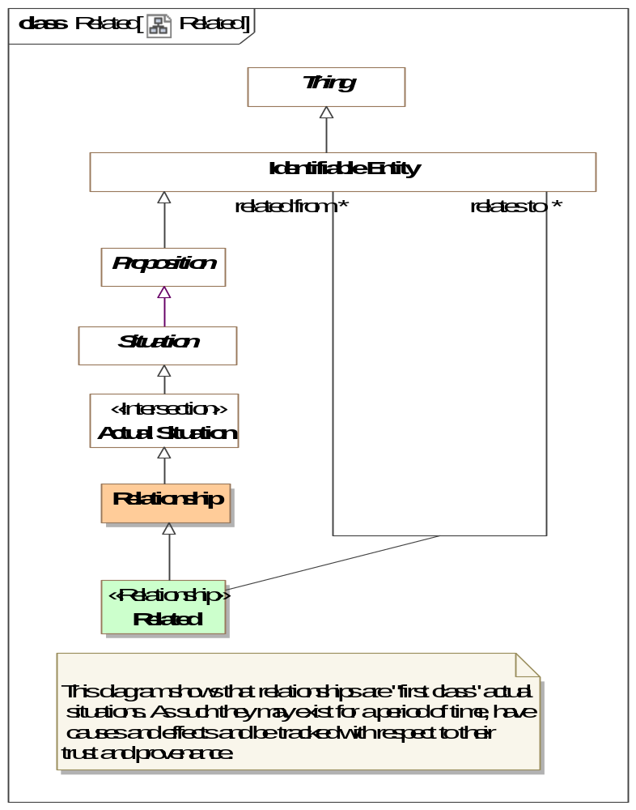
- Related
Direct Supertypes
Relationship
Association Ends
relates to : Identifiable Entity [*] Subsets: performs:Activity
A generic relationship to capture arbitrary relationships that do not have more specific meaning. <relates> is the implicit supertype of all relationships between entities (not including metadata). Note that to remove diagram clutter, subsets of "relates" may not show the subset on all diagrams.
related from : Identifiable Entity [*] Subsets: performs:Activity

Threat-risk-conceptual-model::Generic Concept Library::Events and Activities
Events are things that occur in time, impacting the things involved in those events. Events include actual events as well as patterns of events that describe a process.

Diagram: Events and Activities
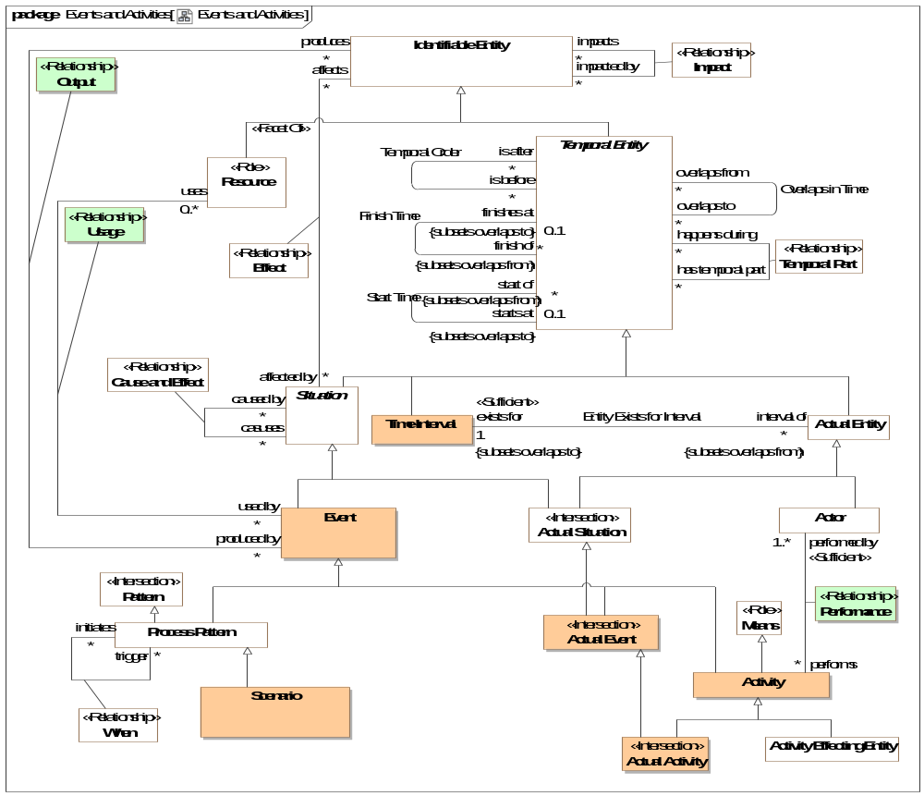
- Events and Activities

Class Activity
An Event performed by one or more actors intended to meet a need.
[UAF] Work, not specific to a single organization, weapon system or individual that transforms inputs (Resources) into outputs (Resources) or changes their state.
Direct Supertypes
Event, Means

Class Actor
An entity capable of behavior - performing an activity or process.
[IDEAS] Agent: Something capable of action.
[FIBO] AutonomousAgent: An agent is an autonomous individual that can adapt to and interact with its environment.
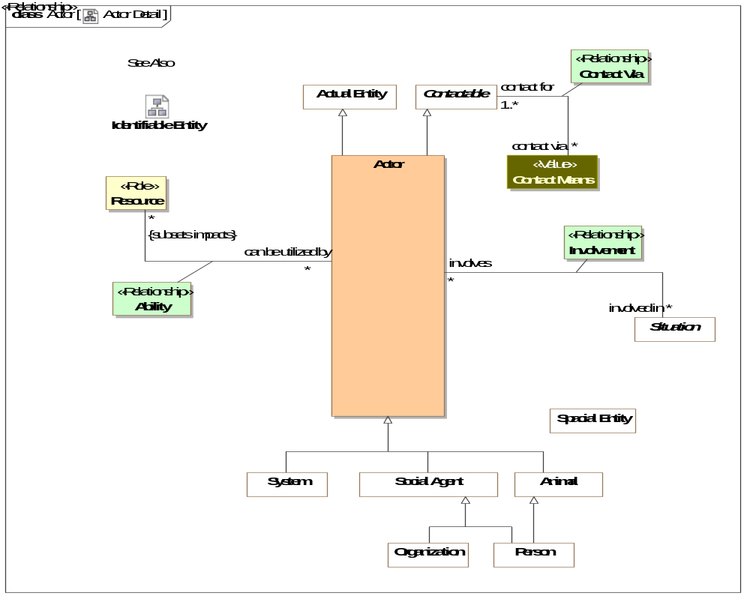
- Actor Detail
Direct Supertypes
Actual Entity, Contactable

Class Actual Activity <<Intersection>>
A specific, actual, activity that has or may happen.
Direct Supertypes
Activity, Actual Event

Class Actual Event <<Intersection>>
A specific individual event that has happened, is happening or may happen.
[FIBO] Occurrence: An Occurrence is a happening of an OccurrenceKind. Each Occur-rence has a DateTimeStamp, which identifies when the Occurrence happened, and a Location (possibly virtual), that identifies where the Occurrence happened.
Direct Supertypes
Actual Situation, Event

Class Event
An Event is something that happens (a.k.a. occurs). A dynamic situation (past, present or future) composed of a set of things changing over a period of time. e.g., a rock falling.
Events are not limited in their timeframe. Events can have long or short timeframes, from an instant to infinity and beyond.
An Event that is "performed by" an actor is considered an activity.
[DOLCE] Perdurant
[BFO] Event: perdurant that is related to exactly two states (its pre-state and its post-state).
An event is related to the states before and after it has happened.
[NIEM] ActivityType
Direct Supertypes
Situation

Association Class Output <<Relationship>>
Outputs from a process or actual event - the things or situations it creates.
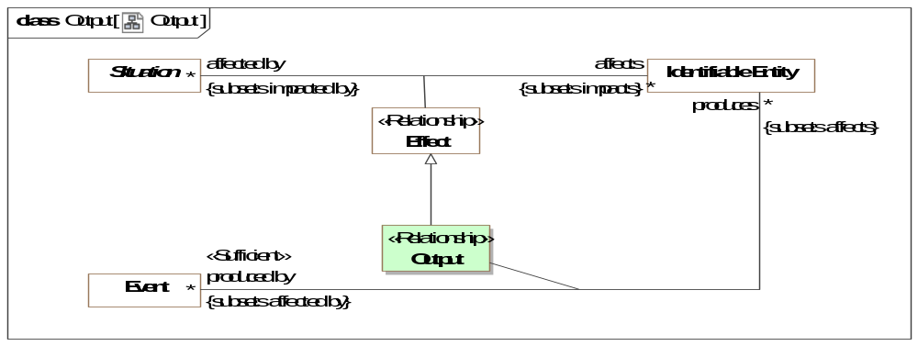
- Output
Direct Supertypes
Effect
Association Ends
produces : Identifiable Entity [*] Subsets: performs:Activity
Resources produced by a process or actual event
produced by : Event [*] Subsets: performs:Activity
Events which produce an entity.

Association Class Performance <<Relationship>>
Performance is the act of an actor as the driving force in the execution of an activity. Related to "Capability" as the ability to perform.
[DOLCE] Subtype of Participation
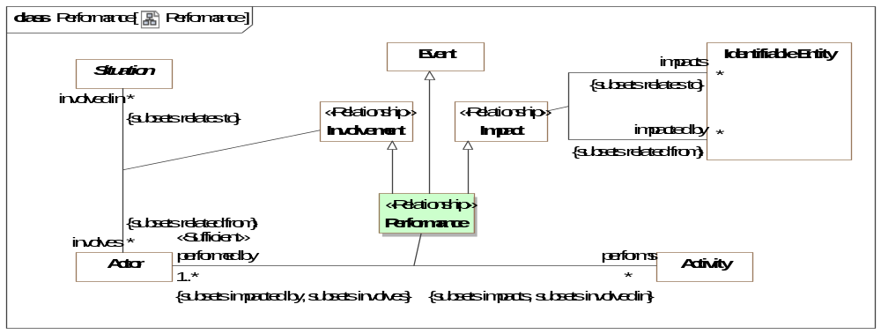
- Performance
Direct Supertypes
Event, Impact, Involvement
Association Ends
performs : Activity [*] Subsets: performs:Activity
An activity performed (executed or enacted) by an actor.
performed by : Actor [1..*] Subsets: performs:Activity
The actor which is the performer of an activity.

Association Class Usage <<Relationship>>
Inputs to a process or actual event - what it uses
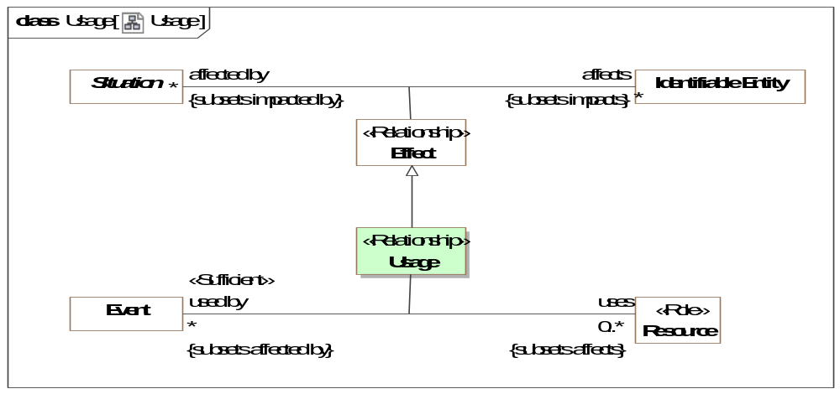
- Usage
Direct Supertypes
Effect
Association Ends
uses : Resource [0..*] Subsets: performs:Activity
A resources used by a process or actual event.
used by : Event [*] Subsets: performs:Activity
A process or actual event that is used by a resource for the resource to fulfill its function.

Threat-risk-conceptual-model::Generic Concept Library::Identifiers and Coordinates
Identification connects identifiers with the entity they identify. Identifiers are values, that is they are immutable "data". An entity may be assigned different identifiers over time and may have many at any one time.
The base Identifier class (defined in SIMF) identifies a set of entities and is not assumed to be unique or to identify only one entity. For example, a name is an identifier but many people could have the same name and a person could have multiple names. Identifiers and the relation to an entity may be contextual.
Identifiers should not be confused with Identity, which is an abstracton of individuality that provide the foundation for identifiers.
The class of Unique Identifiers is more typical of I.T. systems and managed identifiers, such as driver's license numbers. A unique identifier is assumed unique within exactly one Namespace.
Subtypes of Identifier may be specific to identifying particular kinds of entities. For example, a Location Identifier (such as an address or GPS coordinate) is specific to identifying locations.
Note that as with all concepts, identifiers are independent of representation. Since names are so often textual, we also define a representation of names - "Textual Name".
The generic library of identifiers extends the SIMF identifiers with the concepts of coordinates.

Diagram: Identifiers
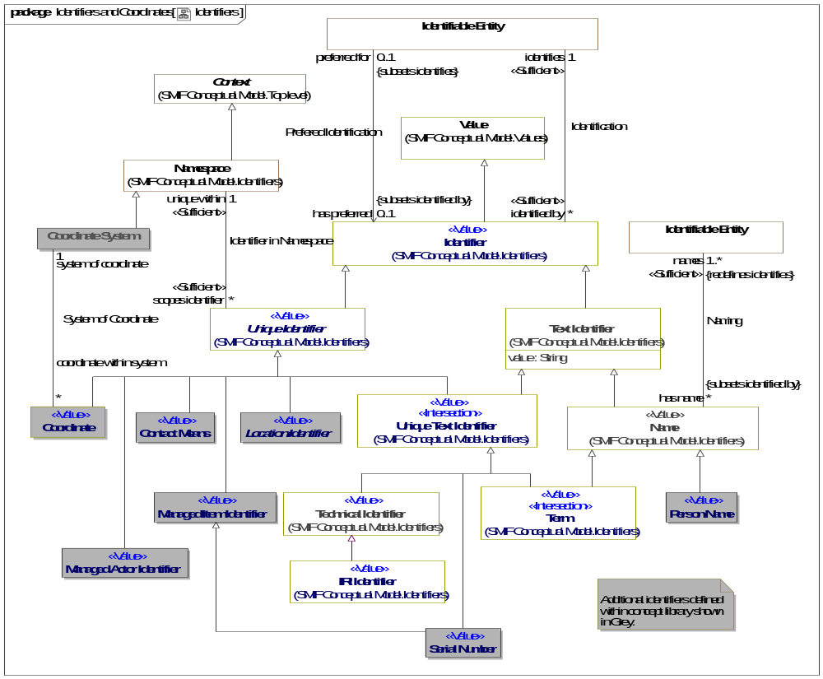
- Identifiers

Class Coordinate <<Value>>
Any set of magnitudes that serve to define the position of a point, line, or the like, by reference to a coordinate system.
Direct Supertypes
Unique Identifier

Class Coordinate System
A reference system for a coordinate. e.g., WGS-84.
[OGC] Set of mathematical rules for specifying how coordinates are to be assigned to points.
Direct Supertypes
Namespace

Association System of Coordinate
Relationship between a coordinate and a system of coordinates that defines how the coordinate is to be interpreted.
Association Ends
system of coordinate : Coordinate System [1] Subsets: performs:Activity
The set of rules and reference points used for interpreting a coordinate.
coordinate within system : Coordinate [*] Subsets: performs:Activity
A particular coordinate identifying an entity within the scope of a coordinate system.

Threat-risk-conceptual-model::Generic Concept Library::Information
Concepts relating to information (including data) about entities.

Diagram: Information Action
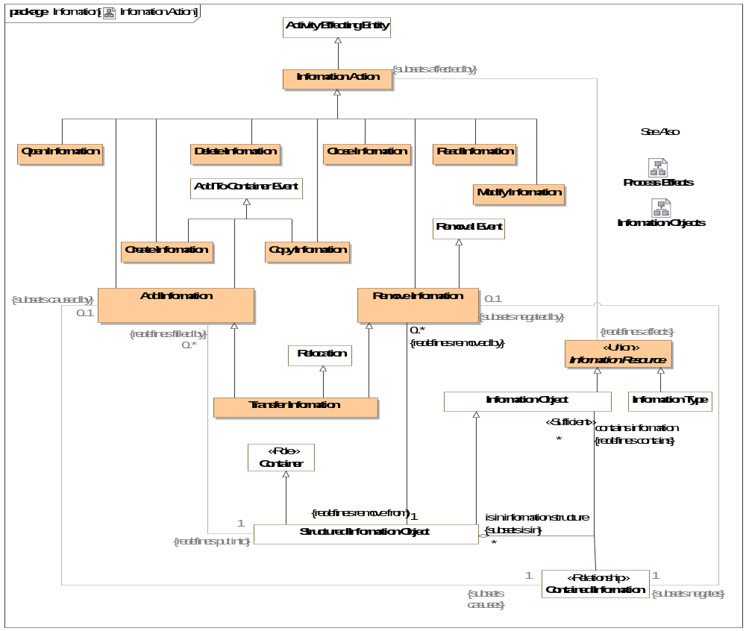
- Information Action

Diagram: Information Objects
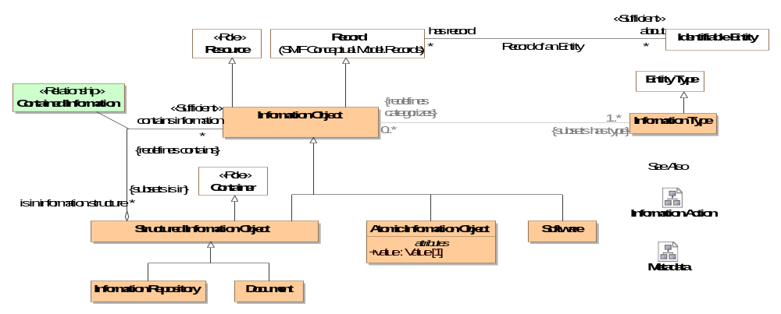
- Information Objects

Diagram: Metadata
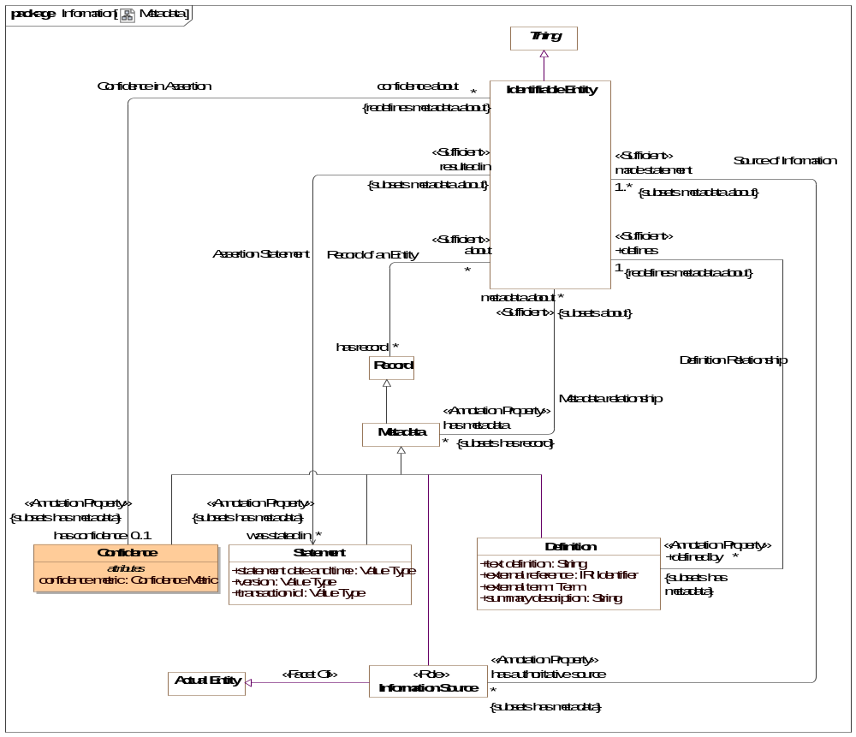
- Metadata

Class Add Information
An action to add information to a repository or information structure.
Direct Supertypes
Add To Container Event, Information Action

Class Atomic Information Object
An atomic information object is a managed piece of information composed entirely of a single value. e.g. an MP3 representation of a song. Note that different viewpoints and abstractions may not agree on what is "atomic". e.g. a music editor may consider a song a series of samples.
Direct Supertypes
Information Object
Attributes
value : Value [1]
Atomic value associated with an atomic information object.

Class Close Information
An action that removes information from visibility.
Direct Supertypes
Information Action

Class Confidence
A statement and measure of the confidence in any fact or set of facts about an entity.
Direct Supertypes
Metadata
Attributes
confidence metric : Confidence Metric
A metric reflecting confidence in an assertion condition or effect.

Association Confidence in Assertion
A relationship relating a degree of confidence with the topic or subject of that confidence. Confidence is metadata about statements in a model; the degree of belief in those statements.
Association Ends
confidence about : Identifiable Entity [*] Subsets: performs:Activity
Subject of confidence; the facts, situations or subject that confidence is being evaluated for.
has confidence : Confidence [0..1] Subsets: performs:Activity
Confidence is a metric quantifying the belief that the facts asserted about the entity are true and valid.

Association Class Contained Information <<Relationship>>
Relationship connecting an information container with what it contains.
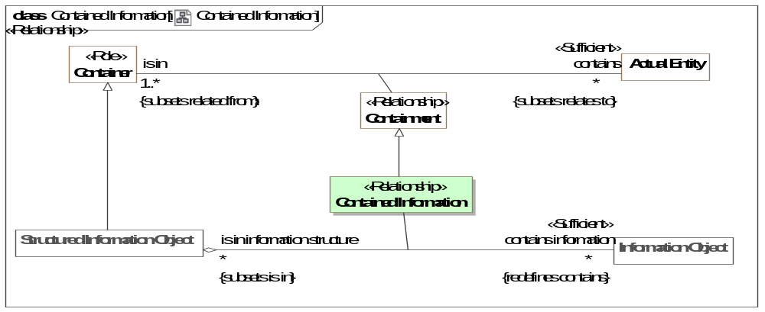
- Contained Information
Direct Supertypes
Containment
Association Ends
contains information : Information Object [*] Subsets: performs:Activity
An information object structurally contained in another.
is in information structure : Structured Information Object [*] Subsets: performs:Activity
Structural containment of an information object within an information object.
Associations
<<Restriction>> : Add Information [0..1] Subsets: caused by:Situation
<<Restriction>> : Remove Information [0..1] Subsets: negated by:Situation

Class Copy Information
An Information Action to duplicate information in another location or container.
Direct Supertypes
Add To Container Event, Information Action

Class Create Information
An action that creates information.
Direct Supertypes
Add To Container Event, Create, Information Action

Class Delete Information
An action to delete information, erase it or render it inaccessible.
Direct Supertypes
Destroy, Information Action

Class Document
A collection of information about a topic, frequently containing some analysis or summary, intended for use by a stakeholder.
Direct Supertypes
Structured Information Object

Class Information Action
An action that impacts information objects.
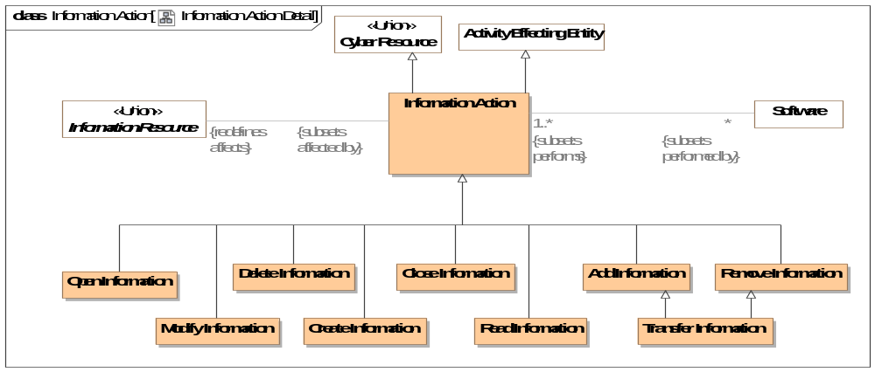
- Information Action Detail
Direct Supertypes
Activity Effecting Entity, Cyber Resource
Associations
<<Restriction>> : Software [*] Subsets: performed by:Actor

Class Information Object
A representation of information, data, facts, assertions or statements about something.
As information may be copied while retaining its identity, the same information copied onto new physical media may be considered the same object. Where the individual representation of information is of concern another object should be used to represent the individual physical thing than holds the information.
As information is a resource it may depend on other resources.
[FIBO] Document
[NIEM] DocumentType
Direct Supertypes
Actual Entity, Cyber Resource, Information Resource, Record, Resource
Associations
<<Restriction>> : Information Type [1..*] Subsets: has type:Type

Class Information Repository
A resource in which information is stored and can then be retrieved.
Direct Supertypes
Structured Information Object

Class Information Resource <<Union>>
Information objects or types that can be manipulated by an information action.

Class Information Type
A categorization of information across any dimension - content, format, source, sensitivity, etc. e.g. a schema. The information type may be used to establish software capabilities and vulnerabilities.
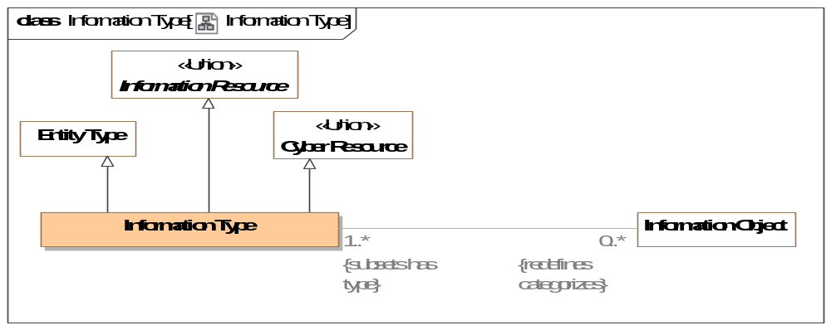
- Information Type
Direct Supertypes
Cyber Resource, Entity Type, Information Resource
Associations
<<Restriction>> : Information Object [0..*] Redefines: categorizes:Thing

Class Modify Information
Action to change information (for good or bad reasons).
Direct Supertypes
Information Action

Class Open Information
Action to gain visibility to some information, e.g., Open a file or an envelope.
Direct Supertypes
Information Action

Class Read Information
An action to read, access, or understand some information.
Direct Supertypes
Information Action

Class Remove Information
An action to remove information from some repository or composite information structure.
Direct Supertypes
Information Action, Removal Event

Class Structured Information Object
An information object that contains sub-elements. e.g., a "record".
Direct Supertypes
Container, Information Object

Class Transfer Information
The transfer of information from one information store to another.
Direct Supertypes
Add Information, Relocation, Remove Information

Threat-risk-conceptual-model::Generic Concept Library::Locations
Concepts related to locations and places.

Diagram: Location
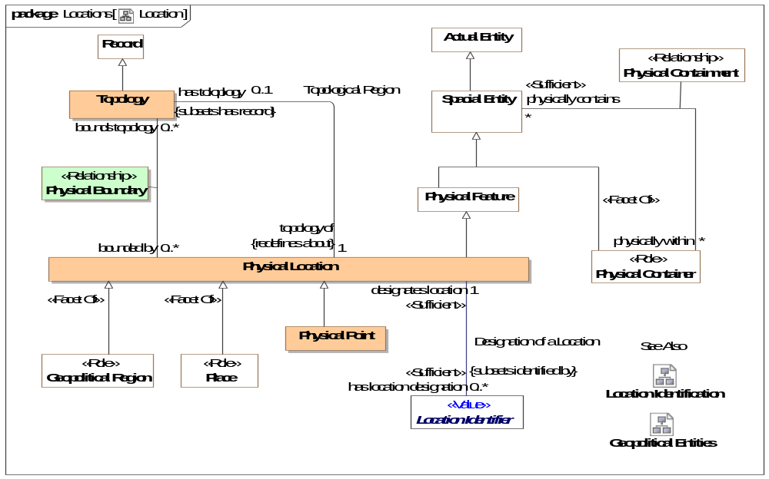
- Location

Diagram: Location Identification
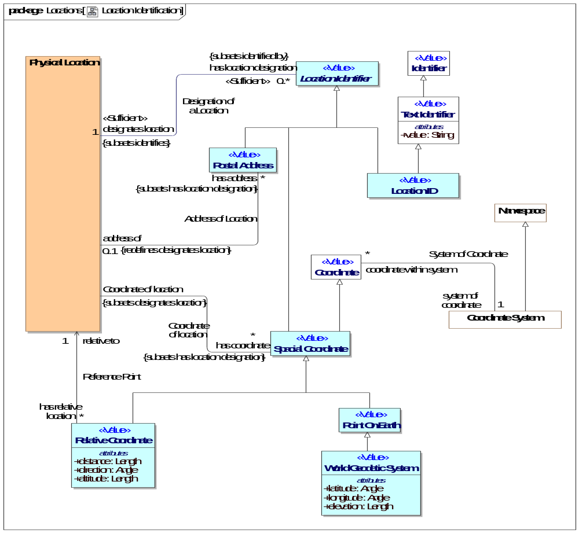
- Location Identification

Association Address of Location
identification of a location by an address. Note that there are postal addresses that do not identify a location, so this relation is optional. However, most postal addresses do identify a location thus this relation is possible.
Association Ends
has address : Postal Address [*] Redefines: categorizes: Thing
A postal address of a physical location.
address of : Physical Location [0..1] Redefines: categorizes: Thing
Location identified by an address.

Association Coordinate of location
Relationship between a physical location and the coordinate that defines its position.
Association Ends
has coordinate : Spacial Coordinate [*] Redefines: categorizes: Thing
A coordinate that identifies a location.
Coordinate of location : Physical Location Redefines: categorizes: Thing
Coordinate of location based on coordinate system.

Association Designation of a Location
Relationship defining the location identified by a location identifier.
Association Ends
designates location : Physical Location [1] Redefines: categorizes: Thing
The physical location identified or described by a location identifier..
has location designation : Location Identifier [0..*] Redefines: categorizes: Thing
A description or identifier that designates a particular location.

Class Location ID <<Value>>
A code, ID or name for a physical location.
Direct Supertypes
Location Identifier, Text Identifier

Class Location Identifier <<Value>>
Any identifier able to uniquely identify a physical location
Syn. spatial reference - description of position in the real world [OGC]
Direct Supertypes
Unique Identifier

Association Class Physical Boundary <<Relationship>>
Boundary describing the topology of a location.
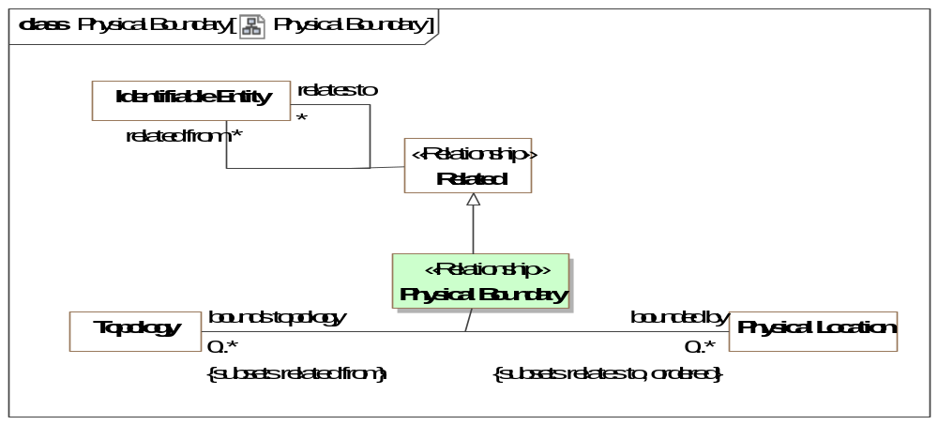
- Physical Boundary
Direct Supertypes
Related
Association Ends
bounded by : Physical Location [0..*] Redefines: categorizes: Thing
The edge points of a topology where each successive pair of features (as well as the first and last points), connected by lines, describes a boundary.
bounds topology : Topology [0..*] Redefines: categorizes: Thing
A location identified by geographic boundaries.

Class Physical Location
A point or extent in physical space.
[NIEM] A geospatial location.
[FIBO] PhysicalLocation: A location in physical space
Direct Supertypes
Physical Feature

Class Physical Point
A dimensionless physical point in space or on the surface of the earth such as a corner or center point.
Direct Supertypes
Physical Location

Class Point On Earth <<Value>>
A point that defines a location on earth where the point is within the bounds of <designates location>.
Direct Supertypes
Spacial Coordinate

Association Reference Point
Reference point for a relative location
Association Ends
relative to : Physical Location [1] Redefines: categorizes: Thing
Where the position of something is relative to a location, the reference location.
has relative location : Relative Coordinate [*] Redefines: categorizes: Thing

Class Relative Coordinate <<Value>>
A coordinate described relative to another. e.g., 5 miles west of the empire state building.
Direct Supertypes
Spacial Coordinate
Attributes
distance : Length
Distance as part of a relative coordinate that, when combined with angle, identifies a point <relative to> another point.
direction : Angle
An angle as part of a coordinate.
altitude : Length
Measure of how much something is above <relative to> something else, usually the earth.

Class Spacial Coordinate <<Value>>
Any point that uniquely identifies a spacial location relative to a coordinate system.
One of a sequence of n numbers designating the position of a point in n-dimensional space [OGC]
Direct Supertypes
Coordinate, Location Identifier

Association Topological Region
Physical location described by a topology.
Association Ends
topology of : Physical Location [1] Redefines: categorizes: Thing
Location described by a topology.
has toloplogy : Topology [0..1] Redefines: categorizes: Thing
Topology that describes a physical location in terms of physical boundaries.

Class Topology
A record of a contiguous 1, 2 or 3 dimensioned area defined by geographic features and points.
[NIEM] AreaType
Direct Supertypes
Record

Class World Geodetic System <<Value>>
The World Geodetic System defines a reference frame for the earth, for use in geodesy and navigation. The latest revision is WGS 84 dating from 1984. [WGS-84]
[NIEM] Location2DGeospatialCoordinateType or Location3DGeospatialCoordinateType (With elevation)
Direct Supertypes
Point On Earth
Attributes
latitude : Angle
Latitude based on the prime meridian.
[FIBO] hasLatitude
longitude : Angle
Longitude based on the prime meridian.
[FIBO] hasLogitude
elevation : Length
Height above nominal sea level.

Threat-risk-conceptual-model::Generic Concept Library::Objectives
Objectives captures how the intents of stakeholder's relate to the real-world consequences of situations that have or may happen. A consequence results in a benefit or harm to these objectives - generally related to a specific entity of value to the stakeholder.
As any situation may have multiple consequences, both benefits and harms, the net desirability of any situation to a stakeholder is calculated in the Stakeholder Desirability Relation by combining all of the related consequences.

Diagram: Objectives
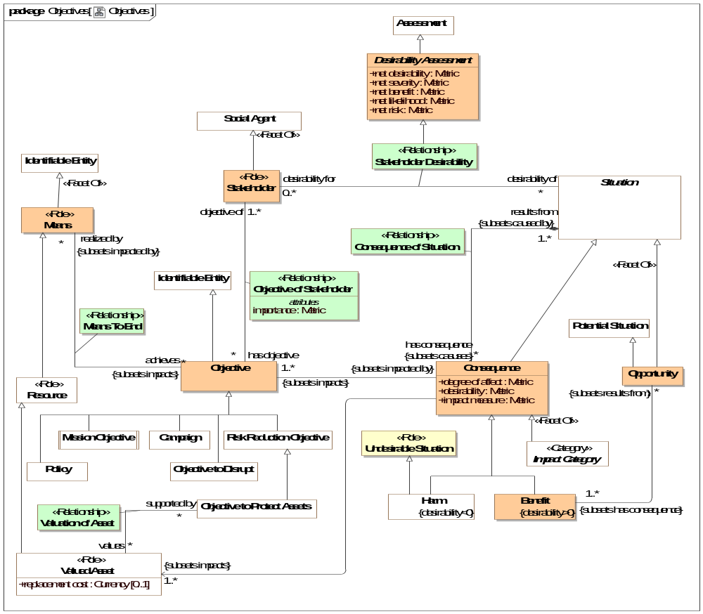
- Objectives

Class Benefit
A benefit is a consequence of a situation having positive desirability.
Direct Supertypes
Consequence

Class Consequence
A consequence or impact of the outcome of a situation affecting objectives of a stakeholder.
NOTE 1 An event can lead to a range of consequences.
NOTE 2 A consequence can be certain or uncertain and can have positive or negative effects on objectives.
NOTE 3 Consequences can be expressed qualitatively or quantitatively.
NOTE 4 Initial consequences can escalate through knock-on effects.
[ISO 73-2009]
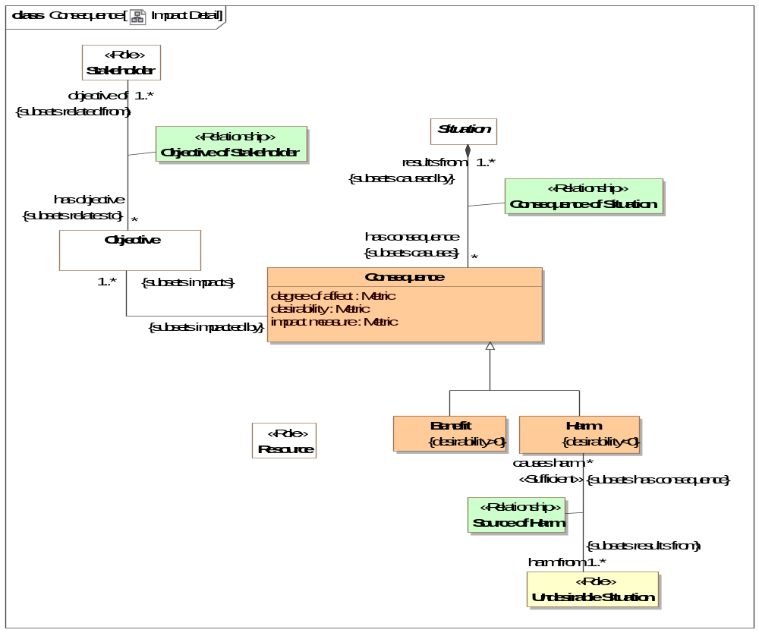
- Impact Detail
Direct Supertypes
Situation
Attributes
degree of affect : Metric
A metric for how much the consequence affects an objective - a measure of harm or benefit.
desirability : Metric
A metric describing the desirability of an impact. May be positive or negative where positive is desirable and negative is undesirable.
impact measure : Metric
A metric for impact where Impact = desirability * likelihood

Association Class Consequence of Situation <<Relationship>>
Impact of a situation - its affect on the objectives of stakeholders.
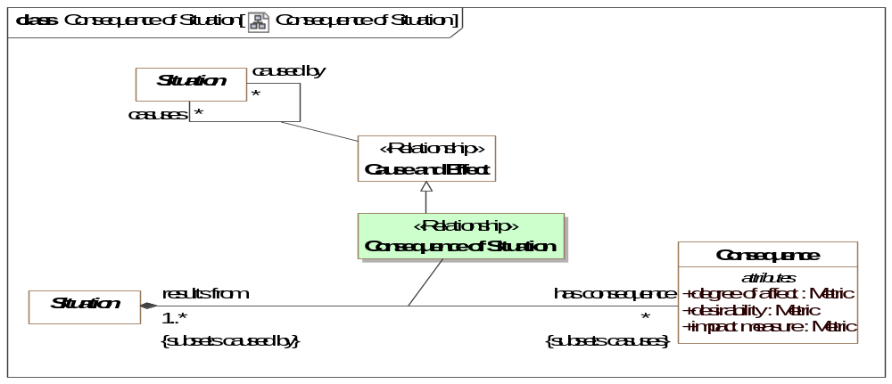
- Consequence of Situation
Direct Supertypes
Cause and Effect
Association Ends
has consequence : Consequence [*] Redefines: categorizes: Thing
A consequence of a situation that impacts the objectives of a stakeholder.
results from : Situation [1..*] Redefines: categorizes: Thing
Situation causing an impact..

Class Desirability Assessment
Desirability measure of a situation. The context of the desirability can be the specific stakeholder desirability relation or a classification of a situation in a context, such as an undesirable situation.
Desirability may be computed by aggregating the impact of a situation on stakeholders but the specific calculation is not specified in the standard.
A positive desirability is an opportunity; a negative desirability is a danger.
When the stakeholder desirability of a situation to a stakeholder has net harm, that harm may be identified as a risk. S
Direct Supertypes
Assessment
Attributes
net desirability : Metric
A metric representing the aggregation of the impact of all consequences of a situation for a stakeholder. (net benefit - net risk)
net severity : Metric
The aggregation of the impact of all detriments (negative consequences) of a situation for a stakeholder.
net benefit : Metric
A metric representing the aggregation of the impact of all benefits (positive consequences) of a situation for a stakeholder.
net likelihood : Metric
The net sum of the likelihood of a situation or risk.
net risk : Metric
A metric representing the aggregation of risk metrics computed as likelihood*impact.

Class Means <<Role>>
[BMM] A means represents any device, capability, regime, technique, restriction, agency, instrument, or method that may be called upon, activated, or enforced to achieve Ends.
Direct Supertypes
Identifiable Entity

Association Class Means To End <<Relationship>>
The relation between a means and an objective such that the means supports the objective.
[BMM] means is impacted by influencer
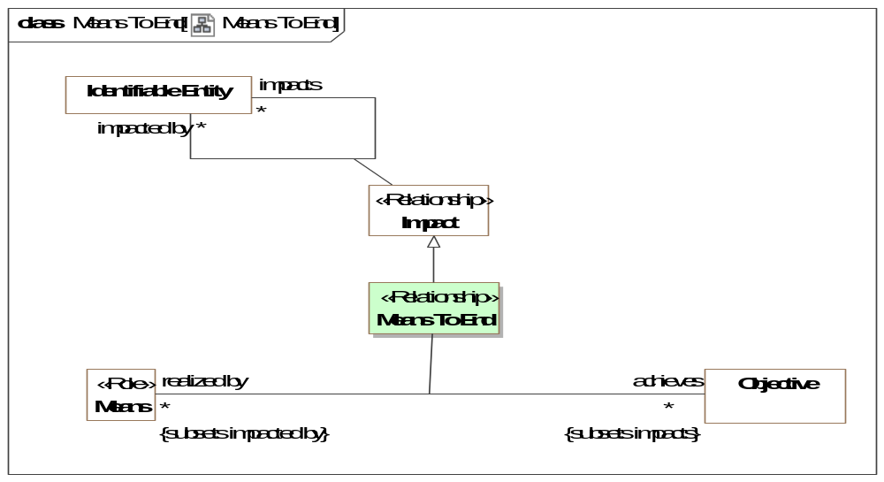
- Means To End
Direct Supertypes
Impact
Association Ends
achieves : Objective [*] Redefines: categorizes: Thing
Objectives supported by a means.
realized by : Means [*] Redefines: categorizes: Thing
Means that serves to meet an objective.

Class Objective
An aim or goal that a stakeholder intends to attain or accomplish; purpose; goal; target.
[BMM] End: something that is to be accomplished.
[BMM] Objective: An Objective is a statement of an attainable, time-targeted, and measurable target that the enterprise seeks to meet in order to achieve its Goals.
[FIBO] Objective
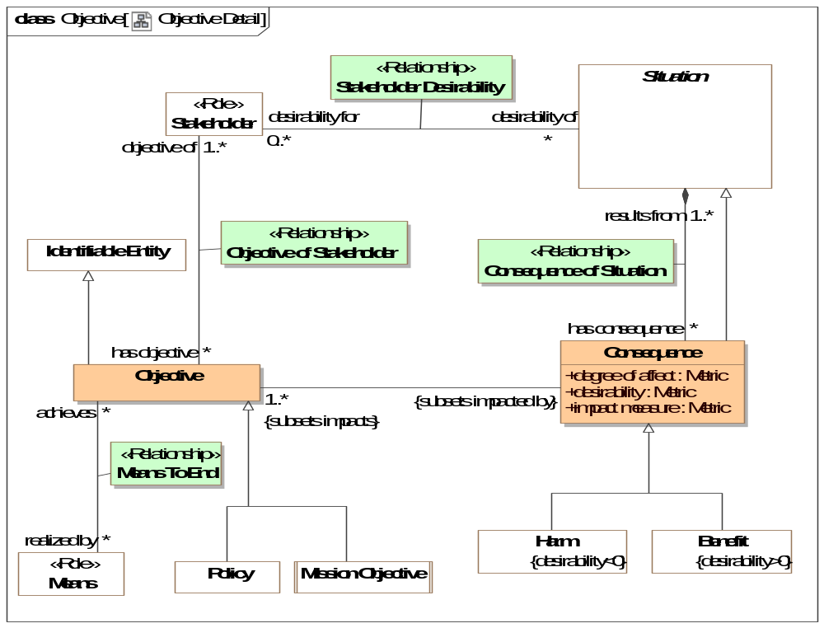
- Objective Detail
Direct Supertypes
Identifiable Entity

Association Class Objective of Stakeholder <<Relationship>>
Relationship between a stakeholder and their objectives.
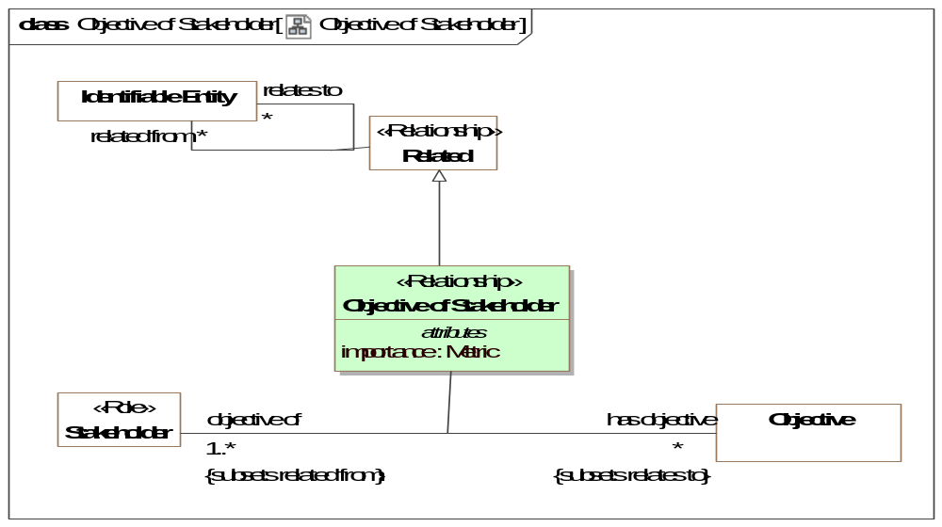
- Objective of Stakeholder
Direct Supertypes
Related
Association Ends
has objective : Objective [*] Redefines: categorizes: Thing
An objective that a stakeholder intends to retain or achieve.
objective of : Stakeholder [1..*] Redefines: categorizes: Thing
A stakeholder having an objective they intend to attain or retain.
Attributes
importance : Metric
A metric of importance of an objective to a stakeholder.

Class Opportunity
An opportunity is any potential future situation having beneficial consequences.
[BMM] Opportunity: This category of Assessment indicates that some Influencer can have a favorable impact on the organization’s employment of Means or achievement of Ends. For example, the bankruptcy of Pizza Company’s major competitor in Region-Y is assessed to be an Opportunity in its Goal “To increase market share.”
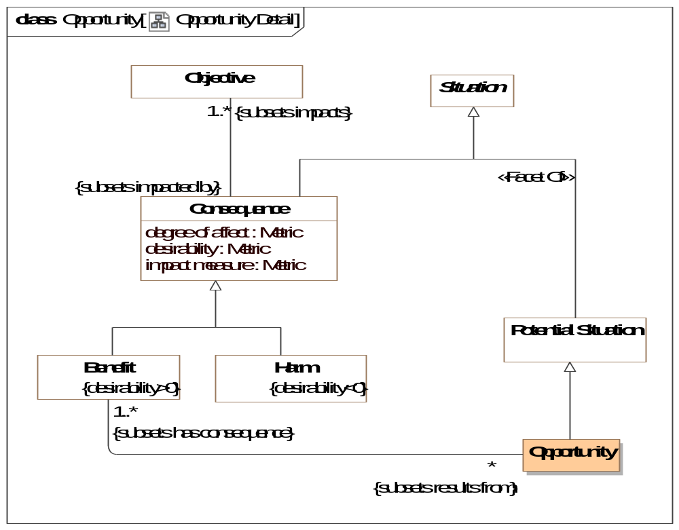
- Opportunity Detail
Direct Supertypes
Potential Situation, Situation

Class Stakeholder <<Role>>
A stakeholder is a responsible performer having objectives and promoting the means for achieving those objectives.
Direct Supertypes
Social Agent

Association Class Stakeholder Desirability <<Relationship>>
A relationship representing the net desirability of a situation for a stakeholder.
Note: Stakeholder desirability is expected to be computed based on aggregating the impact of a situation for a stakeholder. However, the algorithm for this aggregation is not specified in the standard.
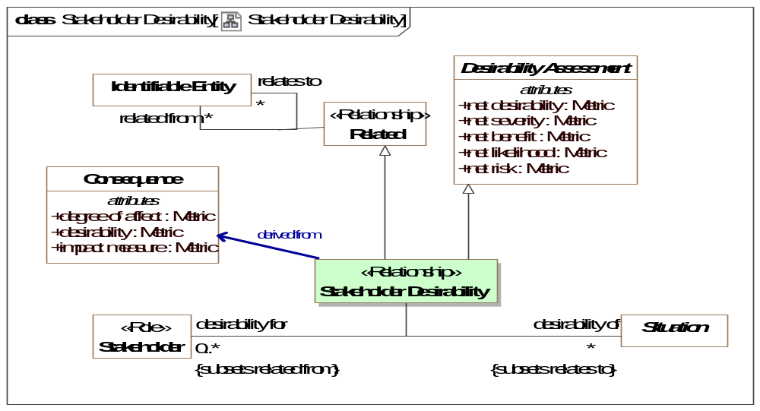
- Stakeholder Desirability
Direct Supertypes
Desirability Assessment, Related
Association Ends
desirability of : Situation [*] Redefines: categorizes: Thing
The situation evaluated in terms of its desirability for a stakeholder.
desirability for : Stakeholder [0..*] Redefines: categorizes: Thing
A stakeholder for which desirability of a situation is evaluated.

Threat-risk-conceptual-model::Generic Concept Library::Observations
Observations are acts where an observer notes some entity (including situations and individuals') that are observed in a situation.

Diagram: Measurement
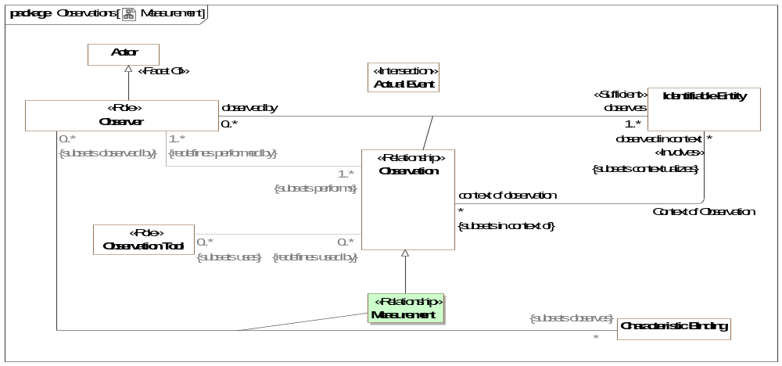
- Measurement

Diagram: Observability
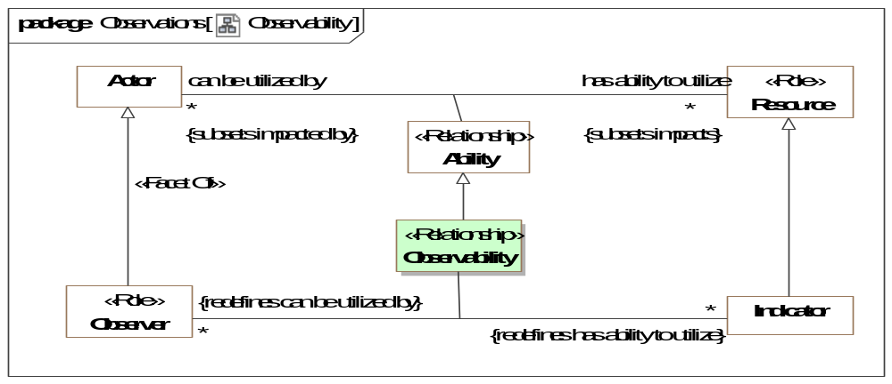
- Observability

Diagram: Observations
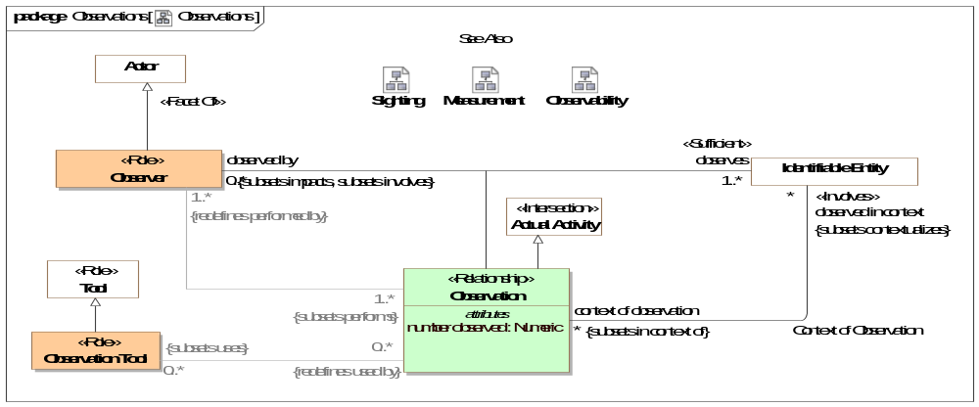
- Observations

Association Context of Observation
Context of an observations - e.g. the physical place, situation or timeframe in which the observation was made.
Direct Supertypes
Extent of Context
Association Ends
observed in context : Identifiable Entity [*] Redefines: categorizes: Thing
The context of an observation, what environment, location, timeframe or system is being observed. e.g. A man with a gun observed in an airport. The man is <observed in context> of the airport.
context of observation : Observation [*] Redefines: categorizes: Thing
Observations made in the context of the subject entity. E.G. Sightings within an airport.

Association Class Measurement <<Relationship>>
A measurement is an observation made by <observed by> that <observes> the value of a characteristic for a particular entity, which is the Characteristic Binding the observer <observes>. The characteristic binding binds a particular value, e.g. 2 meters, with a particular characteristic, e.g. height, of a particular individual, e.g. John Smith.
As a characteristic binding is a temporal entity it has a time and context which may be different from the time and context of the measurement. e.g. The nurse "Sue" took the patients (Joe) weight measurement (Characteristic Binding - Joe <has weight> 94 KG) on 2/5/2010 at 9:31AM which was recorded as the patents current weight for 90 days.
Direct Supertypes
Observation
Association Ends
: Characteristic Binding [*] Redefines: categorizes: Thing
: Observer [0..*] Redefines: categorizes: Thing

Association Class Observability <<Relationship>>
Observability is a relationship representing the capability of an <can be utilized by> actor to observe an <has ability to utilize> indicator.
Direct Supertypes
Ability
Association Ends
: Indicator [*] Redefines: categorizes: Thing
: Observer [*] Redefines: categorizes: Thing

Association Class Observation <<Relationship>>
An observation is an actual (not possible) activity of the <observed by> observer where <observes> has been noticed or perceived as being significant. The observation is <observed in context> such as a place or condition. The observation <uses> any number of observation tools.
Example: Sam, a driver and Observer, notices <observes> a Deer <observed in context> of the road on which he is driving.
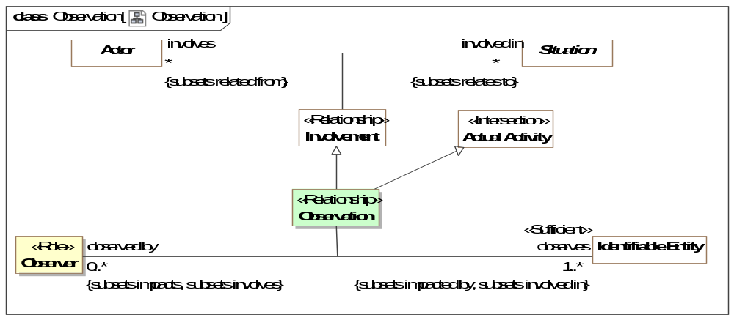
- Observation
Direct Supertypes
Actual Activity, Impact, Involvement
Association Ends
observes : Identifiable Entity [1..*] Redefines: categorizes: Thing
Entity observed by an observer making an observation.
observed by : Observer [0..*] Redefines: categorizes: Thing
Observations of an entity by an observer.
Attributes
number observed : Numeric
The number of individual observations aggregated into a single observation. The <observes> entity will likely be a type.
E.G. Sue saw 5 birds.

Class Observation Tool <<Role>>
A tools that assists in observations. e.g. a wireless microphone is used to observe a conversation.
Direct Supertypes
Tool

Class Observer <<Role>>
Role of an actor that can or has observed something
Direct Supertypes
Actor
Associations
<<Restriction>> : Identifiable Entity [*] Subsets: observes:Identifiable Entity
through association: Sighting
<<Restriction>> : Characteristic Binding [*] Subsets: observes:Identifiable Entity
through association: Measurement

Threat-risk-conceptual-model::Generic Concept Library::Organizations
An Organization is group of persons and/or other actors and resources organized for some end or work.
Subtypes of organizations include governments and corporations.

Diagram: Organization
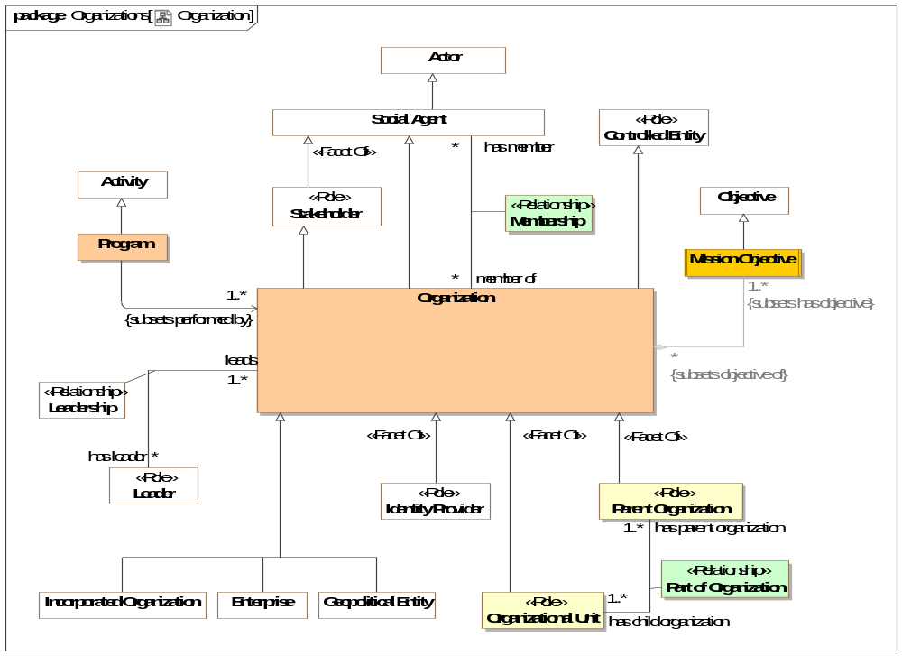
- Organization

Association Class Membership <<Relationship>>
Relationship representing the participation of an actor in an organization. Subtypes of membership may provide more explicit membership kinds.
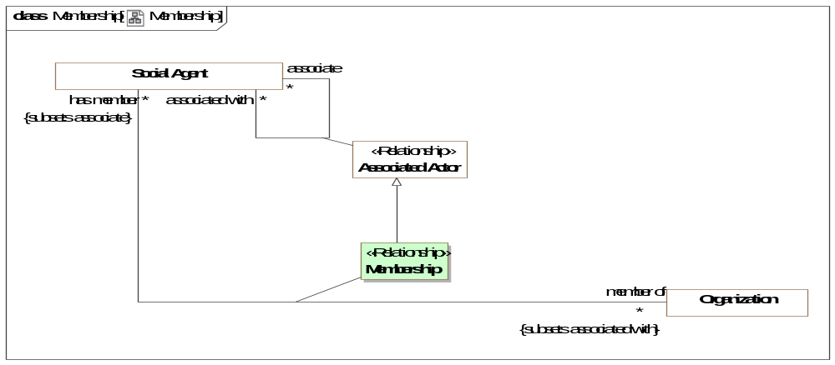
- Membership
Direct Supertypes
Associated Actor
Association Ends
has member : Social Agent [*] Subsets: observes:Identifiable Entity
An assertion of membership in an organization.
[FIBO] hasMember
member of : Organization [*] Subsets: observes:Identifiable Entity
Organization a performer belongs to.
[FIBO] memberOf

Class Mission Objective
A core objective of an enterprise.
[BMM] A Mission indicates the ongoing operational activity of the enterprise. The Mission describes what the business is or will be doing on a day-to-day basis.
Direct Supertypes
Objective

Class Organization
An Organization is a group of persons and/or other actors and resources organized for some end or work
[FIBO] Organization: a social unit of people, systematically structured and managed to meet a need or pursue collective goals on a continuing basis.
[NIEM] OrganizationType
[DOLCE] Society
Direct Supertypes
Controlled Entity, Social Agent, Stakeholder

Class Organizational Unit <<Role>>
Organizational unit is a role that encompasses subdivisions, departments, subsidiaries and other organizational parts of an organization.
[BMM] organization unit: An administrative or functional unit within an organization structure.
Direct Supertypes
Controlled Entity, Organization

Class Parent Organization <<Role>>
Organization with component parts such as divisions and departments.
Direct Supertypes
Controlling Actor, Organization

Association Class Part of Organization <<Relationship>>
Relationship between an organization and its organizational units - the sub-organizations such as departments and subsidiaries.
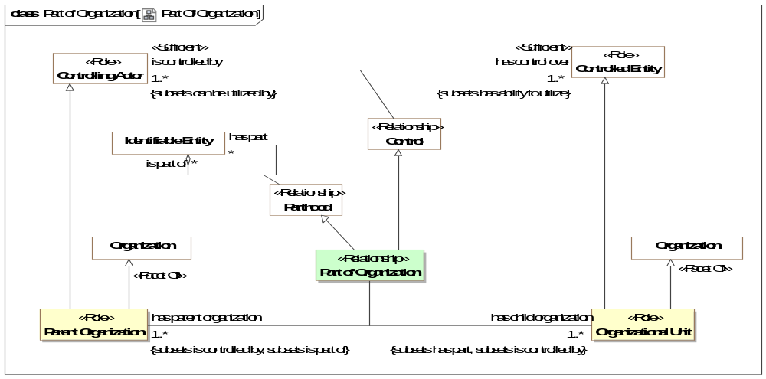
- Part Of Organization
Direct Supertypes
Control, Parthood
Association Ends
has parent organization : Parent Organization [1..*] Subsets: observes:Identifiable Entity
The parent (controlling organization) of another organization.
has child organization : Organizational Unit [1..*] Subsets: observes:Identifiable Entity
An organization constituted as a component of another organization.

Class Program
A set of projects, activities, or services of an organization that are intended to meet a need.
[NIEM] ProgramType
Direct Supertypes
Activity

Threat-risk-conceptual-model::Generic Concept Library::Organizations::Corporations

Diagram: Corporations
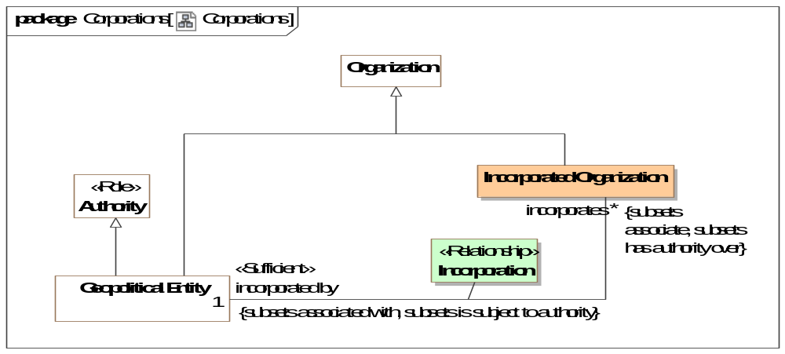
- Corporations

Class Incorporated Organization
An organization recognized by and incorporated by a recognized government.
[FIBO] FormalOrganization: an organization that is recognized in some legal jurisdiction, with associated rights and responsibilities
Direct Supertypes
Organization

Association Class Incorporation <<Relationship>>
Act by which individuals' are voluntarily united into a new entity through the creation of an artificial, intangible, and legal person called a corporation.
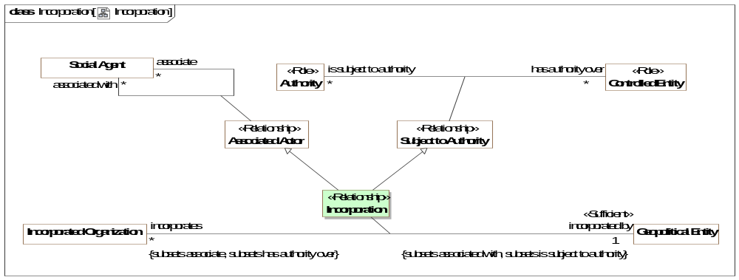
- Incorporation
Direct Supertypes
Associated Actor, Subject to Authority
Association Ends
incorporated by : Geopolitical Entity [1] Subsets: observes:Identifiable Entity
Geopolitical entity incorporating an organization.
incorporates : Incorporated Organization [*] Subsets: observes:Identifiable Entity
An organization incorporated by a government.

Threat-risk-conceptual-model::Generic Concept Library::Organizations::Geopolitical Organizations

Diagram: Geopolitical Entities
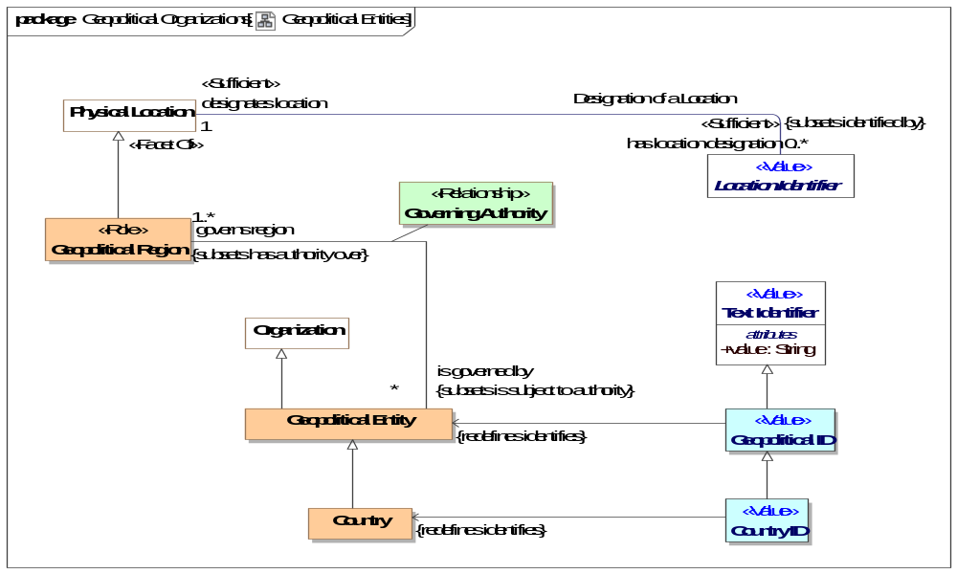
- Geopolitical Entities

Class Country
A nation with its own government, occupying a particular territory (not necessarily contiguous).
[FIBO] Country: A self-governing geopolitical unit that is recognized as a country by the United Nations (more specific concept as being recognized by the U.N.)
Direct Supertypes
Geopolitical Entity

Class Country ID <<Value>>
A code, ID, or name for a country.
[ISO 1087] country identifier: information in a terminological entry (3.8.2) which indicates the name of a geographical region where the designation (3.4.1) is used
Direct Supertypes
Geopolitical ID

Class Geopolitical Entity
An organization which is the governing body of a nation, state, tribe or community.
[FIBO] GeopoliticalEntity (In FIBO this is a subclass of Physical Location. In Threat/risk Geopolitical Region is a role of a physical location. FIBO combines Geopolitical Entity with Geopolitical Region).
Direct Supertypes
Authority, Organization

Class Geopolitical ID <<Value>>
A code, ID or administered name for a geopolitical entity with governmental authority e.g., city, state, county, tribe.
Direct Supertypes
Text Identifier

Class Geopolitical Region <<Role>>
A physical location governed by a geopolitical entity.
[FIBO] GeopoliticalEntity (In FIBO this is a subclass of Physical Location. In Threat/risk Geopolitical Region is a role of a physical location. FIBO combines Geopolitical Entity with Geopolitical Region.
[NIEM] LocaleType
Direct Supertypes
Physical Location

Association Class Governing Authority <<Relationship>>
Relationship representing authority over a region.
Direct Supertypes
Associated Actor, Subject to Authority
Association Ends
governs region : Geopolitical Region [1..*] Subsets: observes:Identifiable Entity
Region governed by a geopolitical entity.
is governed by : Geopolitical Entity [*] Subsets: observes:Identifiable Entity
A governing authority for a region.

Threat-risk-conceptual-model::Generic Concept Library::Permissions
Concepts relating to the permission an actor has to perform some process.

Diagram: Permission
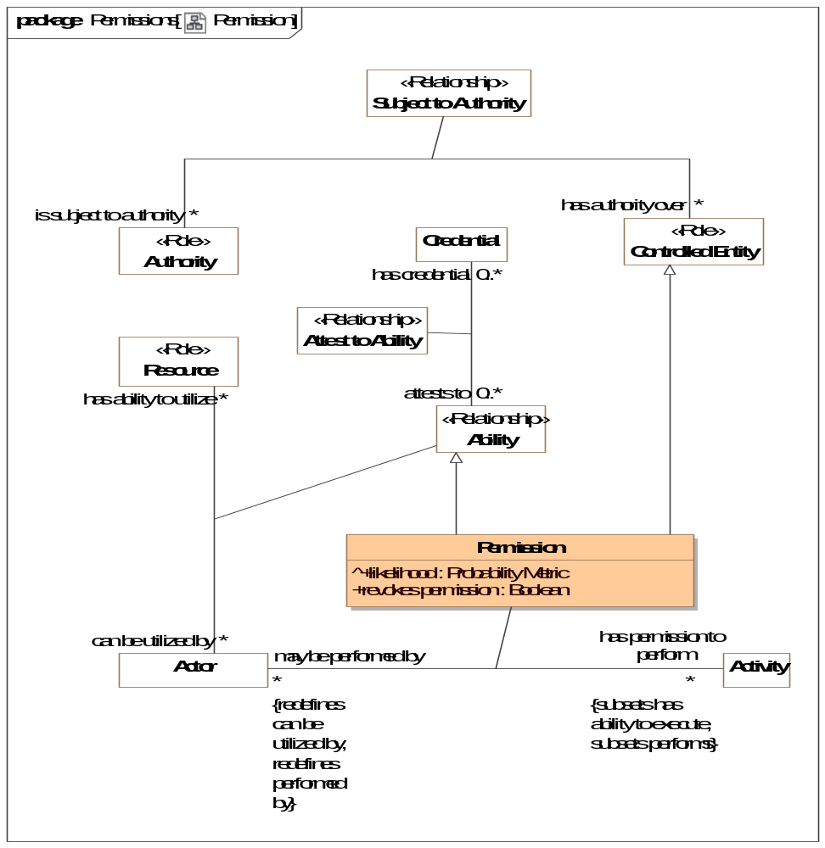
- Permission

Association Class Permission
Permission is a relationship representing authorization granted by an authority to an actor to perform a kind of activity. THe activity may be either an "Actual Activity" or a kind of activity - a Modus Operandi.
Direct Supertypes
Ability, Controlled Entity
Association Ends
has permission to perform : Activity [*] Subsets: observes:Identifiable Entity
Activity the actor has permission to perform.
may be performed by : Actor [*] Subsets: observes:Identifiable Entity
Actors that have permission to perform the subject activity.
Attributes
revokes permission : Boolean
Inverts or removes the permission asserted by the permission relationship.

Threat-risk-conceptual-model::Generic Concept Library::Persons
This person module defines foundation concepts of people such as their location and name. More specific person attributes may augment this specification.

Diagram: Person
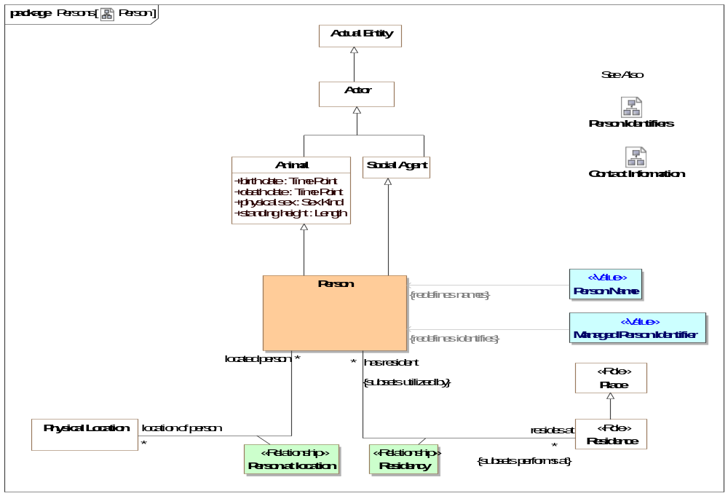
- Person

Diagram: Person Identifiers
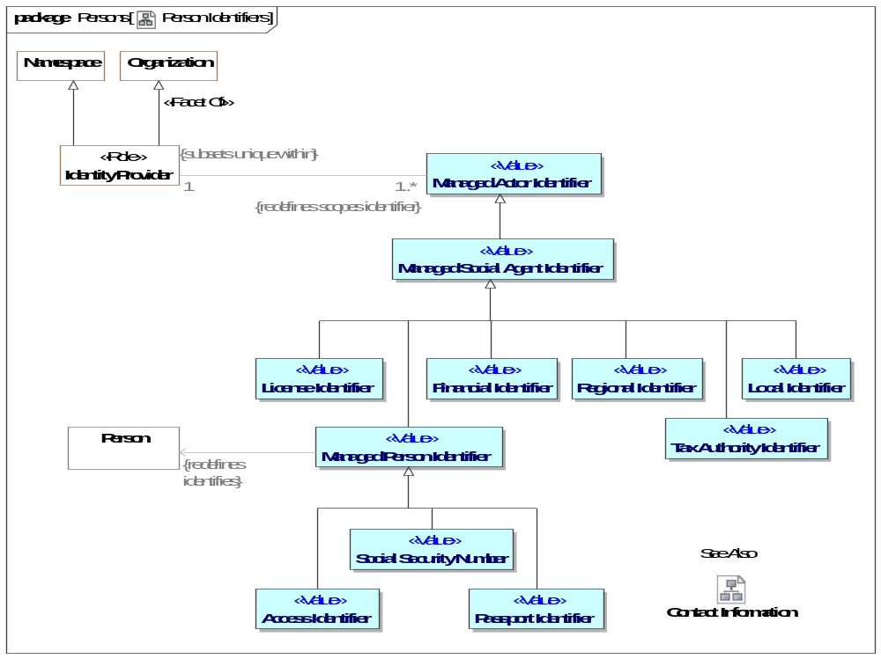
- Person Identifiers

Diagram: Person Name Representations
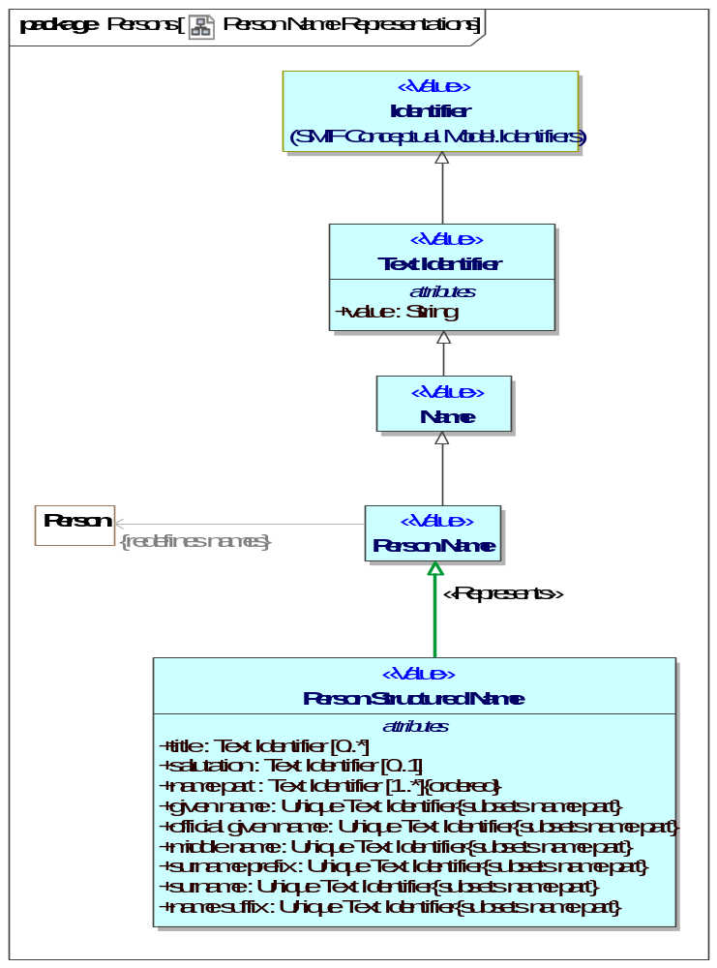
- Person Name Representations

Class Access Identifier <<Value>>
An term, data value or other sign that identifies a person for access to a resource.
Direct Supertypes
Managed Person Identifier

Class Financial Identifier <<Value>>
An identifier for purposes of making financial transactions, such as a credit card number or bank account.
Direct Supertypes
Managed Social Agent Identifier

Class Managed Person Identifier <<Value>>
An identifier for a person managed by some identity provider who asserts the validity of the identifier, frequently but not always a government organization.
Direct Supertypes
Managed Social Agent Identifier

Class Passport Identifier <<Value>>
[NIEM] PersonPassportIdentification (property): An identification of a passport issued to a person.
Direct Supertypes
Managed Person Identifier

Class Person
An individual human being.
[FIBO] Person
[NIEM] PersonType
[DOLCE] (Subtype of) Agentive Physical Object
Direct Supertypes
Animal, Social Agent

Association Class Person at location <<Relationship>>
A relationship representing the location of a person at a particular time.
[NIEM] PersonLocationAssociationType
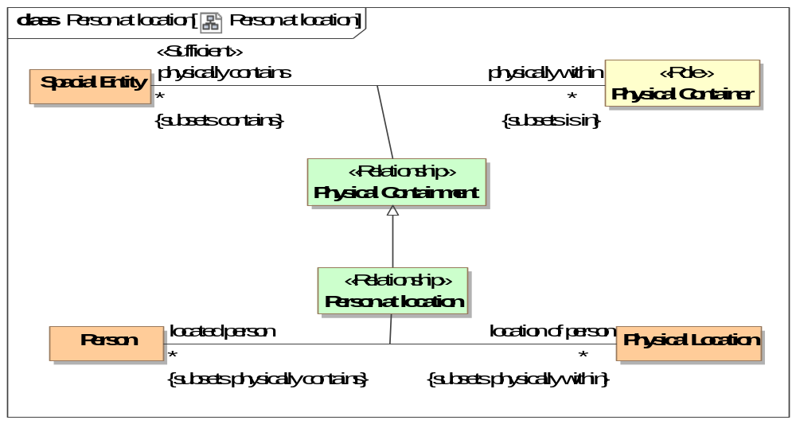
- Person at location
Direct Supertypes
Physical Containment
Association Ends
location of person : Physical Location [*] Subsets: observes:Identifiable Entity
Location of the subject person.
[FIBO] isSituatedAt (mode general concept)
located person : Person [*] Subsets: observes:Identifiable Entity
A person who is at a location.

Class Person Name <<Value>>
Text identifying a person by a recognized name.
[FIBO] hasFullLegalName (More specific concept)
[NIEM] PersonNameType
Direct Supertypes
Name

Class Person Structured Name <<Value>>
A full name of a person in a structured form.
Note: Conversion between structured and textual names is provided by the implementation and is not defined in this specification.
Direct Supertypes
Person Name
Attributes
title : Text Identifier [0..*]
[NIEM] PersonNamePrefixText: A title or honorific used by a person.
salutation : Text Identifier [0..1]
[NIEM] PersonNameSalutationText: A formal sign or expression of greeting that is appropriate for a person.
name part : Text Identifier [1..*]
Parts of a person's name, e.g., surname, given name.
[FIBO] hasFamilyName
given name : Unique Text Identifier
[NIEM] PersonGivenName: A first name of a person.
[FIBO] hasGivenName
official given name : Unique Text Identifier
[NIEM] PersonOfficialGivenName: A name, out of possibly multiple given names, that a person selects to use as his or her official given name.
middle name : Unique Text Identifier
[NIEM] PersonMiddleName: A middle name of a person.
surname prefix : Unique Text Identifier
[NIEM] PursonSurNamePrefix: A prefix that precedes this person's family name such as Van, Von.
surname : Unique Text Identifier
[NIEM] PersonSurName: A last name or family name of a person.
[FIBO] hasSurname
name suffix : Unique Text Identifier
[NIEM] PersonNameSuffixText: A term appended after the family name that qualifies the name.

Association Class Residency <<Relationship>>
A residence of a person - where they live.
[NIEM] PersonResidenceAssociationType
[FIBO] Residence: Note that residence is not the same as domicile, as a person or organization can have many transient residences but only one legal domicile. The domicile of a formal organization is the address (location) where the establishment is maintained or where the governing power of the organization is exercised.
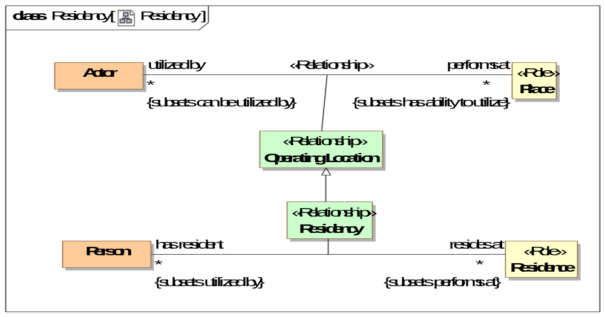
- Residency
Direct Supertypes
Operating Location
Association Ends
resides at : Residence [*] Subsets: observes:Identifiable Entity
A residence of a person, where they live.
[FIBO] isDomiciledIn: identifies the permanent home or principal establishment of an individual or organization
has resident : Person [*] Subsets: observes:Identifiable Entity
A person living in a residence.

Class Social Security Number <<Value>>
[NIEM] PersonSSNIdentification (property): A unique identification reference to a living person; assigned by the United States Social Security Administration.
Direct Supertypes
Managed Person Identifier

Threat-risk-conceptual-model::Generic Concept Library::Physical Entities
This package defines a hierarchy of physical entities and items. Items are inanimate material object as distinct from a living sentient being.

Diagram: Physical Entities
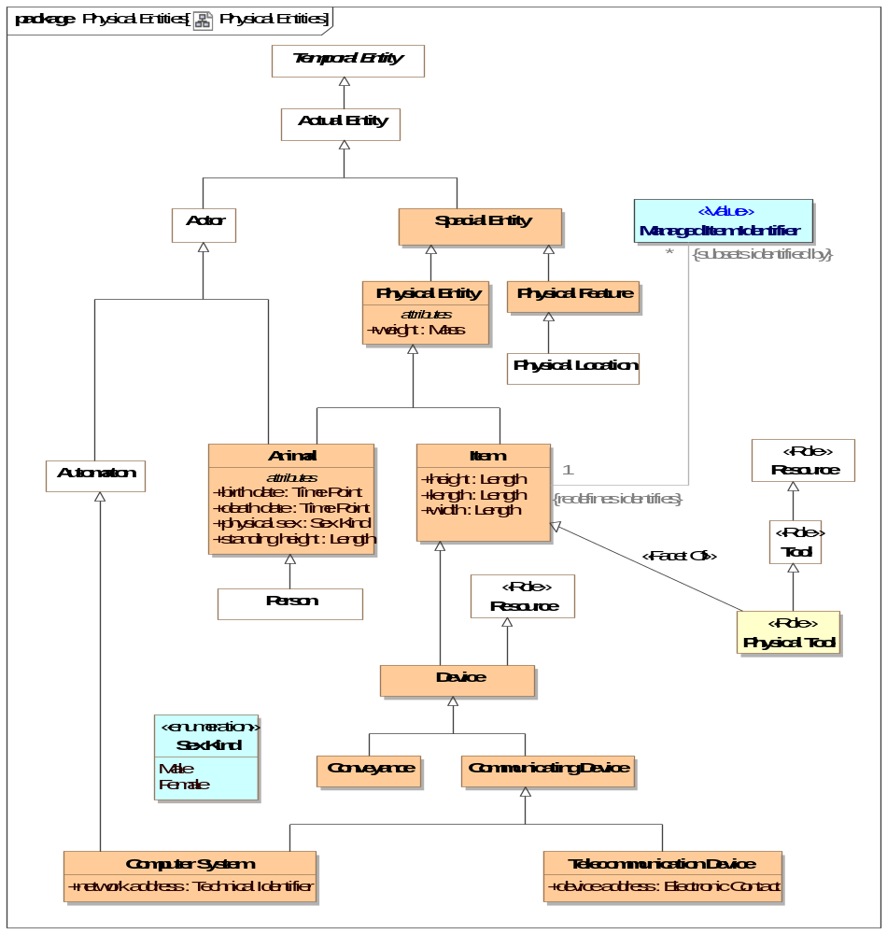
- Physical Entities

Class Animal
Any member of the kingdom Animalia, comprising multicellular organisms that have a well-defined shape and usually limited growth, can move voluntarily, actively acquire food and digest it internally, and have sensory and nervous systems that allow them to respond rapidly to stimuli. A super type of "Person".
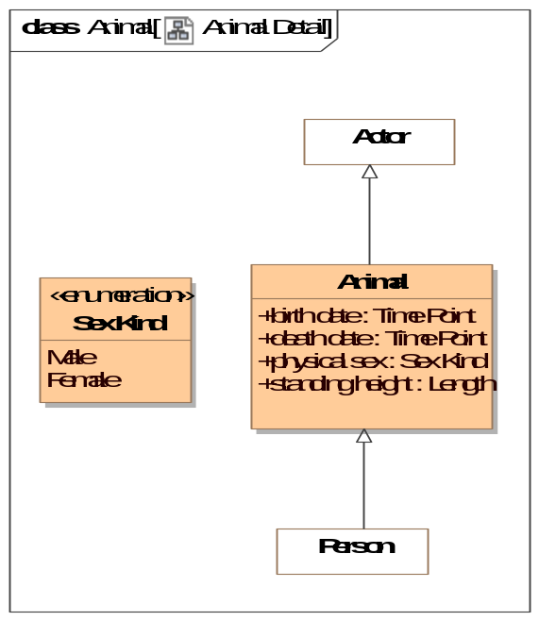
- Animal Detail
Direct Supertypes
Actor, Physical Entity
Attributes
birth date : Time Point
The date an animal (including a person) was born, became an independent entity.
[FIBO] hasDateOfBirth
death date : Time Point
The date an animal (including a person) died, ceased to be living.
physical sex : Sex Kind
Sex of a living thing as indicated by essential physical characteristics, primarily genitalia.
[FIBO] hasGender
standing height : Length
The measurement from base to top or (of a standing person) from head to foot. "Current" is relative to the time frame of the defining context.

Class Conveyance
A device or system providing a means of physical transport from place to place.
[NIEM] ConveyanceType
Direct Supertypes
Device

Class Device
A thing made for a particular purpose; an invention or contrivance, especially a mechanical or electrical one.
[NIEM] DeviceType
Direct Supertypes
Item, Resource

Class Item
An inanimate material object as distinct from a living sentient being.
[NIEM] ItemType
[DOLCE] Non-agentive Physical Object
Direct Supertypes
Physical Entity
Attributes
height : Length
[NIEM]ItemHeightMeasure: A measurement of the height of an item.
A measurement in the vertical plane. For a person, from head to toe.
length : Length
[NIEM] ItemLengthMeasure: A measurement of the length of an item.
A longitudinal measurement - from end to end. Usually greater than width.
width : Length
[NIEM] ItemWidthMeasure: A measurement of the width of an item.
A horizontal measurement - from side to side.

Class Managed Item Identifier <<Value>>
[NIEM] An identification inscribed on or attached to a part, collection of parts, or complete unit by the manufacturer. Syn. ItemSerialIdentification.
[FIBO] ProductIdentifier: an identifier for a product
Direct Supertypes
Unique Identifier

Class Physical Entity
A thing that exists in space and time including people, places, and things.
[DOLCE] Object
[IDEAS] Individual: A Thing that has spatio-temporal extent.
Note1 - this may be some that existed in the past, exists now, or may exist in some future possible world.
Note2 - the Individual may be scattered - i.e. it is the fusion of several disconnect parts.
Direct Supertypes
Spacial Entity
Attributes
weight : Mass
The current weight (as mass) of a physical thing.

Class Physical Feature
Physical features are spacial entities which are generically constantly dependent on physical objects (their hosts). Typical examples of features are “parasitic entities” such as holes, boundaries, surfaces, or stains. Physical features do not have mass independent of their host.
[DOLCE] Feature
Direct Supertypes
Spacial Entity

Class Physical Tool <<Role>>
An physical item intended to be used to perform some function.
Direct Supertypes
Item, Tool

Class Spacial Entity
A thing that exists in space: The union of locations and physical entities.
[DOLCE] Physical Endurant
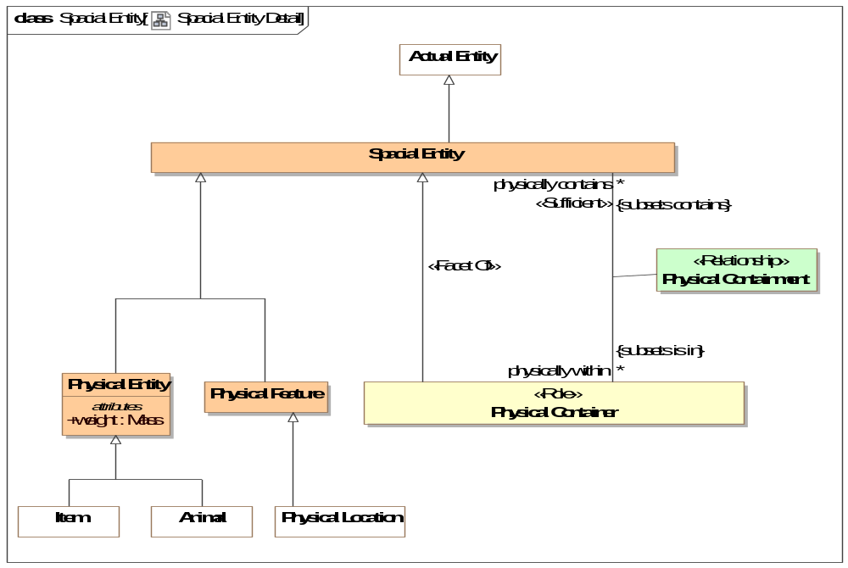
- Spacial Entity Detail
Direct Supertypes
Actual Entity

Class Telecommunication Device
A device for human to human communication over a distance by cable, telegraph, telephone, computer networks, or broadcasting.
[NIEM] TelecommunicationsDeviceType
Direct Supertypes
Communicating Device
Attributes
device address : Electronic Contact
An code or number used to communicate with or through a telecommunications device.

Enumeration Sex Kind
Kinds of sex. Eg. male/female.
package Threat-risk-conceptual-model::Generic Concept Library::Physical Entities
public enum Sex Kind
{Male, Female}

Literals
Male
A male person, plant, or animal. One able to fertilize a female with gametes.
Female
A female person, plant, or animal. Of or denoting the sex that can bear offspring or produce eggs, distinguished biologically by the production of gametes (ova) that can be fertilized by male gametes:
- Physical Entities

Threat-risk-conceptual-model::Generic Concept Library::Places
This package defines concepts related to places. Places are buildings or localities used or intended for a purpose.

Diagram: Place
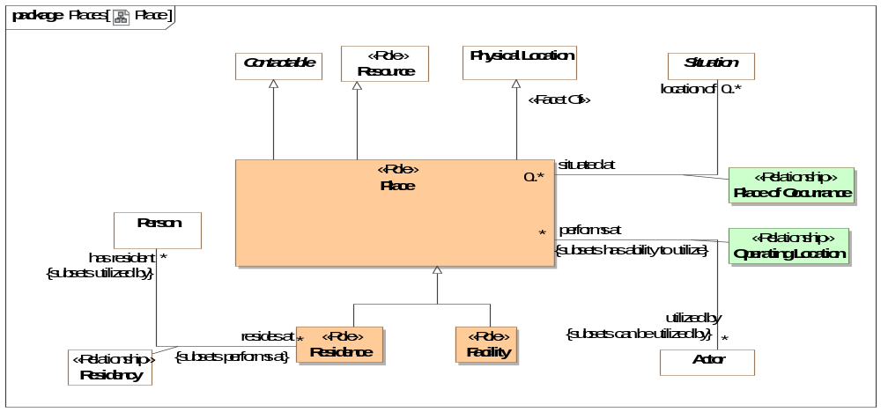
- Place

Class Facility <<Role>>
[NIEM] FacilityType: A building, place, or structure that provides a particular service.
Direct Supertypes
Place

Association Class Operating Location <<Relationship>>
Place where an actor performs activities.
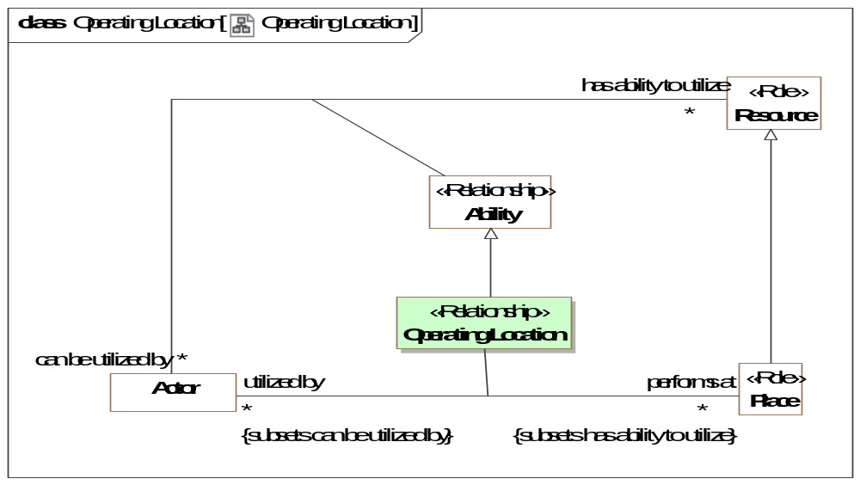
- Operating Location
Direct Supertypes
Ability
Association Ends
performs at : Place [*] Subsets: observes:Identifiable Entity
Places where an actor perform activities.
utilized by : Actor [*] Subsets: observes:Identifiable Entity
Actors who utilizes a place to perform activities.

Class Place <<Role>>
A building or locality used or intended for a specific purpose such as a house or factory.
[FIBO] Facility: something that is built, contrived, established, or installed to serve a particular purpose, or make some course of action or operation easi-er, or provide some capability or service
Direct Supertypes
Contactable, Physical Location, Resource

Association Class Place of Occurrance <<Relationship>>
Relationship describing where something happens.
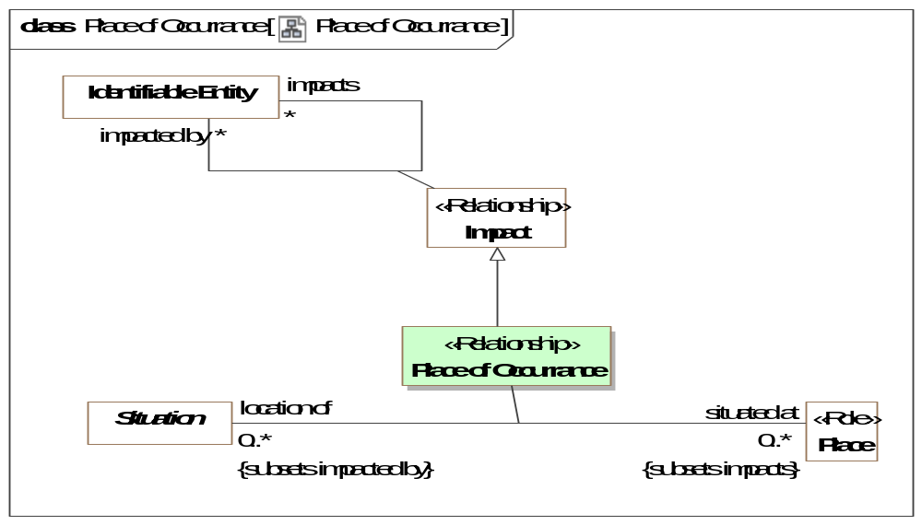
- Place of Occurrance
Direct Supertypes
Impact
Association Ends
situated at : Place [0..*] Subsets: observes:Identifiable Entity
Place where a situation or event is located or happens.
location of : Situation [0..*] Subsets: observes:Identifiable Entity
Situations (Events, incidents, static arrangements, etc.) that happen at the subject place.

Class Residence <<Role>>
A place where people live/reside.
Direct Supertypes
Place

Threat-risk-conceptual-model::Generic Concept Library::Policies
This package defines concepts related to policies. Policies deal with conditions asserted on one entity by another. This includes requirements and laws.

Diagram: Policy
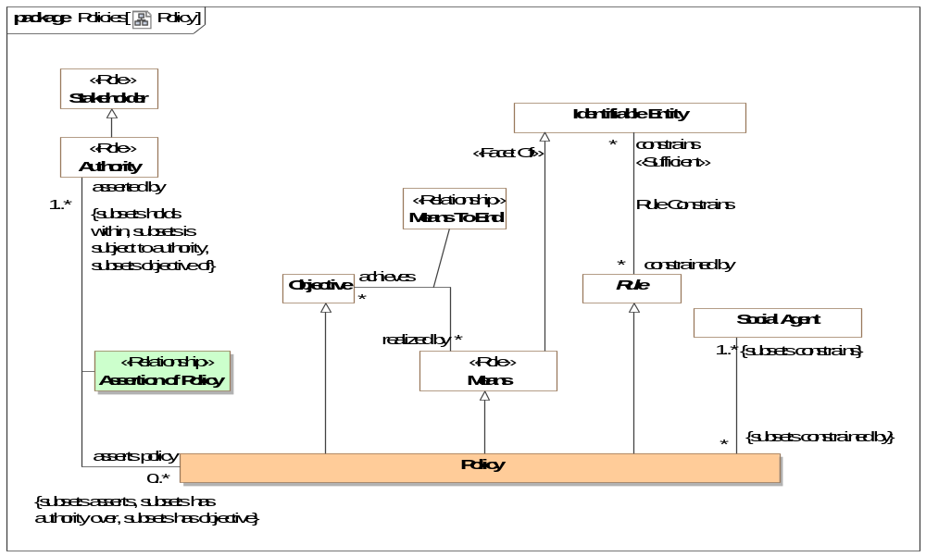
- Policy

Association Class Assertion of Policy <<Relationship>>
The assertion of a policy by an authority.
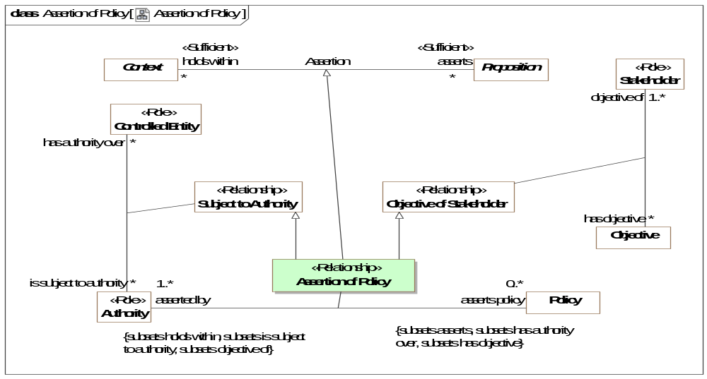
- Assertion of Policy
Direct Supertypes
Assertion, Objective of Stakeholder, Subject to Authority
Association Ends
asserts policy : Policy [0..*] Subsets: observes:Identifiable Entity
A policy asserted by an authority whom states with authority that it must be followed.
asserted by : Authority [1..*] Subsets: observes:Identifiable Entity
The authority that asserts a policy, states with authority that it must be followed

Class Policy
A policy is a thing that is compulsory; a necessary condition.
A statement that identifies a necessary attribute, capability, characteristic, or quality of a system for it to have value and utility to a customer, organization, internal user, or other stakeholder. The constrained parties are identified as the <constrains> responsible performer(s).
A policy is a means in that it fulfills a broader objective. A policy is an objective in that performers seek to comply with the objective. A policy is a state in that it is a situation that exists for a finite period of time.
Policies include requirements.
[BMM] Business policy: directive that is concerned with directly controlling, influencing, or regulating the actions of an enterprise and the people in it and that is not directly enforceable
Direct Supertypes
Controlled Entity, Means, Objective, Rule

Threat-risk-conceptual-model::Generic Concept Library::Predictions
Predictions are acts where an actor predicts that some possible situation will occur.

Diagram: Prediction
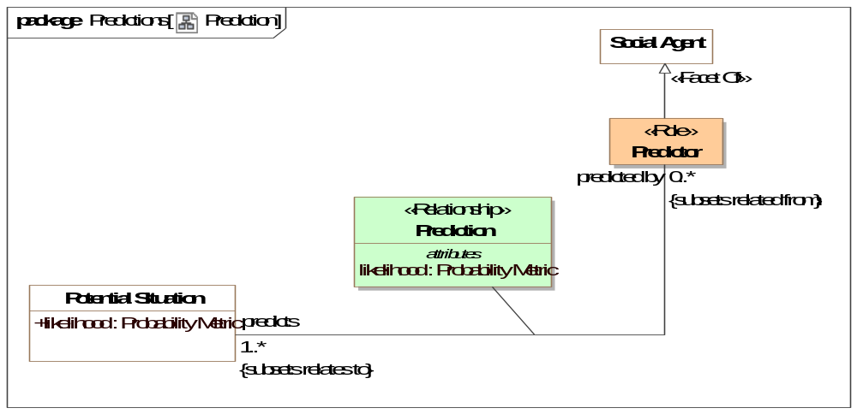
- Prediction

Association Class Prediction <<Relationship>>
A prediction is a forecast that potential situations will happen.
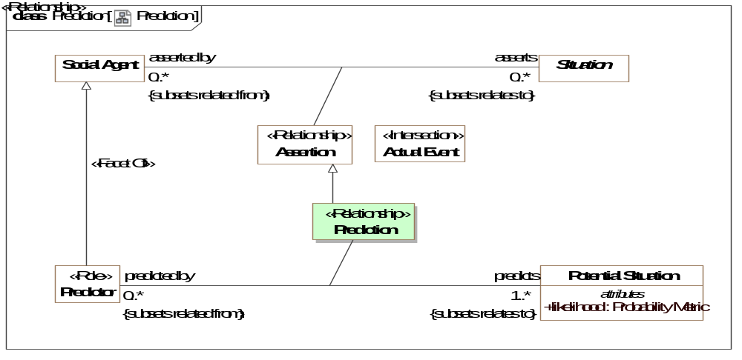
- Prediction
Direct Supertypes
Assertion
Association Ends
predicts : Potential Situation [1..*] Subsets: observes:Identifiable Entity
The situation that is postulated by a prediction.
predicted by : Predictor [0..*] Subsets: observes:Identifiable Entity
Predictor is the role of the actor who made a prediction.
Attributes
likelihood : Probability Metric
Metric representing the possibility that the containing element represents reality.

Class Predictor <<Role>>
The role of an actor making predictions.
Direct Supertypes
Social Agent

Threat-risk-conceptual-model::Generic Concept Library::Processes
A package representing concepts about processes. Processes are templates for (descriptions of) a related sets of Events (activities, events, etc.). Processes may be natural, organizational or carried out by an actor. Processes carried out by an actor are plans.
Processes may require resources - noting that resource can be a role of any entity.
Processes are essentially patterns of Events.
Scenarios are typically less formal processes and describe how a series of Events may play out.

Diagram: Process
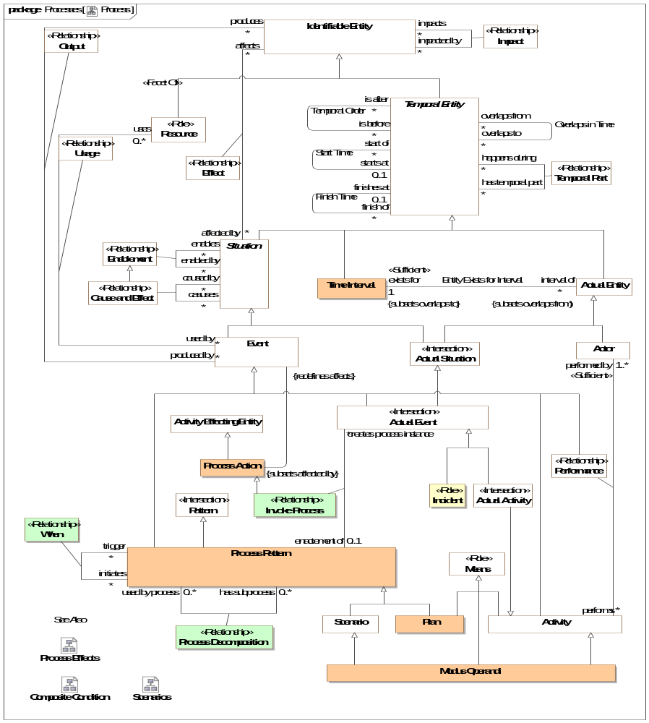
- Process

Association Class Invoke Process <<Relationship>>
The activity of initiating the performance of a process.
The process instance will be classified by the process.
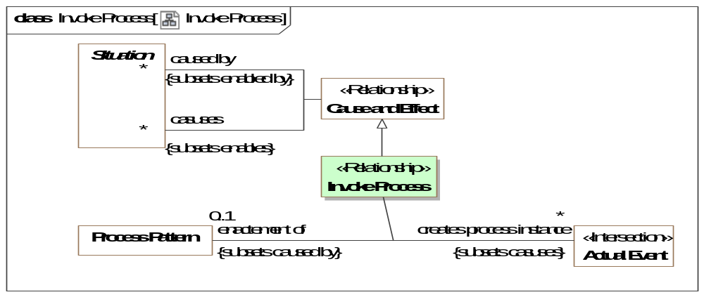
- Invoke Process
Direct Supertypes
Cause and Effect, Create, Process Action
Association Ends
creates process instance : Actual Event [*] Subsets: observes:Identifiable Entity
An actual Event created as the instantiation of a process definition.
enactement of : Process Pattern [0..1] Subsets: observes:Identifiable Entity
Process enacted by an Invoke Process

Class Modus Operandi
A particular way or method an actor typically does something, especially one that is characteristic or well-established. It may or may not have a formal definition of the process.
In threat terms, a particular tactic, technique or procedure for achieving a result.
Syn. TTP [STIX]
Direct Supertypes
Activity, Means, Scenario

Class Plan
A plan is a design for a process that supports a stakeholders objectives. As a process definition a plan is a pattern for a series of activities as well as the resources required to meet objectives.
Scenario's are observed where as plans are designed.
[BMM] Course of Action: A Course of Action is an approach or plan for configuring some aspect of the enterprise involving things, processes, locations, people, timing, or motivation undertaken to achieve Desired Results. In other words, a Course of Action channels efforts towards Desired Results. To help ensure success in this regard, Courses of Action are governed by Directives.
Direct Supertypes
Means, Process Pattern

Class Process Action
An action impacting a potential or realized process.
Direct Supertypes
Activity Effecting Entity

Association Class Process Decomposition <<Relationship>>
Relationship describing the decomposition of a process.
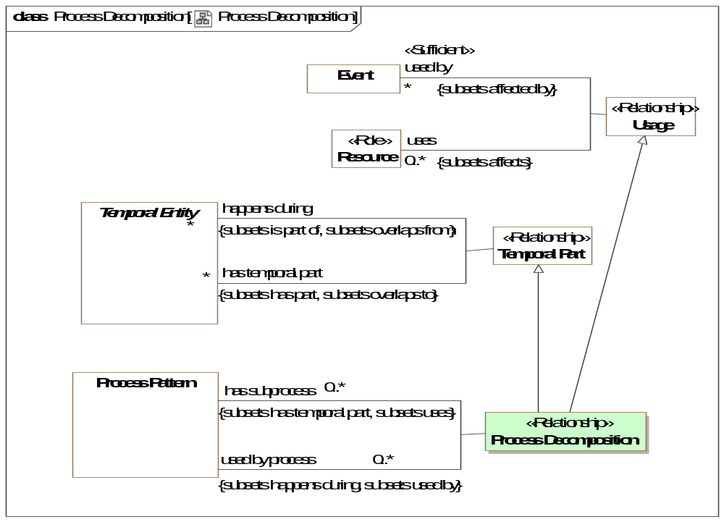
- Process Decomposition
Direct Supertypes
Temporal Part, Usage
Association Ends
has subprocess : Process Pattern [0..*] Subsets: observes:Identifiable Entity
Process occurring within the scope of and in support a composite process.
used by process : Process Pattern [0..*] Subsets: observes:Identifiable Entity
Composite processes which utilize the subject property as a component part.

Class Process Pattern
A process pattern is a template and definition for a family of Events (i.e. actions, events) that results in an outcome. A process may be natural or caused by the activities of actors, in which case it is a plan.
A process may contain other entities, sub-processes and situations to define characteristics and sub-processes of the process. The sub-processes may or may not be known, sub-processes are defined using "Temporal Part".
[ISO 14971:2007] set of interrelated or interacting activities which transforms inputs into outputs
Direct Supertypes
Event, Pattern
Associations
<<Restriction>> : Software [0..*] Subsets: has record:Record

Association Class When <<Relationship>>
A "When" rule defines an atomic process where by a <trigger> conditionally causes the <initiates> process to be invoked when the <trigger> process is matched under conditions(s) of the context - a proactive cause and effect. This results in an invocation of the <initiates> process.
E.g. when <trigger> do <initiates>
Also known as a "Course of action" or "ECA Rule" .
[PRR] ProductionRule: A ProductionRule is a statement of programming logic that specifies the execution of one or more actions in the case that its conditions are satisfied.
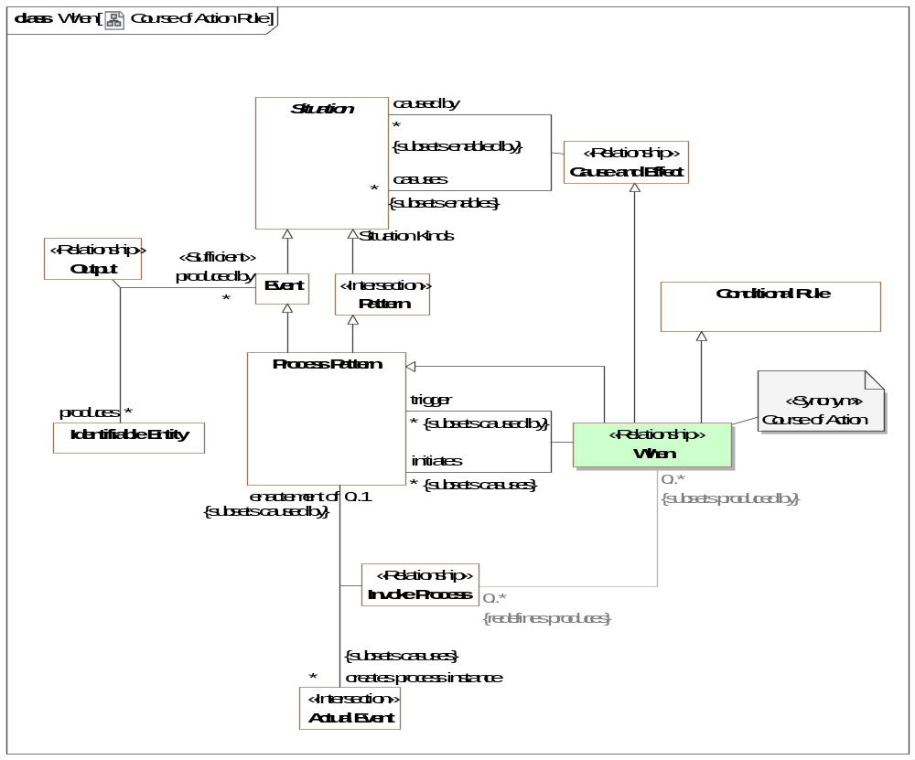
- Course of Action Rule
Direct Supertypes
Cause and Effect, Conditional Rule, Process Pattern
Association Ends
initiates : Process Pattern [*] Subsets: has record:Record
Processes that will occur if the <trigger> process occurs. Consequent.
trigger : Process Pattern [*] Subsets: has record:Record
Processes that may cause the <initiates> process to occur. Antecedent.
Associations
<<Restriction>> : Invoke Process [0..*] Redefines: produces:Identifiable Entity

Threat-risk-conceptual-model::Generic Concept Library::Processes::Composite Conditions
Composite conditions provide for "and"/"or" evaluation of causality between situations.

Diagram: Composite Condition
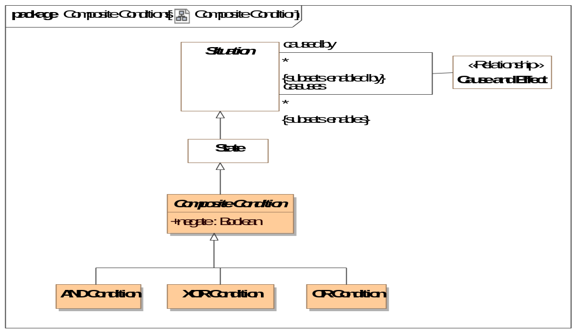
- Composite Condition

Class AND Condition
A situation that is true (happening) only when all "enabled by" are true - AND
Direct Supertypes
Composite Condition

Class Composite Condition
A composite condition is a state that is inferred to be true or false based on the set of "affected by" (input) situations and the logic of the specific composite event subtype and the condition (if any).
The composite condition can then be used to trigger a set of "effects" (output) situations.
Combinations of Events, states. and composite conditions be combined with composite conditions to represent fault, flow or dependency graphs.
Note that cause & effect, negation and enablement are all subtypes of effect and can be combined using composite conditions.
Direct Supertypes
State
Attributes
negate : Boolean
Negates the logic of a complex event - NOT <condition>

Class OR Condition
A composite condition that is true (occurring) when any "affected by" is true - OR
Direct Supertypes
Composite Condition

Class XOR Condition
A state that is True only when exactly one of its "affected by" is true - XOR
Direct Supertypes
Composite Condition

Threat-risk-conceptual-model::Generic Concept Library::Processes::Process Effects
Actions that impact various kinds of entities in specific ways. Such actions can be the subject of or part of processes, permissions, capabilities, or objectives.

Diagram: Process Effects
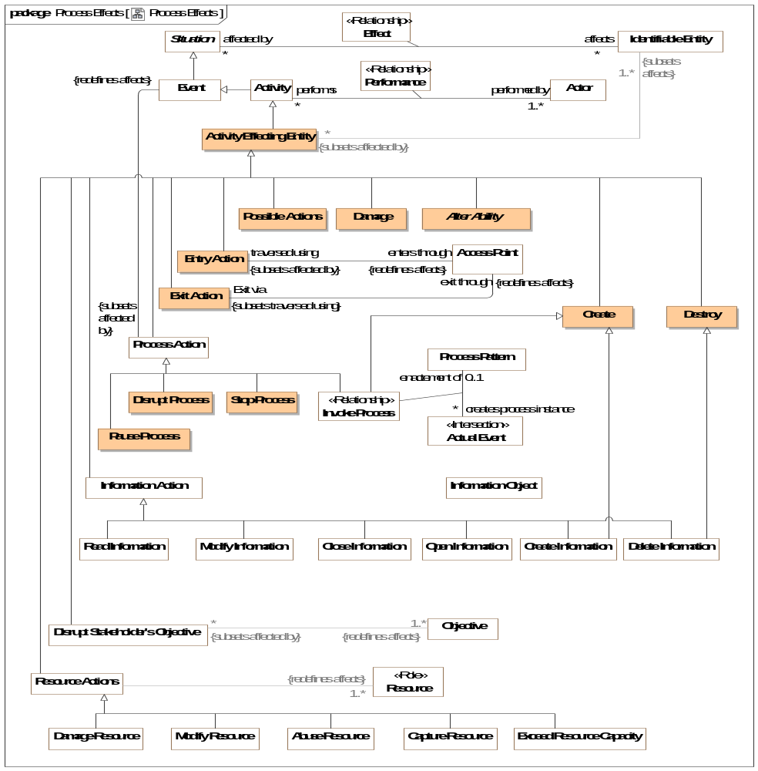
- Process Effects

Class Activity Effecting Entity
An event (planned or actual) that affects specific things in specific ways.
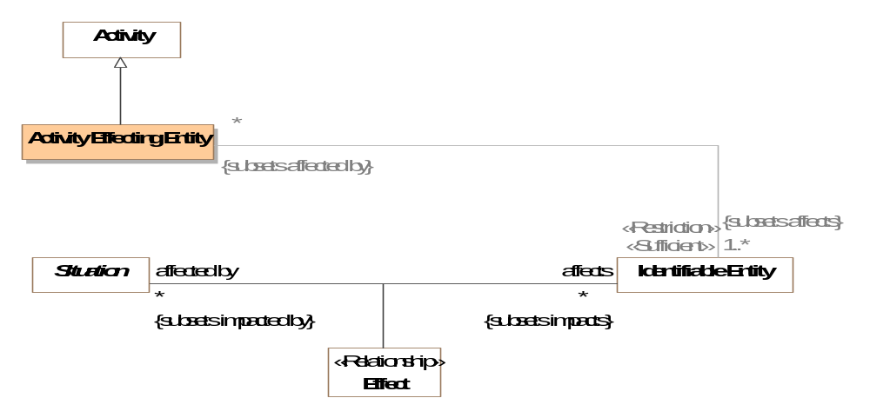
- Event Effecting Entity
Direct Supertypes
Activity

Class Create
The creation of something
Direct Supertypes
Activity Effecting Entity

Class Damage
An action that causes an entity to no longer completely fulfill its purpose.
Direct Supertypes
Activity Effecting Entity

Class Destroy
The destruction or deletion of something.
Direct Supertypes
Activity Effecting Entity

Class Disrupt Process
An action intended to cause a process to not achieve its desired affect.
Direct Supertypes
Damage, Process Action

Class Entry Action
The action of entering through a boundary.
Direct Supertypes
Activity Effecting Entity

Class Exit Action
An action of exiting through a boundary.
Direct Supertypes
Activity Effecting Entity

Class Pause Process
An action that pauses a process instance such that it can be restarted.
Direct Supertypes
Process Action

Class Possible Actions
All possible effects to an entity.
Direct Supertypes
Activity Effecting Entity

Class Stop Process
An action to terminate a process.
Direct Supertypes
Process Action

Threat-risk-conceptual-model::Generic Concept Library::Processes::Scenarios
Scenarios describe sequences and/or dependent situation patterns that include fault trees, attack/defense trees and other scenarios impacting stakeholders.
The attack-defense tree model is based on [Schweitzer 2013]
The attack-defense tree formalism can informally be described as follows. For a security scenario, the main goal of the attacker is depicted by the root node of a tree, an attack goal. Two types of refinement relations help to detail the model. Disjunctive (or) and constructive (and). Both types of refinement are recursively applied. Defense goals lower the probability of an attackers success, attack goals increase the probability.

Diagram: Scenarios
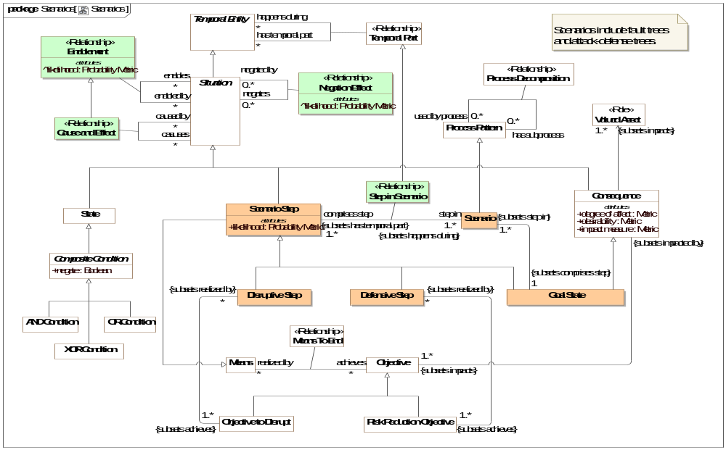
- Scenarios
A performance goal that is an objective to disrupt some resource.

Class Defensive Step
A situation realizing a performance goal that is an objective to protect some valued asset.
Derived from [Schweitzer 2013] Defense node
Direct Supertypes
Scenario Step
Associations
: Risk Reduction Objective [1..*] Subsets: achieves:Objective

Class Disruptive Step
A situation realizing a performance goal that is an objective to disrupt some valued asset.
Derived from [Schweitzer 2013] Attack node
Direct Supertypes
Scenario Step
Associations
: Objective to Disrupt [1..*] Subsets: achieves:Objective

Class Goal State
A goal state is a step in a scenario that directly impacts resources of a stakeholder, thereby impacting the goals of the same or a different stakeholder. Goal states may be positive (e.g. making more money) or negative (e.g. an attack target).
A goal state is usually but not necessarily the end state of a scenario.
Direct Supertypes
Consequence, Scenario Step
Associations
: Scenario [1..*] Subsets: step in:Scenario

Class Scenario
A scenario is a process pattern that provides template for a set of steps (may be but are not always activities) and resource that formally or informally depict how things may happen based on observations of similar occurrences. Scenarios are intended to be descriptive, not prescriptive.
Scenarios are described by at least one scenarios steps, one of which must provide a goal state.
Scenarios include attack/defense and fault trees.
Direct Supertypes
Process Pattern
Associations
: Goal State [1] Subsets: comprises step:Scenario Step

Class Scenario Step
A scenario step is a node in one or more scenarios that ultimately result in consequences.
Direct Supertypes
Means, Situation
Attributes
likelihood : Probability Metric
Metric representing the probability that the scenario step will happen.

Association Class Step in Scenario <<Relationship>>
Definition of a particular step as comprising a particular scenario.
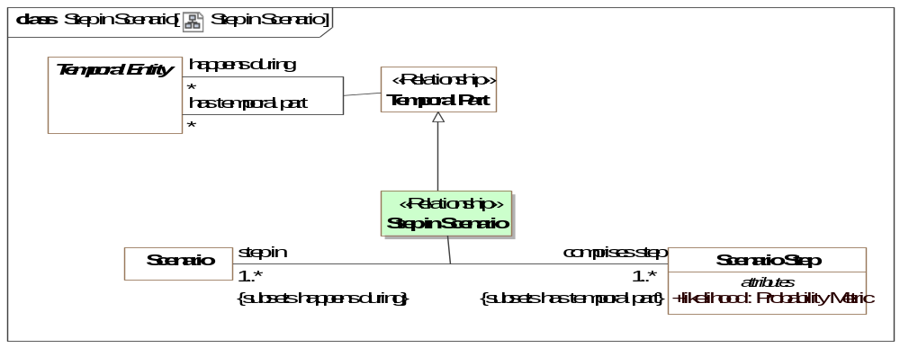
- Step in Scenario
Direct Supertypes
Temporal Part
Association Ends
comprises step : Scenario Step [1..*] Subsets: comprises step:Scenario Step
A step in a scenario that is or leads to a goal state.
step in : Scenario [1..*] Subsets: comprises step:Scenario Step
Scenario in which is defined, in part, be a step.

Threat-risk-conceptual-model::Generic Concept Library::Quantities and Units
This package defines quantities and units. Quantities are the basis for units and measurements.
Qualities of things are represented with respect to what that thing means, not how it is represented. This introduces multiple "quantity kinds" which derive from Value and Quantity. Quantiles are stereotyped as "Quantity Kind".
The representation of a value or quantity will typically use the "primitive types" that are found in I.T. systems such as "Integer", "Real" and "String".
.

Diagram: Quantities and units
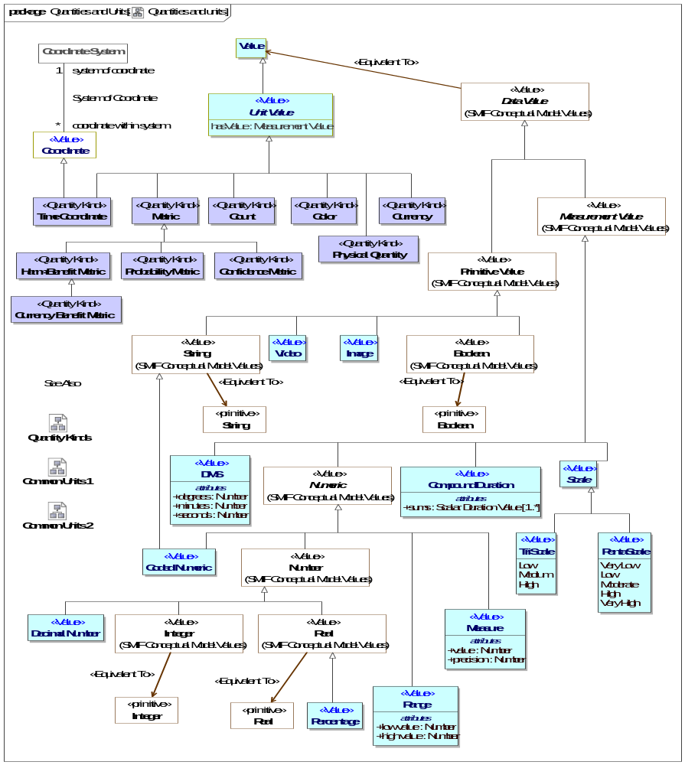
- Quantities and units

Class Confidence Metric <<Quantity Kind>>
Any metric of confidence that something is true or valid.
Direct Supertypes
Metric

Class Count <<Quantity Kind>>
The number of something used as a property or metric, e.g., 5 fish.
Direct Supertypes
Unit Value

Class Currency Benefit Metric <<Quantity Kind>>
A metric for benefit or harm expressed in terms of a currency, such as dollars or yen.
Direct Supertypes
Harm-Benefit Metric

Class Harm-Benefit Metric <<Quantity Kind>>
A metric to quantify benefit or harm.
Direct Supertypes
Metric

Class Metric <<Quantity Kind>>
A standard for measuring or evaluating something in a quantifiable way.
Typical representations of a metric may be a fraction from zero to 1 or a rating such as "high, medium, low". Not to be confused with the "Metric System".
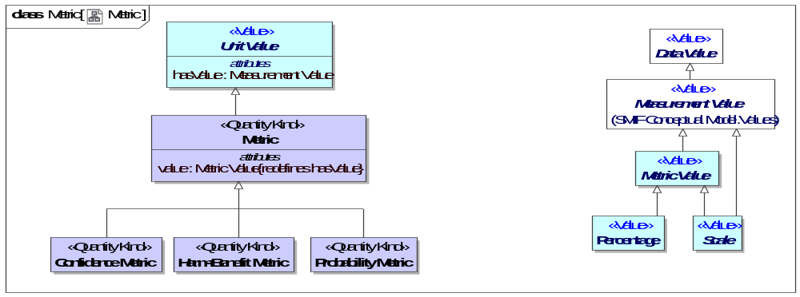
- Metric
Direct Supertypes
Unit Value
Attributes
value : Metric Value
The value of a quantity that, when multiplied by the unit defined in a subtype of quantity kind, specifies a measurement value such as 3 Meters.

Class Probability Metric <<Quantity Kind>>
A metric that represents the possibility that something uncertain will happen.
Direct Supertypes
Metric

Class Time Coordinate <<Quantity Kind>>
An identifier for a particular point in time, recognizing that any such point is an interval at a finer level of granularity.
Specific time coordinate systems, such as ISO or Internet time, specialize Time Coordinate and relate it to a time scale.
[DTV] time point: concept that specializes the concept 'time interval' and that is a member of a time scale
[ISO11404] time: time is a family of datatypes whose values are points in time to various common resolutions: year, month, day, hour, minute, second, and fractions thereof.
Direct Supertypes
Coordinate, Unit Value
Attributes
value : Duration

<<Value>>Enumeration PentaScale <<Value>>
An scale of 5 values the interpretation of which is context specific.
Direct Known Superclasses
Scale
package Threat-risk-conceptual-model::Generic Concept Library::Quantities and Units
public enum PentaScale
{Very Low, Low, Moderate, High, Very High}

Literals
Very Low
Low
Moderate
High
Very High
- Quantities and units

<<Value>>Enumeration TriScale <<Value>>
A scale of 3 arbitrary levels.
Direct Known Superclasses
Scale
package Threat-risk-conceptual-model::Generic Concept Library::Quantities and Units
public enum TriScale
{Low, Medium, High}

Literals
Low
Medium
High
- Quantities and units

Threat-risk-conceptual-model::Generic Concept Library::Quantities and Units::Quantity Kinds
Quantity kinds are abstractions for the way we measure or quantify things, such as mass or length. Units provide specific ways to specify a quantity kind.

Diagram: Quantity Kinds
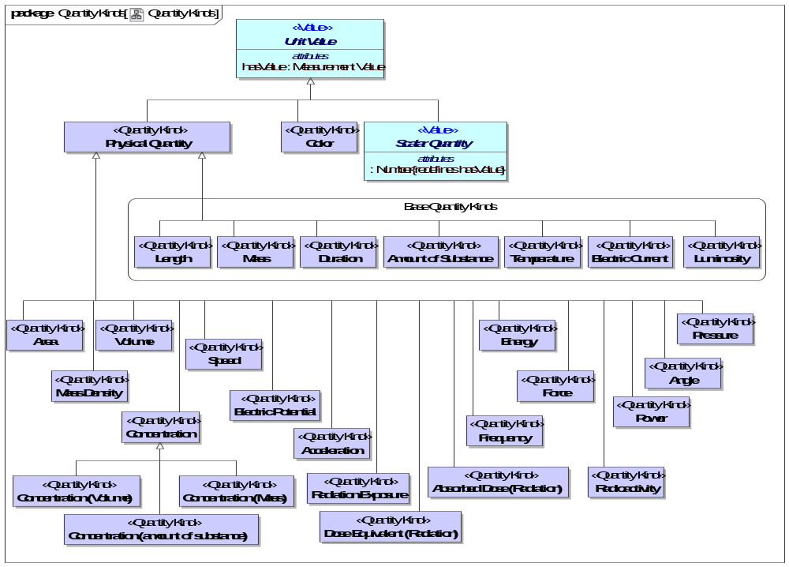
- Quantity Kinds

Class Absorbed Dose (Radiation) <<Quantity Kind>>
The energy of ionizing radiation absorbed per unit mass by a body, often measured in rads.
Direct Supertypes
Physical Quantity, Scalar Quantity

Class Acceleration <<Quantity Kind>>
The rate of change of velocity per unit of time.
Direct Supertypes
Physical Quantity, Scalar Quantity

Class Amount of Substance <<Quantity Kind>>
The abstract unit of the amount of a substance which is the supertype of all amount units and also acts as its "quantity kind".
Amount of substance is a standards-defined quantity that measures the size of an ensemble of elementary entities, such as atoms, molecules, electrons, and other particles. It is sometimes referred to as chemical amount. The International System of Units (SI) defines the amount of substance to be proportional to the number of elementary entities present. The SI unit for amount of substance is the mole. It has the unit symbol mol.
Direct Supertypes
Physical Quantity, Scalar Quantity

Class Angle <<Quantity Kind>>
The space (usually measured in radians or degrees) between two intersecting lines or surfaces at or close to the point where they meet.
Direct Supertypes
Physical Quantity, Scalar Quantity

Class Area <<Quantity Kind>>
[QUDT] Area is a quantity expressing the two-dimensional size of a defined part of a surface, typically a region bounded by a closed curve.
Direct Supertypes
Physical Quantity, Scalar Quantity

Class Color <<Quantity Kind>>
Color is the visual perceptual property corresponding in humans to the categories called red, blue, yellow, and others. Color derives from the spectrum of light (distribution of light power versus wavelength) interacting in the eye with the spectral sensitivities of the light receptors. Color categories and physical specifications of color are also associated with objects or materials based on their physical properties such as light absorption, reflection, or emission spectra. By defining a color space, colors can be identified numerically by their coordinates.
Direct Supertypes
Unit Value

Class Concentration <<Quantity Kind>>
The abstract concept of the amount, mass or volume of one substance in another without being specific as to how it is measured.
Direct Supertypes
Physical Quantity, Scalar Quantity

Class Concentration (amount of substance) <<Quantity Kind>>
Concentration based on amount-of-substance.
Direct Supertypes
Concentration

Class Concentration (Mass) <<Quantity Kind>>
Concentration based on mass per unit of volume.
Direct Supertypes
Concentration

Class Concentration (Volume) <<Quantity Kind>>
Volume concentration is defined as the volume of a constituent divided by the volume of the mixture.
Direct Supertypes
Concentration

Class Currency <<Quantity Kind>>
Any form of money.
[FIBO] Currency: medium of exchange value, defined by reference to the geographical location of the authorities responsible for it
Direct Supertypes
Unit Value

Class Dose Equivalent (Radiation) <<Quantity Kind>>
A measure of the biological damage to living tissue as a result of radiation exposure. Also known as the "biological dose," the dose equivalent is calculated as the product of absorbed dose in tissue multiplied by a quality factor and then sometimes multiplied by other necessary modifying factors at the location of interest. The dose equivalent is expressed numerically in rems or sieverts (Sv) (see 10 CFR 20.1003). For additional information, see Doses in Our Daily Lives and Measuring Radiation. [NRC]
For practical purposes, 1 R (exposure) = 1 rad (absorbed dose) = 1 rem or 1000 mrem (dose equivalent).
Direct Supertypes
Physical Quantity, Scalar Quantity

Class Duration <<Quantity Kind>>
The abstract quantity kind of time which is the supertype of all time duration units.
Time is a measure that allows events to be ordered from the past through the present into the future, and also the measure of durations of events and the intervals between them. Durations are quantities of time, not points or intervals of time.
[DTV] base quantity of the International System of Quantities, used for measuring time intervals.
[IDEAS] Time: A MeasureInstance whose members are individuals' that have a particular temporal dimension of the same length.
[FIBO] Duration: An amount of time.
[UML] Duration
[OWL] xsd:duration
Direct Supertypes
Physical Quantity

Class Electric Current <<Quantity Kind>>
The abstract quantity kind of electric current which is the supertype of all current units.
[QUDT]Electric Current is the flow (movement) of electric charge. The amount of electric current through some surface, e.g., a section through a copper conductor, is defined as the amount of electric charge flowing through that surface over time. Current is a scalar-valued quantity.
The SI unit for measuring an electric current is the ampere, which is the flow of electric charge across a surface at the rate of one coulomb per second.
[IDEAS] ElectricCurrent: A MeasureInstance whose members are individuals' that all have the same electric current flowing through them
Direct Supertypes
Physical Quantity, Scalar Quantity

Class Electric Potential <<Quantity Kind>>
[QUDT] Electric Potential is a scalar valued quantity associated with an electric field.
Direct Supertypes
Physical Quantity, Scalar Quantity

Class Energy <<Quantity Kind>>
The measure of energy- the ability to perform work (such as moving a mass).
Direct Supertypes
Physical Quantity, Scalar Quantity

Class Force <<Quantity Kind>>
(Physical) force is an influence that causes mass to accelerate. It may be experienced as a lift, a push, or a pull.
Force is defined by Newton's Second Law as F = m · a, where F is force, m is mass and a is acceleration. Net force is mathematically equal to the time rate of change of the momentum of the body on which it acts. Since momentum is a vector quantity (has both a magnitude and direction).
Direct Supertypes
Physical Quantity, Scalar Quantity

Class Frequency <<Quantity Kind>>
Repetitions per unit of time. e.g., Hertz.
[IDEAS] Frequency: A MeasureInstance whose instances are individuals' that all oscillate at the same frequency
Direct Supertypes
Physical Quantity, Scalar Quantity

Class Length <<Quantity Kind>>
The abstract unit of distance (or length) which is the supertype of all length units and also acts as its "quantity kind".
In the International System of Quantities, length is any quantity with dimension distance. In other contexts "length" is the measured dimension of an object.
[IDEAS] Length: A MeasureInstance whose instances are individuals' that all have the same length
Direct Supertypes
Physical Quantity, Scalar Quantity

Class Luminosity <<Quantity Kind>>
Luminosity ( or luminous intensity ) is a measure of the wavelength-weighted power emitted by a light source in a particular direction per unit solid angle, based on the luminosity function, a standardized model of the sensitivity of the human eye. The SI unit of luminous intensity is the candela (cd), an SI base unit.
[IDEAS] LuminousIntensity: A MeasureInstance whose members are individuals' that all have the same luminous intensity
Direct Supertypes
Physical Quantity, Scalar Quantity

Class Mass <<Quantity Kind>>
The abstract unit of Mass which is the supertype of all mass units and also acts as its "quantity kind".
The mass of a body is a measure of its inertial property or how much matter it contains. The weight of a body is a measure of the force exerted on it by gravity or the force needed to support it. Gravity on earth gives a body a downward acceleration of about 9.8 m/s2.The SI unit of mass is the kilogram (kg).
[IDEAS] Mass: A MeasureInstance whose members are individuals' that all have the same mass.
Direct Supertypes
Physical Quantity, Scalar Quantity

Class Mass Density <<Quantity Kind>>
The density, or more precisely, the volumetric mass density, of a substance is its mass per unit volume. The symbol most often used for density is ρ (the lower case Greek letter rho). Mathematically, density is defined as mass divided by volume.
Direct Supertypes
Physical Quantity, Scalar Quantity

Class Physical Quantity <<Quantity Kind>>
A measurable property of a physical object.
Direct Supertypes
Unit Value

Class Power <<Quantity Kind>>
(Physical) power is the rate at which work is performed or energy is transmitted, or the amount of energy required or expended for a given unit of time. As a rate of change of work done or the energy of a subsystem, power is: P = W/t where P is power W is work t is time.
Direct Supertypes
Physical Quantity

Class Pressure <<Quantity Kind>>
A quantity kind representing the continuous physical force exerted on or against an object by something in contact with it.
Direct Supertypes
Physical Quantity, Scalar Quantity

Class Radiation Exposure <<Quantity Kind>>
A measure of exposure to radiation.
Direct Supertypes
Physical Quantity, Scalar Quantity

Class Radioactivity <<Quantity Kind>>
Radioactivity is a quantity kind that refers to the amount of ionizing radiation released by a material. Whether it emits alpha or beta particles, gamma rays, x-rays, or neutrons, a quantity of radioactive material is expressed in terms of its radioactivity (or simply its activity), which represents how many atoms in the material decay in a given time period. The units of measure for radioactivity are the curie (Ci) and Becquerel (Bq).
Direct Supertypes
Physical Quantity, Scalar Quantity

Class Speed <<Quantity Kind>>
A Quantity kind representing distance per unit of time.
Direct Supertypes
Physical Quantity, Scalar Quantity

Class Temperature <<Quantity Kind>>
The abstract quantity kind of Thermodynamic temperature which is the supertype of all temperature units and also acts as its "quantity kind".
Thermodynamic temperature is the absolute measure of temperature and it is one of the principal parameters of thermodynamics.
Thermodynamic temperature is defined by the third law of thermodynamics in which the theoretically lowest temperature is the null or zero point.
[IDEAS] ThermodynamicTemperature:
Direct Supertypes
Physical Quantity, Scalar Quantity

Class Volume <<Quantity Kind>>
A quantity kind for the amount of space that a substance or object occupies.
Direct Supertypes
Physical Quantity, Scalar Quantity

Threat-risk-conceptual-model::Generic Concept Library::Quantities and Units::Units
A package of common SI and U.S. Units. Note: All measures in concrete models should be bound to the expected units, even if units are implicit in the data structure.
This package is non-normative in the threat and risk specification. It is supplied to assist users in defining the units used in data structures.

Diagram: Common Units 1
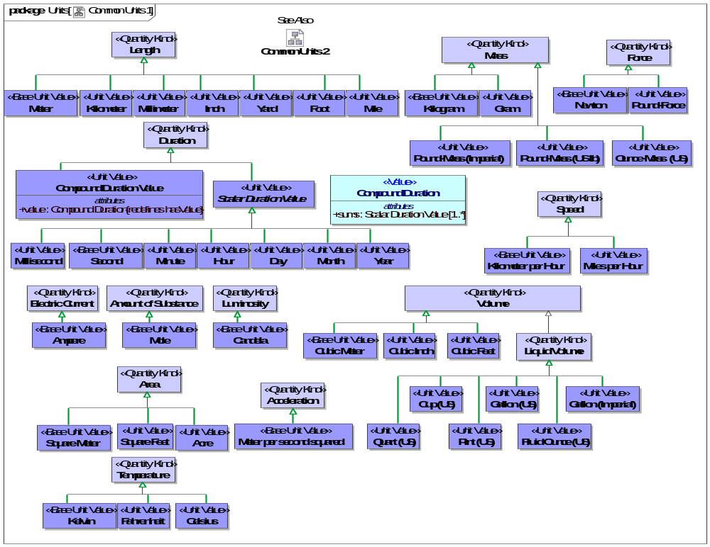
- Common Units 1
An amount of time.

Diagram: Common Units 2
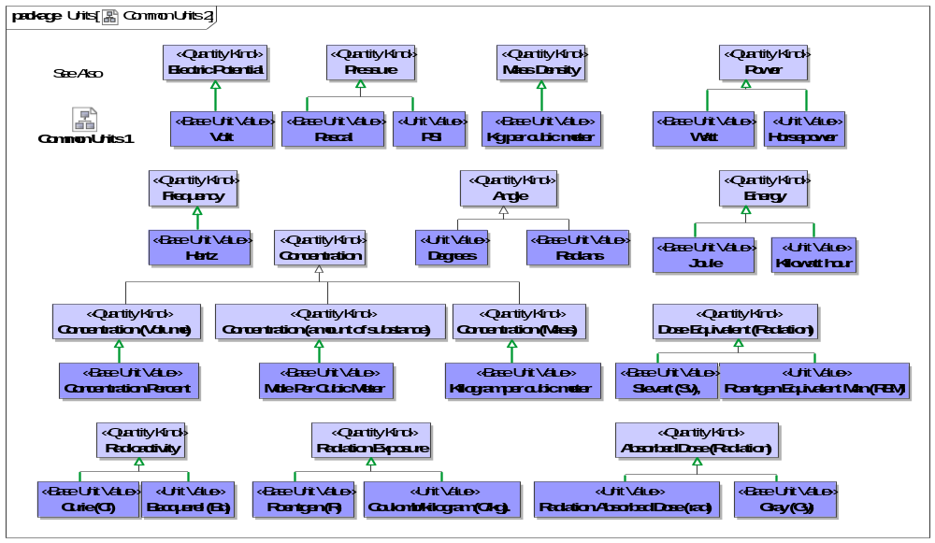
- Common Units 2

Class Acre <<Unit Value>>
1 acre = 43 560 square feet.
Direct Supertypes
Area

Class Ampere <<Base Unit Value>>
[NIST-SI] The ampere is that constant current which, if maintained in two straight parallel conductors of infinite length, of negligible circular cross-section, and placed 1 meter apart in a vacuum, would produce between these conductors a force equal to 2 x 10-7 newton per meter of length.
[IDEAS] electricCurrentInAmperes: A measureNamedNumericallyBy that names an ElectricCurrent with its ValueInAmperes
Direct Supertypes
Electric Current

Class Becquerel (Bq) <<Unit Value>>
The SI unit of radioactivity, corresponding to one disintegration per second.
Direct Supertypes
Radioactivity

Class Candela <<Base Unit Value>>
The candela is the luminous intensity, in a given direction, of a source that emits monochromatic radiation of frequency 540 x 1012 hertz and that has a radiant intensity in that direction of 1/683 watt per steradian.[NIST-SI]
[IDEAS] luminousIntensityInCandela: A measureNamedNumericallyBy that names a LuminousIntensity with its ValueInCandela
Direct Supertypes
Luminosity

Class Celsius <<Unit Value>>
Centigrade. The temperature scale (Celsius scale) in which 0° represents the ice point and 100° the steam point of water.
Direct Supertypes
Temperature

Class Compound Duration Value <<Unit Value>>
A value for a duration derived from the sum of primitive duration values. e.g. 2 days and 3 hours or 2016 years, 12 months and three days.
Direct Supertypes
Duration
Attributes
value : Compound Duration

Class Concentration Percent <<Base Unit Value>>
The volume of a constituent divided by the volume of the mixture.
Direct Supertypes
Concentration (Volume)

Class Coulomb/kilogram (C/kg). <<Unit Value>>
Unit of radiation exposure.
Direct Supertypes
Radiation Exposure

Class Cubic Feet <<Unit Value>>
A volume measured in feet.
Direct Supertypes
Volume

Class Cubic Inch <<Unit Value>>
A volume measured in inches.
Direct Supertypes
Volume

Class Cubic Meter <<Base Unit Value>>
A volume measured in meters.
Direct Supertypes
Volume

Class Cup (US) <<Unit Value>>
8 Fluid Ounces (US).
Direct Supertypes
Liquid Volume

Class Curie (Ci) <<Base Unit Value>>
The SI unit of measure for radioactivity is the curie (Ci) and Becquerel (Bq).
Direct Supertypes
Radioactivity

Class Day <<Unit Value>>
A unit of time equal to 24 hours.
[DTV] day: the precise time unit that is quantified by 86 400 seconds
[OWL] xsd:gDay
Direct Supertypes
Scalar Duration Value

Class Degrees <<Unit Value>>
A unit for an angle from 0-360.
Direct Supertypes
Angle

Class Fahrenheit <<Unit Value>>
The Fahrenheit scale in which 32° represents the ice point and 212° the steam point. of water Symbol: F.
Direct Supertypes
Temperature

Class Fluid Ounce (US) <<Unit Value>>
A unit of volume: 16 fluid ounces = 1 pint (pt)
= 28.875 cubic inches.
Direct Supertypes
Liquid Volume

Class Foot <<Unit Value>>
A foot (pl. feet; abbreviation: ft; symbol: ′, the prime symbol) is a unit of length in the imperial and US customary systems of measurement. Since 1959, both units have been defined by international agreement as equivalent to 0.3048 meters exactly. In both systems, the foot comprises 12 inches and three feet compose a yard.
Direct Supertypes
Length

Class Gallon (Imperial) <<Unit Value>>
A unit of volume.
Direct Supertypes
Liquid Volume

Class Gallon (US) <<Unit Value>>
A measure of the quantity of a substance. 1 gallon (gal) = 231 cubic inches.
Direct Supertypes
Liquid Volume

Class Gram <<Unit Value>>
The gram is a SI unit of mass.
Direct Supertypes
Mass

Class Gray (Gy) <<Base Unit Value>>
[NRC] One of the two units used to measure the amount of radiation absorbed by an object or person, known as the "absorbed dose," which reflects the amount of energy that radioactive sources (with any type of ionizing radiation) deposit in materials (e.g., water, tissue, air) through which they pass. One gray (Gy) is the international system of units (SI) equivalent of 100 rads, which is equal to an absorbed dose of 1 Joule/kilogram. An absorbed dose of 0.01 Gy means that 1 gram of material absorbed 100 ergs of energy (a small but measurable amount) as a result of exposure to radiation.
Direct Supertypes
Absorbed Dose (Radiation)

Class Hertz <<Base Unit Value>>
A unit of frequency. Cycles per second.
[IDEAS] frequencyInHertz: A measureNamedNumericallyBy that names a Frequency with its ValueInHertz
Direct Supertypes
Frequency

Class Horsepower <<Unit Value>>
Horsepower (hp) is a unit of measurement of power (the rate at which work is done). There are many different standards and types of horsepower. This model uses the 746 watt interpretation of horsepower.
Direct Supertypes
Power

Class Hour <<Unit Value>>
A unit of time: 60 Minutes.
[DTV] hour: the precise time unit that is quantified by '3600 seconds'
Direct Supertypes
Scalar Duration Value

Class Inch <<Unit Value>>
A unit of length.
Direct Supertypes
Length

Class Joule <<Base Unit Value>>
The joule (symbol J, also called newton meter, watt second, or coulomb volt) is the SI unit of energy and work.
Direct Supertypes
Energy

Class Kelvin <<Base Unit Value>>
[NIST-SI] The kelvin, unit of thermodynamic temperature, is the fraction 1/273.16 of the thermodynamic temperature of the triple point of water.
[IDEAS] temperatureInKelvin: A measureNamedNumericallyBy that names a ThermodynamicTemperature with its ValueInKelvin
Direct Supertypes
Temperature

Class Kg per cubic meter <<Base Unit Value>>
The SI unit for density.
Direct Supertypes
Mass Density

Class Kilogram <<Base Unit Value>>
[NIST-SI] The kilogram is the unit of mass; it is equal to the mass of the international prototype of the kilogram. [NIST-SI]
[IDEAS] massInKilograms: A measureNamedNumericallyBy that names a Mass with its ValueInKilograms
Direct Supertypes
Mass

Class Kilogram per cubic meter <<Base Unit Value>>
The SI Unit of density.
Direct Supertypes
Concentration (Mass)

Class Kilometer <<Unit Value>>
A unit of length, the SI measure of distances equal to 1000 meters, and equivalent to 3280.8 feet or 0.621 mile.
Symbol: km.
Direct Supertypes
Length

Class Kilometer per Hour <<Base Unit Value>>
The SI unit of speed
Direct Supertypes
Speed

Class Kilowatt hour <<Unit Value>>
The watt-hour (symbolized Wh) is a unit of energy equivalent to one watt (1 W) of power expended for one hour (1 h) of time.
Direct Supertypes
Energy

Class Liquid Volume <<Quantity Kind>>
Volume of a liquid.
Direct Supertypes
Volume

Class Meter <<Base Unit Value>>
The meter is the length of the path traveled by light in vacuum during a time interval of 1/299 792 458 of a second.[NIST-SI]
The meter, (SI unit symbol: m), is the fundamental unit of length in the International System of Units (SI).
[IDEAS] lengthInMeters: A measureNamedNumericallyBy that names a Mass with its ValueInKilograms
Direct Supertypes
Length

Class Meter per second squared <<Base Unit Value>>
The SI Unit of acceleration.
Direct Supertypes
Acceleration

Class Mile <<Unit Value>>
The mile is an English unit of length standardized as exactly 1.609344 kilometers.
Direct Supertypes
Length

Class Miles per Hour <<Unit Value>>
U.S. unit of speed.
Direct Supertypes
Speed

Class Millimeter <<Unit Value>>
A unit of length equal to one thousandth of a meter and equivalent to 0.03937 inch.
Abbreviation: mm.
Direct Supertypes
Length

Class Millisecond <<Unit Value>>
A unit of time: 1/1000th of a second.
[DTV] millisecond
Direct Supertypes
Scalar Duration Value

Class Minute <<Unit Value>>
A unit of time: 60 seconds.
[DTV] minute : the precise time unit that is quantified by '60 seconds'
Direct Supertypes
Scalar Duration Value

Class Mole <<Base Unit Value>>
The mole is a unit of measurement used in chemistry to express amounts of a chemical substance, defined as the amount of any substance that contains as many elementary entities (e.g., atoms, molecules, ions, electrons) as there are atoms in 12 grams of pure carbon-12.
Direct Supertypes
Amount of Substance

Class Mole Per Cubic Meter <<Base Unit Value>>
The SI unit for amount-of-substance concentration.
Direct Supertypes
Concentration (amount of substance)

Class Month <<Unit Value>>
[DTV] month: the nominal time unit that is the duration of a time interval required for one rotation of the Moon in its orbit around the Earth, approximated to a number of days.
[OWL] xsd:gMonth
Direct Supertypes
Scalar Duration Value

Class Newton <<Base Unit Value>>
The SI unit of force. Equivalent to 100,000 dynes. A Newton is equal to the force that would give a mass of one kilogram an acceleration of one meter per second per second.
Direct Supertypes
Force

Class Ounce-Mass (US) <<Unit Value>>
U.S. Unit of Ounce representing Mass.
Direct Supertypes
Mass

Class Pascal <<Base Unit Value>>
The SI unit of pressure, equal to one newton per square meter (approximately 0.000145 pounds per square inch, or 9.9 × 10-6 atmospheres).
Direct Supertypes
Pressure

Class Pint (US) <<Unit Value>>
Unit of liquid volume: 2 pints = 1 quart (qt) = 57.75 cubic inches.
Direct Supertypes
Liquid Volume

Class Pound-Force <<Unit Value>>
Pound-force is equal to the gravitational force exerted on a mass of one avoirdupois pound on the surface of Earth.
Standard gravity is not constant but usually taken to be 9.80665 m/s2 (about 32.174 049 ft/s2) in the context of the surface of the earth.
Direct Supertypes
Force

Class Pound-Mass (Imperial) <<Unit Value>>
A unit of mass that is exactly 453.59237 grams.
Direct Supertypes
Mass

Class Pound-Mass (US lb) <<Unit Value>>
The pound avoirdupois, which forms the basis of the U.S. customary system of mass, is defined as exactly 453.59237 grams.
The avoirdupois pound is legally defined as a measure of mass, but the name pound is also applied to measures of force.
See also: http://www.nist.gov/pml/wmd/metric/upload/frn-59-5442-1959.pdf
Direct Supertypes
Mass

Class PSI <<Unit Value>>
Unit of pounds per square inch.
Direct Supertypes
Pressure

Class Quart (US) <<Unit Value>>
Unit of liquid volume where 4 quarts = 1 gallon (gal) = 231 cubic inches [NIST-UNITS].
Direct Supertypes
Liquid Volume

Class Radians <<Base Unit Value>>
A unit of an angle where there are 2 PI radians in a circle.
Direct Supertypes
Angle

Class Radiation Absorbed Dose (rad) <<Unit Value>>
One of the two units used to measure the amount of radiation absorbed by an object or person, known as the “absorbed dose,” which reflects the amount of energy that radioactive sources deposit in materials through which they pass. The radiation-absorbed dose (rad) is the amount of energy (from any type of ionizing radiation) deposited in any medium (e.g., water, tissue, air). An absorbed dose of 1 rad means that 1 gram of material absorbed 100 ergs of energy (a small but measurable amount) as a result of exposure to radiation. The related international system unit is the gray (Gy), where 1 Gy is equivalent to 100 rad. For additional information, see Doses in Our Daily Lives and Measuring Radiation. [NRC]
Direct Supertypes
Absorbed Dose (Radiation)

Class Roentgen (R) <<Base Unit Value>>
A unit of exposure to ionizing radiation. It is the amount of gamma or x-rays required to produce ions resulting in a charge of 0.000258 coulombs/kilogram of air under standard conditions. [NRC]
Direct Supertypes
Radiation Exposure

Class Roentgen Equivalent Man (REM) <<Unit Value>>
One of the two standard units used to measure the dose equivalent (or effective dose), which combines the amount of energy (from any type of ionizing radiation that is deposited in human tissue), along with the medical effects of the given type of radiation. For beta and gamma radiation, the dose equivalent is the same as the absorbed dose. By contrast, the dose equivalent is larger than the absorbed dose for alpha and neutron radiation, because these types of radiation are more damaging to the human body. Thus, the dose equivalent (in rems) is equal to the absorbed dose (in rads) multiplied by the quality factor of the type of radiation [see Title 10, Section 20.1004, of the Code of Federal Regulations (10 CFR 20.1004), "Units of Radiation Dose"]. The related international system unit is the sievert (Sv), where 100 rem is equivalent to 1 Sv. [NRC]
Direct Supertypes
Dose Equivalent (Radiation)

Class Scalar Duration Value <<Unit Value>>
Number and time unit together giving magnitude of a duration.
[DTV]
Definition:if the atomic duration value is a precise atomic duration value, then the time unit is the reference duration to which the ratio of the duration quantified by the atomic duration value is taken
Definition:if the atomic duration value is a nominal atomic duration value, then the time unit is the reference duration to which the ratio of exactly one element of the duration value set specified by the atomic duration value is taken
Example:“45 minutes” has the time unit ‘minute’
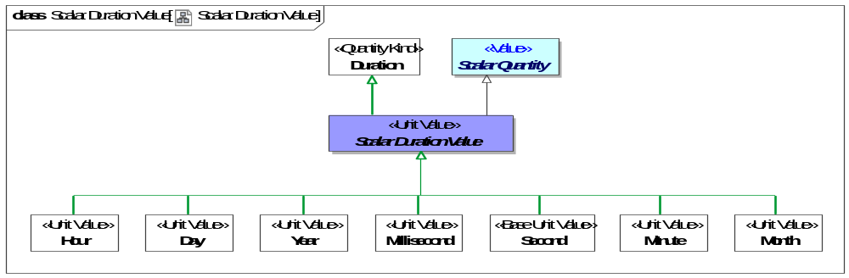
- Scalar Duration Value
Direct Supertypes
Duration, Scalar Quantity

Class Second <<Base Unit Value>>
[NIST-SI] The second (symbol: s) is the base unit of time in the International System of Units (SI) and is also a unit of time in other systems of measurement (abbreviated s or sec); it is the second division of the hour by sixty, the first division by 60 being the minute.
[DTV] second: The second is the duration of 9 192 631 770 periods of the radiation corresponding to the transition between the two hyperfine levels of the ground state of the cesium 133 atom.
[IDEAS] Second: A measureNamedNumericallyBy that names a Time with its ValueInSeconds
Direct Supertypes
Scalar Duration Value

Class Sievert (Sv), <<Base Unit Value>>
The international system (SI) unit for dose equivalent equal to 1 Joule/kilogram. 1 sievert = 100 rem. Named for physicist Rolf Sievert.
Direct Supertypes
Dose Equivalent (Radiation)

Class Square Feet <<Unit Value>>
Area measured in feet.
Direct Supertypes
Area

Class Square Meter <<Base Unit Value>>
Area measured in SI meters.
Direct Supertypes
Area

Class Volt <<Base Unit Value>>
The SI unit of electromotive force, the difference of potential that would drive one ampere of current against one ohm resistance.
Direct Supertypes
Electric Potential

Class Watt <<Base Unit Value>>
The SI unit of power is the joule per second (J/s).
Direct Supertypes
Power

Class Yard <<Unit Value>>
A Unit of length equal to 3 feet.[NIST-UNITS]
Direct Supertypes
Length

Class Year <<Unit Value>>
The period of 365 days (or 366 days in leap years) starting from the first of January, used for reckoning time in ordinary affairs.
[DTV] year: the nominal time unit that is the duration of a time interval required for one revolution of the Earth around the Sun, approximated to an integral number of days
[OWL] xsd:gYear
Direct Supertypes
Scalar Duration Value

Threat-risk-conceptual-model::Generic Concept Library::Resources
This package represents concepts concerning resources. A resource is a role of any entity such that it supports or impacts in a process, impacts the objectives of stakeholders or is the basis of the capability of an actor.
As a role, “Resource” is intended to "mix in" with an entity type such as "Person" or "Process" such that the use of that entity may be understood.
Resources that are a Primary Asset are those that are the direct subject of a stakeholder's objectives.

Diagram: Resource
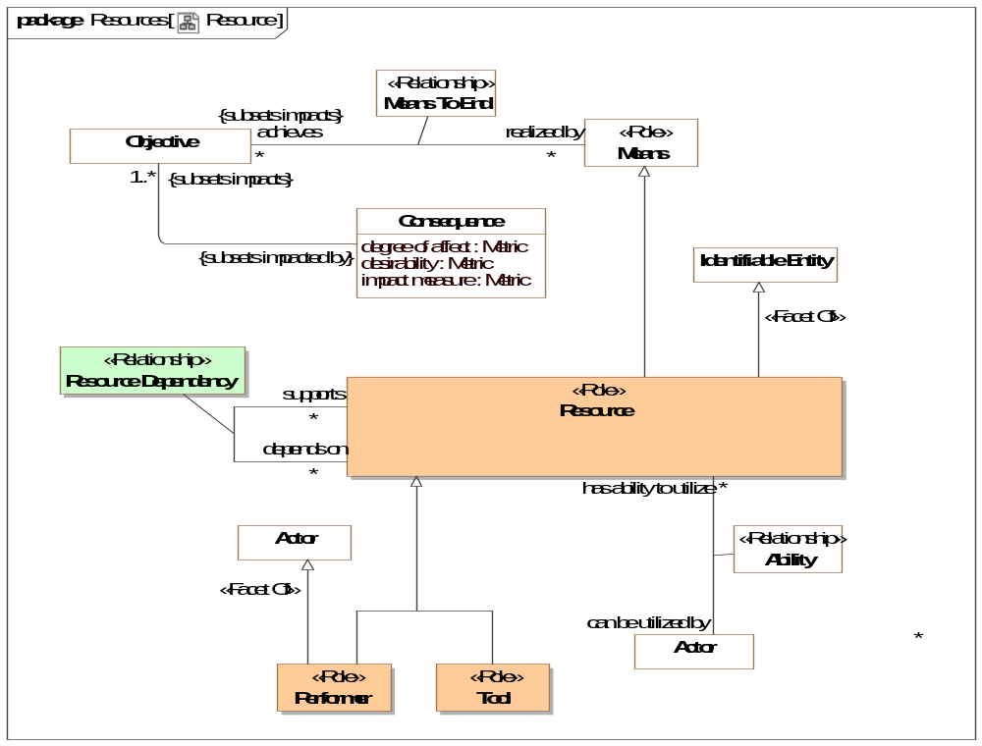
- Resource

Diagram: Resource Actions
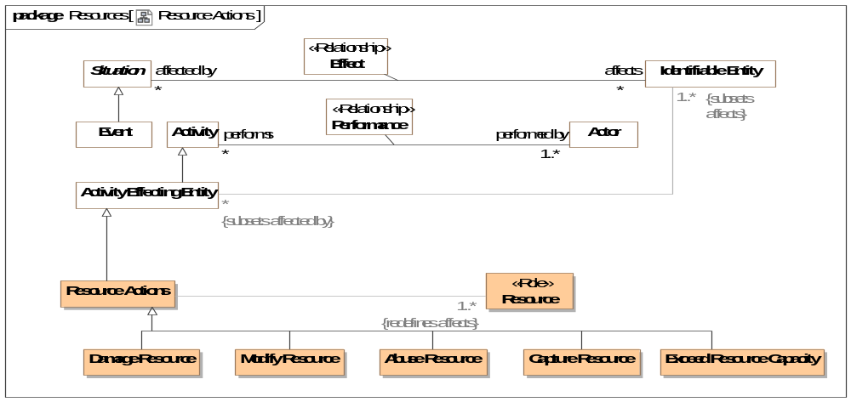
- Resource Actions

Class Abuse Resource
An action to misuse a resource.
Direct Supertypes
Resource Actions

Class Capture Resource
Action to capture or gain control of some resource.
Direct Supertypes
Resource Actions

Class Damage Resource
An action that causes an resource to no longer completely fulfill its purpose..
Direct Supertypes
Damage, Resource Actions

Class Exceed Resource Capacity
An action to exceed the capacity of some resource.
Direct Supertypes
Resource Actions

Class Modify Resource
Action to modify a resource or set of resources.
Direct Supertypes
Resource Actions

Class Performer <<Role>>
A performer is an actor that is a resource to another entity as the performer of activities.
Direct Supertypes
Actor, Resource

Class Resource <<Role>>
A resource is a role of an entity required for or helpful to any operation, activity, process or capability - directly or indirectly. Sometimes called an "asset".
Direct Supertypes
Identifiable Entity, Means

Class Resource Actions
An action impacting a potential or realized resource/asset.
Direct Supertypes
Activity Effecting Entity

Association Class Resource Dependency <<Relationship>>
Relationship between resources where one resource depends on (or uses) another.
A more general concept than [UAF] MapsToCapability: An Abstraction relationship denoting that an Activity contributes to providing a Capability.
[DOLCE] (Subtype of) Dependence
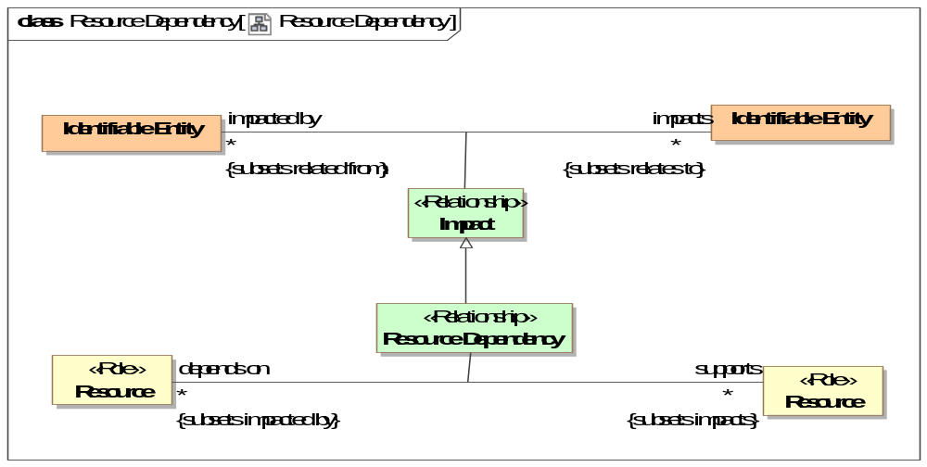
- Resource Dependency
Direct Supertypes
Impact
Association Ends
supports : Resource [*] Subsets: comprises step:Scenario Step
Resources the subject resource supports or enables.
depends on : Resource [*] Subsets: comprises step:Scenario Step
A resource that is required to support the operation of purpose of another resource.

Class Tool <<Role>>
The role of some inanimate thing used to facilitate a process or activity by an actor performing a process or activity.
Direct Supertypes
Resource

Threat-risk-conceptual-model::Generic Concept Library::Response

Diagram: Response
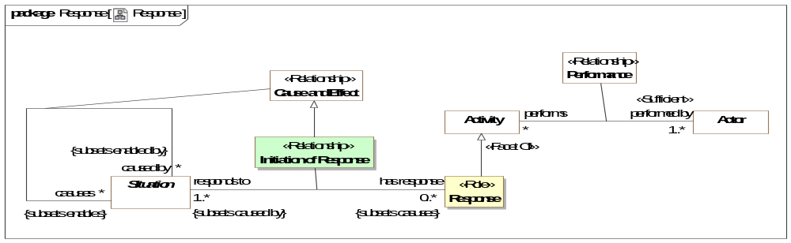
- Response

Association Class Initiation of Response <<Relationship>>
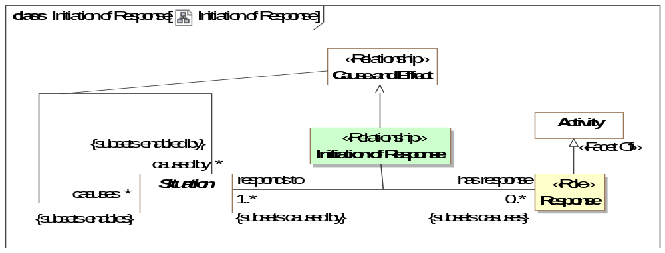
- Initiation of Response
Direct Supertypes
Cause and Effect
Association Ends
has response : Response [0..*] Subsets: comprises step:Scenario Step
responds to : Situation [1..*] Subsets: comprises step:Scenario Step

Class Response <<Role>>
A response is an activity performed by an actor as a reaction to (caused by) another situation.
Direct Supertypes
Activity
Associations
responds to : Situation [1..*] Subsets: caused by:Situation
through association: Initiation of Response

Threat-risk-conceptual-model::Generic Concept Library::Situations
Concepts relative to situations. A situation is a particular configuration of things and their relations including spatial, temporal, and logical connections between those things valid over a period of time. Situations form the basis of all complex, time dependent entities.

Diagram: Situation Timeframes
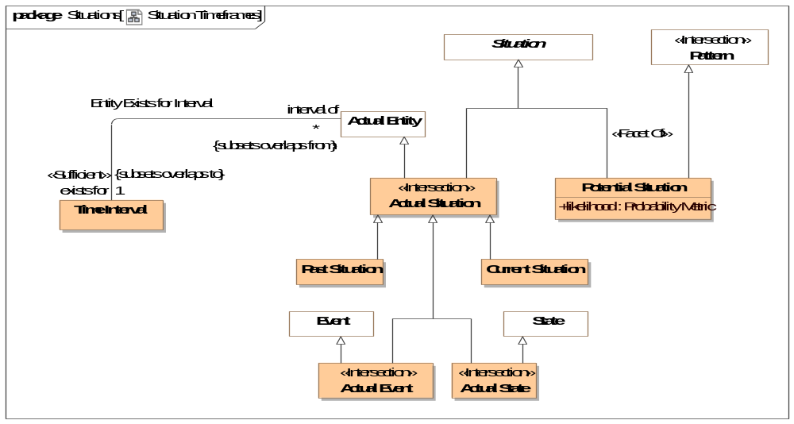
- Situation Timeframes

Diagram: Situations
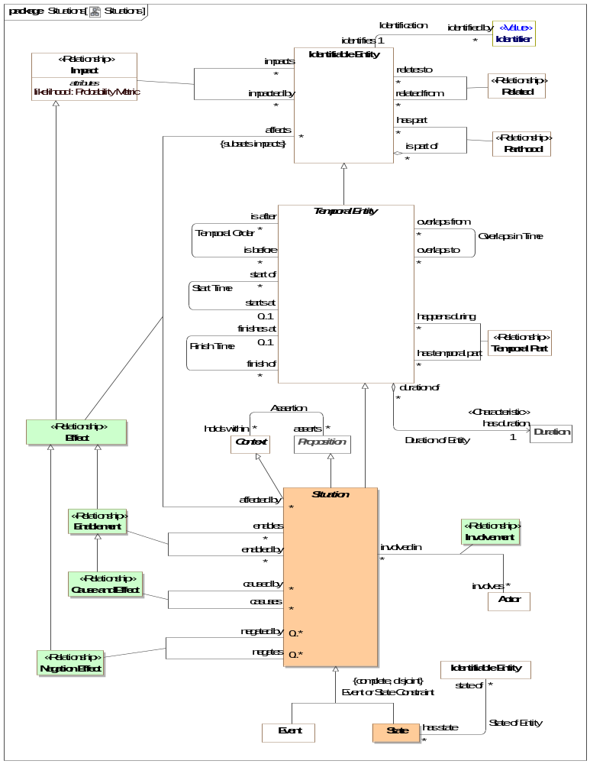
- Situations
This diagram shows the primary associations defined for situations as well as its super types: Temporal Entity and Identifiable Entity. The relationships shown here are those deemed defining for the concept of a situation, they are not all the relationships defined for these types.

Class Actual State <<Intersection>>
A condition that has, will or does exist.
Direct Supertypes
Actual Situation, State

Association Class Cause and Effect <<Relationship>>
The causality relation where the <causes> situation is <caused by> a situation.
[FIBO] cause / caused by
[ISO 1087] causal relation: associative relation (3.2.23) involving cause and its effect
NOTE A causal relation exists between the concepts (3.2.1) 'action' and 'reaction', 'nuclear explosion' and 'fall-out'.
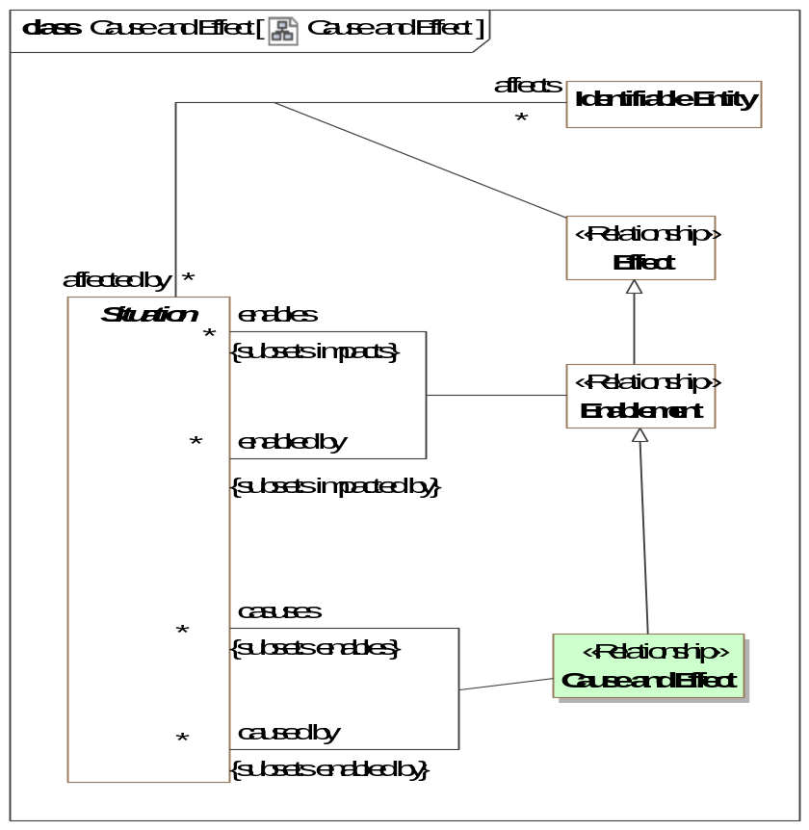
- Cause and Effect
Direct Supertypes
Enablement
Association Ends
caused by : Situation [*] Subsets: caused by:Situation
One of situations that causes the subject situation.
casuses : Situation [*] Subsets: caused by:Situation
A situation caused by another.

Class Current Situation
A situation that is actually occurring at the moment. "the moment" is contextual and interpreted within the context of the model.
Direct Supertypes
Actual Situation, Situation

Association Class Effect <<Relationship>>
Any impact on or alteration of an entity by a situation - an effect of the situation.
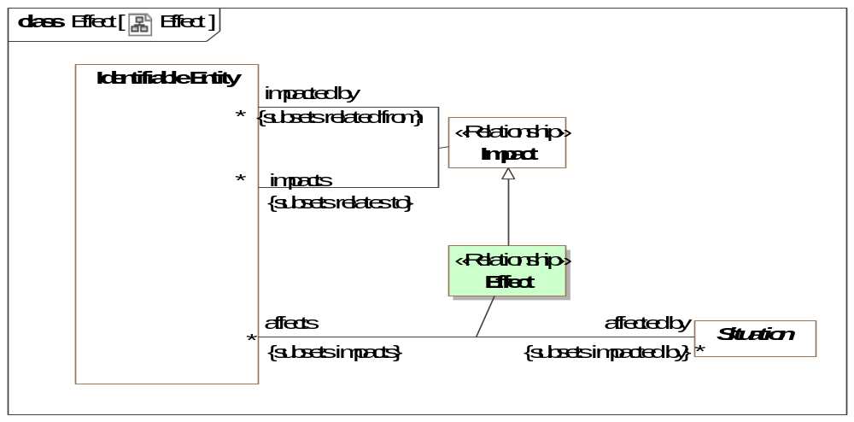
- Effect
Direct Supertypes
Impact
Association Ends
affects : Identifiable Entity [*] Subsets: caused by:Situation
Entities affected by a action
affected by : Situation [*] Subsets: caused by:Situation
Actions that can cause some change in a related entity.

Association Class Enablement <<Relationship>>
A situation that enables (is a condition for), another.
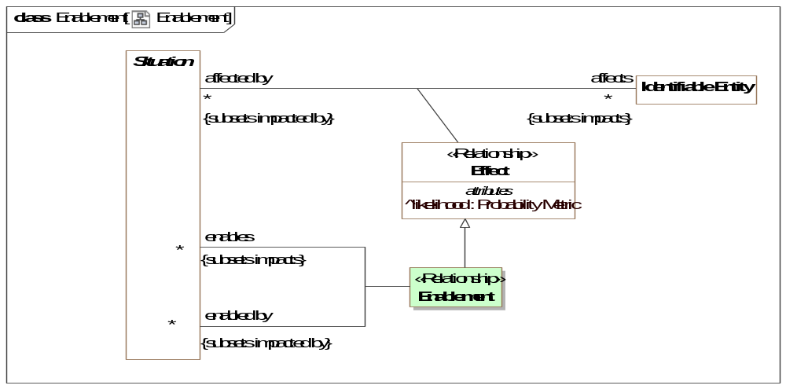
- Enablement
Direct Supertypes
Effect, Impact
Association Ends
enables : Situation [*] Subsets: caused by:Situation
A situation that is enabled by another.
enabled by : Situation [*] Subsets: caused by:Situation
A situation that enables another.

Association Class Involvement <<Relationship>>
The relationship between an actor and situations they are involved in.
[DOLCE] Participation
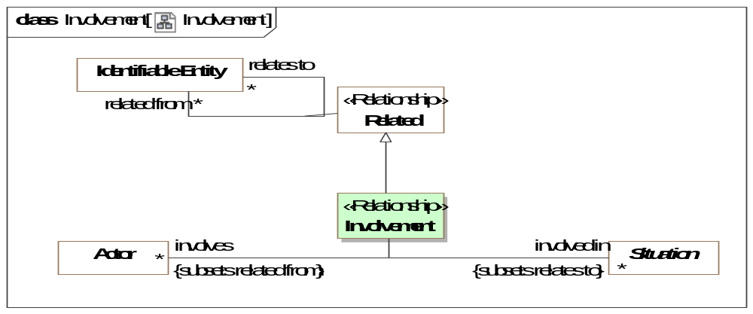
- Involvement
Direct Supertypes
Related
Association Ends
involved in : Situation [*] Subsets: caused by:Situation
Situations in which an actor has any kind of involvement.
involves : Actor [*] Subsets: caused by:Situation
An actor involved in a situation in any way.

Association Class Negation Effect <<Relationship>>
The negative causality relationship - <negated by> prevents or terminates the <negates> situation.
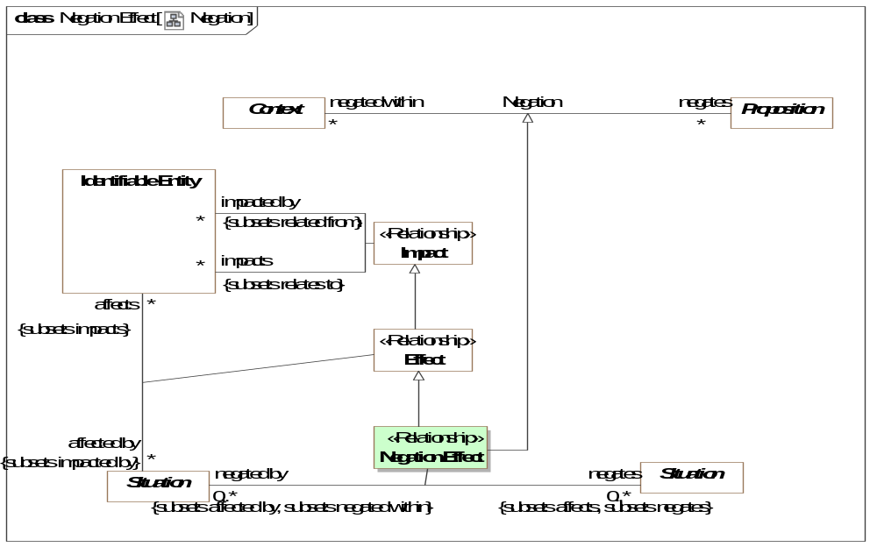
- Negation
Direct Supertypes
Effect, Negation
Association Ends
negated by : Situation [0..*] Subsets: caused by:Situation
A situation that prevents or terminates another.
negates : Situation [0..*] Subsets: caused by:Situation
A situation that is prevented or terminated by another situation.

Class Past Situation
A situation that has actually occurred in the past (recognizing that all such statements are subject to confidence).
Direct Supertypes
Actual Situation, Situation

Class Potential Situation
A situation that has not yet happened but has a potential to happen.
DTV: Situation Kind
Direct Supertypes
Pattern, Situation
Attributes
likelihood : Probability Metric
Metric representing the possibility that the containing element represents reality.

Association Class Scope of Indicator <<Relationship>>
Relationship defining the scope of an indicators validity, the indicator is only valid within this context.
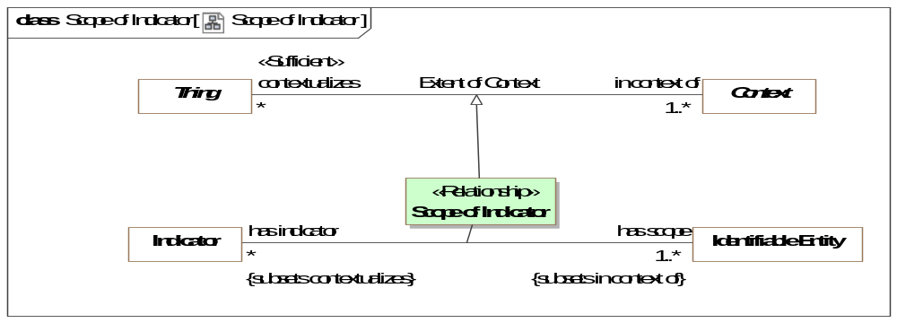
- Scope of Indicator
Direct Supertypes
Extent of Context
Association Ends
has indicator : Indicator [*] Subsets: caused by:Situation
Indicators that influence the evaluation of the state of an entity.
has scope : Identifiable Entity [1..*] Subsets: caused by:Situation
An entity that defines a context for where an indicator is valid.

Class State
A state is a static situation - a particular configuration of entities that is static for a time period, including spatial and logical connections between those things {Snapshot of a Perdurant}
Note that states may be of any length, from an instant to infinity and beyond.
[DOLCE] State
Direct Supertypes
Situation

Association State of Entity
Relationship between a perdurant (something that exits over time) and a "state" of that entity as a snapshot in time.
Association Ends
state of : Identifiable Entity [*] Subsets: caused by:Situation
The endurant entity for which the subject state is a snapshot.
has state : State [*] Subsets: caused by:Situation
A states (or snapshots) of an entity within its lifetime.

Threat-risk-conceptual-model::Generic Concept Library::Social Agents
Actor relationships augment the concept of an actor with concepts of identifiers and associations between actors, including organization membership. See also the base actor class.

Diagram: Social Agent
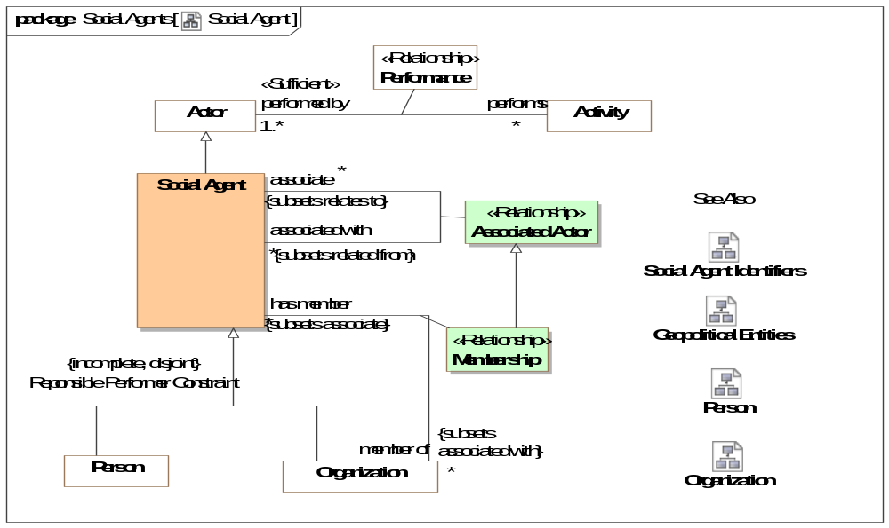
- Social Agent
Actor associations define the concept of an organization and provide a general framework for associations between actors with the use of an Actor Association.

Diagram: Social Agent Identifiers
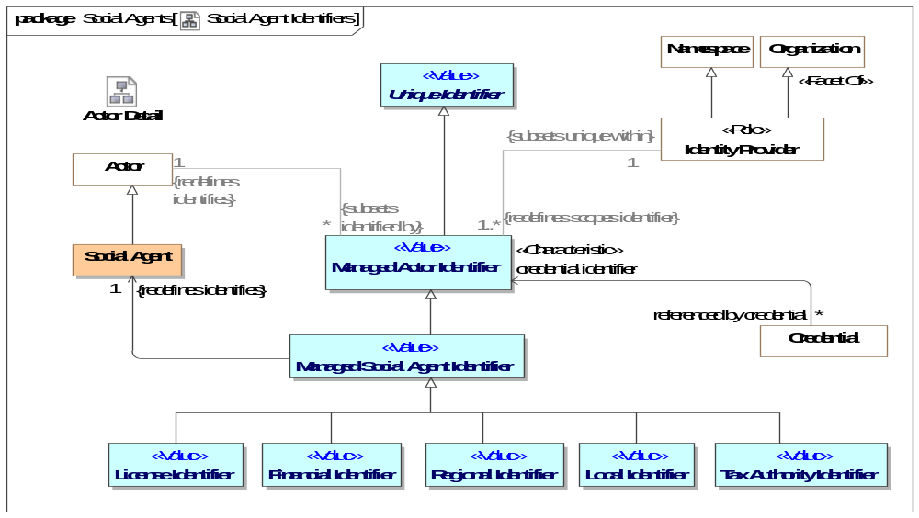
- Social Agent Identifiers

Association Class Assertion <<Relationship>>
The act of making a claim that something is true.
Direct Supertypes
Actual Event, Related
Association Ends
asserts : Situation [0..*] Subsets: caused by:Situation
A situation asserted to be true by a social agent.
asserted by : Social Agent [0..*] Subsets: caused by:Situation
A social agent claiming the truth of a situation.

Association Class Associated Actor <<Relationship>>
An associated actor relationship defines a connection between an actor and some other actor they are associated with in some way. Subtypes of actor association provide additional semantics about the association. As an association class, Actor Associations may have properties and other relationships. Actor associations will typicaly have a timeframe.
[NIEM] PersonOrganizationAssociationType (More specific concept)
[NIEM] PersonPersonAssociationType (More specific concept)
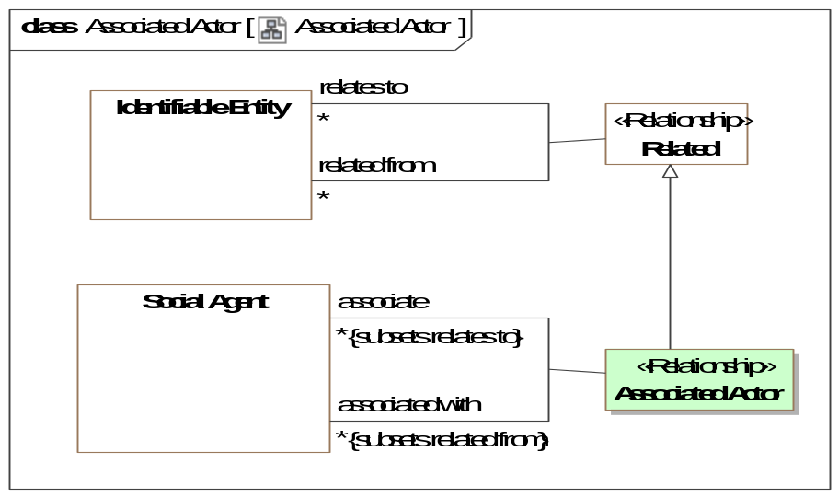
- Associated Actor
Direct Supertypes
Related
Association Ends
associate : Social Agent [*] Subsets: caused by:Situation
The actor associated with another.
associated with : Social Agent [*] Subsets: caused by:Situation
Another actor the subject actor is associated with.

Class License Identifier <<Value>>
[NIEM] An identification that references a license certification or registration of a person or organization for some purpose.
Direct Supertypes
Managed Social Agent Identifier

Class Local Identifier <<Value>>
An identification assigned at a local level (within an organization or community) to a person or organization.
Direct Supertypes
Managed Social Agent Identifier

Class Managed Social Agent Identifier <<Value>>
An identifier for a social agent where the identifier is managed by some authority.
Direct Supertypes
Managed Actor Identifier

Class Regional Identifier <<Value>>
[NIEM] An identification of a person based on a regional ID.
Direct Supertypes
Managed Social Agent Identifier

Class Social Agent
An actor that may have responsibilities - people and organizations. Actors in general may include automated entities and even, in some context, animals. Social agent excludes these other kinds of actors by including (at this time) only people and organizations.
What responsibilities a particular person or organization may have at any particular time is the subject of law and social constructs. A social agent is distinguished in that a person or organization may have such responsibilities in their lifetime.
[NIEM] EntityType
[DOLCE] Social Agent
Direct Supertypes
Actor
Associations
asserts : Situation [0..*] Subsets: relates to:Identifiable Entity
through association: Assertion
A situation asserted to be true by a social agent.
makes accusaton : Perpetrate [0..*] Subsets: asserts:Situation
through association: Accusation
An assertion by a social agent (person or organization) that a threat actor perpetrated some disruptive action.

Class Tax Authority Identifier <<Value>>
An identifier assigned to a person or organization by a tax authority.
Direct Supertypes
Managed Social Agent Identifier

Threat-risk-conceptual-model::Generic Concept Library::Systems
A system is a collection of parts and relationships among these parts that may be organized to accomplish some purpose.
The term ‘system’ can refer to an information processing system but it is also applied more generally. Thus a system may include anything: a system of hardware, software, an enterprise, a federation of enterprises, a business process, some combination of parts of different systems, a federation of systems - each under separate control, a program in a computer, a system of programs, a single computer, a system of computers, a computer or system of computers embedded in some machine, etc.
One of the key strengths of modeling, and one that distinguishes it from implementation technologies like software source code, is that it is an excellent way to represent, understand, and specify systems. [OMG MDA Guide]

Diagram: System
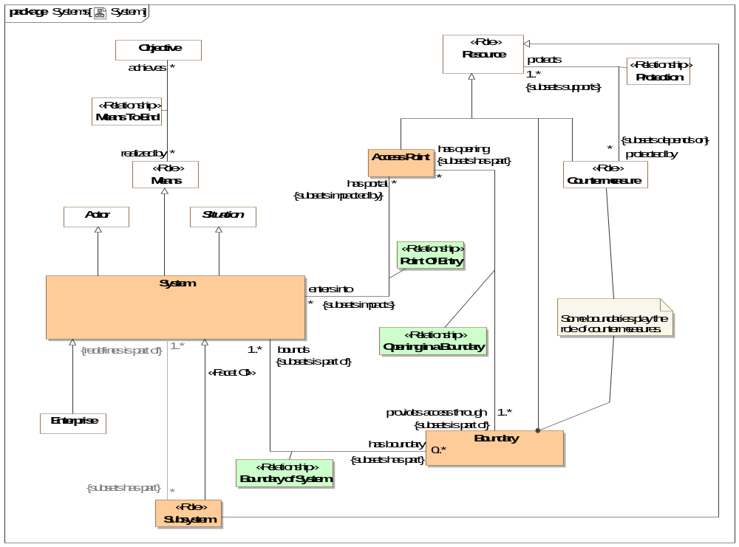
- System

Class Access Point
A point of entry into or out of a system such as a door, gate, port, or "interface" into an information system.
Direct Supertypes
Resource

Class Boundary
Something on the edge of a system that serves to contain or protect components of that system.
Some boundaries protect resources of the system/enterprise and may also be countermeasures.
e.g., Fences, firewalls, skin.
Direct Supertypes
Resource

Association Class Boundary of System <<Relationship>>
An "edge" of a system affording some level of protection or containment for the system.
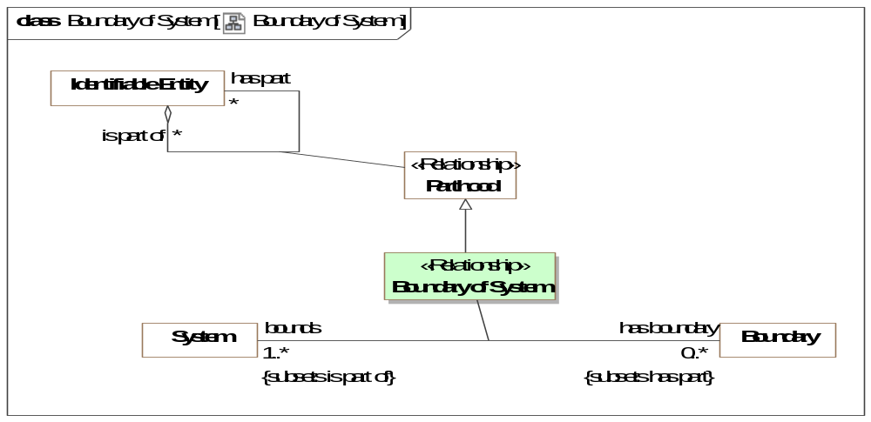
- Boundary of System
Direct Supertypes
Parthood
Association Ends
has boundary : Boundary [0..*] Subsets: asserts:Situation
Logical or physical border of a system (or enterprise) that may serve to define, contain or protect the system.
bounds : System [1..*] Subsets: asserts:Situation
System for which a boundary is an edge.

Association Class Opening in a Boundary <<Relationship>>
An access point that provides an opening for passage through a boundary. An opening has the potential to cause a point of entry and a vulnerability.
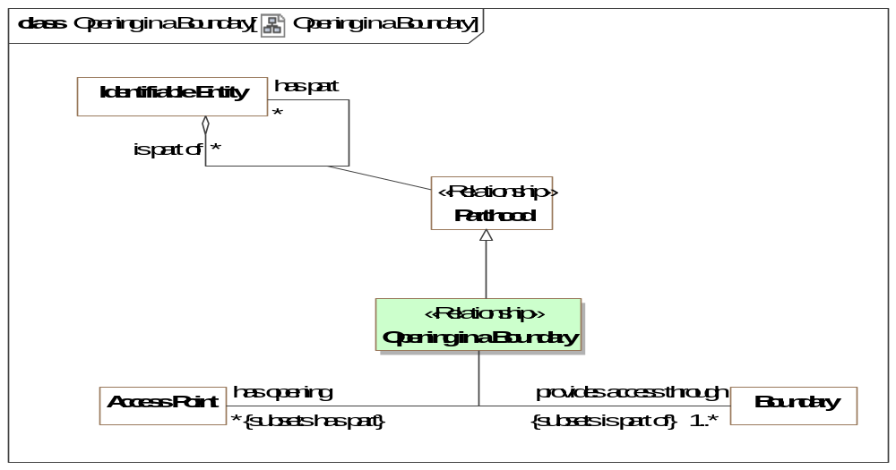
- Opening in a Boundary
Direct Supertypes
Parthood
Association Ends
provides access through : Boundary [1..*] Subsets: asserts:Situation
Boundary through which an entry point provides access. e.g., the wall a door goes through.
has opening : Access Point [*] Subsets: asserts:Situation
A physical or virtual place where access to a system may be provided through a boundary.

Association Class Point Of Entry <<Relationship>>
Relationship between a system and a usable entry point into or out of that system. A point of entry has the potential to cause a vulnerability.
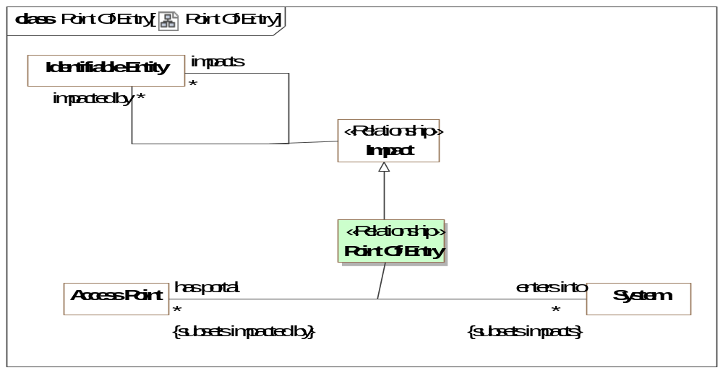
- Point Of Entry
Direct Supertypes
Impact
Association Ends
enters into : System [*] Subsets: asserts:Situation
System into which an entry point provides access. E.G. A room a door enters into.
has portal : Access Point [*] Subsets: asserts:Situation
A point of possible entry into a system.

Class Subsystem <<Role>>
A role of a system as a part of another system as a resource to the owning system.
Direct Supertypes
Resource, System

Class System
[OMG MDA Guide] A system is a collection of parts and relationships among these parts that may be organized to accomplish some purpose.
[UAF] An integrated set of elements, subsystems, or assemblies that accomplish a defined objective. These elements include products (hardware, software, firmware), processes, people, information, techniques, facilities, services, and other support elements .
A system is a situation in that it has constituent parts working together for a finite period.
A system is a means in that it may achieve objectives for stakeholders.
Direct Supertypes
Actor, Means, Situation

Threat-risk-conceptual-model::Generic Concept Library::Time & Temporal Entities
The Time package defines the essential concepts of time and the identification of time intervals.
These time concepts are based on the OMG Date Time Vocabulary [DTV] standard but subsets and simplifies DTV for use in defining, federating and exchanging time aspects of entities.
"Temporal Entity" is introduced as an abstraction to capture the common relationships between time elements. Within DTV these relationships are separate for each kind of time element. The relationships defined for Temporal Entity are grounded in DTV Time Interval as each temporal entity exists for a time interval.
Applications that need to reason about time are encouraged to utilize the full DTV semantics. DTV also contains text that more fully elaborates time concepts.

Diagram: Time
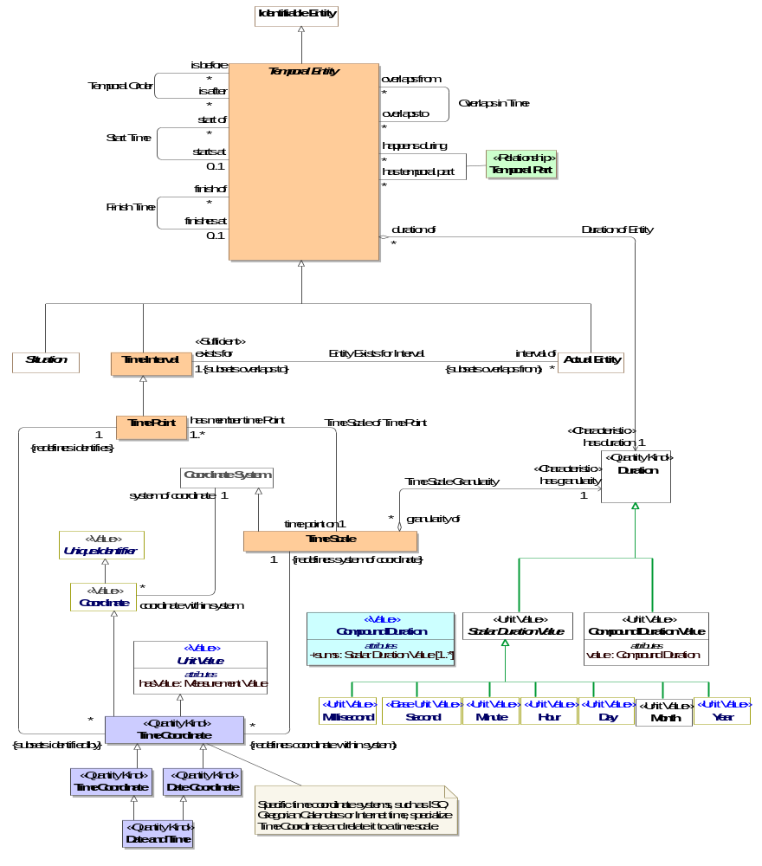
- Time

Class Date and Time <<Quantity Kind>>
[FIBO] DateTimeStamp: A DateTimeStamp combines a Date, a time, and a time
Direct Supertypes
Date Coordinate, Time Coordinate

Class Date Coordinate <<Quantity Kind>>
[FIBO] Date: A Date identifies a calendar day on some calendar.
[NIEM] DateType
Direct Supertypes
Time Coordinate

Association Duration of Entity
[DTV] time interval [of temporal entity] has particular duration:the particular duration is the duration that is the amount of time in the time interval.
Each time interval [Temporal Entity] has a unique duration attribute that is a measure of its size, i.e., the amount of time the time interval occupies. This attribute is mathematically a function that maps time intervals into durations. This mapping function is sometimes called the “range” of a time interval, and some times called the “measure” of a time interval.
Association Ends
duration of : Temporal Entity [*] Subsets: asserts:Situation
Temporal entity for which a duration is applicable.
has duration : Duration [1] Subsets: asserts:Situation
Difference between the start and end time. A non-zero positive value representing the amount of time a temporal entity exists.
[DTV] time interval [of temporal entity] has particular duration:the particular duration is the duration that is the amount of time in the time interval.
Each time interval [Temporal Entity] has a unique duration attribute that is a measure of its size, i.e., the amount of time the time interval occupies. This attribute is mathematically a function that maps time intervals into durations. This mapping function is sometimes called the “range” of a time interval, and some times called the “measure” of a time interval.

Association Entity Exists for Interval
Relationship defining the time interval in which an entity actually exists.
[DTV] occurrence occurs for occurrence interval: the occurrence occurs throughout the occurrence interval and the occurrence does not occur within some time interval2 that meets the occurrence interval and the occurrence does not occur within some time interval3 that is met by the
occurrence interval
[Alen 1983] X is equal to Y: X = Y where X is "interval of" and Y is "exists for". Note that this relates the temporal aspect of "interval of" to the timeframe "exists for".
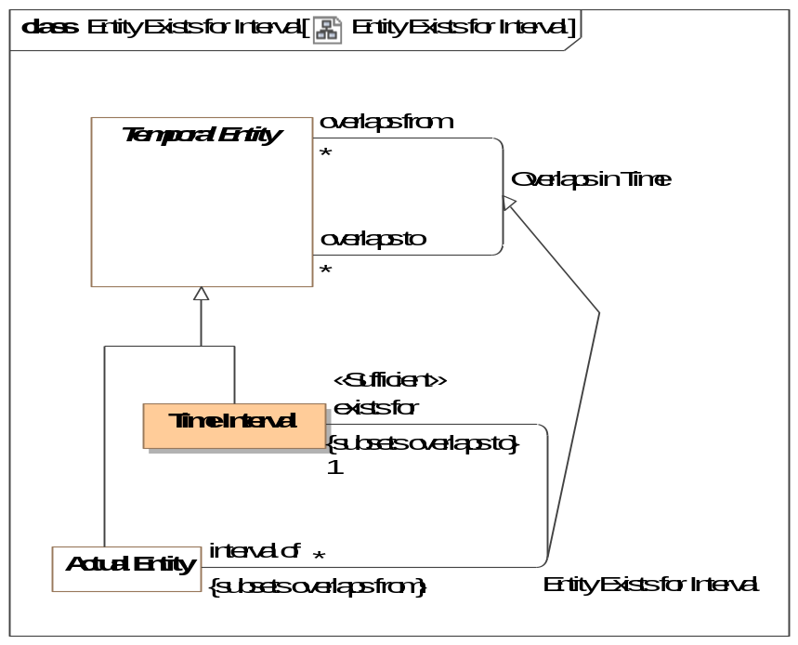
- Entity Exists for Interval
Direct Supertypes
Overlaps in Time
Association Ends
exists for : Time Interval [1] Subsets: asserts:Situation
Time interval where an entity may be considered "actual", that is existent in the domain of discourse.
interval of : Actual Entity [*] Subsets: asserts:Situation
Entity existent for the full extent of a time interval.

Association Finish Time
The time something no longer exists (inclusive).
[DTV] time interval1 finishes time interval2
Synonymous Form:time interval2 is finished by time interval1
Definition:time interval1 is a proper part of time interval2 and there exists no time interval3 that is a proper part of time interval2 and that is after time interval1
[IDEAS] endBoundary: A temporalBoundary where the boundary is a end boundary of the whole.
[Alen 1983] X finishes Y: X f Y where X is "finishes at" and Y is "finish of"
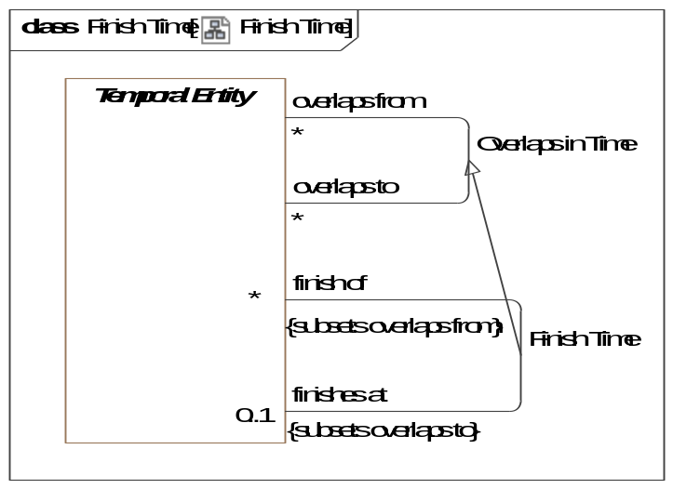
- Finish Time
Direct Supertypes
Overlaps in Time
Association Ends
finish of : Temporal Entity [*] Subsets: asserts:Situation
Thing which no longer exists at a particular time.
finishes at : Temporal Entity [0..1] Subsets: asserts:Situation
Time something no longer exists. (Inclusive)

Association Overlaps in Time
Some or all parts of the related temporal entities exist at the same time. Note that "to" and "from" may be arbitrary. By convention, the containing or prior temporal entity is "from".
[DTV] time interval1 properly overlaps time interval2
An [ISO 1087] temporal relation: sequential relation (3.2.24) involving events in time
[DOLCE] (subtype of) Temporal Quality
[Alen] X overlaps with Y: X o Y, where assignment of X and Y is arbitrary.
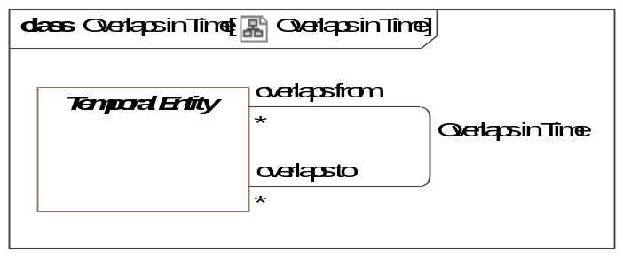
- Overlaps in Time
Association Ends
overlaps from : Temporal Entity [*] Subsets: asserts:Situation
An overlapping temporal component.
overlaps to : Temporal Entity [*] Subsets: asserts:Situation
An overlapping temporal component.

Association Start Time
The time something starts to exist (inclusive).
[DTV] time interval1 starts time interval2
Synonymous Form:time interval2 is started by time interval1
Definition:time interval1 is a proper part of time interval2 and there exists no time interval3 that is a proper part of time interval2 and that is before time interval1.
[IDEAS] startBoundary: A temporalBoundary where the boundary is a start boundary of the whole.
[Alen 1983] X starts Y: X s Y where X is "starts at" and Y is "start of".
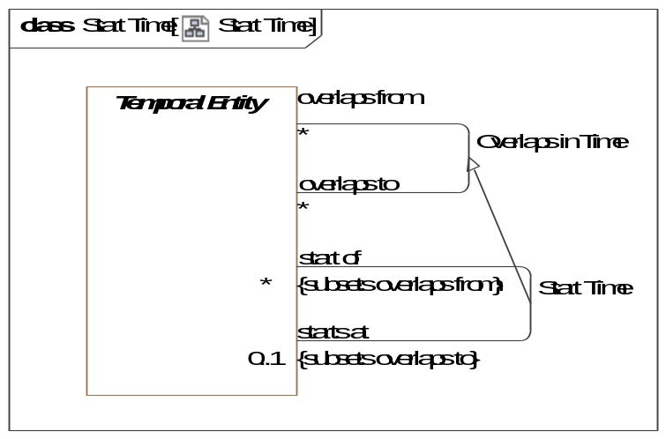
- Start Time
Direct Supertypes
Overlaps in Time
Association Ends
start of : Temporal Entity [*] Subsets: asserts:Situation
Thing which begins to exist at a particular time.
starts at : Temporal Entity [0..1] Subsets: asserts:Situation
Time somethings begins to exist. (inclusive).
[FIBO] hasStartDate

Association Temporal Order
A relationship representing ordering of temporal entities in time where the <starts at> of <is after> is greater than or equal to the <finishes at> of <is before>. Related things do not overlap in time.
[DOLCE] (subtype of) Temporal Quality
[DTV] "time interval1 is properly before time interval2": the time interval1 is before the time interval2 and the time interval1 is before a time interval3 and the time interval3 is before the time interval2
[DTV] time interval1 finishes duration after time interval2: The end of one time interval is duration after the end of the other time interval.
[IDEAS] beforeAfter: A couple that asserts one individuals' temporal extent is completely before the temporal extent of another.
An [ISO 1087] temporal relation: sequential relation (3.2.24) involving events in time
[Alen1983] X takes place before Y: X<Y where X is "is before" and Y is "is after".
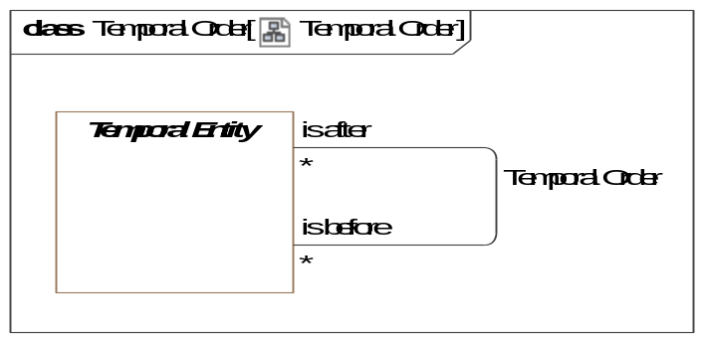
- Temporal Order
Association Ends
is after : Temporal Entity [*] Subsets: asserts:Situation
A temporal entity that starts after the <is before> entity ends.
is before : Temporal Entity [*] Subsets: asserts:Situation
A temporal entity that ends after the <is after> entity starts.

Association Class Temporal Part <<Relationship>>
The time interval of <has temporal part> is within the time interval of <happens durring>.
[DTV] time interval1 is proper part of time interval2: the time interval1 is a proper part of the time interval2 and a time interval3 is a proper part of the time interval2 and a time interval4 is a proper part of the time interval2 and the time interval3 is before the time interval1 and the time interval1 is before the time interval4.
[IDAS] temporalWholePart: A wholePart that asserts the spatial extent of the (whole) individual is co-extensive with the spatial extent of the (part) individual for a particular period of time.
[Alen 1983] X during Y: Xd Y where X is "happens during" and Y is "has temporal part"
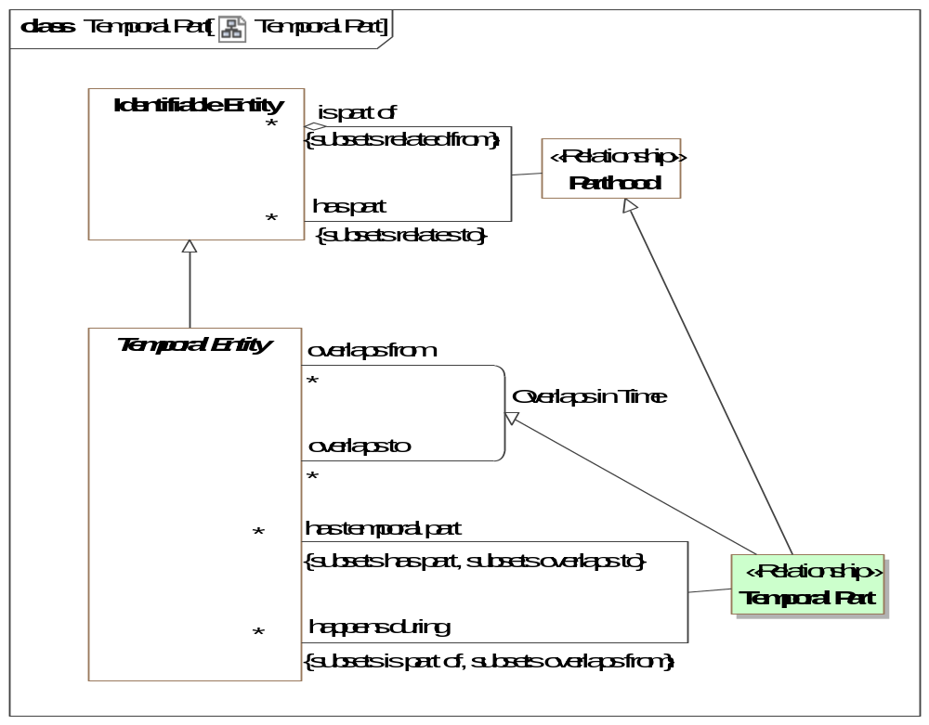
- Temporal Part
Direct Supertypes
Overlaps in Time, Parthood
Association Ends
happens during : Temporal Entity [*] Subsets: asserts:Situation
A situation with overlapping duration (overlapping temporal extent).
has temporal part : Temporal Entity [*] Subsets: asserts:Situation
Sub-durations of anything that happen - a temporal part.

Class Time Coordinate <<Quantity Kind>>
A designation of a particular time.
Direct Supertypes
Time Coordinate

Class Time Interval
A segment of time.
[DTV] "time interval" : segment of the time axis, a location in time.
Note:Every time interval has a beginning, an end, and a duration, even if not known. Every time interval is “finite”, a bounded segment of the Time Axis. The beginning or end of a
time interval may be defined by reference to events that occur for a time interval that is not known.
Note:Time intervals may be ‘indefinite’, meaning that their beginning is ‘primordiality’ or their end is ‘perpetuity’, or both (‘eternity’). This vocabulary assumes that indefinite
time intervals exist and have some duration, but their duration is unknown.
[IDEAS] PeriodOrInstant: An Individual whose spatial extent is infinite, but whose temporal extent is finite or zero.
[UML] TimeInterval
[NIEM] DateRangeType
[DOLCE] Temporal Region
Direct Supertypes
Temporal Entity

Class Time Point
A portion of time deemed atomic on a time scale. As all points in time may be further subdivided into a finer granularity of time, each point in time is also a time interval on some other scale.
The duration of a time point is the same as the granularity of the time scale of the time point.
[DTV] time point: concept that specializes the concept 'time interval' and that is a member of a time scale.
[IDEAS] CalendarPeriod: A Period that corresponds to a recognized date or time.
Direct Supertypes
Time Interval

Class Time Scale
A time scale is a way to reckon time as a series of consecutive time points identified by time coordinates. e.g. Time scale defined by the Gregorian calendar.
[DTV] time scale: regular sequence that each member of the regular sequence is a time point
Direct Supertypes
Coordinate System

Association Time Scale Granularity
[DTV] Time scale has granularity: The granularity of the time scale is the duration of the time points of the time scale.
Association Ends
has granularity : Duration [1] Subsets: asserts:Situation
[DTV] the smallest duration that can be distinguished with a given time scale
granularity of : Time Scale [*] Subsets: asserts:Situation
Duration of each time point on a time scale.

Association Time Scale of Time Point
Relationship defining the time scale on which a time point is defined. e.g. December 7th, 1944 is defined on a Gregorian Calendar time scale.
Association Ends
time point on : Time Scale [1] Subsets: asserts:Situation
Time scale used for defining a time point.
[DTV] time scale has time point:
has member time Point : Time Point [1..*] Subsets: asserts:Situation
Time point defined within a time scale

Threat-risk-conceptual-model::Generic Concept Library::Time & Temporal Entities::ISO Time Scale

Diagram: ISO Time
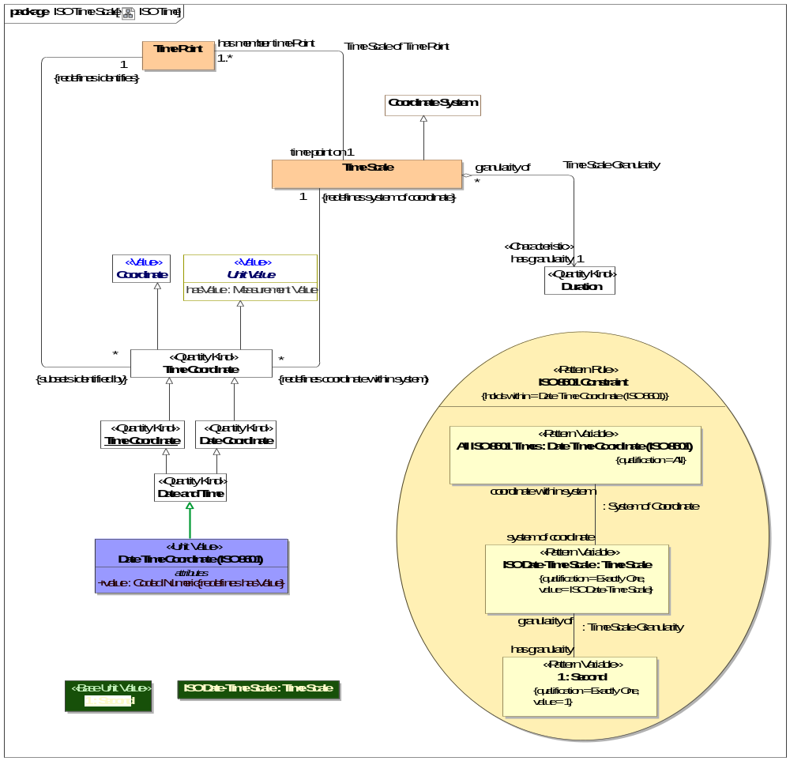
- ISO Time

Class Date Time Coordinate (ISO 8601) <<Unit Value>>
[UAF] A date and time specified in the ISO8601 date-time format including timezone designator (TZD): YYYY-MM-DDThh:mm:ssTZD.
Direct Supertypes
Date and Time
Attributes
value : Coded Numeric
A text string representing a date and time specified in the ISO8601 date-time format including timezone designator (TZD): YYYY-MM-DDThh:mm:ssTZD.

Threat-risk-conceptual-model::Generic Concept Library::Time & Temporal Entities::XSD Time Scale
XSD Representations of date and time

Diagram: XSD Time Scale
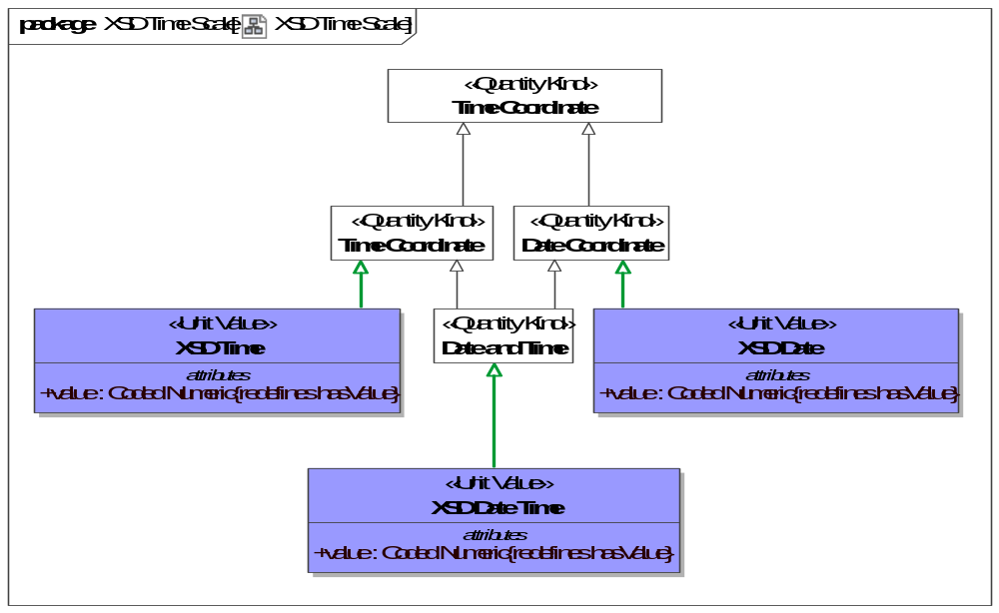
- XSD Time Scale

Class XSD Date <<Unit Value>>
An XSD representation of a date
[OWL] xsd:date.
Direct Supertypes
Date Coordinate
Attributes
value : Coded Numeric
A text string representing a date and time specified in the ISO8601 date-time format including timezone designator (TZD): YYYY-MM-DDThh:mm:ssTZD.

Class XSD Date Time <<Unit Value>>
An XSD representation of a date and time
[OWL] xsd:dateTime
Direct Supertypes
Date and Time
Attributes
value : Coded Numeric
A text string representing a date and time specified in the ISO8601 date-time format including timezone designator (TZD): YYYY-MM-DDThh:mm:ssTZD.

Class XSD Time <<Unit Value>>
An XSD representation of a time
[OWL] xsd:time
Direct Supertypes
Time Coordinate
Attributes
value : Coded Numeric
A text string representing a date and time specified in the ISO8601 date-time format including timezone designator (TZD): YYYY-MM-DDThh:mm:ssTZD.

Threat-risk-conceptual-model::Generic Concept Library::Vendors and Producers
Concepts relating to manufacturers and manufactured things.

Diagram: Vendors and Producers
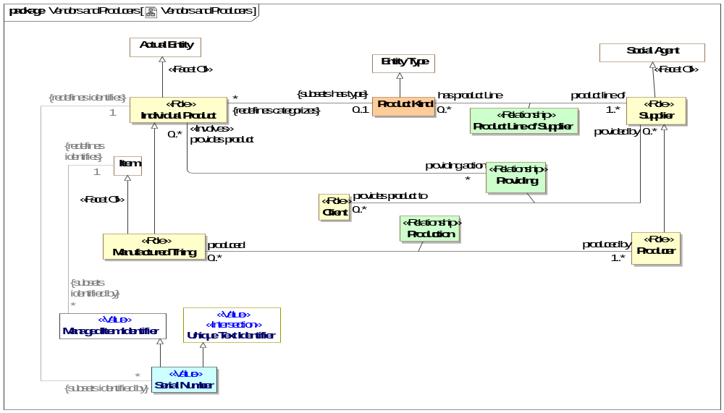
- Vendors and Producers

Class Client <<Role>>
The role of a responsible performer receiving goods or services from a provider.
[FIBO] Client: a party that acquires, or agrees to acquire, ownership (in case of goods), or benefit or usage (in case of services), in exchange for money or other consideration under a contract of sale
Associations
provided by : Supplier [0..*] Subsets: impacted by:Identifiable Entity
through association: Providing
Supplier of a product or service.
[FIBO] isSuppliedBy

Class Individual Product <<Role>>
A specific item or service purchased, sold or offered for sale.
[FIBO] Product: A commercially distributed good that is (1) tangible property, (2) the output or result of a fabrication, manufacturing, or production process, or (3) something that passes through a distribution channel before being consumed or used.
Direct Supertypes
Actual Entity

Class Manufactured Thing <<Role>>
Role of a thing as being made or manufactured.
Direct Supertypes
Individual Product, Item
Attributes
revision : Primitive Value
The revision of a product or good.

Class Producer <<Role>>
Maker of goods or products, usually for sale. Syn: Manufacturer.
[FIBO] Producer: the manufacturer of a product, also called maker.
Direct Supertypes
Supplier

Class Product Kind
A set of similar items or services produced by or delivered by suppliers.
Direct Supertypes
Entity Type

Association Class Product Line of Supplier <<Relationship>>
A kind of product or service offered by a supplier.
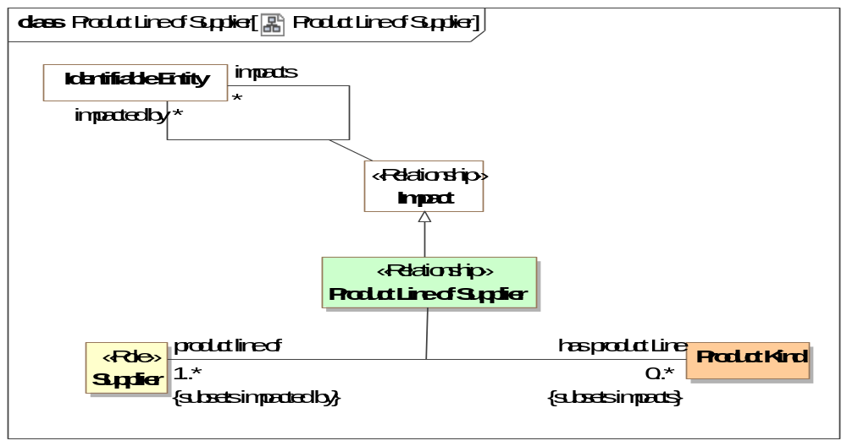
- Product Line of Supplier
Direct Supertypes
Impact
Association Ends
has product Line : Product Kind [0..*] Subsets: impacted by:Identifiable Entity
Product line provided by a manufacturer.
product line of : Supplier [1..*] Subsets: impacted by:Identifiable Entity
Manufacturer of a product line

Association Class Production <<Relationship>>
The making of a <produced> thing <produced by> a producer.
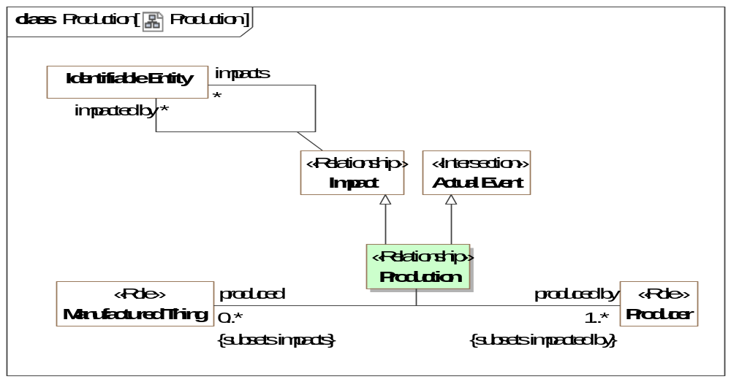
- Production
Direct Supertypes
Actual Event, Impact
Association Ends
produced by : Producer [1..*] Subsets: impacted by:Identifiable Entity
Entity which manufactured or created an item.
produced : Manufactured Thing [0..*] Subsets: impacted by:Identifiable Entity
A products or good made by a manufacturer.

Association Class Providing <<Relationship>>
The providing of a product or service to a consumer.
[FIBO] supplies
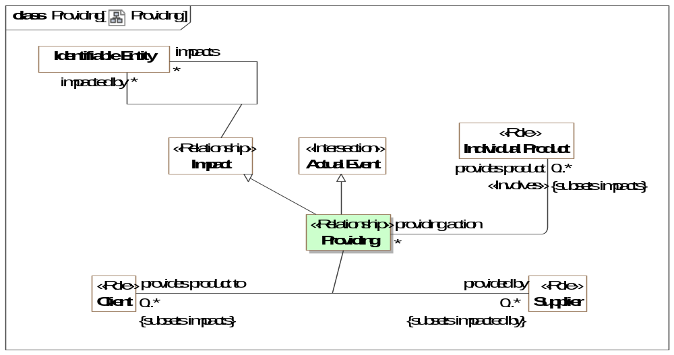
- Providing
Direct Supertypes
Actual Event, Impact
Association Ends
provided by : Supplier [0..*] Subsets: impacted by:Identifiable Entity
Supplier of a product or service.
[FIBO] isSuppliedBy
provides product to : Client [0..*] Subsets: impacted by:Identifiable Entity
Consumer who receives a product or service.
Associations
provides product : Individual Product [0..*] Subsets: impacts:Identifiable Entity
The products provided to <provides product to> by <provided by>.

Class Serial Number <<Value>>
An identifier of an item provided by its producer or supplier.
Direct Supertypes
Managed Item Identifier, Unique Text Identifier

Class Supplier <<Role>>
A person or organization that sells products or services.
[FIBO] a party that supplies goods or services
Direct Supertypes
Social Agent
Associations
has product Line : Product Kind [0..*] Subsets: impacts:Identifiable Entity
through association: Product Line of Supplier
Product line provided by a manufacturer.

Threat-risk-conceptual-model::Threat and Risk Specific Concepts
The risk and threat modules use and specialize more generic concepts to build the risk and threat information sharing and analytics framework.
All risks and threats involve an undesirable situation that is a real or possible situation with consequences that do harm and impact the objectives of stakeholders. The same situation may, of course, not be considered a risk or threat to other stakeholders - some may consider such a situation an objective.
This foundational information is then expanded with metrics and interrelationships such that threats and risks can be fully understood and dealt with.
Fundamental risk/threat specific concepts include:
- Danger
- Risk
- Incident
- Indicator
- Vulnerability
Note that these concepts use and build on more generic concepts that are not risk/threat specific such as "person", "organization", and "Intent".
All undesirable situations derived from the general concept of a "situation"; which is fundamental to this specification.

Diagram: Threat and Risk Specific Concepts
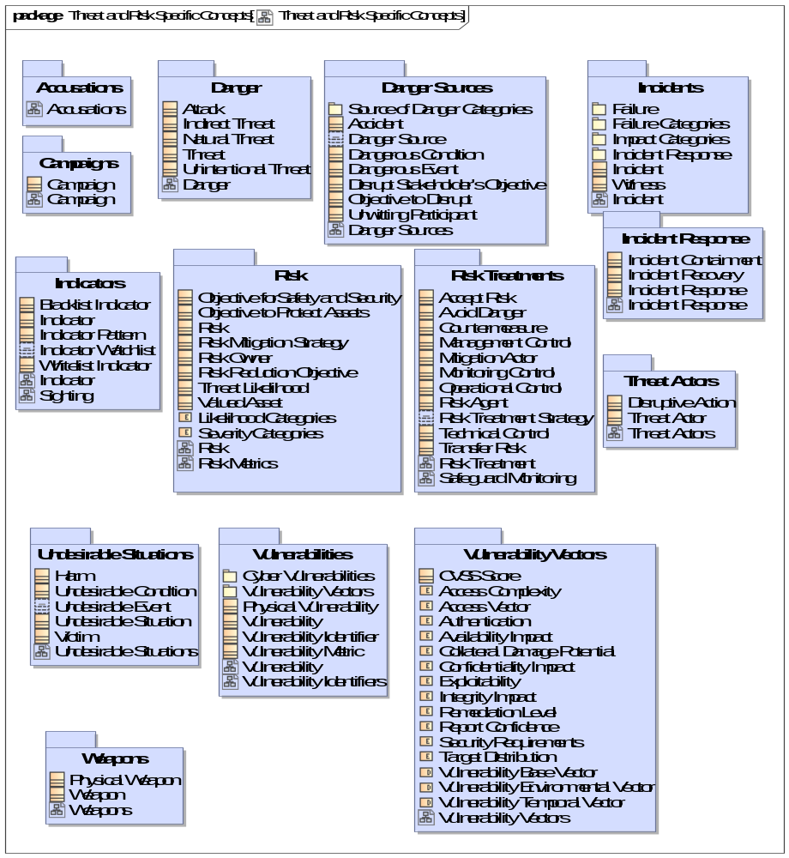
- Threat and Risk Specific Concepts

Threat-risk-conceptual-model::Threat and Risk Specific Concepts::.Summary Diagrams

Diagram: Entity Kinds
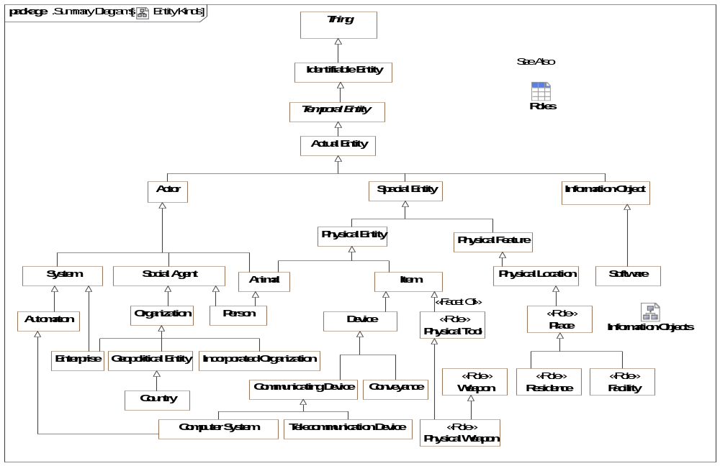
- Entity Kinds

Threat-risk-conceptual-model::Threat and Risk Specific Concepts::Accusations

Diagram: Accusations
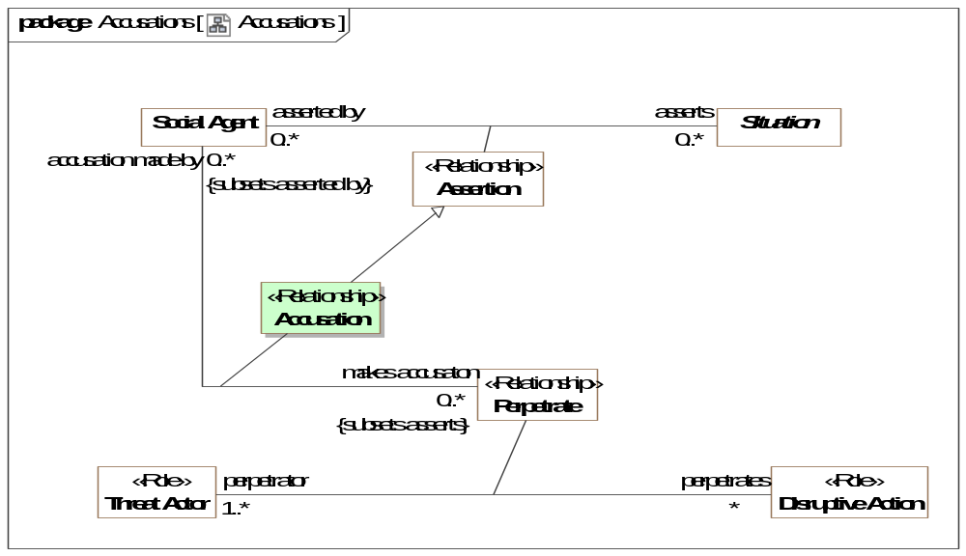
- Accusations

Association Class Accusation <<Relationship>>
An assertion that a perpetrator perpetrated a disruptive action.
Direct Supertypes
Assertion
Association Ends
makes accusaton : Perpetrate [0..*] Subsets: impacts:Identifiable Entity
An assertion by a social agent (person or organization) that a threat actor perpetrated some disruptive action.
accusation made by : Social Agent [0..*] Subsets: impacts:Identifiable Entity
Social agent asserting that a threat actor perpetrated a disruptive action.

Threat-risk-conceptual-model::Threat and Risk Specific Concepts::Campaigns
Campaigns are ongoing activities in an organized and active way realizing a particular objective of stakeholders.

Diagram: Campaign
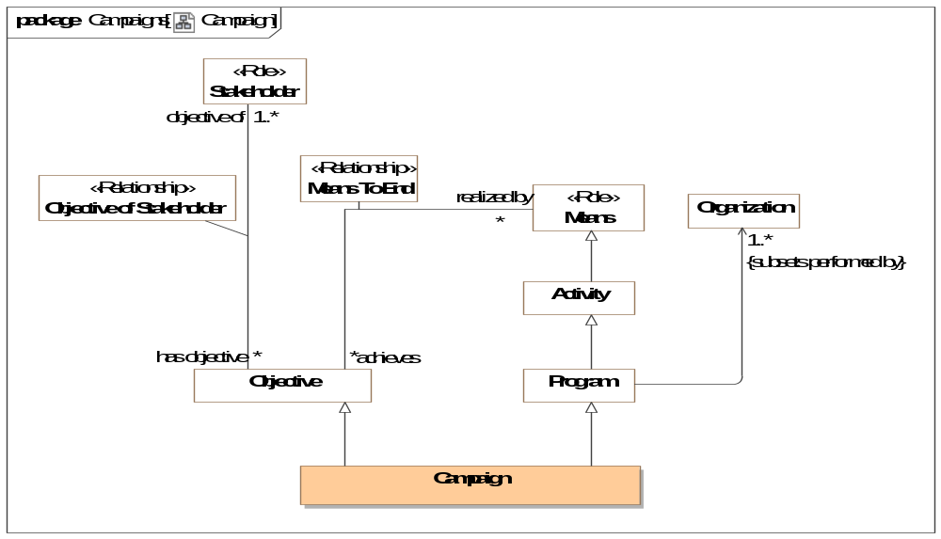
- Campaign

Class Campaign
Campaigns are ongoing work in an organized and active way toward a particular goal, typically a political, military, or social one. A campaign will typically have parts that are the specific activities of the campaign.
A Military campaign is a series of military operations intended to achieve a particular objective, confined to a particular area, or involving a specified type of fighting.
A campaign is also an objective for the activities supporting the campaign.
Direct Supertypes
Objective, Program

Threat-risk-conceptual-model::Threat and Risk Specific Concepts::Danger
Concepts relative to threats. A threat is a situation that increases the likelihood of one or more related incidents.

Diagram: Danger
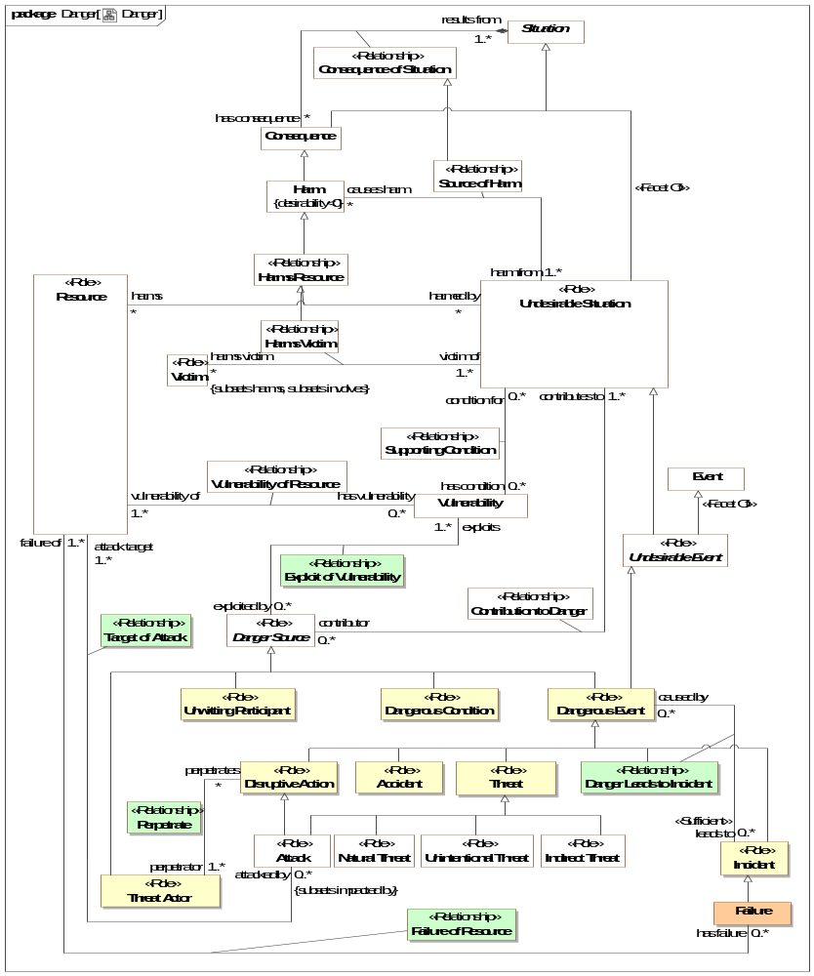
- Danger

Class Attack <<Role>>
A dangerous activity that makes use of and derives benefit from a vulnerability and damages resources.
Direct Supertypes
Activity Effecting Entity, Disruptive Action, Threat

Class Indirect Threat <<Role>>
A threat that does directly cause harm but may lead to other situations that will ultimately cause harm.
Direct Supertypes
Threat

Class Natural Threat <<Role>>
A threat from natural means.
Direct Supertypes
Threat

Association Class Target of Attack <<Relationship>>
Target of attack relates an attack to the resources attacked, the attack targets.
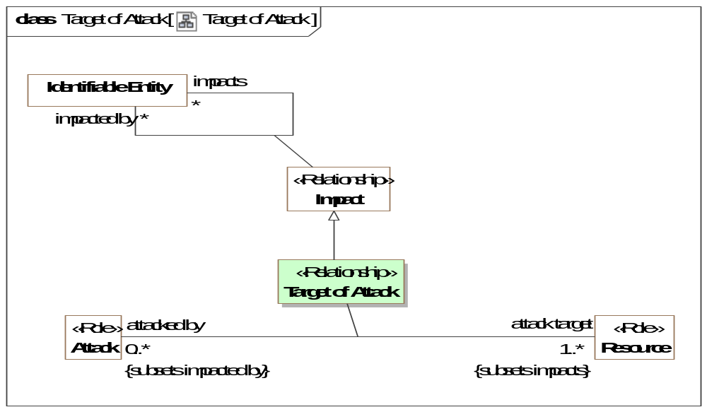
- Target of Attack
Direct Supertypes
Impact
Association Ends
attack target : Resource [1..*] Subsets: impacts:Identifiable Entity
A resource intended to be harmed by an attack.
attacked by : Attack [0..*] Subsets: impacts:Identifiable Entity
Attack on a resource.

Class Threat <<Role>>
A threat is role of a situation that may lead to one or more related incidents or failures.
The threat consists of the existence of zero or more threat actors together with a set of one or more vulnerabilities. Thus, the threat of theft may result in an actual theft (attack), and threats correspond to attacks that are typically classified by attacker motivation (e.g., theft) as opposed to technique (e.g., spoofing). In some books and articles, the different but highly related terms “attack” and “threat” are sometimes confounded by being used as synonyms [Firesmith 03, Tulloch 03].
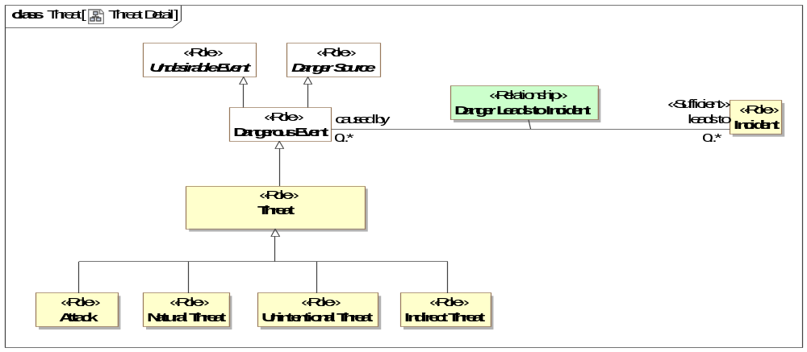
- Threat Detail
Direct Supertypes
Dangerous Event

Class Unintentional Threat <<Role>>
A threat that is natural or not intended to cause harm.
Direct Supertypes
Threat

Threat-risk-conceptual-model::Threat and Risk Specific Concepts::Danger Sources
A package categorizing source of dangers - natural, systematic, or intentional

Diagram: Danger Sources
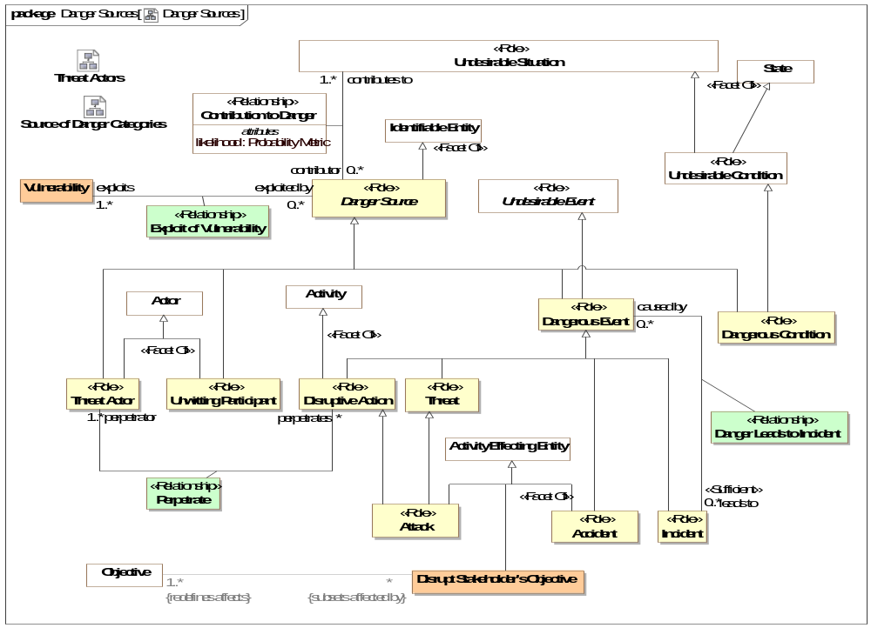
- Danger Sources

Class Accident <<Role>>
An unfortunate incident that happens unexpectedly and unintentionally, typically resulting in damage or injury. e.g. a child falling into an open well in a playground.
Direct Supertypes
Activity Effecting Entity, Dangerous Event

Association Class Contribution to Danger <<Relationship>>
A relationship defining the undesirable situations a danger source contributes to.
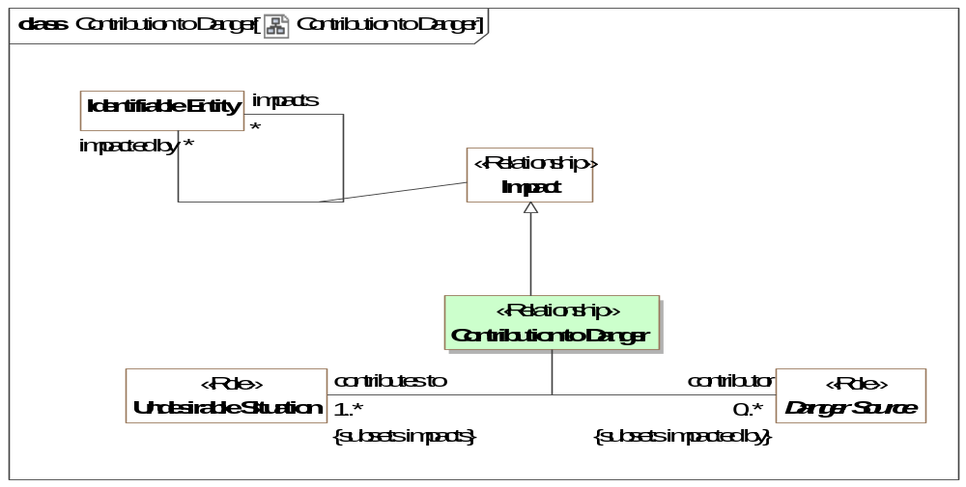
- Contribution to Danger
Direct Supertypes
Impact
Association Ends
contributor : Danger Source [0..*] Subsets: impacts:Identifiable Entity
A danger source that can contribute to the possibility of an undesirable situation occurring.
contributes to : Undesirable Situation [1..*] Subsets: impacts:Identifiable Entity
Undesirable situation that is enabled by a danger source. e.g., an open well contributes to the danger of a child falling in that well.
Attributes
likelihood : Probability Metric

Class Danger Source <<Role>>
The source of any danger - natural, systematic, or intentional, where a danger is a situation (including events) that may lead to an incident that causes harm.
Direct Supertypes
Identifiable Entity
Associations
exploits : Vulnerability [1..*] Subsets: impacts:Identifiable Entity
through association: Exploit of Vulnerability
Vulnerability used by a danger source (intentionally or unintentionally) to directly or indirectly cause harm.

Class Dangerous Condition <<Role>>
A condition (not an event) that may directly or indirectly lead to harm. e.g. an open well in a playground.
Direct Supertypes
Danger Source, Undesirable Condition

Class Dangerous Event <<Role>>
An event that is the source of danger - natural, systematic, or intentional, where a danger is a that may lead to an incident that causes harm.
Direct Supertypes
Danger Source, Undesirable Event

Class Disrupt Stakeholder's Objective
An action intended to harm the objectives of a stakeholder.
Direct Supertypes
Activity Effecting Entity, Disruptive Action

Association Class Exploit of Vulnerability <<Relationship>>
Vulnerabilities that are leveraged by a danger source to cause or potentially cause harm.
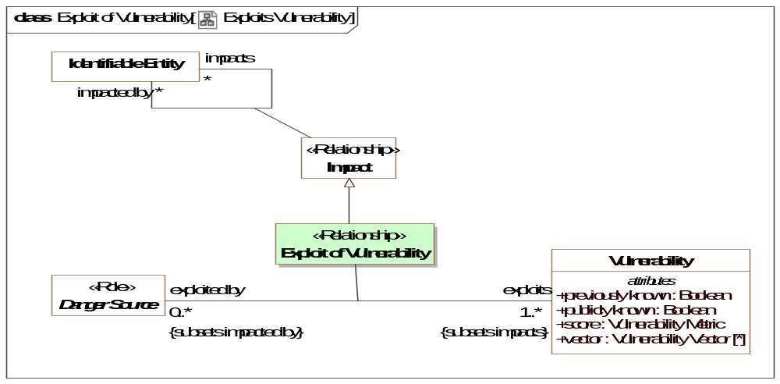
- Exploits Vulnerability
Direct Supertypes
Impact
Association Ends
exploits : Vulnerability [1..*] Subsets: impacts:Identifiable Entity
Vulnerability used by a danger source (intentionally or unintentionally) to directly or indirectly cause harm.
exploited by : Danger Source [0..*] Subsets: impacts:Identifiable Entity
Danger source that can or did exploit a vulnerability such that it leads to an undesirable situation.

Class Objective to Disrupt
Something that efforts or actions are intended to attain such that it damages another in some way or obtains resources not intended for a threat actor.
Direct Supertypes
Objective
Associations
: Disruptive Step [*] Subsets: realized by:Means

Class Unwitting Participant <<Role>>
An actor facilitating an activity or process without their prior knowledge or consent.
Direct Supertypes
Actor, Danger Source

Threat-risk-conceptual-model::Threat and Risk Specific Concepts::Danger Sources::Source of Danger Categories

Diagram: Source of Danger Categories
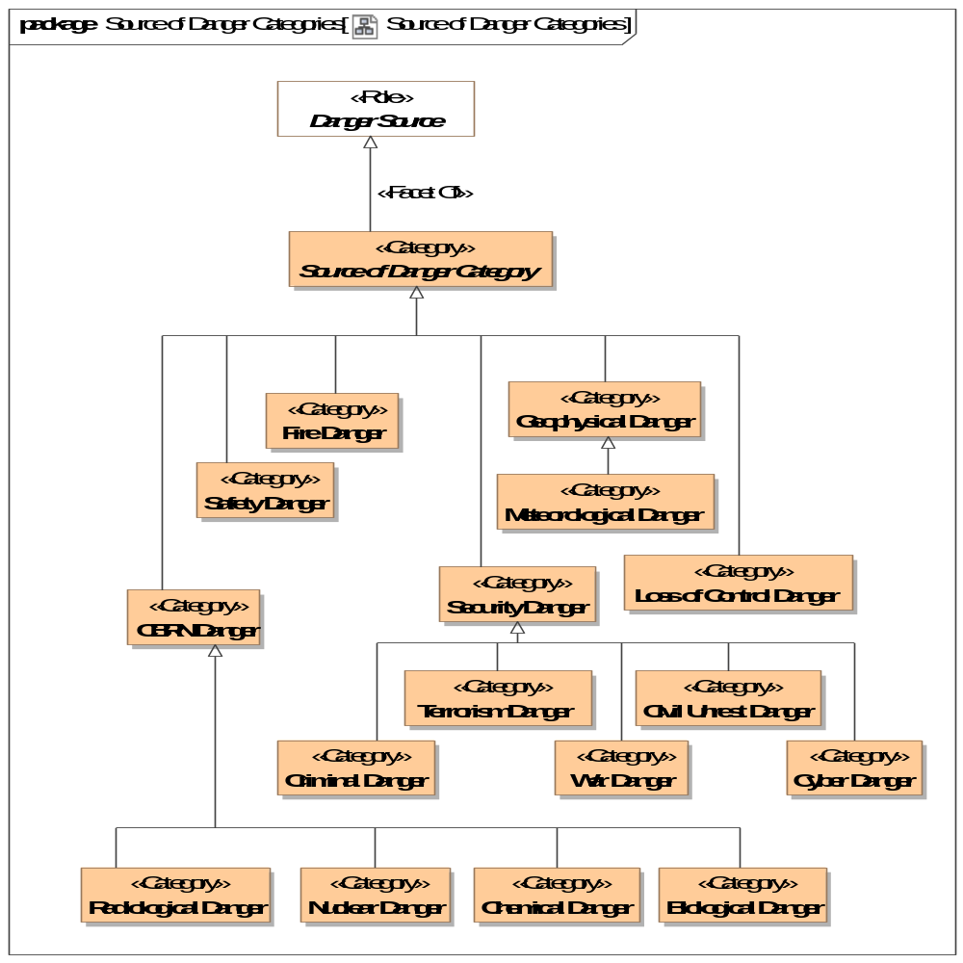
- Source of Danger Categories

Class Biological Danger <<Category>>
Any danger from a biological source.
Direct Supertypes
CBRN Danger

Class CBRN Danger <<Category>>
A Chemical, biological, radiological or nuclear danger.
Direct Supertypes
Source of Danger Category

Class Chemical Danger <<Category>>
A danger from a chemical.
Direct Supertypes
CBRN Danger

Class Civil Unrest Danger <<Category>>
Danger resulting from the actions of a group of people causing disruption of the normal course of society.
Direct Supertypes
Security Danger

Class Criminal Danger <<Category>>
Danger from a criminal activity.
Direct Supertypes
Security Danger

Class Cyber Danger <<Category>>
Danger related to computer systems and networks.
Direct Supertypes
Security Danger

Class Fire Danger <<Category>>
Danger from fire
Direct Supertypes
Source of Danger Category

Class Geophysical Danger <<Category>>
A danger resulting from the geography or movement of the earth.
Direct Supertypes
Source of Danger Category

Class Loss of Control Danger <<Category>>
Categorization of a danger resulting from the control of a system gained by parties not intended to have that control.
Direct Supertypes
Source of Danger Category

Class Meteorological Danger <<Category>>
Category of meteorological impact (e.g., flood).
Direct Supertypes
Geophysical Danger

Class Nuclear Danger <<Category>>
Category of danger from a nuclear blast.
Direct Supertypes
CBRN Danger

Class Radiological Danger <<Category>>
A categorization of danger from radiation.
Direct Supertypes
CBRN Danger

Class Safety Danger <<Category>>
General emergency and public safety danger category. [CAP]
Direct Supertypes
Source of Danger Category

Class Security Danger <<Category>>
[CAP] Danger category of “Security” - Law enforcement, military, homeland and local/private security.
Direct Supertypes
Source of Danger Category

Class Source of Danger Category <<Category>>
A categorization of the source of dangers.
Direct Supertypes
Danger Source

Class Terrorism Danger <<Category>>
Category of danger from terrorism.
Direct Supertypes
Security Danger

Class War Danger <<Category>>
A Category of danger from acts of war.
Direct Supertypes
Security Danger

Threat-risk-conceptual-model::Threat and Risk Specific Concepts::Incidents
Concepts relating to incidents - undesired events that actually happen and impact victims.

Diagram: Incident
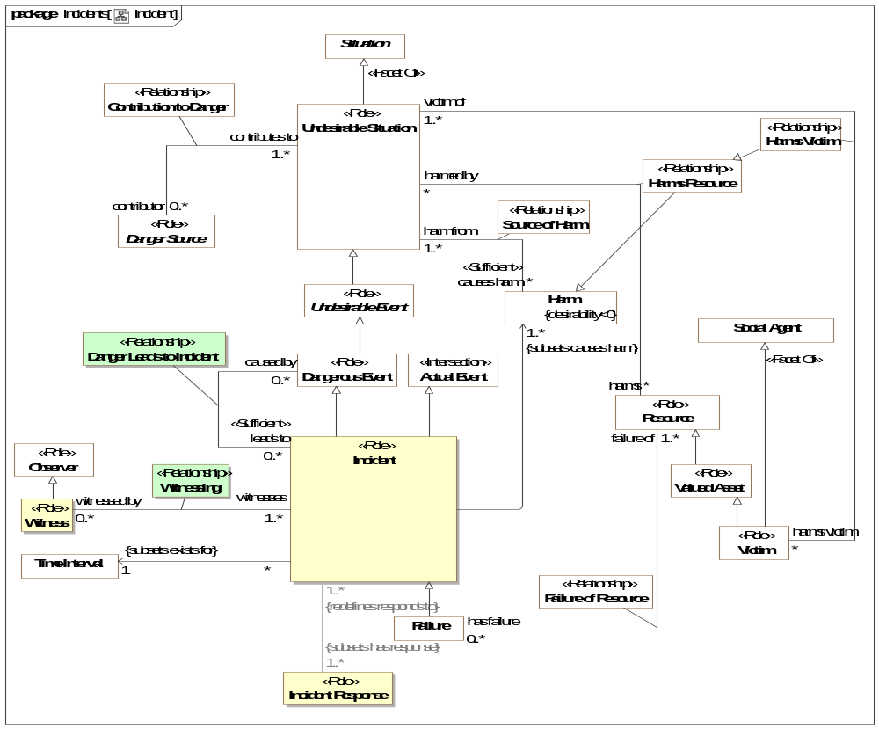
- Incident

Association Class Danger Leads to Incident <<Relationship>>
The relationship between an incident and its causes, dangerous events.
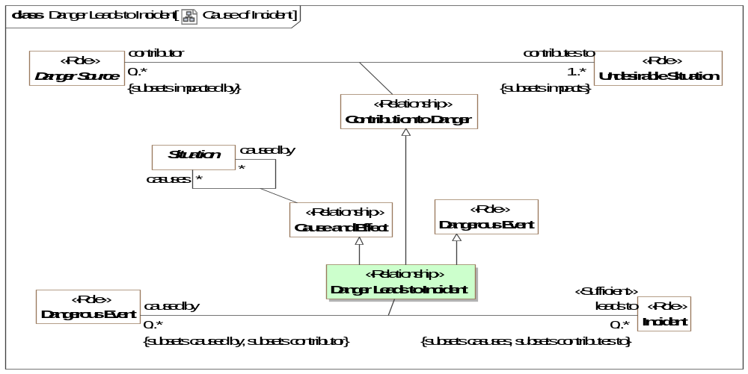
- Cause of Incident
Direct Supertypes
Cause and Effect, Contribution to Danger, Dangerous Event
Association Ends
leads to : Incident [0..*] Subsets: realized by:Means
Incident that is the result of a threat.
caused by : Dangerous Event [0..*] Subsets: realized by:Means
Cause of an incident.

Class Incident <<Role>>
An incident is a dangerous situation that is happening or has happened directly causing harm (detriment) to victims. Kinds of incidents include attacks, disasters, and accidents. Incidents are actualized risks.
[NIEM] IncidentType
Direct Supertypes
Actual Event, Dangerous Event
Associations
<<Restriction>> : Incident Response [1..*] Subsets: has response:Response

Class Witness <<Role>>
Role of a person who observes an event, typically a crime or accident, take place.
Direct Supertypes
Observer

Association Class Witnessing <<Relationship>>
Witnessing is the observation of an incident by a witness
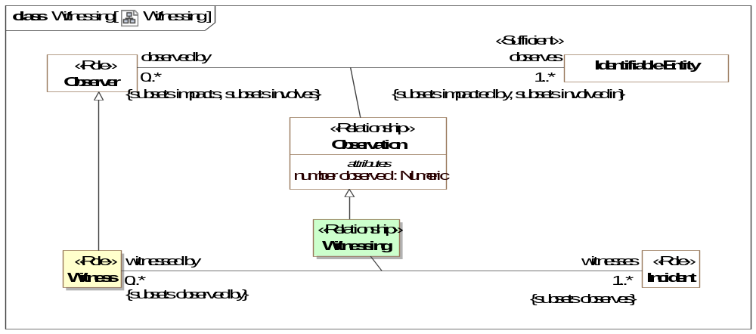
- Witnessing
Direct Supertypes
Observation
Association Ends
witnesses : Incident [1..*] Subsets: has response:Response
Incident observed by a witness.
witnessed by : Witness [0..*] Subsets: has response:Response
Witnesses of an incident

Threat-risk-conceptual-model::Threat and Risk Specific Concepts::Incidents::Failure

Diagram: Failure
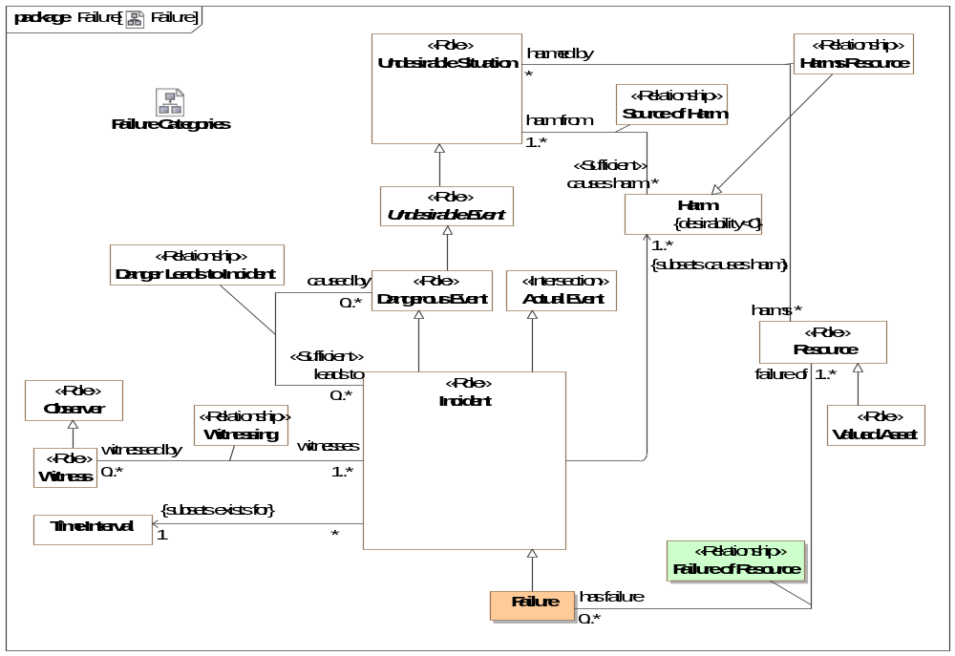
- Failure

Class Failure
Failure is an incident which causes a resource to not fulfill its intended function.
Direct Supertypes
Incident

Association Class Failure of Resource <<Relationship>>
Relationship between a failure event end the resources that have failed.
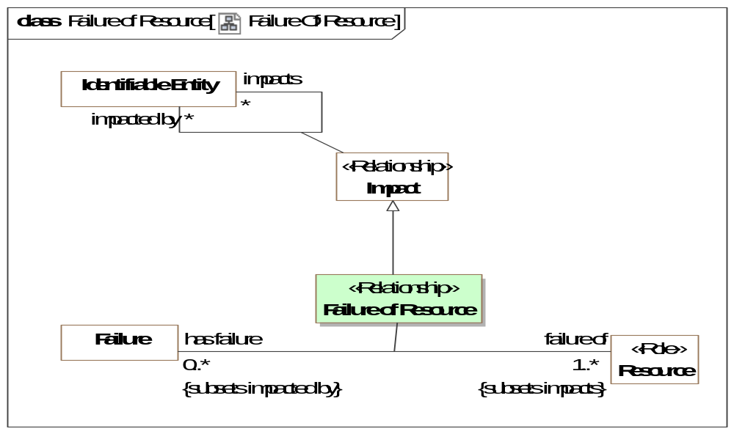
- Failure Of Resource
Direct Supertypes
Impact
Association Ends
has failure : Failure [0..*] Subsets: has response:Response
Realized or potential failures of a resource.
failure of : Resource [1..*] Subsets: has response:Response
Resource that fails in a failure event. The resource is no longer able to fulfill its function as intended.

Threat-risk-conceptual-model::Threat and Risk Specific Concepts::Incidents::Failure Categories

Diagram: Failure Categories
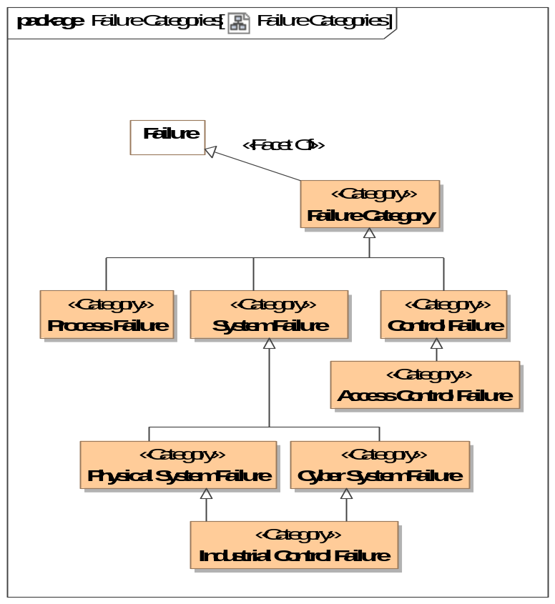
- Failure Categories

Class Access Control Failure <<Category>>
Failure of permission controls to prevent unintended access.
Direct Supertypes
Control Failure

Class Control Failure <<Category>>
Failure of a policy or control process.
Direct Supertypes
Failure Category

Class Cyber System Failure <<Category>>
Failure of any cyber system - hardware, software, or network to operate as intended.
Direct Supertypes
System Failure

Class Failure Category <<Category>>
A category of failure of a resource.
Direct Supertypes
Failure

Class Industrial Control Failure <<Category>>
A category of danger to the automated control of industrial systems.
Direct Supertypes
Cyber System Failure, Physical System Failure

Class Physical System Failure <<Category>>
A category of danger of failure of any physical system.
Direct Supertypes
System Failure

Class Process Failure <<Category>>
Categorization of a failure of a process to fulfill its objectives.
Direct Supertypes
Failure Category

Class System Failure <<Category>>
Category of failure of a system - physical, financial, cyber, etc. such that the system is no longer available to serve its objectives.
Direct Supertypes
Failure Category

Threat-risk-conceptual-model::Threat and Risk Specific Concepts::Incidents::Impact Categories

Diagram: Impact Categories
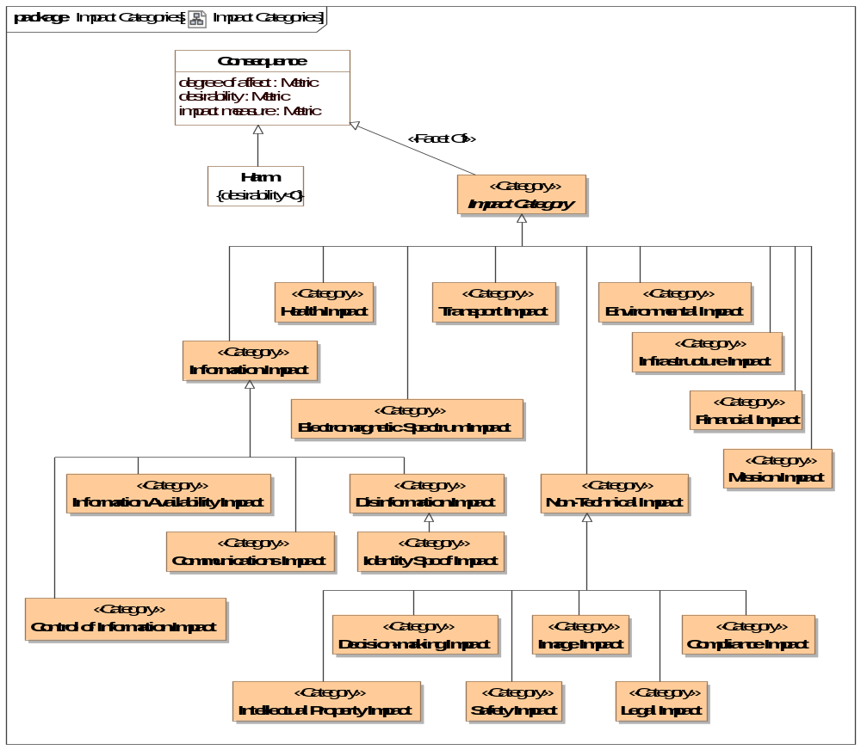
- Impact Categories

Class Communications Impact <<Category>>
Category of impact to the ability to communicate.
Direct Supertypes
Information Impact

Class Compliance Impact <<Category>>
Impact on the ability to comply with policies.
Direct Supertypes
Non-Technical Impact

Class Control of Information Impact <<Category>>
Information becomes available to unauthorized actors (loss of confidentiality).
Direct Supertypes
Information Impact

Class Decision-making Impact <<Category>>
Impact on the ability to make informed decisions.
Direct Supertypes
Non-Technical Impact

Class Disinformation Impact <<Category>>
Impact resulting from incorrect information.
Direct Supertypes
Information Impact

Class Electromagnetic Spectrum Impact <<Category>>
Impact based on disruption in spectrum.
Direct Supertypes
Impact Category

Class Environmental Impact <<Category>>
A danger to the environment.
Direct Supertypes
Impact Category

Class Financial Impact <<Category>>
Impact resulting in loss of capital or the ability to obtain capital.
Direct Supertypes
Impact Category

Class Health Impact <<Category>>
A category of danger to people's health.
Direct Supertypes
Impact Category

Class Identity Spoof Impact <<Category>>
A category of danger where an individuals' identity is assumed by another. .
Direct Supertypes
Disinformation Impact

Class Image Impact <<Category>>
Impact to how an entity is viewed by others.
Direct Supertypes
Non-Technical Impact

Class Impact Category <<Category>>
Categorization of the impact of dangers. Danger categories may be combined.
Direct Supertypes
Consequence

Class Information Availability Impact <<Category>>
A category of danger impact where information becomes unavailable to the information owner.
Availability: Ensuring timely and reliable access to and use of information.
[NIST800]
Direct Supertypes
Information Impact

Class Information Impact <<Category>>
A category of danger impact related to information - its unauthorized use or modification.
Direct Supertypes
Impact Category

Class Infrastructure Impact <<Category>>
Classification of impact to infrastructure such that it is not longer available to fulfill objectives.
Direct Supertypes
Impact Category

Class Intellectual Property Impact <<Category>>
Category indicating a loss or compromise of intellectual property.
Direct Supertypes
Non-Technical Impact

Class Legal Impact <<Category>>
A categorization of impact to legal status or legal measures.
Direct Supertypes
Non-Technical Impact

Class Mission Impact <<Category>>
Category of the impact on the ability to achieve a mission purpose.
Direct Supertypes
Impact Category

Class Non-Technical Impact <<Category>>
Category representing the impact to something other than the ability to operate.
Direct Supertypes
Impact Category

Class Safety Impact <<Category>>
Category of impact to the safety of a resource.
Direct Supertypes
Non-Technical Impact

Class Transport Impact <<Category>>
[CAP] A category of impact to public or private transportation.
Direct Supertypes
Impact Category

Threat-risk-conceptual-model::Threat and Risk Specific Concepts::Incidents::Incident Response

Diagram: Incident Response
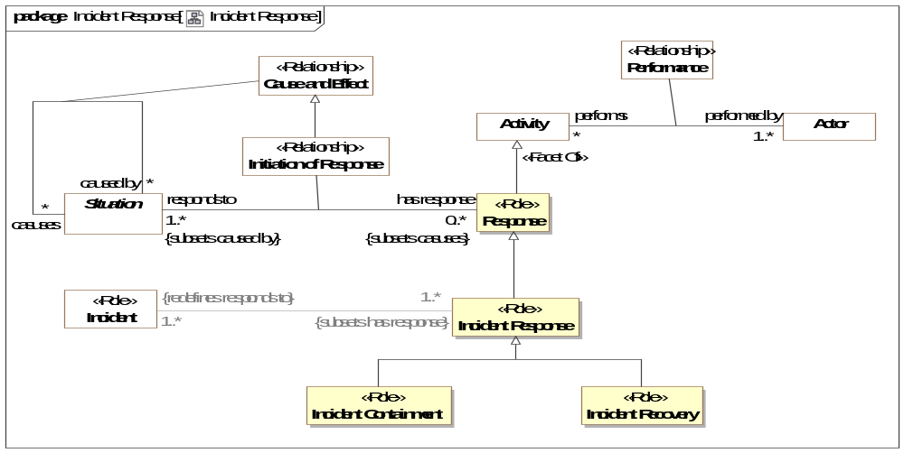
- Incident Response
Incident recovery is an incident response that restores the functionality of impacted resources and systems, including the removal of temporary containment measures.

Class Incident Containment <<Role>>
Containment is an incident response that has two major goals: stopping the spread of the dangers causing the incident and preventing further harm. Containment includes the eradication of latent vulnerabilities of and infections to systems, such as the removal of malware.
Direct Supertypes
Incident Response

Class Incident Recovery <<Role>>
Direct Supertypes
Incident Response

Class Incident Response <<Role>>
Incident response is an activity to address and manage the scope and impact of an incident.
Direct Supertypes
Response
Associations
<<Restriction>> : Incident [1..*] Redefines: responds to:Situation

Threat-risk-conceptual-model::Threat and Risk Specific Concepts::Indicators
Indicators are patterns of situations or lists of entities to watch out for that indicate a situation that may happen. An indicator may be scoped by an entity/situation, which contextualizes when it applies. When a situation matching an indicator is observed there is a sighting of that indicator which is then evidence for an actual situation, such as an incident. e.g., watch for these terrorists in airports.
A sighting is an observation that matches the pattern of an indicator. e.g., the terrorist Killer-Joe was seen at BWI on 12/11/2014 by a police officer Sam Shoe.
Indicators are not certain and may have a likelihood attached to the potential situations for which they are evidence.
Once a sighting flags an indicator, a course of action rule may be fired based on the indicated situation.
Specializations of indicator include indicator patterns (an arbitrary pattern of anything) and watch lists. Indicators may also be grouped.

Diagram: Indicator
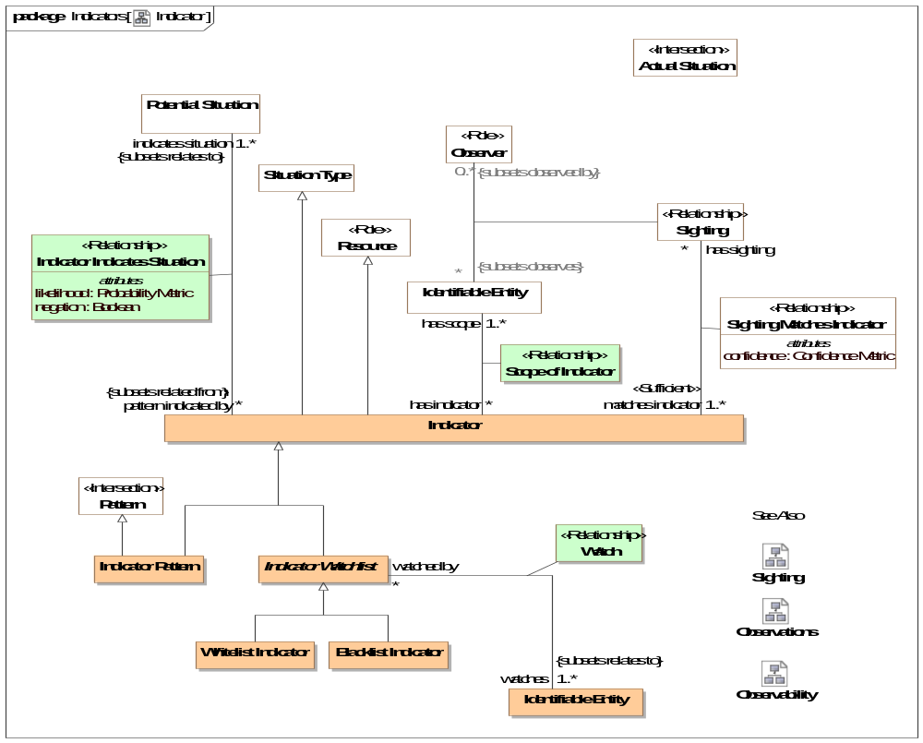
- Indicator

Diagram: Sighting
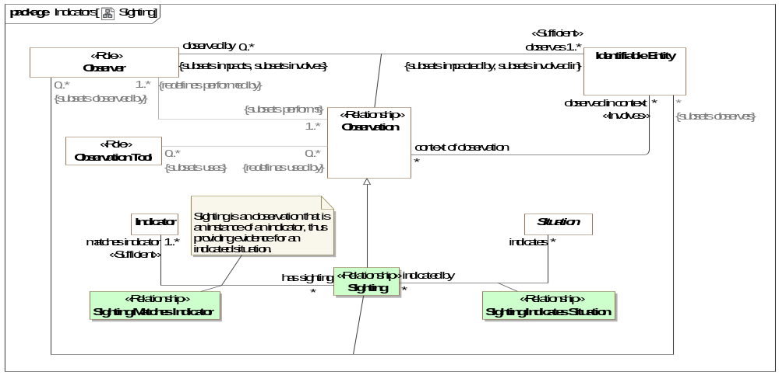
- Sighting

Class Blacklist Indicator
A list of watched entities that are assumed to pose a threat.
Direct Supertypes
Indicator Watchlist

Class Indicator
An indicator is a predicate such that matching sightings are evidence for a possible situation. Sightings matching an indicator suggests further study or action based on a course of action rule.
Subtypes of indicator define what is watched for: a pattern, a watch list or some combination of other indicators. Indicators may be restricted to (relevant only within) a specific scope.
Direct Supertypes
Resource, Situation Type

Association Class Indicator Indicates Situation <<Relationship>>
Relationship between an indicator that classifies some kind of situation and the kind of potential situation that the indicator suggests. The indicator is evidence for the indicated situation.
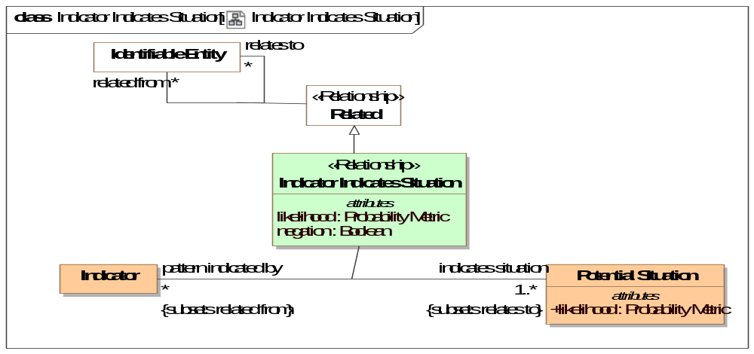
- Indicator Indicates Situation
Direct Supertypes
Related
Association Ends
indicates situation : Potential Situation [1..*] Redefines: responds to: Situation
The situation pattern that may be inferred by a sighting matching the subject indicator.
pattern indicated by : Indicator [*] Redefines: responds to: Situation
Indicator that may be used as evidence that a potential situation has been realized by an actual situation.
Attributes
likelihood : Probability Metric
The probability that the indication relationship actually indicates the situation. Note that likelihood may be negative, indicating that the indicator suggests the absence of the indicated pattern .
negation : Boolean
[STIX] The negate field specifies the absence of the indicated pattern, inverting the sign of "likelihood".

Class Indicator Pattern
An indicator defined by a pattern. When the pattern is matched, the indicator "fires", indicating instances of the indicated potential situations.
Direct Supertypes
Indicator, Pattern

Class Indicator Watchlist
An indicator defined by a set of entities (which can be individuals' or situations) that should be watched for in a particular context. The members of the watch list are represented by "watches". When a watched individual is sighted, the indicator "fires", indicating instances of the indicated potential situations.
Direct Supertypes
Indicator

Association Class Sighting <<Relationship>>
A sighting is a kind of observation that matches one or more indicators and that by matching indicators it increases the likelihood of the situation it <indicates>.
Sightings of indicators are not absolute. Both the matching of the sighting to the indicator and the indicated situation are qualified with a likelihood.
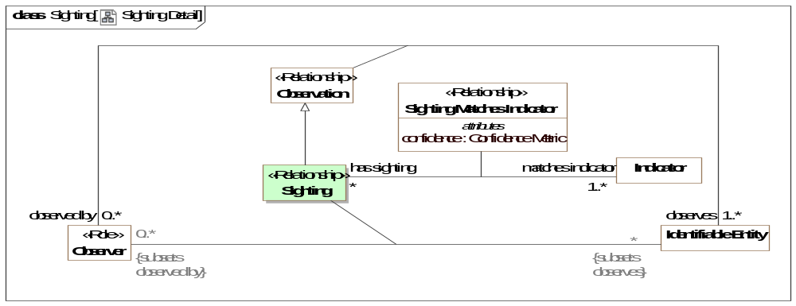
- Sighting Detail
Direct Supertypes
Observation
Association Ends
: Identifiable Entity [*] Redefines: responds to: Situation
: Observer [0..*] Redefines: responds to: Situation

Association Class Sighting Indicates Situation <<Relationship>>
Sightings provide evidence that the <indicates> situation may be occurring. This is based on the probability metric of the indicator the sighting is an instance of. Sighting Indicates Situation is derived from Indicator Indicates Situation where each potential situation indicated becomes a possible actual situation as evidenced by the sighting.
Similar to [SACM] AssertedEvidence: The AssertedEvidence association class records the declaration that one or more artefacts of Evidence (cited by ArtefactElementCitations) provide information that helps establish the truth of a Claim. {AssertedEvidence references the record (artefacts) where as sightings are the actual event which may have record}
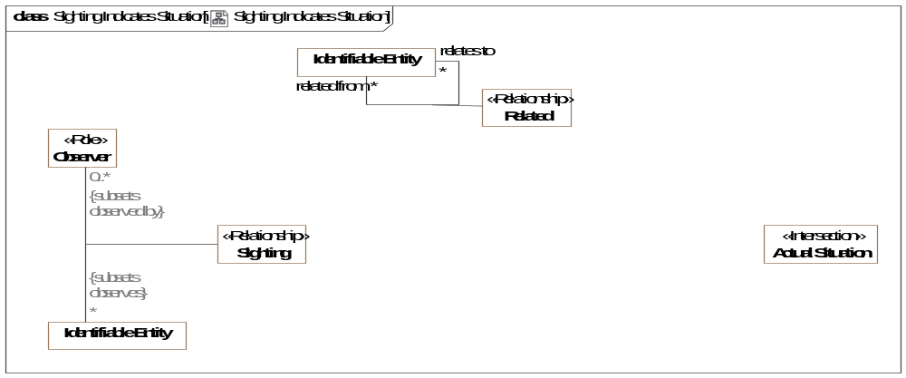
- Sighting Indicates Situation
Direct Supertypes
Related
Association Ends
indicates : Situation [*] Redefines: responds to: Situation
Situation that is indicated by a sighting, the sighting is providing evidence for the situation.
indicated by : Sighting [*] Redefines: responds to: Situation
Sightings that have been observed with respect to an actual situation, providing evidence of the situation.
Attributes
likelihood : Probability Metric
Probability that the specific sighting indicates the specific, actual situation referenced. In many cases this will be the same as the likelihood of the indicator's "Indicator Indicates Situation" likelihood, but specific conditions may increase or decrease that likelihood.

Association Class Sighting Matches Indicator <<Relationship>>
An assertion that a observation matches a particular indicator, thus classifying the observation as a sighting and providing evidence for situations the indicator, indicates.
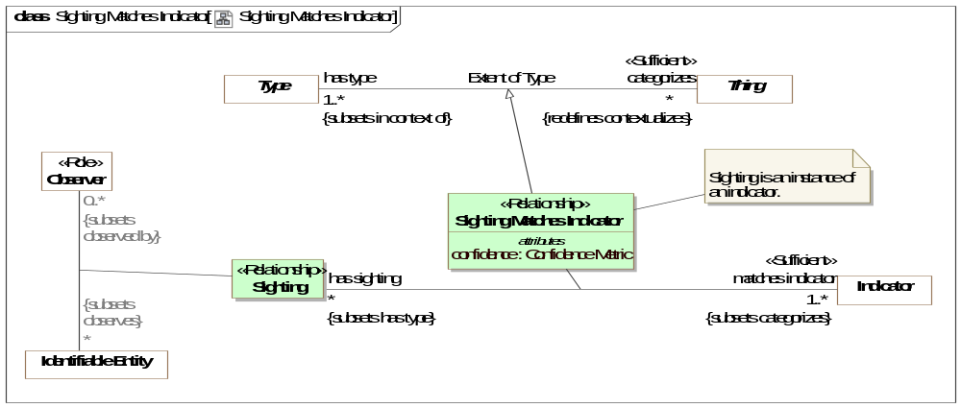
- Sighting Matches Indicator
Direct Supertypes
Extent of Type
Association Ends
matches indicator : Indicator [1..*] Redefines: responds to: Situation
Indicator the subject sighting matches.The subject sighting will then provide evidence for an actual situation that is an instance of the potential situation of the indicator.
has sighting : Sighting [*] Redefines: responds to: Situation
Sightings that match the subject indicator and may therefore imply the indicated situation.
Attributes
confidence : Confidence Metric
Confidence that the observed sighting does actually match the pattern. e.g. The witness is 50% certain that the man in the airport had a gun.

Association Class Watch <<Relationship>>
Relationship defining that <watches> is on the <watched by> watch list.
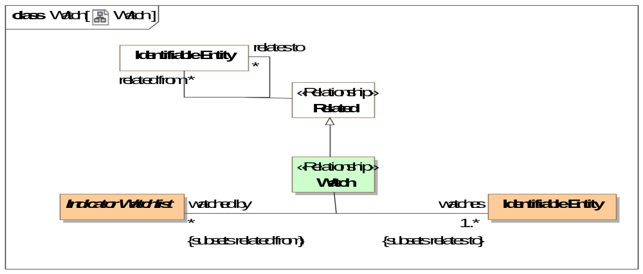
- Watch
Direct Supertypes
Related
Association Ends
watches : Identifiable Entity [1..*] Redefines: responds to: Situation
The entities (individuals', systems, situations, etc.) watched by a watch list.
watched by : Indicator Watchlist [*] Redefines: responds to: Situation
Watch list the subject entity is listed in.

Class Whitelist Indicator
A list of watched entities that are assumed not to pose a threat.
Direct Supertypes
Indicator Watchlist

Threat-risk-conceptual-model::Threat and Risk Specific Concepts::Risk
Concepts relative to risk and risk analytics where risk is an assessment of the potential harm to resources important to a risk owner. At a high level risk is computed as the sum of the likelihood * impact for all resources valued by a risk owner.

Diagram: Risk
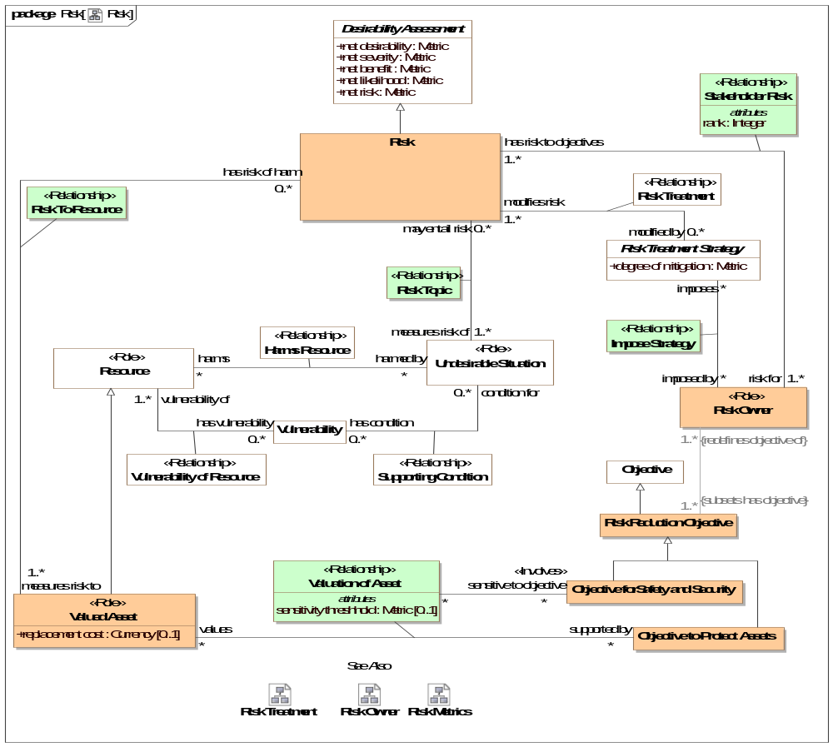
- Risk

Diagram: Risk Metrics
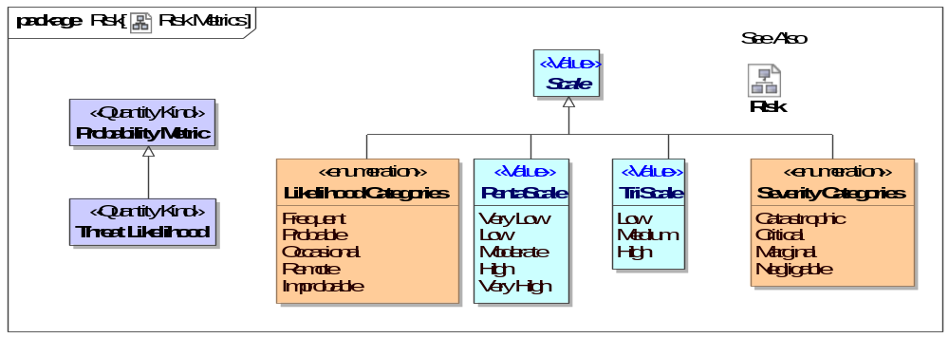
- Risk Metrics

Association Class Impose Strategy <<Relationship>>
A risk owner imposes a risk treatment strategy as a policy with the intent that the strategy reduces their risk to an acceptable level. The policy will be imposed in the entity that the policy <constrains>.
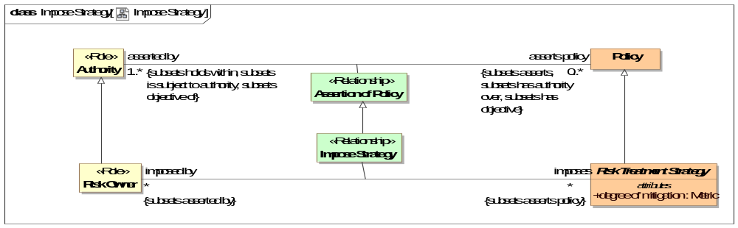
- Impose Strategy
Direct Supertypes
Assertion of Policy
Association Ends
imposes : Risk Treatment Strategy [*] Redefines: responds to: Situation
Risk treatment strategy imposed by a risk owner to mediate the owners risk.
imposed by : Risk Owner [*] Redefines: responds to: Situation
Authority that imposes a risk strategy such that it is intended to reduce their risk.

Class Objective forSafety and Security
Classification of an objective related to the safety and security of a stakeholder. The protection from harm.
Direct Supertypes
Risk Reduction Objective

Class Objective to Protect Assets
Objective of a stakeholder to protect an asset. To reduce the potential harm to valued assets.
Direct Supertypes
Risk Reduction Objective

Class Risk
[CNSSI 4009] Risk is a measure of the extent to which an entity is threatened by a potential circumstance or event, and typically a function of: (i) the adverse impacts that would arise if the circumstance or event occurs; and (ii) the likelihood of Event.
[Note: Information system-related security risks are those risks that arise from the loss of confidentiality, integrity, or availability of information or information systems and reflect the potential adverse impacts to organizational operations (including mission, functions, image, or reputation), organizational assets, individuals', other organizations, and the Nation.]
Direct Supertypes
Desirability Assessment

Class Risk Mitigation Strategy
A plan which minimizes or eliminates the possibility or impact of a danger or risk.
Direct Supertypes
Risk Treatment Strategy

Class Risk Owner <<Role>>
A stakeholder with an objective to manage risk.
[ISO 73:2009] person or entity with the accountability and authority to manage a risk.
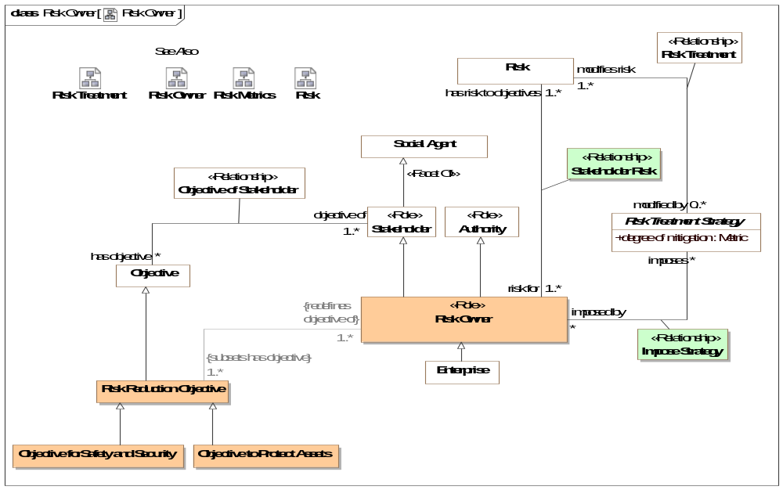
- Risk Owner
Direct Supertypes
Authority, Stakeholder

Class Risk Reduction Objective
An objective of a risk owner to reduce risk.
Direct Supertypes
Objective
Associations
: Defensive Step [*] Subsets: realized by:Means

Association Class Risk To Resource <<Relationship>>
The Risk to Resource relationship identifies the resources for which risk will be measured for the risk owner.
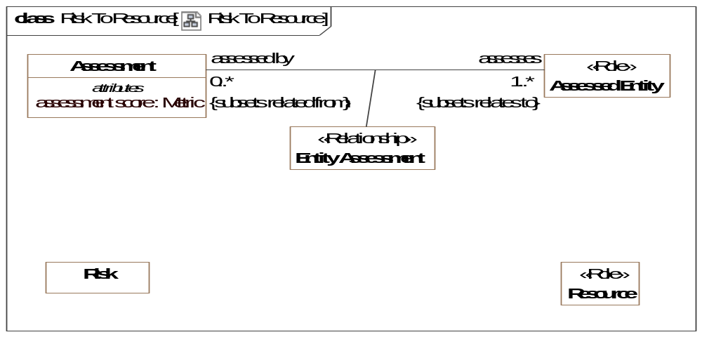
- Risk To Resource
Direct Supertypes
Entity Assessment
Association Ends
measures risk to : Valued Asset [1..*] Subsets: realized by:Means
Resources (aka assets) at risk.
has risk of harm : Risk [0..*] Subsets: realized by:Means
Potential risk to the subject resource.

Association Class Risk Topic <<Relationship>>
One or more undesirable situations that are assessed together in terms of their risk - the impact and likelihood that those situations will cause harm to resources valued by a risk owner.
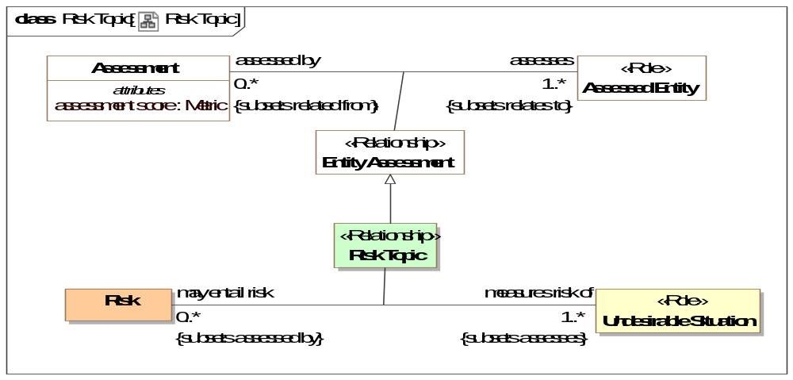
- Risk Topic
Direct Supertypes
Entity Assessment
Association Ends
measures risk of : Undesirable Situation [1..*] Subsets: realized by:Means
Undesirable situations measured in terms of their risk of harming resources valued by a risk owner.
may entail risk : Risk [0..*] Subsets: realized by:Means
Risk resulting from a situation happening where the situation may cause harm to resources valued by a risk owner.

Association Class Stakeholder Risk <<Relationship>>
A relationship representing the impact of risk owned by a risk owner. The impact may be ranked as part of risk assessment.
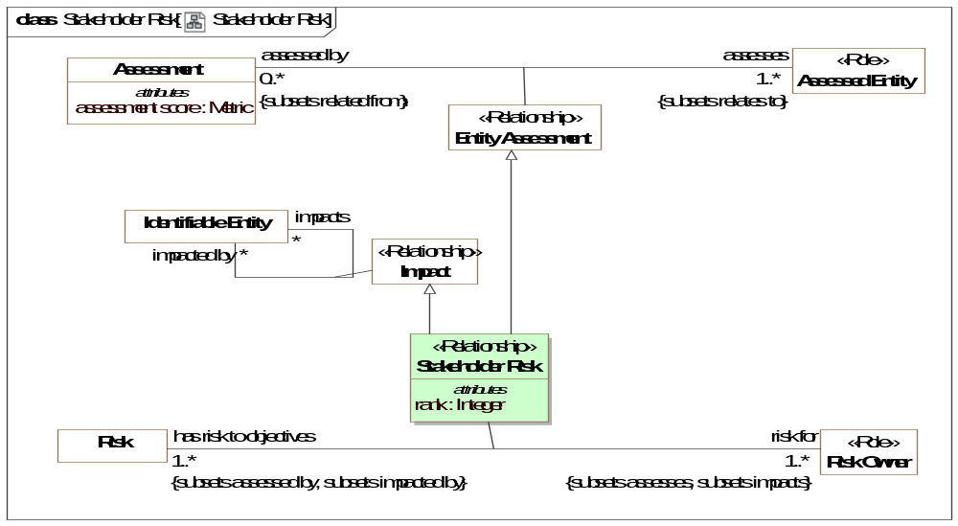
- Stakeholder Risk
Direct Supertypes
Entity Assessment, Impact
Association Ends
risk for : Risk Owner [1..*] Subsets: realized by:Means
Owner of a risk. The risk owner has objectives to minimize the subject risk.
has risk to objectives : Risk [1..*] Subsets: realized by:Means
Risk owned by a risk owner such that the risk may impact the risk owners objectives.
Attributes
rank : Integer
An ordering of how important a risk is relative to all the risks of a risk stakeholder. How the rank is computed is usually determined by net risk but is not specified in this specification.

Class Threat Likelihood <<Quantity Kind>>
A metric representing the likelihood of a threat occurring.
Direct Supertypes
Probability Metric

Association Class Valuation of Asset <<Relationship>>
A relationship representing the set of valued assets for a stakeholder's objectives.
Association Ends
values : Valued Asset [*] Subsets: realized by:Means
An asset for which there is an objective to create, sustain, or protect the asset.
supported by : Objective to Protect Assets [*] Subsets: realized by:Means
An objective that supports the creation, sustainment, or safety of a valued asset.
Attributes
sensitivity threshhold : Metric [0..1]
A metric representing the threshold over which damage to an asset will be of concern to a risk stakeholder.

Class Valued Asset <<Role>>
A system, organization, thing, process or person that is the direct concern of a stakeholder.
[BMM] Asset: something of value owned by the enterprise
Direct Supertypes
Resource
Attributes
replacement cost : Currency [0..1]
Cost to replace the capability offered by the subject valued asset. This may or may not be the cost to replace the asset with an identical one.

Enumeration Likelihood Categories
A high-level scale of likelihood.
Direct Known Superclasses
Scale
package Threat-risk-conceptual-model::Threat and Risk Specific Concepts::Risk
public enum Likelihood Categories
{Frequent, Probable, Occasional, Remote, Improbable}

Literals
Frequent
Likely to occur often in the life of an item, with a probability of Event greater than 10:1 in that life.
Probable
Will occur several times in the life of an item, with a probability of Event less than 10:1 but greater than 10:2 in that life.
Occasional
Likely to occur sometime in the life of an item, with a probability of Event less than 10-2 but greater than 10:3 in that life.
Remote
Unlikely but possible to occur in the life of an item, with a probability of Event less than 10:3 but greater than 10:6 in that life.
Improbable
So unlikely, it can be assumed Event may not be experienced, with a probability of Event less than 10:6 in that life.

Enumeration Severity Categories
A high-level scale of severity.
Direct Known Superclasses
Scale
package Threat-risk-conceptual-model::Threat and Risk Specific Concepts::Risk
public enum Severity Categories
{Catastrophic, Critical, Marginal, Negligable}

Literals
Catastrophic
Could result in death, permanent total disability, loss exceeding $1M, or irreversible severe environmental damage that violates law or regulation.
Critical
Could result in permanent partial disability, injuries, or occupational illness that may result in hospitalization of at least three personnel, loss exceeding $200K but less than $1M, or reversible environmental damage causing a violation of law or regulation.
Marginal
Could result in injury or occupational illness resulting in one or more lost work day(s), loss exceeding $10K but less than $200K, or mitigatible environmental damage without violation of law or regulation where restoration activities can be accomplished.
Negligable
Could result in injury or illness not resulting in a lost work day, loss exceeding $2K but less than $10K, or minimal environmental damage not violating law or regulation.
Known other enumerations
Enumeration Likelihood Categories, Enumeration Severity Categories

Threat-risk-conceptual-model::Threat and Risk Specific Concepts::Risk Treatments
Concepts relative to risk treatment. Risk treatments lessen the likelihood or impact of undesirable situations.

Diagram: Risk Treatment
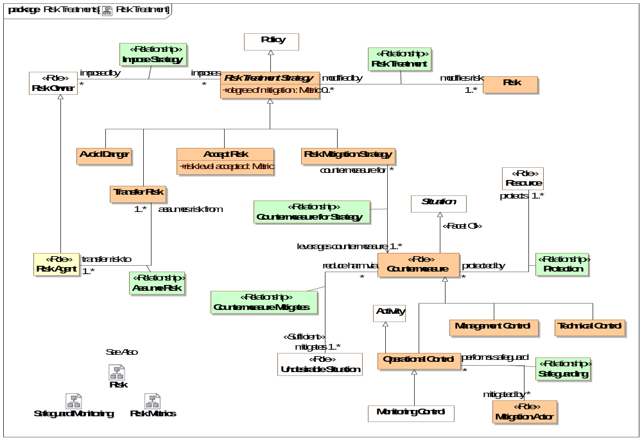
- Risk Treatment

Diagram: Safeguard Monitoring
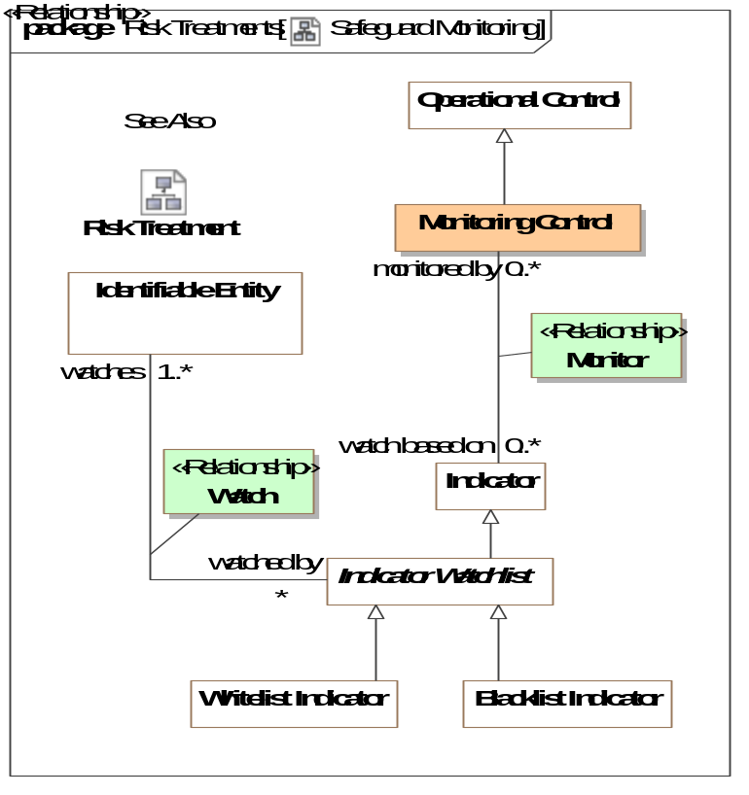
- Safeguard Monitoring

Class Accept Risk
A strategy to live with the consequences of a risk and not mitigate it.
Direct Supertypes
Risk Treatment Strategy
Attributes
risk level accepted : Metric
A metric representing the level of acceptable risk for the accept risk strategy.

Association Class Assume Risk <<Relationship>>
A relationship defining the stakeholder assuming a risk for another as part of a risk transfer risk strategy.
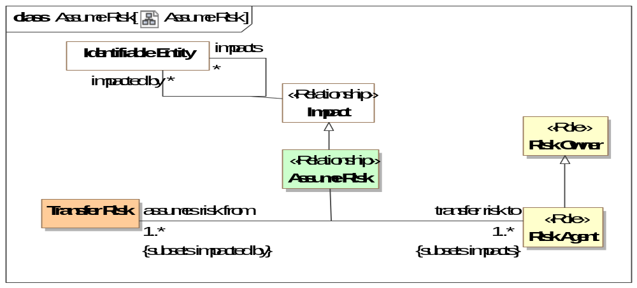
- Assume Risk
Direct Supertypes
Impact
Association Ends
transfer risk to : Risk Agent [1..*] Subsets: realized by:Means
Stakeholder that assumes a risk as the result of a transfer risk action.
assumes risk from : Transfer Risk [1..*] Subsets: realized by:Means
The stakeholder that assumes a risk for another, such as an insurance company.

Class Avoid Danger
A likelihood reduction strategy whereby a stakeholder decides not to engage in a risky activity.
Direct Supertypes
Risk Treatment Strategy

Class Countermeasure <<Role>>
Countermeasure – actions, devices, procedures, techniques, or other measures that are designed to lower the likelihood of a threat scenario succeeding in its objectives, reduce the likely consequences of a threat scenario, or minimizing vulnerabilities that a threat scenario can exploit.
Derived from [ISO 28001:2015], [ISO/IEC 2382:2015]
Related concept: Security controls are safeguards or countermeasures to avoid, detect, counteract, or minimize security risks to physical property, information, computer systems, or other assets.
Direct Supertypes
Resource, Situation

Association Class Countermeasure for Strategy <<Relationship>>
Countermeasure for strategy defines a specific <leverages countermeasure> countermeasure that helps to mitigate risk as part of a <countermeasure for> risk mitigation strategy.
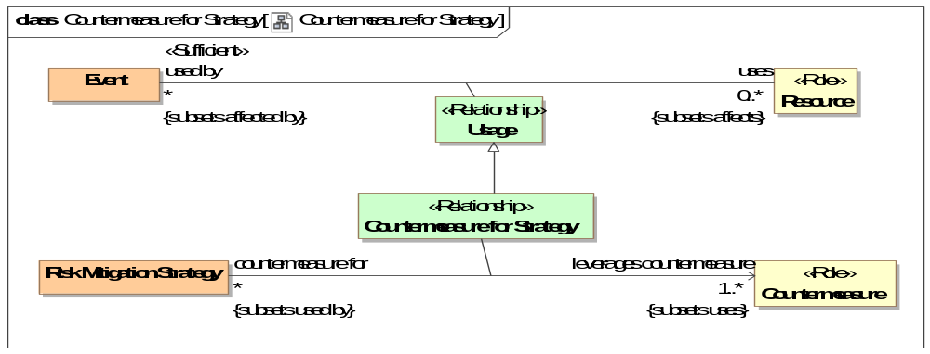
- Countermeasure for Strategy
Direct Supertypes
Usage
Association Ends
leverages countermeasure : Countermeasure [1..*] Subsets: realized by:Means
Countermeasure which serves a risk mitigation strategy.
countermeasure for : Risk Mitigation Strategy [*] Subsets: realized by:Means
Mitigation strategy supported by a countermeasure.

Association Class Countermeasure Mitigates <<Relationship>>
Undesirable situations mitigated by a countermeasure.
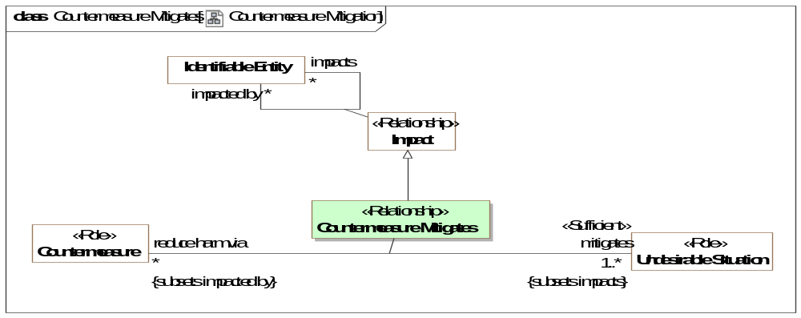
- Countermeasure Mitigation
Direct Supertypes
Impact
Association Ends
reduce harm via : Countermeasure [*] Subsets: realized by:Means
An actual or potential response to a danger to minimize the impact of the subject undesirable situation.
mitigates : Undesirable Situation [1..*] Subsets: realized by:Means
Undesirable situation for which mitigation reduces the likelihood or impact.

Class Management Control
Derived from [NIST.IR.7298]: The security controls (i.e., safeguards or countermeasures) that focus on the management of risk and the management of information system security.
SOURCE: SP 800-37; SP 800-53; SP 800-53A; FIPS 200
Direct Supertypes
Countermeasure

Class Mitigation Actor <<Role>>
Actor that performs a mitigation.
Direct Supertypes
Actor, Resource

Association Class Monitor <<Relationship>>
Monitor relates the <monitored by> safeguard with a <watch based on> indicator such that the monitoring of the indicator becomes a safeguard that <protects> resources.
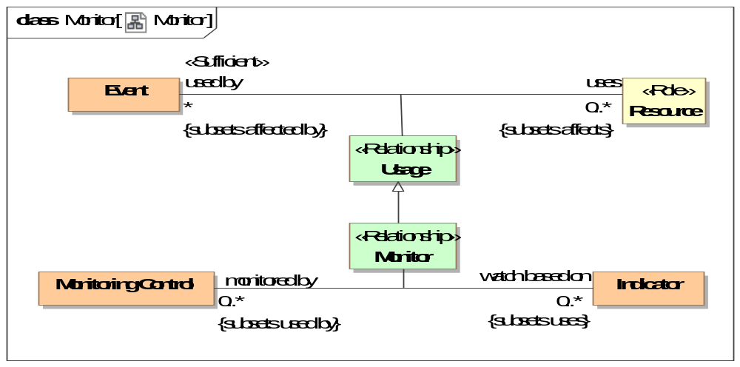
- Monitor
Direct Supertypes
Usage
Association Ends
watch based on : Indicator [0..*] Subsets: realized by:Means
Indicators watched by the subject safeguard.
monitored by : Monitoring Control [0..*] Subsets: realized by:Means
Activities monitoring an indicator using a monitoring safeguard.

Class Monitoring Control
The action or process of observing something or someone based on well-defined indicators so as to mitigate risks.
Direct Supertypes
Operational Control

Class Operational Control
[NIST.IR.7298] The security controls (i.e., safeguards or countermeasures) for an information system that primarily are implemented and executed by people (as opposed to systems).
SOURCE: SP 800-53; SP 800-37; FIPS 200
Direct Supertypes
Activity, Countermeasure

Association Class Protection <<Relationship>>
The protection of a resource by a countermeasure.
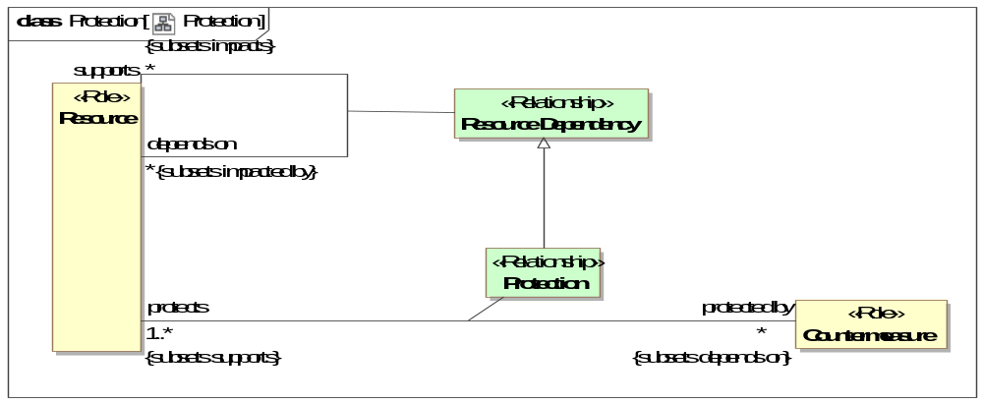
- Protection
Direct Supertypes
Resource Dependency
Association Ends
protects : Resource [1..*] Subsets: realized by:Means
Resource protected by a countermeasure such that the risk to the resource is reduced. Note that resources include actors, people, organizations and things.
protected by : Countermeasure [*] Subsets: realized by:Means
Countermeasure that protects the subject resource.

Class Risk Agent <<Role>>
An entity that assumes risk on behalf of another. e.g. an insurance company.
Direct Supertypes
Risk Owner

Association Class Risk Treatment <<Relationship>>
Risk treatment connects a <modified by> risk treatment strategy with the <modifies risk> Risk that it is intended to reduce.
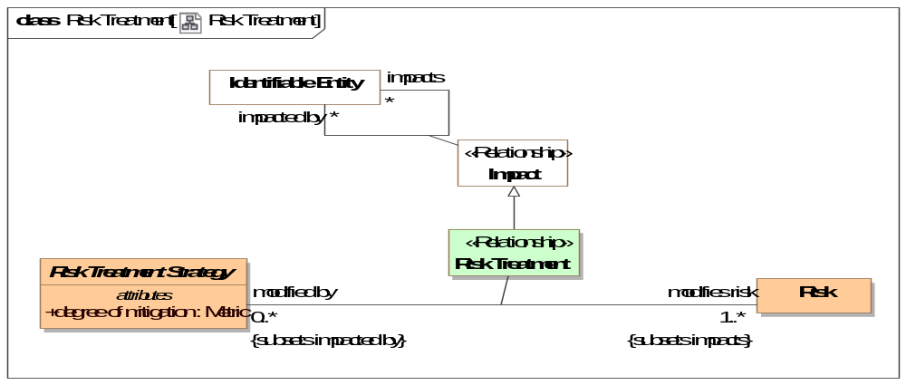
- Risk Treatment
Direct Supertypes
Impact
Association Ends
modifies risk : Risk [1..*] Subsets: realized by:Means
Risk that a risk treatment strategy reduces for the risk owner.
modified by : Risk Treatment Strategy [0..*] Subsets: realized by:Means
A strategy to reduce the subject risk for the risk owner.

Class Risk Treatment Strategy
A plan, method or process for dealing with risk by reducing the likelihood or impact.
Direct Supertypes
Policy
Attributes
degree of mitigation : Metric
A metric for how much a mitigation reduces the likelihood or impact of an undesirable situation.

Association Class Safeguarding <<Relationship>>
The safeguarding relationship relates a <mitigated by> mitigation actor with a <performs safeguard> safeguard activity such that it <protects> resources.
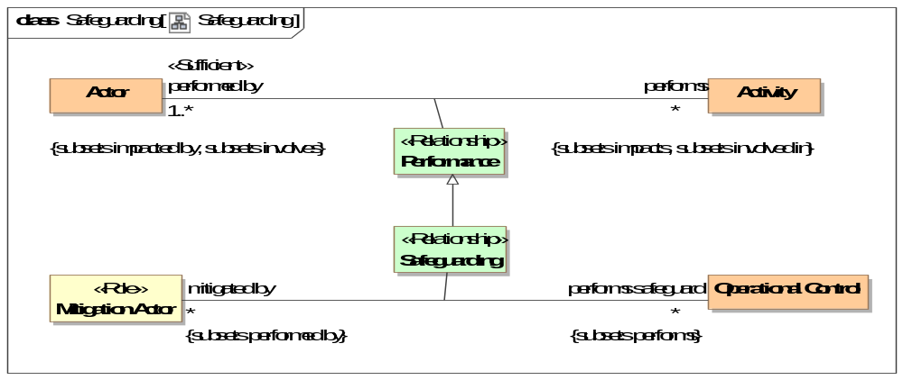
- Safeguarding
Direct Supertypes
Performance
Association Ends
performs safeguard : Operational Control [*] Subsets: realized by:Means
An activity a mitigation actor performs to protect resources identified by <protects>.
mitigated by : Mitigation Actor [*] Subsets: realized by:Means
The actor(s) that perform an activity to safeguard resources.

Class Technical Control
Derived from [NIST.IR.7298]: The security controls (i.e., safeguards or countermeasures) that are primarily implemented and executed by the information system through mechanisms contained in the hardware, software, or firmware components of the system.
SOURCE: SP 800-53; SP 800-53A; SP 800-37; FIPS 200
Direct Supertypes
Countermeasure

Class Transfer Risk
A strategy to cause another to assume the impact of a risk. e.g., insurance.
Direct Supertypes
Risk Treatment Strategy

Threat-risk-conceptual-model::Threat and Risk Specific Concepts::Threat Actors

Diagram: Threat Actors
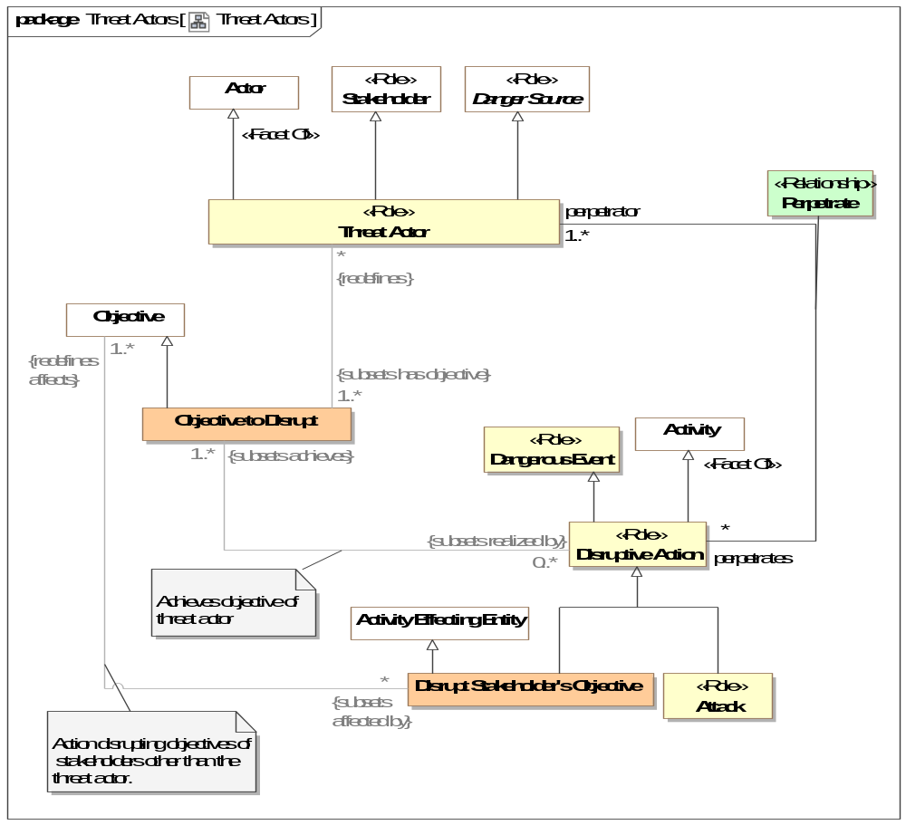
- Threat Actors

Class Disruptive Action <<Role>>
An intentional activity that serves the objectives of a threat actor to cause harm or violate law. Some disruptive actions are threats.
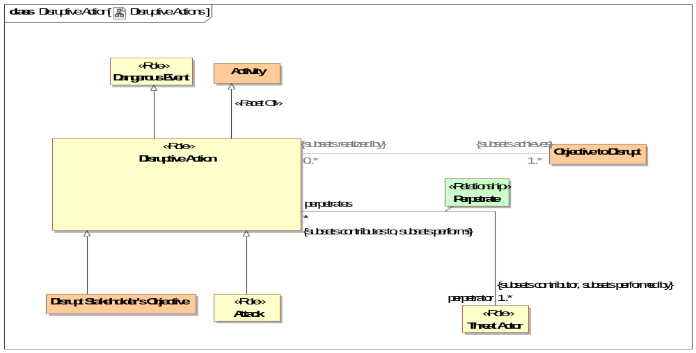
- Disruptive Actions
Direct Supertypes
Activity, Dangerous Event

Association Class Perpetrate <<Relationship>>
An actor involved in perpetrating an attack or other disruptive action.
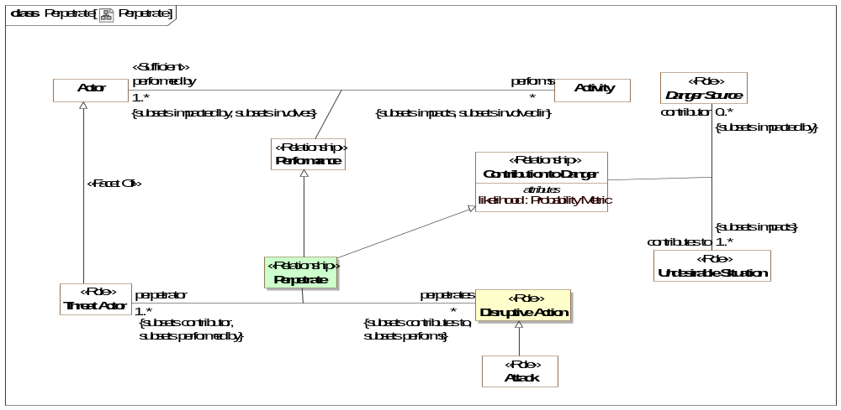
- Perpetrate
Direct Supertypes
Contribution to Danger, Performance
Association Ends
perpetrates : Disruptive Action [*] Subsets: realized by:Means
The activity performed by a threat actor to cause or contribute to an attack.
perpetrator : Threat Actor [1..*] Subsets: realized by:Means
The threat actor performing an activity to cause or contribute to an attack.
Associations
accusation made by : Social Agent [0..*] Subsets: asserted by:Social Agent
through association: Accusation
Social agent asserting that a threat actor perpetrated a disruptive action.

Class Threat Actor <<Role>>
Role of an actor; all or partially responsible for some undesired situation - threat, risk, or attack. Threat actors have intent to do harm.
Direct Supertypes
Actor, Danger Source, Stakeholder

Threat-risk-conceptual-model::Threat and Risk Specific Concepts::Undesirable Situations
Undesirable situations are a fundamentally concept that unifies the threat-risk framework. Undesirable situations classify a situation as one that causes harm to stakeholders (directly or indirectly). Undesirable situations are further specialized across three dimensions:
- Events Vs. Conditions - Events "happen" whereas conditions are a steady state for some period.
- Actual Vs. Potential.
- Intentional Vs. Natural or Systematic. Intentional dangers involve a "threat actor" whereas unintentional only involve weaknesses in resources.
The above are used to define more specific risk & threat concepts, such as:
- Incidents which are actual dangerous situations.
- Disasters and Accidents which are unintentional actual situation (no threat actor).
- Attacks which are actual situations perpetrated by a threat actor.
- Risks which are potential dangerous situations, thus having some level of uncertainty.
- Threats which are intentional risks from a threat actor.
- Hazards which are natural or systematic risks.
Resources also play an important role in the risk/threat framework in that resources are harmed by dangers but risks are also important for attackers to exploit vulnerabilities and for defenders to realize mitigations.

Diagram: Undesirable Situations
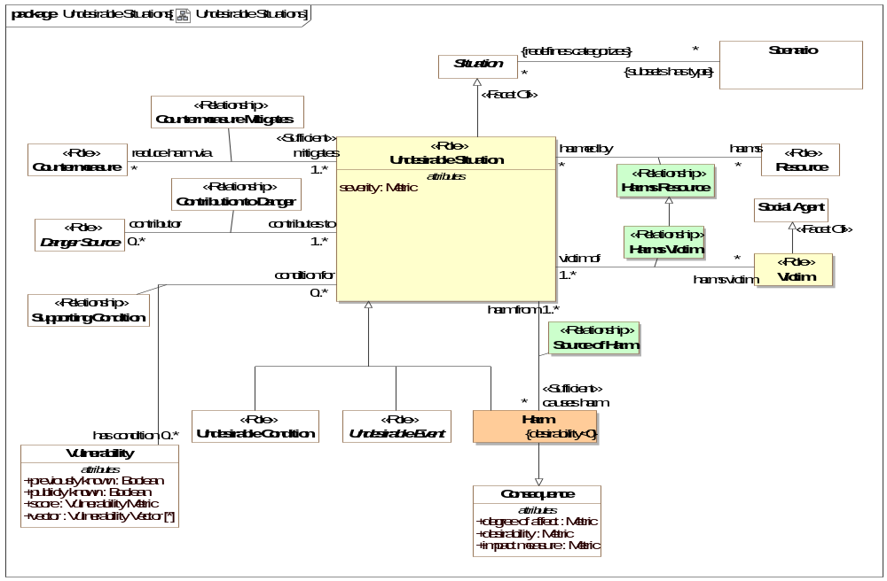
- Undesirable Situations

Class Harm
Harm is a consequence of a situation that negatively impacts the objectives of stakeholders and therefore has negative desirability for those stakeholders.
[Firesmith 2003] Harm is a negative impact associated with an asset. Harm is due to an accident when dealing with safety requirements, is due to an attack when dealing with security requirements, and may be due to both accidents and attacks when dealing with survivability requirements.
[NIEM] Injury (More specific concept - Person specific).
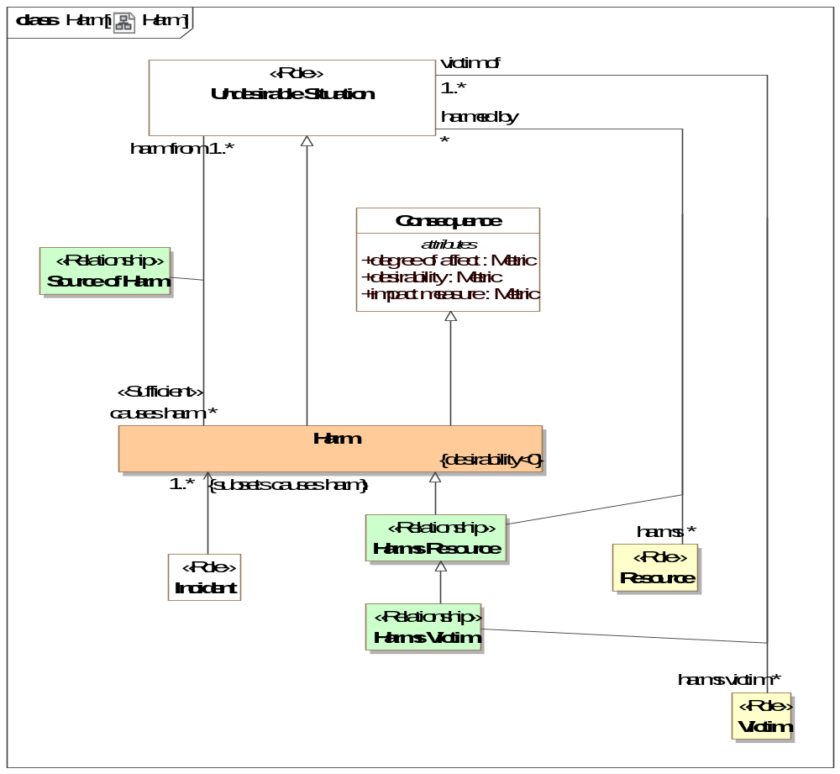
- Harm
Direct Supertypes
Consequence, Undesirable Situation

Association Class Harms Resource <<Relationship>>
Resources harmed or potentially harmed by an undesirable situation.
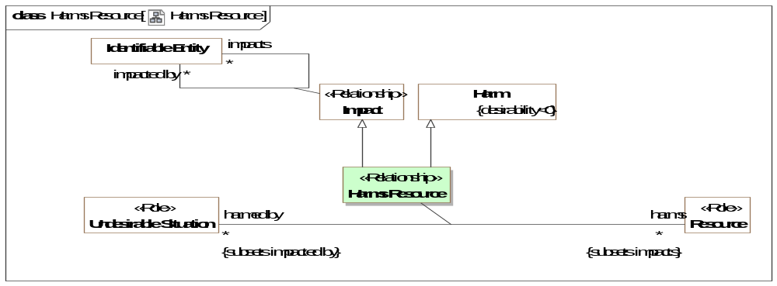
- Harms Resource
Direct Supertypes
Harm, Impact
Association Ends
harms : Resource [*] Subsets: asserted by:Social Agent
harmed by : Undesirable Situation [*] Subsets: asserted by:Social Agent
Attributes
likelihood : Probability Metric

Association Class Harms Victim <<Relationship>>
People or organizations (social agents) harmed or potentially harmed by an undesirable situation.
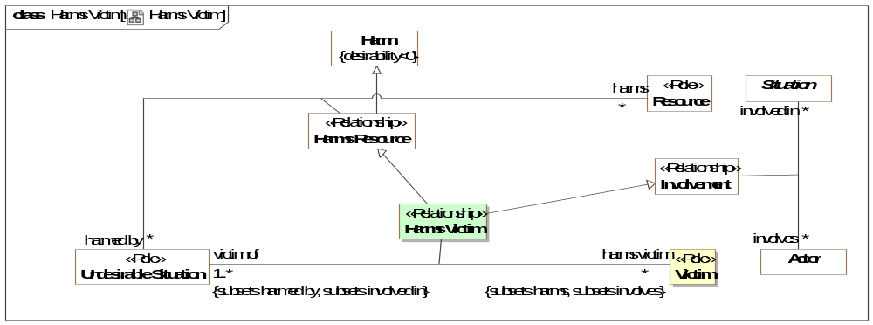
- Harms Victim
Direct Supertypes
Harms Resource, Involvement
Association Ends
harms victim : Victim [*] Subsets: asserted by:Social Agent
Victim harmed by a situation.
victim of : Undesirable Situation [1..*] Subsets: asserted by:Social Agent
Situations for which the subject is a victim.

Association Class Source of Harm <<Relationship>>
Relationship describing the harm produced as a result of a situation.
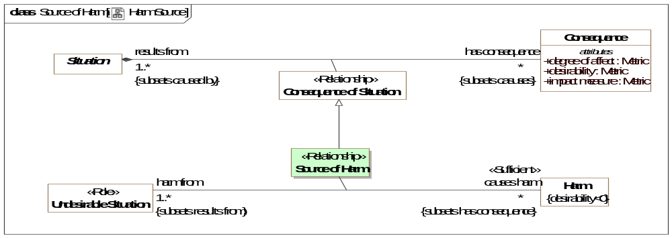
- Harm Source
Direct Supertypes
Consequence of Situation
Association Ends
causes harm : Harm [*] Subsets: asserted by:Social Agent
The harm to a resource caused by a undesirable situation.
harm from : Undesirable Situation [1..*] Subsets: asserted by:Social Agent
Situation which contributes to harm.

Class Undesirable Condition <<Role>>
A role of a situation as an undesirable static situation (a condition, not something happening) that directly or indirectly does or may have detrimental consequences impacting the objectives of stakeholders.
Direct Supertypes
State, Undesirable Situation

Class Undesirable Event <<Role>>
A role of an Event that may directly or indirectly cause harm.
Direct Supertypes
Event, Undesirable Situation

Class Undesirable Situation <<Role>>
An undesirable situation is a role of a situation (condition or event) that has, is, or may cause harm (directly or indirectly). Undesirable situations negatively impact the objectives of stakeholders. An undesirable situation may be classified in the context of the impacted stakeholders - what is undesirable to one stakeholder may be desirable to another.
Direct Supertypes
Situation
Attributes
severity : Metric
A metric for the total harm caused by a undesirable situation.

Class Victim <<Role>>
The role of any actor harmed by an incident.
Direct Supertypes
Social Agent, Valued Asset

Threat-risk-conceptual-model::Threat and Risk Specific Concepts::Vulnerabilities
Vulnerabilities and weaknesses represent flaws or inherent qualities of some resource that can be the source of danger.

Diagram: Vulnerability
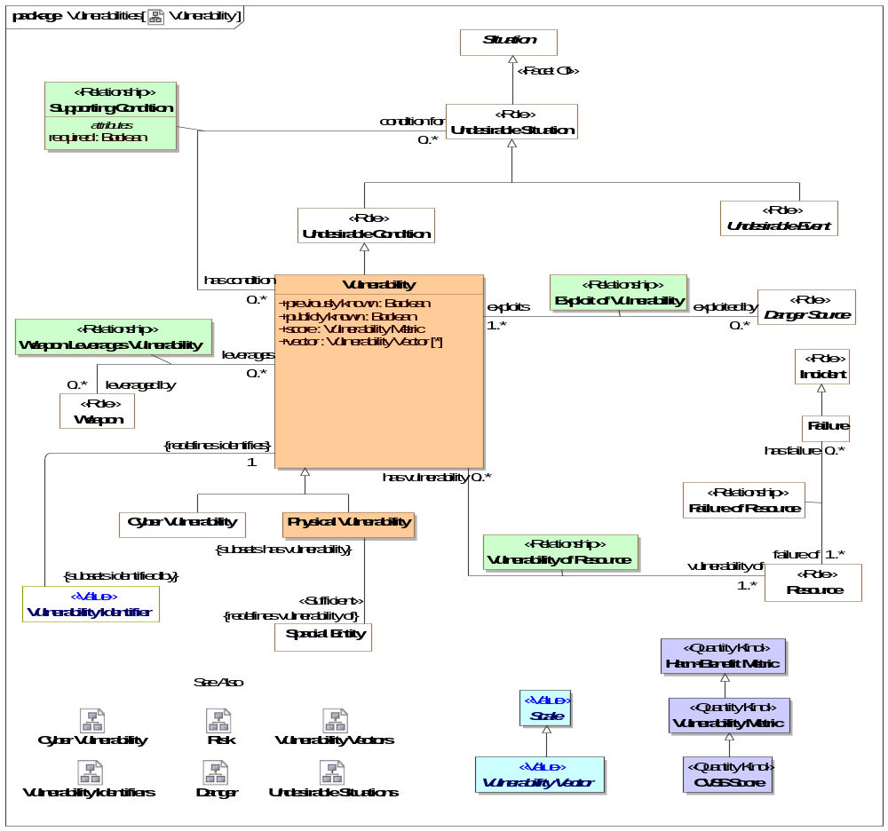
- Vulnerability

Diagram: Vulnerability Identifiers
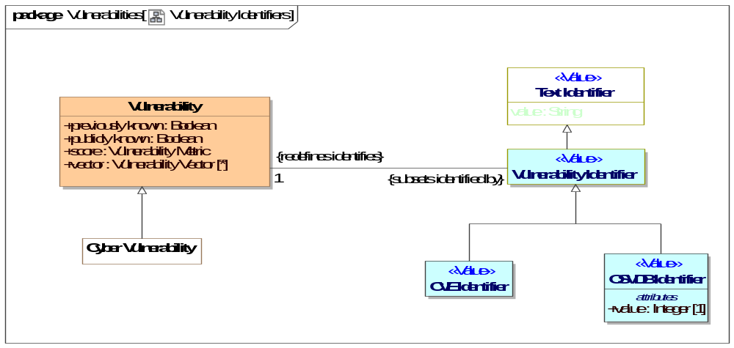
- Vulnerability Identifiers

Class Physical Vulnerability
A category of vulnerability of something to physical danger or attack.
Direct Supertypes
Vulnerability

Association Class Supporting Condition <<Relationship>>
Vulnerabilities required to exist for a threat to transition to an incident.
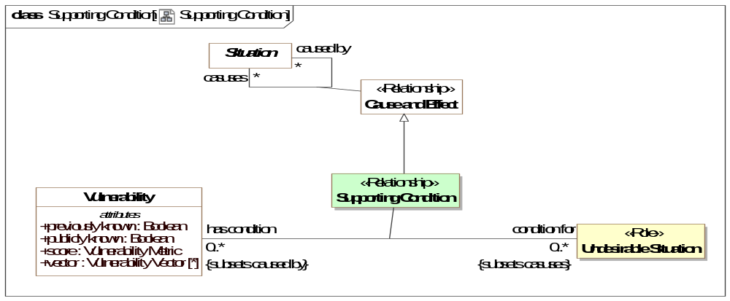
- Supporting Condition
Direct Supertypes
Cause and Effect
Association Ends
condition for : Undesirable Situation [0..*] Subsets: asserted by:Social Agent
Incident or failure for which a vulnerability is a condition.
has condition : Vulnerability [0..*] Subsets: asserted by:Social Agent
A vulnerability as a condition for the a undesirable condition to occur.
Attributes
required : Boolean
True if the condition is required for the undesirable condition to occur, false if the condition is one of many conditions that may enable the undesirable situation.

Class Vulnerability
A Vulnerability (of an object and a cause of failure, i.e. attack, natural cause, mistake, natural cause, accidental cause, or indirect) is the set of conditions under which an object fails under the particular cause of failure.
This is consistent with NIST 800-30 (based on CNSSII 4009)
Vulnerability is a weakness in an information system, system security procedures, internal controls, or implementation that could be exploited by a threat source.
Direct Supertypes
Undesirable Condition
Attributes
previously known : Boolean
At the time of the latest vulnerability characterization, true if the vulnerability had been previously reported, false if newly discovered or "zero day". Time is recorded in the "starts on" property of vulnerability.
publicly known : Boolean
An assertion that the existence of vulnerability is public knowledge, not closely held within an organization.
score : Vulnerability Metric
Score for the severity of the subject vulnerability - may use CVSS or other metrics.
vector : Vulnerability Vector [*]
Factors influencing the subject vulnerabilitie's score.

Class Vulnerability Identifier <<Value>>
An identifier for a vulnerability.
Direct Supertypes
Text Identifier

Class Vulnerability Metric <<Quantity Kind>>
A metric representing the overall impact of a vulnerability.
Direct Supertypes
Harm-Benefit Metric

Association Class Vulnerability of Resource <<Relationship>>
Relationship defining the resources that have a particular vulnerability.
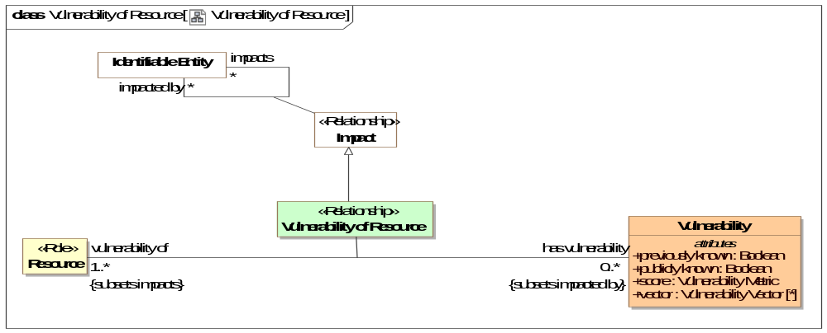
- Vulnerability of Resource
Direct Supertypes
Impact
Association Ends
vulnerability of : Resource [1..*] Subsets: asserted by:Social Agent
Resource the subject vulnerability may impact.
has vulnerability : Vulnerability [0..*] Subsets: asserted by:Social Agent
Vulnerabilities of a resource, ways it may be compromised.

Threat-risk-conceptual-model::Threat and Risk Specific Concepts::Vulnerabilities::Cyber Vulnerabilities

Diagram: Cyber Vulnerability
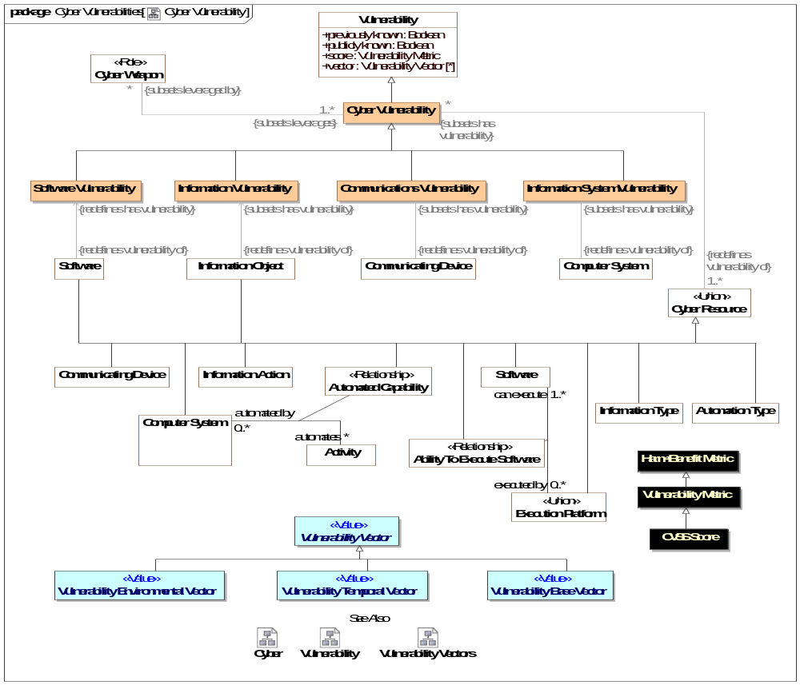
- Cyber Vulnerability

Class Communications Vulnerability
A potential failure of a communications systems to restrict information flow to unintended parties.
Direct Supertypes
Cyber Vulnerability

Class CVE Identifier <<Value>>
An identifier for Common Vulnerabilities and Exposures [https://cve.mitre.org/].
Direct Supertypes
Vulnerability Identifier

Class Cyber Vulnerability
A vulnerability of any cyber related resource.
Direct Supertypes
Vulnerability
Associations
<<Restriction>> : Cyber Weapon [*] Subsets: leveraged by:Weapon
<<Restriction>> : Cyber Resource [1..*] Redefines: vulnerability of:Resource

Class Information System Vulnerability
Category of vulnerability of a computer system and/or its network, software and execution of processes.
Direct Supertypes
Cyber Vulnerability

Class Information Vulnerability
A category of vulnerability of information loss, misuse or corruption.
Direct Supertypes
Cyber Vulnerability

Class OSVDB Identifier <<Value>>
OSVDB is an independent and open sourced web-based vulnerability database created for the security community.[http://osvdb.org/]. This package defines identifiers for referencing OSVDB.
Direct Supertypes
Vulnerability Identifier
Attributes
value : Integer [1]
Index into the OSVDB database.

Class Software Vulnerability
A vulnerability of software such that the software such that the softwares operation is comprised.
Direct Supertypes
Cyber Vulnerability

Threat-risk-conceptual-model::Threat and Risk Specific Concepts::Vulnerabilities::Vulnerability Vectors
[cvss] IT management must identify and assess vulnerabilities across many disparate hardware and software platforms. They need to prioritize these vulnerabilities and remediate those that pose the greatest risk. But when there are so many to fix, with each being scored using different scales, how can IT managers convert this mountain of vulnerability data into actionable information? The Common Vulnerability Scoring System (CVSS) is an open framework that addresses this issue. It offers the following benefits:
- Standardized Vulnerability Scores: When an organization normalizes vulnerability scores across all of its software and hardware platforms, it can leverage a single vulnerability management policy. This policy may be similar to a service level agreement (SLA) that states how quickly a particular vulnerability must be validated and remediated.
- Open Framework: Users can be confused when a vulnerability is assigned an arbitrary score. “Which properties gave it that score? How does it differ from the one released yesterday?” With CVSS, anyone can see the individual characteristics used to derive a score.
- Prioritized Risk: When the environmental score is computed, the vulnerability now becomes contextual. That is, vulnerability scores are now representative of the actual risk to an organization. Users know how important a given vulnerability is in relation to other vulnerabilities.

Diagram: Vulnerability Vectors
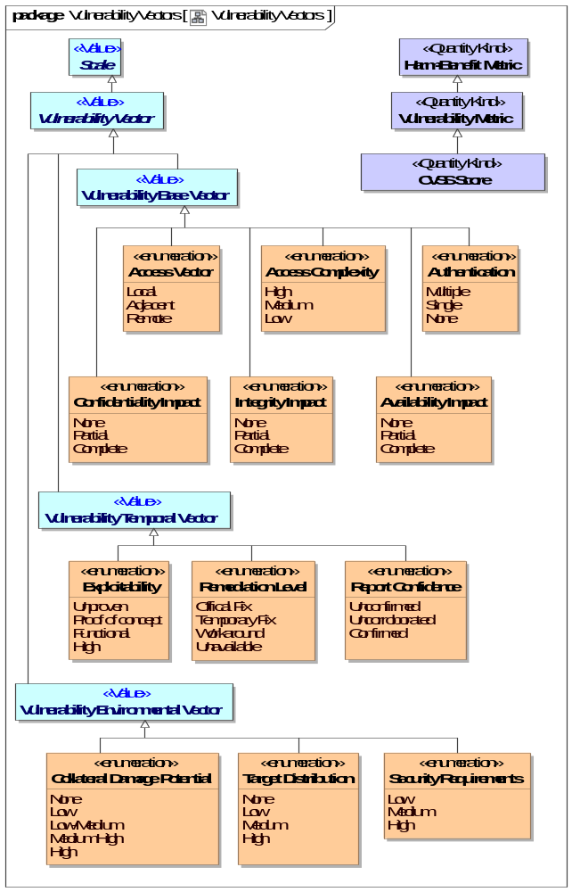
- Vulnerability Vectors

Class CVSS Score <<Quantity Kind>>
Common Vulnerability Scoring System. A number in the range of 0..10 representing a CVSS metric.
[CVSS]
Direct Supertypes
Vulnerability Metric

Enumeration Access Complexity
[CVSS] This metric measures the complexity of the attack required to exploit the vulnerability once an attacker has gained access to the target system. For example, consider a buffer overflow in an Internet service:
once the target system is located, the attacker can launch an exploit at will.
Other vulnerabilities, however, may require additional steps in order to be exploited. For example, a vulnerability in an email client is only exploited after the user downloads and opens a tainted attachment.
The lower the required complexity, the higher the vulnerability score.
Direct Known Superclasses
Vulnerability Base Vector
package Threat-risk-conceptual-model::Threat and Risk Specific Concepts::Vulnerabilities::Vulnerability Vectors
public enum Access Complexity
{High, Medium, Low}

Literals
High
Specialized access conditions exist. For example:
- In most configurations, the attacking party must already have elevated privileges or spoof additional systems in addition to the attacking system (e.g., DNS hijacking).
- The attack depends on social engineering methods that would be easily detected by
- knowledgeable people. For example, the victim must perform several suspicious or
- atypical actions.
- The vulnerable configuration is seen very rarely in practice.
- If a race condition exists, the window is very narrow.
Medium
The access conditions are somewhat specialized; the following are examples:
- The attacking party is limited to a group of systems or users at some level of authorization, possibly untrusted.
- Some information must be gathered before a successful attack can be launched.
- The affected configuration is non-default, and is not commonly configured (e.g., a vulnerability present when a server performs user account authentication via a specific scheme, but not present for another authentication scheme).
- The attack requires a small amount of social engineering that might occasionally fool cautious users (e.g., phishing attacks that modify a web browser’s status bar to show a false link, having to be on someone’s “buddy” list before sending an IM exploit).
Low
Specialized access conditions or extenuating circumstances do not exist. The following are
examples:
- The affected product typically requires access to a wide range of systems and users, possibly anonymous and untrusted (e.g., Internet-facing web or mail server).
- The affected configuration is default or ubiquitous.
- The attack can be performed manually and requires little skill or additional information gathering.
- The “race condition” is a lazy one (i.e., it is technically a race but easily winnable).

Enumeration Access Vector
[CVSS]This metric reflects how the vulnerability is exploited. The more remote an attacker can be to attack a host, the greater the vulnerability score.
Direct Known Superclasses
Vulnerability Base Vector
package Threat-risk-conceptual-model::Threat and Risk Specific Concepts::Vulnerabilities::Vulnerability Vectors
public enum Access Vector
{Local, Adjacent, Remote}

Literals
Local
Local access to a vulnerable resource.
[cvss]A vulnerability exploitable with only local access requires the attacker to have either physical access to the vulnerable system or a local (shell) account. Examples of locally exploitable vulnerabilities are peripheral attacks such as Firewire/USB DMA attacks, and local privilege escalations (e.g., sudo).
Adjacent
A resource vulnerable to an attacker with have access adjacent to the vulnerable resource.
[cvss] Adjacent Network. A vulnerability exploitable with adjacent network access requires the attacker to have access to either the broadcast or collision domain of the vulnerable software. Examples of local networks include local IP subnet, Bluetooth, IEEE 802.11, and local Ethernet segment.
Remote
A vulnerability that does not require physical or virtual proximity.
[cvss] Network: A vulnerability exploitable with network access means the vulnerable software is bound to the network stack and the attacker does not require local network access or local access.
Such a vulnerability is often termed “remotely exploitable”. An example of a network attack is an RPC buffer overflow.

Enumeration Authentication
[CVSS] This metric measures the number of times an attacker must authenticate to a target in order to exploit a vulnerability. This metric does not gauge the strength or complexity of the authentication process, only that an attacker is required to provide credentials before an exploit may occur. The fewer authentication instances that are required, the higher the vulnerability score.
It is important to note that the Authentication metric is different from Access Vector. Here, authentication requirements are considered once the system has already been accessed. Specifically, for locally exploitable vulnerabilities, this metric should only be set to “single” or “multiple” if authentication is needed beyond what is required to log into the system. An example of a locally exploitable vulnerability that requires authentication is one affecting a database engine listening on a Unix domain socket (or some other non-network interface). If the user must authenticate as a valid database user in order to exploit the vulnerability, then this metric should be set to “single.”
Direct Known Superclasses
Vulnerability Base Vector
package Threat-risk-conceptual-model::Threat and Risk Specific Concepts::Vulnerabilities::Vulnerability Vectors
public enum Authentication
{Multiple, Single, None}

Literals
Multiple
Exploiting the vulnerability requires that the attacker authenticate two or more times, even if the same credentials are used each time. An example is an attacker authenticating to an operating system in addition to providing credentials to access an application hosted on that system.
Single
One instance of authentication is required to access and exploit the vulnerability.
None
Authentication is not required to access and exploit the vulnerability.

Enumeration Availability Impact
[CVSS] Impact affecting the availability of a resource for its intended use.
Direct Known Superclasses
Vulnerability Base Vector
package Threat-risk-conceptual-model::Threat and Risk Specific Concepts::Vulnerabilities::Vulnerability Vectors
public enum Availability Impact
{None, Partial, Complete}

Literals
None
[cvss] There is no impact to the availability of the system.
Partial
[cvss] There is reduced performance or interruptions in resource availability. An example is a network-based flood attack that permits a limited number of successful connections to an Internet service.
Complete
[cvss] There is a total shutdown of the affected resource. The attacker can render the resource completely unavailable.

Enumeration Collateral Damage Potential
[CVSS] This metric measures the potential for loss of life or physical assets through damage or theft of property or equipment. The metric may also measure economic loss of productivity or revenue. Naturally, the greater the damage potential, the higher the vulnerability score.
Direct Known Superclasses
Vulnerability Environmental Vector
package Threat-risk-conceptual-model::Threat and Risk Specific Concepts::Vulnerabilities::Vulnerability Vectors
public enum Collateral Damage Potential
{None, Low, Low-Medium, Medium High, High}

Literals
None
[cvss] There is no potential for loss of life, physical assets, productivity, or revenue.
Low
[cvss] A successful exploit of this vulnerability may result in slight physical or property damage. Or, there may be a slight loss of revenue or productivity to the organization.
Low-Medium
[cvss] A successful exploit of this vulnerability may result in moderate physical or property
damage. Or, there may be a moderate loss of revenue or productivity to the
organization.
Medium High
[cvss] A successful exploit of this vulnerability may result in significant physical or property damage or loss. Or, there may be a significant loss of revenue or productivity.
High
[cvss] A successful exploit of this vulnerability may result in catastrophic physical or property damage and loss. Or, there may be a catastrophic loss of revenue or productivity.

Enumeration Confidentiality Impact
[CVSS] This metric measures the impact on confidentiality of a successfully exploited vulnerability.
Confidentiality refers to limiting information access and disclosure to only authorized users, as well as preventing access by, or disclosure to, unauthorized ones. Increased confidentiality impact increases the vulnerability score.
Direct Known Superclasses
Vulnerability Base Vector
package Threat-risk-conceptual-model::Threat and Risk Specific Concepts::Vulnerabilities::Vulnerability Vectors
public enum Confidentiality Impact
{None, Partial, Complete}

Literals
None
[cvss] There is no impact to the confidentiality of the system.
Partial
[cvss] There is considerable informational disclosure. Access to some system files is
possible, but the attacker does not have control over what is obtained, or the scope of
the loss is constrained. An example is a vulnerability that divulges only certain tables
in a database.
Complete
[cvss] There is total information disclosure, resulting in all system files being revealed. The attacker is able to read all of the system's data (memory, files, etc.)

Enumeration Exploitability
This metric measures the current state of exploit techniques or code availability. Public availability of easy-to-use exploit code increases the number of potential attackers by including those who are unskilled, thereby increasing the severity of the vulnerability.
Initially, real-world exploitation may only be theoretical. Publication of proof of concept code, functional exploit code, or sufficient technical details necessary to exploit the vulnerability may follow. Furthermore, the exploit code available may progress from a proof-of-concept demonstration to exploit code that is successful in exploiting the vulnerability consistently. In severe cases, it may be delivered as the payload of a network-based worm or virus. The more easily a vulnerability can be exploited, the higher the vulnerability score.
Direct Known Superclasses
Vulnerability Temporal Vector
package Threat-risk-conceptual-model::Threat and Risk Specific Concepts::Vulnerabilities::Vulnerability Vectors
public enum Exploitability
{Unproven, Proof of concept, Functional, High}

Literals
Unproven
[cvss] No exploit [code] is available, or an exploit is entirely theoretical.
Proof of concept
[cvss] Proof-of-concept exploit [code] or an attack demonstration that is not practical for most systems is available. The code or technique is not functional in all situations and may require substantial modification by a skilled attacker.
Functional
[cvss] Functional exploit [code] is available. The [code/exploit] works in most situations where the vulnerability exists.
High
[cvss] Either the vulnerability is exploitable by functional mobile autonomous code, or no exploit is required (manual trigger) and details are widely available. The code works in every situation, or is actively being delivered via a mobile autonomous agent (such as a worm or virus).

Enumeration Integrity Impact
[CVSS] This metric measures the impact to integrity of a successfully exploited vulnerability. Integrity refers to the trustworthiness and guaranteed veracity of information. Increased integrity impact increases the vulnerability score.
Direct Known Superclasses
Vulnerability Base Vector
package Threat-risk-conceptual-model::Threat and Risk Specific Concepts::Vulnerabilities::Vulnerability Vectors
public enum Integrity Impact
{None, Partial, Complete}

Literals
None
[cvss] There is no impact to the integrity of the system.
Partial
Control over the system is partially comprised.
[cvss] Modification of some system files or information is possible, but the attacker does not have control over what can be modified, or the scope of what the attacker can affect is limited. For example, system or application files may be overwritten or modified, but either the attacker has no control over which files are affected or the attacker can modify files within only a limited context or scope.
Complete
[CVSS] There is a total compromise of system integrity. There is a complete loss of system protection, resulting in the entire system being compromised.

Enumeration Remediation Level
[CVSS] A way to express the degree of remediation that can be provided.
Direct Known Superclasses
Vulnerability Temporal Vector
package Threat-risk-conceptual-model::Threat and Risk Specific Concepts::Vulnerabilities::Vulnerability Vectors
public enum Remediation Level
{Offical Fix, Temporary Fix, Workaround, Unavailable}

Literals
Offical Fix
[cvss] A complete vendor solution is available. Either the vendor has issued an official patch, or an upgrade is available.
Temporary Fix
[cvss] There is an official but temporary fix available. This includes instances where the vendor issues a temporary hotfix, tool, or workaround.
Workaround
[cvss] There is an unofficial, non-vendor solution available. In some cases, users of the affected technology will create a patch of their own or provide steps to work around or otherwise mitigate the vulnerability.
Unavailable
[cvss] There is either no solution available or it is impossible to apply

Enumeration Report Confidence
[CVSS] Confidence in a report.
Direct Known Superclasses
Vulnerability Temporal Vector
package Threat-risk-conceptual-model::Threat and Risk Specific Concepts::Vulnerabilities::Vulnerability Vectors
public enum Report Confidence
{Unconfirmed, Uncorroborated, Confirmed}

Literals
Unconfirmed
[cvss] There is a single unconfirmed source or possibly multiple conflicting reports. There is little confidence in the validity of the reports. An example is a rumor that surfaces from the hacker underground.
Uncorroborated
[cvss] There are multiple non-official sources, possibly including independent security companies or research organizations. At this point there may be conflicting technical details or some other lingering ambiguity.
Confirmed
[cvss] The vulnerability has been acknowledged by the vendor or author of the affected technology. The vulnerability may also be “Confirmed” when its existence is confirmed from an external event such as publication of functional or proof-of-concept exploit code or widespread exploitation.

Enumeration Security Requirements
[CVSS] These metrics enable the analyst to customize the CVSS score depending on the importance of the affected IT asset to a user’s organization, measured in terms of confidentiality, integrity, and availability. That is, if an IT asset supports a business function for which availability is most important, the analyst can assign a greater value to availability, relative to confidentiality and integrity. Each security requirement has three possible values: “low,” “medium,” or “high.” The full effect on the environmental score is determined by the corresponding base impact metrics. That is, these metrics modify the environmental score by reweighting the (base) confidentiality, integrity, and availability impact metrics. For example, the confidentiality impact (C) metric has increased weight if the confidentiality requirement (CR) is “high.” Likewise, the confidentiality impact metric has decreased weight if the confidentiality requirement is “low.” The confidentiality impact metric weighting is neutral if the confidentiality requirement is “medium.” This same logic is applied to the integrity and availability requirements.
Note that the confidentiality requirement will not affect the environmental score if the (base) confidentiality impact is set to “none.” Also, increasing the confidentiality requirement from “medium” to “high” will not change the environmental score when the (base) impact metrics are set to “complete.”
This is because the impact sub score (part of the base score that calculates impact) is already at a maximum value of 10.
The greater the security requirement, the higher the score (remember that “medium” is considered the default).
Direct Known Superclasses
Vulnerability Environmental Vector
package Threat-risk-conceptual-model::Threat and Risk Specific Concepts::Vulnerabilities::Vulnerability Vectors
public enum Security Requirements
{Low, Medium, High}

Literals
Low
[cvss] Loss of [confidentiality | integrity | availability] is likely to have only a limited adverse effect on the organization or individuals' associated with the organization (e.g., employees, customers).
Medium
[cvss] Loss of [confidentiality | integrity | availability] is likely to have a serious adverse effect on the organization or individuals' associated with the organization (e.g., employees, customers).
High
[cvss] Loss of [confidentiality | integrity | availability] is likely to have a catastrophic adverse effect on the organization or individuals' associated with the organization (e.g., employees, customers)

Enumeration Target Distribution
[CVSS] This metric measures the proportion of vulnerable systems. It is meant as an environment-specific indicator in order to approximate the percentage of systems that could be affected by the vulnerability.
The greater the proportion of vulnerable systems, the higher the score.
Direct Known Superclasses
Vulnerability Environmental Vector
package Threat-risk-conceptual-model::Threat and Risk Specific Concepts::Vulnerabilities::Vulnerability Vectors
public enum Target Distribution
{None, Low, Medum, High}

Literals
None
[cvss] No target systems exist, or targets are so highly specialized that they only exist in a laboratory setting. Effectively 0% of the environment is at risk.
Low
[cvss] Targets exist inside the environment, but on a small scale. Between 1% - 25% of the total environment is at risk.
Medum
[cvss] Targets exist inside the environment, but on a medium scale. Between 26% - 75% of the total environment is at risk
High
[cvss] Targets exist inside the environment on a considerable scale. Between 76% - 100% of the total environment is considered at risk.

Threat-risk-conceptual-model::Threat and Risk Specific Concepts::Weapons

Diagram: Weapons
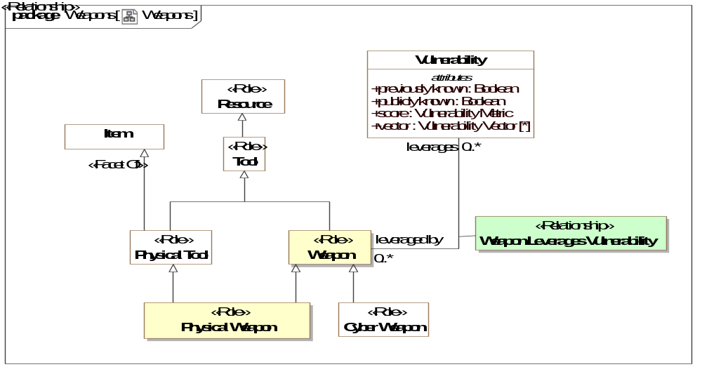
- Weapons

Class Physical Weapon <<Role>>
A physical item intended to exploit a vulnerability and cause harm to some class of entities.
Direct Supertypes
Physical Tool, Weapon

Class Weapon <<Role>>
Role of something used by an actor to cause harm by exploiting vulnerabilities.
Direct Supertypes
Tool

Association Class Weapon Leverages Vulnerability <<Relationship>>
Relationship defining the weapons that can leverage (exploit) a vulnerability.
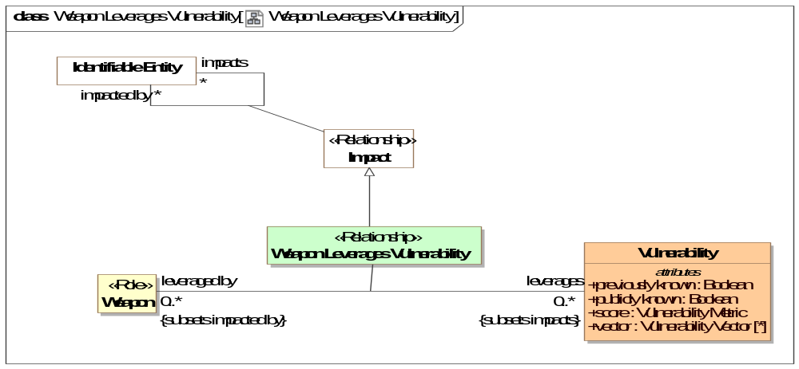
- Weapon Leverages Vulnerability
Direct Supertypes
Impact
Association Ends
leverages : Vulnerability [0..*] Redefines: vulnerability of: Resource
Vulnerability that a weapon helps an actor take advantage of.
leveraged by : Weapon [0..*] Redefines: vulnerability of: Resource
Weapon that can leverage a vulnerability to help an actor take advantage of that vulnerability.

