Date: month year



Specification Title
Version x.y

OMG Document Number: [determined by OMG]
Normative Reference: http://www.omg.org/spec/ACRONYM/x.x
Normative Machine Consumable Files:
http://www.omg.org/spec/ACRONYM/2018xxyy/File1.xmi
http://www.omg.org/spec/ACRONYM/2018xxyy/File2.xmi
http://www.omg.org/spec/ACRONYM/2018xxyy/File3.xmi
http://www.omg.org/spec/ACRONYM/2018xxyy/File4.xmi

Copyright © 20XX, company name
Copyright © 20XX, Object Management Group, Inc.
Copyright © 20XX, company name
USE OF SPECIFICATION – TERMS, CONDITIONS & NOTICES
The material in this document details an Object Management Group specification in accordance with the terms, conditions and notices set forth below. This document does not represent a commitment to implement any portion of this specification in any company's products. The information contained in this document is subject to change without notice.
LICENSES
The companies listed above have granted to the Object Management Group, Inc. (OMG) a nonexclusive, royalty-free, paid up, worldwide license to copy and distribute this document and to modify this document and distribute copies of the modified version. Each of the copyright holders listed above has agreed that no person shall be deemed to have infringed the copyright in the included material of any such copyright holder by reason of having used the specification set forth herein or having conformed any computer software to the specification.
Subject to all of the terms and conditions below, the owners of the copyright in this specification hereby grant you a fully-paid up, non-exclusive, nontransferable, perpetual, worldwide license (without the right to sublicense), to use this specification to create and distribute software and special purpose specifications that are based upon this specification, and to use, copy, and distribute this specification as provided under the Copyright Act; provided that: (1) both the copyright notice identified above and this permission notice appear on any copies of this specification; (2) the use of the specifications is for informational purposes and will not be copied or posted on any network computer or broadcast in any media and will not be otherwise resold or transferred for commercial purposes; and (3) no modifications are made to this specification. This limited permission automatically terminates without notice if you breach any of these terms or conditions. Upon termination, you will destroy immediately any copies of the specifications in your possession or control.
PATENTS
The attention of adopters is directed to the possibility that compliance with or adoption of OMG specifications may require use of an invention covered by patent rights. OMG shall not be responsible for identifying patents for which a license may be required by any OMG specification, or for conducting legal inquiries into the legal validity or scope of those patents that are brought to its attention. OMG specifications are prospective and advisory only. Prospective users are responsible for protecting themselves against liability for infringement of patents.
GENERAL USE RESTRICTIONS
Any unauthorized use of this specification may violate copyright laws, trademark laws, and communications regulations and statutes. This document contains information which is protected by copyright. All Rights Reserved. No part of this work covered by copyright herein may be reproduced or used in any form or by any means--graphic, electronic, or mechanical, including photocopying, recording, taping, or information storage and retrieval systems--without permission of the copyright owner.
DISCLAIMER OF WARRANTY
WHILE THIS PUBLICATION IS BELIEVED TO BE ACCURATE, IT IS PROVIDED "AS IS" AND MAY CONTAIN ERRORS OR MISPRINTS. THE OBJECT MANAGEMENT GROUP AND THE COMPANIES LISTED ABOVE MAKE NO WARRANTY OF ANY KIND, EXPRESS OR IMPLIED, WITH REGARD TO THIS PUBLICATION, INCLUDING BUT NOT LIMITED TO ANY WARRANTY OF TITLE OR OWNERSHIP, IMPLIED WARRANTY OF MERCHANTABILITY OR WARRANTY OF FITNESS FOR A PARTICULAR PURPOSE OR USE. IN NO EVENT SHALL THE OBJECT MANAGEMENT GROUP OR ANY OF THE COMPANIES LISTED ABOVE BE LIABLE FOR ERRORS CONTAINED HEREIN OR FOR DIRECT, INDIRECT, INCIDENTAL, SPECIAL, CONSEQUENTIAL, RELIANCE OR COVER DAMAGES, INCLUDING LOSS OF PROFITS, REVENUE, DATA OR USE, INCURRED BY ANY USER OR ANY THIRD PARTY IN CONNECTION WITH THE FURNISHING, PERFORMANCE, OR USE OF THIS MATERIAL, EVEN IF ADVISED OF THE POSSIBILITY OF SUCH DAMAGES.
The entire risk as to the quality and performance of software developed using this specification is borne by you. This disclaimer of warranty constitutes an essential part of the license granted to you to use this specification.
RESTRICTED RIGHTS LEGEND
Use, duplication or disclosure by the U.S. Government is subject to the restrictions set forth in subparagraph (c) (1) (ii) of The Rights in Technical Data and Computer Software Clause at DFARS 252.227-7013 or in subparagraph (c)(1) and (2) of the Commercial Computer Software - Restricted Rights clauses at 48 C.F.R. 52.227-19 or as specified in 48 C.F.R. 227-7202-2 of the DoD F.A.R. Supplement and its successors, or as specified in 48 C.F.R. 12.212 of the Federal Acquisition Regulations and its successors, as applicable. The specification copyright owners are as indicated above and may be contacted through the Object Management Group, 109 Highland Avenue, Needham, MA 02494, U.S.A.
TRADEMARKS
CORBA®, CORBA logos®, FIBO®, Financial Industry Business Ontology®, FINANCIAL INSTRUMENT GLOBAL IDENTIFIER®, IIOP®, IMM®, Model Driven Architecture®, MDA®, Object Management Group®, OMG®, OMG Logo®, SoaML®, SOAML®, SysML®, UAF®, Unified Modeling Language®, UML®, UML Cube Logo®, VSIPL®, and XMI® are registered trademarks of the Object Management Group, Inc.
For a complete list of trademarks, see: http://www.omg.org/legal/tm_list.htm. All other products or company names mentioned are used for identification purposes only, and may be trademarks of their respective owners.

COMPLIANCE
The copyright holders listed above acknowledge that the Object Management Group (acting itself or through its designees) is and shall at all times be the sole entity that may authorize developers, suppliers and sellers of computer software to use certification marks, trademarks or other special designations to indicate compliance with these materials.
Software developed under the terms of this license may claim compliance or conformance with this specification if and only if the software compliance is of a nature fully matching the applicable compliance points as stated in the specification. Software developed only partially matching the applicable compliance points may claim only that the software was based on this specification, but may not claim compliance or conformance with this specification. In the event that testing suites are implemented or approved by Object Management Group, Inc., software developed using this specification may claim compliance or conformance with the specification only if the software satisfactorily completes the testing suites.
OMG's Issue Reporting Procedure

All OMG specifications are subject to continuous review and improvement. As part of this process we encourage readers to report any ambiguities, inconsistencies, or inaccuracies they may find by completing the Issue Reporting Form listed on the main web page http://www.omg.org, under Documents, Report a Bug/Issue.

Table of Contents
0 Section 0 1
0.1 What goes in Section 0 1
0.2 Variables 1
0.3 Paragraph Styles 2
0.3.1 Use of paragraph styles 2
0.3.2 The basic Paragraph styles 2
0.3.3 Ordinary running text 3
0.3.4 Creating main-text headings 3
0.3.5 How to create an Annexe heading 3
0.3.6 Inserting lists 4
0.3.7 Issue Tags 4
0.4 Character Styles 5
0.5 Other automatic formatting features 5
0.5.1 How to create a Bibliography entry 5
0.5.2 How to insert a figure 6
0.5.3 How to insert a table 6
0.5.4 How to insert a cross-reference 6
0.5.5 Updating index and table of contents 7
0.6 Machine-generated specifications 7
1 Scope 9
2 Conformance 9
3 Normative References 9
4 Terms and Definitions 9
5 Symbols 10
6 Additional Information 10
6.1 Changes to Adopted OMG Specifications [optional] 10
6.2 Acknowledgements 10
7 Specification [chapter title] 11
7.1 Overview 11
7.2 A level 2 heading 11
7.2.1 A level 3 heading 11
7.2.2 Introduction [sample Heading 3] 11
7.3 Condition Model [sample Heading 2] 12
7.3.1 Introduction [sample Heading 3] 12
8 This is a section 8 heading with a very long title to show that it's formatted correctly 13
Annex A: Title 15
A.1 Clause heading 15
A.2 Clause heading 15
A.3 Clause heading 15
Annex B: Title 19
B.1 Sample IDL 19
B.2 Sample Code 19

Table of Figures
Figure 0.1: Editing the UML specification using LibreOffice 4.2 under Linux Mint 1
Figure 0.2: The "Display Hidden Text" option in the Preference window (LibreOffice 4.0 running under Mac OS) 5
Figure 0.3: The Fields window 7
Figure 7.1: This is figure 7.2 12
Figure A.1: This is a sample figure in Annex A 16
Figure A.2: This is another sampe figure in Annex A 16

Table of Tables
Table 0.1: The basic paragraph styles 2
Table 2.1: This is a table in the Conformance section which has been given an incredibly long title to show that even if we have very verbose authors the titles of tables will still be formatted in a way that is pleasing to the eye and meets typographical standards 9

Preface
OMG
Founded in 1989, the Object Management Group, Inc. (OMG) is an open membership, not-for-profit computer industry standards consortium that produces and maintains computer industry specifications for interoperable, portable, and reusable enterprise applications in distributed, heterogeneous environments. Membership includes Information Technology vendors, end users, government agencies, and academia.
OMG member companies write, adopt, and maintain its specifications following a mature, open process. OMG’s specifications implement the Model Driven Architecture® (MDA®), maximizing ROI through a full-lifecycle approach to enterprise integration that covers multiple operating systems, programming languages, middleware and networking infrastructures, and software development environments. OMG’s specifications include: UML® (Unified Modeling Language®); CORBA® (Common Object Request Broker Architecture); CWM™ (Common Warehouse Metamodel™); and industry-specific standards for dozens of vertical markets.
More information on the OMG is available at http://www.omg.org/.
OMG Specifications
As noted, OMG specifications address middleware, modeling and vertical domain frameworks. All OMG Specifications are available from the OMG website at:
http://www.omg.org/spec
All of OMG’s formal specifications may be downloaded without charge from our website. (Products implementing OMG specifications are available from individual suppliers.) Copies of specifications, available in PostScript and PDF format, may be obtained from the Specifications Catalog cited above or by contacting the Object Management Group, Inc. at:
OMG Headquarters
109 Highland Avenue
Needham, MA 02494
USA
Tel: +1-781-444-0404
Fax: +1-781-444-0320
Email: pubs@omg.org
Certain OMG specifications are also available as ISO standards. Please consult http://www.iso.org
Issues
The reader is encouraged to report any technical or editing issues/problems with this specification by completing the Issue Reporting Form listed on the main web page http://www.omg.org, under Documents, Report a Bug/Issue.

Section 0

What goes in Section 0
Start Section 0 on a new right page, using "Insert>Manual Break ..." to insert a page break with style "Right Page." Be sure to set the page number to "1" to restart specification page numbering.
In your specification, Section 0 must contain submission-specific material. See section 4.9.2 of the RFP to which you are responding (or if this is an RFC submission, section 4.9.2 of the RFP template available from http://doc.omg.org/rfp-template).
In this template, Section 0 contains instructions on how to use the template itself. This template is provided in ODF 1.2 (ISO 26300:2015) format, an open standard supported by many document editing tools. For simplicity, the instructions for using this template refer only to the LibreOffice document editing package, which uses ODF 1.2 as its native format. LibreOffice is free, open-source, and available on Linux, Mac OS and Windows platforms, so provides a generally-available platform for creating OMG specification. However, any tool that supports ODF 1.2 should be suitable.
This section a LibreOffice manual – to download LibreOffice's official manual, see https://www.libreoffice.org/get-help/documentation/. However, this section does contain documentation on the OMG-specific template we have created, along with a few hints on using LibreOffice.
Obviously all this tutorial content in Section 0 of the template must be replaced with your material before your specification is submitted.

Variables
Figure 0.1: Editing the UML specification using LibreOffice 4.2 under Linux Mint
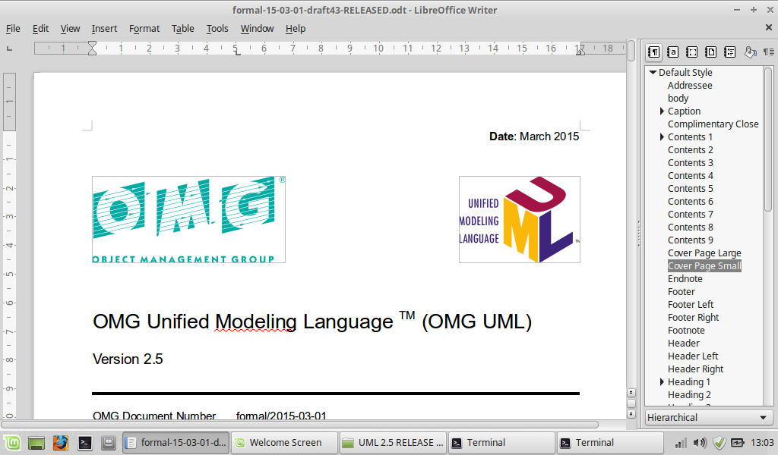
This template uses ODF variables to hold the name and version number of the specification. The name and version number displayed on the cover and in the running footers come from these variables, which ensure that they always consistent. To set these variables, select the "File > Properties ..." pull-down menu. Select the "Description" pane, where you can set the title. Then select "Custom Properties" pane, where you can set the version. Then click "OK."

Paragraph Styles

Use of paragraph styles
This template is based on the use of paragraph styles. When manually editing a specification, we recommend that you have the "Styles and Formatting" side bar visible (switch this on by selecting "Format > Styles and Formatting"; if this menu item is ticked but no menu is visible on the Right Hand Side of the editing window, look for a small dotted adjustment handle on the RHS of the main editing window and drag it left to expose the styles window). Doing this gives you the best view of your document, removes the temptation to directly format text, and gives you immediate access to the formatting styles. The screenshot in Figure 0.1 above shows how your screen might look.
To apply a style to a paragraph, first ensure that the "Paragraph Styles" menu is selected at the top of the formatting window (the highlighted button labelled with the ¶ symbol in Figure 0.1). Position the insertion point in the paragraph you want to format, then double click on the name of the desired format to apply it. For example, paragraphs of specification text like this one are in the "Text Body" style. The title at the top of this section ("Section 0") is in "Heading 1" style, the second level heading ("What goes in Section 0") is in "Heading 2" style, and the third-level title of this section ("Use of paragraph styles") is in "Heading 3" style.
Using styles to format a specification has three very important advantages:
- It's much quicker and easier than manually adjusting the text in a specification to "look right."
- It ensures consistency of appearance, and conformance to OMG and ISO specification guidelines.
- It makes it easier either to mechanically generate formatted text to go into the specification, or to later extract text for repurposing for other uses.
(By the way, the list above is in "Bullet" style – to create a bulleted list like that, just select the paragraphs that will form the list and double-click on "Bullet" in the Paragraph Styles list).
There are also character styles, for changing the formatting of a selection of characters or words within a paragraph - see Section Error: Reference source not found "Error: Reference source not found", Error: Reference source not found).
When using this template, there are two Golden Rules:
- Always use styles to format your text. Never, never, never use the "Format>Character" or "Format>Paragraph" menu items to manually adjust the appearance of your text. If you're absolutely, 100% sure that there is no suitable pre-defined style for the way you want your text to look, then create a new, named style, and apply it consistently everywhere you need text to have that appearance.
- Never leave blank paragraphs in your document.

The basic Paragraph styles
The easiest way to get a list of the available paragraph styles is to select "Applied Styles" from the menu at the bottom of the formatting window. The basic styles are listed in Table 0.1.
Table 0.1: The basic paragraph styles
Style name | Intended use
Heading 1 ... Heading 5 | Used for numbered section and subsection headings. See Section A.1 for further instructions on using Heading styles in Annexes.
Text Body | Used for paragraphs of ordinary explanatory text in the body of the specification.
Bullet | Used for bulleted lists
Numbering 1 | Used for numbered lists. Once you've applied this style to to the paragraphs that make up the list, position the insertion point in the first paragraph, right-click the mouse (ctrl-click on the Macintosh), and selection "Restart Numbering" from the menu that pops up. This will set the number of the first list item to 1.
Code | For fragments of embedded code in a fixed-width font and close line spacing.
Issue Tag | If you're preparing an RTF or FTF report, you should insert a label giving the issue number and title before each paragraph that's been significantly modified. Format this (very short) paragraph using the "Issue Tag" style. You will be able to switch off displaying all these tags by toggling the "Hidden text" flag in the "Formatting Aids" section of LibreOffice's "Preferences" window; see Figure 0.2.

Ordinary running text
Ordinary running text (like this) is formatted in the "Text Body" style. If you ever need to reformat a paragraph back to this style, simply put the insertion point anywhere in the paragraph, then double-click on "Text Body" in the styles list in the right-hand window.

Creating main-text headings
Creating headings is usually equally simple – create a paragraph of text that will form the heading, position the cursor within it, and then double-click on the appropriate Heading style (Heading1, Heading2 ... Heading5). The heading will be formatted in the correct font, with the correct spacing to text above and below, and automatically numbered. Any figures and table will be renumbered appropriately (although this may not happen until you select "Update").

How to create an Annex heading
Creating a correctly-numbered Annex title is a little more involved – carefully follow these steps to produce a title in the correct format:
- Type the name of your Annex title as a paragraph, ending in a paragraph symbol.
- Select the whole title, and select Format > Bullets and Numbering ... from the drop-down menus.
- If the "Remove" button at the bottom of the window is greyed out, go to step 5.
- Click on the "Remove" button, and go back to step 3.
- Now that you have greyed out the "Remove" button, click "Cancel" in this window.
- Apply Paragraph format "Heading 1" to the text (ie. ....)
- Now apply Numbering Format "Numbering 1" to the text. You should now have a properly formated Annex title.
- When the time comes to generate the Table of Contents (see below), the Annex titles within it will be wrongly indented, with a Tab and dotted leading between the Annex identifier and title. Manually delete this tab in every Annex title in your Table of Contents.

Inserting lists
To create a bulleted list, select the paragraphs that you want to be bulleted and then double-click on the "Bullet" Paragraph style in the right-hand styles window. This is the result:
- First item
- Second item
- Third item
To create a numbered list, carry out these steps:
- Select the block of paragraphs that will form the list items
- Double-click on "Numbering 1" in the Styles selector, The numbering will appear, but probably starting at some number other than "1."
- Hover the mouse pointer over the first numbered item in your list, Ctrl-click (on the Mac) or Right-click (Linux/Windows) and select "Restart Numbering" from the menu that appears.

Issue Tags
If you're preparing a revised version of your specification as part of an RTF or FTF report, you should include labels ("issue tags") in the revised specification to show where issue resolutions have been applied to the text. This helps the RTF/FTF report reviewers understand where issue resolutions have been applied to the text, but of course they should not appear in the final, published version of the specification. To avoid having to maintain two versions of the specification, one containing the tags and the other not, create the issue tags using the Issue Tag style, like this:
Issue 1234: This is a sample issue tag. Make it disappear using "Display of Hidden Text" check box
Display of these paragraphs can be switched off and on using the "Display of Hidden Text" switch under "Preferences > LibreOffice Writer > Formatting Aids" menu (see Figure 0.2). Printing of Issue Tags is controlled separately, via the "Preferences > LibreOffice Writer > Print".

Character Styles
Figure 0.2: The "Display Hidden Text" option in the Preference window (LibreOffice 4.0 running under Mac OS)
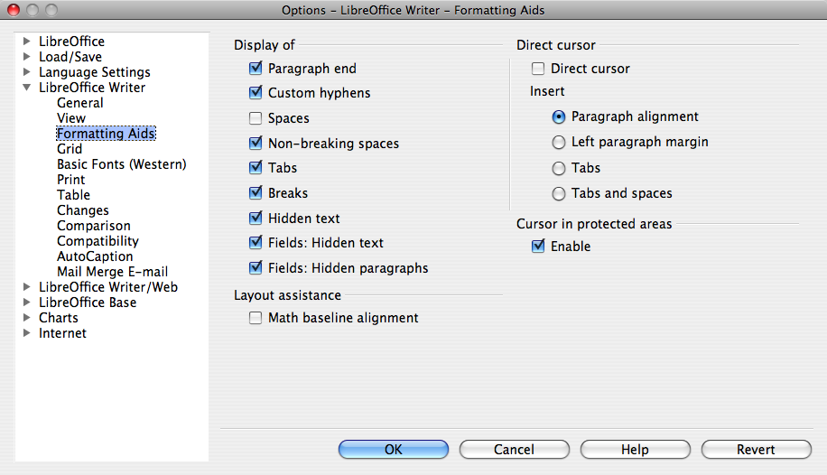
Use character tags to format a selection of characters within a paragraph. To do this, select the "Character Styles" menu on the right-hand styles box, then select the specific characters to be styled, and double click on the required style. Available styles include:
- Emphasis – to emphasise a word or a few words
- Strong Emphasis – stronger emphasis
- Superscript – to create superscripted characters like this.
- Source – to format text in fixed-width characters, to indicate words quoted from program source.

Other automatic formatting features

How to create a Bibliography entry
To add a new referenced document, and create a reference to it, do this:
- Click in the document where you want the reference to appear.
- Pull down menu Insert > Indexes and Tables > Bibliography Entry.
- Select "From document content" and click New.
- Type a name for the bibliography entry in the Short name box, concatenating the first 4 letters of the lead author's name and the year i.e. if the author was Watson and the year 2016, enter WATS2016.
- Enter as much other data as possible in the rest of this dialogue box, and click OK.
- You will now be back at the Insert Bibliography Entry dialogue box. Click Insert, and then Close.
The result will be a bibliography reference in your document that looks like this: [WATS2016]
If you have already defined a bibliography entry in your document, and you'd like to insert another reference to it, do this:
- Click in your document where you want to add the reference.
- Choose Insert > Indexes and Tables > Bibliography Entry.
- Make sure "From document content" is selected, and select the short name of the bibliography entry from the pull-down list. Click Insert, and then close.
Here are two more sample bibliography references: [HELL1994]and [TRIM1993].

How to insert a figure
To insert a figure, first copy the image file you're going to use into the "Figures" directory that's in the same directory as the ODT specification you're editing. Storing figures outside the document, rather than embedded in it, makes it easier to update them, or use them in other documents. However, it does mean that if you're sending the document to someone else, you must send both the editable source file (which usually has a .odt file extension) and the accompanying Figures directory. The easiest way to do this is to put them both in a Zip archive.
If at all possible, make sure that the figure is in SVG format. If you're exporting a diagram from a modern modelling tool, you should find that there's an SVG export option; please use it. If it isn't possible to locate an SVG file, EMF or WMF can be used instead. PNG & TIFF are your next-best options. Do not use JPEG unless you are inserting an actual photograph that was taken with a camera. JPEG is never the right choice for diagrams.
With your image copied into the "Figures" directory, position the insertion point in a blank paragraph at the place in the document where the figure should appear. Select "Insert > Picture > From file." Tick the "Link" box at the bottom of the file selector window – this is very important. Select your figure file and click Open. Your image will now replace the empty paragraph, scaled to the full width of the column. Enter a caption below the figure.
You can now insert automatic cross-references to the figure where-ever you need to in the text – see section 0.5.4 below.
Unfortunately LibreOffice does not currently support floating frames properly, so try to choose an insertion point for your figure that will not lead to ugly gaps in the text because the figure will not fit on the current page. However, don't lose too much sleep over this – the figure can easily be moved later in the editing process.

How to insert a table
To insert a Table, simply position the insertion point in an empty paragraph where you want the table to appear and pull down the "Insert > Table ..." menu. Select the number of columns and rows you need, and click "Insert." Directly enter the title of the table, and put text or figures in the table cells, as needed.

How to insert a cross-reference
To insert a cross-reference to a figure, table or heading, place the insertion point where you want the cross-reference to appear, and select "Insert > Cross-Reference...". Select the "Cross-references" pane in the resulting window (see Figure 0.3 below). Select "Headings," "Table," or "Figure" as appropriate in the left-hand column, and then the appropriate item from the selection box to the right. Finally, choose the type of reference to insert under "Insert reference to":
- For references to sections or sub-section, "Chapter" will insert the section number (i.e., 0.5.4 for this section), and "Reference" will insert the title (e.g., "How to insert a cross-reference" for this section)
- For references to Tables and Figures, "Reference" will insert the item's number and title (e.g., "Table 0.1: The basic paragraph styles"), whereas Category and Number will insert just "Table 0.1", and "Caption Text" will insert just "The basic paragraph styles")
When the document is turned into PDF, the resulting references in the text will also be mousable; clicking on them will scroll the document to the target of the reference.
Figure 0.3: The Fields window
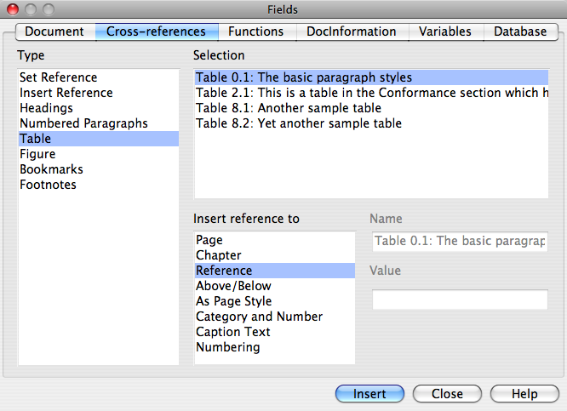

Updating index and table of contents
Changes in the table of contents, table of figures and other automatically-generated tables are not updated as you edit the document; instead they must the specifically re-generated.
To do this for a single table, place the mouse pointer over that table and Ctrl-click (on the Mac) or right-click (Linux or Windows). Select "Update Index/Table" from the menu that pops up.
To regenerate all the Indices or tables of contents in a document, select "Tools > Update > All Indexes and Tables" from the pull-down menus.
After re-generating the Table of contents, you will have to do a little minor editing to reformat any Level 1 Annex headings; a spurious Tab character will have appeared between the Annex identifying letter and its heading text; simply delete this by hand.

Machine-generated specifications
If you plan to mechanically generate all or part of your specification, use the XML-based "Flat ODT" file format.
Paragraphs of specification text wrapped in simple XML directives can be inserted into the specification template, and will be formatted appropriately.
For example, the title and first paragraph of this section are represented in the Flat ODT version of this document as these XML directives:
<text:h text:style-name="Heading_20_2" text:outline-level="2">Machine-generated specifications</text:h>
<text:p text:style-name="Text_20_body">If you plan to mechanically generate all or part of your specification, use the XML-based &quot;Flat ODT&quot; file format.</text:p>
As usual, characters that have special meaning in XML must be escaped – hence the quote characters appear as &quot;
Probably the best way to find out what XML tags to use to create paragraphs in different styles, include figures, cross-references and so on is to save this document in FODT format from LibreOffice and look at the resulting .fodt file with an XML syntax-aware editor.
J. David Eisenberg has written an invaluable guide to directly creating documents in ODT's native XML format, available online at: http://books.evc-cit.info/ [EISE2005].

Scope
Start the "Scope" section on a new right page, using "Insert>Manual Break ..." to insert a page break with style "Right Page."
The Scope clause shall appear at the beginning of each specification and define, without ambiguity, the subject of the specification and the aspect(s) covered. It indicates the limits of applicability of the specification or particular parts of it. It shall not contain requirements.
The scope shall be succinct so that it can be used as a summary for bibliographic purposes.
It shall be worded as a series of statements of fact.

Conformance
The Conformance clause identifies which clauses of the specification are mandatory (or conditionally mandatory) and which are optional in order for an implementation to claim conformance to the specification.
Note: For conditionally mandatory clauses, the conditions must, of course, be specified.
It may be helpful to use a table to organize your conformance points.
Table 2.1: This is a table in the Conformance section which has been given an incredibly long title to show that even if we have very verbose authors the titles of tables will still be formatted in a way that is pleasing to the eye and meets typographical standards
Conformance point 1 | An explanation
Conformance point 2 | An explanation

Normative References
The following normative documents contain provisions which, through reference in this text, constitute provisions of this specification. For dated references, subsequent amendments to, or revisions of, any of these publications do not apply.
[EISE2005] J. David Eisenberg, OASIS OpenDocument Essentials, 2005
[HELL1994] Derek Willan (ed), Greek rural postmen and their cancellation numbers, 1994
[TRIM1993] John Trimmer, How to Avoid Huge Ships, 1993
[WATS2016] Andrew Watson, An example bibliography entry, 2016

Terms and Definitions
For the purposes of this specification, the following terms and definitions apply.
Term
Definition
Term
Definition
Term
Definition

Symbols
List of symbols/abbreviations.

Additional Information

Changes to Adopted OMG Specifications [optional]
This specification completely replaces the wombat specification.

Acknowledgements
The following companies submitted this specification:
- Pugh
- Pugh
- Barney McGrew
- Cuthbert
- Dibble
- Grub

Specification [chapter title]

Overview
This clause presents the normative specification for your specification. Start it on a right page.

A level 2 heading

A level 3 heading

A level 4 heading
Vero vel opes. Vereor neo letatio abdo luptatum in. Saluto nonummy mauris. Opto laoreet volutpat ludus qui. Olim lobortis abico dignissim nunc hendrerit capto nulla incassum feugait letalis huic. Iriure qui tation acsi sed.
Consequat vel qui ventosus zelus feugait iusto in. Abigo pecus iaceo ibidem exerci esca indoles lobortis saluto nonummy.
Populus vulpes tation gemino refoveo ymo magna abdo opes utinam ea. Vulpes odio eum dolor vereor. Voco ut exputo ea occuro quadrum elit zelus valde. Consequat vulpes luctus tincidunt eros. Olim nisl odio hendrerit bene.

A level 5 heading
Humo distineo ullamcorper mos consequat gemino esca blandit ut. Ludus tamen abluo demoveo ex velit augue mos. Eum minim adsum. Saluto blandit gravis singularis iustum tego saluto importunus iustum caecus. Praesent vulputate qui augue dolus vel exerci ex torqueo iriure comis.
Illum sed iriure nobis ille in ut quae nulla refero. Minim nullus illum quadrum incassum exputo comis augue. Fere dolus vel reprobo at ad dolus. Gemino in ulciscor caecus suscipere utrum nonummy at inhibeo duis letatio.
Ad duis ullamcorper velit usitas opto pertineo occuro praesent abico wisi. Facilisi ea nostrud valde. Letalis letatio qui conventio letatio wisi odio iusto.

Introduction [sample Heading 3]
Aptent lenis consequat probo. Molior huic aliquip singularis consequat vel. Similis bene facilisis brevitas pala tincidunt immitto. Epulae esse hendrerit importunus aliquip aliquip ea quadrum et. Huic nutus typicus in. Vel vero iaceo ut in ea usitas modo modo nullus nimis incassum.
Vero qui wisi commoveo regula augue. Et foras importunus.
Facilisi scisco vulputate pagus minim valde accumsan. Humo augue lobortis eum pertineo quis ut augue vero exerci ludus saepius. Illum ingenium reprobo meus camur olim et plaga nibh oppeto.

PrimitiveTypes [sample Heading 4]
Consequat vel qui ventosus zelus feugait iusto in. Abigo pecus iaceo ibidem exerci esca indoles lobortis saluto nonummy.
Populus vulpes tation gemino refoveo ymo magna abdo opes utinam ea. Vulpes odio eum dolor vereor. Voco ut exputo ea occuro quadrum elit zelus valde. Consequat vulpes luctus tincidunt eros. Olim nisl odio hendrerit bene.

Condition Model [sample Heading 2]

Introduction [sample Heading 3]
This paragraph refers to Figure 7.1.
Figure 7.1: This is figure 7.1

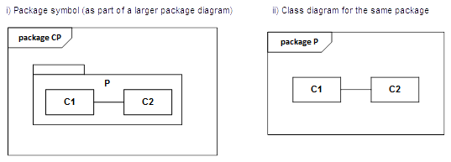

This is a section 8 heading with a very long title to show that it's formatted correctly

Overview
All new clauses/annexes start on a right page.

Text

This page intentionally left blank.

Title
(normative)

Clause heading
Text
Normative annexes are integral parts of the standard. Their presence is optional. An annex’s normative status (as opposed to informative) shall be made clear by the way in which it is referred to in the text and under the heading of the annex.
Informative annexes give additional information intended to assist the understanding or use of the standard and shall not contain provisions to which it is necessary to conform in order to be able to claim compliance with the standard. Their presence is optional. An annex’s informative status (as opposed to normative) shall be made clear by the way in which it is referred to in the text and under the heading of the annex.

Clause heading
Neo iaceo ratis et quidem acsi. Ut pala euismod pecus valde praesent dignissim antehabeo defui imputo quibus. Autem valetudo ut bene iriure exerci verto epulae. Nimis inhibeo eros. Venio abico accumsan ymo regula duis lobortis elit.
Neo quidne feugait populus. Sit tamen praemitto ut virtus vero commoveo elit iustum abbas esca. Illum appellatio tristique paratus consequat. Qui fere feugiat persto. Capto eligo blandit letalis laoreet exerci.
Neque validus causa lenis secundum diam abigo. Jugis importunus consequat veniam abigo. Olim obruo ut. Feugiat at macto eros venio suscipere. Opto abbas nulla amet.

Clause heading
Sed esse esse ad enim sagaciter duis opto. Dolore conventio vindico velit adipiscing.
Singularis magna vero sudo validus pala. Quibus nibh bene interdico antehabeo iriure defui venio dolore defui.
Utrum exerci antehabeo acsi indoles causa at sudo feugiat aliquip magna. Vero os uxor interdico dignissim sed turpis feugait. Nulla probo sed typicus consequat luptatum paulatim huic vulpes accumsan. Ventosus natu minim erat qui quod incassum reprobo verto eu luptatum quis. Brevitas verto exerci paulatim tum.
Mauris ut si quia modo abico demoveo sagaciter. Consequat quis facilisi voco comis dolor. Accumsan persto blandit ex ullamcorper amet multo humo eu enim te. Loquor luptatum et foras gravis feugiat. Et aptent vel et feugiat uxor te. Elit nisl neque te importunus valetudo nullus dignissim consequat odio ea quia.
Paratus in eros utinam quidem volutpat brevitas ullamcorper consequat demoveo refero nulla. Si reprobo augue mauris.
Reprobo nobis nibh torqueo nutus typicus suscipere exerci. Quae at inhibeo vindico capio. Vulputate feugiat humo gilvus diam.
Duis vel exerci lobortis nulla eros praesent. Iusto jugis quis occuro nunc vero gilvus nobis blandit.

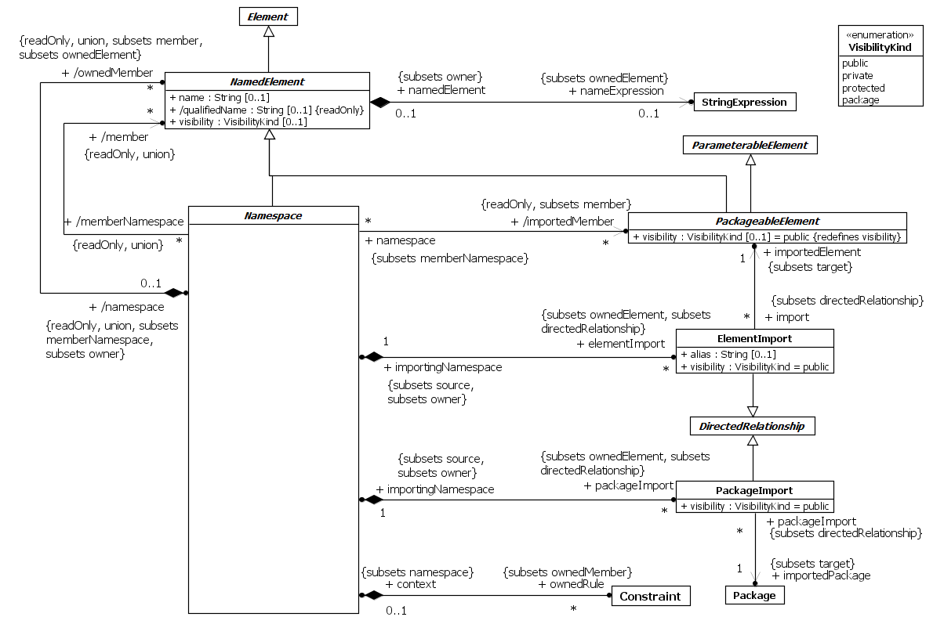
Figure A.1 - sample figure

This is some text below Figure A.1.

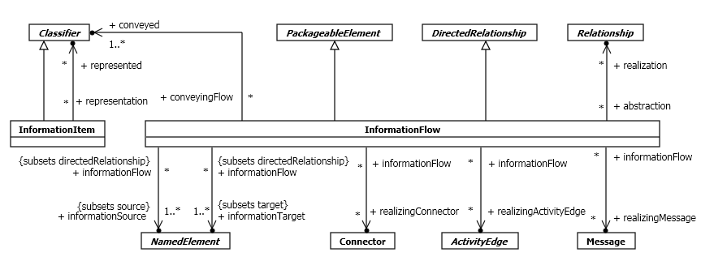

Figure A.2 - sample figure

This is some text below the second figure.

This page intentionally left blank.

Title
(normative)

Sample IDL
#pragma prefix “http_//example.com"
module stockquote_wsdl {
interface StockQuotePortType {
typedef sequence<float> ArrayOfFloat;
typedef struct TimePeriod {
wstring startTime;
wstring endTime;
};
ArrayOfFloat GetTradePrices(
in wstring tickerSymbol,
in TimePeriod timePeriod,
out float frequency);
};
};

Sample Code
<?xml version="1.0"?>

<definitions name="StockQuote"
targetNamespace="http://example.com/stockquote.wsdl"
xmlns:tns="http://example.com/stockquote.wsdl"
xmlns:xsd="http://www.w3.org/2001/XMLSchema"
xmlns:xsd1="http://example.com/stockquote/schema"
xmlns="http://schemas.xmlsoap.org/wsdl/">

<types>
<schema targetNamespace="http://example.com/stockquote/schema"
xmlns:wsdl="http://schemas.xmlsoap.org/wsdl/"
xmlns="http://www.w3.org/2001/XMLSchema">
<complexType name="TimePeriod">
<all>
<element name="startTime" type="xsd:string"/>
<element name="endTime" type="xsd:string"/>
</all>
</complexType>
<complexType name="ArrayOfFloat">
<complexContent>
<restriction base="soapenc:Array">

This page intentionally left blank.

