SMIF Conceptual Model Reference

Diagram: SMIF Packages
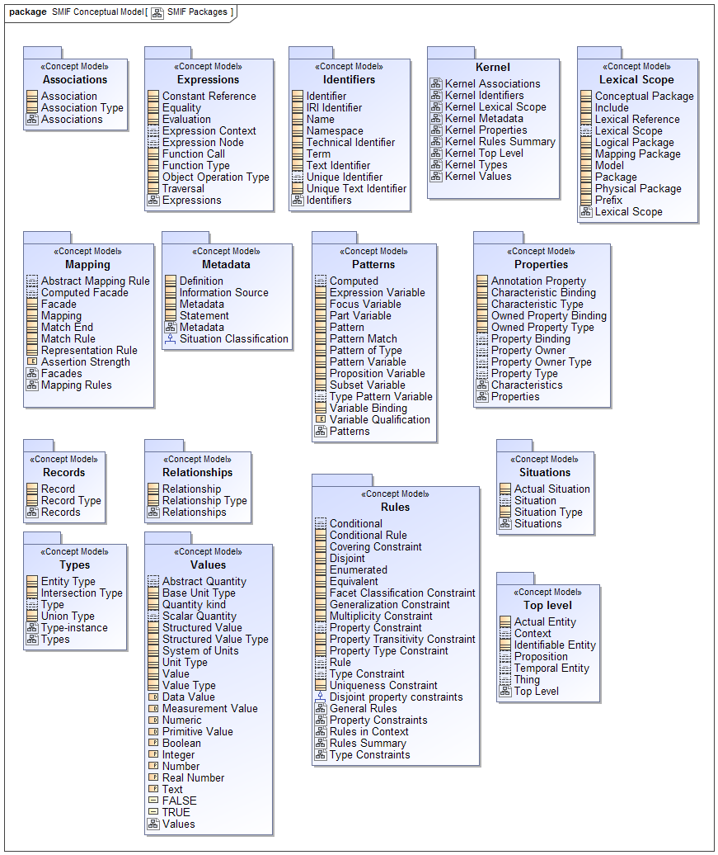
- SMIF Packages

SMIF Conceptual Model::Associations
An association asserts a formal condition involving related things, the association ends. An association may be asserted within a context as true or false within that context. Each association has a number of bindings of which are immutable for that association.
Associations are differentiated from relationships in that associations are fully dependent on the things they relate. These are known as "formal", "thin", "internal" or "intrinsic" relations in much of the literature.

Diagram: Associations
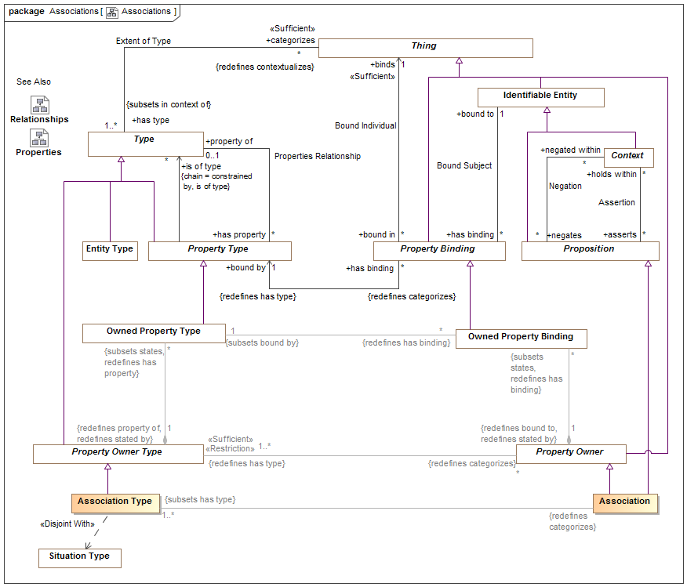
- Associations

Class Association
An association makes a logical statement involving related things, the association ends. An association may be asserted within a context as true or false within that context. Each association type has a number of bindings of which are immutable for that association.
An association may be true or false within its context and is atomic in its truth value.
Associations are differentiated from relationships in that associations are not situations - they are not temporal and do not change over time. Associations may be a consequence of relationships or other situations or may be derived from qualities of associated ends.
Associations can "own" owned property bindings as their "ends".
See also: Relationship
[Guizzardi] Intrinsic Relation
[UML] Link
[DOLCE] Formal Relation

Direct Supertypes
Property Owner, Proposition

Associations
: Association Type [1..*] Subsets: has type:Type

Class Association Type
A type of Association (See Association for details) which defines a set of "Association Property Types" which are the types of association property bindings. Associations are not situations - the are not temporal things. THis does not prevent subtypes of associations from being situations.
[Guizzardi] Intrinsic Relation Type
[UML] Association
[OWL] For binary associations, may be considered a pair of properties that are Inverse Object Properties.

Direct Supertypes
Property Owner Type

Associations
: Association Redefines: categorizes:Thing

SMIF Conceptual Model::Expressions
Expressions define computations across SMIF models.

Diagram: Expressions
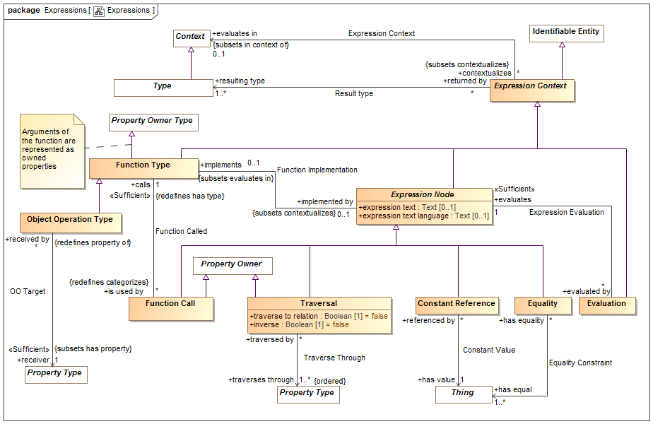
- Expressions
Expressions define computations

Class Constant Reference
A calculation that returns a thing identified by <has value>.
[FIBO] Constant
[FUML] LiteralSpecification where subtype of literal is determined by the type of <has value>.
-LiteralInteger->type is Integer or a subtype
-LiteralReal-> type is not integer or a subtype
-LiteralBoolean->type is Boolean
-LiteralString->type is Text

Direct Supertypes
Expression Node

Associations
has value : Thing [1]
A constant value referenced in an expression.

Association Constant Value
Relationship defining a link to a constant value within an expression.

Association Ends
has value : Thing [1]
A constant value referenced in an expression.
referenced by : Constant Reference [*]
Referencing constant expression node.

Class Equality
Returns TRUE if all <has equal> things have the same value or represent the same thing or set of things regardless of how they are represented.
Equality will return TRUE or FALSE.
[ISO11404: EqualityIn every value space there is a notion of equality, for which the following rules hold:
⎯ for any two instances (a, b) of values from the value space, either a is equal to b, denoted a = b , or a is not equal to b, denoted a ≠ b ;
⎯ there is no pair of instances (a, b) of values from the value space such that both a = b and a ≠ b ;
⎯ for every value a from the value space, a = a ;
⎯ for any two instances (a, b) of values from the value space, a = b if and only if b = a ;
⎯ for any three instances (a, b, c) of values from the value space, if a = b and b = c , then a = c . On every datatype, the operation Equal is defined in terms of the equality property of the value space, by:
⎯ for any values a, b drawn from the value space, Equal(a,b) is true if a = b , and false otherwise.

Direct Supertypes
Expression Node

Associations
has equal : Thing [1..*]
Set of things that must have the same value or represent the same thing or set of things for Equality to return true.

Association Equality Constraint
Relationship defining set of things that will be evaluated for equality.

Association Ends
has equal : Thing [1..*]
Set of things that must have the same value or represent the same thing or set of things for Equality to return true.
has equality : Equality [*]
Equality constraints for a thing.

Class Evaluation
The evaluation of an expression. All references to an evaluation shall return the result of evaluating the <evaluates> expression node. All expression nodes referenced within an evaluation shall return the result of evaluating that expression node.
An evaluation may be used in place of anything that requires the <resulting type> of the evaluation.

Direct Supertypes
Expression Context

Associations
evaluates : Expression Node [1]
The expression node "head" an evaluation evaluates.

Association Expression Context
Context in which an expression will be evaluated.

Direct Supertypes
Extent of Context

Association Ends
evaluates in : Context [0..1]
Context of evaluation and namespace resolution for an expression.
contextualizes : Expression Context [*]
Expressions referencing a context.

Class Expression Context
An abstract element defining the static or dynamic evaluation context and resulting type of an expression.
An expression context that is referenced by another expression context inherits the referencing context by default.

Direct Supertypes
Identifiable Entity

Associations
evaluates in : Context [0..1] Subsets: in context of:Context
Context of evaluation and namespace resolution for an expression.
resulting type : Type [1..*]
Type of the result of a function
[UML] type (of an operation or expression).

Association Expression Evaluation
Relationship defining the expression that will be evaluated by an evaluation.

Association Ends
evaluates : Expression Node [1]
The expression node "head" an evaluation evaluates.
evaluated by : Evaluation [*]
Evaluations of an expression node.

Class Expression Node
An abstract class representing the computation of a value which is then bound to the context from which it is called. Each expression node has a type of the most general type it can return.
An expression node may reference other elements. Where the other elements are also expression nodes they will be considered part of the referencing expression and evaluated in the context of that expression.
The set of related expression nodes forms a "tree" for evaluation.
[FIBO] Expression
[UML] Expression

Direct Supertypes
Expression Context

Attributes
expression text : Text [0..1]
Textual expression of the expression which is further refined by subtypes of expression.
[UML] StringExpression
expression text language : Text [0..1]
expression language used for the expression text

Associations
evaluated by : Evaluation [*]
Evaluations of an expression node.

Class Function Call
An element of an expression that performs some operation based on a function type and produces a result. I.e. plus(a,1).
Arguments are bound to the function call via bindings.

Direct Supertypes
Expression Node, Property Owner

Associations
calls : Function Type [1] Redefines: has type:Type
Function called

Association Function Called
Relationship defining the function (a type) called by a function call.

Direct Supertypes
Extent of Type

Association Ends
calls : Function Type [1] Redefines: has type: Type
Function called
is used by : Function Call [*] Redefines: has type: Type
Function calls using a function declaration.

Association Function Implementation
Relationship defining the implementation of a function by an expression.

Direct Supertypes
Expression Context

Association Ends
implemented by : Expression Node [0..1] Redefines: has type: Type
Expression which defines the implementation of a function.
implements : Function Type [0..1] Redefines: has type: Type
Function implemented by an expression

Class Function Type
A declaration of a function which performs a calculation on arguments (properties) to produce a result (function result). I.e. the definition of plus(a:Number, b:Number).
Functions are intended to be side-effect free and context free (they only depend on their arguments and don't change anything) but assertions to specify that certain functions are pure may be required,
Note: FUNCTION ARGUMENTS ARE PROPERTIES of the function.
[FUML] Operation where ownedParameter corresponds with <has property> and type corresponds with <resulting type>.

Direct Supertypes
Expression Context, Property Owner Type

Associations
implemented by : Expression Node [0..1] Subsets: contextualizes:Thing
Expression which defines the implementation of a function.
is used by : Function Call [*] Redefines: categorizes:Thing
Function calls using a function declaration.

Class Object Operation Type
An operation bound to a specific "receiver" in the "Object Oriented" sense.
[FUML] Operation

Direct Supertypes
Function Type

Associations
receiver : Property Type [1] Subsets: has property:Property Type
The property that is the receiver of an object operation.
[UML] class (of Operation)

Association OO Target
Relationship defining the "target" type of an object oriented function.

Association Ends
receiver : Property Type [1] Subsets: has property:Property Type
The property that is the receiver of an object operation.
[UML] class (of Operation)
received by : Object Operation Type [*] Subsets: has property:Property Type
The Object Operation for which a receiver is defined.

Association Result type
Relationship defining the type or types returned by an expression evaluation.

Association Ends
resulting type : Type [1..*] Subsets: has property:Property Type
Type of the result of a function
[UML] type (of an operation or expression).
returned by : Expression Context [*] Subsets: has property:Property Type
Method returning a type.

Class Traversal
Traversal from the current <evaluates in> context to another across a relation or other structure.
A traversal is a structure such that the structure's bindings may hold other properties of a traversal constant as independent variables where <traverses through> is the dependent variable. The traversal shall be considered to have the type of the relation it is traversing. Traversing binary relations does not require any bindings.
[OWL] ObjectPropertyChain

Direct Supertypes
Expression Node, Property Owner

Attributes
traverse to relation : Boolean [1] = false
Where traverse to relation is false, the traversal will return the bound element(s) of the <traverses through> property from the current context via any intermediate relationships.
Where traverse to relation is true, the traversal shall return the structure/situation/relationship owning the property binding.
By default, traverse to relation is false.
inverse : Boolean [1] = false
Indicates that the traversal is defined based on properties that reference the current context. This results in traversing "backwards" across a property to an inverse property or the relation.

Associations
traverses through : Property Type [1..*]
Property or properties through which a traversal traverses as the dependent variable(s).

Association Traverse Through
Relationship defining the property of the current context which will be traversed.

Association Ends
traverses through : Property Type [1..*]
Property or properties through which a traversal traverses as the dependent variable(s).
traversed by : Traversal [*]
Traversals through a property.

SMIF Conceptual Model::Facets
The facet package defines facets, roles and phases. Types that "mix in" to other types in a specific context or timeframe.

Diagram: Facets
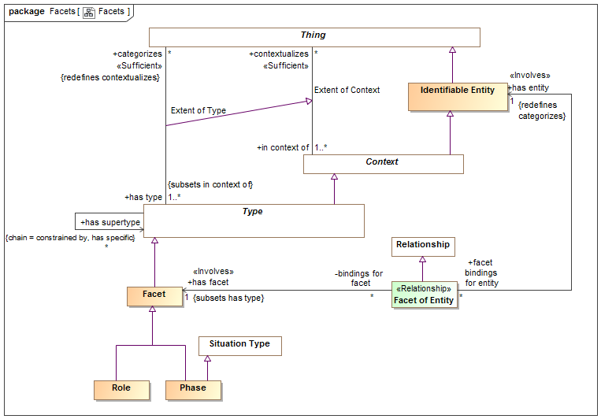
- Facets

Class Facet
A facet is a "mix in" type that defines an aspect of something but does not define the identity or "fundamental" (A.K.A. "Rigid") type of that thing, but some potentially transient role, phase or other way to classify it. Something must have at least one type that is not a facet to define that things identity.
Facets do not define independent identity of the referent but technology implementations may create independent objects to represent a facet.
An instance of a facet must also have a type that is not a facet to provide the identity of the instance.
The type(s) a facet may categorize may be constrained by a Facet Generalization Constraint. E.g. Policeman is a role of a person.
[Guarino1994] Non-Substantial sortal
[Guizzard] Non-Rigid Universal: A universal G is non-rigid iff for a w ∈ W There is an x such that x ∈ extw(G), and there is a w∈ W such that x ∉extw(G)
[JSKR] Prehension (Relative

Direct Supertypes
Type

Associations
: Facet Classification Constraint Subsets: has general:Type

Class Facet of Entity
Facet of entity is the binding of a particular entity to a facet. May also be considered an "as a" relationship. In the case of a role, it states that an entity plays the role, e.g. "Joe as a policeman". In the case of a phase, it states that an entity has that phase and that it is a phase of that entity, e.g. Sue as a teenager.
Facet of Entity is a kind of contextual categorization in that the entity assumes all of the characteristics of the facet where the Facet of Entity is asserted. E.g. if Joe has a policeman role, Joe is a policeman.
Facet of entity is an "Extent of Type" association reified as a relationship in that the binding of the entity to the facet may be valid in particular context or time frame. Facet of entity may be the consequence of a relationship. Note: Not represented as an association class due to OMG-MOF limitations.
Facet of entity may only relate entities that have a type compatible with the type of the facet, as defined by a Facet Classification Rule.
[FIBO] (for roles of actors) AgentInRole.
[FIBO] (for roles of anything else) ThingInRole
[Guarino1994] Externally Dependent Moment (Also called "Qua individual")
[JSKR] Prehension

Direct Supertypes
Relationship

Associations
has facet : Facet [1] Subsets: has type:Type
The facet that an entity assumes when it is the facet of an entity.
[FIBO] (for roles) playsRole
has entity : Identifiable Entity [1] Redefines: categorizes:Thing
The entity having a facet (including roles and phases).
[FIBO] (for roles) isPlayedBy

Class Phase
A phase (or state) is a static characteristic of something that exists for limited time(s). Something takes on or looses a phase as a result of some event. E,g, Teenager, living, closed invoice.
A Phase is a situation in that there is a situation coincident with each phase.
[Guizzardi] (Phased-Sortal): Let PS be a universal and let S be a
substance sortal specialized (restricted by) PS. Now, let extw(~PS) = extw(S) \ extw(PS)
be the complement of the extension of PS in world w. In this formula, the
symbol \ represents the set theoretical operation of set difference. The
universal PS is a phased-sortal iff for all worlds w ∈ W, there is a w ∈ W such
that extw(PS) ∩ extw(~PS) ≠ ∅

Direct Supertypes
Facet, Situation Type

Class Role
A role is a facet type that defines a specific purpose or behavior of a class of things. E.g. teacher, policeman, or employer.
[FIBO] Role. Note that partyInRole or thingInRole are implied by classification of a thing.

Direct Supertypes
Facet

SMIF Conceptual Model::Identifiers
Terms and identifiers provide for signs for (ways to identify) anything.

Diagram: Identifiers
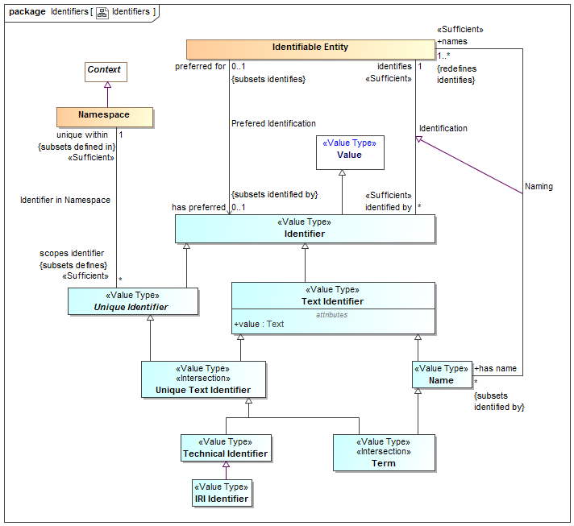
- Identifiers
An identifier that can be represented as text. The text is in the "value" property.
[IDEAS] Sign: An Individual that signifies a Thing.

Association Identification
Relationship defining an identifier for an entity.
[IDEAS] namedBy: A couple that asserts that a Name describes a Thing.
[ISO 1087] Designation

Association Ends
identifies : Identifiable Entity [1] Redefines: categorizes: Thing
The entity an identifier identifies.
[FIBO] identifies: is the relationship between something and that which provides a unique reference for it
[ISO 1087] designator: representation of a concept (3.2.1) by a sign which
denotes it
identified by : Identifier [*] Redefines: categorizes: Thing
An identifier for an <Entity>.
[FIBO] hasDenotation

Class Identifier
An identifier is any value that is used to distinguish an entity from other entities. Note that any identifier may be contextualized by one or more context, including language context. Identifiers are a “sign” for an identity where identity is an abstraction of individuality that is the basis for identifiers.
[IDEAS] Name: A Representation that identifies a Thing.
[FIBO] Identifier
[CL] Term: expression which denotes an individual, consisting of either a name or, recursively, a function term applied to a sequence of arguments, which are themselves terms

Direct Supertypes
Value

Associations
identifies : Identifiable Entity [1]
The entity an identifier identifies.
[FIBO] identifies: is the relationship between something and that which provides a unique reference for it
[ISO 1087] designator: representation of a concept (3.2.1) by a sign which
denotes it

Association Identifier in Namespace
Relationship defining the namespace within which a unique identifier is defined and unique.
[ISO 1087] monosemy: relation between designations (3.4.1) and concepts (3.2.1) in a given language in which one designation only relates to one concept

Direct Supertypes
Definition

Association Ends
unique within : Namespace [1]
The namespace in which an identifier is defined and has a unique value.
[FUML] memberNamespace
scopes identifier : Unique Identifier [*]
An Identifier defined within the scope of a namespace.
[FUML] member

Class IRI Identifier
A IRI/URI Identifier for an entity, as defined in [RFC3987].
[FIBO] anyURI

Direct Supertypes
Technical Identifier

Class Name
A word or set of words by which a person, animal, place, or thing is known, addressed, or referred to. Names are not necessarily unique.
[IDEAS] Name: A Representation that identifies a Thing.
[CL] Discourse Name

Direct Supertypes
Text Identifier

Associations
names : Identifiable Entity [1..*] Redefines: identifies:Identifiable Entity
An entity named by a name.

Class Namespace
A namespace is a context that provides a way to make identifiers unique and identify exactly one entity. For example, the Virginia driver's license division provides unique driver's license numbers.
Similar to [IDEAS] UniqueNamingScheme: A NamingScheme where different Names will not contain tokens of the same Representation Type.
Note: SMIF identifiers are not instances of their namespace.
[FIBO] IdentificationScheme: system for allocating identifiers to objects
[ISO 1087] terminology 1: set of designations (3.4.1) belonging to one special language (3.1.3)
[FUML] Namespace
[CL] Vocabulary

Direct Supertypes
Context

Associations
scopes identifier : Unique Identifier [*] Subsets: defines:Thing
An Identifier defined within the scope of a namespace.
[FUML] member

Association Naming
Relationship defining a human meaningfully name for an entity.

Direct Supertypes
Identification

Association Ends
names : Identifiable Entity [1..*] Subsets: defines:Thing
An entity named by a name.
has name : Name [*] Subsets: defines:Thing
A human meaningful name for an entity.
[FIBO] hasName: that by which some thing is known; may apply to anything
[OWL] rdfs:label

Association Prefered Identification
Relationship defining the preferred identifier for an entity.
[ISO 1087] preferred term: term (3.4.3) rated according to the scale of the term acceptability rating (3.4.14) as the primary term for a given concept (3.2.1)

Direct Supertypes
Identification

Association Ends
has preferred : Identifier [0..1] Subsets: defines:Thing
Default identifier to use for an entity.
Where multiple identifiers are preferred in differing context any method for selecting the most preferred identifier is implementation specific and not specified by this standard.
[FUML] NamedElement.name: Note: An Identifier that is <preferred for> an entity is equivalent to the name of a named element.
preferred for : Identifiable Entity [0..1] Subsets: defines:Thing
The entity an identifier is preferred for.

Class Technical Identifier
A technical identifier is defined within a technical system, information structure or system of systems for references and identity within that system or information element. Such identifiers may have no meaning outside of that system.
Typical technical identifiers include inter document "refs", record numbers, etc. The system should be referenced as the namespace.

Direct Supertypes
Unique Text Identifier

Class Term
A word, phrase or name used by stakeholders to uniquely identify entities.
[ISO 1087] term: verbal designation of a general concept in a specific subject field.

Direct Supertypes
Name, Unique Text Identifier

Class Text Identifier
A code or other simple value that can be represented as text, identifying something that may or may not be unique. Simple identifiers may be codes, names, numbers or compound values.
[NIEM] IdentificationType (IdentificationID=value)

Direct Supertypes
Identifier

Attributes
value : Text
Text value of an identifier

Class Unique Identifier
A unique identifier is an entity used to uniquely identify something. The identified thing is referenced by what the identifier <identifies>.
Identifiers are defined and <unique within> a lexical scope as its namespace.
Multiple identifiers may use the same word or text value (or other forms of values) in differing <unique within> namespaces such that the same word may have different meanings in different context.
An entity may have any number of identifiers.

Direct Supertypes
Identifier

Associations
unique within : Namespace [1] Subsets: defined in:Lexical Scope
The namespace in which an identifier is defined and has a unique value.
[FUML] memberNamespace

Class Unique Text Identifier
An <Identifier> that is represented using text. e.g. a "word", "phrase" or "name".

Direct Supertypes
Text Identifier, Unique Identifier

SMIF Conceptual Model::Kernel
The kernel subsets the SMIF classes. The diagrams in this package illustrate the concrete classes that are used to define the SMIF language.
Note that shaded classes are not instantiated in the kernel and may be "flattened". Specifications for each class and association are defined in the corresponding package for that concept.

Diagram: Kernel Associations
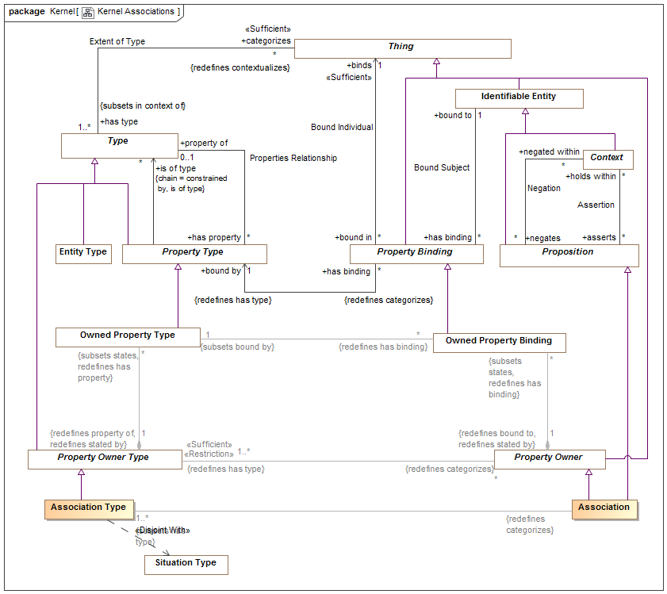
- Kernel Associations

Diagram: Kernel Identifiers
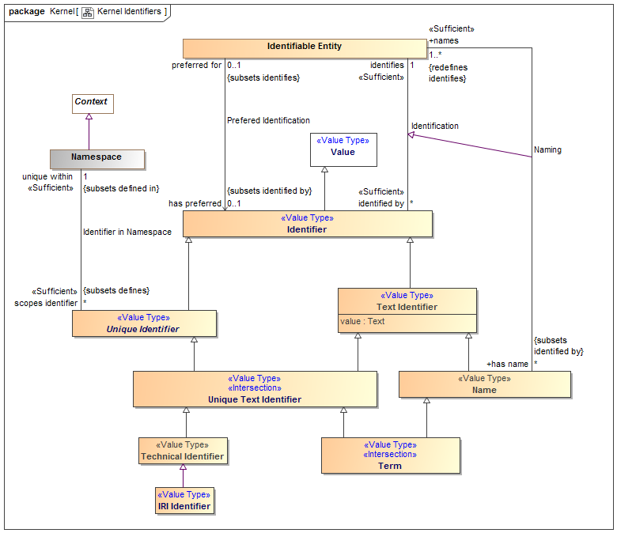
- Kernel Identifiers
An identifier that can be represented as text. The text is in the "value" property.
[IDEAS] Sign: An Individual that signifies a Thing.

Diagram: Kernel Lexical Scope
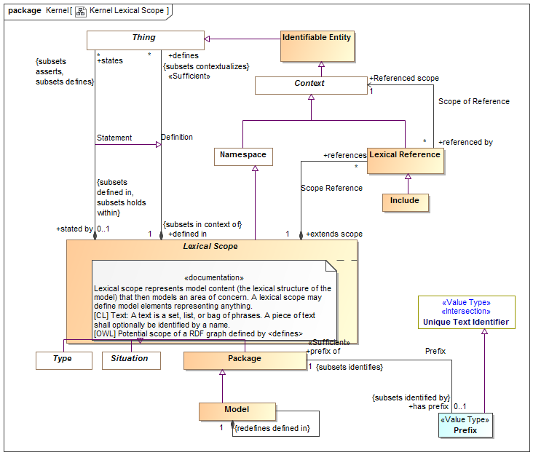
- Kernel Lexical Scope

Diagram: Kernel Metadata
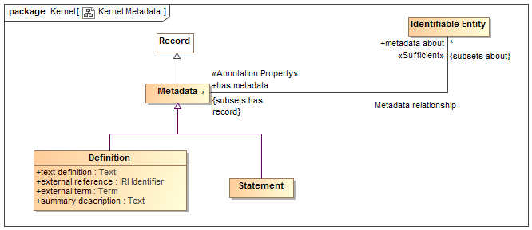
- Kernel Metadata

Diagram: Kernel Properties
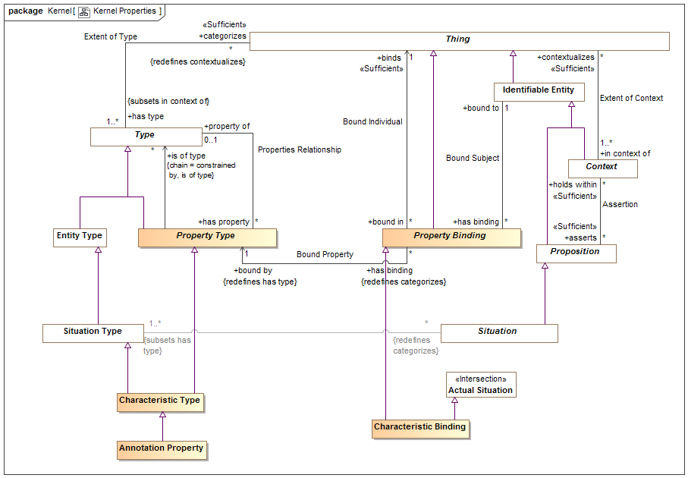
- Kernel Properties

Diagram: Kernel Rules Summary
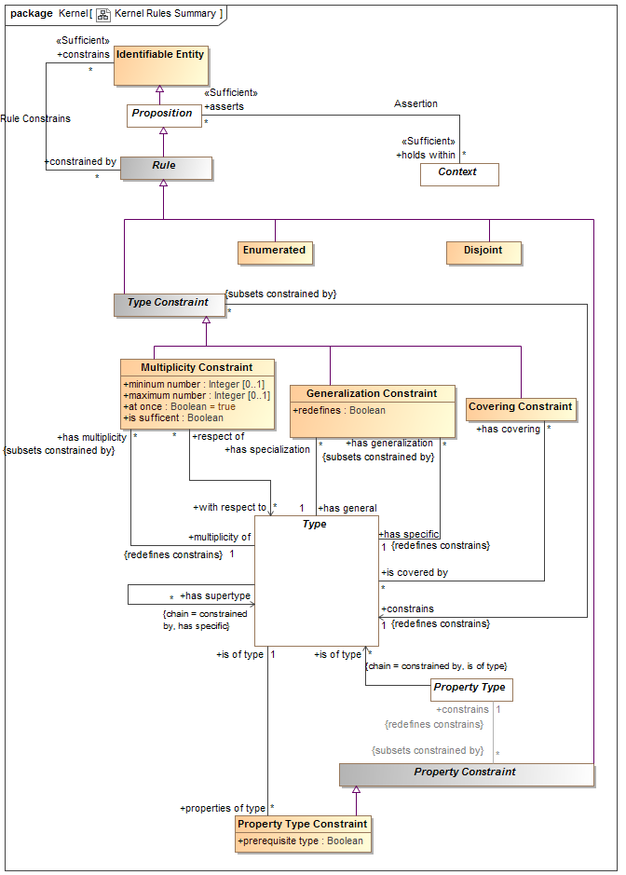
- Kernel Rules Summary
This diagram shown a summary of the primary rules.

Diagram: Kernel Top Level
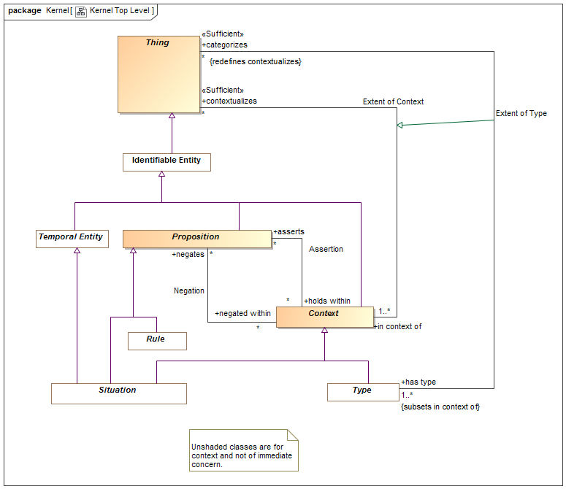
- Kernel Top Level
Diagram showing summary of top level classes and significant subtypes.

Diagram: Kernel Types
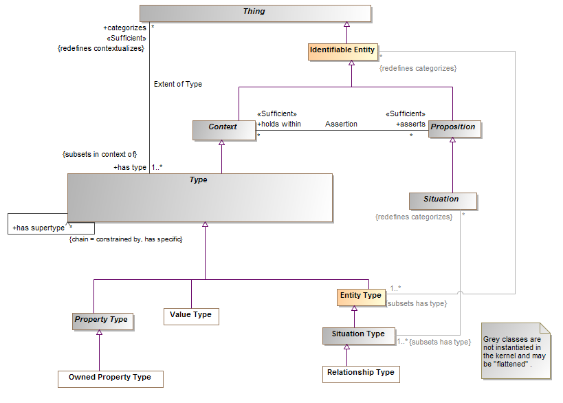
- Kernel Types

Diagram: Kernel Values
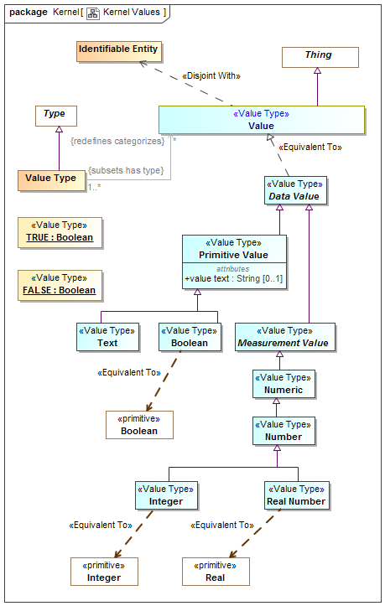
- Kernel Values

SMIF Conceptual Model::Lexical Scope
Lexical scope defines the structure of models and the ownership of model elements.

Diagram: Lexical Scope
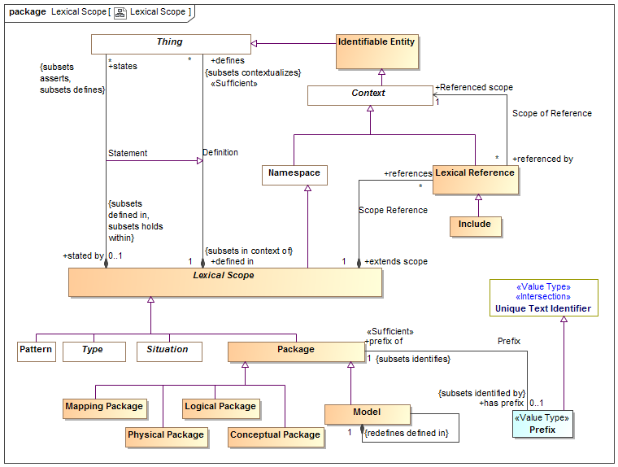
- Lexical Scope

Class Conceptual Package
A model of a real or possible world as conceived by the model authors.

Direct Supertypes
Package

Association Definition
Relationship defining the set of elements defined within a lexical scope.
[OWL] RDF Graph

Direct Supertypes
Extent of Context

Association Ends
defines : Thing [*] Subsets: defined in:Lexical Scope
A model element defined within a lexical scope.
Definition within a scope does not assert everything within a scope but the lexical scope may be independently asserted, thus asserting what it defines.
[FUML] ownedElement, ownedMember
defined in : Lexical Scope [1] Subsets: defined in:Lexical Scope
Lexical scope defining model elements.
[UML]owner

Class Include
An "Include" is an external scope that is visible and asserted by the owning lexical scope.
[FUML] PackageImport
[CL] Importation: An importation contains a name. The intention is that the name identifies a piece of Common Logic content represented externally to the text, and the importation re-asserts that content in the text.

Direct Supertypes
Lexical Reference

Class Lexical Reference
A Lexical Reference is an external scope that is visible to but not necessarily asserted by the owning lexical scope.

Direct Supertypes
Context

Associations
Referenced scope : Context [1]
A referenced context, potentially in another model, that provides visibility to the elements in that context.
[FUML] importedPackage
[OWL] directlyImports (implies "Include")
extends scope : Lexical Scope [1]
A lexical scope that is extended by a lexical reference.
[FUML] importingNamespace

Class Lexical Scope
Lexical scope represents model content (the lexical structure of the model) that then models an area of concern. A lexical scope may define model elements representing anything.
[CL] Text: A text is a set, list, or bag of phrases. A piece of text shall optionally be identified by a name.
[OWL] Potential scope of a RDF graph defined by <defines>

Direct Supertypes
Namespace

Associations
defines : Thing [*] Subsets: contextualizes:Thing
A model element defined within a lexical scope.
Definition within a scope does not assert everything within a scope but the lexical scope may be independently asserted, thus asserting what it defines.
[FUML] ownedElement, ownedMember
references : Lexical Reference [*]
A reference providing visibility of a lexical scope to an internal or external context.
states : Thing [*] Subsets: defines:Thing asserts:Proposition
<states> combines <defines> with <has assertion> to both define and assert an element within a lexical scope. <states> provides a more "structural" organization of concepts that are both defined and asserted in the same structure.
<states> is a convenience for the common case where assertion and lexical containment are combined.

Class Logical Package
A model of information about systems independent of technical representation.

Direct Supertypes
Package

Class Mapping Package
A model defining relationships between other models.

Direct Supertypes
Package

Class Model
A root package. A model has no owner and may be directly referenced as an independent information resource. A model is defined in it's self.

Direct Supertypes
Package

Associations
: Thing [*] Subsets: defines:Thing asserts:Proposition
: Thing [*] Subsets: defines:Thing asserts:Proposition

Class Package
A model element that provides a definitional scope for other model elements. A package may be represented as a "graph".
[ISO 1087] concept system: system of concepts set of concepts (3.2.1) structured according to the
relations among them
[FUML] Package. FUML ownedMember corresponds with SMIF <defines>. FUML "nestedPackage" corresponds with "defines" where the element defined is a package.
[CL] Module: A module consists of a name, an optional set of names called the exclusion set, and a text called the body text.

Direct Supertypes
Lexical Scope

Associations
has prefix : Prefix [0..1] Subsets: identified by:Identifier
An abbreviation that can be used to identify a package.

Class Physical Package
A physical, technology specific, data schema representing information about a real or possible world.

Direct Supertypes
Package

Association Prefix
Relationship defining the prefix for a package.

Direct Supertypes
Identification

Association Ends
has prefix : Prefix [0..1] Subsets: identified by:Identifier
An abbreviation that can be used to identify a package.
prefix of : Package [1] Subsets: identified by:Identifier
An abbreviation for a package.

Class Prefix
A technical abbreviation for a package.

Direct Supertypes
Unique Text Identifier

Associations
prefix of : Package [1] Subsets: identifies:Identifiable Entity
An abbreviation for a package.

Association Scope of Reference
Relationship defining internal or external context that are referenced by a lexical scope using a lexical reference.

Association Ends
Referenced scope : Context [1] Subsets: identifies:Identifiable Entity
A referenced context, potentially in another model, that provides visibility to the elements in that context.
[FUML] importedPackage
[OWL] directlyImports (implies "Include")
referenced by : Lexical Reference [*] Subsets: identifies:Identifiable Entity
References to a context.

Association Scope Reference
Relationship defining references for a scope.

Association Ends
references : Lexical Reference [*] Subsets: identifies:Identifiable Entity
A reference providing visibility of a lexical scope to an internal or external context.
extends scope : Lexical Scope [1] Subsets: identifies:Identifiable Entity
A lexical scope that is extended by a lexical reference.
[FUML] importingNamespace

Association Statement
Relationship defining the set of elements defined within and asserted by a lexical scope.

Direct Supertypes
Definition

Association Ends
states : Thing [*] Subsets: identifies:Identifiable Entity
<states> combines <defines> with <has assertion> to both define and assert an element within a lexical scope. <states> provides a more "structural" organization of concepts that are both defined and asserted in the same structure.
<states> is a convenience for the common case where assertion and lexical containment are combined.
stated by : Lexical Scope [0..1] Subsets: identifies:Identifiable Entity
<stated by> is a lexical scope that both defines and asserts a model element.

SMIF Conceptual Model::Mapping
Mapping rules define how data represents concepts or how different data representations are related.

Diagram: Facades
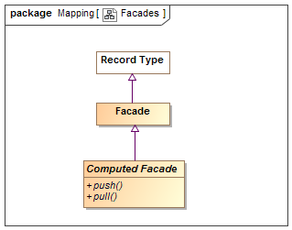
- Facades

Diagram: Mapping Rules
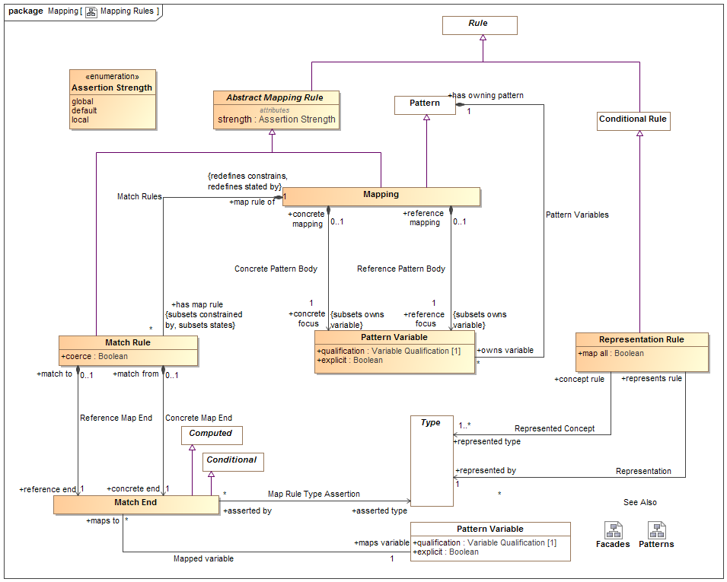
- Mapping Rules

Class Abstract Mapping Rule
Abstract mapping rule is an abstract class for the definition of the strength property.

Direct Supertypes
Rule

Attributes
strength : Assertion Strength
Strength defines what will cause a rule to be considered for being asserted (firing).

Class Computed Facade
A facade that is computed by calling external methods.

Direct Supertypes
Facade

Operations
public push ()
An operation called to evoke the behavior associated with a new facade element being created or modified. Push asserts the more concrete type based on a reference type.
public pull ()
An operation called to evoke the behavior associated with a facade representing existing elements. Pull asserts the reference type based on a more concrete type.

Association Concrete Map End
Relationship to the more concrete end of a match rule.

Association Ends
concrete end : Match End [1] Subsets: identifies:Identifiable Entity
One end of a mapping, to be used for more concrete end.
match from : Match Rule [0..1] Subsets: identifies:Identifiable Entity
Mapping rule owning a "concrete" end.

Association Concrete Pattern Body
Relationship between a mapping and a pattern of the more concrete concepts to be mapped.

Association Ends
concrete focus : Pattern Variable [1] Subsets: identifies:Identifiable Entity
The variable or variables that form the basis for the portion of the pattern for the more concrete (physical) model. The concrete portion of the pattern is derived from the transitive closure of all variables reachable from the pattern variable via characteristics, associations or relationships.
When a pattern matching the set of concrete variables is created or altered the mapping "fires" and the reference pattern is asserted.
The qualification of the referenced variable is constrained to be ""select".
concrete mapping : Mapping [0..1] Subsets: identifies:Identifiable Entity
Mapping for which a more concrete pattern is defined.

Class Facade
An intermediary data type used to hold common mappings. Facades may be computed and/or have mapping rules.

Direct Supertypes
Record Type

Association Map Rule Type Assertion
Relationship defining more concrete types that shall be asserted for an end of a match rule.

Association Ends
asserted type : Type [*] Subsets: identifies:Identifiable Entity
Type that will be asserted for the end that is more concrete than the defined type of a property or relationship. e.g. a unit type.
asserted by : Match End [*] Subsets: identifies:Identifiable Entity
Map rule and that asserts a type

Association Mapped variable
Relationship defining the property that is the source or target of a mapping

Association Ends
maps variable : Pattern Variable [1] Subsets: identifies:Identifiable Entity
Variable that defines a set of elements to map to the other side of the mapping rule. The set of elements shall be those bound to the property on evaluation of the mapping.
maps to : Match End [*] Subsets: identifies:Identifiable Entity
Map rule end for a property

Class Mapping
A mapping is a rule based on a pattern that defines how different representations of the same things correspond. There are two "sub patterns", defined by the concrete and reference variables and other variables reachable from them via characteristics, associations and relationships. These sub-patterns are matched (made to correspond) using "Match Rules"
Patterns define a set of related elements to be mapped based on two distinguished variables, the "concrete body" and the "reference body".
Types in a "concrete" body may be defined to be a representation (data about) a concept in a "reference" pattern.
Match rules define how elements in each of the sub-patterns are mapped, bidirectionally.
A mapping utilizing more specific types subsumes maps for more general types.
Note that the roles of "concrete" and "reference" may or may not reflect different levels of abstraction and in some cases the choice may be arbitrary.

Direct Supertypes
Abstract Mapping Rule, Pattern

Associations
concrete focus : Pattern Variable [1] Subsets: owns variable:Pattern Variable
The variable or variables that form the basis for the portion of the pattern for the more concrete (physical) model. The concrete portion of the pattern is derived from the transitive closure of all variables reachable from the pattern variable via characteristics, associations or relationships.
When a pattern matching the set of concrete variables is created or altered the mapping "fires" and the reference pattern is asserted.
The qualification of the referenced variable is constrained to be ""select".
has map rule : Match Rule [*] Subsets: constrained by:Rule states:Thing
Map rule that is asserted by a mapping.
reference focus : Pattern Variable [1] Subsets: owns variable:Pattern Variable
The variable or variables that form the basis for the portion of the pattern for the more abstract/reference (conceptual) model. The reference portion of the pattern is derived from the transitive closure of all variables reachable from the pattern variable via characteristics, associations or relationships.
When a pattern matching the set of reference variables is created or altered the mapping "fires" and the concrete pattern is asserted.
The qualification of the referenced variable is constrained to be ""select".

Class Match End
One end of a mapping from one thing to another that may be qualified with a condition.
The set of elements to be mapped is the union of the sets of all mapped types and mapped variables that conform to the condition.
Match rules are constrained to apply to only conforming types or types that represent the mapped ends (as specified by a representation rule).
Representation rules applied to a supertype apply to a subtype unless a more specific representation rule is specified for the corresponding types.

Direct Supertypes
Computed, Conditional

Associations
asserted type : Type [*]
Type that will be asserted for the end that is more concrete than the defined type of a property or relationship. e.g. a unit type.
maps variable : Pattern Variable [1]
Variable that defines a set of elements to map to the other side of the mapping rule. The set of elements shall be those bound to the property on evaluation of the mapping.

Class Match Rule
A rule that the 2 ends represent the same things or information about a thing.
Redundant mappings are ignored and identity is preserved across all mappings.

Direct Supertypes
Abstract Mapping Rule

Attributes
coerce : Boolean
Where <coerce> has a value of TRUE a map rule will be evaluated even if the <reference end> is not type compatible with the <concrete end> type.
Where <coerce> is FALSE or unstated a map rule will be evaluated only if the <reference end> is type compatible with the <concrete end> type.
Type compatible shall be defined as one of: Being the same type, <concrete end> being a subtype of <reference end> (as defined by a type generalization rule), <concrete end> being a representation of <reference end> (as defined by a representation rule).
Representation rules applied to a supertype apply to a subtype.

Associations
concrete end : Match End [1]
One end of a mapping, to be used for more concrete end.
reference end : Match End [1]
One end of a match rule, to be used for more abstract end.
map rule of : Mapping [1] Redefines: constrains:Identifiable Entity stated by:Lexical Scope
Mapping containing a map rule.

Association Reference Map End
Relationship to the reference end of a match rule.

Association Ends
reference end : Match End [1] Redefines: constrains: Identifiable Entity stated by: Lexical Scope
One end of a match rule, to be used for more abstract end.
match to : Match Rule [0..1] Redefines: constrains: Identifiable Entity stated by: Lexical Scope
Mapping rule owning a reference" end.

Association Reference Pattern Body
Relationship between a mapping and a pattern of the more abstract concepts to be mapped.

Association Ends
reference focus : Pattern Variable [1] Redefines: constrains: Identifiable Entity stated by: Lexical Scope
The variable or variables that form the basis for the portion of the pattern for the more abstract/reference (conceptual) model. The reference portion of the pattern is derived from the transitive closure of all variables reachable from the pattern variable via characteristics, associations or relationships.
When a pattern matching the set of reference variables is created or altered the mapping "fires" and the concrete pattern is asserted.
The qualification of the referenced variable is constrained to be ""select".
reference mapping : Mapping [0..1] Redefines: constrains: Identifiable Entity stated by: Lexical Scope
Mapping for which a more abstract pattern is defined.

Association Representation
More concrete type that represents information about the represented concept of a representation rule.

Association Ends
represented by : Type [1] Redefines: constrains: Identifiable Entity stated by: Lexical Scope
The representation of a concept in a more specific form
represents rule : Representation Rule Redefines: constrains: Identifiable Entity stated by: Lexical Scope
Rule defining a representation of a type.

Class Representation Rule
A representation rule states that the <represented type> has a representation defined by the <represented by> type.
Representation rules are used to filter Map Rules such that only represented concepts may be mapped.
A representation is usually complimented with one or more mapping rules.

Direct Supertypes
Conditional Rule

Attributes
map all : Boolean
Specifies a direct mapping between instances of the types in both directions.
<map all> is equivalent to a mapping with a rule mapping properties of each type but is lower precedence than other mappings - if types have a more specific map it will apply first.

Associations
represented by : Type [1]
The representation of a concept in a more specific form
represented type : Type [1..*]
A more general or abstract concept that is being represented.

Association Represented Concept
More abstract type that is <represented by> a more concrete type of a representation rule.

Association Ends
represented type : Type [1..*]
A more general or abstract concept that is being represented.
concept rule : Representation Rule
Rule defining a concept that is represented by another, more concrete, concept.

Enumeration Assertion Strength
Rule strength defines what will cause a rule to be considered for being asserted (firing).
package SMIF Conceptual Model::Mapping
public enum Assertion Strength
{global, default, local}

Literals
global
The rule will be in effect globally.
default
The rule will only be in effect if no other rule is in effect for the same elements.
local
The rule will only be in effect if required to fulfill another rule.

Known other enumerations
Enumeration Assertion Strength

SMIF Conceptual Model::Metadata
Metadata defines data about model elements (their source, definition or trust), which can be differentiated from model elements about the subject domain.

Diagram: Metadata
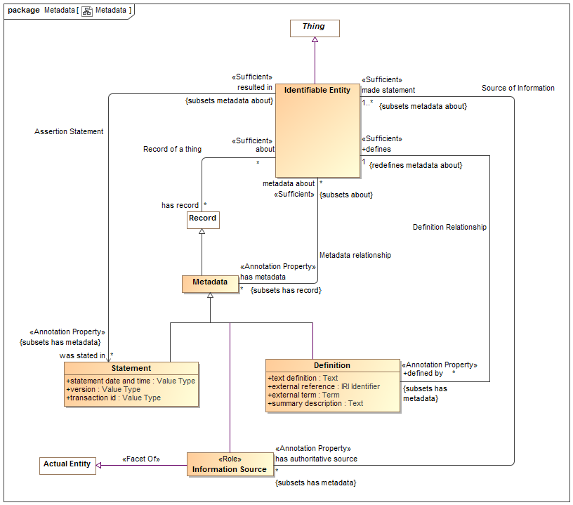
- Metadata

Association Assertion Statement
Relationship defining the original statement, speech act or information artifact that asserted something in a model.

Direct Supertypes
Metadata relationship

Association Ends
was stated in : Statement [*]
Metadata representing the speech act, document or other record where a statement captured in a model was made.
[OWL] rdfs:isDefinedBy
resulted in : Identifiable Entity
Statement made in a statement by an information source.

Class Definition
An informal or natural language definition of a something and potentially a reference to external definitions.
A Definition may be in the context of a natural language to scope the language it is expressed in.
[ISO 1087] definition: representation of a concept (3.2.1) by a descriptive statement which serves to differentiate it from related concepts
[FUML] Comment (where body corresponds with "text definition").

Direct Supertypes
Metadata

Attributes
text definition : Text
Text describing a something in natural language. The language may be indicated by a context of the definition.
[OWL] rdfs:comment
external reference : IRI Identifier
A reference to an external information resource that further defines something.
[FIBO] ReferenceDOcument
external term : Term
Specific term in an external resource that further defines something.
summary description : Text
A short description of something.

Associations
defines : Identifiable Entity [1] Redefines: metadata about:Identifiable Entity
Some thing described by a definition.
[FIBO] defines
[FUML]annotatedElement

Association Definition Relationship
Relationship between a thing and its definitions.

Direct Supertypes
Metadata relationship

Association Ends
defines : Identifiable Entity [1] Redefines: metadata about: Identifiable Entity
Some thing described by a definition.
[FIBO] defines
[FUML]annotatedElement
defined by : Definition [*] Redefines: metadata about: Identifiable Entity
An informal description of something.
[FIBO] hasDefinition
[UML] comment
[FUML] ownedComment

Class Information Source
Metadata defining the origin or provenance of a set of statements in a model or data.
Note that the source could be a human, an organization, a mapping or other automated processes.

Direct Supertypes
Actual Entity, Metadata

Associations
made statement : Identifiable Entity [1..*] Subsets: metadata about:Identifiable Entity
Metadata representing statements made by an authoritative source.
Sources may be people, organizations, documents, information systems, etc.

Class Metadata
Information about the source, provenance or origin of information. Metadata may be a managed entity, providing for provenance.
[NIEM] MetadataType

Direct Supertypes
Record

Associations
metadata about : Identifiable Entity [*] Subsets: about:Identifiable Entity
The subject of metadata, the entity described by the metadata.
[OWL] annotationSubject of Annotation Assertion

Association Metadata relationship
Relationship between something and metadata about that thing; data about data.
[OWL] AnnotationAssertion

Association Ends
metadata about : Identifiable Entity [*] Subsets: about:Identifiable Entity
The subject of metadata, the entity described by the metadata.
[OWL] annotationSubject of Annotation Assertion
has metadata : Metadata [*] Subsets: about:Identifiable Entity
Metadata associated with (data about the information concerning) the subject entity.
[OWL] AnnotationProperty, annotationValue of Annotation Assertion

Association Record of a thing
Relationship between a thing and records (or information) about that thing.
Note that in SMIF, things refer to the actual thing they represent, not data about it (unless the type is a record, in which case the "thing" is the data). This relationship recognizes that both a thing and data about the thing are things.
[IDEAS] describedBy: A representedBy that asserts that a Description describes a Thing.

Association Ends
about : Identifiable Entity [*] Subsets: about:Identifiable Entity
The thing described by a record.
has record : Record [*] Subsets: about:Identifiable Entity
A record about something.

Association Source of Information
Relation defining an entity making a statement represented within a model. E.g. the person or organization that made a statement.
[ISO 1087] source identifier: information in a terminological entry (3.8.2) which indicates the source documenting the terminological data (3.8.1)

Association Ends
made statement : Identifiable Entity [1..*] Subsets: about:Identifiable Entity
Metadata representing statements made by an authoritative source.
Sources may be people, organizations, documents, information systems, etc.
has authoritative source : Information Source [*] Subsets: about:Identifiable Entity
Metadata representing the authority behind a statement - who or what made a statement captured in a model.

Class Statement
Statements provide metadata as to the source of information - who or what said it.
This source of the information may be captured using "InformationSource" metadata about the metadata.
[ISO11404] provision that conveys information

Direct Supertypes
Metadata

Attributes
statement date and time : Value Type
Metadata representing the date and time the statement was made or modified.
version : Value Type
Metadata representing an identifier for a version of information.
transaction id : Value Type
Identifier for an act or transaction creating or modifying information.

SMIF Conceptual Model::Patterns
Patterns are templates for structures or compositions of things that may then be expressed as instances of the pattern.

Diagram: Patterns
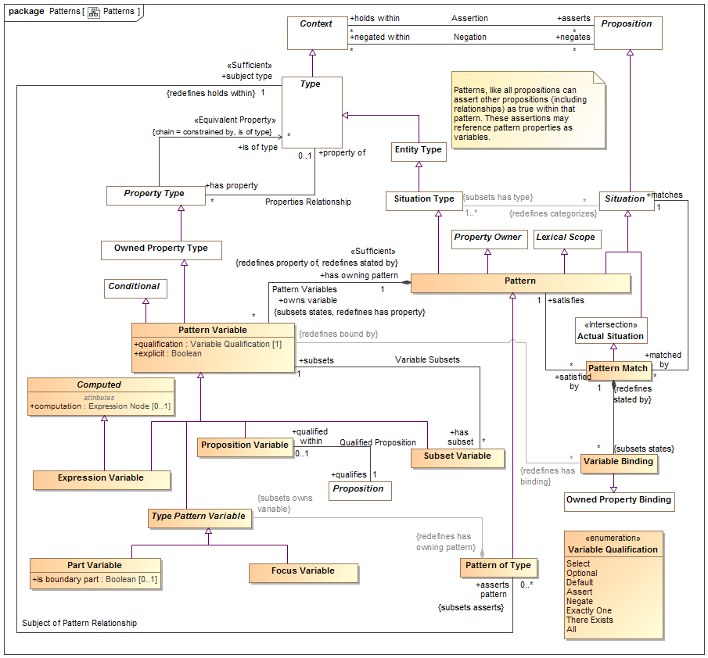
- Patterns

Class Computed

Attributes
computation : Expression Node [0..1]
<computation> provides an expression that computes a value for the variable based on the expression applied to the current context..

Class Expression Variable
An expression variable defines the value of the variable as computed by <computation>. Note that expression variables are not always able to be asserted or reversed and may therefore not provide for bi-directional mapping patterns. Any ability to assert or reverse a computation is implementation specific.

Direct Supertypes
Computed, Pattern Variable

Class Focus Variable
A property variable of a pattern representing the extent of the subject type within the context of the owning pattern.
The value of qualification shall be "Select".
The <has type> of the variable is asserted be the same as the subject type of the pattern.

Direct Supertypes
Type Pattern Variable

Association Match Rules
Relationship defining the match rules for a mapping.

Direct Supertypes
Rule Constrains, Statement

Association Ends
has map rule : Match Rule [*] Subsets: about:Identifiable Entity
Map rule that is asserted by a mapping.
map rule of : Mapping [1] Subsets: about:Identifiable Entity
Mapping containing a map rule.

Class Part Variable
A pattern property variable representing a part of the subject type. Additional relations and rules may be made about the part. A type with parts is by its nature a composition.

Direct Supertypes
Type Pattern Variable

Attributes
is boundary part : Boolean [0..1]
True if the property is on the boundary of the pattern and connectible (may have relationships) external to the pattern. e.g. "Port"

Class Pattern
A pattern represents a set of assertions true about individuals or sets of individuals qualified by pattern properties. All propositions asserted or negated by a pattern (as a context) are considered "templates" where identity is not required to match.
The structure of the pattern is defined by the properties and asserted (sub) situations (including relationships) that are asserted by the pattern.
In many cases the relationships and rules defined for a pattern will reference pattern properties. These relationships will hold for instances of the pattern where things are bound to the pattern properties.
[DTV] general situation kind: situation kind that is not an individual situation kind. A situation kind is a general situation kind if it can be exemplified by more than one Event in some possible world, even when it cannot have more than one Event in the possible world chosen to be the universe of discourse.
[UML] StructuredClassifier. Also Similarity with TemplateSignature
[OWL] May be used to represent Class Expressions

Direct Supertypes
Lexical Scope, Property Owner, Situation, Situation Type

Associations
owns variable : Pattern Variable [*] Subsets: states:Thing Redefines: has property:Property Type
A variable property defined within the context of a pattern that is used as part of the patterns definition.
[UML] ownedAttribute
satisfied by : Pattern Match [*]
Pattern match that satisfies a pattern.

Association Pattern Bindings

Association Ends
: Variable Binding [*]
: Pattern Match [1]

Class Pattern Match
A pattern match provides the corespondents between a pattern and the situations it matches using variable bindings.
A pattern match implies and proves that the pattern <categorizes> the situation.
The matched pattern <states> any consequences of the matching, such as the pattern <categorizes> the pattern instance.
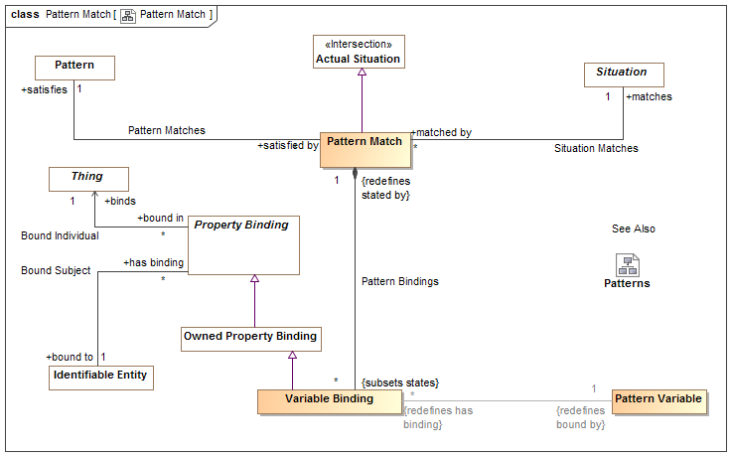
- Pattern Match

Direct Supertypes
Actual Situation

Associations
: Variable Binding [*] Subsets: states:Thing
satisfies : Pattern [1]
Pattern that is satisfied by a "Pattern Match" based on a set of "Variable Bindings".
matches : Situation [1]
The situation qualified as matching the <satisfies> pattern based on the set of "Variable Bindings" stated.

Association Pattern Matches

Association Ends
satisfies : Pattern [1]
Pattern that is satisfied by a "Pattern Match" based on a set of "Variable Bindings".
satisfied by : Pattern Match [*]
Pattern match that satisfies a pattern.

Class Pattern of Type
A pattern of type defines a set of properties and relationships that must hold true for all instances of a type. Where the pattern includes parts, the subject type is a composition.
Patterns augment the semantics of th subject type in the context of the pattern.

Direct Supertypes
Pattern

Associations
: Type Pattern Variable Subsets: owns variable:Pattern Variable
subject type : Type [1] Redefines: holds within:Context
The type which is the context of a pattern of type. The pattern is "about" the subject type.

Class Pattern Variable
A pattern variable is a property of a pattern that provides a contextual property within that pattern for rules and relationships to be bound to.
A pattern variable is a placeholder for all or a subset of the instances of the variables type.
Properties of an association or relationship may be bound to a pattern variable where the type of the pattern variable is compatible with the type of the relationship's property type.
[UML] Similarity with TemplateParameter
[CL] Functional Term

Direct Supertypes
Conditional, Owned Property Type

Attributes
qualification : Variable Qualification [1]
<qualification> defines the behavior of an element with respect to a pattern - how the variable impacts the selection, evaluation or assertion of the pattern.
explicit : Boolean
If true, Element must be explicitly asserted as the indicted type, not derived or inferred from a supertype or super property.

Associations
: Variable Binding [*] Redefines: has binding:Property Binding
has owning pattern : Pattern [1] Redefines: property of:Type stated by:Lexical Scope
Pattern owning a pattern variable.
has subset : Subset Variable [*]
Subsets of the variable.
maps to : Match End [*]
Map rule end for a property

Association Pattern Variables
Relationship defining variable properties within a pattern.

Direct Supertypes
Statement

Association Ends
owns variable : Pattern Variable [*]
A variable property defined within the context of a pattern that is used as part of the patterns definition.
[UML] ownedAttribute
has owning pattern : Pattern [1]
Pattern owning a pattern variable.

Class Proposition Variable
A proposition variable utilizes some proposition (e.g. relationships) as a part of the definition of a pattern, it extends a basic proposition in that it adds properties to determine the effect the assertion has on pattern instances.
A Proposition Variable is a lexical scope context that <asserts> or <negates> other propositions qualified by <has strength> and <explicit>. As a lexical scope it may "own" the asserted propositions.
Proposition Variable is often used with associations and relationships to define the way pattern properties are related to other pattern properties or actual entities.
For a pattern associations, [UML] Connector. (type = has type). Each ConnectorEnd corresponds with a Structured Property Binding.

Direct Supertypes
Pattern Variable

Associations
qualifies : Proposition [1]

Association Qualified Proposition
Association defining exactly one proposition (such as an association) qualified by a qualified proposition variable.

Association Ends
qualifies : Proposition [1]
qualified within : Proposition Variable [0..1]

Association Situation Matches

Association Ends
matches : Situation [1]
The situation qualified as matching the <satisfies> pattern based on the set of "Variable Bindings" stated.
matched by : Pattern Match [*]
Pattern matches that match the subject situation.

Association Subject of Pattern Relationship
Relationship defining the subject pattern of a type specific pattern.

Direct Supertypes
Assertion

Association Ends
asserts pattern : Pattern of Type [0..*]
A pattern asserted for all instances of a type. Where the pattern includes parts, the type defines a composition.
subject type : Type [1]
The type which is the context of a pattern of type. The pattern is "about" the subject type.

Class Subset Variable
In a pattern or mapping rule, defines a property that represents a subset of another property. The subset may be constrained by a more specific type, expressions or required cardinalities.
qualification shall be one of {Select, Optional, Default, Assert, Negate}.
Where qualification "Default" the default shall only be applied if all <has subset" of the <subsets> variable are empty.

Direct Supertypes
Pattern Variable

Associations
subsets : Pattern Variable [1]
Variable that a subset variable subsets. The subset variable shall be populated by a subset of the <subsets> variable based on the type and constraints of the subset variable.

Class Type Pattern Variable
Type Pattern variable is an abstract supertype that provides for a restriction that parts and focus properties must be owned by a pattern of a type.

Direct Supertypes
Pattern Variable

Associations
: Pattern of Type Redefines: has owning pattern:Pattern

Class Variable Binding
A variable binding defines a value for a particular variable of a particular owning pattern as part of a pattern match.

Direct Supertypes
Owned Property Binding

Associations
: Pattern Variable [1] Redefines: bound by:Property Type
: Pattern Match [1] Redefines: stated by:Lexical Scope

Association Variable Subsets
Set of subsets of a pattern variable.

Association Ends
subsets : Pattern Variable [1] Redefines: stated by: Lexical Scope
Variable that a subset variable subsets. The subset variable shall be populated by a subset of the <subsets> variable based on the type and constraints of the subset variable.
has subset : Subset Variable [*] Redefines: stated by: Lexical Scope
Subsets of the variable.

Enumeration Variable Qualification
Variable qualification values define the behavior of an element with respect to a pattern - how it impacts the selection, evaluation or assertion of the pattern.
package SMIF Conceptual Model::Patterns
public enum Variable Qualification
{Select, Optional, Default, Assert, Negate, Exactly One, There Exists, All}

Literals
Select
Select is used in query and mapping patterns, all elements of the classified type that match the pattern are selected as instances of the pattern.
Select may be considered a qualified "All". Select does not assert the existence of something, it determines the existence of a pattern match such that other assertions may be made.
Where a pattern is asserted, "Select" variables shall be asserted.
Relationships between properties with <quantifier>=Select must hold between the selected properties for the pattern to be asserted.
Optional
Optional is used in query and mapping patterns, the property shall be populated as a consequence of the pattern matching.
Where a pattern is asserted, "Optional" variables shall not be asserted.
Optional is the default if no qualification is stated.
Default
The element will be asserted only if no other values are asserted within the pattern or as pre-existing assertions.
Assert
The property does not impact the selection of the pattern, it is an asserted consequence of the pattern.
Negate
The property does not impact the selection of the pattern, it is negated consequence of the pattern - it may not exist.
Exactly One
The existential quantifier limited to exactly one of a potentially larger set of the properties type.
There Exists
The existential quantifier - at least one of the properties type.
All
The universal quantifier - the quantified property is a stand-in for all elements of the existent of the quantified type
- Patterns

SMIF Conceptual Model::Properties
Properties define the most granular connections between entities or values. Properties may be used as the ends of relationships, to represent individual characteristics or as elements of a data structure.

Diagram: Characteristics
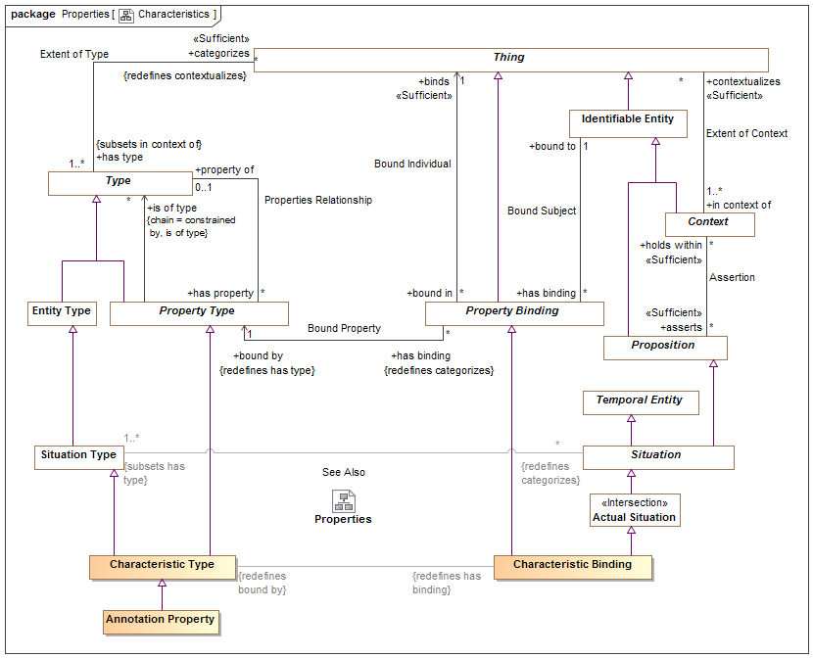
- Characteristics

Diagram: Properties
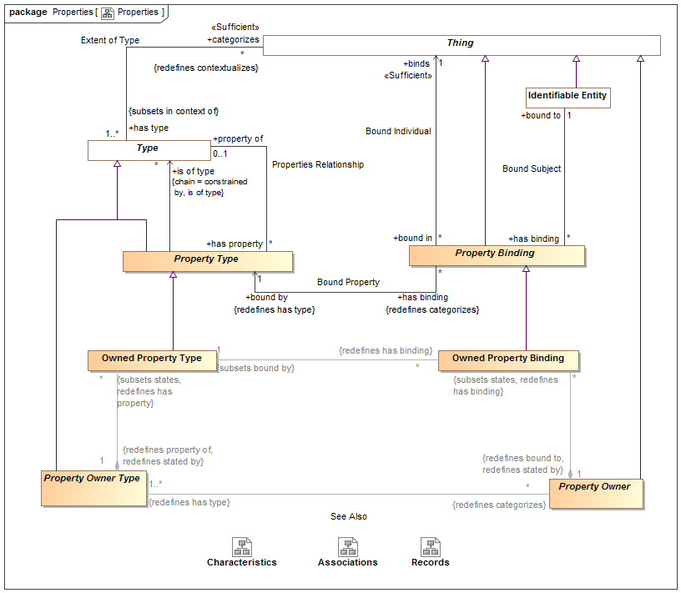
- Properties

Class Annotation Property
An annotation property is a specialization of property where the referenced elements represent metadata about the related proposition, structure or information (or model element) rather than a fact or condition of the domain being represented.
For an annotation property, <is of type> describes instances of the structured type for which the property is defined.
Typical uses of annotations include provenance of information, when a record was created, etc.
[ISO11404] annotation: descriptive information unit attached to a datatype, or a component of a datatype, or a procedure (value), to characterize some aspect of the representations, variables, or operations associated with values of the datatype

Direct Supertypes
Characteristic Type

Association Bound Individual
Relationship defining the thing bound to a subject based on a bound property - the "object" of the property binding.

Association Ends
binds : Thing [1] Redefines: stated by: Lexical Scope
The thing bound to a property in a specific situation. E.g. if the weight of truck-XYZ is 4500 LBS, the bound individual would be "4500 LBS".
[FUML] value
[OWL] rdf:object
bound in : Property Binding [*] Redefines: stated by: Lexical Scope
Bindings in which a thing participates.

Association Bound Property
Relationship defining the property type that defines the semantics of a property binding. E.g. if the weight of truck-XYZ is 4500 LBS, the bound property could be "has weight".

Direct Supertypes
Extent of Type

Association Ends
has binding : Property Binding [*] Redefines: stated by: Lexical Scope
Bindings referencing a property.
bound by : Property Type [1] Redefines: stated by: Lexical Scope
The property a binding binds a thing to.
[FUML] definingFeature
[OWL] rdf:predicate

Association Bound Subject
Relationship defining the subject of a bound property. Where the subject is a relationship, the relationship becomes transparent and the applicable subject(s) are the other ends of the relationship. E.g. if the weight of truck-XYZ is 4500 LBS, the bound subject would be Truck-XYZ".

Association Ends
has binding : Property Binding [*] Redefines: stated by: Lexical Scope
Bindings asserted for properties within a situation.
bound to : Identifiable Entity [1] Redefines: stated by: Lexical Scope
The subject of a property binding.
[FUML] owningInstance (note that in SMIF the owner and subject may not be the same). Where the are the same, the semantics are the same as FUML.
[OWL] rdf:subject

Class Characteristic Binding
A characteristic of a specific thing, e.g. the color of Pump-1234 in the <bound to> entity. A characteristic is a "first class" element and may participate in relationships and have annotations.
[IDEAS] measureOfIndividual: A typeInstance that asserts an Individual is an instance of a Measure - i.e. the Individual "has" a property corresponding to the Measure.
[ISO 1087] characteristic: abstraction of a property of an object (3.1.1) or of a
set of objects
[Guizzardi] quality(x) =def ∃!U qualityUniversal(U) ∧ (x::U)
[DOLCE] Quality

Direct Supertypes
Actual Situation, Property Binding

Associations
: Characteristic Type Redefines: bound by:Property Type

Class Characteristic Type
A kind of characteristic of a type of thing may have, e.g. paint may have a color. Characteristic kind is the type of characteristic bindings which are "first class" elements and may participate in relationships and have meta-characteristics.
[IDEAS] Property: An IndividualType whose members all exhibit a common trait or feature. Often the Individuals are states having a property (the state of being 18 degrees centigrade), where this property can be a CategoricalProperty (qv.) or a DispositionalProperty (qv.).
[ISO 1087] type of characteristics: category of characteristics (3.2.4) which serves as the criterion of subdivision when establishing concept systems. NOTE The type of characteristics colour embraces characteristics (3.2.4) being red, blue, green, etc. The type of characteristics material embraces characteristics made of wood, metal, etc.
[FIBO] Simple Property: Simple Properties are assertions about things in a class, which may be framed in terms of some simple type of information.
[Guizzardi] qualityUniversal(U) =def intrinsicMomentUniversal(U) ∧ ∃!x QS(x) ∧ assoc(x,U)
[DOLCE] Quality Type
[OWL] rdf:Statement

Direct Supertypes
Property Type, Situation Type

Associations
: Characteristic Binding Redefines: has binding:Property Binding

Class Owned Property Binding
An owned property binding defines a value for a particular property of a particular owning property type (or structure).
Similar to an OWL triple, an owned property binding does not have independent identity.
Constraint: Each owned property binding must be <bound by> an owned property type that is owned by the <has type> owned type of the <bound to> property owner.
Owned property type is abstract and not intended to directly represent semantic elements.

Direct Supertypes
Property Binding

Associations
: Owned Property Type [1] Subsets: bound by:Property Type
A structure property binding may bind a characteristic.
: Property Owner [1] Redefines: bound to:Identifiable Entity stated by:Lexical Scope

Class Owned Property Type
An owned property type is a property definition defined as a composite part of an association type - most often used in data structures and relationships. Association property types are the types of association property bindings. Also known as "association end".
[FIBO] Relationship Property
[FUML] memberEnd (of association) Property

Direct Supertypes
Property Type

Associations
: Owned Property Binding [*] Redefines: has binding:Property Binding
: Property Owner Type [1] Redefines: stated by:Lexical Scope property of:Type

Association Properties Relationship
Relationship defining the set of properties defined for a type.
Where the <property of> type is a relationship type, the "subject" of the property is the other ends (properties) of the relationship.
Where the <property of> type is not a relationship, the subject of the property is the <property of> type.

Association Ends
has property : Property Type [*] Redefines: stated by: Lexical Scope property of: Type
A property of a structured type such that there may be bindings of a thing to instances of the structured type with reference to the property which defines the semantics of the bound thing withing the context of the structure.
[FUML] feature
[UML] memberEnd. attribute (of classifier).
property of : Type [0..1] Redefines: stated by: Lexical Scope property of: Type
Type for which a property is relevant. The domain of the property.
<property of> excludes "Owned Property Type" and ("Association Type" that is not "Relationship Type")
[FUML] featuringClassifier
[OWL] Domain

Class Property Binding
A property value binding binds a particular thing (the value) to a situation based on a defined property.
Where <binds> is an expression evaluation, the property value shall evaluate to the evaluation of the expression.
Where <binds> is a property, the property value shall be the property values bound to that property in <bound to> situation.
The bound to thing must conform with the <is of type> type of the property. If the bound individual conforms to the "requires type" of the property, the <is of type> of the bound thing will be asserted.
The type of the <bound to> structure must (directly or indirectly) have the type the <bound by> properties <property of> type.
[FUML] Slot (Noting that in SMIF the binding may or may not be owned by the subject, depending on the subtype of property).
[CL] Binding:
[OWL] Union(ObjectPropertyAssertion, DataPropertyAssertion, AnnotationAssertion), RDF Triple
=Note: RDF Triples do not have identity where as some subtypes of SMIF:Property Type do have identity and are therefor statements.

Direct Supertypes
Thing

Associations
binds : Thing [1]
The thing bound to a property in a specific situation. E.g. if the weight of truck-XYZ is 4500 LBS, the bound individual would be "4500 LBS".
[FUML] value
[OWL] rdf:object
bound by : Property Type [1] Redefines: has type:Type
The property a binding binds a thing to.
[FUML] definingFeature
[OWL] rdf:predicate
bound to : Identifiable Entity [1]
The subject of a property binding.
[FUML] owningInstance (note that in SMIF the owner and subject may not be the same). Where the are the same, the semantics are the same as FUML.
[OWL] rdf:subject

Class Property Owner
Property Owner is an abstract element for anything that may own a set of property bindings. This element is abstract and not intended to directly represent domain concepts. Subtypes of property owner provide semantic interpretation.

Direct Supertypes
Thing

Associations
: Owned Property Binding [*] Subsets: states:Thing Redefines: has binding:Property Binding
: Property Owner Type [1..*] Redefines: has type:Type

Class Property Owner Type
A type of Property Owner (See Property Owner for details) which defines a set of "Owned Property Types" which are the types of owned property bindings.
Property owner is abstract and not intended to directly represent semantic elements.

Direct Supertypes
Type

Associations
: Property Owner [*] Redefines: categorizes:Thing
: Owned Property Type [*] Subsets: states:Thing Redefines: has property:Property Type

Class Property Type
A property type defines the way in which instances of a type participate in (or, are involved in) instances of another type (including relationships). Sometimes called a variable, argument or role.
In a conceptual model the terms associated with a property kind are typically "verb phrases" defining how instances of the involved type participate in the situation or relationship.
In a record (data structure) the property is a "slot" of a record and may have a term which is a noun or verb phrase.
So that constraints of a type flow to relationships involving that type: All propositions that hold within a type referenced by <is of type> hold within the structured type referenced by <property of>. I.e. the structured type is in the context of the types of its properties.
In a function, a property is a function argument.
[Guizzardi] MomentUniversal
[FUML] Parameter where owner is operation. Otherwise Property.
[UML] Property. All typed elements in SMIF are Property Types.
[CL] Operator: distinguished syntactic role played by a specified component within a functional term
[OWL] rdf:Property, ObjectUnionOf(owl:ObjectProperty, oe;DatatypeProperty).

Direct Supertypes
Type

Associations
is of type : Type [*]
A type of instances bound to a property. Also known as the "range" of a property.
If asserted the property rule shall be owned and asserted by the properties <property of> type.
[OWL] Range
: Property Constraint [*] Subsets: constrained by:Rule
property of : Type [0..1]
Type for which a property is relevant. The domain of the property.
<property of> excludes "Owned Property Type" and ("Association Type" that is not "Relationship Type")
[FUML] featuringClassifier
[OWL] Domain

SMIF Conceptual Model::Records
A record of the condition of an entity at a point in time - this includes facts, speech acts and DBMS records. Records are a kind of information.
Records are typically used in data representations, not conceptual models.

Diagram: Records
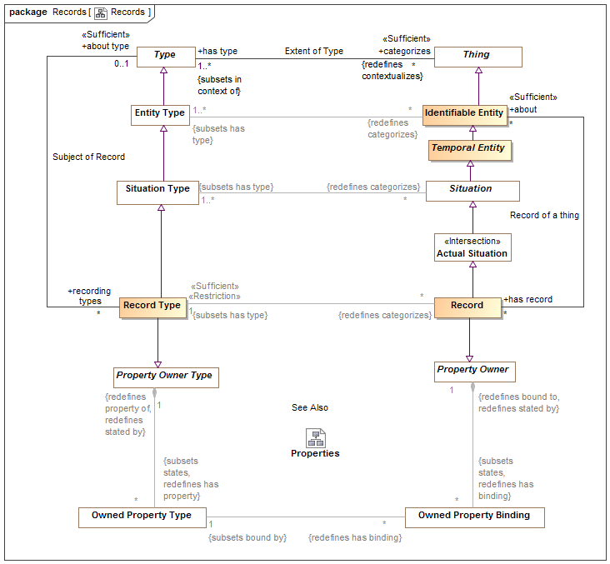
- Records

Class Record
A record of the condition of an entity at a point in time - this includes facts, speech acts and DBMS records.
Records are typically used in data representations, not conceptual models. Records specialize associations as owners of properties.
[IDEAS] A Representation that describes a Thing

Direct Supertypes
Actual Situation, Property Owner

Associations
about : Identifiable Entity [*]
The thing described by a record.
: Record Type [1] Subsets: has type:Type

Class Record Type
Type of the record of the condition of an entity at a point in time - this includes facts, speech acts and DBMS records.
A record type may involve variant and invariant types as variables. Those that are enumerated in a "uniqueness constraint" are invariant (independent variables) uniquely identify the situation which is the subject of the fact type where as the other variables may change over time (dependent variables).
Record types may be grounded in atomic relations by using invariant conditions.
Record types represent typical "data structures".

Direct Supertypes
Property Owner Type, Situation Type

Associations
: Record [*] Redefines: categorizes:Thing
about type : Type [0..1]
Thing for which a record exists

Association Subject of Record
Relationship defining types of records for another type.

Association Ends
about type : Type [0..1]
Thing for which a record exists
recording types : Record Type [*]
Record for a thing.

SMIF Conceptual Model::Relationships
Relationships are primitive but identifiable conditions that relate other entities through properties of the relationships. Relationships have their semantics described by a relationship type. The ends of relationships are defined by "structured property type", a relationship may have any number of "ends".
Relationships are first-class "actual" and "temporal" things that exist in their own right. These are known as "external relations" in much of the theoretical literature.

Diagram: Relationships
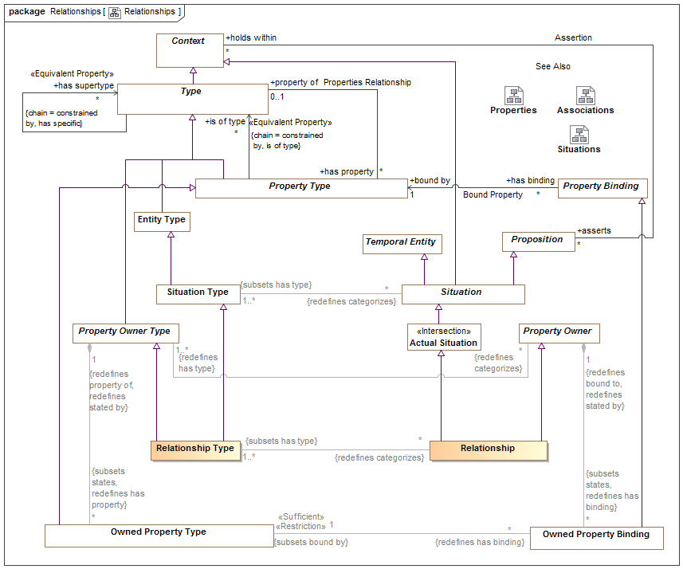
- Relationships
Relations are atomic actual situations that bind 2 or more properties as a fact.

Class Relationship
A relationship defines a situation involving related things. A relationship may be asserted within a context as true or false within that context. Each relationship type has a number of bindings of which do not change for the life of the relationship..
A relationship may be true or false within its context (including a timeframe) but is atomic in its truth value.
Relationships may participate in (be bound to) other relationships and as such bindings involving a relationship may change over time. That is, relationships are "first class" objects.
[IDEAS] tuple: A relationship between two or more things.
Note: SMIF allows one end of a relationship.
[OWL] An OWL class that is a subclass of SMIF: Relationship

Direct Supertypes
Actual Situation, Property Owner

Associations
: Relationship Type [1..*] Subsets: has type:Type

Class Relationship Type
A relationship type defines a type of condition, the relationship, involving related things. A relationship may be asserted within a context as true or false within that context. Each relationship type has a number of <has property> "structured property type" properties which describe the role of the related things with respect to the relationship, values of which uniquely do not change for the life of the relationship.
A relationship may be true or false within its context (including a timeframe) but is atomic in its truth value.
Relationships may participate in (be bound to) other relationships and as such bindings involving a relationship may change over time.
The terms for properties of a relationship in a conceptual model are typically verb phrases, connecting the relationship with the related types.
[FIBO] A kind of Mediating Thing
[IDEAS] TupleType: The Powertype of tuple.
[FUML] Association where memberEnd corresponds with <has property>. Note that SMIF relationships are "first class" and may also be considered to correspond to an association class where there are any properties or other relationships referencing the subject relationship.
[UML] AssociationClass (note that "end ownership" is meaningless in SMIF).
[Guizzardi2015] Relator: endurants of a special kind, with the power of connecting (mediating) other endurants. Note: Guissardi "mediation" corresponds with relationship properties.

Direct Supertypes
Property Owner Type, Situation Type

Associations
: Relationship [*] Redefines: categorizes:Thing

SMIF Conceptual Model::Rules
Rules define constraints or behaviors that are asserted in specified context.

Diagram: General Rules
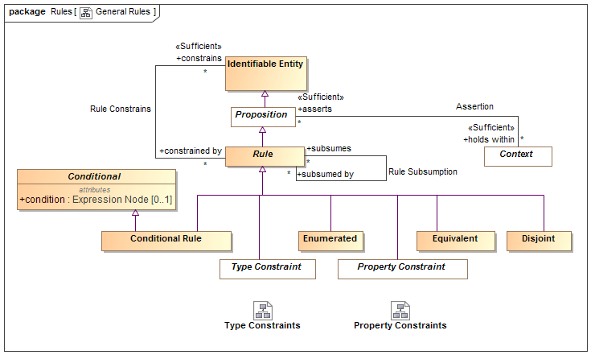
- General Rules

Diagram: Property Constraints
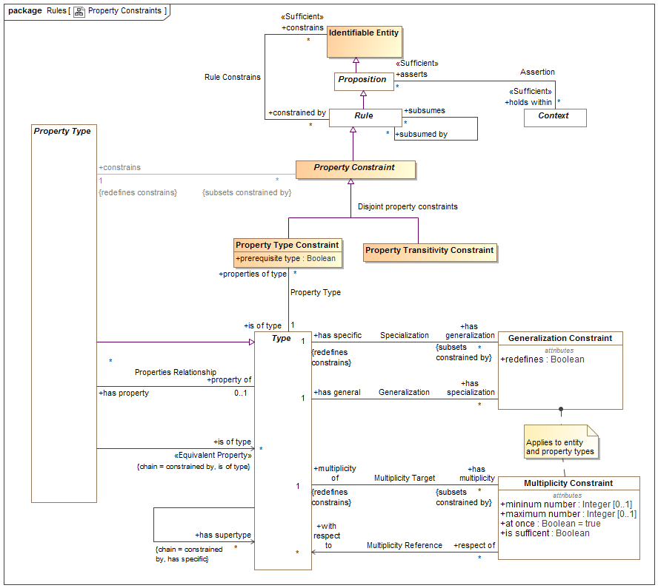
- Property Constraints
This diagram focuses on rules about properties.

Diagram: Rules in Context
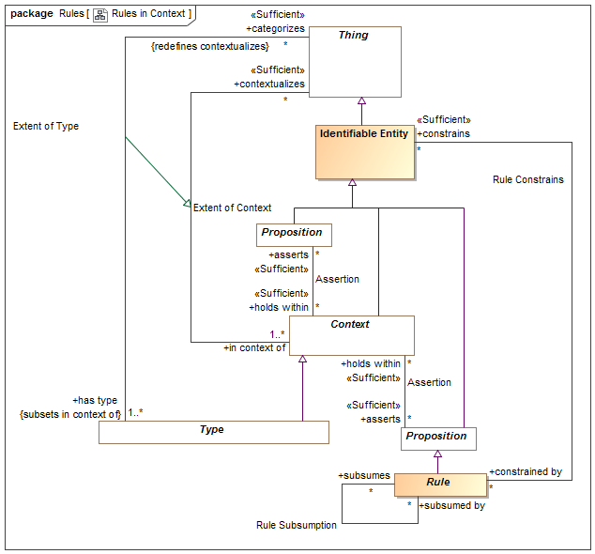
- Rules in Context
This diagram shows how rules are propositions that may be asserted within any context to apply to any other context, thus realizing the "open world assumption".

Diagram: Rules Summary
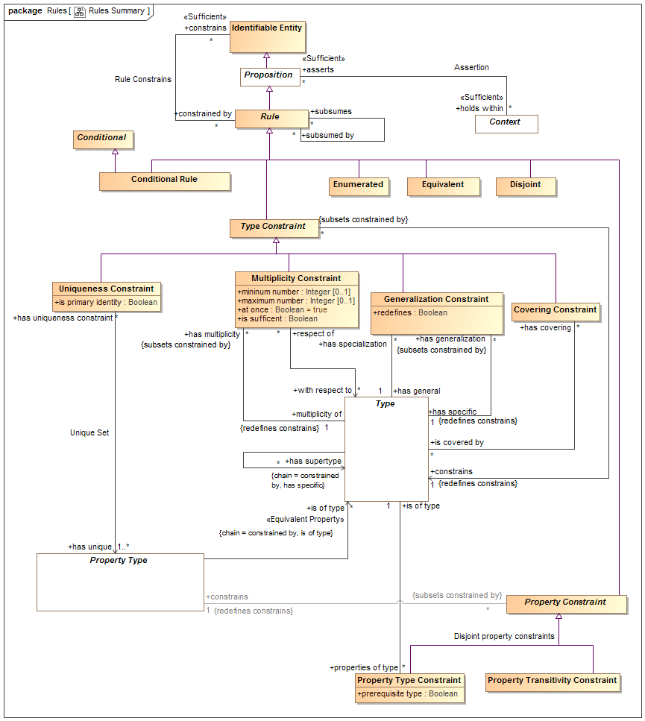
- Rules Summary
This diagram shown a summary of the primary rules.

Diagram: Type Constraints
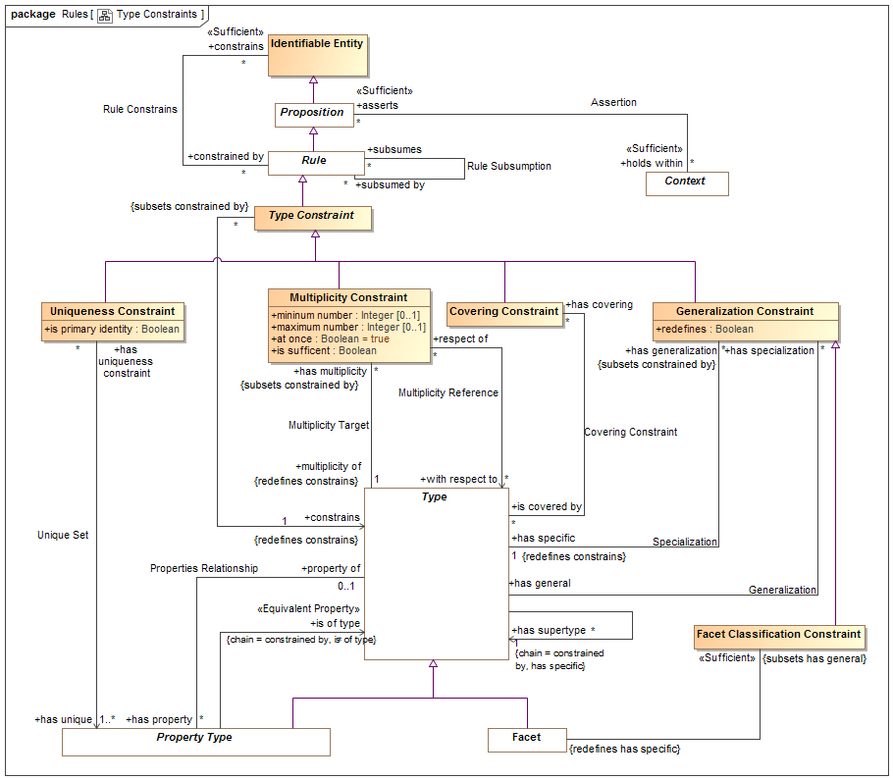
- Type Constraints
This diagram focuses on rules about types (note that property types are also types).

Class Conditional
Anything with a condition defined by an expression.

Attributes
condition : Expression Node [0..1]
Condition that must be TRUE for an element to be asserted. All values other than "TRUE" are FALSE.

Class Conditional Rule
A rule with a general expression as a condition that applies to what the rule <constrains>. Where asserted, the condition must be true.
[UML] Constraint where "context" corresponds with <holds within> and "constrainedElement" corresponds with "constrains". "specification" corresponds with "condition".

Direct Supertypes
Conditional, Rule

Class Covering Constraint
A constraint that the extent (<categorizes> things) of the <constrains> type is equivalent to the union of the extents of the <is covered by> types.
[UML] GeneralizationSet with isCovering=TRUE. "constrains" corresponds with the common "general" of each Generalization". "is covered by" corresponds with each "special" of each generalization.

Direct Supertypes
Type Constraint

Associations
is covered by : Type [*]
A type covered by a covering constraint.
The <constrains> type must be a direct supertype of all <is covered by> types.

Association Covering Constraint
Relationship defining the types covered by a covering constraint.

Association Ends
is covered by : Type [*]
A type covered by a covering constraint.
The <constrains> type must be a direct supertype of all <is covered by> types.
has covering : Covering Constraint [*]
Covering constraints of a type.

Class Disjoint
Disjoint is a rule that the things denoted by what the rule <constrains> do not and may not denote any of the same set of things.
When applied to a context (including types) all elements contextualized are included in the set of disjoint individuals.
[FIBO] Mutually Exclusive sets
[IDEAS] PartitionOfSetOfDisjointIndividuals: A FusionOfSetOfIndividuals whose fusioned Type is a SetOfDisjointIndividuals.
[UML] [UML] GeneralizationSet with isDisjoint=TRUE. "constrains" corresponds with "is covered by" of each "special" of each generalization. Note the SMIF does not require that disjoint elements have a common supertype, one may be inferred for UML mapping.
[OWL: Union(DisjointClasses, DisjointObjectProperties, DisjointDataProperties, DifferentIndividuals)

Direct Supertypes
Rule

Class Enumerated
The contextualized elements of the <constrains> context is a closed (enumerated) set, it can not be extended. A.K.A. "Closed World Assumption". Elements may not be asserted by any context other than the one specified in <holds within>.
[FIBO] Selections of Things
[FUML] Wen constraining a type, corresponds with [FUML] "Enumeration". SMIF enumerations are not limited to literals. The "ownedLiteral" corresponds with all elements owned by <holds within>.
[ISO11404] Enumerated: enumerated is a family of datatypes, each of which comprises a finite number of distinguished values having an intrinsic order.
[OWL] ObjectUnitionOf( DataOneOf, ObjectOneOf )

Direct Supertypes
Rule

Class Equivalent
Equivalent is a rule that the things the rule <constraints> denote the same set of things. When applied to a context (including types) each thing the context contextualizes is included in the set of equivalent things.
Related to*: [ISO 1087] synonymy: relation between or among terms (3.4.3) in a given language representing the same concept (3.2.1)
Related to*: [ISO 1087] equivalence: relation between designations (3.4.1) in different languages representing the same concept (3.2.1)
* SMIF relates concepts, not terms. synonymy may also be represented by multiple terms for the same concept.
[OWL] Union( SameIndividual, EquivalentClasses, EquivalentObjectProperties, EquivalentDataProperties)

Direct Supertypes
Rule

Class Facet Classification Constraint
A Facet Classification Constraint asserts that the specialized type is "non rigid" with respect to the general (rigid) type - that is the <has specific> type may change over the lifetime of instances of the <has general> type. The <has specific> type will be inferred to be a Facet. e.g. "Registered voter" is a facet of a person.
[FIBO] isPlayedBy

Direct Supertypes
Generalization Constraint

Associations
: Facet Redefines: has specific:Type

Association Generalization
Relationship defining the general type of a generalization constraint.
[ISO 1087] generic concept: concept (3.2.1) in a generic relation (3.2.21) having the narrower intension (3.2.9)

Association Ends
has general : Type [1] Redefines: has specific: Type
The general type in the Generalization rule.
[ISO 1087] concept (3.2.1) in a generic relation (3.2.21) having the broader intension (3.2.9)
[FUML] General (Where redefines is false or not defined)
[FUML] RedefinableElement.redefinedElement (Where redefines is true)
has specialization : Generalization Constraint [*] Redefines: has specific: Type
Specialization rules for a type.

Class Generalization Constraint
A Type Generalization Constraint is a taxonomic relationship between a more general <has general> type and a more specific <has specific> type. Each instance of the specific type is also an instance of the general type. The specific type inherits the properties and rules of the more general type.
The extent (<categorizes> property) of the specific type is the same as or a subset of the extent of the more general type.
Note that "multiple inheritance" is supported.
[IDEAS] superSubtype: A couple relating two Types which asserts that one type is a subset of the other.
[ISO 1087] generic relation: genus-species relation relation between two concepts (3.2.1) where the intension (3.2.9) of one of the concepts includes that of the other concept and at least one additional delimiting characteristic (3.2.7)
[FIBO] Inheritance
[UML] Generalization
[Guizzardi] (Specialization relation): Let F and G be two universals such that F is a specialization of G. Then, for all w ∈ W we have that extw(F) ⊆ extw(G)
[OWL] Union(SubClassOf, SubPropertyOf)

Direct Supertypes
Type Constraint

Attributes
redefines : Boolean
Defines the generalization as a redefinition, subsuming the more general type in the definitional context.
Where <redefines> is true the more specific type subsumes the more general type in the definition context. In this case the more general and more specific sets are equivalent. A type may be redefined multiple times, as long as it is unambiguous which definition applies for a particular instance.
Where <redefines> is false or not defined the more specific type represents a subset of the more general property.
Redefinition is most often used with properties (as defined in UML) but may also be applied to other types.

Associations
has general : Type [1]
The general type in the Generalization rule.
[ISO 1087] concept (3.2.1) in a generic relation (3.2.21) having the broader intension (3.2.9)
[FUML] General (Where redefines is false or not defined)
[FUML] RedefinableElement.redefinedElement (Where redefines is true)
has specific : Type [1] Redefines: constrains:Identifiable Entity
The specific type in a generalization rule.
[ISO 1087] generic concept: concept (3.2.1) in a generic relation (3.2.21) having the narrower intension (3.2.9)
[FUML] specific
[ISO11404] A subtype is a datatype derived from an existing datatype, designated the base datatype, by restricting the value space to a subset of that of the base datatype whilst maintaining all characterizing operations. Subtypes
are created by a kind of datatype generator which is unusual in that its only function is to define the relationship between the value spaces of the base datatype and the subtype.
[OWL] Union( rdfs:subClassOf, SubObjectPropertyOf, SubDataPropertyOf)

Class Multiplicity Constraint
A Multiplicity constraint constrains the number of bindings <multiplicity of> types (including property types) may have in a particular instance of the constrained type.
For a property type, The number of instances bound to a property for the set of instances bound to <with respect to> shall be limited by the minimum and maximum number of the multiplicity.
For non-property types, the multiplicity shall apply to the extent of the type as described by <classifies>.
[IDEAS] superSubType
[FUML] MultiplicityElement: Note: Multiplicity Constraint constraining a type has semantics included in to UML MultiplicityElement.
[OWL] Union(ObjectMaxCardinality, ObjectMinCardinality, ObjectExactCardinality, DataMaxCardinality, DataMinCardinality, DataExactCardinality)

Direct Supertypes
Type Constraint

Attributes
mininum number : Integer [0..1]
Minimum number in a set as constrained by a multiplicity.
[FUML] MultiplicityElement.lowerValue
[OWL] MinCardinality
maximum number : Integer [0..1]
Maximum number in a set as constrained by a multiplicity.
[FUML] MultiplicityElement.upperValue
[OWL] maxCardinality
at once : Boolean = true
When at once is true, the constraint applies for each snapshot in time but not across snapshots (e.g. a car can have at most one driver at a time). When at once is false the constraint applies across all time (e.g. a person has exactly one birth mother across all time).
is sufficent : Boolean
One of the set of sufficient conditions that will infer the type designated in <constrains>.

Associations
with respect to : Type [*]
One or more types or properties that define the "from" side of a multiplicity.
Where with respect to is undefined and <multiplicity of> is a property, all properties that are <property of> the same structured type as <multiplicity of> shall be considered the set of <with respect to> properties. I.e. all the "other ends" of a relationship.
<with respect to> provides for complex multiplicities across n-ary situations, data structures and relationships.
multiplicity of : Type [1] Redefines: constrains:Identifiable Entity
The type or property that is the subject of a multiplicity constraint.

Association Multiplicity Reference
Multiplicity may be defined between things. E.g. there are 2 wheels on a motorcycle. This is most often required where relationships have more than 2 ends.
Multiplicity reference defines the "from" side of such a multiplicity (e.g. the motorcycle).

Association Ends
with respect to : Type [*] Redefines: constrains: Identifiable Entity
One or more types or properties that define the "from" side of a multiplicity.
Where with respect to is undefined and <multiplicity of> is a property, all properties that are <property of> the same structured type as <multiplicity of> shall be considered the set of <with respect to> properties. I.e. all the "other ends" of a relationship.
<with respect to> provides for complex multiplicities across n-ary situations, data structures and relationships.
respect of : Multiplicity Constraint [*] Redefines: constrains: Identifiable Entity
Multiplicity constraints using a property or type as a <with respect to> reference.

Association Multiplicity Target
Relationship defining the type a multiplicity rule applies to. Note that properties are types and may also have multiplicity constraints.

Direct Supertypes
Rule Constrains

Association Ends
multiplicity of : Type [1] Redefines: constrains: Identifiable Entity
The type or property that is the subject of a multiplicity constraint.
has multiplicity : Multiplicity Constraint [*] Redefines: constrains: Identifiable Entity
Multiplicity constraint of a type or property.

Class Property Constraint
Abstract supertype for constraints that constrain properties types.

Direct Supertypes
Rule

Associations
constrains : Property Type [1] Redefines: constrains:Identifiable Entity

Class Property Transitivity Constraint
A transitive property defined by <constrains> interlinks two individuals A and C whenever it interlinks A with B and B with C for some individual B.
For example "larger than" is transitive in that if Joe is larger than Sue and Sue is Larger then Sam, then Joe is larger than Sam.
[OWL] TransitionObjectProperty

Direct Supertypes
Property Constraint

Association Property Type
Relationship defining the type of a property.

Association Ends
is of type : Type [1] Redefines: constrains: Identifiable Entity
A required type of a thing bound to a property.
Note that the type may be inferred based on the value of <prerequisite type>.
[OWL] rdfs:range,
properties of type : Property Type Constraint [*] Redefines: constrains: Identifiable Entity
Properties typed by a type

Class Property Type Constraint
A property type constraint defines the type(s) of a property.
All elements bound to a property must have the type <is of type>. <is of type> may be pre-existing or inferred based on the value of <prerequisite type>.
Note that Property Type Constraint is a rule independent of the definition of a property to allow for the type of a property to be refined in a more restrictive context.
[FUML] TypedElement.type: Note: A property type constraint applied to a property has the same semantics as a UML TypedElement.
[OWL] Union( AllValuesFrom, SomeValuesFrom, DataPropertyRange, ObjectPropertyRange)). <is of type> corresponds to rdfs:Range. <constrains> corresponds to rdfs:Domain (note that in an association type or relationship type with two property types, the range will be the domain of the "opposite" property, if any).

Direct Supertypes
Property Constraint

Attributes
prerequisite type : Boolean
If true, <is of type> is a prerequisite - the bound thing must be of the given type for the property to be bound. A non prerequisite type will cause a binding to infer <is of type>, provided all prerequisite types have been satisfied.

Associations
is of type : Type [1]
A required type of a thing bound to a property.
Note that the type may be inferred based on the value of <prerequisite type>.
[OWL] rdfs:range,

Class Rule
A rule is a proposition that constrains one or more entities by limiting possible conditions or producing some effect.
Note that rules may or may not be defined in the same context that they hold within or constraint. This support the "open world assumption" that a rule may be asserted outside of the scope of the rule or what the rule is constraining.

Direct Supertypes
Proposition

Associations
constrains : Identifiable Entity [*]
The entity or entities constrained by a rule.
Where a rule constrains a context, all things contextualized by the context shall be subject to the rule.
Where there are no <constrains> for a rule, the rule applies globally - to the universal context.
subsumes : Identifiable Entity [*]
When a rule subsumes another the subsumed rule will not apply (fire) if the <subsumed by> rules applies (fires).
Where rules are also patterns, a rule may specialize another which will subsume the specialized rule as well as include the generalized rule parts as parts of the specialized rule.
subsumed by : Identifiable Entity [*]
When rule is <subsumed by> another the subsumed rule will not apply (fire) if the <subsumed by> rules applies (fires).

Association Rule Constrains
Relationship defining the entity constrained by a rule. Where no constrained entity is specified, all entities are constrained with the scope of <holds within> are constrained.

Association Ends
constrains : Identifiable Entity [*]
The entity or entities constrained by a rule.
Where a rule constrains a context, all things contextualized by the context shall be subject to the rule.
Where there are no <constrains> for a rule, the rule applies globally - to the universal context.
constrained by : Rule [*]
Rules applying to an entity.

Association Rule Subsumption
Relationship defining rule subsumption. When a rule subsumes another the subsumed rule will not apply (fire) if the <subsumed by> rules applies (fires).

Association Ends
subsumes : Rule [*]
When a rule subsumes another the subsumed rule will not apply (fire) if the <subsumed by> rules applies (fires).
Where rules are also patterns, a rule may specialize another which will subsume the specialized rule as well as include the generalized rule parts as parts of the specialized rule.
subsumed by : Rule [*]
When rule is <subsumed by> another the subsumed rule will not apply (fire) if the <subsumed by> rules applies (fires).

Association Specialization
Relationship defining the specific type of a generalization constraint.

Direct Supertypes
Rule Constrains

Association Ends
has specific : Type [1]
The specific type in a generalization rule.
[ISO 1087] generic concept: concept (3.2.1) in a generic relation (3.2.21) having the narrower intension (3.2.9)
[FUML] specific
[ISO11404] A subtype is a datatype derived from an existing datatype, designated the base datatype, by restricting the value space to a subset of that of the base datatype whilst maintaining all characterizing operations. Subtypes
are created by a kind of datatype generator which is unusual in that its only function is to define the relationship between the value spaces of the base datatype and the subtype.
[OWL] Union( rdfs:subClassOf, SubObjectPropertyOf, SubDataPropertyOf)
has generalization : Generalization Constraint [*]
Generalization rules for a type

Class Type Constraint
A constraint of a type, including Relationships types.

Direct Supertypes
Rule

Associations
constrains : Type [1] Redefines: constrains:Identifiable Entity

Association Unique Set
Relationship defining the set of properties that uniquely identify an instance of the constrained type.

Association Ends
has unique : Property Type [1..*] Redefines: constrains: Identifiable Entity
The set of involved properties within a type that uniquely identify an individual.
has uniqueness constraint : Uniqueness Constraint [*] Redefines: constrains: Identifiable Entity
Uniqueness constraints for a property.

Class Uniqueness Constraint
A constraint that, within the <constrains> type the rule applies to, the set of instances bound to the set of types in the "has unique" relation must be unique and serves to define the "identity" of each individual.
Note: Uniqueness may be used to define a "key".
[OWL] HasKey where CE (subject class expression) is <constrains> and <has unique> is Union(ObjectPropertyExpression, DataPropertyExpression)

Direct Supertypes
Type Constraint

Attributes
is primary identity : Boolean
A uniqueness constraint that can be interpreted as a "primary key", the identity of an entity.

Associations
has unique : Property Type [1..*]
The set of involved properties within a type that uniquely identify an individual.

SMIF Conceptual Model::Situations
A situation is a particular configuration of things and their relations including spatial, temporal, and logical connections between those things valid over a period of time. Situations form the basis of all complex, time dependent entities.

Diagram: Situations
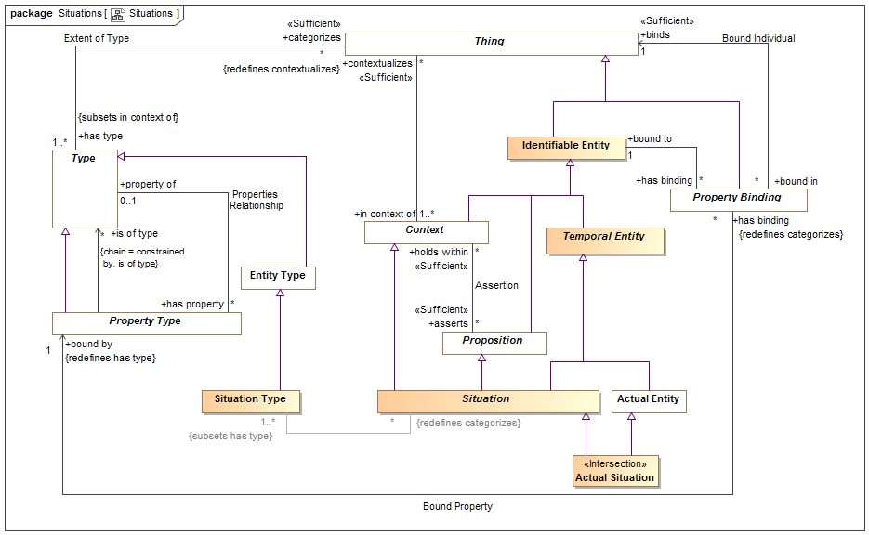
- Situations

Class Actual Situation
An actual situation is an individual situation that actually exists, happened in the past or may exist in some possible world, not a template or process definition. Such situations must exist for a time interval, however there are no constraints on such a time interval - from an instant to the life of the universe.
DTV: Occurrence: state of affairs that is a happening in the universe of discourse
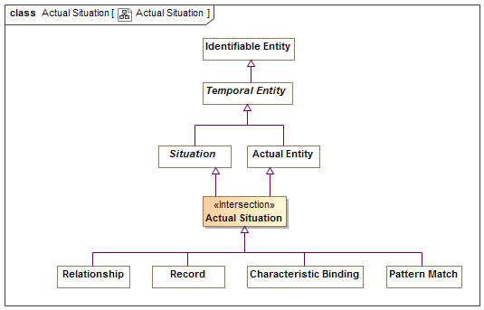
- Actual Situation

Direct Supertypes
Actual Entity, Situation

Class Situation
A situation is an identifiable entity composed of an arrangement of entities and the relations between them over a time interval. Situations are propositions and may be asserted as true or false in some context. Situations may change over time, unless otherwise constrained. As an identifiable entity, situations may participate in relationships, thus situations are "first class" elements in SMIF.
[SBVR] "State of affairs"
[JSKR] Nexus

Direct Supertypes
Context, Lexical Scope, Proposition, Temporal Entity

Associations
: Situation Type [1..*] Subsets: has type:Type
matched by : Pattern Match [*]
Pattern matches that match the subject situation.

Class Situation Type
A situation type defines a kind of identifiable arrangement of individuals, assertions and the relations between them over a timespan. As an identifiable entity, situations may participate in other situations and relationships by being bound to properties of those situations or relationships with bindings, thus situations are “first class” entities in a SMIF model.
The roles or behaviors things (any entity or value) may play in a situation are identified as properties of the situation type.
Entity types and roles may also be situation types.
Syn. Type of a state of affairs.
A situation type may have properties such that instances, may bind things to structures based on properties.
Things may be bound to a structure (i.e. play a role in the structure) via properties. Things bound to properties of a structure may change over time, unless otherwise constrained.
[DTV] situation kind: state of affairs that may or may not happen in some possible world

Direct Supertypes
Entity Type

Associations
: Situation [*] Redefines: categorizes:Thing

SMIF Conceptual Model::Top level
The top level objects provide the foundation for all objects in a SMIF model

Diagram: Top Level
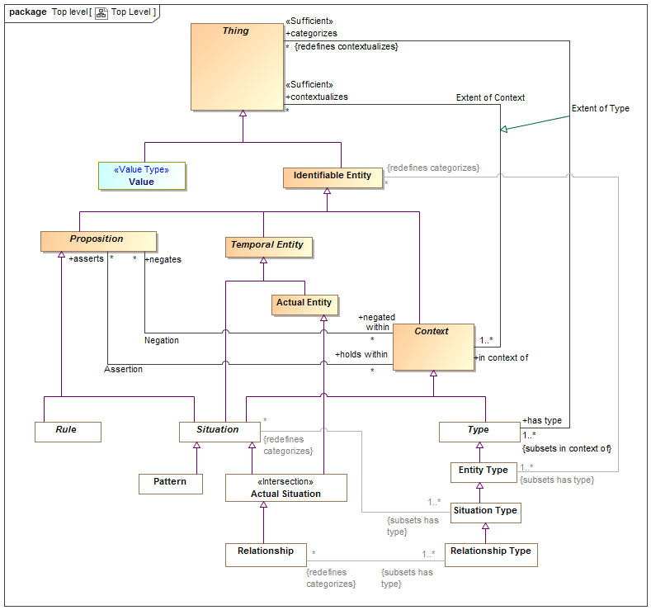
- Top Level
Diagram showing summary of top level classes and significant subtypes.

Class Actual Entity
An actual entity is an identifiable, temporal and individual person, specific object, process enactment, agreement, etc. Actual Entities do not have to be physical, e.i. may denote social constructs. Actual entities are disjoint from types.
A more specific class of actual entity (e.g., Person) is intended to refine the classification of the individual thing.
Individuality (or selfhood) is the state or quality of being an individual; particularly of being separate from other individuals and possessing identity. Actual entities typically have a lifetime and some individuals may change over that lifetime. Individuals may have parts that together help define the individual but may change over time.
"Actual" does not imply current existence.
[ISO 1087] individual concept: concept (3.2.1) which corresponds to only one object
[UML] Loose correspondence with "InstanceSpecification". SMIF instances are direct instances of their types, there is no "indirection" through value specification as their is in UML.
[Guizzardi] (individual concept)
[CL] Individual: one element of the universe of discourse
[DOLCE] Particular: particulars are entities which have no instances
[JSKR] Independent. Can be considered "Actuality" when including social constructs in [JSKR] Physical.
[OWL] Individual
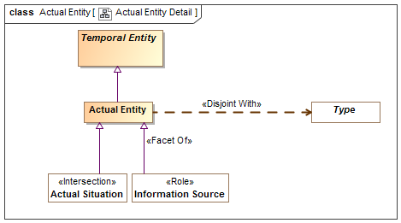
- Actual Entity Detail

Direct Supertypes
Temporal Entity

Association Assertion
An assertion relationship between a context and the propositions asserted within that context. The <asserts> proposition is asserted (defined as "true") for all things contextualized by the <holds within> context. Assertion of truth is not absolute, it is relative to the context. For example, something could be asserted within a context where that entire context is asserted to be false.
Assertion is transitive.
[CL] Implication
[OWL] Assertion; Any [OWL] Assertion included in a graph (All assertions in an OWL graph are asserted by the graph)

Association Ends
asserts : Proposition [*] Redefines: categorizes: Thing
Proposition that is asserted (must be true) for anything contextualized by a context.
As types are a context, types may assert a proposition for their instances.
holds within : Context [*] Redefines: categorizes: Thing
Context in which a proposition is asserted (required to be true). Anything contextualized by the context is subject to the proposition.

Class Context
A <Context> is a grouping of <contextualizes> things that are related in some way.
A <Context> also <asserts> propositions that hold for all things the context <contextualizes>, thus providing the link between an assertion and the set of things asserted. Likewise a context <negates> propositions that are false within the context.
Subtypes of <Context>, such as <Type> ascribe more semantics to the context as well as the things it <contextualizes>.
A context provides a binding between a set of propositions and the things those propositions apply to.
[CL] Sort: any subset of the universe of discourse over which some quantifier is allowed to range
[ISO 1087] concept field: unstructured set of thematically related concepts (3.2.1)
[JSKR] Mediating
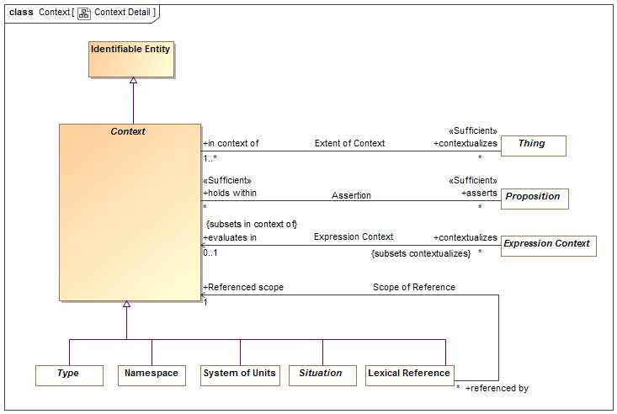
- Context Detail

Direct Supertypes
Identifiable Entity

Associations
asserts : Proposition [*]
Proposition that is asserted (must be true) for anything contextualized by a context.
As types are a context, types may assert a proposition for their instances.
contextualizes : Thing [*]
The set of things contextualized by a <Context>, or "in" the <Context> and therefor subject to the <asserts> propositions of the <Context>.
negates : Proposition [*]
Proposition that is negatively asserted (must be FALSE) for anything contextualized by a context.
As types are a context, types may assert or negate a proposition for their instances.

Association Extent of Context
The association between a context and the set of things contextualized by that context, defining the extent of the context, a set.
[ISO 1087] extension: totality of objects (3.1.1) to which a concept (3.2.1)
corresponds

Association Ends
contextualizes : Thing [*]
The set of things contextualized by a <Context>, or "in" the <Context> and therefor subject to the <asserts> propositions of the <Context>.
in context of : Context [1..*]
A <Context> that contextualizes a thing making what it <contextualizes> subject to the propositions referenced by <has assertion> of the context.
A thing may be <in context of> one or more context.
[FIBO] hasContext

Class Identifiable Entity
An identifiable entity is any identifiable thing other than values, this includes individuals, types, axioms, situations, speech acts, information structures, etc.
Identifiable entities always have some kind of identity and may have identifiers. Note that identity is an abstraction that may have representation in models as any number of identifiers, also known as a "sign".
[OWL] Entity type (Implied in section [OWL] 5.8) as an instance of rdfs:Class
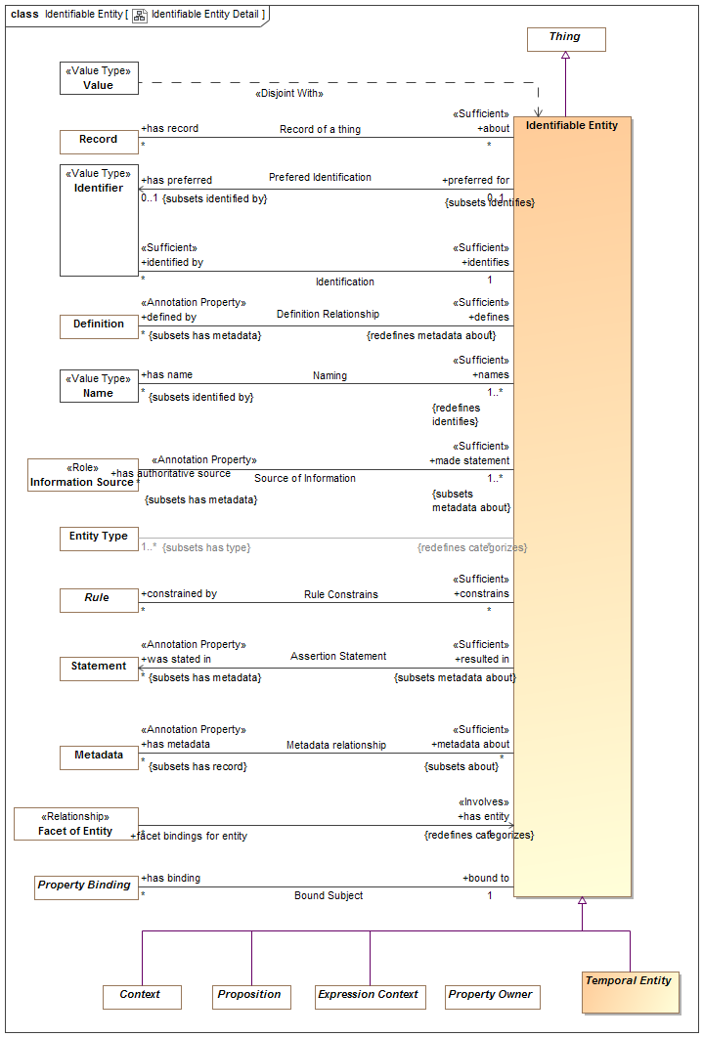
- Identifiable Entity Detail

Direct Supertypes
Thing

Associations
was stated in : Statement [*] Subsets: has metadata:Metadata
Metadata representing the speech act, document or other record where a statement captured in a model was made.
[OWL] rdfs:isDefinedBy
has preferred : Identifier [0..1] Subsets: identified by:Identifier
Default identifier to use for an entity.
Where multiple identifiers are preferred in differing context any method for selecting the most preferred identifier is implementation specific and not specified by this standard.
[FUML] NamedElement.name: Note: An Identifier that is <preferred for> an entity is equivalent to the name of a named element.
: Entity Type [1..*] Subsets: has type:Type
defined by : Definition [*] Subsets: has metadata:Metadata
An informal description of something.
[FIBO] hasDefinition
[UML] comment
[FUML] ownedComment
identified by : Identifier [*]
An identifier for an <Entity>.
[FIBO] hasDenotation
has metadata : Metadata [*] Subsets: has record:Record
Metadata associated with (data about the information concerning) the subject entity.
[OWL] AnnotationProperty, annotationValue of Annotation Assertion
has name : Name [*] Subsets: identified by:Identifier
A human meaningful name for an entity.
[FIBO] hasName: that by which some thing is known; may apply to anything
[OWL] rdfs:label
has record : Record [*]
A record about something.
constrained by : Rule [*]
Rules applying to an entity.
has authoritative source : Information Source [*] Subsets: has metadata:Metadata
Metadata representing the authority behind a statement - who or what made a statement captured in a model.
has binding : Property Binding [*]
Bindings asserted for properties within a situation.

Association Negation
An assertion relationship between a context and the propositions negated (FALSE) within that context. The <negates> proposition is asserted as FALSE for all things contextualized by the <negated within> context. Assertion or negation of truth is not absolute, it is relative to the context.
[CL] Negation+Implication

Association Ends
negates : Proposition [*]
Proposition that is negatively asserted (must be FALSE) for anything contextualized by a context.
As types are a context, types may assert or negate a proposition for their instances.
negated within : Context [*]
Context in which a proposition is negated (required to be FALSE). Anything contextualized by the context is subject to the proposition.

Class Proposition
A proposition is statement, or condition with a truth value (true or false) that can be determined or asserted with some level of confidence (assessment of confidence being outside of this specification).
All "facts", statements, speech acts, relationships and rules are propositions.
Propositions may be asserted to be true within a context which they <holds within>.
For a situation, the proposition is true if the situation is actual (i.e., takes place, obtains).
[SBVR] the state of affairs is posited by the proposition and if the state of affairs were actual, the proposition would be true
[CL] Sentence: unit of logical text which is true or false, i.e. which is assigned a truth-value in an interpretation
[JSKR] Proposition
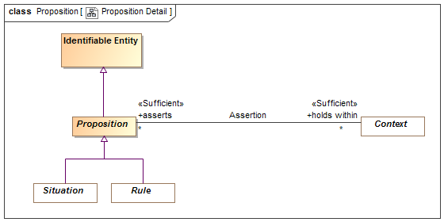
- Proposition Detail

Direct Supertypes
Identifiable Entity

Associations
holds within : Context [*]
Context in which a proposition is asserted (required to be true). Anything contextualized by the context is subject to the proposition.
negated within : Context [*]
Context in which a proposition is negated (required to be FALSE). Anything contextualized by the context is subject to the proposition.
qualified within : Proposition Variable [0..1]

Class Temporal Entity
A temporal is anything that has a timespan. Temporal things may have temporal relationships with other temporal things.
Note that relationships defined for [DTV] Time Intervals may be specified for <temporal Entity> but are not specified in SMIF.
[JSKR] Continuant
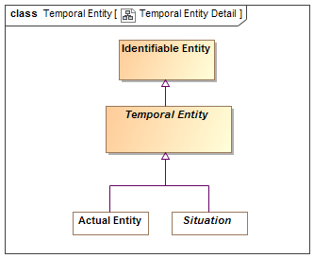
- Temporal Entity Detail

Direct Supertypes
Identifiable Entity

Class Thing
Any thing or value that does or may exist in any possible world. Thing is the supertype of all types and may therefore participate in unbounded relations.
Instances of Thing are referred to as "a thing" in this model.
[IDEAS] Thing
[OWL] Thing
[ISO 1087] object: anything perceivable or conceivable
[FIBO] Thing
[Guizzardi] Thing
[FUML] Element
[JSKR] "T"
[OWL] rdfs:Resource
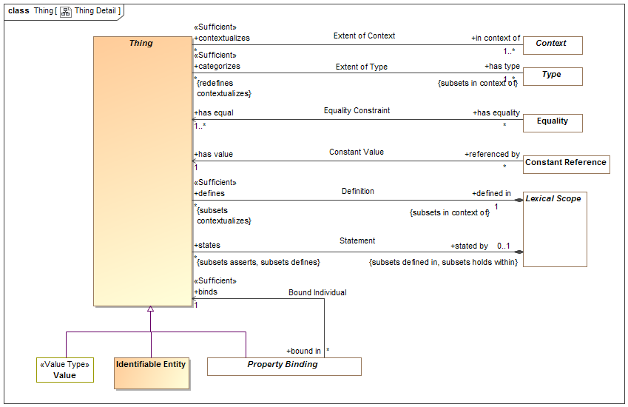
- Thing Detail

Associations
defined in : Lexical Scope [1] Subsets: in context of:Context
Lexical scope defining model elements.
[UML]owner
in context of : Context [1..*]
A <Context> that contextualizes a thing making what it <contextualizes> subject to the propositions referenced by <has assertion> of the context.
A thing may be <in context of> one or more context.
[FIBO] hasContext
has type : Type [1..*] Subsets: in context of:Context
A type that holds for something.
Things may have multiple types and these types may change over time.
The <categorized> thing satisfies the constraints of the <has type> type.
[FIBO] isClassifiedBy
[OWL] rdf:type
stated by : Lexical Scope [0..1] Subsets: defined in:Lexical Scope holds within:Context
<stated by> is a lexical scope that both defines and asserts a model element.

SMIF Conceptual Model::Types
Types provide for ways to categorize anything based on what it is, the roles it plays or the phases it may be in.
Something may be categorized by any number of types (multiple classification assumption).

Diagram: Type-instance
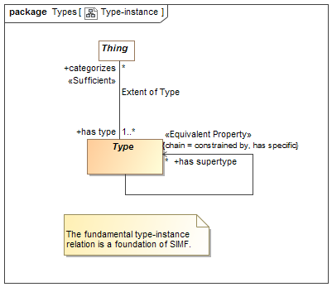
- Type-instance

Diagram: Types
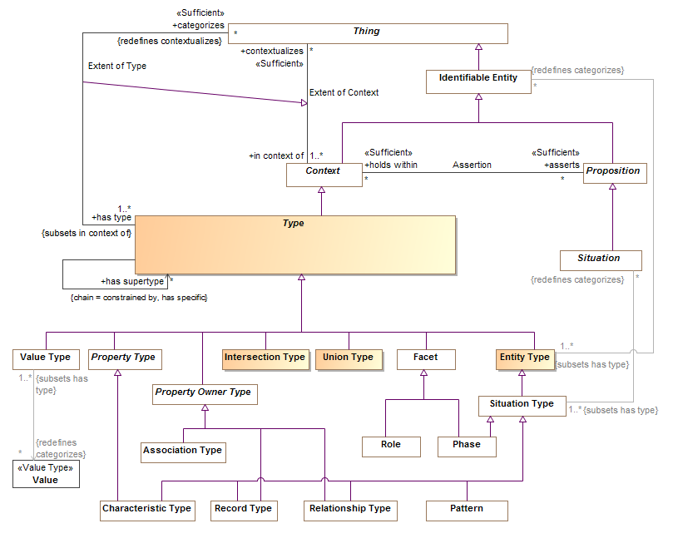
- Types

Class Entity Type
A type of an identifiable entity. All concrete entity instances must have at least one entity type. Entity type may be mixed with other types to fully define an entity.
[FUML] Classifier
[Guarino1994] Substantial or Pseudo-Sortal (Substantial being concrete)
[Guizzardi] A Rigid Universal.
(Rigid Universal): A universal G is rigid (or modally constant) iff for any w,w ∈ W 3. extw(G) = extw(G) Putting definitions 4.1 and 4.3 together, we have that for any rigid universal G the following is true 4. ext(G) = extw(G), for all w ∈ W A rigid universal is one that applies to its instances necessarily, i.e., in every possible world. Every substance sortal G is a rigid universal.
[OWL] rdfs:Class (as Entity Type does not include values). However, non=primitive values are typically represented as rdfs:Class

Direct Supertypes
Type

Associations
: Identifiable Entity [*] Redefines: categorizes:Thing

Association Extent of Type
The relation between a type and the things that type categorizes, the instances which defines the extent of the type, a set.
[IDEAS] typeInstance: A couple that asserts that a Thing is a member of a Type.
[Guizzardi] (Extension functions): Let W be a non-empty set of
possible worlds and let w ∈ W be a specific world. The extension function extw(G) maps a universal G to the set of its instances in world w. The extension function ext(G) provides a mapping to the set of instances of the
universal G that exist in all possible worlds, such that ext(G) = U w∈W w ext (G)
[OWL] ClassAssertion

Direct Supertypes
Extent of Context

Association Ends
categorizes : Thing [*] Redefines: categorizes: Thing
The set of things described by a type, the "extent" of the type.
The thing a type <categorizes> is subject to the <has assertion> propositions of the type.
[FIBO] classifies
has type : Type [1..*] Redefines: categorizes: Thing
A type that holds for something.
Things may have multiple types and these types may change over time.
The <categorized> thing satisfies the constraints of the <has type> type.
[FIBO] isClassifiedBy
[OWL] rdf:type

Class Intersection Type
An intersection is a type that has an extent which is the complete intersection of the extents of all supertypes. Intersection is a stronger statement than a subtype as a subtype may not be a complete intersection.
[MathWorld] The intersection of two sets A and B is the set of elements common to A and B. This is written A intersection B, and is pronounced "A intersection B" or "A cap B."

Direct Supertypes
Type

Class Type
A <Type> is a categorization of any thing based on specific criteria. The specific criteria may or may not be formalized in a model.
A <Type> <categorizes> a set of <Thing>s which comprises the "extent" of the type.
A <Type> is a <Context> where the things it <categorizes> are <in the context> of the <Type>.
[IDEAS] Type: A set (or class) of Things.
[ISO 1087] general concept: concept (3.2.1) which corresponds to two or more objects (3.1.1) which form a group by reason of common properties
[FIBO] Classifier: a standardized classification or delineation for something, per some scheme for such delineation, within a specified context
[FUML] Type
[CL] Type:: logical framework in which expressions in the logic are classified into syntactic or lexical categories (types) and restricted to apply only to arguments of a fixed type
[Guarino1994] Discriminating Predicate
[OWL] Union(rdfs:Class, rdfs:Datatype)

Direct Supertypes
Context, Lexical Scope

Associations
has supertype : Identifiable Entity [*] Redefines: categorizes:Thing
Supertypes(s) of a type as defined by generalization rules.
All statements made about the supertype are true for the subtype. The extent (categorizes) of the subtype is a subset of the extent of the supertype.
Has supertype is a a derived association based on generalization rules.
categorizes : Thing [*] Redefines: contextualizes:Expression Context
The set of things described by a type, the "extent" of the type.
The thing a type <categorizes> is subject to the <has assertion> propositions of the type.
[FIBO] classifies
has property : Property Type [*]
A property of a structured type such that there may be bindings of a thing to instances of the structured type with reference to the property which defines the semantics of the bound thing withing the context of the structure.
[FUML] feature
[UML] memberEnd. attribute (of classifier).
asserts pattern : Pattern of Type [0..*] Subsets: asserts:Proposition
A pattern asserted for all instances of a type. Where the pattern includes parts, the type defines a composition.
has covering : Covering Constraint [*]
Covering constraints of a type.
has specialization : Generalization Constraint [*]
Specialization rules for a type.
has multiplicity : Multiplicity Constraint [*] Subsets: constrained by:Rule
Multiplicity constraint of a type or property.
properties of type : Property Type Constraint [*]
Properties typed by a type
recording types : Record Type [*]
Record for a thing.
has generalization : Generalization Constraint [*] Subsets: constrained by:Rule
Generalization rules for a type

Class Union Type
A Union is a type that has an extent which is the complete union of the extents of all types that specialize the Union.
[FIBO] Logical Unions
[MathWorld] Given two sets A and B, the union is the set that contains elements or objects that belong to either A or to B or to both. We write A È B
[OWL] ObjectUnionOf( ObjectUnionOf, DataUnionOf)

Direct Supertypes
Type

SMIF Conceptual Model::Values
The values package defines the concepts of values and quantities expressed in units.

Values may be differentiated from entities in that values have no independent lifetime or "identity" other than the value its self. E.g. the number 5 "just is" and can't be changed. Properties and relations referencing values can, of course, change but the values are constant.
The failure to properly express units in data models often results in errors, inefficiencies and risk. Translation and federations between models, schema and data sources that is not cognizant of the units used would be even more error prone and risky. For example, what does “Speed limit 50” mean? For these reasons the SMIF language provides specific support for specifying quantity kinds and unit types in conceptual, logical and physical models. The SMIF mapping rules may then perform the appropriate unit conversions.
The foundation of information specification in SMIF at all levels is the type system. Types specified for all properties and relations involving values must match the types of the related values. The concepts of units and values as defined in "VIM" [JCGM 200-2008] is used as the basis for defining the types used in SMIF to guarantee type safety of quantities across different representations. Since many existing models and schema do not include well defined units some effort may be required to find and then specify the implicit units based on documentation, SME interviews or inspection of data or source code. It is recommended that the units used by external models and schema be determined prior to attempting federation and integration of information based on those models or schema.
VIM [JCGM 200-2008] concepts of quantities and units
VIM defines
- quantity: property of a phenomenon, body, or substance, where the property has a magnitude that can be expressed as a number and a reference [ed. to a unit]
- kind of quantity (kind): aspect common to mutually comparable quantities
- measurement unit (unit): real scalar quantity, defined and adopted by convention, with which any other quantity of the same kind can be compared to express the ratio of the two quantities as a number
SMIF concepts of quantities and units
SMIF uses the VIM concepts to define "quantity values" and types to capture the quantity kind and unit. Types are defined for each Unit. The goals for this type based approach are:
- That it is clearly grounded in semantics as defined in VIM
- That a type may be used to specify the range of a property or relation involving unit based values.
- That a quantity value (e.g. 5 grams) be representable as a simple number with a type.
- That there is a clear type hierarchy starting with a representationally independent type in a conceptual model (e.g. mass) that can be further specialized to a specific unit in a logical model (e.g. grams) and further specialized to be represented by a physical data type (e.g. “double”).
- That external models and schema may have unit specifications asserted without changing the schema.
- That a quantity of an entity be able to be referenced without a specific quantity value being known (e.g. John’s weight).
- That systems of units such as [ISO-80000] or [OMG QUDV] (A part of SysML) be able to be directly referenced as the definition of a unit.
SMIF defines three types to realize the above goals: Quantity Kind, Unit Type, Base Unit Type. SMIF also defines Quantity Values, which are instances of unit types.
In VIM a quantity has a magnitude that is expressed as a number and a reference. The SMIF quantity value is the numeric value of such a quantity where the reference is specified by the “unit reference” property of the quantity value’s type. The quantity value’s type is a “Unit Type”. The Unit type has attributes for converting a unit to a base unit, a symbol and a unit reference. Based on VIM the unit reference may be “a measurement unit, a measurement procedure, a reference material, or a combination of such” and is specified with a description that contains reference information. In summary, the reference of a SMIF quantity value is determined indirectly through its unit type. A quantity value has exactly one unit type and exactly one Quantity Kind. A quantity value expressed in any unit of the same quantity kind may be converted to any other unit of the same quantity kind.
This type-based sapproach allows specification of a property at the conceptual (quantity kind) logical (unit type) or physical (unit type with a numeric type) levels. Such specifications use the same type-based approach used for other aspects of the models. Given this information a SMIF implementation may correctly and reliably convert between compatible types regardless of representation. Please see the specification of the value types, attributes and relationships for more detail.

Example:
- A specification for a road segment has a property “Speed limit”.
- The type of this property in a reference conceptual model is “Speed:Quantity Kind”.
- A unit “Kilometer per Hour:Unit Type” is defined as a subtype of “Speed:Quantity Kind” with a “unit reference” of “[ISO-80000.4] Kilometer per Hour”. Note that quantity kinds and unit types would normally be defined in reference models that correspond to a “system of units”.
- Miles per hour is also defined as a subtype of Speed.
- A physical schema defines “Speed-KPH: Integer”.
- A SMIF mapping rule maps “Speed limit” to “Speed-KPH” and asserts a type of “Kilometer per Hour” on the “Speed-KPH” end.
- A data file defines a road “Route One” with a speed limit of 100:KPH-Int.
- When converted to a U.S. application this speed limit of route one can be viewed as 62:MPH-Int.

Diagram: Values
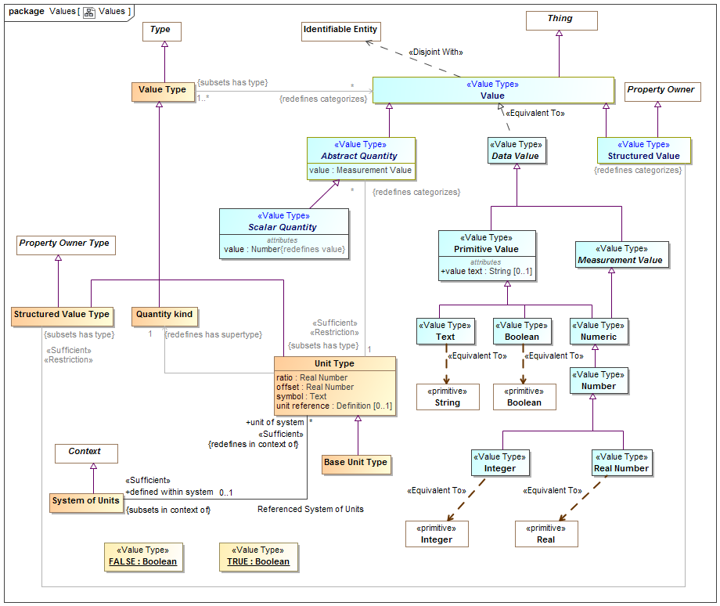
- Values

Class Abstract Quantity
A quantity value is a numeric magnitude with a unit type that may be used as the value of a quantity property as defined by [JCGM 200:2008]. The reference of the quantity is defined by the "unit reference" property of the Unit Type.
Each quantity value has exactly one subclass of a Quantity Kind as a type.
In a physical model a quantity value must have a type that specifies its unit (e.g. "Gram") and may have a data type specifying its numeric representation (e.g. "Double").
[JCGM 200:2008] A quantity is a property of a phenomenon, body, or substance, where the property has a magnitude that can be expressed as a number and a reference.
Note: A quantity as defined here is a scalar. However, a vector or a tensor, the components of which are quantities, is also considered to be a quantity.
[IDEAS] ScaleMapping: A CoupleType whose members are all the couples linking MeasurePoints to RealNumbers. The CoupleType (i.e. the set of couples) represents the scale.
e.g. 5cm is an instance of the unit type "Centimeter"
[FIBO] QuantityValue: number and measurement unit together giving magnitude of a quan-tity
[Guizzardi] (quale): A point in a n-dimensional quality domain can
be represented as a vector v = x1 xn where each xi represents each of the integral dimensions that constitute the domain. A multidimensional quale is therefore the vector representing the several quality dimensions that are mutually dependent in a quality domain.

Direct Supertypes
Value

Attributes
value : Measurement Value
The value of a quantity that, when multiplied by the unit defined in a subtype of quantity kind, specifies a measurement value such as 3 Meters.
[OWL] rdf:value restricted to abstract quantity

Associations
: Unit Type [1] Subsets: has type:Type

Class Base Unit Type
One unit type of a quantity kind may be marked as the base unit within a system of units. The base unit provides the basis for conversions between units of the same quantity kind. The base unit always has a ratio of one and an offset of zero.
Type of a [JCGM 200:2008] measurement unit that is adopted by convention for a base quantity
[FIBO] (type of) Base Unit: a measurement unit that is defined by a system of units to be the reference measurement unit for a base quantity
There ma be at most one base unit for a quantity kind within a system of units.

Direct Supertypes
Unit Type

Class Quantity kind
[JCGM 200:2008] A Quantity Kind is an aspect common to mutually comparable quantities represented by one or more units. Units with a common quantity kind may be algorithmically converted to any other unit of that quantity kind. e.g. temperature.
Quantity kinds are a supertype of unit types which are then a type of all quantity values, Quantity values are mutually comparable with all other quantity values categorized by the same quantity kind.
[FIBO] QuantityKind: a categorization type for “quantity” that characterizes quantities as being mutually comparable
[DOLCE] Quality Space

Direct Supertypes
Value Type

Association Referenced System of Units
Relationship between a system of units and the set of unit types defined within that system.

Direct Supertypes
Extent of Context

Association Ends
defined within system : System of Units [0..1] Subsets: has type:Type
The system of units in which a unit is defined and is the basis for ratio and offset.
By default the system of units is "si": http://www.iso.org/iso/iso_catalogue/catalogue_ics/catalogue_detail_ics.htm?csnumber=30669
unit of system : Unit Type [*] Subsets: has type:Type
Unit type defined within a system of units

Class Scalar Quantity

Direct Supertypes
Abstract Quantity

Attributes
value : Number
The value of a quantity that, when multiplied by the unit defined in a subtype of quantity kind, specifies a measurement value such as 3 Meters.

Class Structured Value
A value that may have sub-elements (owned properties) defined as "structure property type".

Direct Supertypes
Property Owner, Value

Associations
: Structured Value Type Subsets: has type:Type

Class Structured Value Type
A structured value type is a type of value that has parts represented as properties - also used for "data types" and forms.

Direct Supertypes
Property Owner Type, Value Type

Associations
: Structured Value Redefines: categorizes:Thing

Class System of Units
[JCGM 200:2008] A set of base units and derived units, together with their multiples and submultiples, defined in accordance with given rules, for a given system of quantities.
[FIBO] SystemOfUnits: a set of measurement units associated with a system of quantities, together with a set of rules that assign one measurement unit to be the base unit for each base quantity in the system of quantities and a set of rules for the derivation of other units from the base units

Direct Supertypes
Context

Associations
unit of system : Unit Type [*] Redefines: in context of:Context
Unit type defined within a system of units

Class Unit Type
A Unit type is a type of a quantity value referencing a specific unit. A Unit Type a required type of a property representing a quantity.
Each quantity value has a reference as defined by the "unit reference" property of the quantity value's type.
[JCGM 200:2008] A Unit is a real scalar quantity, defined and adopted by convention, with which any other quantity of the same quantity kind can be compared to express the ratio of the two quantities as a number. e.g. Degrees Centigrade, Miles.
Each unit type represents refinement of a quantity kind using generalization and is thus substitutable for that quantity kind. Typically quantity kinds are used in conceptual models and unit types in physical or logical models.
Unit types may only subtype quantity kinds or other units.
Note that unit types are not units, but the type of quantity values expressed in a common unit as defined in [JCGM 200:2008].
[IDEAS] MeasureCategory: A MeasureType whose members are recognized types of MeasureInstance.

Direct Supertypes
Value Type

Attributes
ratio : Real Number
The multiplier by which to multiple the referenced unit to convert to the base unit within a system of units.
offset : Real Number
The difference between zero in the referenced unit and zero in the base unit after the ratio is applied within a system of units.
symbol : Text
The accepted symbol for the unit referenced by the unit type
unit reference : Definition [0..1]
The unit reference is the reference to a unit shared by all quantities values that are instances of a unit type.
[JCGM 200:2008] A reference can be a measurement unit, a measurement procedure, a reference material, or a combination of such. For magnitude of a quantity.
Typical references include ISO 8000 and OMG QUDV.

Associations
: Quantity kind [1] Redefines: has supertype:Type
: Abstract Quantity [*] Redefines: categorizes:Thing
defined within system : System of Units [0..1] Subsets: in context of:Context
The system of units in which a unit is defined and is the basis for ratio and offset.
By default the system of units is "si": http://www.iso.org/iso/iso_catalogue/catalogue_ics/catalogue_detail_ics.htm?csnumber=30669

Class Value
A Value is an atomic. immutable piece of information without a specific lifetime or identity independent of the value. Values include numbers, strings and other atomic "primitive" data. Values also include structured values, which are immutable.
In UML values may be defined by the name of an instance specification with a value type.
[IDEAS] Representation: A SignType where all the individual Signs are intended to signify the same Thing.
[ISO11404] The identification of members of a datatype family, subtypes of a datatype, and the resulting datatypes of datatype generators may require the syntactic designation of specific values of a datatype.
[OWL] data values

Direct Supertypes
Thing

Class Value Type
A type categorizing values where a value is an atomic piece of information without a specific lifetime or identity independent of that value. Values include numbers, strings and other atomic "primitive" data.
[IDEAS] RepresentationType: A Type that is the Powertype of Representation.
[FUML] DataType
[ISO11404] datatype: set of distinct values, characterized by properties of those values, and by operations on those values
[OWL] rdfs:Datatype (Note that some values are represented as OWL classes)

Direct Supertypes
Type

Associations
: Value [*] Redefines: categorizes:Thing

