SMIF UML Profile (Normative)
This section defines the UML profile for conceptual modeling and mapping. In order to improve UML’s suitability for modeling real-world concepts, this profile interprets standard UML with semantic extensions, as detailed below:

Concept Modeling Profile Semantics
A concept[CC1] model can be expressed in UML with the concept modeling profile. The profile defines the interpretation of UML concepts used, extends UML concepts with “stereotypes” and makes some UML semantics more specific to concept modeling. While there are some extensions, every effort is made to use “generic UML” class diagrams, as they are well understood and supported. [CC2] It only provides stereotypes to extend UML to make concept models more expressive. For example, without complex OCL constraints, UML normally has no way to express that, in the context of some class, some values must be of some type, all values must be of some type, or that the property chain has father • has brother is equivalent to the property has uncle. Other examples of extensions include Roles and Phases to describe how entities may be classified in different context or over time. These extended notions are introduced here, in subsequent sections. Readers are referred to the UML specification and the many books and courses on UML for an in-depth treatment of generic UML.
This section is intended to define the semantics of UML used in this specification to represent concept models. [CC3] The subset of UML used for concept modeling is primarily that known as “Class models”, the most commonly used part of UML. Our scope further narrows what we utilize to exclude behaviors and methods – elements used for object oriented design. Those elements may be present, but they are ignored for the purposes of concept modeling.
The[CC4] goal of a concept model is to unambiguously define durable conceptualizations of the real or an imaginary [CC5] world. One can think of a concept model as describing a "subject area", which can be as small or large as desired (e.g., the concepts across the entire financial industry, or merely the concepts within one organization). Concepts are, of course, the foundation of a concept model. Concepts are how we think about the world. They are modeled as combinations of classes, datatypes, enumerations, associations, and properties. A related goal of a concept model is to be as non-technical and business-friendly as possible. That means that names for concepts should contain spaces rather than what’s called “CamelCasedWords” or “Underscore_Separated_Words”. It is the job of the transformations to convert those names into lexemes that are acceptable to more technical tooling.
A concept model owned by subject matter experts is more durable than a data model or logical information model designed with a particular system in mind. Thus, one definition of concepts and properties can be represented by multiple logical information models, each optimizing for different technical goals. Note that there are multiple interpretations of “logical model” that span from almost conceptual to near a data schema. Conceptual models can be used to help federate any of these levels of abstraction.
A concept model is not an information or data model. When someone think about concepts, they think about real-world things, not data structures or even natural language text about those things. These real-world concepts become the pivot points around which we define and relate the many terms, languages and data structures that describe those things. For example, every Person has biological mother one Person, which is essential to being a Person. Such concepts provide criteria that narrow the definition of what a Person concept is, it does not specify that a system should store every person’s mother. What is contextual is our knowledge of that or our need to know it, which is the subject of an information model. For another example, it would be reasonable for a concept model to assert that an eye has a measurable visual acuity, but not to define how visual acuity will be represented within a computer as bits and bytes, or how often visual acuity will be stored within a database. Such technical concerns should be elaborated in a data model, which has elements that can be well defined by a concept model. Note, however, that things such as tables and columns are valid concepts in their own right – as “data things”, but they are different from the real-world concepts they might represent.
Concept models can be modular. A concept model may refer to things in a number of other concept models. This is useful for refining another organization's concept model, separately maintaining overlapping concepts between organizations or disciplines, or more easily managing smaller subject areas.
A concept model consists of a network of concepts with a simple essential structure. That structure is the definition of classes, relations between them and their characteristics. Classes represent abstractions of “things” in our world – including physical things like trees or people and “made up” things like agreements.
Other concepts connect those things - the relations between things are UML associations that have properties. Things have characteristics such as weight or color. Things can also have properties that are attributes of a class. This basic network of classes, associations, and properties forms the foundation of the concept model and defines the conceptual framework and vocabulary of a domain. Each of these concepts may have names, which form the vocabulary of a domain of interest. Various assertions are then made about these concepts and their connections that further refine the semantics of those concepts – multiplicities of relationships, specializations between concepts, essential properties of things, etc.
One of the fundamental ways we understand and organize concepts is their arrangement into hierarchies, where general concepts are specialized to form more specific concepts within a specific context or with more specific characteristics. A concept model can arrange all the fundamental elements into conceptual hierarchies using generalization relationships. In contrast, another kind of hierarchy is a structural data hierarchy – where data elements contain other data elements. As the purpose of a concept model is not representing data, data hierarchies are not part of a concept model, they are typically part of logical information models that represent concepts. To allow for the many viewpoints that can exist for any concept, a concept can be in many generalization hierarchies at the same time.
The following section defines how UML with conceptual extensions is used to represent the foundational network of concepts using classes, associations, and properties. Additional constraints, expressed as rules, are then attached to this basic framework to enhance semantic expression and the ability of automation to federate and analyze information about those concepts.

Classes
Classes specify, or classify, a set of things, according to some set of rules or understanding. Classification is the essential mechanism of conceptualization we use. Classes specify a set of things belonging to that class – this is called the class’s extent. Each element of the class is an instance of that class –it is something the class classifies. Classifications may be arranged in hierarchies.
In the UML concept model, a class is diagramed as a box with a name at the top. In some cases, a definition is also shown next to the box in a “note” form.
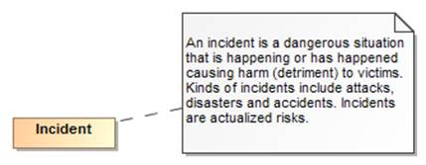
Figure 5 Example of a Class
The above example shows the class “Incident” and its definition. It should be noted that a class is a way to classify something. It is natural to classify something multiple ways. For example, we may classify a situation as also being a danger or, to someone else, an opportunity to do harm. This is different from many technology models (e.g. Java) that only allow something to be classified in one way and the classification is fixed. The basic assumption of a concept model is that unless specified otherwise, something may be classified in any number of ways and those classifications may change over time.

Instances
While not usually used in the definition of the concept model, instances can also be shown in UML and are utilized to illustrate examples or to define well known instances, like the “United States of America”. Since the model is conceptual, instances of classes are proxies, or “signs”, for the “real thing” in the world – not data about them or other technology artifacts.
Instances are also shown as a box, but have a “:” separating the name of the instance from its classes.
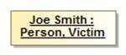
Figure 6 Instance Example
The above example shows a information about an instance named “Joe Smith” that is classified as a “Person” and a “Victim”.

Class Generalization
Since Aristotle, classes have been arranged in hierarchies – from most general concepts to more specific ones. In UML this is shown as a Generalization – an arrow with a solid line from the more specific concept to the more general. The more general class is known as the Superclass (or Supertype) and the more specific the Subclass (or Subtype). Generalization has some specific semantic rules:
• Everything that is true about the superclass must be true about all its subclasses
• The extent of the subclass is a subset of the extent of the superclass
• All properties and associations that apply to instances of a class also apply to instances of all its subtypes
In a concept model, a class may have any number of superclasses or subclasses. In contrast, some technologies (Like XML Schema) limit the number of superclasses to one.
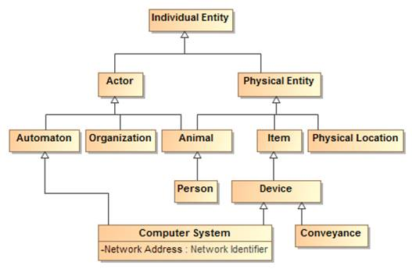
Figure 7 Class Hierarchy Example
The above example shows a class hierarchy with multiple levels.

Note that all properties and associations defined for all superclasses of a class apply to that class. For that reason a complete understanding of a class and its potential properties must include such superclasses.

A generalization is a subsumption relationship between a more general class and a more specific class. Every instance of the specific class is also an instance of the subsuming general class. Because of this subsumption relationship, the specific class inherits all of the necessary conditions of the more general classifier.

For a simple example, if we define “Futsal Team” as a subclass of “Soccer Team”, then the set of individuals in “Futsal Team” must be a subset of the set of individuals in “Soccer Team”.
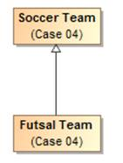
Figure 8 Simple Generalization Example

There are four variations on generalization described in the following subsections. The first variation corresponds to the example above: overlapping and incomplete subclasses. That variation is the default in both UML and concept modeling.

Overlapping and Incomplete Subclasses
This variation is the default in both UML and in concept modeling. In this variation, an instance can be a member of the superclass and / or any number of subclasses. In this sense, the classification of instances is “incomplete”—sometimes an instance is classified by one or more specific subclasses, and sometimes it is not.

For example, the diagram below shows four instances (represented by white diamonds). One is an instance of “Manufacturer”, one is an instance of “Windshield Manufacturer”, one is an instance of “Car Manufacturer”, and one is an instance of both “Windshield Manufacturer” and “Car Manufacturer”.

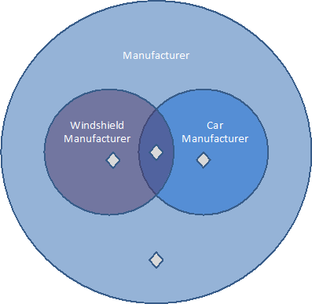

Figure 9 An example of incomplete subclasses

In both standard UML and in concept modeling, incomplete and overlapping subclasses are shown with either no notation, or with the equivalent notation {incomplete, overlapping} near the generalization arrow.

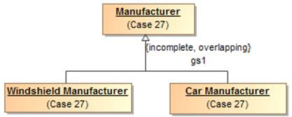

Figure 10 Incomplete and overlapping subclasses in standard UML notation

Disjoint and Incomplete Subclasses
This variation means that an instance can only be classified by at most one of the disjoint classes. Disjoint classes cannot have any overlap in their instances.

The diagram below shows three instances. One is an instance of “Cat”, one is an instance of “Dog”, and one is an instance of “Animal”. An instance classified as both “Cat” and “Dog” is impossible because there is no overlap between the two classes. In the most basic terms, an instance of a “Cat” cannot be an instance of a “Dog”, and vice versa.

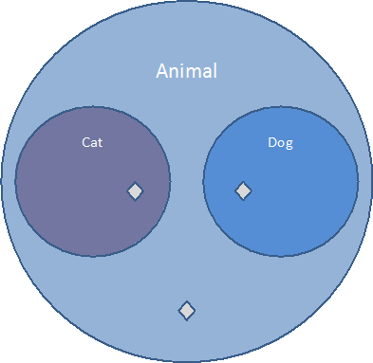

Figure 11 Disjoint Subclasses
The following diagram shows an example of disjoint subclasses in standard UML notation. It shows that “Dog”, “Cat”, and “Mouse” are all subclasses of “Animal”. In addition, the standard UML {incomplete, disjoint} notation declares all of the subclasses to be incomplete and disjoint. Intuitively, an instance of the subclass “Dog” is an instance of the superclass “Animal”, but it cannot also be an instance of the “Cat” or “Mouse” subclasses. It is incomplete because there can be many more kinds of animals.

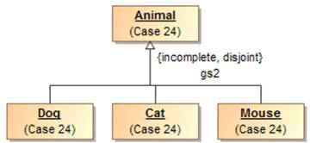

Figure 12 Incomplete and disjoint subclasses in standard UML notation
The profile also supports a dependency stereotyped as «Disjoint With» to specify that anything can be disjoint, even if they are not subclasses of a common super type. disjoint subclasses. For example, the class Animal has three disjoint subclasses, Cat and Dog. [CC6]

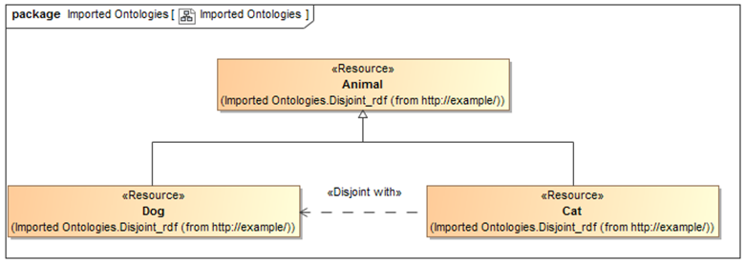[CC7]
Figure 13 Alternative «Disjoint With» Stereotype

Complete and Overlapping Subclasses
This variation means that an instance can only be classified by at least one of the subclasses; it cannot be classified by only the superclass. Keep in mind that an instance of a subclass is indirectly an instance of a superclass at the same time.

For example, the following diagram shows three instances. One is an instance of “Windshield Manufacturer”, one is an instance of “Car Manufacturer”, and one is an instance of both “Car Manufacturer” and “Windshield Manufacturer”. Note that there can be no instance of “Manufacturer” that is not also an instance of one of the subclasses.

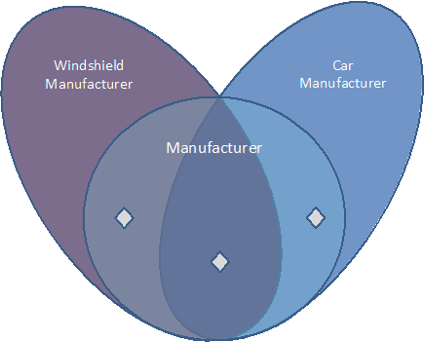[CC8]

Figure 14 An example of complete subclasses
The diagram below shows an example of complete and overlapping subclasses in standard UML notation. The diagram shows that “Steering Wheel Manufacturer”, “Car Manufacturer”, and “Windshield Manufacturer” are all subclasses of “Manufacturer”. In addition, the standard UML {complete, overlapping} notation declares that the subclasses are complete and overlapping.

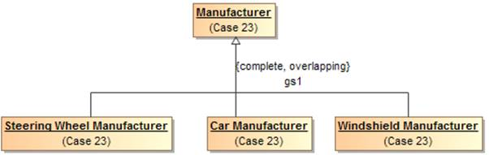[CC9]

Figure 15 Complete subclasses in standard UML notation

Disjoint and Complete Subclasses
This variation means that an instance can only be classified by one of the subclasses. The instance cannot be classified as only the superclass, and it cannot be classified by two subclasses at the same time.

For example, in the subsequent diagram, two instances are shown. One is an instance of “Windshield Manufacturer”, and one is an instance of “Car Manufacturer”. There can be no instance of “Manufacturer” that is not also an instance of one of the subclasses, and there can be no instance that is classified as both a “Windshield Manufacturer” and a “Car Manufacturer” at the same time.
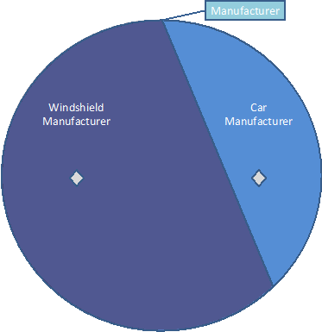[CC10]
Figure 16 Disjoint and complete instances

The diagram below shows an example of disjoint and complete subclasses in standard UML notation. The diagram shows that “Steering Wheel Manufacturer”, “Car Manufacturer”, and “Windshield Manufacturer” are all subclasses of “Manufacturer”. In addition, the standard UML {complete, disjoint} notation declares that the subclasses are complete and disjoint.

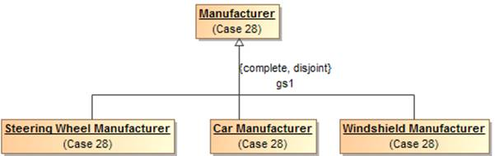

Figure 17 Disjoint and complete subclasses in standard UML notation

Properties
Properties represent qualities inherent in something, such as size, weight or a time. Each property has a “type” for the kind of value that represents that quality. A property is a characteristic that an individual can have, or, as explained in a subsequent section, an individual must have to qualify as a particular concept.

Most properties are relations between concepts, usually expressed as a verb phrase, such as "Heart comprised of Chamber" or "Geographic Region identified by Address". This kind of property is generally drawn as a UML association end, as part of a UML association.

Some properties are relations with data types, such as a standard UML Date, usually expressed as a prepositional phrase, such as "Person born on Date" or a noun phrase, such as “Person birth date Time Point”. This kind of property is generally drawn as a UML attribute, within an attribute compartment of the most general classifier that can have that quality.
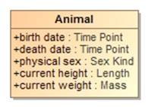
Figure 18 Example of Properties
The above example shows that an animal has the qualities of birthdate, death date, physical sex, height and weight. Note that these is no assumtion that these qualities may be known, required or that different data sources may or may not agree on them – just that an animal has these qualties. Instances of properties are facts about the entity they describe. In concept models, attributes are only used for qualities, never to relate different entities.

A much smaller number of properties represent metadata, usually expressed as a noun phrase, such as "Anything description String" or "Anything see also URI". To represent metadata, this profile provides a stereotype called «Annotation Property» that can be applied to a standard UML property in a concept model.

Note that because every class ultimately specializes the special class «Anything», when that <<Anything>> has properties, those properties can be used by instances of any class. Moreover, classes or subclasses can have constraints on the values of properties that only hold from that class and below in the generalization hierarchy. See subsequent sections for further explanation.

Associations
Associations describe facts about how entities are related. Associations are shown as lines between the classes that have related instances. At each end of the line is an “association end” property – the association end describes how the instances of the class on the far end relate to those of the near end. If there are limits to how many instances may be related, these are also shown. Since an association has at least two ends, the association may be read in any direction, but is the same “fact”. The properties involved are considered “inverse properties”. [CC11] The association end properties are typically verbs or verb phrases, but in some cases, such as when an association is reified as a class, the association ends can become noun phrases[CC12] . In either case the name denotes the intent of the class at the other end of the line.
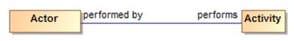
Figure 19 Association Example
The above example says that there are relations between actors and activities such that the actor performs the activity and the activity is performed by the actor. These are considered two ways to “read” the same fact. Like any fact, relations may be true for some period of time or in some specific situation.
As can be seen in the example the ends of associations are typically verb phrases which can then be read as <the actor> performs <the activity>. In other cases the ends are nouns in which case they represent a role being played. If a role were used above instead of “performed by” it could read: <activity> has performer <actor> (the has in this sentence being implied by english grammar).
This combination of classes and associations with ends forms the basis for nouns and verbs common to human language. The terms used for the nouns and verbs should be both consistent with their semantics and resonate with stakeholders – sometimes this is a bit of a challenge.
In some cases the ends of the relation are sufficent to define it, in other cases it makes more sense to give the association a name and its own definition. Associations and association ends, like classes, can be part of a hierarchy.
Note that unspecified multiplicities are interpreted as unconstrained: having a minimum cardinality of 0 and a maximum cardinality of “*”.

Property and association end hierarchies
Like class hierarchies, attributes and association ends (we will just call both properties from now on) can also be arranged in hierarchies of more or less specific properties. In UML, property hierarchies are represented using either “Subsets” or “Redefines”. [CC13] What a property subsets or redefines is shown next to its name in in the diagram (Note that by convention this is not shown on summary diagrams, only the primary definition of the property). If a property completely subsumes the other in a particular context it uses a “Redefines” – that is the redefining and redefined properties have the same set of values. If the more general concept can also be used in the context a “Subsets” is used.
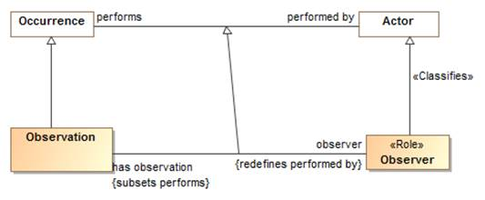
Figure 20 Example of Association End Hierarchy
The above example shows that the “has observation” and “observer” properties are specializations of the “performs” and “performed by” concepts. The property “observer” redefines “performed by” – that is, an Observation always has an observer, never a “performed by” any other kind of actor. Likewise “has observation” specializes “performs” but an instance of Observer can perform other activities as well. Note the generalization between the associations is implied, but is shown in this example for clarity.
Where a redefined or subset property has no name, it is an indication that the property type and/or multiplicity is merely constrained in some way. No new properties or associations are actually defined for a constraint (more on this below).

Association Classes
In a concept model any “fact” may have properties. Of particular importance is the “provenance” of the fact – where the fact came from and thus how much it can be trusted. Facts can also be time-bound, true for some period or only valid within some context. Where an association may have additional specific properties or may participate in other relationships, an “association class” is used. As implied by its name, an association class has both the properties of an association and the properties of a class. More complex associations between things use association classes. An association class is diagrammed as an association line and a class box with a dashed line between the association line and its class. While the association line and box may seem somewhat visually distinct – they are the “same concept”.
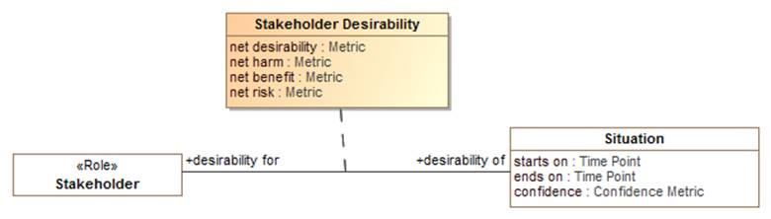
Figure 21 Association Class Example
The above example shows the “Stakeholder Desirability” relation. Between any situation and any stakeholder there can be some metrics as to how much that stakeholder desires or wants to avoid that situation. The Stakeholder Desirability association class represents these as properties of the association: net desirability, net harm, net benefit and net risk – which can all be poitive or negative reflecting a benefit or harm, respectivly.

Annotation
This profile provides a way to comment on any element using annotations. One can annotate classes, properties, and models using an open-ended system of annotation properties. An annotation property defines information about the model (metadata), not about the subject domain. A property can be made an annotation property using the «Annotation Property» stereotype on a UML property[CC14] .

Every «Annotation» is a textual value for an «Annotation Property». An annotation describes some subject using an annotation property and a (usually textual) value. An annotation should specify a tagged value called “value for” that refers to an «Annotation Property».

For example, the following diagram illustrates several UML comments stereotyped with «Annotation»
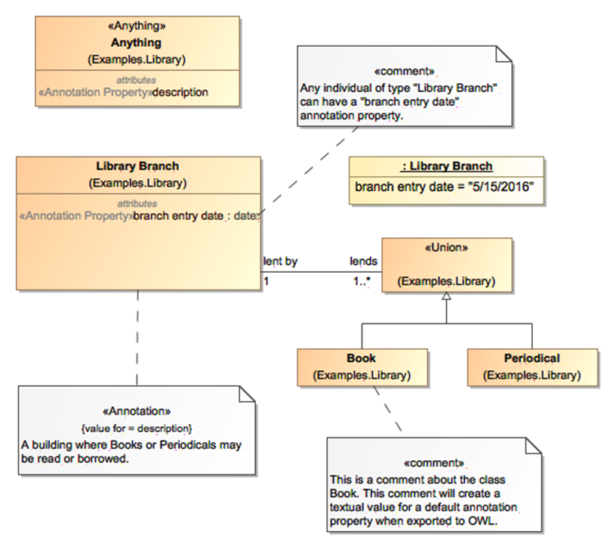
Figure 22 Annotation Examples[CC15]

Specific kinds of classes
There are additional concept modeling specific stereotypes documented in the reference section that further define the semantics of a class. Some of these stareotypes are very important for understanding the concept model and are further explained here. These are roles, phases and quantity kinds.

Anything
The stereotype «Anything» can be applied to any class to make it special[CC16] . Every such special class is equivalent to one topmost class (⊤) of which all other classes are subclasses. Thus, a property of a class marked as «Anything» is inherited by all subclasses. In addition, while the name of a such a marked class is irrelevant, consistently naming such classes “Anything” in all concept models avoids any confusion with normal classes.

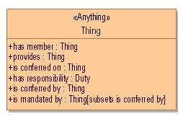
Figure 22 «Anything» Example

Union
A «Union» is a class that has an extent (set of instances) which is equivalent to the union of the extents of all types that specialize the Union (Subclasses). Specializing types shall include subtypes and types that realize the union. The union can be either named or unnamed. When it is unnamed, it can only be used at the domain or range of a property.[CC17]
Note: UML realizations are included to support unions across external models because UML generalization cannot be used across external models due to the ownership of generalization.
An anonymous union class always implies a complete subclass generalization. [CC18]
The following diagram states that an instance of a Person may have a value of type Cat or Dog for the cares for property. The diagram also states that an instance of a Cat or a Dog may have a value of type Person for the cared for by property.

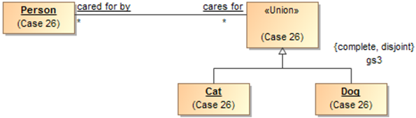
Figure 23 A union class

Intersection
An «Intersection» is a class that has an extent (set of instances) equivalent to the intersection of the extents of all supertypes. Intersection is a stronger statement than a subtype, as a subtype may be a subset of the intersection. An instance of all the supertypes implies an instance is also an instance of the intersection type.
For intersection, The SMIF profile considers UML generalization and UML realization equivalent. This is due to ownership and legacy considerations in UML. Generalization is the preferred representation.
Note: Realizations are included to support unions across external models. UML generalization can not be used across external models due to the ownership of generalization.[CC19]

Facets, Roles, Phases and <<Facet Of>>
Some types may be considered the “fundamental” type of something that is essential to its being and identity for its entire lifetime; this is the default assumption of most classes. Other types classify something in a specific context or for a period of time, SMIF calls these “Facets”. Examples of facets are “Roles” and “Phases” that something may have over its lifetime. The facets an instance is classified with may change over time and may be only valid within a particular context or viewpoint. Facets are defined with a <<Facet Of>> generalization to another type, the type of thing that can be so classified. For example, “Policeman” can classify a “Person”.
Context specific types such as Roles and Phases are classifications and expected to be used in this more contextual and dynamic fashion; these types may be assigned to or removed from an instance over time or in a context.
For an instance to be classified with a classification, it must also have the type of what the classification <<Facet Of>>. To use the example above, a “Policeman” can’t classify a Toaster since the toaster is not a person. Please see the “Role” and “Phase” discussion for more usage scenarios of <<Facet Of>>.
Implementation note: most programming languages do not allow for direct representation of multiple classifications, multiple inheritance or context. A common implementation pattern is to represent classifications, roles and phases as independent objects related to the object they classify. An example of this is the iUnkown pattern in .NET.
The following stereotypes define additional classification semantics.

Roles
Roles are facet classes that are expected to be dynamic and contextual, such as teacher, victim or president. A role is defined using a class with the <<Role>> stereotype and, optionally, a <<Facet Of>> generalization. Implementation technologies should interpret roles as classifications that may be added to or removed from an instance over time and may be defined in a particular context. A role is usually required to be a role of some particular other class, for example a teacher is expected to be a role of a person (at least until a computer takes her job). The constraint of what a role must be a role of is defined using a <<Facet Of>> stereotype of a generalization. A role will also frequently have a relationship with something where the multiplicity is at least one. For example, a person is a parent if they have at least one child.
Many implementation languages don’t have the capacity to represent roles, so roles are sometimes implemented is the single and unchangeable “type” of a class or DBMS table. The problem with this is that the same individual may not be connected across all their roles. Specifically representing roles allows the same individual to play multiple roles and for these roles to change – this better reflects the reality of the world and the way we think about it.

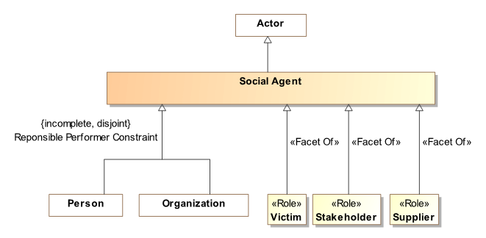
Figure 22 Role Example
The above example shows that an actor can be a person or organization and that either could be classified as being able to play the Owner and/or a Victim role.
Roles help to decouple concepts in models and specifically allow an instance to “play” multiple roles at the same time or over time. Roles, when combined with quantification constraints, clearly define the semantics of roles. For example, we could say that a victim must be a victim of some incident and an owner must own something.
By convention, properties typed by roles may have the same name as the role, this can be read as “has <role>”, e.g. “has victim”, however full verb phrases may be more appropriate in some situations.

Phases
Phases are facet classes that are expected to classify an instance over a specific span of time, such as a teenager, “legal adult” or “Paid Invoice”. A teenager is a person between the ages of 13 and 19 (inclusive) – perhaps “legal adult” is of age 19 or older – we may also want to consider people living or dead, thus “alive” and “dead” would be phases of a lifeform. Phase may be considered a synonym for the “State” of something.
A phase is defined as a class with the <<Phase>> stereotype. Like roles, phases use the <<Facet Of>> stereotype of a generalization to define what a phase must be a phase of.
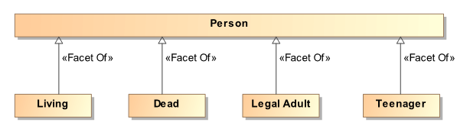[CC20]
Figure 23 Phases of a person
Also like roles, phases help to decouple concepts in models and specifically allow an instance to “be in” multiple phases (or multiple roles) at the same time or over time. If an instance cannot be in two phases at the same time or be in a role and a phase a “disjoint with” constraint can be used to state that restriction. For example, “Dead” is disjoint with “Legal Adult” and “Living”. Only a “Legal adult” can commit to a contract.

Quantity kinds and units
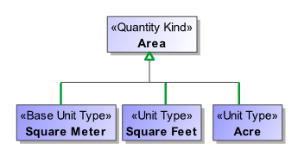
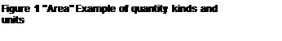
[CC21] Fundamental to understanding and describing something is physical and other qualities such as temperature, length and color. Many data models fail to capture units of measure explicitly which can and has[1] resulted in dramatic systems failures. A concept for somethings weight should properly be typed by a measure of weight, not an “int” or “real” – which are just ways to represent numbers without knowing what they mean. Of course there needs to be numbers, but in relation to their units.
In that there are different units that can represent the same kind of measure, such as degrees Celsius and degrees Fahrenheit can represent the same temperature – an abstraction is used above like units. The abstraction for a measurable unit is called a <<Quantity Kind>>. Examples of quantity kinds include Length, mass, temperature, frequency, etc.
As any element of measurement data must be specific to a specific unit in a specific data exchange, the <<UnitType>> stereotype is used to define a unit for a quantity kind. A <<Represents>> stereotype of generalization (Diagrammed as a green arrow) is used to say that the unit represents the quantity kind.
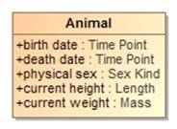
In the example above, the “Area” quantity kind (indicated by a black shaded class) can be represented by (the green lines) “Square Meter”, “Square Feet” or an “Acre”. One unit may be nominated as the “Base Unit” and will be used to express conversion factors between the units. As per SI specifications, the Square Meter is the base unit.
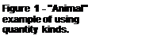
By convention quantity kinds are used in fully conceptual models whereas units are used in data models. The “Animal” example shows quantity kinds being used to define properties of animals.

Assertions about concepts
Above we defined the network of essential concepts as classes, relationships and properties. Additional assertions may be made about those concepts using both UML foundational and extended profile capabilities. The following define the kinds of assertions that can be made. Note that the term “property” applies to both simple properties and the ends of associations.

Property Ownership
The concept modeling profile of UML interprets the owner (defining class) of a property definition as the subject of that property (its domain) and the context in which that property must conform to certain constraints.
Constraints may be placed on a property. These constraints can include multiplicity, which includes a minimum cardinality and a maximum cardinality, a type for the property, existential quantification, and universal quantification. [CC22] When an instance is a member of a class, all of that class’ constraints must be met.
Property ownership is not interpreted as “slots” in an object. Property values may or may not be independent of the instance that defined them, thus supporting an OWL/RDF, or “open world”, interpretation of properties and associations.

Cardinality

Cardinality defines how many value of a property may exist for a particular subject instance. For example, how many ages can a person have? The obvious answer is that a person can have at most one age at any one point in time. Thus cardinalities represent the number of instances at any one time – regardless of how it is represented.
UML allows the cardinality of a property to be left unspecified, in which case it defaults to 1..1. The concept modeling profile interprets unspecified cardinalities as 1 (one) based on UML defaults. Note that conceptual models do define what you may or must know or what the requirements of a data model are – they define what must be true about the world as it is conceived.

Constraining properties and associations
A cardinality of one or more defined for a property requires that an instance of the related element must exist for an instance of the domain (owning class) of that property or association end to be valid. For example, a living person must have exactly one living brain. This is known as an existential quantification (∃) or qualified constraint in first order logic. Existential quantification is defined using UML cardinality and, potentially, subsets.
An existential quantification can be stated for a newly defined property or an existing one. For a newly defined property this is done by simply stating cardinality greater than one. For example, a phone must have at least one button with a “has buttons” association end and a cardinality of “1..*”. When a new property is being defined it is given a name. If an existing property is being constrained (without a new property being defined) it subsets or redefines [CC23] the existing property and does not need a name. In the concept modeling profile of UML, any cardinality requiring one or more creates an existential quantification constraint.
A property is not limited to a minimum and a maximum cardinality (known as multiplicity) for just one type. A property can have a multiplicity for a superclass, while at the same time having a more specific multiplicity for one or more subclasses of that superclass. This type of constraint is an assertion that, among other possible values, the number of values of one of these subclasses is between some minimum and maximum cardinality.
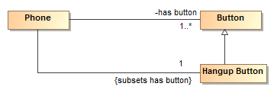
Figure 27 Phone constraint: A phone must have a hangup button

For example, we may say a phone must have one or more buttons with a “has button” property but exactly one of those buttons must be the “hang up button”. We would then define an unnamed property with the type “hang up button” that subsets the “has button” property with a cardinality of 1. If we wanted the Hangup Button to also define a new property, we would give that property a name.
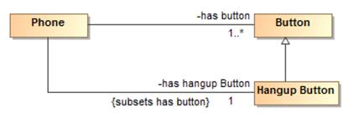
Figure 28 Hangup button with new property

In the concept modeling interpretation of UML, subsetting or redefining a property without giving the new property a different name (or leaving off the new property name altogether) creates a constraint without defining a new property.
As {subsets} or {redefines} with an omitted name is not well defined in UML, in the concept modeling profile it is used to state that a subset of values must meet the stated cardinality and type constraints of the subsetting property. It does not define an instantiable property of the domain, although it does indicate a context in which this constraint holds: the owning class and its subclasses.
The diagram below shows an existential quantification constraint on the global property “is conferred by” (from the Anything “Thing). The multiplicity is such that at least one of the instances of the property constraint must be one of the types in the union.
Note that the property adding the constraint is unnamed. This is equivalent, in this case, to naming this property the same as the property being constrained (“is conferred by” from the Anything “Thing”).

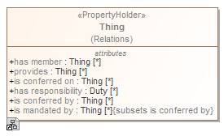[CC24] 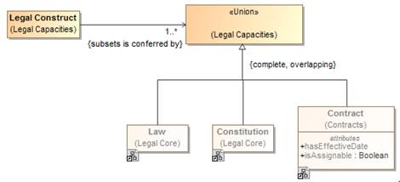
Figure 29 Constraining a global property

Tightening a property’s type
Sometimes it is necessary, in the context of some class, to constrain all the values of a property to a particular type. When defining a new property, the type of that property asserts that all values of that property must be of the given type. This is known as a universal quantification or for-all constraint (∀) in first order logic. This kind of constraint is an assertion that only values of the specified type are valid, and the number of values must be between some minimum and maximum multiplicity.
Where all values of a property must be of a given type in a specialized property, UML {redefines} is used as part of the definition of the property. [CC25] If the redefined property is given a name, a new property with the quantification is defined. If the redefined property does not have a name, the existing property is constrained in the more specialized context (usually a subclass).
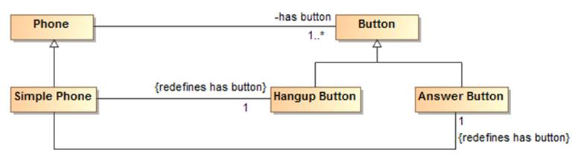
Figure 30 Example of redefines
The example above shows a “simple phone” that has exactly two buttons and they must be an answer button and a hangup button. Since redefines is used, no other buttons are allowed.
The diagram below shows the introduction of a new property “consists of”, defining a universal quantification constraint on the property. The constraint states that, in the context of Soccer Team and any of its subclasses, all values of this property must be of the type “Soccer Player” and that there must be between 5 and 11 values of this property.
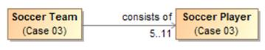
Figure 31 Example of cardinality range
The diagram below shows a universal quantification constraint on the property “observer”. Where any occurrence can be performed by any actor, an observation must be performed by an entity in the role of observer.

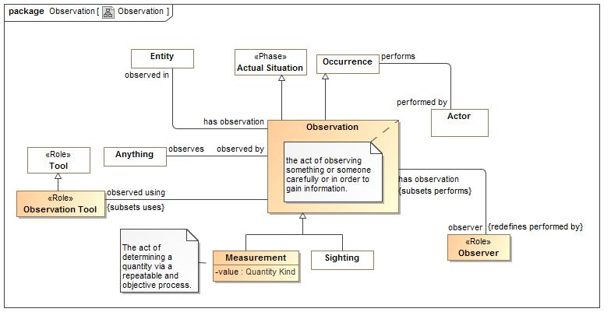[CC26]
Figure 32 Observation Example

Inferring a type from its properties
A property's multiplicity or type is declared in the context of an owning class or a special «Anything» class. These declarations are always necessary conditions for an instance to be a member of the owning class[CC27] , or, in the case of «Anything», for an instance to be valid at all.
Another kind of condition is known as necessary and sufficient. A class with at least one necessary and sufficient condition is known as a defined class[CC28] , which means the differentiating characteristics of the class that make it distinguishable from its parent and sibling classes are defined. Note that using a necessary and sufficient condition on a property with a minimum cardinality of zero is not meaningful.[CC29]

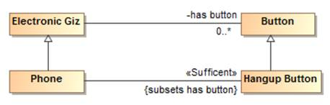
Figure 33 Phone example for sufficient

The diagram above defines a phone as any “electronic giz” that has a hangup button. The existence of a hangup button is sufficient to know something is a phone.[CC30]
In the concept modeling interpretation of UML, a property that has the «Sufficient» stereotype applied to it indicates that when an instance satisfies the multiplicity and type constraints for all the sufficient property’s’ values, not only is a necessary condition for being an instance of the class met, it is a sufficient condition.. This necessary and sufficient condition could allow an inferencing engine to classify that instance as a member of the class that owns the property. All <<sufficient>> constrains of the class and all superclasses must be met for an instance’s type to be inferred.[CC31]

In the concept modeling interpretation of UML, a property that has the «Sufficient» stereotype applied to it indicates that when an instance satisfies the multiplicity and type constraints for all the sufficient property’s’ values, not only is a necessary condition for being an instance of the class met, a sufficient condition is also met. This necessary and sufficient condition allows an inferencing engine [CC32] to classify that instance as a member of the class with that condition. Once an instance is classified automatically, the conditions on any other properties that have the «Sufficient» stereotype, including those inherited from superclasses, merely become necessary conditions the instance must meet to be a valid member of the owning class. An instance satisfying the constraints of all the «Sufficient» properties is enough for an inferencing engine to automatically classify an instance.

The diagram below shows that when an instance with the property “has contract with” satisfies specific multiplicity (“1..*”) and type constraints (of type ‘Steering Wheel Manufacturer” and “Windshield Manufacturer”) for the property’s values, the instance meets necessary and sufficient conditions to be a member of the class “Car Manufacturer”. Therefore, an inferencing engine [CC33] would classify this as an instance of the class “Car Manufacturer”. As discussed above, an instance meeting all of these necessary and sufficient conditions is enough to classify the instance. The conditions on the values of these properties become necessary conditions on an instance for it to be a valid member of class “Car Manufacturer.”[CC34] Also, an instance meeting all of the necessary and sufficient conditions is enough to distinguish instances of the class “Car Manufacturer’ from its parent class “Manufacturer.”
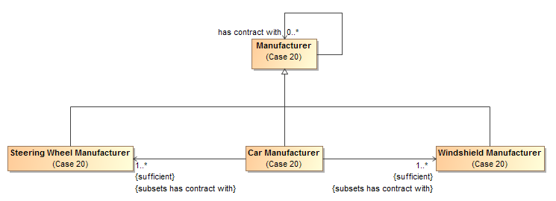[CC35]

Figure 35 An example of necessary and sufficient condition

Property Chain
A property chain is useful for composing a property from two or more other properties that are put together in a chain[CC36] . It defines the property with reference to the other properties. The property chain allows you to navigate from a starting class (the one with the stereotype «Equivalent Property») [CC37] through a chain of properties that take a path through the same or multiple other classes.

A property chain is an ordered list of linked properties, therefore, it should have two or more “chain” tagged values[CC38] .

Note | • An existential or universal quantification restriction cannot have or be a part of a subproperty chain, although the property it restricts can[CC39] .  • A sub-property can have or be part of a subproperty chain for another property.

The following example describes a Person class that has two subclasses “Female Person” and “Male Person”, and four properties “has parent”, “has father”, “has uncle”, and “has brother”. The stereotype of the property “has uncle” will be «Equivalent Property», and the tagged value is chain = has father, has brother. (Note that the «Equivalent Property» stereotype is suppressed in this diagram, but the tagged values are not.)[CC40]

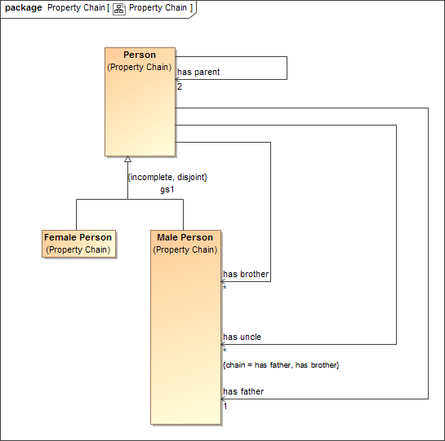
Figure 34 Property Chain Example

Equivalent Property
An «Equivalent Property» [CC41] allows you to represent equivalent properties [CC42] in a model. You can make a property equivalent to two or more other properties by applying the stereotype «Equivalent Property» to the referenced properties and the tagged value “equivalent to” the equivalent properties.

Note | • An existential or universal quantification restriction cannot have or be an equivalent property, although the property it restricts can.[CC43]  • A sub-property can have or be an equivalent property.

The following figure shows the equivalent properties in a diagram[CC44] .
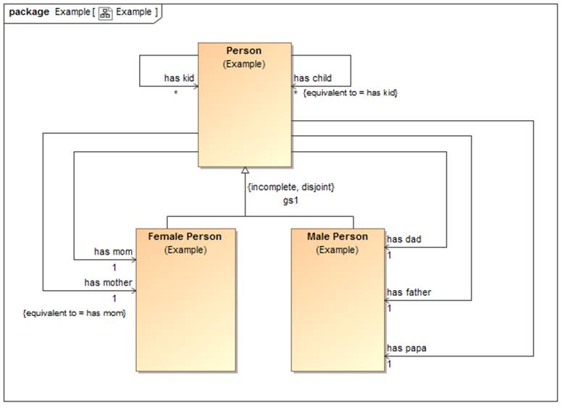

Figure 35 Equivalent properties Example
In the example, the property “has mother” is equivalent to the property “has mom”.

Equivalent Class
An «Equivalent Class» stereotype applied to a generalization can specify equivalence between two classes. Class equivalence expresses a generalization relationship stereotyped as «Equivalent Class». Tools may draw this with a double-headed arrow.[CC45]

The following figure shows two equivalent classes in a diagram.

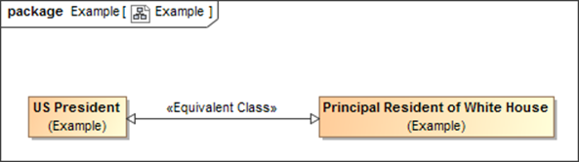
Figure 36 Two Equivalent Classes in the Concept Modeler

In the example, the equivalence class arrow defines that the two classes are semantically equivalent to each other.

SMIF Profile::SMIF Concept Modeling Profile Reference
The conceptual modeling profile defines the conceptual modeling capabilities of SMIF in UML.

Diagram SMIF Conceptual Modeling Profile
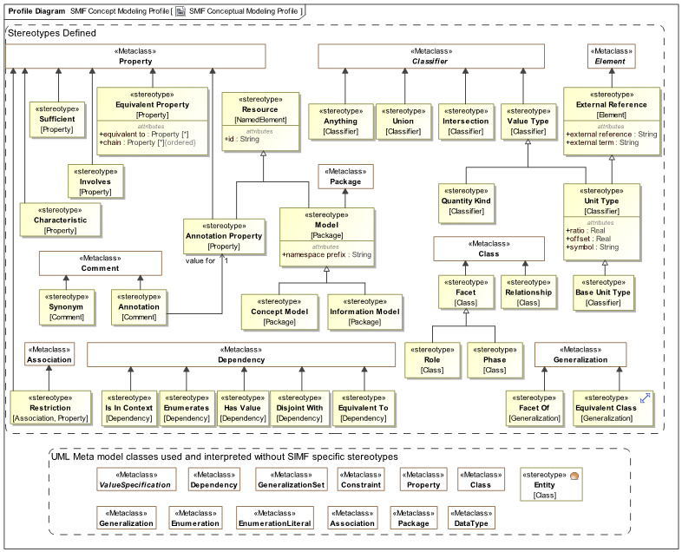

Figure 1 SMIF Conceptual Modeling Profile

Stereotype Annotation
An <<Annotation>> comment provides a textual "body" as a "value for" one <<Annotation Property>> describing the annotatedElement(s).
Base Classes
• Comment
Tag Definitions
value for : Annotation Property [1]
<value for> is the property for which the <<Annotation>> is providing a value.

1.2.3 Stereotype Annotation Property
An <<Annotation Property>> is a kind of <<Resource>> that asserts a property represents metadata rather than assertions about the subject domain.
Base Classes
• Property
Direct Supertypes
• Resource

1.2.4 Stereotype Anything
<<Anything>> is a class that represents anything and is equivalent to all other classes of anything in any other model or logic. The defined class is equivalent to SMIF:Anything, OWL:Thing and other "top level" classes.
Because of this equivalence, every class in every model virtually inherits from Anything, just as all OWL classes virtually inherit from owl:Thing.
<<Anything>> classes may be used to define "global properties".[CC46]
Base Classes
• Classifier

Stereotype Base Unit Value
<<Base Unit Value>> is a kind of <<Unit Value>> that marks one Unit Value of a quantity kind as the base Unit Value within a model. The base Unit Value provides the basis for conversions between units of the same quantity kind. The base unit always has a ratio of one and an offset of zero.
Base Classes
• Classifier
Direct Supertypes
• Unit Value

Stereotype Characteristic
A kind of characteristic a type of thing may have, e.g. paint may have a color. Characteristics are the type of characteristic bindings which are "first class" elements and may participate in relationships and have other characteristics.

[IDEAS] Property: An IndividualType whose members all exhibit a common trait or feature. Often the Individuals are states having a property (the state of being 18 degrees centigrade), where this property can be a CategoricalProperty (qv.) or a DispositionalProperty (qv.).

[ISO 1087] type of characteristics: category of characteristics (3.2.4) which serves as the criterion of subdivision when establishing concept systems. NOTE The type of characteristics colour embraces characteristics (3.2.4) being red, blue, green, etc. The type of characteristics material embraces characteristics made of wood, metal, etc.
[UML] Property
Base Classes
• Property

Stereotype Concept Model
A <<Concept Model>> is a kind of <<Model>> that represents concepts in a real or possible world. Instances of elements in a concept model are "real world" things, not data about those things.
Base Classes
• Package
Direct Supertypes
• Model

Stereotype Disjoint With
A <<Disjoint With>> dependency is an assertion that two model elements do not and may not denote any of the same set of entities.
When applied to a classifier, every element of the classifier's extent (set of instances) is included in the set of disjoint things.

Base Classes
• Dependency

Stereotype Enumerates
An <<Enumerates>> dependency asserts that the supplier of the dependency is a type and the client of the dependency is a package containing a complete set of possible instance specifications. In this way, <<Enumerates>> is more general than a UML Enumeration because it can enumerate more than just UML data types.
Base Classes
• Dependency

Stereotype Equivalent Class
A <<Equivalent Class>> generalization is an assertion that two classes have the same extents (set of instances). Unlike ontological languages it is not assumed that the two elements are consistent, as statements from different context may or may not agree.
Base Classes
• Generalization

Stereotype Equivalent Property
<<Equivalent Property>> is a declaration that a property is equivalent to one or more other properties (using "equivalent to") or is equivalent to a chain of other properties (using "chain"). <<Equivalent Property>> with at least one value for the "equivalent to" property is an alternative way of expressing <<Equivalent To>>, without introducing additional lines on a diagram.
Either "equivalent to" or "chain" must have a value.
Base Classes
• Property
Tag Definitions
chain : Property [*]

An ordered list of properties forming a "property composition" expressing a traversal path that is equivalent to the stereotyped property. This is similar to a "property chain".

Due to potential "missing information" in creating a chain, a chain may or may not be able to be determined from asserting the chained property. Such a determination is defined in the mapping rules for that property in a particular context.

Note that a chain may also be defined with mapping rules.

equivalent to : Property [*]

A set of properties that the <<Equivalent Property>> is equivalent to. Note that equivalence can also be declared with a <<Equivalent To>> dependency.

1.2.12 Stereotype Equivalent To
An <<Equivalent To>> dependency is an assertion that two model elements represent the same thing or the same set of things. Unlike ontological languages it is not assumed that the two elements are consistent, as statements from different contexts may or may not agree.
Base Classes
• Dependency

1.2.13 Stereotype External Reference
<<External Reference>> provides traceability to the source of a "fact" in a model based on some external information resource. This references helps to facilitate provenance. Reference is a statement about the model data and has no semantic implication. Source reference may impact the trust in a statement but the evaluation of trust is outside of this specification.
External reference is combined with the owned comment(s) to create SMIF descriptions as defined in the SMIF meta model..
Base Classes
• Element
Tag Definitions
external reference : String

Specifies the location URL of the external resource. The format must comply with [RFC3987].

external term : String

The external term or location of the information in the source. The form of expression of the term or term path is dependent on the referenced technology.

Stereotype Facet Of
A <<Facet Of>> generalization is a "mix in" or "non rigid" classification of an entity beyond any fundamental (rigid) entity type.
An instance must be typed by the classifies supertype for it to also be classified as the classifies subtype. A classification may be contextual, such as within a relation, situation and/or time frame. Instances may have any number of types and facets may change over time.
<<Facet Of>> is used in defining what a <<Role>> may be a role of, and for phases, what a <<Phase>> is a phase of.
<<Facet Of>> Implies that specialized type is a <<Facet>>
Facets may be added to or removed from an individual over time and in different context.
Base Classes
• Generalization

Stereotype Has Value
A <<Has Value>> dependency asserts that the client of the dependency is a type and the supplier of the dependency is an instance specification that defines acceptable values for one or more properties of that type. Each slot of the instance specification is a possible value for a corresponding property in the type.

<<Has Value>> corresponds to one or more OWL property restrictions containing a "hasValue" constraint.

Base Classes
• Dependency

Stereotype Information Model[CC52]
An <<Information Model>> is a kind of <<Model>> that represents
a model for some purpose, independent of technical implementation. An information model may contain logical models or data models, as well as other logical viewpoints.
Base Classes
• Package
Direct Supertypes
• Model

Stereotype Intersection
An <<Intersection>> is a class that has an extent (set of instances) equivalent to the intersection of the extents of all supertypes. Intersection is a stronger statement than a subtype, as a subtype may be a subset of the intersection. An instance of all the supertypes implies an instance is also an instance of the intersection type.
For intersection, The SMIF profile considers UML generalization and UML realization equivalent. This is due to ownership and legacy considerations in UML. Generalization is the preferred representation.
Note: Realizations are included to support unions across external models. UML generalization cannot be used across external models due to the ownership of generalization.

Base Classes
• Classifier

Stereotype Involves
<<Involves>> defines a property of a class as the "end" of a relationship - the way in which instances of a a relationship participate in (or, are involved in) instances of another type (including other relationships). Sometimes called a variable, argument or role.
In a conceptual model the terms associated with an <<Involves>> property are typically "verb phrases" defining how instances of the involved type participate in the relationship.
Base Classes
- Proeprty

Stereotype Is In Context
<<Is In context>> is an assertion that the client of the dependency is in the context of the supplier of the dependency. All assertions and rules defined in the supplier context apply to the client and everything in the context of the client (i.e., it is transitive). Packages, classes, situations and instances are typical contexts. Note that <<Is In Context>> is the default interpretation of a dependency, if no stereotype is specified it will be interpreted as <<Is In Context>>.
Base Classes
• Dependency

Stereotype Model[CC53]
<<Model>> is stereotype of package that may have an id (see <<Resource>>) and/or a namespace prefix (like the "dc" in "dc:title").
Base Classes
• Package
Tag Definitions
namespace prefix : String

A hint as to an appropriate abbreviation for a model that may be used in some technology mappings, such as XML. The prefix should be short and contain only letters and numbers and must start with a letter. e.g., "dc" in "dc:title".

Direct Supertypes
• Resource

Stereotype Phase
A <<Phase>> (a.k.a. "State") is a classification of an entity based on change of that entity over time. A <<Phase>> <<Facet Of>> the types that may have that phase (e.g., "Teenager").
A phase is a [DOLCE] "non rigid sortal", a type that may change over the lifetime of an entity.
Base Classes
• Class

Stereotype Quantity Kind
<<Quantity Kind>> is an aspect common to mutually comparable quantities represented by one or more units. Units with a common quantity kind may be algorithmically converted to any other unit of that quantity kind. e.g. temperature.[ JCGM 200:2008].
Units with a common quantity kind may be algorithmically converted to any other unit of that quantity kind. e.g. temperature. SMIF takes a wider view of quantity kinds to include conversions that may be contextual and time dependent, such as currencies.
Base Classes
• Classifier
Direct Supertypes
• Value

Stereotype Relationship
A relationship defines a condition involving related things. A relationship may be asserted within a context as true or false within that context. Each instance of a relationship has a number of bindings to the "ends" of the relationship which do not change for the life of the relationship..
A relationship may be true or false within its context (including a time frame) but is atomic in its truth value.
Relationships may participate in (be bound to) other relationships and as such bindings involving a relationship may change over time. That is, relationships are "first class" objects.
The relationship stereotype may be used with association classes or classes. All associations are implicitly relationships. Classes stereotyped as relationships should stereotype the relationship ends as <<Involves>>.
Base Classes
• Class (including association class)

Stereotype Resource
A <<Resource>> is anything that can be referenced by an identifier in a model, ontology or vocabulary. The resource identifier is often an IRI.[CC54]
Base Classes
• NamedElement
Tag Definitions
id : String

A unique identifier for any resource.
When defined for a Package, id has the format defined in [RFC3987]. In this case, it is equivalent to UML:URI, and setting one will set the other.

Stereotype Restriction
A restriction is a property or association that constrains an existing property or association rather than defining a new concept in a domain.
Properties with no name or the same name as a property they subset or redefine are implicitly restrictions. Associations with a restriction as an end are implicitly restrictions.
Base Classes
- Association
- Property

Stereotype Role
A <<Role>> is a classification of an entity based on that entity's behavior, participation in a situation, or capabilities. A <<Role>> <<Facet Of>> the types that may play that role. e.g., "Teacher" <<Facet Of>> “Person”.
A role is a [DOLCE] "non rigid sortal", [CC55] a type that may change over the lifetime of an entity.
Base Classes
• Class

Stereotype Sufficient
Specifying <<Sufficient>> for one or more of a classes or association’s properties means that an instance having an acceptable cardinality of values for all of those properties implies that the instance is an instance of that type.[CC56]
Base Classes
• Property

Stereotype Synonym
<<Synonym>> defines an alternate name for the annotated elements of the comment. The alternate name is the body of the comment.
The alternate name will not be the "preferred name" of the element.
Base Classes
• Comment

Stereotype Union
A <<Union>> is a class that has an extent (set of instances) which is equivalent to the union of the extents of all types that specialize the Union (Subclasses). Specializing types shall include subtypes and types that realize the union.
Note: UML realizations are included to support unions across external models because UML generalization can not be used across external models due to the ownership of generalization.
[MathWorld] Given two sets A and B, the union is the set that contains elements or objects that belong to either A or to B or to both.
Base Classes
• Classifier

Stereotype Unit Value
A <<Unit Value>> is a <<Value>> with an <<External Reference>> that represents a type of a quantity value referencing a specific unit. A Unit Value is a required type of a property representing a quantity.
[JCGM 200:2008] A Unit is a real scalar quantity, defined and adopted by convention, with which any other quantity of the same quantity kind can be compared to express the ratio of the two quantities as a number. e.g. Degrees Centigrade, Miles.

Each Unit Value represents refinement of a quantity kind using generalization and is thus substitutable for that quantity kind. Typically, quantity kinds are used in conceptual models and Unit Values in physical or logical models.
Unit Values may only subtype quantity kinds and numbers.
Note that Unit Values are not units, but the type of quantity values expressed in a common unit as defined in [JCGM 200:2008].
Each instance of a Unit Value shares a common unit (as defined by standards) with a reference defined by "external reference" and "external term".
Classifiers defined as <<Unit Value>> shall semantically subclass the SMIF model “Unit Value” class.
Base Classes
• Classifier
Tag Definitions
offset : Real
The difference between zero in the unit and zero in the base unit after the ratio is applied to the base unit as defined within the same model.
ratio : Real
The multiplier by which to multiply the unit to convert to the base unit as defined within the same model.
symbol : String
The accepted symbol for a unit. e.g. "g" for "Gram".
Direct Supertypes
• External Reference
• Value

Stereotype Value
A <<Value>> is a type representing an atomic unit of information without independent identity. Values include numbers, strings and enumerations. In some cases values may have internal structure. Values do not change over time.
Quantity kinds and units are also values. Values may stereotype any classifier. UML data types, including primitives and enumerations, are implicitly values.
Classifiers defined as <<Value>> shall semantically subclass the SMIF model “Value” class.
Base Classes
• Classifier

UML Profile – SMIF Patterns & Model Mapping Profile
Pattern based rules provide a general framework for stating the consistency of and between SMIF models and elements. The primary use of patterns is for mappings between data models and conceptual models using a <<Mapping Rule>> however a <<Pattern Rule>> may be used to assert consistency within a model, for example to represent generic assertions such as “all birds have feathers”. Pattern based rules are declarative in nature.
Mapping rules define how a particular data model or schema <<Represents>> information about the concepts defined in conceptual reference models. This facilitates an “n-way” mapping of information represented using different data models. Since conceptual models are not data models they do not have any particular representation for “data instances” of that model. Instances of a conceptual model would be the real things in the real world os a possible world based on real world concepts[CC57] . The real-world concepts are the “pivot points” between the data representations. Of course implementations may automate data models that correspond closely to conceptual reference model, but that is outside of this specification.
Due to the various ways to represent information, mappings can become complex. The UML representation of mappings simplifies these mappings as much as possible. Note that details of the mapping relations are defined in the profile specification.

Structure of Rule Specifications
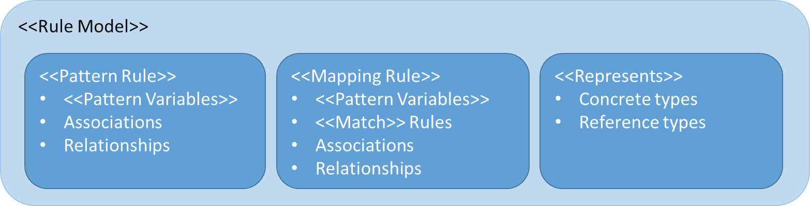
Figure 24. Structure of Rule Specifications
There is an expected structure for defining rules. This normally starts with a <<Rule Model>> package that contains other rules. Note that any “namespace” can contain rules, including classes. By default, rules will hold within the namespace they are defined in but another namespace may be specified by setting the <holds within> tag of a rule. Packages stereotyped as <<Rule Model>> are considered to hold universally within any model in which they are in context. Within a rule context, such as a <<Rule Model>> there may be generic rules marked as <<Rule>>, <<Represents>> rules or <<Mapping Rule>>s.
<<Rule>>s and <<Mapping Rule>>s contain <<Pattern Element>>s that define the pattern of the rule. Pattern elements can be UML “Parts” (which are properties), connectors and connector ends. There are various stereotypes for pattern elements to further define their effect on the pattern. A <<Mapping Rule>> may also contain <<Map Rules>> which specify how different pattern elements may represent the same facts. Mapping rules are bi-directional and can may changes between “either side” of the mapping.
The difference between a <<Rule>> and a <<Mapping Rule>> is that a <<Rule>> simply states something that must hold (be true) within a model. For example, that fish can swim. A <<Mapping Rule>> creates a correspondence between different representations of the same facts using <<Map>> rules.[CC58]

Rule Model
<<Rule model>> is a stereotype of Package to indicate that the contents should be asserted as rules.
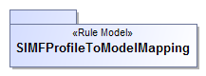
Figure 25 Example Rule Model
The package SMIFProfileToModelMapping is a rule model and will hold within any model in which it is included.

Representations
The foundation of mapping is the <<Represents>> dependency between classes. Represents says that a particular type found in a logical or physical model represents information about a real or abstract concept in a conceptual model. By default, <<Represents>> does not implement a mapping, it defines what elements can be mapped and thus restricts mappings. For simple “one-one” mappings there is an optional tag for <<Represents>> to <<map-all>> known instances of one Class to another.
Example
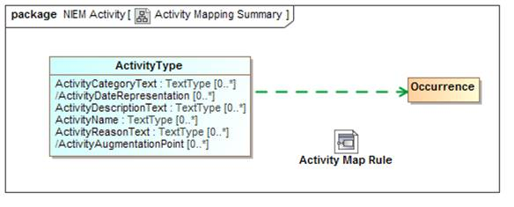
Figure 26 Activity Mapping Summary Example
The above example shows that an “ActivityType” from NIEM-Core represents an Occurrence as defined in the threat/risk conceptual model. By convention we show the represents dependency as a green dashed. Representations provide the ost abstract level of mapping. This diagram also shows that that there is a more detailed activity map rule for the same types which will map the properties and relationships between these types.
What this means is that some ActivityType instances represent some information about occurrences in “real world” activities. Based on the SMIF mapping riles, this also implies that relationships involving an occurrence can be validly mapped to relationships involving an activity and that properties of an occurrence can validly be mapped to properties of an activity, <<Represents>> relations provide type-safety for mappings.
What this does not say is that ActivityType and Occurrence are equivalent and can necessarily be mapped 1..1. How they are mapped is detailed in mapping rules. However, if the <map-all> tag of <<Represents>> is set true then ActivityType and Occurrence will be asserted as being mapped 1..1, bidirectionally (mapping of types and properties is considered independent, each property must also be mapped). Note that <map-all> implies nothing about the properties and relationships, only the mapped types (each type, property and relationship is an independent concept that is mapped independently).
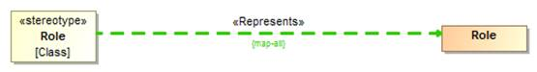
Figure 27 {map all} Example
In the figure above, all UML classes stereotyped as <<Role>> will be mapped to the Role class in the SMIF model.

Mapping Rules
The detail of mappings happens in classifiers stereotyped as <<Mapping Rule>>s. Mapping Rules define patterns of data types and patterns of concepts that have map correspondence rules. The <<Map>> correspondence rules do the real work, mapping element by element.
Mapping representation rules are, externally, not that interesting. They are just a classes or components stereotyped as <<Mapping Rule>>. However, note that Mapping Rules may specialize other rules – in which case they include the more general rule but may restrict the <<Match>> elements. Mapping rules may also <<Subsume>> other rules, in which case they take precedence over the other rule where the subsuming rule is in context.
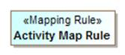
Figure 28 Representation Rule External Example
The above defines a mapping rule for activities that is an assertion that the enclosed pattern must hold and provides a context (in this case the enclosing package) where the map rules are asserted. If we look inside the Activity Map Rule we see the structure and maps.

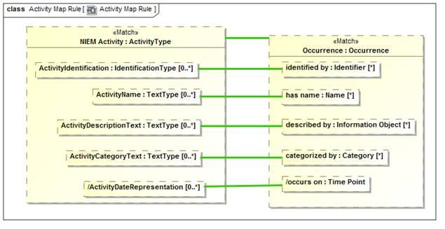
Figure 29 Representation Rule Internal Structure

The above example is the internal “structure” of the Activity Map Rule. In this case the mapping is very 1..1 and simple. Inside of the rule we see “parts” that represent “ActivityType” named “NIEM Activity” and “Occurrence” named “Occurrence”. The green line between them is a “Map” rule, represented as a UML connector stereotyped as <<Map>>. This states that in this simple pattern NIEM Activities and Occurrences map 1..1. We could also have put filter constraints on that mapping, but in this case did not.
We also see the “<<Match>> on “Occurrence” and NIEM Activity. Match defines the “starting point” for the pattern with respect to the model containing the <<Match>> element. A mapping engine will find all instances of Occurrence (in any data format) and map those to NIEM Activity. It will also find all NIEM Activities and map them to Occurrences. All other parts of this mapping become relative to the “Match” elements.
Within both NIEM Activity and Occurrence we see other parts, parts of those types. The green lines create mapping assertions between those parts within the context of this rule. This within this rule “ActivityName: maps to “has name”.
A map correspondence is essentially “best efforts”, the types of the mapped elements must either match or have a mapping rule that allows them to be mapped. If, for example, an occurrence had an identifier that was an image and NIEM did not allow for image identifiers, that “fact” would not be mapped. How a mapping engine handles maps excluded by type is outside of this specification.
Mapping for primitive data types, such as strings and numbers, is provided by the mapping engine implementation based on each mapped technology. This allows, for example, an identifier that is represented as an integer to be mapped to a string.
The important point to remember is that mapping any fact requires that the types are compatible. That type compatibility is defined by <<Represents>> rules between the types. The requirement for type matching may be overridden by setting the <coerce> tag of the <<Map>> rule, but in most cases type safety of <<Map>> rules is desirable.
In that there may be multiple <<Map>> rules between the same thing, one can be marked as the <<Default>>. A default rule will be applied only if no other rules have fired.
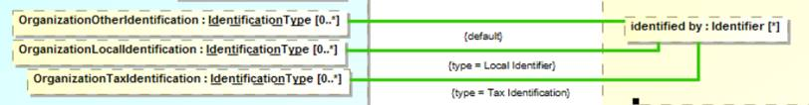
Figure 30. Default <<Map>> Example
Figure 30 shows a <<Mapping Rule>> fragment of three properties mapped to one based on types of the identifiers. If none of the more specific identifiers match “OrganizationOtherIdentification” will be the default. Similar defaults may be defined for subsets.

<<Match>> Elements
The foundation of SMIF rules is patterns. When a rule is asserted the SMIF implementation attempts to “match” the pattern to existing situations and then “assert” that the pattern is “true”. The <<Match>> elements are those that must pre-exist for the pattern to even be considered. Relating this to a SQL Query, the <<Match>> elements would be in the “Where” clause.
If there is more than one related <<Match>> element, they must all be “true” for the pattern to hold (be asserted). If there are any constraints for the <<Match>> elements they must also hold. Constraints include condition expressions, the type(s) of the pattern elements and multiplicities.
Once a pattern is <<Matched>>, all properties, relationships and subsets from the match elements are “filled in” from existing information.
What happens if, as these other elements are being filled in, some other constraint is violated? This depends on the kind of rule. For a general rule the constraint will be asserted – made to be true by attempting to each required element. In the case of a mapping rule the rule is in an error state, the behavior of an implementation in response to an error state is implementation specific.
In a mapping rules, after the <<Match>> elements have been matched and any relationships followed, any <<Map>> rules for the pattern are applied.
Note that for a mapping rule there will be two “sides” that are matched – normally the “Conceptual” side and the “Physical/logical” side. Each “side” is considered a separate match set. Sides are determined by <<Match>> elements connected by anything other than a <<Map>> rule.
Figure 28 shows simple a <<Match>> that is simple – just matching a single element on each side. The next example shows more complex matches.
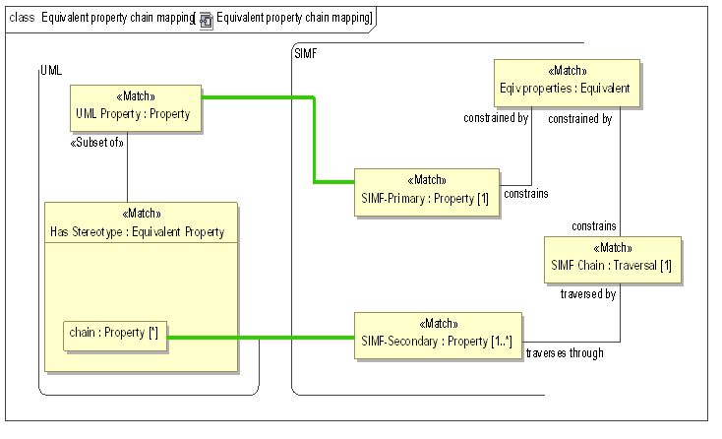
Figure 31. More Interesting <<Match>> Example
Figure 29 shows vary specific match patterns on both sides. On the UML side (left) a <<Match>> property must have a subset that is a <<Match>> Equivalent Property stereotype (this means match all properties that have the <<Equivalent Property>> stereotype applied. If “UML Property” is not a “Property” or there does not exist a subset of it that has the type :Equivalent Property then this “side of the pattern doesn’t match.
On the other side (the SMIF meta model) there must be a pattern of an “Equivalent” constraint that constrains exactly one “Property” and also constraints exactly one “Traversal”. These patterns are very specific because there are very specific ways to represent general concepts (like equivalence) in the UMLprofile.
Once a pattern on one side is matched, the other side is “asserted”, creating the required elements.

Pattern element traversals and patterns
The above Activity Map Rule is simple and 1..1, when we get such a simple mapping we shout for joy – because our job is easy. However, there is frequently complexity on “both sides” of the mapping – something in the data model may map to multiple things in the conceptual model or require a “Path” through multiple concepts. Likewise, there may be intermediate “technical artifacts” that have no real meaning in a conceptual model. This is why we say we are mapping patterns.
For our next example we will look at Incidents, which are a subclass of activities in NIEM and occurrences in the threat/risk conceptual model. Since these are subclasses on “both sides”, we only need to describe the additional properties of an incident.
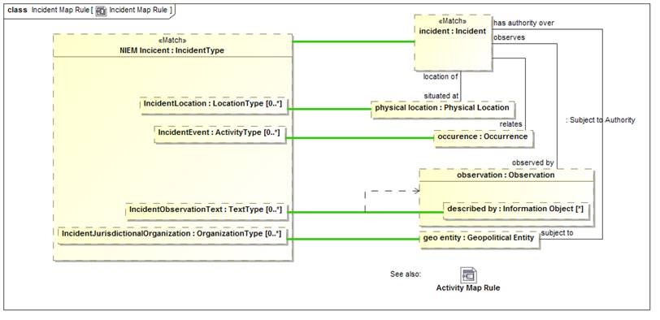
Figure 32 More detailed map rule
The example above shows how a NIEM Incident (named NIEM Incident) maps to a conceptual incident (named “incident”). Incident Map is a subtype of Activity Map so the Activity map rules will all apply to incidents so we don’t need to repeat them here.
We will start with a <<Match>> of “Incident”. Note the line from “incident” to “physical location” labeled “situated at”. The mapping engine will start with an incident and fill in the set of “physical locations iff the “situated at” relationship exists for that instance and what it relates to is a Physical Location. If that relationship does not exist, “physical location” will be null (empty). Note that physical location could also have multiple values since “situated at” does not have a restricted cardinality.
The values that “end up” in “physical location” will be mapped to “IncidentLocation” in NIEM. Likewise, any mapping in the other direction will hold – any populated “IncidentLocation” will populate “physical location” as well as the relationship to an incident. Once the rule is satisfied, the pattern will hold for all instances of NIEM IncidentType and Incidents. How cardinality mismatches are handled is not specified by SMIF, a mapping engine could, for example, log issues.
Now consider the element “described by” within “observation”. This will be populated if the “has observation” relation exists from an incident and that instance has a “described by” property. IncidentObservationText is mapped to “described by” within such an observation. But, in this case, UML notation is a bit misleading, “described by” is a part of the Observation type, not this particular observation part. Since other objects in this rule may have a “described by” property it becomes non-deterministic which “described by” we are talking about. We want to say that we are mapping to the “described by” in the context of the “observation” part. The dependency from the green line to “observation” defines that the context of this map rule is only valid in the context of “observation”, thus making the map deterministic. As many context dependencies as are necessary may be specified for any map rule. All map rules are considered to be in the context of the enclosing Representation Rule. <<Match>> properties take precedence for resolution - some tools may report if a map is non deterministic.

Multiplicity constraints in patterns
It is sometimes necessary to constraint pattern properties to have a specific number of values. This may occur either in matching the pattern or as the result of following various paths. The same multiplicity constraint that is used to constrain other properties, such as on the ends of relationships, may be used to constraint pattern properties. Multiplicity constraints may also be used on the “ends” of connectors between pattern properties, to constraint the number of relationships (actual ground facts) that must exist between the pattern properties.
Setting the multiplicity constraint of a pattern property constrains it to have the specified set of values. If a <<Match>> is constrained, the pattern must match the constraint. If not a match, the pattern multiplicity will be satisfied by the rules engine. If, for any reason, this and other constraints cannot be satisfied the issue will be handled by the rules engine. The method for handling constraint violations is not specified.
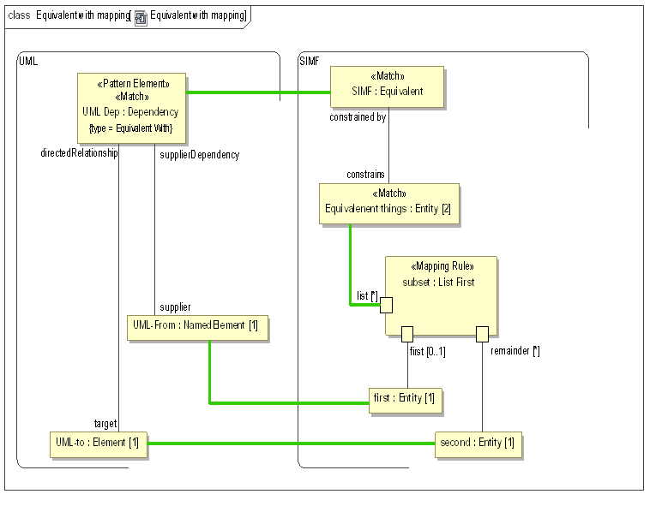
Figure 37. Example of setting multiplicity constraints on <<Match>>
In the above example a SMIF Equivalent has exactly 2 <constrains> entities. This is the condition for matching the pattern. This matching pattern then maps the Equivalent constraint to a UML dependency stereotyped as <<Equivalent with>>.
Once these base patterns are mapped the two mapped entities will be mapped to the <supplier> and <target> of the UML dependency via a “List First” rule. The List First rule separates a list into its first and remaining elements.

Subsets of Pattern Elements
Conceptual models use sub classing, multiple inheritance, roles and phases to more accurately and intuitively represent the domain of interest. Many data technologies do not support these concepts and even if they did, would probably structure implementation classes differently. In other cases, there may be restrictions on the “extant” of what maps to what that require calculations or other constraints. To provide for these cases we use <<Subsets>> in mapping patterns. A subset defines another part (property) that holds a subset of the instances of the superset part, based on the type, relationship values and other constraints of the subset part.
To understand this feature we will first look at models for “Entity” and “Actor” in NIEM and the threat conceptual model, respectively.
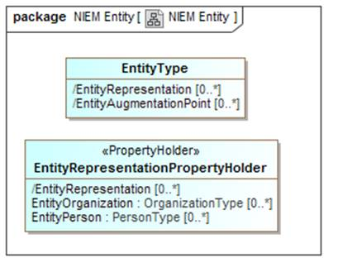
Figure 33 NIEM Entity Example
In NIEM, an “EntityType” has a “substitution group” property with properties that can be “EntityOrganization” or “EntityPerson” to allow the entity to represent one or the other. The general rules for mapping NIEM state that substitution groups are considered subtypes of the primary type.

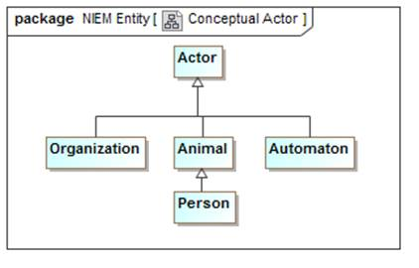
Figure 34 Conceptual Actor Example
In the Threat conceptual model “Actor” is a Supertype of Organization and, indirectly person. It is also a Supertype of “Automaton”. An Automaton can’t be an actor in NIEM so it will not be mapped (However we could define a NIEM extension to allow this).
We want to map actors to NIEM entities, but see that they are very different “shapes”.

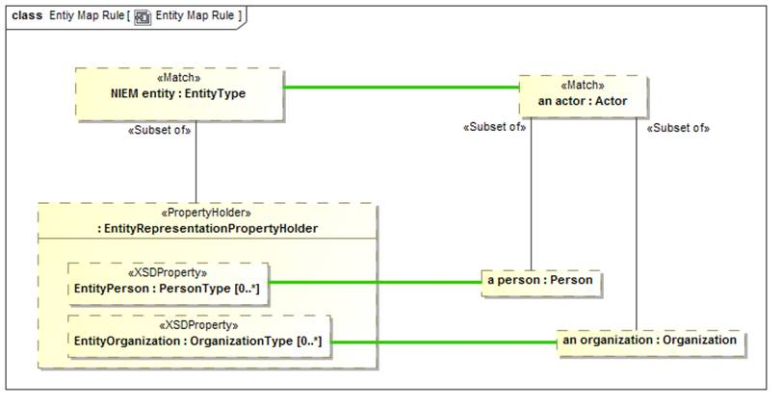
Figure 35 Subset part example
In the above example we see the actor - EntityType mapping. Notice “a person” of type “Person”. “a person” is defined to be a <<Subset of>> actor – that is every actor that is of type “Person” will populate the “a person” part. If an actor is not a Person, “a person” will be null. “a person” is then mapped to “EntityPerson”, a property of “Entity” by way of the substitution group (sorry that this gets into some NIEM substitution group details, but you probably get the basic idea).
Likewise, “an organization” will map to EntityOrganization iff “an actor” is an Organization. Note that if “an actor” is neither of these, it will not map to any NIEM property.
Note also that there could be other constraints on the subset parts, such as required relations or constraint expressions.

<<Pattern Element>> computations and constraints
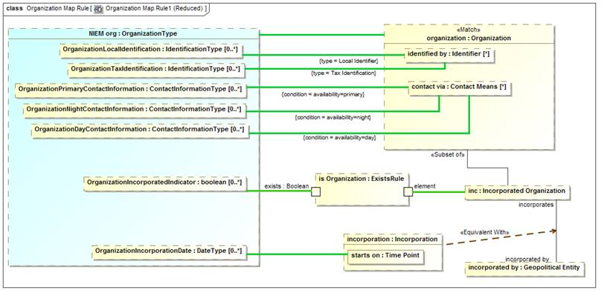
Figure 36 Map constraints example
To continue the tour of the primary mapping capabilities we will look at a subset of the “Organization” mapping.
Note the “type=” on two maps to “identified by”. In the conceptual model there are subtypes of identifiers. In NIEM there are special properties for some of these identifiers. The “type=” constraint on a map says that the map will be constrained to the type (on the specified end) of the actual instance matched the specified type. So “OrganizationLocalIdentification” will only map to “identified by” if the type if the identifier includes “Local Identifier”. Likewise, “OrganizationTaxIdentification” will only map to “identified by” if the type includes “Tax Identifier” (remembering that a SMIF concept instance can have multiple types). Likewise, the reverse is true; those properties will “assert” the type of the identifiers they reference.
On the maps to “contact via” we see “condition=”. Condition is a tag of <<Pattern Element>> that references a UML expression. The conditions referenced are properties of the association between an organization and “Contact Means”. The maps will be constrained to the “availability” property is set as indicated. Likewise, if an organization is being created, that property will be set by the same condition.
Note that “inc” is a subset of an organization only if it plays the role of an “Incorporated Organization”. In NIEM there is a Boolean set if the organization is incorporated. The “ExistsRule” is a computation rule (that is its implementation is outside the specification). But in this case ExistsRule’s behavior is defined – the exists Boolean will be true when the mapped “element” has some value. This results in the NIEM “OrgainizationIncorporatedIndicator” corresponding to the organization being incorporated.
If the organization is incorporated it will have an incorporation relationship to its incorporating body (incorporated by). That incorporation relationship will contain its date of incorporation, which is mapped to the NIEM property. In UML association classes have to be put into a structure like this in two pieces, the “line” and the “box”. Since both the line and the box represent the same “fact”, they are asserted to be equivalent – this is only required when association class properties need to be accessed and is required because UML has no way to show connectors as association classes.
The end result is that the more “flat” representation of an Organization in NIEM is mapped to the concept model.

<<Pattern Element>> strength
A connector between parts will both follow a relationship and assert that relationship. There are times when the “strength” of a rule implied by a connector needs to be more explicitly specified. The <strength> tag of <<Pattern Element>> allows different options for what is asserted by a connector. These are: match, assert, default and exists. The default is “assert”. Definitions of each of these is in the reference section. In the following sections we will provide some examples. Note that strength=Match is the same as the <<Match>> stereotype and is not repeated here.

<<Pattern Element>> strength=Assert
Assert, the default, defines a pattern element. A pattern element operates in two modes: Pattern match and assertion.
When the <<Match>> elements match an existing situation the rule is consider to have “fired”. Properties and relationships of the matched elements, that are represented in the pattern as <<pattern elements>>, are “filled in” by following paths from the <<Match>> elements through properties and relationships to other pattern elements. Note that property elements may be null, contain a single element or contain sets of elements.
Once elements are matched and the properties and relationships followed, the <<Map>> rules “assert” that corresponding elements represent the same “facts”, perhaps in other forms or structures. Relationships between the elements, also represented as pattern elements, are then also asserted between the mapped elements. In this way the entire pattern on “both sides” (if it is a mapping pattern) is “made consistent”.
Strength=assert defines a pattern element as playing both roles – as a part of the pattern match “query” as well as what should be asserted within a pattern.

<<Pattern Element>> strength=Exists
In some cases it is required that we match a pattern but do not “assert” that some element or relationship exists, but if it does exist we need to apply some more rules. “Exists” will test for an element with creating it.

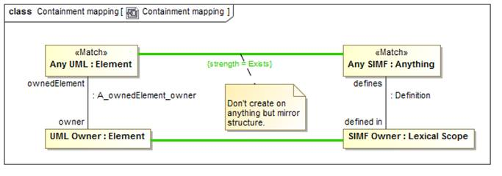
Figure 38 strength = Exists example
In mapping UML to SMIF we do not necessarily want to map every element. But where there are mappings we would like to make the ownership hierarchies match. A match of “Any UML” has a <<Map>> to <<Any SMIF>> but the <strength>> is specified as “Exists”. This means that they should be mapped if the elements exist but the mapping should not be asserted by this rule (it may be asserted by other rules). Where they do exist, the UML owner should be mapped to the SMIF owner.

<<Pattern Element>> strength=Default
Model information can come from multiple sources, model organizations and rules. There are time where a pattern element should be a default, asserted only if no other source is asserting the same element.

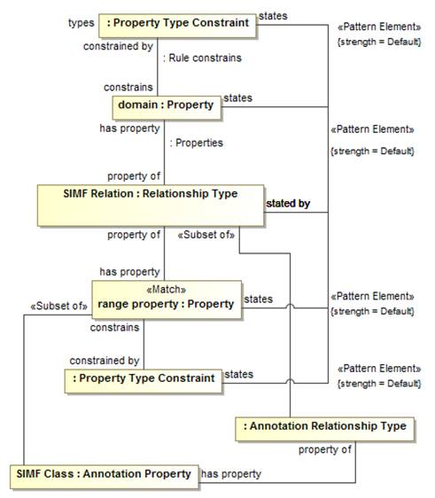
Figure 39 strength = Default example
In the above fragment we several states/stated by connectors that have strength=Default. What is intended is that “states” (which defines model organization) will be asserted by this rule only if the value is not asserted by some other rule.

<<Pattern Element>> quantifier
There are times when we need to define generic rules, not specific to a mapping or populate rule variables based on the entire extent of a type, or some constrained subset of the extent. In logic this is done with “quantifiers”. A <<Pattern Element>> may have a <quantifier> tag that specifies the content of a pattern property based on the extent of its type.
The quantifier can have values of: None, There Exists, Exactly One, Some, Most, All or Match. Note the close correspondence of quantifiers with those in predicate logics (with some extension). Definitions of each of these is in the reference section.
The quantified properties may then be used as the ends of relationships, making assertions about the set of quantified things.
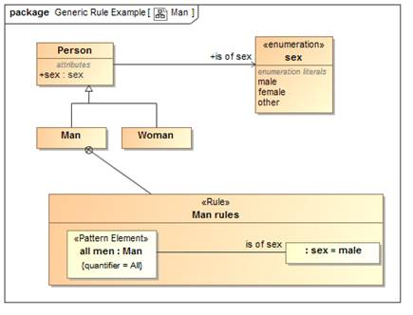
Figure 40 Generic Rule Using Quantifiers
In the above example we assert the fact that “all men <is of sex> Male” in a <<Rule>> called “Man rules”. This rule is owned by (and therefor in the context of), the class “Man”.
The pattern element named “all men” has a type of “Man” and a quantifier=All. This means that the element will be “filled” with all men, statements made in this rule will apply to all men. We then have a connector typed <is of sex> to “Male”. This asserts that all men are male.
Note that quantified elements can also have connectors to other quantified elements, so we could say things like “all men like Most tools” or “John likes all supermodels living in New York”.
Note that how rules are resolved is implementation specific. Some “inference” systems may create new facts while others may check that certain facts are correct.

<<Pattern Element>> explicit
Most elements are mapped regardless of their source – explicitly asserted in a model or derived based on rules. There are times where only explicitly asserted elements need be mapped. In this case the element is marked with the <explicit> tag as TRUE.
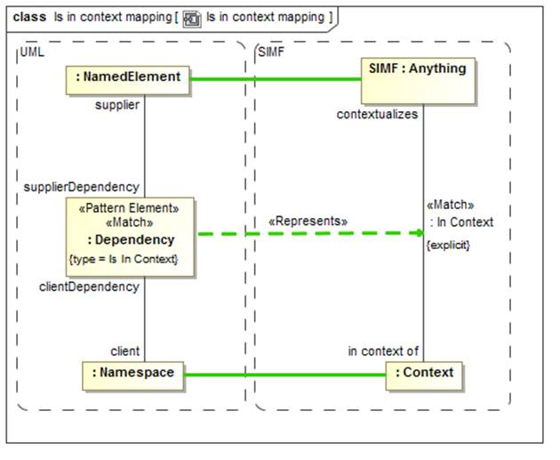
Figure 41 Example of "explicit" pattern elements
The above example shows that the “in context of” relationship in SMIF should only be mapped to UML if it is explicitly asserted.

Property Chains
Rules may also be used within a conceptual or logical model, an example being the “property chain” concept from OWL which allows a “path” through properties to be equivalent to another property.
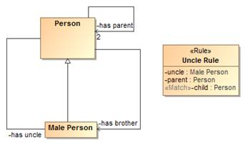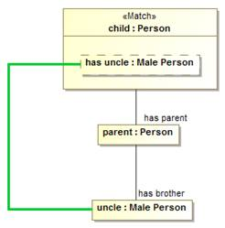
Figure 44 Property Chain Example
In this example we see a simple model of a person with parents and male people that can be brothers or uncles. The “Uncle Rule” states that the “path” through “has parent” to “has brother” <<Map>>s to “has uncle”.
The above is one way to specify a chain, another would be with the <chain> tag of an <<Equivalent Property>> which is more compact but less powerful.

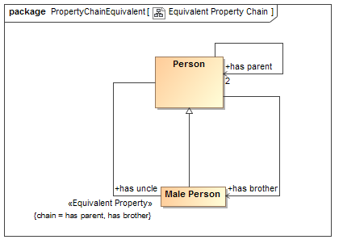
Figure 45 Property Chain as Equivalent Property
The above example says the same thing as the property chain rule, using the more compact <chain> tag of <<Equivalent Property>>

Pattern Precedence
It is possible for more than one pattern to match for the same set of values. The general rule is that all patterns that match will execute. Where this may produce redundant elements a pattern may either subtype or subsume another. Where a pattern subtypes another and the more specific pattern matches, the more specific pattern will include the rules of the more general pattern.
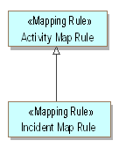
Figure 46. Example of Pattern Generalization
An incident is a kind of activity. The incident rules subtypes and subsumes that activity map. An activity that is an incident will use the incident map rules as well as the sub-rules defined within activity.
Where a pattern uses a <<Subsumes>> dependency, if the <supplier> pattern matches it will prevent the <target> pattern from executing for the same set of values.
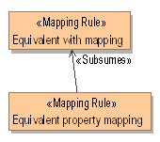
Figure 47. Example of Rule Subsumption
Using “Equivalent With” is more general but >Equivalent Property” more compact. If equivalence can be expressed with “Equivalent Property” it subsumes “Equivalent With”.

Generic Rules
Most of our examples have used mapping rules. Rules are also generic patterns that can be asserted to hold within some context. Generic rules generally use quantifiers rather than <<Match>> but can be stated either way. A quantifier defines a pattern property that contains a set of instances defined by the property type. The quantifier specifies how many instances will be in the set from none to all.
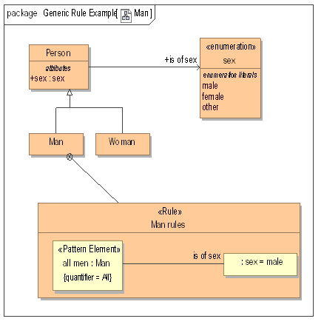
Figure 48. Generic Rule Example
Figure 47 provides an example of a generic <<Rule>>. The rule states that as part of the definition of the class Man, the “Man rule” applies which says that all men <is of sex> male. The Pattern element “all men” has “quantifier = All” which is really what makes it represent all men, not the name. “all men” then has a relationship to a constant “sex = male” (the default value of a property is considered its value). The result is the “assertion” that all men will have the same sex.
Note that more than one property may be quantified, for example we could say “All men like at least one supermodel” by quantifying “a supermodel” with “quantifier = There exists” and creating a connector “likes” between them. Options for quantifiers are: None, There Exists, Exactly One, Some, Most, All. Note that for an interpretation in first order logic, There Exists, Some and Most are the same, even if they may have an intuitive distinction. In other logics concepts like “Most” may offer a default.

Facades and Representation Computations
In some cases, it is desirable to have mapping rules as “reusable pieces” that can provide a “Face” to a model that fits better for one or more mapping rules. There is also the case where these rules fall outside of the expressive power of mapping rules and are best done in calculations (program code or fUML models).
Facades provide for making a new “face” of either a conceptual model or data model element. A Façade is a class with additional properties and/or relations that can be derived from the element it represents. Either mapping rules or computations are then used to “populate” the façade or map the façade back to what it represents. The façade implementation keeps the façade properties consistent as any connector implies change in a property value.
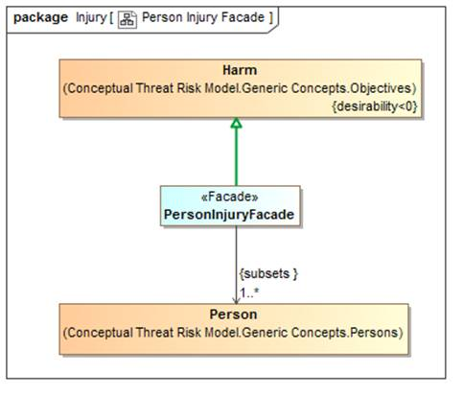
Figure 42 Facade Example
The “PersonalInjuryFacade” above represents the concept of “Harm” but only where the harm impacts a Person. In NIEM, injury is only considered relative to a person – so this façade provides such a “View” of the conceptual model, harm restricted to personal injury. In this case no additional representation rule is required, but such a façade could also define new properties or associations that would be populated in the same way as a data model.
Note that in this case the <<Represents>> relation is applied to a generalization to assert that “PersonInjuryFacade” includes all of the features of “Harm” and is also a representation of it.
Facades can also use “Computations” or Representation Rules to define their properties.
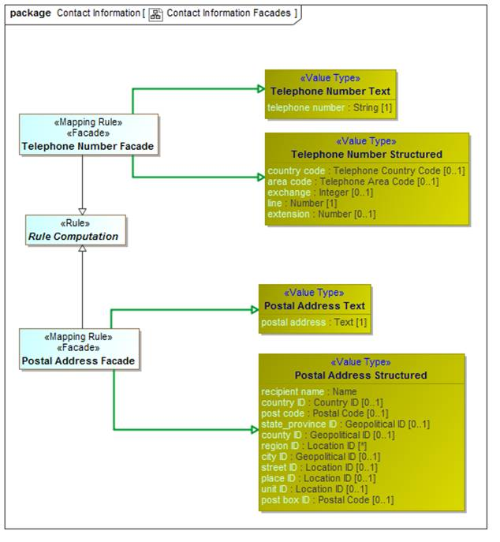
Figure 43 Computation Facade Examples
In the above example both a telephone number façade and address façade are “computed” based on combining both a structured and unstructured representation of telephone numbers and addresses. The specific computation is external to the specification and defined by implementations. These implementations could be implemented in any language, including “ALF”, the executable language of UML.
The mapping engine is responsible for implementation of computation behavior and should update a computed Façade whenever any of its elements changes (some implementations may group such changes in a transaction).
In summary, facades and computations provide for reusability and extensibility of mappings.

SMIF Profile::SMIF Patterns Profile Reference
The SMIF rules profile defines the way to model rules and mapping within and between data sources via a conceptual model.

Diagram SMIF Patterns Profile
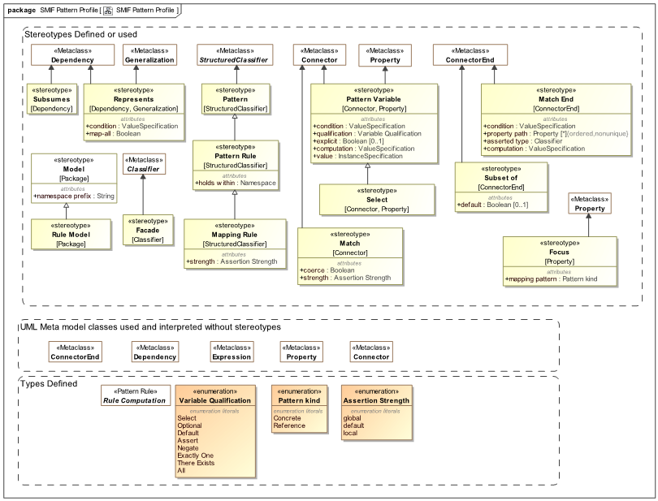

Figure 1 SMIF Rules Profile
Computation computes a value for the mapping end based on the expression applied to the mapped property or relationship.
Where computation is used inverse mapping is not specified - any inverse mapping is implementation specific.

Stereotype Facade
<<Facade>> defines a classifier as being a view of (facade of) one or more other classifiers. Facades usually define additional properties that match some external view of a conceptual model element.
A facade will represent the classifier for which it is a facade. A Facade will use one of two methods to relate the facade properties to the conceptual Model:
* <<Rule>> using the facade.
* Applying the <<computation>> stereotype and Subclassing "Representation Computation"

Base Classes
• Classifier

Stereotype Map
<<Map>> defines an equality rule between two properties in a <<Rule>> - they must represent the same information, perhaps using different representations.
Maps should be drawn <from> the representation <to> the more conceptual.
<<Map>> may be used between models, as is common for a <<Mapping Rule>> or within one model to equate different representations for the same thing (e.g., property paths).
Base Classes
• Connector
Tag Definitions
coerce : Boolean

Where <coerce> has a value of TRUE a map rule will be evaluated even if the <from> is not type compatible with the <to> type.
Where <coerce> is FALSE or unstated a map rule will be evaluated only if the <from> is type compatible with the <to> type.
Type compatible shall be defined as one of: Being the same type, <from> being a subtype of <to> (as defined by a type generalization rule), <from> being a representation of <to> (as defined by a representation rule).
Representation rules applied to a supertype apply to a subtype.

condition : ValueSpecification

<condition> is an expression that must be true for the map rule to hold.

default : Boolean

<default> is true if the map should be enforced only if no other maps apply.

type : Classifier

<type> is a restriction on the type of a property or relation that a map represents. One "side" of the map connector must have this type.

Stereotype Mapping Rule
<<Mapping Rule>> defines a pattern structure described by a structured classifier that shows how both "sides" of a representation (conceptual and logical) are related. Each "side" must match, including any traversals through structures defined with properties and connectors. Such traversals are links which may also have filters to more precisely define the pattern.
The pattern is described using structured classifier properties and connectors.
The mapping engine ensures that the patterns match, bidirectionally.
Base Classes
• StructuredClassifier
Direct Supertypes
• Rule

Stereotype Match
Match specifies an element in a structure that must match a model element for the pattern to match. The match is the starting point for the pattern from which all paths are computed.
<<Match> is a shortcut for <<Pattern Element>> strength=Match
Base Classes
• Connector
• ConnectorEnd
• Property
Direct Supertypes
• Pattern Element

Stereotype Pattern Element
<<Pattern element>> further defines a connector, connector end or property within a pattern based on the tag values.
Note that the UML default value may be used to set the initial value of a pattern element.
Base Classes
• Connector
• ConnectorEnd
• Property
Tag Definitions
computation : ValueSpecification

<computation> computes a value for the pattern element based on the expression.
Where computation is used inverse mapping is not specified - any inverse mapping is implementation specific.

condition : ValueSpecification

<condition> states a condition that must be true within the scope of the pattern element. This can be used for pattern matching, setting values or restriction of paths.

explicit : Boolean [0..1]

If <explicit> is true, the pattern element must be explicitly asserted as the indicted type, not derived or inferred from a supertype or super property.

quantifier : Quantifier

A property that defines a quantification within a pattern. The quantifier defines the set of things that will populate the pattern property for all instances of the pattern.

Quantifiers operate over the type of a pattern element and define a set or subset that corresponds to the extend of the pattern elements type.

e.g. for all people p: People is the context and P is the quantified property. In SMIF the quantified property would typically be named <quantifier> <type>. So the above quantified property would be named "all people". The quantified property will be asserted to have the quantified type.

strength : Pattern Element Strength

<strength> defines the behavior of an element with respect to a pattern - how it impacts the selection, evaluation or assertion of the pattern.

type : Classifier

<type> is a restriction on the type of a property or relation that a pattern element represents.

Enumeration Pattern Element Strength
Pattern Element Strength defines a set of options for the mapping behavior of a pattern element.
Literals:
Assert
The element will be asserted as required for a valid pattern. Assert is the default.
Default
The element will be asserted only if no other values are asserted within the pattern or as pre-existing assertions.
Exists
Existing element that will be used to compute other values but does not otherwise impact the pattern.
Match
Match is used in query and mapping patterns, all elements of the classified type that match the pattern are selected as instances of the pattern.
Match may be considered a qualified "All". Match does not assert the existence of something, it determines the existence of a pattern match such that other assertions may be made.
Relationships between properties with <quantifier>=Match must hold between the matched properties for the pattern to match.

Enumeration Quantifier
The set of quantifiers for pattern variables. Quantifiers operate over the type of a pattern element and define a set or subset that corresponds to the extend of the pattern elements type.
Literals:
All
The universal quantifier - the quantified property is a stand-in for all elements of the extent of the quantified type
Exactly One
The existential quantifier limited to exactly one of a potentially larger set
Most
A stratified existential quantifier with a default for a "typical" value - example: <Most> people have 2 arms.
For logics that do not support "most", most may be interpreted as "There Exists".
None
A quantifier where no instance of the type may fill the role. E.g. "there may not exist".
Some
A stratified existential quantifier for a common values - example: <Some> people like computers.
For logics that do not support "some", some may be interpreted as "There Exists".
There Exists
The existential quantifier - at least one element must exist.

Stereotype Represents
<<Represents>> is an assertion that the source type or feature provides a more concrete way to represent the target type or feature. Represents may be used within conceptual models or from a physical model to a conceptual model.
• A representation that is a dependency or realization makes no assumption that the types are substitutable.
• A representation that is a generalization is substitutable for what it represents.

Base Classes
• Dependency
• Generalization
Tag Definitions
condition : ValueSpecification

<condition> is an expression that must be true for the source to represent the target.

map-all : Boolean

<map-all> implies a direct mapping between instances of the types in both directions.
<map all> is equivalent to a mapping with a rule mapping properties of each type but is lower precedence than other mappings - if types have a more specific map it will apply first.

Stereotype Rule
<<Rule>> defines a pattern that must hold true for the context of the rule.
The pattern is described using structured classifier properties and connectors.
A rule is a pattern structure described by a structured classifier that shows how elements are related. Each mapped element must match, including any traversals through structures defined with properties and connectors. Such traversals are links which may also have filters to more precisely define the pattern. The mapping engine ensures that the patterns match, bidirectionally.
Base Classes
• StructuredClassifier
Tag Definitions
holds within : Namespace

<holds within> is the context in which a rule is asserted (required to be true). Anything contextualized by the context is subject to the proposition.
If not stated the rule is asserted by its owner.

Stereotype Rule Model
A <<Rule Model>> defines a package as containing rule specifications and asserts those rules to be true.
Base Classes
• Package
Direct Supertypes
• Model

Stereotype Subset of
In a pattern or mapping rule, <Subset of> defines a pattern property that represents a subset of another property. The subset may be constrained by a more specific type, expressions, values or required cardinalities.
Subset stereotypes the end of a connector that is the superset.
Base Classes
• ConnectorEnd
Tag Definitions
default : Boolean [0..1]

True if the subset should be populated only if no other subsets have been populated.

Stereotype Subsumes
<<Subsumes>> is a dependency between rules. When a rule subsumes another the subsumed rule will not apply (fire). if the <subsumed by> rules applies (fires).
Where rules are also patterns, a rule may specialize another which will subsume the specialized rule as well as include the generalized rule parts as parts of the specialized rule.
Base Classes
• Dependency

SMIF Profile::SMIF Computation Rules
Computation rules define mappings that are implemented via external methods. As such the implementation is defined by implementations, not the specification.

Diagram SMIF Computation Rules
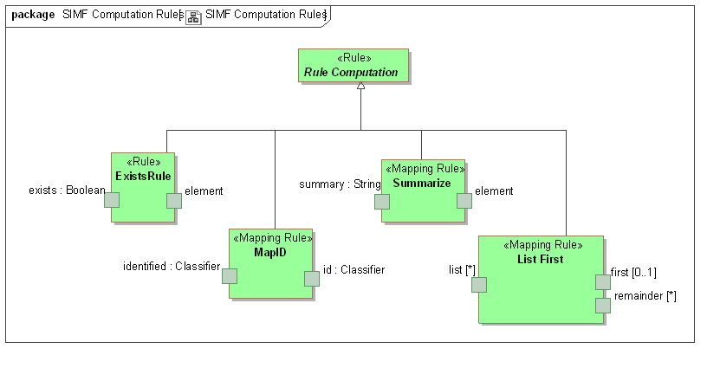

Figure 1 SMIF Computation Rules

Class ExistsRule
<<Exists Rule> is a rule to map the existence of an <element> to a boolean.
<exists> is true iff <element> is not null.
Direct Supertypes
• Rule Computation
Attributes
element

exists : Boolean

Class List First
The <List First> rules will take the <list> property and place the first element into<first>. If <list> is empty, <first> will be empty.
If there are more <list> elements than 1, all remaining elements are placed as a set in <remainder>.
If <list> is an un-ordered set the order will be indeterminate but repeatable.
<<List First>> is bidirectional and will compute <list> by appending <first> and <remainder>.
Note that this will act like a LISP CDR/CAR pair
Direct Supertypes
• Rule Computation
Attributes
first [0..1]

list [*]

remainder [*]

Class MapID
<<MapID>> is a rule where the source is an ID and the target is a class, maps an instance of the ID to an instance of the class.
Direct Supertypes
• Rule Computation
Attributes
id : Classifier

identified : Classifier

Class Rule Computation
<<Rule Computation>> is an abstract supertype for a facade that includes external implementation. The implementation is outside of this specification.

Class Summarize
<<Summarize>> is a rule that produces a natural language description of an element. Summarize may not be bi-directional and is expected to have information loss.
<summary> is a summary of <element>.
Content of summary is implementation specific.
Direct Supertypes
• Rule Computation
Attributes
element

summary : String

Profile mapping to SMIF Model (Normative)
The following diagrams summarize the mapping which is further defined in the UML mapping model.
Note – this section is out of date and due to be revised.

SMIFProfileToModelMapping::High level representation
The following diagrams show the <<Represents>> rules defined between the profile and the SMIF model.

Diagram: Anything
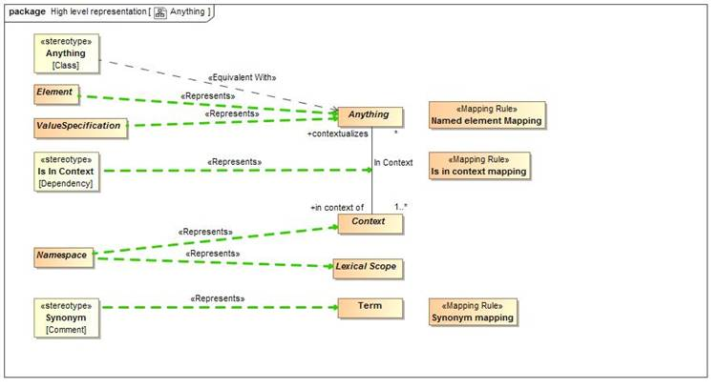
Figure 1. Anything

Diagram: Classes
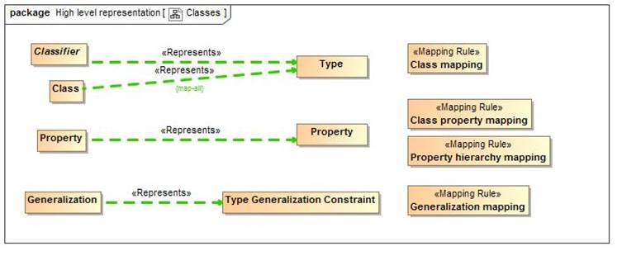
Figure 2. Classes

Diagram: Lexical Structure
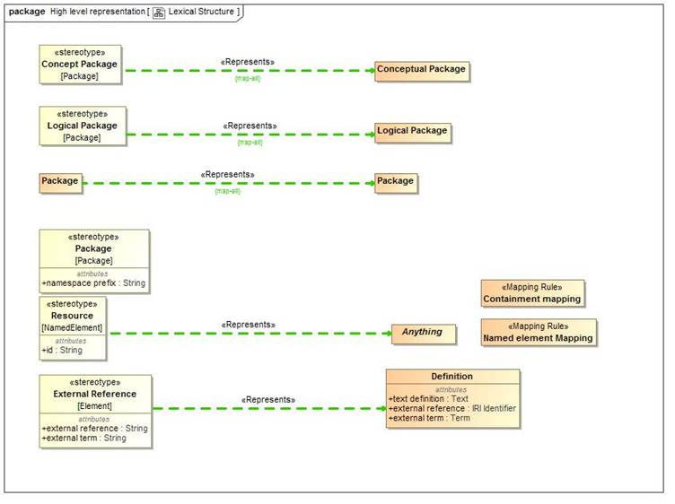
Figure 3. Lexical Structure

Diagram: Patterns
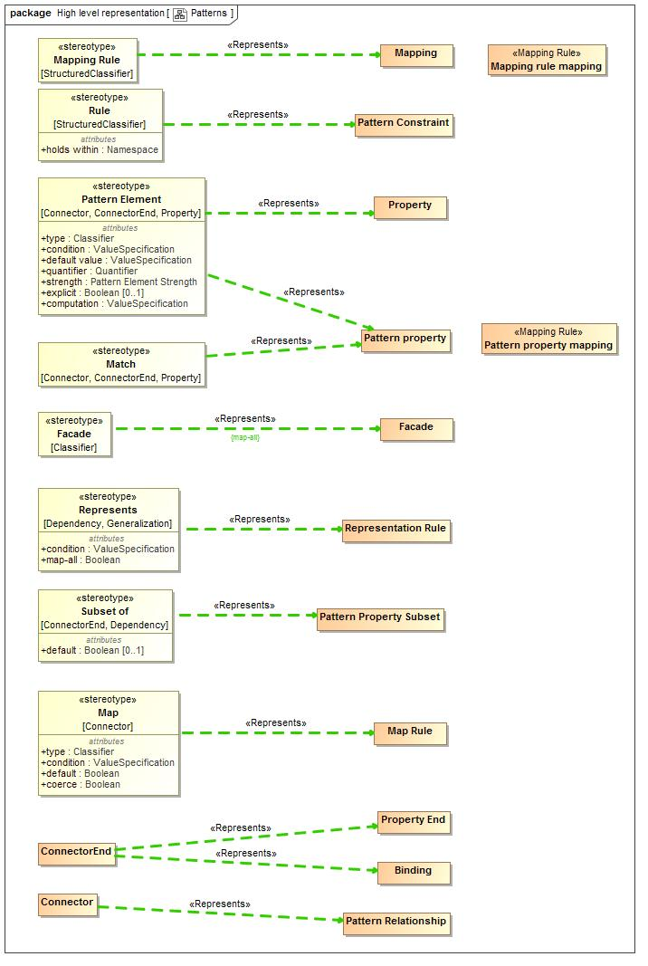
Figure 4. Patterns

Diagram: Relationships
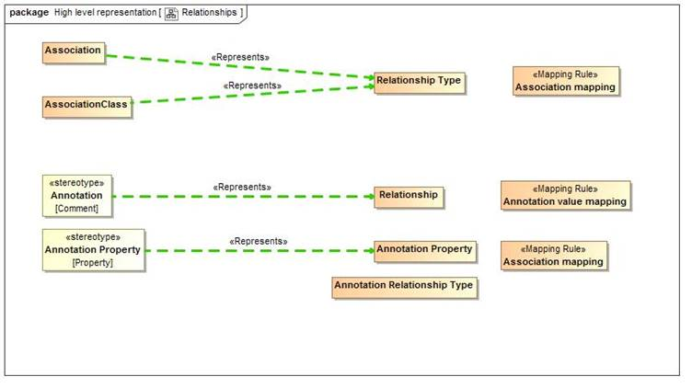
Figure 5. Relationships

Diagram: Rules
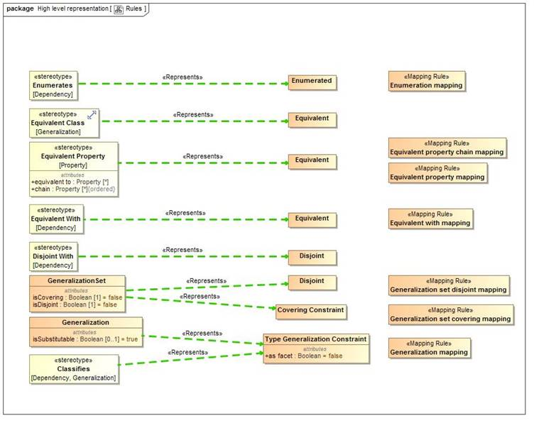
Figure 6. Rules

Diagram: Types
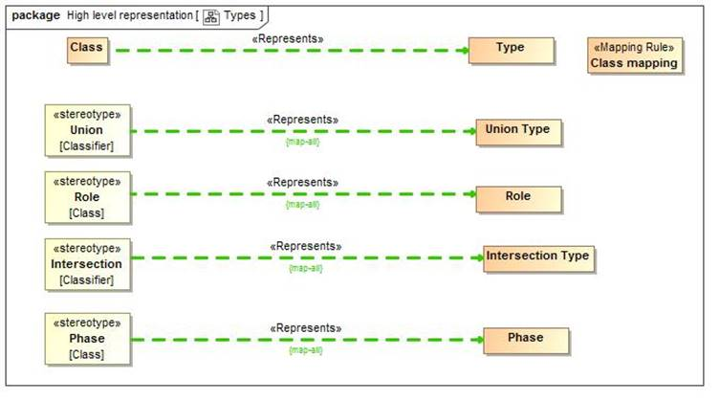
Figure 7. Types

Diagram: Values
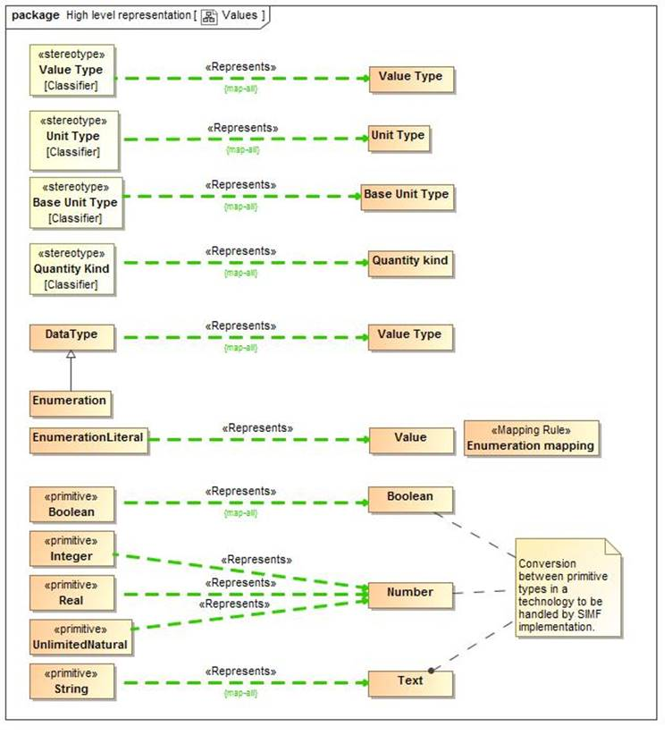
Figure 8. Values

SMIFProfileToModelMapping::Mapping rules
The following are the mapping rules that hold for mapping the SMIF profile to the SMIF model.

Class Annotation value mapping
Annotation value mapping defines a direct correspondence between a UML <<Annotation>> stereotype of a comment and a SMIF Relationship typed by a Annotation Relationship Type. It then creates the properties for the Annotation Relationship Type and binds the subject of the annotation to the annotated element and the annotation property to the string "body" value of the annotation.
Note that an annotation defines a property instance, it does not define a new property.
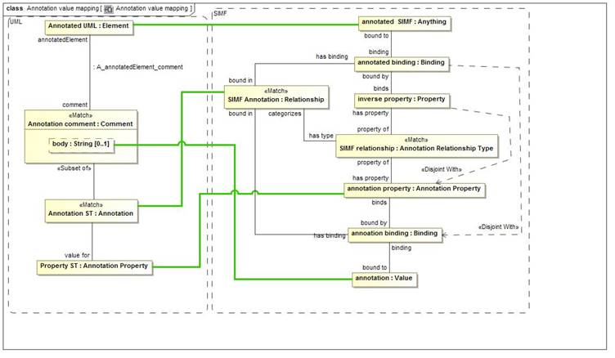
Figure 1. Annotation value mapping
package SMIFProfileToModelMapping::Mapping rules

Class Association mapping
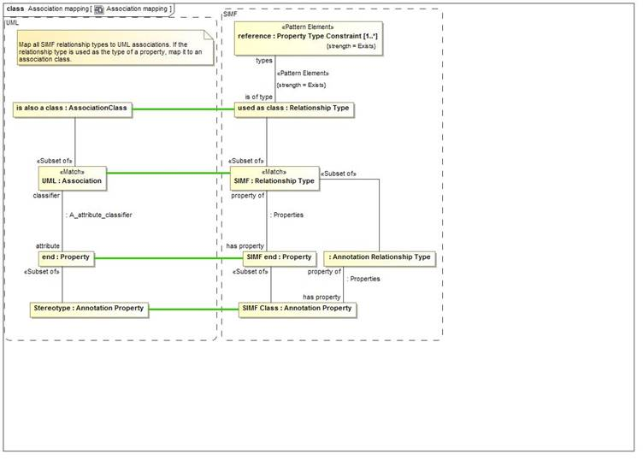
Figure 2. Association mapping
The Association mapping draws a direct correspondence between a UML association and a SMIF Relationship Type. It maps each property of the association to a SMIF property.
SMIF does not distinguish between associations and association classes (all associations are essentially classes). As a convention, a UML association class will be created only when the association is used as an type of some other property.
For annotations, UML <<Annotation Property>> corresponds with a SMIF Annotation Property as a property of a Annotation Relationship Type.
package SMIFProfileToModelMapping::Mapping rules

Class Class mapping
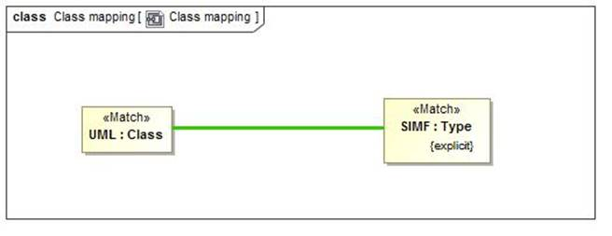
Figure 3. Class mapping
UML Classes correspond directly to explicitly asserted SMIF types.
package SMIFProfileToModelMapping::Mapping rules

Class Class property mapping
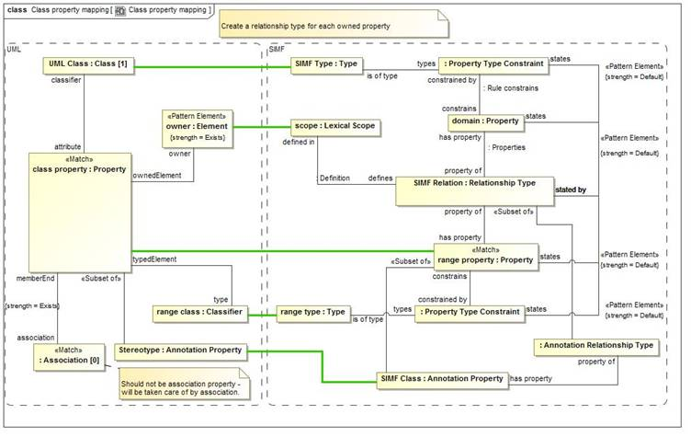
Figure 4. Class property mapping
Properties of UML classes correspond with a pattern involving a relationship. SMIF conceptual models to not define properties directly on types but each is an independent relationship type.
Each UML Property corresponds with a SMIF property with a type that matches the UML property type. The SMIF property becomes a property of a Relationship Type with a "domain" property corresponding to the UML class owning the property.
UML properties marked as an <Annotation Property>> Correspond to a SMIF Annotation Property and further classify the relationship as a Annotation Relationship Type.
package SMIFProfileToModelMapping::Mapping rules

Class Containment mapping
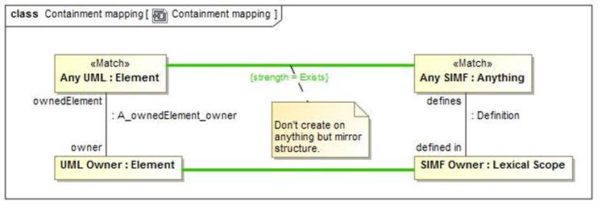
Figure 5. Containment mapping
Containment mapping forces the UML ownership structure and the SMIF lexical structure to match.
package SMIFProfileToModelMapping::Mapping rules

Class Enumeration mapping
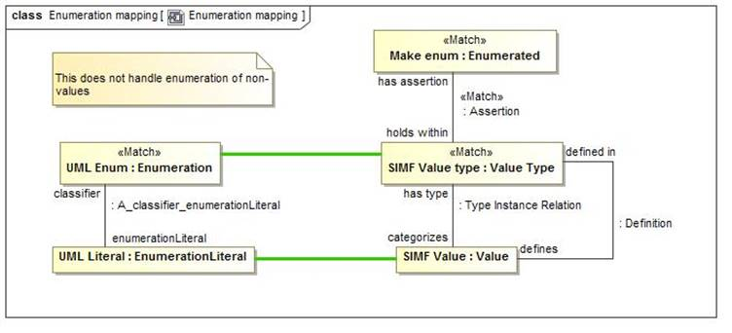
Figure 6. Enumeration mapping
Enumeration mapping draws a correspondence between UML Enumerations and a SMIF Value with an "Enumerated" constraint.
While SMIF may enumerate non-Values UML does not support this semantic.
package SMIFProfileToModelMapping::Mapping rules

Class Equivalent property chain mapping
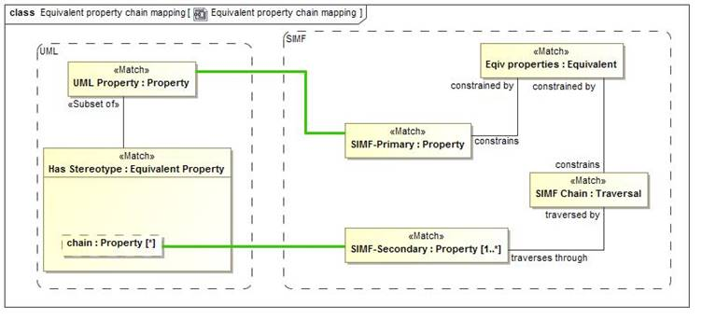
Figure 7. Equivalent property chain mapping
Equivalent property chain mapping maps the UML stereotype <<Equivalent Property>> with a "chain" tag to a SMIF "Equivalent" constraint constraining a SMIF Traversal of that chain.
The stereotyped property corresponds with the <constrains> property of the Equivalent constraint.
package SMIFProfileToModelMapping::Mapping rules

Class Equivalent property mapping
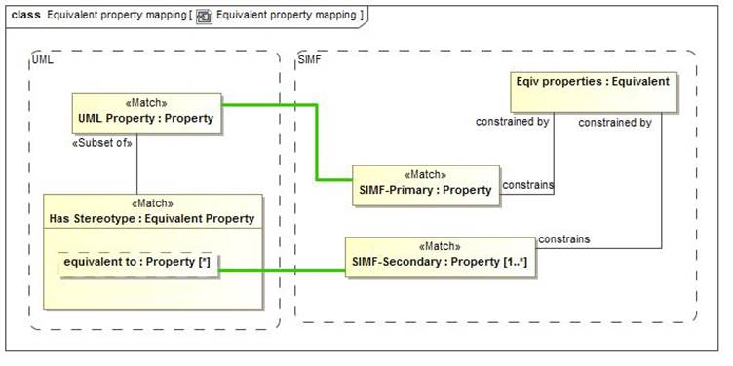
Figure 8. Equivalent property mapping
Equivalent property chain mapping maps the UML stereotype <<Equivalent Property>> with a <equivalent to> tag to a SMIF "Equivalent" constraint constraining a SMIF Secondary property.
The stereotyped property corresponds with the <constrains> property of the Equivalent constraint.
package SMIFProfileToModelMapping::Mapping rules

Class Equivalent with mapping
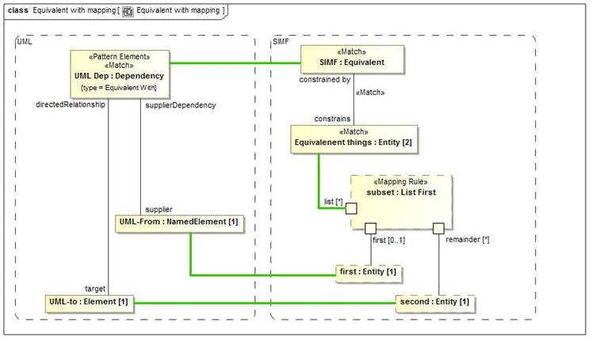
Figure 9. Equivalent with mapping
Equivalent with draws a correspondence between a UML dependency stereotyped as <<Equivalent With>> and a SMIF equivalent constraint with exactly 2 constrained elements. The first element is mapped to the dependency supplier and the second element to the dependency target.
The "List First" rule is used to divide the list elements.
Note that SMIF Equivalent constraints with more than 2 constrained elements will map to a generalization set.
package SMIFProfileToModelMapping::Mapping rules

Class Generalization mapping
The generalization mapping rule draws a direct correspondence between a UML Generalization and a SMIF Type Generalization Constraint.

The UML <<Facet Of>> constraint corresponds with the "as facet" boolean of the SMIF constraint.
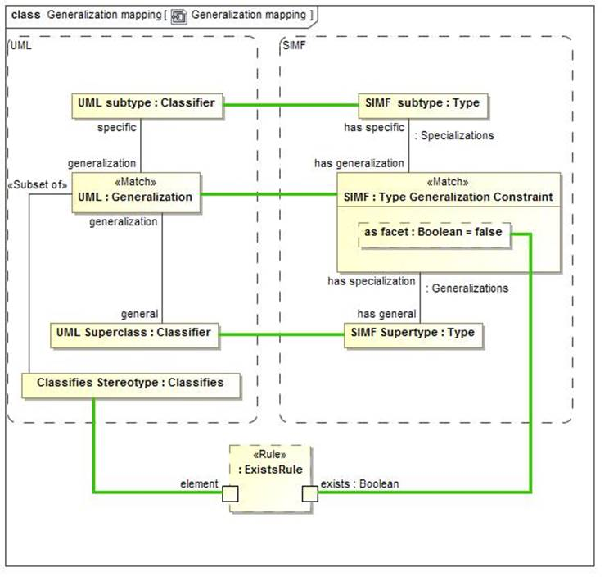
Figure 10. Generalization mapping
package SMIFProfileToModelMapping::Mapping rules

Class Generalization set covering mapping
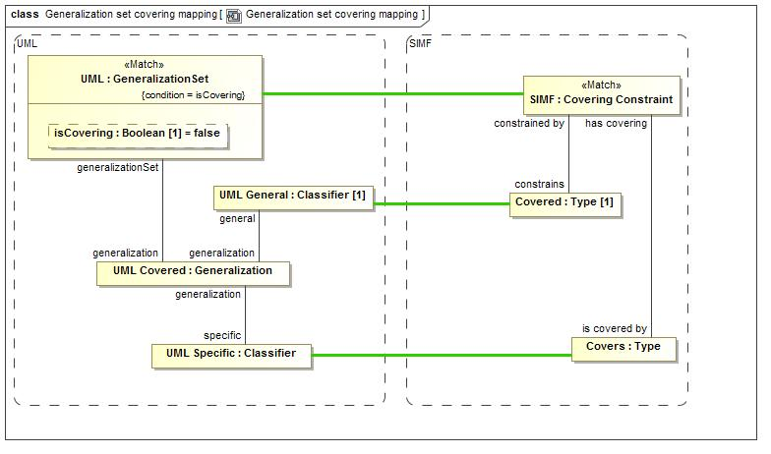
Figure 11. Generalization set covering mapping
Generalization set covering constraint draws a correspondence between a generalization set where isCovering is true and a SMIF Covering Constraint.
The generalization set has a set of UML covered <<Generalization>>s, all of which must have the same <general> Classifier, which is mapped to the <holds within> type.
The <specific> classifiers correspond to a set of <is covered by> types.
package SMIFProfileToModelMapping::Mapping rules

Class Generalization set disjoint mapping
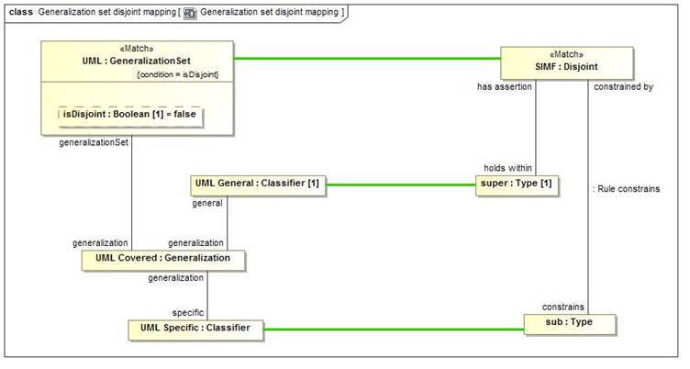
Figure 12. Generalization set disjoint mapping
Generalization set disjoint constraint draws a correspondence between a generalization set where isDisjoint is true and a SMIF Disjoint Constraint.
The generalization set has a set of UML covered <<Generalization>>s, all of which must have the same <general> Classifier, which is mapped to the <holds within> type.
The <specific> classifiers correspond to a set of <is covered by> types.
package SMIFProfileToModelMapping::Mapping rules

Class Is in context mapping
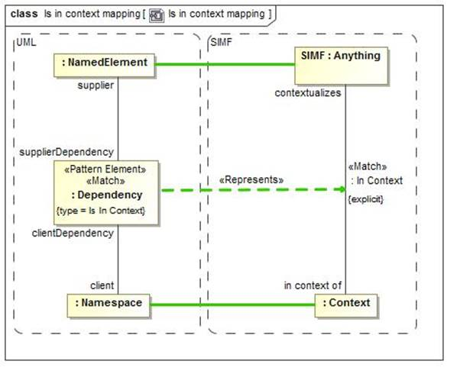
Figure 13. Is in context mapping
Is in contest mapping draws a correspondence between a UML dependency with a <<Is In CContext>> stereotype and an explicit "In Context" Relationship. The relationship is Explicit if it has been explicitly asserted, not inferred.
package SMIFProfileToModelMapping::Mapping rules

Class Mapping rule mapping
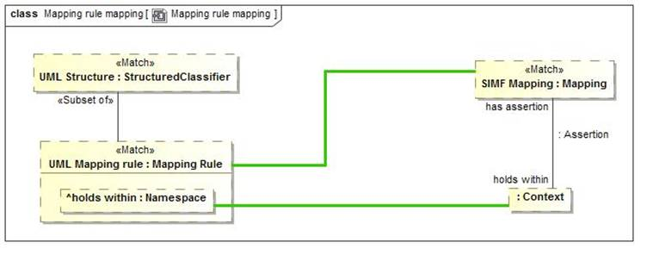
Figure 14. Mapping rule mapping
The Mapping rule mapping draws a correspondence between any UML StructuredClassifier marked as a <<Mapping Rule>> and a SMIF Mapping. The <holds within> tag then maps to the context the mapping holds within.
Any structured classifier may be created from SMIF.
package SMIFProfileToModelMapping::Mapping rules

Class Named element Mapping
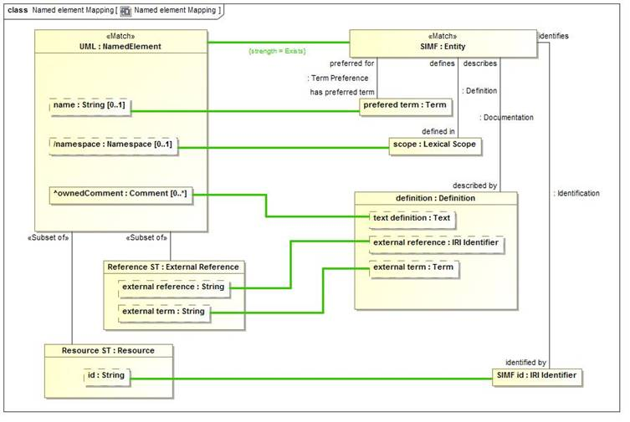
Figure 15. Named element Mapping
package SMIFProfileToModelMapping::Mapping rules

Class Pattern property mapping
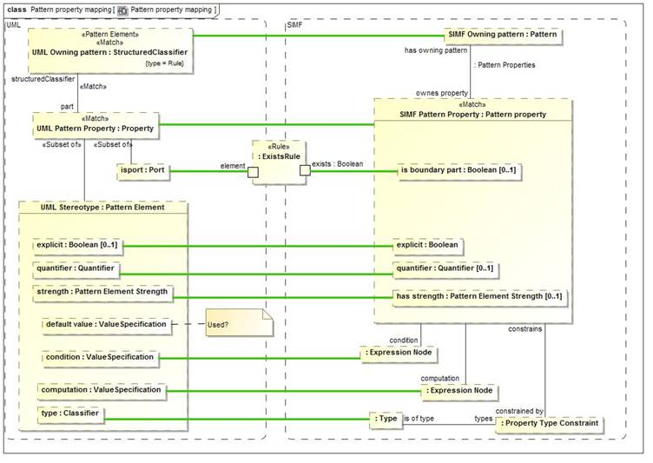
Figure 16. Pattern property mapping
Pattern property mapping makes a correspondence between any UML property that is <part> of a <Rule> and a SMIF Pattern Property.
The owning StructuredClassifier corresponds with the pattern that owns the Pattern Property.
If the UML Property is stereotyped as a <<Pattern Element>> the tags correspond with the explicit, quantifier, condition, computation and has strength properties of the SMIF pattern property.
The <type> of the UML Pattern Element is constrained to be a required <is of type> of the pattern property.
package SMIFProfileToModelMapping::Mapping rules

Class Property hierarchy mapping
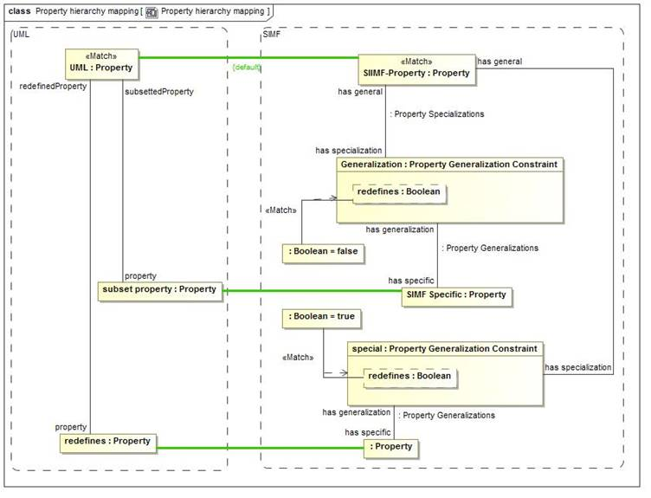
Figure 17. Property hierarchy mapping
Property hierarchy mapping, for properties that have been mapped in other ways, maps UML subsetted properties to a Property Generalization Constraint with redefines=false.
It also maps UML redefines properties to a Property Generalization Constraint with redefines=true.
package SMIFProfileToModelMapping::Mapping rules

Class Synonym mapping
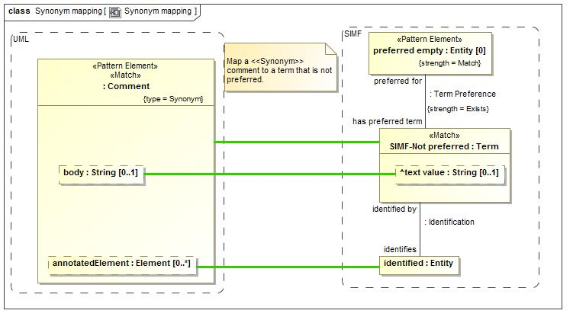
Figure 18. Synonym mapping
Synonym mapping maps a UML Comment with a <<Synonym>> stereotype to a SMIF Term that identifies the element that is annotated by the comment in UML.
A Synonym term is not a preferred term.
package SMIFProfileToModelMapping::Mapping rules

[1] https://en.wikipedia.org/wiki/Mars_Climate_Orbiter

[CC1]Need to nail down our terminology and use consistently.
[CC2]Pete asserts the semantics are different – I don’t think so. Need to resolve.
[CC3]Redundant and not well worded
[CC4]This section is somewhat redundant with the specification introduction but you may want to include it for those only reading this section. However, it should be consistent.
[CC5]We have been using “real or a possible world”
[CC6]Perhaps a better example would be ones that did not share a direct common supertype – perhaps animal and mineral.
[CC7]By the way, when you paste in the diagrams – do it in SVG to make Andrew happy.
[CC8]Doesn’t seem right. Both are manufacturers.
[CC9]Not a great example in that the set is not complete.
Perhaps Silverware: Knife, fork, spoon? (perhaps not exactly true but more true). Remember the “Spork”?
[CC10]Also not an example that fits the assertion. Perhaps the animal kingdom?? Or, Computer storage: Rotating or solid state?
[CC11]I would remove – not true for n-ary and would need to define term.
[CC12]Don’t know that this is true, the representation should not change the semantics
[CC13]Need definitions
[CC14]May want to mention and make an example of the built-in annotation <<anything>> described by Definition. Note that the mapping supports <<Annotation>> of these and also maps the UML documentation element to a Definition which can be augmented by <<External Reference>>.
[CC15]From pete:
“is a comment an annotation property”? Make it clear it is an annotation value.
[CC16]J Seems odd.
[CC17]Not sure this constraint is needed.
[CC18]Why would we jump to that conclusion? Seems like a mxing of semantics and would be non-obvious.
[CC19]Redundant.
[CC20]Could use your generalization set here.
[CC21]Changed picture
[CC22] don’t assume math people.
[CC23]Somewhere these need to be defines, perhaps this is the place.
[CC24]Out of date – also, mixing <<Anything>> with this example may be more challenging.
[CC25]Not true (was a change)
[CC26]May be to complex an example since you have others.
[CC27]Only if 1+
[CC28]Pete: Bad term
[CC29]Hmmm. Could it be sufficient and not necessary?
[CC30]Should show “1”
[CC31]Need to think about how much we -require-inference. I’m not sure we should here. It could be just a model validity check, other implementations could do inference. I think we should keep this very open. For one thing, this could make it fall into the “ontology” category. This is true in other places as well.
[CC32]Said again.
[CC33]Again
[CC34]Pete: still not clear whether the sufficient condition is to have a contract with a Steering Wheel AND a Windshield manufacturer
[CC35]Out of date
[CC36]Can we not use the term in its definition?? Perhaps “be defining a path through other properties that have the same starting point.
[CC37]Pete: not in example; in any case surely it will be applied to a property not a class
[CC38]More accurately – it has one tag value with 2 or more elements.
[CC39]Don’t know where this restriction came from, seems counter-productive and may prevent some of the OntoUML restrictions. REMOVE!
[CC40]Should show for example. Also show property chain ST
[CC41]Pete: how does this relate to previous section using the same stereotype?
[CC42]Perhaps you could be less circular?
[CC43]Again, don’t know where this restriction comes from or why.
[CC44]Pete: not a good example - these are synonyms
[CC45]Remove or make optional to stay within normal UML
[CC46]More – what is a global property?
[CC47]facet (including roles and phases)
[CC48]<<Facet Of>>
[CC49]facet
[CC50]facet
[CC51]facets
[CC52]tbd
[CC53]tbd
[CC54]below it says [RFC3987] We should be consistent.
[CC55]Tbd – really need to nail down.
[CC56]A bit hard to read
[CC57]Pete: not so simple - semiotic triangle involved
consider putting in semiotic triangle picture and explanation.
[CC58]Consider name change for one or the other

