SMIF Mapping to OWL 2 (normative)
Examples are given below that show the transformation of UML modeled in SMIF to an exported OWL 2 ontology. The OWL ontologies are presented in OWL Functional Syntax.

The first diagram below, for a simple UML class, shows the ontology is transformed as the package containing the UML class. Subsequent diagrams do not show the package in the diagram for the sake of brevity.

Class
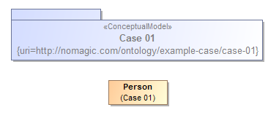
Ontology(<http://nomagic.com/ontology/example-case/case-01>
Declaration(
Class(:Person)
)
AnnotationAssertion(rdfs:label :Person "Person"@en)
)

Class Generalization
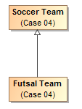
Ontology(<http://nomagic.com/ontology/example-case/case-04>
Declaration(
Class(:FutsalTeam)
)
Declaration(
Class(:SoccerTeam)
)
AnnotationAssertion(rdfs:label :FutsalTeam "Futsal Team"@en)
SubClassOf(:FutsalTeam :SoccerTeam)
AnnotationAssertion(rdfs:label :SoccerTeam "Soccer Team"@en)
)

Class with Datatype Property
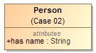
Ontology(<http://nomagic.com/ontology/example-case/case-02>
Import(<http://www.omg.org/spec/PrimitiveTypes/20100901>)
Declaration(
Class(:Person)
)
Declaration(
DataProperty(:hasName)
)
Declaration(
AnnotationProperty(<http://purl.org/dc/terms/description>)
)
Declaration(
Datatype(xsd:string)
)
AnnotationAssertion(rdfs:label :Person "Person"@en)
SubClassOf(
:Person
ObjectIntersectionOf(
DataMaxCardinality(1 :hasName xsd:string)
DataMinCardinality(1 :hasName xsd:string)
)
)
AnnotationAssertion(rdfs:label :hasName "has name"@en)
DataPropertyDomain(:hasName :Person)
DataPropertyRange(:hasName xsd:string)
AnnotationAssertion(http://purl.org/dc/terms/description <http://www.omg.org/spec/PrimitiveTypes/20100901#String> "An instance of String defines a piece of text. The semantics of the string itself depends on its purpose, it can be a comment, computational language expression, OCL expression, etc. It is used for String attributes and String expressions in the metamodel."@en)
)

Class with Self-Referential Object Property
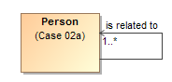
Ontology(<http://nomagic.com/ontology/example-case/case-02a>
Declaration(
Class(:Person)
)
Declaration(
ObjectProperty(:isRelatedTo)
)
AnnotationAssertion(rdfs:label :Person "Person"@en)
SubClassOf(
:Person
ObjectIntersectionOf(
ObjectMinCardinality(1 :isRelatedTo :Person)
)
)
AnnotationAssertion(rdfs:label :isRelatedTo "is related to"@en)
ObjectPropertyDomain(:isRelatedTo :Person)
ObjectPropertyRange(:isRelatedTo :Person)
)

Class with Object Property
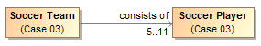
Ontology(<http://nomagic.com/ontology/example-case/case-03>
Declaration(
Class(:SoccerPlayer)
)
Declaration(
Class(:SoccerTeam)
)
Declaration(
ObjectProperty(:consistsOf)
)
AnnotationAssertion(rdfs:label :SoccerPlayer "Soccer Player"@en)
AnnotationAssertion(rdfs:label :SoccerTeam "Soccer Team"@en)
SubClassOf(
:SoccerTeam
ObjectIntersectionOf(
ObjectMaxCardinality(11 :consistsOf :SoccerPlayer) ObjectMinCardinality(5 :consistsOf :SoccerPlayer)
)
)
AnnotationAssertion(rdfs:label :consistsOf "consists of"@en)
ObjectPropertyDomain(:consistsOf :SoccerTeam)
ObjectPropertyRange(:consistsOf :SoccerPlayer)
)

<<Anything>> with Datatype Property

Ontology(<http://nomagic.com/ontology/example-case/case-03a>
Import(<http://www.omg.org/spec/PrimitiveTypes/20100901>)
Declaration(
DataProperty(:hasName)
)
Declaration(
AnnotationProperty(<http://purl.org/dc/terms/description>)
)
Declaration(
Datatype(xsd:string)
)
SubClassOf(
owl:Thing
ObjectIntersectionOf(
DataMaxCardinality(3 :hasName xsd:string)
DataMinCardinality(2 :hasName xsd:string)
)
)
AnnotationAssertion(rdfs:label :hasName "has name"@en)
DataPropertyRange(:hasName xsd:string)
AnnotationAssertion(http://purl.org/dc/terms/description
<http://www.omg.org/spec/PrimitiveTypes/20100901#String> "An instance of String defines a piece of text. The semantics of the string itself depends on its purpose, it can be a comment, computational language expression, OCL expression, etc. It is used for String attributes and String expressions in the metamodel."@en)
)

<<Anything>>with Self-Referential Object Property

Ontology(<http://nomagic.com/ontology/example-case/case-03b>
Declaration(
ObjectProperty(:isRelatedTo)
)
SubClassOf(
owl:Thing
ObjectIntersectionOf(
ObjectMinCardinality(1 :isRelatedTo)
)
)
AnnotationAssertion(rdfs:label :isRelatedTo "is related to"@en)
)

<<Anything>> with Object Property

Ontology(<http://nomagic.com/ontology/example-case/case-03c>
Declaration(
Class(:Liquid)
)
Declaration(
ObjectProperty(:isDissolvedBy)
)
AnnotationAssertion(rdfs:label :Liquid "Liquid"@en)
SubClassOf(
owl:Thing
ObjectIntersectionOf(
ObjectMinCardinality(1 :isDissolvedBy :Liquid)
)
)
AnnotationAssertion(rdfs:label :isDissolvedBy "is dissolved by"@en)
ObjectPropertyRange(:isDissolvedBy :Liquid)
)

Class with Object Property without Range
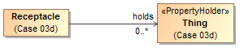
Ontology(<http://nomagic.com/ontology/example-case/case-03d>
Declaration(
Class(:Receptacle)
)
Declaration(
ObjectProperty(:holds)
)
AnnotationAssertion(rdfs:label :Receptacle "Receptacle"@en)
AnnotationAssertion(rdfs:label :holds "holds"@en)
ObjectPropertyDomain(:holds :Receptacle)
)

Class with Subproperty
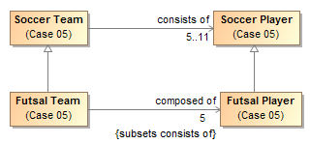
Ontology(<http://nomagic.com/ontology/example-case/case-05>
Declaration(
Class(:FutsalPlayer)
)
Declaration(
Class(:FutsalTeam)
)
Declaration(
Class(:SoccerPlayer)
)
Declaration(
Class(:SoccerTeam)
)
Declaration(
ObjectProperty(:composedOf)
)
Declaration(
ObjectProperty(:consistsOf)
)
AnnotationAssertion(rdfs:label :FutsalPlayer "Futsal Player"@en)
SubClassOf(:FutsalPlayer :SoccerPlayer)
AnnotationAssertion(rdfs:label :FutsalTeam "Futsal Team"@en)
SubClassOf(:FutsalTeam :SoccerTeam)
SubClassOf(
:FutsalTeam
ObjectIntersectionOf(
ObjectMaxCardinality(5 :composedOf :FutsalPlayer) ObjectMinCardinality(5 :composedOf :FutsalPlayer)
)
)
AnnotationAssertion(rdfs:label :SoccerPlayer "Soccer Player"@en)
AnnotationAssertion(rdfs:label :SoccerTeam "Soccer Team"@en)
SubClassOf(
:SoccerTeam
ObjectIntersectionOf(
ObjectMaxCardinality(11 :consistsOf :SoccerPlayer) ObjectMinCardinality(5 :consistsOf :SoccerPlayer)
)
)
AnnotationAssertion(rdfs:label :composedOf "composed of"@en)
SubObjectPropertyOf(:composedOf :consistsOf)
ObjectPropertyDomain(:composedOf :FutsalTeam)
ObjectPropertyRange(:composedOf :FutsalPlayer)
AnnotationAssertion(rdfs:label :consistsOf "consists of"@en)
ObjectPropertyDomain(:consistsOf :SoccerTeam)
ObjectPropertyRange(:consistsOf :SoccerPlayer)
)

Class with Universal Quantification Constraint on Property I
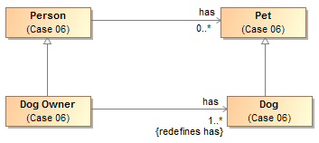
Ontology(<http://nomagic.com/ontology/example-case/case-06>
Declaration(
Class(:Dog)
)
Declaration(
Class(:DogOwner)
)
Declaration(
Class(:Person)
)
Declaration(
Class(:Pet)
)
Declaration(
ObjectProperty(:has)
)
AnnotationAssertion(rdfs:label :Dog "Dog"@en)
SubClassOf(:Dog :Pet)
AnnotationAssertion(rdfs:label :DogOwner "Dog Owner"@en)
SubClassOf(:DogOwner :Person)
SubClassOf(
:DogOwner
ObjectIntersectionOf(
ObjectMinCardinality(1 :has :Dog)
ObjectAllValuesFrom(:has :Dog)
)
)
AnnotationAssertion(rdfs:label :Person "Person"@en)
AnnotationAssertion(rdfs:label :Pet "Pet"@en)
AnnotationAssertion(rdfs:label :has "has"@en)
ObjectPropertyDomain(:has :Person)
ObjectPropertyRange(:has :Pet)
)

Class with Universal Quantification Constraint on Property II
This example differs from the previous example primarily in that the superclasses “Person” and “Pet” are from a different package than their subclasses “Dog Lover” and “Dog,” respectively. This is reflected in the OWL ontology by the import of this namespace.

The superclasses “Person” and “Pet”, defined in the package “Case 06”, are a different color and a lighter shade than the classes defined in the package “Case 07”. This is to distinguish them from the classes defined in this package. MagicDraw’s AutoStyler plugin can automatically set the properties for classes and other UML elements “defined elsewhere,” that is in a package not containing the defining diagram for the UML element (See section 2.2, Automatic Styling of Concept Models.).
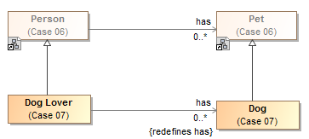
Ontology(<http://nomagic.com/ontology/example-case/case-07>
Import(<http://nomagic.com/ontology/example-case/case-06>)
Declaration(
Class(<http://nomagic.com/ontology/example-case/case-06#Person>)
)
Declaration(
Class(<http://nomagic.com/ontology/example-case/case-06#Pet>)
)
Declaration(
Class(:Dog)
)
Declaration(
Class(:DogLover)
)
Declaration(
ObjectProperty(<http://nomagic.com/ontology/example-case/case-06#has>)
)
AnnotationAssertion(rdfs:label :Dog "Dog"@en)
SubClassOf(:Dog <http://nomagic.com/ontology/example-case/case-06#Pet>)
AnnotationAssertion(rdfs:label :DogLover "Dog Lover"@en)
SubClassOf(:DogLover <http://nomagic.com/ontology/example-case/case-06#Person>)
SubClassOf(
:DogLover ObjectIntersectionOf(
ObjectAllValuesFrom(<http://nomagic.com/ontology/example-case/case-06#has> :Dog)
)
)
)

Class with Existential Quantification Constraint on Property
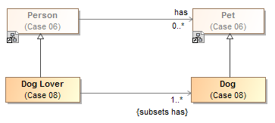
Ontology(<http://nomagic.com/ontology/example-case/case-08>
Import(<http://nomagic.com/ontology/example-case/case-06>)
Declaration(
Class(<http://nomagic.com/ontology/example-case/case-06#Person>)
)
Declaration(
Class(<http://nomagic.com/ontology/example-case/case-06#Pet>)
)
Declaration(
Class(:Dog)
)
Declaration(
Class(:DogLover)
)
Declaration(
ObjectProperty(<http://nomagic.com/ontology/example-case/case-06#has>)
)
AnnotationAssertion(rdfs:label :Dog "Dog"@en)
SubClassOf(:Dog <http://nomagic.com/ontology/example-case/case-06#Pet>)
AnnotationAssertion(rdfs:label :DogLover "Dog Lover"@en)
SubClassOf(:DogLover <http://nomagic.com/ontology/example-case/case-06#Person>)
SubClassOf(
:DogLover
ObjectIntersectionOf(
ObjectMinCardinality(1 <http://nomagic.com/ontology/example-case/case-06#has> :Dog) ObjectSomeValuesFrom(<http://nomagic.com/ontology/example-case/case-06#has> :Dog)
)
)
)

<<Anything>> with Self-Referential Subproperty

Ontology(<http://nomagic.com/ontology/example-case/case-11>
Declaration(
ObjectProperty(:contains)
)
Declaration(
ObjectProperty(:holds)
)
AnnotationAssertion(rdfs:label :contains "contains"@en)
SubObjectPropertyOf(:contains :holds)
AnnotationAssertion(rdfs:label :holds "holds"@en)
)

<<Anything>> Holder with Subproperty
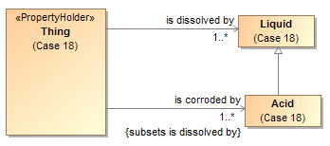
Ontology(<http://nomagic.com/ontology/example-case/case-18>
Declaration(
Class(:Acid)
)
Declaration(
Class(:Liquid)
)
Declaration(
ObjectProperty(:isCorrodedBy)
)
Declaration(
ObjectProperty(:isDissolvedBy)
)
AnnotationAssertion(rdfs:label :Acid "Acid"@en)
SubClassOf(:Acid :Liquid)
AnnotationAssertion(rdfs:label :Liquid "Liquid"@en)
SubClassOf(
owl:Thing
ObjectIntersectionOf(
ObjectMinCardinality(1 :isCorrodedBy :Acid)
)
)
SubClassOf(
owl:Thing
ObjectIntersectionOf(
ObjectMinCardinality(1 :isDissolvedBy :Liquid)
)
)
AnnotationAssertion(rdfs:label :isCorrodedBy "is corroded by"@en)
SubObjectPropertyOf(:isCorrodedBy :isDissolvedBy)
ObjectPropertyRange(:isCorrodedBy :Acid)
AnnotationAssertion(rdfs:label :isDissolvedBy "is dissolved by"@en)
ObjectPropertyRange(:isDissolvedBy :Liquid)
)

Class with Subproperty without a Range
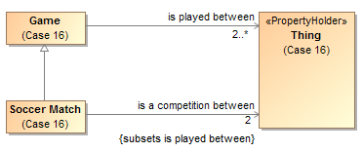
Ontology(<http://nomagic.com/ontology/example-case/case-16>
Declaration(
Class(:Game)
)
Declaration(
Class(:SoccerMatch)
)
Declaration(
ObjectProperty(:isACompetitionBetween)
)
Declaration(
ObjectProperty(:isPlayedBetween)
)
AnnotationAssertion(rdfs:label :Game "Game"@en)
SubClassOf(
:Game
ObjectIntersectionOf(
ObjectMinCardinality(2 :isPlayedBetween)
)
)
AnnotationAssertion(rdfs:label :SoccerMatch "Soccer Match"@en)
SubClassOf(:SoccerMatch :Game)
SubClassOf(
:SoccerMatch
ObjectIntersectionOf(
ObjectMaxCardinality(2 :isACompetitionBetween) ObjectMinCardinality(2 :isACompetitionBetween)
)
)
AnnotationAssertion(rdfs:label :isACompetitionBetween "is a competition between"@en)
SubObjectPropertyOf(:isACompetitionBetween :isPlayedBetween)
ObjectPropertyDomain(:isACompetitionBetween :SoccerMatch)
AnnotationAssertion(rdfs:label :isPlayedBetween "is played between"@en)
ObjectPropertyDomain(:isPlayedBetween :Game)
)

Class with Necessary and Sufficient Property
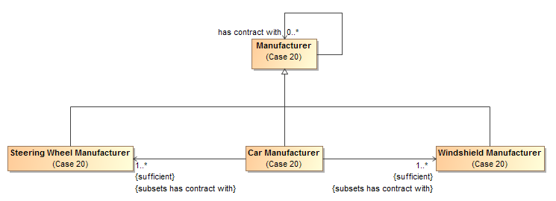

Ontology(<http://nomagic.com/ontology/example-case/case-20>
Declaration(
Class(:CarManufacturer)
)
Declaration(
Class(:Manufacturer)
)
Declaration(
Class(:SteeringWheelManufacturer)
)
Declaration(
Class(:WindshieldManufacturer)
)
Declaration(
ObjectProperty(:hasContractWith)
)
AnnotationAssertion(rdfs:label :CarManufacturer "Car Manufacturer"@en)
EquivalentClasses(
:CarManufacturer
ObjectIntersectionOf(
ObjectMinCardinality(1 :hasContractWith :SteeringWheelManufacturer) ObjectSomeValuesFrom(:hasContractWith :SteeringWheelManufacturer)
)
)
EquivalentClasses(
:CarManufacturer
ObjectIntersectionOf(
ObjectMinCardinality(1 :hasContractWith :WindshieldManufacturer)
ObjectSomeValuesFrom(:hasContractWith :WindshieldManufacturer)
)
)
SubClassOf(:CarManufacturer :Manufacturer)
AnnotationAssertion(rdfs:label :Manufacturer "Manufacturer"@en)
AnnotationAssertion(rdfs:label :SteeringWheelManufacturer "Steering Wheel Manufacturer"@en)
SubClassOf(:SteeringWheelManufacturer :Manufacturer)
AnnotationAssertion(rdfs:label :WindshieldManufacturer "Windshield Manufacturer"@en)
SubClassOf(:WindshieldManufacturer :Manufacturer)
AnnotationAssertion(rdfs:label :hasContractWith "has contract with"@en)
ObjectPropertyDomain(:hasContractWith :Manufacturer)
ObjectPropertyRange(:hasContractWith :Manufacturer)
)

Class With Property Having Unspecified Multiplicity
UML allows the cardinality of a property to be left unspecified. The concept modeling profile interprets unspecified cardinalities as being zero to many (“0..*”).

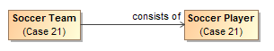
Ontology(<http://nomagic.com/ontology/example-case/case-21>
Declaration(
Class(:SoccerPlayer)
)
Declaration(
Class(:SoccerTeam)
)
Declaration(ObjectProperty(:consistsOf))
AnnotationAssertion(rdfs:label :SoccerPlayer "Soccer Player"@en)
AnnotationAssertion(rdfs:label :SoccerTeam "Soccer Team"@en)
AnnotationAssertion(rdfs:label :consistsOf "consists of"@en)
ObjectPropertyDomain(:consistsOf :SoccerTeam)
ObjectPropertyRange(:consistsOf :SoccerPlayer)
)

