Famous Composers in
Conceptual Domain and Generic Model

A part of a SIMF federation case

Version 2013-01-21-1400-SN

In this paper we use the following case Domain SJ008f.
This domain is representative for n-ary facts where n can have any integer value from 1 upwards. This domain is also representative to introduce the core integrity rules. It is also representative to cover Fact Communication Patterns and Rules Communication Patterns. It can be described as follows:

- Domain SJ008f - Requirements for the domain Famous composers

- Domain SJ008f is about some aspects of famous composers and some related
- aspects.
- Sjir is the owner of domain SJ008f and he has very precise ideas what is
- within the scope of domain SJ008f. He and other people in his hamlet are
- interested in famous composers, but only if it is also known in the domain which
- their birth country is.
- As living famous composers are also declared within scope,
- the age at which a famous composer died, if applicable, is also within scope.
- Furthermore he wants to know the capital city of every country that is the birth
- country of a famous composer.
- Needless to say famous composers in domain SJ008f have exactly one birth
- country.
- And also needless to say that each birth country has exactly one capital city.
- And also that each capital city is the capital of exactly one such country.

- Version 2013-01-21-1400

Table of contents

Domain Specific Fact Types 2
List of used Meta (Generic) Fact Types 6
Meta (Generic) Fact Types 7

Domain Specific Fact Types

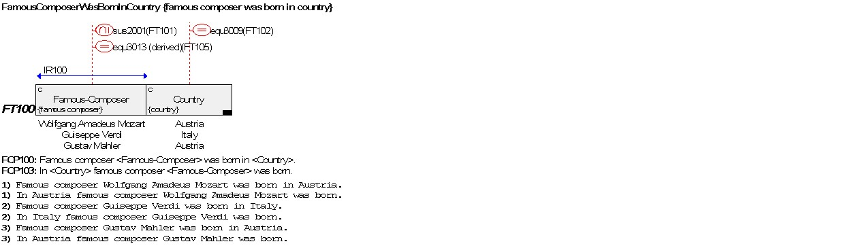
1.
2.
3.

FCP100
FCP103
FCP100
FCP103
FCP100
FCP103

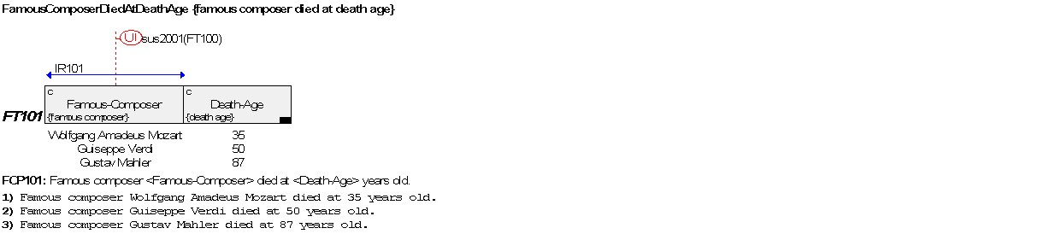
1.
2.
3.

FCP101
FCP101
FCP101

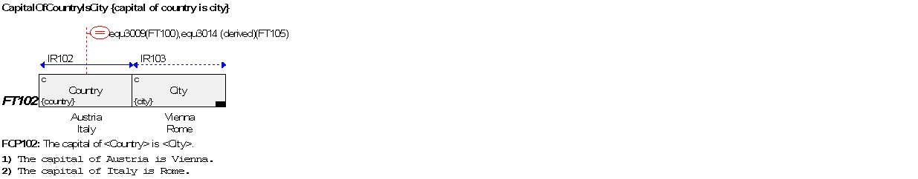
1.
2.

FCP102
FCP102

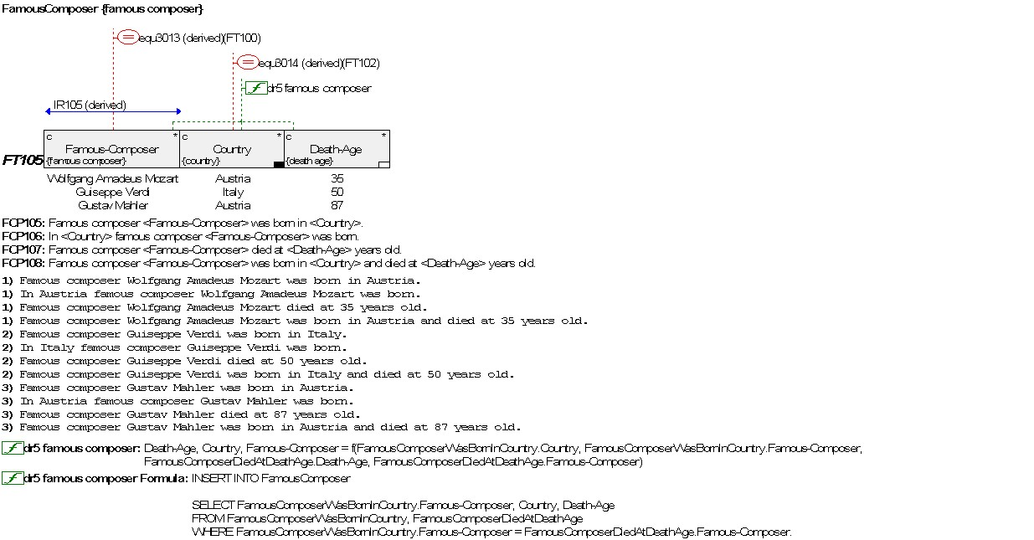
1.
2.
3.
FCP105
FCP106
FCP107
FCP108
FCP105
FCP106
FCP107
FCP108
FCP105
FCP106
FCP107
FCP108

List of used Meta (Generic) Fact Types

The following meta fact types will be used in increment 1 and 2. This list is useful when looking at the represented meta fact type diagrams, to see quickly the relationships between the meta fact types.
Meta Fact Type
Short code - Name

MFT1000 - Deep Structure Fact (Is Instance Of Fact Type)
MFT1010 - Deep Structure Fact Composition
MFT1020 - Connection Between Surface Structure Fact And Deep Structure Fact
MFT1025 - Generated Surface Structure Fact Text
MFT1050 - Fact Type (Is Owned By Stakeholder)
MFT1060 - Fact Type Composition
MFT1100 - Fact Communication Pattern (Is Used To Communicate About Deep Structure Facts Of Fact Type)
MFT1110 - Fact Communication Pattern Composition
MFT1130 - Fact Communication Pattern Composition Constant
MFT1140 - Fact Communication Pattern Composition Variable
MFT1200 - Uniqueness Integrity Rule (Restricts Variables of Fact Type)
MFT1210 - Uniqueness Integrity Rule Composition

Meta (Generic) Fact Types

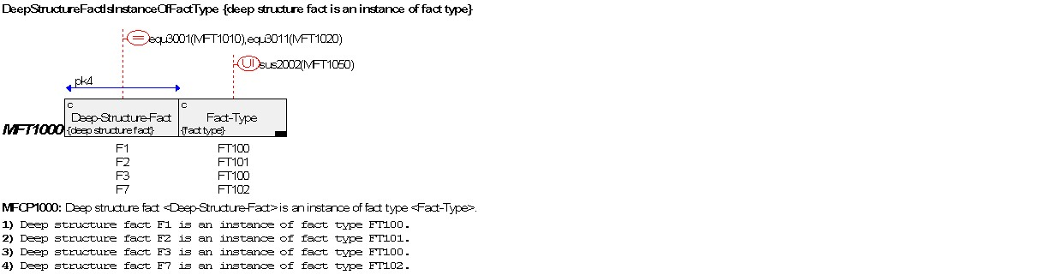
1.
2.
3.
4.
MFCP1000
MFCP1000
MFCP1000
MFCP1000
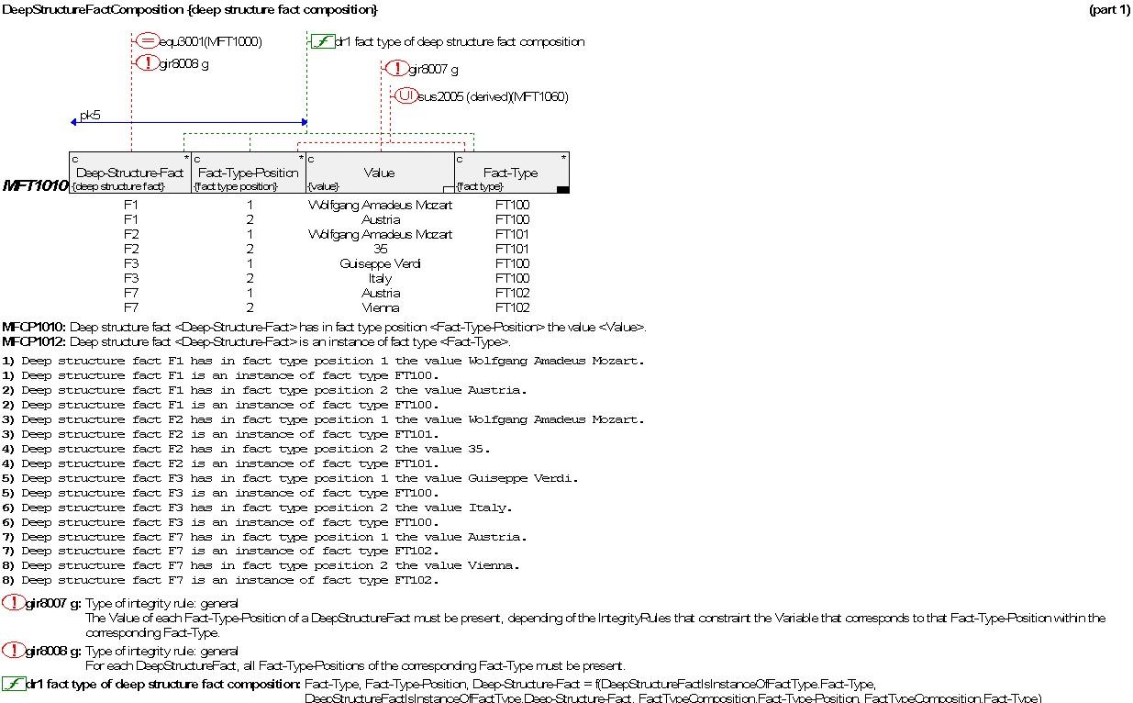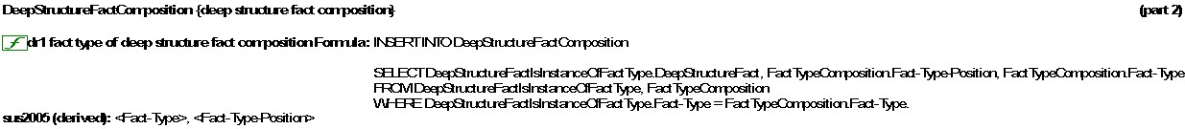
1.
2.
3.
4.
5.
6.
7.
8.
MFCP1010
MFCP1012
MFCP1010
MFCP1012
MFCP1010
MFCP1012
MFCP1010
MFCP1012
MFCP1010
MFCP1012
MFCP1010
MFCP1012
MFCP1010
MFCP1012
MFCP1010
MFCP1012

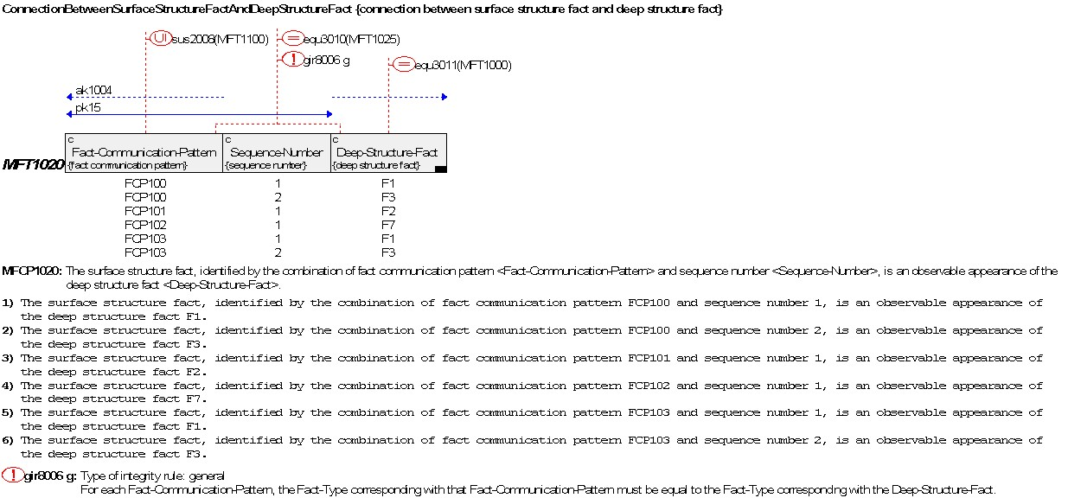
MFCP1020

MFCP1020

MFCP1020

MFCP1020

MFCP1020

MFCP1020
1.
2.
3.
4.
5.
6.

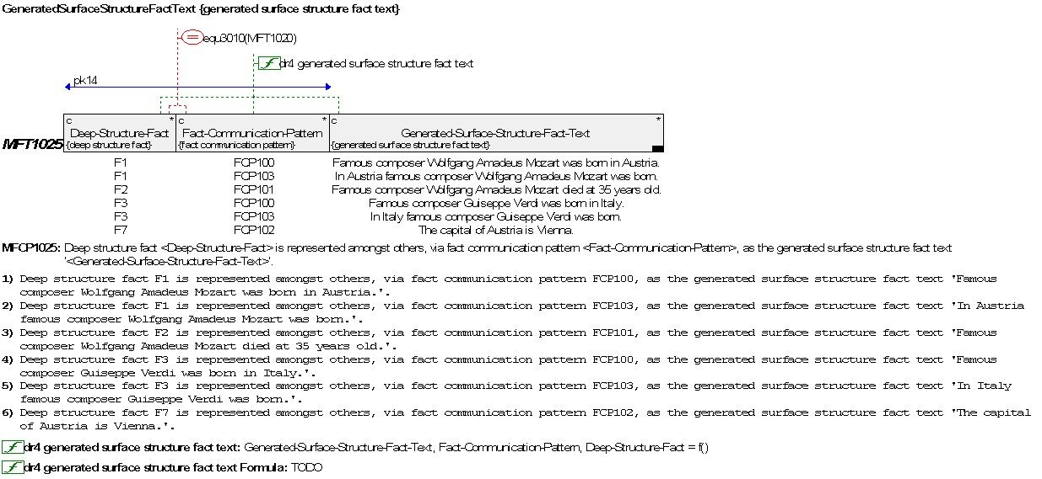
1.
2.
3.
4.
5.
6.
MFCP1025

MFCP1025

MFCP1025

MFCP1025

MFCP1025

MFCP1025

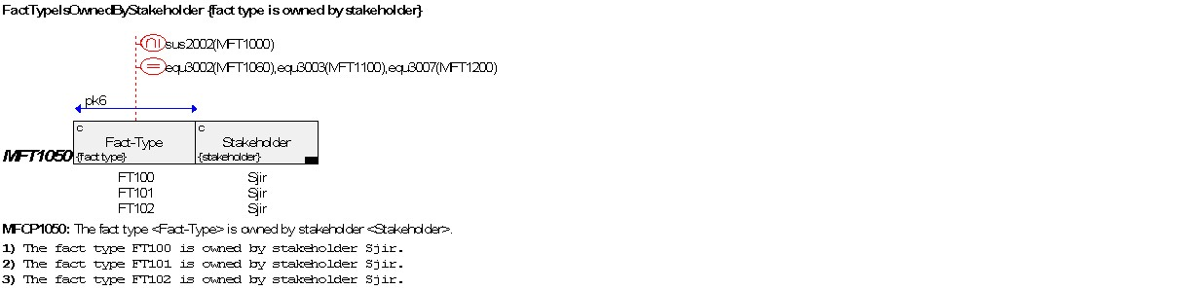
1.
2.
3.
MFCP1050
MFCP1050
MFCP1050

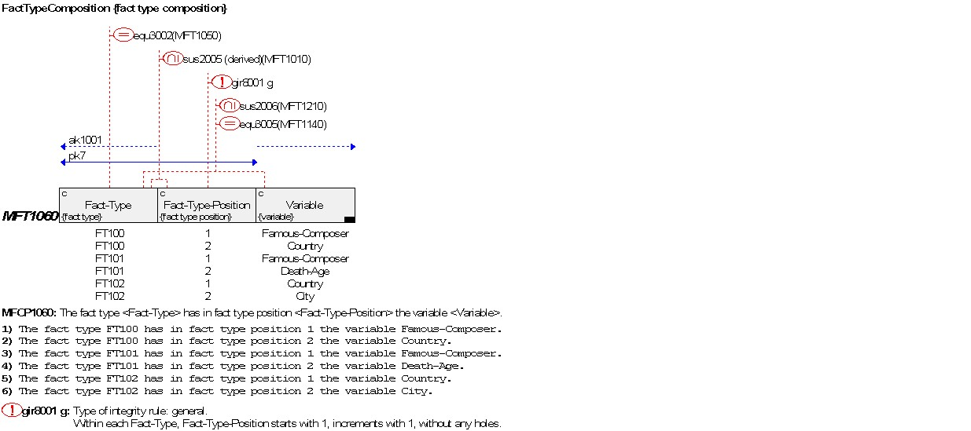
1.
2.
3.
4.
5.
6.
MFCP1060
MFCP1060
MFCP1060
MFCP1060
MFCP1060
MFCP1060

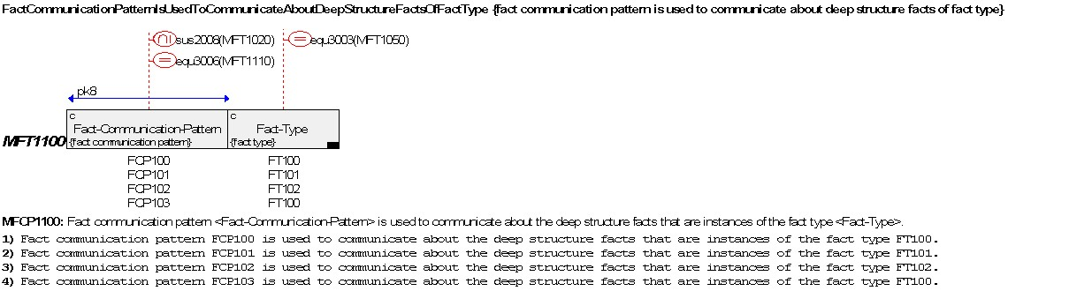
1.
2.
3.
4.
MFCP1100
MFCP1100
MFCP1100
MFCP1100

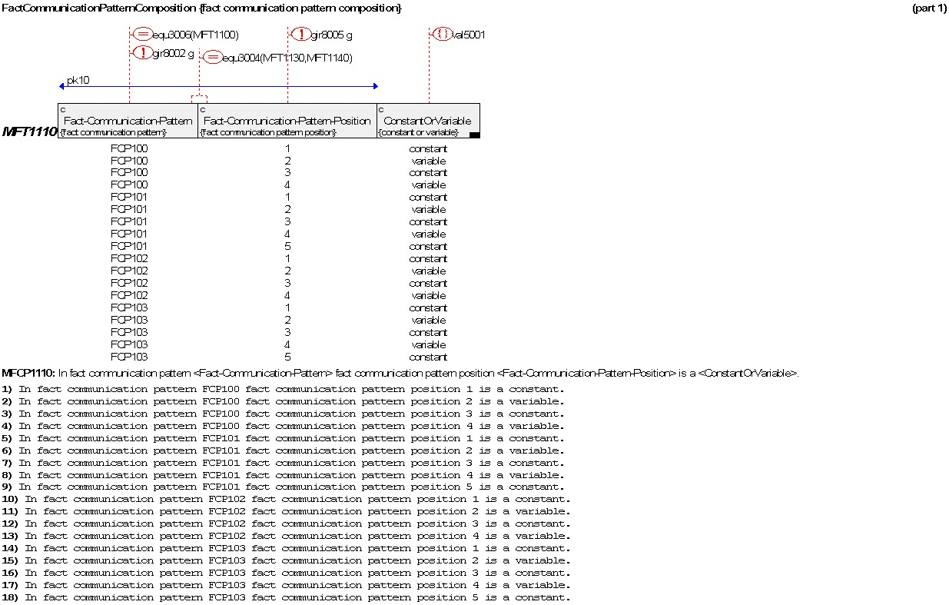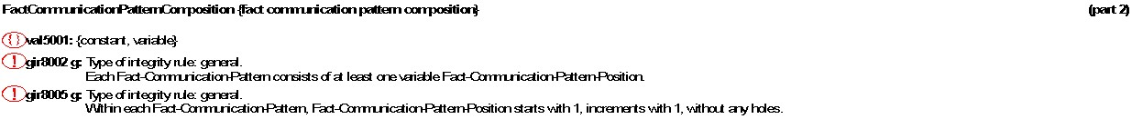
1.
2.
3.
4.
5.
6.
7.
8.
9.
10.
11.
12.
13.
14.
15.
16.
17.
18.
MFCP1110
MFCP1110
MFCP1110
MFCP1110
MFCP1110
MFCP1110
MFCP1110
MFCP1110
MFCP1110
MFCP1110
MFCP1110
MFCP1110
MFCP1110
MFCP1110
MFCP1110
MFCP1110
MFCP1110

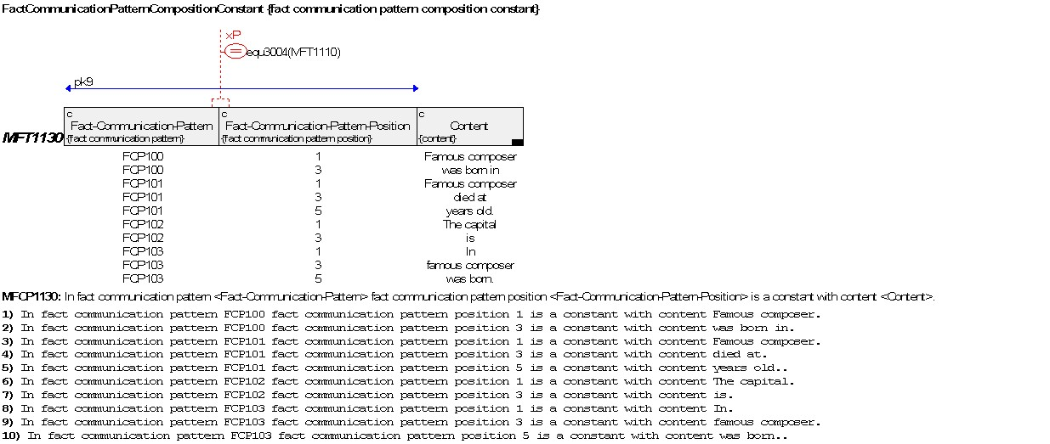
1.
2.
3.
4.
5.
6.
7.
8.
9.
10.
MFCP1130
MFCP1130
MFCP1130
MFCP1130
MFCP1130
MFCP1130
MFCP1130
MFCP1130
MFCP1130
MFCP1130

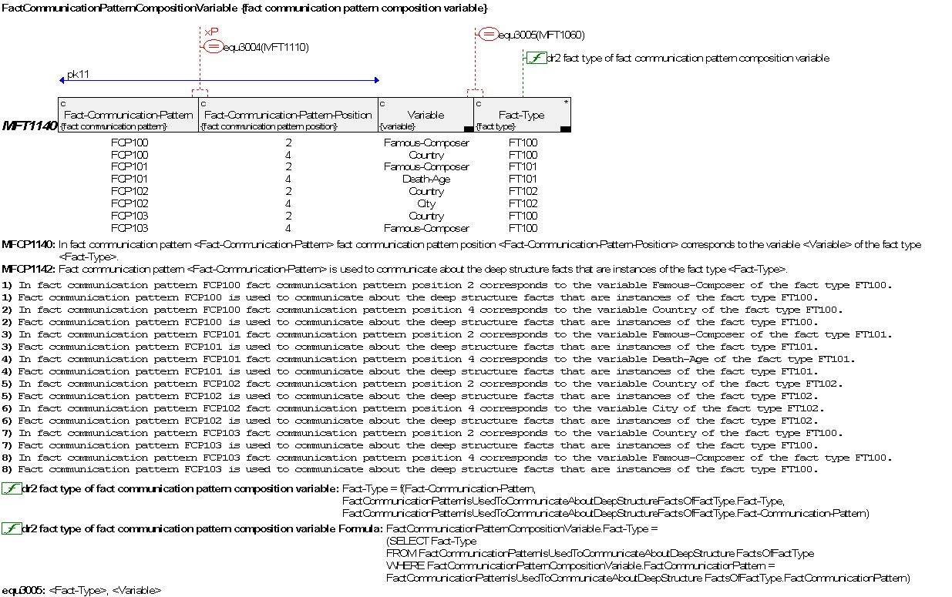
1.
2.
3.
4.
5.
6.
7.
8.
MFCP1140
MFCP1142
MFCP1140
MFCP1142
MFCP1140
MFCP1142
MFCP1140
MFCP1142
MFCP1140
MFCP1142
MFCP1140
MFCP1142
MFCP1140
MFCP1142
MFCP1140
MFCP1142

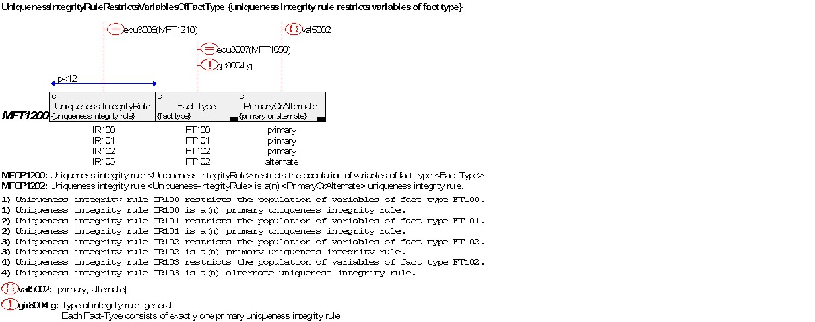
1.
2.
3.
4.
MFCP1200
MFCP1202
MFCP1200
MFCP1202
MFCP1200
MFCP1202
MFCP1200
MFCP1202

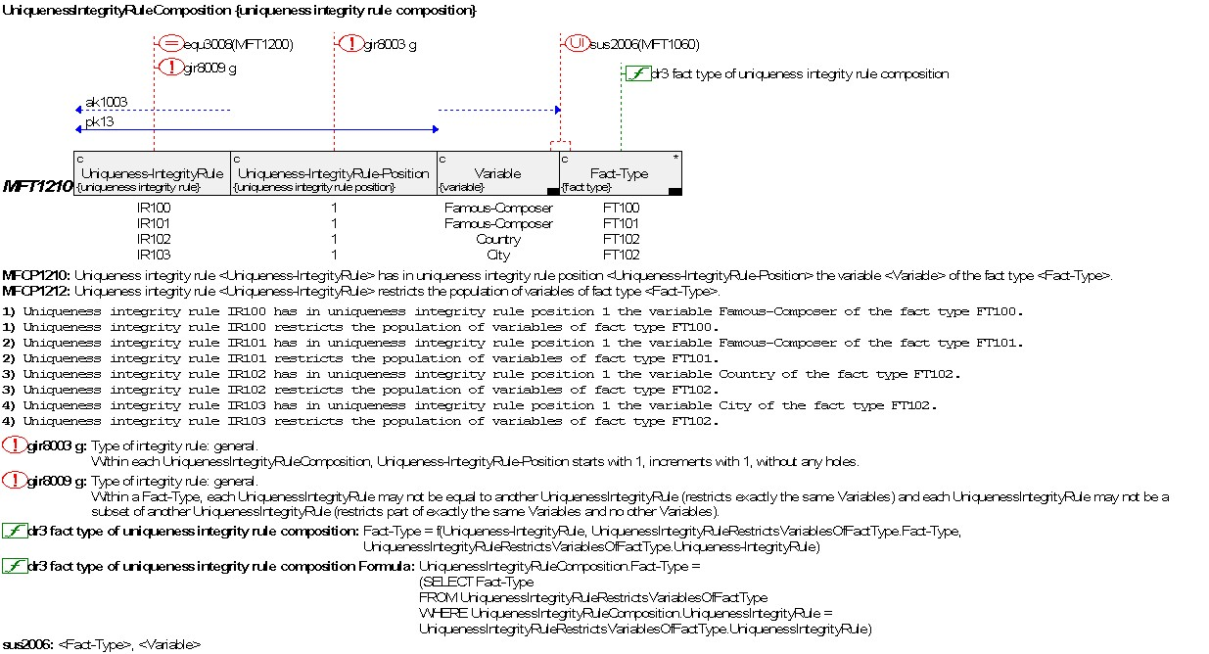
1.
2.
3.
4.
MFCP1210
MFCP1212
MFCP1210
MFCP1212
MFCP1210
MFCP1212
MFCP1210
MFCP1212

