Model Driven Solutions – Lockheed Martin Corporation

Executable SysML Reference Implementation

Software Design Description (SDD)

RFP No. ????.??
Table of Contents
1 Introduction 1
2 Design CONTEXT 1
2.1 Major Components 1
2.1.1 XMI Import 1
2.1.1.1 Design Goals 1
2.1.2 XMI Export 1
2.1.3 Execution Infrastructure 1
2.1.4 Event Listener Infrastructure 1
2.1.4.1 Design Goals 1
2.1.5 Debugging Infrastructure 1
2.1.6 User Interface 1
2.1.7 Service Provider Interface (SPI) 1
2.2 Use Cases 1
3 Design 2
3.1 Packages 2
3.1.1 org.modeldriven.fuml.xmi 2
3.1.1.1 XmiBindingNode 3
3.1.1.2 XmiBindingNodeVisitor 3
3.1.1.3 XmiIdentity 4
3.1.1.4 XmiNode 4
3.1.1.5 XmiReader 4
3.1.1.6 XmiNodeVisitor 5
3.1.1.7 XmiElement 5
3.1.1.8 BindingXmiReader 5
3.1.1.9 AbstractXmiNodeVisitor 5
3.1.1.10 ModelSupport 6
3.1.1.11 XmiReference 6
3.1.1.12 XmiReferenceElement 6
3.1.1.13 XmiReferenceAttribute 7
3.1.2 org.modeldriven.fuml.xmi.validation 7
3.1.2.1 ValidationErrorCollector 8
3.1.2.2 ValidationError 8
3.1.2.3 ErrorSeverity 8
3.1.2.4 ErrorCode 9
3.1.2.5 ErrorCategory 10
3.1.2.6 ValidationException 11
3.1.3 org.modeldriven.fuml.assembly 11
3.1.3.1 ElementAssembler 12
3.1.3.2 ElementGraphAssembler 12
3.1.3.3 AssemblerNode 12
3.1.3.4 AssemblerVisitor 13
4 references 13

List of Figures
Error! No table of figures entries found.

List of Tables
Table 1 – References 12

List of Tables in Appendices
Table Appendix ‎D-1 Acronyms 13

Introduction

Design CONTEXT

Major Components

XMI Import

Design Goals

Strict Validation. Either accept the input stream and load/run it successfully or reject it with an intelligible user error that includes the XMI source line number. No “hanging” load or run operations as a result of un-trapped external or internal error conditions!!

Large Document Support. XML documents will grow large probably necessitating stream parsing or document reduction through provisioning.

XMI Export

Execution Infrastructure

Event Listener Infrastructure

Design Goals

Detailed Events. Support events at a “token granularity” facilitating the eventual visualization of token queuing, offers etc… by the RI and third party drawing and simulation tools.

Debugging Infrastructure

User Interface

Service Provider Interface (SPI)

Use Cases

Design

Packages
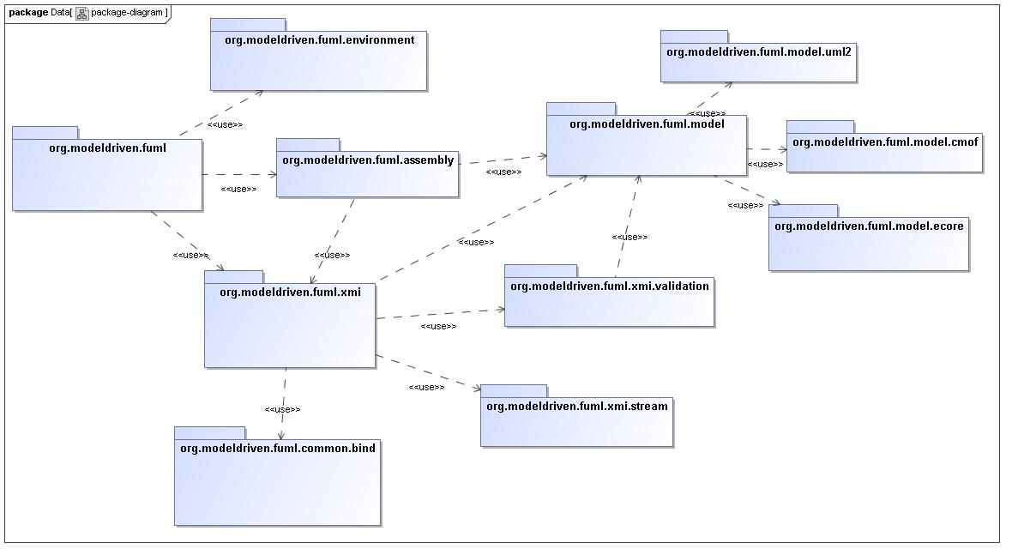
Figure 1 - package-diagram Diagram

org.modeldriven.fuml.xmi

Definition
This package contains interfaces and classes used for XMI processing under both a stream-based StAX parser as well as an XML data-binding approach. Differences across both the stream-parsing and data-binding approaches are generalized using common interfaces. The stream parsing approach using StAX is far more flexible in terms of both the error handling as well as the nature of the target structure(s), and it is therefore used for import of XMI from sources outside the execution environment. The XML data-bind XMI import approach is used for controled internal metamodel documents.

Composition
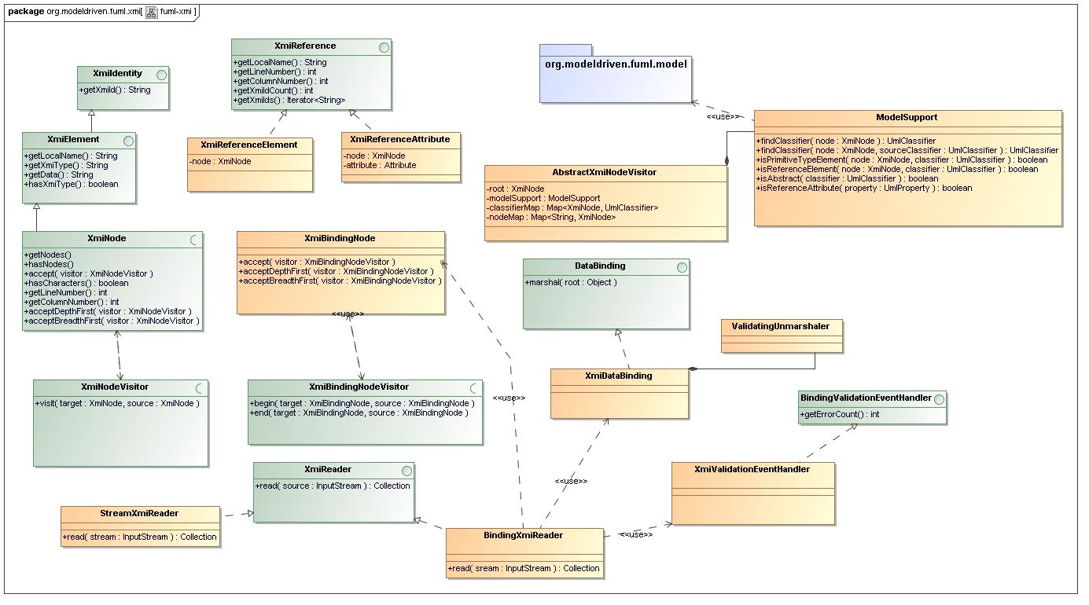
Figure 2 - fuml-xmi Diagram

XmiBindingNode
The class serves and the superclass for all JAXB generated classes used for XMI processing. It encapsulates a Java reflection-based traversal algorithm allowing visitor clients to receive events for any attached node regardless of its binding-node subclass. The traversal algorithm bypasses JAXB generated "generic" JAXBElement nodes, sheilding the visitor client from these uninteresting container objects.
Operations
- accept -
- acceptDepthFirst -
- acceptBreadthFirst -

XmiBindingNodeVisitor
Visitor interface receiving traversal events for XmiBindingNode traversals.
Operations
- begin - An operation representing the begining of a visitable node's scope of interest to a visitor client.
- end - An operation representing the begining of a visitable node's scope of interest to a visitor client.

XmiIdentity
Represents the identity of an XMI object used in XMI import or target model assembly.
Operations
- getXmiId - Returns the XMI identifier for this element.

XmiNode
A visitor pattern implementation class that walks a given XmiNode hierarchy checking for various error conditions, creating and gathering ValidationError instances into a collection helpfull for user feedback. This class can be initialized with an initial list of errors gathered from another context, and errors may be added to it's collection ad-hoc. This class supports strict validation of imported XMI data by utilizing visitor based traversal of an XMI node hierarchy to simplify processing. The validation is model-driven, as it leverages the runtime metamodel to diagnose various error conditions.
Operations
- getNodes -
- hasNodes -
- accept -
- hasCharacters -
- getLineNumber - Returns the line number in the input stream where this node originated.
- getColumnNumber - Returns the column number in the input stream where this node originated.
- acceptDepthFirst -
- acceptBreadthFirst -

XmiReader
Interface to unify multiple XMI import processing approaches.
Operations
- read - Processes the given stream returning a collection of top level results nodes.

XmiNodeVisitor
Visitor interface receiving traversal events for XmiNode traversals.
Operations
- visit - An operation representing the begining of a visitable node's scope of interest to a visitor client.

XmiElement
Interface generalizing XMI elements across both stream-based XMI import and assembly into the target FUML java model. An element may have character data as well as element and attribute data.
Operations
- getLocalName - Returns the unqualified name for this element.
- getXmiType - Returns the XMI type for ths element.
- getData - Returns character data, if exists, for this element.
- hasXmiType - Returns whether the element has an XMI type property.

BindingXmiReader
XML data-bing based XMI import processor capable of expanging the input XMI stream into another format as a precursor to binding. Currently an expansion XSL template is used to "stripe" the XMI content based on declated 'type' information. The expanded "striped" XMI format lends itself far more easily to the standard JAXB data binding implementation.
Operations
- read - Processes the given stream returning a collection of top level results nodes.

AbstractXmiNodeVisitor
General XMINodeVisitor implementation superclass encapsulating common structure and logic across both XMI validation and target structure assembly processing.
Attributes
- root - The visitor root node which is the source traversal node.
- modelSupport - The model-support delegate.
- classifierMap - A map of nodes to assigned classifiers used for XMI reference post-processing.
- nodeMap - A map of XMI id strings to XMiNodes used for XMI reference post-processing.

ModelSupport
Stateless model-related logic delegate class.
Operations
- findClassifier - Returns the classifier for the given node, if exists.
- findClassifier - Returns the classifier for the given node, if exists.
- isPrimitiveTypeElement - Returns whether the given node represents a primitive type.
- isReferenceElement - Returns whether the given node represents a primitive type.
- isAbstract -
- isReferenceAttribute - Returns whether the given property is a reference property (owned attribute).

XmiReference
Encapsulates any number of XMI ids, which are references to either internal or external objects, alone with context information related to the source, whether XML element or attribute related.
Operations
- getLocalName - Returns the unqualifed name for the reference source attribute or element.
- getLineNumber - Returns the line number for the reference attribute or element source.
- getColumnNumber - Returns the column number for the reference attribute or element source.
- getXmiIdCount - Returns the number if XMI ids encapsulated by this reference.
- getXmiIds - Return an interator instance for the XMI ids.

XmiReferenceElement
Element related implementation of XmiReference.
Attributes
- node - The element node for this reference.

XmiReferenceAttribute
Attribute oriented implementation of XmiReference.
Attributes
- node - The element node.
- attribute - The StAX attribute for this reference.

org.modeldriven.fuml.xmi.stream

Definition

Composition
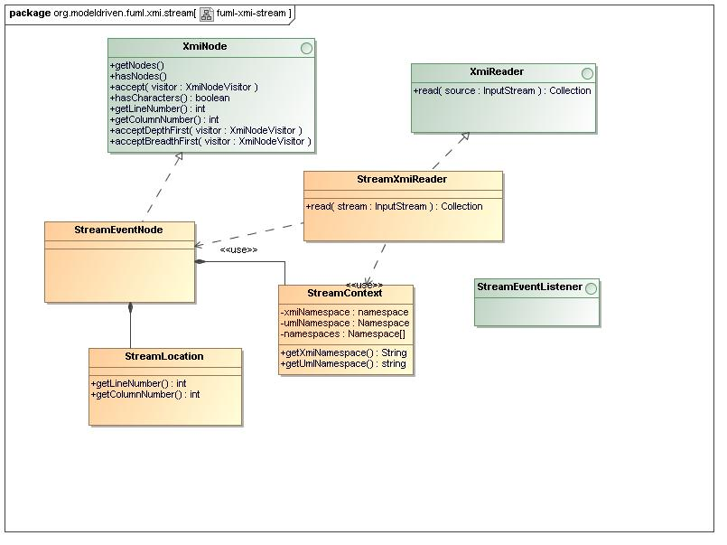
Figure 3 - fuml-xmi-stream Diagram

StreamEventNode

Attributes
- -
- -
- -

StreamXmiReader
Stream based XMI import using the StAX parser. Only start-element and characters events are processed, other events being ignored. Events of interest are allocated from the stream into immutable events and arranged into a hierarchy for ease of processing by interested clients.
Operations
- read - Processes the given stream returning a collection of top level results nodes.

StreamLocation

Attributes
- -
Operations
- getLineNumber -
- getColumnNumber -

StreamEventListener

StreamContext
Encapsulates context information for the current XMI stream, including namespaces and other resources. Namespaces are loaded from the (XML) root element based on a configurable set of supported namespaces for various domains. If no namespace is found within the supported namespaces for a particular domain, an error is thrown.
Attributes
- -
- xmiNamespace - The XMI namespace for the current stream.
- umlNamespace - The UML namespace for the current stream.
- namespaces -
Operations
- getXmiNamespace -
- getUmlNamespace -

org.modeldriven.fuml.xmi.validation

Definition
This package supports strict validation of imported XMI data through modeling of error codes, categories and severites and by utilizing visitor based traversal of an XMI node hierarchy to simplify processing. The validation is model-driven, as it leverages the runtime metamodel to diagnose various error conditions.

Composition
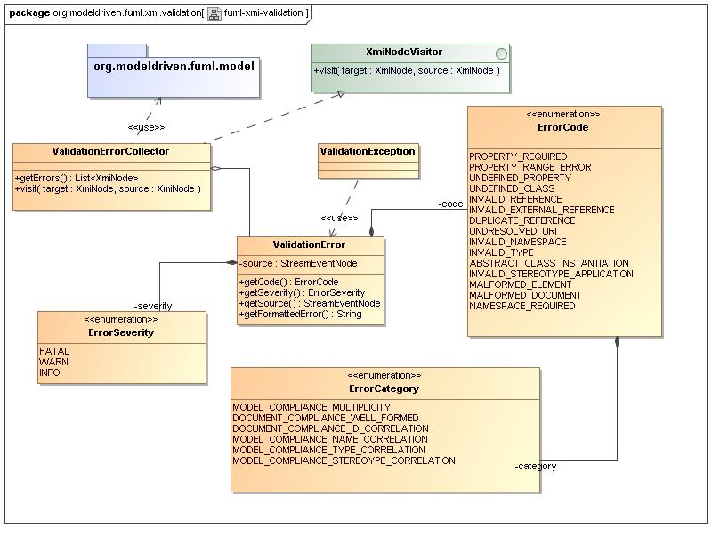
Figure 4 - fuml-xmi-validation Diagram

ValidationErrorCollector
A visitor pattern implementation class that walks a given XmiNode hierarchy checking for various error conditions, creating and gathering ValidationError instances into a collection helpfull for user feedback. This class can be initialized with an initial list of errors gathered from another context, and errors may be added to it's collection ad-hoc. This class hevily leverages the fuml.model package.
Operations
- getErrors - Returns the error collection
- visit -

ValidationError

Contains detailed error information suficient for generation of formatted, informative error messages for use in simple logging as well as web displays. Errors are categorized and have a associated severity as well as source information including element and location information.
Attributes
- severity -
- code -
- source –
Operations
- getCode -
- getSeverity -
- getSource -
- getFormattedError -

ErrorSeverity
Represents various severity levels for error conditions encountered during validation processing.

Literals
- FATAL - The error is non-recoverable
- WARN - The error is recoverable
- INFO - The error is intended as an informative message

ErrorCode
Represents the set of possible errors that may be incurred during XMI validation.

Literals
- PROPERTY_REQUIRED - Indicates a violation of the multiplicity lower-value minimum for a structural feature for an element within a model, where the property is not found and the lower-value is greater than zero. This is a "convienence" literal used to indicate the common condition where an (XML) attribute or element representing the structural feature within a model element is missing within the XMI source document.
- PROPERTY_RANGE_ERROR - Indicates an violation of the multiplicity lower-value minimum or the upper-value maximum for a structural feature for an element within a model.
- UNDEFINED_PROPERTY - Indicates that a given structural feature, represented by an (XML) attribute or element, does not exist within the context of the current model class.
- UNDEFINED_CLASS - Indicates that a given model class or classifier, represented by an (XML) element, does not exist within the current model.
- INVALID_REFERENCE - Indicates the failure to correlate a given reference or id, represented by an (XML) element or attribute value, with any model element within the current execution environment.
- INVALID_EXTERNAL_REFERENCE -
- DUPLICATE_REFERENCE - Indicates the failure to correlate a given reference or id, represented by an (XML) element or attribute value, because an identical existing reference or id has already beed correlated within the current execution environment.
- UNDRESOLVED_URI - Indicates that the URI used in the case where this error was generated was not a standard URI. XMI allows reference to objects defined in external files, and this method of reference is typically used to refer to the standard UML Stereotypes, objects in a Profile, or in the case that the test data is a meta-model, UML itself. Standard URIs are associated with the aforementioned specifications.
- INVALID_NAMESPACE - Indicates a namespace URI that is unknown to the execution environment.
- INVALID_TYPE - Indicates the type of an object providing a property violates the type constraint declared by the class owning the property, as declared in the UML metamodel.
- ABSTRACT_CLASS_INSTANTIATION - Indicates the attempt to instantiate a class that is declated abstract int the UML metamodel.
- INVALID_STEREOTYPE_APPLICATION - Indicates that a stereotype was applied to an object not of a type declared by the profile as valid for application of the stereotype.
- MALFORMED_ELEMENT - Indicates the presence of an XML element that is not "well-formed".
- MALFORMED_DOCUMENT - Indicates the presence of an XML document that is not "well-formed".
- NAMESPACE_REQUIRED - Indicates the absence of a required namespace within a document.

ErrorCategory
Repesents various groupings or categorizations of validation errors.

Literals
- MODEL_COMPLIANCE_MULTIPLICITY - Indicates a violation of one of the specified cardinalities for a structural feature within an element. The multiplicity specifies valid cardinalities for the collection of values associated with an instantiation of a structural feature.
- DOCUMENT_COMPLIANCE_WELL_FORMED -
- DOCUMENT_COMPLIANCE_ID_CORRELATION - Indicates the inability to associate an id value, represented by an (XML) element value or attribute value, with a referenced element within an internal or external model.
- MODEL_COMPLIANCE_NAME_CORRELATION - Indicates the inability to associate a name, represented by an (XML) element or attribute name, with a named element within a model.
- MODEL_COMPLIANCE_TYPE_CORRELATION - Indicates the inability to associate a name, represented by an (XML) element or attribute name, with a named element within a model.
- MODEL_COMPLIANCE_STEREOYPE_CORRELATION -

ValidationException
Exception class to encapsulate ValidationError instances in a throwable wrapper. It's message text is formatted by default and includes precise location information from the input stream.

org.modeldriven.fuml.assembly

Definition
This package supports the assembly of the target fUML java-model object graph structure from a given XMI node hierarchy. Rather than utilizing an intermediate java model then "mapping" from the intermediate model to fUML, this package utilizes a "direct-to-fUML" approach based on StAX stream events arranged in a node hierarchy. The assembly is model-driven, as it leverages the runtime metamodel to determine the target package and classifier types, feature and parameter types, defaults and multiplicities. During assembly, the runtime metadata is used to precicely call reflective methods within the target fUML java model, illiminating costly reflection-based searching. It diagnoses various error conditions and then leverages the validation package to generate precise errors, including location information for the user, logging warning messages or throwing fatal errors.

Composition
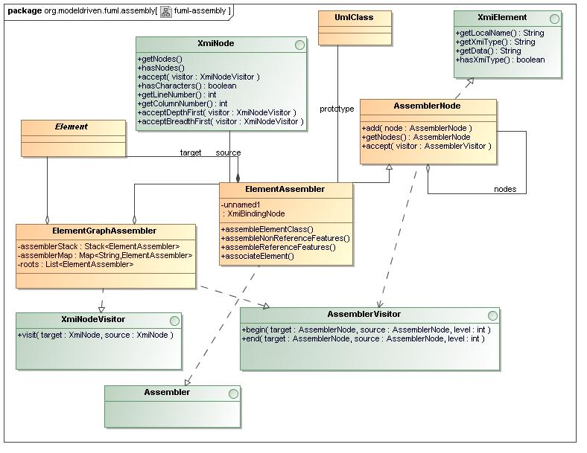
Figure 5 - fuml-assembly Diagram

ElementAssembler

Attributes
- source -
Operations
- assembleElementClass -
- assembleNonReferenceFeatures -
- assembleReferenceFeatures -
- associateElement -

ElementGraphAssembler
Given a strict hierarchy of XmiNode instances, this class assembles a graph structure composed of fUML Element instances. In general, for each node in the XmiNode hierarchy, the XmiNode is supplanted by an ElementAssembler node, the original XmiNode then being used as a delegate. This assembler "scafholding" is kept inplace until all elements in the target graph structure are fullly assembled and linked.
Attributes
- assemblerStack - Stack which maintains the current XmiNOde hierarchical path\, used to make linkages between elements.
- assemblerMap - A global map of assemblers used for reference lookup across any element within the current execution environment.
- roots - The resulting list of assembled Element roots.

AssemblerNode
Encapsulates traversal logic as required by the Visitor pattern.
Operations
- add - Adds the given "child" node to this node.
- getNodes - Returns the current list of "child" nodes for this node.
- accept - Receives a visitor for traversal with this node as the traversal context root.

AssemblerVisitor
Visitor interface which requires, for each node encountered in a traversal, both the beginning and ending of the acceptance of each node to be signaled.
Operations
- begin -
- end -

org.modeldriven.fuml.event

Definition

Composition
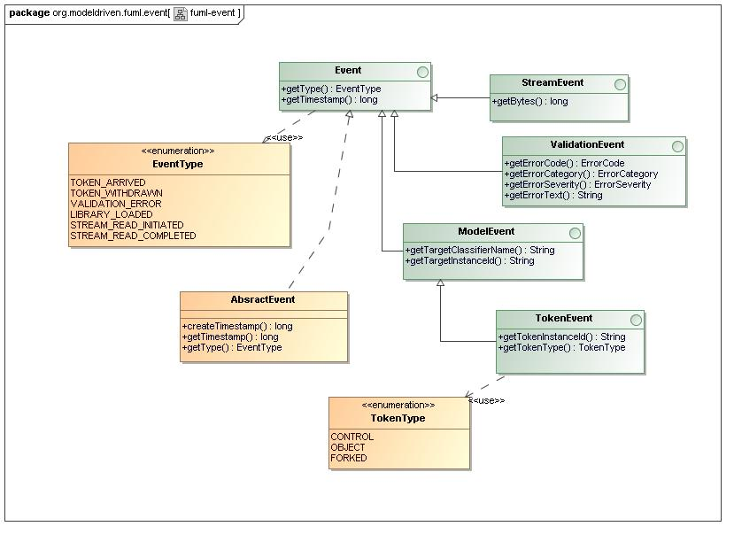
Figure 6 - fuml-event Diagram

references
Table 1 – References
Reference Name | Reference Title | Reference Organization | Reference Contact Info

A1

A2

Acronyms
Table Appendix C-1 Acronyms
Acronym | Description

