
A division of Data Access Technologies, Inc.
8605 Westwood Center Drive, Suite 505
Vienna, VA 22182

Prepared for

Under Purchase Order II0400381
Executable fUML Reference Implementation
Software Design Description
Revision: 1.1
January 14, 2009
Revision History
Revision | Date | Description | Author
1.1 | December 12, 2008 | Initial version created. | Scott Cinnamond
 | January 14, 2009 | Formatted for delivery. | Ed Seidewitz

Table of Contents
1 Introduction 5
1.1 Purpose 5
1.2 Scope 5
1.3 Overview 5
1.4 Design and Technology Decisions 5
1.4.1 StAX Parser 5
1.4.1.1 StAX Background 5
1.5 Design Goals 2
1.5.1 Leverage Runtime Metadata 2
1.5.2 Incremental Processing 2
2 Package org.modeldriven.fuml 3
2.1 Class AbstractImport 3
2.1.1 Attribute Detail 4
2.1.2 Operation Detail 4
2.1.3 Relation Detail 4
2.2 Class Fuml 4
2.2.1 Operation Detail 5
2.2.2 Relation Detail 5
2.3 Class ModelImport 5
2.3.1 Operation Detail 6
2.3.2 Relation Detail 6
2.4 Class PackagedElementImport 7
2.4.1 Operation Detail 7
2.4.2 Relation Detail 8
2.5 Interface Import 8
2.5.1 Operation Detail 9
2.5.2 Relation Detail 9
2.6 Interface ImportRegistry 9
2.6.1 Operation Detail 9
2.6.2 Relation Detail 10
3 Package org.modeldriven.fuml.xmi 11
3.1 Class AbstractXmiNodeVisitor 12
3.1.1 Attribute Detail 12
3.1.2 Relation Detail 13
3.2 Class AbstractXmlReference 13
3.2.1 Attribute Detail 13
3.2.2 Relation Detail 13
3.3 Class BindingXmiReader 14
3.3.1 Operation Detail 14
3.3.2 Relation Detail 14
3.4 Class ModelSupport 15
3.4.1 Attribute Detail 15
3.4.2 Operation Detail 15
3.4.3 Relation Detail 16
3.5 Class XmiBindingNode 16
3.5.1 Attribute Detail 17
3.5.2 Operation Detail 17
3.5.3 Relation Detail 17
3.6 Class XmiDataBinding 18
3.6.1 Attribute Detail 18
3.6.2 Relation Detail 18
3.7 Class XmiExternalReferenceElement 18
3.7.1 Relation Detail 19
3.8 Class XmiInternalReferenceElement 19
3.8.1 Relation Detail 19
3.9 Class XmiMappedReference 20
3.9.1 Attribute Detail 20
3.9.2 Relation Detail 20
3.10 Class XmiNodeFinder 20
3.10.1 Attribute Detail 21
3.10.2 Relation Detail 21
3.11 Class XmiNodeVisitorStatus 21
3.11.1 Attribute Detail 21
3.11.2 Relation Detail 22
3.12 Class XmiReferenceAttribute 22
3.12.1 Attribute Detail 22
3.12.2 Relation Detail 22
3.13 Class XmiReferenceElement 23
3.13.1 Relation Detail 23
3.14 Class XmiValidationEventHandler 23
3.14.1 Operation Detail 24
3.14.2 Relation Detail 24
3.15 Interface XmiBindingNodeVisitor 24
3.15.1 Operation Detail 24
3.15.2 Relation Detail 25
3.16 Interface XmiElement 25
3.16.1 Operation Detail 25
3.16.2 Relation Detail 25
3.17 Interface XmiIdentity 26
3.17.1 Operation Detail 26
3.17.2 Relation Detail 26
3.18 Interface XmiNode 26
3.18.1 Operation Detail 27
3.18.2 Relation Detail 27
3.19 Interface XmiNodeVisitor 27
3.19.1 Operation Detail 27
3.19.2 Relation Detail 28
3.20 Interface XmiReader 28
3.20.1 Operation Detail 28
3.20.2 Relation Detail 29
3.21 Interface XmiReference 29
3.21.1 Operation Detail 29
3.21.2 Relation Detail 30
4 Package org.modeldriven.fuml.xmi.stream 31
4.1 Class StreamContext 32
4.1.1 Attribute Detail 32
4.1.2 Operation Detail 32
4.1.3 Relation Detail 33
4.2 Class StreamLocation 33
4.2.1 Attribute Detail 33
4.2.2 Operation Detail 33
4.2.3 Relation Detail 34
4.3 Class StreamNode 34
4.3.1 Attribute Detail 34
4.3.2 Operation Detail 35
4.3.3 Relation Detail 35
4.4 Class StreamNodeEvent 36
4.4.1 Attribute Detail 36
4.4.2 Operation Detail 36
4.4.3 Relation Detail 36
4.5 Class StreamReader 36
4.5.1 Attribute Detail 37
4.5.2 Operation Detail 37
4.5.3 Relation Detail 37
4.6 Interface StreamEventListener 38
4.6.1 Operation Detail 38
4.6.2 Relation Detail 38
4.7 Interface StreamNodeListener 39
4.7.1 Operation Detail 39
4.7.2 Relation Detail 39
5 Package org.modeldriven.fuml.xmi.validation 40
5.1 Class ValidationError 41
5.1.1 Attribute Detail 41
5.1.2 Operation Detail 42
5.1.3 Relation Detail 42
5.2 Class ValidationErrorCollector 42
5.2.1 Attribute Detail 43
5.2.2 Operation Detail 43
5.2.3 Relation Detail 44
5.3 Class ValidationException 44
5.3.1 Relation Detail 44
5.4 Enumeration ErrorCategory 45
5.4.1 Literal Detail 45
5.4.2 Relation Detail 46
5.5 Enumeration ErrorCode 46
5.5.1 Literal Detail 46
5.5.2 Relation Detail 48
5.6 Enumeration ErrorSeverity 49
5.6.1 Literal Detail 49
5.6.2 Relation Detail 49
6 Package org.modeldriven.fuml.assembly 50
6.1 Class AssemblerNode 50
6.1.1 Attribute Detail 51
6.1.2 Operation Detail 51
6.1.3 Relation Detail 51
6.2 Class AssemblerResultsProfile 52
6.2.1 Attribute Detail 52
6.2.2 Relation Detail 52
6.3 Class AssemblyContext 52
6.3.1 Attribute Detail 52
6.3.2 Relation Detail 53
6.4 Class ElementGraphAssembler 53
6.4.1 Attribute Detail 53
6.4.2 Relation Detail 54
6.5 Class ElementStubAssembler 54
6.5.1 Attribute Detail 55
6.5.2 Relation Detail 55
6.6 Interface Assembler 55
6.6.1 Relation Detail 56
6.7 Interface AssemblerVisitor 56
6.7.1 Operation Detail 56
6.7.2 Relation Detail 56
7 Package org.modeldriven.fuml.common.bind 57
7.1 Interface BindingValidationEventHandler 57
7.1.1 Operation Detail 57
7.1.2 Relation Detail 57
7.2 Interface DataBinding 58
7.2.1 Operation Detail 58
7.2.2 Relation Detail 58
8 Package org.modeldriven.fuml.config 59
8.1 Class BehaviorExecutionMapping 59
8.1.1 Attribute Detail 60
8.1.2 Relation Detail 60
8.2 Class Configuration 60
8.2.1 Attribute Detail 60
8.2.2 Relation Detail 60
8.3 Class FumlConfiguration 61
8.3.1 Attribute Detail 61
8.3.2 Operation Detail 61
8.3.3 Relation Detail 62
8.4 Class ImportAdapter 62
8.4.1 Attribute Detail 63
8.4.2 Relation Detail 63
8.5 Class ImportConfiguration 63
8.5.1 Attribute Detail 63
8.5.2 Relation Detail 63
8.6 Class LibraryImport 64
8.6.1 Attribute Detail 64
8.6.2 Relation Detail 64
8.7 Class MappingConfiguration 65
8.7.1 Attribute Detail 65
8.7.2 Relation Detail 65
8.8 Class SupportedNamespace 65
8.8.1 Attribute Detail 66
8.8.2 Relation Detail 66
8.9 Enumeration ImportAdapterType 66
8.9.1 Literal Detail 66
8.9.2 Relation Detail 67
8.10 Enumeration NamespaceDomain 67
8.10.1 Literal Detail 67
8.10.2 Relation Detail 67
8.11 Enumeration ReferenceMappingType 68
8.11.1 Literal Detail 68
8.11.2 Relation Detail 68
9 Package org.modeldriven.fuml.environment 69
9.1 Class ExecutionEnvironment 69
9.1.1 Attribute Detail 69
9.1.2 Operation Detail 70
9.1.3 Relation Detail 70
10 Package org.modeldriven.fuml.library 71
10.1 Class Library 71
10.1.1 Attribute Detail 71
10.1.2 Operation Detail 72
10.1.3 Relation Detail 72
10.2 Class LibraryModelImport 72
10.2.1 Operation Detail 73
10.2.2 Relation Detail 73
11 Package org.modeldriven.fuml.model 75
11.1 Class Model 75
11.1.1 Attribute Detail 76
11.1.2 Operation Detail 76
11.1.3 Relation Detail 77
11.2 Interface Class 78
11.2.1 Relation Detail 78
11.3 Interface Classifier 78
11.3.1 Relation Detail 79
11.4 Interface Element 79
11.4.1 Relation Detail 79
11.5 Interface NamedElement 79
11.5.1 Relation Detail 79
11.6 Interface Operation 80
11.7 Interface Property 80
11.7.1 Relation Detail 80
11.8 Interface TypedElement 80
11.8.1 Relation Detail 80
Appendix A. References 81
Appendix B. Acronyms 82

Introduction

Purpose
This document provides design background as well as class, interface, and enumeration specifications. The specification provides the details of the types being modeled within the Executable fUML Reference Implementation.

Scope
This document is currently focused only on packages involved with the “mechanics” of executing models rather that the many packages involved with syntax or semantic representations of the models themselves. It is intended to define class specifications for these portions of the Executable fUML Reference Implementation

Overview
This document provides a list of all packages with a summary for each. Each package has a section that contains a list of its classes, interfaces and enumeration type, with a summary for each. Class and Interface specifications contain description, summary tables, detailed member descriptions, and relation tables.

Design and Technology Decisions
Below are listed the various design and technology related decisions under the Executable fUML Reference Implementation.

StAX Parser
The StAX parser is a newer stream-based “pull” parser, and within the Executable fUML Reference Implementation, the StAX parser is used for reading of all external XMI documents including used models and libraries, with the goal of providing the highest available level of flexibility and system performance.

StAX Background
Processing XML documents has become a critical and integral part of most applications being developed today. Depending on different environments, there are various ways to process an XML document within a program. All these can be broadly categorized into two approaches:

- Tree-based APIs: DOM (Document Object Model) implementations use this technique. They basically load the whole XML file into memory and process it. The model they build is usually larger than the original XML document, thus duplicating and wasting memory.
- Event-based APIs: When this type of a parser is given some XML to process, it sends out events corresponding to the information items it finds. The common approach has been to use a push-based approach like SAX to process the XML. This is more efficient than DOM, in terms of memory. The problem with the push model is that once started, it goes to the end of the document and the caller must be ready to handle all of the events in one shot. So the caller that invokes the parser has no control over the parsing phase.

Both of these models give little or no control to the user in this parsing process. Once started, whether tree-based or event-based, both parsing approaches consume the whole data stream at once. JSR 173 defines a pull streaming model, StAX (short for "Streaming API for XML"), for processing XML documents. In this model, unlike in SAX, the client can start, proceed, pause, and resume the parsing process. The client has complete control as the user must call the parser to proceed by calling reader.next(). The parser will proceed to the next step only after that. This is the main difference between pull and push parsing. In push parsing, as with SAX, once the SAX parser starts sending events, the user or the client application has no control over it. But in pull parsing, as seen here, the client application can decide the phase of parsing at its own discretion.

Design Goals

Leverage Runtime Metadata
Model Driven Architecture (MDA) is primarily centered on “reuse of expertise” rather than reuse of implemented code [Wilkie2004]. Under MDA, such expertise is captured in the form of domain models, then later leveraged 1.) At software build-time, yielding various platform-specific artifacts 2.) At system run-time, by executing the models yielding some system behavior. This design goal calls for leveraging models or metadata under a third category involving externally referencing models for the purposes of system automation or generic processing.

The set of metadata artifacts representing the fUML Syntax, fUML Semantics as well as its UML Infrastructure and Superstructure are substantial, comprising over 33 thousand lines of interchange data.

Rather than duplicating fundamental metadata constructs from this important resource for use at run-time, subsystems within the Executable fUML Reference Implementation should adhere to designs driven by some canonized form of runtime metadata backed by the fUML artifacts. Over the last few years, such approaches have in fact emerged as software design patterns related specifically to leveraging metadata at run-time under various system contexts. Some of these include Enterprise Messaging or EAI, in particular the transformation of messages [Hohpe2004] and object-relational mapping [Fowler2003] [Rising2000].

Incremental Processing
While loading of an entire model may be desirable under some scenarios, where very large models are involved because of memory limitations, partial or incremental loading is also required. Designs involving loading, validation and assembly of XMI encoded models should be flexible enough to accommodate any size “chunk” of a model, and should free memory after each chunk is processed. For instance during model execution, rather than an all-or-nothing approach, smaller units such as Activities and Behaviors should be loaded, and only such elements not in compliance should be invalidated, while all others should be fully processed and associated memory released for garbage collection.

Package org.modeldriven.fuml

Description
This package leverages several lower-level packages and provides a command-line entry point for loading model files and libraries and launching model executions. Some of the underlying packages used by this package include 1.) The fuml.xmi.stream package, used for reading XMI input streams and receiving stream event notifications to trigger processing 2.) The fuml.xmi.validation package, used to validate all or portions of an XMI stream against fUML metadata 3.) The fuml.assembly package, used to construct fUML object graphs or behavior element "stubs" for invalid sub-graphs and 4.) The fuml.environment package - used to register assembled graph "roots" and execute assembled behaviors.

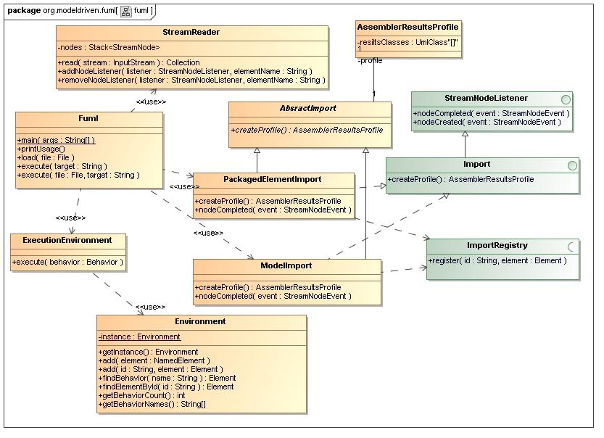
- fuml Diagram

Name | org.modeldriven.fuml
Qualified Name | org.modeldriven.fuml

Class AbstractImport
Description
Supports default behavior and data for derived classes.
Name | AbstractImport
Qualified Name | org.modeldriven.fuml::AbstractImport
Visibility | public
Abstract | true
Base Classifier
Realized Interface

Attribute Detail
Following are the attributes for class, AbstractImport.
Table 1 – AbstractImport Attribute Detail

Atttribute Name | Description | Type |  | Visibility
profile |  |  | AssemblerResultsProfile |  | private

Operation Detail
Following are the operations for class, AbstractImport.

Table 2 – AbstractImport Operation Detail

Operation Name | Description |  | Type | Parameters |  | Visibility
createProfile |  | Abstract assembly profile creation method. | AssemblerResultsProfile |  | public

Relation Detail
Following are the relations for class, AbstractImport.

Table 3 – AbstractImport Relation Detail

Relation Type | Related Elements
Association | AbstractImport  AssemblerResultsProfile
Generalization | AbstractImport  ModelImport
Generalization | AbstractImport  PackagedElementImport
Generalization | AbstractImport  LibraryModelImport

Class Fuml
Description
Execution entry point class for command line processing and other clients requiring access to fUML model execution at a high level.
Name | Fuml
Qualified Name | org.modeldriven.fuml::Fuml
Visibility | public
Abstract | false
Base Classifier
Realized Interface

Operation Detail
Following are the operations for class, Fuml.

Table 4 – Fuml Operation Detail

Operation Name | Description |  | Type | Parameters |  | Visibility
execute |  |  |  | inout target : String | public
execute |  | Validates and loads the given file, then executes the given target. |  | inout file : File  inout target : String | public
load |  | Validates and loads the given file without executing it. |  | inout file : File | public
main |  |  |  | inout args : String[] | public
printUsage |  | Prinst out the command line usage with examples. |  |  | public

Relation Detail
Following are the relations for class, Fuml.

Table 5 – Fuml Relation Detail

Relation Type | Related Elements
Usage | Fuml  StreamReader
Usage | Fuml  PackagedElementImport
Usage | ExecutionEnvironment  Fuml
Usage | Fuml  ModelImport

Class ModelImport
Description
This class supports all-or-nothing validation and assembly into fUML of an XMI stream using the UML 'Model' structure as the fundamental import unit. As the 'Model' structure is read from the stream, this class is notified using the StreamNodeListener interface. It then validates the given node hierarchy using ValidationErrorCollector from the xmi.validation package. If no validation errors are detected, the node hierarchy is assembled into a fUML object graph using ElementGraphAssembler from the fuml.assembly package. Otherwise if fatal validation errors are detected, the fatal validation errors are listed and an exception is thrown.
Name | ModelImport
Qualified Name | org.modeldriven.fuml::ModelImport
Visibility | public
Abstract | false
Base Classifier | - AbstractImport
Realized Interface | - Import

Operation Detail
Following are the operations for class, ModelImport.

Table 6 – ModelImport Operation Detail

Operation Name | Description |  | Type | Parameters |  | Visibility
createProfile |  | Builds an assembly profile geared for all-or-nothing assembly of libraries and user models which includes some of the following elements: Activity, FunctionBehavior, Operation, Property, Signal, Datatype, Class, Package. | AssemblerResultsProfile |  | public
nodeCompleted |  | Event listener implementation method triggering core import processing. |  | inout event : StreamNodeEvent | public

Relation Detail
Following are the relations for class, ModelImport.

Table 7 – ModelImport Relation Detail

Relation Type | Related Elements
Generalization | AbstractImport  ModelImport
Interface Realization | Import  ModelImport
Usage | ElementStubAssembler  ModelImport
Usage | ModelImport  ValidationErrorCollector
Usage | ElementGraphAssembler  ModelImport
Usage | ImportRegistry  ModelImport
Usage | Fuml  ModelImport
Usage | ElementStubAssembler  ModelImport

Class PackagedElementImport
Description
This class supports incremental validation and assembly into fUML of an XMI stream using UML 'packagedElement' structures as the fundamental import unit. A 'packagedElement', within an XMI stream, or a 'PackagableElement' (the element at which the association-end terminates) can be composed as any number of possible elements derivitive of PackagebleElement. Some of these are Activity, FunctionBehavior, Signal, Class and Package.
As 'packagedElement' structures are read from the stream, this class is notified using the StreamNodeListener interface. It then validates the given node hierarchy using ValidationErrorCollector from the xmi.validation package. If no validation errors are detected, the node hierarchy is assembled into a fUML object graph using ElementGraphAssembler from the fuml.assembly package, and the node (sub) hierarchy is "clipped" from it's parent, allowing memory to be garbage collected. Otherwise, if only internal reference errors are detected the node hierarchy is left in tact for re-validation and assembly within a larger context or import granularity. Otherwise if fatal validation errors are detected, a fUML element "stub" is created using ElementStubAssembler, and the node (sub) hierarchy is "clipped" from it's parent. The stub element is linked into the model, but at execution time, any attempt to exeute the stub is prevented and the fatal validation errors are listed.
Name | PackagedElementImport
Qualified Name | org.modeldriven.fuml::PackagedElementImport
Visibility | public
Abstract | false
Base Classifier | - AbstractImport
Realized Interface | - Import

Operation Detail
Following are the operations for class, PackagedElementImport.

Table 8 – PackagedElementImport Operation Detail

Operation Name | Description |  | Type | Parameters |  | Visibility
createProfile |  | Builds a "lower-level" assembly profile geared for incremental assembly of libraries and user models which includes some of the following elements: Activity, FunctionBehavior, Operation, Property, Signal, Datatype, Class, Package. | AssemblerResultsProfile |  | public
nodeCompleted |  | Event listener implementation method triggering core import processing. |  | inout event : StreamNodeEvent | public

Relation Detail
Following are the relations for class, PackagedElementImport.

Table 9 – PackagedElementImport Relation Detail

Relation Type | Related Elements
Generalization | AbstractImport  PackagedElementImport
Interface Realization | Import  PackagedElementImport
Usage | ElementGraphAssembler  PackagedElementImport
Usage | Fuml  PackagedElementImport
Usage | ElementStubAssembler  PackagedElementImport
Usage | ImportRegistry  PackagedElementImport
Usage | PackagedElementImport  ValidationErrorCollector

Interface Import
Description
Supports an end-to-end library or user model import by extending stream-based functionality associating it with assembly processing.
Name | Import
Qualified Name | org.modeldriven.fuml::Import
Visibility | public
Base Classifier | - StreamNodeListener

Operation Detail
Following are the operations for interface, Import.

Table 10 – Import Operation Detail

Operation Name | Description | Type | Parameters | Visibility

Relation Detail
Following are the relations for interface, Import.
Table 11 – Import Relation Detail

Relation Type | Related Elements
Generalization | Import  StreamNodeListener
Interface Realization | Import  PackagedElementImport
Interface Realization | Import  LibraryModelImport
Interface Realization | Import  ModelImport

Interface ImportRegistry
Description
An abstraction that supports the registration of fUML elements by various client implementations such as library or user model oriented import clients.
Name | ImportRegistry
Qualified Name | org.modeldriven.fuml::ImportRegistry
Visibility | public
Base Classifier

Operation Detail
Following are the operations for interface, ImportRegistry.

Table 12 – ImportRegistry Operation Detail

Operation Name | Description | Type | Parameters | Visibility

Relation Detail
Following are the relations for interface, ImportRegistry.
Table 13 – ImportRegistry Relation Detail

Relation Type | Related Elements
Usage | ImportRegistry  ModelImport
Usage | ImportRegistry  PackagedElementImport

Package org.modeldriven.fuml.xmi
Description
The XMI package provides abstractions bridging major components and special case logic found within the XMI file format.
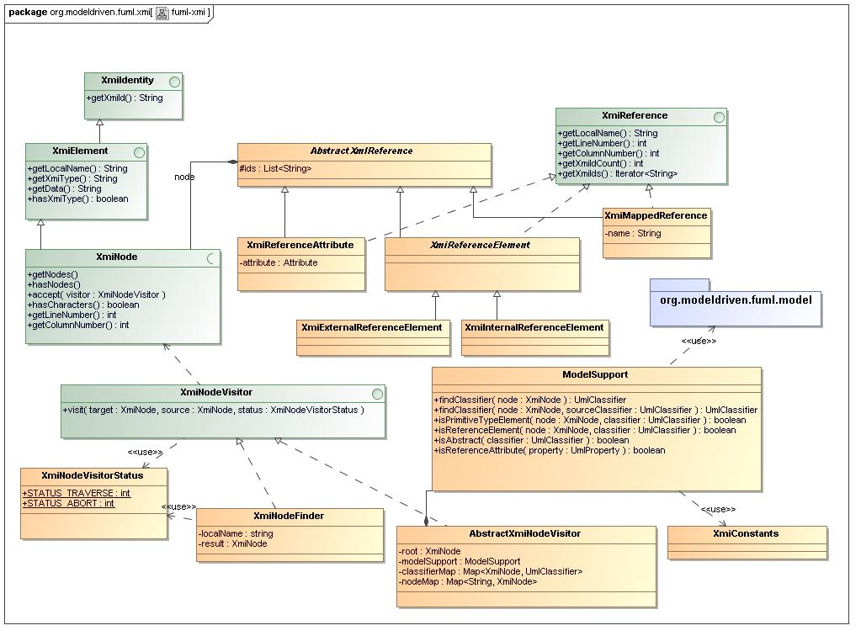
- fuml-xmi Diagram

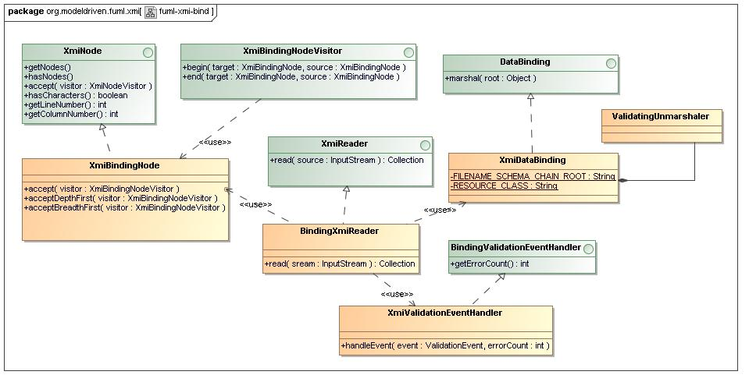
- fuml-xmi-bind Diagram

Name | org.modeldriven.fuml.xmi
Qualified Name | org.modeldriven.fuml.xmi

Class AbstractXmiNodeVisitor
Description
General XMINodeVisitor implementation superclass encapsulating common structure and logic across both XMI validation and target structure assembly processing.
Name | AbstractXmiNodeVisitor
Qualified Name | org.modeldriven.fuml.xmi::AbstractXmiNodeVisitor
Visibility | public
Abstract | false
Base Classifier
Realized Interface | - XmiNodeVisitor

Attribute Detail
Following are the attributes for class, AbstractXmiNodeVisitor.
Table 14 – AbstractXmiNodeVisitor Attribute Detail

Atttribute Name | Description | Type |  | Visibility
classifierMap | A map of nodes to assigned classifiers used for XMI reference post-processing. |  | Map<XmiNode, UmlClassifier> |  | private
modelSupport | The model-support delegate. |  | ModelSupport |  | private
nodeMap | A map of XMI id strings to XMiNodes used for XMI reference post-processing. |  | Map<String, XmiNode> |  | private
root | The visitor root node which is the source traversal node. |  | XmiNode |  | private

Relation Detail
Following are the relations for class, AbstractXmiNodeVisitor.

Table 15 – AbstractXmiNodeVisitor Relation Detail

Relation Type | Related Elements
Association | AbstractXmiNodeVisitor  ModelSupport
Generalization | AbstractXmiNodeVisitor  ValidationErrorCollector
Interface Realization | AbstractXmiNodeVisitor  XmiNodeVisitor

Class AbstractXmlReference
Description
Contains cefault functionalty for XmiReference implementation classes.
Name | AbstractXmlReference
Qualified Name | org.modeldriven.fuml.xmi::AbstractXmlReference
Visibility | public
Abstract | true
Base Classifier
Realized Interface

Attribute Detail
Following are the attributes for class, AbstractXmlReference.
Table 16 – AbstractXmlReference Attribute Detail

Atttribute Name | Description | Type |  | Visibility
ids | A collection of XMI id references, helping to abstract single valued and milti-valued references. |  | List<String> |  | protected

Relation Detail
Following are the relations for class, AbstractXmlReference.

Table 17 – AbstractXmlReference Relation Detail

Relation Type | Related Elements
Association | AbstractXmlReference  XmiNode
Generalization | AbstractXmlReference  XmiReferenceAttribute
Generalization | AbstractXmlReference  XmiReferenceElement
Generalization | AbstractXmlReference  XmiMappedReference

Class BindingXmiReader
Description
XML data-binding based XMI import processor capable of expanding the input XMI stream into another format as a precursor to binding. Currently an expansion XSL template is used to "stripe" the XMI content based on declared 'type' information. The expanded "striped" XMI format lends itself far more easily to the standard JAXB data binding implementation.

Name | BindingXmiReader
Qualified Name | org.modeldriven.fuml.xmi::BindingXmiReader
Visibility | public
Abstract | false
Base Classifier
Realized Interface | - XmiReader

Operation Detail
Following are the operations for class, BindingXmiReader
Table 18 – BindingXmiReader
Operation Detail

Operation Name | Description |  | Type | Parameters |  | Visibility
read |  | Processes the given stream returning a collection of top level results nodes. | Collection | inout sream : InputStream | public

Relation Detail
Following are the relations for class, BindingXmiReader
Table 19 – BindingXmiReader
Relation Detail

Relation Type | Related Elements
Interface Realization | BindingXmiReader  XmiReader
Usage | BindingXmiReader  getPackageForClass
Usage | BindingXmiReader  XmiDataBinding
Usage | accept  BindingXmiReader
Usage | BindingXmiReader  XmiValidationEventHandler

Class ModelSupport
Description
Stateless model-related logic delegate class. Handles metadata related logic specific for the the XMI package or it's sub-packages.
Name | ModelSupport
Qualified Name | org.modeldriven.fuml.xmi::ModelSupport
Visibility | public
Abstract | false
Base Classifier
Realized Interface

Attribute Detail
Following are the attributes for class, ModelSupport.
Table 20 – ModelSupport Attribute Detail

Atttribute Name | Description | Type | Visibility

Operation Detail
Following are the operations for class, ModelSupport.

Table 21 – ModelSupport Operation Detail

Operation Name | Description |  | Type | Parameters |  | Visibility
findClassifier |  | Returns the classifier for the given node, if exists. | UmlClassifier | inout node : XmiNode | public
findClassifier |  | Returns the classifier for the given node, if exists, based on the xmi:type attribute of the given source node. | UmlClassifier | inout node : XmiNode  inout sourceClassifier : UmlClassifier | public
isAbstract |  | Returns whether the given classifier is abstract. | boolean | inout classifier : UmlClassifier | public
isPrimitiveTypeElement |  | Returns whether the given node represents a primitive type. | boolean | inout classifier : UmlClassifier  inout node : XmiNode | public
isReferenceAttribute |  | Returns whether the given property is a reference property (owned attribute). | boolean | inout property : UmlProperty | public
isReferenceElement |  | Returns whether the given node represents a primitive type. | boolean | inout classifier : UmlClassifier  inout node : XmiNode | public

Relation Detail
Following are the relations for class, ModelSupport.

Table 22 – ModelSupport Relation Detail

Relation Type | Related Elements
Association | AbstractXmiNodeVisitor  ModelSupport
Usage | ModelSupport  org.modeldriven.fuml.model
Usage | ModelSupport  XmiConstants

Class XmiBindingNode
Description
The class serves and the superclass for all JAXB generated classes used for XMI processing. It encapsulates a Java reflection-based traversal algorithm allowing visitor clients to receive events for any attached node regardless of its binding-node subclass. The traversal algorithm bypasses JAXB generated "generic" JAXBElement nodes, sheilding the visitor client from these uninteresting container objects.
Name | XmiBindingNode
Qualified Name | org.modeldriven.fuml.xmi::XmiBindingNode
Visibility | public
Abstract | false
Base Classifier
Realized Interface | - XmiNode

Attribute Detail
Following are the attributes for class, XmiBindingNode.
Table 23 – XmiBindingNode Attribute Detail

Atttribute Name | Description | Type | Visibility

Operation Detail
Following are the operations for class, XmiBindingNode.

Table 24 – XmiBindingNode Operation Detail

Operation Name | Description |  | Type | Parameters |  | Visibility
accept |  |  |  | inout visitor : XmiBindingNodeVisitor | public
acceptBreadthFirst |  |  |  | inout visitor : XmiBindingNodeVisitor | public
acceptDepthFirst |  |  |  | inout visitor : XmiBindingNodeVisitor | public

Relation Detail
Following are the relations for class, XmiBindingNode.

Table 25 – XmiBindingNode Relation Detail

Relation Type | Related Elements
Association | ElementAssembler  XmiBindingNode
Generalization | ElementAssembler  XmiBindingNode
Interface Realization | XmiBindingNode  XmiNode
Usage | XmiBindingNode  XmiBindingNodeVisitor
Usage | Model  XmiBindingNode

Class XmiDataBinding
Description
Encapsulates XMI package specific data binding information.
Name | XmiDataBinding
Qualified Name | org.modeldriven.fuml.xmi::XmiDataBinding
Visibility | public
Abstract | false
Base Classifier
Realized Interface | - DataBinding

Attribute Detail
Following are the attributes for class, XmiDataBinding.
Table 26 – XmiDataBinding Attribute Detail

Atttribute Name | Description | Type |  | Visibility
FILENAME_SCHEMA_CHAIN_ROOT | The file name of the root schema. |  | String |  | private
RESOURCE_CLASS | The class used to load schema file resources. |  | String |  | private

Relation Detail
Following are the relations for class, XmiDataBinding.

Table 27 – XmiDataBinding Relation Detail

Relation Type | Related Elements
Association | ValidatingUnmarshaler  XmiDataBinding
Interface Realization | DataBinding  XmiDataBinding
Usage | BindingXmiReader  XmiDataBinding
Usage | BindingValidationEventHandler  XmiDataBinding

Class XmiExternalReferenceElement
Description
This class is an XmiReference implementation holding XMI external reference data and related information found within XML elements. External references within an XML entity are found in the xmi:href attribute of an entity.External XMI references target model entities from an XMI source outside the source where the reference is found. For more information on XMI references see the XmiReference interface documentation.
Name | XmiExternalReferenceElement
Qualified Name | org.modeldriven.fuml.xmi::XmiExternalReferenceElement
Visibility | public
Abstract | false
Base Classifier | - XmiReferenceElement
Realized Interface

Relation Detail
Following are the relations for class, XmiExternalReferenceElement.

Table 28 – XmiExternalReferenceElement Relation Detail

Relation Type | Related Elements
Generalization | XmiExternalReferenceElement  XmiReferenceElement

Class XmiInternalReferenceElement
Description
This class is an XmiReference implementation holding XMI internal reference data and related information found within XML elements. The character data within a reference element may hold any number of internal XMI references to entities within a model, seperated by space (' ') character delimiters. Only "internal" references are found in XML entity character data within an XMI formatted source. Internal references target model entities found in the same source XMI as the reference. Internal references within an XML entity may also be found in the xmi:idref attribute of an entity. For more information on XMI references see the XmiReference interface documentation.
Name | XmiInternalReferenceElement
Qualified Name | org.modeldriven.fuml.xmi::XmiInternalReferenceElement
Visibility | public
Abstract | false
Base Classifier | - XmiReferenceElement
Realized Interface

Relation Detail
Following are the relations for class, XmiInternalReferenceElement.

Table 29 – XmiInternalReferenceElement Relation Detail

Relation Type | Related Elements
Generalization | XmiInternalReferenceElement  XmiReferenceElement

Class XmiMappedReference
Description
This class is an XmiReference implementation holding derived XMI internal reference data and related information. Internal reference are derived based configuration mapping information and used to create a mapped-reference. For more information on XMI references see the XmiReference interface documentation.
Name | XmiMappedReference
Qualified Name | org.modeldriven.fuml.xmi::XmiMappedReference
Visibility | public
Abstract | false
Base Classifier | - AbstractXmlReference
Realized Interface | - XmiReference

Attribute Detail
Following are the attributes for class, XmiMappedReference.
Table 30 – XmiMappedReference Attribute Detail

Atttribute Name | Description | Type |  | Visibility
name |  |  | String |  | private

Relation Detail
Following are the relations for class, XmiMappedReference.

Table 31 – XmiMappedReference Relation Detail

Relation Type | Related Elements
Generalization | AbstractXmlReference  XmiMappedReference
Interface Realization | XmiMappedReference  XmiReference

Class XmiNodeFinder
Description
Class that leverages the Visitor pattern to locate descendant node(s) within an XmiNode hierarchy.
Name | XmiNodeFinder
Qualified Name | org.modeldriven.fuml.xmi::XmiNodeFinder
Visibility | public
Abstract | false
Base Classifier
Realized Interface | - XmiNodeVisitor

Attribute Detail
Following are the attributes for class, XmiNodeFinder.
Table 32 – XmiNodeFinder Attribute Detail

Atttribute Name | Description | Type |  | Visibility
localName | The unqualified name of the target node(s) within an XmiNode hierarchy. |  | string |  | private
result | The result node within an XmiNode hierarchy, determined during traversal. |  | XmiNode |  | private

Relation Detail
Following are the relations for class, XmiNodeFinder.

Table 33 – XmiNodeFinder Relation Detail

Relation Type | Related Elements
Interface Realization | XmiNodeFinder  XmiNodeVisitor
Usage | XmiNodeFinder  XmiNodeVisitorStatus

Class XmiNodeVisitorStatus
Description
A class used to communicate traversal logic changes required by a client.
Name | XmiNodeVisitorStatus
Qualified Name | org.modeldriven.fuml.xmi::XmiNodeVisitorStatus
Visibility | public
Abstract | false
Base Classifier
Realized Interface

Attribute Detail
Following are the attributes for class, XmiNodeVisitorStatus.
Table 34 – XmiNodeVisitorStatus Attribute Detail

Atttribute Name | Description | Type |  | Visibility
STATUS_ABORT | Indicates that a traversal should be aborted. |  | int |  | public
STATUS_TRAVERSE | Indicates that a traversal should be continued. |  | int |  | public

Relation Detail
Following are the relations for class, XmiNodeVisitorStatus.

Table 35 – XmiNodeVisitorStatus Relation Detail

Relation Type | Related Elements
Usage | XmiNodeFinder  XmiNodeVisitorStatus
Usage | XmiNodeVisitor  XmiNodeVisitorStatus

Class XmiReferenceAttribute
Description
This class is an XmiReference implementation holding reference data and related information found within XML attributes. An attribute may hold any number of references to entities within a mode, separated by space (' ') character delimiters. Only "internal" references are found in XML attributes within an XMI formatted source. Internal references target model entities found in the same source XMI as the reference. For more information on XMI references, see the XmiReference interface documentation.
Name | XmiReferenceAttribute
Qualified Name | org.modeldriven.fuml.xmi::XmiReferenceAttribute
Visibility | public
Abstract | false
Base Classifier | - AbstractXmlReference
Realized Interface | - XmiReference

Attribute Detail
Following are the attributes for class, XmiReferenceAttribute.
Table 36 – XmiReferenceAttribute Attribute Detail

Atttribute Name | Description | Type |  | Visibility
attribute | The StAX stream attribute for this reference. |  | Attribute |  | private

Relation Detail
Following are the relations for class, XmiReferenceAttribute.

Table 37 – XmiReferenceAttribute Relation Detail

Relation Type | Related Elements
Generalization | AbstractXmlReference  XmiReferenceAttribute
Interface Realization | XmiReference  XmiReferenceAttribute

Class XmiReferenceElement
Description
This abstract class is an XmiReference implementation serving as a superclass for classes holding reference data and related information found within XML elements. For more information on XMI references see the XmiReference interface documentation.
Name | XmiReferenceElement
Qualified Name | org.modeldriven.fuml.xmi::XmiReferenceElement
Visibility | public
Abstract | true
Base Classifier | - AbstractXmlReference
Realized Interface | - XmiReference

Relation Detail
Following are the relations for class, XmiReferenceElement.

Table 38 – XmiReferenceElement Relation Detail

Relation Type | Related Elements
Generalization | AbstractXmlReference  XmiReferenceElement
Generalization | XmiExternalReferenceElement  XmiReferenceElement
Generalization | XmiInternalReferenceElement  XmiReferenceElement
Interface Realization | XmiReference  XmiReferenceElement

Class XmiValidationEventHandler
Description
Default handler, simply logging validation error events.
Name | XmiValidationEventHandler
Qualified Name | org.modeldriven.fuml.xmi::XmiValidationEventHandler
Visibility | public
Abstract | false
Base Classifier | - BindingValidationEventHandler
Realized Interface | - BindingValidationEventHandler

Operation Detail
Following are the operations for class, XmiValidationEventHandler

Table 39 – XmiValidationEventHandler
Operation Detail

Operation Name | Description |  | Type | Parameters |  | Visibility
handleEvent |  |  |  | inout errorCount : int  inout event : ValidationEvent | public

Relation Detail
Following are the relations for class, XmiValidationEventHandler

Table 40 – XmiValidationEventHandler
Relation Detail

Relation Type | Related Elements
Generalization | BindingValidationEventHandler  XmiValidationEventHandler
Interface Realization | BindingValidationEventHandler  XmiValidationEventHandler
Usage | BindingXmiReader  XmiValidationEventHandler

Interface XmiBindingNodeVisitor
Description
Visitor interface receiving traversal events for XmiBindingNode traversals.
Name | XmiBindingNodeVisitor
Qualified Name | org.modeldriven.fuml.xmi::XmiBindingNodeVisitor
Visibility | public
Base Classifier

Operation Detail
Following are the operations for interface, XmiBindingNodeVisitor.

Table 41 – XmiBindingNodeVisitor Operation Detail

Operation Name | Description | Type | Parameters | Visibility

Relation Detail
Following are the relations for interface, XmiBindingNodeVisitor.

Table 42 – XmiBindingNodeVisitor Relation Detail

Relation Type | Related Elements
Association | Model  XmiBindingNodeVisitor
Usage | XmiBindingNode  XmiBindingNodeVisitor

Interface XmiElement
Description
Interface generalizing XMI elements across both stream-based XMI import and assembly into the target FUML java model. An element may have character data as well as element and attribute data.
Name | XmiElement
Qualified Name | org.modeldriven.fuml.xmi::XmiElement
Visibility | public
Base Classifier | - XmiIdentity

Operation Detail
Following are the operations for interface, XmiElement.

Table 43 – XmiElement Operation Detail

Operation Name | Description | Type | Parameters | Visibility

Relation Detail
Following are the relations for interface, XmiElement.
Table 44 – XmiElement Relation Detail

Relation Type | Related Elements
Generalization | XmiElement  XmiNode
Generalization | XmiElement  XmiIdentity
Interface Realization | AssemblerNode  XmiElement

Interface XmiIdentity
Description
Represents the identity of an XMI object used in XMI import or target model assembly.
Name | XmiIdentity
Qualified Name | org.modeldriven.fuml.xmi::XmiIdentity
Visibility | public
Base Classifier

Operation Detail
Following are the operations for interface, XmiIdentity.

Table 45 – XmiIdentity Operation Detail

Operation Name | Description | Type | Parameters | Visibility

Relation Detail
Following are the relations for interface, XmiIdentity.
Table 46 – XmiIdentity Relation Detail

Relation Type | Related Elements
Generalization | XmiElement  XmiIdentity
Interface Realization | AssemblerNode  XmiIdentity
Interface Realization | ElementAssembler  XmiIdentity

Interface XmiNode
Description
Models the hierarchical aspects of an element within a tree of XMI elements and supports Visitor pattern oriented traversals of the hierarchy.
Name | XmiNode
Qualified Name | org.modeldriven.fuml.xmi::XmiNode
Visibility | public
Base Classifier | - XmiElement

Operation Detail
Following are the operations for interface, XmiNode.

Table 47 – XmiNode Operation Detail

Operation Name | Description | Type | Parameters | Visibility

Relation Detail
Following are the relations for interface, XmiNode.
Table 48 – XmiNode Relation Detail

Relation Type | Related Elements
Association | ElementAssembler  XmiNode
Association | ElementAssembler  XmiNode
Association | ElementAssembler  XmiNode
Association | AbstractXmlReference  XmiNode
Generalization | XmiElement  XmiNode
Interface Realization | XmiBindingNode  XmiNode
Interface Realization | StreamNode  XmiNode
Usage | XmiNode  XmiNodeVisitor

Interface XmiNodeVisitor
Description
Visitor interface receiving traversal events for XmiNode traversals.
Name | XmiNodeVisitor
Qualified Name | org.modeldriven.fuml.xmi::XmiNodeVisitor
Visibility | public
Base Classifier

Operation Detail
Following are the operations for interface, XmiNodeVisitor.

Table 49 – XmiNodeVisitor Operation Detail

Operation Name | Description | Type | Parameters | Visibility

Relation Detail
Following are the relations for interface, XmiNodeVisitor.
Table 50 – XmiNodeVisitor Relation Detail

Relation Type | Related Elements
Interface Realization | AbstractXmiNodeVisitor  XmiNodeVisitor
Interface Realization | XmiNodeFinder  XmiNodeVisitor
Interface Realization | ValidationErrorCollector  XmiNodeVisitor
Interface Realization | ElementGraphAssembler  XmiNodeVisitor
Usage | XmiNode  XmiNodeVisitor
Usage | XmiNodeVisitor  XmiNodeVisitorStatus

Interface XmiReader
Description
Reader interface to abstract multiple XMI import processing approaches, for instance JAXB imports and StAX stream imports.
Name | XmiReader
Qualified Name | org.modeldriven.fuml.xmi::XmiReader
Visibility | public
Base Classifier

Operation Detail
Following are the operations for interface, XmiReader.

Table 51 – XmiReader Operation Detail

Operation Name | Description | Type | Parameters | Visibility

Relation Detail
Following are the relations for interface, XmiReader.
Table 52 – XmiReader Relation Detail

Relation Type | Related Elements
Interface Realization | BindingXmiReader  XmiReader
Interface Realization | StreamReader  XmiReader

Interface XmiReference
Description
This interface is used to abstract away differences between the various types of XMI references allowed within the XMI format. XMI references are found in both XML attributes as well as XML elements in an XMI source.

XMI ID's and XMI References
XMI id's are system generated identifiers (typically UUID's) resulting from the serialization of a model, typically a graph structure, as XML which is a strict hierarchy. They are found within the (XMI namespace) xmi:id attribute of many XML elements in a typical XMI formatted file. While the xmi:id attribute uniquely identifies a single entity within a model, the id may be used to refer to the entity from any number of other locations within XMI file. XMI references may be encoded as attributes or elements and may be encoded in several ways. In addition, multiple references may be found with the same XMI attribute or element, refering to any number of other entities within the file.
Internal and External References
Internal XMI references are those that target model entities within the same XMI source where the reference is found. For instance for an internal reference '123' to be valid, some element within the same file must have an xmi:id attribute equal to '123'. External XMI references target model entities from an XMI source outside the source where the reference is found. External references are encoded differently than internal references and are only found as XML elements.

Name | XmiReference
Qualified Name | org.modeldriven.fuml.xmi::XmiReference
Visibility | public
Base Classifier

Operation Detail
Following are the operations for interface, XmiReference.

Table 53 – XmiReference Operation Detail

Operation Name | Description | Type | Parameters | Visibility

Relation Detail
Following are the relations for interface, XmiReference.
Table 54 – XmiReference Relation Detail

Relation Type | Related Elements
Interface Realization | XmiReference  XmiReferenceAttribute
Interface Realization | XmiMappedReference  XmiReference
Interface Realization | XmiReference  XmiReferenceElement

Package org.modeldriven.fuml.xmi.stream

Description
This package manages processing of large stream-based XMI imports. It leveraging the StAX "pull" parser to process only (XML) elements of interest while ignoring others based on namespace-sensitive configuration information. Incremental stream processing is facilitated using a standard event-listener pattern, where listeners may receive an event, completely process the allocated stream portion, then clip the portion from it's parent allowing memory to be garbage collected. This incremental approach therefore facilitates processing of very large input streams by minimizing memory utilization.

StAX Overview:
Processing XML documents has become a critical and integral part of most applications being developed today. Depending on different environments, there are various ways to process an XML document within a program. All these can be broadly categorized into two approaches:
- Tree-based APIs: DOM (Document Object Model) implementations use this technique. They basically load the whole XML file into memory and process it. The model they build is usually larger than the original XML document, thus duplicating and wasting memory.
- Event-based APIs: When this type of a parser is given some XML to process, it sends out events corresponding to the information items it finds. The common approach has been to use a push-based approach like SAX to process the XML. This is more efficient than DOM, in terms of memory. The problem with the push model is that once started, it goes to the end of the document and the caller must be ready to handle all of the events in one shot. So the caller that invokes the parser has no control over the parsing phase.

Both of these models give little or no control to the user in this parsing process. Once started, whether tree-based or event-based, both parsing approaches consume the whole data stream at once. JSR 173 defines a pull streaming model, StAX (short for "Streaming API for XML"), for processing XML documents. In this model, unlike in SAX, the client can start, proceed, pause, and resume the parsing process. The client has complete control as the user must call the parser to proceed by calling reader.next(). The parser will proceed to the next step only after that. This is the main difference between pull and push parsing. In push parsing, as with SAX, once the SAX parser starts sending events, the user or the client application has no control over it. But in pull parsing, as seen here, the client application can decide the phase of parsing at its own discretion.

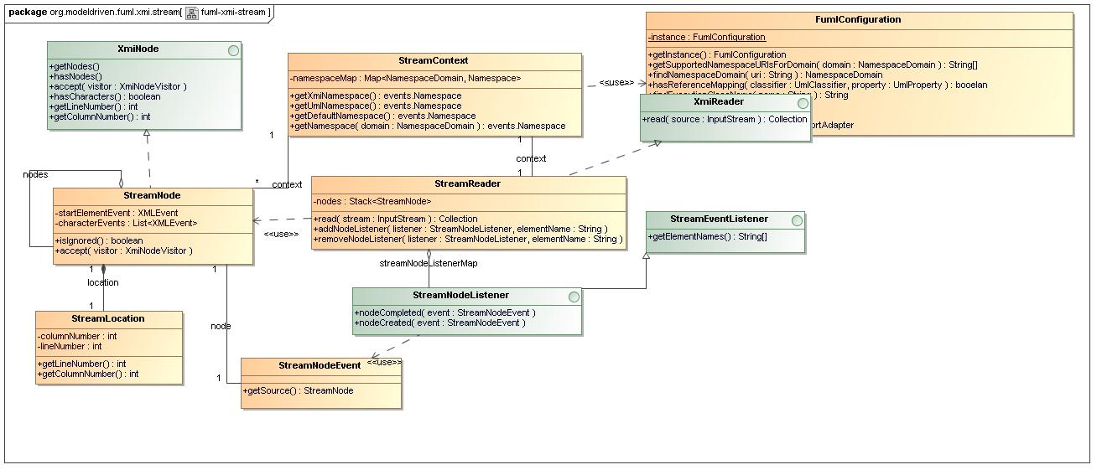
- fuml-xmi-stream Diagram

Name | org.modeldriven.fuml.xmi.stream
Qualified Name | org.modeldriven.fuml.xmi.stream

Class StreamContext
Description
Encapsulates context information for the current XMI stream, including namespaces and other resources. Namespaces are loaded from the (XML) root element based on a configurable set of supported namespaces for various domains. If no namespace is found within the supported namespaces for a particular domain, an error is thrown.
Name | StreamContext
Qualified Name | org.modeldriven.fuml.xmi.stream::StreamContext
Visibility | public
Abstract | false
Base Classifier
Realized Interface

Attribute Detail
Following are the attributes for class, StreamContext.
Table 55 – StreamContext Attribute Detail

Atttribute Name | Description | Type |  | Visibility
namespaceMap | Maps NamespaceDomain configuration items with stream spacific namespace instances. For instance the 'UML' domain may be mapped to a namespace with the URI: http://www.eclipse.org/uml2/2.0.0/UML. |  | Map<NamespaceDomain, Namespace> |  | private

Operation Detail
Following are the operations for class, StreamContext.

Table 56 – StreamContext Operation Detail

Operation Name | Description |  | Type | Parameters |  | Visibility
getDefaultNamespace |  | Returns the default namespace found and registered for the current stream. | events.Namespace |  | public
getNamespace |  | Returns the namespace for the given namespace domain, found and registered for the current stream, if any. | events.Namespace | inout domain : NamespaceDomain | public
getUmlNamespace |  | Returns the UML namespace found and registered for the current stream. | events.Namespace |  | public
getXmiNamespace |  | Returns the XMI namespace found and registered for the current stream. | events.Namespace |  | public

Relation Detail
Following are the relations for class, StreamContext.

Table 57 – StreamContext Relation Detail

Relation Type | Related Elements
Association | StreamContext  StreamNode
Association | StreamContext  StreamReader
Usage | FumlConfiguration  StreamContext
Usage | StreamContext  StreamReader

Class StreamLocation
Description
Stream location data necessary only because Sun's StAX implementation "loses" location data immediately after it is allocated. This class us used to copy location data and associate it with the concerned start-element.
Name | StreamLocation
Qualified Name | org.modeldriven.fuml.xmi.stream::StreamLocation
Visibility | public
Abstract | false
Base Classifier
Realized Interface

Attribute Detail
Following are the attributes for class, StreamLocation.
Table 58 – StreamLocation Attribute Detail

Atttribute Name | Description | Type |  | Visibility
columnNumber |  |  | int |  | private
lineNumber |  |  | int |  | private

Operation Detail
Following are the operations for class, StreamLocation.

Table 59 – StreamLocation Operation Detail

Operation Name | Description |  | Type | Parameters |  | Visibility
getColumnNumber |  |  | int |  | public
getLineNumber |  |  | int |  | public

Relation Detail
Following are the relations for class, StreamLocation.

Table 60 – StreamLocation Relation Detail

Relation Type | Related Elements
Association | StreamLocation  StreamNode

Class StreamNode
Description
Encapsulates a set of related XML (stream) events. Stream events are objects allocated by the StAX parser from the current stream and include element and attribute as well as namespace and location information. The primary event encapsulated is always a start-element event, but one of more 'characters' events may be added if character data for the element is encountered in the stream.
Name | StreamNode
Qualified Name | org.modeldriven.fuml.xmi.stream::StreamNode
Visibility | public
Abstract | false
Base Classifier
Realized Interface | - XmiNode

Attribute Detail
Following are the attributes for class, StreamNode.
Table 61 – StreamNode Attribute Detail

Atttribute Name | Description | Type |  | Visibility
characterEvents | The list of caracter(s) events allocated by the StAX allocator for the related start-element event. |  | List<XMLEvent> |  | private
startElementEvent | The start-element XML event allocated by the StAX allocator. |  | XMLEvent |  | private

Operation Detail
Following are the operations for class, StreamNode.

Table 62 – StreamNode Operation Detail

Operation Name | Description |  | Type | Parameters |  | Visibility
accept |  | Traverses a StreamNode node hierarchy using 'this' node as the root, calling the given visitor as a node is encountered. |  | inout visitor : XmiNodeVisitor | public
isIgnored |  | Returns true if this node is to be ignored for traversals based on common namespace-sensitive configuration information. | boolean |  | public

Relation Detail
Following are the relations for class, StreamNode.

Table 63 – StreamNode Relation Detail

Relation Type | Related Elements
Association | StreamNode  XMLEvent
Association | StreamContext  StreamNode
Association | StreamLocation  StreamNode
Association | StreamNode  StreamNodeEvent
Association | StreamNode
Interface Realization | StreamNode  XmiNode
Usage | FumlConfiguration  StreamNode
Usage | StreamNode  StreamReader

Class StreamNodeEvent
Description
Encapsulates the node(s) of concern and other state for this event.
Name | StreamNodeEvent
Qualified Name | org.modeldriven.fuml.xmi.stream::StreamNodeEvent
Visibility | public
Abstract | false
Base Classifier
Realized Interface

Attribute Detail
Following are the attributes for class, StreamNodeEvent.
Table 64 – StreamNodeEvent Attribute Detail

Atttribute Name | Description | Type | Visibility

Operation Detail
Following are the operations for class, StreamNodeEvent.

Table 65 – StreamNodeEvent Operation Detail

Operation Name | Description |  | Type | Parameters |  | Visibility
getSource |  | Returns the node of concern for this event. | StreamNode |  | public

Relation Detail
Following are the relations for class, StreamNodeEvent.

Table 66 – StreamNodeEvent Relation Detail

Relation Type | Related Elements
Association | StreamNode  StreamNodeEvent
Usage | StreamNodeEvent  StreamNodeListener

Class StreamReader
Description
Stream based XmiReader implementation utilizing the StAX parser. For more information on the StAX parser, see the package-level documentation. Only start-element, end-element and character(s) events are processed, other events being ignored. Certain start-element events are also ignored based on namespace-sensitive configuration information. Events of interest are allocated from the stream into immutable nodes and arranged into a hierarchy for ease of processing by interested clients. Clients are notified using a standard event-listener pattern. NOTE: event queues are not currently used to asynchronously publish events, as clients are intended to completely process relevant portions of the stream freeing or "clipping" any and all possible allocated nodes from the hierarchy for garbage collection.
Name | StreamReader
Qualified Name | org.modeldriven.fuml.xmi.stream::StreamReader
Visibility | public
Abstract | false
Base Classifier
Realized Interface | - XmiReader

Attribute Detail
Following are the attributes for class, StreamReader.
Table 67 – StreamReader Attribute Detail

Atttribute Name | Description | Type |  | Visibility
nodes |  |  | Stack<StreamNode> |  | private

Operation Detail
Following are the operations for class, StreamReader.

Table 68 – StreamReader Operation Detail

Operation Name | Description |  | Type | Parameters |  | Visibility
addNodeListener |  | Registers a given (stream) node listener with this reader, associating the listener with the given element name. |  | inout elementName : String  inout listener : StreamNodeListener | public
read |  | Processes the given stream returning a collection of top level results nodes. | Collection | inout stream : InputStream | public
removeNodeListener |  | Registers a given (stream) node listener with this reader, associating the listener with the given element name. |  | inout elementName : String  inout listener : StreamNodeListener | public

Relation Detail
Following are the relations for class, StreamReader.

Table 69 – StreamReader Relation Detail

Relation Type | Related Elements
Association | StreamContext  StreamReader
Association | StreamNodeListener  StreamReader
Interface Realization | StreamReader  XmiReader
Usage | Fuml  StreamReader
Usage | Library  StreamReader
Usage | StreamNode  StreamReader
Usage | StreamContext  StreamReader

Interface StreamEventListener
Description
A base listener interface for this package. Makes the assumption that all events for the stream package are triggered by XML elements within the stream.
Name | StreamEventListener
Qualified Name | org.modeldriven.fuml.xmi.stream::StreamEventListener
Visibility | public
Base Classifier

Operation Detail
Following are the operations for interface, StreamEventListener.

Table 70 – StreamEventListener Operation Detail

Operation Name | Description | Type | Parameters | Visibility

Relation Detail
Following are the relations for interface, StreamEventListener.
Table 71 – StreamEventListener Relation Detail

Relation Type | Related Elements
Generalization | StreamEventListener  StreamNodeListener

Interface StreamNodeListener
Description
An event dispatch interface used to notify interested clients of stream node allocation related events occurring during processing of an XML stream.
Name | StreamNodeListener
Qualified Name | org.modeldriven.fuml.xmi.stream::StreamNodeListener
Visibility | public
Base Classifier | - StreamEventListener

Operation Detail
Following are the operations for interface, StreamNodeListener.

Table 72 – StreamNodeListener Operation Detail

Operation Name | Description | Type | Parameters | Visibility

Relation Detail
Following are the relations for interface, StreamNodeListener.
Table 73 – StreamNodeListener Relation Detail

Relation Type | Related Elements
Association | StreamNodeListener  StreamReader
Generalization | StreamEventListener  StreamNodeListener
Generalization | Import  StreamNodeListener
Usage | StreamNodeEvent  StreamNodeListener

Package org.modeldriven.fuml.xmi.validation

Description
This pacakge leverages the underlying (parent) package, fuml-xmi. It supports strict validation of XMI import data across several error categories involving structural compliance of the (XML/XMI) document itself as well as the UML model represented by the XMI document. Both document compliance and model compliance conditions are enumerated under several errror categories listing various well-formedness, correlation and other broad groupings. An ErrorCode enumeration links specific error conditions to respective categories and a ValidationError class links error codes to a parsing-context specific ErrorSeverity.
To gather various UML model compliance errors, a ValidationErrorCollector class employs the Visitor pattern to traverse a given hierarchy of XmiNode objects mapping collected errors for later convienent and efficent access. While many XML structural compliance conditions are caught by the underlying XML parsing technology and captured under the document compliance related error categories and codes, several application-level XML problems are also captured externally, such as namespace related problems.

Design Goals:

- Independance from Model-Execution or Other Concerns. In order to support web-based compliance checking of fUML models, the validation infrastructure must be independant or "stand-alone". For instance a user may want to validate a model numerous times, resolving various errors before ever attempting to execute the model. To support independant XMI model validation, this package primarially references only the fuml.xmi and fuml.model packages. Execution related processing is seperated into various independant packages such as fuml.environment and fuml.assembly.

- Leverage Runtime Metadata Resources. Under the fuml.model package quick access to UML Superstructure, Infrastructure and fUML-specific metadata is provided. For more information on runtime metadata, see the fuml.model package documentation. Rather than duplicating fundamental metadata constructs or logic, the validation package is in fact driven by this external metadata, greatly simplifying processing logic. Among elements determined at runtime using the fuml.model package are package-names, classifier types, feature and parameter names and types, defaults and multiplicities.
- Incremental Processing. While compliance checking of an entire model may be desirable under some scenarios, partial or incremantal validation is required under others. For instance during model execution, rather than an all-or-nothing validation approach, only packaged elements not in compliance should be invalidated, while all others sould be fully processed. This goal is accommodated using the Visitor pattern where any XmiNode in a hierarchy may be passed into the validation processing and used as the "root" node for the purposes of traversal. Any errors incurred are local to the traversal root, and depending on the severity may be used to invalidate the root and its descendants.

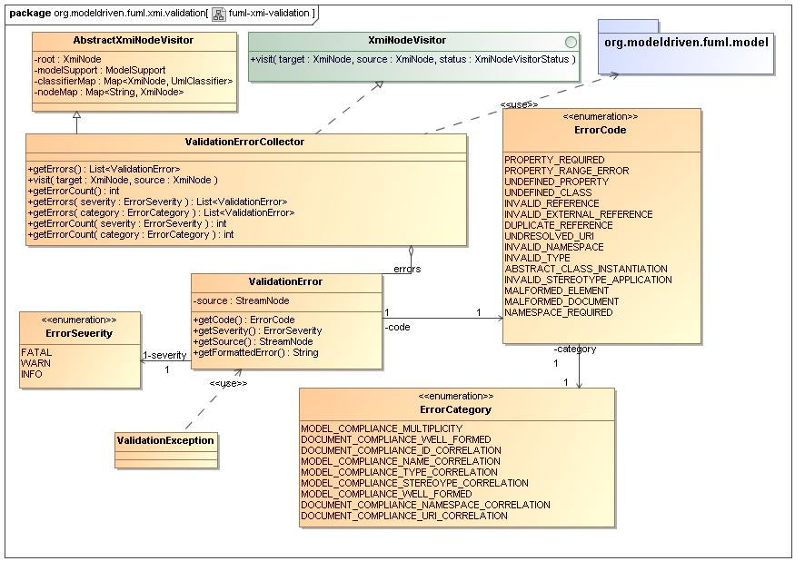
- fuml-xmi-validation Diagram

Name | org.modeldriven.fuml.xmi.validation
Qualified Name | org.modeldriven.fuml.xmi.validation

Class ValidationError
Description
Contains detailed error information sufficient for generation of formatted, informative error messages for use in simple logging as well as web displays. Errors are categorized and have a associated severity as well as source information including element and location information.
Name | ValidationError
Qualified Name | org.modeldriven.fuml.xmi.validation::ValidationError
Visibility | public
Abstract | false
Base Classifier
Realized Interface

Attribute Detail
Following are the attributes for class, ValidationError.
Table 74 – ValidationError Attribute Detail

Atttribute Name | Description | Type |  | Visibility
severity |  |  | ErrorSeverity |  | private
source |  |  | StreamNode |  | private

Operation Detail
Following are the operations for class, ValidationError.

Table 75 – ValidationError Operation Detail

Operation Name | Description |  | Type | Parameters |  | Visibility
getCode |  |  | ErrorCode |  | public
getFormattedError |  |  | String |  | public
getSeverity |  |  | ErrorSeverity |  | public
getSource |  |  | StreamNode |  | public

Relation Detail
Following are the relations for class, ValidationError.

Table 76 – ValidationError Relation Detail

Relation Type | Related Elements
Association | ErrorSeverity  ValidationError
Association | ErrorCategory  ValidationError
Association | ErrorSeverity  ValidationError
Association | ErrorCode  ValidationError
Association | ValidationError  ValidationErrorCollector
Usage | ValidationError  ValidationException

Class ValidationErrorCollector
Description
A visitor pattern implementation class that walks a given XmiNode hierarchy checking for various error conditions, creating and gathering ValidationError instances into a collection helpful for user feedback. This class can be initialized with an initial list of errors gathered from another context, and errors may be added to it's collection ad-hoc. This class heavily leverages the fuml.model package. For more information on runtime metadata, see the fuml.model package documentation.
Name | ValidationErrorCollector
Qualified Name | org.modeldriven.fuml.xmi.validation::ValidationErrorCollector
Visibility | public
Abstract | false
Base Classifier | - AbstractXmiNodeVisitor
Realized Interface | - XmiNodeVisitor

Attribute Detail
Following are the attributes for class, ValidationErrorCollector.
Table 77 – ValidationErrorCollector Attribute Detail

Atttribute Name | Description | Type | Visibility

Operation Detail
Following are the operations for class, ValidationErrorCollector.

Table 78 – ValidationErrorCollector Operation Detail

Operation Name | Description |  | Type | Parameters |  | Visibility
getErrorCount |  | Returns a count representing the number of errors in the entire unfiltered, error collection. | int |  | public
getErrorCount |  | Returns a count representing the number of errors in the error collection filtered by severity. | int | inout severity : ErrorSeverity | public
getErrorCount |  | Returns a count representing the number of errors in the error collection filtered by severity. | int | inout category : ErrorCategory | public
getErrors |  | Returns a list representing the entire unfiltered, error collection. | List<ValidationError> |  | public
getErrors |  | Returns a list representing the entire unfiltered, error collection. | List<ValidationError> | inout severity : ErrorSeverity | public
getErrors |  | Returns a list representing the error collection filtered by category. | List<ValidationError> | inout category : ErrorCategory | public
visit |  |  |  | inout source : XmiNode  inout target : XmiNode | public

Relation Detail
Following are the relations for class, ValidationErrorCollector.

Table 79 – ValidationErrorCollector Relation Detail

Relation Type | Related Elements
Association | ValidationError  ValidationErrorCollector
Generalization | AbstractXmiNodeVisitor  ValidationErrorCollector
Interface Realization | ValidationErrorCollector  XmiNodeVisitor
Usage | LibraryModelImport  ValidationErrorCollector
Usage | ModelImport  ValidationErrorCollector
Usage | PackagedElementImport  ValidationErrorCollector
Usage | org.modeldriven.fuml.model  ValidationErrorCollector

Class ValidationException
Description
Exception class to encapsulate ValidationError instances in a throwable wrapper. It's message text is formatted by default and includes precise location information from the input stream.
Name | ValidationException
Qualified Name | org.modeldriven.fuml.xmi.validation::ValidationException
Visibility | public
Abstract | false
Base Classifier | - XmiException
Realized Interface

Relation Detail
Following are the relations for class, ValidationException.

Table 80 – ValidationException Relation Detail

Relation Type | Related Elements
Generalization | ValidationException  XmiException
Usage | ValidationError  ValidationException

Enumeration ErrorCategory
Description
Represents various error groupings or categorizations across both XMI document level compliance and UML model compliance.
Name | ErrorCategory
Qualified Name | org.modeldriven.fuml.xmi.validation::ErrorCategory
Visibility | public
Base Classifier

Literal Detail
Following are the literals for enumeration, ErrorCategory.

Table 81 – ErrorCategory Literal Detail

Literal Name | Description
DOCUMENT_COMPLIANCE_ID_CORRELATION | Indicates the inability to associate an id value, represented by an (XML) element value or attribute value, with a referenced element within an internal or external model.
DOCUMENT_COMPLIANCE_NAMESPACE_CORRELATION | Indicates an invalid or missing required namespace.
DOCUMENT_COMPLIANCE_URI_CORRELATION | Indicates a URI which cannot be correlated.
DOCUMENT_COMPLIANCE_WELL_FORMED | A miscelaneous category for any document compliance issues not captured in other categories.
MODEL_COMPLIANCE_MULTIPLICITY | Indicates a violation of one of the specified cardinalities for a structural feature within an element. The multiplicity specifies valid cardinalities for the collection of values associated with an instantiation of a structural feature.
MODEL_COMPLIANCE_NAME_CORRELATION | Indicates the inability to associate a name, represented by an (XML) element or attribute name, with a named element within a model.
MODEL_COMPLIANCE_STEREOYPE_CORRELATION | Indicates a UML strerotype that cannot be correlated.
MODEL_COMPLIANCE_TYPE_CORRELATION | Indicates the inability to associate a name, represented by an (XML) element or attribute name, with a named element within a model.
MODEL_COMPLIANCE_WELL_FORMED | A miscelaneous category for any model compliance issues not captured in other categories.

Relation Detail
Following are the relations for enumeration, ErrorCategory.

Table 82 – ErrorCategory Relation Detail

Relation Type | Related Elements
Association | ErrorCategory  ValidationError
Association | ErrorCategory  ErrorCode
Association | ErrorCategory  ErrorCode

Enumeration ErrorCode
Description
Represents the set of possible errors that may be incurred during XMI validation. Each enumeration literal is linked by default to it's ErrorCategory as a convenience for clients.
Name | ErrorCode
Qualified Name | org.modeldriven.fuml.xmi.validation::ErrorCode
Visibility | public
Base Classifier

Literal Detail
Following are the literals for enumeration, ErrorCode

Table 83 – ErrorCode
Literal Detail

Literal Name | Description
ABSTRACT_CLASS_INSTANTIATION | Indicates the attempt to instantiate a class that is declated abstract int the UML metamodel.
DUPLICATE_REFERENCE | Indicates the failure to correlate a given reference or id, represented by an (XML) element or attribute value, because an identical existing reference or id has already beed correlated within the current execution environment.
INVALID_EXTERNAL_REFERENCE
INVALID_NAMESPACE | Indicates a namespace URI that is unknown to the execution environment.
INVALID_REFERENCE | Indicates the failure to correlate a given reference or id, represented by an (XML) element or attribute value, with any model element within the current execution environment.
INVALID_STEREOTYPE_APPLICATION | Indicates that a stereotype was applied to an object not of a type declared by the profile as valid for application of the stereotype.
INVALID_TYPE | Indicates the type of an object providing a property violates the type constraint declared by the class owning the property, as declared in the UML metamodel.
MALFORMED_DOCUMENT | Indicates the presence of an XML document that is not "well-formed".
MALFORMED_ELEMENT | Indicates the presence of an XML element that is not "well-formed".
NAMESPACE_REQUIRED | Indicates the absence of a required namespace within a document.
PROPERTY_RANGE_ERROR | Indicates an violation of the multiplicity lower-value minimum or the upper-value maximum for a structural feature for an element within a model.
PROPERTY_REQUIRED | Indicates a violation of the multiplicity lower-value minimum for a structural feature for an element within a model, where the property is not found and the lower-value is greater than zero. This is a "convienence" literal used to indicate the common condition where an (XML) attribute or element representing the structural feature within a model element is missing within the XMI source document.
UNDEFINED_CLASS | Indicates that a given model class or classifier, represented by an (XML) element, does not exist within the current model.
UNDEFINED_PROPERTY | Indicates that a given structural feature, represented by an (XML) attribute or element, does not exist within the context of the current model class.
UNDRESOLVED_URI | Indicates that the URI used in the case where this error was generated was not a standard URI. XMI allows reference to objects defined in external files, and this method of reference is typically used to refer to the standard UML Stereotypes, objects in a Profile, or in the case that the test data is a meta-model, UML itself. Standard URIs are associated with the aforementioned specifications.

Relation Detail
Following are the relations for enumeration, ErrorCode
.

Table 84 – ErrorCode
Relation Detail

Relation Type | Related Elements
Association | ErrorCategory  ErrorCode
Association | ErrorCategory  ErrorCode
Association | ErrorCode  ValidationError

Enumeration ErrorSeverity
Description
Represents various severity levels for error conditions encountered during validation processing. Such severities are intended to be processing context-specific. For instance, errors encountered during a simple compliance check, may be linked to warning-level severities, while errors encountered during assembly of a target java object-model may be linked to a fatal severity.
Name | ErrorSeverity
Qualified Name | org.modeldriven.fuml.xmi.validation::ErrorSeverity
Visibility | public
Base Classifier

Literal Detail
Following are the literals for enumeration, ErrorSeverity.

Table 85 – ErrorSeverity Literal Detail

Literal Name | Description
FATAL | The error is non-recoverable
INFO | The error is intended as an informative message
WARN | The error is recoverable

Relation Detail
Following are the relations for enumeration, ErrorSeverity.

Table 86 – ErrorSeverity Relation Detail

Relation Type | Related Elements
Association | ErrorSeverity  ValidationError
Association | ErrorSeverity  ValidationError

Package org.modeldriven.fuml.assembly

Description
This package supports the assembly of the target fUML java-model object graph structure from a given XMI node hierarchy. Rather than utilizing an intermediate java model then "mapping" from the intermediate model to fUML, this package utilizes a "direct-to-fUML" approach based on StAX stream events arranged in a node hierarchy. The assembly is model-driven, as it leverages the runtime metamodel to determine the target package and classifier types, feature and parameter types, defaults and multiplicities. During assembly, the runtime metadata is used to precicely call reflective methods within the target fUML java model, illiminating costly reflection-based searching. It diagnoses various error conditions and then leverages the validation package to generate precise errors, including location information for the user, logging warning messages or throwing fatal errors.

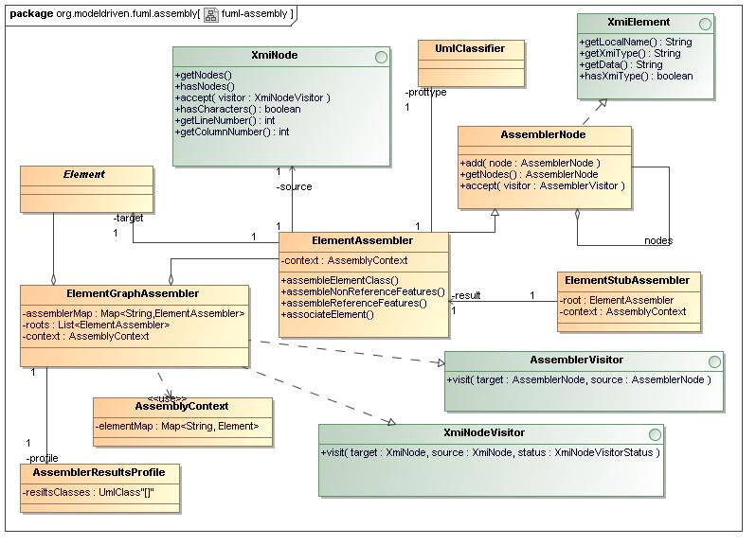
- fuml-assembly Diagram

Name | org.modeldriven.fuml.assembly
Qualified Name | org.modeldriven.fuml.assembly

Class AssemblerNode
Description
Encapsulates traversal logic as required by the Visitor pattern.
Name | AssemblerNode
Qualified Name | org.modeldriven.fuml.assembly::AssemblerNode
Visibility | public
Abstract | false
Base Classifier
Realized Interface | - XmiElement  - XmiIdentity

Attribute Detail
Following are the attributes for class, AssemblerNode.
Table 87 – AssemblerNode Attribute Detail

Atttribute Name | Description | Type | Visibility

Operation Detail
Following are the operations for class, AssemblerNode.

Table 88 – AssemblerNode Operation Detail

Operation Name | Description |  | Type | Parameters |  | Visibility
accept |  | Receives a visitor for traversal with this node as the traversal context root. |  | inout visitor : AssemblerVisitor | public
add |  | Adds the given "child" node to this node. |  | inout node : AssemblerNode | public
getNodes |  | Returns the current list of "child" nodes for this node. | AssemblerNode |  | public

Relation Detail
Following are the relations for class, AssemblerNode.

Table 89 – AssemblerNode Relation Detail

Relation Type | Related Elements
Association | AssemblerNode
Generalization | AssemblerNode  ElementAssembler
Interface Realization | AssemblerNode  XmiIdentity
Interface Realization | AssemblerNode  XmiElement
Usage | AssemblerNode  AssemblerVisitor

Class AssemblerResultsProfile
Description
Describes "root" elements required as results from the assembly of an Element graph.
Name | AssemblerResultsProfile
Qualified Name | org.modeldriven.fuml.assembly::AssemblerResultsProfile
Visibility | public
Abstract | false
Base Classifier
Realized Interface

Attribute Detail
Following are the attributes for class, AssemblerResultsProfile.
Table 90 – AssemblerResultsProfile Attribute Detail

Atttribute Name | Description | Type |  | Visibility
resiltsClasses |  |  | UmlClass |  | private

Relation Detail
Following are the relations for class, AssemblerResultsProfile.

Table 91 – AssemblerResultsProfile Relation Detail

Relation Type | Related Elements
Association | AbstractImport  AssemblerResultsProfile
Association | AssemblerResultsProfile  ElementGraphAssembler

Class AssemblyContext
Description
Used to capture global in-progress assembly information related to an import.
Name | AssemblyContext
Qualified Name | org.modeldriven.fuml.assembly::AssemblyContext
Visibility | public
Abstract | false
Base Classifier
Realized Interface

Attribute Detail
Following are the attributes for class, AssemblyContext.
Table 92 – AssemblyContext Attribute Detail

Atttribute Name | Description | Type |  | Visibility
elementMap | Contains a map of XMI id strings to fUML elements. Elements within this context may be successfully completed fUML elements or element "stubs" representing portions of an import stream found to be invalid. |  | Map<String, Element> |  | private

Relation Detail
Following are the relations for class, AssemblyContext.

Table 93 – AssemblyContext Relation Detail

Relation Type | Related Elements
Usage | AssemblyContext  ElementGraphAssembler

Class ElementGraphAssembler
Description
Given a strict hierarchy of XmiNode instances, this class assembles a graph structure composed of fUML Element instances. In general, for each node in the XmiNode hierarchy, the XmiNode is supplanted by an ElementAssembler node, the original XmiNode then being used as a delegate. This assembler "scafholding" is kept inplace until all elements in the target graph structure are fullly assembled and linked.
Name | ElementGraphAssembler
Qualified Name | org.modeldriven.fuml.assembly::ElementGraphAssembler
Visibility | public
Abstract | false
Base Classifier
Realized Interface | - AssemblerVisitor  - XmiNodeVisitor

Attribute Detail
Following are the attributes for class, ElementGraphAssembler.
Table 94 – ElementGraphAssembler Attribute Detail

Atttribute Name | Description | Type |  | Visibility
assemblerMap | A global map of assemblers used for reference lookup across any element within the current execution environment. |  | Map<String,ElementAssembler> |  | private
context | The current global assembly context |  | AssemblyContext |  | private
profile |  |  | AssemblerResultsProfile |  | private
roots | The resulting list of assembled Element roots. |  | List<ElementAssembler> |  | private

Relation Detail
Following are the relations for class, ElementGraphAssembler.

Table 95 – ElementGraphAssembler Relation Detail

Relation Type | Related Elements
Association | ElementAssembler  ElementGraphAssembler
Association | Element  ElementGraphAssembler
Association | AssemblerResultsProfile  ElementGraphAssembler
Interface Realization | AssemblerVisitor  ElementGraphAssembler
Interface Realization | ElementGraphAssembler  XmiNodeVisitor
Usage | ElementGraphAssembler  PackagedElementImport
Usage | ElementAssembler  ElementGraphAssembler
Usage | ElementGraphAssembler  org.modeldriven.fuml.model
Usage | ElementGraphAssembler  LibraryModelImport
Usage | ElementGraphAssembler  ModelImport
Usage | AssemblyContext  ElementGraphAssembler

Class ElementStubAssembler
Description
When a particular portion or "frame" within a stream representing a fUML element and its sub-elements is found to be invalid, it must still be linked to valid elements within the stream. This class creates an empty fUML element class as a "stub", such that it can be linked to other elements and so that it's validity (i.e. the fact that it is a stub) can be determined at runtime. On execution, if a stub is encountered a fatal user exception is thrown.
Name | ElementStubAssembler
Qualified Name | org.modeldriven.fuml.assembly::ElementStubAssembler
Visibility | public
Abstract | false
Base Classifier
Realized Interface

Attribute Detail
Following are the attributes for class, ElementStubAssembler.
Table 96 – ElementStubAssembler Attribute Detail

Atttribute Name | Description | Type |  | Visibility
context | The current global assembly context |  | AssemblyContext |  | private
result |  |  | ElementAssembler |  | private
root |  |  | ElementAssembler |  | private

Relation Detail
Following are the relations for class, ElementStubAssembler.

Table 97 – ElementStubAssembler Relation Detail

Relation Type | Related Elements
Association | ElementAssembler  ElementStubAssembler
Usage | ElementStubAssembler  PackagedElementImport
Usage | ElementStubAssembler  ModelImport
Usage | ElementStubAssembler  ModelImport

Interface Assembler
Description

Name | Assembler
Qualified Name | org.modeldriven.fuml.assembly::Assembler
Visibility | public
Base Classifier

Relation Detail
Following are the relations for interface, Assembler.
Table 98 – Assembler Relation Detail

Relation Type | Related Elements
Interface Realization | Assembler  ElementAssembler

Interface AssemblerVisitor
Description
Visitor interface which requires, for each node encountered in a traversal, both the beginning and ending of the acceptance of each node to be signaled.
Name | AssemblerVisitor
Qualified Name | org.modeldriven.fuml.assembly::AssemblerVisitor
Visibility | public
Base Classifier

Operation Detail
Following are the operations for interface, AssemblerVisitor.

Table 99 – AssemblerVisitor Operation Detail

Operation Name | Description | Type | Parameters | Visibility

Relation Detail
Following are the relations for interface, AssemblerVisitor.
Table 100 – AssemblerVisitor Relation Detail

Relation Type | Related Elements
Interface Realization | AssemblerVisitor  ElementGraphAssembler
Usage | AssemblerNode  AssemblerVisitor

Package org.modeldriven.fuml.common.bind

Description

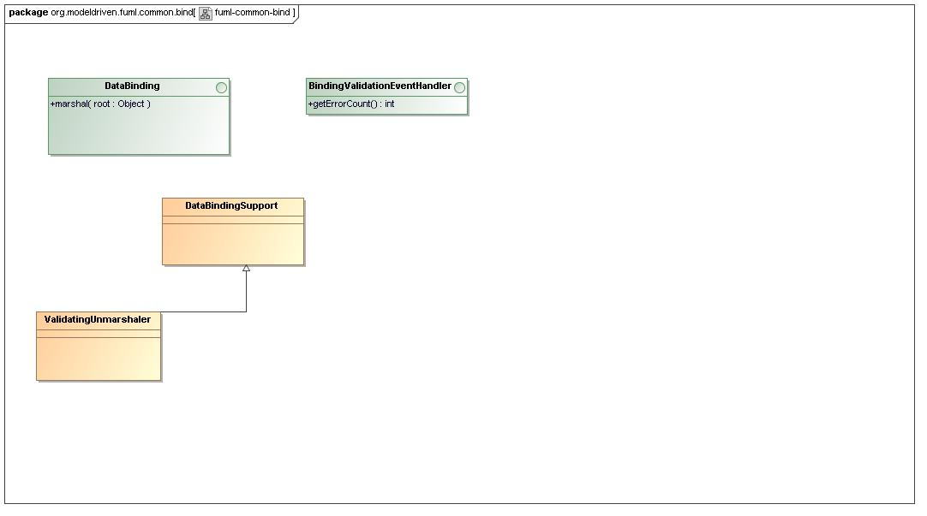
- fuml-common-bind Diagram

Name | org.modeldriven.fuml.common.bind
Qualified Name | org.modeldriven.fuml.common.bind

Interface BindingValidationEventHandler
Description
Extends the JAXB validation event handler for use in XMI import.
Name | BindingValidationEventHandler
Qualified Name | org.modeldriven.fuml.common.bind::BindingValidationEventHandler
Visibility | public
Base Classifier

Operation Detail
Following are the operations for interface, BindingValidationEventHandler.

Table 101 – BindingValidationEventHandler Operation Detail

Operation Name | Description | Type | Parameters | Visibility

Relation Detail
Following are the relations for interface, BindingValidationEventHandler.
Table 102 – BindingValidationEventHandler Relation Detail

Relation Type | Related Elements
Interface Realization | BindingValidationEventHandler  XmiValidationEventHandler

Interface DataBinding
Description
Encapsulates marshaling as wells as both validating and non-validating unmarshaling from various input sources and types.
Name | DataBinding
Qualified Name | org.modeldriven.fuml.common.bind::DataBinding
Visibility | public
Base Classifier

Operation Detail
Following are the operations for interface, DataBinding.

Table 103 – DataBinding Operation Detail

Operation Name | Description | Type | Parameters | Visibility

Relation Detail
Following are the relations for interface, DataBinding.
Table 104 – DataBinding Relation Detail

Relation Type | Related Elements
Interface Realization | DataBinding  ModelDataBinding
Interface Realization | DataBinding  LibraryConfigDataBinding
Interface Realization | DataBinding  XmiDataBinding

Package org.modeldriven.fuml.config

Description
This package handles simple XML representation and unmarshaling of various configuration structures. All configuration classes are generated and used at runtime in a read-only context. A singleton "root" class, FumlConfiguration, is the single access point through which clients access configuration information.
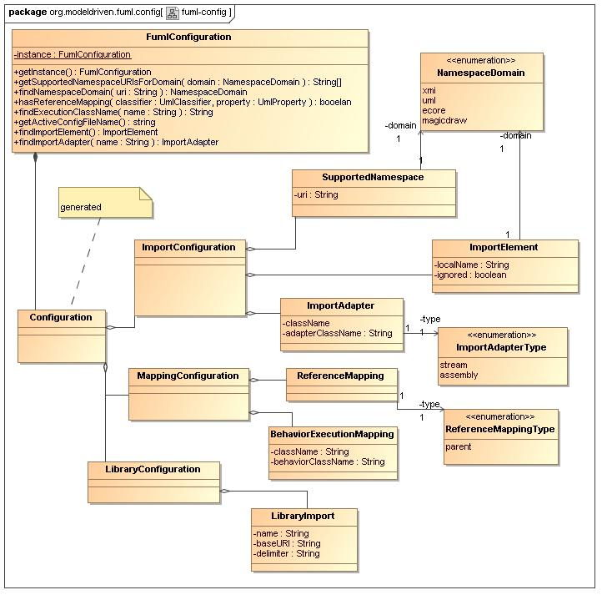
- fuml-config Diagram

Name | org.modeldriven.fuml.config
Qualified Name | org.modeldriven.fuml.config

Class BehaviorExecutionMapping
Description
Maps a library class name to a specific behavior execution class.
Name | BehaviorExecutionMapping
Qualified Name | org.modeldriven.fuml.config::BehaviorExecutionMapping
Visibility | public
Abstract | false
Base Classifier
Realized Interface

Attribute Detail
Following are the attributes for class, BehaviorExecutionMapping.
Table 105 – BehaviorExecutionMapping Attribute Detail

Atttribute Name | Description | Type |  | Visibility
behaviorClassName | The qualified behavior class anme. |  | String |  | private
className | The qualified library class name. |  | String |  | private

Relation Detail
Following are the relations for class, BehaviorExecutionMapping.

Table 106 – BehaviorExecutionMapping Relation Detail

Relation Type | Related Elements
Association | BehaviorExecutionMapping  MappingConfiguration

Class Configuration
Description
Configuration "root" class.
Name | Configuration
Qualified Name | org.modeldriven.fuml.config::Configuration
Visibility | public
Abstract | false
Base Classifier
Realized Interface

Attribute Detail
Following are the attributes for class, Configuration.
Table 107 – Configuration Attribute Detail

Atttribute Name | Description | Type | Visibility

Relation Detail
Following are the relations for class, Configuration.

Table 108 – Configuration Relation Detail

Relation Type | Related Elements
Association | Configuration  ImportConfiguration
Association | Configuration  MappingConfiguration
Association | Configuration  FumlConfiguration
Association | Configuration  LibraryConfiguration

Class FumlConfiguration
Description
Singleton configuration root class used at runtime to determine various configuration structural elements and properties.
Name | FumlConfiguration
Qualified Name | org.modeldriven.fuml.config::FumlConfiguration
Visibility | public
Abstract | false
Base Classifier
Realized Interface

Attribute Detail
Following are the attributes for class, FumlConfiguration.
Table 109 – FumlConfiguration Attribute Detail

Atttribute Name | Description | Type |  | Visibility
instance | The static singleton instance. |  | FumlConfiguration |  | private

Operation Detail
Following are the operations for class, FumlConfiguration.

Table 110 – FumlConfiguration Operation Detail

Operation Name | Description |  | Type | Parameters |  | Visibility
findExecutionClassName |  | Returns the execution environment execution class name for the given library class name. | String | inout name : String | public
findImportAdapter |  | Returns the import adapter, if exists, for the given class name. | ImportAdapter | inout name : String | public
findImportElement |  | Returns the import element, if exists, for the given class name. | ImportElement |  | public
findNamespaceDomain |  | Returns the namespace domain for the given namespace URI, if exists. | NamespaceDomain | inout uri : String | public
getActiveConfigFileName |  | Returns the full file path for the configuration file currently in use. | string |  | public
getInstance |  | Returns the sole instance of this singleton class. | FumlConfiguration |  | public
getSupportedNamespaceURIsForDomain |  | Returns an array of namespace URI's for the given domain. | String[] | inout domain : NamespaceDomain | public
hasReferenceMapping |  | Returns whether the given classifier has a reference mapping configured for the given property. | booelan | inout classifier : UmlClassifier  inout property : UmlProperty | public

Relation Detail
Following are the relations for class, FumlConfiguration.

Table 111 – FumlConfiguration Relation Detail

Relation Type | Related Elements
Association | Configuration  FumlConfiguration
Usage | FumlConfiguration  StreamNode
Usage | FumlConfiguration  StreamContext

Class ImportAdapter
Description
Represents an adapter used at runtime to modify inbound data.
Name | ImportAdapter
Qualified Name | org.modeldriven.fuml.config::ImportAdapter
Visibility | public
Abstract | false
Base Classifier
Realized Interface

Attribute Detail
Following are the attributes for class, ImportAdapter.
Table 112 – ImportAdapter Attribute Detail

Atttribute Name | Description | Type | Visibility
adapterClassName | The unqualified adapter class name | String | private
className | The unqualified element class name |  | private
type |  | ImportAdapterType | private

Relation Detail
Following are the relations for class, ImportAdapter.

Table 113 – ImportAdapter Relation Detail

Relation Type | Related Elements
Association | ImportAdapter  ImportAdapterType
Association | ImportAdapter  ImportConfiguration

Class ImportConfiguration
Description
Import configuration root class.
Name | ImportConfiguration
Qualified Name | org.modeldriven.fuml.config::ImportConfiguration
Visibility | public
Abstract | false
Base Classifier
Realized Interface

Attribute Detail
Following are the attributes for class, ImportConfiguration.
Table 114 – ImportConfiguration Attribute Detail

Atttribute Name | Description | Type | Visibility

Relation Detail
Following are the relations for class, ImportConfiguration.

Table 115 – ImportConfiguration Relation Detail

Relation Type | Related Elements
Association | ImportConfiguration  ImportElement
Association | ImportConfiguration  SupportedNamespace
Association | Configuration  ImportConfiguration
Association | ImportAdapter  ImportConfiguration

Class LibraryImport
Description
Represents an internal library loaded at runtime as libraries are referenced.
Name | LibraryImport
Qualified Name | org.modeldriven.fuml.config::LibraryImport
Visibility | public
Abstract | false
Base Classifier
Realized Interface

Attribute Detail
Following are the attributes for class, LibraryImport.
Table 116 – LibraryImport Attribute Detail

Atttribute Name | Description | Type | Visibility
baseURI | The URI to uses as the basis for looking up elements within this library. | String | private
delimiter | The delimiter character(s) used to seperate URI tokens. | String | private
name | The unqualified file name. | String | private

Relation Detail
Following are the relations for class, LibraryImport.

Table 117 – LibraryImport Relation Detail

Relation Type | Related Elements
Association | LibraryConfiguration  LibraryImport

Class MappingConfiguration
Description
Mapping configuration root class.
Name | MappingConfiguration
Qualified Name | org.modeldriven.fuml.config::MappingConfiguration
Visibility | public
Abstract | false
Base Classifier
Realized Interface

Attribute Detail
Following are the attributes for class, MappingConfiguration.
Table 118 – MappingConfiguration Attribute Detail

Atttribute Name | Description | Type | Visibility

Relation Detail
Following are the relations for class, MappingConfiguration.

Table 119 – MappingConfiguration Relation Detail

Relation Type | Related Elements
Association | MappingConfiguration  ReferenceMapping
Association | BehaviorExecutionMapping  MappingConfiguration
Association | Configuration  MappingConfiguration

Class SupportedNamespace
Description
Class representing a specific namespace URI that is to be supported for the associated NamespaceDomain.
Name | SupportedNamespace
Qualified Name | org.modeldriven.fuml.config::SupportedNamespace
Visibility | public
Abstract | false
Base Classifier
Realized Interface

Attribute Detail
Following are the attributes for class, SupportedNamespace.
Table 120 – SupportedNamespace Attribute Detail

Atttribute Name | Description | Type | Visibility
domain |  | NamespaceDomain | private
uri | The namespace URI. | String | private

Relation Detail
Following are the relations for class, SupportedNamespace.

Table 121 – SupportedNamespace Relation Detail

Relation Type | Related Elements
Association | ImportConfiguration  SupportedNamespace
Association | NamespaceDomain  SupportedNamespace

Enumeration ImportAdapterType
Description
An enumeration indicating the type of import adapter.
Name | ImportAdapterType
Qualified Name | org.modeldriven.fuml.config::ImportAdapterType
Visibility | public
Base Classifier

Literal Detail
Following are the literals for enumeration, ImportAdapterType.

Table 122 – ImportAdapterType Literal Detail

Literal Name | Description
assembly | Indicates an adapter invoked during assembly processing. See the fuml.assembly package for more information on assembly processing.
stream | Indicates an adapter used within stream processing.

Relation Detail
Following are the relations for enumeration, ImportAdapterType.

Table 123 – ImportAdapterType Relation Detail

Relation Type | Related Elements
Association | ImportAdapter  ImportAdapterType

Enumeration NamespaceDomain
Description

Name | NamespaceDomain
Qualified Name | org.modeldriven.fuml.config::NamespaceDomain
Visibility | public
Base Classifier

Literal Detail
Following are the literals for enumeration, NamespaceDomain.

Table 124 – NamespaceDomain Literal Detail

Literal Name | Description
ecore | The ecore namespace domain
magicdraw | The MagicDraw namespace domain
uml | The UML namespace domain
xmi | The XMI namespace domain

Relation Detail
Following are the relations for enumeration, NamespaceDomain.

Table 125 – NamespaceDomain Relation Detail

Relation Type | Related Elements
Association | ImportElement  NamespaceDomain
Association | NamespaceDomain  SupportedNamespace

Enumeration ReferenceMappingType
Description
Represents a mapping configuration type relating derived references to the respective mapped location.
Name | ReferenceMappingType
Qualified Name | org.modeldriven.fuml.config::ReferenceMappingType
Visibility | public
Base Classifier

Literal Detail
Following are the literals for enumeration, ReferenceMappingType.

Table 126 – ReferenceMappingType Literal Detail

Literal Name | Description
parent | Indicates a parent mapping.

Relation Detail
Following are the relations for enumeration, ReferenceMappingType.

Table 127 – ReferenceMappingType Relation Detail

Relation Type | Related Elements
Association | ReferenceMapping  ReferenceMappingType

Package org.modeldriven.fuml.environment

Description

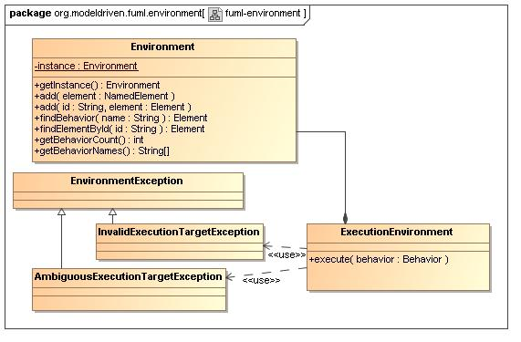
- fuml-environment Diagram

Name | org.modeldriven.fuml.environment
Qualified Name | org.modeldriven.fuml.environment

Class ExecutionEnvironment
Description
Delegate class used to execute behaviors.
Name | ExecutionEnvironment
Qualified Name | org.modeldriven.fuml.environment::ExecutionEnvironment
Visibility | public
Abstract | false
Base Classifier
Realized Interface

Attribute Detail
Following are the attributes for class, ExecutionEnvironment.
Table 128 – ExecutionEnvironment Attribute Detail

Atttribute Name | Description | Type | Visibility

Operation Detail
Following are the operations for class, ExecutionEnvironment.

Table 129 – ExecutionEnvironment Operation Detail

Operation Name | Description |  | Type | Parameters | Visibility
execute |  | Executes the given behavior. |  | inout behavior : Behavior | public

Relation Detail
Following are the relations for class, ExecutionEnvironment.

Table 130 – ExecutionEnvironment Relation Detail

Relation Type | Related Elements
Association | Environment  ExecutionEnvironment
Usage | Environment  ExecutionEnvironment
Usage | ExecutionEnvironment  Fuml
Usage | AmbiguousExecutionTargetException  ExecutionEnvironment
Usage | EnvironmentException  ExecutionEnvironment
Usage | ExecutionEnvironment  InvalidExecutionTargetException

Package org.modeldriven.fuml.library

Description

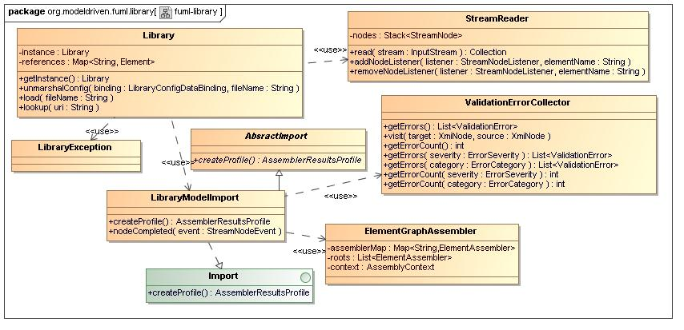
- fuml-library Diagram

Name | org.modeldriven.fuml.library
Qualified Name | org.modeldriven.fuml.library

Class Library
Description
This class loads an orded set of UML (library) artifacts, mapping unique element names to elements for easy lookup.
Name | Library
Qualified Name | org.modeldriven.fuml.library::Library
Visibility | public
Abstract | false
Base Classifier
Realized Interface

Attribute Detail
Following are the attributes for class, Library.
Table 131 – Library Attribute Detail

Atttribute Name | Description | Type | Visibility
instance | Singleton instance. | Library | private
references | Library map of registered elements. | Map<String, Element> | private

Operation Detail
Following are the operations for class, Library.

Table 132 – Library Operation Detail

Operation Name | Description |  | Type | Parameters |  | Visibility
getInstance |  | Retruns the (single) instance of this class. | Library |  | public
load |  | Reads the given library file loading the XMI into a fUML object grap, mapping relevant "root" objects to URI's. |  | inout fileName : String | public
lookup |  |  |  | inout uri : String | public
unmarshalConfig |  |  |  | inout binding : LibraryConfigDataBinding  inout fileName : String | public

Relation Detail
Following are the relations for class, Library.

Table 133 – Library Relation Detail

Relation Type | Related Elements
Usage | Library  LibraryConfigDataBinding
Usage | Library  LibraryException
Usage | Library  LibraryModelImport
Usage | Library  StreamReader

Class LibraryModelImport
Description
This class supports all-or-nothing validation and assembly into fUML of an XMI stream using the root UML 'Model' structure as the fundamental import unit. As the 'Model' structure is read from the stream, this class is notified using the StreamNodeListener interface. It then validates the given node hierarchy using ValidationErrorCollector from the xmi.validation package. If no validation errors are detected, the node hierarchy is assembled into a fUML object graph using ElementGraphAssembler from the fuml.assembly package. Otherwise if fatal validation errors are detected, the fatal validation errors are listed and an exception is thrown.
Name | LibraryModelImport
Qualified Name | org.modeldriven.fuml.library::LibraryModelImport
Visibility | public
Abstract | false
Base Classifier | - AbstractImport
Realized Interface | - Import

Operation Detail
Following are the operations for class, LibraryModelImport.

Table 134 – LibraryModelImport Operation Detail

Operation Name | Description |  | Type | Parameters | Visibility
createProfile |  | Builds an assembly profile geared for all-or-nothing assembly of libraries which includes some of the following elements: Activity, FunctionBehavior, Operation, Property, Signal, Datatype, Class, Package. | AssemblerResultsProfile |  | public
nodeCompleted |  | Event listener implementation method triggering core import processing. |  | inout event : StreamNodeEvent | public

Relation Detail
Following are the relations for class, LibraryModelImport.

Table 135 – LibraryModelImport Relation Detail

Relation Type | Related Elements
Generalization | AbstractImport  LibraryModelImport
Interface Realization | Import  LibraryModelImport
Usage | LibraryModelImport  ValidationErrorCollector
Usage | Library  LibraryModelImport
Usage | ElementGraphAssembler  LibraryModelImport

Package org.modeldriven.fuml.model

Description
This package supports model-driven software designs by providing efficient, convienent access to runtime metadata. By using external metadata provided by this package, clients are freed to focus on relevant tasks, rather than embedding metadata and related business logic, facilitating more elegant implementation results. All metadata java object-model classes used by this package are generated at build-time using XML Schema and JAXB 2 Data Binding. On initialization, a configurable ordered set of UML artifacts are unmarshaled and merged. See the Model class description for more information.

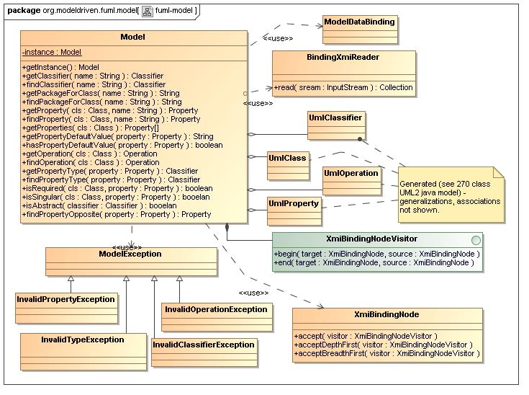
- fuml-model Diagram

Name | org.modeldriven.fuml.model
Qualified Name | org.modeldriven.fuml.model

Class Model
Description
This class is a singleton through which all metadata for the fuml.model package is accessed. It supports basic metadata operations such as determining package names, classifier types, feature and parameter names and types, defaults and multiplicities. All underlying metadata classes are are generated at build-time using XML Schema and JAXB 2 Data-Binding, XmiBindingNode being configured as the generic superclass. On initialization, a configurable ordered set of UML artifacts are unmarshaled and merged. The Visitor pattern is used to support merge and other traversal related operations (See the XmiBindingNodeVisitor interface). UML packages, classifiers, properties and other elements are mapped internally and accessed through simple public methods for effient and convienent access by cleints.
Name | Model
Qualified Name | org.modeldriven.fuml.model::Model
Visibility | public
Abstract | false
Base Classifier
Realized Interface

Attribute Detail
Following are the attributes for class, Model.
Table 136 – Model Attribute Detail

Atttribute Name | Description | Type | Visibility
instance | The static singleton instance. | Model | private

Operation Detail
Following are the operations for class, Model.

Table 137 – Model Operation Detail

Operation Name | Description |  | Type | Parameters | Visibility
findClassifier |  | Returns the classifier for the given name if exists, otherwise returns null. | Classifier | inout name : String | public
findOperation |  | Returns the operation for the given name associated with the given classifier, if exists. Otherwise returns null. | Operation | inout cls : Class | public
findPackageForClass |  | Returns the qualified package name for the given classifier name if exists, otherwise returns null. | String | inout name : String | public
findProperty |  | Returns the property for the given name assiciated with the given classifier if exists, otherwise return null. | Property | inout cls : Class  inout name : String | public
findPropertyOpposite |  | Returns the opposite property, if exists, for the given property. Otherwise returns null. | Property | inout property : Property | public
findPropertyType |  | Returns the type classifier, if exists, for the given property. Otherwise returns null. | Classifier | inout property : Property | public
getClassifier |  | Returns the classifier for the given name if exists, otherwise throws an InvalidClassifierException. | Classifier | inout name : String | public
getInstance |  | Returns the single instance. | Model |  | public
getOperation |  | Returns the operation for the given name associated with the given classifier, if exists. Otherwise throws InvalidOperationException. | Operation | inout cls : Class | public
getPackageForClass |  | Returns the qualified package name for the given classifier name if exists, otherwise throws an InvalidClassifierException. | String | inout name : String | public
getProperties |  | Returns an array of properties for the given class and its ancestry. | Property[] | inout cls : Class | public
getProperty |  | Returns the property for the given name assiciated with the given classifier if exists, otherwise throws an InvalidPropertyException. | Property | inout cls : Class  inout name : String | public
getPropertyDefaultValue |  | Returns the default (string) value, if exists, for the given property. | String | inout property : Property | public
getPropertyType |  | Returns the type classifier, if exists, for the given property. Otherwise throws InvalidTypeException. | Classifier | inout property : Property | public
hasPropertyDefaultValue |  | Returns whether a default (string) value exists for the given property. | boolean | inout property : Property | public
isAbstract |  | Returns whether the given classifier is abstract. | booelan | inout classifier : Classifier | public
isRequired |  | Returns whether the given property is required (it's lower-value > 0 ) for the given class. | boolean | inout cls : Class  inout property : Property | public
isSingular |  | Returns whether the given property is singular (it's upper-value == 1) for the given class. | booelan | inout cls : Class  inout property : Property | public

Relation Detail
Following are the relations for class, Model.

Table 138 – Model Relation Detail

Relation Type | Related Elements
Association | Model  UmlClass
Association | Model  UmlProperty
Association | Model  UmlOperation
Association | Model  XmiBindingNodeVisitor
Association | Model  UmlClassifier
Usage | Model  XmiBindingNode
Usage | Model  ModelException
Usage | Model  ModelDataBinding

Interface Class
Description

Name | Class
Qualified Name | org.modeldriven.fuml.model::Class
Visibility | public
Base Classifier | - Classifier

Relation Detail
Following are the relations for interface, Class.
Table 139 – Class Relation Detail

Relation Type | Related Elements
Generalization | Class  Classifier

Interface Classifier
Description

Name | Classifier
Qualified Name | org.modeldriven.fuml.model::Classifier
Visibility | public
Base Classifier

Relation Detail
Following are the relations for interface, Classifier.
Table 140 – Classifier Relation Detail

Relation Type | Related Elements
Generalization | Class  Classifier

Interface Element
Description

Name | Element
Qualified Name | org.modeldriven.fuml.model::Element
Visibility | public
Base Classifier

Relation Detail
Following are the relations for interface, Element.
Table 141 – Element Relation Detail

Relation Type | Related Elements
Generalization | Element  NamedElement

Interface NamedElement
Description

Name | NamedElement
Qualified Name | org.modeldriven.fuml.model::NamedElement
Visibility | public
Base Classifier | - Element

Relation Detail
Following are the relations for interface, NamedElement.
Table 142 – NamedElement Relation Detail

Relation Type | Related Elements
Generalization | Element  NamedElement
Generalization | NamedElement  TypedElement

Interface Operation
Description

Name | Operation
Qualified Name | org.modeldriven.fuml.model::Operation
Visibility | public
Base Classifier

Interface Property
Description

Name | Property
Qualified Name | org.modeldriven.fuml.model::Property
Visibility | public
Base Classifier | - TypedElement

Relation Detail
Following are the relations for interface, Property.
Table 143 – Property Relation Detail

Relation Type | Related Elements
Generalization | Property  TypedElement

Interface TypedElement
Description

Name | TypedElement
Qualified Name | org.modeldriven.fuml.model::TypedElement
Visibility | public
Base Classifier | - NamedElement

Relation Detail
Following are the relations for interface, TypedElement.
Table 144 – TypedElement Relation Detail

Relation Type | Related Elements
Generalization | Property  TypedElement
Generalization | NamedElement  TypedElement

Appendix A. References
Table A-1 References
Reference ID | Reference
[Wilkie2004] | “Model Driven Architecture with Executable UML” - Chris Raistrick, Paul Francis, John Wright, Colin Carter, Ian Wilkie – Cambridge University Press, 2004 PP. 39
[Hohpe2004] | “Enterprise Integration Patterns” – Gregor Hohpe, Bobby Woolf , Addison Wesley 2004, PP. 130 “Channel Adapters” , PP. 328 “Metadata Management”
[Rising2000] | “The Pattern Almanac 2000” - Linda Rising, Addison Wesley 2000 - PP. 108 “Object Metadata”
[Fowler2003] | “Patterns of Enterprise Application Architecture” – Martin Fowler, Addison Wesley, 2003 - PP. 306 “Metadata Mapping”

Appendix B. Acronyms
Table B-2 Acronyms
Acronym | Description
fUML | Foundational Unified Modeling Language
MDA | Model Driven Architecture
EAI | Enterprise Application Integration
RI | Reference Implementation

