This archive contains MATLAB codes of both the original BGCT and improved BGCT models described in the following two papers:

**Paper 1**

Title: Bidirectional Control of Absence Seizures by the Basal

Ganglia: A Computational Evidence (2014)

Authors: Mingming Chen, Daqing Guo*, Tiebin Wang, Wei Jing, Yang

Xia, Peng Xu, Cheng Luo, Pedro A. Valdes-Sosa, and Dezhong Yao*

Journal: PLoS Computational Biology

Emails: twqylsf@gmail.com and dqguo@uestc.edu.cn

**Paper 2**

Title: Critical Roles of the Direct GABAergic Pallido-cortical Pathway in

Controlling Absence Seizures (2015, in press, DOI: 10.1371/journal.pcbi.1004539)

Authors: Mingming Chen, Daqing Guo∗, Min Li, Tao Ma, Shengdun Wu,

Jingling Ma, Yan Cui, Yang Xia, Peng Xu, and Dezhong Yao*

Journal: PLoS Computational Biology

Emails: twqylsf@gmail.com and dqguo@uestc.edu.cn

In addition, this archive also provides a comparable XPPAUT implementation of the original BGCT model.

Please see the scripts in BGCT_matlab_paper1 file for the MATLAB codes of the original BGCT model, and the BGCT_Basic.ode for the comparable XPPAUT code. The detailed information of these codes is described as follows:

1. The main mainFig2C.m script generates figures similar (not identical due to starting in a random initial condition) to Fig 2C in the paper 1. Zooming in on the origins of the subplots in the figure mainFig2C.m generated should therefore look something like:

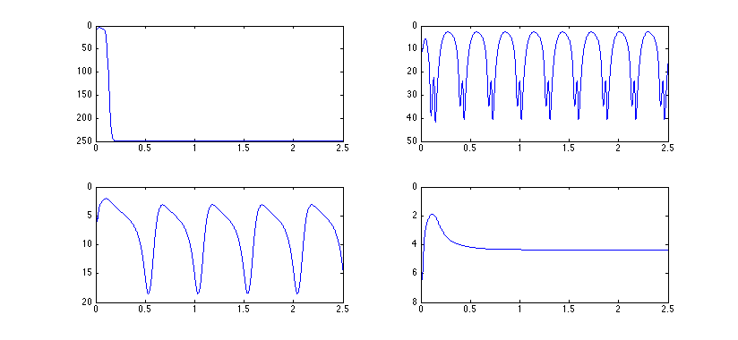

1. The scripts (main_bifurcation_Fig2A, main_bifurcation_Fig2B, main_bifurcation_Fig3C, and main_bifurcation_Fig3D) generate all bifurcation diagrams presented in paper 1. For each set of experimental parameters, we run 30 trails using different random initial conditions for checking the possible bistable dynamics.
2. The scripts (main_2D_analysis_Fig2DE, main_2D_analysis_Fig3AB, main_2D_analysis_Fig4AB, main_2D_analysis_Fig5AB) generate two-dimensional state and frequency diagrams similar to Figs 2D, 2E, 3A, 3B, 4A, 4B, 5A, and 5B in paper 1.

Please see the scripts in BGCT_matlab_paper2 file for the MATLAB codes of the improved BGCT model by incorporating a new efferent pathway representing direct connection from the GPe to the cerebral cortex. The detailed information of these codes is described as follows:

1. The BGCT_subfun_GPe_Basic script is the basic implementation of the improved BGCT model.
2. The scripts (BGCT_subfun_GPe_Fig2_So, BGCT_subfun_GPe_Fig4_Fig5_Sol, BGCT_subfun_GPe_Fig6_Fig7_Sol) generate the data used to plot two-dimensional state and frequency diagrams similar to Figs. 2, 4, 5, 6 and 7 in paper 2. For each set of experimental parameters, we run 30 trails using different random initial conditions for checking the possible bistable dynamics.
3. The BGCT_subfun_GPe_Fig3_Sol script generates all data used to plot the bifurcation diagrams, frequency diagrams as well as the mean firing rates for several critical neural populations in Fig 3 (paper 2).

Note that the other figures in these two papers could be easily reproduced using the codes provided in this archive by suitably tuning parameters.

MATLAB is commercial software available from http://www.mathworks.com

and XPPAut is free from http://www.math.pitt.edu/~bard/xpp/xpp.html

This archive was provided by Daqing Guo and Mingming Chen.