VOY Company

This document describes the **VOY** Company to ensure a better understanding of the company architecture since **VOY** Company is facing a problem at the selling service level. The service is quite unavailable especially during the rush hour. To resolve this problem **VOY** decides to describe some key points of its architecture in this document to help identifying the source of the service unavailability.

In the next sections of the current document, we will describe the company’s principles; we will then introduce the existing information system before illustrating the migration plans for the next year.

# The company description

**VOY** Company is a service travel discount company that provides for its customers a list of most unsold trips by other travel agencies. It offers various travel/vacation packages at sale price. The discount of prices may be up to 50% of the original price basically offered by the source travel agencies.

The sale prices of **VOY** offers can be explained by the fact that the departure going and coming dates are fixed and imposed by the company. The customer must be ready to travel in the fifteen days after the reservation.

# The existing Information System modeling (AS-IS)

The mission of **VOY** is to enable travelers to seek for and purchase a board array of products from more than 600 airlines, 25 car rental companies, many thousands of lodging properties worldwide, etc.

Therefore, **VOY** is facing the need to provide a very good system quality to book cheapest reservations for multi-modals travels by train, plane, moto, boat and car with an innovative way to reference suppliers. It is going to consolidate the C2C existing systems and allow visitor adding by himself new travel offers.

Today the company achieved a fast hit thanks to its booking abilities. Its booking site experienced a pretty growth period that depends in part on bringing round new customers during the information-unit phase of their purchase cycles.

The company now wants to achieve higher recipes per sale and higher levels of customer retention, while developing new recipes from sponsorships, syndication and third-party retail channels.

To realize these goals, **VOY** teams plan for content-related initiatives in the next fiscal year that would expose customers to more and better-targeted content, both onsite and pushed to customers via a variety of vehicles. At the same time, the company targets to lower costs with its management systems.

The basic System Architecture of **VOY** includes the travel agency’s complete customer service process. It contains functions for reservation, invoicing, cashier, account ledgers, accounts receivable, accounting reports, basic customer relationship management, agents, destinations/ products, producers, event reports, as well as E-mail and reference payments from external interfaces, and sales statistics, etc.

The travel agency operating process is built into the basic system.  All general specialty functions are also included:

* Reservation changes
* Reservation cancellation,
* Tax management,
* Preliminary and final invoices,
* Automatic credit notes,
* Target-specific terms of payment,
* Commissions,
* Entry into accounts based on the first day of travel,
* Reporting to the Consumer Agency, etc.

Expansion modules can be chosen according to needs:

* A tour operator;
* A hotel booking office, etc.

Choose a customer, products sold, and pricing if necessary. Ask **VOY** site to perform invoicing, the Company’s site then takes care of the rest: Taxes, commissions, capacity, pricing, and entry of information into accounting.

## Sales

As **VOY** targets to get a large market, the **VOY** reputation needs to be very faultless. Some regular surveys will be proposed to customers and we target to reach a satisfying rate of 80% of customers. Here, the central booking office refers to all companies that provide accommodation and related services in the area they are located. Usually, **VOY** has connection with ski resort or other kind of holiday facility. **VOY** can also offer some of their own capacity for sale. An important part of the company’s intermediately services is communication with the owners and caretakers of the accommodation, and with providers of other services. Another important duty is the automatic settlement of owner /service provider portions for reservations made. But the central booking office is already using this technics offered by the suitable group of additional services to reach the current satisfaction which is about 60% today.

Consequently we focus on the reservation process, **VOY** targets to get a rate of cancellations of less than 3%. The Commercial Department needs to be proactive to detect all problems in the following services: booking a trip, paying a trip. The department must manage correctly the reservation situations according to the system capacities. They need to constantly supervise capacity and warn of and prevent over-bookings. They also need to calculate utilization rates. In addition, they need to facilitate the automatic accounting process. Information is logged automatically into the system when reservations are made. The accounting report shows how much is accounted and to whom. Material due for banks are prepared using the accounting process so users don’t have to ask for it. All work related to accounting can be done quickly and efficiently with a few keystrokes.

## Offers

**VOY** Company offers travels which correspond to formulas, destinations and hosting services.

A formula is a choice between the following:

1. Plane or boat
2. Hotel
3. Plane or boat + hotel
4. Plane or boat + car
5. Plane or boat + hotel+ car

A destination is identified by the continent:

1. North Africa,
2. Africa (except the North),
3. Europe,
4. Asia,
5. America, etc.

The journey is always done in a single country.

The hosting service can be:

1. Accommodation only,
2. Breakfast
3. Half board
4. Full board

There is only one provision of accommodation for the whole stay.

The **VOY** innovation this year is focused on their customers: Allow a customer adding new travel offers. Therefore, the subscription of partnership needs to be very easy to use and very reliable. The central booking office can be expanded by taking into account this new function. Accommodation reservations are made on a day-level, and no capacity is reserved for the day of departure. Everyone in the company knows what time check-out must occur on the day of departure, and new customers coming in on the same day to the same room are known. Handling based on times of the day is therefore not completely necessary. Client needs for each product a specific detailed calendar to manage himself his travels, arriving, departures, etc.

With time reservation functions, two factors can be managed:

* Unusual arrival or departure times
* Reservation of additional services on a per hour-basis

If it has been agreed with the customer that instead of the normal check-out time or 12, check-out will take place at 3 PM, then this information will be included with the reservation, and the corresponding calendar is updated consequently so other customers are related to the same information. When making a new reservation for the same room, the system gives a warning about the unusual check-out time, and suitable arrangements can be made with the newly arriving customer.

Additional services such as conferences rooms and sauna times can be reserved on a per-hour basis with the time reservation function. If the conference room is reserved for 91M-3PM, another reservation can be made for 5PM-8PM. A number of sauna times can be reserved for the same evening, for example 4PM-6PM and 7PM-9PM, and the system warns if overlapping bookings are being made.

## Travel Broking

A secondary business is offered by **VOY:** selling trip listing for B2B partners. The IP system will need to provide an SOA access based on Websphere AS 4 to access remotely to several services like ListingOffers.

Here **VOY** employed their travel agencies which act primarily as an intermediary for indirect sales. Sales items include flight and ship tickets, package trips from different tour operators, accommodations, event tickets, etc. In addition to indirect sales, activities also include the agency’s own production on a made to order basis. This means that a package is created when an order comes in. An order is often preceded by offer stage, where the agency creates package for the offer. Actual tour operator activities don’t exist, which means trips are not available for general sale.

The **VOY** System is sufficient for this type of agency, but expansions may be useful. The Fin voice system is often required by customers. Other expansions will make internal activities more efficient. Available expansions to the agency’s system are generally intended to make indirect sales more efficient.

## Internal cost optimization

To improve the service quality and the TCO, OpenSource software’s are preferred as more as possible.

**VOY** is working on consolidating their booking site. The objective is primarily focusing on decreasing the rate of face to face reservations; as well as the rate of reservations by phone.

Intermediary agent’s system can be expanded with the Internet system, through which consumers can reserve flights and hotels by themselves as well as create travel packages (dynamic packages). The site manages connections to external systems used for flights and hotel searches according to customer requests. The site calculates and organizes the results and presents them to customers. The customer is then free to choose a trip, selecting either flight only, accommodation only, or creating a package with both flights and accommodation.

The Company site manages the whole reservation process from the moment a customer first makes contact until the customer pays for the reservation. Once the site has received confirmation of payment, it saves the whole reservation, including payment details into the Company server, accommodation reservations into hotels, Plane companies etc.

## Geographic organization

Today, **VOY** is composed of 3 agencies: Toulouse, Lyon and Bordeaux. The last agency is newly bought; since October 2014. The existing company based in Bordeaux had a duplicated commercial service with the Toulouse agency. As there was a duplication of commercial management business service, **VOY** decided to focus the Toulouse agency service on Partnership management and the Bordeaux agency service on offers management. Then Lyon agency is responsible of the booking system centralization and hosts every purchasing manager’s.

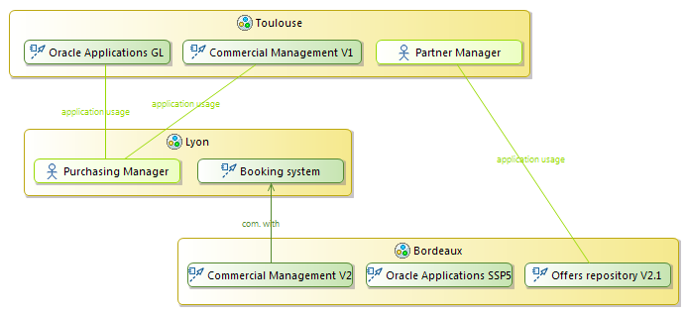

# The Migration plans for the next year

Let’s zoom in the general objective of customer’s satisfaction, **VOY** need primarily to facilitate the reservation process. The goal of this step is to reach more than 99% of selling service availability.

By looking into the Company’s architecture, we see that the “Booking a trip” business service is central for the described objective.

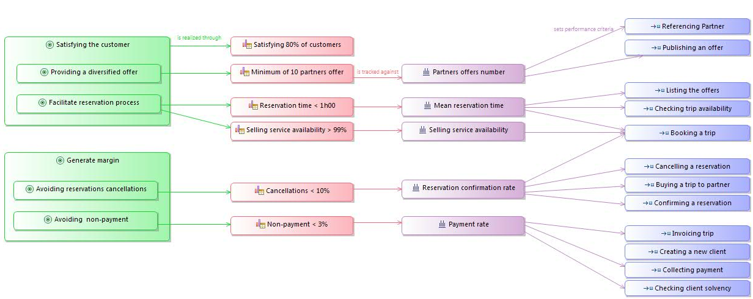

This “Booking a trip” service is provided by the booking management application which has identified several failures during the last year.

This application relies on several technologies:

* Client :
  + OS : Windows XP
  + Language : Java 5
* Server :
  + OS : Linux Redhat ES 4.3
  + Language : Java 5
  + Applications Server: WebShpere AS 7
  + Database : Oracle 10G

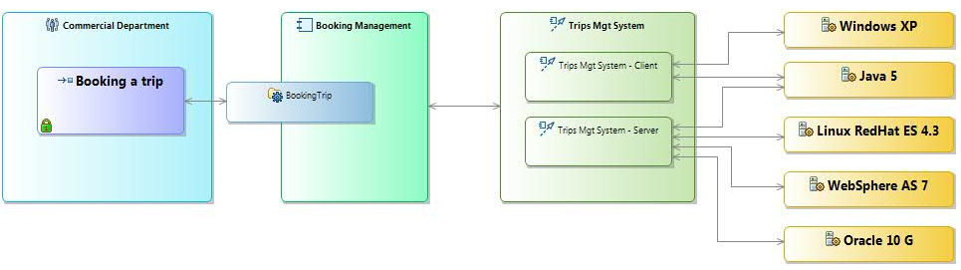

An audit has been realized and proves that the concerned failure is basically related to the technology used to run the whole application. It’s the Linux Redhat ES.

**VOY** IT Managers recognized that the used server version is quite old (4.3). They also found that the “Linux Redhat AS 6.0”; the new version of the same technology does fix all the detected problems in the earlier one.



That’s why **VOY** managers are now looking to replace the buggy technology by the newest one. They need first to justify their choice; then they need to establish a detailed impact analysis of the Linux RedHat ES 4.3 upgrade before producing a migration plan to take action.

They noticed that the use of the existing technology is impacting many levels: the technology, the application and the business levels.

All the related impacts described earlier in the document are illustrated in the following picture:

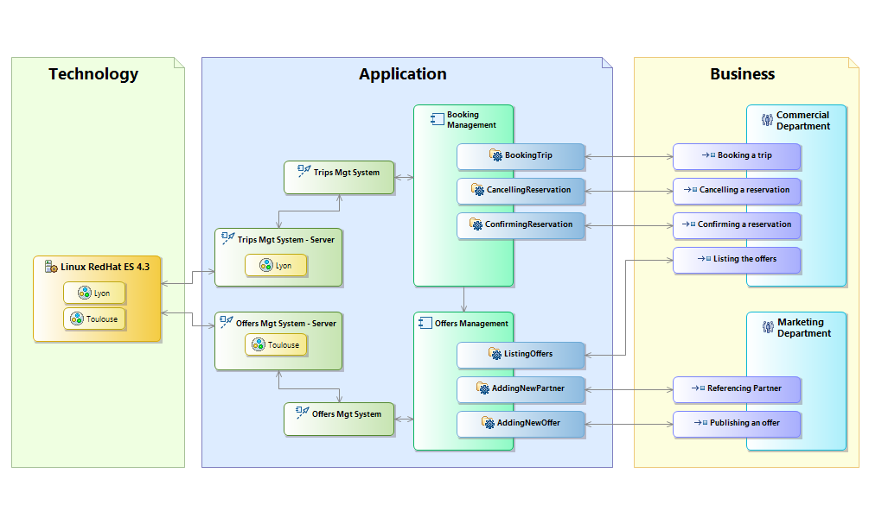

We look to replace the “**Linux RedHat ES 4.3**” component by the “**Linux RedHat ES 6**” component.

The migration plan of improvements between the current architecture and the future one are represented by replacing at the Technology level the buggy server by the new one.

This impacts directly the “Trips Mgt System Server” at Lyon agency and the “Offers Mgt System Server” at Toulouse agency.