|  |  |  |
| --- | --- | --- |
| **Date** | **Subject** | **Location** |
| **2014.11.08** | **Kick-off meeting** | **KoçSistem Headquarters, Istanbul, Turkey** |

**Attendees:**

|  |  |  |
| --- | --- | --- |
| **Name** | **Function** | **Company** |
| Ferhat Erata [FE] | Project Leader | UNIT |
| Etienne Juliot [EJ] | French Consortium Coordinator | OBEO |
| Dr. Erhan Mengüsoğlu [EM] | Turkish Consortium Coordinator | Mantis |
| Hale Gezgen [EG] | Secondary Contact Point | KoçSistem |
| Moharram Challenger [MC] | Secondary Contact Point | UNIT |
| Claire Gardent [SC] | Primary Contact Point | CNRS |

**Agenda:**

|  |  |
| --- | --- |
| **Topic** | **Comment** |
| Project official Kick-off Date  (M1 - [M] Kick-Off Meeting) | Official start date is 1 October 2014. This is the kick-off meeting |
| Workshop Meeting | 2-day workshop in January (face-face technical meeting) in Izmir (Smyrna), Turkey, search for a direct flight from Toulouse/Nantes  (<https://unit.doodle.com/pprrtcqg7fqp7w64>) |
| Yearly meetings | Yearly face-to-face meetings will be organized and synched at [Models](http://www.modelsconference.org/), [EclipseCon](https://www.eclipsecon.org) (additional to [ModelsWard](http://www.modelsward.org/), ECMDA conferences) |
| Project Site | [www.modelwriter.eu](http://www.modelwriter.eu) (will be later hosted on GitHub)  <http://modelwriter.github.io/> |
| Source Code Management (Repositories) | GitHub (Private Repository for use cases, Public Repository for Open Source Platform) <https://github.com/ModelWriter>  Work Package 1 - <https://github.com/ModelWriter/WP1>  Work Package 2 - <https://github.com/ModelWriter/WP2>  Work Package 3 - <https://github.com/ModelWriter/WP3>  Work Package 4 - <https://github.com/ModelWriter/WP4>  Work Package 5 - <https://github.com/ModelWriter/WP5>  Work Package 6 - <https://github.com/ModelWriter/WP6>  Work Package 7 - <https://github.com/ModelWriter/WP7> |
| Project Deliverables | <https://github.com/ModelWriter/Deliverables/issues> |
| Project Wiki | GitHub (<https://github.com/ModelWriter/Project-Collaboration/wiki>)  GitHub (for each WP, <https://github.com/ModelWriter/WP3/wiki>) |
| Project Email Account | Google Apps ([project@modelwriter.eu](mailto:project@modelwriter.eu)) |
| Project Emailing List | Google Groups ([consortium@modelwriter.eu](mailto:consortium@modelwriter.eu)) |
| Project Forum | <https://groups.google.com/a/modelwriter.eu/forum/#!forum/consortium> |
| Project Discussion | GitHub (<https://github.com/ModelWriter/Project-Collaboration/issues>) |
| Document Co-authoring | Google Drive (<http://goo.gl/IRjcKq>) |
| Document Management | GitHub (<https://github.com/ModelWriter/Document-Management>) |
| Issue Tracking | GitHub Issues, e.g. <https://github.com/ModelWriter/WP5/issues>)  Work Package 1 - <https://github.com/ModelWriter/WP1/issues>  Work Package 2 - <https://github.com/ModelWriter/WP2/issues>  Work Package 3 - <https://github.com/ModelWriter/WP3/issues>  Work Package 4 - <https://github.com/ModelWriter/WP4/issues>  Work Package 5 - <https://github.com/ModelWriter/WP5/issues>  Work Package 6 - <https://github.com/ModelWriter/WP6/issues>  Work Package 7 - <https://github.com/ModelWriter/WP7/issues> |
| Project Product Backlog  (Waffle.io and GitHub Issues) | <https://waffle.io/modelwriter/product-backlog>  <https://github.com/ModelWriter/Product-Backlog/issues> |
| Scrum Management  (Waffle.io and GitHub Issues) | Waffle.io and GitHub Issues, e.g. <https://waffle.io/ModelWriter/WP5>  Work Package 1 - <https://waffle.io/ModelWriter/WP1>  Work Package 2 - <https://waffle.io/ModelWriter/WP2>  Work Package 3 - <https://waffle.io/ModelWriter/WP3>  Work Package 4 - <https://waffle.io/ModelWriter/WP4>  Work Package 5 - <https://waffle.io/ModelWriter/WP5>  Work Package 6 - <https://waffle.io/ModelWriter/WP6>  Work Package 7 -<https://waffle.io/ModelWriter/WP7> |
| Teams | <https://github.com/orgs/ModelWriter/teams>  ---  <https://github.com/orgs/ModelWriter/teams/owners>  <https://github.com/orgs/ModelWriter/teams/pcc>  <https://github.com/orgs/ModelWriter/teams/tcc>  <https://github.com/orgs/ModelWriter/teams/wp1-committers>  <https://github.com/orgs/ModelWriter/teams/wp2-committers>  <https://github.com/orgs/ModelWriter/teams/wp3-committers>  <https://github.com/orgs/ModelWriter/teams/wp4-committers>  <https://github.com/orgs/ModelWriter/teams/wp5-committers>  <https://github.com/orgs/ModelWriter/teams/wp6-committers>  <https://github.com/orgs/ModelWriter/teams/wp7-committers> |
| Requirement Management | User Requirements Document (URD) & Software Requirements Document (SRD) (<https://github.com/ModelWriter/Requirements> )  WP1 - T1.7 – Consolidated User Requirements: A common User Requirements Document (URD) (D1.7.1) will be compiled from the catalogues of Industrial Use Case partners, resulting in a common list of formal requirements with initial prioritization, taking into account both national priorities and international commonalities / synergies.  WP1 - T1.9 – Software Requirements: A common Software Requirements Document (SRD) (D1.9.1) derived from the previous URD will identify and prioritize the functional and nonfunctional requirements for the ModelWriter IDE, addressing the selected User Requirements. |
| ITEA & ARTEMIS Co-summit 2015 - ModelWriter | UNIT will participate in ITEA & ARTEMIS Co-summit to present ModelWriter project. |
| Leadership of Work Package 1 - Industrial Use Cases and Requirements (SA) | For the sake of balanced work package distribution wrt countries and companies, Airbus seems the most suitable partner for industrial use case (EJ, FE) |
| Work Package Distribution | [Work Package 1](https://github.com/ModelWriter/WP1) - Industrial Use Cases and Requirements (? AIRBUS)  [Work Package 2](https://github.com/ModelWriter/WP2) - Semantic Parsing and Generation of Documents and Documents Components (LORIA)  [Work Package 3](https://github.com/ModelWriter/WP3) - Model to/from Knowledge Base (UNIT)  [Work Package 4](https://github.com/ModelWriter/WP4) - Knowledge Base Design and Implementation (MANTIS)  [Work Package 5](https://github.com/ModelWriter/WP5) - Project Management (UNIT)  [Work Package 6](https://github.com/ModelWriter/WP6) - ModelWriter Architecture, Integration and Evaluation (OBEO)  [Work Package 7](https://github.com/ModelWriter/WP7) - Standardization, Dissemination and Exploitation (OBEO) |
| M3 - [D] Industrial Use Cases and Requirements and Corpora | M3 -> M4 : write a reasonable justification in the report when it is done about shifting one month. |
| Meetings Recurrence | Meetings every two weeks. The first one is national and the second one is international. |
| Project Coordination Committee (PCC) | [[From The ModelWriter FPP](https://drive.google.com/a/unitbilisim.com/file/d/0B115qHHFY_rud1YzdGxiWlZPeFk/view?usp=sharing)] The **Project Coordination Committee** (PCC) consists of one representative for each participating partner. Such PCC is chaired by the Project Leader (UNIT), who endorses the overall responsibility for the execution of the contract, for the effective global management of the project, for maintaining contact with the ITEA organization and for monitoring the interaction and the relative progress of the work amongst the partners. |
| Technical Coordination Committee (TCC) | [[From The ModelWriter FPP](https://drive.google.com/a/unitbilisim.com/file/d/0B115qHHFY_rud1YzdGxiWlZPeFk/view?usp=sharing)] The **Technical Coordination Committee** (TCC) made up of the Work Package leaders. The TCC carries the overall technical responsibility of the project. Each work package leader is responsible for the progress, results, achievements and problems (incl. Technical Risks) within his work package, and periodically reports to the TCC. |
| Project Cooperation Agreement (PCA) & IPR (Intellectual Property Rights) | [[From the ITEA Rules & Regulations](https://drive.google.com/a/unitbilisim.com/file/d/0B115qHHFY_ruUzNSMjBZWlU2NUU/view?usp=sharing)] All partners in each ITEA project have to sign a Project Cooperation Agreement (PCA). The PCA details the cooperation between the project partners (contractors, and if applicable, subcontractors). For some PAs the PCA - signed by all partners - is a prerequisite for granting a funding contract or for executing the payments. The PCA has to explain:  a. the purpose and scope of the co-operation  b. the execution of subcontracting  c. financing aspects (if applicable)  d. confidentiality regulations  The main elements of a PCA are laid down in a PCA model. When submitting an FPP, all partners have to declare to the ITEA organisation that a PCA has been or will be signed. |
| OSS (Open Source Software) Licence | [From the ModelWriter FPP, The Dissemination Plan] OSS components should be defined. OSS Licences such as EPL (<http://choosealicense.com/licenses/>) |
| Eclipse Project Submission | [[From The ModelWriter FPP](https://drive.google.com/a/unitbilisim.com/file/d/0B115qHHFY_rud1YzdGxiWlZPeFk/view?usp=sharing)] dissemination & exploitation plan and open source campaign. |
| Goal definitions according to FPP | Goal definitions prior to product backlog must be set based on FPP by the consortium. |
| Creation of the Product Backlog of the project | Project Partners must contribute the product backlog (Features/Requirements)  <https://github.com/ModelWriter/Product-Backlog> |
| National Workshop on 4 Dec and 5 Dec 2014 in Ankara, Turkey in 5th Turkish Software Architecture Conference (UYMK 2014). | Presentation in Turkish Software Architecture Conference (UYMK 2014) <http://uymk.org.tr/> |
| ModelWriter presentation, call for OSS contribution, Dissemination Activity | Presentation in Turkish Software Architecture Conference (UYMK 2014) <http://uymk.org.tr/> |

**Action plan:**

|  |  |  |
| --- | --- | --- |
| **Item** | **Assigned to** | **Due Date** |
| Inform Belgian partners about kick-off meeting [Done] | [FE] | 2014-11-14 |
| Send a doodle for workshop dates between 12-19 January 2015 [Done] | [FE] | 2014-11-21 |
| Collect GitHub usernames from partners[Done] | [FE] | 2014-11-14 |
| Share ModelWriter Documents - Share Google Drive Link | [FE] | 2014-11-14 |
| ITEA & ARTEMIS Co-summit 2015 - ModelWriter Exhibition requirements  Call for participation to ModelWriter | [FE] | 2014-11-21 |
| Send an email to Anne, Airbus for taking the leadership of WP1 [Done] | [FE] | 2014-11-21 |
| Send a doodle to vote for the day of the regular meeting | [FE] | 2014-11-21 |
| Organize a national consortium meeting (17-18-19 November 2014) [Done] | [FE] | 2014-11-21 |
| From each company, request project primary, secondary point of contacts, and technical contact (PCC and/or TCC members) (preferably by doodle) | [FE] | 2014-11-21 |
| Share Meeting Minutes to project partners [Done] | [FE] | 2014-11-21 |
| Organize Waffle for GitHub (Workflow States, Queue, Product Backlog, Ready, In Progress, Deferred, Done) [Done] | [FE] | 2014-11-21 |
| Create a User Manual for Github [Done] | [FT] | 2014-11-21 |
| Create a User Manual for Waffle-GitHub Integration | [FT] | 2014-11-21 |
| Create a User Manual for GitHub-Eclipse Integration (EGit) [Done] | [FT] | 2014-11-21 |
| Planning Product-Backlog/Releases/Sprint (Milestones/Deliverables) [Done] | [FE] | 2014-11-21 |
| Inform French Partners about the Turkish funding is officially approved. | [FE] | 2014-11-21 |
| Create a User Manual for Github-GitHub for Windows | [FE] | 2014-11-21 |
| Create an initial version for PCA | [MC] | 2014-11-21 |
| Create a Requirements repository and issue list and scrum board for User Requirements Document (URD) and Software Requirements Document (SRD) [Done] | [FE] | 2014-11-21 |

**Distribution:**

|  |
| --- |
| **Name <Email>, Function, Company** |
| Ferhat Erata <[ferhat@computer.org](mailto:ferhat@computer.org)>, Project Leader (UNIT)  Etienne Juliot <[etienne.juliot@obeo.fr](mailto:etienne.juliot@obeo.fr)>, French Consortium Coordinator (OBEO)  Marwa Rostren <[marwa.rostren@obeo.fr](mailto:marwa.rostren@obeo.fr)>, Technical Contact (OBEO)  Erhan Mengüsoğlu <[erhanmengusoglu@mantis.com.tr](mailto:erhanmengusoglu@mantis.com.tr)>, Turkish Consortium Coordinator (Mantis)  Güven Köse <[guvenkose@mantis.com.tr](mailto:guvenkose@mantis.com.tr)>, Secondary Contact Point (Mantis)  Claire Gardent <[claire.gardent@loria.fr](mailto:claire.gardent@loria.fr)>, Primary Contact Point (CNRS-LORIA)  Samuel Cruz-Lara <[Samuel.Cruz-Lara@loria.fr](mailto:Samuel.Cruz-Lara@loria.fr)>, Secondary Contact Point (CNRS-LORIA)  Geylani Kardas <[geylani.kardas@ege.edu.tr](mailto:geylani.kardas@ege.edu.tr)>, Technical Consultant (KoçSistem)  Mehmet Önat <[mehmet.onat@kocsistem.com.tr](mailto:mehmet.onat@kocsistem.com.tr)>, Primary Contact Point (KoçSistem)  Hale Gezgen <[hale.gezgen@kocsistem.com.tr](mailto:hale.gezgen@kocsistem.com.tr)>, Secondary Contact Point (KoçSistem)  Moharram Challenger <[moharram.challenger@unitbilisim.com](mailto:moharram.challenger@unitbilisim.com)>, Secondary Contact Point (UNIT)  Hans Vangheluwe <[Hans.Vangheluwe@uantwerpen.be](mailto:Hans.Vangheluwe@uantwerpen.be)>, Technical Consultant (UNIT)  Emil Khamitov <[emil.khamitov@unitbilisim.com](mailto:emil.khamitov@unitbilisim.com)>, Financial Contact Point (UNIT)  Ersan Gürdoğan <[ersan@hisbim.com](mailto:ersan@hisbim.com)>, Primary Contact Point (HISBIM)  Taskin Kızıl <[taskin@hisbim.com](mailto:taskin@hisbim.com)>, Secondary Contact Point (HISBIM)  Anne Monceaux <[anne.monceaux@airbus.com](mailto:anne.monceaux@airbus.com)>, Primary Contact Point (EADS-AIRBUS)  Monique Snoeck <[Monique.Snoeck@kuleuven.be](mailto:Monique.Snoeck@kuleuven.be)>, Belgian Consortium Coordinator (KUL-2)  Marie-Francine Moens <[sien.moens@cs.kuleuven.be](mailto:sien.moens@cs.kuleuven.be)>, Primary Contact Point (KUL-1)  Marc Sturzel <[marc.sturzel@itea3.org](mailto:marc.sturzel@itea3.org)>, ITEA Programme Coordinator (ITEA)  Ezgi Bener <[ezgi.bener@tubitak.gov.tr](mailto:ezgi.bener@tubitak.gov.tr)>, EUREKA National Project Coordinator (TUBITAK)  Murat Güler <[murat.guler@tubitak.gov.tr](mailto:murat.guler@tubitak.gov.tr)>, TEYDEB Programme Coordinator (TUBITAK) |

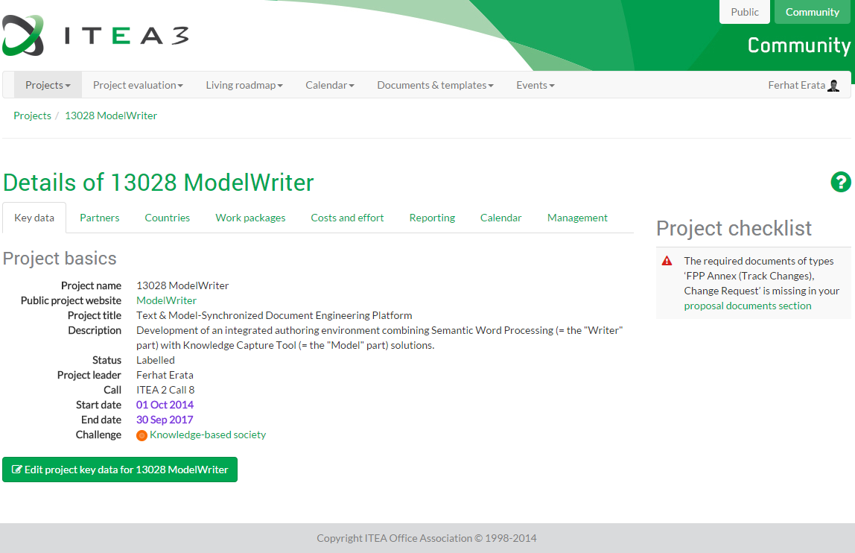

|  |  |
| --- | --- |
|  | **Ferhat Erata**  **ModelWriter Project International Consortium Leader** |