* 1. UC-TR-04 Integration with ALM Tools

Developing applications and tracing the lifecycle of the applications is a very complex task and it has many inherent challenges. Application lifecycle includes the entire time from the idea of developing the application to the end of application’s life. In general, the main lifecycle activities of Application Lifecycle Management (ALM) are reported as follows: project & portfolio management, [requirements management](http://en.wikipedia.org/wiki/Requirements_management), architecture and design, software development, software testing,  software configuration management, change ( [issue & defect) management](http://en.wikipedia.org/wiki/Change_management_(engineering)), and build & [release management](http://en.wikipedia.org/wiki/Release_management).

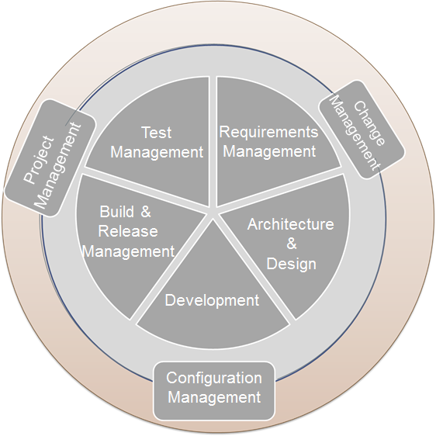

Figure 1. ALM basic activities

A lot of the big software development companies have made a lot of investments to build an integrated ALM platform which would cover the entire lifecycle of an application.

This Use Case aims at integrating ModelWriter with requirements management portion of the Application Lifecycle Management (ALM) tools. In a typical ALM platform, “requirement” is represented as a structured requirement object rather than text.

We defined a structured requirement object as an entity, that have a set of lifecycle states, defined transitions between these states, history of changes, related attributes (unique id, priority, severity, validation method etc.), and traceability information to various project artefacts such as other requirements, design model, source code, bugs, test cases etc.

Here, the textual representation is regarded as de-normalized output of the live object, however it is still needed because of contractual obligations in CMMI type projects.

|  |  |
| --- | --- |
| UC-TR-03 | Integration with ALM tools |
| Versioning Info | V1.0.0 dated 28-Apr-2015 |
| Description | Show that the ModelWriter can extract required elements from structured requirement objects in ALM tool to generate automatic design model.  Show that the ModelWriter’s can generate requirements specification document from structured requirement objects in ALM tool. |
| Actors | Requirements Engineer/Manager, System/Software Architect |
| Assumptions | * All the traceability information would continue to be followed from the structured requirement object via ALM tool. (ModelWriter does not need to have any traceability information) * Textual representation of requirements are stored in MS Word documents. * Design models are stored in Sparx Systems Enterprise Architect. * Structured requirement objects are stored in Microsoft Team Foundation Server. |
| Steps | * Scenario1:   + From a set of structured requirement objects in the ALM tool, ModelWriter would create a natural-language text requirement document. * Scenario2:   + From a set of structured requirement objects in the ALM tool, ModelWriter would create/synch a design model.   + From a design model, ModelWriter would create/synch to a set of structured requirement objects. |
| Variations (optional) | Scenario1: From a natural-language text requirement document, ModelWriter would create/synch to a set of requirement objects. |
| Non-functional (optional) | The system should have a Word plugin for natural-language text transformation.  The natural-language support should be in both English and Turkish |
| Issues | A common format between ALM platforms and ModelWriter may need to be implemented. |