Project Plan

Sydney Airbnb Data System Development

Shahab Moheb (s5264189)

Vaibhav Jha (s5295470)

Jakob Karl (s5289718)

Table of Contents

1.0 Introduction 3

1.1 Problem Background 3

1.2 Scope 3

1.3 Document contents 3

2.0 Work Breakdown Structure 4

3.0 Activity Definition & Estimation 5

4.0 Gantt Chart 6

# Introduction

## Background

The document provides a comprehensive overview of the Sydney Airbnb Data System Development project, encompassing its structure, workflow, and essential components. The initial 1.0 section provides insights into the project's background and scope, setting the stage for the document's contents. Moving into section 2.0, the Work Breakdown Structure, elaborates on every crucial task and sub-task integral to the project's completion. This segment is partnered with section 3.0, which provides the finer details of each WBS task, describing their characteristics and anticipated completion timelines as well as task predecessors and what phase of the project they are. Moreover, the document's 4.0 section focuses on the Gantt Chart, offering a visual representation of the project's timeline, interdependencies, and milestones. This document provides a comprehensive resource for understanding and navigating the project's evolution.

## Scope

The goal of this system is to allow users to search the data with a more user-friendly method. To do this there are 5 main subsystems that are going to be created to do this.

1. Query Interface Subsystem: This subsystem is designed to offer a user-friendly and intuitive interface for everyone. Not only is it text-based, but it also helps by suggesting text completions as you type. Plus, it comes with voice search and advanced search features to make your search experience even smoother.
2. Data Processing Subsystem:  it is to use advanced algorithms to search the large amount of data quickly and efficiently in real time. Filtering and sorting options to customize search results.
3. Visualization Subsystem: Its purpose is to present data patterns, charts, graphs, images, and interactive maps for location-based data visually attractive.
4. User Profile and Customization Subsystem: Purpose of this subsystem is to customise user’s search experience based on past behaviour, the key feature of this subsystem is saving user information such as account creation and bookmarks frequently accessed data and suggest searches to user based on previous behaviour.
5. Feedback and Improvement Subsystem:  Its purpose is to ask users their opinion using ratings, feedback forms, and surveys to enhance the system based on user’s needs.

## Document contents

The document provides a comprehensive overview of the Sydney Airbnb Data System Development project, encompassing its structure, workflow, and essential components. The initial 1.0 section offers insights into the project's background and scope, setting the stage for the document's contents. In section 2.0, the Work Breakdown Structure is detailed, elaborating on each crucial task and sub-task essential for project completion. This segment is seamlessly paired with section 3.0, which delves into the finer points of each WBS task, describing their characteristics, anticipated timelines for completion, as well as their task predecessors and corresponding project phases. Moreover, the document's 4.0 section is dedicated to the Gantt Chart, offering a visual representation of the project's timeline, interdependencies, and pivotal milestones. This holistic document serves as a comprehensive resource for comprehending and navigating the project's progression. It outlines the details of the project's Work Breakdown Structure for task development in section 2.0, while section 3.0 offers insights into the system's functionality in relation to the Airbnb dataset. Additionally, it elucidates each activity from the WBS and Gantt Chart, complete with estimated task durations throughout the project. Lastly, the document encompasses Gantt Chart 4.0, providing a detailed depiction of work distribution and its anticipated completion timeline.

# Work Breakdown Structure

Diagram 1 illustrates the exhaustive Work Breakdown Structure (WBS) of the project, presenting a detailed account of every task essential for the project's seamless progression from the planning stage to its final completion. This carefully crafted WBS provides a comprehensive overview of the entire project, encapsulating its various facets and intricacies.

***Diagram 1:* Work Breakdown Structure of Project**

# Activity Definition & Estimation

Table 1 displays the tasks within the Work Breakdown Structure, accompanied by concise task descriptions and estimated durations for each phase of the project. The WBS serves as a pivotal tool for project planning, outlining not only individual tasks but also their sequential dependencies. By ensuring that tasks and their prerequisites are clearly outlined, the WBS mitigates the risk of overlooking crucial components within the system.

***Table 1:*** *WBS Definition and Estimations*

|  |  |  |  |  |
| --- | --- | --- | --- | --- |
| **Work Breakdown Structure Definition and Estimations** | | | | |
| **Activity Number** | **Phase** | **Task Description** | **Estimated Duration (days)** | **Predecessor** |
| ***1.1*** | Planning | Project Startup | 2 | 1.1 |
| *1.1.1* | Planning | Schedule team meeting | 2 | *1.1* |
| *1.1.2* | Planning | Define project requirement | 1 | 1.1.1 |
| *1.1.3* | Planning | Choosing additional analysis tool | 2 | 1.1.2 |
| *1.1.4* | Planning | Choosing datasets | 1 | 1.1.3 |
| *1.1.5* | Planning | Choosing additional analysis tool | 1 | 1.1.4 |
| *1.2* | Planning | Setup GitHub Repository | 1 | 1.1.5 |
| *1.2.1* | Planning | Clone provided repo | 1 | 1.1.5 |
| *1.2.2* | Planning | Configure access for team members | 1 | 1.1.5 |
| ***2.1*** | Planning | Prepare Project Plan | 10 | 1.2.2 |
| *2.1.1* | Planning | Create Project Overview | 2 | 1.2.2 |
| *2.1.2* | Design | Design Work Breakdown Structure | 2 | 1.2.2 |
| *2.1.3* | Design | Activity Time Estimation & Definition | 2 | 2.1.1 |
| *2.1.4* | Design | Create Gantt Chart & schedule | 2 | 2.1.2 |
| *2.2* | Design | Software Design | 6 | 2.1.3 |
| *2.2.1* | Design | System Vision Statement | 2 | 2.1.3 |
| *2.2.2* | Design | List System Requirements | 2 | 2.2.1 |
| *2.2.3* | Design | Draft use cases for the software | 2 | 2.2.2 |
| *2.2.4* | Design | Highlight System Components & software design | 2 | 2.2.2 |
| *2.2.5* | Design | Initial User Interface Design | 1 | 2.2.4 |
| *3.1* | Development | Code Software | 23 |  |
| *3.1.1* | Development | System 1: Listing information by Area | 4 |  |
| *3.1.2* | Development | System 2: Distribution of Property Prices | 3 |  |
| *3.1.3* | Development | System 3: Keyword record retrieval | 2 |  |
| *3.1.4* | Development | System 4: Customer comments on cleanliness | 2 |  |
| *3.1.5* | Development | System 5: Listings filter by date | 3 |  |
| *3.2* | Development | Create User Manual | 3 |  |
| *3.2.1* | Development | Draft usage steps | 2 |  |
| *3.2.2* | Development | Include screenshots for software features | 1 |  |
| *4.1* | Testing | Software Testing | 15 |  |
| *4.1.1* | Development | Create a testing plan | 2 |  |
| *4.1.2* | Testing | Unit testing for each system | 2 |  |
| *4.1.3* | Testing | Examine outcomes of test coverage | 1 |  |
| *4.2* | Testing | Progress Monitoring | 5 |  |
| *4.2.1* | Closing | Update Gantt Chart to reflect actual dates | 2 |  |
| *4.2.2* | Testing | Regular team check-ins to adherence adherence to plan | 9 |  |
| *5.1* | Closing | Final Documentation | 8 |  |
| *5.1.1* | Closing | Update Project Plan with actual data | 2 |  |
| *5.1.2* | Closing | Finalize Software Design Document | 2 |  |
| *5.1.3* | Closing | Complete User Manual | 1 |  |
| *5.1.4* | Closing | Executive Summary data analysis | 3 |  |
| *5.1.5* | Closing | Software Testing Report | 2 |  |
| *5.2* | Closing | Finalize Commit on GitHub | 2 |  |
| *5.2.1* | Closing | Ensure uploading all necessary files | 1 |  |
| *5.2.2* | Closing | Update git_log.txt | 1 |  |
| *5.3* | Closing | Project Review | 2 |  |
| *5.3.1* | Closing | Team meeting to assess project accomplishments. | 1 |  |
| *5.3.2* | Closing | Record lessons learned for future projects. | 1 |  |

# Gantt Chart

Diagram 2 shows a Gantt Chart created from the Work Breakdown Structure in Diagram 1. This Gantt Chart serves as a visual representation, delineating all essential tasks for project completion. The Gantt Chart allows for monitoring the projects process, enabling the team to stay aware of deadlines and what should be completed in certain timeframes.

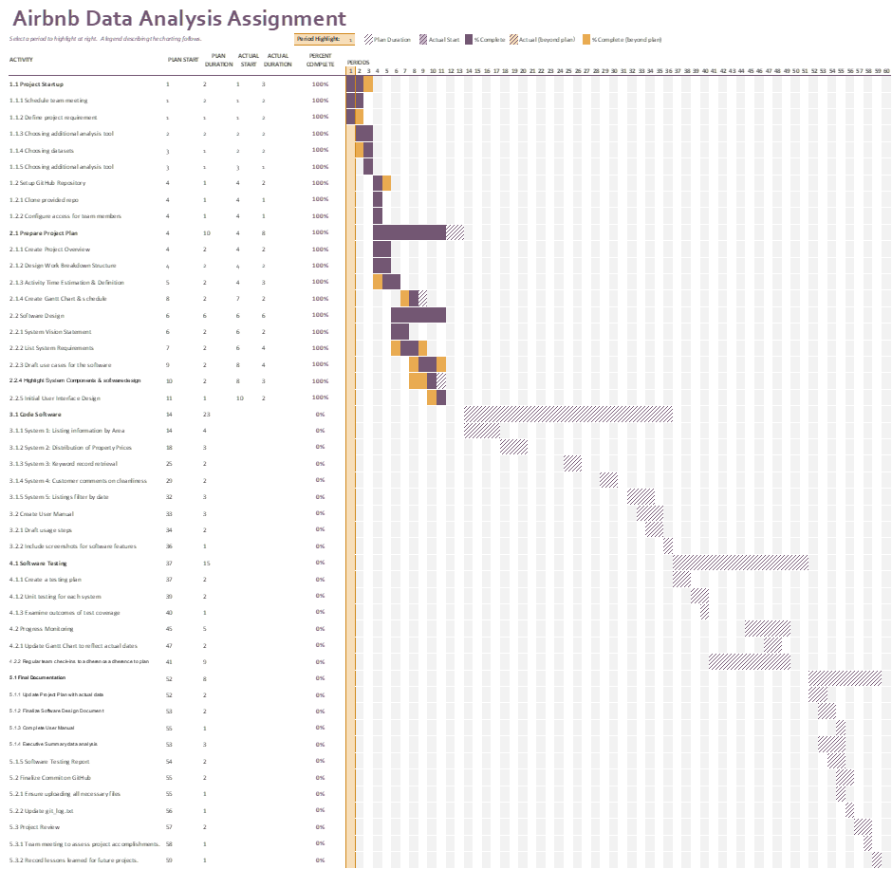

***Diagram 2:*** *Gantt Chart*