User Manual

Sydney Airbnb Data System Development

Shahab Moheb (s5264189)

Vaibhav Jha (s5295470)

Jakob Karl (s5289718)

Table of Contents

1.0 Home Page 3

2.0 Check Cleanliness 6

3.0 Filter By Suburb 8

4.0 Plot Price Distribution 10

5.0 Filter By Keyword 11

6.0 Filter By Date 12

7.0 Advanced Filter & Sort 13

# Home Page

Running the program will open a window that looks like this (refer to diagram 1), The home page welcomes the user and gives a brief description of the program and prompts for the user to search for a listing ID. There are also 6 buttons placed at the bottom for the user to use to filter the Airbnb data.

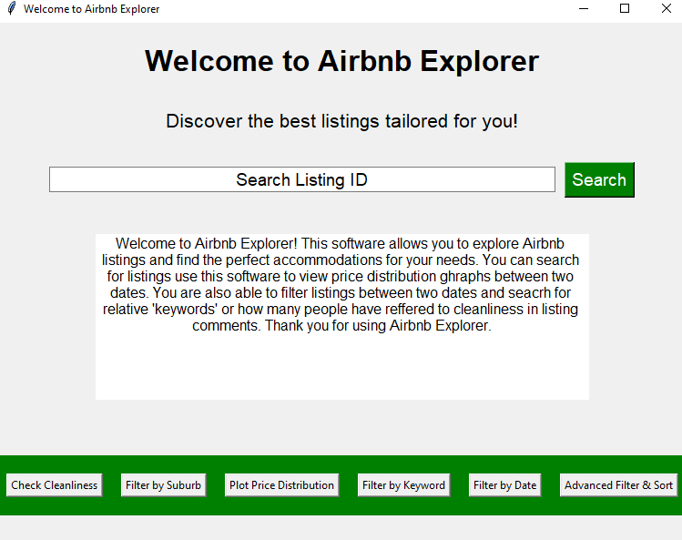

***Diagram 1:* Home Page**

To search for a listing the user will enter the listing ID to bring up a table of relevant information about that listing. This is displayed in the diagram below.

***Diagram 2:* Listing ID Search**

To filter the data the user can select any of the buttons to refine the data by their choice of, suburb, keyword, and date. There is also an option for users to view how many comments relate to cleanliness in the data as well as view a price distribution graph of listing prices between two dates of their choice. An example of the user selecting one of these functions is displayed in diagram 3 below.

***Diagram 3:* User selection Example**

# Check Cleanliness

On selecting the check cleanliness button, the page changes like this:

***Diagram 4:* Check Cleanliness Button**

By pressing the Check Cleanliness Comments button, the user will be provided a pop-up window that provides a count of how many comments have been left that are related to cleanliness of the Airbnb properties.

***Diagram 5:* Cleanliness Count**

# Filter By Suburb

On selecting the filter by suburb button, the page changes like this: prompting the user to select a Suburb.

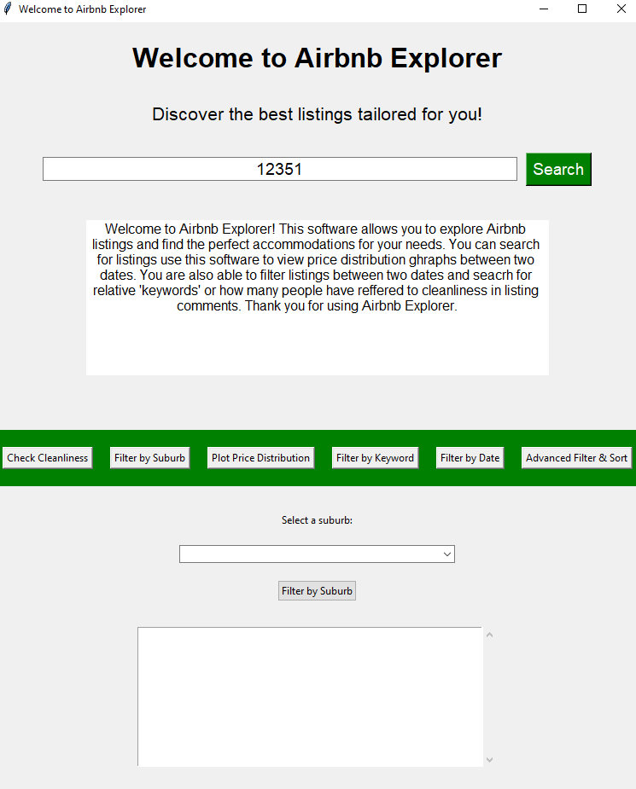

***Diagram 6:* Filter By Suburb**

By selecting the drop-box the user is given the option of a list of suburbs in Sydney to select from:

***Diagram 7: Suburb Selection***

Once the user selects the suburb of choice and searches, they are provided a list of listings that are located in that suburb of choice where they can then take the listing ID and search for it in the home search window.

***Diagram 8:* Suburb Search Results**

# Plot Price Distribution

On selecting the filter by suburb button, the page changes like this: prompting the user to select two dates.

***Diagram 9:* Plot Price Distribution**

Once the user selects two dates and filters the data they are provided with a plot that shows the price distribution from lowest to highest cost and how many listings are listed at that price range.

# Filter By Keyword

On selecting the filter by keyword button, the page changes like this: prompting the user to select two dates and enter a ‘keyword’.

***Diagram 10:* Filter By Keyword**

Upon the user selecting the dates and ‘keyword’ they want to search for the user will be provided a pop-up window of listing ID’s that the user will be able to use to search for in the home search bar.

***Diagram 11:* Filtered ‘Keyword’ Results**

# Filter By Date

On selecting the filter by date button, the page changes like this: prompting the user to select two dates.

***Diagram 12:* Filter By Date**

Upon entering the two desired dates the user wants to search between the search result will appear in a pop-up window providing the user with a table of listing results as shown in diagram 13.

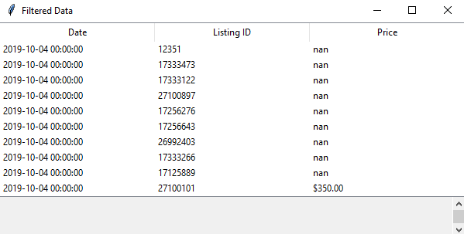

***Diagram 13:* Results for Filter By Date**

# Advanced Filter & Sort

On selecting the advanced filter and sort button, the page changes prompting the user to enter the minimum price they would like to spend and the maximum price, so the search result only provides results within the price range. The user is also prompted to enter a minimum review score and can then choose to sort the data by price or review score.

***Diagram 14:* Advanced Filter**

Once all the boxes are filled in the user is provided with a table as seen in diagram 15 that displays all the listings that are suited to all the information they have provided.

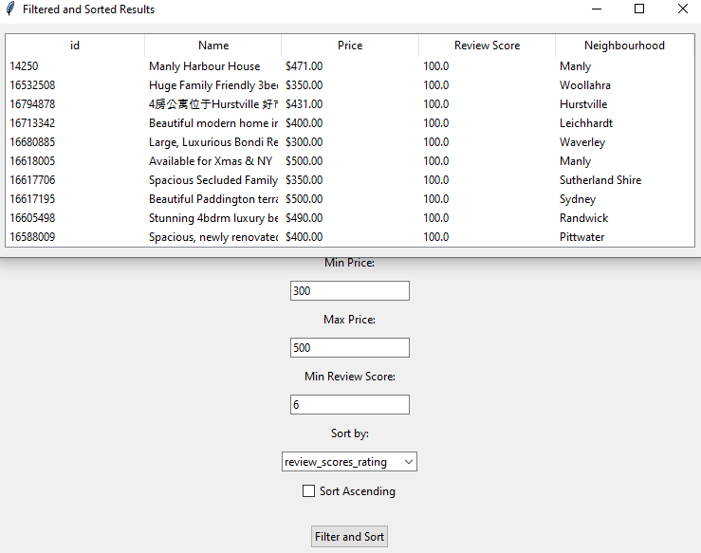

***Diagram 15:* Advanced Filter Results**