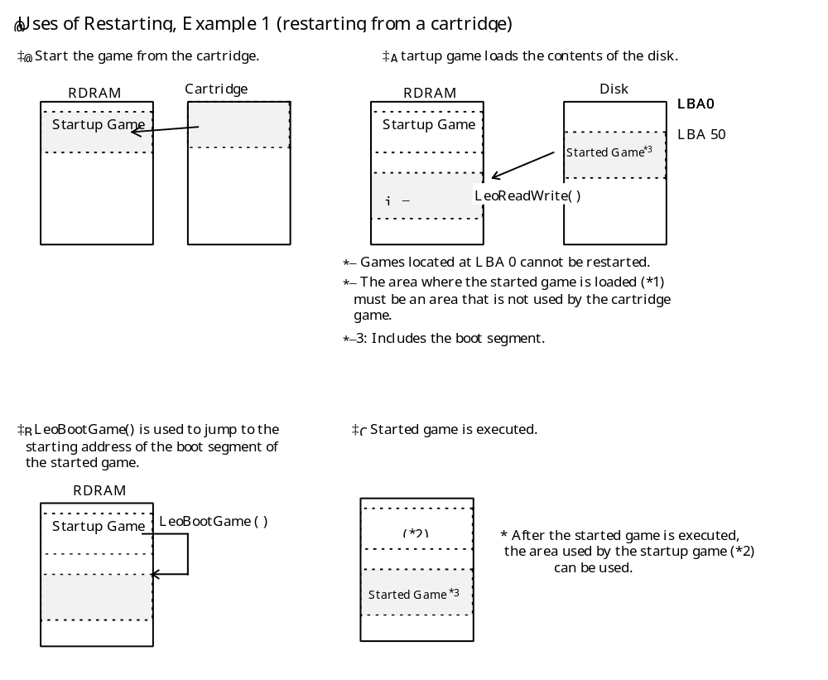

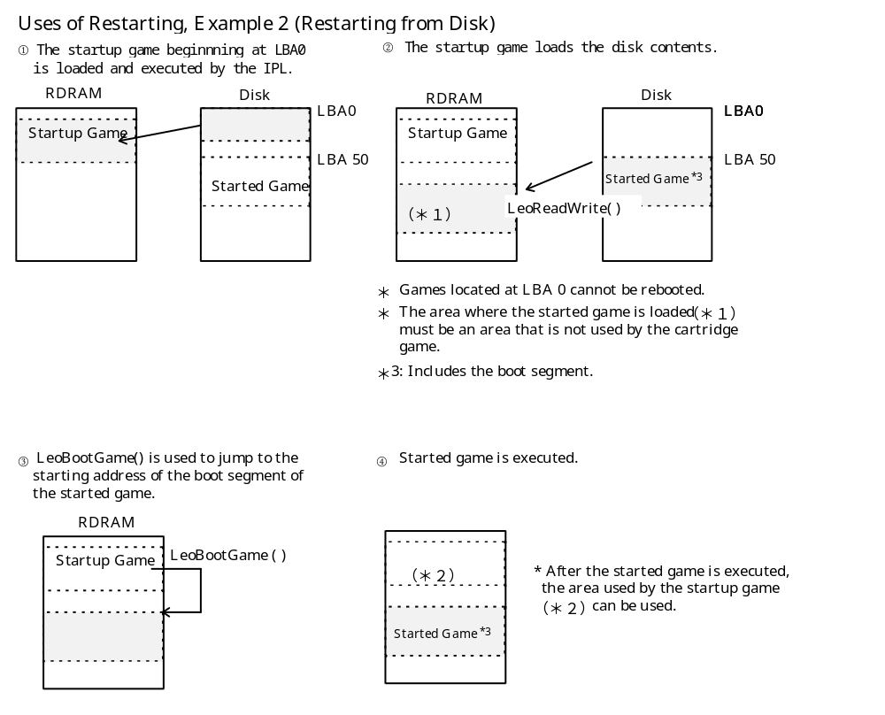

Obtain the ID of the disk to be loaded and confirm that it is the desired disk.
Obtain the LBA storage address and size of the the boot segment^{*1} of the started game to be called.^{*2}

Use this information to load the boot segment^{*1} of the started game into RDRAM.
Pass the starting address of the started game's boot segment to LeoBootGame( ).

