N64 TUTORIAL

N64 PROGRAMMING BASICS

★



PREFACE

This Tutorial seeks to clearly explain the information you need for the development of NINTENDO64 applications. It is organized into the four tutorials described below. In each tutorial, we utilize sample programs to give concrete form to the explanations.

N64 PROGRAMMING BASICS

This tutorial covers the basic information you need to understand for all N64 programs.

GRAPHICS
This tutorial focuses on how to use the RSP and RDP architecture, the heart of graphics processing on the N64.

AUDIO
This tutorial explains N64 audio and how to use the special audio library, mainly through examples using NINTENDO64 Sound Tools.

DEVICE
This tutorial explains the SI (Serial Interface) and the PI (Parallel Interface), two of the main components of the N64.

We hope this TUTORIAL gives you an in depth understanding of N64 application development and helps you create more advanced N64 programs.

N64 TUTORIAL Table of Contents <N64 Programming Basics>
INTRODUCTION 1
Chapter 1 N64 Programming with NuSystem 3
1.1 Welcome to the World of N64 Programming 3
1.2 Introduction to NuSystem 3
1.3 Compiling the Sample 4
1.4 Creating the ROM File 5
Chapter 2 Mechanism of N64 Programming 6
2.1 Introduction 6
2.2 N64 program features 6
2.3 N64 program execution flow 6
2.4 boot portion of a typical N64 program 7
2.5 boot portion in NuSystem 9
2.6 basic2 rendering routine 9
2.7 Memory Usage in N64 Programs 10
2.8 Compiling and linking 11
Chapter 3 The display list and tasks 12
3.1 Rendering basics - the display list - 12
3.2 What is the display list? 12
3.3 Two kinds of display lists 14
3.4 Analyzing part of the sample source 16
3.5 minor note 17
3.6 Executing the display list - Tasks - 17
Chapter 4 n64 programming toolbox- useful functions for nusystem………………………………………………………………………………………….19
4.1 practical application of nusystem functions 19
4.2 Displaying character strings with the debug console 19
4.3 Advanced uses of the debug console 20
4.4 The performance meter 21
4.5 Standard C functions 21
4.6 The basic4 sample program 22

INTRODUCTION

This tutorial is directed at programmers who are new to N64 application development. It aims to give such readers a basic understanding and familiarity with N64 programming.
Since you must have a firm understanding of all of the topics brought up here in order to put together an N64 program, we suggest you take the time to thoroughly digest the information we present in each chapter.
Additionally, before you read this tutorial, please read through the N64 KANTAN Manual.

Chapter 1 N64 PROGRAMMING WITH NUSYSTEM

1.1 Welcome to the World of N64 Programming

Everyone reading this tutorial is connected with N64 game development in one way or another. Some may even have already written N64 programs. Once you actually begin N64 program development, you will be surprised at the rich functionality and abundant possibilities of the N64. However, you need a firm grasp of the basics to tap into this high-performance system.
This TUTORIAL is written for people who are creating their first N64 program or are just about to start N64 programming. It seeks to give you the skills you need to make full use of the advanced functions of the N64 system.
The N64 program development environment has grown far more powerful and convenient since it was first created, such that even beginning programmers can now make interesting games, provided they understand the important points brought up in the N64 TUTORIAL.

Programmers can now select between several N64 program development environments. The explanations in this tutorial assume use of the exeGCC compiler and linker operating under Windows, and use of the PARTNER-N64 debugger. However, the explanations about the N64 and about the sample programs are also relevant to people creating N64 games in other development environments.

In this introductory chapter, we will start by executing an N64 sample program to get a taste of N64 programming.

1.2 Introduction to NuSystem

The sample program SNAKE TAIL HACK introduced in this chapter is a relatively large program, requiring several libraries in addition to the N64 basic development environment.
Some people may not know about the N64 library structure, so before compiling the program a brief explanation about the N64 libraries will be provided.

The series of libraries and headers required for N64 program development are collectively called the "N64 OS", which is installed under c:\ultra by default. If you have installed it to another directory, please read the explanations below making adjustments according to the environment you are using.
When you use exeGCC to compile an N64 program, you need to have the proper environment variables and execution file path set. Since the batch file setup.bat for setting environment variable is located in c:\ultra, it's a good idea to set this batch file to be executed when Windows starts up. The environmental variable ROOT indicating the N64 OS top directory (normally c:\ultra) is defined in setup.bat. Furthermore, you call setupgcc.bat to set the exeGCC switch, and setuplib.bat to set the command's execution file path.
Be sure to make these settings, since they are necessary and indispensable for N64 programming (at least when using exeGCC).

In addition to these essential OS libraries, this tutorial also uses the library called NuSystem to put the program together. In fact, SNAKE TAIL HACK was originally provided as a sample program for NuSystem.
You should have received NuSystem included in the NINTENDO64 Developers Kit, so if you have not done so yet, make sure to install NuSystem now before you read any further.

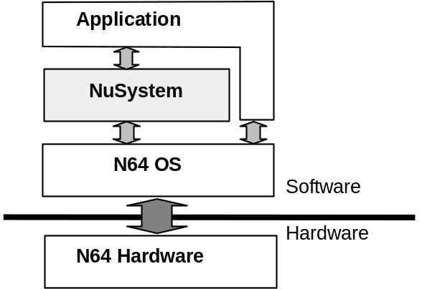

Figure 1-1 Relative positions of N64 OS and NuSystem
The NINTENDO64 Developers Kit installs in c:\nintendo, and not in c:\ultra (as the default setting, so adapt this to match your environment if the settings are different). When the installation is complete, the NuSystem headers, libraries and sample programs should be expanded under c:\nintendo\n64kit\nusys.
SNAKE TAIL HACK is located in the NuSystem sample directory in a subdirectory called nusnake.
In the next section, we will try compiling the sample program located in this directory.

1.3 Compiling the Sample

Now that we have all that is needed to build SNAKE TAIL HACK, we will compile the program. Since the SNAKE TAIL HACK directory already contains a makefile usable with exeGCC, all we need to do is compile. However, if the NINTENDO64 Developers Kit is installed in any directory other than c:\nintendo, you need to make few preparations first. This is because the makefile macro N64KITDIR in the makefile in the SNAKE TAIL HACK directory describes the full path. Unless you completely rewrite the path or define the environmental variable, you will get an error at compile time stating that the header file and library cannot be found. Therefore, you must be sure and modify the makefile in the nusnake directory to match your environment.

List 1-1 See nusnake "makefile"
N64KITDIR = c:\nintendo\n64kit
NUSYSINCDIR = $(N64KITDIR)/nusys/include
NUSYSLIBDIR = $(N64KITDIR)/nusys/lib

After you rewriting the makefile, open the MS-DOS prompt in the SNAKE TAIL HACK directory nusnake. Enter "make" on the prompt line and SNAKE TAIL HACK will start to build. If an error occurs, check whether the header's include path and the library's search path are set correctly.
After the program has been built, load and execute the file called nusnake.out with PARTNER-N64 to launch a battle style game with four snakes. Naturally, you need to connect a Controller before running the program. SNAKE TAIL HACK can perform Controller Pak processes, but you do not need to insert a Controller Pak to run the program. To learn how to operate the sample program, read the explanation in the NuSystem section of the Allmanual.
As you will see when you execute SNAKE TAIL HACK, this sample program also implements the playback of background music and sound effects in addition to the basic Controller processes. Although the main theme of this tutorial is programming with NuSystem, we will also cover graphics and sound related tools so programs such as this can be created.

1.4 Creating the ROM File

If you look at the SNAKE TAIL HACK makefile you will notice that it can be described in almost the same way as programs developed with the general-purpose gcc compiler. In fact, the command structure is similar to the general GNU environment, with the compiler named gcc, the linker named ld, and the C preprocessor named cpp.
However, there is one big difference. Lines 71 and 72 of the makefile are written as follows:

List 1-2 See nusnake "makefile"
$(TARGET) $(APP): spec $(OBJECTS)
$(MAKEROM) spec –I$(NUSYSINCDIR) –r $(TARGETS) –e $(APP)

Line 71 indicates that the final targets $(TARGETS) and $(APP) are dependent on the object and a file called "spec". However, the role of this spec file is ambiguous. Line 72 activates the $(MAKEROM) command, but there is no definition for $(MAKEROM). If you study the file called $(ROOT)/usr/include/make/PRdefs that is included in Line 8 of the makefile, you will see that a command called "mild" has been specified. This command will not be familiar to you as well.
Next, we will explain what is happening here. Specified here is the creation (in other words, the linking) of an N64-executable ROM image. The spec file is the settings file that provides the link information pertaining to the ROM image.
Execution files that run on the N64 are generally named with the extension ".n64," while the debug symbol information files corresponding to those execution files are named with the extension ".out."

Incidentally, if you build an N64 application following the procedures we have just covered and store it in ROM or burn it into a flash cartridge for a commercial product, the game will not run. You still need to use the "makemask" command to convert the *.n64 file into a form that can be executed in ROM. Of course, you do not need to worry about this as long as you use PARTNER-N64 for debugging, but it is a good thing to remember.

Chapter 2 MECHANISM OF N64 PROGRAMMING

2.1 Introduction

When creating an N64 application, the program is written using the C language. The assumption is that you have already learned C, so it should not be difficult to understand the development language itself. However, since you are putting together a different style program than what is common in C programming, we will start with an explanation so you can get accustomed to this style.
At this point, it should be easy to write user programs using NuSystem, but there are still some things that you need to understand. With the help of the sample program "basic2," which is the most basic of programs with a minimum of functions, we will address such general questions as "How is an N64 program executed?" and "What is the best way to write an N64 program?"
The aim of this chapter is to give you a basic sense of N64 programming.

2.2 N64 Program Features

One of the main features of programs that run on the N64 is that numerous threads operate cooperatively. In the sense that the N64 supports the execution of multiple threads, you can say that the N64 OS is a multi-thread OS.
The concept of threads plays a very large role in all subsequent explanations of N64 programming, so it is important to realize their importance. If you use NuSystem, there is almost no need to be aware of thread processes. Thus, you do not need to cover them thoroughly.

First of all, we will begin by considering the execution of a typical program written in C. When you activate the program, execution proceeds from the main function, which calls subroutines and library functions as the program progresses.
To describe the flow of the program, a concrete example follows. When you activate the program, main starts the processing. main rarely completes the processing on its own. It usually calls other functions to share the load. When these other functions complete their tasks, main uses the results to restart its own processing based on the results. When this work is done, the program is completed.
main and these other functions cooperate together, each doing a share of the work. However, note that whenever main calls other functions to do processing, it goes into a state of waiting until the processing is done. In other words, only one function is doing anything at any one time.
In this type of program, only one function is executed at a time, so if you follow the execution flow as described in the source program, you will intuitively understand the order in which computations are being performed.

In contrast, when writing an N64 program, with its multi-thread OS, you need to consider the fact that several functions will be processing at the same time. Since there is still only one CPU, strictly speaking the computations are not performed at the same time. Rather, an executing function will halt temporarily so the computation for another function can be performed, and it seems as if multiple functions are operating in parallel.
The term "thread" is used to express this series of computational procedures operating in parallel this way. Using a concrete example again, even after a process has been passed to a separate function, the main function keeps processing.

2.3 N64 Program Execution Flow

Next, we will move onto explaining N64 programs in a format closer to C language.
In an N64 program, the first thing that is activated is the boot function specified by the programmer. The way to specify this boot function is explained later in Section 2.8, “Compiling and Linking”. For the time being, we will only mention the function called, “boot”.

The boot function it is the first function called in the program, so in this sense it is similar to the main function. However, unlike the main function, the boot function does not need to call all the functions required for the program.

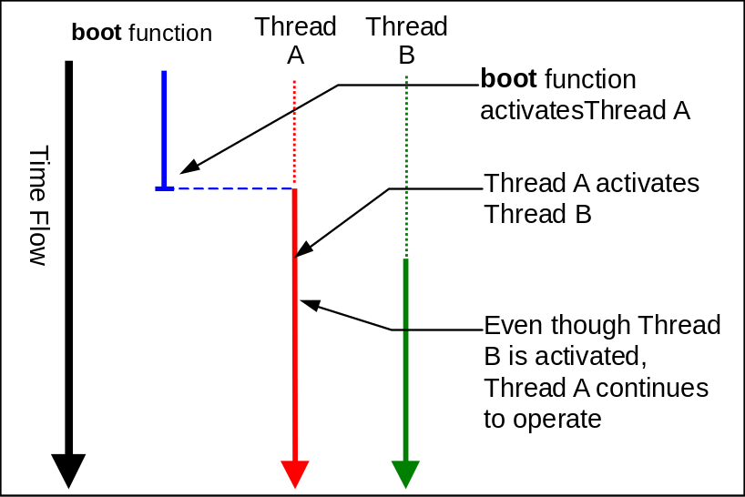

Figure 2-1 boot function and threads
For example, say the boot function activates Thread A. If Thread A is in charge of the principal work of the program, then you can terminate the boot function at this point, since Thread A can be expected to accomplish its processes. Actually, we are talking about general multi-thread programming here, and the situation is a little different for the N64. We will explain this in detail in the next section.
Next, assume that Thread A activates Thread B, which performs other tasks. Since a thread is a group of processes executing in parallel, Thread A can continue its own work even after activating Thread B.
In N64 programming, each thread is given a role to play, with one in charge of graphics processes and another in charge of audio playback, for example, and the threads all work together to realize operation of the whole program.
In addition, you can set the order of priority for the various threads. So when the graphics thread and the audio thread are both activated, the process can give priority to the audio thread, since the game player is more aware of an audio dropout than a loss of some video frames.

2.4 Boot Portion of a Typical N64 Program

Thus far, we have tried to paint a picture of how a multi-thread program operates. Starting with this section, we will get into more detailed explanations using a program actually written for the N64.

In an N64 program, first you prepare a thread called the "idle thread." As the name implies, the idle thread is executed when the CPU is free, and it is given the lowest priority. Although the term "idle thread" may not sound familiar, this thread is absolutely essential for an N64 program. The reason is that the N64 program always needs at least one active thread at all times. The idle thread must exist at all times so it can be executed when all higher priority threads become inactive.

You create the idle thread as well as all other threads by calling the osCreateThread function.

List 2-1
void boot(void)
{
/* Initialize hardware and software */
osInitialize();

/* Create and activate the idle thread */
osCreateThread(&idleThread, IDLE_THREAD_ID, idle, (void *)0,
(idleThreadStack + STACKSIZE / sizeof(u64)), OS_PRIORITY_IDLE);
osStartThread(&idleThread);
}

Usually the idle thread is constructed such that it lowers its own priority and continues to exist after calling several initialization functions and activating the "main thread," which as the name implies is the main thread of the program.
In a simple program, the idle thread basically goes into a loop after it has done its job and no longer needs to execute, as in the "idle" function (which is the idle thread itself) shown below.

List 2-2
static void idle(void *argument)
{
/* Initialize VI */
osCreateViManager(OS_PRIORITY_VIMGR);
osViSetMode(&osViModeTable[OS_VI_NTSC_LAN1]);

/* Create and activate the PI Manager thread */
osCreatePiManager((OSPri)OS_PRIORITY_PIMGR,
&PiMessageQ, PiMessages, NUM_PI_MSGS);

(Parts have been omitted)

/* Activate the main thread */
osCreateThread(&mainThread, MAIN_THREAD_ID, mainproc, arg,

(mainThreadStack + STACKSIZE / sizeof(u64)),
MAIN_THREAD_PRI);
osStartThread(&mainThread);

/* Make itself the lowest priority thread */
osSetThreadPri(0, 0);

/* Repeat loop without doing anything */
for(;;);
}

Typically, the idle thread lowers its own priority and then kills time in an infinite loop after the main thread has been activated.
In contrast to this, the main thread performs a wide variety of operations that vary, depending on the program. In this tutorial, we will take a stepwise approach in our explanation of the main thread, using by way of example of an advanced main thread that we will introduce one part at a time.

2.5 Boot Portion of NuSystem

When an actual N64 application is booted up, it always goes through the procedures explained so far, but if you use NuSystem, you can omit all of these boot processes. This is because NuSystem has a special function called nuBoot that takes charge of all of the necessary processes when booting.
Thanks to nuBoot, the programmer does not have to deal with the boot part of the program, and can start writing from the functions that make up the main thread. In fact, no boot process is described in any of the source files of basic2.
If you are not using NuSystem, then the mainproc function (the main thread) must perform a variety of processes in order to render graphics, but if you leave these processes to NuSystem, then the main thread function becomes very simple, as shown below:

List 2-3 See basic2 "main.c"
/* The "main" function */
void mainproc(void *dummy)
{
/* Initialize graphics */
nuGfxInit();

/* Register vertical retrace callback */
nuGfxFuncSet((NUGfxFunc)vsyncCallback);

/* Turn video output ON */
nuGfxDisplayOn();

/* Afterwards, vsyncCallback performs rendering at each */

/* vertical retrace, so put mainproc into an infinite loop. */
while(1);
}

This source is short and simple, so it should be easy to understand from the comments, but we will explain it below.
nuGfxInit is one of the functions supplied by NuSystem. As its name implies, it performs graphics-related initializations. To be more specific, it registers the framebuffers (which hold the video output images) and the rendering routines (called microcode). We will talk about the microcode in a later chapter.
nuGfxFuncSet sets (the pointer to) the user functions for rendering. The function set here is a so-called callback function that is called repeatedly in time with vertical retrace events. The user sees the result of each rendering process performed in this function as a frame of video output.
nuGfxDisplayOn is the function that allows the rendering result to be output to video. If, on the other hand, the nuGfxDisplayOff function is called, then the entire screen appears black.

In the basic2 sample program, once the vsyncCallback function that performs simple rendering is registered, vsyncCallback is called automatically, and there is nothing else for mainproc to do. So, it enters into an infinite "while" loop.
If you need to use the main thread to perform some process other than rendering, you can just delete the while loop and write the next process.

2.6 The basic2 Rendering Routine

Below is the source for vsyncCallback, the basic2 rendering callback function that was just registered. As you can see, this function does nothing itself, but relies on a function called Draw to complete the tasks.

List 2-4 See basic2 "main.c"
void vsyncCallback(int pendingTaskCount)
{
Draw();
}

The Draw function directly writes values to the framebuffer holding the video output image, and prepares the image for output. Since the same value is written to all pixels, the screen output is a single color. However, the color changes as time passes. More specifically, since the RGB intensity value is provided by the unsigned char type variable(appropriately multiplied), the screen color gradually changes in proportion to the increase in "col".

List 2-5 See basic2 "graphic.c"
/* Function in charge of drawing */
void Draw(void)
{
int i, j;
static unsigned char col = 0;

/* Directly write into the framebuffer */
for(j = 0; j < SCREEN_WD * SCREEN_HT; j++)
nuGfxCfb_ptr[j] = GPACK_RGBA5551(col, 2 * col, 3 * col, 1);
col++;

(The rest is omitted)
}

The other processes performed by the Draw function will be explained in a later chapter.

2.7 Memory Usage in N64 Programs

Note that the framebuffer holding the rendered image is implemented as a simple array pointed to by nuGfxCfb_ptr. In other words, the memory area for the framebuffer is not allocated ahead of time in the N64 system. Rather, the program itself prepares a memory area (array) for use as the framebuffer.

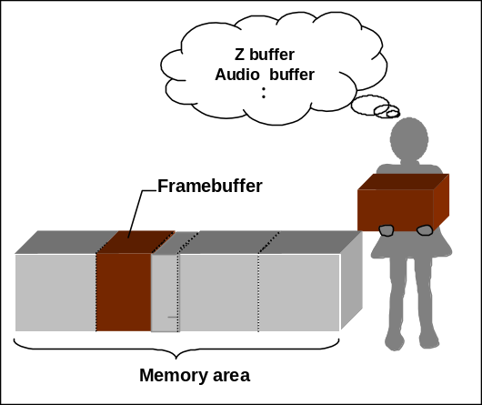

Figure 2-2 Specifying the memory area

The programmer specifies how memory will be used in the N64 in this way. The framebuffer is the best example, but the audio buffer and the Z-buffer are also memory areas that are specified. Of course, if you use NuSystem, these different buffers are set aside automatically, but they can also be customized to meet the programmer's needs.
We will gradually explain the various buffers, memory and ROM in later chapters, but for now, please remember that no special area has been prepared for the framebuffer.

2.8 Compiling and Linking

In section 2.3 we introduced the boot function "boot" without much explanation. Yet there is no set specification for this function, and the programmer is free to change the settings for this function using the spec file, which we introduced in Chapter 1. .
The spec file specifies the final ROM image information for the compiled object files when they are linked.

List 2-6 See basic2 "spec"
#include <nusys.h>

/* Code area */
beginseg
name "code"
flags BOOT OBJECT
entry nuBoot
address NU_SPEC_BOOT_ADDR
stack NU_SPEC_BOOT_STACK
include "codesegment.o"
include "$(ROOT)/usr/lib/PR/rspboot.o"
include "$(ROOT)/usr/lib/PR/gspF3DEX.fifo.o"
(Some lines have been omitted)
include "$(ROOT)/usr/lib/PR/gspS2DEX.fifo.o"
include "$(ROOT)/usr/lib/PR/gspS2DEX.fifo_d.o"
endseg

beginwave
name "64basic2"
include "code"
endwave

Take a look at the actual spec file for the basic2 program. On line 7, you see the following description:

entry nuBoot

As you probably already understand, if for example, you were to write "entry afunc" here, the function afunc would become the boot function that is executed when the program is activated (if you use NuSystem, please call nuBoot).
You can also specify with the spec file, the array to be used as the framebuffer area (the program, and not the spec file, determines what it will be used for).

Chapter 3 THE DISPLAY LIST AND TASKS

3.1 Rendering Basics - The Display List -

In the program we explained in Chapter 2, values are directly written into the framebuffer inside the drawing function, and the animation of the whole screen changing color is implemented by gradually changing the value.
However, writing directly into the framebuffer is generally not a very good idea, because of problems relating to execution speed and the consistency of the buffer contents. Moreover, if you want to display 3D polygons, you have to render the 3D models on your own, so the technique of directly writing into the framebuffer has real limitations. It is much better to take advantage of the special characteristics of the N64 hardware for graphics-related processes.
To perform graphics processes efficiently on the N64, the first thing you need to do is understand the concept of the display list. By using display lists, you can leave rendering to another processor, and not to the CPU, creating programs that make better use of the N64 hardware.
The aim of this chapter is to give you a basic understanding of the display list. We will do this using a sample program that implements 2D animation of a single-color rectangle.
The items explained in this chapter form the essential foundation of N64 programming, so we will cover them one at a time.

3.2 What is the Display List?

If you go through the N64 Kantan Manual or the Programming Manual, you will see the abbreviations RSP and RDP come up all the time. These are processors. Leaving out the architectural details, think of them in the following way:

RSP --- Graphics construction and audio
RDP --- Graphics rendering

The important thing to realize is that the N64 has processors for graphics and audio that exist separately from the main CPU performing general computations.
A variety of functions have been prepared for the N64 that are designed to make efficient use of these processors. The programmer combines these various function calls to compose an N64 program.
However, in N64 programming, you cannot make practical use of the functionality of the hardware by simply calling the library functions. This is where the display list becomes important.
Think of the display list as an instruction booklet for the RSP and the RDP. Instead of "calling the function directly," you "specify what function to call" and the processor executes the work you want done.

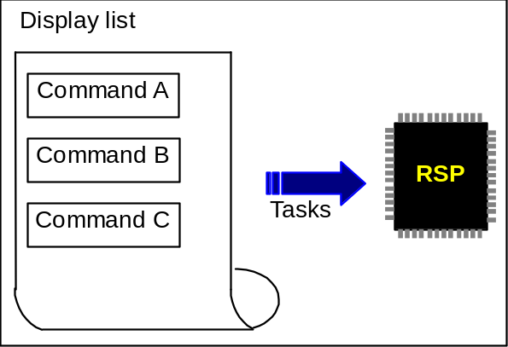

Figure 3-1 Conceptualized display list

In N64 programming language, functions are often called commands, not "functions." Therefore, the display list, with list of commands, is sometimes called the command list.
The command list is processed by a program called the microcode, which is loaded into the RSP for execution. There are various kinds of microcode, such as microcode to playback audio and microcode to display sprites, and a variety of ways to use them. This all may seem confusing to some readers at this point. Microcode will be explained later, but at this point keep these terms in mind.
In C language terminology, the commands in the display list are implemented as macros. In other words, commands are fundamentally different from functions and function pointers. They are ultimately expanded to simple 64-bit constants (type Gfx), so they can be stored as the elements of an array.
Since commands are macros, all command definitions are located in the header file. If you want to know more about this, take at look at the header file <gbi.h>. You will see various definitions and methods of implementation relating to the display list.
There are two broad kinds of display lists: static and dynamic. This subject will be brought up again in a later section.

Next, we will move to an explanation of what specifically a display list is, using the sample program basic3 for our comparisons.
First, take a look at graphic.c. The two arrays rspinit_dl and rdpinit_dl have been defined there.

List 3-1 See basic3 "graphic.c"

/* Display list for initializing the RSP */
Gfx rspinit_dl[] = {
gsSPViewport(&viewport),
gsSPClearGeometryMode(G_SHADE | G_SHADING_SMOOTH |

G_CULL_BOTH | G_FOG | G_LIGHTING | G_TEXTURE_GEN |
G_TEXTURE_GEN_LINEAR | G_LOD),
gsSPTexture(0, 0, 0, 0, G_OFF),
gsSPEndDisplayList(),
};

/* Display list for initializing the RDP */
Gfx rdpinit_dl[] = {
gsDPSetCycleType(G_CYC_1CYCLE),
gsDPSetScissor(G_SC_NON_INTERLACE, 0, 0,
SCREEN_WD, SCREEN_HT),
gsDPSetCombineKey(G_CK_NONE),
gsDPSetAlphaCompare(G_AC_NONE),
gsDPSetRenderMode(G_RM_NOOP, G_RM_NOOP2),
gsDPSetColorDither(G_CD_DISABLE),
gsDPPipeSync(),
gsSPEndDisplayList(),
};

You can deduce what these arrays are based on their names. The first is the display list for initializing the RSP, and the second is the display list for initializing the RDP. The elements like "gsSPViewport(&viewport)" in the display lists are the commands.

We previously compared the display list to a function call. In a function call, the desired computation is performed at the time the function is called. The situation is different for the display list. If all you do is create the display list (i.e., write the instruction booklet), no computations will be executed. You must also pass the display list for execution. In the N64 vocabulary, the display list is passed to a "task." Tasks will be explained later. First we will go over the basic knowledge needed to construct the display list.

3.3 Two Kinds of Display Lists

In the display list we used as an example in the previous section, the display list was provided as a Gfx type data array. You may have wondered at that time whether display lists are always that inflexible.
Actually, this is a valid point. If the array is to be defined, the elements must be decided at the time of compilation. In other words, the contents of the display list must all be provided as constants before interpretation by the compiler. Imagine you are using the display list to draw a rectangle on the screen. If you must provide all information about the rectangle's position, size and fill color as constants, then you cannot change the color or move the position at the time of execution. Naturally, there will be times when you want a "dynamic" display list rather than this "static" kind of the display list.
In fact, both kinds of display lists are available: static and dynamic. As you may have surmised, rspinit_dl and rdpinit_dl are classified as static display lists. A static display list is suitable for initialization purposes since it is almost always okay to decide on the contents at compile time.
To see an example of a dynamic display list, look at the array glist defined in graphic.c.

List 3-2 See basic3 "graphic.c"
/* Display list */
Gfx glist[GLIST_LENGTH];
Gfx * glistp;

The glist array also stores a display list, but unlike rspinit_dl and rdpinit_dl, none of the array content is specified at compile time. In other words, at the time when the array is defined, the memory area for storing the commands is reserved, but the content remains empty.
The functions that actually create the contents of glist are ClearBackground and DrawBlueRectangle. When gSP... or gDP... commands are called, the commands are stored one by one in glist.

List 3-3 See basic3 "graphic.c"
void DrawBlueRectangle(void)
{
/* The blue rectangle's upper-left coordinates */
static int x = 0, y = 0;

/* Specify the fill color (moving rectangle, blue)*/
gDPSetFillColor(glistp++,
(GPACK_RGBA5551(0, 0, 255, 1) << 16 |

GPACK_RGBA5551(0, 0, 255, 1)));

/* This process when the blue rectangle protrudes from the screen */
if(x >= SCREEN_WD)
x = 0;
if(y >= SCREEN_HT)
y = 0;

/*
* If the blue rectangle protrudes from the bottom of the screen, divide it into top and bottom
* parts for display. The top and bottom look like they are connected. Since the code is
* complicated, do not process in the horizontal direction.
*/
if(y + 100 >= SCREEN_HT)
{
/* If it protrudes, draw two rectangles. */
gDPFillRectangle(glistp++, x, y, x + 100, SCREEN_HT – 1);
gDPPipeSync(glistp++);
gDPFillRectangle(glistp++, x++, 0,
x + 100, (y++) + 100 – SCREEN_HT);
}
else
{
/* If it does not protrude, one rectangle is sufficient. */
gDPFillRectangle(glistp++, x++, y++, x + 100, y + 100);
}
gDPPipeSync(glistp++);
}

There is a line in the DrawBlueRectangle function that reads like this:

gDPFillRectangle(glistp++, x++, y++, x + 100, y + 100);

Here, x and y are variables, so they take various values during execution. A dynamic display list can handle these with no problem, making it possible to create the animation of a moving rectangle.

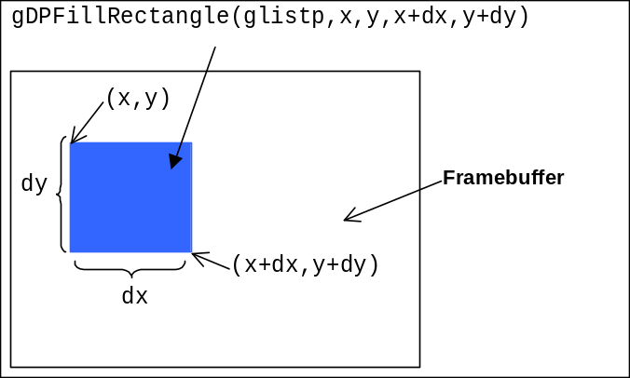
Figure 3-2 The gDPFillRectangle command in operation

Once a command has been stored in a certain element in the glist array, you cannot overwrite that space with the next command. Thus, you follow a procedure of inserting commands in order into the command list while incrementing the Gfx pointer variable glistp.

Characteristics of the two types of display lists
 | Static display list | Dynamic display list
Advantages | Fast to build (decided at compile time) and easy to handle. | You can decide the contents at execution time.
Disadvantages | Command contents are fixed and inflexible. | Slow to build at execution time (rendering speed is the same).

3.4 Analyzing Part of the Sample Source

Next we will analyze some of the sample source. For these explanations, the sample program basic3 will be used.
First, take a look at the static display lists rspinit_dl and rdpinit_dl in graphic.c.
Here are several important yet simple commands:

gsSPViewport(&viewport)
Provides the pointer to the viewport structure Vp and sets the projection transformation parameters necessary for the size of the display window and the display of polygons.

gsDPSetCycleType(G_CYC_1CYCLE)
Specifies the rendering mode. The number of pixels that you can fill at any one time and the usable drawing functions vary depending on the mode, but this is not important for our purposes now.

gsDPSetScissor(G_SC_NON_INTERLACE, 0, 0, SCREEN_WD, SCREEN_HT)
Specifies the area in which you can draw. This is the same as specifying the clipping area for the so-called clipping process. Note that if you omit this command, the screen image will not be displayed correctly.

You may have noticed a convention in the naming of these commands. The SP and DP in the names indicate commands for the RSP processor or the RDP processor. Also, the initials gs at the front of the name indicate these are commands for a static display list. Commands for a dynamic display list have only the initial g at the front of their names.
In general, commands have been prepared in two versions, g... and gs... for dynamic and static display lists. Since both types of commands operate in exactly the same way, we will not distinguish between them in subsequent explanations. Yet note that g... commands take one extra argument not required by gs... commands, namely, the address where the command should be stored. If you look at the g... commands appearing in graphic.c you will see that they all have glistp++ as the first argument.

Next, we will look at some of the basic commands found in the dynamic display list:

gSPDisplayList(glistp++, rdpinit_dl)
The display list rdpinit_dl is included in the dynamic display list glist.
rspinit_dl is included in the same way.

gDPSetColorImage(glistp++, G_IM_FMT_RGBA, G_IM_SIZ_16b, SCREEN_WD,
osVirtualToPhysical(nuGfxCfb_ptr))
This command specifies the address of the framebuffer intended for the fill color operation. In this example, pixels are expressed in 16-bit format and the framebuffer nuGfxCfb_ptr has an image width of SCREEN_WD. nuGfxCfb_ptr is a global variable for the framebuffer prepared by NuSystem. osVirtualToPhysical is a function that converts virtual addresses to physical addresses. Since the RDP operates on the basis of physical addresses, you need to explicitly make this conversion.

gDPSetFillColor(glistp++, (GPACK_RGBA5551(r, g, b, 1) << 16 |
GPACK_RGBA551(r, g, b, 1)))
This command specifies the fill color. In this example, the background color expressed by r, g and b is set. By using the GPACK_RGBA5551 macro, you can convert the 8-bit RGB elements into the 5551 format, with 5-bit RGB elements and a 1-bit alpha value.

gDPFillRectangle(glistp++, 0, 0, SCREEN_WD - 1, SCREEN_HT - 1)
Specifies the size of the rectangle to fill. If you want to fill the whole screen with the background color, you set this line to the entire area of the screen.

gSPEndDisplayList(glistp++)
The command indicates the end of the display list. In the same way, the gsSPEndDisplayList command is put on the end of the static display lists rspinit_dl and rdpinit_dl.

3.5 Minor Note

The ClearBackground function is designed so you can specify the background color with the three arguments r, g and b at execution time. Assume the background will be fixed to a specific color. In this case, it might seem unnecessary to do a dynamic display list, and that the load at execution time could be reduced by defining this as a static display list. However, there is a reason why this display list is defined dynamically. In fact, it is impossible to substitute a static display list.

List 3-4 See basic3 "graphic.c"
void ClearBackground(u8 r, u8 g, u8 b)
{
gDPPipeSync(glistp++);
/* Set to fill mode (G_CYC_FILL) */
gDPSetCycleType(glistp++, G_CYC_FILL);
/* Specify the subject to fill (the next displayed framebuffer) */
gDPSetColorImage(glistp++, G_IM_FMT_RGBA,
G_IM_SIZ_16b, SCREEN_WD,
osVirtualToPhysical(nuGfxCfb_ptr));
(The rest is omitted)

If you look carefully at the contents of ClearBackground, you will see that the symbol nuGfxCfb_ptr is referenced. nuGfxCfb_ptr is a pointer managed by NuSystem that is always set to point to the next framebuffer for rendering. Since this pointer points to a different framebuffer in every rendering frame, it cannot be determined at compile time. Consequently, it is impossible to implement ClearBackground as a static display list.

3.6 Executing the Display List - Tasks -

In our explanation of how to construct a display list there was one important point that was not covered. Telling the N64 to perform rendering in accordance to the display list just made was not described. This is where the concept of "tasks" comes in to play. If you use NuSystem, you can write N64 programs without giving much thought to tasks, so we will keep our explanation simple, using a metaphor.

Assume that a certain company has only one extremely fast computer(think of this as a work station). This computer is not connected to a network, so only one person can use it at a time. People who want to use the computer must write their "name" and the "work description" on a "reservation sheet" and then submit this to the manager. When a person's turn comes, they can use the computer until their work is completed.
In this example, the "reservation sheet" is the task. This task contains both the name of the person doing the work and a description of the work being done. The "computer" in this example is the RSP processor in the N64. Since the RSP can perform only one job at a time, everybody must wait in turn to use it. The "work description" in this example is the display list. The display list is basically an instruction booklet, and rendering is performed by the RSP's execution of these instructions.

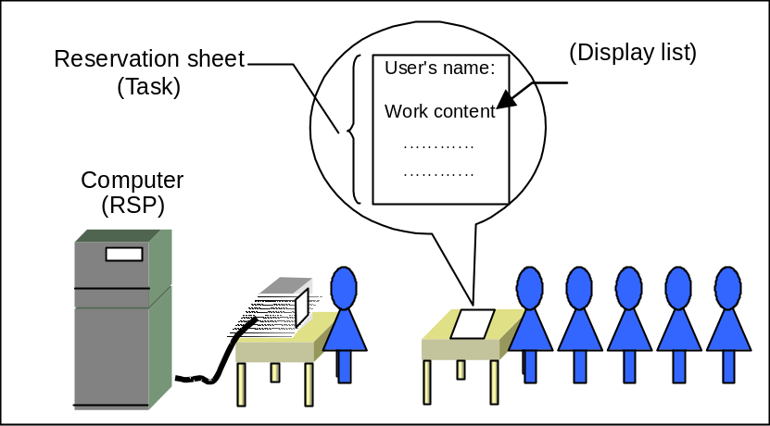

Figure 3-3 Conceptual drawing of tasks
Additionally, the "person performing the work" is the microcode. Think of the microcode as a small program that executes the display list. With people, efficiency and the quality of the results will vary from person to person, even when they perform the same work. The same thing applies to microcode. Older microcode executes the display list slower, while newly developed microcode has expanded high-level functions. To give an actual example, the F3DEX2 series microcode puts a lighter load on the system during rendering compared to the older F3DEX series.
As mentioned above, NuSystem makes task management far less complex. The only thing the programmer has to do to activate a task is call the nuGfxTaskStart function. An example of this can be found in the Draw function in graphic.c.

List 3-5 See basic3 "graphic.c"
/* Activate the task */
nuGfxTaskStart(glist,
(s32)(glistp - glist) * sizeof(Gfx),
NU_GFX_UCODE_F3DEX, NU_SC_SWAPBUFFER);

nuGfxTaskStart activates the task internally after receiving the pointer to the start of the display list, the size of the display list, and flags for the type of microcode and whether or not to swap the framebuffer.

Chapter 4 N64 PROGRAMMING TOOLBOX – USEFUL FUNTIONS FOR NUSYSTEM

4.1 Practical Application of NuSystem Functions

When you begin programming in N64 or any other new environment, you need to create test programs and gradually learn the new programming techniques.
For these test programs, it would be ideal if you could create a very simple framework for the overall program, and then concentrate on programming with functions you want to experiment with.
In this final chapter of the Programming Basics Tutorial, some of the useful functions available in NuSystem will be introduced.

4.2 Displaying Character Strings with the Debug Console

NuSystem provides a group of functions that are very useful for debugging, so we will begin with an explanation of these.

When you begin developing programs using functions that are new to you, things often do not work out as expected. Most probably have experienced using printf to output the values of specific variables to the screen so you can check the behavior of a program.
The N64 library has a function called osSyncPrintf that works like printf to display character strings in the window of the debugger. However, osSyncPrintf can be inconvenient to use. For example, when you try to output the values of variables that vary each time a frame is rendered, a large volume of character strings are displayed one after the other on the debugger screen.
The NuSystem debug console can be very useful in this situation. The debug console implements a virtual console window for the N64 video output so that you can display character strings more easily. By setting the location where character strings are to be output, characters will not scroll on and on like with the osSyncPrintf function.

First we will start by introducing the functions used for displaying character strings. They follow the C standard functions.

nuDebConPrintf
This function displays formatted character strings like printf. Some specifiers are not supported in some versions of NuSystem, so check the manual before using this function. To output a 64-bit value, attach the "ll" qualifier.

nuDebConPutc
Outputs one character to the console.

nuDebConCPuts
Outputs the provided character strings to the console.

nuDebConPuts
Outputs the provided character strings to the console. The null character at the end of the character string is replaced with the linefeed character. In other words, if you display character strings with this function, they are automatically linefed.

If you read about these functions in the manual, you will see that an integer called wndNo must be given as the first argument. This argument refers to the window number. NuSystem has four independent debug console windows, and the programmer is free to use any of them. wndNo is the argument that specifies which of these four windows to display the character strings in. The macro constants NU_DEB_CON_WINDOW0, ..., ..., NU_DEB_CON_WINDOW3 are defined in the header file <nusys.h> for use as the console window numbers. Use these macro constants whenever possible to specify the window numbers in your programs.

4.3 Advanced Uses of the Debug Console

As we explained, NuSystem can display data in four console windows. If you simply open all four windows in the entire screen, the consoles will overlap and the character string data will be difficult to view. Of course, with Nusystem, the four console windows do not necessarily have to fill up the entire screen. The programmer is free to specify the size and position of each window.
The following five functions have been prepared for changing the console window settings:

nuDebConWindowPos
This sets the position of the window. The arguments required are the window number and the coordinates of the point at the upper-left corner of the window. Specify the coordinate values with the screen coordinates.

nuDebConWindowSize
This sets the size of the window. The arguments are the window number, and the number of columns and the number of lines in the window. The specifiable ranges are 1 to 40 columns and 1 to 30 lines.

nuDebConWindowSet
This sets the window's position and size at once. If you want to change both the position and size of a window at the same time, this function is more efficient than calling nuDebConWindowPos and nuDebConWindowSize separately.

nuDebConWindowShow
This sets a specific console window to display/not display. It is more efficient to not display unnecessary windows.

nuDebConScroll
This specifies whether or not to scroll when character strings line feed down to the very bottom line of the window. If scrolling is disabled, the data continues to be output starting back at the top of the console window.

In addition to these console window attributes, you can also set attributes like position and text color to the character strings.
The following four functions are used to specify character attributes:

nuDebConTextColor
This sets the color of the character strings. When you call this function, all subsequent character strings are displayed in the window in the specified color. The character color is specified with the integers 0 to 15, but macro constants like NU_DEB_CON_TEXT_BLACK and NU_DEB_CON_TEXT_WHITE etc. have also been defined, so please use these macros whenever possible in your program.

nuDebConTextPos
This sets the position where display of the next character string will start. The position is specified using column and line numbers.

nuDebConTextAttr
This sets the attribute of the character string. Choices include NU_DEB_CON_ATTR_NORMAL (normal text) and NU_DEB_CON_ATTR_BLINK (blinking text). When you call this function, all subsequent character strings are assigned the specified attribute.

nuDebConClear
This clears the displayed character strings.

This covers most of the functions relating to the debug console. However, you cannot display character strings by simply assembling these functions together. The reason is that the debug console is strictly a virtual console window. In order to output character strings to the debug console window, each character must be cut out from the font image and lined up for display internally. That is to say, a task must be activated internally and a display list used to output the character strings. To have NuSystem activate the console display task, you must call the nuDebConDisp function. In other words, after calling your series of character string display functions you must then call nuDebConDisp.
For an example of the debug console in actual use, see the source of the sample program basic4 and section 4.6 later in this chapter.

4.4 The Performance Meter

Another useful function provided by NuSystem is the performance meter display.

The N64 hardware includes a unit called the RCP containing the RSP and the RDP, which we mentioned in Chapter 3. These two processors are in charge of audio and graphics processes, freeing the CPU to concentrate on other computational jobs. Graphics tasks are executed by both processors, as described before, while processes relating to audio playback are handled as tasks executed in the RSP.
As you can see, the RCP plays an extremely important role as the unit where graphics and audio tasks are executed. So it would thus be very useful during game development if you can grasp how large a computational load is being placed on the RCP. The NuSystem performance meter shows this load in the form of a simple bar graph.

There are two functions for displaying the performance meter. The two functions differ a little in display content, but both are called using the same syntax.

nuDebTaskPerfBar0
This displays the type0 performance meter, which displays the RSP's audio tasks and graphics tasks and the RDP's overall processing time.

nuDebTaskPerfBar1
This function displays the type1 performance meter, which shows more items than the type0 meter.

4.5 Standard C Functions

In the NINTENDO64 Developer's Kit where Nusystem exists, the nustd library, which is a subset library of standard C language functions, is included.
It is beyond the scope of this tutorial to explain the whole nustd library, but some representative functions will be introduced. If you would like to read about the functions in detail, see the Standard Function Reference in the NuSystem section of Allmanual.
Library functions relating to memory include memcpy, memset and memcmp. Functions for manipulating character strings include strlen and strcat. You can compare character strings with the strcmp function, and you can convert between character strings and numeric values using the atoi, atol and atof functions.
The library also defines routines like malloc, free and realloc for reserving/freeing memory, but make sure to call the InitHeap function to reserve the heap area before you use any of these routines.
The whole set of general-use math functions needed for graphics operations and physical computations are also defined. The list includes sin, cos, tan, exp, log, log10, pow and sqrt.

However, a substantial group of standard C functions are contained in libnustd.a as well as the debug version of this library, called libnustd_d.a, so remember to link one of these libraries.

4.6 The basic4 Sample Program

The basic4 sample program utilizes the functions explained in this chapter to implement an application with a simple menu.
The program has two modes: the menu mode and the animation mode. The program runs in menu mode when the static variable IsMenuMode in the Draw function of graphic.c is set to 1. When this variable is set to 0, the program runs in animation mode.

Animation mode
This mode draws moving rectangles using the same rendering routine used in the basic3 program, with almost no modifications. However, you can also change the color of the rectangle when in menu mode. You can switch to menu mode by pressing the Start button.

Menu mode
This mode displays the menu for selecting a color for the rectangle displayed in animation mode. Choose between red, green and blue by pressing RIGHT/LEFT on the Control Pad. When you press the Start button, the mode switches to animation mode.

A variety of debug console functions are utilized to display the menu in this sample program, so if you want to see an example of actual usage of the debug console, we recommend you look through graphic.c.

The basic4 sample program also contains a routine for Controller input. The process is not very difficult, so you should be able to comprehend things by reading the sample source. To learn more about the Controller, see the relevant chapter in the Device Tutorial.

This chapter's sample program is written not only to draw rectangles, but also to display the debug console and the performance meter. Ultimately, it is the Draw function in graphic.c that instructs NuSystem to render these.

List 4-1 See basic4 "graphic.c"

/* Activate a task for rendering a rectangle (no swap) */
nuGfxTaskStart(glist,

(s32)(glistp - glist) * sizeof(Gfx),
NU_GFX_UCODE_F3DEX, NU_SC_NOSWAPBUFFER);

/* Display the menu if in menu mode */
if(IsMenuMode)
{
ShowMenu(RectColor);
nuDebConDisp(NU_SC_NOSWAPBUFFER);
}

/* Controller process */
HandleController(&IsMenuMode, &RectColor);

/* Display the performance meter */
nuDebTaskPerfBar1(1, 210, NU_SC_SWAPBUFFER);

Important here is that the last argument in both nuGfxTaskStart and nuDebConDisp is NU_SC_NOSWAPBUFFER. If you do not suppress swapping with this argument, then the framebuffer will be swapped when the rendering of the rectangle or the debug console has been completed. As a result, when you call nuDebTaskPerfBar1, the performance meter will be displayed in a different framebuffer than the rectangle or the debug console.

