N64 TUTORIAL

★



N64 TUTORIAL Table of Contents <Graphics>

Introduction 1
Chapter 1 The basics of N64 graphics -- Introduction to RSP -- 3
1.1 RSP & RDP -- graphics essentials -- 3
1.2 Creating a transformation matrix 4
1.3 Passing the transformation matrix to the RSP 6
1.4 Defining and loading vertices 8
1.5 Defining models 9
1.6 view port 10
1.7 Summary 11
Chapter 2 Adding color to a model 13
2.1 various ways of adding color 13
2.2 Primitive color 14
2.3 Vertex color 15
2.4 Lighting 16
2.5 Defining lights 17
2.6 Geometry mode 18
2.7 Combine mode & Rendering mode 19
Chapter 3 Simple texture mapping 21
3.1 texture mapping flow 21
3.2 Loading textures 22
3.3 Texture image format 23
3.4 Texture coordinates 25
3.5 Clamp, wrapping & mirror 26
3.6 Texture Filter 27
3.7 Other commands relating to texture settings 28
3.8 supplement on RDP modes 28
Chapter 4 The Color Combiner 30
4.1 architecture of the Color Combiner 30
4.2 Source color & source alpha 31
4.3 Combine mode 32
4.4 Review of combine mode 33
4.5 Gradations with textures 34
4.6 Texture inversion 35
4.7 Coloring with noise 37
Chapter 5 Semi-transparent objects & the alpha value 39
5.1 The Alpha Combiner 39
5.2 Texture formats with alpha values 40
5.3 Semi-transparent objects and the rendering mode 41
5.4 Running the sample program 43
5.5 Alpha compare 44
Chapter 6 Rendering mode and anti-aliasing 47
6.1 overview of Anti-aliasing on the N64 47
6.2 Coverage value 48
6.3 Color Blender 50
6.4 Defined rendering modes 51
6.5 Video filter 54
Chapter 7 Z buffering 57
7.1 Determining depth with the Z buffer 57
7.2 Preparations for using the Z buffer 57
7.3 Z value and DeltaZ 60
7.4 Depth source 60
7.5 Rendering modes when using the Z buffer 60
7.6 VI mode and special functions 61
Chapter 8 Advanced rendering techniques 64
8.1 Pipeline mode (cycle type) 64
8.2 1-Cycle mode & 2-Cycle mode 66
8.3 The Combiner in 2-Cycle mode 66
8.4 The Blender in 2-Cycle mode (Fog) 67
8.5 Points to note about semi-transparent fog 69
Chapter 9 Advanced texture mapping 71
9.1 Tiles 71
9.2 Multi-tile textures 73
9.3 Primitive tile 73
9.4 Highlights 74
9.5 Reflection mapping 76
9.6 Mipmaps 78
9.7 Variations on mipmapping 79
Chapter 10 Texture rectangles 83
10.1 Introduction to texture rectangles 83
10.2 Using primitive depth 84
10.3 Large texture rectangles 84
10.4 Transparency effects in Copy mode 86
10.5 Multi-tile texture rectangles 88
10.6 summary of graphics 89
Reference bibliography 92

INTRODUCTION

The "Graphics" section of the N64 Tutorial focuses on the essence of graphics processing in the N64, explaining the architecture and the ways of using the RSP and RDP so that you, the programmer, will have the technical capacity to put together advanced graphics programs.

Nearly all of the essential topics relating to 3D graphics are covered here, so by the time you have finished reading this tutorial you should have acquired the ability to produce 3D images as you had envisioned them. Starting with Chapter 1, go through the topics in order, making sure you gain a solid understanding of each one.

CHAPTER 1 THE BASICS OF N64 GRAPHICS – INTRODUCTION TO RSP --

In this introductory chapter of the Graphics tutorial, we focus on the RSP, which is one of the core elements of the RCP that lies at the heart of N64 graphics programming. We explain every procedure from the description of a model to its rendering, with the aid of concrete examples of source code.

1.1 RSP & RDP -- Graphics Essentials --

If you think about the flow of an N64 program from defining a model to rendering that model, it is generally the same as any graphics process. However, to put together an effective N64 application, you need to understand what kind of processes are happening and at what point in this flow. In this section, we draw a simple outline showing where the various processes are performed in this flow.

The first thing you need to understand is that the majority of graphics processing in the N64 is conducted by the RSP and the RDP. Of course, you could also directly write a synthesized image to the framebuffer for display with the CPU. However, this is a very involved topic so it will not be covered in this tutorial.
So what, then, is the CPU's role in an N64 graphics program? The CPU instructs these two processors which processes they should perform. Each instruction is a "command" and a collection of these commands is called the "display list." More about the display list can be learned in Chapter 3 of the N64 Programming Basics Tutorial.
The RSP and RDP receive their instructions and go about the business of rendering graphics. You need to understand how roles are shared between these two processors.
It is the RSP's job to calculate the geometry of the 3D graphics. This involves computations relating to vertex coordinates and normal vector transformations, lighting and texture mapping.
Note that the RSP does not go as far as to actually add colors. Although we said the RSP calculates texture coordinates, it is not the job of this processor to determine which pixels get what colors.
As implied, the RSP does a lot of number crunching. The RSP is a lot like the N64 CPU in terms of hardware, and it has a Vector Unit capable of performing a number of calculations at the same time.
The RDP takes the results of these calculations by the RSP and outputs images to the framebuffer. In a word, the role of the RDP is to output graphics. In actuality, the RDP is a processor with extremely advanced functionality and expressive ability, performing such tasks as texture filtering, pixel color combining, and blending with the frame buffer.
When looking at the RDP from a functional standpoint, it is better to break it up into a number of units like the Texture Engine, Combiner and Blender. Here we will treat the RDP as a single entity when explaining which processes in the graphics flow the device performs. Details about its texture-related functions are covered in Chapters 3 and 9, while the Combiner is covered in Chapter 4, and topics relating to the Blender are covered in Chapters 5 to 7.

From the above explanations you can see that the RSP and the RDP need to share roles and work cooperatively in order to display 3D graphics on the N64. In other words, a 3D graphics program must make active use of both processors. That being said, we will focus in this chapter on providing an explanation of how to make basic use of the RSP.

1.2 Creating a Transformation Matrix

In a typical graphics process, you render polygons after establishing the position of the model and the camera and setting the view port. The same is true for the N64; before rendering graphics you must prepare the model view transformation matrix and the projection transformation matrix.
There are two ways of indicating a matrix in an N64 program: as a 4x4 two-dimensional array, or as an Mtx union. By using the latter method and defining the matrix as a union, the array is concealed from the user. Typical N64 OS matrix manipulation functions come in two versions, one for arrays and one for unions. The functions that take arguments in array format are named with an F as the last letter (e.g., guLookAtF). Please remember this convention.
Also note that with the union format, each element in the array is expressed in fixed decimal s15.16 format, so you need to be careful when explicitly setting elements. If you are going to separately set elements inside the program, it is best to use the floating point array format.

Next, we will look at a number of functions that the N64 OS has available for manipulating matrices.

Creating a Projection Transformation Matrix
You can use any of the following functions to create a projection transformation matrix:
guPerspective(F) Use for perspective transformations
guOrtho(F) Use for orthogonal transformations
guFrustum(F) Use when defining a perspective transformation from the viewing volume.

Creating a Model View Transformation Matrix
Use the guLookAt(F) function to create a model view transformation matrix

guLookAt(F) Defines the model view transformation from the viewpoint, the lookat point and the up vector.

Figure 1-1 shows how you can use the guLookAt(F) function to specify the viewpoint and the point that acts as the center of the screen.

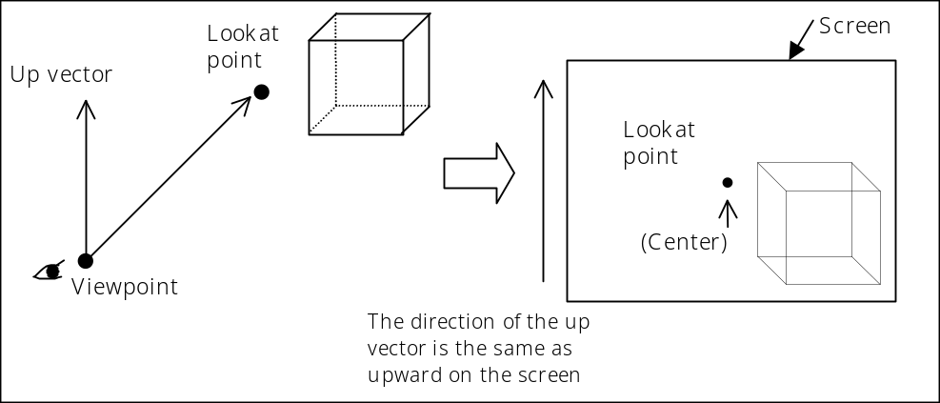
Figure 1-1 Conceptual drawing of the guLookAt(F) function

However, in this tutorial we are going to construct a model view transformation that combines scaling, rotation and translation without making use of the guLookAt(F) function.

There are many different useful functions available for matrix calculations in addition to the ones below. They are all easy to use, so we will leave the details to the Function Reference and settle here for a simple explanation of each.

guMtxIdent(F) Initializes the matrix as the identity matrix
guScale(F) Sets scale matrix in the given matrix
guRotate(F) Sets rotation matrix in the given matrix
guRotateRPY(F) Creates rotation matrix from roll, pitch and yaw
guTranslate(F) Sets translation matrix in the given matrix
guMtxCatF Multiplies floating point matrices
guMtxCatL Multiplies fixed point matrices
guMtxF2L Converts floating point matrix to fixed point
guMtxL2F Converts fixed point matrix to floating point.

You use these functions in the program to create the projection transformation matrix and the model view transformation matrix. To give a concrete example of this process we have displayed part of the gfx1.c sample program in the frame below.

List 1-1
/* Function creating the projection transformation matrix */
guPerspective(&projection,
&perspNorm,
45.0, /* Viewing angle */
(float)SCREEN_WD / (float)SCREEN_HT, /* Aspect ratio */
10.0, 100.0, /* Distance to clipping plane */
1.0);

/* Create rotation matrix */
guRotateF(fmat1, theta, 1.0, 1.0, 0.5);
/* Translation matrix in order to keep the distance from the viewpoint */
guTranslateF(fmat2, 0.0, 0.0, -50.0);
/* Multiply 2 matrices （Put result in fmat1) */
guMtxCatF(fmat1, fmat2, fmat1);
/* Convert matrix from floating point to fixed point */
guMtxF2L(fmat1, &modeling);

Most of the calculations done in this code are common to general graphics processes, but let's give a brief explanation will be given of guPerspective, the function that creates the projection matrix. The first argument in this function is the pointer to the matrix union. guPerspective appropriately sets the elements of the array indicated by this argument. The second argument, perspNorm, helps maintain computational precision by dividing by the w-coordinate value of the calculated screen coordinates. When you call guPerspective the appropriate scaling constant is stored in perspNorm. Specify this with the gSPPerspNormalize command and pass it to the RSP.
See Figure 1-2 about the viewing angle, aspect ratio and distance to the clipping plane.

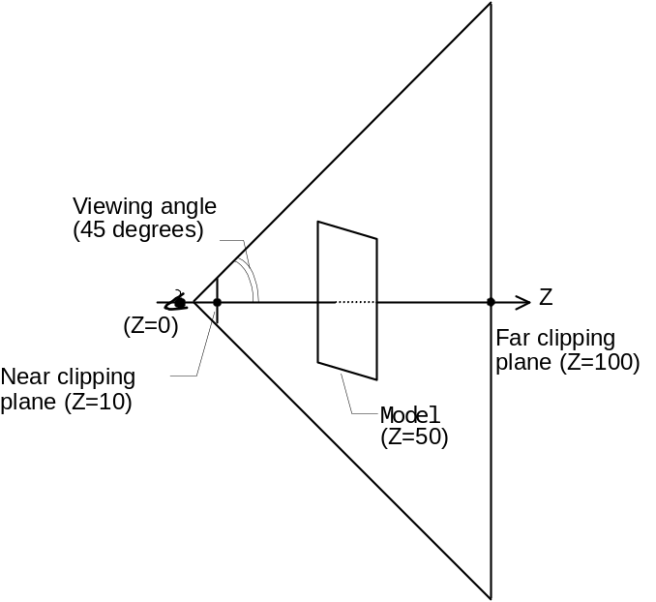
Figure 1-2 The 3D world settings of gfx1.c

The final argument of guPerspective is the scaling constant for the whole matrix. Every element of the matrix is multiplied by this value within guPerspective. For example, when drawing a small-scale 3D world, you could use the scaling constant to enlarge the overall geometry in order to maintain the computational precision until it is time for rendering.

1.3 Passing the transformation matrix to the RSP

Once the transformation matrix has been created as described above, you need to send it to the RSP. To do this you use the gSPMatrix command.
The gSPMatrix command takes not only the pointer to the matrix you want to pass to the RSP, but also the type of the transformation matrix, and the flag that specifies operations to the matrix stack. For the flag, do a bitwise OR of the following constants:

G_MTX_MODEL VIEW Load the model view transformation matrix
G_MTX_PROJECTION Load the projection transformation matrix
G_MTX_LOAD Load matrix to top of the matrix stack
G_MTX_MUL Multiply matrix to top of the matrix stack
(The result becomes the new top of the stack)
G_MTX_PUSH Push matrix to stack before matrix operation
G_MTX_NOPUSH Do not push matrix to stack before matrix operation

When vertices are loaded, the RSP transforms the vertex coordinates and normal vectors. Those vectors are transformed based on the transformation matrix that is set at the time, so you should set the matrix before loading the vertices.

List 1-2
/* Specify a projection transformation matrix */
gSPMatrix(glistp++,
&projection,
G_MTX_PROJECTION |
G_MTX_LOAD |
G_MTX_NOPUSH);
/* Specify a model transformation matrix */
gSPMatrix(glistp++,
&modeling,
G_MTX_MODEL VIEW |
G_MTX_LOAD |
G_MTX_NOPUSH);
/* Scaling of homogeneous coordinates */
gSPPerspNormalize(glistp++, &perspNorm);

There are three other points you need to be aware of in relation to the gSPMatrix command. These are explained below:

1. The pointer to the matrix is a segment address
As described in Chapters 9 and 10 of the Programming Manual, the address passed to the RSP is an RSP segment address. However, in the samples in this Graphics tutorial, the first command in the display list is:

gSPSegment(glistp++, 0, 0);

thus, there is no problem even when a KSEG0 virtual address is passed as is to the RSP. See Chapters 9 and 10 of the Programming Manual to learn more about these kinds of memory management topics.

2. Cache writeback is performed
The RSP cannot directly read/write the contents of RDRAM, so data is transferred using DMA. As noted in the Programming Manual (for example, in Section 3.6.2 Data Cache), there is the chance of invalid data being transferred if the data stored in data cache is DMA transferred without writing back to RDRAM.

3. The matrix has fixed-point format
When handling a floating-point format matrix, you must remember to convert it into fixed point format before passing it to gSPMatrix.

1.4 Defining and Loading Vertices

Once the matrix has been loaded into the RSP, the next step is to load the vertices in order to define the model. As mentioned previously, when the vertices are loaded into the vertex buffer the coordinates are transformed according to the set matrix, so you need to remember to load the matrix before you load the vertices.

Next we will cover defining vertices. Vertex information is stored in the Vtx union. The meanings of some of the elements in the Vtx union change when coloring with vertex color, and when performing lighting processes. This will be explained in detail in the next chapter when we talk about shading.

List 1-3
static Vtx square_vtx[] = {
{-10, -10, 0, 0, 0, 0, 255, 0, 0, 255},
{ 10, -10, 0, 0, 0, 0, 0, 255, 0, 255},
{ 10, 10, 0, 0, 0, 0, 0, 0, 255, 255},
{-10, 10, 0, 0, 0, 0, 255, 255, 255, 255},
};

In this example the Vtx union is an array, so an explanation will be done by focusing on single elements in the array.
The first three elements in the Vtx structure are short type integer values that store the x, y, z coordinates of the vertex. This example defines a vertex with the coordinate values (-10, -10, 0).
The next element is not being used at the present time, so will not be explained here. The next two elements following this are parameters relating to texture mapping, and will be covered in Chapter 3 when we talk about the handling of textures.
The last four elements indicate the color of the vertex in the order of R, G, B, A. See Chapter 6 for details about A, the alpha value. As will be explained in the next chapter, in the case of lighting you need to store the normal vector components here rather than the RGB values.

Once you have defined vertices this way, load them into the RSP's vertex buffer using the gSPVertex command.

List 1-4
/* Load the model's vertices */
gSPVertex(glistp++, square_vtx, 4, 0);

The arguments in gSPVertex specify the pointer to the Vtx union array, followed by the number of vertices to be loaded, and the index at the start of the load destination. Both the number of vertices that can be loaded at the same time and the range of valid index values will differ, depending on the microcode that is being used. (The valid range of index values also depends on the size of the vertex buffer.)

Number of vertices that can be loaded at the same time:

F3DEX2  F3DEX2.NoN  F3DLX2  F3DLX2.NoN  L3DEX2 | 1 ~ 32
F3DEX2.Rej  F3DLX2.Rej | 1 ~ 64

Specifiable starting index:

F3DEX2  F3DEX2.NoN  F3DLX2  F3DLX2.NoN  L3DEX2 | 0 ~ 31
F3DEX2.Rej  F3DLX2.Rej | 0 ~ 63

1.5 Defining Models

A 3D model on the N64 is defined as the planes or lines that connect the vertices stored in the vertex buffer. Thus, you define a model after loading the vertices into the vertex buffer as explained in the previous section.
Below are two typical commands used for defining a model:

gSP1Triangle Defines a single triangle
gSP2Triangles Defines two triangles at once

Here we explain the parameters of the gSP1Triangle command.

List 1-5
/* Create one square from the loaded vertices */
gSP1Triangle(glistp++, 0, 1, 2, 0);
gSP1Triangle(glistp++, 0, 2, 3, 0);

The three arguments following glistp are the indices in the vertex buffer for the three vertices of the triangle you want to define. The order in which they are specified determines the front and back of the plane. The method of specification follows the rules of the right-handed coordinate system, representing a surface with the vertices connected in the counter-clockwise direction.
The final argument is used when you are performing flat shading to specify which vertex color to use to fill the surface. It can take a value of 0, 1 or 2. In the the next chapter, we cover shading and explain this argument again in greater detail, so even if you do not have a complete understanding proceed on to the next section.

If you understand gSP1Triangle, then gSP2Triangles will not be complicated; you simply specify two sets of the gSP1Triangle arguments in the same order.

List 1-6
/* Create one square from the loaded vertices */
gSP2Triangles(glistp++, 0, 1, 2, 0, 0, 2, 3, 0);

As you can see, gSP2Triangles has the same effect as calling gSP1Triangle twice, but you can accomplish the job with only one command, so using gSP2Triangles helps reduce the size of the display list.
Furthermore, some special commands (e.g., F3DLP.Rej and F3DLX.Rej) have been optimized based on the assumption that you are using gSP2Triangles, so this command also has an advantage in terms of speed.
Massive numbers of triangles are handled in an actual game, so we recommend using gSP2Triangles as much as possible.

1.6 View Port

The RSP is in charge of coordinate transformations all the way to the screen coordinates, so you need to give the RSP view port information as well.
Setting the view port is similar to loading arrays and vertices: first you set the parameters in the appropriate union, and then you tell the RSP about the pointer to that union using a display list command. The Vp union used at this time has the following Vp_t structure as a member:

typedef struct {
short vscale[4]; /* scale, 2 bits fraction */
short vtrans[4]; /* translate, 2 bits fraction */
/* both the above arrays are padded to 64-bit boundary */
} Vp_t;

vscale[0] and vtrans[0] are the scaling and offset values of the x component, while vscale[1], vtrans[1] are the comparable values for the y component, and vscale[2], vtrans[2] are those for the z component. (The rest of the elements are defined for the purpose of padding.)

This is probably still rather confusing, so a source sample will be used to explain more concretely. SCREEN_WD and SCREEN_HT are values representing the height and width of the screen in pixels in a macro defined with the header file.

List 1-7
static Vp view port = {
SCREEN_WD * 2, SCREEN_HT * 2, G_MAXZ / 2, 0,
SCREEN_WD * 2, SCREEN_HT * 2, G_MAXZ / 2, 0,
};

This example defines a view port encompassing the whole screen. After the RSP geometry engine performs the projection transformation on the vertex coordinates, it divides those x,y,z components by the homogeneous component values. The result for each of the x,y,z components is a value between -1 and 1.
The values in this [-1, 1] range are used for the scaling and offset values mentioned previously to convert to screen coordinates.
Below is an equation expressing how x coordinate is actually converted into a screen coordinate:

(Equation 1)

screen_x = x * (SCREEN_WD / 2) + SCREEN_WD / 2

If x = -1 then screen_x = 0. If x = 1 then screen_x = SCREEN_WD. In the same way, the y component changes to a value between 0 and SCREEN_HT. In other words, the point is distributed over the entire screen. The z component is explained in Chapter 7, which talks about the Z buffer, and will not be touched on now.

The scaling & offset value written as "SCREEN_WD * 2" in the sample source becomes "SCREEN_WD / 2" in Equation 1. This is because the Vp_t structure members are in s13.2 format, so it was multiplied by 4 in the sample source.

1.7 Summary

The explanations in this chapter were somewhat concise, but managed to mention actual computations performed by the RSP and programs that use the RSP.
If you take a look at the gfx.1 sample source you will notice a number of commands that we have not explained at all. Yet, all of these commands are named with the gDP* convention and are related to the RDP. We will begin explaining the RDP in the next chapter and bring up a number of gDP* commands. If you can get a firm grasp on each of these commands as you read through this tutorial, you will gain a deep understanding of how to use all of the essential commands as well as the hardware architecture that lies behind them.

Moreover, some of the gSP* commands that we could not explain here will be brought up in later chapters. The geometry mode setting commands gSPClearGeometryMode and gSPSetGeometryMode will be covered in detail in the next chapter, and commands relating to textures will be clearly explained in Chapters 3 and 9.

The structures and commands relating to graphics are all defined in <gbi.h> (though things relating to the S2DEX sprite microcode are in <gs2dex.h>). Take a look at <gbi.h> if you want to learn how the macros are implemented and how the various constants are defined. You may also want to check out the header file as needed so you can gain a full understanding.

CHAPTER 2 ADDING COLOR TO A MODEL

In the previous chapter, we explained how the RSP performs geometry calculations and how those computational processes are described in a program. The RSP basics were pretty much covered in that chapter, so from here on we will shift focus to the processes managed by the RDP. Providing you here with a general explanation of the RDP would be a very lengthy undertaking, so instead we will unravel it a little at a time by covering a different theme in each chapter.

In this chapter, we will give you a rudimentary understanding of the RDP while explaining how color is added to a model. We will also bring up the topic of the RSP geometry mode, which was passed over in Chapter 1. Please make sure you understand the topics handled here, because they will form the basis for your understanding of the operation of things like the Texture Unit, Combiner and Blender, which are touched on in subsequent chapters.

2.1 Various Ways of Adding Color

In the graphics field, the term "shading" is generally used to refer to the coloring of a model. “shade” refers to shadows, so rather than “coloring”, “adding shades” is a more accurate term.
Out there in the real world, it is very rare to find an object that appears to have the exact same coloring over its entire surface. In most cases, parts of the object will be lighter and parts will be darker, due to the different positions and brightness of light sources in the vicinity. Also, if there is some obstruction in the path of a light source, this will cast a shadow on part of the surface of the object.
For these reasons, in the graphics world you cannot achieve realistic images if you simply fill the triangle surfaces with single colors. Practically all graphics processing systems color surfaces with appropriate gradations in order to express shading. This all explains why coloring a model is sometimes called shading (regardless of whether shade is expressed).

Moving beyond this general discussion, terms that are specific to the N64 will be explained next.
In the N64 world, if you exclude textures, then there are three broad ways to color a model.
The first way is to set the "primitive color" for a drawn primitive and color the entire primitive with that color. For example, say you have set the primitive color to yellow, and then you define a triangle using the gSP1Triangle command. When this is done, the entire surface of the triangle will be painted yellow. The actual process is not as simple as implied here, since you also need to set a number of other parameters (explained in later sections), but thinking of the general process in this way is fine. However, please remember that in the N64 world, this coloring method is not called shading.
The second way to add color is with a rendering method based on the "vertex color," as was used for the sample in the previous chapter. As you will recall, the vertex color was set in the last four elements of the Vtx union.
The third and final way color is to use shading to express how light illuminates the model, taking into consideration the position and direction of light sources and the direction of the model. This is called "lighting."

With the N64, the two coloring methods based on vertex color and lighting are collectively referred to as "shading."
Furthermore, shading is divided into two kinds of methods called "flat shading" and "smooth shading."

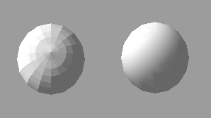
Figure 2-1 Flat Shading and Smooth Shading

We explain each of these methods of adding color to a model in the ensuing three sections. However, we only give a fragmentary explanation in each section, so read all the way through to sections "2.6, Geometry Mode" and "2.7, Combine Mode and Render Mode."

2.2 Primitive Color

Primitive color gives color to the entire "drawn primitive" (e.g., one triangle). You can set it using the gDPSetPrimColor command. The gDPSetPrimColor pseudo-prototype is shown below (it is a macro, so no warning is given even if the types do not agree).

gDPSetPrimColor(Gfx * gdl, unsigned int m, unsigned int l,
unsigned int r, unsigned int g, unsigned int b, unsigned int a);

As you can guess from the names, "r, g, b and a" are the red, green, blue and alpha values of the primitive color. The existence of "m" and "l" parameters will not be of concern until LOD is explained in Chapter 9.
The primitive color settings are extremely simple, so for an abbreviated example of the use of gDPSetPrimColor, some source extracted from the gfx2.c sample program is provided below:

List 2-1
/*
* To attach color using primitive color, try assigning
* a different primitive color to each surface.
*/

/* Create surface 1 */
gDPSetPrimColor(glistp++, 0, 0, 255, 0, 0, 255);
gSP2Triangles(glistp++, 4, 6, 7, 0, 4, 5, 6, 0);
gDPPipeSync(glistp++);
/* Create surface 2 */
gDPSetPrimColor(glistp++, 0, 0, 0, 255, 0, 255);
gSP2Triangles(glistp++, 6, 5, 2, 1, 2, 5, 1, 1);
gDPPipeSync(glistp++);

In this example, surface 1 is colored red and surface 2 is colored green. When you color a model this way, the colors are not affected by the direction in which the model is facing or by the presence or absence of lights.
Next, the meaning of DPPipeSync, which is inserted between gSP2Triangles and gDPSetPrimColor will be explained. To do this, observe what happens when DPPipeSync is deleted from the display list:

List 2-2
/* Create surface 1*/
gDPSetPrimColor(glistp++, 0, 0, 255, 0, 0, 255);
gSP2Triangles(glistp++, 4, 6, 7, 0, 4, 5, 6, 0);
/* No gDPPipeSync */
/* Create surface 2 */
gDPSetPrimColor(glistp++, 0, 0, 0, 255, 0, 255);
gSP2Triangles(glistp++, 6, 5, 2, 1, 2, 5, 1, 1);

When the image is rendered according to this display list, the rendering of surface 1 begins after the primitive color has been set to red. One might think that once the rendering of surface 1 is completed, the primitive color of surface 2 (red) is set and then the rendering of surface 2 begins. However, pipeline processing occurs within the RDP, so sometimes the next command starts to execute before the previous command has been completed. In other words, the primitive color for surface 2 might be set while surface 1 is still being rendered, in which case surface 1 would be colored both red and green.

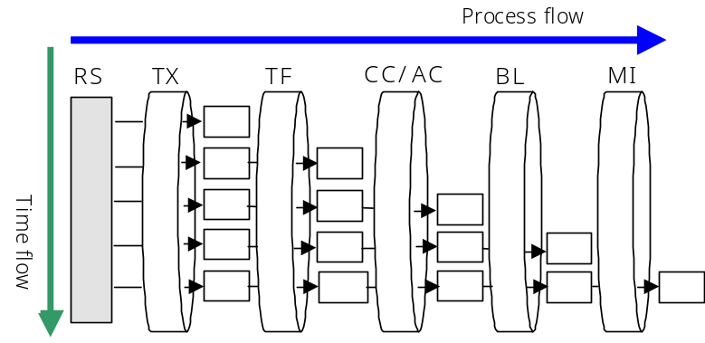
Figure 2-2 Schematic of Pipeline Processing

To counter this problem, you insert the gDPPipeSync command between the command that defines the primitive and the command that updates the primitive attributes.
As its name implies, the gDPPipeSync command acts to synchronize pipeline processing and attribute updates, waiting when necessary in order to prevent the kind of inconsistent rendering mentioned above.

2.3 Vertex Color

You have already seen an example of rendering using vertex color back in Chapter 1, in the gfx1.c sample program. Setting the vertex color is simply a matter of setting the last four elements in the Vtx union.
As was mentioned above in section 2.1, the use of vertex color and the use of lighting to shade things are together called shading, and shading is divided into the two processes of flat shading and smooth shading.
Back in Chapter 1, Section 1.5, "Defining the Model," we omitted an explanation of the last argument in the gDP1Triangle command. This last argument has special meaning when you perform flat shading.

gSP1Triangle(Gfx * gdl, int v0, int v1, int v2, int flag);

When flat shading is performed, the "flag" argument takes the value 0, 1 or 2, specifying which vertex to use (v0, v1 or v2) for coloring. The color of the specified vertex is used to paint the entire surface.
In contrast, when smooth shading is used to shade things, the colors of all three vertices are used to color the inside of the surface. As a result, the "flag" argument has no meaning, even when it specifies a vertex.
When you flat shade using vertex color, the surface is colored uniformly, regardless of the direction in which the surface is pointing, so the rendering result is the same as when filling with primitive color. However, with smooth shading, the inside of the surface can be filled with a smooth change in color. In the gfx1.c sample of the previous chapter, smooth shading is implemented to express squares filled with a variety of colors.
Switching between flat shading and smooth shading will be described later in "2.6, Geometry Mode."

2.4 Lighting

Lighting is a bit more complicated than the primitive color and vertex color processes, since the following two changes are required:

・ Put normal vectors in the model (to be exact, the model vertices)
・ Define the light

Defining the light will be covered in the next section. Here we will explain how to add normal vector information to the model.

List 2-3
static Vtx cube_vtx[] = {
/*
* Vertex information when lighting is ON.
* Normal vectors are stored here, rather than vertex color.
* This is for smooth shading.
*/
{-10, -10, -10, 0, 0, 0, -73, -73, -73, 255},
{ 10, -10, -10, 0, 0, 0, 73, -73, -73, 255},
{ 10, 10, -10, 0, 0, 0, 73, 73, -73, 255},
{-10, 10, -10, 0, 0, 0, -73, 73, -73, 255},
{-10, -10, 10, 0, 0, 0, -73, -73, 73, 255},
{ 10, -10, 10, 0, 0, 0, 73, -73, 73, 255},
{ 10, 10, 10, 0, 0, 0, 73, 73, 73, 255},
{-10, 10, 10, 0, 0, 0, -73, 73, 73, 255},
};

The Vtx union for storing vertex information is used as type Vtx_t when setting vertex color, and as type Vtx_tn when setting normal vectors.
The only difference between type Vtx_t and type Vtx_tn is that one holds "the vertex color RGB components" and the other holds "the normal vector x,y,z components." All other elements are common to both.
The thing you need to be aware of is that when treating them as normal vector component values, each element becomes a signed 8bit number. Also, the normal vectors need to be normalized.
In other words, you must scale so that either of the following conditions is met:

sqrt(x * x + y * y + z * z) == 127
or
x * x + y * y + z * z == 127 * 127

Since lighting is one of the N64 shading methods, you can choose to perform either flat shading or smooth shading.

For flat shading, the lighting is calculated using the vertex normal information specified in the last argument of the gSP1Triangle command, and the resulting color is applied to the entire surface. The surface color will vary depending on the direction of the surface and the light settings, but any one surface will be filled with only one color.

2.5 Defining Lights

The way to position lights in the 3D world is to define light structures and then pass these to the RSP using commands.
Eight kinds of light structures are available, corresponding to the number of diffuse lights. In the following (pseudo) type definition, M takes a value of 0 to 7 indicating the number of diffuse lights. Note that when M = 0, Light l[M] becomes l[1].

typedef struct {
Ambient a;
Light l[M]; /* When M = 0 the value becomes l[1] */
} LightsM;

Generally speaking, the gdSPDefLightsM macro is used when defining the light structure, rather than specifying the structure members directly. See the definitions in <gbi.h> if you want to know details about Ambient and Light.

List 2-4
/* Structure defining the lights (diffuse light + ambient light) */
Lights1 light = gdSPDefLights1( 0, 0, 100, /* Blue ambient light */
255, 0, 0, /* Red diffuse light */
0, 127, 0); /* Direction toward diffuse light */

This example and its comments should give you the general impression. Below we show the order in which the gdSPDefLightsM macro passes arguments and initializes LightsM:

R, G, B components of the ambient light
R, G, B components of the first diffuse light
x,y,z components of the direction vector for the first diffuse light
R, G, B components of the second diffuse light
x,y,z components of the direction vector for the second diffuse light
:
:

The RGB components can take any value from 0 to 255 while the xyz components can take any value from -128 to 127.
The thing you need to be careful about here is that the direction vector of the light does not refer to the direction in which the light is shining, but rather the direction toward the light source. In other words, the light direction specified in this structure is opposite the direction in which the light is actually shining. Also note here that, unlike the normal vector of the vertex, the direction vector of the light does not need to be normalized.

Once the light has been defined and the information has been communicated to the RSP using the gSPSetLightsM macro, the light settings are finished.

List 2-5
/* Positioning the light */
gSPSetLights1(glistp++, light);

2.6 Geometry Mode

Thus far, we have talked about how to change primitive color, how to set vertex color, and the procedure for positioning lights. However, specifying rendering using these specific coloring methods is a separate matter.
To select a coloring method and to switch between flat shading and smooth shading you change the "geometry mode," which was brought up in a previous chapter, but not explained at the time.

The following two macros can be used to change the geometry mode:

gSPSetGeometryMode Set the specified geometry mode
gSPClearGeometryMode Clear the specified geometry mode

These two commands pass the bit-OR of the following flags:

G_SHADE Shading
G_SHADING_SMOOTH Smooth shading
G_LIGHTING Lighting
G_CULL_FRONT Front face culling
G_CULL_BACK Back face culling
G_CULL_BOTH G_CULL_FRONT | G_CULL_BACK
G_ZBUFFER Z buffering (Chapter 7)
G_FOG Fog (Chapter 8)
G_TEXTURE_GEN Use highlights & reflection mapping (Chapter 9)
G_TEXTURE_GEN_LINEAR Use Reflection Mapping (Chapter 9)

So, for example, to color a surface using primitive color you would turn off the G_SHADE, G_SHADING_SMOOTH and G_LIGHTING flags. Then, as explained in the next section, by setting the combine mode to G_CC_PRIMITIVE you can add color using primitive color.
To color a surface using vertex color, you turn on G_SHADE and turn off G_LIGHTING. Then if G_SHADING_SMOOTH is turned off, flat shading is performed, and if it is turned on, smooth shading is performed.
For lighting, you turn on both G_SHADE and G_LIGHTING. As with vertex color, if G_SHADING_SMOOTH is turned off, then flat shading is used for rendering, and if it is turned on, then smooth shading is used.

2.7 Combine Mode & Rendering Mode

As we explained in the previous section, you need to set the geometry mode for each color you add, but that is not sufficient. You also need to be aware of the RDP settings. However, this is a very complex topic, so here we will only explain the procedure for doing the settings, and will be covered in later parts of the tutorial, starting with Chapter 4.

One of the things you need to set in the RDP is the combine mode. You set the appropriate mode using the gDPSetCombineMode macro.
For example, to add color using primitive color (in other words, not using shading), you would instruct the RDP to conduct rendering using primitive color as follows:

List 2-6
gDPSetCombineMode(glistp++, G_CC_PRIMITIVE, G_CC_PRIMITIVE);

On the other hand, if you want to use a shading method (vertex color or lighting), you would set the mode as follows to render based on shading:

List 2-7
gDPSetCombineMode(glistp++, G_CC_SHADE, G_CC_SHADE);

Another essential RDP mode is the so-called rendering mode. At the present time, the same rendering mode can be used by all three coloring methods.

List 2-8
gDPSetRenderMode(glistp++, G_RM_OPA_SURF, G_RM_OPA_SURF2);

The explanation for rendering mode is also rather lengthy, so it will be explained gradually from Chapters 5 through 7.

CHAPTER 3 SIMPLE TEXTURE MAPPING

By using the shading methods explained in the previous chapter you can express surface shading, and if you also perform lighting you can depict model coloring in a way that corresponds to the location of lights in the vicinity.
Building on this, the general way to add realism to your images is to use texture mapping to reproduce patterns on the surfaces of polygons.
The explanations in this chapter are designed to provide you with a basic understanding of texture mapping. Texture mapping on the N64 is a very complex topic, and the explanation provided here is not complete by any account. Later in Chapter 9 the subject will be brough up again and how to use more advanced textures will be explained.

3.1 Texture Mapping Flow

The N64 uses the values S, T for the texture coordinates. Among the various processes relating to texture mapping, it is the job of the RSP to perform such tasks as scaling of the texture.

The RSP passes the ST values to the RDP, which uses these values to select texels for rendering and to perform filtering processes as specified by the programmer. This architecture is represented by the block diagram in Figure 3-1.

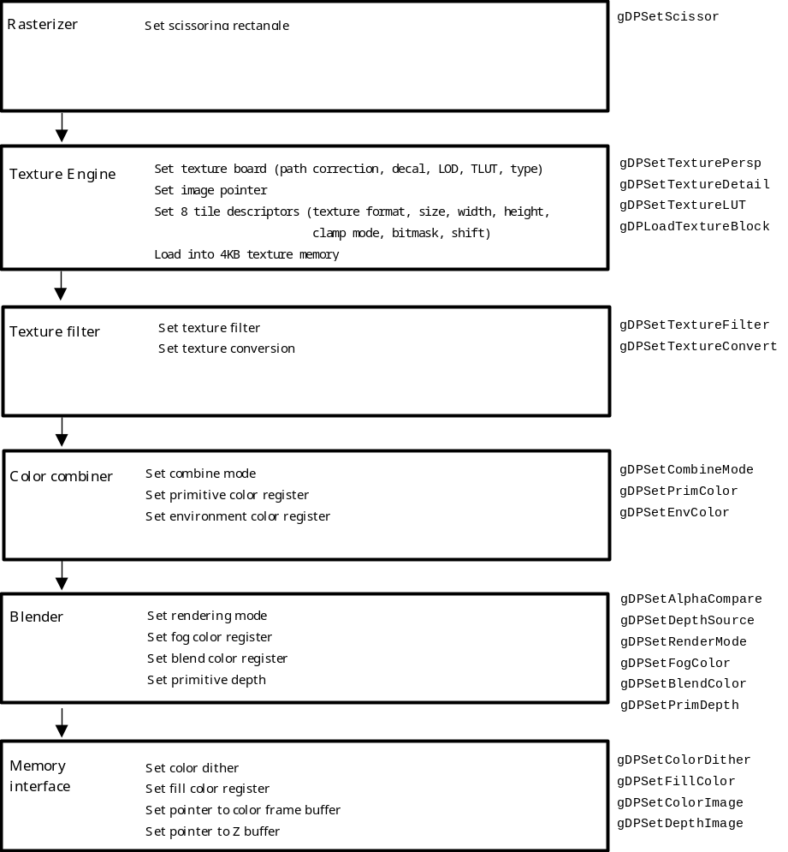
Figure 3-1 RDP Block Diagram
The job of the Texture Engine is to manage such processes as loading the texture image from memory into the RDP's texture memory (TMEM), and selecting texels that correspond to specific pixels from that loaded image.
The Texture Engine also manages tiles, which is the name for the memory blocks in TMEM. We will talk about tiles in Chapters 9 and 10, so for now just remember that the RDP has 4KB of texture memory called TMEM, and that this can be thought of as one continuous buffer.
The Texture Filter enlarges or reduces mapped texels so they correspond to the size of the drawn primitives, at the same time filtering to smooth out the texture. We talk more about this in "3.6, Texture Filter."
As mentioned above, TMEM has a capacity of 4KB, so given a texture with 16bit texels, the maximum size texture that can be loaded at one time is 64x32. Thus, if you want to map a texture that is larger than this to a polygon, you need to divide up the texture and perform several smaller mapping processes.

If you look at the flow of processes involved in the display of textures from the programmer's point of view, generally speaking the following procedures need to be performed:

・Enable textures, and specify scaling and tiles (gSPTexture)
・Associate vertices with their ST values in the Vtx union (gSPVertex)
・Set the appropriate combine mode and rendering mode
(gDPSetCombineMode, gDPSetRenderMode)
・Set the correct state for the Texture Engine and Texture Filter
(gDPSetTexture* commands)
・Load the texture into TMEM (gDPLoadTexture* commands)
・Render the primitive (gSP1Triangle, gSP2Triangles)

These commands do not need to be executed in the exact order we have shown here, but the settings must all be completed before rendering the primitive (i.e., before defining the primitive)

3.2 Loading Textures

With the N64, if you do not load a texture into TMEM you cannot utilize texture mapping and texture rendering, so first we will look at the method used to load textures into TMEM.

gDPLoadTextureBlock(
Gfx *gdl,
u32 timg,
u32 fmt,
u32 siz,
u32 width,
u32 height,
u32 pal,
u32 cms,
u32 cmt,
u32 masks,
u32 maskt,
u32 shifts,
u32 shiftt )

The second argument in the gDPLoadTextureBlock command expresses the pointer to the texture image. In a game program, a texture for display is generally sent from ROM to RDRAM as needed, and that (segment) address is passed to gDPLoadTextureBlock. However, in this tutorial, the texture data is converted to C source format and included in the object as an initialized array.

The fifth and sixth arguments represent the size of the image. They provide values that indicate the width and height in texels of the texture that is to be loaded. As mentioned before, TMEM has a capacity of 4KB, so a very large texture cannot be loaded all at once.
The gDPLoadTextureBlock command has many other arguments, but because explaining them all would be a lengthy undertaking, so the explanations have been divided up for each argument into separate sections.

3.3 Texture Image Format

List 3-1
/* Load texture (image rgba16sign1) */
gDPLoadTextureBlock(glistp++,
rgba16sign1, /* pointer to texture image */
G_IM_FMT_RGBA, /* texel format */
G_IM_SIZ_16b, /* texel size */
32, 32, /* image width & height */
0, ... (omitted)

The third and fourth arguments of gDPLoadTextureBlock express the format of the texture image that is to be loaded and the texel size.
The texture format tells how the texture image is displayed in color space. The N64 can utilize any of the following five kinds of texture formats:

G_IM_FMT_RGBA Texels expressed as RGB and alpha value
G_IM_FMT_IA Texels expressed as intensity (R=G=B=I) and alpha
value
G_IM_FMT_I Texels expressed only as intensity (R=G=B=A=I)
G_IM_FMT_YUV Texels expressed in YUV^{*1} format
G_IM_FMT_CI Texels expressed by color index (i.e., using palettes)

The texel size expresses the number of bits of each texel. It can be any of the following four:

G_IM_SIZ_32b
G_IM_SIZ_16b
G_IM_SIZ_8b
(G_IM_SIZ_4b)

(Note: G_IM_SIZ_4b cannot be used with the gDPLoadTextureBlock command. To use this size, please use the gDPLoadTextureBlock_4b command.)

The texture image should express a texture format and texel size that is appropriate for a given picture quality and the way in which the image is to be used. However, you cannot combine all texture formats with all texel sizes in any which way you want. The following table shows the permissible combinations and the bit allocation for each component in the specified situation.

 |  | G_IM_SIZ_ (size)
 |  | 4b | 8b | 16b | 32b
G_IM_FMT_  (format) | RGBA |  |  | ○  (5/5/5/1) | ○  (8/8/8/8)
G_IM_FMT_  (format) | YUV^{*1} |  |  | ◯
G_IM_FMT_  (format) | CI | ○ | ○
G_IM_FMT_  (format) | IA | ○  (3/1) | ○  (4/4) | ○  (8/8)
G_IM_FMT_  (format) | I | ○ | ○

The samples in this tutorial do not deal with color index textures and YUV^{*1} textures. If you are going to use color index textures, remember to set the texture lookup table using the gDPLoadTLUT_pal* command. Similarly, if you are going to use YUV^{*1} textures, remember to perform color conversion in the Texture Filter using the gDPSetConvert and gDPSetTextureConvert commands.

^{*1} The operation of YUV textures is not guaranteed at the present time.

3.4 Texture Coordinates

Next, an explanation of the texture coordinate system, a topic that plays an essential role in any understanding of textures, will be provided.
The texture coordinate system describes the location in space of a texture, with the "s axis" in the horizontal direction, and the "t axis" in the vertical direction. The s-axis component is called the S value and the t-axis component is called the T value.
The ST values, then, can be thought of as corresponding to the texel coordinates.
The texture mapping of a polygon is merely a matter of deriving the ST values of each vertex.
Figure 3-2, below, shows a texture with width (w) and height (h) being mapped to a square polygon.

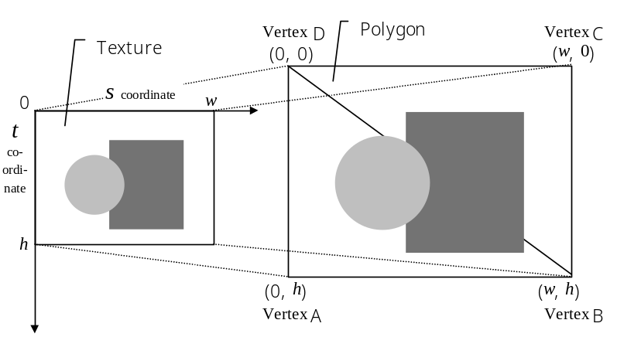
Figure 3-2 Mapping a texture to a polygon

The correspondence between vertices and ST values is specified by the Vtx union describing the vertex information. The Vtx union was talked about in Chapter 1. Recall the fifth and sixth elements in this union, which we put off explaining in Chapter 1.

List 3-2
static Vtx cube_vtx[] = {
{-10, -10, -10, 0, 31 << 6, 31 << 6, 0, 0, 0, 255},
{ 10, -10, -10, 0, 0 << 6, 31 << 6, 0, 0, 0, 255},
(omitted)

In this example (gfx3.c edited for easy reading), the width and height of the texture are both 32 texels. The first vertex corresponds to the lower-right corner of the texture (31, 31) while the second vertex corresponds to the lower-left corner (0, 31).
The ST value elements are described in 10.5 fixed-point format in the Vtx union, so to store an integer value you should shift 5 bits to the left. However, in the above example the integers are shifted by 6 bits. To explain the reason for this, we will introduce the gSPTexture command and then clarify.
Before you perform texture mapping, you need to use the gSPTexture command to enable the texture and to set the tile index that will be used for the texture coordinate scaling constants.

gSPTexture(Gfx *gdl, s32 sc, s32 tc, s32 level, s32 tile, s32 on)
sc Scaling value for texture coordinate s (16bit precision, .16)
tc Scaling value for texture coordinate t (16bit precision, .16)
level Maximum number of mipmap levels -１
tile Tile descriptor index (3bit precision, 0~7)
on Texture flag
G_ON (texture on)
G_OFF (texture off)

The second and third arguments of this command get the scaling constants for texture mapping in 0.16 fixed-point format. In other words, the ST values received by the RDP are the ST values computed by the RSP multiplied by these scaling values.
The next argument is specified when texture mapping (mipmapping, etc.) is done in relation to level of detail (LOD). We cover LOD textures in Chapter 9, so for now set this to 0. The argument after that specifies the tile index, but this is also not brought up until Chapter 9.
The final argument enables the functioning of the Texture Engine when it is set to G_ON. If you set this to G_OFF the Texture Engine becomes unavailable.

Next we will look at an actual example from gfx3.c

List 3-3
/* Enable texture and set scaling parameters */
gSPTexture(glistp++, 0x8000, 0x8000, 0, G_TX_RENDERTILE, G_ON);

In this example, the scaling constants take on the value of 0x8000, or 0.5 if written in floating point. The technique of initially scaling the ST values with 0.5 is one of the techniques typically used in N64 programs. Now recall how the ST values in the Vtx union were shifted 6 bits even though 5 bits would have been OK. When the ST values are first doubled and then multiplied by a scaling constant of 0.5, they return to their original values. The reason this is done is that the scaling constant does not have an integer component, so you cannot correctly express a value of 1. That is why you do the more complicated method, and "first double, then halve." However, instead of this complex process, you can assign many bits to the decimal portion, thereby boosting computational precision and also enabling two-stage scaling.

3.5 Clamp, Wrapping & Mirror

When texture mapping, there is no rule that says the texture must cover the entire polygon. For example, when mapping an orderly texture like bricks, it would be easier if you could do the mapping with a small texture that you could put down like sections of wallpaper. In fact, there is a mapping method that works this way, called "wrapping." You can specify this attribute using the gDPLoadTextureBlock command:

List 3-4
/* Load texture (image rgba16sign1) */
gDPLoadTextureBlock(glistp++,
rgba16sign1, /* pointer to texture image */
G_IM_FMT_RGBA, /* texel format */
G_IM_SIZ_16b, /* texel size */
32, 32, /* image width & height */
0, /* LUT (palette) index (not used here) */
G_TX_WRAP, G_TX_WRAP, /* s, t direction clamp-wrap-mirror flags */
5, 5, /* s, t mask */
G_TX_NOLOD, G_TX_NOLOD); /* shift (no shift here) */

In this example, the G_TX_WRAP constant is specified in the 8th and 9th arguments. When this is done, the wrapping attribute is set in the tile of the loaded texture. The four following constants have been defined for specification here:

G_TX_WRAP Enable wrapping
G_TX_CLAMP Do not wrap
G_TX_MIRROR Enable mirror-image wrapping
G_TX_NOMIRROR Do not mirror-image wrap

The next two arguments take the mask values carried out on the ST values. That is, the ST values passed to the RDP and a bitwise AND is done with the mask values to get the final ST values, on which the selection of texels is based.

In the gfx3.c sample program, you can change the wrapping flag (__CWS_S__, __CWS_T__) and mask value (__MASK_S__, __MASK_T__) as well as the maximum ST values for each face of the cube (__MAX_S__, __MAX_T__) with the macro definitions. Therefore, make a variety of changes to the settings to see what happens.

3.6 Texture Filter

In the RDP, the output from the Texture Engine is sent to the unit called the Texture Filter for filtering, after which it is passed to the Color Combiner.
In the Texture Filter, filtering is performed in association with texel sampling to enlarge or reduce the texture.

Use the gDPSetTextureFilter command to select a sampling filter method:

gDPSetTextureFilter(Gfx *gdl, u32 type)
type The texture sampling mode
G_TF_POINT Point sampling
(Enlarge single texels. Enlarged texels look like blocks)
G_TF_AVERAGE Box average
(Averaged, so smoother than point sampling)
G_TF_BILERP Bilinear
(Approximate bilinear interpolating 3 pixels)

Usually you achieve the best results using bilinear interpolation, but this may not always be the case, depending on the orderliness of the texture and the scale at which the texture is being displayed. For actual games, you will also need to preprocess the texture data based on a thorough understanding of the topics covered in Chapters 12 and 13 of the Programming Manual.

3.7 Other Commands Relating to Texture Settings

Here we introduce four other commands relating to textures. The first three commands will be brought up again later in Chapters 9 and 10, so refer there for concrete examples of their use.

gDPSetTexturePersp(Gfx *gdl, u32 enable)
Specifies whether or not to perform perspective correction on the texture. When texture mapping to polygons this should be set to G_TP_PERSP.

enable The perspective correction flag
G_TP_NONE (turns perspective correction off)
G_TP_PERSP (turns perspective correction on)

gDPSetTextureLOD(Gfx *gdl, u32 mode)
This command sets the mode for multi-tile textures. Specify G_TL_LOD for mipmapping and other LOD-compliant texture mapping.
mode Texture mode
G_TL_TILE (turns LOD tile selection off)
G_TL_LOD (turns LOD tile selection on)

gDPSetTextureDetail(Gfx *gdl, u32 type)
Specifies the texture sampling type when performing LOD-compliant texture mapping. See Chapter 9 for details.
type Texture sampling type
G_TD_CLAMP (clamp)
G_TD_SHARPEN (sharp)
G_TD_DETAIL (detail)

gDPSetTextureLUT(Gfx *gdl, u32 mode)
Specifies whether or not the texture image will use a lookup table (LUT), and if so, what kind.
mode Texture mode
G_TT_NONE (Do not use TLUT)
G_TT_RGBA16 (Use TLUT with entries in 16bit RGBA format)
G_TT_IA16 (Use TLUT with entries in 16bit IA format)

3.8 Supplement on RDP Modes

In this last section, we provide a simple explanation about the various mode settings in the gfx3.c sample program.
First of all, the only thing specified for geometry mode is G_CULL_BACK. In other words, none of the shading functions are used.
The combine mode is set to G_CC_DECALRGB. A detailed explanation of combine mode will be given in Chapter 4, so here we will only note that when the mode is set to G_CC_DECALRGB only the texture color and alpha value are used. That is why there is no need to specify G_SHADE for geometry mode.

The rendering mode is set to G_RM_OPA_SURF and G_RM_OPA_SURF2, as always. We will continue to use these settings until Chapter 5, so for now no explanation for the rendering mode will be provided.

CHAPTER 4 THE COLOR COMBINER

The texture mapping we explained in the previous chapter simply attached a texture image to a polygon. With the N64, you can produce a variety of interesting visual effects using textures.
The Combiner and the Blender units in the RDP play essential roles in the realization of these effects, and you will need a complete understanding of these units if you are going to put together advanced graphics programs.
In this chapter we present a detailed explanation of how to use the functions of the Combiner, presenting a number of examples of visual effects obtained by combining colors together in this unit of the RDP.

4.1 Architecture of the Color Combiner

The Combiner, located after the Texture Filter along the RDP pipeline, combines together a number of source colors and source alphas to determine the output color and the output alpha. These output values are then sent to the Blender. In this chapter, we are going to ignore this fact and instead talk as if the output from the Combiner is directly displayed on the screen.

You can think of the Combiner as two separate units: the "Color Combiner" calculating RGB color and the "Alpha Combiner" dealing with alpha values. We do not begin to talk about sample programs that make use of alpha values until Chapter 5. However, because the Color Combiner and the Alpha Combiner are extremely similar in operation, if you understand the Color Combiner you can use the Alpha Combiner in the same way.

The Color Combiner calculates the output color by combining the various source colors and source alphas using the following equation:

Output = (a - b) * c + d

The source colors and source alphas that can be used for a, b, c, d differ for each coefficient. As shown in Figure 4-1, a number of source colors & alphas can be selected as the input source for each coefficient.

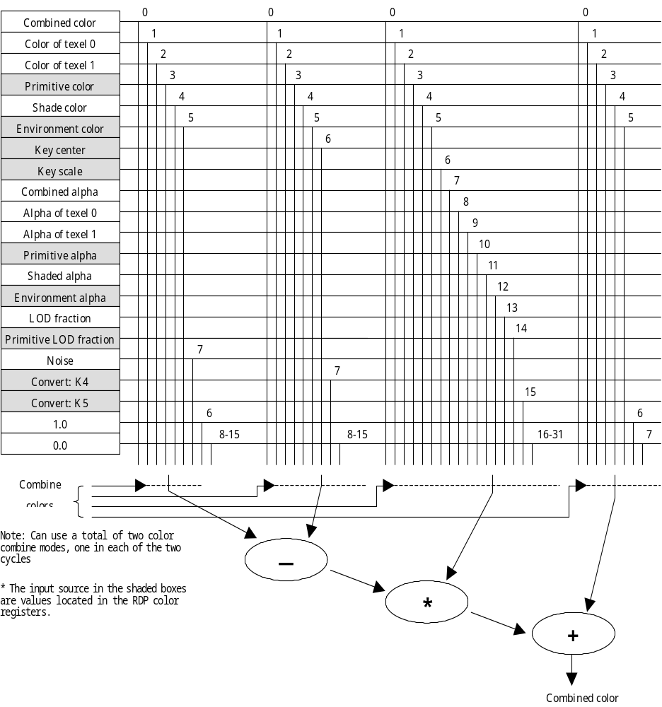
Figure 4-1 Color Combiner input source

One thing to note here is that a number of source alphas can be used for the c coefficient regardless of the color computation. Due to this, special texture effects can be realized based on the alpha value.

4.2 Source Color & Source Alpha

In this section, we will provide a simple overview of the source colors/alphas that can be used as the input source for each coefficient.

Shade color & alpha
This is the color and alpha that result from the shading calculation. You use this source when the geometry mode is set to G_SHADE. Of course, when lighting is performed the shade color results from the lighting calculation.

Primitive color & alpha
This is the color & alpha set in the primitive color register with the gDPSetPrimColor command.

Environment color & alpha
This is the color & alpha set in the environment color register with the gDPSetEnvColor command.

Texel color & alpha
The texel color and alpha obtained from the texture. In one-cycle mode, you can use only texel 0, whereas in two-cycle mode you can use both texel 0 and texel 1. Chapter 10 covers an example of a multi-tile texture in two-cycle mode.

Combined color & alpha
The color & alpha calculated in the Combiner in the first cycle when the mode is set to two-cycle mode. These are used as the source for the calculations in the second cycle. Chapter 8 covers an example of two-cycle mode.

LOD Coefficient
This is input source that can get the LOD factor when LOD processing is performed. LOD is explained in Chapter 9.

Primitive LOD Coefficient
This is input source that can get the primitive LOD coefficient set by gDPSetPrimColor.
Key
This is input source that can get the chroma key^{*2} factor. It is set by gDPSetKeyR and gDPSetKeyGB.

^{*2} Chroma key operation cannot be guaranteed at this time.

Convert K4, K5
This is input source that can get the YUV^{*3}--RGB conversion factors K4, K5. These can be set with the gDPSetConvert command.

*³ Operation of YUV textures cannot be guaranteed at this time.

The programmer can freely use the primitive color register and environment color register as general-purpose color registers. Thus, for example, the primitive color register does not have to be used only for the storage of primitive color, but can also be used for the linear interpolation factor in order to realize fade-in and fade-out effects. Also, the primitive LOD coefficient can be used for other purposes when LOD calculations are not being performed.

In the next section, we will explain how these source colors and source alphas are specified with commands.

4.3 Combine Mode

Up until now, we have been using combine mode without giving a very detailed explanation. All we have actually been doing is specifying the source color and source alpha for the coefficients a, b, c, d.
There is a macro defined in <gbi.h> called gDPSetCombineLERP. The contents of this macro are shown below:

#define gDPSetCombineLERP(pkt, a0, b0, c0, d0, Aa0, Ab0, Ac0, Ad0, \
a1, b1, c1, d1, Aa1, Ab1, Ac1, Ad1) \
{ \
Gfx *_g = (Gfx *)(pkt); \
\
_g->words.w0 = _SHIFTL(G_SETCOMBINE, 24, 8) | \
_SHIFTL(GCCc0w0(G_CCMUX_##a0, G_CCMUX_##c0, \
G_ACMUX_##Aa0, G_ACMUX_##Ac0) | \
GCCc1w0(G_CCMUX_##a1, G_CCMUX_##c1), \
0, 24); \
_g->words.w1 = (unsigned int)(GCCc0w1(G_CCMUX_##b0, \
G_CCMUX_##d0, \
G_ACMUX_##Ab0, \
G_ACMUX_##Ad0) | \
GCCc1w1(G_CCMUX_##b1, \
G_ACMUX_##Aa1, \
G_ACMUX_##Ac1, \
G_CCMUX_##d1, \
G_ACMUX_##Ab1, \
G_ACMUX_##Ad1)); \
}

The gDPSetCombineLERP macro has many arguments, but all of the arguments besides "pkt" (the argument for the display list pointer) are there to specify source color and source alpha for the coefficients.

a0, b0, c0 and d0 are the cycle-1 source color & alpha, and they are used to perform the following calculation:

Output color = (a0 - b0) * c0 + d0

In the same way, Aa0, Ab0, Ac0 and Ad0 are the cycle-1 source alpha, and they are used to calculate the alpha value with the following equation:

Output alpha = (Aa0 - Ab0) * Ac0 + Ad0

a1, b1, c1, d1, Aa1, Ab1, Ac1and Ad1 are the cycle-2 source color & alpha. In one-cycle mode, the same combine mode must be set in both cycles.

4.4 Review of Combine Mode

Thus far, we have been using combine mode without knowing much about it. Next, we will look at the combine mode definitions and see how those definitions are realized.

If you look at <gbi.h>, you'll see that the gDPSetCombineMode command macro is defined as follows:

#define gDPSetCombineMode(pkt, a, b) gDPSetCombineLERP(pkt, a, b)

In other words, as previously mentioned, setting the combine mode is nothing more than using the gDPSetCombineLERP command to set the input source for linear arithmetic in the Combiner.

So how are the definitions actually set for the combine mode used in the sample programs (gfx1.c to gfx3.c) we have been talking about up to now?
The G_CC_SHADE mode that colors the model using shading color is defined in <gbi.h> as follows:

#define G_CC_SHADE 0, 0, 0, SHADE, 0, 0, 0, SHADE

With this, the output color = (0 - 0) * 0 + shade color = shade color. In other words, the result of the shading calculation is output without being changed in any way. The same is true for the alpha value. Take a look at the definition for G_CC_PRIMITIVE mode:

#define G_CC_PRIMITIVE 0, 0, 0, PRIMITIVE, 0, 0, 0, PRIMITIVE

As you can see, this specifies that the primitive color & alpha be output unchanged.

These fall in the class of very simple combine modes, but many other combine modes have been prepared in <gbi.h>. For details, see the section on gDPSetCombineMode in the Function Reference.
What kinds of visual effects result from the use of these preset combine modes? To gain a deeper understanding of combine mode, define a number of combine modes of your own at this point and see what happens.

Flat shading is used for all coloring in this chapter's gfx4.c sample program. Thus, assuming that the Combiner performs no combining with texture color, etc., each surface of the cube will be colored with a single color. In other words, you do not necessarily need to use smooth shading to produce interesting and beautiful visual effects.

4.5 Gradations with Textures

As the first example, we will look at the implementation of a combine mode to express the gradation of a single color on the surface of a cube. If you compile and run gf4.c without making any changes, the images like those shown in Figure 4-2 will appear on the screen.

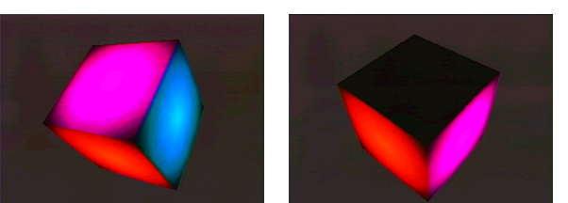
Figure 4-2 Screen shots from sample program gfx4.c

These are the results from the combine mode as set on line 280 of the gfx4.c program.

List 4-1
/*
* Combiner outputs shade color (single color) multiplied
* by texture intensity.
* color = (SHADE - 0) * TEXEL0 + 0 = SHADE * TEXEL0
*/
gDPSetCombineLERP(glistp++, SHADE, 0, TEXEL0, 0,
0, 0, 0, SHADE,
SHADE, 0, TEXEL0, 0,
0, 0, 0, SHADE);

In this example, the shade color is multiplied by an 8bit intensity texture and output from the Combiner. The alpha value is the shade alpha, but it this has no special meaning in this example because no degree of transparency is employed.
Figure 4-3 shows the texture(shading image) used. It is a gradation drawing, white in the center changing to black at the four corners of the square. When you multiply a flat shade color by this texture color, you get an effect like that shown in Figure 4-2.


Figure 4-3 The texture used in the sample

With intensity textures, the intensity of the texture is used for the R, G, B, A channels. It is important to remember that the texture intensity is copied in for not only the R, G, B colors but also for the alpha value as well.

4.6 Texture Inversion

If you change "undef" to "define" in line 27 of gfx4.c the texture color will be inverted for mapping. In this case, 16bit RGBA color texture is used just like the sample program in the previous chapter.
To invert the texture color, you set the texture color to t and output 1-t. You can carry out texture inversions by setting the combine mode as follows:

Output color = (1 - texture color) * 1 + 0

However, there is one point you need to keep in mind here. You cannot specify a value of 1 as the source for the c coefficient in (a - b) * c + d. There is always some source color prepared as 1, and this is what must be selected as the source for c. In the gfx4.c sample program, the primitive color register is used for this purpose.

List 4-2
/* Set it so the primitive color is used as the source of value 1 */
gDPSetPrimColor(glistp++, 0, 0, 255, 255, 255, 255);

/*
* Inverted texture color components are output from the Combiner
* color = (1 - TEXEL0) * 1 + 0 = 1 - TEXEL0
* (The primitive color is simply used as input for value 1)
*/
gDPSetCombineLERP(glistp++, 1, TEXEL0, PRIMITIVE, 0,
0, 0, 0, SHADE,
1, TEXEL0, PRIMITIVE, 0,
0, 0, 0, SHADE);

When this is done, the primitive color register (as well as the environment color register) can be used to not only specify the primitive color, but also as a general-purpose color register when the circumstances arise.
Figure 4-4 shows the kinds of results you get by inverse texture mapping using the combine mode described above.

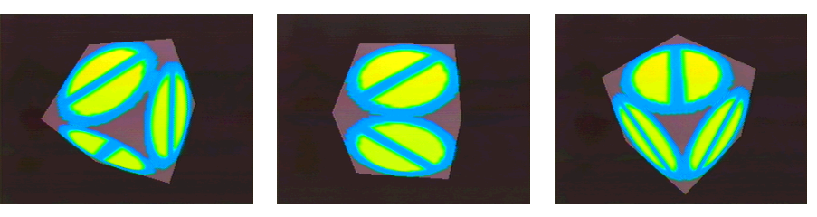
Figure 4-4 Screen shots from gfx4.c sample program when __INVERT__ is ON

4.7 Coloring with Noise

As our final example of a custom combine mode, we will look at a very different type of visual effect.

If you look again at Figure 4-1 you will notice that "noise" is one of the input sources for the a coefficient of (a - b) * c + d. If you take that noise and multiply it by the shade color and use that as the source for a output by the Combiner, you can get an image like the static you might see on TV at the end of the broadcast day.

List 4-3
/*
* Shade color (single color) multiplied by noise is output
* from the Combiner
* color = (NOISE - 0) * SHADE + 0 = NOISE * SHADE
* Only the a coefficient of (a - b) * c + d gets noise as the source
*/
gDPSetCombineLERP(glistp++, NOISE, 0, SHADE, 0,
0, 0, 0, SHADE,
NOISE, 0, SHADE, 0,
0, 0, 0, SHADE);

Using this combine mode, random black noise covers the surfaces of the primitive colored with single shade colors.
The noise value does not have a very large dynamic range, so the shade color is either output as-is or it becomes 0 (black).

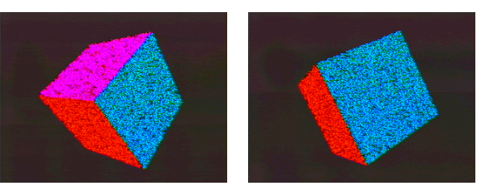
Figure 4-5 Screen shots of sample program gfx4.c、with __NOISE__ ON

CHAPTER 5 SEMI-TRANSPARENT OBJECTS & THE ALPHA VALUE

So far, none of the sample programs has touched on the concept of transparency when rendering models and textures. But in real game programs, textures are often pasted onto polygons with parts that are transparent.
The so-called alpha value plays a large role in such scenes, with the transparency of those pixels controlled according to the alpha value. Strictly speaking, the alpha value does not define the transparency but rather the opacity of the pixels, so the higher the alpha value the greater the opaqueness.
In this chapter, we explain texture mapping with regards to the alpha value so you know how to express transparent models and textures. Then we will touch on the Blender, which is positioned after the Combiner in the RDP pipeline (see Figure 5-1), so you have a firm foundation for the explanations in and after Chapter 6.

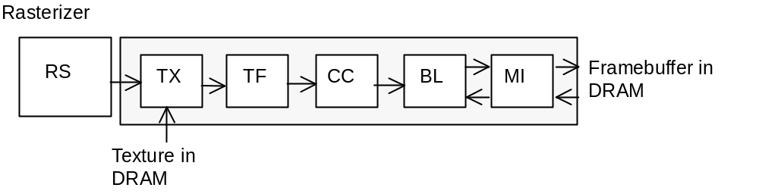
Figure 5-1 The RDP pipeline structure (1-Cycle mode)

5.1 The Alpha Combiner

The Combiner can perform linear arithmetic on the alpha value to determine the output alpha in the same way that it performs calculations on RGB color. Think of this process as being performed inside the Combiner by the Alpha Combiner.
The Alpha Combiner, like the Color Combiner, performs linear arithmetic to calculate the output alpha from the various source alphas.

Output alpha = (a - b) * c + d

The source alphas that can be selected for each of these coefficients are shown in Figure 5-2.

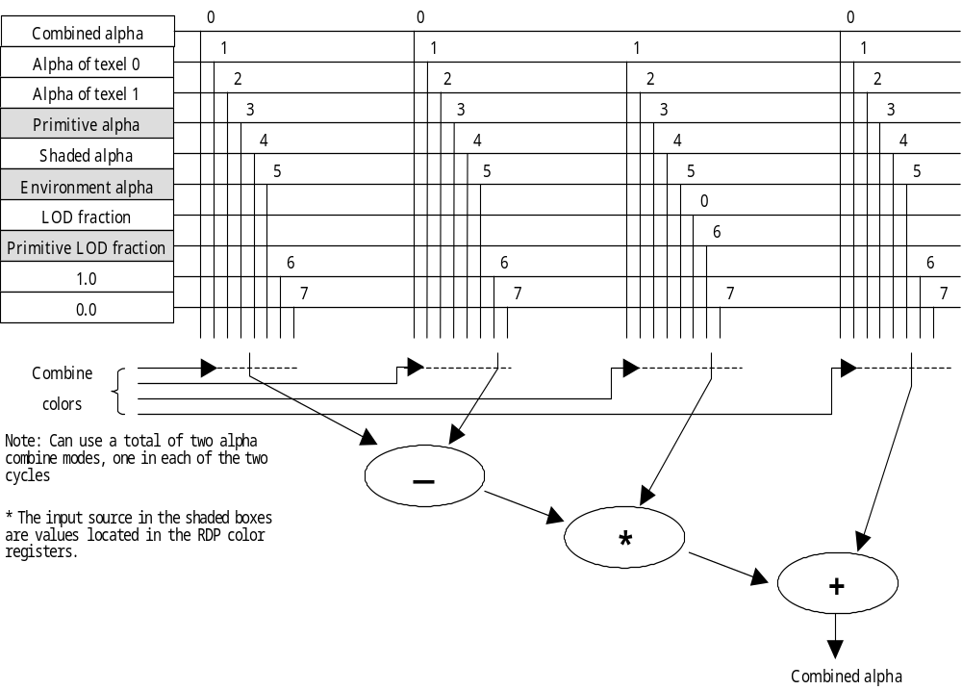
Figure 5-2 Alpha Combiner input source

The Alpha Combiner is remarkably similar to the Color Combiner in terms of operation and input source, so it should not be difficult to understand. However, as touched on in the previous chapter, you need to remember that with intensity textures, the intensity is automatically used for the texel alpha.

5.2 Texture Formats with Alpha Values

With the exception of the YUV^{*4} format, all texture formats that can be used by the N64 contain alpha value information. Below we look at the advantages and disadvantages of each format from the point of view of the use of alpha values.
(^{*4}) The operation of YUV textures cannot be guaranteed at this time.

RGBA32
The most expressive texture format, but also the one that requires the most data. The alpha value can express a 256-step scale, meaning you can achieve anti-aliasing-like effects by setting the alpha value a little lower for the outline of the texture.

RGBA16
Considering its balance of expressive capability and data volume, this texture format is used most often. However, RGBA16-format textures only have 1bit of alpha information. As a result, texels can only be expressed as completely transparent or completely opaque.

IA16
This texture format allocates 8bits for intensity and 8bits for alpha value information.

IA8
This format is similar to IA16, but only 4bits each are allocated for intensity and alpha value information. Each texel can be expressed with 1byte, so you decrease the data size.

IA4
This texture format has 3bits of intensity and 1bit of alpha value information.

I8
This texture format has only 8bits of intensity information. Yet, the intensity is automatically used for the alpha value, so this format is useful when creating special effects with textures. It caries enough information to express gradations, etc.

I4
This is an extremely compact texture format designed for image data, likes fonts that do not need a number of colors. Since the intensity is automatically used for the alpha value, this format can also be used to handle background (i.e., black texels) as transparent parts.

5.3 Semi-transparent Objects and the Rendering Mode

If you modified the sample program in the previous chapter and mapped with the rgba16sign1_a texture, which has some transparent parts, you would notice that the polygon does not become transparent in the way you might expect. That is to say, if you tried to map texture data incorporating alpha value information in the same way as done with all of the sample programs up to now, you would not be able to achieve transparency effects. This is because the rendering mode in the Blender has not been set correctly.

In the sample programs up to now, all tasks could be accomplished by specifying G_RM_OPA_SURF for the rendering mode. The "OPA" in this mode name stands for opaque. This is the mode for the rendering of opaque surfaces, and transparency effects will not show up in this mode, even when you map textures that have alpha values. That is why G_RM_XLU_SURF and G_RM_XLU_SURF2 are used as the rendering modes in the gfx5.c sample program. The "XLU" in the mode names stands for transparent.

We will not get into too much detail about the Blender in this chapter, but we will talk a little about the operations of the Blender so you will understand the differences between G_RM_OPA_SURF and G_RM_XLU_SURF.
The Blender is a unit like the Combiner that performs linear arithmetic to mix colors. Unlike the combining that goes on in the Combiner, the Blender takes the pixel color & alpha passed from the Combiner, and blends this with the pixel color & alpha present in the framebuffer. Moreover, when operating in 2-Cycle mode, the Blender output from the first cycle can be fed back as input for the second cycle.
The smaller the alpha value output from the Combiner (or calculated in the first cycle), the more transparent the pixel, so the smaller the proportion of mixing with the pixel in the frame buffer. Conversely, if the alpha value is large, then the pixel is opaque, so mixing is performed to replace the pixel currently in the framebuffer.

Although the Blender has this important role of blending colors, the rendering mode determines what coefficients are present in the linear arithmetic and it is possible, depending on the mode, for no blending to be performed and the pixel color & alpha to be simply overwritten in the framebuffer. The G_RM_OPA_SURF is one such mode, and when this mode is set, the pipeline color will be overwritten to the framebuffer no matter how many pixel alpha values there are.
Typically, the calculation is made with the following kind of linear expression:

new frame buffer color = pixel color * 1 + framebuffer color * 0

That is why you cannot use the G_RM_OPA_SURF mode in programs where you want to make the most of alpha values for texture mapping like the gfx5.c sample program. When G_RM_XLU_SURF mode is used, blending is performed in relation to alpha values, so you can achieve transparency effects without any problems.

The various rendering modes are considered in detail in Chapters 6 and 7, so refer to these for more information.

5.4 Running the Sample Program

Now that we have covered the most important points regarding the display of semi-transparent objects, we will look at the gfx5.c sample program source for concrete examples.

First compile and run gfx5.c without making any changes. The intensity texture "circle" was also used in gfx4.c. Here in gfx5.c, the intensity of this texture is used for the alpha value in order to display a semi-transparent cube.

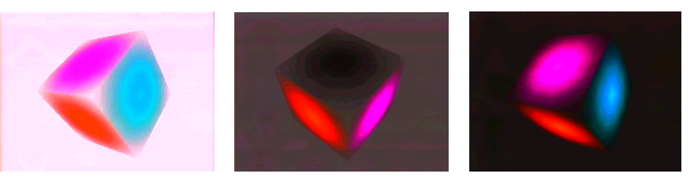
Figure 5-3 Screen shots from gfx5.c sample program
In this example, the combine mode is set as follows:

List 5-1
/*
* The shade color is multiplied by the texture intensity and output
* by the Combiner for the color, while the texture alpha (the intensity
* becomes the color) is output by the Combiner for the alpha.
*/
gDPSetCombineLERP(glistp++, SHADE, 0, TEXEL0, 0,
0, 0, 0, TEXEL0,
SHADE, 0, TEXEL0, 0,
0, 0, 0, TEXEL0);

As you can see from looking at the source, the mode is set so the product of the shade color multiplied by the texel color is output for the color, and the texel alpha is output for the alpha value. (Because this is an intensity texture, the intensity becomes the alpha value).

As mentioned earlier, the rendering mode is changed to G_RM_XLU_SURF and G_RM_XLU_SURF2. When operating in 1-Cycle mode, you need to specify for the second cycle's rendering mode the rendering mode of the first cycle with "2" attached.

List 5-2
/* Set rendering mode (semi-transparent) */
gDPSetRenderMode(glistp++, G_RM_XLU_SURF, G_RM_XLU_SURF2);

Next try running gfx5.c after changing "undef" to "define" on line 28. When this is done, mapping is performed in the same way, but using a color texture in RGBA16 format instead of an intensity texture. For this, the combine mode is set so that both the color and the alpha of the texel are output as is.

List 5-3
/* Texel color and alpha are output as is from the Combiner */
gDPSetCombineLERP(glistp++, 0, 0, 0, TEXEL0,
0, 0, 0, TEXEL0,
0, 0, 0, TEXEL0,
0, 0, 0, TEXEL0);

In RGBA16 format, the alpha value of the texture is expressed by 1bit, so there is a clear demarcation between completely transparent places and completely opaque places. In other words, a 1bit alpha value is input to the Combiner as 0 or scaled up to 256.

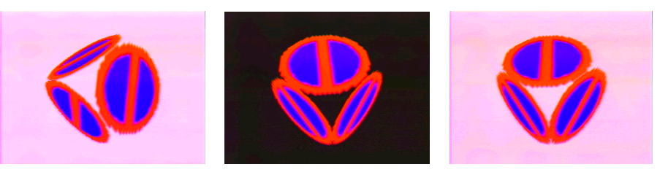
Figure 5-4 Screen shot from sample program gfx5.c when __COLOR__ is defined

5.5 Alpha Compare

A macro is available in the gfx5.c sample program that can be customized to use or disable the alpha compare function.
The alpha compare function is set using the gDPSetAlphaCompare command. This command sets the mode of the alpha compare function. The three following modes can be selected:

1. Disable the compare function（G_AC_NONE）
2. Compare with the blend color（G_AC_THRESHOLD）
3. Compare with a random dither value（G_AC_DITHER）

When you define __ALPHA_COMPARE__ on line 35 of the gfx5.c sample program (please undef __COLOR__), the mode is set to compare with the blend color. The pipeline alpha and the blend alpha (the alpha value set in the color register in the Blender) are compared, and if the pipeline alpha is smaller, then that pixel is not written to the framebuffer. In other words, pixels that have an alpha value smaller than the blend alpha are treated as completely transparent pixels.

Now try changing the value of __ALPHA_THRESHOLD__ on line 39 of gfx5.c from the default of 50 to a variety of different values. You will see that the region of the intensity texture that is completely cut-off changes, with the value of __ALPHA_THRESHOLD__ acting as the boundary.

When the alpha compare mode is set to dither on line 294 of gfx5.c, the edges of the intensity texture will look like large collections of particles.

List 5-4
gDPSetAlphaCompare(glistp++, G_AC_DITHER);

The alpha compare function lets you express transparency even in copy mode, where the Combiner and Blender processes are not performed. This is a way to realize visual effects while controlling the load. We will bring up this topic again when we explain texture rectangles in Chapter 10.

CHAPTER 6 RENDERING MODE AND ANTI-ALIASING

In Chapter 5, we explained how to realize transparency effects by mapping transparent textures having alpha values. In concert with this, we also provided a simple explanation of how the Blender blends framebuffer pixels and pipeline pixels. However, the role of the Blender is not simply to produce transparency effects.
In this chapter, we build on our understanding of the Blender by introducing the extremely important topic of anti-aliasing. We also go into more details about the blending process, which was only roughly explained in Chapter 5, and introduce the various rendering modes.

6.1 Overview of Anti-aliasing on the N64

Algorithms for anti-aliasing and theories of implementation are the subjects of widespread research in the graphics field. In general though, much anti-aliasing is based on the process of dividing a pixel up into finer subpixels, determining the color of each, and then averaging these with what is called supersampling.
The problem with this method is that it takes time to calculate the colors of the subpixels, and you also need to reserve memory to store the subpixel colors. The N64 requires rendering processes that are both fast and memory-efficient, so this method has been simplified and a special architecture implemented for anti-aliasing.

For anti-aliasing on the N64, the pipeline color and the framebuffer color are blended based on an amount called the coverage value. The coverage value represents the extent to which a given pixel is covered by a primitive. When this value is small, the background color is heavily emphasized, whereas when this value is large, the pipeline color is more emphasized in the blending.

If you just consider this role of the coverage value, it may seem that the coverage value is very similar to the alpha value. However, it is conceptually important to distinguish between the two. To wit, the coverage value is a number that describes the geometrical concept of the extent to which a pixel is covered by a primitive, whereas the alpha value describes the transparency of the pixel without any other meaning attached. Of course, this is not to say that the two values are unrelated, since the product of the coverage value multiplied by the alpha value can be used for the coverage value and the alpha value inside the Blender.

We will talk more of the coverage value in the next section. Here we will give a simple presentation of how anti-aliasing is performed on the N64.
You can think of anti-aliasing as a two-stage process on the N64:

(1) Anti-aliasing with the Blender (see Figure 6-1)
In this stage, aliased interior edges of polygons are eliminated. An interior edge is an edge that is shared by two polygons.

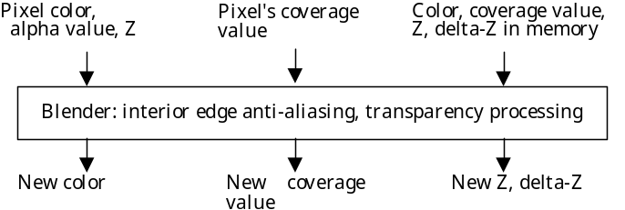
Figure 6-1 The data flow in anti-aliasing (Stage 1)

2. Anti-aliasing with the Video Interface (VI) (see Figure 6-2)
In this second stage, the silhouette edges of the polygon are anti-aliased. Silhouette edges are all exterior edges of the rasterized polygon. This anti-aliasing process is executed at the stage when data is sent from the framebuffer to the DAC.

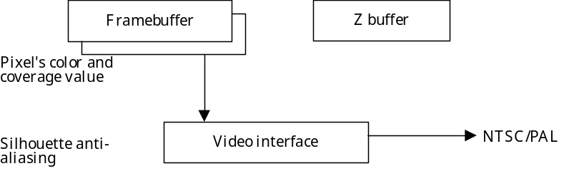
Figure 6-2 The data flow in anti-aliasing (Stage 2)

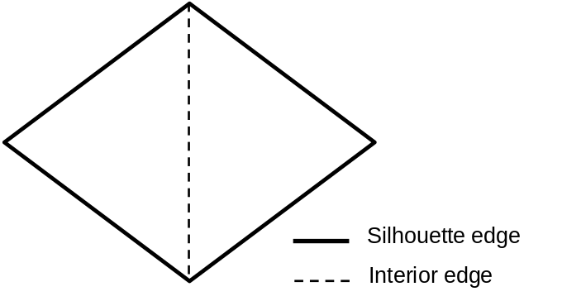
Figure 6-3 Interior edge and silhouette edges

In the following sections, we will provide detailed explanations of how coverage values are calculated and about blending in the Blender.

6.2 Coverage Value

Thus far, we have used the term "coverage value", rather freely but if you do not know how this value is calculated, you cannot understand anti-aliasing on the N64.
When a polygon is rendered on the N64, each pixel is subdivided into a 4x4 grid of subpixels, and a determination is made about which subpixels are covered by the polygon, and which subpixels are not.
However, because only 3bits are allocated for the coverage value, a dither mask is implemented as shown in Figure 6-4 so the coverage value can be limited to a value from 0 to 8. Then 1 is subtracted from this coverage value and the result is stored in the framebuffer.

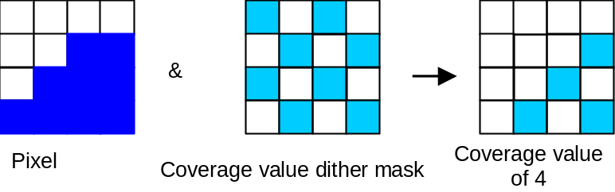
Figure 6-4 Dither mask for coverage value

With gDPFillRectangle, the coverage values are all set to 1 at the time of initialization. What this means is that an image in its initial state is treated as background.
To learn about the proper format for coverage values stored in the framebuffer, see Chapter 15.5.6, "Color Image Format" in the Programming Manual.

6.3 Color Blender

Now that we have explained how the coverage value is calculated, next we will talk about the blending process with the Blender.
The Blender, like the Combiner, performs linear arithmetic on values obtained from a number of input sources to determine the color for output.

Color = (p * a + m * b) / (a + b)

In this expression, p and m are the colors for blending. You can change the colors that will serve as the basis for mixing by selecting specific input sources. The coefficients a and b are the alpha values. The extent of blending of p and m is adjusted according to these values.

The usable input source colors are the same for p and m. The appropriate source is chosen from the list below:

Mux Select | Source
0 | First cycle - pixel's RGB  Second cycle - the blended RGB from first cycle
1 | RGB in memory
2 | Blend (register's) RGB
3 | Fog (register's) RGB

In contrast, the usable input source for a and b are different from one another. This is due to the fact that they are blend coefficients. Often values of (b = 1 - a) are used.

A Mux input source
Mux Select | Source
0 | Color Combiner's output alpha
1 | Fog (register's) alpha
2 | Shade alpha
3 | 0.0

B Mux input source
Mux Select | Source
0 | 1.0 － a mux output
1 | Alpha in memory (coverage value)
2 | 1.0
3 | 0.0

The difference between the Blender and the Combiner is that the Blender can use the framebuffer RGB and the framebuffer alpha as input sources. In other words, with the Blender, a new polygon can be rendered and blended while another polygon is being drawn.
Also, the Blender output does not necessarily have to be written back to the framebuffer, but sometimes can be removed if there is no need to write back the result of Z buffering. The blend result can also be removed sometimes when alpha comparing.

In the case of the Combiner, the linear arithmetic coefficients are in essence the combine mode. In the same way, it would seem plausible that you could call these linear coefficient settings the rendering mode. Actually, the rendering mode is more complicated than the combine mode, and the term refers to not only the p, m, a, and b input sources, but also a number of flag settings relating to anti-aliasing and Z buffering.
A review of the role of all of these flags is beyond the scope of this tutorial. You can read the details in Chapter 15 of the Programming Manual. Here we will only cover the number of rendering modes that have already been defined in <gbi.h>.

6.4 Defined Rendering Modes

You have already used the macros G_RM_OPA_SURF and G_RM_XLU_SURF for the rendering mode in the sample program. These are just two of a number of rendering mode macros that are defined in <gbi.h>. It would be difficult to remember all of these macros, so therefore some kind of systematic understanding is necessary.

There is a certain convention used in naming rendering mode macros. All of these macros begin with "G_RM" followed by symbols that classify the rendering mode.

AA_: indicates anti-aliasing
ZB_: indicates Z buffering
OPA_ (opaque), XLU_ (transparent) etc.: indicate the transparency of the object
SURF, DECAL, LINE, INTER, TERR etc.: indicate the type of the object

There are a few exceptions to this naming convention, however, among the rendering modes defined in <gbi.h>. For example, G_RM_NOOP which stops the operations of the Blender, and G_RM_PASS outputs the input as it came from the Combiner without changes. There are also the rendering modes G_RM_FOG_SHADE_A and G_RM_FOG_PRIM_A relating to fog, which is brought up in Chapter 8.

6.4.1 Anti-aliasing and the Rendering Mode

Next we will look at how to use rendering modes from the point of view of anti-aliasing.

First, take a look at the gfx6.c sample program. Anti-aliasing is switched on and off in the program by defining and undefining __ANTI-ALIASING__ on line 27. If you compare the program with and without __ANTI-ALIASING__ defined, you will notice that the only difference is in the rendering mode.
When __ANTI-ALIASING__ is not defined, the mode is set to G_RM_XLU_SURF, similar to the gfx5.c in Chapter 5. Yet when __ANTI-ALIASING__ is defined, the mode is changed to G_RM_AA_XLU_SURF.

As described above, the "AA_" in G_RM_AA_XLU_SURF means anti-aliasing, and in this mode, anti-aliasing is performed by the Blender. Think of any rendering mode with AA_ in its name as a mode that performs anti-aliasing. Conversely, any mode that does not have AA_ in its name does not perform anti-aliasing.

If the rendering mode has RA_ rather than AA_ in its name, then it is in “simple anti-aliasing mode” that performs an abbreviated form of anti-aliasing without reading the color from memory. Rendering is faster with this rendering mode compared to a normal AA_ mode, but the quality of the anti-aliasing is lower.

You need to keep the following points in mind about anti-aliasing:

(1) When the Blender performs anti-aliasing, so does the VI
When you render using a rendering mode with anti-aliasing on, make sure to enable VI anti-aliasing for the second pass. If you do not do this, then silhouette edges will not be anti-aliased. VI anti-aliasing can be switched on and off by specifying the VI mode with osViSetMode. For details, see Chapter 7.6, "VI Mode and Special Functions."

(2) Disable anti-aliasing when rendering a 2D background
When a 2D image is being rendered for the background, there is no pixel in memory that anti-aliasing can use for blending. For more efficient rendering you should turn off anti-aliasing.

6.4.2 Z buffering and the Rendering Mode

To perform Z buffering, you use a rendering mode that has ZB_ in its name (e.g., G_RM_AA_ZB_OPA_SURF). The modes that perform Z buffering will reference and if necessary write to the Z buffer when a pixel is being rendered, thus the overall speed of rendering slows. Therefore, when rendering background you should use a rendering mode with Z buffering turned off.
We will explain Z buffering on the N64 in detail in the next chapter.

Rendering Subject and the Rendering Mode

Many rendering modes are defined in <gbi.h> in accordance with the characteristics of the object being rendered. A number of these modes have already been utilized in the sample programs. For example, opaque objects have been rendered using G_RM_OPA_SURF mode, and (semi)-transparent objects have been rendered using G_RM_XLU_SURF. Also, in gfx6.c, anti-aliasing is performed using G_RM_AA_XLU_SURF mode, which you could call an expanded version of semi-transparent mode.

In addition to the transparency related modes OPA_ (opaque) and XLU_ (transparent), there is another special rendering mode defined in <gbi.h> called texture edge mode (TEX_EDGE).
Texture edge mode is useful for billboard-type texture mapping, which is a technique often used to express objects like trees. Billboard texture mapping is a simple way of expressing objects like trees with a small number of polygons. If you were to use a normal semi-transparent rendering mode with this technique, when the object was enlarged even the alpha values would be interpolated, and you would get a blurry image around the outline of the texture. With texture edge mode, no blurring due to alpha values is introduced into the final image, so this is a better mode to utilize with billboard texture mapping.
In billboard texture mapping, the textures for objects like trees are mapped by combining rectangular polygons together in a cross-shape. Objects are expressed with extremely simple polygons, and you can achieve a bit of a 3D effect unrelated to the angle as long as you render from the horizontal.

Three different texture edge modes are defined in <gbi.h>:

G_RM_TEX_EDGE
G_RM_AA_TEX_EDGE
G_RM_AA_ZB_TEX_EDGE

As for OPA (opaque) and XLU (transparent), a number of different rendering modes have been defined for different types of objects and for different situations.

Surface (SURF)
This is for a normal polygon surface. Rendering modes we have used so far that belong to this type include G_RM_OPA_SURF and G_RM_AA_XLU_SURF.

Decal surface (DECAL)
The decal surface rendering modes are a bit different from other rendering modes, as they are not used to simply render polygons.
To use a decal surface type rendering mode, you must first render a separate polygon. Then, when you try to render a polygon in decal mode, it will only be rendered if there is already a rendered polygon with the same geometry. If none exists, nothing will be rendered.
When rendering in decal surface mode, the presence of a matching geometry polygon is determined using the Z value, so the Z buffer must be enabled. Three decal surface modes are defined: G_RM_AA_ZB_OPA_DECAL, G_RM_RA_ZB_OPA_DECAL and G_RM_AA_ZB_XLU_DECAL. As you can see from the names, all three are modes in which the Z buffer is enabled.

Other rendering modes include LINE, which renders only the edges of the polygon, INTER, which is the mode for rendering interpenetrating polygons, and TERR, which is the mode for rendering terrain.

Think of the texture edge mode TEX_EDGE as a special case of the OPA_SURF rendering mode. Be careful not to confuse this with the mode to render just the edges of the polygon.

6.4.4 Coexistence of Rendering Modes

As described in the previous section, a variety of opaque and transparent rendering modes has been prepared in <gbi.h>. However, when combining these modes together to render a scene, attention must be given to the order in which the objects are drawn.

As a general rule, first render opaque objects and then render semi-transparent objects. The reason for this is that Z values are not written in semi-transparent rendering mode. As a result, even if you were to render the semi-transparent objects first, they would be completely overwritten by the opaque objects, and the image generated would have an odd front-to-back relationship.
Also, when rendering two semi-transparent objects, if you do not render starting from the one further in distance, the order of priority will not be correctly expressed.
If you render starting from the closest opaque object, you can boost performance when using the Z buffer. This is because, by comparing Z values, the processing of pixels that do not need to be rendered is suspended at an early stage.

Figure 6-5 Depicts the order of priority of rendering among rendering modes.

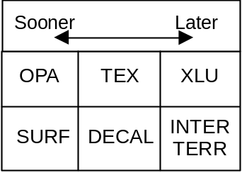
Figure 6-5 Rendering mode rendering order

Accordingly, the following group of rendering modes should be rendered in the order in which they are listed:

OPA_SURF
OPA_DECAL
OPA_INTER
TEX_EDGE
XLU_SURF
XLU_DECAL
XLU_INTER

6.5 Video Filter

The gfx6.c sample program includes functions to make silhouette edge shapes and coverage values visible. To try this, change undef to define on line 37. When you do this, those places where the coverage value in the framebuffer is not 1 appear black, while everything else (where the coverage value = 1) is colored white.
Of course, when anti-aliasing is turned off, the coverage value in the frame buffer remains the default maximum value, so everything becomes white. Therefore, you need to confirm that line 27 is set to define.
Run the sample program in this state, and at the point in time when blending is finished you will see black lines for the parts that have not been anti-aliased yet (based on the coverage values in the framebuffer after interior edge anti-aliasing has been completed). This is the silhouette edge that is anti-aliased by the video filter.

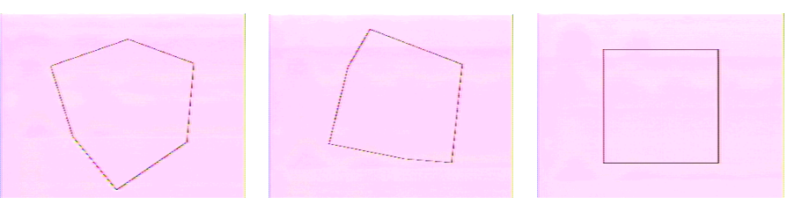
Figure 6-6 Screen shots of gfx6.c sample program with __ANTI-ALIASING__ and __SHOW_COVERAGE__ defined.
The video filter performs anti-aliasing according to the following formula:

Output = coverage value * pixel color + (1 - coverage value) * background color

The "pixel color" is the color of the framebuffer pixel that is now being anti-aliased. The "background color" is the color most different from the "pixel color," as selected from among the 3x5 array of pixels neighboring the pixel that is now being anti-aliased. This is used for smoothly blending the image.

In addition to making the coverage value visible, we will try an experiment defining a rendering mode. By defining __CVG_X_ALPHA__ on line 37 of gfx6.c, you add the CVG_X_ALPHA flag to the rendering mode. (To learn about what other flags can be used, see Chapter 15 of the Programming Manual.) When the CVG_X_ALPHA flag is specified, the coverage value and the alpha value are multiplied together, and the product is used for the coverage value and for the alpha value. As a result, when the coverage value is made visible, not only the silhouette but also the interior of the polygon is colored black.

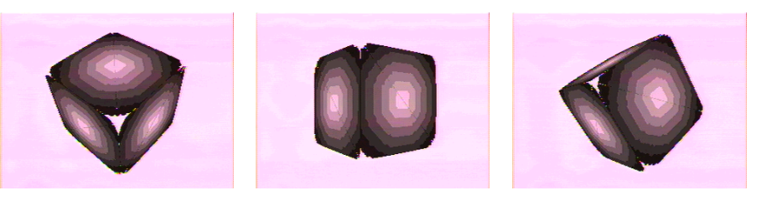
Figure 6-7 Screen shots of sample program gfx6.c when __ANTI-ALIASING__, __SHOW_COVERAGE__ and __CVG_X_ALPHA__ are defined.

Chapter 7 Z BUFFERING

We have reached the midway point of the Graphics tutorial now and gone into quite a bit of detail about the Combiner and the Blender. In this chapter, we bring up the topic of Z buffering to give you a general understanding of how this relates to the Blender. We will concentrate on the basics here (by basic, we do not mean easy), and then cover expansions on the theme in subsequent chapters. If there are parts you do not fully understand, please make the effort to reread the pertinent sections to gain a deeper comprehension of things.

7.1 Determining Depth with Z Buffering

In the sample programs up through Chapter 6, we displayed a single cube model, changing the texture mapped to the cube and performing various processes in the Combiner and Blender. Even by doing just these things, you saw how it is possible to effect large changes in the final appearance of the image.
For the purpose of explaining the N64 system of Z buffering, we have prepared a sample program in this chapter that uses models that cannot be displayed correctly without Z buffering. The single cube is changed to models of thin rods that are displayed overlapping. There is only one set of model data, but this data is reused to render three rods.

First try running the gfx7.c sample program as is without any changes. The three rods overlap one another, but do they do not look like they have been rendered correctly.

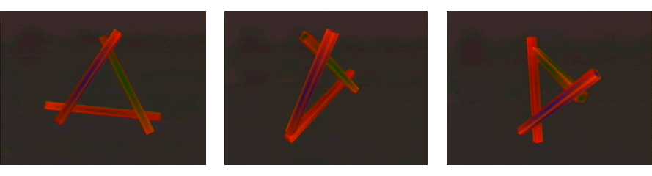
Figure 7-1 Screen shots of gfx7.c sample program
By default, the gfx7.c program renders the poles without the use of Z buffering. The models simply ride on top of one another. With the default settings, the poles are not displayed correctly, and one pole always sits entirely in the front-most plane.

Next we will change undef to define in line 32 of gfx7.c and compile and run the program again. This time the rendering should correctly reflect the depth of the model.

Line 32 of gfx7.c defines the __Z_BUFFER__ macro. When this macro is defined, rendering is performed using Z buffering. In order to accurately render the three overlapping pole models you need the help of the Z buffer.
The gfx7.c sample program differs from the samples of the previous chapters in that it makes repeated use of the same model to display three cubes (converted into pole shapes). Thus, if you simply place the shared model view matrix on the matrix stack, you end up pushing the matrix stack to make use of it later. We will not cover the subject of matrix manipulations in this chapter, so if you are interested in this topic, see the DrawCube function in gfx7.c.

7.2 Preparations for Using the Z Buffer

A detailed explanation about Z buffering and Z values will appear in later sections. Here we will focus on the procedures you need to go through in order to make use of the Z buffer.
To make active use of Z buffering in an N64 program, you must follow the three procedures below to prepare for use of the Z buffer.

1. Set the geometry mode to G_ZBUFFER
2. Set the rendering mode to a mode that uses the Z buffer
3. Clear the Z buffer at the start of every frame (before rendering the primitive)

No special explanation is required about the geometry mode. You simply place the mode constant you want to set in the gSPSetGeometryMode command.

List 7-1
gSPSetGeometryMode(glistp++, G_ZBUFFER | G_SHADE | G_SHADING_SMOOTH |
G_CULL_BACK);

For the rendering mode, gfx7.c uses G_RM_AA_ZB_OPA_SURF. Modes with "ZB" in their name have a macro definition that specifies the Z buffer enable flag Z_CMP. If you want to read more about the rendering modes, see the Programming Manual, Chapter 15.7, "Blender Modes and Assumptions."

List 7-2
/* Opaque - anti-aliasing - Z buffering */
gDPSetRenderMode(glistp++, G_RM_AA_ZB_OPA_SURF, G_RM_AA_ZB_OPA_SURF2);

To register and clear the Z buffer you need to put together a number of RDP commands, but it is not a specialized operation. To explain the procedure we will use the example of the ClearBackground function from gfx7.c. The code is shown below:

List 7-3
gDPPipeSync(glistp++);
gDPSetCycleType(glistp++, G_CYC_FILL);
/* Set the Z buffer */
gDPSetDepthImage(glistp++, nuGfxZBuffer);
/* Specify the subject of coloring (Z buffer) */
gDPSetColorImage(glistp++, G_IM_FMT_RGBA, G_IM_SIZ_16b, SCREEN_WD,
nuGfxZBuffer);
/* Specify the color (background Z value, maximum Z value) */
gDPSetFillColor(glistp++, (GPACK_ZDZ(G_MAXFBZ, 0) << 16 |
GPACK_ZDZ(G_MAXFBZ, 0)));
/* Clear the Z buffer */
gDPFillRectangle(glistp++, 0, 0, SCREEN_WD - 1, SCREEN_HT - 1);

In this code, the gDPSetDepthImage command is used to tell the RDP the address of the Z buffer. In this case, the NuSystem global variable nuGfxZBuffer is given as the Z buffer address. Registering the Z buffer is completed with the call of this one command.
Of course, the pointer passed to this command must be a segment address. As mentioned before, in this tutorial physical address 0 is mapped to segment address 0, so you can pass the virtual address as is.

The next necessary step is to clear (initialize) the Z buffer. You do this the same way as when you clear the framebuffer by using a combination of the gDPSetColorImage command and gDPSetFillColor command.
However, in the case of the Z buffer, the value you use when clearing is not the value for a color, but the value for the maximum Z value. In our example from gfx7.c, the Z buffer is cleared using the macro constant G_MAXFBZ, which indicates the maximum Z value, and the DeltaZ value of 0. When clearing (or filling) the Z buffer, typically the GPACK_ZDZ macro defined in <gbi.h> is used to pack the fill value. We will bring up the topic of the DeltaZ value in the next section.

7.3 Z Value and DeltaZ

With the Z value, you can determine the depth-relationship between the polygon now being rendered and the polygon that has already been rendered in the framebuffer. Using the Z buffer algorithm, you either overwrite the framebuffer if the polygon now being rendered is in front of the other polygon, or else you do nothing.
The task can be accomplished with just the Z value if you are determining the depth of different polygons. Yet, the Z value does not provide enough information to determine whether the polygon rendered in the framebuffer and the polygon now being rendered are the same or not. When rendering decal polygons on the N64, such a determination is essential.

This is where the DeltaZ value comes into play. The DeltaZ value is calculated by computing the rate of change of the Z value of the polygon from the slope of the rendering plane.
One problem is that when a polygon is rendered in the depth-wise direction, the DeltaZ value can become extremely large. Because the allowable range of differences in Z value expands, pixels that ought to be hidden become visible and interior edges are not correctly anti-aliased. To prevent this from happening, the pixel's coverage value can be weighted and blended with the DeltaZ value.
See the Programming Manual, Chapter 15.5.9, "Z Image Format" to read about the format and precision for expressing Z values.

7.4 Depth Source

There is an internal color register in the RDP called the primitive color. A similar thing can be done with the Z value, setting a uniform depth for the entire primitive. This value is called the primitive depth. By using the primitive depth, you can render texture rectangles at a specific depth.

The primitive depth is set using the gDPSetPrimDepth command, which takes the Z value and the DeltaZ value as arguments.

gDPSetPrimDepth(Gfx *gdl, s32 z, s32 dz)
gdl -- Display list pointer
z -- Z value
dz -- DeltaZ value

Use the gDPSetDepthSource command to update the Z value input source for Z values computed during rendering. When you specify G_ZS_PIXEL as the source in this command, the Z value of the polygon is utilized. When you specify G_ZS_PRIM, the primitive depth is utilized.

gDPSetDepthSource(Gfx *gdl, u32 source)
gdl -- Display list pointer
source -- Depth source value
G_ZS_PIXEL (Use each pixel's Z value and DeltaZ value)
G_ZS_PRIM (Use primitive depth register's Z value and DeltaZ value)

7.5 Rendering Modes when Using the Z Buffer

As was explained in the previous chapter, to use Z buffering you must render with a rendering mode that has "ZB" in its name.
However, Z buffering has more than a little effect on rendering performance. So when you are drawing background or otherwise do not need to use Z buffering, you should reset the rendering mode to one that disables the Z buffer.

Also, note that the RDP can hang up if you attempt to access the Z buffer when operating in Fill mode or Copy mode. For this reason, be sure to use the G_RM_NOOP rendering mode, which disables the Z buffer (along with the Blender itself), when in Fill mode or Copy mode.

7.6 VI Mode and Special Functions

Next we will move on to a different subject in this section and talk about the video interface (VI).
One of the main settings relating to the video interface is the VI mode. The VI mode must be set appropriately in order to use high-resolution displays and a 32bit framebuffer. The VI mode is set using the osViSetMode function.
However, what you pass to the osViSetMode function is not an integer value indicating the VI mode, but rather the address of the table holding the settings for the various VI parameters.

void osViSetMode(OSViMode *mode);
mode -- The VI mode
Returned value -- none

The display mode is set in the VI. The VI supports a total of 56 display modes: 14 NTSC, 14 PAL, 14 MPAL, and 14 full-screen PAL (FPAL). For each of these modes, you can set attributes for interlace or non-interlace, 16bit color pixels or 32bit color pixels, and low resolution or high resolution.
The 56 modes are indicated with five switches for high/low resolution, 16/32bit color pixels, anti-aliasing/point sampling, filtering/non-filtering and MPAL／PAL／FPAL／NTSC format. The symbol names for these modes are defined in <os.h>. So for example, OS_VI_NTSC_LPN1 indicates support for low-resolution, point sampling, non-interlace and 16bit color pixels. OS_VI_PAL_LPN1 indicates support for the same, but in PAL format.

The last four characters in the symbol name (LPN1, etc.) are made up from the following codes:

1st character | H = High resolution
1st character | L = Low resolution
2nd character | A = Anti-aliasing
2nd character | P = Point sampling
3rd character | Low resolution | N = Non-interlace
3rd character | Low resolution | F = Interlace
3rd character | High resolution | N = Non-interlace
3rd character | High resolution | F = De-flickered interlace
4th character | 1 = 16bit pixel size
4th character | 2 = 32bit pixel size

There is a systematic naming convention followed for these VI mode symbol names. You can read more about this in the Function Reference. Here we will provide an explanation using concrete examples.

If you take a look at the SetupResolution function in gfx7.c, you will see how the VI mode changes according to the macro definitions. When the __HIRES__ macro is defined, the VI mode is changed as follows to high-resolution, anti-aliasing, non-interlace and a 16bit framebuffer.

List 7-4
osViSetMode(&osViModeTable[OS_VI_NTSC_HAN1]);

In the same way, when the __32BIT__ macro is defined (and __HIRES__ is not defined) then the VI mode is set to low-resolution, anti-aliasing, non-interlace and a 32bit framebuffer.

List 7-5
osViSetMode(&osViModeTable[OS_VI_NTSC_LAN2]);

When you use an array like that in List 7-4 and 7-5, the entire array is linked. If you want to avoid this, set something like &osViModeNtscHan1 using individual VI mode variables.

You can switch gamma correction on and off in the gfx7.c sample program using the osViSetSpecialFeatures function. On line 51, change __GAMMA__ to either OS_VI_GAMMA_ON or OS_VI_GAMMA_OFF and then run the program to see what difference gamma correction makes to the brightness of the image output to the screen. The osViSetSpecialFeatures function can be used to switch the settings ON/OFF for four different special features: gamma correction, gamma correction dithering, divot elimination, and dither filtering.

Note that when you call osViSetMode the VI special feature settings are all set to that VI mode's default values. In NuSystem, gamma correction is turned off by default, so you will notice a brighter screen display when you define __HIRES__ or __32BIT__ and change the VI mode to one with gamma correction turned on.

Of course, when you change the resolution and framebuffer size you must also change the view port settings and display list to match those changes. The size of the framebuffer and the Z buffer also change. We will not go into detail in this tutorial, but if you look at gfx7.c, you will see how to customize the framebuffer and the Z buffer when using NuSystem and how to clear the 32bit framebuffer.

CHAPTER 8 ADVANCED RENDERING TECHNIQUES

In all of the sample programs we have seen up to this point, we have used Fill mode to clear the framebuffer and Z buffer, and we have used 1-Cycle mode for the rendering of polygons. The N64 system also has a 2-Cycle mode which is useful for more complicated kinds of rendering. In this chapter, we will focus on an explanation of 2-Cycle mode, covering both the special features and points of caution regarding each pipeline mode (cycle type).

8.1 Pipeline Mode (Cycle Type)

The RDP has four pipeline modes, which we will describe in separate sections below. Switching between pipeline modes alters the structure of the RDP pipeline, changing the complexity of rendering and the richness of functionality.
In simple rendering mode, processing is fast but there is little functionality, whereas in high-function mode some rendering processes can take a lot of time. Thus, you need to fully appreciate the different characteristics of each pipeline mode so you can use them efficiently.
When we talk about the rendering speed for each pipeline mode in the sections below, please remember that these are strictly the peak values. The actual rendering efficiency will vary depending on whether or not you are using anti-aliasing and Z buffering, and where in RDRAM the framebuffer and Z buffer are located.

8.1.1 Fill Mode

When you set the RDP pipeline to Fill mode, you can fill (clear) the framebuffer and the Z buffer at the efficient rate of 64bits per clock tick. That means if you have a 16bit framebuffer, you can fill 4 pixels per clock tick. In Fill mode, pixels are filled so quickly that the processes in the other units of the RDP cannot keep up. For this reason, the majority of the RDP calculation pipeline is not used in Fill mode.
As the name implies, Fill mode is used to fill (clear) the color framebuffer and Z buffer. In the sample programs we have seen up to now, Fill mode is set in the display list for initialization of the framebuffer and Z buffer. As you can see from the schematic in Figure 8-1, the RDP pipeline has a very simple form when in Fill mode.


Figure 8-1 The RDP pipeline in Fill mode
In Fill mode, absolutely no Combiner and Blender processes are performed. There is a danger of the RDP hanging up if you access the Z buffer in the Blender when in Fill mode, so you should set the rendering mode as shown below so the Blender is kept in a safe state.

gDPSetRenderMode(G_RM_NOOP,G_RM_NOOP2);

8.1.2 Copy Mode

Copy mode lets you copy an image at the rate of 64bits per clock tick (4 pixels per clock for a 16bit framebuffer). Pixels are copied quickly, so like Fill mode, the majority of the RDP calculation pipeline is not utilized in Copy mode.
Copy mode is used for the efficient copying (rendering) of 2D images. In the sample program in Chapter 10, polygons are rendered in 1-Cycle mode and 2D images are rendered in Copy mode. Of course, 2D images can also be rendered in 1-Cycle mode, and you can even set 2-Cycle mode if you are making use of multi-tile textures.
Figure 8-2 is a schematic of the RDP pipeline in Copy mode. As you can see, if you exclude the alpha compare write enable/disable function, the only ability Copy mode has is to copy data from texture memory to the framebuffer.
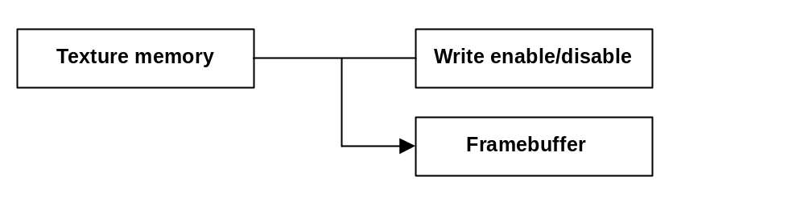
Figure 8-2 The RDP pipeline in Copy mode
No processes are performed in the Combiner and the Blender when in Copy mode, just like when in Fill mode. There is a danger of the RDP hanging if you access the Z buffer in the Blender when in Copy mode, so you should set the rendering mode as shown below so the Blender is kept in a safe state.

gDPSetRenderMode(G_RM_NOOP,G_RM_NOOP2);

8.1.3 1-Cycle Mode

1-Cycle mode is the mode for creating images at the rate of 1 pixel per clock tick. When rendering polygons you must use 1-Cycle mode (or 2-Cycle mode).
Unlike Fill mode and Copy mode, in 1-Cycle mode all of the functional blocks of the RDP come into play, including the Texture Unit and the Combiner and Blender, as schematized in Figure 8-3.

Figure 8-3 The RDP pipeline in 1-Cycle mode

8.1.4 2-Cycle Mode

In 2-Cycle mode, each pixel is created in two passes down the same kind of pipeline seen in 1-Cycle mode. As the name implies, rendering in 2-Cycle mode is performed at the rate of 1 pixel every 2 clock ticks.
Figure 8-4 shows a schematic of the RDP pipeline in 2-Cycle mode. As you can see, it is not simply two of the 1-Cycle pipelines linked end-to-end. Rather, it is structured as if the Texture Units and Combiners were operating in parallel.

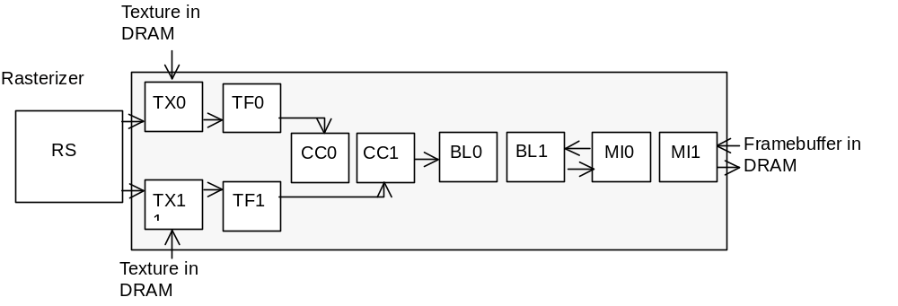
Figure8-4 The RDP pipeline in 2-Cycle mode

8.2 1-Cycle Mode & 2-Cycle Mode

There is really no need to go into further detail about Fill mode and Copy mode. Both have a very simple pipeline structure and it should be clear how they are used. For the rest of this chapter we will focus on an explanation of the differences between 1-Cycle mode and 2-Cycle mode.

Actually, 1-Cycle mode is a richly functional mode that is sufficient for most of your rendering needs. Processing takes longer in 2-Cycle mode, so think of it as the mode you only use when there is something you cannot achieve with 1-Cycle mode.
Next we will cover the things that 2-Cycle Mode can do that 1-Cycle Mode cannot.

Use multi-tile textures (Combiner)
You need to set the RDP pipeline to 2-Cycle mode in order to put texels together from two textures in the Combiner, and to perform LOD-related texture mapping. We talk more about multi-texture tiles in Chapters 9 and 10.

Combine a number of source colors (Combiner)
The Combiner can use the linear equation (a - b) * c + d to determine the pixel color and pixel alpha. But this expression is not sufficient if you want to make a calculation that reflects many more source colors (alphas). In this case, you would use 2-Cycle mode and perform (a - b) * c + d twice in order to calculate a more complicated pixel color (alpha). Later in this chapter, we will give an example of how to use this type of 2-Cycle mode.

Fog function (Blender) & ordinary blending
You need to set the pipeline to 2-Cycle mode in order to enable the Fog function in the Blender and also perform blending. We will talk about Fog later in this chapter.

In summary, you use 2-Cycle mode when you want to operate the Combiner and/or the Blender in 2 cycles.

8.3 The Combiner in 2-Cycle Mode

First we will start with an example where the Combiner is used for 2 cycles. We will try interpolating the color using one texture and shade color as well as noise as the sources.
There are many ways of combining these source colors, but for this example, we will multiply the shade color by the noise component, which is the same calculation made in the gfx4.c sample program when __NOISE__ is defined.
We will perform this calculation in the first cycle. Then, in the second cycle, we'll use the result of this calculation and the texel as the sources, and interpolate both based on the appropriate coefficient. When you define __INTERPOLATION__ on line 45 of gfx8.c, the environment color register is used for the interpolation coefficient, and the combine mode is set as shown below:

List 8-1
/* Set RDP cycle type */
gDPSetCycleType(glistp++, G_CYC_2CYCLE);

/* Enable textures, set scaling parameters */
gSPTexture(glistp++, 0x8000, 0x8000, 0, G_TX_RENDERTILE, G_ON);

gDPSetEnvColor(glistp++, interp, interp, interp, 255);
gSPSetGeometryMode(glistp++, G_ZBUFFER | G_SHADE | G_SHADING_SMOOTH
| G_CULL_BACK);
/* Color interpolation using 2-Cycle mode */
gDPSetCombineLERP(glistp++, NOISE, 0, SHADE, 0,
0, 0, 0, 0,
COMBINED, TEXEL1, ENVIRONMENT, TEXEL1,
0, 0, 0, 1);

The 10th argument in gDPSetCombineLERP is the COMBINED macro, which indicates the value calculated in the first cycle. In the second cycle, the value in the environment color register is used as the coefficient to interpolate the result of the first cycle and the texel.

There are two points to note here. First, the Color Combiner coefficient in the second cycle is not TEXEL0 but TEXEL1. In other words, in the second cycle, the texture set as the primitive tile is referenced as TEXEL1. Second, in this sample program, transparent polygons are not rendered, so no alpha value is interpolated and the output from the second cycle is 1.

In this example, the Blender functions are only active for one cycle. For this reason, in the part where you set the rendering mode (line 340), the second argument gets G_RM_NOOP, and nothing is blended in the first cycle.

List 8-2
/* Opaque - anti-aliasing - Z buffering */
gDPSetRenderMode(glistp++, G_RM_NOOP, G_RM_AA_ZB_OPA_SURF2);

8.4 The Blender in 2-Cycle Mode (Fog)

Next let's bring up the topic of Fog, which can be realized when the Blender operates in 2-Cycle mode. In the Fog process, the fog parameter is calculated based on the Z value of each vertex, and the fog color and pixel color are then blended according to this parameter.
The Fog process is not very difficult to use, but it is important to remember to follow the procedures described below.

8.4.1 Set the Geometry Mode

When implementing the Fog process on a polygon, you must change the thickness of the fog to correspond to the distance between the polygon and the camera. In order to do this, you need to make use of the geometry information of the polygon. Polygon geometry calculations are the job of the RSP, so when you enable the Fog function you also need to do this in the RSP.

List 8-3
/* Fog mode */
gSPSetGeometryMode(glistp++, G_FOG | G_ZBUFFER | G_SHADE |
G_SHADING_SMOOTH | G_CULL_BACK);

8.4.2 Set the Pipeline Mode to 2-Cycle Mode

In order to perform Fog processing you must set the pipeline mode to 2-Cycle mode.

List 8-4
/* Set the RDP cycle type */
gDPSetCycleType(glistp++, G_CYC_2CYCLE);

8.4.3 Set the Appropriate Rendering Mode

When rendering with fog, the fog is blended in the Blender in the first cycle and in the framebuffer in the second cycle.
For the first cycle, the rendering mode should be specified as either of the following:

G_RM_FOG_SHADE_A
Blend fog using the shade alpha
G_RM_FOG_PRIM_A
Blend fog using the fog alpha (the fog color register's alpha value)

If you use the latter of these two rendering modes, a uniform fog effect will be implemented on pixels of differing depth.
For the second cycle, you should set the rendering mode the same way you would for 1-Cycle mode, using either G_RM_AA_ZB_OPA_SURF2 or G_RM_AA_ZB_XLU_SURF2.

List 8-5
/* Fog - transparent - anti-aliasing - Z buffering */
gDPSetRenderMode(glistp++, G_RM_FOG_SHADE_A, G_RM_AA_ZB_XLU_SURF2);

8.4.4 Determine Fog Color and Fog Location & Thickness

If you follow the procedure up to this point, you are just about ready to use the Fog process. However, you still need to specify the essential elements of fog color, position and thickness.
Setting the fog color is a simple process of using the gDPSetFogColor command to set the RGBA components in the RDP's fog color register. This command works exactly like gDPSetEnvColor and gDPSetBlendColor, so we will not provide a very in depth explanation.

gDPSetFogColor(Gfx *gdl, u32 r, u32 g, u32 b, u32 a)
gdl -- Display list pointer
r -- Red component of RGBA color (8bit precision, 0 - 255)
g -- Green component of RGBA color (8bit precision, 0 - 255)
b -- Blue component of RGBA color (8bit precision, 0 - 255)
a -- Alpha component of RGBA color (8bit precision, 0 - 255)

This sets the RDP's fog color. Fog color is a general-use color register inside the Blender (BL). For details, see the N64 Programming Manual, Chapter 12.7.3, "BL Internal Color Registers."

Use the gSPFogPosition command to specify the effective distance for fog and the fog thickness. The gSPFogPosition command takes two arguments in addition to the display list pointer. These two arguments specify, respectively, the fog's starting point and the fog's saturation point. Both can take any value between 0 and 1000, with 0 being the near clipping plane and 1000 being the far clipping plane. The fog's starting point is the point at which fog effects become valid, so any part in front of that point will not take a fog effect. Any part behind the fog saturation point will be completely filled with the fog color.

gSPFogPosition(Gfx *gdl, s32 min, s32 max)
gdl -- Display list pointer
min -- Where fog starts (takes value of 0 (near plane) to 1000 (far plane))
max -- Where fog saturates (takes value of 0 (near plane) to 1000 (far plane))

This specifies where the fog starts and where it saturates. Fog changes the color of an object based on its Z position. Normally, the farther away an object is from the viewpoint, the more it is mixed with the "fog color" (see gDPSetFogColor), becoming closer in color to the fog color.

List 8-6
gDPSetFogColor(glistp++,
__FOG_INTENSITY__,
__FOG_INTENSITY__,
__FOG_INTENSITY__,
255);
gSPFogPosition(glistp++, 700, 1000);

To enable this fog process in the gfx8.c sample program, define __FOG__ on line 26.

8.5 Points to Note about Semi-transparent Fog

Since Fog is a function realized in the Blender, it may seem at first glance that the process has no effect on the Combiner, but you need to be careful when vertex alphas are used in the Combiner.
An explanation using a concrete example will be done. In the sample we just talked about (with __FOG__ defined), the combine mode is set so that

(1 - 0) * TEXEL0 + 0

is output for the alpha value of the second cycle.

List 8-7
gDPSetCombineLERP(glistp++, SHADE, 0, TEXEL0, 0,
0, 0, 0, 0,
0, 0, 0, COMBINED,
1, 0, TEXEL0, 0);

There is a reason why the shade alpha is not specified as the input alpha source in the same way as the color. The reason is that when fog is applied, the Z value is written in the location of the vertex buffer's alpha by the RSP, so you cannot be certain of the value of the vertex alpha. Consequently, when applying fog to a semi-transparent object, you need to be careful and not use the vertex alpha when rendering.
Also, the fog parameters stored in the vertex alpha region are calculated inside the RSP when vertices are calculated. Thus, when you change vertex colors with the gSPModifyVertex command, there is a chance that the calculated fog parameters will be affected in a negative way. For this reason, when you are using the Fog function it is a good idea not to use the gSPModifyVertex command.

When you define __FOG__ on line 26 of the gfx8.c sample program and also define __VERTEX_ALPHA__ on line 40, then fog is enabled and the combine mode is set to use vertex alphas. This has been prepared strictly for learning purposes, and you should take care not to use this as a model when you put together actual N64 applications.

CHAPTER 9 ADVANCED TEXTURE MAPPING

9.1 Tiles

The RDP's TMEM has a memory capacity of 4KB, but this can be thought of as being divided into a number of blocks. Each block is called a tile, and up to 8 tiles can be utilized. Each tile can take parameters describing such things as the texture's starting position in TMEM, the texture format and the size. Together, these parameters are called the texture tile descriptor.

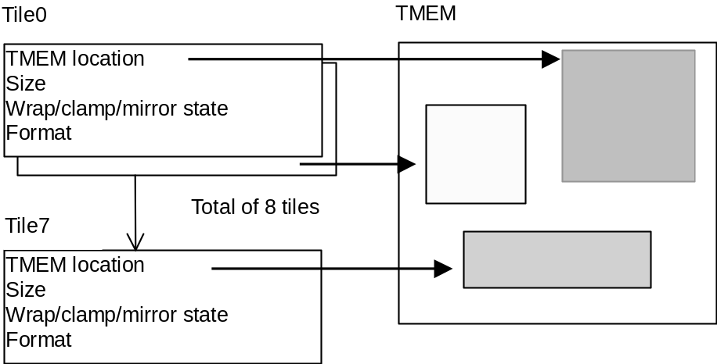
Figure 9-1 Tile descriptors and TMEM

The N64 can perform advanced texture processes like positioning two highlight light sources, and texture mapping with mipmaps corresponding to the model's LOD. However, to realize these kinds of processes you need to understand the concept of tiles.
Thus far, all of the sample programs have made use of only one texture, so we could put programs together without paying any attention to texture tiles. Next, we will look at ways of expressing images with texture tiles, but before that we will explain a little about tiles.

You set the tile descriptor using the gDPSetTile command.

gDPSetTile(
Gfx *gdl,
u32 fmt,
u32 siz,
u32 line,
u32 tmem,
u32 tile,
u32 palette,
u32 cmt,
u32 cms,
u32 maskt,
u32 masks,
u32 shiftt,
u32 shifts )

gdl Display list pointer

fmt Texture image format
G_IM_FMT_RGBA (RGBA format)
G_IM_FMT_YUV (YUV^{*5} format)
G_IM_FMT_CI (CI format)
G_IM_FMT_IA (AI format)
G_IM_FMT_I (I format)
^{*5} The operation of YUV textures cannot be guaranteed at this time.

siz Size of pixel components
G_IM_SIZ_4b (4bits/1texel)
G_IM_SIZ_8b (8bits/1texel)
G_IM_SIZ_16b (16bits/1texel)
G_IM_SIZ_32b (32bits/1texel)

line Size of 1 line (s-axis) of texture tile (9bit precision, 0 - 511)

tmem Address of texture tile origin (9bit precision, 0 - 511)

tile Index of parameter-setting tile descriptor (3bit precision, 0 - 7)

palette Position of palette for 4bit color index textures (4bit precision, 0 - 15)

cms s-axis mirror, wrap, clamp flags
G_TX_MIRROR (Enable mirroring)
G_TX_NOMIRROR (Disable mirroring)
G_TX_WRAP (Enable wrapping)
G_TX_CLAMP (Enable clamping)

cmt t-axis mirror, wrap, clamp flags
G_TX_MIRROR (Enable mirroring)
G_TX_NOMIRROR (Disable mirroring)
G_TX_WRAP (Enable wrapping)
G_TX_CLAMP (Enable clamping)

masks s-axis mask (4bit precision, 0 - 15)
G_TX_NOMASK (Do not mask, 0)
Numerical value n (Mask, 1 - 15)

maskt t-axis mask (4bit precision, 0 - 15)
G_TX_NOMASK (Do not mask, 0)
Numerical value n (Mask, 1 - 15)

shifts s-coordinate shift value
(For low-level detail textures, 4bit precision, 0 - 15)
G_TX_NOLOD (Do not shift, 0)
Numerical value n (Shift, 1 - 15)

shiftt t-coordinate shift value
(For low-level detail textures, 4bit precision, 0 - 15)
G_TX_NOLOD (Do not shift, 0)
Numerical value n (Shift, 1 - 15)

Many different arguments were set in the gDPLoadTextureBlock and gDPLoadTextureTile commands used in the sample programs we have seen up to now, but items like the wrapping flag and the mask value and shift value are actually set as tile descriptors.

9.2 Multi-tile Textures

The simplest example of the use of multi-tile textures is for the mapping of a number of textures. If you can load a collection of textures together at once in TMEM, then when you map different textures to different polygons you do not need to reload the texture data each time.
In this way, the programmer can also manage textures as tiles. Therefore, in order to make use of the N64's advanced texture functionality, you need a firm grasp of the concept of tiles.

There are a number of effects you cannot produce on the N64 without the use of multi-tile textures. The various effects can be broadly grouped into the two following categories:

1. The use of different textures in cycle 1 and cycle 2.
(We will call these no-LOD multi-tile textures)

2. The use of different textures that comply to the LOD
(We will call these LOD multi-tile textures)

Morphing is a good example of this first class of effects. It is used in Super Mario 64 to gradually change the portrait of Princess Peach into Bowser. To achieve this special effect, the textures for Princess Peach and Bowser are loaded into two tiles, and the combine mode is set for a linear interpolation between the two. By changing the interpolation coefficient in each frame, you can smoothly morph between the two textures. There is a sample program in Chapter 10 that employs this idea to morph texture rectangles.

Mipmapping is a perfect example of this second classification of effects. In mipmapping, the texture used for mapping is changed(interpolation of the textures is also done) to match the size of the polygon being rendered in order to reduce texture aliasing which occurs when the polygon becomes smaller.

The use of LOD with multi-tile textures is determined by whether G_TL_TILE (no LOD) or G_TL_LOD is set in the gDPSetTextureLOD command.

Although morphing can be done with no-LOD multi-tile textures, the example we gave from Super Mario 64 was actually done with multi-tile textures corresponding to the LOD of the portrait.

9.3 Primitive Tile

Regardless of whether LOD is enabled or disabled, if you are going to use multi-tile textures you need to determine the primitive tile, which is the tile on which a number of texture tiles are based.
The primitive tile index is specified in the second-to-last argument in the gSPTexture command.

For no-LOD multi-tile textures, the primitive tile is accessed in cycle 1 and the next tile after the primitive tile is accessed in cycle 2. In terms of the input source to the Combiner, TEXEL0 is the primitive tile and TEXEL1 is the next tile after the primitive tile.
For LOD multi-tile textures, the tile is selected based on the calculation of the LOD value. When LOD is 0 (the largest size) then primitive tile is used. When LOD is n, the (primitive tile + n) tile is used.
The table below shows the relationship between the tile index and the LOD index when the primitive tile is set to Tile2.

Tile index | LOD index
0 | －
1 | －
2 | 0
3 | 1
4 | 2
5 | 3
6 | －
7 | －

Actually, you can think of highlight textures as being a variation on multi-tile textures. For the textures for light source 1 and light source 2, the programmer can use any tile specified with the gDPSetHiliteTile command (or the gDPSetHilite1Tile and gDPSetHilite2Tile commands).

9.4 Highlights

The procedure you follow to produce highlights is explained in the Programming Manual in Chapter 11.7.4, "Specular Highlights," so here we will give just a simple explanation using the source from the gfx9.c sample program.

Whereas the Programming Manual presents sample code to position two highlight light-sources, the gfx9.c sample program makes use of only one highlight. Thus, you will probably want to look at gfx9.c to see how to position just one highlight light-source.

9.4.1 Preparing the Structure

To perform lighting using highlights, you define the LookAt type variable and Hilite type variable, and pass these to the guLookAtHilite function and initialize. The guLookAtHilite function takes a number of arguments, but none are very difficult to understand. For details, please see the Function Reference.

List 9-1
guLookAtHiliteF(fmat2, &lookat, &hilite,
0.0, 0.0, 50.0,
0.0, 0.0, 0.0,
0.0, 1.0, 0.0,
0.0, 1.0, 0.0, /* Direction of highlight light-source */
0.0, 0.0, 1.0, /* A non-zero value even when not used */
__TEXTURE_WIDTH__,
__TEXTURE_HEIGHT__);

9.4.2 Preparing the Light

Although the direction of the highlight light-source is specified in guLookAtHilite, you also need to define a light structure that points in the same direction. In the case of the gfx9.c sample program, diffuse light is also used at the same time as a highlight.

List 9-2
Lights1 light = gdSPDefLights1( 0, 0, 50, /* Blue ambient light */
250, 150, 30, /* Gold diffuse light */
0, 127, 0); /* Direction toward diffuse light */

9.4.3 Loading the Texture

The texture coordinate scaling parameters and the primitive tile are specified in gSPTexture. G_TX_RENDERTILE, which is a macro constant defined in <gbi.h>, connotes Tile0. If you use either gDPLoadTextureBlock or gDPLoadTextureTile, then the texture will be automatically loaded to the G_TX_RENDERTILE tile. The color that is used for highlight color is the one set for primitive color.

List 9-3
/* Enable textures, set scaling parameters */
gSPTexture(glistp++,
(__TEXTURE_WIDTH__ - 1) << 6,
(__TEXTURE_HEIGHT__ - 1) << 6,
0, G_TX_RENDERTILE, G_ON);
/* (Parts have been omitted) */
/*
* Load highlight texture (image i8hilite)
* Wrapping is turned on
*/
gDPLoadTextureBlock(glistp++,
i8hilite, /* Pointer to texture image */
G_IM_FMT_I, /* Texel format */
G_IM_SIZ_8b, /* Texel size */
__TEXTURE_WIDTH__, /* Image width */
__TEXTURE_HEIGHT__, /* Image height */
0, /* LUT (highlight) index. (Not used here) */
G_TX_WRAP | G_TX_NOMIRROR,
/* Clamp, wrap, mirror flags in s direction */
G_TX_WRAP | G_TX_NOMIRROR,
/* Clamp, wrap, mirror flags in t direction */
__TEXTURE_BITS_X__, /* s mask */
__TEXTURE_BITS_Y__, /* t mask */
G_TX_NOLOD, G_TX_NOLOD); /* Shift (No shift here) */
/* The primitive color becomes the color of the highlight light */
gDPSetPrimColor(glistp++, 0, 0, 255, 255, 255, 255);

9.4.4 Other Commands

To use highlight textures, you also need to set the various modes with the following commands. Note that G_TEXTURE_GEN has been added to geometry mode.

List 9-4
gSPLookAt(glistp++, &lookat);
/* Please set G_TEXTURE_GEN in geometry mode */
gSPSetGeometryMode(glistp++, G_TEXTURE_GEN | G_LIGHTING |
G_ZBUFFER | G_SHADE | G_SHADING_SMOOTH | G_CULL_BACK);
/* G_CC_HILITERGB = PRIMITIVE, SHADE, TEXEL0, SHADE, 0, 0, 0, SHADE */
gDPSetCombineMode(glistp++, G_CC_HILITERGB, G_CC_HILITERGB);
/* Light position */
gSPSetLights1(glistp++, light);
/* Set highlight texture tile */
gDPSetHilite1Tile(glistp++, G_TX_RENDERTILE, &hilite,
__TEXTURE_WIDTH__, __TEXTURE_HEIGHT__);

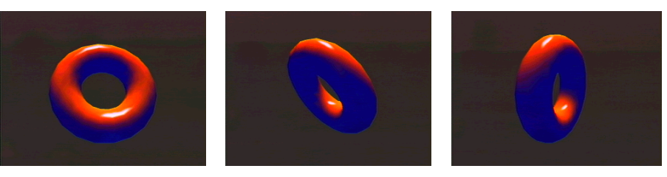
Figure 9-2 Screen shots of gfx9.c sample program with __HILITE__ defined.

9.5 Reflection Mapping

Reflection mapping effects are produced in the same way as highlights, so here we will only focus on an explanation of the way in which they differ.

9.5.1 Preparing the Structure

For reflection mapping, you pass the LookAt type variable to the guLookAtReflect function and initialize. For a detailed explanation of the guLookAtReflect function, please see the Function Reference.

List 9-5
/*
* Set the view structure
*/
guLookAtReflectF(fmat2, &lookat,
0.0, 0.0, 50.0,
0.0, 0.0, 0.0,
0.0, 1.0, 0.0);

Preparing the Light

Unlike highlighting, in the case of reflection mapping there is not a single kind of light. Therefore, if you impinge with a strong diffuse light, the color can be clamped as a result of the lighting calculation. In the gfx9.c sample program, the color of the diffuse light is set to 0, and this colorless diffuse light is used for reflection mapping.

List 9-6
/*
* If the diffuse light is strong when reflection mapping,
* the color of the illuminated area can be clamped.
*/
Lights1 light = gdSPDefLights1( 0, 0, 50, /* Blue ambient light */
0, 0, 0, /* Diffuse light has no color */
0, 127, 0); /* Direction toward diffuse light */

9.5.3 Other Commands

The other commands are basically the same as when highlighting, except that when reflection mapping you can also specify G_TEXTURE_LINEAR_GEN in the geometry mode. When this is specified, cylindrical texture coordinate transformations are executed.

Also, the color used for reflection mapping is the color set as the ambient color.

List 9-7
gSPLookAt(glistp++, &lookat);
/* Please set G_TEXTURE_GEN (and G_TEXTURE_GEN_LINEAR) in the geometry mode */
gSPSetGeometryMode(glistp++, G_TEXTURE_GEN | G_LIGHTING | G_ZBUFFER |
G_SHADE | G_SHADING_SMOOTH | G_CULL_BACK);
/* G_CC_REFLECTRGB = ENVIRONMENT, 0, TEXEL0, SHADE, 0, 0, 0, SHADE */
gDPSetCombineMode(glistp++, G_CC_REFLECTRGB, G_CC_REFLECTRGB);
/* Light position */
gSPSetLights1(glistp++, light);
/* The ambient color becomes the color of the reflected light */
gDPSetEnvColor(glistp++, 250, 160, 50, 255);

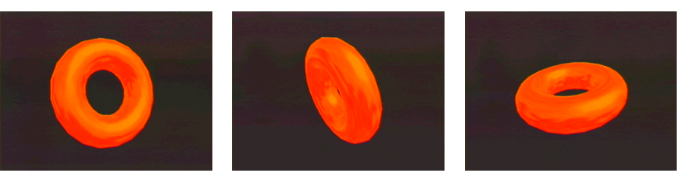
Figure 9-3 Screen shots of gfx9.c sample program with __REFLECTION__ defined.
We've just got finished saying that the color for highlights is determined by the primitive color, and the color for reflection mapping is determined by the ambient color. But this is only because that is how the combine modes G_CC_HILITERGB and G_CC_REFLECTRGB are defined. If you alter the combine mode, you can use the color from other input sources. We talked earlier about the ability to define custom combine modes. So for those who are interested, go ahead and try making some of your own highlight and reflection mapping effects.

9.6 Mipmaps

9.6.1 Tile Settings

Next we will talk about techniques that make use of LOD multi-tile textures. One typical example is mipmapping. The gfx9lod.c sample program uses LOD multi-tile textures for mipmapping.

When mipmapping is performed, the texture is switched (and then interpolated) according to the LOD, so you need to prepare a number of textures of differing resolution.

The mipmap texture "rgb16brickmm" used in the gfx9lod.c sample program was created using the SGI development environment rgb2c, but you can create the mipmap texture using any general-purpose graphics editor. In short, you need one maximum-size texture and a succession of increasingly reduced textures, each half the width and half the height of the previous one, ending with a 1x1 size texture. This whole series of textures is collectively called a mipmap texture.

In the gfx9lod.c sample program, the mipmap texture is loaded as one continuous texture, and the tile descriptor is set to indicate each separate texture. The sample code shown below is taken from rgb16brickmm.h.

List 9-8
/* tmem address (in tmem word) */
#define TOP_ADDR 128

Gfx rgba16brickmm_dl[] = {
gsDPSetTextureImage( 0, 2, 1, rgba16brickmm_buf),
gsDPSetTile( 0, 2, 0, 0 + TOP_ADDR, G_TX_LOADTILE, 0, 0, 0, 0, 0, 0, 0),
/* 1365 = 32 * 32 + 16 * 16 + 8 * 8 + 4 * 4 + 2 * 2 + 1 * 1 */
/* 1372 % 4 == 0 */
gsDPLoadBlock( G_TX_LOADTILE, 0, 0, 1372, 0),
gsDPSetTile(G_IM_FMT_RGBA,
G_IM_SIZ_16b,
8, /* line */
0 + TOP_ADDR, /* tmem */
1, /* tile */
0, /* palette */
0, /* cmt */
5, /* maskt */
0, /* shiftt */
0, /* cms */
5, /* masks */
0), /* shifts */
gsDPSetTileSize(0, /* tile */
0, /* uls */
0, /* ult */
31 << G_TEXTURE_IMAGE_FRAC, /* lrs */
31 << G_TEXTURE_IMAGE_FRAC), /* lrt */
/* (From here, do gsDPSetTile, gsDPSetTileSize for the next tile) */

In this code, the pointer to the mipmap texture is set with the gsDPSetTextureImage command and then the starting address for G_TX_LOADTILE (Tile7) is set. The gsDPLoadBlock command specifies that the texture be loaded into the G_TX_LOADTILE tile. Because the starting address of the G_TX_LOADTILE tile is (0 + TOP_ADDR), the texture is loaded to the TMEM word address where TOP_ADDR is located.

The reason the G_TX_RENDERTILE and G_TX_LOADTILE macros have been prepared is so the tile used when rendering the tile used when loading can be differentiated and the two operations run at the same time. These tile numbers are defined simply for convenience, and you do not necessarily have to load the texture to the G_TX_LOADTILE tile.

Although it was not shown in the above sample source, you also need to use gsDPSetTile and gsDPSetTileSize to set the tile descriptors for the lower-resolution textures. You know about the TMEM address, but also remember to set shifts and shiftt to the same value as the LOD (although for non-square textures sometimes values different from the LOD are inserted here).

9.6.2 Other Settings

Once the tile settings have been properly made, the rest of the steps are relatively easy. You simply make some changes to the settings in the commands we have been using up to now.
First, use the gSPTexture command to specify the mipmap level and primitive tile. The gfx9lod.c sample program uses a 32x32 texture, and since 32 = 2⁵ the mipmap level is set to 5.
Next, taking detail texture (explained in the next section) into consideration, you set the highest-resolution texture to the (G_TX_RENDER_TILE + 1) tile so G_TX_RENDERTILE (Tile0) is not used. For this, the primitive tile must be (G_TX_RENDER_TILE + 1).

List 9-9
/* When detail texture not used, Tile0 is empty */
gSPTexture(glistp++, 0x8000, 0x8000,
5, /* Mipmap level */
G_TX_RENDERTILE + 1, /* Tile number of highest-resolution mipmap */
G_ON);

Also, you insert the following command in order to notify the RDP that you are using LOD multi-tile textures and performing mipmapping.

List 9-10
/* Specify selection of LOD-compliant texture */
gDPSetTextureLOD(glistp++, G_TL_LOD);
/* Normal mipmapping */
gDPSetTextureDetail(glistp++, G_TD_CLAMP);

When you run gfx9lod.c you will see an animation of two somersaulting cubes moving toward and away from you on the screen. One cube is mipmapped and one is not. When the two cubes are far away, you can see the jagged edges in the pattern of the cube that has not been mipmapped.

9.7 Variations on Mipmapping

As mentioned in the previous section, mipmapping can prevent the jagged edges that can result when rendering the polygon small. However, when displaying the polygon large, you still need to enlarge the highest-resolution texture for rendering. To draw this enlarged texture more sharply, two modes are available: Sharp mode and Detail mode.

Sharp Mode

Sharp mode is easy to use: simply set the G_TD_SHARPEN constant in the gDPSetTextureDetail command. In Sharp mode, when the texture is enlarged, an extrapolation is made based on the two highest-resolution mipmap textures so the texture is displayed with a more natural-looking edge.

List 9-11
/* Use Sharp mode */
gDPSetTextureDetail(glistp++, G_TD_SHARPEN);

9.7.2 Detail Mode

Detail mode differs from Sharp mode in that you need a separate kind of texture called a detail texture. Typically, you use a texture that displays the pattern in finer detail for the detail texture, but in the gfx9lod.c sample program, an image that is completely unrelated to the mipmap texture is used as the detail texture. As a result, when the cube model approaches near to the viewpoint, you can clearly see how the detail texture has been blended.

List 9-12
/* When using a detail texture, set that texture to Tile0 */
gSPTexture(glistp++, 0x8000, 0x8000,
5, /* Mipmap level */
G_TX_RENDERTILE, /* Tile number of detail texture */
G_ON);
/* (Parts have been omitted) */
/* Use detail texture */
gDPSetTextureDetail(glistp++, G_TD_DETAIL);
/* Load detail texture */
gDPLoadTextureTile(glistp++,
circle,
G_IM_FMT_I,
G_IM_SIZ_8b,
32, 32,
0, 0,
31, 31,
0,
G_TX_WRAP, G_TX_WRAP,
5, 5,
15, 14); /* << 1 and << 2 */

The detail texture is loaded one tile in front of the highest-resolution mipmap texture. In the gfx9lod.c sample program, since the highest-resolution mipmap texture is placed in the (G_TX_RENDERTILE + 1) tile, the detail texture is stored in G_TX_RENDERTILE.

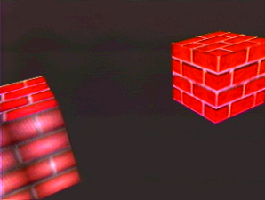
Figure 9-4 Screen shot of gfx9lod.c sample program with __DETAIL__ defined.

CHAPTER 10 TEXTURE RECTANGLES

In Chapter 9, we explained from a variety of different angles the methods for mapping textures to polygons. In fact, it might seem like we have covered all areas of this topic. When you are putting together a game application, there often will be times when in addition to mapping textures to polygons, you will also want to display simple 2D graphics on the screen. So in this chapter, we bring up the subject of texture rectangles as a method for drawing 2D graphics.

10.1 Introduction to Texture Rectangles

With the N64, you have a number of choices when rendering textures as 2D graphics. You can:

1. Draw them as texture rectangles
2. Draw them as sprites, using the sprite microcode
3. Draw them by emulating sprite functions with the 3D microcode

From the point of view of performance, the first two are the most practical choices. An explanation of how to use the sprite microcode would be very lengthy and is beyond the scope of this tutorial. Here we will limit ourselves to the topic of texture rectangles. Since we have already gone into great detail about textures, it should be easy to understand how to render using texture rectangles.

You use the gSPTextureRectangle command or the gSPScisTextureRectangle command to render with texture rectangles. Both commands define texture rectangle primitives.

GSPTextureRectangle(  Gfx *gdl,  u32 ulx,  u32 uly,  u32 lrx,  u32 lry,  s32 tile,  s32 s,  s32 t,  s32 dsdx,  s32 dtdy) | gSPScisTextureRectangle(  Gfx *gdl,  s32 ulx,  s32 uly,  s32 lrx,  s32 lry,  s32 tile,  s32 s,  s32 t,  s32 dsdx,  s32 dtdy)

gdl Display list pointer
ulx Rectangle's upper-left x-coordinate (10.2, 0.0 - 1023.75)
uly Rectangle's upper-left y-coordinate (10.2, 0.0 - 1023.75)
lrx Rectangle's lower-right x-coordinate (10.2, 0.0 - 1023.75)
lry Rectangle's lower-right y-coordinate (10.2, 0.0 - 1023.75)
tile Tile descriptor index (3bit precision, 0 - 7)
s Texture s-coordinate of upper-left corner of rectangle (s10.5)
t Texture t-coordinate of upper-left corner of rectangle (s10.5)
dsdx Change in s per change in x (s5.10)
dtdy Change in t per change in y (s5.10)

The thing you need to be careful about with these two commands is that in both 1-Cycle mode and 2-Cycle mode, the right-most column and the bottom-most row are not rendered for reasons of anti-aliasing. On the other hand, in Copy mode the entire specified rectangle is rendered.

In the DrawSmallRectangle function in the gfx10.c sample program, the static variables posx and posy define the upper-left screen coordinates for the drawing of a small texture rectangle.

List 10-1
/* Draw a texture rectangle */
gSPTextureRectangle(glistp++,
posx << 2, posy << 2,
(posx + RECT_WD) << 2, (posy + RECT_HT) << 2,
G_TX_RENDERTILE,
0 << 5, 0 << 5,
1 << 10, 1 << 10);

You must turn texture perspective off when drawing texture rectangles.

List 10-2
/* Texture rectangle, so turn texture perspective correction off */
gDPSetTexturePersp(glistp++, G_TP_NONE);

10.2 Using Primitive Depth

In the gfx10.c sample program, a value of 0, which is the smallest Z value, is specified for the primitive Z in order to display the small texture rectangle as forward as possible.

List 10-3
/* Make the cycle type 1-Cycle mode */
gDPSetCycleType(glistp++, G_CYC_1CYCLE);
/* Use texture color & alpha in combine mode */
gDPSetCombineMode(glistp++, G_CC_DECALRGBA, G_CC_DECALRGBA);
/* Rendering mode */
gDPSetRenderMode(glistp++,G_RM_AA_ZB_TEX_EDGE, G_RM_AA_ZB_TEX_EDGE2);
/* Set the Z value source */
gDPSetDepthSource(glistp++, G_ZS_PRIM);
/* Set the Z value of the texture rectangle */
gDPSetPrimDepth(glistp++, 0, 0);

G_RM_AA_ZB_TEX_EDGE is used for the rendering mode. The TEX_EDGE mode is designed for billboard-type texture mapping. To learn details about the settings of this mode, see the definition for G_RM_AA_ZB_TEX_EDGE.

10.3 Large Texture Rectangles

Besides displaying the small texture rectangle, the gfx10.c sample program is also designed by default to display an animation of a wide picture scrolling from left to right in the background. At a size of 720x240, this background image is way too large to fit into the 4KB of TMEM. The image must be divided up for repeated loading and texture rectangle rendering.

List 10-4
for(i = 0; i < (BACK_HT / ROWS); i++)
{
gDPLoadTextureTile(glistp++,
panorama,
G_IM_FMT_RGBA,
G_IM_SIZ_16b,
BACK_WD,
BACK_HT,
posx,
i * ROWS,
posx + (SCREEN_WD - 1),
i * ROWS + (ROWS - 1),
0,
G_TX_WRAP, G_TX_WRAP,
0, 0,
G_TX_NOLOD, G_TX_NOLOD);
gSPTextureRectangle(glistp++,
0 << 2,
(i * ROWS) << 2,
(SCREEN_WD - 1) << 2,
(i * ROWS + (ROWS - 1)) << 2,
G_TX_RENDERTILE,
posx << 5, (i * ROWS) << 5,
4 << 10, 1 << 10);
}

In this example, ROWS number of rows (the default is 2) are loaded at a time for texture rectangle rendering within the "for" loop.
The cycle type is the high-speed Copy mode. In Copy mode, 4 pixels are transferred in every 1 cycle, so we recommend this mode when all you are going to do is render without changing the image.
However, you need to be aware that in order to copy 4 pixels in 1 cycle, the change in S value in every cycle is four times larger. That is why the second to the last argument in the gSPTextureRectangle command gets [4 << 10] and not [1 << 10].

When you repeatedly load and render as shown here, the number of commands becomes extremely large and sometimes the display list is not big enough to accommodate them all. In fact, the display list becomes much larger than you might think, because the load commands gDPLoadTextureBlock and gDPLoadTextureTile are actually combinations of a number of lower-level commands. If you get in a situation where the last half of the texture rectangle is not rendered, we suggest you try increasing the size of the display list.

List 10-5
#define gDPLoadTextureBlock(pkt, timg, fmt, siz, width, height, \
pal, cms, cmt, masks, maskt, shifts, shiftt) \
{ \
gDPSetTextureImage(pkt, fmt, siz##_LOAD_BLOCK, 1, timg); \
gDPSetTile(pkt, fmt, siz##_LOAD_BLOCK, 0, 0, G_TX_LOADTILE, \
0 , cmt, maskt, shiftt, cms, masks, shifts); \
gDPLoadSync(pkt); \
gDPLoadBlock(pkt, G_TX_LOADTILE, 0, 0, \
(((width)*(height) + siz##_INCR) >> siz##_SHIFT) -1, \
CALC_DXT(width, siz##_BYTES)); \
gDPPipeSync(pkt); \
gDPSetTile(pkt, fmt, siz, \
(((width) * siz##_LINE_BYTES)+7)>>3, 0, \
G_TX_RENDERTILE, pal, cmt, maskt, shiftt, cms, masks, \
shifts); \
gDPSetTileSize(pkt, G_TX_RENDERTILE, 0, 0, \
((width)-1) << G_TEXTURE_IMAGE_FRAC, \
((height)-1) << G_TEXTURE_IMAGE_FRAC) \
}
#define gDPLoadTextureTile(pkt, timg, fmt, siz, width, height, \
uls, ult, lrs, lrt, pal, \
cms, cmt, masks, maskt, shifts, shiftt) \
{ \
gDPSetTextureImage(pkt, fmt, siz, width, timg); \
gDPSetTile(pkt, fmt, siz, \
(((((lrs)-(uls)+1) * siz##_TILE_BYTES)+7)>>3), 0, \
G_TX_LOADTILE, 0 , cmt, maskt, shiftt, cms, masks, \
shifts); \
gDPLoadSync(pkt); \
gDPLoadTile(pkt, G_TX_LOADTILE, \
(uls)<<G_TEXTURE_IMAGE_FRAC, \
(ult)<<G_TEXTURE_IMAGE_FRAC, \
(lrs)<<G_TEXTURE_IMAGE_FRAC, \
(lrt)<<G_TEXTURE_IMAGE_FRAC); \
gDPPipeSync(pkt); \
gDPSetTile(pkt, fmt, siz, \
(((((lrs)-(uls)+1) * siz##_LINE_BYTES)+7)>>3), 0, \
G_TX_RENDERTILE, pal, cmt, maskt, shiftt, cms, masks, \
shifts); \
gDPSetTileSize(pkt, G_TX_RENDERTILE, \
(uls)<<G_TEXTURE_IMAGE_FRAC, \
(ult)<<G_TEXTURE_IMAGE_FRAC, \
(lrs)<<G_TEXTURE_IMAGE_FRAC, \
(lrt)<<G_TEXTURE_IMAGE_FRAC) \
}

10.4 Transparency Effects in Copy Mode

As we explained previously, rendering in Copy mode is fast, but you skip over all the processing that goes on in the Combiner and Blender. Thus, you cannot make use of functions like Z buffering, which is processed with the Blender.
There is one exception, however, and that is the alpha compare function, which can be used even in Copy mode.

Next we will change the gfx10.c sample program to render in copy mode, and then use the alpha compare function to get a transparency effect. When you change line 40 from undef to define, the small texture rectangle is rendered in Copy mode.

List 10-6
/* Set the cycle type to Copy mode */
gDPSetCycleType(glistp++, G_CYC_COPY);
/* Specify 0 for the combine mode coefficients */
gDPSetCombineLERP(glistp++, 0, 0, 0, 0,
0, 0, 0, 0,
0, 0, 0, 0,
0, 0, 0, 0);
/* Set rendering mode to G_RM_NOOP, G_RM_NOOP2 (Blender does nothing) */
gDPSetRenderMode(glistp++, G_RM_NOOP, G_RM_NOOP2);
/*
* Set the blend color alpha to 1 in order to perform an
* alpha compare and remove the background. When this is done,
* places with an alpha of 0 become transparent pixels. This also
* works in G_RM_NOOP mode where Blender processes are skipped.
*/
gDPSetBlendColor(glistp++, 0, 0, 0, 1);
gDPSetAlphaCompare(glistp++, G_AC_THRESHOLD);

/* (Parts have been omitted) */

/* Draw the texture rectangle */
gSPTextureRectangle(glistp++,
posx << 2, posy << 2,
(posx + RECT_WD - 1) << 2, (posy + RECT_HT - 1) << 2,
G_TX_RENDERTILE,
0 << 5, 0 << 5,
4 << 10, 1 << 10);
gDPPipeSync(glistp++);
/* Set alpha compare back to OFF */
gDPSetAlphaCompare(glistp++, G_AC_NONE);

By looking at the above source you should be able to deduce what is happening, but a simple explanation of the steps in order follows.

- The cycle type is set to Copy mode (G_CYC_COPY).
- All of the combine mode coefficients are set to 0 (the pipeline does not pass through the Combiner in Copy mode).
- The rendering mode is set to G_RM_NOOP (the pipeline does not pass through the Blender in Copy mode).
- An alpha compare of type G_AC_THRESHOLD is performed.
- The blend color alpha value is set to 1 (texels with an alpha value of less than 1 become transparent).
- Since this is Copy mode, the texture rectangle's lower-right coordinates are changed.
- gDPPipeSync is inserted before the alpha compare mode is returned to G_AC_NONE.

10.5 Multi-tile Texture Rectangles

Next, we turn to the topic of multi-tile texture rectangles. Naturally, this involves the use of no-LOD multi-tile textures.
Of course, to benefit from the use of a multi-tile texture you need to load the texture with a consideration for tiles. Thus, it is no good simply using a load command like gDPLoadTextureBlock or gDPLoadTextureTile, which cannot specify what tile number to load. You would be better off using the gDPLoadMultiTile command. You could also choose to make direct use of the low-level gDPLoadBlock, gDPSetTile and gDPSetTileSize commands, like when we loaded mipmap textures in the previous chapter.

When you change undef to define on line 34 of the gfx10.c sample program, multi-tile texture rectangles are used for texture rectangle morphing.

Take a look below at the source for the part where the texture is loaded and the texture rectangle is drawn:

List 10-7
for(i = 0; i < (BACK_HT / ROWS); i++)
{
gDPLoadMultiTile(glistp++,
tree1,
0,
G_TX_RENDERTILE,
G_IM_FMT_RGBA,
G_IM_SIZ_16b,
BACK_WD,
BACK_HT,
0,
i * ROWS,
SCREEN_WD - 1,
i * ROWS + (ROWS - 1),
0,
G_TX_WRAP, G_TX_WRAP,
0, 0,
G_TX_NOLOD, G_TX_NOLOD);
gDPLoadMultiTile(glistp++,
tree2,
240,
G_TX_RENDERTILE + 1,
G_IM_FMT_RGBA,
G_IM_SIZ_16b,
BACK_WD,
BACK_HT,
0,
i * ROWS,
SCREEN_WD - 1,
i * ROWS + (ROWS - 1),
0,
G_TX_WRAP, G_TX_WRAP,
0, 0,
G_TX_NOLOD, G_TX_NOLOD);
gSPTextureRectangle(glistp++,
0 << 2,
(i * ROWS) << 2,
(SCREEN_WD - 1) << 2,
(i * ROWS + ROWS) << 2,
/* Not (ROWS - 1) like in Copy mode */
G_TX_RENDERTILE,
0 << 5, (i * ROWS) << 5,
1 << 10, 1 << 10);
}

When the program runs with this source, a texel from the tree1 texture is input for the Combiner's TEXEL0, and a texel from the tree2 texture is input for TEXEL1.
After that, you can set combine mode to perform linear interpolation on TEXEL0 and TEXEL1. Next, we show what happens when the environment alpha for the interpolation coefficient is used:

List 10-8
gDPSetCycleType(glistp++, G_CYC_2CYCLE);
gDPSetCombineLERP(glistp++, TEXEL1, TEXEL0, ENV_ALPHA, TEXEL0,
0, 0, 0, TEXEL0,
0, 0, 0, COMBINED,
0, 0, 0, COMBINED);
gDPSetRenderMode(glistp++, G_RM_PASS, G_RM_PASS);
gDPSetTexturePersp(glistp++, G_TP_NONE);

gDPSetEnvColor(glistp++, 0, 0, 0, (blend >> 8) & 0xFF);

In the gfx10.c sample program, the int type variable "blend" is the interpolation coefficient and it is gradually changed, with the environment alpha being set to the value of the "blend" variable in every frame. We used a minor adjustment here to make "blend" change at a slow rate, but this is not that essential.

10.6 Summary of Graphics

This completes the Graphics part of the N64 Tutorial. We brought up a variety of issues and provided some detailed explanations where we needed to delve into a topic. By reading this tutorial and applying its concepts, you should be able to create some advanced N64 graphics applications.
At first glance, this Graphics Tutorial may have impressed you as focusing exclusively on explanations pertaining to 3D graphics. But in fact, a comprehensive understanding of the functionality of the RDP also helps when rendering 2D graphics (texture rectangles and sprite microcode).

Although we did not touch on this subject in the tutorial, to make your work more efficient we suggest using the Nintendo Intermediate File Format (NIFF) as the intermediate format for storing data created with CG Tools, which is readily available on the market. To learn more about this, see the NIFF Manual the Allmanual.

We would like to conclude by hoping you can all create high quality games with the techniques you have learned with the help of this tutorial.

Reference bibliography

Open GLTM Programming Guide
J. Neider, T. Davis, M. Woo Addison-Wesley

Introduction to Graphics
Yoshio Sato, Ascii

Practical Graphics
Yoshio Sato, Ascii

Applied Graphics
Masataka Ota, Akira Takeuchi, Takayuki Oguchi, Ascii

