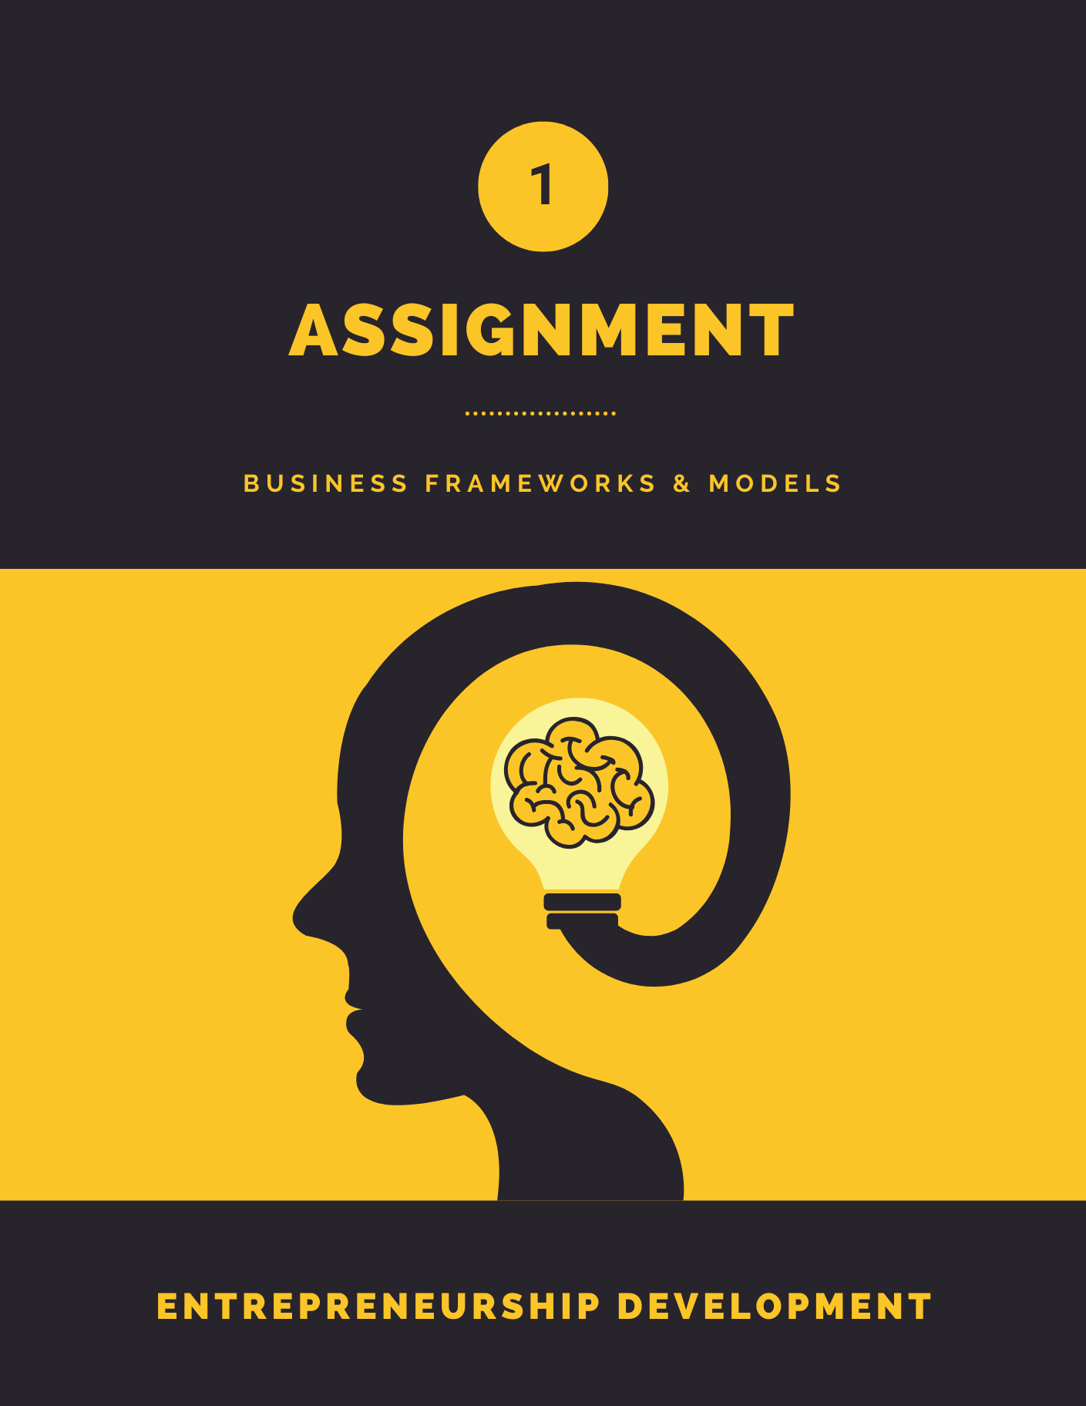



## Instructions

Students are required to prepare and analyze various business frameworks based on a chosen business idea or case study. This assignment aims to deepen your understanding of strategic tools used in business analysis and decision-making.

**Required Frameworks:**

1. **SWOT Analysis**: Evaluate the Strengths, Weaknesses, Opportunities, and Threats related to your chosen business idea.
2. **Competitor Matrix**: Analyze the competitive landscape by comparing key competitors based on critical factors such as pricing, product offerings, market positioning, etc.
3. **Porter’s Five Forces**: Assess the competitive forces that impact your business, including the threat of new entrants, bargaining power of suppliers, bargaining power of buyers, threat of

substitute products or services, and industry rivalry.

1. **Value Proposition Canvas**: Define the value your business offers to customers by mapping out customer needs, pain points, and your solutions.
2. **Business Model Canvas**: Outline the core aspects of your business model, including key partners, activities, resources, value propositions, customer relationships, channels, customer segments, cost structure, and revenue streams.

**Submission Guidelines:**

* + Write your **NAME, ENROLLMENT NUMBER, and COURSE** on the front page of assignment as well as in the submission form.
  + **Due Date**: All assignments must be submitted by **13th September**. No extensions will be granted.
  + **Original Work**: Each submission must be an original effort. **Copying from other students or any external sources will result in a zero mark**. Plagiarism in any form will not be tolerated.
  + **Timely Submission**: Submit your assignment on or before the deadline. Late submissions will result in a **deduction of 5 marks** from total.
  + **Submission Link**: The submission link is available on the course website. Ensure your file is uploaded correctly to avoid any technical issues. (PDF format only)

Assignment 1

## Student Details

**13-9-2024**

**ICT**

**CS**

**T24162172001**

**Patel Vishva Rakeshbhai**

**Name -**

**Enrollment Number -**

**Department -**

**Course -**

**Date -**



Using the questions from the previous page as a guide, fill out each quadrant with the

**strengths, weaknesses, opportunities, and threats** that are unique to your business.

|  |  |
| --- | --- |
| **STRENGTHS**    * Growing demand * A wide range of products under one roof. * Government support for startups. * Personalized customer service Store. | **WEAKNESSES**   * High initial setup and marketing costs.      * Strong competition from established brands * Supply chain challenges due to reliance on imports. * Marketing efforts to build brand recognition. |
| **OPPORTUNITIES**   * Expansion into online sales      * collaboration to tech enthusiasts * Increasing demand for gaming and custom PCs. * Potential for offering tech workshops and education. | **THREATS**   * Intense price competition from e-commerce businesses.      * Fluctuating tech product prices. * Rapid changes in technology customer choices. * Economic fluctuations affecting consumer spending’s . |

## SMALL BUSINESS COMPETITIVE ANALYSIS

**Reliance Digital**

|  |  |  |  |
| --- | --- | --- | --- |
|  | **CROMA** |  |  |
| **SUMMARY**  describe what you already know about your competitors | Croma is a well-established electronics retailer in India offering a wide range of products, from consumer electronics to IT hardware, home appliances, and more. | Reliance Digital is a part of the Reliance Retail conglomerate and has positioned itself as a top retailer for consumer electronics and appliances. |  |

*Now do the research to add more detail to the following attributes.*

|  |  |  |  |
| --- | --- | --- | --- |
| **TARGET CUSTOMERS** | Individuals, families, and professionals from the middle classes. | Families with middle to upper incomes and a passion for technology. |  |
| **PRODUCT OR SERVICE PRICING** | Competitive, with continuous discounts and EMI plans available. | Competitive pricing, including sales discounts and a zero-down EMI. |  |
| **GENERAL MARKETING STRATEGY** | In-store focus with national advertising campaigns and loyalty programs. | Aggressive promotion, particularly during festivals, with JioMoney reward offers. |  |
| **ONLINE MARKETING STRATEGY** | Strong e-commerce presence, including social media, SEO, and digital advertising. | E-commerce, internet marketing, and social media presence are all seamlessly connected. |  |
| **STRENGTHS** | Extensive shop network, outstanding customer service, and strong brand connections. | Exclusive offers are made possible by Reliance's strong brand, extensive inventory, and Jio ecosystem. |  |
| **WEAKNESSES** | Higher prices in certain categories, as well as a reliance on physical stores. | Inconsistent service quality across sites, with sometimes higher rates. |  |
| **COMPETITIVE ADVANTAGE** | Trusted brand with broad product offerings and strong online-offline cooperation. | Powerful brand, broad shop network, and Jio-exclusive discounts. |  |

### Value Proposition Canvas

*Designed for: Designed by: Date: Version:*

**13-9-2024**

**Micro Center Alike**

**Patel Vishva**

**Product Customer**

**Fears**

Poor customer service and technical support.

A Delays or product unavailability.

Higher prices than other large shops.

High-quality, dependable technology goods and expert assistance.

A one-stop shop for both conventional and specialty technology products.

Shopping both online and offline is convenient and hassle-free.

* Access to a diverse choice of technology goods, many of which are customizable.
* Competitive pricing, convenient payment choices, and regular deals/discounts.
* Quick, dependable technical
* assistance and product support.

**Needs**

**Wants**



|  |  |
| --- | --- |
| **Benefits**   * Online and offline stores integrate seamlessly. * Personalized shopping experience for tech enthusiasts. * Quick delivery, simple returns, and after-sales service. * An engaging shopping atmosphere for tech enthusiasts, complete with demo rooms where they can check out products. * A wide range of technological products and components. * Affordable prices and flexible financing options. * Specialized customer service and technical support. | **Experience** |
| **Features**   * Custom PC components, gaming accessories, and specialized electronics. * Easy-to-use online platform and in-store assistance. * Seasonal discounts and loyalty schemes. |

Gamers, small businesses, and professionals are looking for specialized gadgets, custom-built PCs, and excellent customer service.

Other electronic merchants include Croma, Reliance Digital.  
Amazon and Flipkart are two online sites that sell similar product

MicroCenter alike

**Product Ideal Customer**

**Substitutes**

# PORTER'S FIVE FORCES ANALYSIS TEMPLATE



THREAT OF NEW ENTRY POWER OF BUYERS THREAT OF SUBSTITUTES POWER OF SUPPLIERS

* Customers have several options (such as Croma and Reliance Digital) and can simply switch based on pricing or service.
* Buyers can bargain for better prices, discounts, and financing choices, especially during sales seasons.
* Large e-commerce platforms such as Amazon and Flipkart provide similar technology products with added ease and discounts.
* Generic electronics businesses may offer lower-cost alternatives to specialized products, but without customized service.
* There are multiple providers for tech components, gaming equipment, and electronics, allowing you to negotiate lower prices.
* However, exclusive or premium brands may have more control over pricing and availability.
* Starting a tech retail business demands a significant investment in goods, shop locations, and e-commerce infrastructure.
* However, rising demand for specialist technology products may entice new entrants, particularly online-only platforms.



COMPETITIVE RIVALRY

* The market is congested with established firms such as Croma and Reliance Digital.
* To differentiate yourself in this competitive market, aggressive pricing, improved customer service, and creative products will be critical.



### Business Model Canvas

**13-9-2024**

**Patel Vishva**

**MicroCentre Alike**

*Designed for: Designed by: Date: Version:*

|  |  |  |  |  |  |
| --- | --- | --- | --- | --- | --- |
| **Key Partners**   * Suppliers: Tech manufacturers. * Logistics partners: Delivery services for online orders. * Technology partners: Web development, e-commerce platforms. * Financial partners: Payment gateway providers, Banks. * **Motivations for partnerships:** * Optimization and economy. * Risk reduction * Access to new technology and expertise. | **Key Activities**   * Customer service: Providing expert technical support. * Distribution: Fast and reliable order fulfillment (both online and in-store). * Categories: * Custom PCs, Tech products * Problem solving | **Value Propositions**   * Custom-built PCs: Build to specific customer needs (e.g., gaming, professional use). * Wide variety: Offering wide range of tech products and hard-to-find components. * Affordable pricing: Competitive prices with financing options. * Expert support: Personalized technical assistance and consultation. * Characteristics: * Customization. * Risk reduction (reliable products, support). * Convenience and accessibility. | | **Customer Relationships**   * Personal assistance: customer care through via in-store help desks and online chat. * Community engagement: Building relationships with tech enthusiasts through workshops and demo events. * Loyalty programs: Offer discounts and reward points for repeat customers. * Costs: Moderate, as customer service and engagement activities are essential. | **Customer Segments**   * Tech enthusiasts: Looking for specialized products and custom-built PCs. * Gamers: Needing high-performance components and accessories. * Small businesses: Requiring reliable hardware for operations and servers. * Professional users: Seeking specialized equipment for design, development, and production. |
| **Key Resources**   * Intellectual: Brand reputation, expertise in tech, customer loyalty. * Human: Skilled sales and support staff, PC-building experts. * Financial: Investment in inventory, technology, and logistics. | **Channels**   * Physical stores: Hands-on experience with products, in-person technical support. * Online platform: E-commerce site for easy purchasing, and delivery. * Social media: Engaging with customers, promoting products, and increasing sales. |
| **Cost Structure**   * Fixed Costs: Store rent, employee salaries, utilities, technology maintenance. * Variable Costs: Inventory purchasing, marketing, delivery services. * Economies of scale: Buying tech products in bulk, leading to discounts from suppliers. * **Business Focus:** * Value-driven: Offering quality products with excellent support and customization. | | | **Revenue Streams**   * Asset sales: sale of technology devices, components, and accessories. * Service fees: Charging for custom PC-building services and tech support. * Financing fees: Earning from third-party financing partners. * **Pricing models:** * Fixed pricing (product-dependent, segment-dependent). * Dynamic pricing (seasonal specials and negotiations). | | |

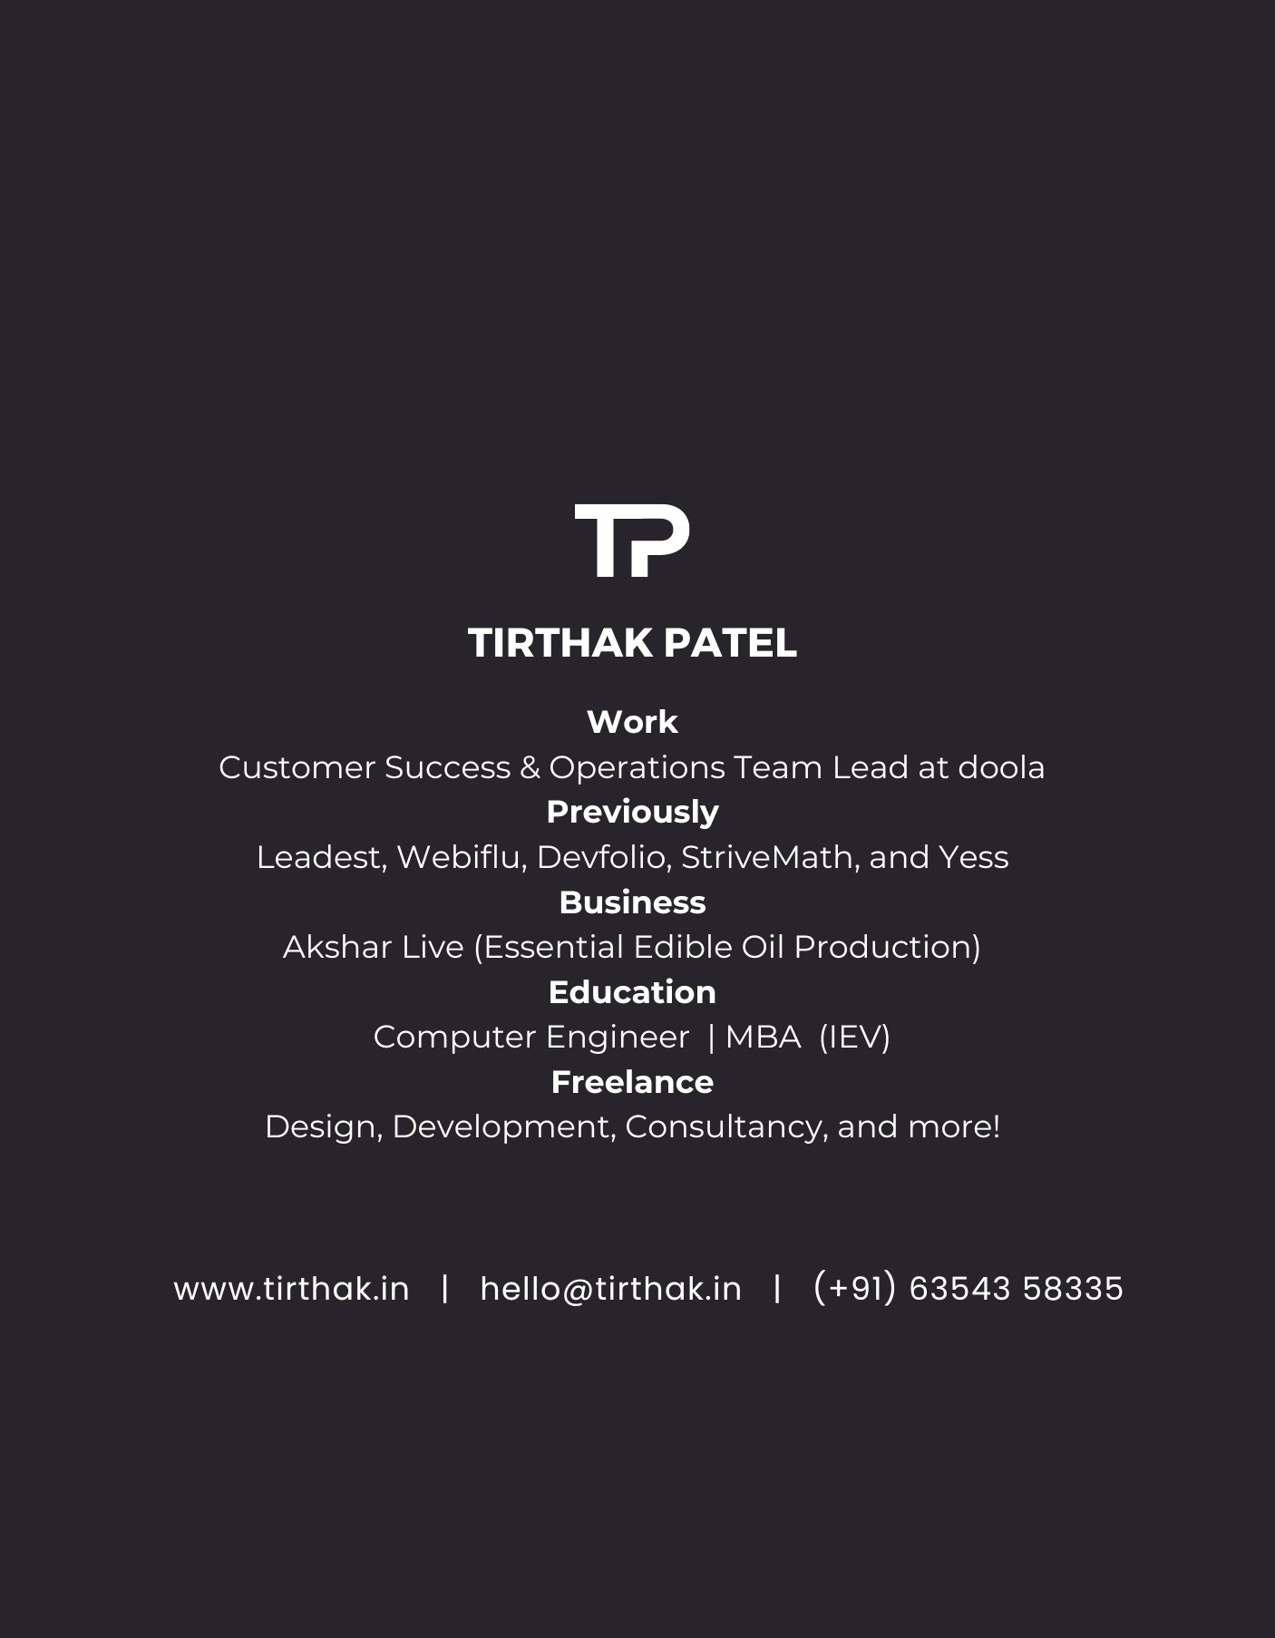



Assignment 2