**Institute of Computer Technology**

**B. Tech. Computer Science and Engineering**

**Semester: IV**

**Sub: Front End Technologies**

**Course Code: 2CSE401**

**Practical Number:2**

**Objective:**

Design an appropriate web page with the help of HTML and CSS stylesheet.

**Code :**

* **Index.html**

<html>

<head>

<title>

GCERT

</title>

<link href="https://cdnjs.cloudflare.com/ajax/libs/font-awesome/5.15.3/css/all.min.css" rel="stylesheet"/>

<link href="https://fonts.googleapis.com/css2?family=Roboto:wght@400;700&amp;display=swap" rel="stylesheet"/>

<link href="styles.css" rel="stylesheet"/>

</head>

<body>

<div class="container">

<div class="header">

<img alt="GCERT Logo" height="100" src="logo.jpg" width="100"/>

<div>

<h1>

Gujarat Council of Educational Research and Training, Gandhinagar

</h1>

<p>

(Declared as Academic Authority as per RTE Act 2009)

</p>

<p>

Education Department - Government of Gujarat

</p>

</div>

<div class="search-bar">

<input placeholder="Search..." type="text"/>

<div class="language-switcher">

<a href="#">

English

</a>

<a href="#">

ગુજરાતી

</a>

</div>

</div>

</div>

<div class="nav">

<a href="#">

Home

</a>

<a href="#">

Contact

</a>

<a href="#">

Feedback

</a>

<a href="#">

Sitemap

</a>

<a href="#">

Help Desk

</a>

<a href="#">

Screen Reader Access

</a>

<a href="#">

English

</a>

<a href="#">

ગુજરાતી

</a>

</div>

<div class="main-content">

<div class="left-column">

<div class="box">

<h2>

About GCERT

</h2>

<img alt="About GCERT" height="150" src="https://storage.googleapis.com/a1aa/image/93nJtDALWW-yo623LBuzefeNFvKt_LdJDVPN0n45hq8.jpg" width="150"/>

</div>

<div class="box">

<h2>

Related Links

</h2>

<img alt="Related Links" height="150" src="https://storage.googleapis.com/a1aa/image/ehZKgE1k6KxotcOiZut_LQtEcEyYnmU9IgUqdgUg6QI.jpg" width="150"/>

</div>

<div class="box calendar">

<h2>

Calendar

</h2>

<table>

<tr>

<th>

Su

</th>

<th>

Mo

</th>

<th>

Tu

</th>

<th>

We

</th>

<th>

Th

</th>

<th>

Fr

</th>

<th>

Sa

</th>

</tr>

<tr>

<td>

29

</td>

<td>

30

</td>

<td>

31

</td>

<td>

1

</td>

<td>

2

</td>

<td>

3

</td>

<td>

4

</td>

</tr>

<tr>

<td>

5

</td>

<td>

6

</td>

<td>

7

</td>

<td>

8

</td>

<td>

9

</td>

<td>

10

</td>

<td>

11

</td>

</tr>

<tr>

<td>

12

</td>

<td>

13

</td>

<td>

14

</td>

<td>

15

</td>

<td>

16

</td>

<td>

17

</td>

<td>

18

</td>

</tr>

<tr>

<td>

19

</td>

<td>

20

</td>

<td>

21

</td>

<td>

22

</td>

<td>

23

</td>

<td>

24

</td>

<td>

25

</td>

</tr>

<tr>

<td>

26

</td>

<td>

27

</td>

<td>

28

</td>

<td>

1

</td>

<td>

2

</td>

<td>

3

</td>

<td>

4

</td>

</tr>

</table>

</div>

<div class="box">

<img alt="India.gov.in" height="150" src="https://storage.googleapis.com/a1aa/image/e8FNj9n8Dd9kIRCfeDPaJz-g8hlYML3IIahDtnHLxmc.jpg" width="150"/>

</div>

<div class="box">

<img alt="DigiLocker" height="150" src="https://storage.googleapis.com/a1aa/image/zvsc0aP_C2vzj_Et7zcmRgOtTVAYe0qH-Uz2NQLvQ7k.jpg" width="150"/>

</div>

</div>

<div class="center-column">

<div class="box">

<img alt="Main Image" height="200" src="heading.jpg" width="600"/>

</div>

<div class="box">

<h2>

Overview

</h2>

<p>

Gujarat Council of Educational Research and Training (GCERT) is a pivotal institution at the state level for the enhancement of qualitative education at primary and secondary schools.

</p>

<p>

It was "State Institute of Education" before 1988. It was later upgraded as a SCERT in 1988, under the resolution of State Education Department. The upgraded SCERT, now named as Gujarat Council of Educational Research and Training (GCERT) is a fully structured State level academic institution and is controlled and guided by a Governing body as well as an Executive Committee.

</p>

<p>

<a href="#">

Read More

</a>

</p>

</div>

<div class="box">

<h2>

Latest News

</h2>

<p>

ગુજરાત કાઉન્સિલ ઓફ એજ્યુકેશનલ રિસર્ચ એન્ડ ટ્રેનિંગ દ્વારા 2016 થી 2021 સુધીના મુખ્યમંત્રીઓના સંદેશા પ્રકાશિત કરવામાં આવ્યા છે.

</p>

<p>

NEP 2020 Initiatives

<span style="color: red;">

new

</span>

</p>

<p>

રાષ્ટ્રીય ઇ-પુસ્તકાલય

</p>

<p>

સેક્સ્યુઅલ હેરેસમેન્ટ પ્રિવેન્શન કમિટી

</p>

</div>

</div>

<div class="right-column">

<div class="box">

<h2>

Jeevanshikshan Magazine

</h2>

</div>

<div class="box">

<h2>

GR &amp; Notification

</h2>

</div>

<div class="box">

<h2>

Right to Information Act

</h2>

</div>

<div class="box">

<h2>

GCERT DIKSHA

</h2>

</div>

<div class="box">

<h2>

GCERT DIGITAL DESK

</h2>

</div>

<div class="box">

<h2>

Textbooks List

</h2>

</div>

<div class="box">

<h2>

Guiding Forefathers

</h2>

<img alt="Guiding Forefathers" height="150" src="https://storage.googleapis.com/a1aa/image/_zIIYK28v1ZVZmjnDTcOsp8Uk7Ie9Mso5uw8nh-Wzyo.jpg" width="150"/>

</div>

<div class="box">

<h2>

Director Says

</h2>

<p>

I am very happy to handover this site to the people of Gujarat.

</p>

<p>

<a href="#">

Read More

</a>

</p>

</div>

<div class="box">

<h2>

GSWAN

</h2>

<img alt="GSWAN" height="150" src="https://storage.googleapis.com/a1aa/image/T45fOOJ_H3UW4n4qf9lLYRcuaEWdrMdZ8Gh1hXT881A.jpg" width="150"/>

</div>

</div>

</div>

<div class="footer">

<p>

SEARCH YOUR NAME IN THE VOTERS LIST

</p>

</div>

</div>

</body>

</html>

* **style.css**

body {

font-family: 'Roboto', sans-serif;

margin: 0;

padding: 0;

background: linear-gradient(to bottom, #7dbf9e, #ffffff);

}

.container {

width: 100%;

max-width: 1200px;

margin: 0 auto;

background: #fff;

padding: 10px;

}

.header {

display: flex;

align-items: center;

padding: 10px;

}

.header img {

width: 100px;

height: auto;

margin-right: 20px;

}

.header h1 {

font-size: 24px;

margin: 0;

}

.header p {

font-size: 14px;

margin: 5px 0;

}

.search-bar {

display: flex;

flex-direction: column;

margin-left: 20px;

}

.search-bar input[type="text"] {

padding: 5px;

margin-bottom: 5px;

font-size: 14px;

}

.search-bar .language-switcher {

display: flex;

justify-content: space-between;

}

.search-bar .language-switcher a {

text-decoration: none;

color: #000;

font-size: 14px;

}

.nav {

display: flex;

justify-content: space-between;

background: orange;

padding: 10px;

}

.nav a {

text-decoration: none;

color: #000;

font-size: 14px;

}

.main-content {

display: flex;

flex-wrap: wrap;

}

.left-column, .right-column {

width: 100%;

max-width: 300px;

padding: 10px;

}

.center-column {

flex: 1;

padding: 10px;

}

.box {

background: #f9f9f9;

padding: 10px;

margin-bottom: 10px;

}

.box h2 {

font-size: 18px;

margin: 0 0 10px;

}

.box p {

font-size: 14px;

margin: 0 0 10px;

}

.box img {

width: 100%;

height: auto;

}

.calendar {

text-align: center;

}

.calendar table {

width: 100%;

border-collapse: collapse;

}

.calendar th, .calendar td {

border: 1px solid #ddd;

padding: 5px;

text-align: center;

}

.footer {

text-align: center;

padding: 10px;

background: #f1f1f1;

}

@media (max-width: 768px) {

.main-content {

flex-direction: column;

}

.left-column, .right-column, .center-column {

max-width: 100%;

}

}

**Output :**

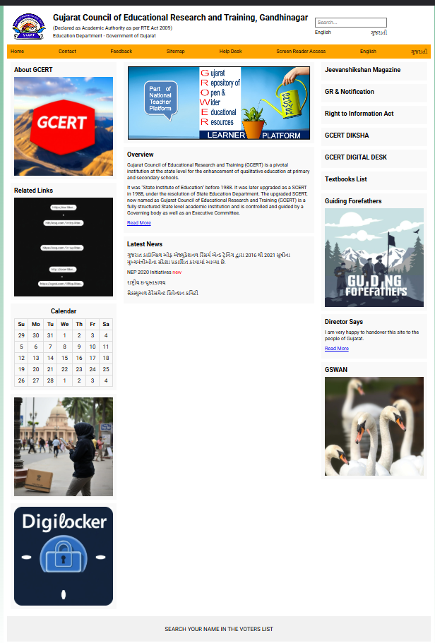

Q.2. Problem definition:

Pooja would like to withdraw Rs. X from an ATM. The cash machine will only accept the transaction if X is a multiple of 5, and Pooja's account balance has enough cash to perform the withdrawal transaction (including bank charges). For each successful withdrawal the bank charges Rs. 5. Calculate Pooja's account balance after an attempted transaction.

**Code :**

import java.util.Scanner;

public class ATMWithdrawal {

public static void main(String[] args) {

Scanner scanner = new Scanner(System.in);

System.out.print("Enter the withdrawal amount: ");

int X = scanner.nextInt();

System.out.print("Enter your initial account balance: ");

double Y = scanner.nextDouble();

double remainingBalance = calculateBalance(X, Y);

System.out.printf("Your remaining balance is: %.2f\n", remainingBalance);

scanner.close();

}

public static double calculateBalance(int X, double Y) {

if (X % 5 != 0) {

return Y; // Invalid withdrawal amount

}

double requiredBalance = X + 5;

if (Y < requiredBalance) {

return Y; // Insufficient funds

}

return Y - requiredBalance;

}

}

**Output :**

Enter the withdrawal amount: 2000

Enter your initial account balance: 5000

Your remaining balance is: 2995.00

Q.3. Make a program to obtain a number N and increment its value by 1 if the number is divisible by 4,6 and 10 otherwise decrement its value by 1.

**Code :**

import java.util.Scanner;

public class NumberIncrementDecrement {

public static void main(String[] args) {

Scanner scanner = new Scanner(System.in);

System.out.print("Enter a number: ");

int N = scanner.nextInt();

if (N % 4 == 0 && N % 6 == 0 && N % 10 == 0) {

N++; // Increment by 1

} else {

N--; // Decrement by 1

}

System.out.println("New value of N: " + N);

scanner.close();

}

}

**Output :**

Enter a number: 60

New value of N: 61

Q.4. Compute the real roots of the equation: ax2+bx+c=0.

**Code :**

import java.util.Scanner;

public class SimpleQuadraticSolver {

public static void main(String[] args) {

Scanner scanner = new Scanner(System.in);

// Input coefficients a, b, and c

System.out.print("Enter a: ");

double a = scanner.nextDouble();

System.out.print("Enter b: ");

double b = scanner.nextDouble();

System.out.print("Enter c: ");

double c = scanner.nextDouble();

// Calculate the discriminant

double discriminant = b * b - 4 * a * c;

// Determine the number of roots

if (a == 0) {

if (b == 0) {

System.out.println("No solution.");

} else {

System.out.println("One root: " + (-c / b));

}

} else if (discriminant < 0) {

System.out.println("No real roots.");

} else if (discriminant == 0) {

System.out.println("One root: " + (-b / (2 * a)));

} else {

double root1 = (-b + Math.sqrt(discriminant)) / (2 * a);

double root2 = (-b - Math.sqrt(discriminant)) / (2 * a);

System.out.println("Two roots: " + root1 + " and " + root2);

}

scanner.close();

}

}

**Output :**

Enter a: -1

Enter b: 1

Enter c:

0

Two roots: -0.0 and 1.0

Q.5. Determines a student’s grade, for that, you have to write an appropriate program, which will read five subject marks from the user, and then have to find total and average marks of given five subjects. On the basis of the average marks, you have to find grade as per the following condition:

-if the average score =90% =>grade=O

-if the average score >=70% and <90%=> grade=A

-if the average score>=50% and <70% =>grade=B

-if the average score>=40% and <50% =>grade=C

-if the average score<40% =>grade=Fail

**Code :**

import java.util.Scanner;

public class GradeCalculator {

public static void main(String[] args) {

Scanner scanner = new Scanner(System.in);

// Array to store the marks of 5 subjects

int[] marks = new int[5];

int total = 0;

// Input marks for 5 subjects

System.out.println("Enter the marks for 5 subjects:");

for (int i = 0; i < 5; i++) {

System.out.print("Subject " + (i + 1) + ": ");

marks[i] = scanner.nextInt();

total += marks[i]; // Calculate total marks

}

// Calculate average marks

double average = total / 5.0;

// Determine the grade based on the average marks

String grade;

if (average >= 90) {

grade = "O";

} else if (average >= 70) {

grade = "A";

} else if (average >= 50) {

grade = "B";

} else if (average >= 40) {

grade = "C";

} else {

grade = "Fail";

}

// Display the total, average, and grade

System.out.println("Total Marks: " + total);

System.out.println("Average Marks: " + average);

System.out.println("Grade: " + grade);

scanner.close();

}

}

**Output :**

Enter the marks for 5 subjects:

Subject 1: 90

Subject 2: 92

Subject 3: 89

Subject 4: 87

Subject 5: 96

Total Marks: 454

Average Marks: 90.8

Grade: O