**Healthy Eating and Well-Being App:**

A web app that helps users better understand the value of nutrition in their food through taking pictures of food items. Next-gen food application made using the advanced, generative AI capabilities of Google for the Gemini model and Streamlit for constructing the UI. This will definitely help those people who are more interested in observing how much calorie they got and finding ways of dealing with the problem in a meaningful fashion to change their own well-being.

**Features:**

**Image Uploader:** User can upload any image of their meal, which the app uses for analysis and thus provides detailed nutrition regarding the food item uploaded.

**AI-Powered Analysis:** Utilizing advanced features available with a high-end version of the Gemini Generative AI model, developed by Google, it makes sure that the application provides an in-depth and elaborative breakdown on all the food items entering into that specific image. It comprises a calorie count for each item, with an elaborative nutritional profile that describes all essential nutrients and components associated with those food items.

**User-Friendly Interface:** The application has been developed on Streamlit; hence, it's clean, intuitive, and beautiful to work in. As far as design is concerned, the tool yields an easy, smooth interface—no catches in moving from one step to another.

**How It Works:**

**Image Upload**:

Various formats, such as JPG, JPEG, and PNG, allow the user to upload pictures in this application. In a close, almost blunt affirmation that a load was successful, it becomes the ceiling, so to speak, of the screen after the upload is complete.

**AI Interaction**:

With an image uploaded, the app prepares the image data with extreme caution for consumption and forwards the data to Google Generative AI, where it is analysed and generated. Working with a pre-set, well-defined, and pre-made prompt, the AI model goes very deep into the image at hand. For this prompt, the model is asked to list all the food forms in that image and the quantity of calories in it, then provide a further breakdown percentage of the nutritional components such as carbohydrates, fats, fibers, and sugars for deeper insights into nutrition.

**Display Results**:

Then, it shows an AI-generated response that further elaborates on the calories and takes it to minute details of the nutritional review of the meal selected. It also gives a suggestion of whether that particular meal can be healthy or not.

**Code Breakdown:**

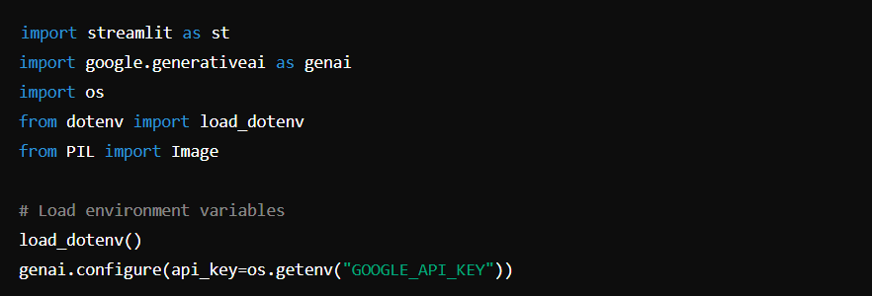

**Loading Environment Variables**:

It would load the Google API key from a hidden file .env that would securely store the environment variables. It was set such that the application used the Gemini model configuration in Google's suite of Generative AI. This was achieved by loading an API key first, which would allow interfacing with the model effectively.

**Google Generative AI Configuration**:

The app is configured to use the Gemini model from Google’s Generative AI by loading the API key.

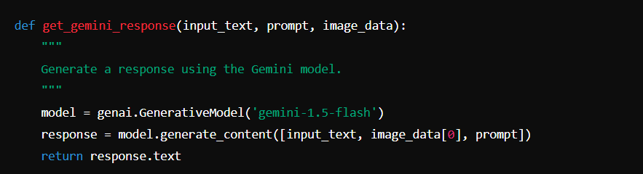

**Generating AI Response:**

It is a simple function that takes the text plus an image and uses the Gemini model to produce the new content to be incorporated in social media sites.

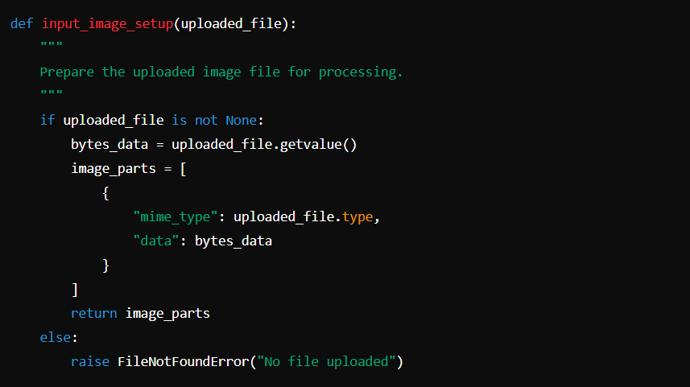

**Image Processing:**

This function takes the uploaded image performs a conversion on it to make the image usable by the AI model by returning the image data and the mime type of the uploaded image.

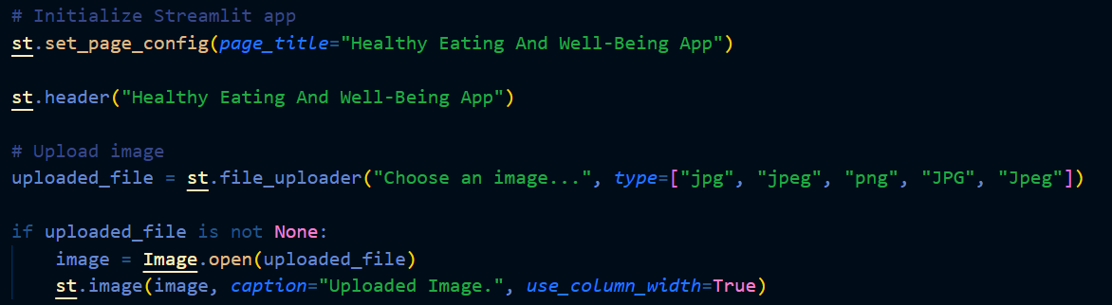

**Streamlit Interface Setup:**

The application begins with an introduction of title and header of the app. Augmented reality; one of the features, and this is because users can also upload images that are integrated into the app.

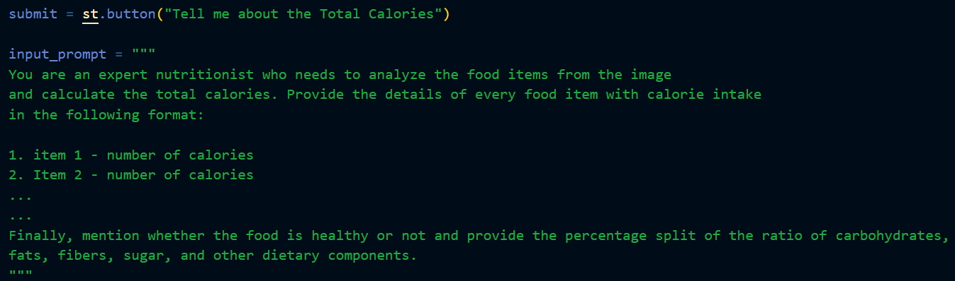

**User Interaction and Prompt:**

In this regard, the app features a button whereby a user can submit the image for analysis. The prompt is used to set the style, structure and type of output that the AI model will be creating.

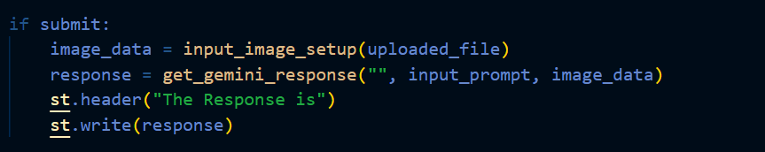

**Displaying Results:**

Upon processing of the image, a result from the AI model is often shown on an interface and ensures the user gets information on the nutrition value.

**Prerequisites:**

* Python 3.8+
* Streamlit
* Google Generative AI Python Client
* Dotenv

### Installation:

### Clone This Repository

### git clone <https://github.com/Modhitha-yeddula/nutrition-app-using-gemini-pro.git>

### cd healthy-eating-app

### Install the required Packages

### pip install -r requirements.txt

### Set up Your ‘.env’ file with your Google API Key

### GOOGLE_API_KEY =” your_api_key_here”

### Run The App

### streamlit run app.py

### Contribution:

### Feel free to submit issues or pull requests if you find any bugs or have suggestions for improvements.