**To display todays date and current time**



**To display device name of the terminal where user is now working**



**To display the calender of the month April 1993**

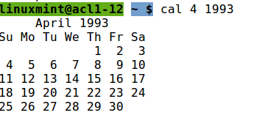

**To display every one who is currently logged in**



**To display user name and corresponding information**



**To display a text on the screen**



**To create a file**

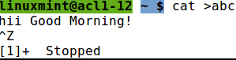

**To type (concatenate) a named file on the screen**



**To display two files with a single command**



**To list file names**

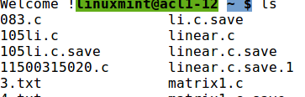

**To list file names in reverse order**

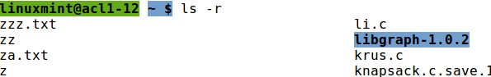

**To List files sorted by time modified (latest first)**

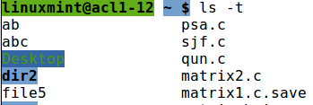

**To List all files including . Files**

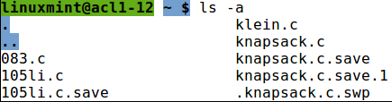

**To change file access rights (change mode)**

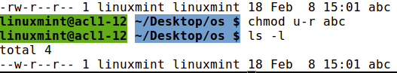

**To remove others read permission for abc file**

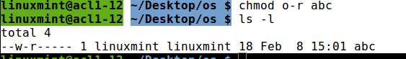

**To Count no. of lines, words and characters in a file**

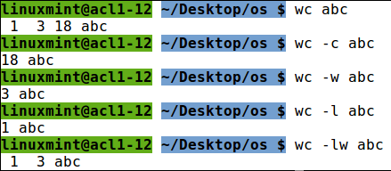

**To Copy content of one file to another**

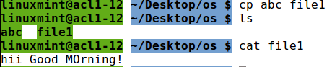

**To Change file name**

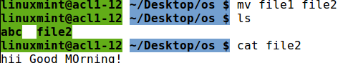

**To Remove a file**



**To Remove a file after confirmation**

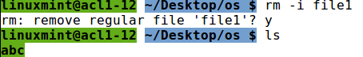

**To create a sub directory**



**To Change current directory**



**To remove a sub directory**



**To display space consumed by the current directory as well as its sudirectories (in**

**blocks, block=512 bytes)**

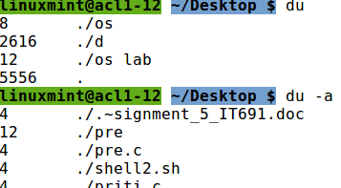

**Comparing files**



**To display only common lines**



**Locating files using find command**

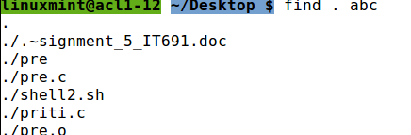

**To display specific files using wild-card characters (wild-card character must be specified in**

**double quotes.)**



**Sorting a file**

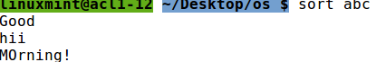

**Searching a pattern within a file**



**To display the lines not matching with the given pattern**

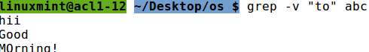

**To display all lines having 'hi' followed by any character**



**File- identify file types**



**Ifconfig**

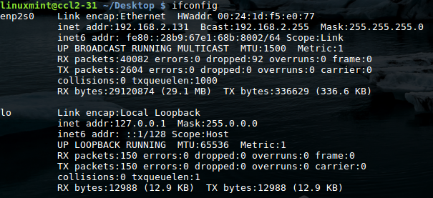

**ping**

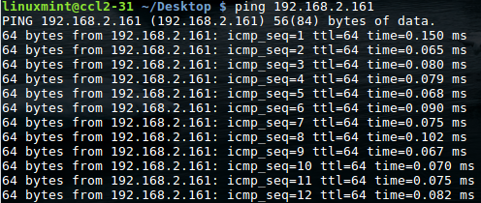

**uname**



**ps**

