Name :Modi Manan Kirankumar
ETHICAL HACKING TASK 01 – INFORMATION GATHERING & RECONNAISSANCE
Target Information
Website Name: OWASP Juice Shop
URL: https://juice-shop.github.io/
Reason for Choosing the Target:
OWASP Juice Shop was selected because it is an intentionally vulnerable web application developed for security awareness, training, and ethical hacking practice. It is widely used by cybersecurity professionals and students to learn web application security concepts in a safe and legal environment.
Part B: WHOIS Lookup
WHOIS Findings
Parameter | Details
Domain Name | github.io
Registrar | MarkMonitor Inc.
Registration Date | 2013-03-08
Expiry Date | 2027-03-08
Name Servers | ns-692.awsdns-22.net, ns-1622.awsdns-10.co.uk, dns1.p05.nsone.net, dns2.p05.nsone.net
Domain Status | clientDeleteProhibited, clientTransferProhibited, clientUpdateProhibited
Screenshot
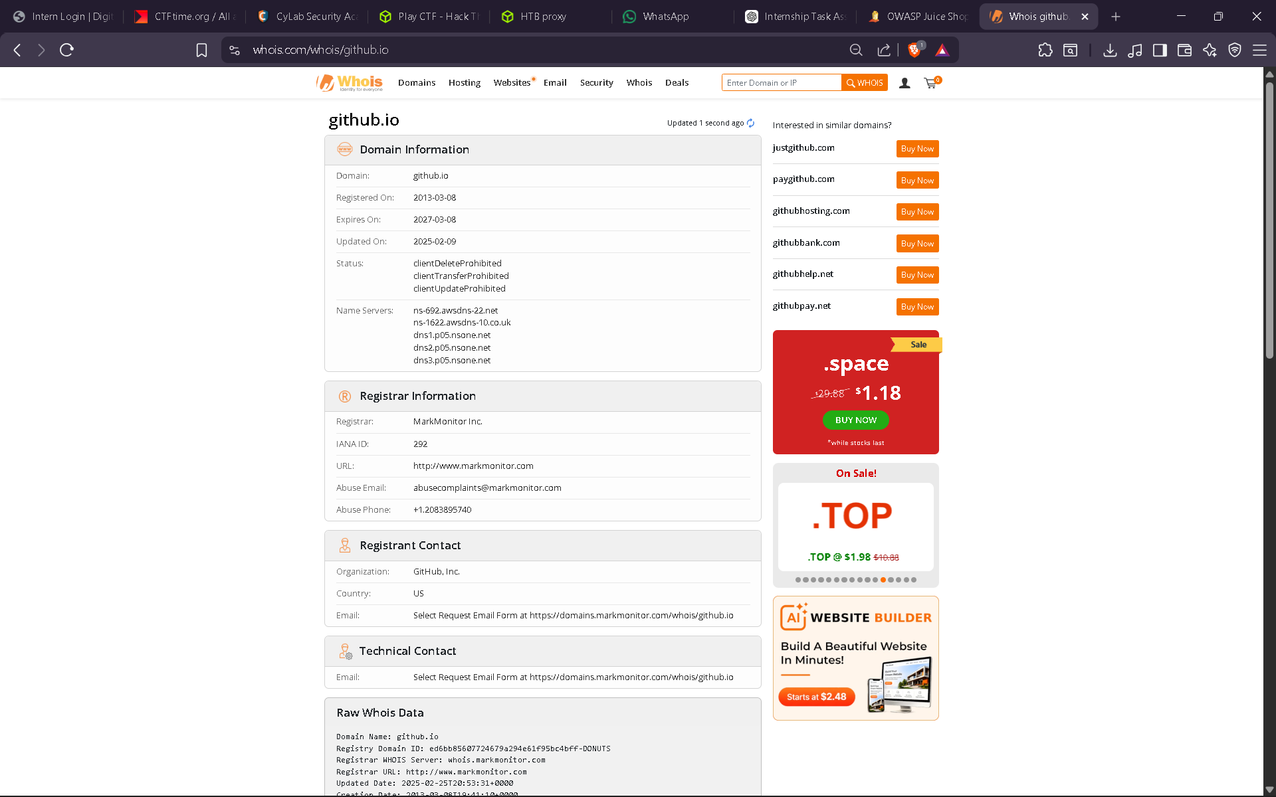
Part C: DNS Enumeration
DNS Findings
A Records
Domain | IP Address
juice-shop.github.io | 185.199.108.153
juice-shop.github.io | 185.199.109.153
juice-shop.github.io | 185.199.110.153
juice-shop.github.io | 185.199.111.153
AAAA Records
Domain | IPv6 Address
juice-shop.github.io | 2606:50c0:8000::153
juice-shop.github.io | 2606:50c0:8001::153
juice-shop.github.io | 2606:50c0:8002::153
juice-shop.github.io | 2606:50c0:8003::153
MX Record
No MX record was identified.
TXT Record
No TXT record was identified.
NS Records
The domain uses Amazon Route53 and NSOne name servers.
Screenshot
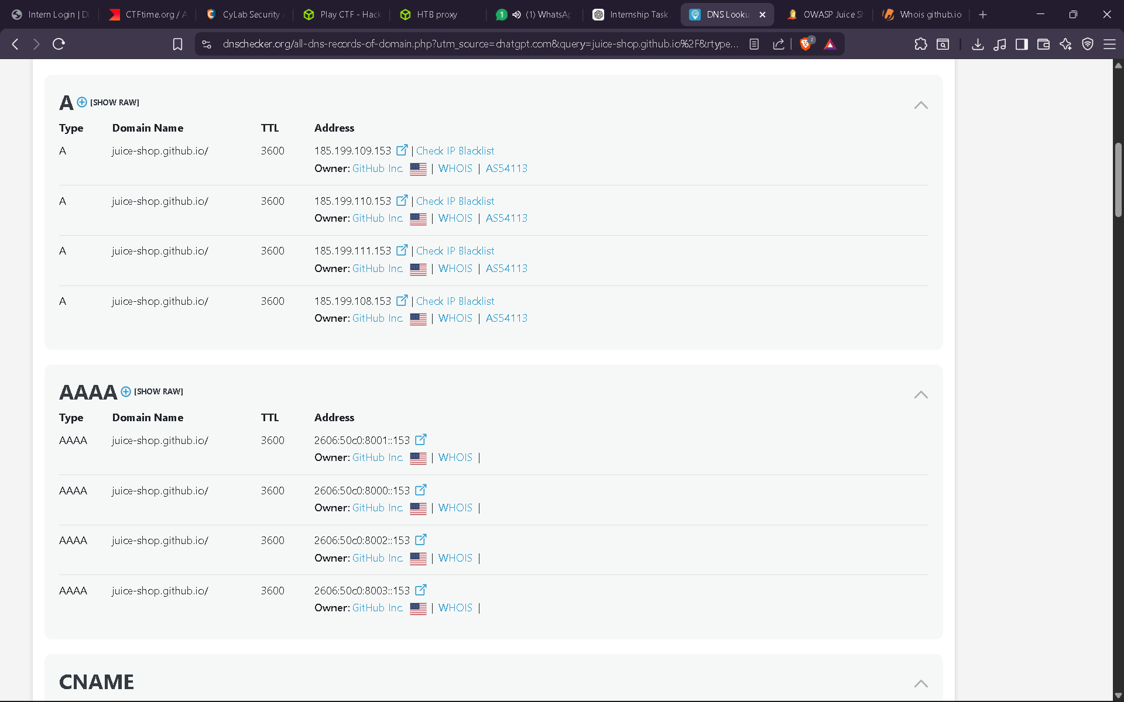
Part D: Website Technology Identification
Technologies Identified
Category | Technology
Font Scripts | Google Font API
Font Scripts | Font Awesome 5.15.4
CDN | Cloudflare
CDN | cdnjs
CDN | Fastly
Caching | Varnish 1.1
PaaS | GitHub Pages
UI Framework | Tailwind CSS
Summary
The target website is hosted on GitHub Pages and utilizes multiple CDN providers including Cloudflare and Fastly to improve performance and availability. The application uses Tailwind CSS for frontend styling and integrates external resources such as Google Fonts and Font Awesome. Varnish caching is employed to improve response times and content delivery.
Screenshot
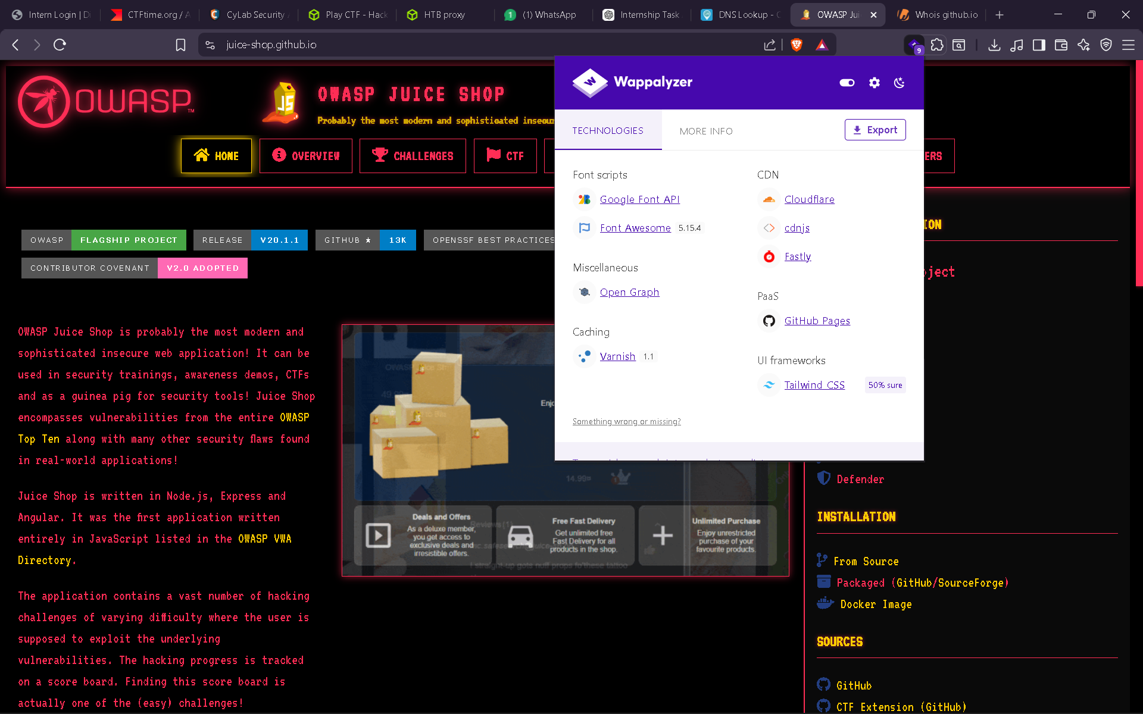

Part E: HTTP Security Headers
Header | Present (Yes/No) | Purpose
Strict-Transport-Security | Yes | Enforces HTTPS communication
Content-Security-Policy | No | Protects against XSS attacks
X-Frame-Options | No | Protects against clickjacking
X-Content-Type-Options | No | Prevents MIME-type sniffing
Referrer-Policy | No | Controls referrer information leakage
Observation
The website enforces HTTPS using the Strict-Transport-Security header. However, several important security headers such as Content-Security-Policy, X-Frame-Options, and X-Content-Type-Options are missing, which may expose users to certain client-side attacks.
Screenshot
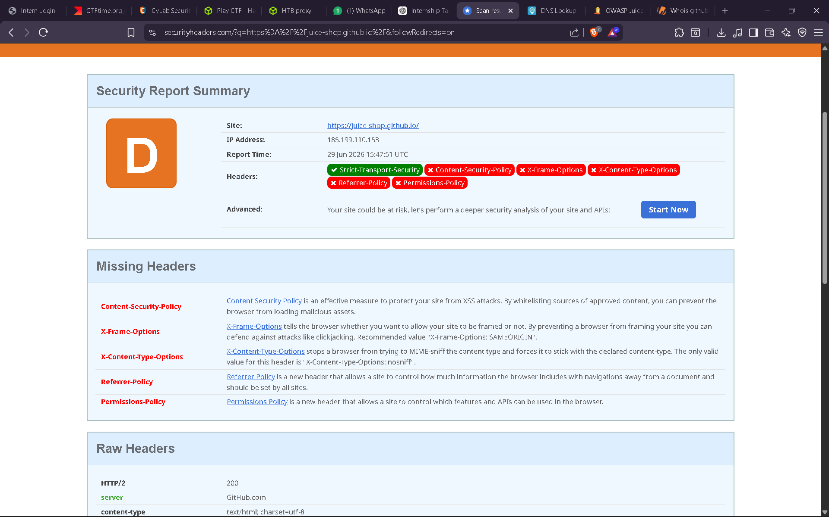
Part F: Robots.txt & Sitemap Analysis
robots.txt Analysis
The file https://juice-shop.github.io/robots.txt was checked and no robots.txt file was found. The server returned a 404 Not Found response.
sitemap.xml Analysis
The file https://juice-shop.github.io/sitemap.xml was checked and no sitemap.xml file was found. The server returned a 404 Not Found response.
Findings
Question | Answer
Does the website have a robots.txt file? | No
Does the website have a sitemap.xml file? | No
What information can be learned from these files? | Since both files are absent, no additional information regarding hidden directories, crawling rules, or indexed pages could be obtained.
Screenshot
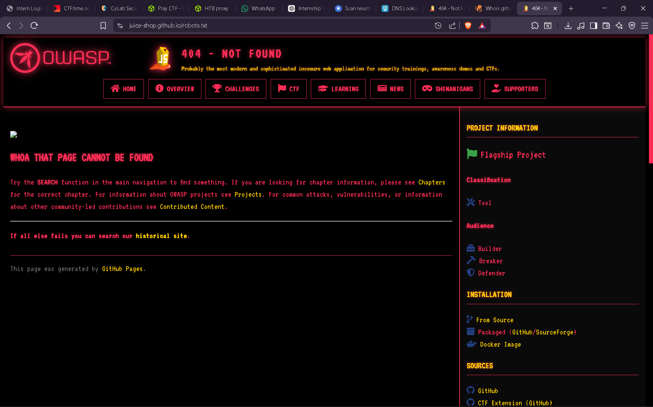

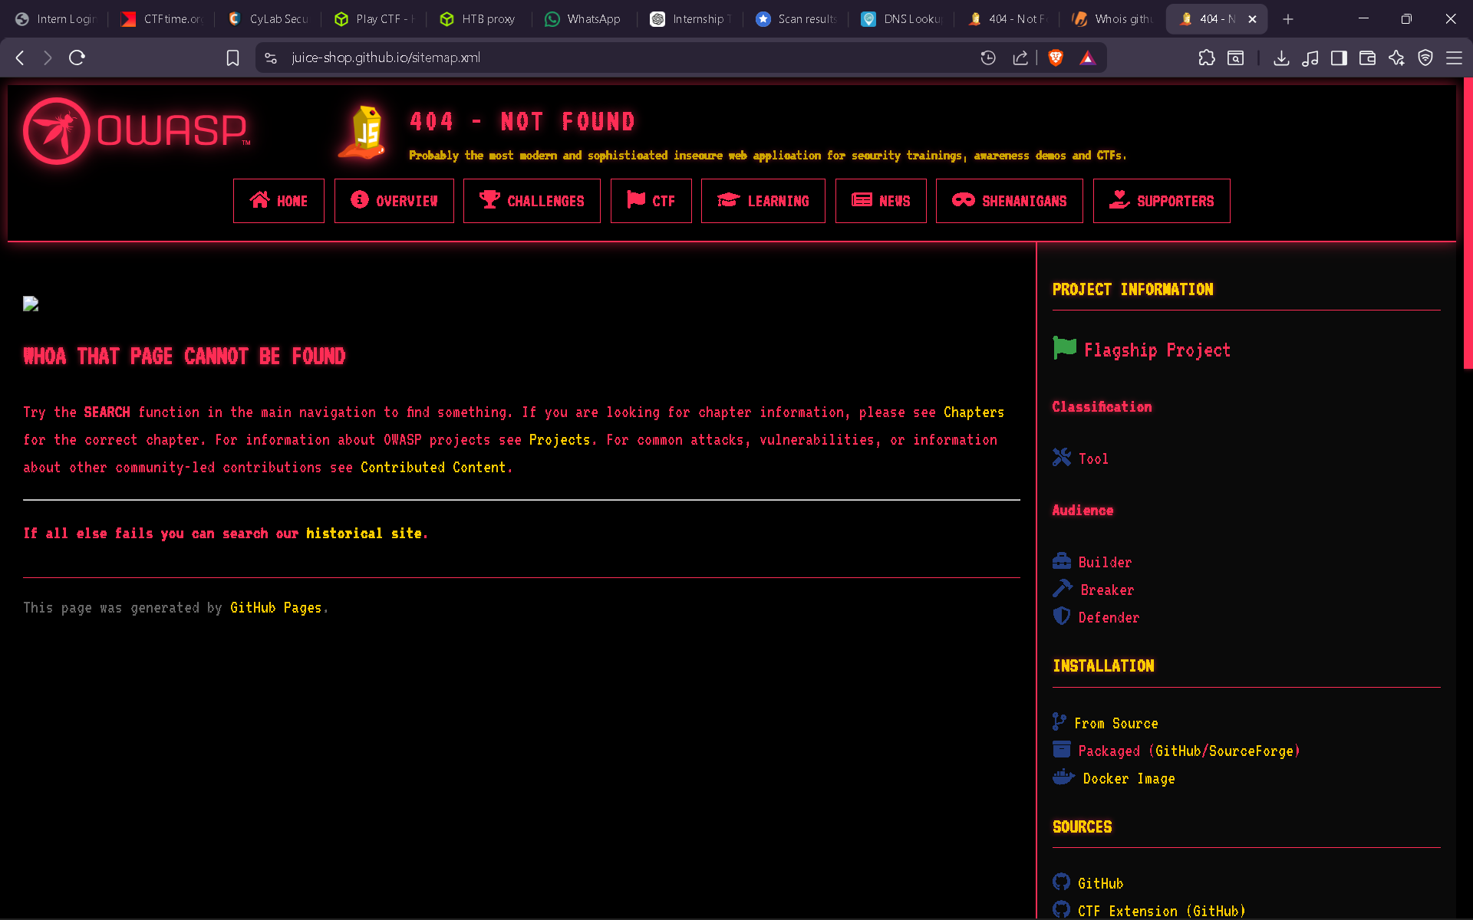

Overall Observations
- The target website is hosted on GitHub Pages.
- Multiple CDN providers are used to improve website performance.
- HTTPS enforcement is enabled through HSTS.
- Several recommended security headers are missing.
- No robots.txt or sitemap.xml files were present.

Conclusion
During this reconnaissance exercise, publicly available information about the target website was collected without interacting directly with the application's internal functionality. WHOIS lookup, DNS enumeration, technology fingerprinting, and security header analysis were performed successfully. The assessment revealed that the website is hosted on GitHub Pages and uses several third-party technologies such as Cloudflare, Fastly, and Tailwind CSS. Security header analysis identified that although HTTPS enforcement is enabled through HSTS, several important security headers are missing. Additionally, no robots.txt or sitemap.xml files were present. This activity demonstrated how passive reconnaissance can provide valuable information about a target system while maintaining ethical and legal boundaries. Strong reconnaissance skills help security professionals understand a target's attack surface and prepare for further security assessments in an authorized manner.

