Linux Task 02: Users, Groups & File Permissions

Part A: Understanding Users
What is your current username?
- manan
What is UID?
- UID is the User Identifier. The UID for the user "manan" is 1000.
What is GID?
- GID is the Group Identifier. The GID for the user "manan" is 1000.
What information does /etc/passwd contain?
- It contains user account information, specifically: username, password (x means encrypted in /etc/shadow), User ID (UID), Group ID (GID), User ID Info (GECOS field), Home directory, and default shell (/usr/bin/zsh).
[Screenshot: Part A Output]
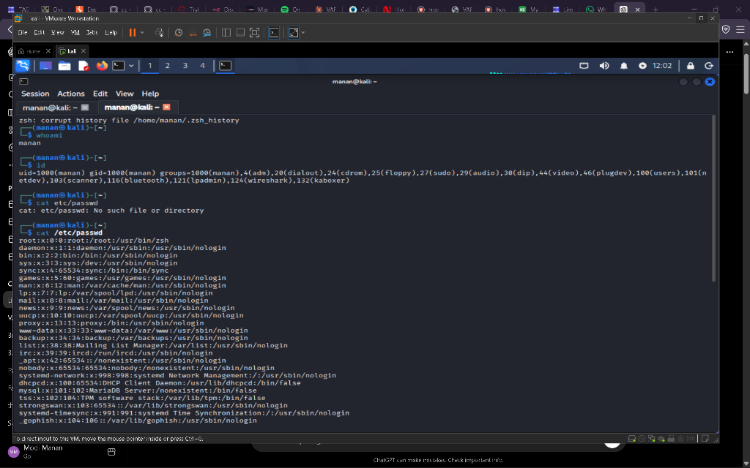

Part B: Create Users & Groups
Groups created: interns, cyberteam
Users created: student1, student2, student3
Users were added to the groups successfully. student1 was added to interns, student2 to cyberteam, and student3 to both interns and cyberteam.
[Screenshot: Part B Output]
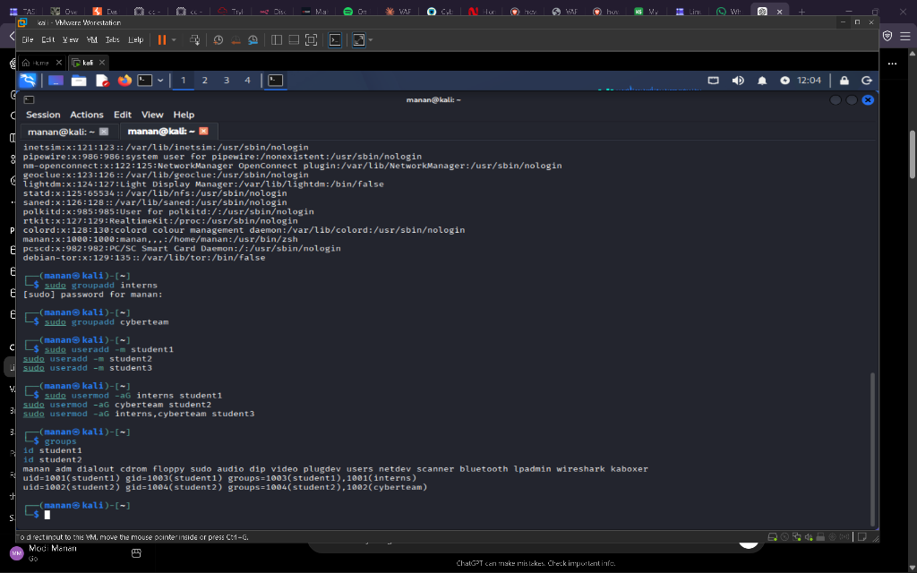

Part C: File Ownership
Folder "CyberSecurity_Project" and files "report.txt", "notes.txt", "credentials.txt" created.
Original Owner | New Owner | Command Used
manan | student1 | sudo chown student1 report.txt
[Screenshot: Part C Output]
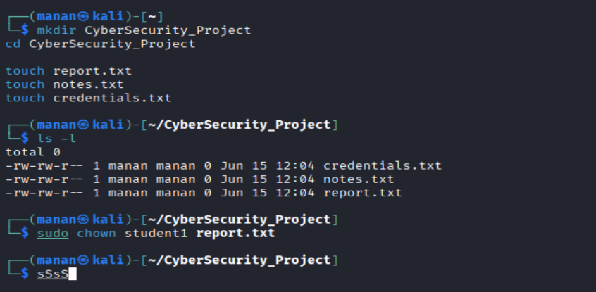

Part D: File Permissions
File "security_policy.txt" created.
Commands used to modify permissions:
1. Read Only (r--r--r--): chmod 444 security_policy.txt
2. Read & Write (rw-rw-r--): chmod 664 security_policy.txt
3. Full Access (rwxrwxrwx): chmod 777 security_policy.txt
[Screenshot: Part D Output (Not provided in chat, please add)]

Part E: Permission Analysis
755
- Owner Rights: rwx (Read, Write, Execute) - 7
- Group Rights: r-x (Read, Execute) - 5
- Other User Rights: r-x (Read, Execute) - 5
- Real-world use case: Executable scripts or directories that others need to read and enter (e.g., /bin, /usr/bin).
644
- Owner Rights: rw- (Read, Write) - 6
- Group Rights: r-- (Read Only) - 4
- Other User Rights: r-- (Read Only) - 4
- Real-world use case: Standard text files and configuration files. Everyone can read, only the owner can modify.
777
- Owner Rights: rwx (Read, Write, Execute) - 7
- Group Rights: rwx (Read, Write, Execute) - 7
- Other User Rights: rwx (Read, Write, Execute) - 7
- Real-world use case: Temporary shared directories (like /tmp). It is insecure for regular files.
600
- Owner Rights: rw- (Read, Write) - 6
- Group Rights: --- (None) - 0
- Other User Rights: --- (None) - 0
- Real-world use case: Sensitive files like SSH private keys or personal password files.
700
- Owner Rights: rwx (Read, Write, Execute) - 7
- Group Rights: --- (None) - 0
- Other User Rights: --- (None) - 0
- Real-world use case: Personal private directories (like ~/.ssh) to restrict all access from other users.

Part F: Security Challenge
File | Recommended Permission | Reason
password_backup.txt | 600 | Highly sensitive file. Only the owner should be able to read and write it. No one else should have access.
public_notice.txt | 644 | The owner needs to edit it, but everyone else should only be able to read it.
system_log.txt | 640 | The owner (root/system) can write to it. A specific admin group can read it. Others should not have access for security reasons.
personal_notes.txt | 600 | Personal files should only be accessible by the owner to maintain privacy.

Part G: Linux Security Research
Why are file permissions important?
- File permissions are the cornerstone of Linux security. They prevent unauthorized access, accidental modification, and malicious exploitation of files and directories by controlling exactly who can read, write, or execute a file.
What happens if sensitive files are given 777 permissions?
- Giving sensitive files 777 permissions means any user or process on the system can read, modify, or execute them. This could lead to data theft, system compromise, or unauthorized modifications (e.g., altering configuration files or injecting malicious code).
What is the principle of Least Privilege?
- The Principle of Least Privilege (PoLP) states that a user, program, or process should only be granted the minimum necessary access rights or permissions required to perform their specific task, and nothing more. This minimizes potential damage in case of an error or security breach.
Why do organizations restrict user access?
- Organizations restrict user access to protect confidential data, maintain system stability, ensure compliance with regulations, and prevent accidental or intentional misuse of resources. Access restrictions limit the "blast radius" of compromised accounts.

