Name : Modi Manan Kirankumar
ETHICAL HACKING TASK 02 - NETWORK SCANNING & SERVICE ENUMERATION
Part A: Install Nmap
Nmap was successfully installed and verified on the system.
Verification Command
nmap --version
Result
- Nmap Version: 7.98
- Platform: x86_64-pc-linux-gnu
- Available nsock engines: epoll, poll, select
Screenshot
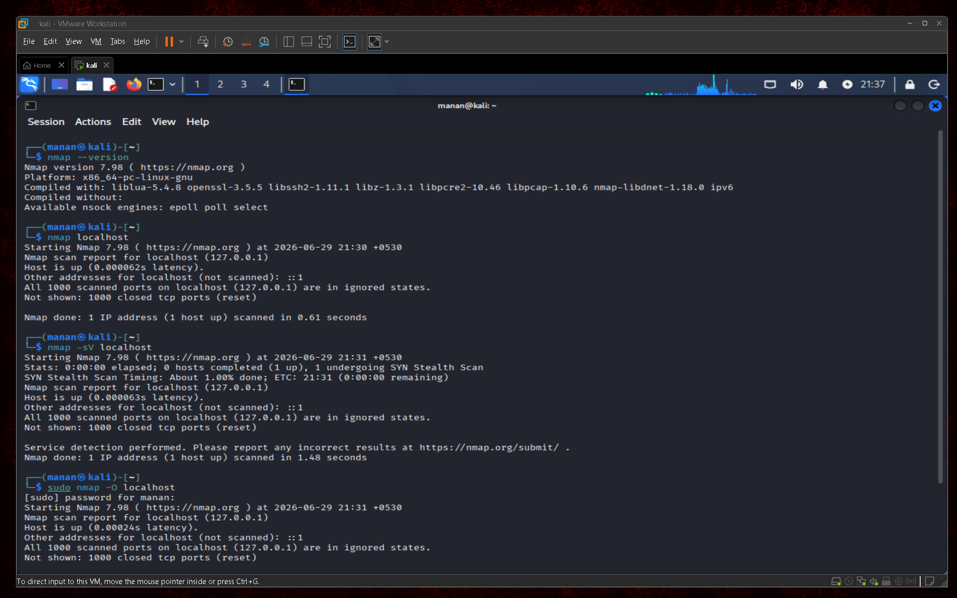
Part B: Scan Your Local Machine
Command Used
nmap localhost
Scan Results
Port Number | State | Service
None | Closed | No active services detected
Total Open Ports
0 open ports were identified during the scan.
Services Running
No active network services were detected on the localhost during the scan.
Screenshot

Part C: Service Version Detection
Command Used
nmap -sV localhost
Service Version Detection Results
No open ports were detected; therefore, no service versions could be identified.
Port | Service | Version
None | N/A | N/A
Observation
Since no services were listening on the default scanned ports, Nmap was unable to perform service version detection.
Screenshot

Part D: Operating System Detection
Command Used
sudo nmap -O localhost
Findings
Was the operating system detected?
Partially. Nmap was unable to determine the exact operating system because multiple OS fingerprints matched the host.
Which OS was identified?
The target system is running Kali Linux, but Nmap reported:
"Too many fingerprints match this host to give specific OS details."
Why is OS detection useful during penetration testing?
Operating system detection helps security professionals identify the underlying operating system running on a target machine. This information assists in identifying operating system-specific vulnerabilities, selecting suitable attack techniques, and improving the overall effectiveness of security assessments.
Screenshot


Part E: Common Port Research
Port | Protocol | Purpose | Common Security Risks
20/21 | FTP | File transfer between systems | Anonymous access, weak passwords
22 | SSH | Secure remote administration | Brute-force attacks, weak credentials
23 | Telnet | Remote administration | Credentials transmitted in plaintext
25 | SMTP | Email transfer | Open relay abuse, spam attacks
53 | DNS | Domain name resolution | DNS amplification attacks
80 | HTTP | Web communication | Unencrypted communication, web attacks
110 | POP3 | Email retrieval | Plaintext credential exposure
143 | IMAP | Email access and synchronization | Weak authentication mechanisms
443 | HTTPS | Secure web communication | SSL/TLS misconfigurations
445 | SMB | File and printer sharing | SMB exploits, ransomware
3389 | RDP | Remote desktop access | Brute-force attacks, unauthorized access

Part F: Scan Analysis
Which services are currently running?
No active network services were detected during the scan.
Are all open ports necessary?
Since no open ports were identified, there are currently no unnecessary network services exposed.
Which services could become security risks if misconfigured?
Services such as SSH, HTTP, SMB, FTP, and RDP could become security risks if they are misconfigured, use weak authentication, or are not regularly updated.
Which port would you disable if it wasn't required?
If a service such as SSH (Port 22) was not required, it should be disabled to minimize the attack surface.
Part G: Professional Scan Report
Scan Date
29 June 2026
Target System
Localhost (127.0.0.1)
Commands Used
nmap localhost
nmap -sV localhost
sudo nmap -O localhost
Open Ports
No open ports were detected.
Running Services
No active services were identified.
Operating System
Kali Linux (exact fingerprint could not be determined by Nmap).
Observations
- The localhost system was reachable and responsive.
- No open TCP ports were detected on the default scan range.
- No active network services were identified.
- OS detection produced multiple matching fingerprints and could not identify the exact operating system.
- The system currently has a minimal network exposure, reducing the attack surface.
Recommendations
- Continue to disable unnecessary services.
- Keep the operating system and installed applications updated.
- Regularly perform network scans to monitor exposed services.
- Use strong authentication and firewall rules when enabling network services.
Conclusion
During this task, network scanning and service enumeration were performed using Nmap on the local system. The scans revealed that no active network services were currently exposed on the localhost, indicating a minimal attack surface. Service version detection was unable to identify any software versions due to the absence of open ports. Operating system detection demonstrated how Nmap attempts to fingerprint systems based on network characteristics, although it could not determine the exact operating system because multiple fingerprints matched the host. This exercise provided practical experience with Nmap and highlighted the importance of regularly scanning systems to identify exposed services and reduce potential security risks.

