Name : Modi Manan Kirankumar
Cyber Security Task 01 - Personal Security Audit & Cyber Awareness Assessment
Part A: Device Security Assessment
System Security Assessment
Parameter | Details
Operating System | Windows 11 Home Single Language
OS Version | Version 25H2 (OS Build 26200.8737)
Is the system updated? | Yes
Antivirus Installed? | Yes (Bitdefender Antivirus)
Firewall Enabled? | Yes
Description
Operating System: Windows 11 Home Single Language
OS Version: Version 25H2 (OS Build 26200.8737)
System Updated: Yes. The system is fully updated, and Windows Update shows "You're up to date."
Antivirus Installed: Yes. Bitdefender Antivirus is installed and active on the system.
Firewall Enabled: Yes. Windows Firewall is enabled for Domain, Private, and Public networks.
Screenshots to Include:
1. OS_Information.png
2. Windows_Update_Status.png
3. Antivirus_Status.png
4. Firewall_Status.png
Part B: Password Security Review
1. What makes a strong password?
A strong password is long, unique, and contains a combination of uppercase letters, lowercase letters, numbers, and special characters. It should not contain personal information.
2. Why should passwords be unique?
Unique passwords ensure that if one account is compromised, other accounts remain secure.
3. What is Multi-Factor Authentication (MFA)?
Multi-Factor Authentication (MFA) is a security method that requires users to provide two or more verification methods, such as a password and a verification code sent to a mobile device.
4. What are the risks of password reuse?
Password reuse increases security risks because if one account is compromised, attackers may gain access to multiple accounts using the same password.
Password Policy
1. Use passwords with at least 12 characters.
2. Include uppercase and lowercase letters.
3. Use numbers and special characters.
4. Avoid using personal information such as names or birth dates.
5. Enable Multi-Factor Authentication whenever possible
Part C: Online Account Security Check
Account | MFA Enabled | Strong Password | Recovery Email Configured
Google | Yes | Yes | Yes
GitHub | Yes | Yes | Yes
LinkedIn | No | Yes | Yes
Part D: Cyber Threat Research
1. Phishing
Definition
Phishing is a cyberattack in which attackers trick users into revealing sensitive information through fake emails, websites, or messages.
Real-World Example
Attackers send fake banking emails asking users to verify account credentials.
Prevention Methods
- Verify sender email addresses.
- Avoid clicking suspicious links.
- Enable Multi-Factor Authentication.
- Use updated antivirus software.
2. Malware
Definition
Malware is malicious software designed to damage, disrupt, or gain unauthorized access to computer systems.
Real-World Example
Computer viruses spread through infected email attachments or downloads.
Prevention Methods
- Install antivirus software.
- Keep software updated.
- Download files only from trusted sources.
- Avoid opening suspicious attachments.
3. Ransomware
Definition
Ransomware is malicious software that encrypts a victim's files and demands payment to restore access.
Real-World Example
The WannaCry ransomware attack in 2017 affected thousands of organizations worldwide.
Prevention Methods
- Regularly back up important data.
- Keep systems updated.
- Avoid suspicious email attachments.
- Use reliable antivirus software.
4. Social Engineering
Definition
Social engineering involves manipulating people into revealing confidential information or performing actions that compromise security.
Real-World Example
An attacker impersonates IT support and asks an employee to reveal their password.
Prevention Methods
- Verify identities before sharing information.
- Be cautious of urgent requests.
- Never share passwords.
- Participate in cybersecurity awareness training.
5. Data Breach
Definition
A data breach occurs when unauthorized individuals gain access to confidential information.
Real-World Example
The Equifax data breach in 2017 exposed sensitive information of millions of users.
Prevention Methods
- Use strong and unique passwords.
- Enable Multi-Factor Authentication.
- Encrypt sensitive data.
- Regularly update systems and applications.
Part E: Cyber Security Awareness Poster
Selected Topic
Phishing Awareness
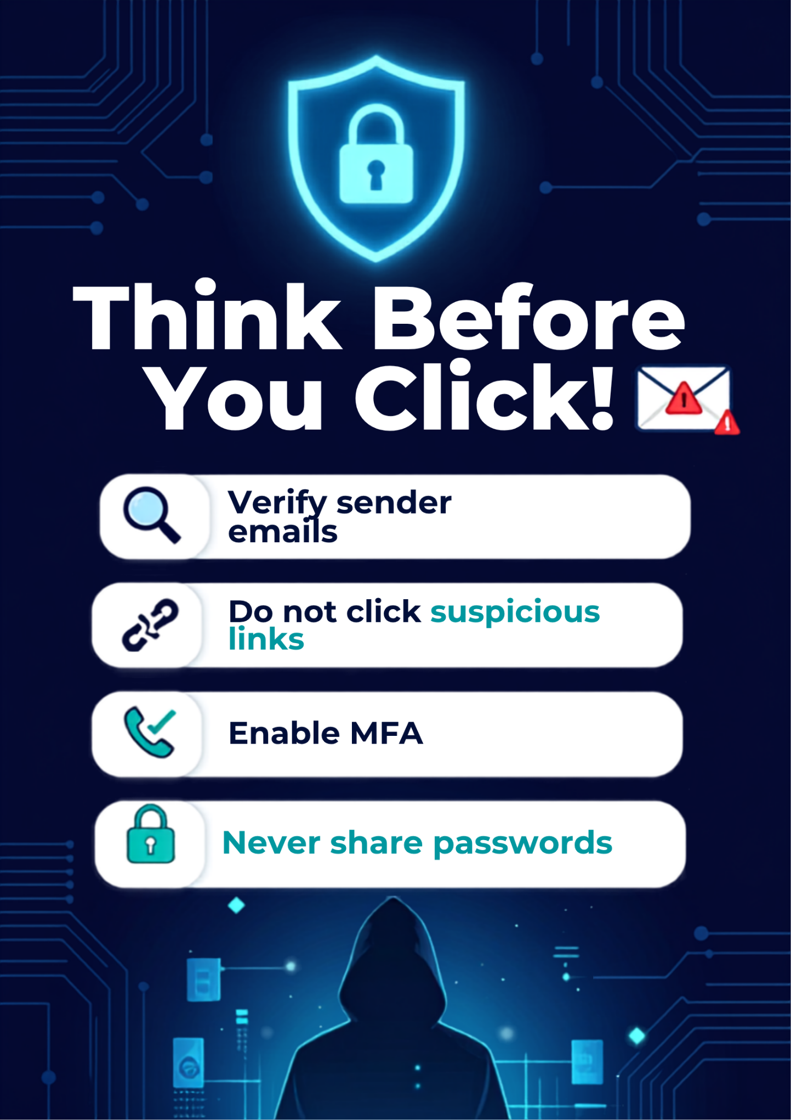

Part F: Security Reflection
Cybersecurity is essential for protecting personal and organizational information in today's digital world. During this security assessment, I identified several risks in my own digital habits. One of the major risks I found was occasionally reusing passwords across multiple accounts. I also realized that I sometimes delay installing software updates, which may expose my system to security vulnerabilities. In addition, I noticed that I do not enable Multi-Factor Authentication on all my online accounts.
To improve my security posture, I plan to implement several security measures immediately. First, I will use unique and strong passwords for all online accounts and store them securely using a password manager. Second, I will enable Multi-Factor Authentication on all important accounts to provide an additional layer of security. I will also ensure that my operating system and software are regularly updated. Furthermore, I will remain cautious while opening emails and clicking links to avoid phishing attacks.
Cybersecurity is important because individuals and organizations rely heavily on digital technologies for communication, banking, education, and business operations. Strong cybersecurity practices help protect sensitive information, prevent financial losses, maintain privacy, and ensure the safe use of technology. Developing secure digital habits is essential for everyone in today's interconnected world.

