

Mpumelelo Chonco

CLDV6212 - Cloud Development Portfolio of Evidence Part 1

ST 10449316

<https://st10449316abcretails.azurewebsites.net/>



Table of Contents

Azure Services Added 2

Containers 2

File shares 2

Queues 3

Tables 4

Information in table storage 5

Multimedia information 6

Queues used 6

Files and documents 7

Web app deployment 7

# Azure Services Added

## Containers

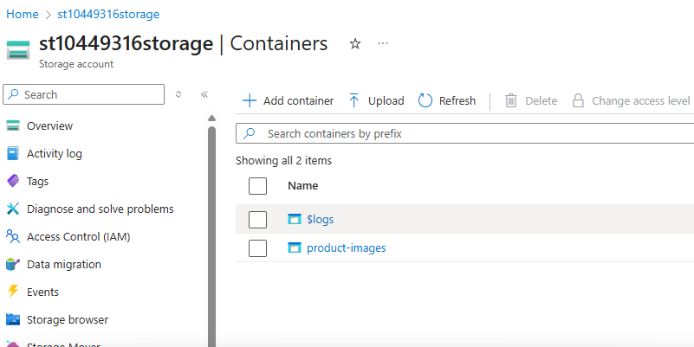

## File shares

## Queues

## Tables

# Information in table storage

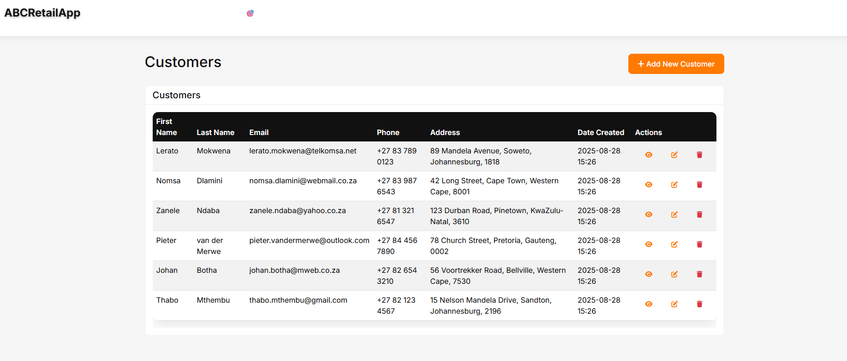

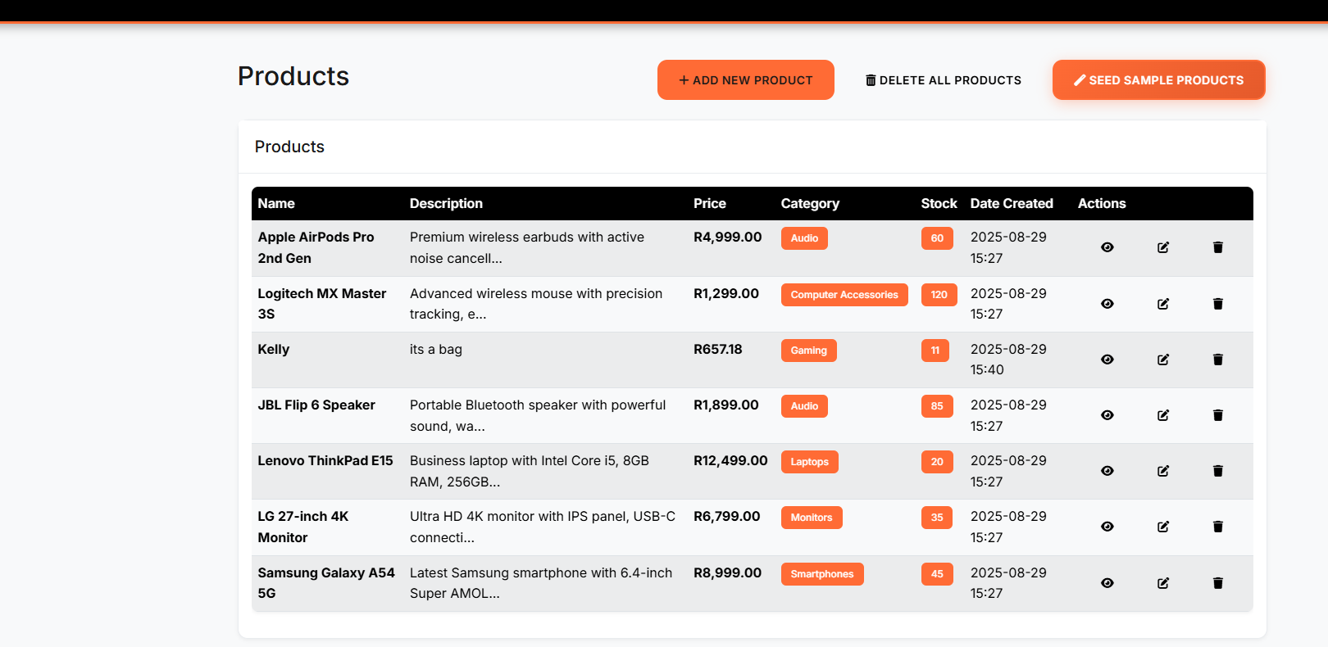

# Multimedia information

# Queues used

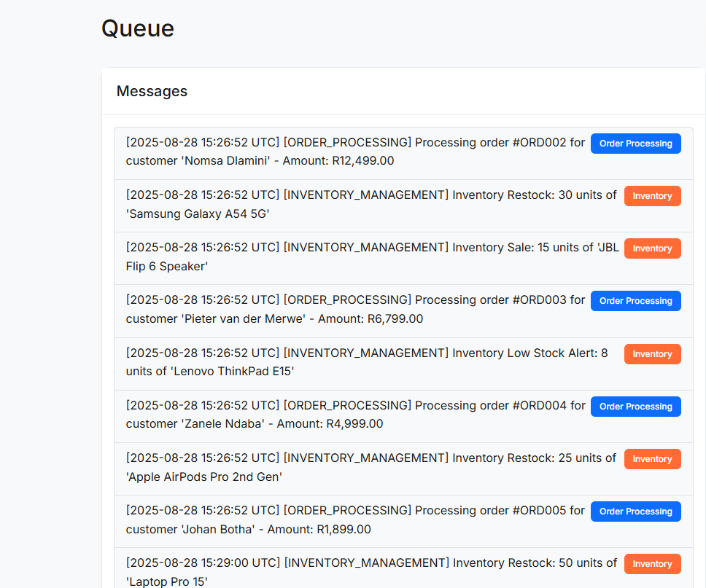

# Files and documents

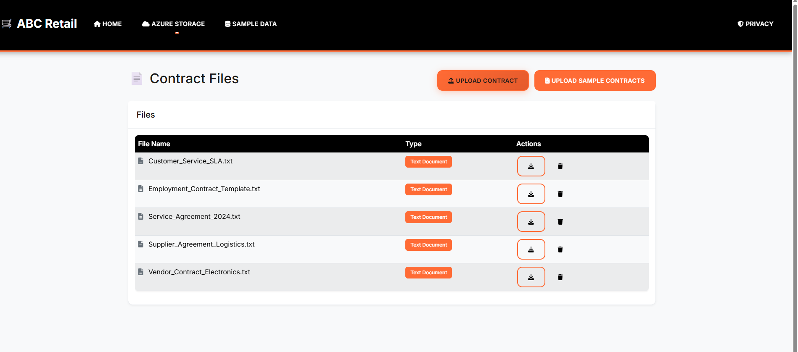

# Web app deployment

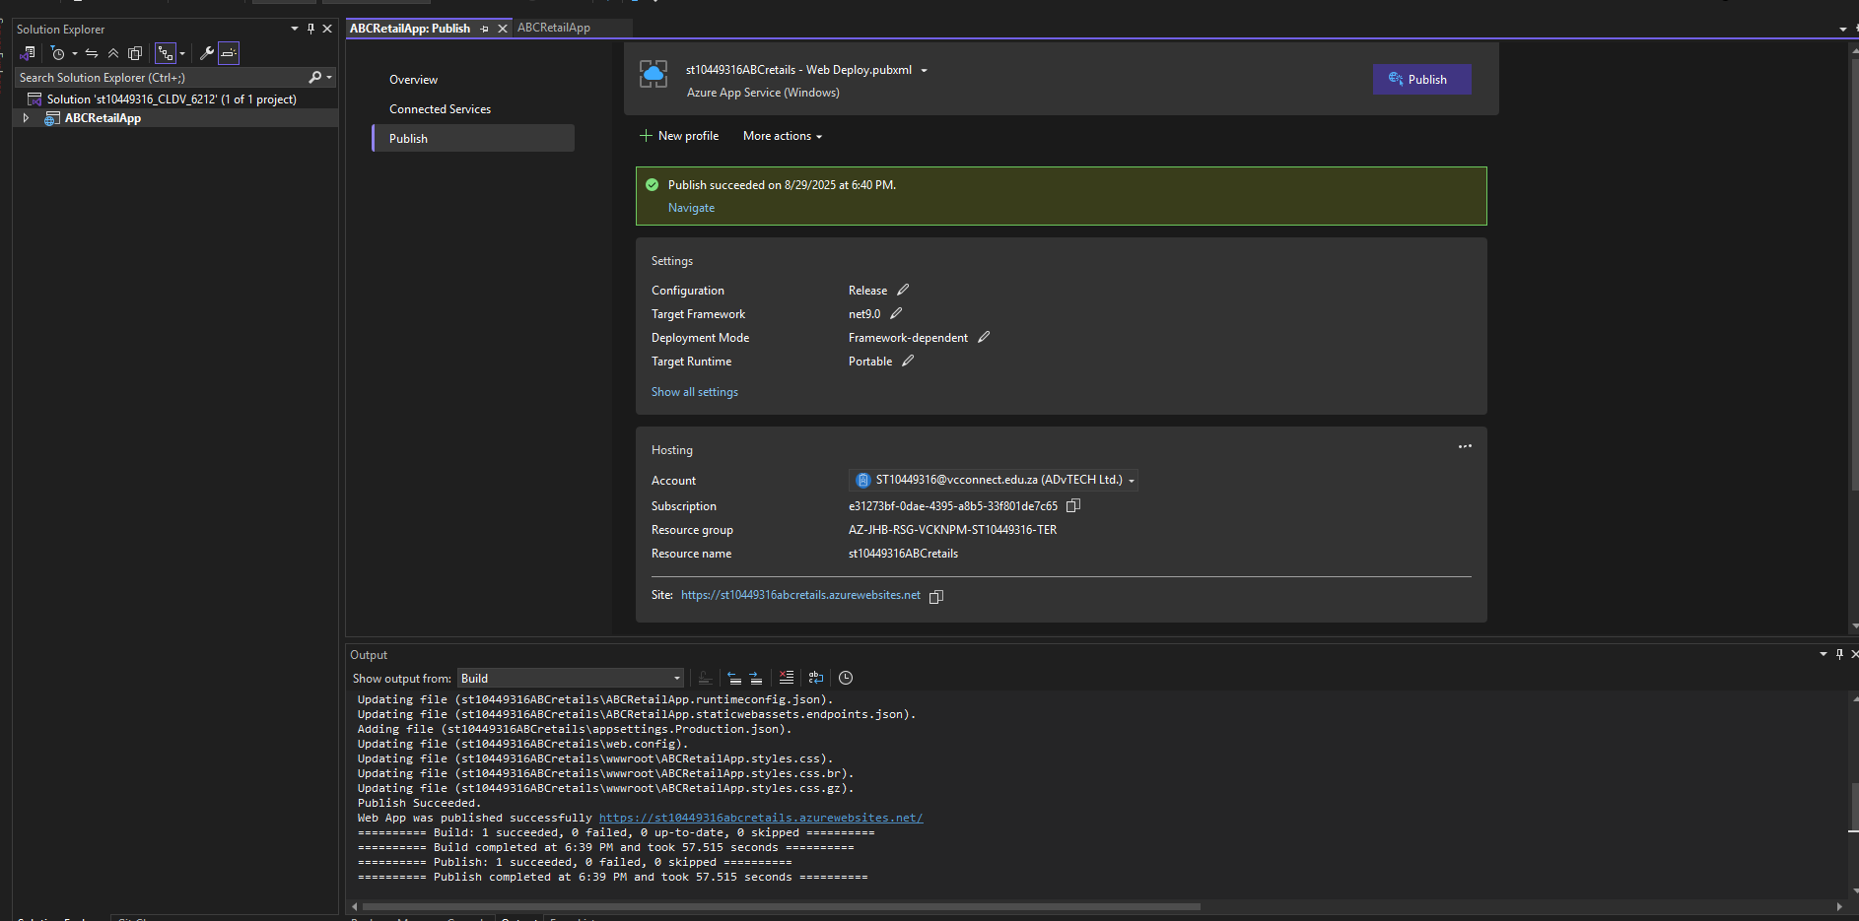

https://st10449316abcretails.azurewebsites.net/