Contingency Tables

Andy Grogan-Kaylor

4 May 2020 14:51:32

# Key Concepts and Commands

# Flipping Two Coins

## Setup

. clear all

. set seed 3846

Good value labels are **key** here.

. label define nickel ///  
> 1 "heads for nickel" ///   
> 0 "tails for nickel" // define value label

. label define quarter ///   
> 1 "heads for quarter" ///   
> 0 "tails for quarter" // define value label

. set obs 1000 // 1000 observations  
number of observations (_N) was 0, now 1,000

. * curiously it takes around 1000 obs for the proportions  
. * below to "take hold"

. generate nickel = rbinomial(1, .75) // unfair nickel

. generate quarter = rbinomial(1, .5) // fair quarter

. label values nickel nickel // assign value label

. label values quarter quarter // assign value label

## Crosstabulation

. tabulate nickel quarter, row col  
  
┌───────────────────┐  
│ Key │  
├───────────────────┤  
│ frequency │  
│ row percentage │  
│ column percentage │  
└───────────────────┘  
  
 │ quarter  
 nickel │ tails for heads for │ Total  
─────────────────┼──────────────────────┼──────────  
tails for nickel │ 104 140 │ 244   
 │ 42.62 57.38 │ 100.00   
 │ 21.62 26.97 │ 24.40   
─────────────────┼──────────────────────┼──────────  
heads for nickel │ 377 379 │ 756   
 │ 49.87 50.13 │ 100.00   
 │ 78.38 73.03 │ 75.60   
─────────────────┼──────────────────────┼──────────  
 Total │ 481 519 │ 1,000   
 │ 48.10 51.90 │ 100.00   
 │ 100.00 100.00 │ 100.00

## Graphing (Mosaic Plot)

. * ssc install spineplot // mosaicplots (spineplots)

. * ssc install scheme-burd, replace // BuRd graph scheme

. spineplot nickel quarter, scheme(burd)

. graph export nickel-quarter.png, width(500) replace  
(file nickel-quarter.png written in PNG format)

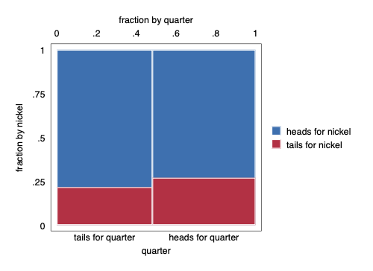

Mosaic Plot

## Bar Chart

Does a bar chart work to visualize these relationships?

. graph bar, over(quarter) over(nickel) scheme(burd)

. graph export nickel-quarter-bar1.png, width(500) replace  
(file nickel-quarter-bar1.png written in PNG format)

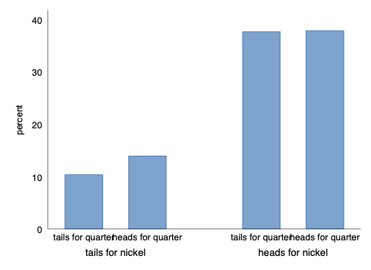

Bar Chart 1

Option asyvars adds a crucial color element.

. graph bar, over(quarter) over(nickel) scheme(burd) asyvars

. graph export nickel-quarter-bar2.png, width(500) replace  
(file nickel-quarter-bar2.png written in PNG format)

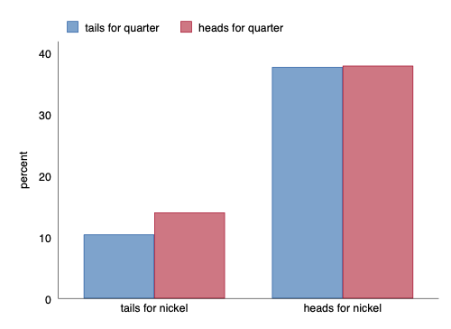

Bar Chart 2

And hbar may improve legibility even more.

. graph hbar, over(quarter) over(nickel) scheme(burd) asyvars

. graph export nickel-quarter-bar3.png, width(500) replace  
(file nickel-quarter-bar3.png written in PNG format)

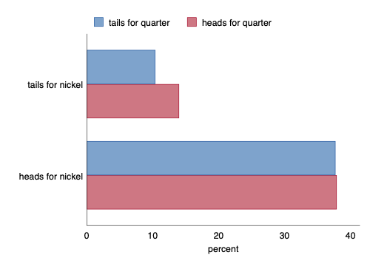

Bar Chart 3

# 1961 French Skiiers

. clear all

## Define Matrix

. matrix input FrenchSkiiers = (31, 109 \ 17, 122)

. matrix rownames FrenchSkiiers = Placebo AscorbicAcid

. matrix colnames FrenchSkiiers = Cold NoCold

. matrix list FrenchSkiiers  
  
FrenchSkiiers[2,2]  
 Cold NoCold  
 Placebo 31 109  
AscorbicAcid 17 122

## Theme Music

## Try Making a Data Set From Matrix

. svmat FrenchSkiiers, name(count)  
number of observations will be reset to 2  
Press any key to continue, or Break to abort  
number of observations (_N) was 0, now 2

. list  
  
 ┌─────────────────┐  
 │ count1 count2 │  
 ├─────────────────┤  
 1. │ 31 109 │  
 2. │ 17 122 │  
 └─────────────────┘

## Enter Data By Hand

There are many alternative commands to do this, but the easiest way is using edit.

I have already done this. Note the structure of the data is different from above.

. use "FrenchSkiiers.dta", clear

. list // list the data  
  
 ┌─────────────────────────────────┐  
 │ Tx Outcome Count │  
 ├─────────────────────────────────┤  
 1. │ Ascorbic Acid Cold 17 │  
 2. │ Ascorbic Acid No Cold 122 │  
 3. │ Placebo Cold 31 │  
 4. │ Placebo No Cold 109 │  
 └─────────────────────────────────┘

## Mosaic Plot

. spineplot Tx Outcome, scheme(burd)

. graph export FrenchSkiiers1.png, width(500) replace  
(file FrenchSkiiers1.png written in PNG format)

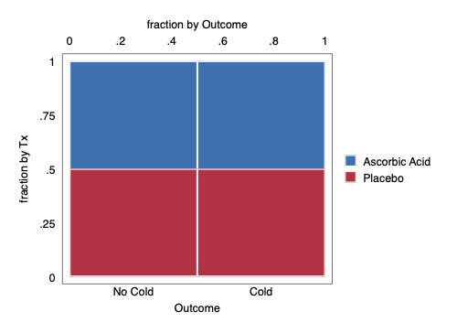

Mosaic Plot Attempt 1

spineplot Outcome Tx [fweight=Count], scheme(burd) // order matters to interpretability

graph export FrenchSkiiers2.png, width(500) replace

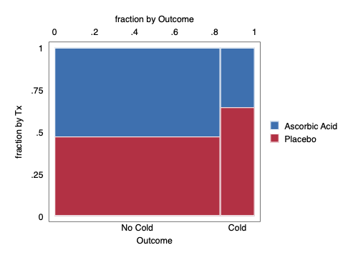

Mosaic Plot Attempt 2

# Definitions and Notation

$\begin{matrix}c_{ij} & c_{ij} & c_{i•} \\ c_{ij} & c_{ij} & c_{i•} \\ c_{•j} & c_{•j} & c_{••}\end{matrix}$