Ordinal and Multinomial Logistic Regression

Andy Grogan-Kaylor

11 May 2020

# Meta-Background

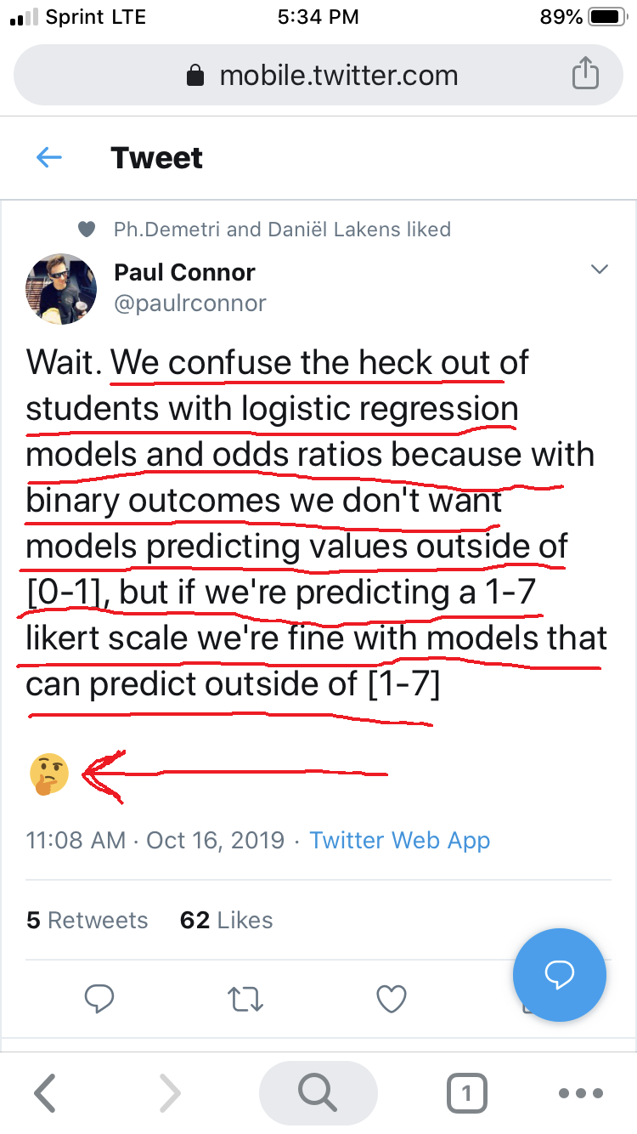

Tweet About Ordinal Models

# Key Concepts and Commands

* Implementations differ; formulas are our friends
* Extensions to logistic model: ordinal and multinomial logit
$$F(y)=β_{0}+βx_{1}+βx_{2}+...$$

* Ordinal model
$y(1, 2, 3, etc.)=β_{0}+βx_{1}+βx_{2}+...$

* Multinomial model
$y(2 vs. 1)=β_{0}+βx_{1}+βx_{2}+...$

$y(3 vs. 1)=β_{0}+βx_{1}+βx_{2}+...$

* Think about OR’s, predicted probabilities, non-linearity

# Get The Data (General Social Survey)

. clear all

. set maxvar 10000 // increase number of allowable variables

. use "/Users/agrogan/Box Sync/DATA WAREHOUSE/General Social Survey/GSS7218_R1.DTA", clear

. keep sex maeduc paeduc age degree

. save GSSsmall.dta, replace  
file GSSsmall.dta saved

. describe // describe the data  
  
Contains data from GSSsmall.dta  
 obs: 64,814   
 vars: 5 11 May 2020 18:15  
 size: 324,070   
───────────────────────────────────────────────────────────────────────────────────────────────  
 storage display value  
variable name type format label variable label  
───────────────────────────────────────────────────────────────────────────────────────────────  
age byte %8.0g AGE age of respondent  
paeduc byte %8.0g LABK highest year school completed, father  
maeduc byte %8.0g LABK highest year school completed, mother  
degree byte %8.0g LABL r's highest degree  
sex byte %8.0g SEX respondents sex  
───────────────────────────────────────────────────────────────────────────────────────────────  
Sorted by:

# Thinking About Your Data and Data Wrangling

It is always good to think about your data and what the values of different variables represent. In Stata, however, there is very little additional data wrangling to prepare the data. In R, there is considerable data wrangling since we have to employ special commands to work with *variable* and *value* labels and to ensure that *numeric* variables are recoded as *factors*. In Stata there are no such issues!!! 😜